The Goldstein Rotation Rule Version 6 PhL 7.15.12

1. Preliminary Note: Notation for Differentiation d/dt. 2
2. The G Rule for arbitrary vector a. 2
3. The Apparatus and its Observer at Rest in Frame S'. 4
4. The Purpose of this Effort 6
5. Determination of r(t). 8
6. Determination of v(t) = (dr/dt)_{S} 8
Comments on results obtained so far: significance of primes; "vectors under rotation" 10
7. Determination of a(t) = (dv/dt)_{S} 12
8. The Fictitious Forces 13
9. Determination of L(t) and (dL/dt)_{S} 15
10. Conclusions for the Original Problem 17
11. Solving the Inverse Problem 18

The general context of this document is that we have some Apparatus observed from two frames of reference called S and S' . As we shall see in Figure 1 below, frame S' is rotating in a certain manner with respect to frame S.

Notation:

• Frame S has Cartesian basis unit vectors en, while Frame S' has Cartesian basis unit vectors e'n .

• Any vector a can be expanded in two obvious ways: a = ai ei = a'i e'i.

• In the work below, we shall have occasion to use vectors which themselves contain a prime as part of the name of the vector, such as a'. For such a vector, the expansions are written as a' = (a')i ei = (a')'i e'i where an extra pair of parentheses is added to prevent ambiguity.

• The prime symbol has three distinct uses in this document, and each use is very important:

(1) It is used to label a vector such as a'. The vector a' is not the same as the vector a.
(2) It is used to label components and basis vectors in frame S', such as a'i or (a')'i or e'i.
(3) It is used on the frame label S' in derivatives taken in frame S', such as (da/dt)S' or (da'/dt)S' .

• The following notations will be used for position, velocity, acceleration and angular momentum:

r position vector of a Particle in frame S (tail on origin of frame S)
r' position vector of same Particle viewed from frame S' (tail on origin of frame S')

v ≡ (dr/dt)S velocity of a Particle viewed from frame S
v' ≡ (dr'/dt)S' velocity of same Particle viewed from frame S'

a ≡ (dv/dt)S acceleration of a Particle viewed from frame S
a' ≡ (dv'/dt)S' acceleration of same Particle viewed from frame S'

L = r x mv angular momentum of a Particle viewed from frame S
(dL/dt)S its rate of change viewed from frame S

L' = r' x mv' angular momentum of same Particle viewed from frame S'
(dL'/dt)S' its rate of change viewed from frame S'

1. Preliminary Note: Notation for Differentiation d/dt.

When we say "differentiate something with respect to time t", does it make a difference if we do this in frame S or in frame S'?

Here is an example:

de'i/dt = ω x e'i // in frame S, see derivation of this fact below, Eq. (4.4)
de'i/dt = 0 // in frame S' (because the e'i are fixed in frame S' )

Therefore, it seems that the act of "applying d/dt" can in fact depend on which frame you do it in. Therefore, we had better add something to our notation to distinguish things. Then

(de'i/dt)S = ω x e'i // in frame S
(de'i/dt)S' = 0 // in frame S'

Now what about differentiating a known scalar function like f(t) = 4t + 3t3. The derivative is the same in both frames for such a scalar function,

(df(t)/dt)S = (df(t)/dt)S' = df(t)/dt = (t) = 4 + 9t2 ,

so for scalar functions we can dispense with frame labeling. This applies also to the component of a tensor Tij..(t) where we would say

(dTij..(t)/dt)S = (dTij..( (t)/dt)S' = dTij..(t)/dt

Although Tij..(t) is the component of a tensor, it is a scalar function in the sense that it is just a single function. For a vector we might perhaps have f(t) = vi(t), some velocity component.

2. The G Rule for arbitrary vector a.

Note: In this and other documents we refer to the following equation

(da/dt)S = ω x a + (da/dt)S' (2.1)

as "the G Rule for vector a". G stands for Herbert Goldstein, the Rule appears on page 133 of his classic 1950 book Classical Mechanics. Perhaps another name for this rule would be "the rule which relates the derivatives of a vector taken in two frames which are rotating with respect to each other ". Since the Rule applies to any vector a, sometimes the vector is left out and one writes this operator equation,

(d/dt)S = ω x + (d/dt)S' . (2.2)

We shall now derive this Rule. Expand the vector a in frame S' components :

a = a'i e'i (2.2)

Differentiate a in frame S

(da/dt)S = (da'i/dt)S e'i + a'i(de'i/dt)S // chain rule

= (da'i/dt)S e'i + a'i ω x e'i // see Equ. (4.4), (de'i/dt)S = ω x e'i

= (da'i/dt)S e'i + ω x a'i e'i // move in scalar factor a'i

= (da'i/dt)S e'i + ω x a // recognize expansion of a

= (da'i/dt) e'i + ω x a // derivative of scalar function needs no label

so we have shown that

(da/dt)S = ω x a + (da'i/dt) e'i (2.3)

Now go back to the start

a = a'i e'i (2.2)

and differentiate this time in frame S' to get,

(da/dt)S' = (da'i/dt)S' e'i + a'i(de'i/dt)S'

= (da'i/dt)S' e'i + a'i* 0 // obvious fact that (de'i/dt)S' = 0

= (da'i/dt) e'i // derivative of scalar function needs no label (2.4)

Thus our results above are

(da/dt)S = (da'i/dt) e'i + ω x a (2.3)

(da/dt)S' = (da'i/dt) e'i . (2.4)

Inserting the second into the first gives the G Rule for vector a,

(da/dt)S = ω x a + (da/dt)S' . (2.1)

This then gives the connection between the derivative of a vector a in S compared to in S'.

Example: Suppose a = e'i . Then our rule (2.1) says

(de'i /dt)S = ω x e'i + (de'i/dt)S' (2.5)

But we noted earlier that (de'i/dt)S' = 0 and that (de'i /dt)S = ω x e'i so "the rule holds". We could have established (2.5) from the start "by inspection", and then derived (2.1) from it as follows. Rewrite (2.5),

(de'i /dt)S – ω x e'i – (de'i/dt)S' = 0 (2.5a)

Then from the expansion a = a'i e'i we have

(da/dt)S = a'i(de'i /dt)S ω x a = a'i ω x e'i (da/dt)S' = a'i (de'i/dt)S'

(da/dt)S – ω x a – (da/dt)S' = a'i(de'i /dt)S – a'i ω x e'i – a'i (de'i/dt)S'

= a'i [(de'i /dt)S – ω x e'i – (de'i/dt)S'] = a'i [0] = 0 => (da/dt)S = ω x a + (da/dt)S'

Comment: Are there any restrictions on the vector a for which this Rule applies? The only fact used above about a is that a can be expanded on Cartesian basis vectors as a = a'i e'i and that the component fields a'i(t) are differentiable. Since the unit vectors e'i are true tensorial vectors with respect to rotations, we conclude that a must also be a true tensorial vector under rotations. If the tail of vector a does not lie at the origin of frame S', we just translate a such that this is the case. The conclusion then is that this Rule applies to any vector a which transforms as a vector under rotations. Examples: r, v, a, p, L (position, velocity, acceleration, linear momentum, angular momentum).

3. The Apparatus and its Observer at Rest in Frame S'.

In our general "experiment" to be described below, frame S' is rotating with respect to frame S. This does not necessarily imply that frame S is "at rest", but frame S will be "at rest" with respect to the paper on which we make drawings below. If frame S is truly at rest with respect to the stars, then frame S is called an inertial frame, and in such a frame Newton's 2nd Law F = ma is valid. We do not in general assume that S is such an inertial frame.

Imagine now that we have some Apparatus sitting in frame S' which contains a Particle which undergoes some motion. An Observer also sitting in frame S' has some measurement equipment, can see the axes of frame S' of course, and does certain measurements on the Particle as frame S' is rotating with respect to frame S. Here then are some of the actions of the Observer in Frame S' :

• He takes note of the location of the Particle at time t and writes it down. This location we are going to denote by the vector symbol r' -- the first of several vectors we shall introduce which have a prime as part of the vector name. Our Observer will take note of the components of this vector by using the expansion in frame S',

r'(t) = (r')'i e'i (r')'i = r' • e'i

The vectors e'i are of course the basis vectors for frame S'.

• He notes the mentioned location r'(t), waits one tick dt of time, then notes new location r'(t+dt). From these two measurements he deduces the velocity in frame S' which we shall call v'. Thus

v'(t) = [r'(t+dt) – r'(t)]/(dt) or v'(t) = (dr'/dt)S'

• Next, he lets another tick go by and records r'(t+2dt) as well. Then he determines the acceleration of the Particle a' according to

v'(t+dt) = [r'(t+2dt) – r'(t+dt)]/(dt)

a'(t) = [v'(t+dt) - v'(t)]/(dt) or a'(t) = (dv'/dt)S'

He could of course go on to measure higher derivatives of the motion, but we will let him stop here.

• Knowing r' and v', the Observer knows the angular momentum of the Particle

L'(t) = r'(t) x mv'(t)

• Recall that each of the three vectors r', v' , a' and L' could be expanded in terms of the basis vectors of either frame S' (as he did above) or frame S. For example

a' = (a')i ei = (a')'i e'i

Example: Suppose the entire Apparatus consists of a single Particle just floating at rest in inertial Frame S. Our Observer in rotating frame S' will duly observe that this Particle follows a curved path in frame S' with some r'(t), and from that he will deduce v'(t) and a'(t) and L'(t).

Other Examples: The Particle might be a mass on one or more springs, or it might be Particle in ballistic flight, or it might be a Particle of matter in a gear wheel which is turning in some complicated machine, or it might be a Particle of a fluid or of an elastic solid.

4. The Purpose of this Effort

Given the frame S' Observer's measured values r'(t), v'(t), a'(t), we want to be able to know the values of r(t), v(t), a(t) which describe the motion of the same Particle as observed from a different frame S. The relation between the two frames is given by this picture:
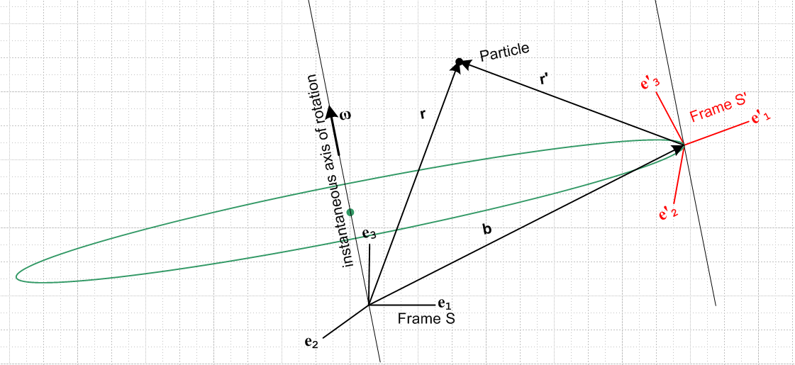 Fig 1

The picture requires some explanation. At some time t, frame S' has some particular Orientation relative to frame S which is determined by some vector θ= θ(t) of rotation parameters,

e'n(t) = R(θ) en R(θ) = exp(-iθ • J) i (Jk)ij = εkij (4.1)

Note: In (4.1), we imagine the unit vectors of both systems as having their tails at a common point since we are just talking about relative orientation.

The origin of frame S' is located at the tip of a vector called b whose tail lies at the origin of frame S. In a very small time interval surrounding time t, the origin of frame S' rotates along a small portion of the green circle shown (center at green dot). It motion is instantaneously lined up with this curve. We think of frame S' including its origin, its axes, its e'n unit basis vectors, and its contained Apparatus as rigidly rotating at this rate ω. The length of vector b is a constant during this rotation.

This ω(t) is the instantaneous angular velocity of frame S' relative to frame S. We say "instantaneous" since both and |ω| can be changing in time. To understand the meaning of ω, consider

e'n(t+dt) = R(dφ) e'n(t) where R(dφ) = some small rotation about the ω vector axis (4.2)

de'n = e'n(t+dt) - e'n(t) = [R(dφ) - 1] e'n(t) = -idφ • J e'n(t) = -idφk Jk e'n(t) (4.3a)

=> (de'n)i = -idφk (Jk)ij (e'n(t))j = - dφkεkij (e'n(t))j = εikj dφk (e'n(t))j

=> de'n = dφ x e'n (4.3b)

=> (de'n/dt)S = ω x e'n n = 1,2,3 where ω ≡ dφ/ddt (4.4)

Thus ω tells us how the unit vectors e'n are instantaneously rotating relative to frame S. The three e'n all rotate in the same manner because the entire frame S' is rotating as a rigid object.

In the picture above, then, frame S' and everything fixed within it as well as vector b all rotate together at ω about the origin of frame S with instantaneous angular velocity ω. For example,

(de'n/dt)S' = 0 (db/dt)S' = 0

Comments:

• Note that, in general,

e'n(t+dt) = R(dφ) e'n(t) = R(dφ) R(θ) en = R(θ + dΩ) en ≠ R(θ + dφ) en (4.5)

where |dΩ| is proportional to |dφ| but dΩ is some complicated function of θ and dφ. This function is only simple of it happens that θ and dφ (or ω) point in the same direction, in which case dΩ = dφ.

• Often Frame S is taken to be a frame "at rest with respect to the stars" meaning it is an "inertial frame" in which Newton's non-relativistic law F = ma applies ( it does not apply in rotating frame S'). For the sections of this document which don't deal with F = ma, frame S need not be such an inertial frame.

• Goldstein refers to frame S as the space frame, and frame S' as the body frame. In his analysis, our Apparatus is just a rigid body at rest in frame S'.

• We could consider a different situation in which frame S' rotates at ω about its origin and b stays fixed, but that is not the situation we wish to consider here. Another situation of possible interest might be either of these rotation senses combined with an active variation of the origin-spanning vector b(t). Finally, system S' could rotate about some arbitrary ω axis passing through neither of the origins of the two frames. The scenario of Fig 1 is suitable for working with earth and phonograph rotations, see below.

• The limit b → 0 causes the origins of the two frames to coincide and this results in a simplification of some of the equations in sections below. We have then b = 0 and ≡ (db/dt)S = 0, etc.

• Three applications of the above situation are:

(1) An ant (Particle) is moving around on a phonograph record rotating on its spindle with some ω(t). The frame S' might be set up some distance |b(t)| from the spindle, and might have its e'1 axis pointing to the right and its e'2 axis pointing to the spindle. That is to say, e'1 = ' and e'1 = -' if we think of r',θ' as polar coordinates for rotating frame S'.

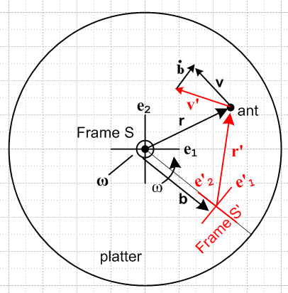 Fig 2

(2) On the Earth, Cartesian frame S might be an inertial frame located at Earth center with pointing to the North Pole. The axis points out through a point on the equator to some fixed distant star (the X Star), and then is the third Cartesian axis which points out through a different point on the equator to the Y Star. Meanwhile, Frame S' has its origin at some arbitrary point on the surface of the Earth. For this system, the ' axis points "up", meaning in the direction for Frame S in sphericals. The ' axis points to the East, and the ' axis points North. The earth rotates at some ω = ω with ω > 0.

(3) Some Apparatus is located in Frame S instead of S', and Frame S' is a "camera platform" which flies around in some complicated way and observes the activity in frame S. In this case, both ω(t) and b(t) would be under the command of the pilot of the camera platform.

5. Determination of r(t).

Well, this is quite simple. We have, looking at Fig 1 above,

r = r' + b (5.1)

Since our Observer in frame S' determined r'(t) and since the above "setup" determines b(t). we immediately know r(t) and this part of our Purpose is achieved. This equation will be used many times in what follows.

6. Determination of v(t) = (dr/dt)S

(a) Compute (dr/dt)S in a form suitable for G Rule Comparison

Start with our Section 2 result above, which was

r = r' + b (5.1)

Differentiate this in frame S to get

(dr/dt)S = (dr'/dt)S + (db/dt)S . (6.1)

Now use the G Rule for vector r' (equation (2.1) with a = r')

(dr'/dt)S = ω x r' + (dr'/dt)S' (6.2)

Then we have

(dr/dt)S = ω x r' + (dr'/dt)S'+ (db/dt)S (6.3)

It is easy to see from the picture that (this can be derived by the same steps leading to (4.4) above )

(db/dt)S = ω x b (6.4)

so we then have

(dr/dt)S = ω x r' + (dr'/dt)S'+ ω x b (6.5)

Combining the first and last terms and using the fact (5.1) that r = r' + b , we find

(dr/dt)S = ω x r + (dr'/dt)S'

which is to say

v = ω x r + v' (6.6)

Along with r = r' + b , the equation v = ω x r + v' will be used many times below.

(b) Compare with the G rule for r and get expression for (dr/dt)S'

The G Rule (2.1) applied to a = r says that

(dr/dt)S = ω x r + (dr/dt)S' (6.7)
So we may conclude from (6.6a) that

(dr/dt)S' = (dr'/dt)S' = v' (6.8)

Here is a much faster way obtain this same result:

r = r' + b (5.1)

(dr/dt)S' = (dr'/dt)S' + (db/dt)S' = (dr'/dt)S' + 0 = (dr'/dt)S'

because vector b is constant when viewed from frame S' (just as e'n are constants).

So first, we are consistent with the G Rule for r, and second, we know how to compute v ≡ (dr/dt)S .

(c) Compute (dr/dt)S in fully reduced form.

From (6.6) and (5.1) we get

v(t) = ω x r + v' = ω x [r' + b] + v' = ω x r' + ω x b + v'
or
v(t) = v' + ω x r' + ω x b (6.9)

Our Purpose was to find v(t) and there it is in terms of known quantities ω, b, r' and v' .

Comments on results obtained so far: significance of primes; "vectors under rotation"

(a) Evaluation of results so far in either frame : primes are important

At this point, we have obtained these two results

r = r' + b (5.1)
v = v' + ω x r' + ω x b (6.9)

Either equation can be "evaluated" in either frame S or frame S'. Evaluation in frame S gives

ri = (r')i + bi
vi = (v')i + εijkωj(r')i + εijkωjbi

while evaluation in frame S' gives

(r)'i = (r')'i + (b)'i
(v)'i = (v')'i + εijk(ω)'j(r')'i + εijk(ω)'j(b)'i .

This is a situation where we fully expect to have (r')i ≠ (r)'i and (v')i ≠ (v)'i as mentioned in the introduction, so the careful placement of primes is very important.

(b) Inverse Transformation Rule for vectors that are vectors under rotation.

Our definition of symbol R ≡ R(θ) used above in (4.1) tells us that, while basis vectors rotate this way,

e'n = R en or (e'n)i = Rij(en)j ,

"vectors under rotations" expanded in these basis vectors must transform this inverse way,

V' = R-1 V or V'i ≡ (V)'i = (V')i = (R-1)ijVj ,

where for such vectors there is no distinction between (V)'i and (V')i. This "inverse transformation rule" follows because only then are the two expansions of V valid,

V = Vj ej = V'ie'i ,

a fact we shall now verify in a series of short steps:

Step 1: The Cartesian basis vectors have these properties

δn,k = en • ek = e'n • e'k and (en)k = δn,k .

Step 2: Note that

em • e'n = em • Ren = (em)i Rij(en)j = δm,i Rijδn,j = Rmn .

Step 3: Claim that

e'n = Ren => en = Rnm e'm .

To see this, dot both sides of the claimed equation into e'k (complete basis) and use Steps 1 and 2,

en • e'k = Rnm e'm • e'k => Rnk = Rnm δm,k = Rnk .

Since the claimed equation is true in each of its components, it must be true in a vector sense.

Step 4: Now we show that the two expansions are valid making use of Step 3,

V = V'ie'i = [(R-1)ijVj]e'i = (RT)ijVje'i = RjiVje'i = Vj [Rjie'i] = Vj ej .

(c) Vectors r and v are not vectors under rotations, whereas ω and b are.

Given the transformations stated above

r = r' + b (5.1)
v = v' + ω x r' + ω x b (6.9)

it is clear that the pairs of vectors (r,r') and (v,v') are not "vectors under rotations" since

r' ≠ R-1r v' ≠ R-1v .

On the other hand, the vectors ω and b appearing in these formulas are normal "vectors under rotations" and one can write, in the same sense as V above,

b' = R-1b ω' = R-1ω

These equations just indicate that the vectors ω and b have different components when viewed from frame S' as compared to when viewed from frame S. Here is a picture showing a typical ω and b,

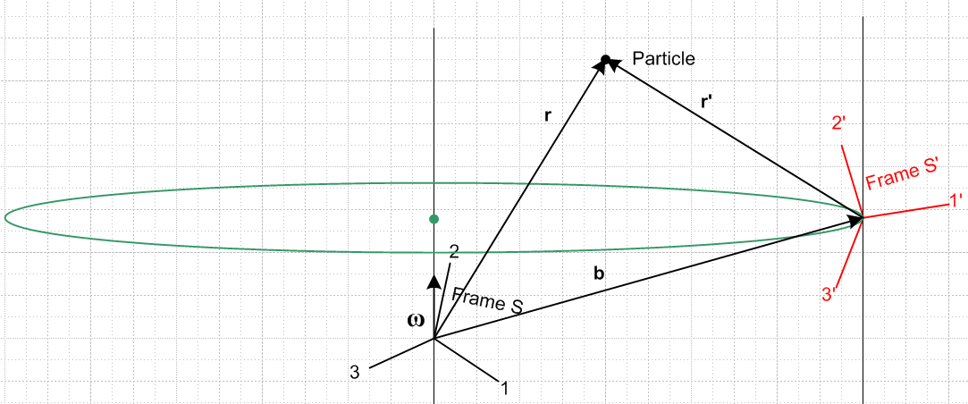

As for any vectors under rotation, we have

b'i ≡ (b')i = (b)'i ω'i ≡ (ω')i = (ω)'i

so we don't have to worry about parentheses for these vectors' components.

7. Determination of a(t) = (dv/dt)S

(a) Compute (dv/dt)S in a form suitable for G Rule Comparison

Let's start then with (6.6),

v = (dr/dt)S = ω x r + v' (6.6b)

Apply d/dt in frame S to get

a = (dv/dt)S = (dω/dt)S x r + ω x (dr/dt)S + (dv'/dt)S

Define ≡ (dω/dt)S and recall that v = (dr/dt)S so the above says (reordering terms)

(dv/dt)S = ω x v + x r + (dv'/dt)S (7.1)

For our Particle of interest, w x v is the centripetal acceleration toward the rotation axis, x r is the tangential acceleration due to varying ω, and (dv'/dt)S is the residual acceleration of the body in frame S', but measured in frame S. We can convert this to a frame S' derivative using the G rule for v',

(dv'/dt)S = ω x v' + (dv'/dt)S' = ω x v' + a' (7.2)

so that then

a(t) = (dv/dt)S = ω x v + x r + ω x v' + a' . (7.3)

For use later, we can replace v' = v - ω x r to get

a(t) = (dv/dt)S = 2ω x v + x r - ω x (ω x r) + a' . (7.4)

(b) Compare with the G rule for v and get expression for (dv/dt)S'

Now the G Rule for v tells us that

(dv/dt)S = ω x v + (dv/dt)S' . (7.5)

Comparison of (7.5) and (7.3) shows that,

(dv/dt)S' = x r + ω x v' + a' . (7.6)

(c) Compute (dr/dt)S in fully reduced form.

We found above that,

a = (dv/dt)S = ω x v + x r + ω x v' + a' (7.3)

where recall that the ω x v' term came from the G rule for v' which appears as (7.2) above. The last step is to replace v appearing in the ω x v term by v = ω x r + v' from (6.9) to get

(dv/dt)S = ω x [ω x r + v'] + x r + ω x v' + a'

= ω x (ω x r) + ω x v' + x r + ω x v' + a'

= ω x (ω x r) + 2 ω x v' + x r + a'

and we see that our substitution has generated a second ω x v' term and we end up then with

a(t) = ω x (ω x r) + x r + 2 ω x v' + a' (7.7)

Thus we have found a(t) in terms of known quantities. The final reduction uses (5.1) r = r' + b to get

a(t) = ω x (ω x r') + ω x (ω x b) + x r' + x b + 2 ω x v' + a' (7.8)

8. The Fictitious Forces

If Frame S is an inertial frame, then Newton's 2nd Law in that frame, F = ma, is valid in frame S and we can write, using (7.7),

F = ma = mω x (ω x r) + m x r + 2mω x v' + ma' . (8.1)

Our Observer in Frame S' would like to use his own personal "Newton's Law",

F' = m a' . (8.2)

Solving (8.1) for ma' we get

F' = F – mω x (ω x r) – m x r – 2mω x v'

= F + Ffict (8.3)

where

Ffict = – mω x (ω x r) – m x r – 2mω x v' (8.4)

So our Observer in Frame S' is allowed to use his own version of Newton's Law, (8.2), as long as he includes in his sum of forces the "fictitious" forces shown in (8.4).

The first fictitious force – mω x (ω x r) is the centrifugal (center-fleeing) force pushing our Particle away from the rotation axis, and ω x (ω x r) is the associated centripetal acceleration. To see that this is the case, consider this picture which shows vectors r and ω,

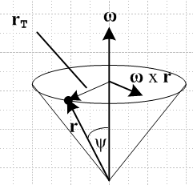 Fig 3

Using the right hand rule, one can see then that ω x (ω x r) is a vector pointing in the opposite direction to the vector labeled rT. From the location of the Particle at r, this vector points toward the center of the circle on which the particle is instantaneously rotating at time t, and this is the correct direction for centripetal (center seeking) acceleration. The magnitude of the vector is |ω x (ω x r)| = ω | ω x r | = ω2rsinψ = ω2rT and this is the correct magnitude for the centripetal acceleration. So the centripetal acceleration ω x (ω x r) points toward the rotation axis, while the centrifugal force – mω x (ω x r) is directed away from the rotation axis, as all Merry-Go-Round (not to mention Rotor) riders well know.

The second fictitious force – m x r in (7.10) exists only if ω ≠ constant. In the special case the happens to be in the direction of ω, meaning ω> 0 (this would apply in our phonograph platter scenario if the platter is spinning up) then x r is in the same direction as ω x r shown in Fig 3 and that is the direction of the tangential acceleration of a point on the platter. Correspondingly, a Particle in Frame S' feels a fictitious force – m x r in the opposite direction.

The third fictitious force

– 2mω x v' = + 2m v' x ω

is the famous Coriolis force which causes a ballistic Particle to deflect to the right in the northern hemisphere and to the left in the southern hemisphere.

9. Determination of L(t) and (dL/dt)S

Our frame S' observer can measure (set m = 1)

L' = r' x v' (9.1)

and add this to his list of dutiful measurements made in frame S'. We then have

(dL' /dt)S' = (dr'/dt)S' x v' + r' x (dv'/dt)S'

= v' x v' + r' x a' = r' x a'
or
(dL'/dt)S' = r' x a' . (9.2)

Meanwhile, in frame S we have

L = r x v (9.3)

Inserting (6.9) v = ω x r + v' into the above gives

L = r x [ω x r + v'] = r x (ω x r) + r x v'

and then using (5.1) r = r' + b just in the last term gives

L = r x (ω x r) + r' x v' + r x b = r x (ω x r) + L' + r x b

so then

L = L' + r x b + r x (ω x r) with r = r' + b (9.4)

and we have found L(t) as a function of known quantities, one of our goals stated above.

(a) Compute (dL/dt)S in a form suitable for G Rule Comparison

As for the derivative of L,

(dL/dt)S = (dr/dt)S x v + r x (dv/dt)S = v x v + r x (dv/dt)S = r x (dv/dt)S = r x a (9.5)

We then use (7.3),

a = ω x v + x r + ω x v' + a' (7.3)

to find that

(dL/dt)S = r x [ω x v + x r + ω x v' + a']

= r x(ω x v) + r x ( x r) + r x (ω x v') + r x a' (9.6)

The vector identity A x (B x C) + cyclic = 0 shows that

r x (ω x v) = ω x (r x v) - v x (r x ω)

= ω x L - v x (r x ω)

which we install into (9.6) to get

(dL/dt)S = ω x L - v x (r x ω) + r x ( x r) + r x (ω x v') + r x a' (9.7)

Since v = ω x r + v' from (6.9), we find that

- v x (r x ω) = [ω x r + v']x (r x ω) = v' x (r x ω)

so (9.7) may be written as

(dL/dt)S = ω x L + v' x (r x ω) + r x ( x r) + r x (ω x v') + r x a' (9.8)

But now the second and fourth terms can be combined using the identity above which we write as

r x (ω x v') = ω x (r x v') - v' x (r x ω)

and therefore

(dL/dt)S = ω x L + ω x (r x v') + r x ( x r) + r x a' (9.9)

Using r = b + r' just in the last term results, with the help of (9.2), gives

r x a' = b x a' + r' x a' = b x a' + (dL'/dt)S'

so that we can relate (dL/dt)S to (dL'/dt)S' in this way,

(dL/dt)S = ω x L + ω x (r x v') + r x ( x r) + b x a' + (dL'/dt)S' (9.10)

(b) Compare with the G rule for L and get expression for (dL/dt)S'

The G Rule for L states that

(dL/dt)S = ω x L + (dL/dt)S' (9.11)

so we conclude from (9.9) that

(dL/dt)S' = ω x (r x v') + r x ( x r) + r x a' (9.12)

(c) Compute (dL/dt)S in fully reduced form.

We had in (9.6),

(dL/dt)S = r x (ω x v) + r x ( x r) + r x (ω x v') + r x a' . (9.6)

Since (6.9) v = ω x r + v', the first term may be written

r x (ω x v) = r x (ω x (ω x r)) + r x (ω x v')

The triple cross term may be simplified by using this vector identity

A x [ B x (C x D) ] = B [A,C,D] - (A•B) (C x D)
r x [ ω x (r x ω) ] = ω [r,r,D] - (r•ω) (r x ω) = - (r•ω) (r x ω) (9.13)

so that

r x(ω x v) = - (r•ω) (r x ω) + r x(ω x v')

Then we have

(dL/dt)S = - (r•ω) (r x ω) + r x ( x r) + 2r x (ω x v') + r x a' with r = r' + b (9.14)

10. Conclusions for the Original Problem

We seem to have accomplished our Purpose, and here are the results for frame S quantities in terms of ω, , b (see Fig 1) and frame S' quantities

r = b + r' (5.1)

v = ω x r + v' (6.9)

a = ω x (ω x r) + x r + 2 ω x v' + a' (7.7)

L = L' + r x b + r x (ω x r) (9.4)

(dL/dt)S = - (r•ω) (r x ω) + r x ( x r) + 2r x (ω x v') + r x a' (9.14)

There are three G rules, those for r, v, and L and they are of course all valid with expressions as shown:

(dr/dt)S = ω x r + (dr/dt)S' (6.7)
(dr/dt)S' = v' (6.8)

(dv/dt)S = ω x v + (dv/dt)S' . (7.5)
(dv/dt)S' = x r + ω x v' + a' (7.6)

(dL/dt)S = ω x L + (dL/dt)S' (9.11)
(dL/dt)S' = ω x (r x v') - r x (r x ) + r x a' (9.12)

Newton's 2nd Law for an Observer on the rotating frame S' has this form

F' = m a' where F' = F + Ffict where (8.2,3)

Ffict = – mω x (ω x r) – m x r – 2mω x v' = the fictitious forces (8.4)

F = any forces acting on the Particle in Frame S (eg, gravity)

11. Solving the Inverse Problem

Consider these two problems which concern the exact same physical situation:

Original Problem: given r', v', a', L' find r, v, a, L

Inverse Problem: given r, v, a, L find r', v', a', L'

Here we want to invert the equations summarized in Section 9,

r = b + r' (5.1)

v = ω x r + v' (6.9)

a = ω x (ω x r) + x r + 2 ω x v' + a' (7.7)

L = L' + r x b + r x (ω x r) (9.4)

(dL/dt)S = - (r•ω) (r x ω) + r x ( x r) + 2r x (ω x v') + r x a' (9.14)

to get a solution to the Inverse Problem. The first equation is easily inverted

r' = r - b (11.1)

and so is the second

v' = v - ω x r (11.2)

The third equation requires a small effort,

a' = a – ω x (ω x r) – x r – 2 ω x v'

= a – ω x (ω x r) – x r – 2 ω x [v - ω x r]

= a – ω x (ω x r) – x r – 2 ω x v + 2 ω x (ω x r)

= a + ω x (ω x r) – x r – 2 ω x v (11.3)

The L equation is also trivial to invert

L' = L – r x b – r x (ω x r) (11.4)

For the (dL/dt)S equation, we start with its alternate form (9.10)

(dL/dt)S = ω x L + ω x (r x v') + r x ( x r) + b x a' + (dL'/dt)S'

to find that

(dL'/dt)S' = (dL/dt)S – ω x L – ω x (r x v') – r x ( x r) – b x a' (11.5)

which we leave "as is". One can insert (11.2) and (11.3) for v' and a', but the result has many terms.

We may now summarize the solution of the Inverse Problem:

r' = r - b (11.1)

v' = v - ω x r (11.2)

a' = a + ω x (ω x r) – x r – 2 ω x v (11.3)

L' = L – r x b – r x (ω x r) (11.4)

(dL'/dt)S' = (dL/dt)S – ω x L – ω x (r x v') – r x ( x r) – b x a' (11.5)

Example 1: Referring to Fig 1, suppose a Particle floats at rest at the origin of inertial Frame S. This means that we have r = 0, v = 0, a = 0, L = 0. What does an Observer within Frame S' see? The results are quite simple :

r' = - b
v' = 0
a' = 0
L' = 0
(dL'/dt)S' = 0

In Frame S'. the Particle appears at location r' = -b and just sits there doing nothing as S' rotates. In Figure 1, Frame S' including the b vector rotates around the Frame S origin.

Example 2: Referring to Fig 1, suppose a Particle floats at rest at some point r = r0 in inertial Frame S. This means that we have r = r0, v = 0, a = 0, L = 0. What does an Observer within Frame S' see?

r = r0 // in this example, these things are always the same.

r' = r0 - b // says r'(t) describes a circular motion which seems right.

v' = - ω x r0 // this seems wrong since it says v' = constant
a' = ω x (ω x r0) – x r0

L' = – r0 x b – r0 x (ω x r0)

(dL'/dt)S' = – ω x (r0 x v') – r0 x ( x r0) – b x a'

How can the Particle go in a circular motion in Frame S' and have a constant velocity??? Save for the next day. Must be something simple I hope. Could the whole inverse concept be wrong?

Issue # 1: The Particle really does have the constant velocity direction shown as v' = - ω x r

First, here is a picture showing Frame S' on our phono record at some time.

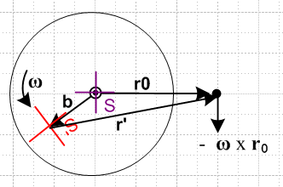

At some slightly later time, red frame S' is in a slightly new position. Here I draw these two adjacent positions and the fixed Particle dot

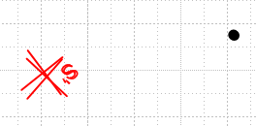

Now I take the second position and the dot and group them together, and then I rotate that group until the two red frames align,

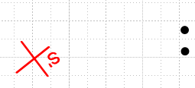

You see that the black dot has in fact moved in the -ω x r0 direction as the formula predicts. This will be true for any pair of adjacent red S' positions you pick around the circle. Let's repeat the experiment starting here:

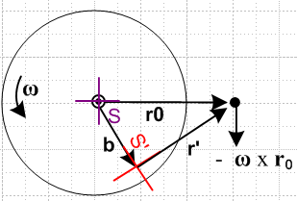

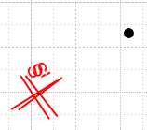 => 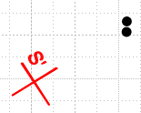

and we get the same result.

Issue # 2: Paths of the Particle.

After several hours, I am having a LOT of trouble with two simple questions:

(1) what does the path of the particle look like in Frame S ?
(2) what does the path of the particle look like in Frame S' ?

Next day: Phrases are not always clear. Question (1) could mean what is r in frame S, or it could mean what is r' in frame S. Here I will compute both of these:

(1a) Path of particle r in frame S

r (in frame S) = r0 = constant since r = riei = roe1 // case closed on this one!

(1b) Path of particle r in frame S'

Now from just-made doc "a simple theorem about basis vectors.doc" (phys/QM/ang mom) we know

e'n = Rz(φ)en => $\left(\begin{matrix}e'1 \\ e'2\end{matrix}\right)$ = Rz(-φ)$\left(\begin{matrix}e1 \\ e2\end{matrix}\right)$ => e'n = R-1(φ)nm em
or
e'1 = cosφ e1 + sinφ e2
e'2 = - sinφ e1 + cosφ e2

Therefore expand r in frame S'

r = r'ne'n where r'n = r • e'n so that

r'1 = x' = r • (cosφ e1 + sinφ e2) = roe1 • (cosφ e1 + sinφ e2) = rocosφ
r'2 = y' = r • (-sinφ e1 + cosφ e2) = roe1 • ( -sinφ e1 + cosφ e2) = - rosinφ

So we seem to get

x' = rocosφ = r'1
y'= - rosinφ = r'2

This shows that the path of r in frame S' is a circle as shown on the right below,

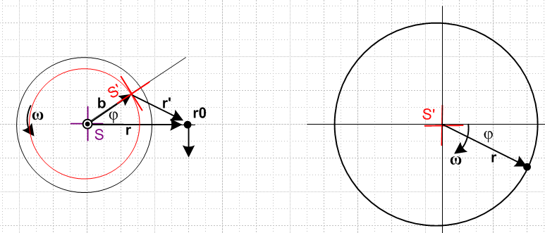

You can see that the two pictures "agree". On the right of course the tail of r has been pinned to the frame S' origin. On the right in frame S' the vector r rotations CW, whereas on the left frame S' rotates CCW.

Comment: Since r = r0 always, the picture on the right shows that r0 is NOT a constant vector when viewed from frame S'. It rotates! So when I had v' = - ω x r0 and was worried that this seemed odd since the RHS is a constant, well, RHS is NOT a constant viewed from frame S'.

(2a) Path of particle r' in frame S

We now that r = b + r' and therefore

r' = r - b

The Frame S components of both sides are

(r')i = (r)i - (b)i

But we know from (1a) that r = roe1

(r)i = roδi,1

And we know that b = bR(φ)e1 so (b)i = bRij(e1)j = bRi1

(r')i = roδi,1 - bRi1

Write these out explicitly to get

(r')1 = r0 - R11 = r0 - bcosφ
(r')2 = 0 - R21 = - bsinφ

which says for r' = (r')iei = xiei for a graph

x = r0 - bcosφ
y = - bsinφ

Here is a picture of this situation

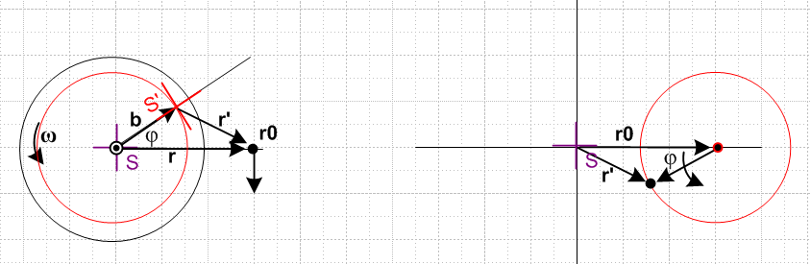

Again the figures make sense. The vector r' always points to the right in frame S.

(2a) Path of particle r' in frame S'

The expansion here may be taken as

r' = (r')'ie'i where (r')'i = r' • e'i

so we have

(r')'i = r' • e'i = (r - b) • e'i = r • e'i - b • e'i = (r)'i - (b)'i

Now we compute from above

b = bR(φ)e1 = bR(φ) R-1(φ) e'1 = b e'1

and this agrees with the picture notion that from frame S', b always points to the right. Thus

b • e'i = b e'1• e'i = b δ1,i = (b)'i

And we found earlier that

x' = rocosφ = (r)'1
y'= - rosinφ = (r)'2

Therefore we find that

(r')'1 = (r)'1 - (b)'1 = rocosφ - b
(r')'2 = (r)'2 - (b)'2 = - rosinφ

or for purposes of plotting

x' = rocosφ - b
y' = - rosinφ

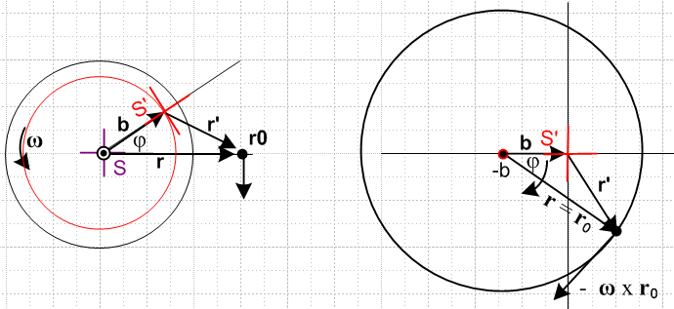

and again (finally!) the picture makes sense. Note that ω points out of the plane of paper in all pictures.

Comment: The picture on the right shows what the vectors r and r' look like viewed from Frame S'.

Now we can face this question: How can we have v' always pointing down in frame S, v' = - ω x r0,

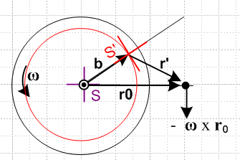

while at the same time the particle goes around in a circle. We need to ponder the meaning of v' a bit:

v' = - ω x r0

If we look at this in frame S', the useful picture is the big circle on the right above, and in that picture you see that the vector - ω x r0 is in a perfectly reasonable direction to be the velocity of the particle going around in a circle. Looking at vector v' in Frame S is a "cross" view that is not very convenient.
Now here is perhaps the confusing picture. We had this picture showing r' in frame S

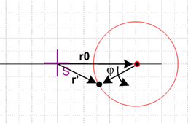

The thing that appears to be a velocity in this picture is really (dr'/dt)S and this is not
the same as v' = (dr'/dt)S' and the difference is the G rule term! So if you want to have position and velocity "make sense", you need to plot them both in their natural frames, and that is what the large circle picture on the right above is doing.

***************************************************************

(2a) Vector r' as seen in frame S'

Now from just-made doc "a simple theorem about basis vectors.doc" (phys/QM/ang mom) we know

e'n = Rz(φ)en => $\left(\begin{matrix}e'1 \\ e'2\end{matrix}\right)$ = Rz(-φ)$\left(\begin{matrix}e1 \\ e2\end{matrix}\right)$ => e'n = R-1(φ)nm em
or
e'1 = cosφ e1 + sinφ e2
e'2 = - sinφ e1 + cosφ e2

Therefore expand r' in frame S'

r' = (r')'ne'n where (r')'n = r' • e'n so that

(r')'1 = r' • e'1 = (r0 - b) • e'1 = r0 • e'1 – b • e'1 = (r0e1) • e'1 - b
= (r0e1) • (cosφ e1 + sinφ e2) - b = r0cosφ - b

(r')'2 = r' • e'2 = (r0 - b) • e'2 = r0 • e'2 – b • e'2 = (r0e1) • e'2
= (r0e1) • (-sinφ e1 + cosφ e2) - b = - rosinφ

So we end up then with

(r')'1 = - b + r0cosφ
(r')'2 = - rosinφ

And here is the picture

and again the picture makes sense. Note that ω points out of the plane of paper in all pictures. This picture on the right shows BOTH the vector r' as seen in S', and the vector r as seen in S'. I am totally happy with how these two pictures show the same thing for both these vectors.

(1b) Path of particle r in frame S'

Since r' = r0 - b and r = r0 we write r' = r - b and then r = r' + b . That means, evaluating on the e'i

(r)'i = (r')'i + (b)'i

and we just look at the two cases

(r)'1 = (r')'1 + (b)'1 = - b + r0cosφ + b = r0cosφ

(r)'2 = (r')'2 + (b)'2 = - rosinφ + 0 = -r0sinφ

=> r = (r0cosφ)e'1 + (-r0sinφ) e'2

This continues to bother me. Does the picture on the right really show r as viewed from S' ? It shows the orientation of r correctly, it just does not show the tail position correctly.
Well go back to the starting point which is r = r' + b . If have r' as shown on the right side of the previous picture, and if we add b to every point on that locus, we get the locus shown here for r, there is no avoiding this fact. We also then have r = (r)'ie'i which means tail at origin.
Start once again with r = r' + b . If we expand each vector like so:

(r)'ie'i = (r')'ie'i + (b)'ie'i

then we conclude that

(r)'i = (r')'i + (b)'i

So we have already put r = (r)'ie'i into the stew which means we have already put r tail at origin.
Instead of doing this, start again with r = r' + b . We found the trajectory of r' assuming its tail is at the S' origin, Then notice that this picture shows r = r' + b so this then gives the path of r without putting the tail of r at the origin.

