The Goldstein Rotation Rule Version 7 PhL 7.20.12

1. Notation, various uses of Primes and other Preliminaries. 1
(a) the basis vectors e_{n} and e'_{n} and two ways in which they are related. 1
(b) Expansions of a vector and use of primes and parentheses 2
(c) Special case where a'_{i} is unambiguous. 3
(d) When are Two Vectors Equal? 5
(e) The Small Rotation of a vector about an axis. 5
(f) The time rate of change of a vector 7
(g) The time rate of change of a vector when multiple Frames are involved 8
2. The G Rule for arbitrary vector a. 11
3. The Apparatus and its Observer at Rest in Frame S'. 13
4. The Relation between the Two Frames. 14
5. The overall goal, and the Determination of r(t). 17
6. Determination of v(t) = (dr/dt)_{S} 17
7. Determination of a(t) = (dv/dt)_{S} 20
8. The Fictitious Forces 21
9. Determination of L(t) and (dL/dt)_{S} 23
10. Conclusions for the Original Problem 25
11. Solving the Inverse Problem 26

The general context of this document is that we have some Apparatus observed from two frames of reference called S and S' . As we shall see below, frame S' is rotating and translating in a certain manner with respect to frame S.

1. Notation, various uses of Primes and other Preliminaries.

(a) the basis vectors en and e'n and two ways in which they are related.

Frame S has Cartesian basis unit vectors en, while Frame S' has Cartesian basis unit vectors e'n . The two sets of basis vectors are related by some rotation we shall call R,

en = R e'n for n = 1,2...N or (en)i = Rij(e'n)j (1.1)

The above relation between en and e'n can also be written in this manner, where the RHS is a sum of vectors,

en = (R-1)nm e'm , or e'n = Rnm em (1.2)

a fact we shall now prove in a short series of steps:

Step 1: The Cartesian basis vectors have these properties

δn,k = en • ek = e'n • e'k and (en)k = δn,k . (1.3)

Step 2: Note that

em • e'n = em • [R-1en] = (em)i (R)-1ij(en)j = δm,i (R)-1ij δn,j = (R-1)mn . (1.4)

Step 3: Our little theorem makes this claim:

en = Re'n => en = (R-1)nm e'm .

Dot both sides of the claimed equation into e'k (a complete basis) and use Steps 1 and 2,

en • e'k = (R-1)nm e'm • e'k => (R-1)nk = (R-1)nm δm,k = (R-1)nk .

Since the claimed equation is true in each of its components, it must be true in a vector sense.

(b) Expansions of a vector and use of primes and parentheses

Normally, given a vector a, we can expand it on either set of basis vectors and we write, with implied summation on i,

a = ai ei = a'i e'i . ai = a • ei a'i = a • e'i (1.5)

If we know that we are going to also be working with a vector named a', then we might want to be more careful about how we label components. A safe method would be this:

a = (a)i ei = (a)'i e'i (a)i = a • ei (a)'i = a • e'i
a' = (a')i ei = (a')'i e'i (a')i = a' • ei (a')'i = a' • e'i (1.6)

Here, a prime inside a parentheses is part of the vector name, whereas a prime outside a parentheses denotes a vector component in frame S' (while no prime there means a component in frame S). Unless the relationship between vectors a and a' has a certain simple form, it is very likely that (a')i ≠ (a)'i . In this case the notation a'i would be ambiguous since one doesn't know whether it refers to (a')i or (a)'i. It is true that the notation ai could be unambiguously identified with (a)i, but we shall maintain the parentheses just to be uniform.

Example 1. As an example of the four expansions above, let us consider a = en :

en = (en)i ei => (en)i = δn,i // by inspection

e'n = (e'n)'i e'i => (e'n)'i = δn,i // by inspection

en = (en)'i e'i => (en)'i = (R-1)ni // using (2) that en = (R-1)nm e'm

e'n = (e'n)i ei => (e'n)i = Rni // using (2) that e'n = Rnm em

We can now restate these results showing the dot products which represent each expansion coefficient, and in this way we obtain expressions for all the dot products,

en = (en)i ei => (en)i = en • ei = δn,i

e'n = (e'n)'i e'i => (e'n)'i = e'n • e'i = δn,i

en = (en)'i e'i => (en)'i = en • e'i = (R-1)ni = RTni = Rin

e'n = (e'n)i ei => (e'n)i = e'n • ei = Rni (1.7)

Notice that all these results are consistent with claims made earlier

(c) Special case where a'i is unambiguous.

We shall now examine the type of relationship between a' and a in which (a')i = (a)'i and therefore we can use the notation a'i without ambiguity.

First of all, if R is any rotation, meaning RTR = 1, we know that

a • b = [Ra] • [Rb] (1.8)

One line proof:

[Ra] • [Rb] = [Ra]k[Rb]k = RkiaiRkjbj = (RT)jk Rkiaibj = (RTR)jiaibj = δj,iaibj = aibi = a • b

Now, we are going to find the relationship between (a)'i and (a)i in the following manner.

(a)'n = a • e'n = [R a] • [R e'n] // valid for any rotation R as shown above
= [R a] • en // using the specific rotation appearing in en = R e'n
= [R (a)m em] • en // inserted expansion a = (a)m em
= (a)m (Rem) • en // extracted number (a)m from [...]
= (a)m (Rem)k(en)k // wrote out dot product
= (a)m Rki(em)i(en)k // wrote out (Rem)k
= (a)m Rkiδm,iδn,k // used (em)i = δm,i twice
= Rnm (a)m

Therefore we have shown that the (a)'n and (a)n are related in this manner

(a)'n = Rnm (a)m (1.9)
Now suppose we define the vector a' in this manner

a' ≡ Ra (1.10)

If a vector transforms according to (1.10), we say it is a "vector under rotations" which means it "transforms as a vector under rotations".

When written in frame S components this says

(a')n = Rnm(a)m (1.11)

Comparison of (8) and (10) shows that

(a)'n = (a')n (1.12)

and therefore in this case we can use

a'n ≡ (a)'n = (a')n (1.13)

Thus, if the vectors a and a' are related by a' = Ra where R is the rotation appearing in en = R e'n , then we can dispense with the parentheses as shown in (12). We still have (a')'i which requires parentheses.

Example 2: Consider equation (1.1) ,

en = R e'n

Since this is not of the form a' ≡ Ra, we may not dispense with the parentheses. In fact from (7) above we have

(en)'i = Rin
(e'n)i = Rni

and these are not the same.

Example 3: Soon we shall be dealing with an equation r' = r - b. Since this is not for the form r' ≡ Rr , we may not dispense with the parentheses, and we expect that (r')i and (r)'i will be different.

[ Footnote: More generally, if R is the linearized version of some general transformation x' = F(x) at a point x, so that dx' = R(x) dx, then (1.10) says that a "transforms as a contravariant vector with respect to the underlying transformation F ". In general R(x) is not a rotation and is a function of location. In this document we deal only with R(x) = R = a rotation that is the same at all points in space. It turns out that the notation a'i is unambiguous in this general case as well. The proof of this fact is just as shown above, except the • symbol represents the covariant dot product a • b = ijaibj where is the covariant metric tensor. In this document we always have ij = δi,j. ]

(d) When are Two Vectors Equal?

This topic will probably seem strange and unnecessary, but it has been a constant annoyance to the author so here are some words on the subject.
When we say two vectors A and B are the same or are equal, we mean that the two vectors have the same components in the same coordinate system and we write A = B. This does not require that vectors A and B coincide, it might be that B is a translated copy of A. To be really fussy, we could define a stronger equality A B to mean that not only do the vectors have the same components in the sense of A = B, but the vectors actually coincide with each other. We shall have no use for A B in this document. For us, two vectors are "the same" even if translated from one another.
In light of this interpretation of vectors being equal, we can examine the meaning of certain statements. For example, we normally say "a particle is located at r in frame S ". This really means the particle is at point r in frame S which has coordinates (x,y,z). What this means in terms of the vector r is that if the vector r is translated so that its tail is at the origin of frame S, then its tip will be at the particle location. The vector r can be drawn anywhere in a picture. It describes the displacement of a particle in frame S from the origin in frame S.

Example 4: When we say en = R e'n as in (1) above, it is understood that the tails of all vectors involved (the en and the e'n) are at a common location, as in this picture

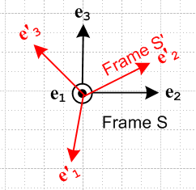

even though in our application, the en are drawn with their tails at the origin of Frame S while the e'n are drawn with their tails at the origin of Frame S'.

Example 5: In the expansion r = (r)iei we normally think of vector r having its tail at the origin of Frame S, while in the expansion r = (r')'ie'i one would be inclined to think of vector r as having its tail at the origin of Frame S'. In our stricter sense of coincidence noted above, we might say (r)i ei (r')'i e'i but this is not of interest. What we care about is that (r)i ei = (r')'i e'i in the sense A = B above and we don't care if the vectors A and B are translated relative to one another. What we care about is that the vectors have the same components in a given Frame.

(e) The Small Rotation of a vector about an axis.

We do this first analytically, and second graphically. In the analytical approach, the reader must accept a few facts about rotation matrices. The 3x3 matrix which rotates a vector by angle θ about rotation axis is given by

R(φ) = exp(-i φ • J) (1.14)

where the (J)k are 3x3 matrices known as the rotation generator matrices:

J1 = 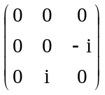 J2 = 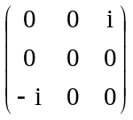 J3 = 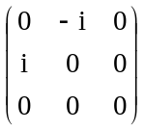 (1.15)

The values in these three matrices can be summarized in this single statement,

(Jk)ij = -i εkij (1.16)

where ε is the totally antisymmetric permutation tensor defined by

εabc = +1 if abc is an obtained from 123 by an even number of pairwise swaps (such as 312)
εabc = -1 if abc is an obtained from 123 by an odd number of pairwise swaps (such as 213)
εabc = 0 otherwise (ie, when two or more indices have the same value such as 122 or 333) (1.17)

so that, for example, εabc = - εbac regardless of index values.
It is convenient to define a vector rotation angle in this manner

φ ≡ φ (1.18)

and then the same rotation may be written in these new ways,

R(φ) = R(φ) = exp(-i φ • J) (1.19)

For a small rotation dφ = dφ, this may be approximated as (using ex = 1 + x + ... but applied to x = matrix)

R(dφ) = exp(-i dφ • J) ≈ 1 - i dφ • J (1.20)

With these preliminary remarks out of the way, we can consider the rotation of a vector by a small amount as we move from time t to time t + dt,

a(t+dt) = R(dφ) a(t) (1.21)

where we have in mind that dφ ≡ dφ is in some arbitrary direction which is unrelated to the direction of the vector a(t) . We then find that the change in vector a is given by

da = a(t+dt) - a(t) = R(dφ) a(t) - a(t) ≈ [1 - i dφ • J] a(t) - a(t) = - i dφ • J a(t) = - i dφk Jka(t)

Taking the ith component of the above equation we get

dai = - i dφk[Jka]i = - i dφk(Jk)ijaj = - i dφk( -i εkij ) aj = - εkij dφk aj = + εikj dφk aj

and going back to vector notation we find that

da = dφ x a (1.22)

which is our main result.
Here then is a graphical derivation of this same fact for a limited geometry. Consider this picture

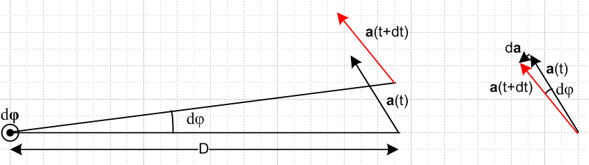

where the small rotation vector dφ points out of the plane of paper, and where a(t) happens to lie in the plane of paper (hence this picture does not cover the most general case). Using the right hand rule for cross products, we can see that da (shown on the right) lies in the direction of dφ x a, so we can write that da = C dφ x a where C is some constant. We can determine C from the equation |da| = C |dφ x a| . Since dφ and a are at right angles, we know that |dφ x a| = |dφ| |a| = dφ a. But from the picture on the right it seems quite clear that |da| ≈ a dφ. Therefore

|da| = C |dφ x a| => dφ a = C dφ a => C = 1

so we end up with da = dφ x a which agrees with the result above obtained by other methods. In the case that a does not lie in the plane of paper, the geometric derivation takes more work, and in this case we just rely on the analytic result.
Notice the fact that da = dφ x a does not depend on the distance D between the rotation axis and the tail of vector a! The result is true even if this distance is 0 so that the tail of vector a lies right on the rotation axis. In this case the pair of arrows in the left picture coincides with the pair of arrows in the right picture.

(f) The time rate of change of a vector

In the previous section we found that

da = dφ x a (1.22)

Dividing by dt gives

(da/dt) = ω x a where ω ≡ dφ/dt (1.23)

This is a fundamental result of great importance in this document. This equation gives the rate of change of a vector a if vector a is rotating at angular frequency ω about a rotation axis coinciding with vector ω . The distance D of vector a from the rotation axis plays no role in this result.
Note that one might have ω = ω(t) so the vector ω could be changing in both direction and magnitude as time progresses. But at time t, we have a definite (t), and this is sometimes referred to as the instantaneous axis of rotation at time t.

(g) The time rate of change of a vector when multiple Frames are involved

In the work to follow below, we shall be interested in Frame S and Frame S' as shown in this picture

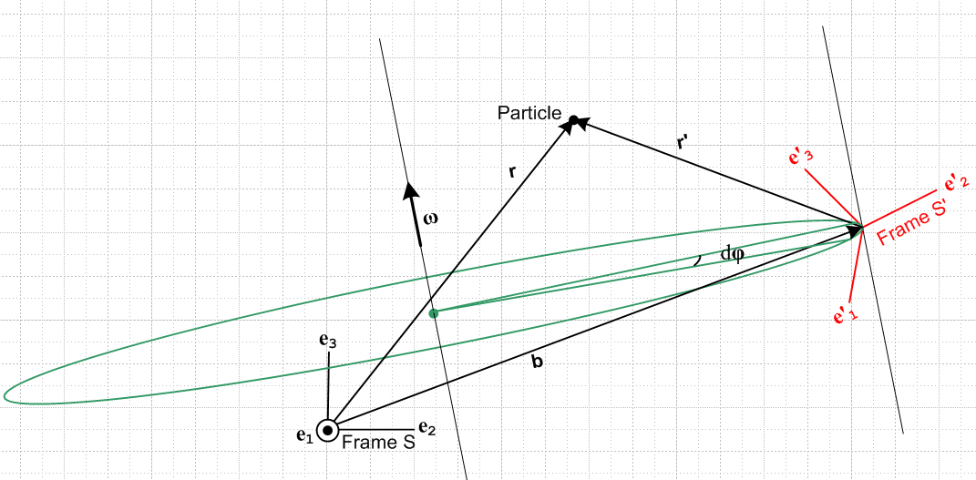

We shall discuss this picture more below, here we take just a preliminary look. Frame S' is seen to be rotating instantaneously about a certain axis with a rate ω where ω = ω . It is rotating in this manner relative to frame S which is glued to the paper as shown.

Rate of change of the basis vctors.

We can thus apply our rate of change rule (***) to the basis vectors e'n and we find that

(de'n/dt ) = ω x e'n .

Since we are computing this derivative while "standing" in Frame S, we now add a label S showing this fact

(de'n/dt)S = ω x e'n . (1.24)

Were we to compute this same derivative standing in Frame S', we would get

(de'n/dt)S' = 0 (1.25)

because in Frame S' the basis vectors e'n are not rotating at ω, but are just sitting there frozen. By the same argument, we know that

(den/dt)S = 0 (1.26)

What about the fourth possible derivative (den/dt )S' ? We will show in Section 2 that in fact

(den/dt)S' = – ω x en , (1.27)

but we can here give the following blurry argument as to why this is so. In order to stop frame S' from rotating in the above picture, we have to apply a rotation of rate -ω to our piece of paper along the ω axis in the picture. This then stops the rotation of frame S', but it causes frame S to rotate in the opposite direction relative to frame S'. This "opposite direction" accounts for the minus sign in the above equation. Perhaps this toy argument could be cleaned up, but we will derive the above by other means so we don't need this geometric argument.

Conclusion: We thus arrive at the notion that, when dealing with multiple frames of reference and vectors represented in terms of their respective basis vectors, we absolutely must indicate the frame in which the time derivative is being computed.

Some facts about time derivatives of vectors and of components of vectors.

[1] Suppose we have a pair of vectors a and a' related in some way. We can associate with these two vectors four different time derivatives:

(da/dt)S (da/dt)S' (da'/dt)S (da'/dt)S'

In the first and last derivatives, the prime or lack of it matches between the vector and the frame label. We shall define the following notation using these two derivatives

≡ (da/dt )S ' ≡ (da'/dt )S' (1.28)

The other two "cross derivatives" have no special notation but will appear in various equations below.

[2] Just as a reminder, each of the four derivatives shown on the first line above can be expanded onto either frame S or frame S basis vectors, and so each of the four derivatives has frame S and frame S' components. This statement would be true for any set of vectors and we just remind the reader that the notation like (da/dt )S does not mean the components are evaluated only in frame S. Just as an example, the first derivative has these two expansions :

(da/dt )S = [(da/dt )S]i ei = [(da/dt )S]'i e'i

where the components are given by

[(da/dt )S]i = (da/dt )S • ei [(da/dt )S]'i = (da/dt )S • e'i .

[3] If one is differentiating a component of a vector, such as ai(t) = 3t2, there is no need to add the frame label since the derivative of this function is 6t no matter what frame it is computed in. This is true when differentiating any component of any tensor. That is to say, if Tij..(t) is a component of a tensor, then

(dTij..(t)/dt)S = (dTij..( (t)/dt)S' = (dTij..(t)/dt) (1.29)

[4] Let us now look in more detail at some of our derivatives:

(da/dt )S = (d [ (a)iei] /dt )S = (d(a)i/dt)S ei + (a)i (dei/dt )S = (d(a)i/dt) ei

=> [(da/dt )S]j = (d(a)i/dt) ei • ej = (d(a)i/dt) δi,j = (d(a)j/dt) .

(da/dt )S' = (d [ (a)iei] /dt )S' = (d(a)i/dt)S' ei + (a)i (dei/dt )S' = (d(a)i/dt) ei – (a)i ω x ei

=> [(da/dt )S']j = (d(a)i/dt)δij – (a)i (ω x ei) • ej = d(a)j/dt – (a)i (ω x ei) • ej

In the first case, the operations (take a component of a vector) and (differentiate with respect to t) commute so either one can be done first. In the second case this is not so because we get an extra term. The point here is merely that one must be careful not to always assume operations commute.

[5] The following notations will be used for position, velocity, acceleration and angular momentum:

r position vector of a Particle in frame S
r' position vector of same Particle viewed from frame S'

= (db/dt)S rate of change of the translation vector connecting origins of S and S'

v = = (dr/dt)S velocity of a Particle viewed from frame S
v' = ' = (dr'/dt)S' velocity of same Particle viewed from frame S'

a = = (dv/dt)S acceleration of a Particle viewed from frame S
a' = ' = (dv'/dt)S' acceleration of same Particle viewed from frame S'

L = r x mv angular momentum of a Particle viewed from frame S
= (dL/dt)S its rate of change viewed from frame S

L' = r' x mv' angular momentum of same Particle viewed from frame S'
' = (dL'/dt)S' its rate of change viewed from frame S' (1.30)

In particular, notice in the above list the v' ≠ (dr/dt)S'.

2. The G Rule for arbitrary vector a.

Note: In this and other documents we refer to the following equation

(da/dt)S = (da/dt)S' + ω x a (2.1)

as "the G Rule for vector a". G stands for Herbert Goldstein, the Rule appears on page 133 of his classic 1950 book Classical Mechanics. Perhaps another name for this rule would be "the rule which relates the derivatives of a vector taken in two frames which are rotating with respect to each other ". Since the Rule applies to any vector a, sometimes the vector is left out and one writes this operator equation,

(d/dt)S = (d/dt)S' + ω x . (2.2)

We shall now derive this Rule. Expand the vector a in frame S' components :

a = a'i e'i . (2.2)

Differentiate a in frame S

(da/dt)S = (da'i/dt)S e'i + a'i(de'i/dt)S // product rule

= (da'i/dt)S e'i + a'i ω x e'i // using (1.24)

= (da'i/dt)S e'i + ω x a'i e'i // move in scalar factor a'i

= (da'i/dt)S e'i + ω x a // recognize expansion of a

so we have shown that

(da/dt)S = ω x a + (da'i/dt)S e'i . (2.3)

Now go back to the start

a = a'i e'i (2.2)

and differentiate this time in frame S' to get,

(da/dt)S' = (da'i/dt)S' e'i + a'i(de'i/dt)S'

= (da'i/dt)S' e'i + a'i* 0 // using (1.25)

= (da'i/dt)S' e'i (2.4)

Thus our results above are

(da/dt)S = (da'i/dt)S e'i + ω x a (2.3)

(da/dt)S' = (da'i/dt)S'e'i . (2.4)

It was noted in Section 1 (g) [3] that the frame label on the time derivative of a vector component is superfluous, so we can write (da'i/dt)S = (da'i/dt)S' = (da'i/dt) so the above become

(da/dt)S = (da'i/dt)e'i + ω x a (2.5)

(da/dt)S' = (da'i/dt)e'i . (2.6)

Inserting (2.6) into (2.5) then gives our G Rule,

(da/dt)S = (da/dt)S' + ω x a (2.1)

This then gives the connection between the derivative of a vector a in S compared to in S'.

Example 1: Suppose a = e'i . Then our rule (2.1) says

(de'i/dt)S = ω x e'i + (de'i/dt)S' (2.5)

But we noted in (1.25) the obvious fact that (de'i/dt)S' = 0, so the above becomes

(de'i/dt)S = ω x e'i

which agrees with (1.24).

Example 2: Suppose a = ei . Then our rule (2.1) says

(dei/dt)S = ω x ei + (dei/dt)S' (2.5)

But we noted in (1.26) the obvious fact that(dei/dt)S = 0, so the above becomes

(dei/dt)S' = – ω x ei

and we have now derived the claim made in (1.27).

Comment: Are there any restrictions on the vector a for which the Rule (2.1) applies? The only fact used above about a is that a can be expanded on Cartesian basis vectors as a = a'i e'i and that the component fields a'i(t) are differentiable. Since the unit vectors e'i are true tensorial vectors with respect to rotations, we conclude that a must also be a true tensorial vector under rotations. If the tail of vector a does not lie at the origin of frame S', we just translate a such that this is the case. The conclusion then is that this Rule applies to any vector a which transforms as a vector under rotations. Examples: r, v, a, p, L (position, velocity, acceleration, linear momentum, angular momentum).

3. The Apparatus and its Observer at Rest in Frame S'.

In our general "experiment" to be described below, frame S' is rotating with respect to frame S. This does not necessarily imply that frame S is "at rest", but frame S will be "at rest" with respect to the paper on which we make drawings below. If frame S is truly at rest with respect to the stars, then frame S is called an inertial frame, and in such a frame Newton's 2nd Law F = ma is valid. We do not in general assume that S is such an inertial frame.

Imagine now that we have some Apparatus sitting in frame S' which contains a Particle which undergoes some motion. An Observer also sitting in frame S' has some measurement equipment, can see the axes of frame S' of course, and does certain measurements on the Particle as frame S' is rotating with respect to frame S. Here then are some of the actions of the Observer in Frame S' :

• He takes note of the location of the Particle at time t and writes it down. This location we are going to denote by the vector symbol r' -- the first of several vectors we shall introduce which have a prime as part of the vector name. Our Observer will take note of the components of this vector by using the expansion in frame S',

r'(t) = (r')'i e'i (r')'i = r' • e'i

The vectors e'i are of course the basis vectors for frame S'.

• He notes the mentioned location r'(t), waits one tick dt of time, then notes new location r'(t+dt). From these two measurements he deduces the velocity in frame S' which we shall call v'. Thus

v'(t) = [r'(t+dt) – r'(t)]/(dt) or v'(t) = (dr'/dt)S'

• Next, he lets another tick go by and records r'(t+2dt) as well. Then he determines the acceleration of the Particle a' according to

v'(t+dt) = [r'(t+2dt) – r'(t+dt)]/(dt)

a'(t) = [v'(t+dt) - v'(t)]/(dt) or a'(t) = (dv'/dt)S'

He could of course go on to measure higher derivatives of the motion, but we will let him stop here.

• Knowing r' and v', the Observer knows the angular momentum of the Particle

L'(t) = r'(t) x mv'(t)

• Recall that each of the vectors r', v' , a' and L' could be expanded in terms of the basis vectors of either frame S' (as he did above) or frame S. For example

a' = (a')i ei = (a')'i e'i

Example: Suppose the entire Apparatus consists of a single Particle just floating at rest in inertial Frame S. Our Observer in rotating frame S' will duly observe that this Particle follows a curved path in frame S' with some r'(t), and from that he will deduce v'(t) and a'(t) and L'(t).

Other Examples: The Particle might be a mass on one or more springs, or it might be Particle in ballistic flight, or it might be a Particle of matter in a gear wheel which is turning in some complicated machine, or it might be a Particle of a fluid or of an elastic solid.

4. The Relation between the Two Frames.

The relation between the two frames is shown in this picture, a snapshot at some time t :
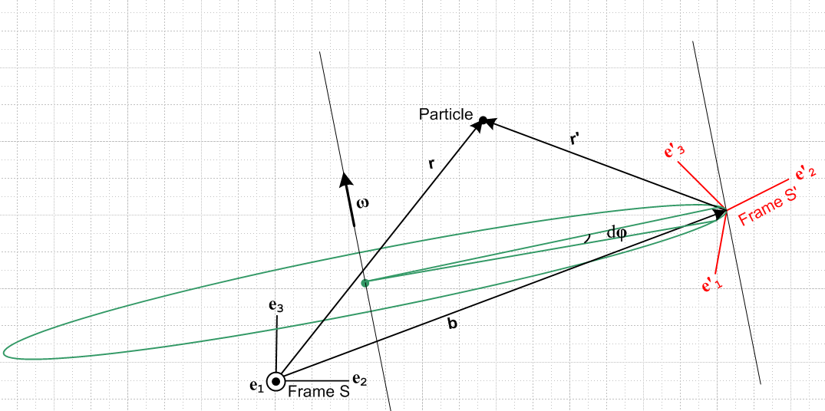 Fig 1

The axes of Frame S are "aligned with paper" as shown and remain fixed relative to paper. The origin of Frame S' is displaced by amount b from the origin of Frame S. The orientation of the axes of Frame S' are related to those of Frame S by (1.1) which says en = R(θ) e'n , where the vector angle θ describes this relative orientation at time t. Frame S' is instantaneously rotating about some axis indicated by ω(t) and at the same time is instantaneously translating according to b(t). The origin of Frame S' is instantaneously rotating along the green circle shown which has its center on the rotation axis.
Suppose Frame S' contains a rigid object fixed relative to the Frame S' axes. If we were to select some point P in that rigid object, that point P would be instantaneously rotating about the ω(t) axis along a circle similar to the one shown above, but which has a different radius and a different center point along the rotation axis. And this point P would be instantaneously translating according to b(t).
If ω were constant in time, the origin of S' really would move along the full green circle shown, but we have in mind that ω = ω(t) and this varies in time, both in magnitude and direction. Thus, the green circle is itself tilting to stay in a plane perpendicular to ω(t).
Viewed from Frame S, the motion of the unit vectors of Frame S' move according to several equations we have already dealt with

e'n(t) = R-1[θ(t)] en = R[-θ(t)] en (1.1)

e'n(t) = Rnm(t) em (1.2)

(de'n/dt)S = ω(t) x e'n(t) . (1.24)

In the general case, the motion of vector b can be decomposed into two parts according to the

(db/dt)S = (db/dt)S' + ω x b

Two special cases of Figure 1 are of interest.

Comments:

• Note that, in general, using (1.1),

e'n(t+dt) = R(dφ) e'n(t) = R(dφ) R(-θ) en = R(-θ + dΩ) en ≠ R(-θ + dφ) en (4.5)

Here |dΩ| is proportional to |dφ| but dΩ is some complicated function of θ and dφ. This function is only simple of it happens that θ and dφ (or ω) point in the same direction, in which case dΩ = dφ.

• Often Frame S is taken to be a frame "at rest with respect to the stars" meaning it is an "inertial frame" in which Newton's non-relativistic law F = ma applies ( it does not apply in rotating frame S'). For the sections of this document which don't deal with F = ma, frame S need not be such an inertial frame.

• Goldstein refers to frame S as the space frame, and frame S' as the body frame. In his analysis, our Apparatus is just a rigid body at rest in frame S'.

• The limit b = 0 causes the origins of the two frames to coincide and this results in a simplification of some of the equations in sections below. We have then b = 0 and ≡ (db/dt)S = 0, etc.

Two special cases are of interest:

Special Case #1. The rotation axis always passes through the origin of frame S, and the vector b is rigidly attached to the frame S' basis vectors (as if these four vectors were thin metal rods soldered together).

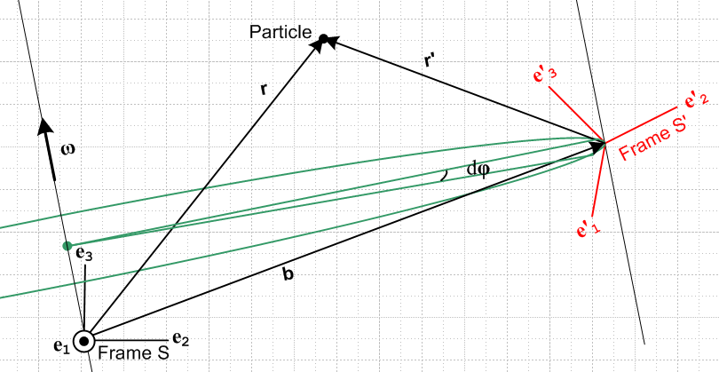 Special Case #1

In this case there is some constant (independent of t) rotation R1 for which b' = R1b (this just gives the components of vector b in frame S') and we have that

(db'/dt)S' = (db/dt)S' = 0 . // (dR1/dt) = 0

In other words, as viewed from Frame S', the soldered rod which is vector b never moves at all. Using the G Rule for vector b we find that

(db/dt)S ≡ (db/dt)S' + ω x b = ω x b .

This fact is rather obvious in this case since it is similar to (1.24) which says (de'n/dt)S = ω x e'n . Restating the last result

= ω x b

Notice that the change in b is always perpendicular to b so the length |b| never changes, as appropriate for a soldered metal rod.

Special Case #2. The rotation axis passes through the origin of frame S' even as the Frame S' moves. In this case, the vector b(t) describes that movement and we can write

(db/dt)S = = v1

where then v1 describes the velocity of the origin of Frame S' relative to Frame S.

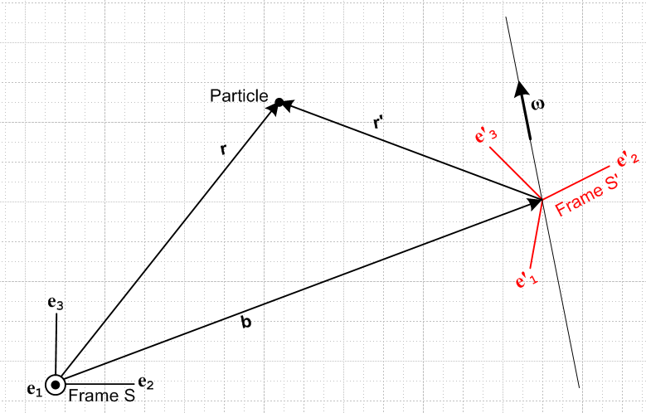 Special Case #2

Three Sample Applications. The first two fall into the Special Case #1 Category, while the third is an example of Special Case #2.

(1) Phonograph Record. An ant (Particle) is moving around on a phonograph record rotating on its spindle with some ω(t). The frame S' might be set up some distance b = |b(t)| from the spindle, and might have its e'1 axis pointing to the right and its e'2 axis pointing to the spindle. That is to say, e'1 = and e'1 = - if we think of r,θ as polar coordinates for fixed frame S. In this application, ω(t) = ω(t) e3 and the rotation axis passes though the origin of Frame S (Special Case #1). Thus, (t) = e3 is a constant. Conversely, vector b(t) maintains its magnitude b, but (t) rotates about the spindle at angular rate ω(t). The triangle of velocities is explained in Section 6 below, equation (6.5s).

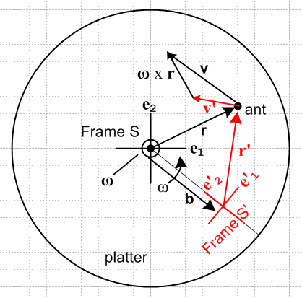 Fig 2

(2) Earth. On the Earth, Cartesian frame S might be an inertial frame located at Earth center with e3 pointing to the North Pole. The e1 axis points out through a point on the equator to some fixed distant star (Star 1), and then e2 is the third Cartesian axis which points out through a different point on the equator to Star 2.
Frame S' has its origin at some arbitrary point on the surface of the Earth. For this system, the e'3 axis points "up", meaning in the direction for Frame S spherical coordinates. The e'1 axis points to the East, and the e'2 axis points North.
The earth rotates at some ω = ωe3 with ω > 0. Vector b(t) connecting the two frame origins maintains its length but rotates as determined by ω. Thus, this is a Special Case #1 application.

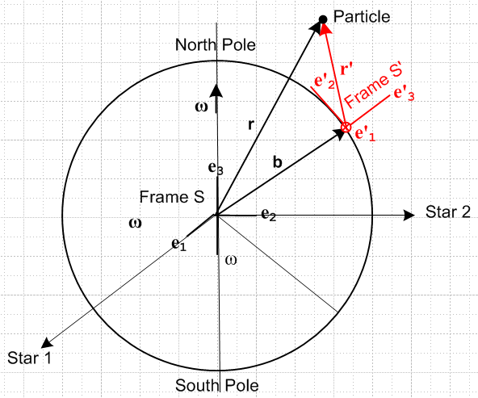

(3) Camera. Some Apparatus is located in Frame S instead of S', and Frame S' is a "camera platform" which flies around in some complicated way and observes the activity in frame S. In this case, both ω(t) and b(t) would be under the command of the pilot of the camera platform. One would set this up as a Special Case #2 situation, so ω passes through the Frame S' origin and = v1 is the velocity of the platform origin and b(t) is its location relative to frame S. One would use the "inverse problem" equations given below to get the primed quantities (like v') in terms of the unprimed ones (like v).

5. The overall goal; the Determination of r(t).

Goal: Given the frame S' Observer's measured values r'(t), v'(t), a'(t) and L'(t) for a Particle, we want to know the values of r(t), v(t), a(t), L(t) which describe the motion of the same Particle as observed from the different frame S.

The first order of business is to find r(t). According to Fig 1 above,

r(t) = r'(t) + b(t)

In general everything depends on time. We will suppress the time argument to reduce symbol count, so
r = r' + b (5.1)

Since our Observer in frame S' determined r'(t) and since the above "setup" determines b(t). we immediately know r(t) and this part of our Goal is achieved. This equation will be used many times in what follows.

6. Determination of v(t) = (dr/dt)S

Start with (5.1),

r = r' + b . (5.1)

Differentiate this in frame S to get

(dr/dt)S = (dr'/dt)S + (db/dt)S . (6.1)

Now use the G Rule for vector r' (equation (2.1) with a = r')

(dr'/dt)S = (dr'/dt)S' + ω x r' . (6.2)

Inserting (6.2) into (6.1) gives

(dr/dt)S = (dr'/dt)S' + ω x r' + (db/dt)S . (6.3)

Using three of the definitions made in Section 1 (g) [5] this may be written

v = v' + ω x r' + (6.4)

This then tells us v(t) in terms of r'(t) and v'(t), so we have obtained 2/4ths of our goal stated at the start of Section 5.

Note: Marion uses the a hybrid notation which first has S↔S' relative to ours, and he then refers to his frame S' as the fixed frame (subscript f), and his frame S as the rotating frame (subscript r). He also uses

b → R so = (db/dt)S → (dR/dt)S' = (dR/dt)fixed = V

so when our equation (6.4) is translated into his notation, one gets his p 343 equation (11.2) which reads

vf = vr + ω x r + V // Marion notation

Recall that Goldstein refers to the fixed frame as the space frame, and the rotating frames as the body frame.

Now just to obtain another form of this result, replace r' = r - b to get

v = v' + ω x r – ω x b + (6.5)

The G Rule (2.1) applied to a = r says that

(dr/dt)S = (dr/dt)S' + ω x r (6.6)
So we may conclude from (6.5) that

(dr/dt)S' = v' – ω x b + (6.7)

This last object is one of the two cross derivatives mentioned in Section 1 (g) [1] with a = r. The other cross derivative (dr'/dt)S can be obtained from (6.2) as

(dr'/dt)S = v' + ω x r' (6.8)

and we may summarize all four derivatives in one place:

(dr/dt)S = v, // the velocity of the Particle as measured in Frame S

(dr'/dt)S' = v', // the velocity of the Particle as measured in Frame S'

(dr/dt)S' = v' – ω x b + = v - ω x r // (6.7) and then (6.5)

(dr'/dt)S = v' + ω x r' = v - // (6.8) and then (6.4) (6.9)

Special Case #1

If the rotation axis happens to pass through the origin of Frame S, and if the length of b(t) is not changing, then the vector b is fixed relative to Frame S' (see Fig 1). The four vectors b and e'n are rigidly soldered to each other and rotate together. This special case applies in the Earth and Phonograph applications mentioned above. Just as one has (de'n/dt)S = ω x e'n from (1.24), so also one has, in this special case,

(db/dt)S = ω x b (6.10)

Thus the last two terms in (6.5) or (6.7) cancel giving the simpler results

v = v' + ω x r . (6.5s)

(dr/dt)S' = v' (6.7s)

so that not only do we have v' = (dr'/dt)S', but also v' = (dr/dt)S' which is a cross derivative. This last result can also be obtained as follows. Since in the special case (db/dt)S' = 0 , similar to (de'n/dt)S' = 0 of (1.25), one has

(dr/dt)S' = (dr'/dt)S' + (db/dt)S' = (dr'/dt)S' = v'

which is the same as (6.7s)

Equation (6.5s) agrees with Goldstein page 135 equation (4-104) where he uses v' = vr (where r means in the rotating system S') and v = vs (where s means the space system S).

Comment #1: At this point, we have obtained these two general results

r = r' + b (5.1)
v = v' + ω x r' + (6.4)

Either equation can be "evaluated" in either frame S or frame S'. Evaluation in frame S gives

ri = (r')i + bi
vi = (v')i + εijkωj(r')i + ()i

while evaluation in frame S' gives

(r)'i = (r')'i + (b)'i
(v)'i = (v')'i + εijk(ω)'j(r')'i + ()'i .

This is a situation where we fully expect to have (r')i ≠ (r)'i and (v')i ≠ (v)'i as mentioned in Section 1 (b), so the careful placement of primes is very important.

Comment #2 Given the transformations stated above

r = r' + b (5.1)
v = v' + ω x r' + (6.4)

it is clear that in general the pairs of vectors (r,r') and (v,v') are not "vectors under rotations" in the sense of (1.10), since

r' ≠ Rr v' ≠ Rv

where R is the rotation appearing in (1.1) which relates our two frames, en = R e'n .

On the other hand, the vectors ω and b appearing in these formulas are normal "vectors under rotations" in the sense of (1.10),

b' = Rb ω' = Rω . (6.11)

These equations just indicate that the vectors ω and b have different components when viewed from frame S' as compared to when viewed from frame S. For these vectors, according to Section 1 (c), we can use b'i and ω'i without the need for parentheses :

b = biei = b'ie'i ω = ωiei = ω'ie'i (6.12)

7. Determination of a(t) = (dv/dt)S

Start with (6.5),

v = v' + ω x r – ω x b + (6.5)

Apply d/dt in frame S to get, using a = (dv/dt)S,

a = (dv'/dt)S + (dω/dt)S x r + ω x (dr/dt)S - (dω/dt)S x b - ω x + (d2b/dt2)S

Define ≡ (dω/dt)S and = (d2b/dt2)S to get

a = (dv'/dt)S + x r + ω x v - x b - ω x + (7.2)

We can convert (dv'/dt)S to a frame S' derivative using the G rule for v',

(dv'/dt)S = (dv'/dt)S' + ω x v' = a' + ω x v' (7.3)

so that then

a = a' + ω x v' + x r + ω x v - x b - ω x + (7.4)

Now replace v using (8***)

a = a' + ω x v' + x r + ω x [v' + ω x r – ω x b + ] - x b - ω x +

= a' + ω x v' + x r + ω x v' + ω x (ω x r) – ω x (ω x b) + ω x - x b - ω x +

= a' + 2ω x v' + x r + ω x (ω x r) – ω x (ω x b) - x b +

= a' + 2ω x v' + x r' + ω x (ω x r') +

so that

a = a' + 2ω x v' + x r' + ω x (ω x r') + (7.5)

Special Case #1

This is the same special case mentioned in the previous section, so we have

= ω x b (6.10)
= x b + ω x = x b + ω x (ω x b) (7.6)

Then (7.5) becomes

a = a' + 2ω x v' + x r' + ω x (ω x r') + (7.7)

= a' + 2ω x v' + x r' + ω x (ω x r') + x b + ω x (ω x b)

= a' + 2ω x v' + x r + ω x (ω x r)

which is to say,

a = a' + 2ω x v' + x r + ω x (ω x r) (7.8)

The three terms on the right of (7.7) other than a' are associated with the fictitious forces that arise in our special case situation which includes the rotating earth scenario mentioned earlier.

Comment: The earth has ω= 7.29 x 10-5 sec-1 and r = 6.4 x 106 m. At the equator which is the location of the maximum of ω x (ω x r) one has | ω x (ω x r)| = ω2r = .034 m sec-2. For an object going 5 m/sec, the second term is at most 7.29 x 10-4 m sec-2.

Comment: Marion states equation (7.7) above as equation (11.17) on page 344 of his book (but in his notation where S↔S' and b → R). He then (I feel erroneously) argues that the can be ignored in practice (relative to the other terms) because it is small and this leads to his equation (11.19) which is just (7.7) above with = 0. But ω x (ω x r') is not the centripetal acceleration because this is the wrong r. Goldstein gets it right in his (4-107) p 135.
It is possible that Marion has both frames with a common origin so that then b = 0 and r = r' , but that is not what the figure on page 341 suggests!
I see that my Marion book is nowadays called "Marion and Thornton", and the franchise is still going (5th edition 2003). I will download a copy just to see if they have repaired this problem.
Well, it is changed, but still not very clean. The comments about ≈ 0 are gone, but the confusion exists until page 395 where ω = constant and = ω x b is actually used (and = ω x ). Marion has died and Thornton kept the original section and then wrote his own about earth motions where repairs are made.

Comment: I think my Berkeley mechanics book has problems as well. It starts on page 84 suggesting that the rotating frame has the same origin as the static frame (which would mean b = 0 for me). In this case we have r = r' and I agree with their result (I would set = 0 ) . But then on page 86 they put their little rotating frame on the surface of the earth which does not have b = 0. It is an "advanced topic" in the book and is a bit of a hack job.

8. The Fictitious Forces for Special Case #1

In our special case #1 situation, if in addition Frame S is an inertial frame, then Newton's 2nd Law in that frame, F = ma, is valid in frame S and we can write, using (7.7),

F = ma = mω x (ω x r) + m x r + 2mω x v' + ma' . (8.1)

Our Observer in Frame S' would like to use his own personal "Newton's Law",

F' = m a' . (8.2)

Solving (8.1) for ma' we get

F' = F – mω x (ω x r) – m x r – 2mω x v'

= F + Ffict (8.3)

where

Ffict = – mω x (ω x r) – m x r – 2mω x v' (8.4)

So our Observer in Frame S' is allowed to use his own version of Newton's Law, (8.2), as long as he includes in his sum of forces the "fictitious" forces shown in (8.4).

The first fictitious force – mω x (ω x r) is the centrifugal (center-fleeing) force pushing our Particle away from the rotation axis, and ω x (ω x r) is the associated centripetal acceleration. To see that this is the case, consider this picture which shows vectors r and ω,

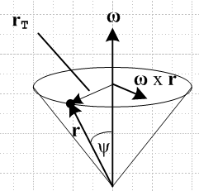 Fig 3

Using the right hand rule, one can see then that ω x (ω x r) is a vector pointing in the opposite direction to the vector labeled rT. From the location of the Particle at r, this vector points toward the center of the circle on which the particle is instantaneously rotating at time t, and this is the correct direction for centripetal (center seeking) acceleration. The magnitude of the vector is |ω x (ω x r)| = ω | ω x r | = ω2rsinψ = ω2rT and this is the correct magnitude for the centripetal acceleration. So the centripetal acceleration ω x (ω x r) points toward the rotation axis, while the centrifugal force – mω x (ω x r) is directed away from the rotation axis, as all Merry-Go-Round (not to mention Rotor) riders well know.

The second fictitious force – m x r in (7.10) exists only if ω ≠ constant. In the special case the happens to be in the direction of ω, meaning ω> 0 (this would apply in our phonograph platter scenario if the platter is spinning up) then x r is in the same direction as ω x r shown in Fig 3 and that is the direction of the tangential acceleration of a point on the platter. Correspondingly, a Particle in Frame S' feels a fictitious force – m x r in the opposite direction.

The third fictitious force

– 2mω x v' = + 2m v' x ω

is the famous Coriolis force which causes a ballistic Particle to deflect to the right in the northern hemisphere and to the left in the southern hemisphere.

continue editing here, everything above this line is OK (except as indicated in red)

9. Determination of L(t) and (dL/dt)S

Our frame S' observer can measure (set mass m = 1)

L' = r' x v' (9.1)

Taking the frame S' time derivative gives,

(dL' /dt)S' = (dr'/dt)S' x v' + r' x (dv'/dt)S'

= v' x v' + r' x a' = r' x a'
or
(dL'/dt)S' = r' x a' = ' (9.2)

Meanwhile, in frame S we have

L = r x v (9.3)

which using (5.1) and (6.4) becomes

L = [r' + b] x [v' + ω x r' + ] (9.4)

= r' x v' + r' x (ω x r') + r' x + b x v' + b x (ω x r') + b x (9.5)

From (9.1) we recognize the first term as L'.
Thus we have found L(t) as a function of Frame S' quantities, so the last item in our goal list is completed.

Taking the frame S derivative of L = r x v we find that (similar to (9.2))

= x v + r x = v x v + r x a = r x a , (9.6)

and then using (5.1) and (7.5) for a we get

= [r' + b] x [a' + 2ω x v' + x r' + ω x (ω x r') + ] (9.7)

which is a sum of 10 terms we won't bother to write out. One of these terms is r' x a' = ' from (9.2).

10. Summary

We now summarize the results of the Sections 6 though 9 :

r = b + r' (5.1)

v = v' + ω x r' + (6.4)

a = a' + 2ω x v' + x r' + ω x (ω x r') + (7.5)

L = [r' + b] x [v' + ω x r' + ] (9.4)

= [r' + b] x [a' + 2ω x v' + x r' + ω x (ω x r') + ] (9.7)

Summary for Special Case #1

In this case described earlier we have

= ω x b and = x b + ω x (ω x b)

which means that

ω x r' + = ω x r
and
x r' + ω x (ω x r') + = x r' + ω x (ω x r') + x b + ω x (ω x b)

= ω x (ω x r) + x r

Thus the above equations become for Special Case #1 :

r = b + r' (5.1)

v = v' + ω x r (6.5s)

a = a' + 2ω x v' + x r + ω x (ω x r) (7.8)

L = [r' + b] x [v' + ω x r] (9.4)

= [r' + b] x [a' + 2ω x v' + x r + ω x (ω x r)] (9.7) with (7.8)

11. The Inverse Problem

Consider these two problems which concern the exact same physical situation:

Problem: given r', v', a', L' find r, v, a, L // results summarized in Section 10

Inverse Problem: given r, v, a, L find r', v', a', L'

The first equation of the above summary is easily inverted

r = b + r' =>

r' = r - b (11.1)

The second equation can also be inverted easily :

v = v' + ω x r' + =>

v' = v – ω x r' – = v – ω x [r - b] –

= v - ω x r + ω x b - (11.2)

The third equation requires a bit more effort

a = a' + 2ω x v' + x r' + ω x (ω x r') + =>

a' = a – 2ω x v' – x r' – ω x (ω x r') –

= a – 2ω x [v - ω x r + ω x b - ]– x [r - b] – ω x (ω x [r - b]) –

= a – 2 ω x v + 2 ω x (ω x r) - 2 ω x (ω x b) + 2 ω x – x r + x b
- ω x (ω x r) + ω x (ω x b) –

= a – 2 ω x v + ω x (ω x r) - ω x (ω x b) + 2 ω x – x r + x b – (11.3)

The inversion of the fourth equation goes this way :

L' = r' x v' = [r - b] x [- ω x r + ω x b - ]

= - r x (ω x r) + b x (ω x r) + r x (ω x b) – b x (ω x b) - r x + b x (11.4)

The inversion of the final equation is done similarly :

' = r' x a'

= [r - b] x [a – 2 ω x v + ω x (ω x r) - ω x (ω x b) + 2 ω x – x r + x b – ] (11.5)

Summary of the inverse problem results:

r' = r - b (11.1)

v' = v - ω x r + ω x b - (11.2)

a' = a – 2 ω x v + ω x (ω x r) - ω x (ω x b) + 2 ω x – x r + x b – (11.3)

L' = - r x (ω x r) + b x (ω x r) + r x (ω x b) – b x (ω x b) - r x + b x (11.4)

' =[r - b] x [a – 2 ω x v + ω x (ω x r) - ω x (ω x b) + 2 ω x – x r + x b – ] (11.5)

**********************************************************************************

Example 1: Referring to Fig 1, suppose a Particle floats at rest at the origin of inertial Frame S. This means that we have r = 0, v = 0, a = 0, L = 0. What does an Observer within Frame S' see? The results are quite simple :

r' = - b
v' = 0
a' = 0
L' = 0
(dL'/dt)S' = 0

In Frame S'. the Particle appears at location r' = -b and just sits there doing nothing as S' rotates. In Figure 1, Frame S' including the b vector rotates around the Frame S origin.

Example 2: Referring to Fig 1, suppose a Particle floats at rest at some point r = r0 in inertial Frame S. This means that we have r = r0, v = 0, a = 0, L = 0. What does an Observer within Frame S' see?

r = r0 // in this example, these things are always the same.

r' = r0 - b // says r'(t) describes a circular motion which seems right.

v' = - ω x r0 // this seems wrong since it says v' = constant
a' = ω x (ω x r0) – x r0

L' = – r0 x b – r0 x (ω x r0)

(dL'/dt)S' = – ω x (r0 x v') – r0 x ( x r0) – b x a'

How can the Particle go in a circular motion in Frame S' and have a constant velocity??? Save for the next day. Must be something simple I hope. Could the whole inverse concept be wrong?

Issue # 1: The Particle really does have the constant velocity direction shown as v' = - ω x r

First, here is a picture showing Frame S' on our phono record at some time.

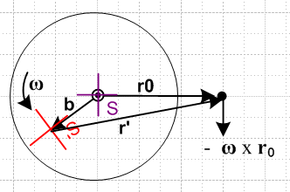

At some slightly later time, red frame S' is in a slightly new position. Here I draw these two adjacent positions and the fixed Particle dot

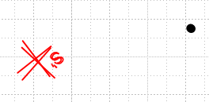

Now I take the second position and the dot and group them together, and then I rotate that group until the two red frames align,

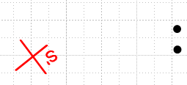

You see that the black dot has in fact moved in the -ω x r0 direction as the formula predicts. This will be true for any pair of adjacent red S' positions you pick around the circle. Let's repeat the experiment starting here:

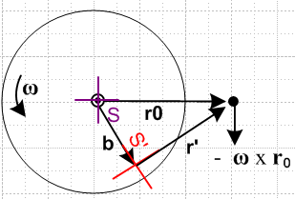

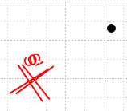 => 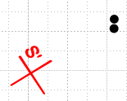

and we get the same result.

Issue # 2: Paths of the Particle.

After several hours, I am having a LOT of trouble with two simple questions:

(1) what does the path of the particle look like in Frame S ?
(2) what does the path of the particle look like in Frame S' ?

Next day: Phrases are not always clear. Question (1) could mean what is r in frame S, or it could mean what is r' in frame S. Here I will compute both of these:

(1a) Path of particle r in frame S

r (in frame S) = r0 = constant since r = riei = roe1 // case closed on this one!

(1b) Path of particle r in frame S'

Now from just-made doc "a simple theorem about basis vectors.doc" (phys/QM/ang mom) we know

e'n = Rz(φ)en => $\left(\begin{matrix}e'1 \\ e'2\end{matrix}\right)$ = Rz(-φ)$\left(\begin{matrix}e1 \\ e2\end{matrix}\right)$ => e'n = R-1(φ)nm em
or
e'1 = cosφ e1 + sinφ e2
e'2 = - sinφ e1 + cosφ e2

Therefore expand r in frame S'

r = r'ne'n where r'n = r • e'n so that

r'1 = x' = r • (cosφ e1 + sinφ e2) = roe1 • (cosφ e1 + sinφ e2) = rocosφ
r'2 = y' = r • (-sinφ e1 + cosφ e2) = roe1 • ( -sinφ e1 + cosφ e2) = - rosinφ

So we seem to get

x' = rocosφ = r'1
y'= - rosinφ = r'2

This shows that the path of r in frame S' is a circle as shown on the right below,

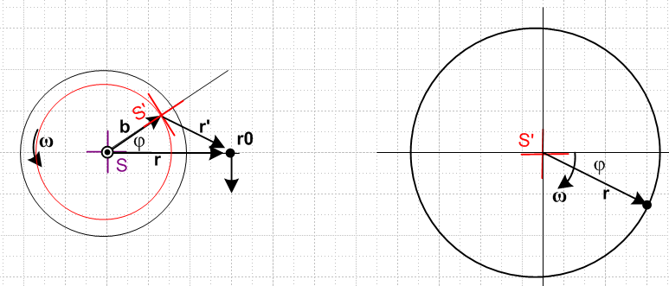

You can see that the two pictures "agree". On the right of course the tail of r has been pinned to the frame S' origin. On the right in frame S' the vector r rotations CW, whereas on the left frame S' rotates CCW.

Comment: Since r = r0 always, the picture on the right shows that r0 is NOT a constant vector when viewed from frame S'. It rotates! So when I had v' = - ω x r0 and was worried that this seemed odd since the RHS is a constant, well, RHS is NOT a constant viewed from frame S'.

(2a) Path of particle r' in frame S

We now that r = b + r' and therefore

r' = r - b

The Frame S components of both sides are

(r')i = (r)i - (b)i

But we know from (1a) that r = roe1

(r)i = roδi,1

And we know that b = bR(φ)e1 so (b)i = bRij(e1)j = bRi1

(r')i = roδi,1 - bRi1

Write these out explicitly to get

(r')1 = r0 - R11 = r0 - bcosφ
(r')2 = 0 - R21 = - bsinφ

which says for r' = (r')iei = xiei for a graph

x = r0 - bcosφ
y = - bsinφ

Here is a picture of this situation

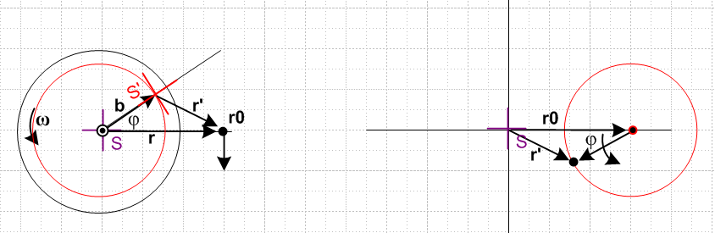

Again the figures make sense. The vector r' always points to the right in frame S.

(2a) Path of particle r' in frame S'

The expansion here may be taken as

r' = (r')'ie'i where (r')'i = r' • e'i

so we have

(r')'i = r' • e'i = (r - b) • e'i = r • e'i - b • e'i = (r)'i - (b)'i

Now we compute from above

b = bR(φ)e1 = bR(φ) R-1(φ) e'1 = b e'1

and this agrees with the picture notion that from frame S', b always points to the right. Thus

b • e'i = b e'1• e'i = b δ1,i = (b)'i

And we found earlier that

x' = rocosφ = (r)'1
y'= - rosinφ = (r)'2

Therefore we find that

(r')'1 = (r)'1 - (b)'1 = rocosφ - b
(r')'2 = (r)'2 - (b)'2 = - rosinφ

or for purposes of plotting

x' = rocosφ - b
y' = - rosinφ

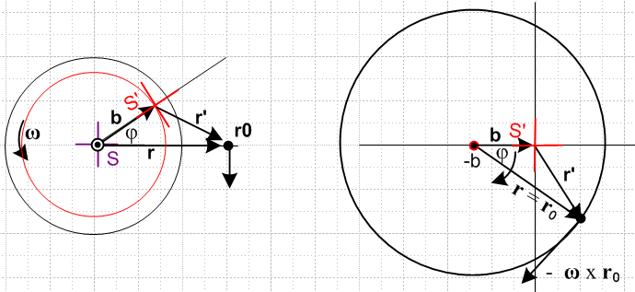

and again (finally!) the picture makes sense. Note that ω points out of the plane of paper in all pictures.

Comment: The picture on the right shows what the vectors r and r' look like viewed from Frame S'.

Now we can face this question: How can we have v' always pointing down in frame S, v' = - ω x r0,

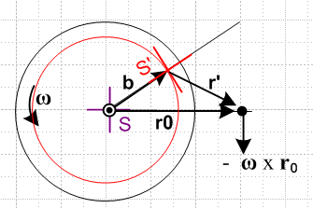

while at the same time the particle goes around in a circle. We need to ponder the meaning of v' a bit:

v' = - ω x r0

If we look at this in frame S', the useful picture is the big circle on the right above, and in that picture you see that the vector - ω x r0 is in a perfectly reasonable direction to be the velocity of the particle going around in a circle. Looking at vector v' in Frame S is a "cross" view that is not very convenient.
Now here is perhaps the confusing picture. We had this picture showing r' in frame S

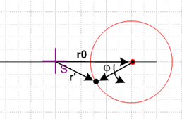

The thing that appears to be a velocity in this picture is really (dr'/dt)S and this is not
the same as v' = (dr'/dt)S' and the difference is the G rule term! So if you want to have position and velocity "make sense", you need to plot them both in their natural frames, and that is what the large circle picture on the right above is doing.

***************************************************************

(2a) Vector r' as seen in frame S'

Now from just-made doc "a simple theorem about basis vectors.doc" (phys/QM/ang mom) we know

e'n = Rz(φ)en => $\left(\begin{matrix}e'1 \\ e'2\end{matrix}\right)$ = Rz(-φ)$\left(\begin{matrix}e1 \\ e2\end{matrix}\right)$ => e'n = R-1(φ)nm em
or
e'1 = cosφ e1 + sinφ e2
e'2 = - sinφ e1 + cosφ e2

Therefore expand r' in frame S'

r' = (r')'ne'n where (r')'n = r' • e'n so that

(r')'1 = r' • e'1 = (r0 - b) • e'1 = r0 • e'1 – b • e'1 = (r0e1) • e'1 - b
= (r0e1) • (cosφ e1 + sinφ e2) - b = r0cosφ - b

(r')'2 = r' • e'2 = (r0 - b) • e'2 = r0 • e'2 – b • e'2 = (r0e1) • e'2
= (r0e1) • (-sinφ e1 + cosφ e2) - b = - rosinφ

So we end up then with

(r')'1 = - b + r0cosφ
(r')'2 = - rosinφ

And here is the picture

and again the picture makes sense. Note that ω points out of the plane of paper in all pictures. This picture on the right shows BOTH the vector r' as seen in S', and the vector r as seen in S'. I am totally happy with how these two pictures show the same thing for both these vectors.

(1b) Path of particle r in frame S'

Since r' = r0 - b and r = r0 we write r' = r - b and then r = r' + b . That means, evaluating on the e'i

(r)'i = (r')'i + (b)'i

and we just look at the two cases

(r)'1 = (r')'1 + (b)'1 = - b + r0cosφ + b = r0cosφ

(r)'2 = (r')'2 + (b)'2 = - rosinφ + 0 = -r0sinφ

=> r = (r0cosφ)e'1 + (-r0sinφ) e'2

This continues to bother me. Does the picture on the right really show r as viewed from S' ? It shows the orientation of r correctly, it just does not show the tail position correctly.
Well go back to the starting point which is r = r' + b . If have r' as shown on the right side of the previous picture, and if we add b to every point on that locus, we get the locus shown here for r, there is no avoiding this fact. We also then have r = (r)'ie'i which means tail at origin.
Start once again with r = r' + b . If we expand each vector like so:

(r)'ie'i = (r')'ie'i + (b)'ie'i

then we conclude that

(r)'i = (r')'i + (b)'i

So we have already put r = (r)'ie'i into the stew which means we have already put r tail at origin.
Instead of doing this, start again with r = r' + b . We found the trajectory of r' assuming its tail is at the S' origin, Then notice that this picture shows r = r' + b so this then gives the path of r without putting the tail of r at the origin.

