The Goldstein Rotation Rule Version 8 PhL 7.23.12

Introduction 2
1. Notation, important role of the Prime Symbol, and other Preliminaries. 2
(a) the basis vectors e_{n} and e'_{n} and two ways in which they are related. 3
(b) Expansions of a vector and use of primes and parentheses 3
(c) Special case where a'_{i} is unambiguous. 4
(d) When are Two Vectors Equal? 6
(e) The Small Rotation of a vector about an axis. 7
(f) The time rate of change of a rotating vector 9
(g) Rate of change of the basis vectors. 9
(h) Notations for the many time derivatives of vectors r, r', b and L 10
(i) No frame label is needed for d/dt of a scalar function. 13
(j) Non-commutation of operations d/dt and taking a component 13
2. The G Rule for arbitrary vector a and its derivation (Transport Theorem) 15
3. The Apparatus and its Observer at Rest in Frame S'. 18
4. The Relationship between the Two Frames S and S' 19
(a) Explanation of Figure 1: Frame S in the plane of paper. 19
(b) Explanation of Figure 2: Vector ω pointing directly out of paper 21
(c) The Meaning of (db/dt)_{S'} = _{S'} 21
(d) Special Case #1 : ω axis through Frame S origin 23
(e) Special Case #2 : ω axis through Frame S' origin 24
(f) The Phonograph Turntable 24
(g) The Earth 25
(h) The Flying Camera Platform 26
5. The Goal of the next two sections 26
6. Determination of velocities 27
(a) Velocity v_{S'} 27
(b) Velocity v ≡ v_{S} 27
(c) Velocity v'_{S} 28
(d) Velocity Summary 28
(e) Velocities for Special Cases 28
(f) Comments 29
7. Determination of accelerations 30
(a) Acceleration a'_{S} 30
(b) Acceleration a ≡ a_{S} 31
(c) Acceleration a_{S'} 31
(d) Acceleration Summary 32
(e) Relation between _{S} and _{S'} 32
8. The Fictitious Forces 33
(a) Development of the Fictitious Forces 33
(b) Interpretation of the Centrifugal and Euler Fictitious Forces 34
(c) Interpretation of the Coriolis Fictitious Force 37
9. Translations into Marion (1970) and Marion & Thornton (M&T, 5th Ed 2004) 38
10. Translations into Goldstein (1970) and Goldstein, Poole and Safko ( GPS, 3rd Ed 2001)) 39
(a) The meaning of r 39
(b) The meaning of a_{s} and a_{r} (and of v_{s} and v_{r}) 40
(c) The hidden approximation is located 41
11. Determination of L(t) and (dL/dt)_{S} 42
12. Summary of the Original Problem Solution 42
13. The Inverse Problem 43
(a) Brute Force Method 43
(b) Swap Rules Method 45
(c) Development of the Fictitious Forces for the inverse problem 46
(d) Summary of the Inverse Problem Equations 47
(e) Why the Swap Rules Work 48
13. Rotating Frames in Curvilinear Coordinates 50

Introduction

The general context of this document is that we have some Apparatus containing a Particle observed from two frames of reference called S and S'. Frame S' is rotating and translating in a certain manner with respect to frame S which is fixed. More details of this picture are presented in Section 4.
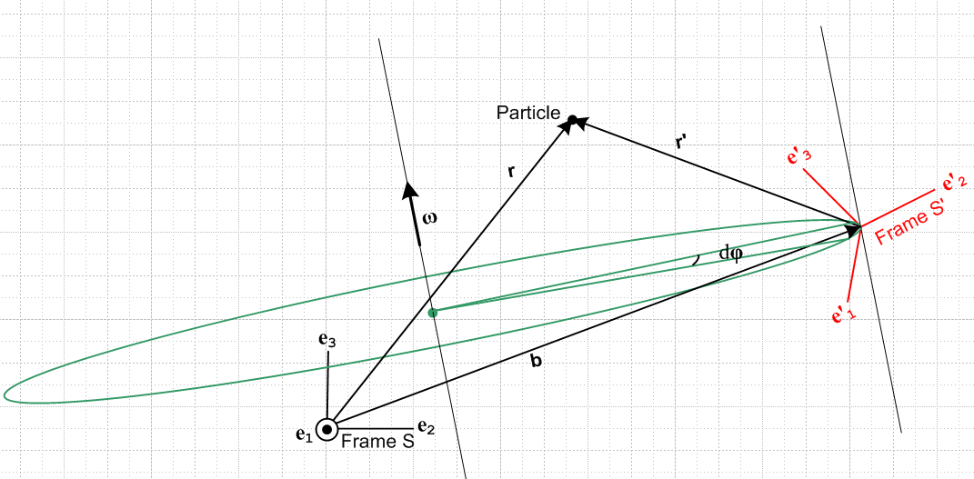 Fig 1

A Particle is located at position r relative to the Frame S origin, and at position r' relative to the Frame S' origin. Since the origins are connected as shown by a vector b, we have r = r' + b.

1. Notation, important role of the Prime Symbol, and other Preliminaries.

(a) the basis vectors en and e'n and two ways in which they are related.

Frame S has Cartesian basis unit vectors en, while Frame S' has Cartesian basis unit vectors e'n . The two sets of basis vectors are related by some rotation we shall call R,

en = R e'n for n = 1,2...N or (en)i = Rij(e'n)j (1.1)

The above relation between en and e'n can also be written in this manner, where the RHS is a sum of vectors, rather than a matrix times a vector as above ( repeated indices have implied sums) ,

en = (R-1)nm e'm , or e'n = Rnm em , (1.2)

a fact we shall now prove in a short series of steps:

Step 1: The Cartesian basis vectors have these properties

δn,k = en • ek = e'n • e'k and (en)k = δn,k . (1.3)

Step 2: Note that

em • e'n = em • [R-1en] = (em)i (R)-1ij(en)j = δm,i (R)-1ij δn,j = (R-1)mn . (1.4)

Step 3: Our little theorem makes this claim:

en = Re'n => en = (R-1)nm e'm .

Dot both sides of the claimed equation into e'k (a complete basis) and use Steps 1 and 2,

en • e'k = (R-1)nm e'm • e'k => (R-1)nk = (R-1)nm δm,k = (R-1)nk .

Since the claimed equation is true in each of its components, it must be true in a vector sense.

(b) Expansions of a vector and use of primes and parentheses

Normally, given a vector a, we can expand it on either set of basis vectors and we write, with implied summation on i,

a = ai ei = a'i e'i . ai = a • ei a'i = a • e'i (1.5)

If we know that we are going to also be working with a vector named a', then we might want to be more careful about how we label components. A safe method would be this:

a = (a)i ei = (a)'i e'i (a)i = a • ei (a)'i = a • e'i
a' = (a')i ei = (a')'i e'i (a')i = a' • ei (a')'i = a' • e'i (1.6)

Here, a prime inside a parentheses is part of the vector name, whereas a prime outside a parentheses denotes a vector component in frame S' (while no prime there means a component in frame S). Unless the relationship between vectors a and a' has a certain simple form, it is very likely that (a')i ≠ (a)'i . In this case the notation a'i would be ambiguous since one doesn't know whether it refers to (a')i or (a)'i. It is true that the notation ai could be unambiguously identified with (a)i, but we shall maintain the parentheses just to be uniform.

Example 1. As an example of the four expansions above, let us consider a = en :

en = (en)i ei => (en)i = δn,i // by inspection

e'n = (e'n)'i e'i => (e'n)'i = δn,i // by inspection

en = (en)'i e'i => (en)'i = (R-1)ni // using (2) that en = (R-1)nm e'm

e'n = (e'n)i ei => (e'n)i = Rni // using (2) that e'n = Rnm em

We can now restate these results showing the dot products which represent each expansion coefficient, and in this way we obtain expressions for all the dot products,

en = (en)i ei => (en)i = en • ei = δn,i

e'n = (e'n)'i e'i => (e'n)'i = e'n • e'i = δn,i

en = (en)'i e'i => (en)'i = en • e'i = (R-1)ni = RTni = Rin

e'n = (e'n)i ei => (e'n)i = e'n • ei = Rni (1.7)

Notice that all these results are consistent with claims made earlier

(c) Special case where a'i is unambiguous.

We shall now examine the type of relationship between a' and a in which (a')i = (a)'i and therefore we can use the notation a'i without ambiguity.

First of all, if R is any rotation, meaning RTR = 1, we know that

a • b = [Ra] • [Rb] (1.8)

One line proof:

[Ra] • [Rb] = [Ra]k[Rb]k = RkiaiRkjbj = (RT)jk Rkiaibj = (RTR)jiaibj = δj,iaibj = aibi = a • b

Now, we are going to find the relationship between (a)'i and (a)i in the following manner.

(a)'n = a • e'n = [R a] • [R e'n] // valid for any rotation R as shown above
= [R a] • en // using the specific rotation appearing in en = R e'n
= [R (a)m em] • en // inserted expansion a = (a)m em
= (a)m (Rem) • en // extracted number (a)m from [...]
= (a)m (Rem)k(en)k // wrote out dot product
= (a)m Rki(em)i(en)k // wrote out (Rem)k
= (a)m Rkiδm,iδn,k // used (em)i = δm,i twice
= Rnm (a)m

Therefore we have shown that the (a)'n and (a)n are related in this manner

(a)'n = Rnm (a)m (1.9)
Now suppose we define the vector a' in this way,

a' ≡ Ra (1.10)

If a vector transforms according to (1.10), we say it is a "vector under rotations" which means it "transforms as a vector under rotations".

When written in frame S components this says

(a')n = Rnm(a)m (1.11)

Comparison of (1.9) and (1.11) shows that

(a)'n = (a')n (1.12)

and therefore in this case we can use

a'n ≡ (a)'n = (a')n (1.13)

Thus, if the vectors a and a' are related by a' = Ra where R is the rotation appearing in en = R e'n , then we can dispense with the parentheses as shown in (12). We still have (a')'i which requires parentheses.

Example 2: Consider equation (1.1) ,

en = R e'n

Since this is not of the form a' ≡ Ra, we may not dispense with the parentheses. In fact from (1.7) we have

(en)'i = Rin
(e'n)i = Rni (1.14)

and these are not the same because rotation matrices are not symmetric.

Example 3: Soon we shall be dealing with an equation r' = r - b. Since this is not for the form r' ≡ Rr , we may not dispense with the parentheses, and we expect that (r')i and (r)'i will be different.

[ Footnote: More generally, if R is the linearized version of some general transformation x' = F(x) at a point x, so that dx' = R(x) dx, then (1.10) says that a "transforms as a contravariant vector with respect to the underlying transformation F ". In general R(x) is not a rotation and is a function of location. In this document we deal only with R(x) = R = a rotation that is the same at all points in space. It turns out that the notation a'i is unambiguous in this general case as well. The proof of this fact is just as shown above, except the • symbol represents the covariant dot product a • b = ijaibj where is the covariant metric tensor. In this document we always have ij = δi,j. ]

(d) When are Two Vectors Equal?

This topic will probably seem strange and unnecessary, but it has been a constant annoyance to the author so here are some words on the subject.
When we say two vectors A and B are the same or are equal, we mean that the two vectors have the same components in the same coordinate system and we write A = B. This does not require that vectors A and B coincide, it might be that B is a translated copy of A. To be really fussy, we could define a stronger equality A B to mean that not only do the vectors have the same components in the sense of A = B, but the vectors actually coincide with each other. We shall have no use for A B in this document. For us, two vectors are "the same" even if translated from one another.
In light of this interpretation of vectors being equal, we can examine the meaning of certain statements. For example, we normally say "a particle is located at r in frame S ". This really means the particle is at point r in frame S which has coordinates (x,y,z). What this means in terms of the vector r is that if the vector r is translated so that its tail is at the origin of frame S, then its tip will be at the particle location. The vector r can be drawn anywhere in a picture. It describes the displacement of a particle in frame S from the origin in frame S.

Example 4: When we say en = R e'n as in (1) above, it is understood that the tails of all vectors involved (the en and the e'n) are at a common location, as in this picture

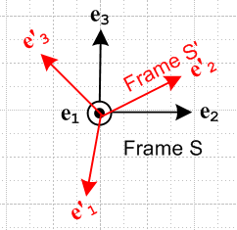

even though in our application, the en are drawn with their tails at the origin of Frame S while the e'n are drawn with their tails at the origin of Frame S'.

Example 5: In the expansion r = (r)iei we normally think of vector r having its tail at the origin of Frame S, while in the expansion r = (r')'ie'i one would be inclined to think of vector r as having its tail at the origin of Frame S'. In our stricter sense of coincidence noted above, we might say (r)i ei (r')'i e'i but this is not of interest. What we care about is that (r)i ei = (r')'i e'i in the sense A = B above and we don't care if the vectors A and B are translated relative to one another. What we care about is that the vectors have the same components in any given Frame.

(e) The Small Rotation of a vector about an axis.

We do this first analytically, and second graphically. In the analytical approach, the reader must accept a few facts about rotation matrices. The 3x3 matrix which rotates a vector by angle φ about rotation axis is given by

R(φ) = exp(-i φ • J) (1.15)

where the (J)k are 3x3 matrices known as the rotation generator matrices:

J1 = 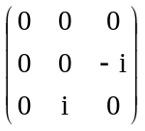 J2 = 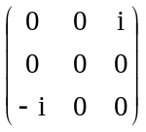 J3 = 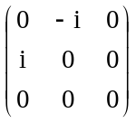 .

The values in these three matrices can be summarized in this single statement,

(Jk)ij = -i εkij (1.16)

where ε is the totally antisymmetric permutation tensor defined by

εabc = +1 if abc is an obtained from 123 by an even number of pairwise swaps (such as 312)
εabc = -1 if abc is an obtained from 123 by an odd number of pairwise swaps (such as 213)
εabc = 0 otherwise (ie, when two or more indices have the same value such as 122 or 333) (1.17)

so that, for example, εabc = - εbac regardless of index values.
It is convenient to define a vector rotation angle in this manner

φ ≡ φ (1.18)

and then the same rotation may be written in these new ways,

R(φ) = R(φ) = exp(-i φ • J) . (1.19)

For a small rotation dφ = dφ , this may be approximated as (using ex = 1 + x + ... but applied to x = matrix)

R(dφ) = exp(-i dφ • J) ≈ 1 - i dφ • J (1.20)

With these preliminary remarks out of the way, we can consider the rotation of a vector a by a small amount as we move from time t to time t + dt [ R(dφ) is not the same rotation as R used above] ,

a(t+dt) = R(dφ) a(t) (1.21)

where we have in mind that dφ ≡ dφ is in some arbitrary direction which is unrelated to the direction of the vector a(t) . We then find that the change in vector a is given by

da = a(t+dt) - a(t) = R(dφ) a(t) - a(t) ≈ [1 - i dφ • J] a(t) - a(t) = - i dφ • J a(t) = - i dφk Jka(t)

Taking the ith component of the above equation we get

dai = - i dφk[Jka]i = - i dφk(Jk)ijaj = - i dφk( -i εkij ) aj = - εkij dφk aj = + εikj dφk aj

and going back to vector notation we find that

da = dφ x a (1.22)
which is our main result.
Here then is a graphical derivation of this same fact for a limited geometry. Consider this picture

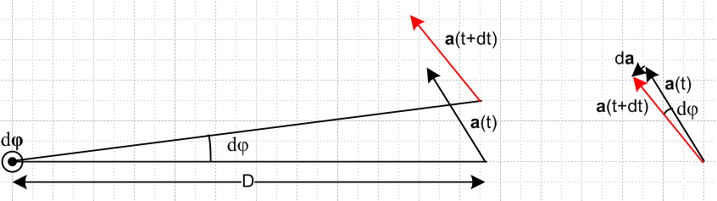

where the small rotation vector dφ points out of the plane of paper, and where a(t) happens to lie in the plane of paper (hence this picture does not cover the most general case). Using the right hand rule for cross products, we can see that da (shown on the right) lies in the direction of dφ x a, so we can write that da = C dφ x a where C is some constant. We can determine C from the equation |da| = C |dφ x a| . Since dφ and a are at right angles, we know that |dφ x a| = |dφ| |a| = dφ a. But from the picture on the right it seems quite clear that |da| ≈ a dφ. Therefore

|da| = C |dφ x a| => dφ a = C dφ a => C = 1

so we end up with da = dφ x a which agrees (1.22) above obtained by other methods. In the case that a does not lie in the plane of paper, the geometric derivation takes more work, and in this case we just rely on the analytic result.
Notice the fact that da = dφ x a does not depend on the distance D between the rotation axis and the tail of vector a! The result is true even if this distance is 0 so that the tail of vector a lies right on the rotation axis. In this case the pair of arrows in the left picture coincides with the pair of arrows in the right picture.

Footnote: The equation R(φ) = exp(-i φ • J) can be interpreted as a rotation in N dimensions with a set of three appropriate NxN generator matrices (Jk)ij. Only when N = 3 is (1.17) valid or even meaningful. In group theoretic language, these NxN matrices Jk form an N-dimensional irreducible representation of the Lie Algebra so(N). When J is exponentiated as shown, the rotations R(φ) are then members of the Lie Group known as the Rotation Group SO(N). The meaning is Special (det = +1), Orthogonal ( as in RTR= 1), and N dimensions. The vector φ then has N parameters.

(f) The time rate of change of a rotating vector

In the previous section we found that

da = dφ x a (1.22)

Dividing by dt gives

(da/dt) = ω x a where ω ≡ dφ/dt (1.23)

This is a fundamental result of great importance in this document. Vector a is doing the circular motion indicated in this picture,

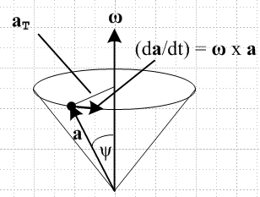

As was just shown, the distance D of vector a from the rotation axis plays no role in the result (1.23), although in the picture it happens that the tail of a is put on the rotation axis. Recall the comments in section (d) about "when are two vectors equal".
Note that one might have ω = ω(t) so the vector ω could be changing in both direction and magnitude as time progresses. But at time t, we have a definite (t), and this is sometimes referred to as the instantaneous axis of rotation at time t, and ω(t) the instantaneous angular velocity. In everything below, we always think of ω in this instantaneous sense, even though we might draw "circles" to show the instantaneous motion at some instant of time t.

(g) Rate of change of the basis vectors.

We can thus apply our rate of change rule (1.23) to the basis vectors e'n and we find that

(de'n/dt ) = ω x e'n .

Since we are computing this derivative while "standing" in Frame S, we now add a label S showing this fact

(de'n/dt)S = ω x e'n . (1.25)

Were we to compute this same derivative standing in Frame S', we would get

(de'n/dt)S' = 0 (1.26)

because in Frame S' the basis vectors e'n are not rotating at ω, but are just sitting there frozen. By the same argument, we know that

(den/dt)S = 0 . (1.27)

What about the fourth possible derivative (den/dt )S' ? We will show in (2.6) below that in fact

(den/dt)S' = – ω x en , (1.28)

It seems at least reasonable that if the e'n are rotating relative to the en by ω, then the en are rotating relative to the e'n by -ω.

Main Conclusion: We thus arrive at the notion that, when dealing with multiple frames of reference and vectors represented in terms of their respective basis vectors, we absolutely must indicate the frame in which a time derivative is being computed.

(h) Notations for the many time derivatives of vectors r, r', b and L

In the Introduction (Fig 1) we described r and r' as the position vectors of a Particle with respect to Frames S and S' . We can associate with these two vectors four different time derivatives.

(dr/dt)S (dr/dt)S' (dr'/dt)S (dr'/dt)S' (1.29)

In the usual manner, we represent a time derivative of a vector by an over-dot, and a second time derivative by an over-double-dot. The first time derivative of position r is velocity v, and the second is acceleration a. The same for r', v' and a' , so

v = v' = '
a = = a' = ' = ' (1.30)

In order to save space, we can define these two operators

∂S ≡ (d/dt)S ∂S' ≡ (d/dt)S' (1.31)

Although the ∂ symbol is used in partial differentiation, our use here is exactly as defined above and so our ∂ is not a partial derivative.

The list of derivatives above can be written now in several ways. In each column below, all objects are exactly the same thing, just written in different notations:

Table of first derivatives of r Table of first derivatives of r'

(dr/dt)S (dr/dt)S' (dr'/dt)S (dr'/dt)S'
S ≡ S' 'S 'S' ≡ '
vS ≡ v vS' v'S v'S' ≡ v'
∂Sr ∂S'r ∂Sr' ∂S'r' (1.32)

For further clutter reduction, we have added the four new notations shown in red according to the following rule: When a vector and all its derivatives (here only one) are all in the same frame, we suppress the frame subscript and just let the prime or lack of it "do the talking", and refer to such as object as being "natural".

What about second derivatives? Things are more complicated now because vector r can have four distinct second derivatives, and so can vector r'.

Table of second derivatives of r

∂S∂Sr ∂S∂S'r ∂S'∂Sr ∂S'∂S'r
SS ≡ S ≡ SS' S'S S'S' ≡ S'
SS ≡ S ≡ SS' S'S S'S' ≡ S'
aSS ≡ aS ≡ a aSS' aS'S aS'S' ≡ aS'

Table of second derivatives of r'

∂S∂Sr' ∂S∂S'r' ∂S'∂Sr' ∂S'∂S'r'
'SS ≡ 'S 'SS' 'S'S 'S'S' ≡ 'S' ≡ '
'SS ≡ 'S 'SS' 'S'S 'S'S' ≡ 'S' ≡ '
a'SS ≡ a'S a'SS' a'S'S a'S'S' ≡ a'S' ≡ a' (1.33)

Here we again use the rule mentioned above that when a vector and all its derivatives are in the same frame, we let the overall prime or lack of it do the talking. We have introduced a second rule as well, which says that whenever both frame subscripts are the same, we suppress one of them to save space.

So now we have the following "natural" vectors having minimal (that is, no) frame subscript clutter:

v a natural in Frame S
' v' ' ' a' natural in Frame S'

Recall from the Introduction that the vector b connects the origins of two frames. We can make a table of first and second derivatives for this vector as well. Although is a velocity and is an acceleration, we shall not make up separate symbol names for these objects (though some authors do). Also, note that there is no vector called b', we just have r = r' + b. Here are the corresponding tables for first and second derivatives of b, where we use only the second rule above that when two frame subscripts are the same we suppress one of them.

Table of first derivatives of b

(db/dt)S (db/dt)S'
S S'
∂Sb ∂S'b

Table of second derivatives of b

∂S∂Sb ∂S∂S'b ∂S'∂Sb ∂S'∂S'b
SS ≡ S SS' S'S S'S' ≡ S' (1.34)

Angular momentum. Although we shall not need much of this information, we can define various forms of angular momentum L = r x p = r x (mv) where the position and velocity always have the same frame sense. In this list we set m = 1 for clarity:

LSS ≡ rSS x vSS = rS x vS = r x v ≡ LS ≡ L
LSS' ≡ rSS' x vSS'
LS'S ≡ rS'S x vS'S
LS'S' ≡ rS'S' x vS'S' = rS' x vS' ≡ LS'

L'SS ≡ r'SS x v'SS = r'S x v'S ≡ L'S
L'SS' ≡ r'SS' x v'SS'
L'S'S ≡ r'S'S x v'S'S
L'S'S' ≡ r'S'S' x v'S'S' = r'S' x v'S' = r' x v' ≡ L'S' ≡ L' (1.35)

For L we compute

= S = ∂SL = ∂S(r x v) = (∂Sr) x v + r x (∂Sv) = v x v + r x a = r x a

A similar result is obtained by priming everything on the above line, so we end up then with

= r x a
' = r' x a' (1.36)

So we now have added four new "natural" vectors to our list: L, L', and '

Comment: Just as a reminder, any derivative in the above section can be expanded onto either frame S or frame S' basis vectors, so any derivative has frame S and frame S' components. This statement would be true for any vector and we just remind the reader that the notation like (dr/dt)S does not mean the components are evaluated only in frame S. Just as an example, this first derivative has these two expansions where the expansion coefficients (components) are shown on the right,

(dr/dt)S = [(dr/dt)S]i ei [(dr/dt)S]i = (dr/dt)S • ei
(dr/dt)S = [(dr/dt)S]'i e'i [(dr/dt)S]'i = (dr/dt)S • e'i .

(i) No frame label is needed for d/dt of a scalar function.

If one is differentiating a component of a vector, such as ai(t) = 3t2, there is no need to add the frame label since the derivative of this function is 6t no matter what frame it is computed in. This is true when differentiating any component of any tensor. That is to say, if Tij..(t) is a component of a tensor, then

(dTij..(t)/dt)S = (dTij..( (t)/dt)S' = (dTij..(t)/dt) . (1.37)

We would like simply to say that the d/dt derivative of any scalar function does not need a label S or S', but the word "scalar" has multiple meanings. In one meaning, any single function f(t) is a scalar function since it is a 1-tuple of functions, but in another meaning (tensorial scalar), only a function which is a rotational scalar is a scalar function, and this would rule out the component of a vector as being a scalar function. We refer to the first meaning in the underlined title of this subsection.

(j) Non-commutation of operations d/dt and taking a component

In a footnote at the end of this subsection, we do four derivative calculations of a generic vector a. Here we state the four results. We put subscripts on the derivatives of components even though we know from [3] that such subscripts, although correct, are superfluous.

[(da/dt )S]j = (d(a)j/dt)S

[(da/dt )S']j = (d(a)j/dt)S' – εjai (a)i ωa

[(da'/dt )S']j = (d(a')i/dt)S' Rij

[(da'/dt )S]j = (d(a')i/dt)S Rij + εjabωaRib(a')i (1.38)

The lack of symmetry is due to the fact that our jth component is always an S frame component, meaning that we have Aj = A • ej . We could write another four equations which have [ ....]'j on the left and these would have R factors in the first two equations.

Now look at the first of the above four lines as LHS = RHS.
On the LHS we first apply (d/dt)S to a, and then we take the jth component of the result.
On the RHS we first take the jth component of a, then we apply (d/dt)S to the result.
The result is the same regardless of the order of doing these two operations.
The two operations "commute". But:

On the second line this is not true because there is an extra term.
On the third line this is not true because there is an extra factor Rij.
On the fourth line this is not true because there is an extra factor Rij and an extra term.

Main Point: In general, the operations of doing d/dt and of taking a component do not commute.
One must never assume commutation in doing calculations.
Goldstein makes this point as a "word of caution" on the bottom of page 133 with an example on the top of page 134. In GPS the caution is stated on page 173, but the example has been removed.

Footnote: Here are details of the above four calculations:

(da/dt )S = (d [ (a)iei] /dt )S = (d(a)i/dt)S ei + (a)i (dei/dt )S = (d(a)i/dt) ei

=> [(da/dt )S]j = (d(a)i/dt) ei • ej = (d(a)i/dt) δi,j = (d(a)j/dt) .

(da/dt )S' = (d [ (a)iei] /dt )S' = (d(a)i/dt)S' ei + (a)i (dei/dt )S' = (d(a)i/dt) ei – (a)i ω x ei

In the above we used (1.27) and (1.28).

Now since (ei)j = δi,j and [ ω x ei] j = εjabωa(ei)b = εjabωaδi,b = εjaiωa, this last line is

[(da/dt )S']j = (d(a)j/dt) – εjai ωa(a)i

For completeness, let's just do the other two derivatives doing copy paste and edit on the above:

(da'/dt )S' = (d [ (a')ie'i] /dt )S' = (d(a')i/dt)S' e'i + (a')i (de'i/dt )S' = (d(a')i/dt) e'i

=> [(da'/dt )S']j = (d(a')i/dt) e'i • ej = (d(a')i/dt) Rij

(da'/dt )S = (d [ (a')ie'i] /dt )S = (d(a')i/dt)S e'i + (a')i (de'i/dt )S = (d(a')i/dt) e'i + (a')i ω x e'i

In the above we used (1.26) and (1.7) and (1.25).

Now since (e'i)j = Rij (see 1.7) and [ω x e'i] j = εjabωa(e'i)b = εjabωaRib this last line is

[(da'/dt )S]j = (d(a')i/dt) Rij + εjabωaRib(a')i

2. The G Rule for arbitrary vector a and its derivation (Transport Theorem)

In this section, a is a generic vector -- it could be any vector (see Comment at the end).

The "G Rule for vector a" is this:

(da/dt)S = (da/dt)S' + ω x a
or (2.1)
∂Sa = ∂S'a + ω x a

where in the second line we use the abbreviations ∂X = (d/dt)X where X is a frame of reference. G is in honor of Herbert Goldstein since the Rule appears on page 133 of his classic 1950 book Classical Mechanics. Perhaps another name for this rule would be "the rule which relates the time derivatives of a vector taken in two frames S and S' where frame S is fixed and frame S' is rotating at instantaneous vector angular velocity ω where the location of the rotation axis does not matter". G Rule for short.

Equation (2.1) goes by a few obscure names, some people calling it a "transport theorem", but most authors who use it give it no name. Since the cross product notation was buried in 19th century Hamilton's quaternions and in Grassman's description of vector areas, it seems unlikely that anyone wrote the G Rule (as shown above) until some time after the landmark Gibbs/Wilson book Vector Analysis was first published in 1901 (and reprinted 7 times most recently as a 1960 Dover book). In this book the cross product notation was first exposed to the general "public" (and bold letters for vectors). It happens that this book makes no mention of the G Rule or even "frames of reference". The ball was just starting to get rolling at that time. Gibbs might have known about the G Rule as in (2.1) circa 1880.

Since the Rule applies to any vector a, sometimes the vector is left out and one writes this operator equation,

(d/dt)S = (d/dt)S' + ω x . (2.2)

In Goldstein's books these equations appear as (space = Frame S = s, body = Frame S' = rotating = r)

(dG/dt)space = (dG/dt)body + ω x G // Goldstein p 133 (4-100)
// GPS p 172 (4.82)
(d/dt)space = (d/dt)body + ω x . // Goldstein p 133 (4-102)
(d/dt)s = (d/dt)r + ω x // GPS p 173 (4.86)

We shall now quickly derive this Rule.

Expand the vector a in frame S' components :

a = a'i e'i . (2.2)

Differentiate a in frame S

(da/dt)S = (da'i/dt)S e'i + a'i(de'i/dt)S // product rule

= (da'i/dt)S e'i + a'i ω x e'i // using (1.25) which says (de'n/dt)S = ω x e'n

= (da'i/dt)S e'i + ω x a'i e'i // move in scalar factor a'i

= (da'i/dt)S e'i + ω x a // recognize expansion of a

so we have shown that

(da/dt)S = ω x a + (da'i/dt)S e'i . (2.3)

Now go back to the start

a = a'i e'i (2.2)

and differentiate this time in frame S' to get,

(da/dt)S' = (da'i/dt)S' e'i + a'i(de'i/dt)S'

= (da'i/dt)S' e'i + a'i* 0 // using (1.26) because the e'i are frozen in S'

= (da'i/dt)S' e'i (2.4)

Thus our results above are

(da/dt)S = (da'i/dt)S e'i + ω x a (2.3)

(da/dt)S' = (da'i/dt)S'e'i . (2.4)

It was noted in Section 1 (h) [3] that the frame label on the time derivative of a vector component is superfluous, so we can write (da'i/dt)S = (da'i/dt)S' = (da'i/dt) so the above become

(da/dt)S = (da'i/dt)e'i + ω x a (2.5)

(da/dt)S' = (da'i/dt)e'i . (2.6)

Inserting (2.6) into (2.5) then gives our G Rule,

(da/dt)S = (da/dt)S' + ω x a . (2.1)

This then gives the connection between the derivative of a vector a in S compared to in S'.

Example 1: Suppose a = e'i . Then our rule (2.1) says

(de'i/dt)S = ω x e'i + (de'i/dt)S' (2.5)

But we noted in (1.26) the obvious fact that (de'i/dt)S' = 0, so the above becomes

(de'i/dt)S = ω x e'i

which agrees with (1.25).

Example 2: Suppose a = ei . Then our rule (2.1) says

(dei/dt)S = ω x ei + (dei/dt)S' (2.5)

But we noted in (1.27) the obvious fact that (dei/dt)S = 0, so the above becomes

(dei/dt)S' = – ω x ei (2.6)

and we have now derived the claim made in (1.28).

Example 3: Suppose a = ω . Then our rule (2.1) says

(dω/dt)S = (dω/dt)S' + ω x ω = (dω/dt)S'

so for this one vector ω both derivatives are the same and we write

(dω/dt)S = (dω/dt)S' ≡ (2.7)

Example 4. Using the dot notation of (1.30), and assuming there are two related vectors a and a', the G Rule states

S = S' + ω x a that is ∂S = ∂S' + ω x a
'S = 'S' + ω x a' that is ∂S' = ∂S'' + ω x a' (2.8)

Example 5. We can apply this rule to any of the 20 or so vectors listed in Section 1 (h) [5]. Here are a few examples:

S = S' + ω x b (2.9)

S = S' + ω x r or vS = vS' + ω x r
'S = 'S' + ω x r' or v'S = v'S' + ω x r'

S = S' + ω x vS or aS = aS' + ω x vS
'S = 'S' + ω x v'S or a'S = a'S' + ω x v'S (2.10)

Comment: Are there any restrictions on the vector a for which the G Rule applies? The only fact used above about a is that a can be expanded on Cartesian basis vectors as a = a'i e'i and that the component fields a'i(t) are differentiable. If the tail of vector a does not lie at the origin of frame S', we just translate a such that this is the case, as per Section 1 (d).

Significance of the G Rule: In all the computations below, basically the only operations done are these:

• Apply the G Rule to some vector
• Apply ∂S to both sides of some equation
• Apply ∂S' to both sides of some equation

3. The Apparatus and its Observer at Rest in Frame S'.

In our general "experiment" to be described below, frame S' is rotating with respect to frame S. This does not necessarily imply that frame S is "at rest", but frame S will be "at rest" with respect to the paper on which we draw Figure 1 below. If frame S is truly at rest with respect to the stars, then frame S is called an inertial frame, and in such a frame Newton's 2nd Law F = ma is valid. We do not in general assume that S is such an inertial frame.

Imagine now that we have some Apparatus sitting in frame S' which contains a Particle which undergoes some motion. The Particle might be a mass on one or more springs, or it might be Particle in ballistic flight, or it might be a Particle of matter in a gear wheel which is turning in some complicated machine, or it might be a Particle of a fluid or of an elastic solid.
An Observer also sitting in frame S' has some measurement equipment, can see the axes of frame S' of course, and does certain measurements on the Particle as frame S' is rotating with respect to frame S. The Particle is located at position r in frame S and position r' in frame S'. The Observer can see Frame S and is aware of both r and r' and can make measurements of them both.
For example, although r is the position vector of the Particle relative to the frame S origin, our Observer measures its components in frame S' this way

r = (r)'ie'i (r)'i = r • e'i

while his measurement of r' reveals these components

r' = (r')'ie'i (r')'i = r' • e'i .

However, the Observer can only measure frame-S' derivatives. From our list we then select these items

S' = (db/dt)S' rate of change of b as viewed from Frame S' (1.32)

vS' = S' = (dr/dt)S'
v'S' = 'S' = (dr'/dt)S' (1.33)

aS' = S' = (dvS'/dt)S' = (d2r/dt2)S'
a'S' = 'S' = (dv'S'/dt)S' = (d2r'/dt2)S' (1.34)

For example, he might measure the frame-S Particle location r(t) at time t as, wait one time tick dt, then measure it again to get r(t+dt). Then

vS'(t) = [r(t+dt) – r(t)]/(dt) or vS'(t) = (dr/dt)S' .

Alternatively, he could measure r'(t) and r'(t+dt) and get

v'S'(t) = [r'(t+dt) – r'(t)]/(dt) or v'S'(t) = (dr'/dt)S' .

Waiting another dt tick, he could measure r(t+2dt) and r'(t+2dt) and then deduce vS'(t+dt) and v'S'(t+dt). From these in turn he could determine

aS'(t) = [vS'(t+dt) - vS'(t)]/(dt) or aS'(t) = (dvS'/dt)S'

a'S'(t) = [v'S'(t+dt) - v'S'(t)]/(dt) or a'S'(t) = (dv'S'/dt)S'

At this point he also knows these two angular momentum vectors

LS' = r x mvS'
L'S' = r' x mv'S' (1.35)

and then using the method just outlined he could measure,.

S' = (dLS'/dt)S'
'S' = (dL'S'/dt)S' (1.36)

4. The Relationship between the Two Frames S and S'

(a) Explanation of Figure 1: Frame S in the plane of paper.

The relation between the two frames is shown in this picture, a snapshot at some time t :

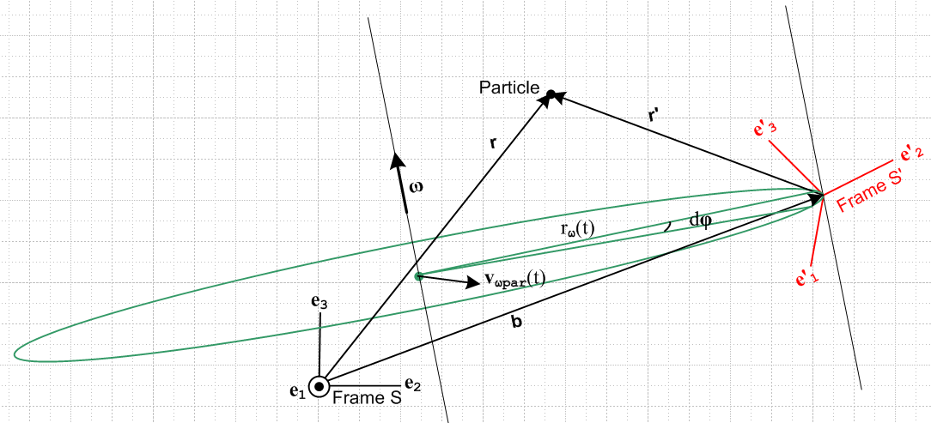 Fig 1

There is a lot to be said about this picture.

The axes e2 and e3 of Frame S are in the plane of paper and are "aligned with paper" as shown and remain fixed relative to paper, so the Frame S origin lies in the plane of paper. The origin of Frame S' is displaced by amount b from the origin of Frame S, and this S' origin does not lie in the plane of paper. The location of the Particle does not lie in the plane of paper, so vectors r, r' and b , although coplanar with each other, are each not in the plane of paper. Similarly, the ω rotation axis does not lie in the plane of paper nor is it parallel to it.
Frame S' is instantaneously rotating about some axis indicated by ω(t). Each of the basis vectors e'n is rotating according to (1.25), (de'n/dt)S = ω x e'n, as the frame S' moves rigidly in rotation about the ω rotation axis. The origin of Frame S' is instantaneously rotating along the green circle of some instantaneous radius rω which has its center on the rotation axis at a green dot. This green dot, meanwhile, is moving at some velocity vωpar in the plane of the green circle relative to Frame S. This indicates the motion of the rotation axis parallel to itself.
Suppose Frame S' contains a rigid object fixed relative to the Frame S' axes. If we were to select some point P in that rigid object, that point P would be instantaneously rotating about the ω(t) axis along a circle similar to the one shown above, but which has a different radius and a different center point along the rotation axis.
If ω were constant in time, the origin of S' really would move along the full green circle shown, but we have in mind that ω = ω(t) and this varies in time, both in magnitude and direction. Thus, the green circle is itself tilting to stay in a plane perpendicular to ω(t).
Viewed from Frame S, the unit vectors of Frame S' are oriented and move according to several equations we have already dealt with

e'n(t) = R-1[θ(t)] en = R[-θ(t)] en (1.1)

e'n(t) = Rnm(t) em (1.2)

(de'n/dt)S = ω(t) x e'n(t) . (1.25)

(b) Explanation of Figure 2: Vector ω pointing directly out of paper

We now draw the same 3D picture from a different perspective. The reader will hopefully forgive the "artist" for not attempting to draw Figure 2 as a precision 3D rotated version of Figure 1, but hopefully the general features of the drawing are sufficient for our purposes below.

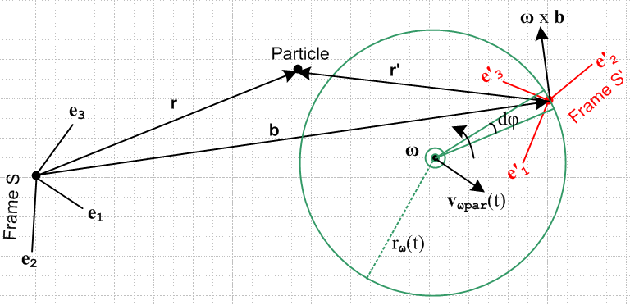 Fig 2

Frame S remains fixed as time varies, but is now rotated relative to Figure 1 and the S origin no longer lies in the plane of paper. At time t for which the picture is drawn, the origin of Frame S' and the green circle and its center all lie in the plane of paper. The ω vector points straight out at the viewer as indicated by the circled dot. Vectors r, r' b do not lie in the plane of paper.
The vector ω x b is (for convenience) drawn with its tail at the S' origin which lies in the plane of paper. Since ω x b is perpendicular to ω, ω x b lies in the plane of paper. It is of course also perpendicular to b.

(c) The Meaning of (db/dt)S' = S'

If we apply the G Rule (2.1) to vector b, we find that

(db/dt)S = (db/dt)S' + ω x b (4.1)
or
(d[b'ie'i]/dt)S = (db'i/dt) e'i + b'i(de'i/dt)S . (4.2)

We want to clearly understand these two terms which contribute to (db/dt)S :

1st term = (db/dt)S' = (db'i/dt) e'i = [(db/dt)S]|e'i fixed (4.3)

2nd term = ω x b = b'i(de'i/dt)S = [(db/dt)S]|b'i fixed (4.4)

The 2nd term is entirely caused by the fact that the e'i are rotating in frame S, which of course is due to the rotation of Frame S' about the ω axis.
Why is this 2nd term contribution to (db/dt)S in the direction ω x b ? It is because (de'i/dt)S = ω x e'i:

2nd term = b'i(de'i/dt)S = b'i [ ω x e'i ] = ω x (b'i e'i) = ω x b.

If our 1st term were zero, we would have (db/dt)S = ω x b which we know indicates that b is doing a certain circular motion in Frame S,

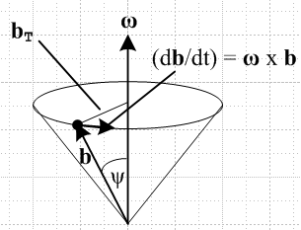

So we may regard the 1st term as measuring the deviation from this circular motion. This 2nd term is unaffected by any ongoing change in the vector ω or by any ongoing change in the location of the rotation axis which contains vector ω.

The 1st term then represents the deviation from the circular motion noted above. There is such a deviation even when ω = constant and the ω axis does not move (vωpar= 0) and radius aω = constant. This 1st term deviation exists in this case because ω x b is not tangent to the green circle but the actual motion of b is tangent to the circle.
When ω = ω(t), there are other sources of this 1st term deviation as well. For example, if ω is in the process of changing direction, the green circle is in the process of tipping out of the plane of paper, and this might contribute to the motion of the S' origin (tip of vector b) a component perpendicular to the plane of paper. Or, it might be that the rotation axis indicated by vector ω is translating sideways in the above picture at some instantaneous velocity vωpar, and this would contribute to the motion of the S' origin (tip of vector b) another amount in the plane of paper.

In order to write down a precise expression for the 1st term (db/dt)S', we need to know many details of how the two frames are arranged. Basically, we need to know about ω(t) (three parameters) and we need to know the instantaneous radius of the green circle rω(t) (a fourth parameter). Then we might compute the "tipping green circle effect" just mentioned. Similarly, we would need to know about the instantaneous parallel velocity of the ω rotation axis vωpar(t) (another two parameters). We are thinking here of these parameters just mentioned as being the "drivers" of Fig 2, and then the vector b comes out however it does. (In Special Case #2 below we will instead think of ω and b as the 6 independent parameters. )

Rather than attempt such a calculation for the general case, we shall just leave this first term (db/dt)S' sitting in all our equations and defer the task of computing (db/dt)S' to a specific application. As noted in (1.33), the shortened symbol for (db/dt)S' is S' ,

S' ≡ (db/dt)S' = 1st term = (db'i/dt) e'i = [(db/dt)S]|e'i fixed (4.5)

In this shortened notation the G Rule (4.1) says

S = S' + ω x b (4.6)

Two special cases are of interest:

(d) Special Case #1 : ω axis through Frame S origin

The rotation axis always passes through the origin of frame S.

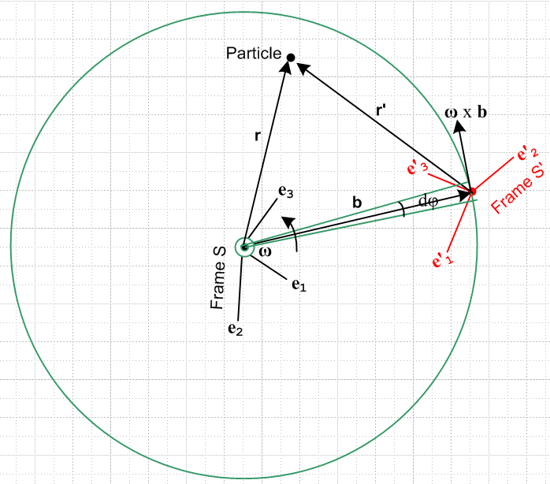 Special Case #1

In this situation, the vector b and the vectors e'n all rotate together as if they were thin metal rods soldered together. This has the immediate implication that, just as (de'n/dt)S' = 0 in (1.26), so we have

S' ≡ (db/dt)S' = 0 (4.9)
and therefore, from (4.6), we have instantaneous circular motion,

S ≡ (db/dt)S = ω x b . (4.10)

This says that, as seen in Frame S, the change in b is always perpendicular to b, so the length of b does not change. We still allow ω = ω(t) and, as (t) changes, the tip of vector b (which is the origin of frame S') describes some path on the surface of a sphere of radius b .

(e) Special Case #2 : ω axis through Frame S' origin

Here the rotation axis always passes through the origin of frame S' :

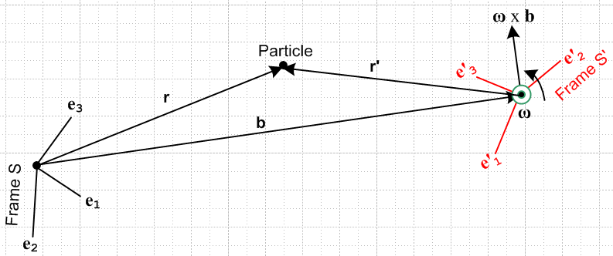 Special Case #2

In this case our green circle has shrunk around the frame S' origin. If we now look at our decomposition,

S = (db/dt)S = (db/dt)S' + ω x b (4.1)
1st term 2nd term

we find that it is fairly useless. The 2nd term is probably a horrible estimate of the left side and just has no relevance. In this kind of situation, we want our "driving parameters" to be the three parameters of b and the three parameters of ω giving the 6 independent (Galilean) parameters defining the instantaneous relationship between the frames. Think of Frame S' as a camera platform which is supported on a boom b(t) and independently controls its own rotation ω(t). In this situation, S is a function of the boom motion, and then we interpret the above equation as telling us what to use for S' in our equations to come below:

S' = S – ω x b

In other words, b and S and ω are given parameters and S' is as shown.

We now look at three sample applications. The first two fall into the Special Case #1 Category, while the third is an example of Special Case #2.

(f) The Phonograph Turntable

Although obsolete, the phonograph turntable continues to provide an excellent visualization of rotating frames. It turns slowly enough for one to actually see it turn, it is fairly large, and the surface is not shiny and completely featureless. It is believed that such turntables normally rotate clockwise in both hemispheres of the Earth, but in our drawing below we imagine it turns the other way.

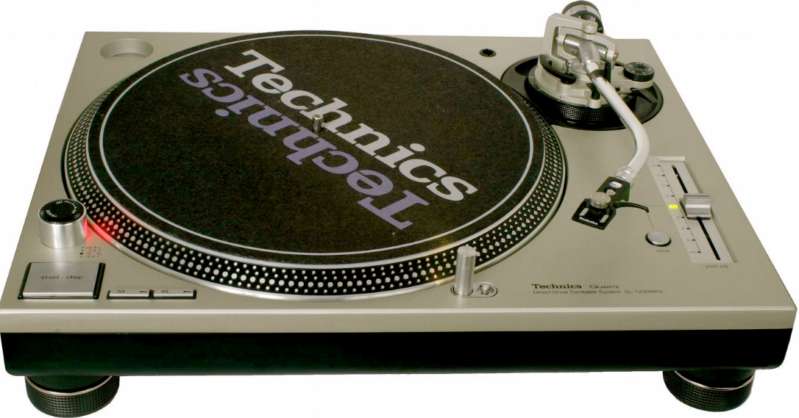

An ant (Particle) is crawling around on such a turntable which is rotating with some ω(t). The frame S' is set up some distance b = |b(t)| from the spindle, and has its e'1 axis pointing to the right and its e'2 axis pointing to the spindle. That is to say, e'1 = and e'1 = - if we think of r,θ as polar coordinates for fixed frame S. In this application, ω(t) = ω(t)e3 and the rotation axis passes though the origin of Frame S (Special Case #1). Thus, (t) = e3 is a constant. Conversely, vector b(t) maintains its magnitude b, but (t) rotates about the spindle at angular rate ω(t).

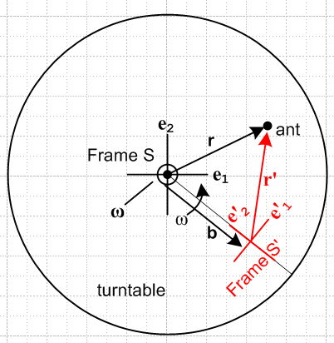 Fig 2

This same type of Frame S' designation would be familiar to Merry-Go-Round riders hanging on and facing the center.

(g) The Earth

On the Earth, Cartesian frame S is taken as an inertial frame (ignoring the usual suspects) located at Earth center with e3 pointing to the North Pole. The e1 axis points out through a point on the equator to some fixed distant star (Star 1), and then e2 is the third Cartesian axis which points out through a different point on the equator to Star 2. Perhaps the e1 star line intersects the Greenwich meridian.
Frame S' has its origin at some arbitrary point on the surface of the Earth. For this system, the e'3 axis points "up", meaning in the direction for Frame S spherical coordinates. The e'1 axis points to the East, and the e'2 axis points North.
The earth rotates at some ω = ωe3 with ω > 0. Since ω passes through the Frame S origin, this is a Special Case #1 application.

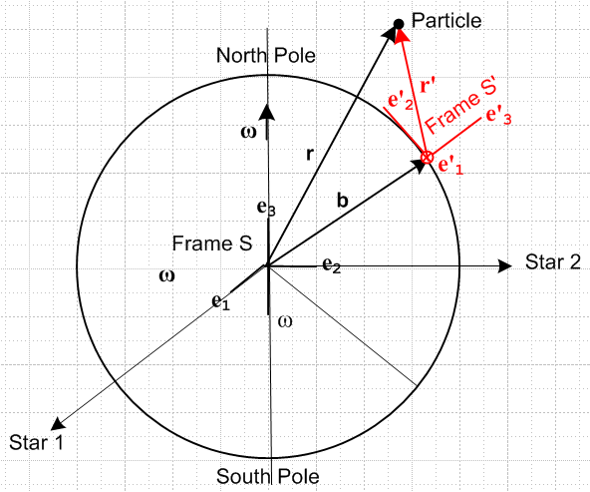

(h) The Flying Camera Platform

Some Apparatus is located in Frame S instead of S', and Frame S' is a "camera platform" which flies around in some complicated way and observes the activity in frame S. In this case, both ω(t) and b(t) would be under the command of the pilot of the camera platform. One would set this up as a Special Case #2 situation, so ω passes through the Frame S' origin and S is the velocity of the platform origin and b(t) is its location relative to frame S. One would use the "inverse problem" equations given below to get the primed quantities in terms of the unprimed ones.

5. The Goal of the next two sections

An Observer in Frame S' measures various properties of a Particle in motion,

r' v' a' L'

We want to know how these properties of the Particle appear in Frame S,

r v a L

and we want to know all the various other v, a, and L forms in terms of the basic S' frame objects listed above. Later we will want to know how to solve "the inverse problem" of finding the primed quantities if the unprimed ones are known.

6. Determination of velocities

The notations used here are described in Section 1 (h). There are four distinct velocities, and we want to express three of them in terms of the fourth which is the natural velocity in frame S' , (dr'/dt)S' = v'S' ≡ v' . We shall make frequent use of (1.24) and (4.1) which we restate here with new equation numbers

r = r' + b (6.1)

S = S' + ω x b (6.2a)

The line above is just the G Rule (2.1) for vector b. Inserting (6.1) as b = r - r' into (6.2a) gives identity

S + ω x r' = S' + ω x r (6.2b)

(a) Velocity vS'

Apply (d/dt)S' to (6.1) to get (6.3a), then use (6.2a) to get (6.3b) :

vS' = v' + S' (6.3a)
vS' = v' + S – ω x b (6.3b)

(b) Velocity v ≡ vS

Apply (d/dt)S to (6.1) r = r'+b to get ∂Sr = ∂Sr' + ∂Sb or

v = v'S + S (6.4)
Now use the G Rule (2.1) for vector r' to get

v'S = v' + ω x r' (6.5)

Inserting (6.5) into (6.4) gives the first line below

v = v' + ω x r' + S (6.6a)
v = v' + ω x r' + S' + ω x b (6.6b)
v = v' + ω x r + S' (6.6c)

The 2nd and 3rd lines make use of (6.2a) and (6.2b) .

(c) Velocity v'S

Solve (6.4) for v'S,

v'S = v – S (6.7)

and then insert (6.6a) into (6.7) to get the first line below (the S terms cancel) . As usual, the remaining two lines come from using (6.1) and (6.2),

v'S = v' + ω x r' (6.8a)
v'S = v' + ω x r – ω x b (6.8b)
v'S = v'' + ω x r + S' - S (6.8c)

(d) Velocity Summary

But here I am picking winning forms, maybe unfair.

v = v' + ω x r' + S = v' + ω x r + S' (6.6a)
vS' = v' + S – ω x b = v' + S' (6.3b)
v'S = v' + ω x r' (6.8a)

(e) Velocities for Special Cases

These cases were discussed above in Section *****.

For Special Case #1, where the ω axis passes through the Frame S origin, in any equations above set

S' = 0
S = ω x b (6.9)

and then the (d) summary results become

v = v' + ω x r Special Case #1 only (6.6a)
vS' = v' Special Case #1 only (6.3b)
v'S = v' + ω x r' general (6.8a)

For Special Case #2, where the ω axis passes through the Frame S' origin, S is a driving parameter, so we select just these forms from the summary

v = v' + ω x r' + S general (6.6a)
vS' = v' + S – ω x b general (6.3b)
v'S = v' + ω x r' general (6.8a)

(f) Comments

(1) Consider these two results from above (picked more or less at random)

r = r' + b (6.1)
v = v' + ω x r + S' (6.6c)

Either equation can be "evaluated" in either frame S or frame S'. Evaluation in frame S gives

(r)i = (r')i + (b)i
(v)i = (v')i + εijk(ω)j(r)k + (S')i

while evaluation in frame S' gives

(r)'i = (r')'i + (b)'i
(v)'i = (v')'i + εijk(ω)'j(r)'i + (S')'i .

This is a situation where we fully expect to have (r')i ≠ (r)'i and (v')i ≠ (v)'i as mentioned in Section 1 (b), so the careful placement of primes in this case is important.

(2) Based on the equations above, it is clear that we have

r' ≠ Rr v' ≠ Rv

where R is the rotation appearing in (1.1) which relates our two frames, en = R e'n . Therefore, in general the pairs of vectors (r,r') and (v,v') are not "vectors under rotations" in the sense of (1.10).

(3) On the other hand, the vectors ω and b appearing in these formulas are normal "vectors under rotations" in the sense of (1.10),

b' = Rb ω' = Rω . (6.11)

These equations just indicate that the vectors ω and b have different components when viewed from frame S' versus when viewed from frame S. For these vectors, according to Section 1 (c), we can use b'i and ω'i without the need for parentheses :

b = biei = b'ie'i ω = ωiei = ω'ie'i (6.12)

7. Determination of accelerations

The notations used here are described in Section 1 (h). There are eight distinct accelerations of interest, and we could to express seven of them in terms of the eighth which is the natural acceleration in frame S', (da'/dt)S' = a'S' ≡ a' . To spare the reader, we shall only express the three accelerations a'S , a ≡aS, and aS' in terms of a'.

(a) Acceleration a'S

The G Rule for v'S says

∂Sv'S = ∂S'v'S + ω x v'S
or
a'S = a'S'S + ω x v'S (7.1)

Notice the unusual cross derivative a'S'S which involves both S and S'. This is one those cross accelerations appearing in the list (1.36). To compute this, we must go back to the G Rule for r'

v'S = v' + ω x r' (6.8a)

Apply ∂S' ≡ (d/dt)S' to both sides to get

∂S'v'S = ∂S'v' + ∂S'(ω x r') = ∂S'v' + x r' + ω x (∂S'r')
or
a'S'S = a' + x r' + ω x v' (7.2)

where we used (2.7) that (dω/dt)S = (dω/dt)S' ≡ . We can now install a'S'S into (7.1) to get

a'S = [a' + x r' + ω x v'] + ω x v'S (7.3)

Now replace v'S again using the G Rule for r' [ (6.8a) a few lines above ]

a'S = [a' + x r' + ω x v'] + ω x [v' + ω x r' ]
or
a'S = a' + x r' + 2 ω x v' + ω x (ω x r') (7.4)

The famous "Coriolis factor of 2" has now appeared and will be trivially transferred into aS in the next section. It is useful to review the steps above to see where this factor of 2 comes from :

1. Write the G Rule for v'S a'S = a'S'S + ω x v'S
2. Write the G Rule for r' v'S = v' + ω x r'
3. Insert 2 into 1 a'S = a'S'S + ω x v' + ω x (ω x r') // 1st ω x v' term
4. Apply ∂S' to 2 to get a'S'S = a' + x r' + ω x v' // 2nd ω x v' term,
5. Install 4 and 3: a'S = [a' + x r' + ω x v'] + ω x v' + ω x (ω x r')

and now we have two ω x v' terms and only natural frame S' objects r', v' and a'.

(b) Acceleration a ≡ aS

Start with (6.4) which is ∂S applied to r = r' + b ,

v = v'S + S (6.4)

Apply ∂S again to get

a = a'S + S (7.5)

Then insert (7.4) for a'S to get the same result as (7.4) with S tacked on,

a = a' + x r' + 2 ω x v' + ω x (ω x r') + S (7.6a)
S S' Euler Coriolis centripetal frame

We have attached a name to each contribution to a and will discuss these terms below. Since we really want all primed objects on the right side, we can anticipate the result (7.10) derived in section (e) below,

S = S' + x b + 2ω x S' + ω x (ω x b) (7.11)

to get this alternate form

a = a' + x r' + 2 ω x v' + ω x (ω x r') + [S' + x b + 2ω x S' + ω x (ω x b) ]

= a' + x r + 2 ω x v' + ω x (ω x r) + 2ω x S' + S' (7.6b)

where we think here of r as just a shorthand for b + r' to compress the number of terms.

(c) Acceleration aS'

Start with (6.3a) which is ∂S' applied to r = r' + b,

vS' = v' + S' (6.3a)

Apply ∂S' again to get

∂S'vS' = ∂S'v' + S'
or
aS' = a' + S' (7.7)

(d) Acceleration Summary

aS = a' + x r' + 2 ω x v' + ω x (ω x r') + S (7.6)
a'S = a' + x r' + 2 ω x v' + ω x (ω x r') (7.4)
aS' = a' + S' (7.7)

(e) Relation between S and S'

Start with the G Rule for S' ,

∂SS' = S' + ω x S'
or
S' = ∂SS' – ω x S' (7.8)

Now apply ∂S to (6.2a)

S = ∂SS' + ∂S (ω x b)
or
∂SS' = S – ∂S (ω x b) (7.9)

Insert this into (7.8) to get the first line below, and then (6.2a) to get the second line,

S' = S – ∂S (ω x b) – ω x S'
= S – ∂S (ω x b) – ω x[S – ω x b ]
= S – x b – 2ω x S + ω x (ω x b) (7.10)

The inversion of this equation may be found by using (6.2a) S = S' + ω x b :

S' = S – x b – 2ω x [S' + ω x b]+ ω x (ω x b)

= S – x b – 2ω x S' – ω x (ω x b)

so then

S = S' + x b + 2ω x S' + ω x (ω x b) (7.11)

8. The Fictitious Forces

(a) Development of the Fictitious Forces

We start with (7.6) which says

a = a' + x r' + 2 ω x v' + ω x (ω x r') + S (7.6)
S S' Euler Coriolis centripetal frame

Newton's law in inertial frame S says

F = ma (8.1)

with a given as above in (7.6), so, reordering the 5 terms,

F = ma = mS + ma' + mω x (ω x r') + 2m ω x v' + m x r' (8.2)

Now suppose we imagine an "effective" version of Newton's Law that works in rotating frame S',

F'eff = ma' (8.3)

Solving (8.2) for ma' tells us that we will need to have (second line uses (8.1))

ma' = F'eff = F – mS – mω x (ω x r') – 2m ω x v' – m x r' (8.4a)
ma' = F'eff = ma – mS – mω x (ω x r') – 2m ω x v' – m x r' (8.4b)

We can write (8.4a) as

F'eff = F + F'fict where, (8.5)
F'fict = – mS – mω x (ω x r') – 2m ω x v' – m x r' (8.6)
frame centrifugal Coriolis Euler

Here F'fict represents "fictitious forces" that "mysteriously" have to be added to "true forces" F to make our bogus (8.3) "Newton's Law" F'eff = ma' be valid in Frame S'.
In some applications the force mS can be neglected compared to other forces. In this case, we can write

F = ma ≈ ma' + mω x (ω x r') + 2m ω x v' + m x r' (8.2)approx

ma' = F'eff ≈ F – mω x (ω x r') – 2m ω x v' – m x r' (8.4a)approx

ma' = F'eff ≈ maS – mω x (ω x r') – 2m ω x v' – m x r' (8.4b)approx

F'eff = F + F'fict (8.5)

F'fict ≈ – mω x (ω x r') – 2m ω x v' – m x r' (8.6)approx
centrifugal Coriolis Euler

(b) Interpretation of the Centrifugal and Euler Fictitious Forces

Consider our general picture from above, where ω points directly at the viewer

Suppose in the above picture v' = 0. Then (8.6) becomes

F'fict = – mS – mω x (ω x r') – m x r'

The – mS fictional force arises because the origin of frame S' is accelerating at S relative to frame S and needs no further comment. We consider the next two at the same time.

Since v' = 0, as seen from Frame S' the vector r' shown above is fixed and so is our Particle. In Frame S, both ends of the vector r' are moving so it is not quite obvious what the vector is doing. To clarify the situation, consider this simplified view extracted from the above drawing (below right), and recall that the vector r' is "soldered" to the Frame S' system and thus rotates with it. Each end of the vector r' is rotating about the ω rotation axis. The two ends of r' rotate on different circles in different planes, but at the same angular frequency ω.

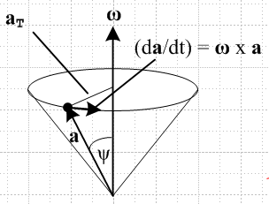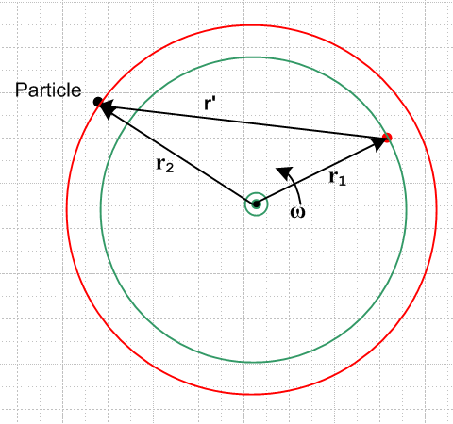

Here the red circle perhaps lies above the plane of paper while the green one lies in the plane of paper, so that r1 lies in the plane of paper but r2 does not. Regardless, we know that the following equations apply

(dr1/dt)S = ω x r1 // r1 + r' = r2 => r' = r2 – r1
(dr2/dt)S = ω x r2 (8.7)

These equations are just the G rule (2.1) applied to vectors r1 and r2, since r1 and r2 are fixed in Frame S'

∂S'r1 = ∂S'r2 = 0.

Subtracting the second equation from the first and using r' = r2 – r1 tells us that (dr'/dt)S = ω x r' so we can then apply our generic cone picture to r' as well :

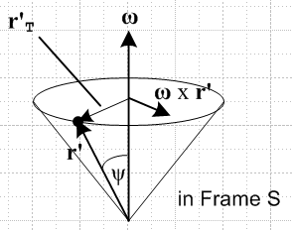 (dr'/dt)S = ω x r' = v'S . (8.8)

Since ∂S'r'= 0, the equation here is just the G Rule for vector r', so that would be a more direct way to obtain this result, but hopefully the pictures above are useful. This cone picture is what we get then if we maintain the Frame S motion of vector r' in our main figure above, but we translate the tail of r' so it lies fixed on the ω rotation axis. φ
Now apply ∂S to the above equation

(d2r'/dt2)S = ∂S(ω x r') = ω x (dr'/dt)S + x r'
or
a'S = ω x v'S + x r' = ω x (ω x r') + x r' (8.9)
Now suppose in the disk at the top of the cone we define temporary polar coordinates r,θ in the obvious manner. Then we have

ω x r' = ω r' sinψ = ω r'T

ω x (ω x r') = ω r'T ω x = - ω2r'T // centripetal acceleration (8.10)

This is then recognized as the usual - ω2R centripetal (center seeking) acceleration for motion around a circle of radius R.
Meanwhile, for the special case that and ω point in the same direction we have

x r' = r' sinψ = r'T // Euler acceleration (8.11)

which is the expected result say for an ant on an accelerating turntable.
Since r' and therefore our Particle are fixed in Frame S', and since the Particle nevertheless feels both these accelerations, it ascribes them as being "fictional" in nature.
If you are standing on a carpet that is being accelerated ac to the right, you feel there is a force -mac shoving you to the left, an example of a fictional force. Thus, given our two fictional accelerations above, we multiply by mass m and add a minus sign to get the fictional forces,

F'fict = – mω x (ω x r') – m x r' + frame + Coriolis x r'
centrifugal Euler

Anyone who as ridden on an accelerating Merry-Go-Round or Rotor is familiar with both the centrifugal and Euler forces.
When is not in the same direction as ω, we still have equation (8.8) and its (d/dt)S derivative (8.9) so the Euler acceleration is x r'. In this case, we can draw a version of the cone picture above with ω replaced by and some different cone angle φ, as shown on the right below. The Euler acceleration is thus tangential to the circle (red arrow) which forms the top of the cone in this picture.

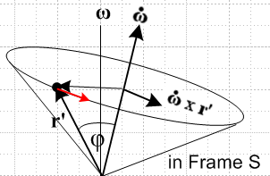

Notice that the vector r' is in exactly the same location in both these pictures. In terms of the cone picture on the left, the red Euler acceleration arrow is at some inscrutable angle relative to the cone.

(c) Interpretation of the Coriolis Fictitious Force

The Coriolis fictitious term is always the main topic of any textbook or web page which deals with motion in rotating frames, so we won't have much to say about it other than to give a popular qualitative explanation of the direction of the effect. We did show very carefully how the factor of 2 arises in the derivation of the term which is Fcor = -2m ω x v', and indeed, the expression itself was derived in full.

So consider the picture below where we launch four colored projectiles from the surface of a moving turntable. The colored arrows on the left show the initial Frame S velocities of these projectiles. In Frame S' these four v' type velocities are the same length and are at right angles (black arrows on the right), but in Frame S the initial v's are not the same size because the turntable adds an upward tangential amount vt in each case. Since Frame S is an inertial frame, we can regard the colored arrows on the left also as representing the trajectories of the projectiles.

So, each projectile is launched with the same initial component vt and, being in free flight, maintains that vt during its flight. Notice that three of the projectiles move into to a region of larger radius, while the orange one heads to a smaller radius region. When a projectile moves to a larger radius, the particles of the turntable move faster CCW than the projectile's vt causing a velocity differential between the turntable and the projectile. We want now to examine this differential in the four cases. The short black arrows on the left show the motion of the turntable particles relative to the projectile, as will now be reviewed.

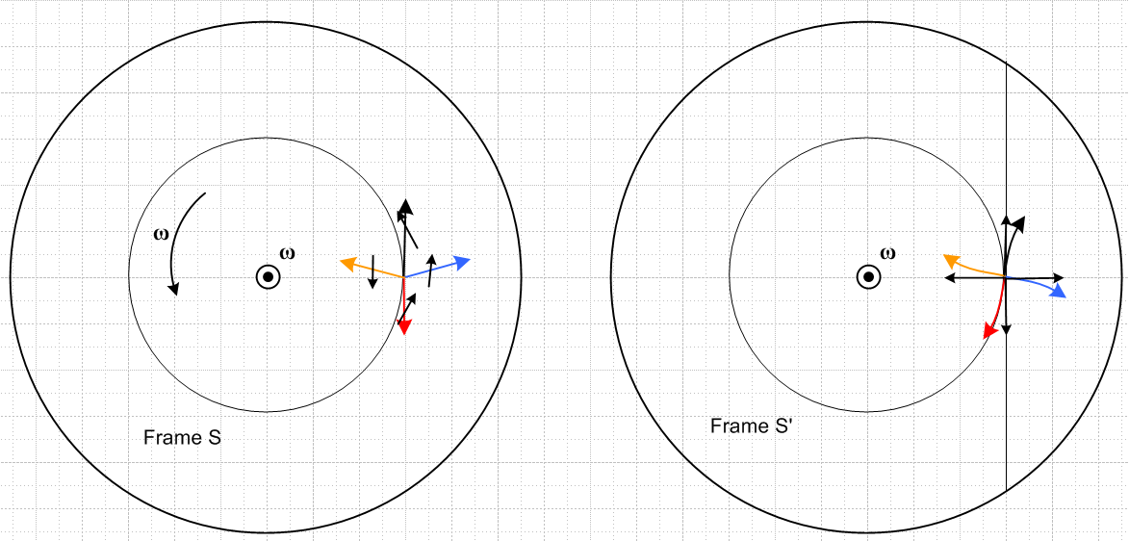

For the black projectile in mid flight, the turntable particles under the projectile are moving to the northwest relative to the projectile, so the projectile is seen to be drifting to the right. Hence the curved black trajectory path on the right.

For the red projectile in mid flight, the turntable particles under the projectile are moving to the northeast relative to the projectile, so the projectile is seen to be drifting to the left. Hence the curved red trajectory path on the right.

For the blue projectile in mid flight, the turntable particles under the projectile are moving to the north relative to the projectile, so the projectile is seen to be drifting south. Hence the curved blue trajectory path on the right.

For the orange projectile in mid flight, the turntable particles under the projectile are moving to the south relative to the projectile (these particles are at a smaller radius and move more slowly than vT), so the projectile is seen to be drifting to the north. Hence the curved orange trajectory path on the right.

Viewed from the direction of launch in Frame S', all four trajectories drift "to the right". This is in agreement with the right hand rule applied to our expression Fcor = -2m ω x v' = +2m v' x ω. What is not particularly obvious from the above discussion is that the | Fcor | is exactly the same for all four projectiles, and indeed for a projectile launched in any direction.

It the turntable were going CW instead of CCW, the drift directions would all be reversed, both by the qualitative argument, and by the Fcor expression. Projectiles would drift to the left instead of to the right.

One can regard our pictures as being of the Earth viewed from the North Pole. In this case, all the vectors are out of the plane of paper, but qualitatively the conclusion is the same: projectiles drift to the right. A view from the South Pole would of course then give drift to the left since then ω is reversed.

The drift picture on the right, when applied to air masses moving into a region of Low pressure, looks like this

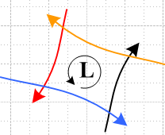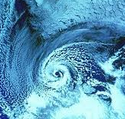

and explains why lower pressure regions are CCW cyclonic in the northern hemisphere. Since lows often drift to the east in the western US, warm Mexican air is felt prior to the low's arrival, and cool Canadian air is felt afterwards.

9. Translations into Marion (1970) and Marion & Thornton (M&T, 5th Ed 2004)

Marion and M&T both swap the primes on the frames relative to us, S ↔ S', which then includes r ↔ r'. The following notations are used ( us → Marion/M&T )

r' → r v → vf v' → vr b → R S → f = V
a → af a'→ ar S → f (9.1)

where subscript r means "rotating frame" and f means "fixed frame". Thus, Marion's and M&T's version of (8.2) reads ( = 0 in Marion but retained in M&T)

F = maS = mS + ma' + mω x (ω x r') + 2m ω x v' + m x r' (8.2)
F = maf = mf + mar + mω x (ω x r) + 2m ω x vr + m x r // Marion p 344 (11.17)
// M&T p 392 (10.23)

Note that for Marion r is a vector to the Particle from the rotating frame origin. Marion's version of our (8.2)approx is then

F = maS ≈ ma' + mω x (ω x r') + 2m ω x v' + m x r' (8.2)approx
F = maf ≈ mar + mω x (ω x r) + 2m ω x vr + m x r // Marion p 344 (11.18)

and finally his version of (8.4b)approx is

ma'S' = F'eff ≈ ma – mω x (ω x r') – 2m ω x v' – m x r' (8.4b)approx
mar = Feff ≈ maf – mω x (ω x r) – 2m ω x vr – m x r // Marion p 344 (11.19)

Meanwhile, translation of our (8.4a) is done this way

ma'S' = F'eff = F - mS – mω x (ω x r') – 2m ω x v' – m x r' (8.4a)
mar = Feff = F - mf – mω x (ω x r) – 2m ω x vr – m x r // M&T p 392 (10.25)

In terms of velocities, recall equation (6.6a) from above,

vS = v'S' + ω x r' + S (6.6a)

The Marion/M&T translation of this equation, using rules (8.7) above, is

vS = v' + ω x r' + S (6.6a)

vf = vr + ω x r + V // Marion p 344 (11.12)
// M&T p 392 (10.17)

10. Translations into Goldstein (1970) and Goldstein, Poole and Safko ( GPS, 3rd Ed 2001))

Goldstein is a bit of a conundrum and requires careful decoding.

(a) The meaning of r

Goldstein also has S↔S' including r↔r' relative to us. We know this because he says on page 135 that his r is a vector "from the origin of the terrestrial system to the given particle". Earlier he says "terrestrial measurements are usually made with respect to a coordinate system fixed in the earth, which therefore rotates uniformly with a constant angular velocity ω relative to the inertial system". Presumably "fixed in the earth" means "fixed on the surface of the earth". Therefore surely the vector he calls r is the one we call r'. This is consistent with a general S↔ S' swap and agrees with Marion's use of vector r. But mainly it is consistent with Goldstein's equations below.

(b) The meaning of as and ar (and of vs and vr)

Recall (7.4) from above

a'S = a' + x r' + 2 ω x v' + ω x (ω x r') (7.4)

Goldstein states the following equation (he has = 0 but we include the term anyway)

as = ar + x r + 2 ω x vr + ω x (ω x r) // Goldstein p 135 (4-105)
// GPS p 175 (4.89)

His subscript r means rotating (same as Marion), while subscript s means space (Marion's fixed system). Comparing our (7.4) to the Goldstein equation above tells us that

G us
r r'
vs v'S // added to this list since consistent with the as line following
as a'S
vr v'
ar a'

Goldstein uses the name vr just the way Marion does. However, for Marion

vf = v
af = a

so we must conclude that vf ≠ vs and af ≠ as. The only comment Goldstein gives (p 135) is that "vs and vr are the velocities of the particle relative to the space and rotating set of axes respectively." As we have seen, there are several kinds of "velocity" so this does not quite nail it down. Since Goldstein is thinking of doing things in terms a position vector from the terrestrial frame, it is not unreasonable to think that

Goldstein Us
vs = (dr/dt)space → (dr'/dt)S = v'S that is vs = v'S
vr = (dr/dt)rot → (dr'/dt)S' = v'S; that is vr = v'S'

in agreement with the small table above. So we conclude that these are the correct Goldstein translation rules

r' → r v'S → vs v'S' → vr
a'S → as a'S'→ ar (10.1)

In terms of the discussion in Section 1, Goldstein has chosen not to use the "natural" velocity and acceleration shown in (1.34) and (1.36).

Let's test them out. Consider our (6.8a) and its Goldstein translation

v'S = v' + ω x r' (6.8a)
vs = vr + ω x r // Goldstein p 135 (4-104)
// GPS p 175 (4.88)

So this is another piece of evidence confirming our interpretation. Notice that (6.8a) is just the G Rule for the vector r', and that is how Goldstein motivates the equation (but with his r).

(c) The hidden approximation is located

In his discussion on page 135 (1970) Goldstein says nothing at all about any approximations, although he does have in mind the specific Earth system. On page 135 he states "the equation of motion" in an equation with no number as

F = mas // Goldstein page 135, no number
// GPS p 175, no number

According to our translation rules, this says that F = ma'S . But the correct Newton's Law is

F = ma (8.1)

and according to our (7.5),

aS = a'S + S , (7.5)

Newton's Law really says

F = ma'S + mS
= mas + mS // Goldstein implied

We conclude that in writing F = mas, Goldstein has snuck in the approximation that S can be neglected. This is the same assumption Marion makes explicitly. So we interpret Goldstein's unnumbered equation as
F = mas + mS ≈ mas (10.2)

His remaining two equations can be obtained as follows. We go back to (8.4a)approx and translate it

ma' = F'eff ≈ F – mω x (ω x r') – 2m ω x v' – m x r' (8.4a)approx
mar = Feff = F – mω x (ω x r) – 2m ω x vr – m x r // Goldstein p 135 (4-106)
// GPS p 175 (4.90)

Next, combine (8.5) and (8.6)approx to get the first line, then translate for the 2nd line,

F'eff = F – mω x (ω x r') – 2m ω x v' – m x r' (8.6)approx + (8.5)
Feff = F – mω x (ω x r) – 2m ω x vr – m x r // Goldstein p 135 (4-107)
// GPS p 175 (4.91)

11. Determination of L(t) and (dL/dt)S

The notations used here are described in Section 1 (h). We set mass m = 1.

From (1.36) we have

L = r x v . (11.1)
= r x a (11.2)

L' = r' x v' . (11.3)
' = r' x a' (11.4)

In Sections 6 and 7 we found that

r = r' + b (6.1)
v = v' + ω x r' + S (6.6a)
a = a' + x r' + 2 ω x v' + ω x (ω x r') + S (7.6a)

Thus (11.1) and (11.2) can be written as

L = [r' + b] x [v' + ω x r' + S] .
= [r' + b] x [a' + x r' + 2 ω x v' + ω x (ω x r') + S]

We have now finished fulfilling the goal set out in Section 5, since we how have L and expressed in terms of frame S' objects.

12. Summary of the Original Problem Solution

We now summarize the results of Sections 6, 7, 8 and 11:

r, v, a position, natural velocity and natural acceleration in Frame S
r', v', a' position, natural velocity and natural acceleration in Frame S'
r = b + r' (6.1)

v = v' + ω x r' + S (6.6a)
v = v' + ω x r + S' (6.6c)

a = a' + x r' + 2 ω x v' + ω x (ω x r') + S (7.6a)
S S' Euler Coriolis centripetal frame

a = a' + x r + 2 ω x v' + ω x (ω x r) + 2ω x S' + S' (7.6b)

L = r x [v] where v = (6.6a) or (6.6c) above (11.4)
= r x [a] where a = (7.6a) or (7.6b) above (11.7)

For using fictional forces we have

F = ma // true Newton's Law in Frame S ` (8.1)
F'eff = ma' // fake Newton's Law in Frame S' (8.3)

F'eff = F + F'fict where, (8.5)
F'fict = – mS – mω x (ω x r') – 2m ω x v' – m x r' (8.6)
frame centrifugal Coriolis Euler

13. The Inverse Problem

Consider these two problems which concern the exact same physical situation:

Problem: given r', v', a', L' , ' find r, v, a, L, // summarized in Section 12

Inverse Problem: given r, v, a, L, find r', v', a', L'. '

We shall first compute the inverse equations "by brute force", then at the end show how they can also be obtained by a set of simple symmetry rules.

(a) Brute Force Method

The first equation (6.1) of the above summary is easily inverted

r = b + r' =>

r' = r - b (13.1)

The second equation (6.6a) can also be inverted easily :

v = v' + ω x r' + S =>

v' = v – ω x r' – S = v – ω x [r - b] – S (13.2a)

= v – ω x r + ω x b - S (13.2b)

= v – ω x r - S' (13.2c)

where (6.2a) was used in the last step

The third equation (7.6) requires a bit more effort. We first solve (7.6) for a'

a = a' + x r' + 2 ω x v' + ω x (ω x r') + S (7.6a)
so
a' = a – x r' – 2 ω x v' – ω x (ω x r') – S (13.3a)

Replace v' using (13.2a),

a' = a – x r' – 2 ω x [v – ω x r' – S] – ω x (ω x r') – S

= a – x r' – 2 ω x v + 2 ω x (ω x r') + 2 ω x S – ω x (ω x r') – S

= a – x r' – 2 ω x v + ω x (ω x r') + 2 ω x S – S (13.3b)

With r' = r – b we can regard the RHS of (13.3b) as being expressed entirely in terms of Frame S objects.

By shuffling terms in (7.10)

S' = S – x b – 2ω x S + ω x (ω x b) (7.10)

2ω x S –S = – x b + ω x (ω x b) – S'

we can replace the last two terms in (13.3b) to get

a' = a – x r' – 2 ω x v + ω x (ω x r') – x b + ω x (ω x b) – S'

= a – x r – 2 ω x v + ω x (ω x r) – S' (13.3c)

The inversion of the fourth equation (11.4) goes this way :

L' = r' x v' = [r - b] x [v – ω x r + ω x b - S] (13.4)

where the first of these the eight terms is r x v = L. Then, similar to (11.6)

' = 'S' = ∂S'L' = ∂S'(r' x v') = (∂S'r') x v' + r' x (∂S'v') = v' x v' + r' x a' = r' x a'
or
' = [r - b] x [a'] with a' = (13.3) (13.5)

Summary of the inverse problem results:

r' = r - b (13.1)
v' = v – ω x r – S' (13.2c)
v' = v – ω x r' – S (13.2a)
a' = a – x r – 2 ω x v + ω x (ω x r) – S' (13.3c)
a' = a – x r' – 2 ω x v + ω x (ω x r') + 2 ω x S – S (13.3b)

L' = r' x [v'] where v' from (13.2) (13.4)
' = r' x [a'] where a' from (13.3) (13.5)

(b) Swap Rules Method

Without any justification yet, let's postulate that we can obtain our inverse problem equations directly from the original problem equations (and vice versa) using this set of swap rules

r↔r' b ↔ -b ω ↔ -ω L ↔ L' (13.6)
v↔v' S ↔ - S' ↔ '
a ↔ a' S ↔ - S'

Later in section (d) we will justify this set of rules.
Since the inverse equations computed by brute force are sitting just above, let's apply these swap rules to them and see what we get:

r = r' + b (13.1)swapped
v = v' + ω x r' + S (13.2c)swapped
v = v' + ω x r + S' (13.2a)swapped
a = a' + x r' + 2 ω x v' + ω x (ω x r') + S (13.3c)swapped
a = a' + x r + 2 ω x v' + ω x (ω x r) + 2 ω x S' + S ' (13.3b)swapped

L = r x [v] where v from (13.2)swapped (13.4)swapped
= r x [a] where a from (13.3)swapped (13.5)swapped

And now we directly quote the summary from Section 12 above

r = b + r' (6.1)
v = v' + ω x r' + S (6.6a)
v = v' + ω x r + S' (6.6c)
a = a' + x r' + 2 ω x v' + ω x (ω x r') + S (7.6a)
a = a' + x r + 2 ω x v' + ω x (ω x r) + 2ω x S' + S' (7.6b)

L = r x [v] where v = (6.6a) or (6.6c) above (11.4)
= r x [a] where a = (7.6a) or (7.6b) above (11.7)

Since the last two sets of equations are identical, we have shown that the swap rules presented above do indeed convert either set of equations into the other,

original problem equations ← swap rules → inverse problem equations

(c) Development of the Fictitious Forces for the inverse problem

Here we assume that Frame S' is an inertial frame and that Frame S is the rotating frame, reversing the case considered earlier in Section 8. We shall mimic that discussion with the appropriate changes.

We start with (13.3c) which says

a' = a – x r – 2 ω x v + ω x (ω x r) – S' (13.7)
S' S Euler Coriolis centripetal frame

Newton's law in inertial frame S' says

F' = ma' (13.8)

with a' given as above in (13.7), so, reordering the 5 terms,

F' = ma' = – mS' + ma + mω x (ω x r) – 2m ω x v – m x r . (13.9)

Now suppose we imagine an "effective" version of Newton's Law that works in rotating frame S,

Feff = ma . (13.10)

Solving (13.9) for ma tells us that we will need to have (second line uses (13.8))

ma = Feff = F' + mS' – mω x (ω x r) + 2m ω x v + m x r (13.11a)
ma = Feff = ma' + mS – mω x (ω x r ) + 2m ω x v + m x r' (13.11b)

We can write (13.11a) as

Feff = F' + Ffict where, (13.12)
Ffict = + mS – mω x (ω x r) + 2m ω x v – m x r (13.13)
frame centrifugal Coriolis Euler

Here Ffict represents "fictitious forces" that "mysteriously" have to be added in Frame S to "true forces" F' (seen in inertial Frame S') to make our bogus (13.10) "Newton's Law" Feff = ma be valid.
All the above results could have been obtained directly from the original discussion using the swap rules (13.6), but it seems useful to just do it all in detail to be convinced.

(d) Summary of the Inverse Problem Equations

r', v', a' position, natural velocity and natural acceleration in Frame S'
r, v, a position, natural velocity and natural acceleration in Frame S
r' = r - b (13.1)

v' = v – ω x r – S' (13.2c)
v' = v – ω x r' – S (13.2a)

a' = a – x r – 2 ω x v + ω x (ω x r) – S' (13.3c)
S' S Euler Coriolis centripetal frame

a' = a – x r' – 2 ω x v + ω x (ω x r') + 2 ω x S – S (13.3b)

L' = r' x [v'] where v' from (13.2) (13.4)
' = r' x [a'] where a' from (13.3) (13.5)

For using fictional forces we have

F' = ma' // true Newton's Law in Frame S (13.8)
Feff = ma // fake Newton's Law in Frame S (13.10)

Feff = F' + Ffict where, (13.12)
Ffict = + mS – mω x (ω x r) + 2m ω x v – m x r (13.13)
frame centrifugal Coriolis Euler

(e) Why the Swap Rules Work

We shall do a series of transformations on our general rotation picture.

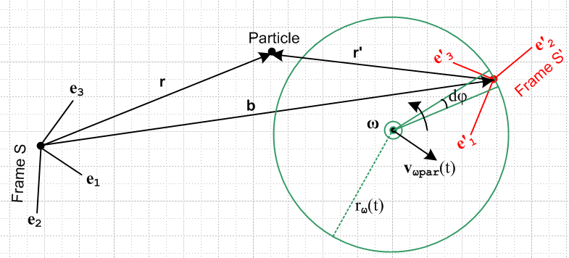

The above picture shows the situation with Frame S' doing instantaneous rotation about the ω rotation axis, and Frame S is fixed. In order to stop from S' from rotating, we must instantaneously rotate the above picture (3D space) at rate -ω about the rotation axis. Doing this gives

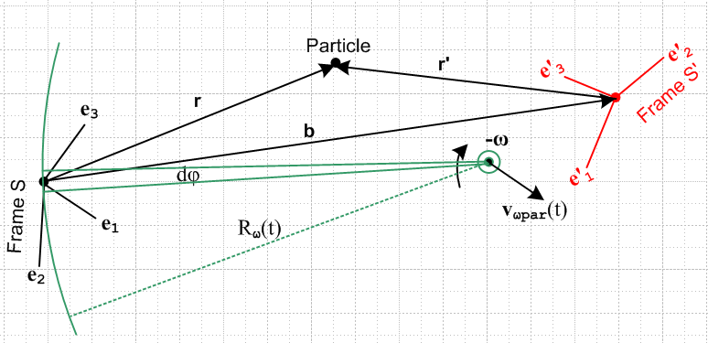

Frame S, which used to be fixed, is now doing instantaneous rotation at -ω about the same axis that Frame S' used to be rotating around.
Next we do two things at once: We first flip the b arrow changing b to -b, then we cosmetically just rotate the picture 180 degrees. This gives,

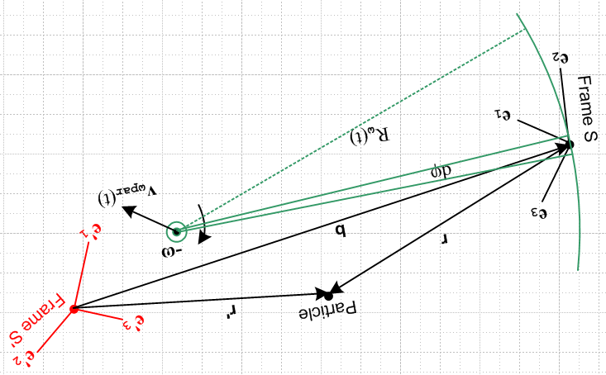

Next, we do a global S↔S' swap on everything (for example, ∂S ↔ ∂'S, r↔r' , e'n↔ en, etc) and at the same time we rotate the text so things are more readable

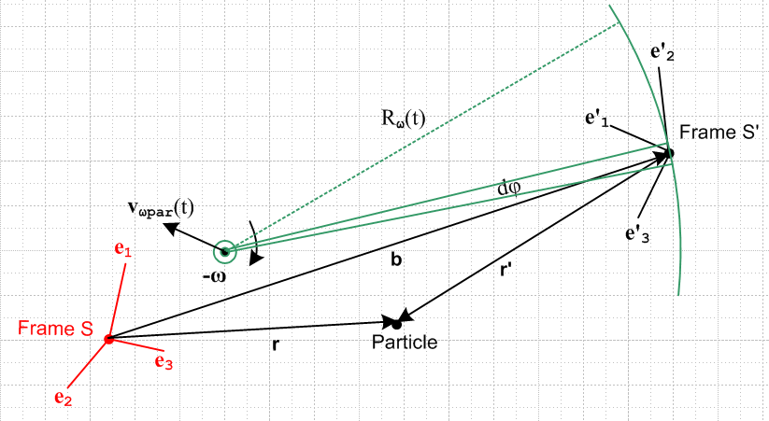

Since objects like Rω(t) and vωpart(t) don't appear in our equation sets, we just ignore them. As a final step, change the color of the two frames, AND make the change ω → -ω

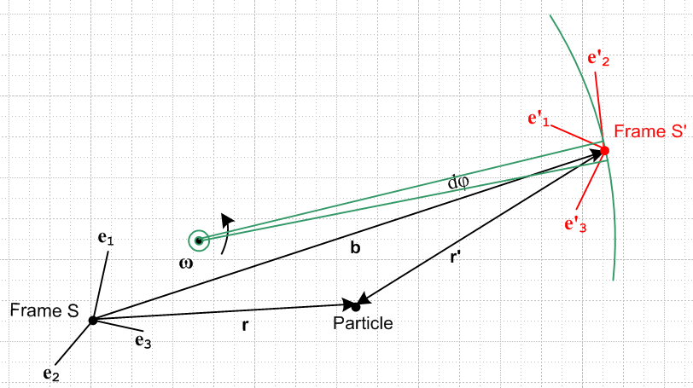

which we can them compare to the original picture

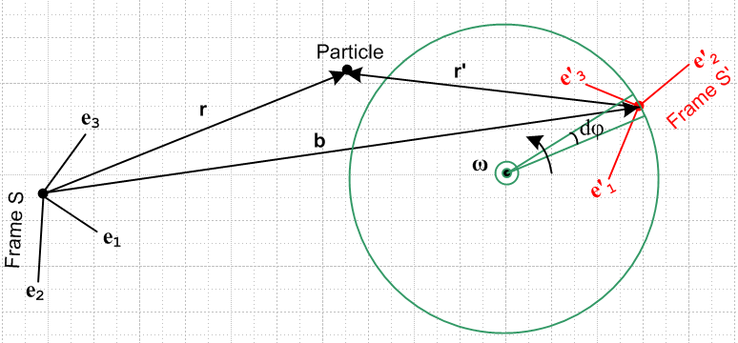

Apart from the fact that the two frames are oriented differently and the Particle is in a different position and the rotation radius and rotation axis are different, these two pictures are kinematically identical. We got from one to the other by doing these changes:

b→ -b S↔S' (and all that entails) ω→ -ω (13.14)

This then is why the "swap rules" (13.6) of the last section convert between the original problem equation set and the inverse problem equation set.

14. Rotating Frames in Curvilinear Coordinates

The solution equations to our Original Problem are summarized in Section 12 above, and those to the Inverse Problem are summarized in Section 13 (d).
All equations are stated in bolded vector notation. Such equations may be evaluated in any orthogonal coordinate system one wants. Any set of orthogonal curvilinear coordinates provides such an orthogonal coordinate system. In general the curvilinear basis vectors like , , for spherical coordinates "move" as the vector they describe moves, unlike the Cartesian basis vectors, but that is fine. For any particular vector, they form a viable set of orthogonal basis vectors.
In theory, we might want to use one curvilinear system of coordinates ξi with basis unit vectors i for frame S, and an entirely different system ξ'i with basis unit vectors 'i for frame S'. If V is an arbitrary vector, we then have these four expansions of interest :

V = Viei = (V)'ie'i = (V)i i = (V)'i 'i

where we use italics to denote curvilinear vector components (in spherical coordinates, e.g., 2 = ). It is common practice, once a curvilinear system is selected, to make these replacements

(V)i → Vξ$_{i}$ (V)'i → Vξ$_{i}$'

In cylindrical coordinates r,θ,z and r',θ',z' this would mean

(V)1 → Vr (V)'1 → Vr'
(V)2 → Vθ (V)'1 → Vθ'
(V)3 → Vz (V)'2 → Vz'

Consider now this equation taken from the Section 12 summary,

v = v' + ω x r + S' (6.6c)

We can view such an equation in any of our four bases, as just discussed above,

(v)i = (v')i + εijk(ω)j(r)k + (S')i components in basis ei
(v)'i = (v')'i + εijk(ω)'j(r)'k + (S')'i components in basis e'i
(v)i = (v')i + εijk(ω)j(r)k + (S')i components in basis i
(v)'i = (v')'i + εijk(ω)'j(r)'k + (S')'i components in basis 'i

For example, in r,θ,z cylindrical coordinates if we have ω = ω, then (ω)j = δj3ω so, in the third equation above

εijk(ω)j(r)k = εijk δj3 (r)k = ω εi3k(r)k = - ω εik3(r)k

Then the third line above becomes

(v)i = (v')i - ω εik3(r)k + (S')i components in basis i

(v)1 = (v')1 - ω ε123(r)2 + (S')i
(v)2 = (v')2 - ω ε213(r)1 + (S')2
(v)3 = (v')3 - ω ε3k3(r)k + (S')3 = (v')3 + (S')3

which translates into

vr = v'r - ω rθ + (S')r = v'r+ (S')r
vθ = (v'θ + ω rr + (S')θ = v'θ + ω r + (S')θ
vz = v'z + (S')z

But is such a component decomposition of v = v' + ω x r + S' useful in a rotating frames problem? At least for the equation shown above, the answer would seem to be no. The reason is that one might want to compute vr , but we have v'r on the right side, and such a component would probably never be a "given" in a frames problem. Rather, one would be given v'r'.

In practice, a better way to solve a rotating frames problem is to go ahead and use curvilinear basis vectors i and/or 'i if they are convenient, but to quickly get them expressed in terms of Cartesian basis vectors and then solve the problem basically with these Cartesian basis vectors. An example of so doing is presented in the next section.

14. Example of Ant crawling on a Turntable

(a) Problem Setup

Consider a turntable occupied by an ant :

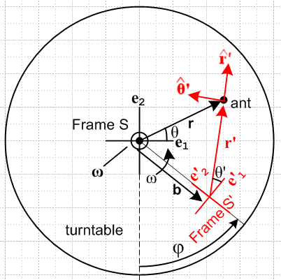

Suppose in the rotating frame S' the ant starts at some point and marches in a straight line at a constant velocity V toward the origin of Frame S'. What is r(t), v(t) and a(t) for the ant as seen in Frame S?

Since we might like to make Cartesian plots of the results, we choose Cartesian coordinates for Frame S. But the ant's motion is best expressed in cylindrical coordinates, so we choose cylindrical coordinates for Frame S'. Therefore,

ri = x,y,z for Frame S basis vectors ei = , ,
ξ'i = r',θ',z' for Frame S' basis vectors 'i = ' , ' , '

(b) What do we know about all the basis vectors?

From the picture one sees that, for the Cartesian unit vectors,

e'i = Rz(φ) ei for example e'1 = Rz(φ) e1

where φ is the instantaneous angle describing the orientation of Frame S' relative to Frame S.
The curvilinear unit vectors can be expressed in terms of the Cartesian ones as follows (stare at the picture)

'i = Rz(θ') e'i that is ' = Rz(θ') e'1 ' = Rz(θ') e'2 ' = Rz(θ') e'3 = e'3

The two rotation relations above can be combined to give

'i = Rz(θ') e'i = Rz(θ') [Rz(φ) ei] = Rz(θ'+ φ) ei .

Since we know that

Rz(ψ) = $\left(\begin{matrix}cosψ & -sinψ & 0 \\ sinψ & cosψ & 0 \\ 0 & 0 & 1\end{matrix}\right)$

we can write 'i = Rz(θ'+ φ) ei as

= $\left(\begin{matrix}cosψ & -sinψ & 0 \\ sinψ & cosψ & 0 \\ 0 & 0 & 1\end{matrix}\right)$$\left(\begin{matrix}e1 \\ e2 \\ e3\end{matrix}\right)$ ψ = θ'+φ
or
= $\left(\begin{matrix}cosψ & -sinψ & 0 \\ sinψ & cosψ & 0 \\ 0 & 0 & 1\end{matrix}\right)$ ψ = θ'+φ

and from the first line of the above, for example,

' = cos(θ'+φ) - sin(θ'+φ)
' = sin(θ'+φ) + cos(θ'+φ)

Similarly we can write e'i = Rz(φ) ei as

$\left(\begin{matrix}e'1 \\ e'2 \\ e'3\end{matrix}\right)$ = $\left(\begin{matrix}cosφ & -sinφ & 0 \\ sinφ & cosφ & 0 \\ 0 & 0 & 1\end{matrix}\right)$$\left(\begin{matrix}e1 \\ e2 \\ e3\end{matrix}\right)$

so for example

e'2 = sinφ e1 + cosφ e2 = sinφ + cosφ

(c) Solving the problem

Ant's Motion in Frame S'.

Assume the ant starts at some (r'0,θ'0) at t = 0 and then crawls at constant velocity V toward the S' origin,

v' = -V '.

We can integrate this within frame S' (where ' is fixed) to get

r'(t) = r'0 -Vt ' r'0 = r'0' = (r'0)x + (r'0)y = x'0 + y'0

The magnitude of r'(t) is given by

r' = r'0 - Vt

and we shall only be interested in times small enough so r' > 0. The angle θ' never changes, so

θ' = θ'0

Finally, since V = constant, the acceleration is

a' = 0

Thus, in line with our Original Problem statement, these are the given quantities in Frame S' ,

r' = r'0 – Vt '
v' = -V '
a' = 0 .

Our goal is to compute r, v and a as seen in Frame S.

Using (***), we can express v' in another way which will be used below,

v' = - Vcos(θ'+φ) - Vsin(θ'+φ)

Relation between Frame S and Frame S'

Assume at time t= 0 frame S' we have φ = φ0.

Assume the rotation follows some angular velocity profile ω = ω(t). Since ω = dφ/dt, we have

dφ/dt = ω(t) => φ(t) = φ0 + $^{\int_{0}^{t}{}}$ ω(τ)dτ .

So from now on, we assume that we know the quantity φ(t).

Motion of vector b.

From the picture we see that

b(t) = -b e'2 = -b [sinφ + cosφ ] = – bsinφ – b cosφ

Trajectory r(t) of the ant in Frame S

From our Section 12 summary (or just from looking at the picture)

r = b + r' (6.1)

Above we found that

b(t) = – bsinφ – b cosφ

' = cos(θ' + φ) - sin(θ' + φ)

r' = r' ' = r'cos(θ' + φ) - r'sin(θ' + φ)

Therefore

r(t) = [ – bsinφ – b cosφ ] + r'cos(θ'+φ) - r'sin(θ'+φ)

= [– bsinφ + r'cos(θ'+φ)] + [– b cosφ - r'sin(θ'+φ)]

Since r' = (r'0 - Vt) and θ' = θ'0 and φ = φ(t) as found by integrating ω(t). we get

r(t) = [– bsinφ +( r'0 - Vt)cos(θ'0+φ)] + [– b cosφ(t) - (r'0 - Vt) sin(θ'0+φ)]

= x + y
where
x = – bsinφ + ( r'0 – Vt)cos(θ'0+φ)
y = – bcosφ – (r'0 – Vt)sin(θ'0+φ)

This r(t) then is the trajectory of the ant in Frame S.

Velocity v(t) of the ant in Frame S

Since the turntable falls into our Special Case #1 pigeonhole of Section 4 (d) (ω through origin of Frame S), we know that S = ω x b and S' = 0 (vector b is soldered to the Frame S' unit vectors). From the summary in Section 12, we select (6.6c)

v = v' + ω x r + S' (6.6c)
which then says ( setting S' = 0)

v = v' + ω x r .

From above we have

v' = -V cos(θ'+φ) +V sin(θ'+φ)

ω x r = [ω] x [x + y ] = ωx – ωy

Therefore,

v = -V cos(θ'+φ) +V sin(θ'+φ) + ωx – ωy

= [-V cos(θ'+φ) – ωy ] + [V sin(θ'+φ) + ωx]

= [-V cos(θ'+φ) – ω{ – bcosφ – (r'0 – Vt)sin(θ'0+φ)} ]
+ [ V sin(θ'+φ) + ω{– bsinφ + ( r'0 – Vt)cos(θ'0+φ)}]

= [-V cos(θ'+φ) + ωbcosφ + ω (r'0 – Vt)sin(θ'0+φ) ]
+ [ V sin(θ'+φ) – ωbsinφ + ω( r'0 – Vt)cos(θ'0+φ)]

= vx + vy

where

vx = -V cos(θ'+φ) + ωbcosφ + ω (r'0 – Vt)sin(θ'0+φ)
vy = V sin(θ'+φ) – ωbsinφ + ω( r'0 – Vt)cos(θ'0+φ)

Acceleration a(t) of the ant in Frame S

From the summary in Section 12 we start with

a = a' + x r + 2 ω x v' + ω x (ω x r) + 2ω x S' + S' (7.6b)

but in this Special Case #1 problem we have S' = 0 and S' = 0 so

a = a' + x r + 2 ω x v' + ω x (ω x r)

We shall ponder the terms one at a time.

Since v' = -V ' with V a constant, we have a' = ∂S'v' = 0.

Our turntable is restricted to have = so similar to *** above we find

x r = x – y

Next, again similar to ***

ω x v' = [ω] x [vx + vy ] = ω vx – ω vy

The last term is

ω x (ω x r) = [ω] x [ωx – ωy] = -ω2x + ω2y // = -ω2 r, centripetal acceleration

Combining all the terms then gives

a = a' + x r + 2 ω x v' + ω x (ω x r)

= 0 + x – y + 2ω vx – 2ω vy -ω2x + ω2y

= [– y– 2ω vy -ω2x] + [x+ 2ω vx+ ω2y]

= ax + ay

where

ax = – y– 2ω vy -ω2x
ay = x+ 2ω vx+ ω2y

where

vx = -V cos(θ'+φ) + ωbcosφ + ω (r'0 – Vt)sin(θ'0+φ)
vy = V sin(θ'+φ) – ωbsinφ + ω( r'0 – Vt)cos(θ'0+φ)

and

x = – bsinφ + ( r'0 – Vt)cos(θ'0+φ)]
y = – bcosφ – (r'0 – Vt)sin(θ'0+φ)

Were we to insert these last four expressions in ***, each acceleration component would have 7 terms.

(d) A special case of the ant problem: ω = constant, b = 0

In this case Frame S' is also centered at the turntable spindle and the ant is crawling in Frame S' toward the spindle.

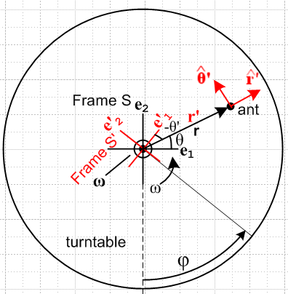

The Ant's Motion in Frame S' is the same as in the more general case.
The φ(t) function is given now by

φ(t) = φ0 + ωt

The trajectory of the ant in Frame S is given by the result above with b = 0,

r(t) = x + y where
x = + ( r'0 – Vt)cos(θ'0+φ)
y = – (r'0 – Vt)sin(θ'0+φ)

The ant's velocity in Frame S is given by

v = vx + vy where
vx = -V cos(θ'+φ) + ω (r'0 – Vt)sin(θ'0+φ)
vy = V sin(θ'+φ) + ω( r'0 – Vt)cos(θ'0+φ)

The ant's acceleration in Frame S is given by (since = 0)

a = ax + ay where
ax = 2ω vy -ω2x
ay = 2ω vx+ ω2y

and where x,y,vx and vy are as stated above.

Suppose now that φ0 = 0 (so Frame S' lines up with Frame S at t=0).
Suppose also that the ant starts at a point to the right of the spindle, so θ'0 = 0 at disance a distance r'0= R.
The trajectory in this case becomes

r(t) = x + y where
x = + ( R – Vt)cos(ωt)
y = – (R – Vt)sin(ωt)

We found above that

ω x r = ωx – ωy

and therefore

ω x (ω x r)

**********************************************************************************

Example 1: Referring to Fig 1, suppose a Particle floats at rest at the origin of inertial Frame S. This means that we have r = 0, v = 0, a = 0, L = 0. What does an Observer within Frame S' see? The results are quite simple :

r' = - b
v' = 0
a' = 0
L' = 0
(dL'/dt)S' = 0

In Frame S'. the Particle appears at location r' = -b and just sits there doing nothing as S' rotates. In Figure 1, Frame S' including the b vector rotates around the Frame S origin.

Example 2: Referring to Fig 1, suppose a Particle floats at rest at some point r = r0 in inertial Frame S. This means that we have r = r0, v = 0, a = 0, L = 0. What does an Observer within Frame S' see?

r = r0 // in this example, these things are always the same.

r' = r0 - b // says r'(t) describes a circular motion which seems right.

v' = - ω x r0 // this seems wrong since it says v' = constant
a' = ω x (ω x r0) – x r0

L' = – r0 x b – r0 x (ω x r0)

(dL'/dt)S' = – ω x (r0 x v') – r0 x ( x r0) – b x a'

How can the Particle go in a circular motion in Frame S' and have a constant velocity??? Save for the next day. Must be something simple I hope. Could the whole inverse concept be wrong?

Issue # 1: The Particle really does have the constant velocity direction shown as v' = - ω x r

First, here is a picture showing Frame S' on our phono record at some time.

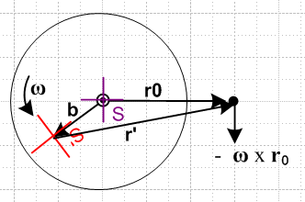

At some slightly later time, red frame S' is in a slightly new position. Here I draw these two adjacent positions and the fixed Particle dot

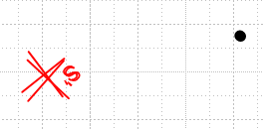

Now I take the second position and the dot and group them together, and then I rotate that group until the two red frames align,

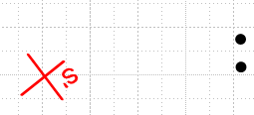

You see that the black dot has in fact moved in the -ω x r0 direction as the formula predicts. This will be true for any pair of adjacent red S' positions you pick around the circle. Let's repeat the experiment starting here:

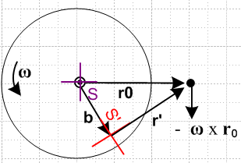

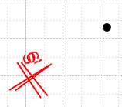 => 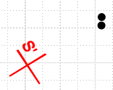

and we get the same result.

Issue # 2: Paths of the Particle.

After several hours, I am having a LOT of trouble with two simple questions:

(1) what does the path of the particle look like in Frame S ?
(2) what does the path of the particle look like in Frame S' ?

Next day: Phrases are not always clear. Question (1) could mean what is r in frame S, or it could mean what is r' in frame S. Here I will compute both of these:

(1a) Path of particle r in frame S

r (in frame S) = r0 = constant since r = riei = roe1 // case closed on this one!

(1b) Path of particle r in frame S'

Now from just-made doc "a simple theorem about basis vectors.doc" (phys/QM/ang mom) we know

e'n = Rz(φ)en => $\left(\begin{matrix}e'1 \\ e'2\end{matrix}\right)$ = Rz(-φ)$\left(\begin{matrix}e1 \\ e2\end{matrix}\right)$ => e'n = R-1(φ)nm em
or
e'1 = cosφ e1 + sinφ e2
e'2 = - sinφ e1 + cosφ e2

Therefore expand r in frame S'

r = r'ne'n where r'n = r • e'n so that

r'1 = x' = r • (cosφ e1 + sinφ e2) = roe1 • (cosφ e1 + sinφ e2) = rocosφ
r'2 = y' = r • (-sinφ e1 + cosφ e2) = roe1 • ( -sinφ e1 + cosφ e2) = - rosinφ

So we seem to get

x' = rocosφ = r'1
y'= - rosinφ = r'2

This shows that the path of r in frame S' is a circle as shown on the right below,

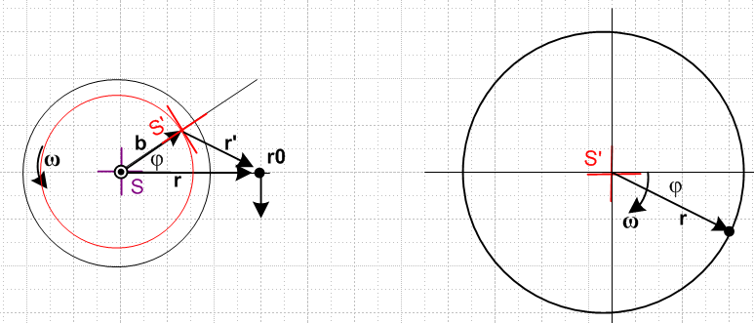

You can see that the two pictures "agree". On the right of course the tail of r has been pinned to the frame S' origin. On the right in frame S' the vector r rotations CW, whereas on the left frame S' rotates CCW.

Comment: Since r = r0 always, the picture on the right shows that r0 is NOT a constant vector when viewed from frame S'. It rotates! So when I had v' = - ω x r0 and was worried that this seemed odd since the RHS is a constant, well, RHS is NOT a constant viewed from frame S'.

(2a) Path of particle r' in frame S

We now that r = b + r' and therefore

r' = r - b

The Frame S components of both sides are

(r')i = (r)i - (b)i

But we know from (1a) that r = roe1

(r)i = roδi,1

And we know that b = bR(φ)e1 so (b)i = bRij(e1)j = bRi1

(r')i = roδi,1 - bRi1

Write these out explicitly to get

(r')1 = r0 - R11 = r0 - bcosφ
(r')2 = 0 - R21 = - bsinφ

which says for r' = (r')iei = xiei for a graph

x = r0 - bcosφ
y = - bsinφ

Here is a picture of this situation

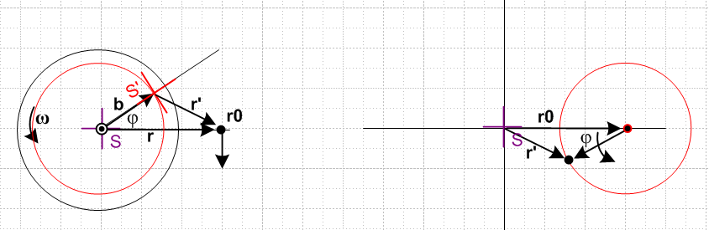

Again the figures make sense. The vector r' always points to the right in frame S.

(2a) Path of particle r' in frame S'

The expansion here may be taken as

r' = (r')'ie'i where (r')'i = r' • e'i

so we have

(r')'i = r' • e'i = (r - b) • e'i = r • e'i - b • e'i = (r)'i - (b)'i

Now we compute from above

b = bR(φ)e1 = bR(φ) R-1(φ) e'1 = b e'1

and this agrees with the picture notion that from frame S', b always points to the right. Thus

b • e'i = b e'1• e'i = b δ1,i = (b)'i

And we found earlier that

x' = rocosφ = (r)'1
y'= - rosinφ = (r)'2

Therefore we find that

(r')'1 = (r)'1 - (b)'1 = rocosφ - b
(r')'2 = (r)'2 - (b)'2 = - rosinφ

or for purposes of plotting

x' = rocosφ - b
y' = - rosinφ

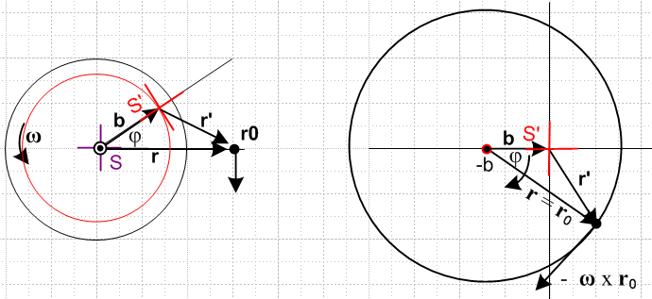

and again (finally!) the picture makes sense. Note that ω points out of the plane of paper in all pictures.

Comment: The picture on the right shows what the vectors r and r' look like viewed from Frame S'.

Now we can face this question: How can we have v' always pointing down in frame S, v' = - ω x r0,

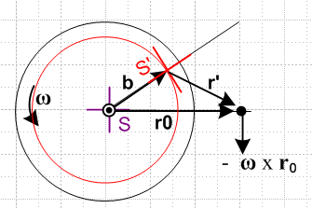

while at the same time the particle goes around in a circle. We need to ponder the meaning of v' a bit:

v' = - ω x r0

If we look at this in frame S', the useful picture is the big circle on the right above, and in that picture you see that the vector - ω x r0 is in a perfectly reasonable direction to be the velocity of the particle going around in a circle. Looking at vector v' in Frame S is a "cross" view that is not very convenient.
Now here is perhaps the confusing picture. We had this picture showing r' in frame S

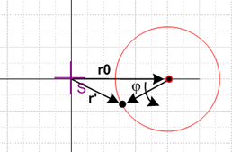

The thing that appears to be a velocity in this picture is really (dr'/dt)S and this is not
the same as v' = (dr'/dt)S' and the difference is the G rule term! So if you want to have position and velocity "make sense", you need to plot them both in their natural frames, and that is what the large circle picture on the right above is doing.

***************************************************************

(2a) Vector r' as seen in frame S'

Now from just-made doc "a simple theorem about basis vectors.doc" (phys/QM/ang mom) we know

e'n = Rz(φ)en => $\left(\begin{matrix}e'1 \\ e'2\end{matrix}\right)$ = Rz(-φ)$\left(\begin{matrix}e1 \\ e2\end{matrix}\right)$ => e'n = R-1(φ)nm em
or
e'1 = cosφ e1 + sinφ e2
e'2 = - sinφ e1 + cosφ e2

Therefore expand r' in frame S'

r' = (r')'ne'n where (r')'n = r' • e'n so that

(r')'1 = r' • e'1 = (r0 - b) • e'1 = r0 • e'1 – b • e'1 = (r0e1) • e'1 - b
= (r0e1) • (cosφ e1 + sinφ e2) - b = r0cosφ - b

(r')'2 = r' • e'2 = (r0 - b) • e'2 = r0 • e'2 – b • e'2 = (r0e1) • e'2
= (r0e1) • (-sinφ e1 + cosφ e2) - b = - rosinφ

So we end up then with

(r')'1 = - b + r0cosφ
(r')'2 = - rosinφ

And here is the picture

and again the picture makes sense. Note that ω points out of the plane of paper in all pictures. This picture on the right shows BOTH the vector r' as seen in S', and the vector r as seen in S'. I am totally happy with how these two pictures show the same thing for both these vectors.

(1b) Path of particle r in frame S'

Since r' = r0 - b and r = r0 we write r' = r - b and then r = r' + b . That means, evaluating on the e'i

(r)'i = (r')'i + (b)'i

and we just look at the two cases

(r)'1 = (r')'1 + (b)'1 = - b + r0cosφ + b = r0cosφ

(r)'2 = (r')'2 + (b)'2 = - rosinφ + 0 = -r0sinφ

=> r = (r0cosφ)e'1 + (-r0sinφ) e'2

This continues to bother me. Does the picture on the right really show r as viewed from S' ? It shows the orientation of r correctly, it just does not show the tail position correctly.
Well go back to the starting point which is r = r' + b . If have r' as shown on the right side of the previous picture, and if we add b to every point on that locus, we get the locus shown here for r, there is no avoiding this fact. We also then have r = (r)'ie'i which means tail at origin.
Start once again with r = r' + b . If we expand each vector like so:

(r)'ie'i = (r')'ie'i + (b)'ie'i

then we conclude that

(r)'i = (r')'i + (b)'i

So we have already put r = (r)'ie'i into the stew which means we have already put r tail at origin.
Instead of doing this, start again with r = r' + b . We found the trajectory of r' assuming its tail is at the S' origin, Then notice that this picture shows r = r' + b so this then gives the path of r without putting the tail of r at the origin.

