When is the Goldstein Rule Valid?

1. The Disproof for v 1
2. When is a Goldstein Rule for some vector V valid? 2
3. Velocity: a place we expect the Goldstein Rule to NOT be valid 3
4. Angular Momentum: a place we expect the Goldstein Rule to NOT be valid 3
5. The Big Mystery Remains 6
6. A possible explanation A 7
7. The Disproof for L 7
7. Another possible explanation B 8
8. Another possible explanation C 8
9. Search the web for validation of this last statement of The Rule 9
10. Assume the G Rule is only meaningful in Cartesian coordinates. Then what? 13

1. The Disproof for v

If the rule did apply to velocity v, we would have

dv/dt = ω x v + dvbody/dt where ω = dφ/dt . (1)

Let's start with what we know IS true,

dr/dt = ω x r + R (dr'body /dt) .

Let's differentiate this thing directly to get

dv/dt = ω x v + x r + (dR/dt) (dr'body /dt) + R(d2r'body /dt2) .

This HAS to be correct. Write as

dv/dt = ω x v + x r + (dR/dt) v'body + R (dv'body/dt) .

Now, concerning (dR/dt), my tenp3 v4 does this for a general R and concludes

(dR/dt)V = ω x (RV) .

Since I have done the above many times, I think it is right. Then we have

dv/dt = ω x v + x r + ω x (R v'body) + R (dv'body/dt) .

Now if we compare this to the so-called Goldstein rule (1) above,

dv/dt = ω x v + dvbody/dt

We would have to conclude that the following is true:

dvbody/dt = x r + ω x (R v'body) + R (dv'body/dt)

But this makes no sense whatsoever. I had been hoping that this would be true

dvbody/dt = R (dv'body/dt) // was hoping

dvbody = R dv'body // was hoping

but obviously neither of these things is true, even when = 0!!
This concludes my "disproof" of this rule.

2. When is a Goldstein Rule for some vector V valid?

The key requirement, I think, is that V must transform as a true vector, which means in our current convention,

V = RV' (1)

which agrees with equation (2) of temp3 v4 section 4. I will now try to reproduce the derivation here in my "current" notation which is to not put any square brackets around things.
If dφ is the instantaneous axis of rotation of frame S' relative to frame S, we can consider the vector V

V(t+dt) = R(dφ)V(t) = [R(dφ) R] V' // (1) used here !

dV = V(t+dt) - V(t) = [R(dφ) R] V' - RV' = R(dφ)V - V = [ R(dφ) - 1] V =>

dV = - i (dφ • J) V (2)

dV = dφ x V (3)

This is how much vector V moves in frame S if it is frozen in frame S' . If we then allow a simultaneous movement in frame S', we get the famous result

dV = dφ x V + dVbody (4)

and now the cat is in the bag. Now dVbody is the amount V changes in frame S due to its "body" change in frame S' ! So we can write

dVbody = R dV'body (5)

Now divide (4) and (5) by dt to get

dV/dt = ω x V + dVbody/dt (6)

(dVbody/dt ) = R (dV'body/dt) (7)

Equation (6) is our Goldstein Rule, which we have now just derived. And (7) is the statement that the object (dV'body/dt) transforms as a vector, just as V transformed as a vector.

Reminder: In this derivation of the Goldstein Rule, it is absolutely crucial that V transform as a vector, otherwise the rule is not true.

3. Velocity: a place we expect the Goldstein Rule to NOT be valid

Suppose we have, for some position vector r,

r = R(t)r'

Since r transforms as a vector, the Goldstein Rule applies to r. Now take the derivative to get velocity v

dr/dt = dt(R(t)r') = (dR/dt) r' + R (dr'/dt) .

Now recall our general rule

(dR/dt)V = ω x (RV) => (dR/dt) r' = ω x (Rr') = ω x r

so the previous equation becomes

dr/dt = ω x r + R (dr'/dt)

v = R v' + ω x r

Notice that in the last equation we do NOT have v = R v' . Therefore, velocity v does NOT transform as a vector under time-dependent R. Therefore, the Goldstein Rule will be invalid for v. Case Closed! In my phono attempts to verify the Goldstein Rule for v, it keeps not working. This is why.

4. Angular Momentum: a place we expect the Goldstein Rule to NOT be valid

Method 1

Consider angular momentum. Since mass m is a common factor in every term, let's just set m = 1 at the start to reduce clutter. Then

L = r x p = r x v Li = εijkrjvk

L' = r' x p' = r' x v' L'i = εijkr'jv'k

Does L transform as a vector or not?

We know from the previous section that

r = Rr' rj = Rjar'a

v = R v' + ω x r vk = Rkbv'b + εkcdωcrd

Let's first compute RL' as follows

L'i = εijkr'jv'k

L's = εsjkr'jv'k

[RL']i = Ris L's = Ris εsjkr'jv'k // RL' = R (r' x v' ) (**)

Now compute L as follows, using the above expressions for rj and vk ,

Li = εijkrjvk = εijk Rjar'a (Rkbv'b + εkcdωcrd)

= εijk Rjar'a Rkbv'b + εijk Rjar'a εkcdωcrd (*)

Now a little side track. In tensor doc App D (f) I show that

ε'abc.. = J [ Raa' Rbb'.... εa'b'c'..]

First, when N = 3, this says

ε'abc = J Raa' Rbb' Rcc'εa'b'c']

Second, when R is a rotation, we have J = 1 and then ε'abc = εabc from section (g). Then

εabc = Raa' Rbb' Rcc'εa'b'c'

Now multiply both sides by Rad and sum on a

Rad εabc = Rad Raa' Rbb' Rcc'εa'b'c' = Rbb' Rcc'εdb'c'

Now convert to dev notation to get

εabcRad = εdb'c' Rbb' Rcc'

This is a rather obscure property of the rotation matrices which I think I have written down elsewhere. Now change to caps

εABCRAD = εDB'C' RBB' RCC'

Since this is true for any R, it must be true for R-1 = RT so rewrite as

εABCRDA = εDB'C' RB'B RC'C

Now try to fit this with what appears above which is εijk RjaRkb .

εAabRiA = εijk Rja Rkb

Resume. We may now rewrite (*) as follows

Li = εijk Rjar'a Rkbv'b + εijk Rjar'a εkcdωcrd

= εAabRiAr'av'b+ εijk Rjar'a εkcdωcrd

Now let's make some changes in this first term's symbols

Risεsjkr'jv'k

Comparison with (**) above shows that this last object is in fact [RL']i so we now have

Li = [RL']i + εijk Rjar'a εkcdωcrd

We now write out this second term in more detail

εijkεkcd Rjar'aωcrd

= εijkRjar'aεkcdωcrd

= εijkRjar'a[ω x r]k

= εijk(Rr')j[ω x r]k

= εijk(r)j[ω x r]k

= (r x [ ω x r ])i

So I think in this painful way I have shown that

L = RL' + r x ( ω x r )

Now let's try to show this directly in vector notation:

Method 2

Consider angular momentum. Since mass m is a common factor in every term, let's just set m = 1 at the start to reduce clutter. Then

L = r x p = r x v

L' = r' x p' = r' x v'

Does L transform as a vector or not?

We know from the previous section that

r = Rr'

v = R v' + ω x r

Therefore

R L' = R [r' x v'] = [Rr'] x [Rv'] = r x [ v - ω x r ] = r x v - r x (ω x r)

= L - r x (ω x r)

and therefore

L = R L' + r x (ω x r)

and there it is. The key fact here is this theorem for rotation matrices R

R (a x b) = (Ra) x (Rb)

which requires only that R be a rotation matrix, it does NOT require that a and/or b transform as vectors.
Now, in the above work we had m = 1 so all L's are really L/m so we really have

L = R L' + m r x (ω x r)

5. The Big Mystery Remains

I have shown that we don't have L = R L' and therefore the Goldstein Rule should not apply for L. Yet on page 158, Goldstein applies the rule to L ! G is talking in the context of a rotating rigid body. Think of this as a 3D phono record rotating as I have it going. Then r would be some 3D point in space, and in general we are NOT going to have r x (ω x r) = 0. In fact

r x (r x ω) = (r•ω)r - r2ω

This "mystery" has been alive and well for at least two weeks now. See paradox doc for more details, Marion does the same thing. s

6. A possible explanation A

Suppose L is the angular momentum of a rigid body which is rotating at instantaneous ω on an axis which passes through the center of mass. Then the "extra term" above would be this

E = m r x (ω x r) → Σ mi ri x (ω x ri)

Suppose as a simple example our rigid body consists of two points of mass m, one at r, one at -r. We have two ants diametrically opposed on our turntable. Then

E = m r x (ω x r) + m (-r) x (ω x (-r)) = 2 m r x (ω x r)

So wrong, this situation does NOT make the extra term vanish.

7. The Disproof for L

If the rule did apply to velocity L, we would have

dL/dt = ω x L + dLbody/dt where ω = dφ/dt . (1)

Let's start with what we know IS true,

dr/dt = ω x r + Rv'body .

dv/dt = ω x v + x r + ω x (R v'body) + R (dv'body/dt)

Then we can compute

dL/dt = m dt(r x v) = m v x v + m r x dv/dt = m r x dv/dt

= m r x [ω x v + x r + ω x (R v'body) + R (dv'body/dt)] (*)

Now,

A x (B x C) + B x (C x A) + C x (A x B) = 0

r x (ω x v) + ω x (v x r) + v x (r x ω) = 0

Then our first term in (*) is

m r x (ω x v) = - mω x (v x r) - mv x (r x ω)

= mω x (r x v) - mv x (r x ω) = ω x L - mv x (r x ω)

We then have

dL/dt = ω x L - mv x (r x ω) + m r x( x r) + m r x [R (dv'body/dt)]

If we compare this with our reputed Goldstein Rule for L, which is

dL/dt = ω x L + dLbody/dt

Then we must have

dLbody/dt = - mv x (r x ω) + m r x( x r) + m r x [R (dv'body/dt)]

but I see no logic to this whatsoever. We should in fact have

dLbody/dt = R dL'body/dt

L'body = m r' x v'body

dL'body/dt = m r' x (v'body/dt)

R dL'body/dt = m R { r' x (v'body/dt) } = m r x R (dv'body/dt)

so we have all that extra stuff - mv x (r x ω) + m r x( x r) .

7. Another possible explanation B

Maybe I just don't understand the meaning of (d/dt)body and (d/dt)space . I will come back to this soon.

8. Another possible explanation C

Maybe this is the correct statement of the Goldstein Rule:

• Let V be any vector that transforms as a vector between a pair of static rotated frames. This would certainly include r, v and L .

• Let frame S' be some frame attached to the rotating body.

• Let frame S be a frame at rest which is instantaneously aligned with frame S' at t = t.

• Assume that frame S' is, at time t, rotating at some vector rate ω = dφ/dt with respect to frame S.

• The vector V has exactly the same components in frame S as in frame S' at time t since the two frames are lined up. So there is no need for any object called V'.

• Suppose the rotation were stopped and that, due to some ongoing process within the body frame, our vector underwent some change dV. This would also be dV in the space frame.

• But now if we turn on the rotation and suppose we have this same change dV within the body frame. We will then have a different change in the space frame due to the rotational motion. We will have

dVspace = dVbody + dφ x V

In this equation, since frames are lined up, the following are all the same

V = Vbody = Vspace

so we don't need to put a label on this V.

• I think the Rule as defined here differs from the Rule I have been using because I was not using the notion of instantaneous alignment of the two frames, and maybe this will explain my mysteries.

9. Search the web for validation of this last statement of The Rule

What do I search for, what search handle? I don't want a sound byte, I want something with lots of words on this specific subject.

• Here is a derivation which does not seem to require alignment of the axes. Author uses my same sense of primed and unprimed.

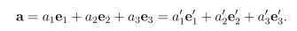

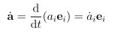

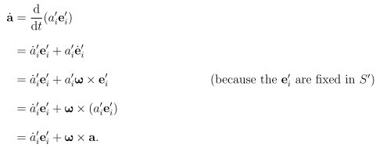

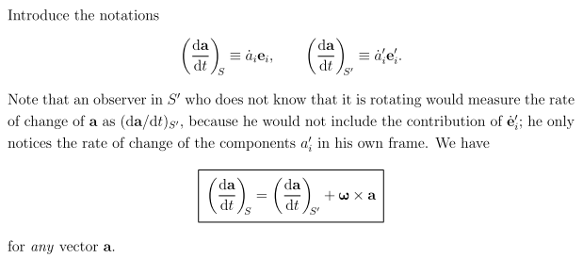

Comments?

1. Notice the crucial step where the comment lies

'i = ω x e'i
or
de'i/dt = ω x e'i

What this really says is this

e'i(t+dt) = R(dφ) e'i

e'i(t+dt) - e'i(t) = [R(dφ)- 1] e'i = -i dφ • J e'i

de'i/dt = -i ω • J e'i = ω x e'i

2. This derivation makes no assumption about S and S' frames being lined up. No connection is ever made between the two sets of basis vectors. I conclude that the frames need not be lined up.

3. In the ω x a term, there is no ambiguity about a. It can be expanded on either basis as he does.

4. Does the above derivation apply say to spherical coordinate basis vectors? It does not seem to matter what kind of basis vectors you use? Go back to the above where he has written

de'i/dt = ω x e'i ω = dφ/dt

Let's review how we know this is true. The claim is

de'i = dφ x e'i

What I do know is true is that

de'i = [R(dφ) - 1] e'i = -i dφ • J e'i = dφ x e'i by the usual "theorem".

Now a question: Is this true if the e's represent curvilinear coordinate unit vectors? I suspect the answer is no! In the above, de'i is supposed to be the total change in e'i, as seen in frame S, in time dt. But if e'i is a curvilinear unit vector, then it might change as well for another reason: The vector of interest V might change in frame S' and this causes an extra de'i contribution. Perhaps then

de'i = dφ x e'i + de'i(body)

For example, we might get

d' = dφ x ' + (d'/dt) dt = dφ x ' + ' ' dt = dφ x ' + dθ' '
d' = dφ x ' – dθ''

Write these again and stare at them

d' = dφ x ' + dθ' '
d' = dφ x ' – dθ' '

Then start that proof again:

= dt[ ar+ aθ ] = r + θ + ar d/dt+ aθ d/dt

= r + θ + ar – aθ = (da/dt)S

= dt[ a'r'+ a'θ']

= 'r' + 'θ' + a'r[ω x ' + ' '] + a'θ[ω x ' – ' ']

Now maybe we would jump into frame S' and claim that

(da/dt)S' = 'r' + 'θ' + a'r ' ' – a'θ ' '

And then we seem to get

(da/dt)S = (da/dt)S' + a'r[ω x ' + a'θ[ω x ']

= (da/dt)S' + [ω x a'r ' + [ω x a'θ ']

= (da/dt)S' + ω x [a'r ' + a'θ ']

= (da/dt)S' + ω x a

and we get the same answer although the derivation is different.

Conclusions on this web scan and work above:

(1) We do NOT assume that frames S and S' are lined up, so my section 8 above is wrong.

(2) The Rule is valid if everything is in polar coordinates as I have done.

Therefore, my "mystery" continues unabated. Maybe I need to ponder the computation of (da/dt)S' .
Compare:

(da/dt)S = ω x a + (da/dt)S'

da/dt = ω x a + dabody/dt

Let's track again through the v case, but in the proper notation

dv/dt = ω x v + (dv/dt)S'

How do you compute this last term object? One way is this

v = v'r'+ v'θ'

Question How do you draw in a picture the following equation

v = vr+ vθ

Answer:

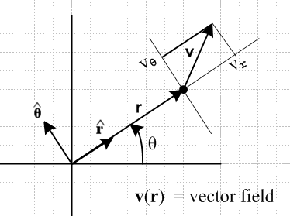

You have to realize that v is a vector field over space to draw this picture.

What is the corresponding picture in frame S' ? This is immensely confusing (par for the 2 week course). Suppose we draw this:

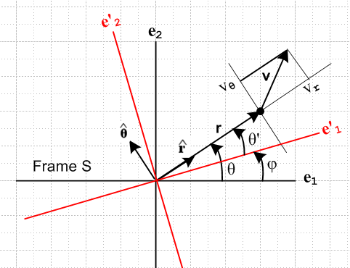

The four vectors , , r and v all have different coordinates in the two frames. So it would seem that

v = vr + vθ

is all you can write. There are no primed things. This makes no sense at all:

v = v'r' + v'θ'

and therefore my polar coordinate derivation above makes no sense at all.

10. Assume the G Rule is only meaningful in Cartesian coordinates. Then what?

Imagine then for velocity v we have

(dv/dt)S= ω x v + (dv/dt)S'

v = viei = v'ie'i // Cartesian

Now make these definitions

= (x/r)e1 + (y/r) e2

= Rz(π/2) = -(y/r) e1 + (x/r) e2

which I repeat to get clean equations

= (x/r)e1 + (y/r) e2 = cosθ e1 + sinθ e2
= -(y/r) e1 + (x/r) e2 = -sinθ e1 + cosθ e2

You could also say that

= Rz(θ) e1
= Rz(θ) e2

and then these are easy to invert

e1 = Rz(-θ)
e2 = Rz(-θ)

But these are not the same kind of equations as I show at the start. These latter equations relate to components of vectors, whereas the first ones relate to vectors. So

= cosθ e1 + sinθ e2
= -sinθ e1 + cosθ e2

sinθ = sinθ cosθ e1 + sin2θ e2
cosθ = -sinθ cosθ e1 + cos2θ e2

sinθ + cosθ = e2

cosθ = cos2θ e1 + sinθ cosθ e2
sinθ = -sin2θ e1 + sinθ cosθ e2

cosθ - sinθ = e1

So there are our two sets of equations of interest:

= cosθ e1 + sinθ e2
= -sinθ e1 + cosθ e2

e1 = cosθ - sinθ
e2 = sinθ + cosθ

But having done all this, how about the following notation idea,

$\left(\begin{matrix}e1 \\ e2\end{matrix}\right)$ = $\left(\begin{matrix}cosθ & -sinθ \\ sinθ & cosθ\end{matrix}\right)$ = Rz(θ)

= $\left(\begin{matrix}cosθ & sinθ \\ -sinθ & cosθ\end{matrix}\right)$$\left(\begin{matrix}e1 \\ e2\end{matrix}\right)$ = Rz(-θ) $\left(\begin{matrix}e1 \\ e2\end{matrix}\right)$

Take transpose of the first equation

( e1 ,e2) = (, ) Rz(θ)T = (, ) Rz(-θ)

Now look at the two expansions for vector v. First we have

v = viei = v1e1 + v2e2

= v1[cosθ - sinθ ] + v2[sinθ + cosθ ]

= (v1cosθ + v2sinθ) + ( -v1 sinθ + v2 cosθ)

= vr + vθ

and so we find that

vr = v1cosθ + v2sinθ
vθ = -v1sinθ + v2cosθ

v1 = vrcosθ - vθsinθ // seems obvious from the above two lines
v2 = vrsinθ + vθcosθ

and again we can write these as

$\left(\begin{matrix}v1 \\ v2\end{matrix}\right)$ = $\left(\begin{matrix}cosθ & -sinθ \\ sinθ & cosθ\end{matrix}\right)$ $\left(\begin{matrix}vr \\ vθ\end{matrix}\right)$ = Rz(θ) $\left(\begin{matrix}vr \\ vθ\end{matrix}\right)$

$\left(\begin{matrix}vr \\ vθ\end{matrix}\right)$ = $\left(\begin{matrix}cosθ & sinθ \\ -sinθ & cosθ\end{matrix}\right)$$\left(\begin{matrix}v1 \\ v2\end{matrix}\right)$ = Rz(-θ) $\left(\begin{matrix}v1 \\ v2\end{matrix}\right)$

Meanwhile, we can do all of the above again with some primes,

= cosθ' e'1 + sinθ' e'2
= -sinθ' e'1 + cosθ' e'2

e'1 = cosθ' - sinθ'
e'2 = sinθ' + cosθ'

$\left(\begin{matrix}e'1 \\ e'2\end{matrix}\right)$ = $\left(\begin{matrix}cosθ' & -sinθ' \\ sinθ' & cosθ'\end{matrix}\right)$ = Rz(θ')

( e'1 ,e'2) = (, ) Rz(θ')T = (, ) Rz(-θ')

v = v'ie'i = v'1e'1 + v'2e'2

= v'1[cosθ' - sinθ' ] + v'2[sinθ' + cosθ' ]

= (v'1cosθ' + v'2sinθ') + ( -v'1 sinθ' + v'2 cosθ')

= vr + vθ

and so we find that

vr = v'1cosθ' + v'2sinθ'
vθ = -v'1sinθ' + v'2cosθ'

These are the same vr and vθ just written in different ways.

Next, consider (dv/dt)S' . In Cartesians we have

v = v'ie'i

(dv/dt)S' = '1 e'1 + '2 e'2 = ('1 '2 ) $\left(\begin{matrix}e'1 \\ e'2\end{matrix}\right)$

Now consider

v1 = vrcosθ - vθsinθ
1 = rcosθ - vr sinθ - θsinθ - vθcosθ

v2 = vrsinθ + vθcosθ
2 = rsinθ + vr cosθ + θcosθ - vθsinθ

Now maybe go again for a vector notation here

1 = rcosθ - vr sinθ - θsinθ - vθcosθ
2 = rsinθ + vr cosθ + θcosθ - vθsinθ

= $\left(\begin{matrix}cosθ & -sinθ \\ sinθ & cosθ\end{matrix}\right)$ + $\left(\begin{matrix}cosθ & -sinθ \\ sinθ & cosθ\end{matrix}\right)$

= $\left(\begin{matrix}cosθ & -sinθ \\ sinθ & cosθ\end{matrix}\right)$ = Rz(θ)
So this says

= Rz(θ)

and then we would also have (since vr = v'r etc)

= Rz(θ')

e'1 = cosθ' - sinθ'
e'2 = sinθ' + cosθ'

We then get

(dv/dt)S' = '1 e'1 + '2 e'2 = (e'1 e'2)

= (, ) Rz(-θ') Rz(θ') = (, )

= (r - vθ ') + ( vr' +θ)

= ('r - v'θ ') + ( v'r' +'θ)

*************************************************************
= (, ) Rz(φ)

= (, ) $\left(\begin{matrix}cosφ & -sinφ \\ sinφ & cosφ\end{matrix}\right)$ = (', ')

= { cosφ (r - vθ) - sinφ(vr +θ) } + { sinφ (r - vθ ) + cosφ (vr +θ) }

= (r - vθ) [cosφ + sinφ] + (vr +θ) [- sinφ + cosφ ]

= (r - vθ)' + (vr +θ) '

Now what are these guys?

a = cosφ + sinφ
b = - sinφ + cosφ

$\left(\begin{matrix}a \\ b\end{matrix}\right)$ = Rz(-φ) = ??

Now I have a fancier picture

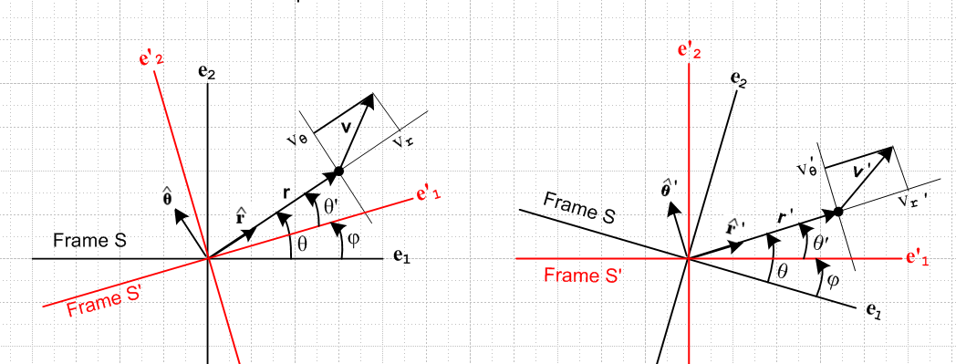

Therefore, in terms of this new picture on the right, we have

$\left(\begin{matrix}a \\ b\end{matrix}\right)$ = Rz(-φ) =

and we then have

(dv/dt)S' = (r - vθ)' + (vr +θ) '

which seems exceedingly strange. It seems that vr = v'r and so on, so we seem then to have

(dv/dt)S' = ('r - v'θ)' + (v'r +'θ) '

And then it seems that

= ' + ω

so then we have

(dv/dt)S' = ('r - v'θ' - v'θω)' + (v'r' + v'rω +'θ) '

But how can this be a function of ω ???

