Rotating curvilinear frames PhL 8.4.12

This is a wrong version of Section 14. I was thinking there were more frames if you "add" curvilinear coordinates, but that is not so.

14. Rotating Frames in Curvilinear Coordinates

In all of the work above we used Cartesian coordinates with basis vectors en in Frame S, and e'n in Frame S'. Suppose in Frame S we consider as an alternate to coordinates ri some orthogonal curvilinear coordinates ξi with their associated unit vectors i which are then alternates to the en . We think of these curvilinear unit vectors i as the axes of a new frame of reference we shall call Frame S. And suppose we do a similar thing in Frame S'. We then have

Cart coords Cartesian Frame curv coords Curvilinear Frame
ri ei (Frame S ) ξi i (Frame S )
(r')i e'i (Frame S' ) ξ'i 'i (Frame S ' )

Comment: I don't think there are really new "frames" here. A "frame" makes you think of some lattice that fills space like a Cartesian frame. All we really have are new unit vectors, new frames.

We might, for example, have ξi be spherical coordinates and ξ'i be toroidal coordinates. Because we have assumed orthogonal curvilinear coordinates, we know

ei• ej = e'i• e'j = i • j = 'i • 'j = δi,j

A vector V can now be expanded in four different ways,

V = Viei = (V)'ie'i = (V)i i = (V)'i 'i

where we use italics to denote curvilinear vector components (in spherical coordinates, e.g., 2 = ). It is common practice, once a curvilinear system is selected, to make these replacements

(V)i → Vξ$_{i}$ (V)'i → Vξ$_{i}$'

In cylindrical coordinates r,θ,z and r',θ',z' this would mean

(V)1 → Vr (V)'1 → Vr'
(V)2 → Vθ (V)'1 → Vθ'
(V)3 → Vz (V)'2 → Vz'

We can now add these two new sets of basis vectors to our earlier general figure showing a rotating frames scenario,

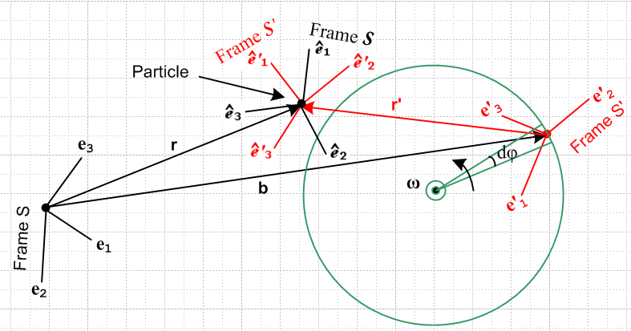

If the ξi were spherical coordinates, then taking the ordering 1,2,3 = r,θ,φ, one would have

1 = 2 = 3 = .

In this case, 1 in the drawing above would be collinear with vector r, but for general curvilinear coordinates (where the coordinate lines are not so simple) this won't be the case, so the picture is meant to illustrate "generic" curvilinear basis vectors.
We now define two rotation matrices R and R' as follows (theorem (1.1)+(1.2) used to get the second equations on each line)

i = R(r) ei => ei = R(r)ijj or i = [R(r)]-1ij ej
'i = R'(r') e'i => e'i = R'(r')ij'j or 'i = [R'(r')]-1ij e'j

Each of these matrices expresses curvilinear basis vectors in terms of Cartesian basis vectors, and of course each matrix is a function of the specific curvilinear coordinate system chosen. As an example, at the end of this section we show an explicit matrix R(r) for spherical coordinates.
When considering the new frames S and S' , one may regard these as "rotating frames" meaning either rotates relative to the other. In analogy with (1.25) through (1.28) we will have

(d'/dt )S = Ω x 'n
(d'/dt )S' = 0 // basis vectors ' are frozen as seen from Frame S '

(d/dt )S = 0 // basis vectors are frozen as seen from Frame S
(d/dt )S' = - Ω x n

The vector Ω describes the instantaneous rotation of Frame S ' relative to Frame S, analogous to ω which describes the instantaneous rotation of Frame S' relative to Frame S.
The G Rule for generic vector a now reads,

(da/dt )S = (da/dt)S' + Ω x a

Sections 6 and 7 on velocities and accelerations can be translated to curvilinear coordinates with these changes

S → S S' → S ' ω → Ω

For example, consider equation (6.6c) from the Section 12 summary (where we use full labeling)

vS = v'S' + ω x r + S' (6.6c)

In the curvilinear scenario this becomes

vS = v'S' + Ω x r + S' (6.6c)

In components, this is, using the convention of italics for curvilinear components,

(vS)i = (v'S')i + (Ω x r)i + (S')i i = 1,2,3

For spherical coordinates, the i = 1 equation would read

(vS)1 = (v'S')1 + (Ω x r)1 + (S')1

And then we use the convention discussed above to get

(vS)r = (v'S')r + (Ω x r)1 + (S')1

Finally we drop the "natural" frame labels and just write

vr = (v')r + (Ω x r)1 + (S')1

Finally after 8 hours of work to get the above equation, I am ready to consider the Paradox which arose yesterday. I think it is clear that when we wrote there in B On the Other Hand,

v' = -V'

we can conclude that this involves the (v')r object appearing above :

(v')r = - V

For part A On the One Hand

Note that ω and Ω are different vectors.

*************************************************************'

We can attempt to show this as follows

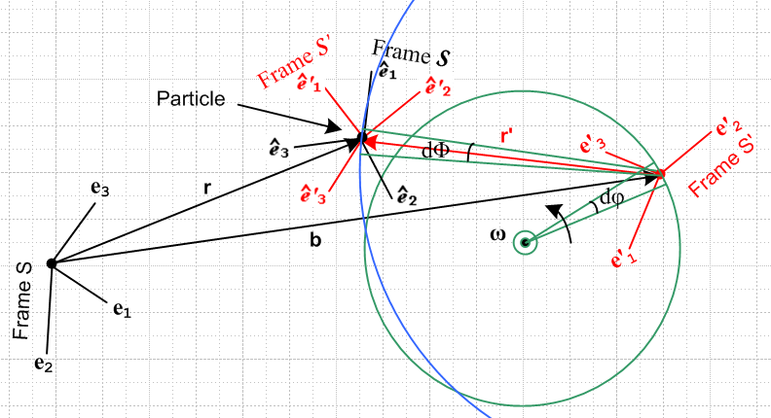

Recall that the origin of Frame S' and the green circle are both in the plane of paper and ω points at the viewer, but the vectors r and r' are generally in in the plane of paper. If Frame S and r are both fixed, then as Frame S' rotates a small amount dφ according to the ω axis of rotation, the r' vector's tail moves a small amount but its tip stays put. This is equivalent to the tail being fixed and the top moving in the opposite direction. In any event, vector r' changes a small amount dr' which instantaneously lies on the blue circle which is parallel to the plane of paper but not in it.

dΩ dΦ

i = R(r) ei
di = dR(r) ei + R(r) dei

(di/dt) = (dR(r)/dt) ei + R(r) (dei/dt)

(d'i/dt) = (dR'(r')/dt) e'i + R'(r') (de'i/dt) Ω = dΦ/dt Ω' = dΦ'/dt

i(t+dt) = R(dΦ) i(t) etc etc => di = dΦ x i => (di/dt ) = Ω x i

'i(t+dt) = R(dΦ') 'i(t) etc etc => d'i = dΦ' x ' => (d'i/dt ) = Ω' x 'i

So end up with

(d'i/dt ) = Ω' x 'i

but how do we draw that in the picture above? But now rename to be consistent with earlier

(d'i/dt ) = Ω x 'i

Restart. We already know that

(de'n/dt)S = ω x e'n and 'i = R'(r') e'i

_________________________________________________________________

Example: Compute R(r) for spherical coordinates.

First, just for reference, here are the three active rotation matrices used below :

Rx(θ) = $\left(\begin{matrix}1 & 0 & 0 \\ 0 & cosθ & -sinθ \\ 0 & sinθ & cosθ\end{matrix}\right)$ Ry(θ) = $\left(\begin{matrix}cosθ & 0 & sinθ \\ 0 & 1 & 0 \\ -sinθ & 0 & cosθ\end{matrix}\right)$ Rz(θ) = $\left(\begin{matrix}cosθ & -sinθ & 0 \\ sinθ & cosθ & 0 \\ 0 & 0 & 1\end{matrix}\right)$

Let Frame S have spherical coordinates. From the usual picture,

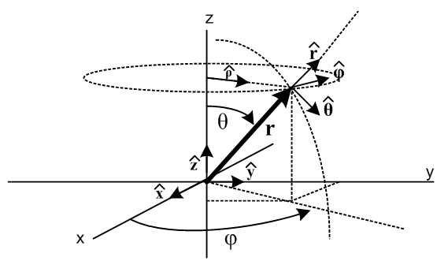

one can see by staring hard enough that

= Rz(φ) Ry(θ) = R R = Rz(φ) Ry(θ)
= Rz(φ) Ry(θ) = R
= Rz(φ) Ry(θ) = R

which we rewrite as

1 = R e3
2 = R e1
3 = R e2 .

We can repair the ordering of the basis vectors en on the right using R2 = (,,) as follows

e3 = R2 e1 $\left(\begin{matrix}0 \\ 0 \\ 1\end{matrix}\right)$ = $\left(\begin{matrix}0 & 1 & 0 \\ 0 & 0 & 1 \\ 1 & 0 & 0\end{matrix}\right)$$\left(\begin{matrix}1 \\ 0 \\ 0\end{matrix}\right)$ R2 = $\left(\begin{matrix}0 & 1 & 0 \\ 0 & 0 & 1 \\ 1 & 0 & 0\end{matrix}\right)$
e1 = R2 e2 $\left(\begin{matrix}1 \\ 0 \\ 0\end{matrix}\right)$ = $\left(\begin{matrix}0 & 1 & 0 \\ 0 & 0 & 1 \\ 1 & 0 & 0\end{matrix}\right)$$\left(\begin{matrix}0 \\ 1 \\ 0\end{matrix}\right)$
e2 = R2 e3 $\left(\begin{matrix}0 \\ 1 \\ 0\end{matrix}\right)$ = $\left(\begin{matrix}0 & 1 & 0 \\ 0 & 0 & 1 \\ 1 & 0 & 0\end{matrix}\right)$$\left(\begin{matrix}0 \\ 0 \\ 1\end{matrix}\right)$

Maple tells us that R2-1 = R2T and det(R2) = 1, confirming that R2 is a rotation. So we then have

1 = R R2 e1
2 = R R2 e2
3 = R R2 e3
or
i = R(r) ei.

We have therefore found the sought-after matrix R(r),

R(r) = R R2 .

Specific evaluation gives

R = Rz(φ) Ry(θ) = $\left(\begin{matrix}cosφ & -sinφ & 0 \\ sinφ & cosφ & 0 \\ 0 & 0 & 1\end{matrix}\right)$$\left(\begin{matrix}cosθ & 0 & sinθ \\ 0 & 1 & 0 \\ -sinθ & 0 & cosθ\end{matrix}\right)$ = $\left(\begin{matrix}cosφcosθ & -sinφ & cosφsinθ \\ sinφsinθ & cosφ & sinφsinθ \\ -sinθ & 0 & cosθ\end{matrix}\right)$

and then
R(r) = R R2 = $\left(\begin{matrix}cosφcosθ & -sinφ & cosφsinθ \\ sinφsinθ & cosφ & sinφsinθ \\ -sinθ & 0 & cosθ\end{matrix}\right)$$\left(\begin{matrix}0 & 1 & 0 \\ 0 & 0 & 1 \\ 1 & 0 & 0\end{matrix}\right)$ = $\left(\begin{matrix}cosφsinθ & cosφcosθ & -sinφ \\ sinφsinθ & sinφcosθ & cosφ \\ cosθ & -sinθ & 0\end{matrix}\right)$

from which we find

[R(r)]-1 = [R(r)]T = $\left(\begin{matrix}cosφsinθ & sinφsinθ & cosθ \\ cosφcosθ & sinφcosθ & -sinθ \\ -sinφ & cosφ & 0\end{matrix}\right)$.

From (***) we may write

j = [R(r) ]-1ij ei
or
= $\left(\begin{matrix}cosφsinθ & sinφsinθ & cosθ \\ cosφcosθ & sinφcosθ & -sinθ \\ -sinφ & cosφ & 0\end{matrix}\right)$$\left(\begin{matrix}e1 \\ e2 \\ e3\end{matrix}\right)$
or
= $\left(\begin{matrix}cosφsinθ & sinφsinθ & cosθ \\ cosφcosθ & sinφcosθ & -sinθ \\ -sinφ & cosφ & 0\end{matrix}\right)$
or
= cosφ sinθ + sinφ sinθ + cosθ
= cosφ cosθ + sinφ cosθ - sinθ
= -sinφ + cosφ

which are the well known expressions for the spherical unit vectors in terms of the Cartesian ones.

*************************************************

i•j = δi,j 'i•'j = δi,j

1 2 3

***********************************************************************

The solution equations to our Original Problem are summarized in Section 12 above, and those to the Inverse Problem are summarized in Section 13 (d).
All equations are stated in bolded vector notation. Such equations may be evaluated in any orthogonal coordinate system one wants. Any set of orthogonal curvilinear coordinates provides such an orthogonal coordinate system. In general the curvilinear basis vectors like , , for spherical coordinates "move" as the vector they describe moves, unlike the Cartesian basis vectors, but that is fine. For any particular vector, they form a viable set of orthogonal basis vectors.
In theory, we might want to use one curvilinear system of coordinates ξi with basis unit vectors i for frame S, and an entirely different system ξ'i with basis unit vectors 'i for frame S'. If V is an arbitrary vector, we then have these four expansions of interest :

V = Viei = (V)'ie'i = (V)i i = (V)'i 'i

where we use italics to denote curvilinear vector components (in spherical coordinates, e.g., 2 = ). It is common practice, once a curvilinear system is selected, to make these replacements

(V)i → Vξ$_{i}$ (V)'i → Vξ$_{i}$'

In cylindrical coordinates r,θ,z and r',θ',z' this would mean

(V)1 → Vr (V)'1 → Vr'
(V)2 → Vθ (V)'1 → Vθ'
(V)3 → Vz (V)'2 → Vz'

Consider now this equation taken from the Section 12 summary,

v = v' + ω x r + S' (6.6c)

We can view such an equation in any of our four bases, as just discussed above,

(v)i = (v')i + εijk(ω)j(r)k + (S')i components in basis ei
(v)'i = (v')'i + εijk(ω)'j(r)'k + (S')'i components in basis e'i
(v)i = (v')i + εijk(ω)j(r)k + (S')i components in basis i
(v)'i = (v')'i + εijk(ω)'j(r)'k + (S')'i components in basis 'i

For example, in r,θ,z cylindrical coordinates if we have ω = ω, then (ω)j = δj3ω , so in the third equation above we get

εijk(ω)j(r)k = εijk ω δj3 (r)k = ω εi3k(r)k = - ω εik3(r)k

Then the third line above becomes

(v)i = (v')i - ω εik3(r)k + (S')i components in basis i
or
(v)1 = (v')1 - ω ε123(r)2 + (S')i
(v)2 = (v')2 - ω ε213(r)1 + (S')2
(v)3 = (v')3 - ω ε3k3(r)k + (S')3 = (v')3 + (S')3

which translates into (since r = r + z = rr + rz , rθ = 0)

vr = v'r - ω rθ + (S')r = v'r + (S')r
vθ = (v'θ + ω rr + (S')θ = v'θ + ω r + (S')θ
vz = v'z + (S')z

But is such a component decomposition of v = v' + ω x r + S' useful in a rotating frames problem? At least for the equation shown above, the answer would seem to be no. The reason is that one might want to compute vr , but we have v'r on the right side, and such a component would probably never be a "given" in a frames problem. Rather, one would be given v'r'.

In practice, a better way to solve a rotating frames problem is to go ahead and use curvilinear basis vectors i and/or 'i if they are convenient, but to quickly get them expressed in terms of Cartesian basis vectors and then solve the problem basically with these Cartesian basis vectors. Examples of so doing is presented in the next section.

