Earth-Moon Tide Calculation PhL 8.11.12

This is the first attempt using these pictures. This stuff is better presented in the next version of this doc which is v2. This assumes M2 always faces M1. So probably just ignore this doc!

1. I draw this picture of two balls orbiting about their center of mass

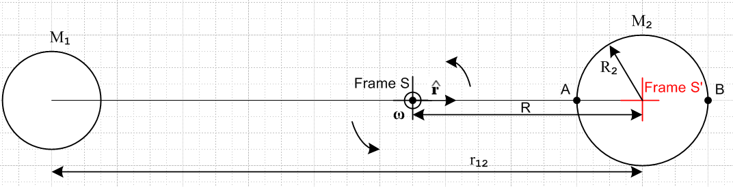
Fig 1
It might be that things come out looking like this if the center of mass lies inside M2 :

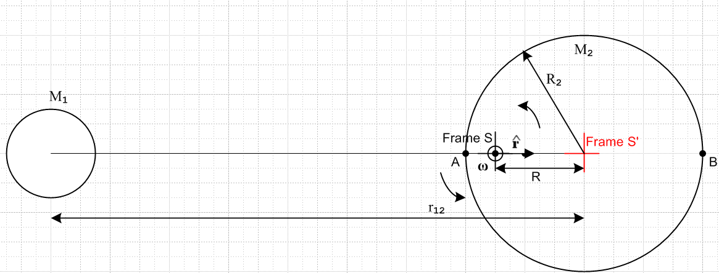
Fig 2

2. Since the center of mass is the point of rotation of this system, and ω passes through the Frame S origin, this is a Special Case #1 situation where (8.12) applies,

F'eff = F – mω x (ω x r) – 2m ω x v' – m x r Special Case #1 (8.12)

3. Frame S' is placed at the center of M2 and rotates with it at ω.

4. We imagine a Particle of mass m sitting in a little hollow cavity at the center of M2 and we ask, in Frame S', what forces does this mass feel? Since it is at rest in Frame S', v' = 0 . Also, the rotation rate is a constant (I think...). So answer is

F'eff = F – mω x (ω x R)

5. The only "real" force acting on our particle is the grav pull from M1. There is no grav from M2 because we are at its center. Therefore

F = -GmM1/r122

6. We know that

-ω x (ω x R) = ω2R

and so we then have

F'eff = -GmM1/r122 + mω2R = m[-GM1/r122 + ω2R]

7. Since our Particle is at rest in rotating Frame S', it has a' = 0 . Since F'eff = ma', we know that
F'eff = 0. Therefore

GM1/r122 = ω2R (1)

8. The center of mass in Frame S is located at the origin of Frame S, so

0 = [M2R - M1(r12-R) ]/(M1+M2)

which says

M2R - M1(r12-R) = 0 => M2R + M1R = M1r12 => (M1+ M2)R = M1r12

so we have

R = r12 * [M1/(M1+ M2)] (2)

Example: Suppose we have two Earths orbiting around each other. We then have from (2) that R = r12/2 so (1) then says

GM2/r122 = ω2R = ω2 r12/2 => r123 = 2GM2/ω2

If we arbitrarily set the period to 27.3 days (the Earth-Moon rotation period) we find that

r123 = 2GM2/ω2

r12 = [2GM2/ω2]1/3 = .48 x 109 m = 4.8 x 108m = 4.8 x 105 km = 480,000 km

Since R2 = 6378 km and R = r12/2 = 240,000 km, certain Figure 1 would apply.

9. We now quote these numbers from three wiki for 1 = moon, 2 = sun

M1 = 7.3477 × 10²² kg moon
M2 = 5.9736×10²⁴ kg^{[3]} earth
r12 = 384,399 km = 3.84399 x 108 m
T = 27.321582 d = 27.312 * 24 * 3600 = 2359756.8 = 2.356 x 106 sec
ω = 2πf =2π/T =(2*3.14159/ 2.356)x10-6 = 2.66688455 x 10-6 rad/sec
G = 6.67384 x 10-11 m3 /( kg sec2)

wiki says:

We install these numbers into Maple with 3 decimal places only

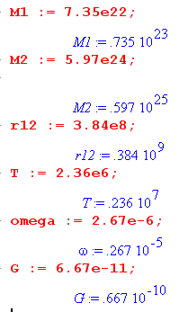

Maple can then compute R according to (2) above,

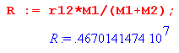

We now compute the left and right sides of (1) to make sure we are OK:

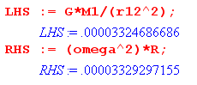

One thing we learn from the above calculation is that

R = 4670 km

R2 = 6378 km

so we must use Figure 2 for the Moon-Earth system since the CMS is inside the earth.

10. Now back to our picture shown in Fig 1. We will treat Fig 2 separately below.

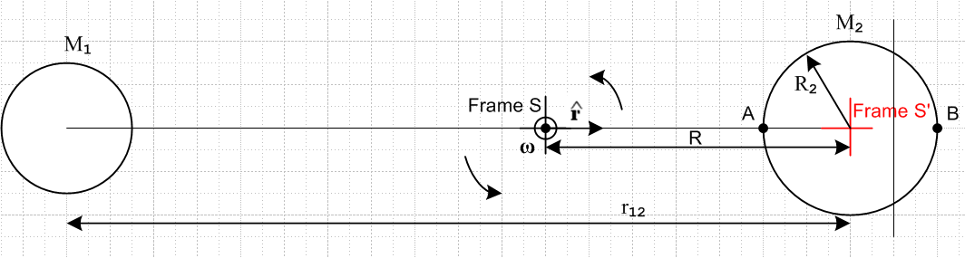

(a) Consider a particle at location B. What are the real forces acting on this particle?

• gravity 1 pulling left
• gravity 2 pulling left
• force of ground pushing to the right, call this fB (an unknown, like tether tension T)

What are the fictional forces"

• centrifugal force pushing to the right

Therefore we can write

F'eff(B) = [ -GmM1/(r12+R2)2 - GmM2/R22 + mω2(R+R2) + fB]

Since Particle at B is at rest in Frame S', we have [..] = 0 and therefore

fB = GmM2/R22 + m[ GM1/(r12+R2)2 - ω2(R+R2)]

The first term is the normal gravity force on particle B, while the remaining terms are the other forces involved. For Earth Moon Maple says that [..] = -.000046591 < 0. Thus, the ground pushes on the particle with a force less than normal gravity and that is because in this system, the other forces are flinging particle B a little to the right.
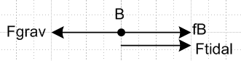
So we can then say

Ftidal(B) = Fgrav - fB = GmM2/R22 - fB = – m[ GM1/(r12+R2)2 - ω2(R+R2)]

= m[ω2(R+R2) - GM1/(r12+R2)2] = m [.00004659] > 0

As you move away from the rotation axis, centrifugal increases, and gravity 1 decreases. At M2 center we had exact matching of these two terms.

(b) Now consider particle at point A.

F'eff(A) = [ -GmM1/(r12-R2)2 + GmM2/R22 + mω2(R-R2) - fA]
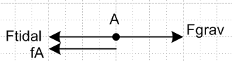
In this case we have Particle A at rest so

fA = GmM2/R22 – GmM1/(r12-R2)2 + mω2(R-R2)

= mg0 – GmM1/(r12-R2)2 + mω2(R-R2) = mg

This time we have

Ftidal(A) = Fgrav- fA = GmM2/R22 - fA= GmM1/(r12-R2)2 - mω2(R-R2)

= m[GM1/(r12-R2)2 - ω2(R-R2)] = m [ .00004655 ]

So first thing to notice: The tidal forces are slightly different on the two sides, about 1/1000 different.
Also

fA= mg = mg0 - Ftidal g = g0 - Ftidal/m

Suppose now we move a little away from the surface so w are distance r from Earth center.
Then just replace R2 by r in the above to get

Ftidal(A,r) = Fgrav- fA = GmM2/r2 - fA= GmM1/(r12-r)2 - mω2(R-r)

= m[GM1/(r12-r)2 - ω2(R-r)]

Then

gA(r) = g0(r) - Ftidal(A,r)/m = g0(r) - [GM1/(r12-r)2 - ω2(R-r)]

and now we have something that varies with r. Similarly

gB(r) = g0(r) - Ftidal(A,r)/m = g0(r) - [ω2(R+r) - GM1/(r12+r)2]

Attempt to calculate the tide height.

I just don't know how to even approach this. I try but fail to write little force balance things.

Subquestion: Imagine a water world where gravity is some g(θ) where θ is latitude. How would a layer of water distribute itself on such a world? Forget tidal forces, forget all the above, just answer this question. Nothing rotates, forget frames. This is the problem I don't know how to solve!
OK, take a Taylor peek.

Consider a little column of water of area A. This column is bulging height h above the nominal surface of our little water planet. This column of water feels a force down that is

Fdown = (ρhA)g = mg

The earth pushes up on the bottom of the column with fA = mg as shown above. So fA = Fdown and we learn zippo.

g as above

What is the tidal force acting on this column? Column has mass ρhA so

Ftidal(A) = m [ .00004655 ] = ρhA [ .00004655 ]

_____________________________________________________________

Attempt to calculate the tide height.

Consider first a Particle of water at point B sitting at the top of the water bulge. The distance from the center is R2 + dr where we want to compute dr. This particle is at rest in Frame S' so F'ext on this force should be 0. But we know that

F'eff(B+dr) = [ -GmM1/(r12+r)2 - GmM2/r2 + mω2(R+r)] where r = R2 + dr

// this must be right

Now we do some approximations.

(r12+r)-2 = r12-2(1 +r/r12)-2 ≈ r12-2( 1 - 2 r/r12 ) = r12-2( 1 - 2 R2/r12 - 2dr/r12)

r-2 = (R2+dr)-2 = R2-2 (1 + dr/R2)-2 = R2-2(1-2 dr/R2)

Then we have

F'eff(B+dr) ≈
[ -GmM1 r12-2( 1 - 2 R2/r12 - 2dr/r12) - GmM2 R2-2(1-2 dr/R2) + mω2(R+R2+dr)]
or
F'eff(B+dr) ≈
m[ -GM1 r12-2 ( 1 - 2 R2/r12 - 2dr/r12) - GM2 R2-2(1-2 dr/R2) + ω2R(1+R2/R+dr/R)]

Now in the last term use

GM1/r122 = ω2R

so

F'eff(B+dr) ≈
m[ -GM1 r12-2 ( 1 - 2 R2/r12 - 2dr/r12) - GM2 R2-2(1-2 dr/R2) + GM1/r122 (1+R2/R+dr/R)]

Now just shuffle things in a rewrite to get

= m GM1 r12-2 [ - ( 1 - 2 R2/r12 - 2dr/r12) - (M2/M1)(r12/R2)2(1-2 dr/R2) + (1+R2/R+dr/R)]

= m GM1 r12-2 [ - 1 + 2 R2/r12 + 2dr/r12) - (M2/M1)(r12/R2)2(1-2 dr/R2) + 1+R2/R+dr/R]

= m GM1 r12-2 [ 2 R2/r12 + 2dr/r12) - (M2/M1)(r12/R2)2(1-2 dr/R2) + R2/R+dr/R]

Now since our Particle atop the B side bulge is at rest in Frame S', we have

[ 2 R2/r12 + 2dr/r12) - (M2/M1)(r12/R2)2(1-2 dr/R2) + R2/R+dr/R] = 0

and we want to solve this for dr. So put the dr terms on the LHS

2dr/r12 + 2 (M2/M1)(r12/R2)2(dr/R2) + dr/R

= - 2 R2/r12 + (M2/M1)(r12/R2)2 - R2/R

and then

dr[ 2/r12 + 2 (M2/M1)(r12/R2)2(1/R2) + (1/R)]

= (M2/M1)(r12/R2)2- 2 R2/r12 - R2/R

and we hope the RHS is positive! We can eliminate R using (2) which says

(1/R) = (1/r12) * (M1+ M2)/M1

Then

dr[ 2/r12 + 2 (M2/M1)(r12/R2)2(1/R2) + (1/r12) * (M1+ M2)/M1]

= (M2/M1)(r12/R2)2- 2 R2/r12 - (R2/r12) * (M1+ M2)/M1
or

(dr/r12)[ 2 + 2 (M2/M1)(r12/R2)2(r12/R2) + (M1+ M2)/M1]

= (M2/M1)(r12/R2)2- 2 (R2/r12) - (R2/r12) * (M1+ M2)/M1
or

(dr/r12)[ 2 + 2 (M2/M1)(r12/R2)3 + 1 + (M2/M1)]

= (M2/M1)(r12/R2)2- (R2/r12) { 2 + 1 + M2/M1 }
or

(dr/r12)[ 3 + 2 (M2/M1)(r12/R2)3 + (M2/M1)]

= (M2/M1)(r12/R2)2- (R2/r12) (3 + M2/M1)

dr = r12 * [(M2/M1)(r12/R2)2- (R2/r12) (3 + M2/M1)] / [ 3 + 2 (M2/M1)(r12/R2)3 + (M2/M1)]

Since I have all this in Maple I can just compute it as

dr = r12 * top/bottom

This gives r12 107 m which I am afraid is not correct, my little "theory" has failed. You can see how this work. In top, the first term wins by a mile, and in bot the middle term wins by a mile, so

dr ≈ r12 * [(M2/M1)(r12/R2)2/[2 (M2/M1)(r12/R2)3]

= r12 * [(r12/R2)-1/[2] = (1/2) r12* R2/r12 = R2/2

So our little tide is half the radius of the earth!

