This is my tidal analysis for the case that the planet whose tides we consider stays facing its partner as it goes around in its orbit. This would be appropriate for considering tides on the moon due to the earth, but it is NOT appropriate for tides on the earth. It is wrong for the earth I now realize. The earth rotates about its center, not about the earth-moon CMS system. So I will store this work here for now, maybe I will do something with it. Today is 8/13/12.

(g) Orbiting objects and Tidal Forces

Assumptions α

In general, a binary system can have a complicated orbit like this one taken from
http://abyss.uoregon.edu/~js/ast222/lectures/lec05.html ,

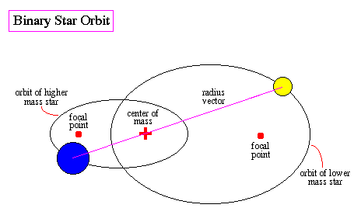

In this section, however, we restrict our interest to a special case where each object traces out a circular path, not an elliptical one. In this picture,

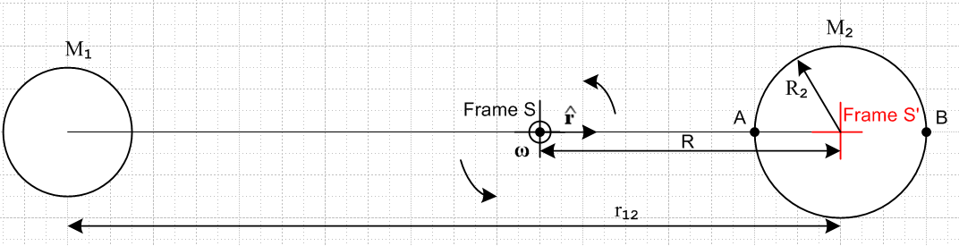

object 2 on the right traces out a circular path of radius R, while object 1 on the left traces a circular path of radius r12 – R. ( The orbit of the moon around the earth is close to circular, having eccentricity is f/a ≈ .05. ) Each object is assumed to be a spherically symmetric mass distribution. We also assume that our two-object system experiences no external torques (e.g.,frictional losses), so ω is a constant and = 0.

Kinematics

Inertial Frame S is placed at the binary system's center of mass and the rotation axis ω passes through the Frame S origin coming out of the plane of paper. Frame S' has its origin at the center of object 2 and Frame S' is glued to object 2. Object 2 is assumed (for now) to rotate in such a way that particles A and B sitting on its surface always lie on the axis between objects 1 and 2. The Moon really does keep the same face pointing to the Earth, but of course the Earth does not keep the same face pointed to the moon. Nevertheless, object 2 above does keep the same face pointing to object 1.
Since Frame S' is then a rotating frame and since the ω rotation axis passes through the origin of Frame S, this is a Special Case #1 system in the sense of Section 4 (d).

For the Moon-Earth system, the picture looks more like this,

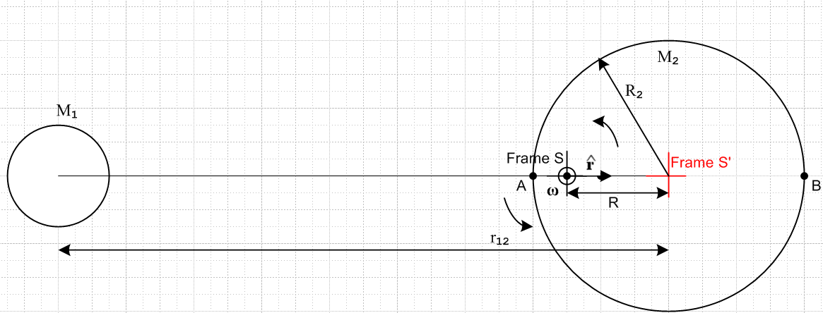

where R is about 3/4 the radius of the earth. Both pictures embody the same kinematics. For example, in the first picture, a particle at A feels centrifugal force ω2(R-R2) while in the lower picture it feels
ω2(R2-R)(-), but of course these quantities are the same.
The center of mass location is determined by

0 = [M2R - M1(r12-R) ]/(M1+M2)

which reports out the obvious fact that

R = r12 [M1/(M1+ M2)] (8.24)

Physics

Consider a Particle placed in a tiny cavity at the origin of Frame S'. This particle, like all other particles of either object, is in a stable orbit about the origin of Frame S. This Particle is therefore at rest with respect to Frame S' and has acceleration a' = 0. According to bogus Newton's Law (8.3), the total effective force acting on this particle is F'eff = ma' = 0.
Since we have a Special Case #1 system, we are allowed to use (8.12) which says

F'eff = F – mω x (ω x r) – 2m ω x v' – m x r Special Case #1 (8.12)

Since we are going to consider only particles at rest in Frame S' and since = 0 this becomes

F'eff = F – mω x (ω x r) . (8.12)'

So for our particle at the center of object 2, we have F'eff = 0, so the RHS of (8.12') must vanish. The only contribution to F (the real forces) is the gravitational attraction of object 1. Thus,

0 = F'eff = [ -GmM1/r122 + mω2R]

and therefore

ω2R = GM1/r122 . (8.25)

Combining this with (8.24) one has

ω2 r12 [M1/(M1+ M2)] = GM1/r122
or
ω2 r12 = G(M1+ M2)/r122 (8.26)

which is analogous to (8.17) for the tether system. This equation defines the allowed pairs (ω, r12) for our orbiting system just as (8.17) defined the allowed pairs (ω,r0) for the tether.
From the pictures and (8.12)' the total force experienced by Particle A is,

F'eff(A) = [ -GmM1/(r12-R2)2 + GmM2/R22 + mω2(R-R2) – fA ] = 0 (8.27)
pulls left pulls right pulls right pushes left

where fA is the force of the ground pushing left on Particle A lying on the surface of object 2. The sum must be 0 since Particle A is at rest in Frame S'. Therefore,

fA = GmM2/R22 - [GmM1/(r12-R2)2 - mω2(R-R2)] . (8.28)

Since point A lies to the left of the center of object 2, we know that the gravitational force due to object 1 is greater at point A than at the center of object 2. Also, we know that the centrifugal force at point A is less than it would be for a particle at the center of object 2. Since these two forces are in exact balance for an object at the center of object 2 (this is what (8.25) says) , we know that [...] > 0 in the above equation. At point A, the surface of object 1 finds that it is pushing out on particle A with a force that is less than the nominal gravitational force GmM2/R22, so "something" is pushing particle A to the left making it lighter in weight. That something is the "tidal force" which is the square bracket in (8.28)

ftidal(A) = [GmM1/(r12-R2)2 - mω2(R-R2)] > 0, pushes to the left on Particle A (8.29)

Now consider Particle B. Analogous to (8.27) we have

F'eff(B) = [ -GmM1/(r12+R2)2 – GmM2/R22 + mω2(R+R2) + fB ] = 0 (8.30)
pulls left pulls left pulls right pushes right
so
fB = GmM2/R22 - [mω2(R+R2) - GmM1/(r12+R2)2] (8.31)

At point B, the centrifugal force is larger than at the center, and the gravitational force from object 1 is less than at the center. Since they are in balance at the center, we have [...] > 0 in (8.31), so we get the first line below, and then below that we copy down (8.29) for comparison

ftidal(B) = m[ω2(R+R2) - GM1/(r12+R2)2] > 0, pushes to the right on Particle B (8.32)
ftidal(A) = m[GM1/(r12-R2)2 - ω2(R-R2)] > 0, pushes to the left on Particle A (8.29)

These values are not the same, but become the same in the limit r12 >> R2 as shown below. If M1 is the moon and M2 the earth we find

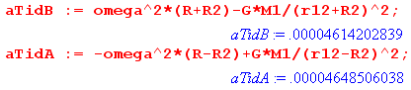

and we are in fact in this r12 ~>> R2 limit since r12 = 384,000 km and R2 = 6378 km.

Comments:

1. We have shown that for any two spherically symmetric objects in circular orbit about each other, either object induces on the other tidal forces which reduce the force of gravity on both the near and far side. If either object is covered with water, that water will "bulge" on both the near and far sides. The essential qualitative argument has been made above concerning the relative sizes of the object 1's gravitational attraction on Particles A and B and the centrifugal force felt by these Particles.

2. If object 1 is the Moon and object 2 is the Earth, the second picture above applies as noted and there is a permanent "high tide" on the sides of the Earth facing toward and away from the Moon. Since the Earth rotates underneath this high tide, any (non pole) point on the earth experiences a high tide nominally every 12 hours. But the Moon moves with a 27.3 day period in the same direction the earth rotates, so when 12 hours has passed, the moon has moved ahead 12/27.3 = 0.44 hours = 26.4 minutes, so one has to wait another 26 minutes for the lunar high tide, so the time between high tides is about 12 hours 26 minutes. This causes the time of high tide to move relative to a wall clock in any location, which is why we have tide tables and tide clocks. There are many other details to ponder: the earth rotation axis is tilted, the earth has a lot of land mass, it is moving about the Sun, water does not flow instantly from one place to another, the earth's rotation drags the tides ahead of where they normally would be, water in a lake cannot get out, etc.

3. The Earth-Sun orbiting system makes its own tides which are roughly half the magnitude of the lunar tides. Sometimes the lunar and solar tides add up and other times they partially cancel:

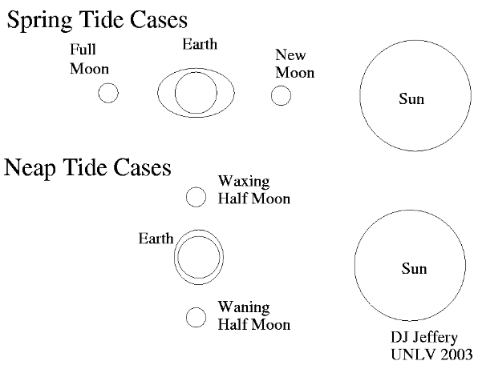

4. If object 1 is the earth and object 2 is the tethered system treated in the previous section, the tidal forces (think points A and B) are what puts tension in the tether trying to rip the thing apart.

5. For binary stars the tidal force can be strong enough in its effect of weakening gravity at points A and B that matter can transfer from point A on the smaller object to the larger.

Approximation for r12 >> R2

In this limit, one can expand,,

(r12+R2)-2 = r12-2(1 + R2/r12)-2 ≈ r12-2( 1 - 2R2/r12 ) (8.33)

so that (8.32) and (8.29) can be written as

ftidal(B)/m ≈ ω2R(1+R2/R) - (GM1/r122) ( 1 - 2R2/r12 ) // red = centripetal term
ftidal(A)/m ≈ (GM1/r122)( 1 + 2R2/r12 ) - ω2R(1-R2/R) .

Then use (8.25) to replace ω2R = (GM1/r122),

ftidal(B)/m ≈ (GM1/r122) (1+R2/R) - (GM1/r122) ( 1 - 2R2/r12 )
ftidal(A)/m ≈ (GM1/r122)( 1 + 2R2/r12 ) - (GM1/r122) (1-R2/R)
or
ftidal(B)/m ≈ (GM1/r122) [ (1+R2/R) - ( 1 - 2R2/r12 ) ]
ftidal(A)/m ≈ (GM1/r122) [( 1 + 2R2/r12 ) - (1-R2/R) ]
or
ftidal(B)/m ≈ (GM1/r122) [ (R2/R) + 2(R2/r12 ) ]
ftidal(A)/m ≈ (GM1/r122) [( 2R2/r12 ) + R2/R) ] (8.34)

so in this limit, the two tidal forces are equal in magnitude. The (R2/R) term comes from the centrifugal force effect, while the 2(R2/r12) comes from the gravitation of object 1. [see frames doc ] If one ignores the centrifugal term, one finds that the sum of the two tidal forces is 4R2GmM1/r123, a fact which appears in various places on the web. The relative sizes of the two terms for 1 = moon and 2 = earth are

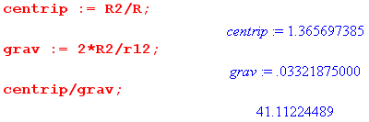

so the centripetal term is in fact 41 times larger than gravitational term for this system. It would be appropriate to ignore the centripetal term in a model where the moon is separated from the earth be a long weightless stick and the earth-moon system is not rotating.
From (8.24) we have

(R2/R) = (R2/r12)(r12/R) = (R2/r12) (M1+ M2)/M1

giving

ftidal(A or B)/m ≈ (GM1/r122) [(R2/r12) (M1+ M2)/M1 + 2(R2/r12 ) ]

= (GM1/r122) (R2/r12) [(M1+ M2)/M1 + 2]

= (GM1/r122) (R2/r12)(3M1+M2)/M1

= (G/r123) R2 (3M1+M2) (8.35)

In the limit M1 >> M2 ( 1 = earth, 2 = tethered satellite) we get

ftidal(A or B)/m ≈ 3 R2(G M1/r123) (8.36)

which replicates the result (8.23). For the moon-earth system, on the other hand, we find

ftidal(A or B)/m = (G/r123) R2 (3M1+M2) = .0000465 m/sec2 = 4.65 x 10-5 m/sec2 (8.37)

Here are the SI numbers used to get the above result, where 1 = Moon and 2 = Earth,

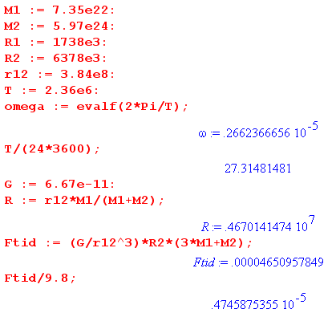

The tidal force is very weak relative to g, down by a factor of 5 x 10-6 as shown above.

Size of the Tides on Earth

We shall not attempt this calculation (see Taylor[1])), but merely comment on it. If one places a Particle at some point C which is off axis in our drawings above, one can compute an effective g which is a function of the polar angle g(θ). We have already seen how g < g0 at points A and B, θ = 0 and π.

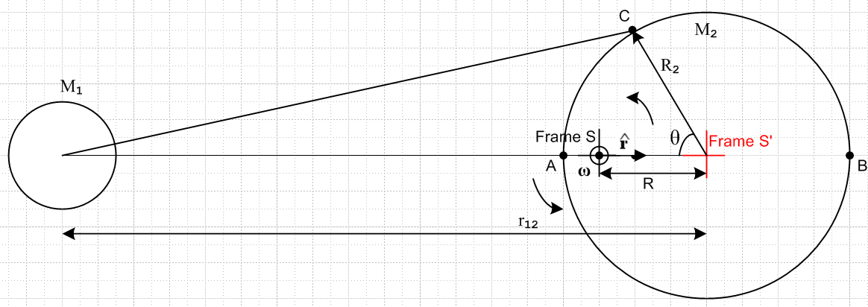

One is then faced with the technical problem of finding the shape of the surface of water on a world covered with water having g(θ). We know that the water surface will bulge at points A and B, and will therefore be reduced in an equatorial region perpendicular to the r12 axis. One solution method is to show that F = mg(θ) is a conservative force (a function of position) and can therefore be derived from a potential V(θ). The water surface, it is then argued, will be an equipotential surface of V. Using this method, Taylor[1] (p 335) comes up nominal figures for the height difference between high and low tides on such a water world: 54 cm (1.8 feet) for the lunar tide and 25 cm (0.82 feet) for the solar tide. Resonance effects in the Bay of Fundy can cause a height difference of 50 feet, but in general Taylor's numbers are in the ball park for a normal shore on the open ocean.

