Do not edit. This is now included in frames doc. This is just a safety backup copy.

(g) Tides on the Earth

The basic picture

In general, the orbit pattern of a binary system has this appearance, where each object traverses its own ellipse
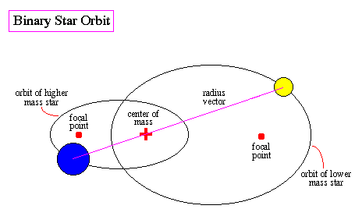

http://abyss.uoregon.edu/~js/ast122/lectures/lec10.html

In this section, however, we restrict our interest to a special case where each object traces out a circular path, not an elliptical one. The picture is this,

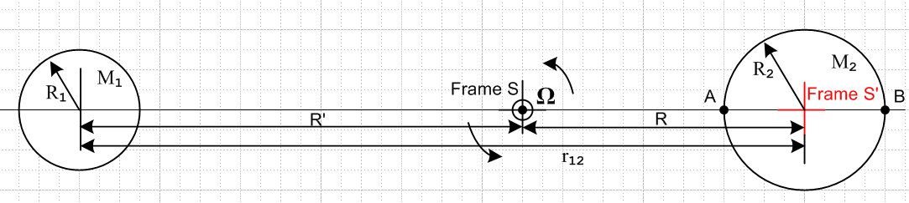

Each sphere is assumed to be a spherically symmetric mass distribution and can thus be treated as a point mass at its center for gravitational purposes. An inertial Frame S has its origin at the center-of-mass point, and the binary system rotates in the plane of paper at angular frequency Ω. Distance R can be found from the usual center-of-mass equation (viewed from Frame S),

0 = [M2R - M1(r12-R) ]/(M1+M2)

which reports out the obvious fact that

R = r12 [M1/(M1+ M2)] . (8.24)

We collect here some information on the sun, earth and moon

MS = 1.99 x 1030 kg RS = 696,000 km
ME = 5.97 x 1024 kg RE = 6371 km (8.25)
MM = 7.35 x 1022kg RM = 1737 km TM = 27.3 days

rS-E = 1.50 x 108 km // average of aphelion and perihelion and perigee e = .016
rM-E = 386,000 km // average of apogee and perigee tilt = 1.45o e = .05

from which we can compute

1 --- 2
sun-earth R'/R1 = .000647
moon-earth R/R2 = 0.737 (8.26)

So for the sun-earth system, the center of mass is basically at the center of the sun, while for the moon-earth system, the center of mass lies at a point 3/4 the radius of the earth from the center. We could redraw our figure for these two cases, but the kinematics does not change, so we won't bother.

Frame S and Frame S'

Frame S as we have noted is a fixed inertial frame whose origin is at the binary system center of mass which is also the point about which each object rotates in a circle.
As object 1 rotates in its orbit, we shall assume it maintains its orientation relative to the stars. So at a time later than that shown above, the situation is this

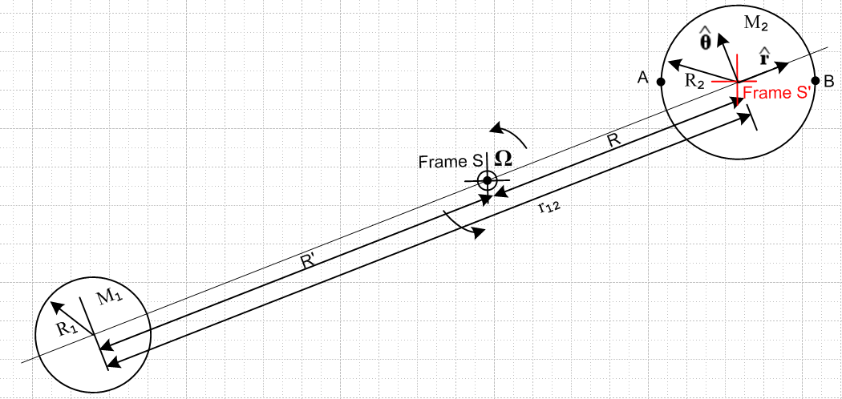

Frame S' is glued to object 2 and is sort of a "frame on gimbals" relative to Frame S which is fixed and never changes.
If the above picture represented the Moon-Earth picture, the moon on the left would in fact be as the drawing suggests, since it keeps its same side facing the earth. We don't care about this issue for object 1 since object 1's only role is to produce a gravitational field at object 2.
We have temporarily turned off the rotation of the Earth about its center (the origin of Frame S'). Later we will turn that back on.

How this tidal model fits in

How exactly does this problem fit into our general framework of rotating frames? It is a Special Case #2 problem of Section 4 (d) with ω = 0 and with the two sets of axes always aligned.

One fictitious force in Frame S'

Recall now equation (8.4a) where the left equality is the "bogus" Newton's Law in Frame S', F is the total "real force" in Frame S', and then we have a list of four fictitious forces in Frame S',

ma' = F'eff = F – mS – mω x (ω x r') – 2m ω x v' – m x r' (8.4a)
frame centrifugal Coriolis Euler

In our application we are going to consider points in Frame S' (that is, points on the non-axis-rotating earth) which are at rest on or in the Earth, so v' = 0. We have noted that ω = 0 and of course = 0, so the above becomes

ma' = F'eff = F – mS (8.4a)'
frame

where only the "frame" fictitious force has survived. Remember that, although Frame S' is not a "rotating frame" since ω= 0, it is still a non-inertial frame having this one fictitious force.

It is clear from the picture that (since R is a constant)

b = R d/dt = Ω d/dt = - Ω

S = R d/dt = RΩ

S = RΩ d/dt = - RΩ2 (8.27)

Therefore (8.4a)' becomes

ma' = F'eff = F + m RΩ2 (8.4a)'

For any Particle at rest in Frame S' (and thus at rest in/on the non-axis-rotating earth), we have a' = 0. so

0 = F + m RΩ2

For a Particle in or on the Earth, F = Fg1 + Fg2 + Fe where

Fg1 = the gravitational force due to object 1
Fg1 = the gravitational force due to object 2
Fe = any non-gravitational force of the earth on the Particle (such as surface pushing on a particle)

Thus we have

0 = Fg1 + Fg2 + Fe + m RΩ2
or
Fe = - (Fg1 + Fg2 + m RΩ2) (8.28)

The relation between r12 and Ω

If we were to replace the earth with a point mass M2 at its center, nothing would change in our orbiting picture. This point mass does a circular orbit around the binary center of mass with radius R and angular frequency Ω. The usual rule for circular motion of a point particle says that the gravitational force balances the centrifugal force, so

M1M2G/r122 = M2Ω2R
or
M1G/r122 = Ω2R (8.29)

Now suppose we replace the original Earth with another Earth with a spherical cavity in the center which contains a point particle of mass m. Then we replace this new earth with a point mass M2'. So we now have a point mass m and a point mass M2' on top of each other, and each mass is going in the circular orbit just described. There is no reason for mass m to do something other than go in the circular orbit of radius R at Ω about the center of mass.
Therefore, if we consider a Particle of mass m located in a cavity in the center of the Earth, this particle just floats in the cavity (not touching the sides) and is stationary in Frame S'. The non-gravitational force of the earth on this Particle is then Fe = 0. The gravitational force Fg2 = 0 as well since the Particle is at the exact center of the Earth. Our equation above then becomes, for this particle,

0 = - (Fg1 + m RΩ2)
or
mM1G/r122 = m RΩ2
or
M1G/r122 = Ω2R

which is the same as (8.29) above. All the extra words above were to reinforce the idea that a Particle at the center of the earth really feels no forces at all from the Earth. It feels Fg1 and it feels the fictitious force mS = - mRΩ2 and these forces exactly cancel.
We can combine (8.24) with (8.29) to get

M1G/r122 = Ω2 r12 [M1/(M1+ M2)]
or
(M1+ M2)G/r123 = Ω2 (8.30)

and this is the relationship between r12 and Ω for given masses M1 and M2. It is analogous to the relation between r0 and ω given in (8.17) for the tethered satellite system.

Tidal Force at an arbitrary point on the Earth

Now consider a particle of mass m at some arbitrary location C on the surface of the earth. We define angles θ and β as shown, where β is typically going to be very small.

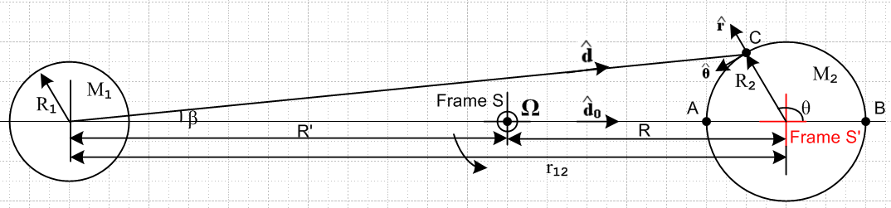

Here we show a brand new and which have nothing to do with those used earlier. And at the same time add two traditionally named unit vectors and 0 (where 0 is the discarded old ). Then (8.28) becomes

Fe = - [ Fg1 + Fg2 + m RΩ20 ] (8.31)

= - [ (-M1mG/d2) + Fg2 + m RΩ20 ]

From (8.29) we replace RΩ2 by M1G/r122 to get

Fe = - [ (-M1mG/d2) + Fg2 + m M1G/r1220 ]

= - [Fg2 + m M1G (/d2 – 0/r122)]

= - Fg2 – m M1G (/d2 – 0/r122) (8.32)

Normally one thinks of Fe = - Fg2, meaning the force of the earth up on an object resting on its surface is equal and opposite to the force of gravity pulling down on the object, so the total force Fe+Fg2 = 0. However, we see here that due to the orbiting with object 1, there is an extra force which is called the tidal force, so

Fe = - Fg2 + Ftid (8.33)

Ftid ≡ – m M1G (/d2 – 0/r122) . (8.34)

It is the fact that object 1's gravitational field varies slightly (in direction and magnitude) at different points on object 2 which results in the tidal force.

Exercise for the Reader: If the rotating moon-earth system were replaced by a static system in which the earth and moon were held apart by a very long, stiff (1020 N) rod, would the tidal force be the same as shown in (8.34)? Or would the water bulge only on the side of the earth facing the moon? Since this latter seems likely, one concludes that it is not just the non-uniformity of the gravitational field that causes the double-bulge tide, it is this non-uniformity in combination with the balance provided by the rotation which causes there to be zero force on a particle at the center of the earth.

Evaluation of the Tidal Force at Four Locations.

We shall now evaluate this tidal force at the four points of the compass in our picture.

At point A we have = 0 and d = (r12-R2), so

Ftid(A) = – m M1G [1/(r12-R2)2- 1/r122] 0 (8.35)

But if r12 >> R2 we have

1/(r12-R2)2 = (r12-R2)-2 = r12-2(1 - R2/r12)-2 ≈ (1/r12)2 (1 + 2R2/r12)
so
Ftid(A) = – m M1G [(1/r12)2 + 2R2/r123 - 1/r122] 0 = – m M1G [2R2/r123] 0

= - 2m(M1G/r122) (R2/r12) 0 (8.36)

which points to the left. Similarly,

Ftid(B) = – m M1G [1/(r12+R2)2- 1/r122] 0

– m M1G [(1/r12)2 - 2R2/r123 - 1/r122] 0 = + m M1G [2R2/r123] 0

= 2m(M1G/r122) (R2/r12) 0 (8.37)

which points to the right.
At the top when θ = π/2 we have d ≈ r12 to first order, so then

Ftid(top) = – m M1G (/d2 – 0/r122) = – m (M1G/r122) ( – 0)

Drawing a thin triangle with edges and 0 shows that

( – 0) ≈ sinβ = (R2/r12) // for point at the top, θ = π/2 (8.38)

and therefore

Ftid(top) = – m (M1G/r122) (R2/r12) (8.39)

which points down. For a point at the bottom, θ = -π/2, we still have (8.38) but of course now points down. So

Ftid(bot) = – m (M1G/r122) (R2/r12) (8.40)

which points up.
Here is a summary of these four results:

Ftid(A) = – 2m(M1G/r122) (R2/r12) 0 // points to the left (8.36)
Ftid(B) = 2m(M1G/r122) (R2/r12) 0 // points to the right (8.37)
Ftid(top) = – m(M1G/r122) (R2/r12) // points down (8.39)
Ftid(bot) = – m(M1G/r122) (R2/r12) // points up (8.40)

We can now draw the famous picture, where the side arrows are twice as long as the top and bottom ones, and where we have added four more arrows for the in-between points. The blue shows the shape of the water surface on a water-covered Earth, and the bulges point toward and away from object 1 which is off to the left,
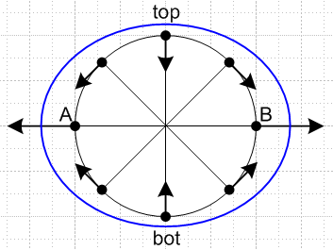

The tidal force acceleration is very weak compared to the local gravitational force on the earth. For the lunar tidal case,

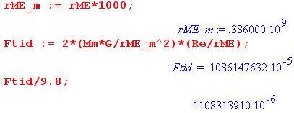

so basically the tidal force is 10-7 the size of g. It is rather amazing what such a small force can do when it is applied to a lot of water.

Equation of the water surface.

One can go on to obtain a general expression for Ftid(θ) for any point on the earth. By writing this force as the gradient of a potential, and by arguing that the surface of the water should be an equipotential surface, one can obtain[13] an equation for the blue surface,

R(θ) = R2 + a cos(2θ)

where the difference between high and low tide (here A/B versus top/bot) is given by

H = 2a = (3/2)R2 (M1/M2)(R2/r12)3

Inserting the numbers given earlier, one gets (km)

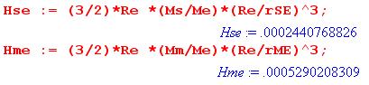
which says

Hsolar_tide = 24 cm = 0.8 feet
Hlunar_tide = 53 cm = 1.8 feet

A non-inlander will recognize these as reasonable ball park values for ocean tides, lending much credence to the model at hand.

Rotation turned back on

We now turn the rotation of the earth back on (we turned if off earlier). This rotation is perpendicular to the plane of paper in our drawings above. At any latitude, an outward-pointing centrifugal force of equal magnitude is added all around the earth, and one argues that this has no effect on the differential tidal force pattern. To the extent the world has an all-water surface and the interface between earth and water is frictionless, one concludes that the blue surface stays put while the earth rotates under it, thus putting high tides nominally 12 hours apart. But the Moon moves with a 27.3 day period in the same direction the earth rotates, so when 12 hours has passed, the moon has moved ahead 12/27.3 = 0.44 hours = 26.4 minutes, so one has to wait another 26 minutes for the lunar high tide, so the time between high tides is about 12 hours 26 minutes. This causes the time of high tide to move relative to a wall clock in any location, which is why we have tide tables and tide clocks.
Roughly the solar tides have half the influence of the lunar ones as shown above, but they add and cancel depending on the position of the sun and moon. This nice picture shows the extremal situations (the term spring tide has nothing to do with the season Spring)

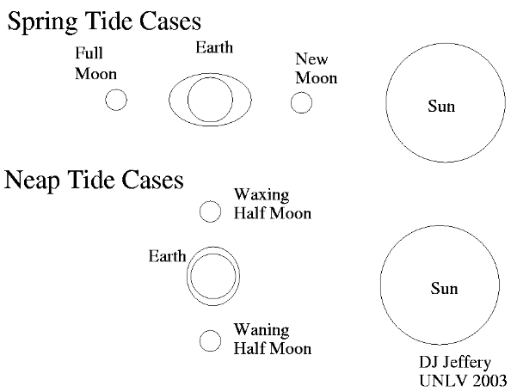

So the maximal tides are about 2 weeks apart and the same is true for the intervening minimal tides.

Many adjustments to the above toy model are required to explain the real tides on the earth. Water does not move around instantly, there is drag of the earth on the water, there are land masses and resonances, lake water has no where to go, and so on.
A good discussion of the above tidal model is given in Taylor's textbook[1] p 330-336. A more detailed discussion is presented in the excellent (and downloadable) paper by Butikov[13]. Both sources are very readable.

