Rotating Frames of Reference
Phil Lucht
Rimrock Digital Technology, Salt Lake City, Utah 84103
last update: October 21, 2012

Maple code is available upon request. Comments and errata are welcome.
The material in this document is copyrighted by the author.

The graphics look ratty in Windows Adobe PDF viewers when not scaled up, but look just fine in this excellent freeware viewer: http://www.tracker-software.com/pdf-xchange-products-comparison-chart .
The table of contents has live links, and use of a wide Bookmarks pane is recommended.

Overview 4
Summary 5
1. Notation, important role of the Prime Symbol, and other Preliminaries 7
(a) The basis vectors e_{n} and e'_{n} and two ways in which they are related 7
(b) Expansions of a vector and use of primes and parentheses 7
(c) Special case where a'_{i} is unambiguous. 8
(d) When are Two Vectors Equal? 10
(e) The Small Rotation of a vector about an axis 11
(f) The time rate of change of a rotating vector 13
(g) Rate of change of the basis vectors 14
(h) Notations for the many time derivatives of vectors r, r', b and L 15
(i) No frame label is needed for d/dt of a scalar function 19
(j) When do operations d/dt and taking a component "commute" ? 20
2. The G Rule for arbitrary vector a and its derivation 22
3. The Apparatus and its Observer at Rest in Frame S' 26
4. The Relationship between the Two Frames S and S' 28
(a) Explanation of Fig 4.1: Frame S in the plane of paper 28
(b) Explanation of Fig 4.2: Vector ω pointing directly out of paper 29
(c) Comments on _{S} and _{S'} 29
(d) Special Case #1 : ω axis through Frame S origin 30
(e) Special Case #2 : ω axis through Frame S' origin 31
(f) The Turntable 32
(g) The earth 33
(h) The Flying Camera Platform 34
5. The Goal of the next two sections 35
6. Determination of velocities 36
(a) Velocity v_{S'} 36
(b) Velocity v ≡ v_{S} 36
(c) Velocity v'_{S} 37
(d) Velocity Summary 37
(e) Velocities for Special Cases 37
(f) Comments 38
7. Determination of accelerations 39
(a) Acceleration a'_{S} 39
(b) Acceleration a ≡ a_{S} 40
(c) Acceleration a_{S'} 41
(d) Acceleration Summary 41
(e) Relation between _{S} and _{S'} 41
8. The Fictitious Forces 43
(a) Development of the Fictitious Forces 43
(b) Interpretation of the Centrifugal and Euler Fictitious Forces 44
(c) Interpretations of the Coriolis Fictitious Force 47
(d) Special Case #1 Problems 51
(e) Problems on the surface of the earth 51
(f) Tethered satellites and Tidal Forces 53
(g) Tides on the earth 57
9. Comparison with Marion (1970), Thornton & Marion (2003) and Taylor (2005) 69
10. Comparison with Goldstein (1950) and Goldstein, Poole and Safko (2001) 71
(a) The meaning of r 71
(b) The meaning of Goldstein's a_{s} and a_{r} (and of v_{s} and v_{r}) 71
(c) A hidden approximation is located 72
11. Angular Momentum and Fictitious Torques; the Reynolds Transport Theorem 74
(a) Introduction 74
(b) Expression of L^{(c)} and ^{(c)} in terms of Frame S' objects 76
(c) Fictitious Torques and Newton's Rotational Law in a non-inertial frame 79
(d) Fictitious Torques and Forces in Fluid Dynamics 80
(e) Comments on the Reynolds Transport Theorem 82
12. Summary of the Forward Problem Solution 86
(a) Summary of the Forward Problem equations (non-swap notation) 86
(b) Summary of the Forward Problem equations (swap notation) 88
13. The Inverse Problem 90
(a) Brute Force Method 90
(b) Swap Rules Method 91
(c) Summary of the Inverse Problem Equations (non-swap notation) 93
(d) Summary of the Inverse Problem Equations (swap notation) 94
(e) Why the Swap Rules (13.6) Work 95
14. Rotating Frames in Curvilinear Coordinates 98
15. Ant on Turntable Problems 101
(a) Kinematics common to all Ant Problems 101
(b) Problem 1: Ant crawls at constant speed V to the Origin of Frame S' 105
(c) Problem 2: Ant spirals in at constant V and Ω to the Origin of Frame S' 113
(d) Problem 3: Inverse Problem: Ant flies in Frame S at constant velocity V 119
(e) The Projectile Problem of Section 8 (c) 128
Appendix A: Derivation of R(ξ) for Spherical Coordinates 134
Appendix B: Relation to Notation used in Tensor Analysis Ref [6] 138
Appendix C: The G Rule for a Tensor of Rank n. 141
Appendix D: The Foucault Pendulum 147
(a) Drawings, Notation, and Coordinates 147
(b) Qualitative Solution 150
(c) The Equations of Motion for a Foucault Pendulum 150
(d) The Spherical Pendulum 153
(e) The Foucault Pendulum 158
References 161

Overview

Our general context is an Apparatus containing a Particle observed from two frames of reference called S and S'. Frame S' is rotating and translating in some arbitrary manner with respect to Frame S as indicated in this drawing,

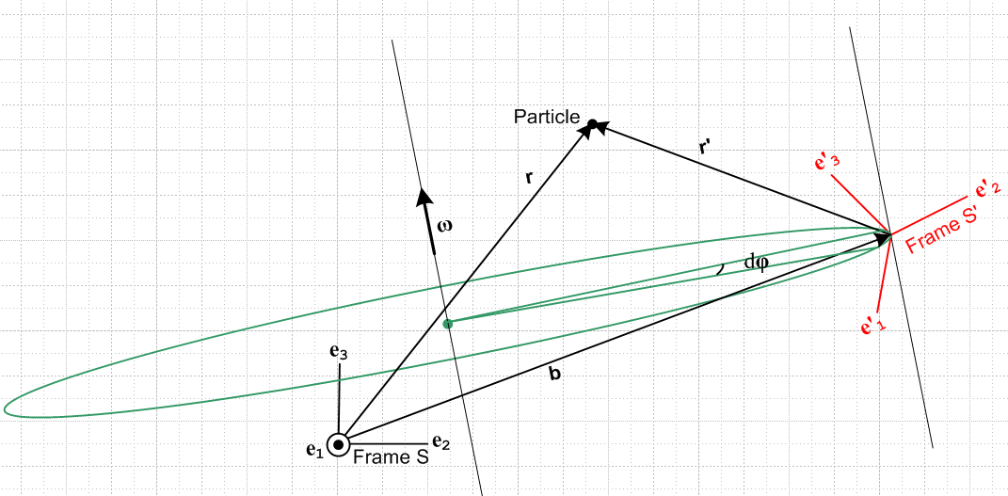 Fig 1

A Particle is located at position r relative to the Frame S origin, and at position r' relative to the Frame S' origin. These vectors are related by r = r' + b where b is a vector connecting the frame origins. Rotation is about some possibly moving axis with some angular velocity ω which might be changing in both direction and magnitude.
This document describes the relationship between the properties of the Particle as measured in these two frames of reference. The entire discussion takes place in a non-relativistic framework where time is the same in the two frames. Even in this limited context, things are fairly complicated.
An important subtopic of the rotating frames discussion might be called "Newtonian mechanics in non-inertial frames" where one considers the fate of F = ma in a non-inertial frame. This is where the famous fictitious forces appear.
Most mechanics textbooks which treat rotating frames, having a multitude of other topics to address, spend 10-20 pages on the subject with the following itinerary: state the G Rule (see below), use it to derive an inter-frame velocity and/or acceleration relation, discuss fictitious forces in a rotating frame with emphasis on the Coriolis force, do a few basic problems, and end up treating the Foucault pendulum. A notable exception is the book of Taylor[1] which devotes 40 pages to the subject including a nice discussion of the tides. (In his book, our frames S and S' are called S0 and S.)
In this document, having the luxury of no space limitations, we try to probe more deeply into the technical nuts and bolts of rotating frames analysis. Almost all calculations are done in line for the reader to see.
The "papal we" mode of presentation is often used below, as if this paper had multiple authors who seem to own the equations, drawings and experiments as their personal possessions. The approved mode of course is to use passive or impersonal sentence constructions as if the author did not exist. Interestingly, Taylor[1] uses the "I mode" which is perhaps more honest and is certainly refreshing.

Summary

Section 1 sets up the notation used throughout the document. As shown in Fig 1, a decision was made that Frame S' is the rotating frame, even though this conflicts with the choice made by many textbook authors. We refer to this notation as our "non-swap" notation and all our development work is done in this notation. One can imagine another version of Fig 1 which has S ↔ S', which is then our "swap" notation. Often it is more convenient to have Frame S be the rotating frame to avoid an avalanche of primes in the equations of interest, and in that case the "swap" notation is more useful. All key results are summaried in Sections 12 and 13 in both "non-swap" and "swap" notations.
Unit basis vectors are ei and e'i for Frame S and Frame S'. A generic vector a can be expanded on either basis. The presence of two frames of reference associates with every vector a another vector a' which leads to the need for a compact notation which distinguishes the components (a')i and (a)'i which are often different. The prime symbol ' plays a central role in the notation and is never used to indicate time differentiation (overdots are used for that purpose).
After considering the meaning of equality for two vectors, we develop the notion of "conical rotational motion" according to = ω x a and then apply that notion to the basis vectors. The need for putting a frame label on the time derivative of a vector (but not a scalar) is demonstrated. It is then shown that the Particle in Fig 1 has four distinct velocities and eight distinct accelerations, reinforcing the need for a precise notation. Finally, it is noted that the operations of computing a time derivative and taking a component generally do not commute.

Section 2 derives and discusses what we call "the G Rule", namely, (da/dt)S = (da/dt)S'+ ω x a where Frame S' rotates at rate ω relative to Frame S and a is an arbitrary vector.

Section 3 describes an Observer and an Apparatus containing a Particle, all of which are in the rotating Frame S'.

Section 4 explains the relationship between Frames S and S' for a general placement of the instantaneous rotation axis about which Frame S' rotates at vector angular frequency ω. Two special cases are identified for the location of this axis, and then three applications are roughly outlined.

Section 5 (which is a single paragraph) states the goal of subsequent sections which is basically to determine how, given Particle properties in Frame S', one may compute these properties in Frame S. The results are eventually summarized in Section 12.

Section 6 derives the relationships among the four velocities mentioned above.

Section 7 derives the relationship among three of the eight accelerations. This and the preceding section are as dry as dust (mud's thirsty sister), but the results are of key importance, so everything is done step by step.

Section 8 addresses the traditional subject of fictitious forces and interprets them. This of course includes the Coriolis force. An arm-waving interpretation of this force is provided for a simple four-projectile problem (on a turntable), and an exact solution to this problem later appears in Section 15. Three applications involving fictitious forces are then considered, but not fully analyzed: problems with moving objects near the surface of the earth, tethered satellites, and ocean tides.

Section 9 relates our notation to that of the texts by Marion[2] (1970), Thornton & Marion[3] [T&M] (2003) and Taylor[1] (2005). It is found that the Marion texts are very close to our "swap" notation.

Section 10 then relates our notation to that of the texts by Goldstein[4] (1950) and Goldstein, Poole and Safko[5][GPS] (2001). It turns out that Goldstein/GPS and Marion/T&M use different velocities and different accelerations in their presentations, a fact that can be somewhat confusing. Furthermore, Goldstein/GPS make an unstated approximation which is declared by Marion.

Section 11 comments on the angular momentum vector L and its time derivative, and notes how these vectors are related in the two frames. The notion of fictitious torques is introduced and an example given.

Section 12 summarizes the set of equations which fulfill the goal stated in Section 5: given properties in Frame S', what are they in Frame S? The results are given in both "non-swap" and "swap" notation.

Section 13 then considers the Inverse Problem: given properties in Frame S, what are they in Frame S'? The inverse equations are first obtained by laboriously inverting those presented in Section 12 (a), and are then obtained by a simple symmetry operation. The Inverse Problem equations are then summarized in both "non-swap" and "swap" notation.

Section 14 briefly adds the complication of having a different orthogonal curvilinear coordinate system in each of the frames S and S'. Up to this point, only Cartesian coordinates have been used in the two frames.

Section 15 treats three "ant on turntable" problems in some detail. In the first two problems, the ant crawls in a certain manner on the turntable as it rotates (Frame S') and the ant's position, velocity and acceleration are computed in inertial Frame S. In the third problem, the ant flies in a straight line in Frame S just over the turntable surface, and the ant's position, velocity and acceleration are computed in Frame S'. Many (hopefully entertaining) Maple trajectory plots are presented, along with the very simple code for these plots. In the final section, the projectile problem of Section 8 (c) is solved as a special case of the third problem, and it is noted that there are hard ways to solve rotation problems that can be avoided.

Appendix A computes a certain matrix R(ξ) which relates spherical unit vectors to Cartesian ones and provides other information related to spherical coordinates.

Appendix B shows how the present document is related to the author's Ref. [6]. For what is called Application 1, the two documents dovetail perfectly, but for Applications 2 and 3 they have a head-on collision. One repair is to call the reference frames A and B instead of S and S', which then results in some rather heavy-handed notation.

Appendix C derives the G Rule for a general tensor of rank-n, leaning on the notation of Ref. [6].

Appendix D discusses the Foucault Pendulum as a limiting case of a Spherical Pendulum.

References are then given for all works mentioned.

1. Notation, important role of the Prime Symbol, and other Preliminaries

(a) The basis vectors en and e'n and two ways in which they are related

Frame S has Cartesian basis unit vectors en, while Frame S' has Cartesian basis unit vectors e'n . The two sets of basis vectors are related by some rotation we shall call R (repeated indices have implied sums),

en = R e'n n = 1,2,3 or (en)i = Rij(e'n)j (1.1)

The above relation between en and e'n can also be written in this manner (a little theorem)

en = (R-1)nm e'm , or e'n = Rnm em , (1.2)

which we prove below in a short series of steps. Notice that the right equation in (1.1) involves a sum of basis vector components, whereas the equations in (1.2) involve a sum of basis vectors.

Step 1: The Cartesian basis vectors have these properties

δn,k = en • ek = e'n • e'k and (en)k = δn,k . (1.3)

where (en)k denotes the components of en in Frame S. Both bases are orthonormal bases.

Step 2: Note that

em • e'n = em • [R-1en] = (em)i (R)-1ij(en)j = δm,i (R)-1ij δn,j = (R-1)mn . (1.4)

Step 3: Our theorem makes this claim:

en = Re'n => en = (R-1)nm e'm .

Dot both sides of the claimed equation into e'k (a complete basis) and use Steps 1 and 2,

en • e'k = (R-1)nm e'm • e'k => (R-1)nk = (R-1)nm δm,k = (R-1)nk .

Since the claimed equation is true in each component k, it must be true as a vector equation.

(b) Expansions of a vector and use of primes and parentheses

Any vector a can be expanded on either set of basis vectors so that, with implied summation on i,

a = ai ei = a'i e'i . ai = a • ei a'i = a • e'i (1.5)

If some other vector named a' is lurking in the wings, one might want to be more careful labeling components. A safe method would be this:

a = (a)i ei = (a)'i e'i (a)i = a • ei (a)'i = a • e'i
a' = (a')i ei = (a')'i e'i (a')i = a' • ei (a')'i = a' • e'i (1.6)

Here, a prime inside a parentheses is part of the vector name, whereas a prime outside a parentheses denotes a vector component in Frame S' (whereas no prime outside means a component in Frame S). Unless the relationship between vectors a and a' has a certain simple form, it is very likely that (a')i ≠ (a)'i . In this case the notation a'i would be ambiguous since one doesn't know whether it refers to (a')i or (a)'i. It is true that the notation ai could be unambiguously identified with (a)i, but we shall maintain the parentheses just to be uniform.

Example 1. As an example of the four expansions above, let us consider a = en :

en = (en)i ei => (en)i = δn,i // by inspection

e'n = (e'n)'i e'i => (e'n)'i = δn,i // by inspection

en = (en)'i e'i => (en)'i = (R-1)ni // using (1.2) that en = (R-1)nm e'm

e'n = (e'n)i ei => (e'n)i = Rni // using (1.2) that e'n = Rnm em

We can now restate these results showing the dot products which represent each expansion coefficient, and in this way we obtain expressions for all the dot products,

en = (en)i ei => (en)i = en • ei = δn,i

e'n = (e'n)'i e'i => (e'n)'i = e'n • e'i = δn,i

en = (en)'i e'i => (en)'i = en • e'i = (R-1)ni = RTni = Rin

e'n = (e'n)i ei => (e'n)i = e'n • ei = Rni (1.7)

Notice that all these results are consistent with claims made earlier

(c) Special case where a'i is unambiguous.

We shall now examine the type of relationship between a' and a in which (a')i = (a)'i and therefore we can use the notation a'i without ambiguity.

First of all, if R is any rotation, meaning RTR = 1, we know that

a • b = [Ra] • [Rb] (1.8)

One line proof:

[Ra] • [Rb] = [Ra]k[Rb]k = RkiaiRkjbj = (RT)jk Rkiaibj = (RTR)jiaibj = δj,iaibj = aibi = a • b

Now, we are going to find the relationship between (a)'i and (a)i in the following manner.

(a)'n = a • e'n = [R a] • [R e'n] // valid for any rotation R as shown above
= [R a] • en // used the specific rotation appearing in en = R e'n
= [R (a)m em] • en // inserted expansion a = (a)m em
= (a)m (Rem) • en // extracted number (a)m from [...]
= (a)m (Rem)k(en)k // wrote out dot product
= (a)m Rki(em)i(en)k // wrote out (Rem)k
= (a)m Rkiδm,iδn,k // used (em)i = δm,i twice
= Rnm (a)m

Therefore we have shown that the (a)'n and (a)n are always related in this manner

(a)'n = Rnm (a)m (1.9)
Now suppose we define a new vector a' in this way,

a' ≡ Ra (1.10)

If a vector a transforms into a' according to (1.10), we say it is a "vector under rotations" which means it "transforms as a vector under rotations".

When written in Frame S components this says

(a')n = Rnm(a)m (1.11)

Comparison of (1.9) and (1.11) shows that

(a)'n = (a')n (1.12)

and therefore in this case we can use

a'n ≡ (a)'n = (a')n (1.13)

Thus, if the vectors a and a' are related by a' = Ra where R is the rotation appearing in en = R e'n , then we can dispense with the parentheses as shown in (12). We still have (a')'i which requires parentheses.

Example 2: Consider equation (1.1) ,

en = R e'n

Since this is not of the form a' ≡ Ra, we may not dispense with the parentheses. In fact from (1.7) we have

(en)'i = Rin
(e'n)i = Rni (1.14)

and these are not the same because rotation matrices are not symmetric.

Example 3: Soon we shall be dealing with an equation r' = r - b. Since this is not of the form r' ≡ Rr , we may not dispense with the parentheses, and we expect that (r')i and (r)'i will be different.

Footnote:[6] More generally, if R is the linearized version of some general transformation x' = F(x) at a point x, so that dx' = R(x) dx, then (1.10) says that a "transforms as a contravariant vector with respect to the underlying transformation F ". In general R(x) is not a rotation and is a function of location. In this document we deal only with R(x) = R = a rotation that is the same at all points in space. It turns out that the notation a'i is unambiguous in this general case as well. The proof of this fact is just as shown above, except the • symbol represents the covariant dot product a • b = ijaibj where is the covariant metric tensor. In this document we always have ij = δi,j.

(d) When are Two Vectors Equal?

This topic will probably seem strange and unnecessary, but it has been a constant annoyance to the author so here are some words on the subject.
When we say two vectors A and B are the same or are equal, we mean that the two vectors have the same components in the same coordinate system and we write A = B. This does not require that vectors A and B coincide. It might be that B is a translated copy of A. To be really fussy, we could define a stronger equality A B to mean that not only do the vectors have the same components in the sense of A = B, but the vectors actually coincide with each other. We shall have no use for A B in this document. For us, two vectors are "the same" even if translated from one another.
In light of this interpretation of vectors being equal, we can examine the meaning of certain statements. For example, we normally say "a particle is located at r in Frame S ". This really means the particle is at point r in Frame S which has coordinates (x,y,z). What this means in terms of the graphic vector r is that if the vector r is translated so that its tail is at the origin of Frame S, then its tip will be at the particle location. The vector r can be drawn anywhere in a picture. It describes the displacement of a particle in Frame S from the origin in Frame S.

Example 4: When we say en = R e'n as in (1) above, it is understood that the tails of all vectors involved (the en and the e'n) are at a common location, as in this picture

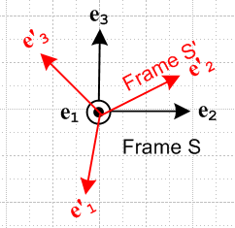 Fig 1.1

even though in our application, the en are drawn with their tails at the origin of Frame S while the e'n are drawn with their tails at the origin of Frame S'.

Example 5: In the expansion r = (r)iei we normally think of vector r having its tail at the origin of Frame S, while in the expansion r = (r')'ie'i one would be inclined to think of vector r as having its tail at the origin of Frame S'. In our stricter sense of coincidence noted above, we might say (r)i ei (r')'i e'i but this is not of interest. What we care about is that (r)i ei = (r')'i e'i in the sense A = B above and we don't care if the vectors A and B are translated relative to one another. What we care about is that the vectors have the same components in any given Frame.

(e) The Small Rotation of a vector about an axis

We do this first algebraically and second geometrically. In the algebraic (linear algebra) approach, the reader must accept a few facts about rotation matrices. The 3x3 matrix which rotates a vector by angle φ about rotation axis according to the right hand rule is given by

R(φ) = exp(-i φ • J) , (1.15)

where the (J)k are 3x3 matrices known as the rotation generator matrices:

J1 = 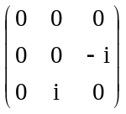 J2 = 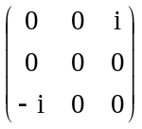 J3 = 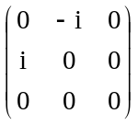 .

The numbers in these three matrices can be summarized in this single statement,

(Jk)ij = - i εkij (1.16)

where ε is the totally antisymmetric permutation tensor defined by

εabc = +1 if abc is an obtained from 123 by an even number of pairwise swaps (such as 312)
εabc = -1 if abc is an obtained from 123 by an odd number of pairwise swaps (such as 213)
εabc = 0 otherwise (ie, when two or more indices have the same value such as 122 or 333) (1.17)

For example, εabc = - εbac regardless of index value. A cross product component can be expressed in terms of the permutation tensor as [a x b]i = εijkajbk with implied sums on j and k.

It is convenient to define a vector rotation angle in this manner

φ ≡ φ (1.18)

and then the rotation (1.15) may be written in these new ways,

R(φ) = R(φ) = exp(-i φ • J) . (1.19)

For a small rotation dφ = dφ , this may be approximated as (using ex = 1 + x + ... but applied to x = matrix)

R(dφ) = exp(-i dφ • J) ≈ 1 - i dφ • J . (1.20)

With these preliminary remarks out of the way, we can consider the rotation of a vector a by a small amount as we move from time t to time t + dt ,

a(t+dt) = R(dφ) a(t) (1.21)

where dφ ≡ dφ is in some arbitrary direction which is unrelated to the direction of the vector a(t) . The change in vector a is given by

da = a(t+dt) - a(t) = R(dφ) a(t) - a(t) ≈ [1 - i dφ • J] a(t) - a(t) = - i dφ • J a(t) = - i dφk Jka(t)

Taking the ith component of the above equation we get

dai = - i dφk[Jka]i = - i dφk(Jk)ijaj = - i dφk( -i εkij ) aj = - εkij dφk aj = + εikj dφk aj

and going back to vector notation we find that

da = dφ x a (1.22)
which is our main result. It tells us the change in a vector a under a small rotation dφ.
Here then is a graphical derivation of this same fact for a limited geometry. Consider this picture

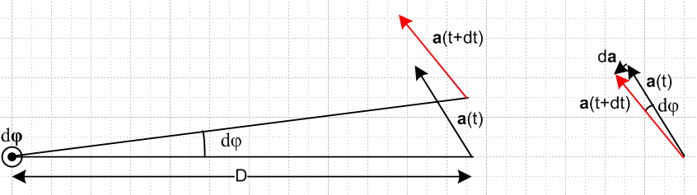
Fig 1.2

where the small rotation vector dφ points out of the plane of paper, and where a(t) happens to lie in the plane of paper (hence this picture does not cover the most general case). Using the right hand rule for cross products, we can see that da (shown on the right) lies in the direction of dφ x a, so we can write that da = C dφ x a where C is some constant. We can determine C from the equation |da| = C |dφ x a| . Since dφ and a are at right angles, we know that |dφ x a| = |dφ| |a| = dφ a. But from the picture on the right it seems quite clear that |da| ≈ a dφ. Therefore

|da| = C |dφ x a| => dφ a = C dφ a => C = 1

so we end up with da = dφ x a which agrees with (1.22). In the case that a does not lie in the plane of paper, the geometric derivation takes more work, and in this case we just rely on the algebraic result. We have made free use of the notion that translated vectors are "equal".
Notice the fact that da = dφ x a does not depend on the distance D between the rotation axis and the tail of vector a! The result is true even if this distance is 0 so that the tail of vector a lies right on the rotation axis. In this case the pair of arrows in the left picture coincides with the pair of arrows in the right picture.

Footnote: The equation R(φ) = exp(-i φ • J) can be interpreted as a rotation in N dimensions with a set of three appropriate NxN generator matrices (Jk)ij. Only when N = 3 is (1.16) valid or even meaningful. In group theoretic language, these NxN matrices Jk form an N-dimensional irreducible representation of the Lie Algebra so(N) which is [Ja, Jb] = iεabcJc. When J is exponentiated as shown in (1.19), the rotations R(φ) are then elements of the Lie Group known as the Rotation Group SO(N). The meaning is Special (det = +1), Orthogonal ( as in RTR= 1), and N dimensions. The vector φ then has N components. For N = 2, the generators are Jk = σk/2 where σk are the so-called 2x2 Pauli matrices associated with "spin 1/2".

(f) The time rate of change of a rotating vector

Note: When an equation is quoted from earlier in the document, the equation number is italicized.

In the previous section we found that,

da = dφ x a (1.22)

Dividing by dt gives

(da/dt) = ω x a where ω ≡ dφ/dt . (1.23)

This equation is a fundamental importance in this document. It describes the rotation of vector a at rate ω about an axis parallel to ω. The equation can be represented by either of these "cone pictures" :

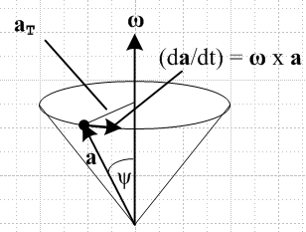 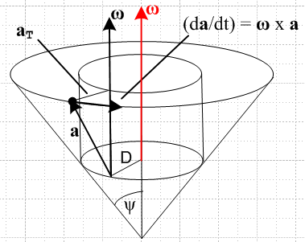 Fig 1.3
(a) (b)
Comments:

1. In (b), the tip of vector a traverses a circular path and so does the tail. The tail is always distance D from the rotation axis. One usually sees the simpler picture (a) where D = 0. Recall from above that distance D of the tail from the rotation axis is irrelevant. The motion of the vector a is exactly the same in both these cone pictures. ( Recall the comments in section (d) about "when are two vectors equal". )

2. It is probably best to describe the rotating motion of vector a as a "conical motion" rather than a "circular motion", even though the tip of vector a travels in a circular motion. In the special case that ψ = π/2, meaning the tip of the cone has moved to the center of its circular end face (and ω • a = 0), then vector a would swing around in a true "circular motion".

3. Note that one might have ω = ω(t) so the vector ω could be changing in both direction and magnitude as time progresses. But at time t we have a definite (t), and this is sometimes referred to as the instantaneous direction of rotation at time t, and ω(t) the instantaneous angular velocity. In everything below, we always think of ω in this instantaneous sense, even though we might draw guide circles and cones to show the instantaneous motion at some instant of time t.

4. Knowledge of vector ω does not in fact say where the rotation axis is located. Again we invoke the comments of section (d) above. There are two translational degrees of freedom in that the rotation axis can be translated parallel to itself in two dimensions. Comparing (a) and (b) above, one sees an example of the same ω but two different rotation axes, one translated relative to the other. In (b) the red and black ω vectors are the same vector. One normally draws the vector ω on the rotation axis as done in red.

5. As noted, in (a) and (b) the conical motion of vector a is the same and is independent of the placement of the rotation axis as long as it is parallel to ω. However, in Figure 1 there is a large change in the physical relationship between Frame S and Frame S' if the rotation axis is translated and ω stays the same.

6. In the case that ω = constant, a simple solution to (1.23) can be obtained. This equation is a system of three coupled first-order linear ordinary differential equations. Writing a = ax + ay + az and ω = ω, the three equations become x = -ωay, y = ωax, and z = 0. Thus x = -ω2ax and we end up with this general solution,

ax(t) = A cos(ωt) – Bsin(ωt) ax(0) = A
ay(t) = A sin(ωt) + Bcos(ωt) ay(0) = B
az(t) = az(0) = C = constant az(0) = C (1.24)

The vector a starts out at some a(0) = (A,B,C) and does the conical motion drawn above, not just in the instantaneous sense, but in the full sense so that a really goes around the entire cone.

(g) Rate of change of the basis vectors

We can apply our rate of change rule (1.23) to the basis vectors e'n to obtain

(de'n/dt ) = ω x e'n .

We are implicitly computing this derivative while "standing" in Frame S. That is to say, looking at Fig 1 in the Introduction above, we can regard Frame S as being fixed to the paper and Frame S' is rotating and its basis vectors e'n are changing as stated above. It is extremely important to make this fact explicit, so we now add a label S showing this fact,

(de'n/dt)S = ω x e'n . (1.25)

Were we to compute this same derivative standing in Frame S', we would get

(de'n/dt)S' = 0 (1.26)

because in Frame S' the basis vectors e'n are not rotating at ω, but are just sitting there frozen. By the same argument, we know that

(den/dt)S = 0 . (1.27)

What about the fourth possible derivative (den/dt )S' ? We will show in (2.9) below that in fact

(den/dt)S' = – ω x en . (1.28)

It seems at least reasonable that if the e'n are rotating relative to the en by ω, then the en are rotating relative to the e'n by -ω.

Main Conclusion: We thus arrive at the notion that, when dealing with multiple frames of reference and vectors represented in terms of their respective basis vectors, we absolutely must indicate with a label the frame in which a time derivative is being calculated.

(h) Notations for the many time derivatives of vectors r, r', b and L

In the Introduction we described r and r' as the position vectors of a Particle with respect to Frames S and S' . We can associate with these two vectors four different time derivatives.

(dr/dt)S (dr/dt)S' (dr'/dt)S (dr'/dt)S' (1.29)

In the usual manner, we represent a time derivative of a vector by an over-dot, and a second time derivative by an over-double-dot. The first time derivative of position r is velocity v, and the second is acceleration a. The same for r', v' and a' , so

v = v' = '
a = = a' = ' = ' (1.30)

In order to save space, we can define these two operators

∂S ≡ (d/dt)S ∂S' ≡ (d/dt)S' (1.31)

Although the ∂ symbol is used in partial differentiation, our use here is exactly as defined above and so our ∂ is not a partial derivative (except in a very abstract sense).

The list of derivatives above can be written now in several ways. In each column below, all objects are exactly the same thing, just written in different notations:

Table of first derivatives of r Table of first derivatives of r'

(dr/dt)S (dr/dt)S' (dr'/dt)S (dr'/dt)S'
S ≡ S' 'S 'S' ≡ '
vS ≡ v vS' v'S v'S' ≡ v'
∂Sr ∂S'r ∂Sr' ∂S'r' (1.32)

For further clutter reduction, we have added the four new notations shown in red according to the following rule: When a vector and all its derivatives (here only one) are all in (or associated with) the same frame, we suppress the frame subscript and just let the prime or lack of it "do the talking", and refer to such as object as being "natural". There is no notational ambiguity in so doing.
The velocities shown in the center two columns above, vS' = (dr/dt)S' and v'S = (dr'/dt)S, shall be referred to as "cross velocities", as distinct from the two "natural velocities".

What about second derivatives? Things are more complicated now because vector r can have four distinct second derivatives, and so can vector r'. Just as done above, we construct a table for each , and in each column of each table, all objects are the same object :

Table of second derivatives of r

∂S∂Sr ∂S∂S'r ∂S'∂Sr ∂S'∂S'r
SS ≡ S ≡ SS' S'S S'S' ≡ S'
SS ≡ S ≡ SS' S'S S'S' ≡ S'
aSS ≡ aS ≡ a aSS' aS'S aS'S' ≡ aS'

Table of second derivatives of r'

∂S∂Sr' ∂S∂S'r' ∂S'∂Sr' ∂S'∂S'r'
'SS ≡ 'S 'SS' 'S'S 'S'S' ≡ 'S' ≡ '
'SS ≡ 'S 'SS' 'S'S 'S'S' ≡ 'S' ≡ '
a'SS ≡ a'S a'SS' a'S'S a'S'S' ≡ a'S' ≡ a' (1.33)

Here we again use the rule mentioned above that when a vector and all its derivatives are in the same frame, we let the overall prime or lack of it do the talking. We have introduced a second rule as well, which says that whenever both frame subscripts are the same, we suppress one of them to save space. In the table above we then have two "natural" accelerations a and a', and six "cross accelerations".

So now we have the following "natural" vectors having minimal (that is, no) frame subscript clutter:

v a natural in Frame S
' v' ' ' a' natural in Frame S'

Recall from the Introduction that the vector b connects the origins of two frames. We can make a table of first and second derivatives for this vector as well. Although is a velocity and is an acceleration, we shall not make up separate symbol names for these objects (though some authors do). Also, note that there is no vector in Fig 1 called b', we just have r = r' + b. Here are the corresponding tables for first and second derivatives of b, where we use only the second rule above that when two frame subscripts are the same we suppress one of them.

Table of first derivatives of b

(db/dt)S (db/dt)S'
S S'
∂Sb ∂S'b

Table of second derivatives of b

∂S∂Sb ∂S∂S'b ∂S'∂Sb ∂S'∂S'b
SS ≡ S SS' S'S S'S' ≡ S' (1.34)

Comment: Just as a reminder, any derivative in the above section can be expanded onto either Frame S or Frame S' basis vectors, so any derivative has Frame S and Frame S' components. This statement would be true for any vector and we just remind the reader that the notation like (dr/dt)S does not mean the components are evaluated only in Frame S. Just as an example, this first derivative has these two expansions where the expansion coefficients (components) are shown on the right,

(dr/dt)S = [(dr/dt)S]i ei [(dr/dt)S]i = (dr/dt)S • ei
(dr/dt)S = [(dr/dt)S]'i e'i [(dr/dt)S]'i = (dr/dt)S • e'i .

Angular momentum. We set mass m = 1, so momentum p = mv = v. One can then think of all L objects below as really being L/m and use that fact to reinsert m's at the end.
The drawing of interest is Fig 2, to which we have added an arbitrary point c,
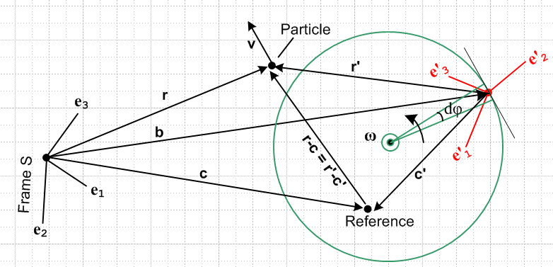 Fig 1.4

Notice from the picture that

b + r' = r b + c' = c r'-c' = r-c

Whereas the linear momentum p of a particle does not require a reference point, angular momentum L does require such a reference point (see Section 11). For example, the Particle in the above figure has many different values of L in Frame S, some of which we might denote as follows,

L(0) = r x v // L in Frame S with respect to Frame S origin
L(c) = (r-c) x v // L in Frame S with respect to Frame S point c
L(b) = (r-b) x v // L in Frame S with respect to Frame S point b
L(b) = r' x v // L in Frame S with respect to Frame S' origin

where the last two lines are exactly the same since b is a vector between the two origins.
Using the general form L(c), we may identify the following two "natural" angular momenta in Frames S and S',

L(c)S ≡ (r-c) x vS = (r-c) x v ≡ L(c)
L'(c')S' ≡ (r'-c') x v'S' = (r'-c') x v' ≡ L'(c') (1.35)

The time derivative of the first of these objects is given by

(c) = (c)S = ∂S L(c)S = ∂S [(r-c) x vS] = (vS - S) x vS + (r-c) x ∂S vS = – S x vS + (r-c) x aS
= – S x v + (r-c) x a .

A similar result is obtained by priming everything on the above line, so we end up with

L(c) = (r-c) x v
(c) = (r-c) x a – S x v

L'(c') = (r'-c') x v'
'(c') = (r'-c') x a' – 'S' x v' (1.36)

These "natural" pairs of objects correspond to each other just the way v and v' correspond. For example an Observer in Frame S will measure L(c) for a Particle with reference to point c, while an Observer in Frame S' will measure L'(c')for that same Particle with reference to that same point in space which he sees as point c' relative to his Frame S' origin.
In the special case that the Frame S and Frame S' origins are permanently aligned (b(t) = 0) and this common origin is selected as the angular momentum reference point (c(t) = c'(t) = 0), we get r = r' and

L(0) = r x v
(0) = r x a

L'(0) = r' x v'
'(0) = r' x a' (1.36a)

The discussion of angular momentum continues in Section 11.

(i) No frame label is needed for d/dt of a scalar function

If one is differentiating a specific component of a vector, such as ai(t) = 3t2, there is no need to add the frame label since the derivative of this function is 6t no matter what frame it is computed in. This is true when differentiating any component of any tensor. That is to say, if Tij..(t) is a component of a tensor, then

(dTij..(t)/dt)S = (dTij..( (t)/dt)S' = (dTij..(t)/dt) . (1.37)

We would like simply to say that the d/dt derivative of any scalar function does not need a label S or S', but the word "scalar" has multiple meanings. In one meaning, any single function f(t) is a scalar function since it is a 1-tuple of functions, but in another meaning (tensorial scalar), only a function which is a rotational scalar is a scalar function, and this would rule out the component of a vector as being a scalar function. We refer to the first meaning in the title of this subsection.

(j) When do operations d/dt and taking a component "commute" ?

Using (1.25) → (1.28), (1.7), and the following other facts,

(eix ej)k = εijk // since (ei)n= δi,n
(ω)'i = Rijωj // (1.9) for ω
(eix e'j)k = εkibRjb (ω)'k // from (1.7)
εkabRiaRjb = εsijRsk // obscure fact about rotation matrices, related to cof(Rij) = Rij

one can compute the following set of time derivative components:

1 [(da/dt )S]j = (d(a)j/dt) // a = (a)iei
2 [(da/dt )S]'j = (d(a)i/dt) Rji
3 [(da/dt )S']j = (d(a)j/dt) – ωk εkij (a)i
4 [(da/dt )S']'j = (d(a)i/dt) Rji – ωk εkim Rjm (a)i
5 [(da/dt )S']'j = (d(a)'j/dt) // a = (a)'ie'i
6 [(da/dt )S']j = (d(a)'i/dt) Rij
7 [(da/dt )S]'j = (d(a)'j/dt) + (ω)'k εkij (a)'i
8 [(da/dt )S]j = (d(a)'i/dt) Rij + (ω)'k εkim Rmj(a)'i (1.38)

The first four are found by expanding a = aiei and the second four by expanding a = (ai)'e'i. The second group can be obtained from the first by doing S ↔ S' (on frame labels and all components), negating ω, and taking R → R-1 = RT.
The details are not so important here as the issue of "commutation". Consider lines 1 and 5,

[(da/dt )S]j = (d(a)j/dt)
[(da/dt )S']'j = (d(a)'j/dt) . (1.39)

In these two cases (only!) we find that these two operations commute with each other

Operation 1: compute (d/dt)X
Operation 2: take the jth Frame X component.

Consider the first line in (1.39). On the left side we first compute the vector (da/dt)S, and second we take the jth Frame S component of the result. On the right side we first take the jth Frame S component of a, and second we compute the derivative. The result is the same either way, so the operations "commute". Recall from section (i) above that the time derivative of a scalar needs no frame label.

For the other six derivatives shown above this is not true because there are extra factors and/or extra terms. We are led to the following theorem:

Commutation Theorem:

(1) In general, the operations of taking a time derivative and taking a component do not commute.

(2) The exception is that the operations do commute if the frame in which the time derivative is computed
is the same as the frame associated with the components which appear on both sides of the equation.

In the first line in (1.39) the time derivative is taken in Frame S, and the components on both sides are Frame S components.

In the second line in (1.39) the time derivative is taken in Frame S', and the components on both sides are Frame S' components. These components are [...]'j and (a)'j.

Goldstein[4] makes this point about non-commutation as a "word of caution" on the bottom of page 133 with an example on the top of page 134. In GPS[5] the caution is stated on page 173, but the example has been removed.

2. The G Rule for arbitrary vector a and its derivation

In this section, a is a generic vector -- it could be any vector.

The "G Rule for vector a" is this (written three equivalent ways)

∂Sa = ∂S'a + ω x a
(da/dt)S = (da/dt)S' + ω x a
S = S' + ω x a (2.1)

where in the first line we use the abbreviations ∂X = (d/dt)X where X is a frame of reference. G is in honor of Herbert Goldstein since the Rule appears on page 133 of his classic 1950 book Classical Mechanics[4] (and he used the vector G instead of our a). Perhaps another name for this rule would be "the rule which relates the time derivatives of a vector taken in two frames of reference S and S' where Frame S is fixed and Frame S' is rotating at instantaneous vector angular velocity ω about some unspecified rotation axis which is parallel to the vector ω".

Equation (2.1) goes by a few obscure names, some people calling it a "transport theorem" or a "basic kinematic equation", but most authors who use it give it no name. The content of (2.1) must have been known to Coriolis[7] in 1835, but the cross product notation was not in use at that time. According to Crowe[8,9], the cross product idea arose gradually from the work of Hamilton (quaternions) and Grassmann (vector areas) as early as the 1840's, and later from work of Gibbs in the 1880's, with the possible involvement of a certain Reverend O'Brien in 1852. In any event, the cross product notation (and bolded vector notation in general) was first introduced to the textbook-reading public when Gibbs gave his student Wilson the task of publishing and improving his notes. Their book Vector Analysis[10], published in 1901, was reprinted 7 times and was then made a Dover book in 1960. It happens, however, that this book makes no mention of the G Rule or even "frames of reference".

Since the G Rule applies to any vector a, sometimes the vector is left out and one writes this operator equation,

(d/dt)S = (d/dt)S' + ω x . (2.2)

In Goldstein's books[4,5] these equations appear as (space = Frame S = s, body = Frame S' = rotating = r)

(dG/dt)space = (dG/dt)body + ω x G // Goldstein p 133 (4-100)
// GPS p 172 (4.82)
(d/dt)space = (d/dt)body + ω x . // Goldstein p 133 (4-102)
(d/dt)s = (d/dt)r + ω x // GPS p 173 (4.86)

Derivation of the G Rule

When one deals with a single specific Cartesian frame of reference, the "facts" quoted below are all obvious, taken for granted, and are easily proven. Nevertheless, we state these facts explicitly.

For any vector v and scalar u, here is Leibniz's Rule when one object is a vector and the other a scalar :

(d[uv]/dt)S = (du/dt) v + u (dv/dt)S S
(d[uv]/dt)S' = (du/dt) v + u (dv/dt)S' S' . (2.3)

The above can be extended to a sum (implied on i) where v(i) is some arbitrary set of labeled vectors,

(d[uiv(i)]/dt)S = (dui/dt) v(i) + ui (dv(i)/dt)S S
(d[uiv(i)]/dt)S' = (dui/dt) v(i) + ui (dv(i)/dt)S' S' . (2.4)

Setting ui = (a)'i and v(i) = e'i we can differentiate a = (a)'ie'i ,

(d[(a)'ie'i]/dt)S = (d(a)'i/dt) e'i + (a)'i (de'i/dt)S S
(d[(a)'ie'i]/dt)S' = (d(a)'i/dt) e'i + (a)'i (de'i/dt)S' S' . (2.5)

Then using the fact (1.25) that (de'i/dt)S = ω x e'i and (1.26) that (de'i/dt)S' = 0, this becomes

(da/dt)S = (d(a)'i/dt) e'i + (a)'i ω x e'i S
(da/dt)S' = (d(a)'i/dt) e'i S' . (2.6)

Insertion of the second line into the first gives

(da/dt)S = (da/dt)S' + (a)'i ω x e'i . (2.7)

But (a)'i ω x e'i = ω x [(a)'i e'i] = ω x a so the above becomes

(da/dt)S = (da/dt)S' + ω x a (2.8)

and our derivation of the G Rule (2.1) is complete. This simple derivation was loosely based on Hunt[11].

Example 1: Suppose a = e'i . Then our rule (2.1) says

(de'i/dt)S = (de'i/dt)S' + ω x e'i

But we noted in (1.26) the obvious fact that (de'i/dt)S' = 0, so the above becomes

(de'i/dt)S = ω x e'i

which agrees with (1.25).

Example 2: Suppose a = ei . Then rule (2.1) says

(dei/dt)S = (dei/dt)S' + ω x ei .

But we noted in (1.27) the obvious fact that (dei/dt)S = 0, so the above becomes

(dei/dt)S' = – ω x ei (2.9)

and we have now derived the claim made in (1.28).

Example 3: Suppose a = ω. Then rule (2.1) says

(dω/dt)S = (dω/dt)S' + ω x ω = (dω/dt)S'

so for this one vector ω both derivatives are the same and we write

(dω/dt)S = (dω/dt)S' ≡ dω/dt = . (2.10)

Example 4. Using the dot notation of (1.30), and assuming there are two related vectors a and a', the G Rule states

S = S' + ω x a that is ∂S = ∂S' + ω x a
'S = 'S' + ω x a' that is ∂S' = ∂S'' + ω x a' (2.11)

Example 5. We can apply this rule to any of the vectors listed in Section 1 (h). Here are a few examples:

S = S' + ω x b (2.12)

S = S' + ω x r or vS = vS' + ω x r
'S = 'S' + ω x r' or v'S = v'S' + ω x r'

S = S' + ω x vS or aS = aS' + ω x vS
'S = 'S' + ω x v'S or a'S = a'S' + ω x v'S (2.13)

Question: Are there any restrictions on the vector a for which the G Rule applies? The only fact used above about a is that a can be expanded on Cartesian basis vectors as a = a'i e'i and that the component fields a'i(t) are differentiable. If the tail of vector a does not lie at the origin of Frame S', we just translate a such that this is the case, as per Section 1 (d).

Significance of the G Rule: In all the computations below, basically the only operations done are these:

• Apply the G Rule to some vector
• Apply ∂S to both sides of some equation
• Apply ∂S' to both sides of some equation

Question: What happens if we instead expand a = aiei? Then similar to (2.5) we have

(d[(a)iei]/dt)S = (d(a)i/dt) ei + (a)i (dei/dt)S S
(d[(a)iei]/dt)S' = (d(a)i/dt) ei + (a)i (dei/dt)S' S' . (2.14)

But using the fact (1.27) that (dei/dt)S = 0 and (2.9) that (dei/dt)S' = – ω x ei we get

(da/dt)S = (d(a)i/dt) ei S
(da/dt)S' = (d(a)i/dt) ei – (a)i ω x ei S' . (2.15)

Inserting the first line into the second and setting (a)i ω x ei = ω x [(a)i ei] = ω x a then gives

(da/dt)S' = (da/dt)S – ω x a (2.16)

which is again the G Rule (2.1) or (2.8).
Finally, the first line of (2.15) can be written as

[(da/dt)S]i = (d(a)i/dt) (2.17)

and the second line of (2.6) can be written as

[(da/dt)S']'i = (d(a)'i/dt) . (2.18)

These are recognized as the two commutating cases in the Commutation Theorem of Section 1 (j). In these cases we can do operations "compute d/dt in Frame X" and "take the ith Frame X component " in either order.

Note: In Appendix C we generalize the G Rule to tensors of arbitrary rank, so the G Rule of this Section is the general case applied to rank 1 tensors (vectors).

3. The Apparatus and its Observer at Rest in Frame S'

In our general "experiment" to be described below, Frame S' is rotating with respect to Frame S. This does not necessarily imply that Frame S is "at rest", but Frame S is at rest with respect to the paper on which we draw Fig 1. If Frame S is truly at rest with respect to the stars, then Frame S is called an inertial frame, and in such a frame Newton's 2nd Law F = ma is valid. We do not in general assume that S is such an inertial frame.
Imagine now that we have some Apparatus sitting in Frame S' which contains a Particle which undergoes some motion. The Particle might be a mass on one or more springs, or it might be Particle in ballistic flight, or it might be a Particle of matter in a gear wheel which is turning in some complicated machine, or it might be a Particle of a fluid or of an elastic solid.
An Observer also sitting in Frame S' has some measurement equipment, can see the axes of Frame S' of course, and does certain measurements on the Particle while Frame S' is rotating with respect to Frame S. The Particle is located at position r in Frame S and position r' in Frame S'. The Observer can see Frame S and is aware of both r and r' and can make measurements of them both.
For example, although r is the position vector of the Particle relative to the Frame S origin, our Observer measures its components in Frame S' this way

r = (r)'ie'i (r)'i = r • e'i

while his measurement of r' reveals these components

r' = (r')'ie'i (r')'i = r' • e'i .

However, the Observer can only measure frame-S' derivatives. From our list we then select these items

vS' = S' = (dr/dt)S'
v'S' = 'S' = (dr'/dt)S' ≡ v' (1.32)

aS' = S' = (dvS'/dt)S' = (d2r/dt2)S'
a'S' = 'S' = (dv'S'/dt)S' = (d2r'/dt2)S' ≡ a' (1.33)

S' = (db/dt)S' rate of change of b as viewed from Frame S' above (1.34)

For example, he might measure the frame-S Particle location r(t) at time t as, wait one time tick dt, then measure it again to get r(t+dt). Then

vS'(t) = [r(t+dt) – r(t)]/(dt) or vS'(t) = (dr/dt)S' .

Alternatively, he could measure r'(t) and r'(t+dt) and get

v'S'(t) = [r'(t+dt) – r'(t)]/(dt) or v'S'(t) = (dr'/dt)S' = v' .

Waiting another dt tick, he could measure r(t+2dt) and r'(t+2dt) and then deduce vS'(t+dt) and v'S'(t+dt). From these in turn he could determine

aS'(t) = [vS'(t+dt) - vS'(t)]/(dt) or aS'(t) = (dvS'/dt)S'

a'S'(t) = [v'S'(t+dt) - v'S'(t)]/(dt) or a'S'(t) = (dv'S'/dt)S' = a' .

At this point he also knows these two angular momentum vectors

LS' = r x mvS'
L'S' = r' x mv'S' (1.35)

and then using the method just outlined he could measure

S' = (dLS'/dt)S'
'S' = (dL'S'/dt)S' . (1.36)

4. The Relationship between the Two Frames S and S'

(a) Explanation of Fig 4.1: Frame S in the plane of paper

The relation between the two frames is shown in this picture, a snapshot at some time t :

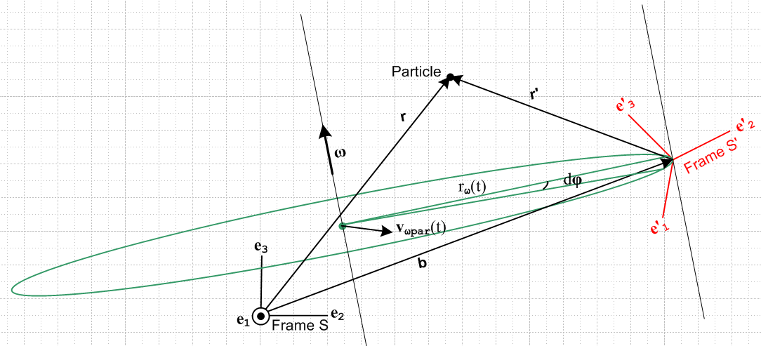
Fig 4.1

There is a lot to be said about this picture (which is the same as Fig 1 in the Overview)

The axes e2 and e3 of Frame S are in the plane of paper and are "aligned with paper" as shown and remain fixed relative to paper, so the Frame S origin lies in the plane of paper. The origin of Frame S' is displaced by amount b from the origin of Frame S, and this S' origin does not lie in the plane of paper. The location of the Particle does not lie in the plane of paper, so vectors r, r' and b , although coplanar with each other, are each not in the plane of paper. Similarly, the ω rotation axis does not lie in the plane of paper nor is it parallel to it.
Frame S' is instantaneously rotating about some axis indicated by ω(t). Each of the basis vectors e'n is rotating according to (1.25), (de'n/dt)S = ω x e'n, as the Frame S' moves rigidly in rotation about the ω rotation axis. The origin of Frame S' is instantaneously rotating along the green circle of some instantaneous radius rω which has its center on the rotation axis at a green dot. This green dot, meanwhile, is moving at some velocity vωpar in the plane of the green circle relative to Frame S. This indicates the motion of the rotation axis parallel to itself.
Suppose Frame S' contains a rigid object fixed relative to the Frame S' axes. If we were to select some point P in that rigid object, that point P would be instantaneously rotating about the ω(t) axis along a circle similar to the one shown above, but which has a different radius and a different center point along the same rotation axis.
If were constant in time and if vωpar were 0, the origin of S' really would move along the full green circle shown, but we have in mind that ω = ω(t) and this varies in time, both in magnitude and direction. Thus, the green circle is itself tilting to stay in a plane perpendicular to ω(t).
Viewed from Frame S, the unit vectors of Frame S' are oriented and move according to several equations we have already dealt with

e'n(t) = R-1(t) en (1.1)

e'n(t) = Rnm(t) em (1.2)

(de'n/dt)S = ω(t) x e'n(t) . (1.25)

(b) Explanation of Fig 4.2: Vector ω pointing directly out of paper

We now draw Fig 4.1 from a different perspective. The reader will hopefully forgive the "artist" for not attempting to draw Fig 4.2 as a precision 3D rotated version of Fig 4.1, but hopefully the general features of the drawing are sufficient for our purposes below.

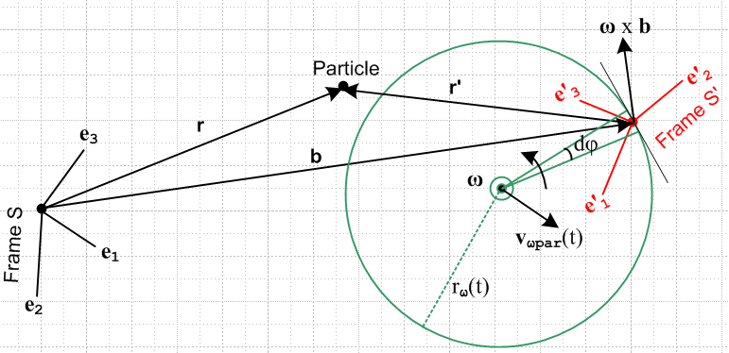
Fig 4.2

Frame S remains fixed as time varies, but is now rotated relative to Fig 4.1 and the S origin no longer lies in the plane of paper. At time t for which the picture is drawn, the origin of Frame S' and the green circle and its center do lie in the plane of paper. The ω vector points straight out at the viewer as indicated by the circled dot. Vectors r, r' b do not lie in the plane of paper.
Fig 4.1 is meant to give the general lay of the land, but Fig 4.2 is the one we will work with below.

(c) Comments on S and S'

The quantity S = (db/dt)S describes the instantaneous velocity of the Frame S' origin relative to that of Frame S. When ω = 0, Frame S' merely translates relative to Frame S with position b, velocity S and acceleration S . When ω ≠ 0, however, for a general placement of the rotation axis one can regard b,
S and S as quantities derived from the location and movement of that axis and from the value of ω, all of which one imagines are controlled by some mechanical outside agency. An exception is Special Case #2 below where the rotation axis passes through the Frame S' origin.

The quantity S' = (db/dt)S' is a "cross velocity" in the sense of Section 1 (h) and is difficult to interpret. In Special Case #1 below, however, the vector b is effectively glued to the Frame S' axes and S' = 0, causing simplification of several equations which will be obtained below.

The connection between S and S' is provided by the G Rule for vector b,

S = S' + ω x b . (4.1)

In Section 7 (e) we derive the relationship between accelerations S = ∂SS and S' = ∂S'S' .

(d) Special Case #1 : ω axis through Frame S origin

The rotation axis always passes through the origin of Frame S, so Fig 4.2 appears as follows,

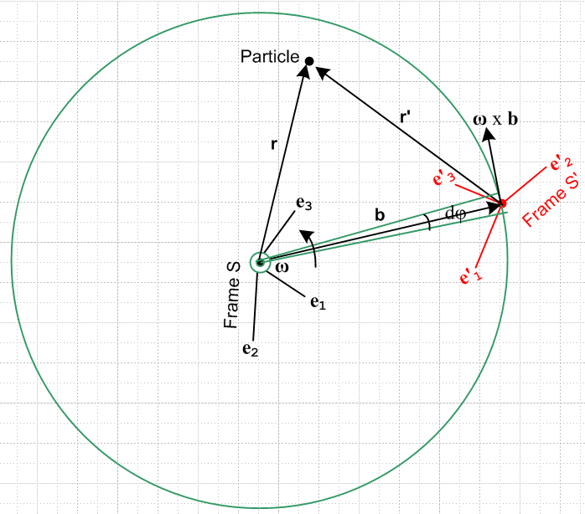 Special Case #1
Fig 4.3

The Frame S' origin and the green circle are still in the plane of paper, but the Frame S origin is in general not, so vector b is not in the plane of paper. In this situation, the vector b and the vectors e'n all rotate together as if they were thin metal rods soldered together. This has the immediate implication that, just as (de'n/dt)S' = 0 in (1.26), so we have

S' ≡ (db/dt)S' = 0 (4.2)
and therefore, from (4.1), we have instantaneous conical motion for b,

S ≡ (db/dt)S = ω x b . (4.3)
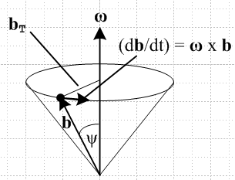 Fig 4.4

This says that, as seen in Frame S, the change in b is always perpendicular to b, so the length of b does not change. We still allow ω = ω(t) and, as (t) changes, the tip of vector b (which is the origin of Frame S') describes some path on the surface of a sphere of radius b in Frame S. Here we allow (t) to change, but the rotation axis must always touch the Frame S origin.

(e) Special Case #2 : ω axis through Frame S' origin

Here the rotation axis always passes through the origin of Frame S' :

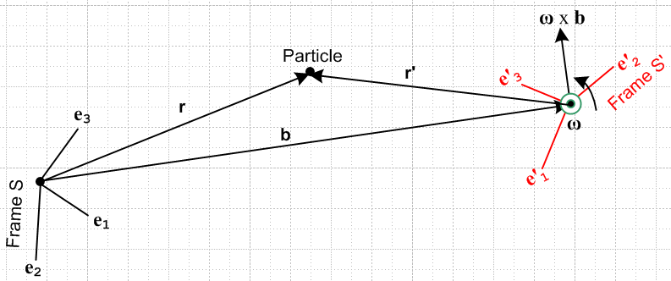 Special Case #2
Fig 4.5

In this case our Fig 4.2 green circle has shrunk around the Frame S' origin. In this situation, we can think of the "driving parameters" being the three parameters of b and the three parameters of ω giving the 6 independent (Galilean) parameters defining the instantaneous relationship between the frames. Think of Frame S' as a camera platform which is supported on a boom b(t) and which independently controls its own orientation and rotation ω(t). Then S and S are determined by b(t), and S' is given by (4.1) as

S' = S – ω x b . (4.4)

We now look at three sample applications. The first two fall into the Special Case #1 category, while the third is an example of Special Case #2.

(f) The Turntable

Although obsolete, the phonograph turntable continues to provide an excellent visualization of rotating frames. It turns slowly enough for one to actually see it turn, it is fairly large, and the surface is not shiny and completely featureless. It is believed that throughout history such turntables normally rotated clockwise in both hemispheres of the earth, but in our drawings below we shall think of our turntable as turning counterclockwise.
 Fig 4.6

An ant (Particle) is crawling around on such a turntable which is rotating with some ω(t). The Frame S' is set up some distance b = |b(t)| from the spindle, and has its e'1 axis pointing "to the right" and its e'2 axis pointing to the spindle. That is to say, e'1 = and e'2 = - if we think of r,θ as polar coordinates for fixed Frame S. In this application, ω(t) = ω(t)e3 and the rotation axis passes though the origin of Frame S, so this is a Special Case #1 situation with (t) = e3 being constant. Conversely, vector b(t) maintains its magnitude b, but (t) rotates about the spindle at angular rate ω(t) as seen from Frame S which is at rest.

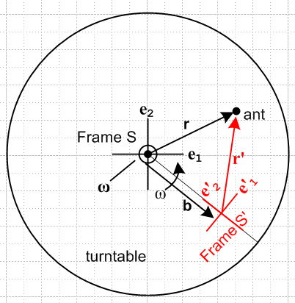 Fig 4.7

This type of Frame S' designation would be familiar to merry-go-round riders hanging on and facing the center. While once in Sydney, the author rode "The Rotor" for which Frame S' can be regarded as being at the cylindrical wall to which the rider is glued by centrifugal force (the circular floor then drops away).

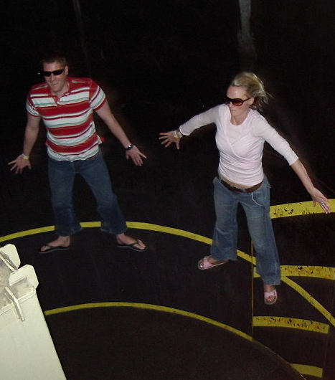
(wiki) Fig 4.8

In Section 15 we shall solve three "ant on turntable" problems using the above geometry.

(g) The earth

The non-rotating Cartesian Frame S is located at earth center with e3 pointing to the North Pole. The e1 axis points out through a point on the equator to some fixed distant star (Star 1), and then e2 is the third Cartesian axis which points out through a different point on the equator to Star 2. If we ignore the earth's orbiting around the sun, and the motion of the Orion spiral galactic arm containing the sun, and the motion of the Milky Way galactic center and so on, then Frame S is an inertial frame.

(continued on next page)

Rotating Frame S' has its origin at some arbitrary fixed point on the surface of the earth. For this system, the e'3 axis points "up", meaning in the direction for Frame S spherical coordinates. The e'1 axis points to the east, and the e'2 axis points north.
The earth rotates at some ω = ωe3 with ω > 0. Since the ω axis passes through the Frame S origin, this is a Special Case #1 application.
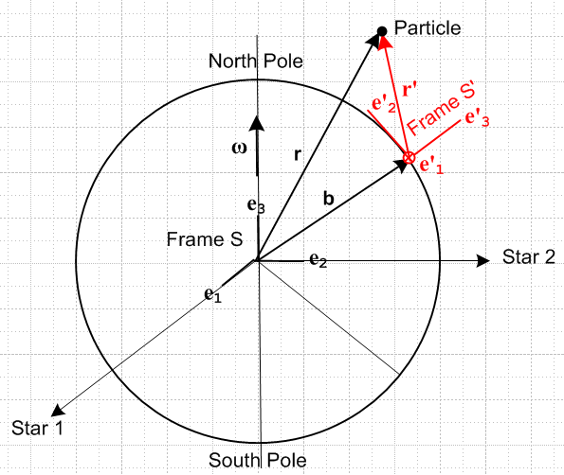
Fig 4.9

Figure 4.9 and the discussion of this section are in the "non-swap" notation mentioned in at the start of the Summary section at the start of this document. In practice, one usually uses the "swap" notation S↔S' for earth problems in order to avoid the appearance of primes in equations. This will be done in Appendix D concerning the Foucault pendulum.

(h) The Flying Camera Platform

Some Apparatus is located in Frame S instead of S', and Frame S' is a "camera platform" which flies around in some complicated way and observes the activity in Frame S. In this case, both ω(t) and b(t) would be under the command of the pilot of the camera platform. One would set this up as a Special Case #2 situation, so ω passes through the Frame S' origin and S is the velocity of the platform origin and b(t) is its location relative to Frame S. One would use the "inverse problem" equations given below to get the primed quantities in terms of the unprimed ones.

5. The Goal of the next two sections

The symbols appearing here are defined in Section 1 (h).

An Observer in Frame S' measures various properties of a Particle in motion,

r' v' a' L'(c') '(c')

We want to know how these properties of the Particle appear in Frame S,

r v a L(c) (c)

and we want to know the various other v and a forms of Section 1 (h) in terms of the basic Frame S' objects listed above.
Later in Section 13 we will want to know how to solve "the inverse problem" of finding the primed quantities if the unprimed ones are known.

6. Determination of velocities

The notations used here are described in Section 1 (h). There are four distinct velocities, and we want to express three of them in terms of the fourth which is the natural velocity in Frame S',

(dr'/dt)S' = v'S' ≡ v' .

We shall make frequent use of the Fig 1 relationship between r and r',

r = r' + b (6.1)

as well as the G Rule for vector b, as in (4.1),

S = S' + ω x b . (6.2a)

Inserting (6.1) as b = r - r' into (6.2a) gives identity

S + ω x r' = S' + ω x r . (6.2b)

(a) Velocity vS'

Apply (d/dt)S' to (6.1) to get (6.3a), then use (6.2a) to get (6.3b) :

vS' = v' + S' (6.3a)
vS' = v' + S – ω x b (6.3b)

(b) Velocity v ≡ vS

Apply (d/dt)S to (6.1) to get ∂Sr = ∂Sr' + ∂Sb or

v = v'S + S . (6.4)
Now use the G Rule (2.1) for vector r' to get

v'S = v' + ω x r' (6.5)

Insert (6.5) into (6.4) to get the first line below. The second and third lines make use of (6.2a) and (6.2b) .

v = v' + ω x r' + S (6.6a)
v = v' + ω x r' + S' + ω x b (6.6b)
v = v' + ω x r + S' (6.6c)

(c) Velocity v'S

Solve (6.4) for v'S,

v'S = v – S (6.7)

and then insert (6.6a) into (6.7) to get the first line below (the S terms cancel),

v'S = v' + ω x r' (6.8a)
v'S = v' + ω x r – ω x b (6.8b)
v'S = v' + ω x r + S' - S (6.8c)

The remaining two lines come from using (6.1) and (6.2b).

(d) Velocity Summary

v = v' + ω x r' + S = v' + ω x r + S' (6.6a,c)
vS' = v' + S – ω x b = v' + S' (6.3b,a)
v'S = v' + ω x r' (6.8a)

(e) Velocities for Special Cases

These cases were discussed above in Section 4 (d) and (e).

For Special Case #1, where the ω axis passes through the Frame S origin, in any equations above set

S' = 0
S = ω x b (6.9)

and then the section (d) summary becomes

v = v' + ω x r Special Case #1 only (6.6a)
vS' = v' Special Case #1 only (6.3b)
v'S = v' + ω x r' general (6.8a)

For Special Case #2, where the ω axis passes through the Frame S' origin, S is a driving parameter, so we select just the S forms from the summary

v = v' + ω x r' + S general (6.6a)
vS' = v' + S – ω x b general (6.3b)
v'S = v' + ω x r' general (6.8a)

(f) Comments

1. Consider these two results from above (picked more or less at random)

r = r' + b (6.1)
v = v' + ω x r + S' (6.6c)

Either equation can be "evaluated" in either Frame S or Frame S'. Evaluation in Frame S gives

(r)i = (r')i + (b)i
(v)i = (v')i + εijk(ω)j(r)k + (S')i

while evaluation in Frame S' gives

(r)'i = (r')'i + (b)'i
(v)'i = (v')'i + εijk(ω)'j(r)'i + (S')'i .

This is a situation where we fully expect to have (r')i ≠ (r)'i and (v')i ≠ (v)'i as mentioned in Section 1 (b), so the careful placement of primes is important.

2. Based on the equations above, it is clear that we have

r' ≠ Rr v' ≠ Rv

where R is the rotation appearing in (1.1) which relates our two frames, en = R e'n . Therefore, in general the pairs of vectors (r,r') and (v,v') are not "vectors under rotations" in the sense of (1.10).

3. On the other hand, the vectors ω and b appearing in these formulas are normal "vectors under rotations" in the sense of (1.10), since we just define b' and ω' by these equations,

b' = Rb ω' = Rω . (6.10)

These equations just indicate that the vectors ω and b have different components when viewed from Frame S' versus when viewed from Frame S. For these vectors, according to Section 1 (c), we can use b'i and ω'i without the need for parentheses :

b = biei = b'ie'i ω = ωiei = ω'ie'i (6.11)

7. Determination of accelerations

The notations used here are described in Section 1 (h). There are eight distinct accelerations of interest, and we could express seven of them in terms of the eighth which is the natural acceleration in Frame S',

(da'/dt)S' = a'S' ≡ a' .

To spare the reader, we shall only express the three accelerations a'S , a ≡ aS, and aS' in terms of a'.

(a) Acceleration a'S

The G Rule for v'S says

∂Sv'S = ∂S'v'S + ω x v'S
or
a'S = a'S'S + ω x v'S . (7.1)

Notice the unusual cross derivative a'S'S which involves both S and S'. This is one those cross accelerations appearing in (1.33). To compute this, we must go back to the G Rule for r',

v'S = v' + ω x r' (6.8a)

Apply ∂S' ≡ (d/dt)S' to both sides to get

∂S'v'S = ∂S'v' + ∂S'(ω x r') = ∂S'v' + x r' + ω x (∂S'r')
or
a'S'S = a' + x r' + ω x v' (7.2)

where we used (2.10) that (dω/dt)S = (dω/dt)S' ≡ . We can now install (7.2) into (7.1) to get

a'S = [a' + x r' + ω x v'] + ω x v'S (7.3)

Now replace v'S in the last term using the G Rule for r' [ (6.8a) a few lines above ]

a'S = [a' + x r' + ω x v'] + ω x [v' + ω x r' ]
or
a'S = a' + x r' + 2 ω x v' + ω x (ω x r') . (7.4)

The famous "Coriolis factor of 2" has now appeared and will be trivially transferred into aS in the next section. It is useful to review the steps above to see where this factor of 2 comes from :

1. Write the G Rule for v'S a'S = a'S'S + ω x v'S
2. Write the G Rule for r' v'S = v' + ω x r'
3. Insert 2 into 1 a'S = a'S'S + ω x v' + ω x (ω x r') // 1st ω x v' term
4. Apply ∂S' to 2 to get a'S'S = a' + x r' + ω x v' // 2nd ω x v' term,
5. Install 4 into 3: a'S = [a' + x r' + ω x v'] + ω x v' + ω x (ω x r')

and now we have two ω x v' terms and only natural Frame S' objects r', v' and a'.

(b) Acceleration a ≡ aS

Start with (6.4) which is ∂S applied to r = r' + b ,

v = v'S + S (6.4)

Apply ∂S again to get

a = a'S + S (7.5)

Then insert (7.4) for a'S into (7.5) to get the same result as (7.4) with S tacked on,

a = a' + x r' + 2 ω x v' + ω x (ω x r') + S (7.6a)
S S' Euler Coriolis centripetal frame

We have attached a name to each contribution to a and will discuss these terms below. Since we really want all primed objects on the right side, we can anticipate the result (7.11) derived in section (e) below,

S = S' + x b + 2ω x S' + ω x (ω x b) (7.11)

to get this alternate form for a ,

a = a' + x r' + 2 ω x v' + ω x (ω x r') + [S' + x b + 2ω x S' + ω x (ω x b) ]

= a' + x r + 2 ω x v' + ω x (ω x r) + 2ω x S' + S' (7.6b)

where we think here of r as just a shorthand for b + r' to reduce the number of terms.

(c) Acceleration aS'

Start with (6.3a) which is ∂S' applied to r = r' + b,

vS' = v' + S' (6.3a)

Apply ∂S' again to get

∂S'vS' = ∂S'v' + S'
or
aS' = a' + S' (7.7)

(d) Acceleration Summary

a = a' + x r' + 2 ω x v' + ω x (ω x r') + S (7.6a)
a'S = a' + x r' + 2 ω x v' + ω x (ω x r') (7.4)
aS' = a' + S' (7.7)

(e) Relation between S and S'

Write the G Rule for S' then solve it for S'

∂SS' = S' + ω x S'
S' = ∂SS' – ω x S' . (7.8)

Now apply ∂S to (6.2a) then solve for ∂SS',

S = ∂SS' + ∂S (ω x b)
∂SS' = S – ∂S (ω x b) . (7.9)

Insert (7.9) into (7.8) to get the first line below, then use (6.2a) to get the second line,

S' = [ S – ∂S (ω x b)] – ω x S'
= S – ∂S (ω x b) – ω x [S – ω x b]
= S – x b – 2ω x S + ω x (ω x b) (7.10)

The inversion of this equation may be found by using (6.2a), S = S'+ ω x b,

S' = S – x b – 2ω x [S' + ω x b]+ ω x (ω x b)

= S – x b – 2ω x S' – ω x (ω x b)

so then

S = S' + x b + 2ω x S' + ω x (ω x b) . (7.11)

In a Special Case #1 problem we have S' ≡ 0 so that

S = x b + ω x (ω x b) Special Case #1 (7.12)

8. The Fictitious Forces

(a) Development of the Fictitious Forces

We start with (7.6a) which says

a = a' + x r' + 2 ω x v' + ω x (ω x r') + S (7.6a)
S S' Euler Coriolis centripetal frame

Newton's law in inertial Frame S says ( m = mass of the Particle)

F = ma (8.1)

with a given as above in (7.6a), so that, reordering the 5 terms,

F = ma = mS + ma' + mω x (ω x r') + 2m ω x v' + m x r' . (8.2)

Now suppose we imagine an "effective" version of Newton's Law that works in rotating Frame S',

F'eff = ma' . (8.3)

Solving (8.2) for ma' tells us that (second line uses (8.1))

ma' = F'eff = F – mS – mω x (ω x r') – 2m ω x v' – m x r' (8.4a)
ma' = F'eff = ma – mS – mω x (ω x r') – 2m ω x v' – m x r' (8.4b)

We can write the second equality in (8.4a) as

F'eff = F + F'fict where (8.5)
F'fict = – mS – mω x (ω x r') – 2m ω x v' – m x r' (8.6)
frame centrifugal Coriolis Euler

Here F'fict represents "fictitious" forces ("pseudo" forces) that mysteriously have to be added to "real forces" F to make our bogus (8.3) "Newton's Law" F'eff = ma' be valid in Frame S'.
If in some problem the force mS can be neglected compared to all other forces, we can write

F = ma ≈ ma' + mω x (ω x r') + 2m ω x v' + m x r' (8.2)approx

ma' = F'eff ≈ F – mω x (ω x r') – 2m ω x v' – m x r' (8.4a)approx

ma' = F'eff ≈ ma – mω x (ω x r') – 2m ω x v' – m x r' (8.4b)approx

F'eff = F + F'fict (8.5)

F'fict ≈ – mω x (ω x r') – 2m ω x v' – m x r' (8.6)approx
centrifugal Coriolis Euler

As we shall see in section (d), this list of approximate equations is not too relevant for "earth problems", but we write the above list mainly for our comparison with Marion and Goldstein given below.

(b) Interpretation of the Centrifugal and Euler Fictitious Forces

Comment: Most books properly focus on the Coriolis term and neglect the other two terms with a casual comment that the centrifugal term is the usual term one expects for a problem involving an object on the rotating earth. Since these books have r ↔ r' , one sees the term ω x (ω x r) and vaguely associates this with the obvious rotation of a Particle on the earth's surface about the central axis of the earth. This is of course a wrong association, since r' in (8.6) is a local vector in Frame S' having nothing to do with the long vector r to the center of the earth (see Fig 4.9). So here we seek an interpretation of ω x (ω x r') where r' is the short vector to the Frame S' origin.

Consider our general Fig 4.2 picture from above, where ω points directly at the viewer,

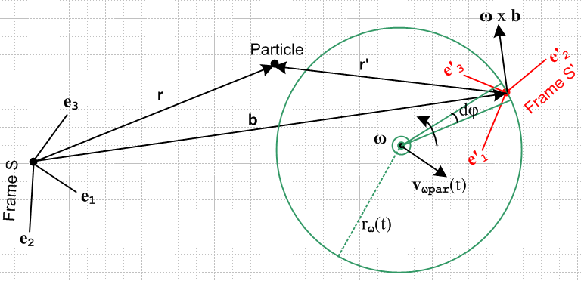 Fig 8.1

Suppose in the above picture v' = 0. Then (8.6) becomes

F'fict = – mS – mω x (ω x r') – m x r' .
frame centrifugal Euler

The – mS fictitious force arises from the acceleration of the origin of Frame S' relative to the origin of Frame S and needs no further comment. This term is non-vanishing in the discussion below.
We now consider the centrifugal and Euler forces at the same time. As usual, all rotations are "instantaneous" since the rotation axis and vector ω may be changing.
Since v' = 0, as seen from Frame S' the vector r' shown above is fixed and so is our Particle. Vector r' is "soldered" to the e'n basis vectors. In Frame S, both ends of the vector r' are moving so it is not quite obvious what the vector is doing. To clarify the situation, consider this simplified view extracted from the above drawing (below right). Each end of the vector r' is rotating about the ω rotation axis. The two ends of r' rotate on different circles in different planes, but at the same angular frequency ω.

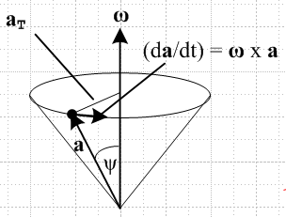 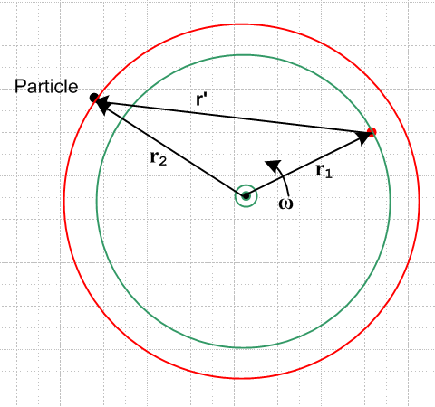 Fig 8.2

Here the red circle perhaps lies above the plane of paper while the green one lies in the plane of paper, so that r1 lies in the plane of paper but r2 does not. Regardless, we know that the following conical motion equations apply (as in (1.23) which says (da/dt)S = ω x a for rotation in Frame S) ,

(dr1/dt)S = ω x r1 // r1 + r' = r2 => r' = r2 – r1
(dr2/dt)S = ω x r2 . (8.7)

These equations are just the G rule (2.1) applied to vectors r1 and r2, since r1 and r2 are fixed in Frame S'

∂S'r1 = ∂S'r2 = 0 .

Subtracting the second equation from the first and using r' = r2 – r1 tells us that (dr'/dt)S = ω x r' so we can then apply our generic cone picture to r' as well :

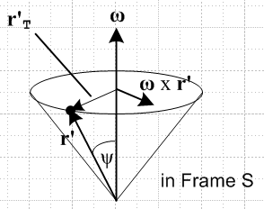 Fig 8.3

(dr'/dt)S = ω x r' = v'S . (8.8)

Since ∂S'r'= 0, (8.8) is just the G Rule for vector r', so that would be a more direct way to obtain this result, but hopefully the previous picture of rotating r' is useful. This cone picture is what we get if we maintain the Frame S motion of vector r' in Fig 8.1 or 8.2, but we translate r' so its tail lies fixed on the ω rotation axis.
Now apply ∂S to (8.8) to get

(d2r'/dt2)S = ∂S(ω x r') = ω x (dr'/dt)S + x r'
or
a'S = ω x v'S + x r' = ω x (ω x r') + x r' . (8.9)
Suppose in the disk at the top of the cone we define temporary polar coordinates r,θ in the obvious manner. Then we have

ω x r' = ω r' sinψ = ω r'T
so
ω x (ω x r') = ω r'T ω x = - ω2r'T // centripetal acceleration (8.10)

This is then recognized as the usual - ω2R centripetal (center seeking) acceleration for motion around a circle of radius R = r'T.
Meanwhile, for the special case that and ω point in the same direction we have

x r' = r' sinψ = r'T // Euler acceleration (8.11)

which is the expected result, say, for a static ant at R = r'T on an accelerating turntable.
Thus we have "interpreted" the centripetal and Euler acceleration contributions as promised. Since r' and therefore our Particle are fixed in Frame S', and since the Particle nevertheless feels both these accelerations, it ascribes to these forces a fictitious nature.
If one stands on a carpet that is being accelerated ac to the right, one feels there is a force -mac shoving him or her to the left, an example of a fictitious force. Thus, given our two fictitious accelerations above, we multiply by mass m and add a minus sign to get the fictitious forces,

F'fict = – mω x (ω x r') – m x r' + frame + Coriolis
centrifugal Euler

Anyone who as ridden on an accelerating merry-go-round is familiar with both the centrifugal and Euler forces.
When is not in the same direction as ω, we still have equation (8.8) and its (d/dt)S derivative (8.9) so the Euler acceleration is x r'. In this case, we can draw a version of the cone picture above with ω replaced by and some different cone angle φ, as shown on the right below. The Euler acceleration is thus tangential to the circle (red arrow) which forms the top of the cone in this picture.

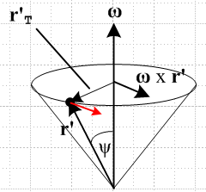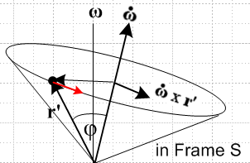
Fig 8.4

Notice that the vector r' is in exactly the same location in both these pictures. In terms of the cone picture on the left, the red Euler acceleration arrow is at some inscrutable angle relative to the cone.

(c) Interpretations of the Coriolis Fictitious Force

Qualitative Arm-Waving Interpretation of the Coriolis Force

The Coriolis fictitious term is always the main topic of any textbook or web page which deals with motion in rotating frames, so we won't have much to say about it other than to give a popular qualitative explanation of the direction of the effect. We did show very carefully how the factor of 2 arises in the derivation of the term which is F'cor = -2m ω x v', and indeed, the expression itself was derived in full. The careful reader will notice a certain amount of "free play" in the workings of what follows.

Consider the pictures below where we launch four colored projectiles horizontally from a launch platform that is screwed to a frictionless turntable surface (perhaps the projectiles are hockey pucks). Fixed Frame S and rotating Frame S' have a common origin at the spindle. The launching is done in rotating Frame S' and the projectiles are sent off in the four directions of the compass at equal speeds V. These velocities are represented by the four black arrows in the right side picture below. The colored arrows on the left show the initial Frame S velocities of these projectiles. In Frame S the initial v's are not the same size because the turntable adds an upward tangential amount vt to each (vt = aω). Since Frame S is an inertial frame, we can regard the colored arrows on the left as also representing the straight-line trajectories of the projectiles in Frame S.

So, each projectile is launched with the same initial adder vt in Frame S and, being in free flight, maintains that vt during its flight. Notice that three of the projectiles move into to a region of larger radius, while the orange one heads to a smaller radius region. When a projectile moves to a larger radius, the particles of the turntable move faster CCW than the projectile's vt causing a velocity differential between the turntable and the projectile. We want now to examine this differential in the four cases. The short black arrows on the left show the motion of the turntable particles relative to the projectile, as will now be reviewed.

(continued on next page)

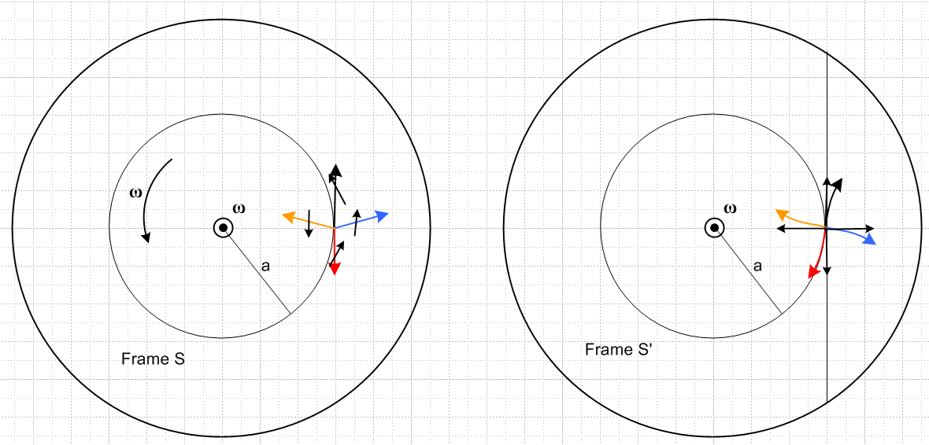
Fig 8.5

For the black projectile in mid flight, the turntable particles under the projectile are moving to the northwest relative to the projectile, so the projectile is seen by the turntable particles to be drifting to the right. Hence the curved black trajectory path on the right of Fig 8.5. On the left below is a crude strobe picture where a turntable particle's path in Frame S is shown in red and the arrows are then transferred to the right with a common tail to show what projectile motion the turntable particle sees in its rest frame.

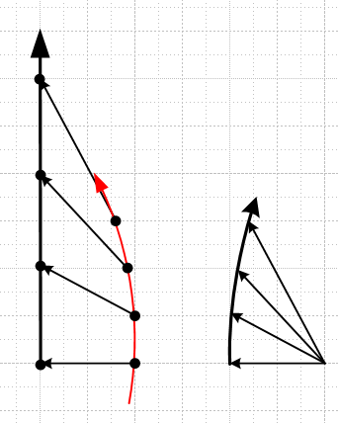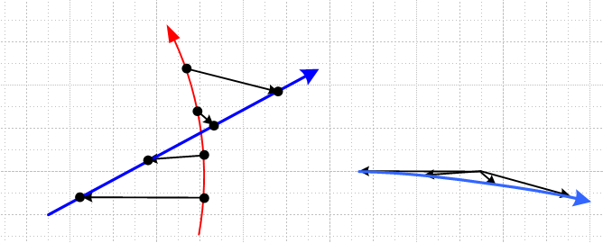

For the blue projectile in mid flight, the turntable particles under the projectile are moving to the north relative to the projectile, so the projectile is seen to be drifting south. Hence the curved blue trajectory path on the right of Fig 8.5. The right strobe picture above shows this effect.

For the red projectile in mid flight, the turntable particles under the projectile are moving to the northeast relative to the projectile, so the projectile is seen to be drifting to the left. Hence the curved red trajectory path on the right.

For the orange projectile in mid flight, the turntable particles under the projectile are moving to the south relative to the projectile (these particles are at a smaller radius and move more slowly than vt), so the projectile is seen to be drifting to the north. Hence the curved orange trajectory path on the right.

Viewed from the direction of launch in Frame S', all four trajectories drift "to the right". This is in agreement with the right hand rule applied to our expression F'cor = -2m ω x v' = +2m v' x ω. What is not particularly obvious from the above qualitative discussion is that the |F'cor| is exactly the same for all four projectiles, and indeed for a projectile launched in any direction.

Comments:

1. If the turntable were going CW instead of CCW, the drift directions would all be reversed, both by the qualitative argument, and by the F'cor expression. Projectiles would drift to the left instead of to the right.

2. One can think of Fig 8.5 as a view of the earth from the North Pole. In this case, the vectors do not lie in the plane of paper, but qualitatively the conclusion is the same: projectiles drift to the right in the northern hemisphere. A view from the South Pole would then show drift to the left in the southern hemisphere since ω is reversed.

3. The colored trajectories on the right in Fig 8.5, when applied to air masses moving into a region of Low pressure, look like this

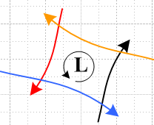 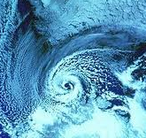 Fig 8.6

and explain why lower pressure regions are CCW cyclonic in the northern hemisphere. Since lows often drift to the east in the western US, warm Mexican air is felt prior to the low's arrival, and cool Canadian air is felt afterwards.

Superposition Interpretation of the Coriolis Force

Recall now the fictitious forces seen by the projectiles in Fig 8.5,

F'fict = – mS – mω x (ω x r') – 2m ω x v' – m x r' . (8.6)
frame centrifugal Coriolis Euler

Since the Frame S and Frame S' origins align, b = 0 and S = 0 . If we assume ω = constant, and express the centrifugal term in a simpler form, then the projectiles are controlled by

F'fict = mω2r' – 2m ω x v' . (8.6)'
centrifugal Coriolis

One can think of this as the superposition of two problems. The centrifugal term alone accelerates the projectiles radially outward in proportion to their distances from the turntable center, so the effect of this term is different for the four projectiles as they progress in flight. The Coriolis term alone causes each projectile to deflect to its right (ω > 0) along a path that is part of a circle as we now show. Recall the bogus Newton's Law F'fict = ma' from (8.3) where a' = (dv'/dt)S'. If F'fict = – 2m ω x v' alone, then we have

(dv'/dt)S' = Ω x v' where Ω = (-2ω) .

According to (1.23) and Fig 1.3 vector v' must rotate on a cone whose axis is Ω. For the turntable situation, however, v' is always in the plane of the turntable, so that cone must be flat, so vector v' goes in a circle at rate Ω. The trajectory r'(t) is then also circular so the Coriolis deflection is part of a circle. Here is some Maple code illustrating this fact for the blue projectile where v'(0) = V', ω = +1, a = 1,V = 1 :

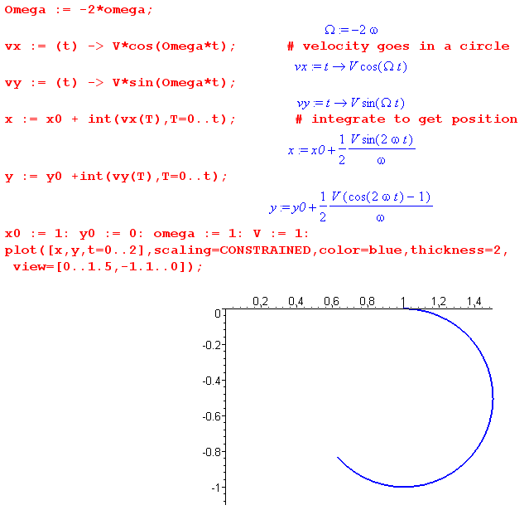

The projectile is deflected "to the right" in this case since ω > 0.
The actual deflection of the four projectiles is then a superposition of the centrifugal and Coriolis motions and is therefore not perfectly circular. We shall solve this problem exactly in Section 15 (e) and plot the all four projectile trajectories.

(d) Special Case #1 Problems

Recall from (8.4a) that

F'eff = F – mS – mω x (ω x r') – 2m ω x v' – m x r' (8.4a)
frame centrifugal Coriolis Euler

If the rotation axis passes through the center of Frame S, we know from (7.12) that

S = x b + ω x (ω x b) Special Case #1 (7.12)

so that, using r = r' + b (6.1) in the third line below,

F'eff = F – m[ x b + ω x (ω x b)] – mω x (ω x r') – 2m ω x v' – m x r'

= F – m ω x (ω x [b +r' ]) – 2m ω x v' – m x [b + r']

= F – mω x (ω x r) – 2m ω x v' – m x r Special Case #1 (8.12)

Problems involving the motion of objects on or near the earth's surface, or of objects in orbit around the earth, fall into Special Case #1. In the first problem class, Frame S' can be defined as shown in Fig 4.9.

Comment: Notice that the centrifugal and Euler terms appearing in specal case (8.12) do in fact involve the "long" vector r going from the Particle to the center of the earth, whereas in general equation (8.4a) and in the comment at the start of section (b) these terms contain r' which is the "short" vector.

(e) Problems on the surface of the earth

Let F0 = mg0 where go = -g0 is a vector pointing to the center of the earth, and g0 = GME/RE2. Then for
problems involving motions of objects near the surface of the earth, one has these real forces,

F = mg0 + possible other real forces

Possible other real forces might include air friction, wind, the action of magnetic fields on charged particles, etc.
For the earth ~ 0.5 msec/day ~ 10-8 sec-2 for seasonal variations and much less for short term variations. Even for r' ~ 1 km, we can neglect the Euler term x r' ~ 10-5 ~ 10-6 g, so (8.12) says

F'eff = (mg0 + possible other real forces) – mω x (ω x r) – 2m ω x v' . (8.13)

[Aside: As shown later in Section 8 (g), the tidal force is 10-7 g, so one neglects terms at one's peril.]

Carrying out a static experiment (v' = 0) to measure the g vector at some location on the earth (no other forces in this experiment), one finds from (8.13),

F'eff = mg0 – mω x (ω x r) r = RE

≡ mg , (8.14)

where g is then the local gravity vector (which does not quite point to earth center). In terms of this g, one then has

F'eff = (mg + possible other real forces) – 2m ω x v' (8.15)

so only the Coriolis fictitious force is left -- the centrifugal term has been absorbed into mg.
By how much do g0 and g differ? We can write

g - g0 = - ω x (ω x r) = ω2r cosθ r = RE (8.16)

where θ is latitude measured from the equator and is the usual cylindrical unit vector pointing away from the rotation axis of the earth at our point on the surface. So we see the direction of the difference to be for any θ. The magnitude is roughly

ω = 7.27 x 10-5 sec-1

r ≈ 6.37 x 106

ω2r cosθ = (7.27)2(6.37) 10-4 = 344 x 10-4 cosθ ~ 3 x 10-2 m/sec2 cosθ ~ (3/1000)g0 cosθ

so the difference is small but not zero. Presumably the local surface of the earth is perpendicular to g and not g0, and one would certainly expect this to be true for a quiet ocean surface.

In the "swap" notation mentioned at the start of the Summary, equations appearing above become:

Feff = (mg0 + possible other real forces) – mω x (ω x r') – 2m ω x v . (8.13)s

Carrying out a static experiment (v = 0) to measure the g vector at some location on the earth (no other forces in this experiment), one finds from (8.13)s,

Feff = mg0 – mω x (ω x r') r' = RE'

≡ mg , (8.14)s

where g is the local gravity vector (which does not quite point to earth center). In terms of this g, one then has

Feff = (mg + possible other real forces) – 2m ω x v (8.15)s

so only the Coriolis fictitious force is left -- the centrifugal term has been absorbed into mg.

g - g0 = - ω x (ω x r') = ω2r' cosθ' ' r' = RE (8.16)s

(f) Tethered satellites and Tidal Forces

Consider a pair of radially aligned tethered masses rotating at constant ω0 in orbit around the center of the earth. We borrow a picture from page 120 of the Tethers in Space Handbook[12],

(continued on next page)

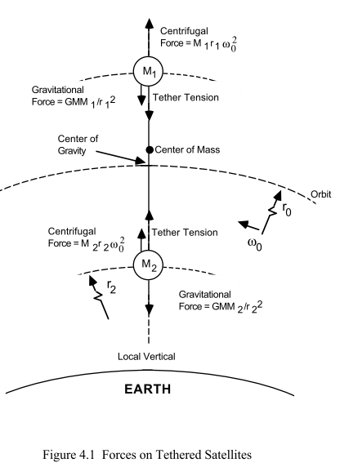 Fig 8.7

One can show that such a system is stable due to a restoring torque and so the line between the masses points to the center of the earth as the satellite orbits. This restoring force plus damping over time is what caused the slightly distorted moon to present its same face to the earth as it orbits.

We assume the masses are equal, M1 = M2 = m, refer to ω0 as ω, and ignore the difference between the center of gravity and the center of mass since this is meant to be a relatively short tether. Treating the entire system as a single object, the balance of centrifugal and gravitational forces results in the usual relation between ω and r0 which is ( M is the mass of the earth)

ω2r0 = GM/r02. (8.17)

Since our system is assumed to be "in orbit", ω and r0 are related in this way. Our rotating frame of reference S' is taken to be a frame in which the tether system is entirely at rest as it orbits around the earth. In Frame S', each mass has v' = 0 so there is no Coriolis term in the fictitious force set. Each mass experiences two "real" forces (gravity and tether tension) and one "fictitious" force – mω x (ω x r) as in (8.12),

– mω x (ω x r) = +mω2r // centri-fugal force

Therefore for the upper mass we can write (8.12) as

F'eff,1 = F – mω x (ω x r1)

= - (mMG/r12) -T + mω2r1

= [ - m MG/r12 + m ω2r1 - T]

= [ f(r1) - T] (8.18)
where
f(r) ≡ -mMG/r2 + mω2r . // f '(r) = 2 mMG/r3 + mω2 (8.19)

Note that f(r0) = 0 according to (8.17). Our bogus Newton's Law (8.3) when applied to the upper mass says F'eff,1 = m a'1 and since that mass is at rest in Frame S', it must be that F'eff,1 = 0. Therefore

T = f(r1) . (8.20)

For the lower mass, the equations are the same as above, but T → -T so one gets T = -f(r2).
Setting r1 = r0 + Δr in (8.20) and (8.19),

T = f(r0 + Δr) = -mMG/ (r0+Δr)2 + mω2(r0+Δr)

= -(mMG/r02) (1 + Δr/ r0)-2 + mω2(r0+Δr)

≈ -(mMG/r02) (1 - 2 Δr/ r0) + mω2(r0+Δr) // (1+x)n ~ 1 + nx for small x

= - mω2r0 (1 - 2 Δr/ r0) + mω2(r0+Δr) // using (8.17)

= 3mω2(Δr)

= 3 (mMG/r03)(Δr)

If ρ represents an arbitrary displacement away from r0, so r = r0 + ρ, then part of what is shown just above is this :

f(r0 + ρ) = 3mω2ρ (8.21)

which looks like this near ρ=0
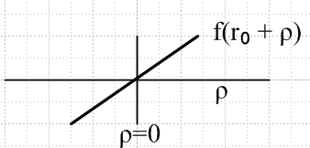 Fig 8.8

This represents the force on any untethered Particle that might be present in Frame S' located a radial distance ρ from r0. A particle at r > r0 is pushed up in Frame S', while a particle at r < r0 is pushed down. Again, this force in Frame S' is due to the combination of gravitational and centrifugal forces, one force real and the other fictitious.

Another way to view the above calculation is this,

T = [f(r0 + Δr) - f(r0)] + f(r0)

= f '(r0) Δr + f(r0)

= f '(r0) Δr

= (2mMG/r03+mω2) Δr

= (2 mω2 + mω2) Δr

= 3mω2 Δr // as in Ref [12] p 123 where Δr = L and ω = ω0

so the tension in the tether due to tidal force is equal to Δr times the derivative of f(r) evaluated at r = r0,

T = Δr f '(r0) = Δr 3mω2 = 3 Δr (mGM/r03) . (8.22)

The tidal force acting up the upper mass is T pushing up, and the tidal force acting on the lower mass is T pulling down, all in Frame S'. One might then write

tidal force per unit mass = ± 3 Δr (GM/r03) // tidal acceleration (8.23)

Notice that 2/3rds of the tidal force arises from the gravitational gradient at the satellite while 1/3 arises from the fact that the satellite keeps facing the earth and is thus rotating once per orbit, causing Frame S' to rotate once per orbit.

Comments:

1. One may regard tension T an example of a "tidal force" which tends to "rip apart" objects in orbit around a central force. In our example, the tidal force is T = f '(r0) Δr = 3 (mMG/r03) Δr. For objects in orbit around the earth, this is a small or moderate force, but for objects orbiting massive black holes, the force is strong enough to rip apart all known materials, a process called "spaghettification".

3. According to (8.17), an untethered water droplet on the surface of the upper mass will migrate to the upper extremity of that mass, while a water droplet on the surface of the lower mass will migrate to the lower extremity of that mass. A crude intuition would seem to say that the earth ought to pull both water drops to the lower extremity of each mass, but that is not what happens. One must get into the rotating Frame S' to see what happens. This is essentially why the usual tides on the earth "bulge" on the side facing the moon and on the side facing away from the moon. The sun also has its smaller effect. This subject is considered in the next section.

3. The tidal forces are felt in non-inertial Frame S' as just discussed. If one incorrectly omits the fictitious centrifugal force in the above analysis, the factor 3 becomes a factor 2, and this is how things are reported in many locations on the web. Interestingly, this very week wiki contributors are arguing about this very issue: http://en.wikipedia.org/wiki/Talk%3ATidal_force . The Swedish wiki page has a 3, the English has a 2 (as of 8/10/12).
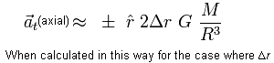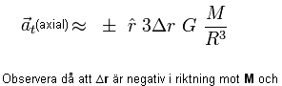

(g) Tides on the earth

The basic picture

In general, the orbit pattern of a binary system has this planar appearance, where each object traverses its own ellipse
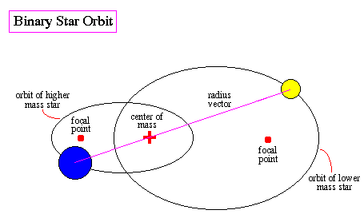
http://abyss.uoregon.edu/~js/ast222/lectures/lec05.html , Fig 8.9

In this section, however, we restrict our interest to a special case where each object traces out a circular path, not an elliptical one. The picture is this,

(continued on next page)

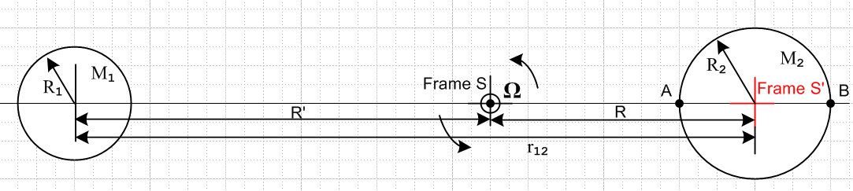
Fig 8.10

Each object is assumed to be a spherically symmetric mass distribution and can thus be treated as a point mass at its center for gravitational purposes. An inertial Frame S has its origin at the center-of-mass point, and the binary system rotates in the plane of paper at angular frequency Ω about this Frame S origin. Distance R can be found from the usual center-of-mass equation (viewed from Frame S),

0 = [M2R - M1(r12-R) ]/(M1+M2)

which reports out the obvious fact that

R = r12 [M1/(M1+ M2)] . (8.24)

We collect here some information on the sun, earth and moon :

MS = 1.99 x 1030 kg RS = 696,000 km
ME = 5.97 x 1024 kg RE = 6371 km (8.25)
MM = 7.35 x 1022kg RM = 1737 km TM = 27.3 days

rS-E = 1.50 x 108 km // average of aphelion and perihelion and perigee e = .016
rM-E = 386,000 km // average of apogee and perigee tilt = 1.45o e = .05

from which we can compute

1 --- 2
sun-earth R'/R1 = .000647
moon-earth R/R2 = 0.737 (8.26)

So for the sun-earth system, the center of mass is basically at the center of the sun, while for the moon-earth system, the center of mass lies at a point 3/4 the radius of the earth from the center. We could redraw our figure for these two cases, but the kinematics does not change, so we won't bother.

Frame S and Frame S'

Frame S as we have noted is a fixed inertial frame whose origin is at the binary system center of mass which is also the point about which each object rotates in a circle.
As object 2 rotates in its orbit, we shall assume it maintains its orientation relative to the stars. So at a time later than that shown above, the situation is this

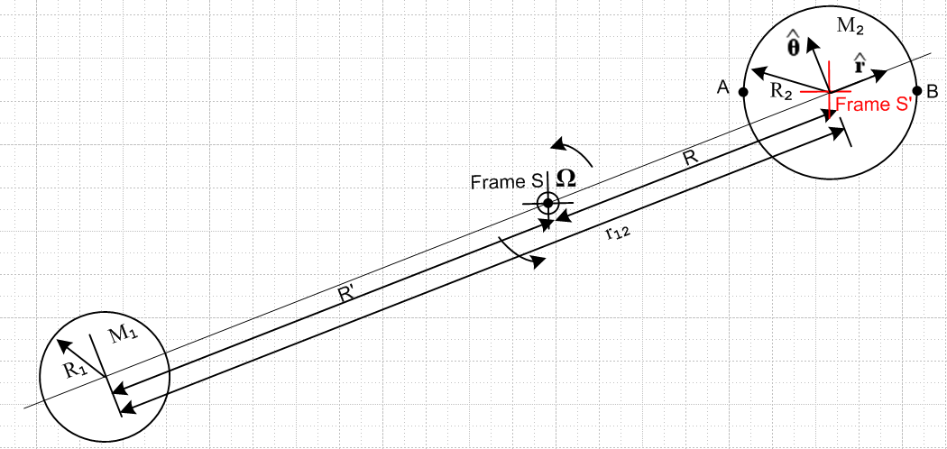
Fig 8.11

Frame S' is glued to object 2 and is sort of a "frame on gimbals" relative to Frame S which is fixed and never changes. [ Alcohol stoves in boat cabins are sometimes mounted on such gimbals.]
If the above picture represented the moon-earth picture, the moon on the left would in fact be as the drawing suggests, since it keeps its same side facing the earth. We don't care about this issue for object 1 since its only role is to produce a gravitational field at object 2.
To apply Fig 8.11 to the moon-earth system, we must temporarily turn off the rotation of the earth about its axis which, incidentally, is perpendicular to the plane of paper (modulo 1.45o), North Pole facing the viewer. Later we will turn the rotation back on and the earth will then rotate CCW with a rotation vector ω pointing out of the plane of paper.

How this tidal model fits in

How exactly does the above specified problem fit into our general framework of rotating frames? It is a Special Case #2 problem of Section 4 (e) with ω = 0 and with the two sets of axes always aligned.

One fictitious force in Frame S'

Recall now equation (8.4a) where the left equality is the "bogus" Newton's Law in Frame S', F is the total "real force" in Frame S', and then we have a list of four fictitious forces in Frame S',

ma' = F'eff = F – mS – mω x (ω x r') – 2m ω x v' – m x r' (8.4a)
frame centrifugal Coriolis Euler

In our application we are going to consider points in Frame S' (that is, points on the non-rotating earth) which are at rest on or in the earth, so v' = 0. We have noted that ω = 0 and of course = 0, so the above becomes

ma' = F'eff = F – mS (8.4a)'
frame

where only the "frame" fictitious force has survived. Remember that, although Frame S' is not a rotating frame in the sense that ω= 0 (its axes do not rotate), it is a rotating frame in the sense that its origin rotates around the origin of inertial Frame S.

It is clear from Fig 8.11 that (since R is a constant)

b = R d/dt = Ω d/dt = - Ω

S = R d/dt = RΩ

S = RΩ d/dt = - RΩ2 . (8.27)

Therefore (8.4a)' becomes

ma' = F'eff = F + m RΩ2 (8.4a)'

For any Particle at rest in Frame S' (and thus at rest in/on the non- rotating earth), we have a' = 0 so

0 = F + m RΩ2 .

For a Particle in or on the earth, the real forces are F = Fg1 + Fg2 + Fe where

Fg1 = the gravitational force due to object 1
Fg2 = the gravitational force due to object 2 (the earth)
Fe = any non-gravitational force

Below, Fe will be the force of the earth pushing out on a Particle resting on its surface. Thus we have

0 = Fg1 + Fg2 + Fe + m RΩ2
or
Fe = - (Fg1 + Fg2 + m RΩ2) (8.28)

Digression: The relation between r12 and Ω

If we were to replace the earth with a point mass M2 at its center, nothing would change in our orbiting picture. This point mass does a circular orbit around the binary center of mass with radius R and angular frequency Ω. The usual rule for circular motion of a point particle says that the gravitational force balances the centrifugal force, so

M1M2G/r122 = M2Ω2R
or
M1G/r122 = Ω2R . (8.29)

Now suppose we replace the original earth with another earth with a spherical cavity in the center which contains a point particle of mass m. Then we replace this new earth with a point mass M2'. So we now have a point mass m and a point mass M2' on top of each other, and each mass is going in the circular orbit just described. There is no reason for mass m to do something other than go in the circular orbit of radius R at Ω about the center of mass.
Therefore, if we consider a Particle of mass m located in a cavity in the center of the earth, this particle just floats in the cavity (not touching the sides) and is stationary in Frame S'. The non-gravitational force of the earth on this Particle is then Fe = 0. The gravitational force Fg2 is 0 as well since the Particle is at the exact center of the earth. Equation (8.28) then becomes, for this particle,

0 = - (Fg1 + m RΩ2)
or
mM1G/r122 = m RΩ2
or
M1G/r122 = Ω2R

which is the same as (8.29) above. All the extra words above were to reinforce the idea that a Particle at the center of the earth really feels no forces at all from the earth. It feels Fg1 and it feels the fictitious force mS = - mRΩ2 and these forces exactly cancel.
We can combine (8.24) with (8.29) to get

M1G/r122 = Ω2 r12 [M1/(M1+ M2)]
or
(M1+ M2)G/r123 = Ω2 (8.30)

and this is the relationship between r12 and Ω for given masses M1 and M2. It is analogous to the relation between r0 and ω given in (8.17) for the tethered satellite system. End of digression.

Tidal Force at an arbitrary point on the earth

Now consider a particle of mass m at some arbitrary location C on the surface of the earth. We define angles θ and β as shown, where β is typically very small,

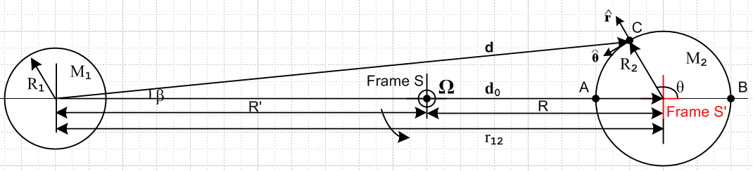
Fig 8.12

Here we show a brand new and which have nothing to do with those used in Fig 8.11. Vector d points to point C from the center of object 1 while vector d0 links the two object centers, so d0 = r12. Then (8.28) becomes

Fe = - [ Fg1 + Fg2 + m RΩ20 ] (8.31)

= - [ (-M1mG/d2) + Fg2 + m RΩ20 ]

From (8.29) we replace RΩ2 by M1G/r122 to get

Fe = - [ (-M1mG/d2) + Fg2 + m M1G/r1220 ]

= - [Fg2 + m M1G (/d2 – 0/r122)]

= - Fg2 – m M1G (/d2 – 0/d02) d0 = r12 (8.32)

Normally one thinks of Fe = - Fg2, meaning the force of the earth up on an object resting on its surface is equal and opposite to the force of gravity pulling down on the object, so the total force Fe+Fg2 = 0. However, we see here that due to the orbiting with object 1, there is an extra force which is called the tidal force, so

Fe = - Fg2 + Ftid (8.33)

Ftid ≡ – m M1G (/d2 – 0/d02) . (8.34)

It is the fact that object 1's gravitational field varies slightly (in direction and magnitude) at different points on object 2 which results in the tidal force. Equation (8.34) appears on p 332 Taylor[1] as equation (9.12) and in Butikov[13] as equation (2).

Comment: If the rotating moon-earth system were replaced by a static system in which the earth and moon were held apart by a very long, stiff (1020 N) rod, would the tidal force be the same as shown in (8.34)? Or would the water bulge only on the side of the earth facing the moon? Since the latter seems likely, one concludes that it is not just the non-uniformity of the gravitational field that causes the double-bulge tide, it is this non-uniformity in combination with the balance provided by the rotation which causes there to be zero force on a particle at the center of the earth.

Evaluation of the Tidal Force at Four Locations.

We shall now evaluate this tidal force at the four points of the compass in Fig 8.12. We use r12 here instead of d0.
At point A we have = 0 and d = (r12-R2), so

Ftid(A) = – m M1G [1/(r12-R2)2- 1/r122] 0 (8.35)

But if r12 >> R2 we have

1/(r12-R2)2 = (r12-R2)-2 = r12-2(1 - R2/r12)-2 ≈ (1/r12)2 (1 + 2R2/r12)
so
Ftid(A) = – m M1G [(1/r12)2 + 2R2/r123 - 1/r122] 0 = – m M1G [2R2/r123] 0

= - 2m(M1G/r122) (R2/r12) 0 (8.36)

which points to the left. Similarly,

Ftid(B) = – m M1G [1/(r12+R2)2- 1/r122] 0

– m M1G [(1/r12)2 - 2R2/r123 - 1/r122] 0 = + m M1G [2R2/r123] 0

= + 2m(M1G/r122) (R2/r12) 0 (8.37)

which points to the right.
At the top when θ = π/2 we have d ≈ r12 to first order, so then

Ftid(top) = – m M1G (/d2 – 0/r122) = – m (M1G/r122) ( – 0)

Drawing a thin triangle with edges and 0 shows that

( – 0) ≈ sinβ = (R2/r12) // for point at the top, θ = π/2 (8.38)

and therefore

Ftid(top) = – m (M1G/r122) (R2/r12) (8.39)

which points down. For a point at the bottom, θ = -π/2, we still have (8.38) but of course now points down. So

Ftid(bot) = – m (M1G/r122) (R2/r12) (8.40)

which points up.
Here is a summary of these four results:

Ftid(A) = – 2m(M1G/r122) (R2/r12) 0 // points to the left (8.36)
Ftid(B) = 2m(M1G/r122) (R2/r12) 0 // points to the right (8.37)
Ftid(top) = – m(M1G/r122) (R2/r12) // points down (8.39)
Ftid(bot) = – m(M1G/r122) (R2/r12) // points up (8.40)

We can now draw the famous picture, where the side arrows are twice as long as the top and bottom ones, and where we have added four more arrows for the in-between points. The blue shows the shape of the water surface on a water-covered earth, and the bulges point toward and away from object 1 which is off to the left,
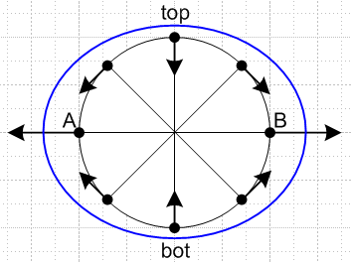 Fig 8.13

The four arrows at NE, NW, SE and SW are not drawn precisely, but show that the tidal forces there drive water currents which result in the bulges and depressions. In the steady state these currents stop and the surface of the water is tilted against these tidal forces.
The tidal force acceleration is very weak compared to the local gravitational force on the earth. For the lunar tidal case, using the A and B tidal force magnitude,

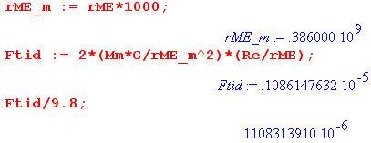

so basically the tidal force is 10-7 the size of g. It is rather amazing what such a small force can do when it is differentially applied to a lot of water.

Equation of the water surface.

From (8.34) one can obtain a general expression for Ftid(θ) for any point C on the earth. By writing this force as the gradient of a potential, and by arguing that the surface of the water should be an equipotential surface, one obtains[13] an equation for the blue surface,

R(θ) = R2 + a cos(2θ) , (8.41)

where the difference between high and low tide (here at A/B versus at top/bot) is given by

H = 2a = (3/2)R2 (M1/M2)(R2/r12)3 . (8.42)

Inserting the numbers given earlier, one gets (km)

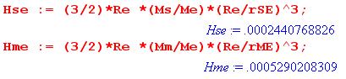
which says

Hsolar_tide = 24 cm = 0.8 feet
Hlunar_tide = 53 cm = 1.8 feet . (8.43)

A non-inlander will recognize these as reasonable ball park values for ocean tides, lending much credence to the model at hand.

Rotation turned back on

We now turn the rotation of the earth back on (we turned if off earlier). This rotation is very close to perpendicular to the plane of paper in our drawings above. At any latitude, an outward-pointing centrifugal force of equal magnitude is added all around the earth, and one argues that this has no effect on the differential tidal force pattern. To the extent the world has an all-water surface and the interface between earth and water is frictionless, one concludes that the blue surface stays put while the earth rotates under it, thus putting high tides nominally 12 hours apart. But the moon moves with a 27.3 day period in the same direction the earth rotates, so when 12 hours has passed, the moon has moved ahead 12/27.3 = 0.44 hours = 26.4 minutes, so one has to wait another 26 minutes for the next lunar high tide, so the time between high tides is about 12 hours 26 minutes. This causes the time of high tide to move relative to a wall clock in any location, which is why we have tide tables and tide clocks.
Roughly the solar tides have half the influence of the lunar ones as shown above. They add and cancel depending on the position of the sun and moon. This nice picture of D.J. Jeffery shows the extremal situations (spring ≠ season Spring)

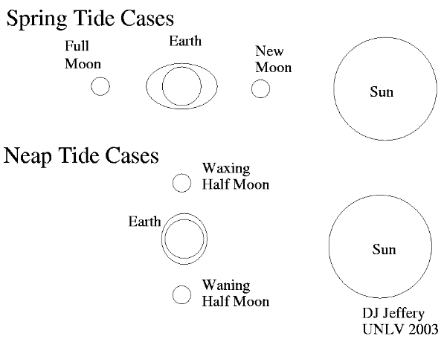 Fig 8.14

So the maximal spring tides are about 2 weeks apart and the same is true for the intervening minimal neap tides.
Many adjustments to the above toy model are required to explain the real tides on the earth. Water does not move around instantly, there is drag of the earth on the water, there are land masses and resonances, lake water has nowhere to go, and so on. For example, a resonance at the Bay of Fundy can causes a 50 foot high/low tide difference.
A good discussion of the above tidal model is given in Taylor's textbook[1] p 330-336. A more detailed discussion is presented in the excellent (and downloadable) paper by Butikov[13]. Both sources are very readable.

Hypothetical moon-facing earth

Consider some parallel-universe earth which presents its same face to the moon at all times. In this situation Frame S', still glued to the earth, becomes a non-inertial frame whose origin and axes rotate together at Ω (b soldered to axes of Frame S'). This is then a Special Case #1 problem driven by a different F'eff (8.12) where one must include a centrifugal fictitious force .

(continued on next page)
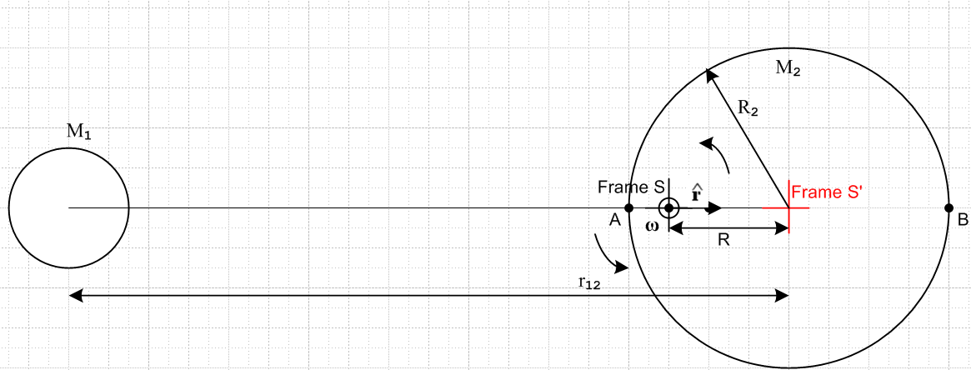

Particles on this earth's surface nearest the moon have a small centripetal acceleration, but those on the far side of the earth have a much larger value, and it turns out this effect swamps the effect of the non-uniform gravity of the moon at the earth. One finds that

ftidal(B)/m = [ ω2(R+R2) – GM1/(r12+R2)2] > 0, pushes to the right on Particle B
ftidal(A)/m = [– ω2(R-R2) + GM1/(r12-R2)2] > 0, pushes to the left on Particle A
ftidal(center)/m = [– ω2(R) + GM1/(r12)2 ] = 0 => ω2R = GM1/(r12)2 (8.44)

Rewrite the first line this way (adding and subtracting the same quantity)

ftidal(B) = m [ {ω2(R+R2) – ω2(R)} + {GM1/(r12)2 – GM1/(r12+R2)2)}]
= [ m {ω2R2 } + m {GM1[1/(r12)2–1/(r12+R2)2)} ]
= [ fcent + fgrav ] (8.45)

where fcent registers the contribution of the centripetal effect and fgrav that of the gravitational gradient. Then

$\frac{fcent}{fgrav}$ = $\frac{(r12+R2)2}{R(2r12+R2)}$ . (8.46)

For 1 = earth and 2 = tethered satellite, R2 is the satellite diameter ≈ 0 and R ≈ r12 so

$\frac{fcent}{fgrav}$ ≈ $\frac{(r12)2}{r12(2r12)}$ = 1/2 // tethered satellite (8.47)

and this is what we found in (8.23) , the centrifugal effect is half the gravitational gradient effect.

For 1 = moon and 2 = earth, the ratio is dramatically different

$\frac{fcent}{fgrav}$ = $\frac{(r12+R2)2}{R(2r12+R2)}$ = 42.13 // moon-facing earth (8.48)

and the centrifugal component is the dominant effect in determining the tides. Using r12>> R2 in (8.44),

ftidal(A or B)/m = 2(GM1/r122)[ (R2/r12) + (R2/2R) ] // moon-facing earth

ftidal(A or B)/m = 2(GM1/r122)[ (R2/r12) ] // real earth (8.37)
Since (R2/r12) = .0165 and (R2/2R) = 0.679 we find this ratio for the points A and B :

tidal force (moon-facing earth)/ tidal force (real earth) = (.0165 + .679)/(.0165) = 42.11

Exercise for the Reader. What is the pattern of tides on a moon-facing earth? What is the maximum high/low tidal difference? Is it 42 times larger than on the real earth? One has to do a careful reading of Butikov's paper[13] to answer these questions. This problem would apply to tides on the moon if it were suddenly covered with water.

9. Comparison with Marion (1970), Thornton & Marion (2003) and Taylor (2005)

In this Section and the next we wish to compare our notation for rotating-frame kinematics and non-inertial-frame physics to the notation of two groups of well-known and well-read textbook authors. What symbols do they use to denote the two frames of reference and the various positions, velocities and accelerations?

Comparison between Marion and T&M notation and our "non-swap" notation

Marion[2] and Thornton & Marion[3] (T&M) both swap the primes on the frames relative to us, S ↔ S', which then includes r ↔ r'. The following notations are used ( us → Marion/T&M )

r' → r v → vf v' → vr b → R S → f = V
a → af a'→ ar S → f (9.1)

where subscript r means "rotating frame" and f means "fixed frame". Thus, Marion's and T&M's version of (8.2) reads ( = 0 in Marion but is retained in T&M)

F = ma = mS + ma' + mω x (ω x r') + 2m ω x v' + m x r' (8.2)
F = maf = mf + mar + mω x (ω x r) + 2m ω x vr + m x r // Marion p 344 (11.17)
// T&M p 392 (10.23)

Note that for Marion r is a vector to the Particle from the rotating frame origin. Marion's version of our (8.2)approx is then

F = ma ≈ ma' + mω x (ω x r') + 2m ω x v' + m x r' (8.2)approx
F = maf ≈ mar + mω x (ω x r) + 2m ω x vr + m x r // Marion p 344 (11.18)

and his version of (8.4b)approx is

ma' = F'eff ≈ ma – mω x (ω x r') – 2m ω x v' – m x r' (8.4b)approx
mar = Feff ≈ maf – mω x (ω x r) – 2m ω x vr – m x r // Marion p 344 (11.19)

Meanwhile, translation of our (8.4a) is done this way

ma' = F'eff = F - mS – mω x (ω x r') – 2m ω x v' – m x r' (8.4a)
mar = Feff = F - mf – mω x (ω x r) – 2m ω x vr – m x r // T&M p 392 (10.25)

Finally, our velocity equation (6.6a) translates, according to rules (9.1), as follows,

v = v' + ω x r' + S (6.6a)
vf = vr + ω x r + V // Marion p 344 (11.12)
// T&M p 392 (10.17)

Comparison between Taylor notation and our "non-swap notation"

These are the translation rules from us to Taylor[1] :

S,S' → S0, S
r,r' → r0, r (9.2)

so he ends up with vector r being the natural position vector in the rotating frame, the same as Marion and Goldstein in the next section.

Comparison between Marion and T&M notation and our "swap" notation

Recall that in our swap notation, Frame S is the rotating frame and Frame S' is the inertial frame. We put primes on forces in inertial frame S' whereas Marion and T&M do not.

True Newton's Law in Inertial Frame S':

F' = ma' = mS' + ma + mω x (ω x r) + 2m ω x v + m x r (8.2)s
F = maf = mf + mar + mω x (ω x r) + 2m ω x vr + m x r // Marion p 344 (11.17)
// T&M p 392 (10.23)

F' = ma' ≈ ma + mω x (ω x r) + 2m ω x v + m x r (8.2)approx,s
F = maf ≈ mar + mω x (ω x r) + 2m ω x vr + m x r // Marion p 344 (11.18)

Bogus Newton's Law in non-inertial Frame S:

ma = Feff ≈ ma' – mω x (ω x r) – 2m ω x v – m x r (8.4b)approx,s
mar = Feff ≈ maf – mω x (ω x r) – 2m ω x vr – m x r // Marion p 344 (11.19)

ma = Feff = F' - mS' – mω x (ω x r) – 2m ω x v – m x r (8.4a)s
mar = Feff = F - mf – mω x (ω x r) – 2m ω x vr – m x r // T&M p 392 (10.25)

Velocity relation:

v' = v + ω x r + S' (6.6a)s
vf = vr + ω x r + V // Marion p 344 (11.12)

10. Comparison with Goldstein (1950) and Goldstein, Poole and Safko (2001)

Goldstein is a bit of a conundrum and requires careful decoding.
GPS refers to Goldstein, Poole and Safko[5].

(a) The meaning of r

Goldstein[4] also has S↔S' including r↔r' relative to our "non-swap" notation. We know this because he says on page 135 that his r is a vector "from the origin of the terrestrial system to the given particle". Earlier he says "terrestrial measurements are usually made with respect to a coordinate system fixed in the earth, which therefore rotates uniformly with a constant angular velocity ω relative to the inertial system". Presumably "fixed in the earth" means "fixed on the surface of the earth". Therefore surely the vector he calls r is the one we call r'. This is consistent with a general S↔ S' swap and agrees with Marion's use of vector r, but mainly it is consistent with Goldstein's own equations as we shall see below.

(b) The meaning of Goldstein's as and ar (and of vs and vr)

Recall (7.4) from above

a'S = a' + x r' + 2 ω x v' + ω x (ω x r') (7.4)

Goldstein states the following equation (he has = 0 but we include the term anyway)

as = ar + x r + 2 ω x vr + ω x (ω x r) // Goldstein p 135 (4-105)
// GPS p 175 (4.89)

His subscript r means rotating (same as Marion), while subscript s means space (Marion's fixed system). Comparing our (7.4) to the Goldstein equation above tells us that

G us
r r'
vs v'S // added to this list since consistent with the as line following
as a'S
vr v'
ar a'

Goldstein uses the name vr just the way Marion does. However, for Marion

vf = v
af = a

so we must conclude that vf ≠ vs and af ≠ as. The only comment Goldstein gives (p 135) is that "vs and vr are the velocities of the particle relative to the space and rotating set of axes respectively." As we have seen in Section 1 (h), there are several kinds of "velocity" so this does not quite nail it down. Since Goldstein is thinking of doing things in terms of a position vector from the "terrestrial frame", it is not unreasonable to think that

Goldstein Us
vs = (dr/dt)space → (dr'/dt)S = v'S that is vs = v'S
vr = (dr/dt)rot → (dr'/dt)S' = v'S; that is vr = v'S'

in agreement with the small table above. So we conclude that these are the correct Goldstein translation rules ( us → Goldstein/GPS )

r' → r v'S → vs v'S' → vr
a'S → as a'S'→ ar (10.1)

In terms of the discussion in Section 1 (h), Goldstein has chosen for his vs and as not to use the "natural" velocity and acceleration v and a shown in (1.32) and (1.33).

Let's test out rules (10.1). Consider our (6.8a) and its Goldstein translation by (10.1) on the second line,

v'S = v' + ω x r' (6.8a)
vs = vr + ω x r // Goldstein p 135 (4-104)
// GPS p 175 (4.88)

So this is another piece of evidence confirming our interpretation. Notice that (6.8a) is just the G Rule for the vector r', and that is how Goldstein motivates the equation (but with his r).

(c) A hidden approximation is located

In his discussion on page 135 (1950) Goldstein says nothing at all about any approximations, although he does have in mind the specific earth system. On page 135 he states "the equation of motion" in an equation with no number as

F = mas // Goldstein page 135, no number
// GPS p 175, no number

According to our translation rules, this says that F = ma'S . But the correct Newton's Law is

F = ma (8.1)

and according to our (7.5),

a = a'S + S , (7.5)

Newton's Law really says

F = ma'S + mS
= mas + mS . // Goldstein implied

We conclude that in writing F = mas, Goldstein has made the approximation that S can be neglected. This is the same assumption Marion makes explicitly. So we interpret Goldstein's unnumbered equation as
F = mas + mS ≈ mas . (10.2)

His remaining two equations can be obtained as follows. We go back to (8.4a)approx and translate it using the rules (10.1),

ma' = F'eff ≈ F – mω x (ω x r') – 2m ω x v' – m x r' (8.4a)approx
mar = Feff = F – mω x (ω x r) – 2m ω x vr – m x r // Goldstein p 135 (4-106)
// GPS p 175 (4.90)

Next, combine (8.5) and (8.6)approx to get the first line, then translate for the 2nd line,

F'eff = F – mω x (ω x r') – 2m ω x v' – m x r' (8.6)approx + (8.5)
Feff = F – mω x (ω x r) – 2m ω x vr – m x r // Goldstein p 135 (4-107)
// GPS p 175 (4.91)

11. Angular Momentum and Fictitious Torques; the Reynolds Transport Theorem

(a) Introduction

Nomenclature is an issue for this subject, and here is a vague partial table of usage:

"physics" continuum mechanics
L = r x p angular momentum moment of momentum (ie, moment of p)
N = r x F (= τ) torque moment of force (ie, moment of F), moment (M or m)
r⊥ = rsinθ moment arm moment arm
Σi ri x Fi with ΣiFi= 0 a sum of torques couple, torque, pure moment

The moment arm r⊥ is the component of r which is perpendicular to F (or p) as in the drawings below.

We shall use the "physics" terminology, so :

A Particle located at position r and having linear momentum p is said to have angular momentum
L = r x p about the origin, in reference to the origin, or with respect to the origin.

A Particle located at position r which is acted upon by a force F is said to experience a torque
N = r x F about the origin, in reference to the origin, or with respect to the origin.

In other words, the tail of vector r is at the origin of the coordinate system and L and N as above are both shown with respect to that point, as in the picture on the left below.
Note that a Particle could refer to an actual point particle, or to a small piece of a rigid body, or to a small chunk of a fluid or an elastic solid.
Sometimes we want to use L and N with respect to some other reference point, call it c, which is not the origin of the coordinate system. This is shown on the right where the origin of the picture on the left has been translated slightly down and to the right,

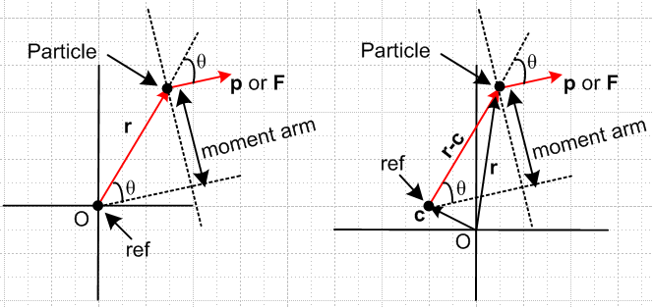 Fig 11.1

The angular momentum and torque with respect to point c are given by

L(c) = (r-c) x p L(0) = r x p
N(c) = (r-c) x F N(0) = r x F

We therefore introduce a label "c" to indicate the point of reference for an L or an N. If the reference point is the origin, then we write things as shown on the right above.
In the work below, a certain amount of complexity is introduced by allowing c ≠ 0, but the intention is to "do the general case". This then brings up the significance of the last line in the little notation table above, and suggests the benefits of dealing with a "couple" when possible. Consider:

Theorem: If the sum of a set of forces acting on an object is 0, then the sum of the torques associated with those forces (acting on that same object) is independent of the point c chosen as the reference point for all the torques.

proof: N(c) = Σi(ri-c) x Fi = Σi rix Fi - c x (ΣiFi) = Σi rix Fi - 0 = N(0) .

Example: Imagine a cylindrical steel bar in a state of torsional strain due to equal and opposite torques applied to the ends of the bar through small grabber chucks, one at each end (no gravity). So N1 = -N2 = N and each torque is twisting the bar counterclockwise as seen looking at each end. The effect of a chuck on the bar can be represented as a continuous sum of tangential forces acting on the thin band of surface of the bar under the chuck, which forces add up to zero (think pairwise). Therefore, since the total force of a chuck on the bar is zero, the torque of a chuck on the bar is independent of reference point. Since the same is true for each end, one can pick some arbitrary point c (such as c = 0) and reference both torques to that point, and then add them "legally" to conclude that the total torque on the bar is 0. The bar thus shows no angular acceleration.

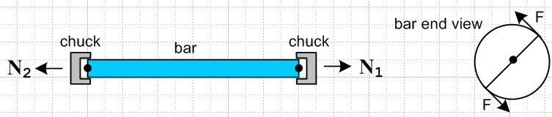 Fig 11.2

In this example, each chuck represents a couple or pure moment acting on the bar.

(b) Expression of L(c) and (c) in terms of Frame S' objects

We replicate the picture presented in Section 1 (h),

Fig 11.3

We again set mass m = 1 so momentum p = mv = v, and c is the location in Frame S of the Reference Point for the angular momentum of our Particle ( which corresponds to point c' in Frame S'). Thus,

L(c) = (r-c) x v
(c) = (r-c) x a – S x v

L'(c') = (r'-c') x v'
'(c') = (r'-c') x a' – 'S' x v' (1.36) (11.1)

where

b + r' = r
b + c' = c
r'-c' = r-c (11.2)

We know from Sections 6 and 7 how r,v,a and r',v',a' are related,

r = r' + b (6.1)
v = v' + ω x r' + S (6.6a)
a = a' + x r' + 2 ω x v' + ω x (ω x r') + S (7.6a) (11.3)

so all that remains is to relate the various c objects. According the G Rule 2.1 applied to c,

S = S' + ω x c . (11.4)

Since b + c' = c we also know that

S + 'S = S (11.5)
S' + 'S' = S' . (11.6)

Combining (11.6) with (11.4) gives

S = 'S' + S' + ω x c . (11.7)

Using (6.2a), S = S' + ω x b, we find another useful relation,

S' + ω x c = S + ω x (c-b) = S + ω x c' . (11.8)

So, we first write L(c) in terms of Frame S' objects as follows,

L(c) = (r-c) x v = (r'-c') x [v' + ω x r' + S]
= (r'-c') x v' + (r'-c') x [ ω x r' + S]
= L'(c') + (r'-c') x [ ω x r' + S] .

Next, we use (11.1) and (11.3) to write (c) in terms of Frame S' objects in this way,

(c) = – S x v + (r-c) x a = – ['S' + S' + ω x c] x [v' + ω x r' + S]
+ (r'-c') x [a' + x r' + 2 ω x v' + ω x (ω x r') + S]

= { – 'S' x v' + (r'-c') x a' } – 'S' x [ω x r' + S] – [S' + ω x c] x [v' + ω x r' + S]
+ (r'-c') x [ x r' + 2 ω x v' + ω x (ω x r') + S]

= '(c') – 'S' x [ω x r' + S] – [S + ω x c'] x [v' + ω x r' + S]
+ (r'-c') x [ x r' + 2 ω x v' + ω x (ω x r') + S]

The two results are then

L(c) = L'(c') + (r'-c') x [ ω x r' + S]

(c) = '(c') – 'S' x [ω x r' + S] – [ω x c' + S] x [v' + ω x r' + S]
+ (r'-c') x [ x r' + 2 ω x v' + ω x (ω x r') + S] . (11.9)

We have now finished fulfilling the goal set out in Section 5, since we now have L(c) and (c) expressed in terms of Frame S' objects. Remember that for m ≠ 1, all the non-L terms in these equations should have a factor of m.

Many alternate forms of (11.9) can be generated using these accumulated relations,

b + r' = r
b + c' = c
r'-c' = r-c (11.2)
v = v' + ω x r' + S (6.6a)
S' + 'S' = S' (11.4b)
S + 'S = S (11.4b)
S = S' + ω x c (11.4a)
S = S' + ω x b (6.2a)
S + ω x r' = S' + ω x r . (6.2b)
S + ω x c' = S' + ω x c (11.6)
S' = S – x b – 2ω x S + ω x (ω x b) (7.10)
S = S' + x b + 2ω x S' + ω x (ω x b) . (7.11)

Special Case #3

Consider this special case situation which is really a subset of our Special Case #2 of Section 4 (e) :

• Frame S is an inertial frame and Frame S' rotates and translates relative to Frame S. The rotation is described by ω and , while the translation by b, S and S .

• The ω axis of rotation of Frame S' relative to Frame S always passes through the origin of Frame S'.

• The reference point for angular momentum in Frame S' is at the origin of Frame S', so c' = 0 and
so c = b at all times. Thus, 'S' = 0 and S = S .

In this situation, equations (11.9) become

L(b) = L'(0) + r' x [ ω x r' + S] // Special Case #3

(b) = '(0) – S x [v' + ω x r' ] + r' x [ x r' + 2 ω x v' + ω x (ω x r') + S] (11.9a)

(c) Fictitious Torques and Newton's Rotational Law in a non-inertial frame

In analogy with Newton's Law F = (dp/dt)S, Newton's Rotational Law in inertial Frame S is given by,

N(c) = (dL(c)/dt)S = (c)S = (c) // true Newton's Rot Law in Frame S (11.10)

where L(c) is the angular momentum of our Particle in Frame S relative to reference point c, and N(c) is some externally applied torque about that same reference point acting on the Particle.

In Frame S' we want to find some effective ("bogus") Newton's Rotational Law,

N'(c')eff = '(c') // bogus Newton's Rot Law in Frame S' (11.11)

N'eff(c') = N(c) + N'(c')fict (11.12)

so then

N(c) + N'(c')fict = '(c') . (11.13)

We can then apply this bogus Newton's Rotational Law in non-inertial Frame S' as long as we include the fictitious torques N'(c')fict along with the real torques N(c) which are just those present in inertial Frame S. This is in complete analogy with the use of fictitious forces as reviewed in Section 8.
Subtracting (11.10) from (11.13) gives,

N'(c')fict = '(c') - (c) .

The difference '(c') - (c) is given by (11.9), so we find that

N'(c')fict = m'S' x [ω x r' + S] + m[ω x c' + S] x [v' + ω x r' + S]
– (r'-c') x [ m x r' + 2mω x v' + mω x (ω x r') + mS] . (11.14)

where we have quietly reinstalled the mass m.
Applied to Special Case #3 of the last section, where c' = 0, b = c, 'S' = 0 and S = S , we get

N'(0)fict = m S x [v' + ω x r']
– r' x [m x r' + 2mω x v' + mω x (ω x r') + mS] . // Special Case #3 (11.14a)

Using (6.6a) to replace [v' + ω x r'] and using (8.6) which gives F'fict for Frame S', the above reads

N'(0)fict = S x (mv) + r' x F'fict // Special Case #3 (11.14b)

The first term is present only if Frame S' is translating relative to Frame S at S≠ 0. Such translation causes the reference point c = b used for Frame S angular momentum to be moving. The second term is the torque about the origin of Frame S' due to the sum of all fictitious forces present in non-inertial Frame S'.

(d) Fictitious Torques and Forces in Fluid Dynamics

In this example we have two reference frames S and S' related as in Special Case #3 outlined above. To this special case we add the extra condition that b = 0 at time instant t. Since c' ≡ 0 this means c = 0 as well at time t. Recall that c is the reference point for torque and angular momentum in Frame S, and c' is the same point expressed in Frame S'.
The object of interest is a blob of fluid contained in a moving volume Vm. The boundary Sm of this volume Vm moves and changes shape such that every point on Sm moves at a velocity which matches the local fluid flow velocity v(r,t). As a result, no particles of fluid either enter or leave the blob volume Vm as it moves. One implication is that the mass M of the blob Vm remains constant. This blob, of some fixed mass M, is our "object of mechanical interest" (later called "the system").
At time t, we imagine that Vm sheds a snake skin Vc which then remains frozen in time. Then Vm(t) aligns with Vc at time t and probably at no other time. Whereas Vm moves, Vc is fixed. Vm is called a "material volume" since it flows with the material, while Vc is called a "control volume". In general, all volume integrals except those being differentiated in time are expressed as integrals over Vc.
Here is Newton's Rotational Law N = (11.10) for the this blob object of mass M in inertial Frame S,

N(0) = ∫Sc r x t dS + ∫Vc r x ρB dV = (d/dt )S [ ∫Vm r x ρv dV ] . // (7.9.1) (11.15)

The numbers in blue will be explained below. Here t is a possible external "surface traction" (force per area) acting on the blob's surface Sc, B is some possible "body force" per unit mass acting on the blob's interior (perhaps gravity g), and ρ is the mass density of the fluid. Notice that ∫Vm r x ρv dV is an integral of dL = r x dp over the blob, where dp = dm v and dm = ρdV, so this integral is L(0)blob referenced to the point c = 0.

What does equation (11.15) look like in non-inertial Frame S' ? According to (11.13) it is this:

N(0) + N'(0)fict = '(0) = (d/dt)S'L'(0) (11.13)
or
( ∫Sc' r' x t dS' + ∫Vc' r' x ρB dV' ) + N'(0)fict = (d/dt )S' [ ∫Vm' r' x ρv' dV'] . (11.16)

Here everything is computed in non-inertial Frame S', but t and B are the same as in Frame S since they are not affected by the fact that the frame is rotating. Also, ρ' = ρ since this is mass per volume and the differential volume element is not affected by a rotation. In particular, the control volume Vc' and its boundary Sc' are fixed in Frame S'. On the right, Vm' aligns with Vc' at time instant t, and

∫Vm' r' x ρ'v' dV' = L'(0)blob .

The question remains: what is the fictitious torque N'(0)fict appearing in (11.16) ? According to (11.14a) it is given by

N'(0)fict = m S x [v' + ω x r']
– r' x [m x r' + 2mω x v' + mω x (ω x r') + mS] . // Special Case #3 (11.14a)

which we adapt to our blob scenario to get, using dm' = ρdV',

N'(0)fict = S x ∫Vc' [v' + ω x r'] dm'
– ∫Vc' r' x [ x r' + 2ω x v' + ω x (ω x r') + S] dm' // (7.9.9) (11.17a)
Euler Coriolis centrifugal frame

where the last "frame" term can be written as –(∫Vc' r' dm') x S.
The interested reader will find the second line of (11.17a) appearing as equation (7.9.9) in Lai et. al.[14] p 431. Apparently Ref [14] assumes that S = 0 so the first term of (11.17a) does not appear. The equation is applied on p 431-432 to a conventional rotating sprinkler which has S = S = 0. The sprinkler is at translational rest and its horizontal watering tube of length 2r0 rotates at ω. The control volume Vc' is the interior of this rotating watering tube, so Vc' is fixed in rotating Frame S'. The solution to the problem is that ω = -(Q/A)sinθ/r0 where A is the area of the orifice on each end of the watering tube, Q is the volume of water flow delivered to the sprinkler, and θ is the angle of each tube-end opening viewed from above.
As usual, dealing with notation is painful. Here is a little translation table relating our notation to that of Ref[14] :

Ref [14] us
F1 S fixed frame
F2 S' rotating frame (moving frame)
r r position in fixed frame
x r' position in rotating frame
(dr/dt)F1 = vF1 (dr/dt)S = vS = v velocity in fixed frame
(dx/dt)F2 = vF2 (dr'/dt)S' = v'S' = v' velocity in rotating frame
R0 b vector linking frame origins
r = R0 + x r = b + r'
(D/Dt)F1 = (D/Dt) (d/dt)S derivative in fixed frame
(a0) F1 = a0 S

In their equations (7.9.1) through (7.9.8) symbol v means vF1 which is our v.
In their equation (7.9.9) showing the fictitious torque, symbol v means vF2 which is our v' .

A similar equation applies for the ficitious forces (rather than torques) in this same fluid dynamics example. Perhaps this should have appeared in Section 8, but the groundwork has been laid here. The equation corresponding to the torque equation (11.16) for a blob of fluid is this

F' + F'fict = (d/dt )S' [ p']
or
( ∫Sc' t dS' + ∫Vc' ρB dV' ) + F'fict = (d/dt )S' [ ∫Vm' ρv' dV']

where

F'fict = – S ∫V' ρdV' – ω x (ω x ∫Vc'r' ρdV' ) – 2 ω x ∫Vc' v'ρdV' – x ∫Vc'r' ρdV'

// (7.7.14) (11.17b)
which is just the fluid-adapted version of (8.6),

F'fict = – mS – mω x (ω x r') – 2m ω x v' – m x r' . (8.6)
frame centrifugal Coriolis Euler

This expression for F'fict appears as the second line of Lai p 429 (7.7.14) where Lai uses a0 = S,
m = ∫V' ρ(x)dV, x = r' and dm = ρdV'.

(e) Comments on the Reynolds Transport Theorem

Although a bit off the path, it seems useful to tie this topic in with the previous section.

1. The operation ∂/∂t = differs from the operation d/dt when applied to an "Eulerian" function of space and time, in which case d/dt is called a material derivative and is written D/Dt in fluid dynamics notation,

df(r,t)/dt = ∂f/∂t + ∇f • dr/dt = ∂f/∂t + v • (∇f) ≡ Df(r,t)/Dt .

In an Eulerian function, the position coordinate r is the current position of a Particle of fluid as one would expect. (In a Lagrangian function, the position argument is the position at which a Particle started out at some earlier time t0. ) In general, any property of a fluid f(r,t) (such as temperature or density or velocity) varies with r, so the v • (∇f) term does not in general vanish.

2. The right side of equation (11.15) shows the total time derivative of an integral over a material volume Vm, which integral represents a mechanical property of our blob object of interest. It is always possible to replace such a time derivative with a set of control volume and control surface integrals using a rather elegant theorem known as the Reynolds Transport Theorem (1903) ,

(d/dt) [ ∫Vm T dV ] = ∫Vc (∂T/∂t) dV + ∫Sc T(v•n) dS = ∫Vc [(dT/dt)+ T div v] dV (11.18)

where T = T(r,t) is any reasonable function. For example, T could be a scalar like ρ, or a component of a vector like r x ρv in (11.15), or a component of any tensor Tijk.... This theorem appears as (7.4.1) and (7.4.2) in Ref [14] page 418 and a proof is given on the next page.
Notice that each term has the units of T times volume/sec.
If T = ρ, the left expression is dM/dt = 0 and the far right integral being 0 for any Vc requires that (dρ/dt) + ρ div v = 0 which is a form of the continuity equation ∂ρ/∂t + div(ρv) in which ρ is mass density and J = ρv is the mass-current density.

3. Although we write Vc = Vm(t) at time t, it is understood that Vc is independent of time -- it is that shed snake skin referred to above. Therefore, one regards (∂Vc/∂t) = (dVc/dt) = 0, and then in (11.18) we can write
∫Vc (∂T(r,t)/∂t) dV = (∂/∂t) [∫Vc T(r,t) dV ] = (d/dt) [∫Vc T(r,t) dV ] (11.19)

where in the last step we use the fact that the integral is a function only of time, since r is integrated out. So The Reynolds Transport Theorem (11.18) can be written this way

(d/dt) [∫Vm TdV] = (d/dt) [∫Vc TdV ] + ∫Sc T(v•n) dS = ∫Vc [(dT/dt)+ T div v] dV (11.20)

4. Writing T = ρb where b is some sort of extensive property per unit mass, (11.20) becomes

(d/dt) [∫Vm b ρdV] = (d/dt) [∫Vc b ρdV ] + ∫Sc bρ(v•n) dS
= ∫Vc [(d(ρb)/dt)+ (ρb) div v] dV . (11.21)

In this case, one can regard ∫Vm b ρdV = ∫Vm b dm as the "total amount of b" in the moving fluid blob. This moving blob which recall maintains all its particles is sometimes called "the system", and the total amount of b in the system might be called Bsys. Then (11.21) can be written as

(dBsys/dt) = (dBCV/dt) + ∫CS bρ(v•n) dS = ∫CV [(d(ρb)/dt)+ (ρb) div v] dV (11.22)

where CV (or C.V.) is a traditional notation for Vc, the control volume, and CS is Sc, the control surface. For example, here is a typical web appearance of the Reynolds Transport Theorem in the form of the left equality in (11.22),

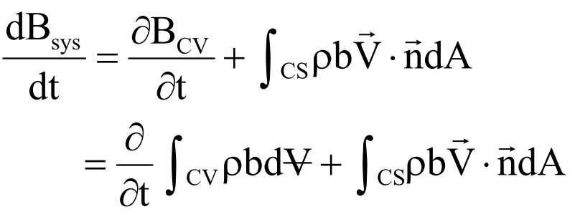

which points out another common notation: V with a horizontal bar () refers to volume, to distinguish it from V without a slash which refers to velocity. We solved this problem by using lower case v for velocity. When the bar is short, one gets which looks a bit like an upside down A, and in fact the logic "for all" symbol ∀ is sometimes used.

5. Conceivably, the vague similarity between the left equation in (11.22) and the G Rule (2.1) might be the reason some people refer to the G Rule as a transport theorem. This does seem far fetched.

6. Applying the left equality of (11.20) to T = r x ρv gives, in Frame S,

(d/dt)S [ ∫Vm r x ρv dV ] = (d/dt) [ ∫Vc r x ρv dV ] + ∫Sc r x ρv (v•n) dS , (11.23)

so that (11.15) may be written

N(0) = ( ∫Sc r x t dS + ∫Vc r x ρB dV )
= (d/dt) [ ∫Vc r x ρv dV ] + ∫Sc (r x ρv) (v•n) dS . // (7.9.8) (11.24)

This says that the total torque on a fluid blob equals the rate of change of the angular momentum contained in the frozen control volume Vc plus the rate of outflow of angular momentum from that volume. This equation appears as (7.9.8) in Ref [431] p 431.
When working in a rotating frame, we have to add to the left side the fictitious torques we state as (11.17a) and Ref [14] states as (7.9.9). Here then are a few quotes from Ref [14], which uses the continuum mechanics terminology as shown in the table at the start of this Section :

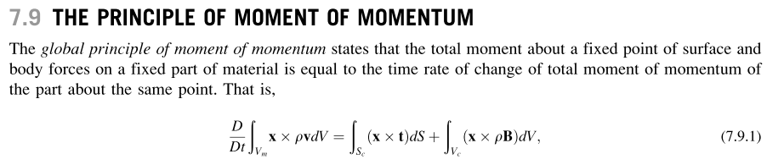
---------------

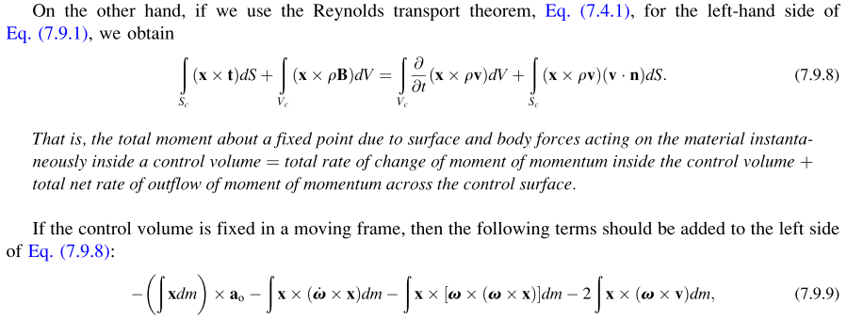

The equation (7.9.8) and its italicized interpretation express the familiar law of conservation of angular momentum. In Ref [14] Chapter 7 Lai et.al. have similar sections for conservation of mass, energy, and linear momentum, and a final section on the inequality of entropy, each of these being a "principle". Each section uses the Reynolds Transport Theorem to replace its D/Dt [∫Vm ...] object, and each section ends up with an equation like (7.9.8) with an italicized interpretation.

12. Summary of the Forward Problem Solution

(a) Summary of the Forward Problem equations (non-swap notation)

We now summarize the results of Sections 6, 7, 8 and 11. The first set of equations below is valid regardless of whether either of these frames is inertial (they could both be non-inertial). The second set of equations involving fictitious forces assumes that Frame S is inertial (and therefore Frame S' is not).

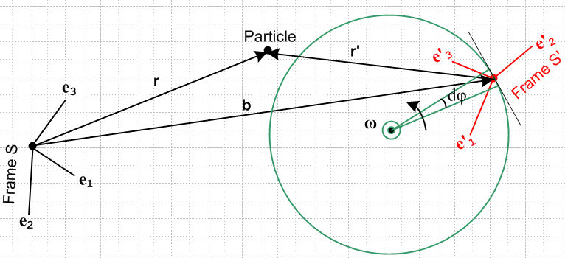
Fig 12.1 (non-swap)
Definitions and Equations

r, v, a position, natural velocity and natural acceleration in Frame S
r', v', a' position, natural velocity and natural acceleration in Frame S'
ω angular velocity of Frame S' relative to Frame S
b vector directed from origin of Frame S to origin of Frame S'
r = b + r' (6.1)

v = v' + ω x r' + S (6.6a)
v = v' + ω x r + S' (6.6c)

a = a' + x r' + 2 ω x v' + ω x (ω x r') + S (7.6a)
S S' Euler Coriolis centripetal frame

a = a' + x r + 2 ω x v' + ω x (ω x r) + 2ω x S' + S' (7.6b)

L(c) = L'(c') + (r'-c') x [ ω x r' + S]

(c) = '(c') – 'S' x [ω x r' + S] – [ω x c' + S] x [v' + ω x r' + S]
+ (r'-c') x [ x r' + 2 ω x v' + ω x (ω x r') + S] . (11.9)

Fictitious Forces (Section 8)

For using fictitious forces we have (Frame S is inertial)

F = ma // true Newton's Law in inertial Frame S (8.1)
F'eff = ma' // fake Newton's Law in rotating Frame S' (8.3)

F'eff = F + F'fict where, (8.5)

For the general case, the fictitious forces can be expressed as

F'fict = – mS – mω x (ω x r') – 2m ω x v' – m x r' (8.6)
frame centrifugal Coriolis Euler

For Special Case # 1 problems (ω axis passes through Frame S origin), we have

F'fict = – mω x (ω x r) – 2m ω x v' – m x r Special Case #1 (8.12)
centrifugal Coriolis Euler

Fictitious Torques (Section 11)

N'(c')fict = m'S' x [ω x r' + S] + m[ω x c' + S] x [v' + ω x r' + S]
– (r'-c') x [ m x r' + 2mω x v' + mω x (ω x r') + mS] . (11.14)

where the second line is just (r'-c') x F'fict from (8.6).

Note: The "swap" which relates swap notation to non-swap notation is simply that all primed objects (things like S, en, r, v, a, c, F, N) are interchanged with their non-primed counterparts. This is just a set of name changes. The vectors b or ω stay the same. So, the picture and equations in section (b) are the same as those of section (a) apart from this swap of primes.

(b) Summary of the Forward Problem equations (swap notation)

We now restate the above equations in S↔S' swapped notation. The first set of equations below is valid regardless of whether either of these frames is inertial (they could both be non-inertial). The second set of equations involving fictitious forces assumes that Frame S' is inertial (and therefore Frame S is not).

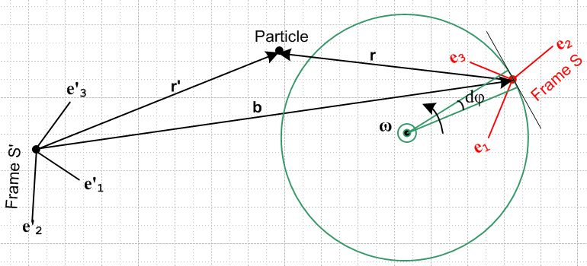
Fig 12.2 (swap)

Definitions and Equations

r', v', a' position, natural velocity and natural acceleration in Frame S'
r, v, a position, natural velocity and natural acceleration in Frame S
ω angular velocity of Frame S relative to Frame S'
b vector directed from origin of Frame S' to origin of Frame S
r' = b + r (6.1)s

v' = v + ω x r + S' (6.6a)s
v' = v + ω x r' + S (6.6c)s

a' = a + x r + 2 ω x v + ω x (ω x r) + S' (7.6a)s
S' S Euler Coriolis centripetal frame

a' = a + x r' + 2 ω x v + ω x (ω x r') + 2ω x S + S (7.6b)s

L'(c') = L(c) + (r-c) x [ ω x r + S']

'(c') = (c) – S x [ω x r + S'] – [ω x c + S'] x [v + ω x r + S']
+ (r-c) x [ x r + 2 ω x v + ω x (ω x r) + S'] . (11.9)s

Fictitious Forces (Section 8)

For using fictitious forces we have (Frame S' is inertial)

F' = ma' // true Newton's Law in inertial Frame S' (8.1)s
Feff = ma // fake Newton's Law in rotating Frame S (8.3)s

Feff = F' + Ffict (8.5)s

For the general case, the fictitious forces can be expressed as

Ffict = – mS' – mω x (ω x r) – 2m ω x v – m x r (8.6)s
frame centrifugal Coriolis Euler

For Special Case # 1 problems (ω axis passes through Frame S' origin), we have

Ffict = – mω x (ω x r') – 2m ω x v – m x r' Special Case #1 (8.12)s
centrifugal Coriolis Euler

Fictitious Torques (Section 11)

N(c)fict = mS x [ω x r + S'] + m[ω x c + S'] x [v + ω x r + S']
– (r-c) x [ m x r + 2mω x v + mω x (ω x r) + mS'] . (11.14)s

where the second line is just (r-c) x Ffict from (8.6)s.

Note: The "swap" which relates swap notation to non-swap notation is simply that all primed objects (things like S, en, r, v, a, c, F, N) are interchanged with their non-primed counterparts. This is just a set of name changes. The vectors b or ω stay the same. So, the picture and equations in section (b) are the same as those of section (a) apart from this swap of primes.

13. The Inverse Problem

Consider these two problems which concern the exact same physical situation (non-swap notation):

Forward problem: given: r', v', a', L'(c'), '(c')
find: r, v, a, L(c), (c) // summarized in Section 12 (a)

Inverse problem: given: r, v, a, L(c), (c)
find: r', v', a', L'(c'), '(c') // to be summarized in (c) below

We shall first compute the inverse equations by brute force, then at the end show how they can be obtained by a set of simple swap rules.

(a) Brute Force Method

Looking at the Section 12 (a) summary, equation (6.1) is easily inverted

r = b + r' =>

r' = r - b (13.1)

Similarly for (6.6a), where the third line below uses identity (6.2a),

v = v' + ω x r' + S (6.6a)
v' = v – ω x r' – S (13.2a)
v' = v – ω x r – S' (13.2b)

Equation (7.6a) requires a bit more effort to invert. We first solve (7.6a) for a'

a = a' + x r' + 2 ω x v' + ω x (ω x r') + S (7.6a)
a' = a – x r' – 2 ω x v' – ω x (ω x r') – S (13.3a)

Replace v' using (13.2a),

a' = a – x r' – 2 ω x [v – ω x r' – S] – ω x (ω x r') – S

= a – x r' – 2 ω x v + 2 ω x (ω x r') + 2 ω x S – ω x (ω x r') – S

= a – x r' – 2 ω x v + ω x (ω x r') + 2 ω x S – S (13.3b)

With r' = r – b we can regard the RHS of (13.3b) as being expressed entirely in terms of Frame S objects.

Now, by first shuffling terms in (7.10),

S' = S – x b – 2ω x S + ω x (ω x b) => (7.10)

2ω x S – S = – x b + ω x (ω x b) – S'

we can replace the last two terms in (13.3b) to get

a' = a – x r' – 2 ω x v + ω x (ω x r') – x b + ω x (ω x b) – S'

= a – x r – 2 ω x v + ω x (ω x r) – S' (13.3c)

Inversion of the L(c) and (c) can also be done by this brute force method, but we spare the reader and instead quote the results later after establishing the "swap rules method".

Summary of the inverse problem results:

r' = r - b (13.1)
v' = v – ω x r – S' (13.2b)
v' = v – ω x r' – S (13.2a)
a' = a – x r – 2 ω x v + ω x (ω x r) – S' (13.3c)
a' = a – x r' – 2 ω x v + ω x (ω x r') + 2 ω x S – S (13.3b)

(b) Swap Rules Method

Without any justification yet, let's postulate that we can obtain our inverse problem equations directly from the forward problem equations (and vice versa) using this set of swap rules

r ↔ r' b ↔ – b ω ↔ – ω L(c) ↔ L'(c') (13.6)
v ↔ v' S ↔ – S' (c) ↔ '(c')
a ↔ a' S ↔ – S'

Later in section (e) we will justify this set of rules.
Since the inverse equations computed by brute force are sitting just above, let's apply these swap rules to them and see what we get:

r = r' + b (13.1)swapped
v = v' + ω x r' + S (13.2c)swapped
v = v' + ω x r + S' (13.2a)swapped
a = a' + x r' + 2 ω x v' + ω x (ω x r') + S (13.3c)swapped
a = a' + x r + 2 ω x v' + ω x (ω x r) + 2 ω x S' + S ' (13.3b)swapped

And now we directly quote the summary from Section 12 (a) above

r = b + r' (6.1)
v = v' + ω x r' + S (6.6a)
v = v' + ω x r + S' (6.6c)
a = a' + x r' + 2 ω x v' + ω x (ω x r') + S (7.6a)
a = a' + x r + 2 ω x v' + ω x (ω x r) + 2ω x S' + S' (7.6b)

Since the last two sets of equations are identical, we have shown that the swap rules presented above do indeed convert either set of equations into the other,

forward problem equations ← swap rules → inverse problem equations

(c) Summary of the Inverse Problem Equations (non-swap notation)

The term "non-swap" notation in the title of this subsection just refers to the labeling of the picture below. It has nothing to do with the Swap Rules shown in (13.6). The equations below are the inverse problem equations corresponding to the forward problem equations given in Section 12 (a).

Fig 13.1 (non-swap)

r', v', a' position, natural velocity and natural acceleration in Frame S'
r, v, a position, natural velocity and natural acceleration in Frame S
ω angular velocity of Frame S' relative to Frame S
b vector directed from origin of Frame S to origin of Frame S'
r' = r - b (13.1)

v' = v – ω x r – S' (13.2b)
v' = v – ω x r' – S (13.2a)

a' = a – x r – 2 ω x v + ω x (ω x r) – S' (13.3c)
a' = a – x r' – 2 ω x v + ω x (ω x r') + 2 ω x S – S (13.3b)

L'(c') = L(c) – (r-c) x [ ω x r + S']

'(c') = (c) + S x [ω x r + S'] + [ω x c + S'] x [v – ω x r – S']
+ (r-c) x [ – x r – 2 ω x v + ω x (ω x r) – S'] . (13.7)

These (inverse problem, non-swap notation) equations are related to the (forward problem, swap notation) equations of Section 12 (b) by ω ↔ –ω and b ↔ –b. This fact serves as a check on the first equations above, and is used to obtain the L equations from those in Section 12 (b).

(d) Summary of the Inverse Problem Equations (swap notation)

The term "swap" notation in the title of this subsection just refers to the labeling of the picture below. It has nothing to do with the Swap Rules shown in (13.6). The equations below are the inverse problem equations corresponding to the forward problem equations given in Section 12 (b).

Fig 13.2 (swap)

r, v, a position, natural velocity and natural acceleration in Frame S
r', v', a' position, natural velocity and natural acceleration in Frame S'
ω angular velocity of Frame S relative to Frame S'
b vector directed from origin of Frame S' to origin of Frame S
r = r' - b (13.1)s

v = v' – ω x r' – S (13.2b)s
v = v' – ω x r – S' (13.2a)s

a = a' – x r' – 2 ω x v' + ω x (ω x r') – S (13.3c)s
a = a' – x r – 2 ω x v' + ω x (ω x r) + 2 ω x S' – S' (13.3b)s

L(c) = L'(c') – (r'-c') x [ ω x r' + S]

(c) = '(c') + 'S' x [ω x r' + S] + [ω x c' + S] x [v' – ω x r' – S]
+ (r'-c') x [ – x r' – 2 ω x v' + ω x (ω x r') – S] . (13.8)

These (inverse problem, swap notation) equations are related to the (forward problem, non-swap notation) equations of Section 12 (a) by ω ↔ –ω and b ↔ –b. This fact serves as a check on the first equations above, and is used to obtain the L equations from those in Section 12 (a).

(e) Why the Swap Rules (13.6) Work

We shall do a series of transformations on our general rotation picture Fig 4.2,

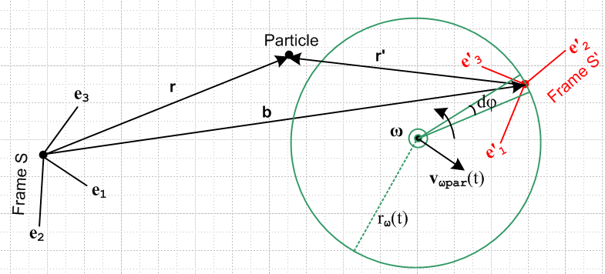 Fig 13.3

The above picture shows the situation with Frame S' doing instantaneous rotation about the ω rotation axis, and Frame S is fixed. In order to stop Frame S' from rotating, we must instantaneously rotate the above picture (3D space) at rate -ω about the rotation axis. Doing this gives

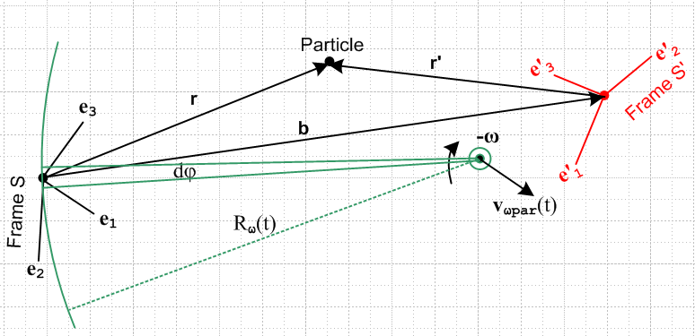 Fig 13.4

Frame S, which used to be fixed, is now doing instantaneous rotation at -ω about the same axis about which Frame S' used to be rotating.
Next we do two things at once: We first flip the b arrow changing b to -b, then we cosmetically just rotate the above picture 180 degrees. This gives,
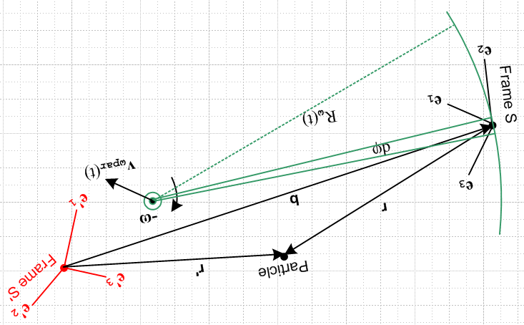 Fig 13.5

Next, we do a global S↔S' swap on everything (for example, ∂S ↔ ∂S', r↔r' , e'n↔ en, etc) and at the same time we rotate the text so things are more readable,

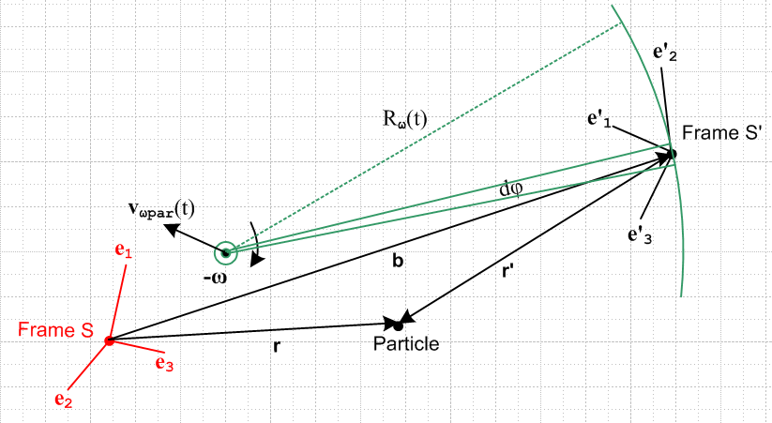 Fig 13.6

Since objects like Rω(t) and vωpart(t) don't appear in our equation sets, we just ignore them. As a final step, change the color of the two frames, AND make the change ω → -ω

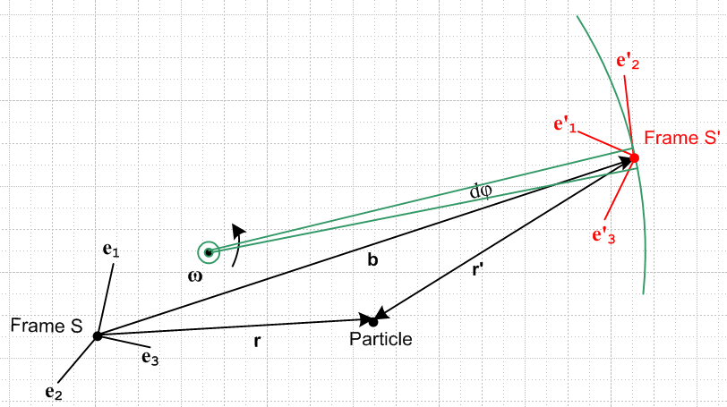 Fig 13.7

which we can them compare to the original forward picture

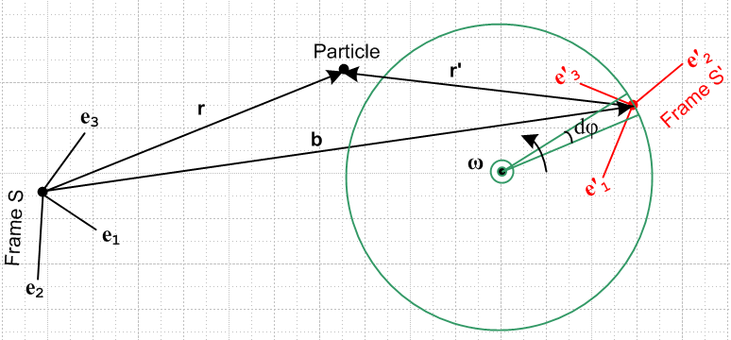 Fig 13.3

Apart from the fact that the two frames are oriented differently and the Particle is in a different position and the rotation radius and rotation axis are different, these two pictures are kinematically identical. In other words, any equation we derive in terms of variables r, r', b, ω, etc for the last two pictures will be the same, an example being r = r' + b.

We got from one picture to the other by doing these changes, which are seen to be the same as (13.6),

b→ -b S↔S' (and all that entails) ω→ -ω (13.9)

Since the swap rules take the physical kinematic picture back to itself, the same swap rules acting on any valid equation derived from either of these equivalent pictures produces an equation which is also valid. In other words, the swap rules embody a symmetry of both the picture and the equations.

This then is why the "swap rules" (13.6) convert between the forward problem equation set and the inverse problem equation set.

14. Rotating Frames in Curvilinear Coordinates

The solution equations to our Forward Problem are summarized in Section 12 (a) and (b) above, and those to the Inverse Problem are summarized in Section 13 (c) and (d). All equations are stated in bolded vector notation. Such equations may be projected onto (dotted with) any complete set of basis vectors, such as the , , used in spherical coordinates. Every orthogonal curvilinear coordinate system has such a set of orthonormal unit basis vectors which we shall call i, orthonormality meaning i • j = δi,j. In general, curvilinear basis vectors like i= , , are different at different points in space, so one can think of them as i(r). It is appropriate then to use them as basis vectors for a vector field V(r) or for a vector associated with a discrete Particle located at position r such as the velocity or acceleration of that Particle.
We might want to use one curvilinear system of coordinates ξi with basis unit vectors i for Frame S, and an entirely different system ξ'i with basis unit vectors 'i for Frame S'. We might, for example, have ξi be spherical coordinates and ξ'i be toroidal coordinates. Here then is the situation,

Cartesian coords and basis vectors Curvilinear coords and basis vectors
Frame S ri ei ξi i
Frame S' (r')i e'i (ξ')i 'i (14.1)

ei• ej = e'i• e'j = i • j = 'i • 'j = δi,j // orthonormality of all bases (14.2)

There must exist some matrix R(ξ) such that i(r) = R(ξ) ei for any given curvilinear system. Using the theorem of (1.1) and (1.2) we can write this useful information regarding the basis vectors :

i = R(ξ) ei => ei = R(ξ)ijj or i = [R(ξ)]-1ij ej
'i = R'(ξ') e'i => e'i = R'(ξ ')ij'j or 'i = [R'(ξ ')]-1ij e'j (14.3)

Example of an R(ξ) matrix. In spherical coordinates with ordering 1,2,3 = r,θ,φ, where θ is the polar angle and φ the azimuth, the matrix R(ξ) is given by (note that R-1 = RT),

R(ξ) = $\left(\begin{matrix}cosφsinθ & cosφcosθ & -sinφ \\ sinφsinθ & sinφcosθ & cosφ \\ cosθ & -sinθ & 0\end{matrix}\right)$ [R(ξ)]-1 = $\left(\begin{matrix}cosφsinθ & sinφsinθ & cosθ \\ cosφcosθ & sinφcosθ & -sinθ \\ -sinφ & cosφ & 0\end{matrix}\right)$ (14.4)

as shown in Appendix A at the end of this document. We can then use (14.3) that i = [R(ξ) ]-1ij ej to write

= = $\left(\begin{matrix}cosφsinθ & sinφsinθ & cosθ \\ cosφcosθ & sinφcosθ & -sinθ \\ -sinφ & cosφ & 0\end{matrix}\right)$ = [R(ξ) ]-1 = [R(ξ) ]-1$\left(\begin{matrix}e1 \\ e2 \\ e3\end{matrix}\right)$ (14.5)

or
= cosφsinθ + sinφsinθ + cosθ
= cosφcosθ + sinφcosθ – sinθ
= –sinφ + cosφ (14.6)

Expansions and naming. If V is an arbitrary vector, we then have these four expansions of interest :

V = Viei Vi = V • ei
V = (V)'i e'i (V)'i = V • e'i
V = (V)i i (V)i = V • i
V = (V)'i 'i (V)'i = V • ei (14.7)

where we use italics to denote curvilinear vector components. It is common practice, once a curvilinear system is selected, to make these replacements so the italics are no longer needed,

(V)i → Vξ$_{i}$ (V)'i → Vξ$_{i}$' (14.8)

In cylindrical coordinates r,θ,z and r',θ',z' this would mean, for example,

(V)1 → Vr (V)'1 → Vr'
(V)2 → Vθ (V)'1 → Vθ'
(V)3 → Vz (V)'2 → Vz' (14.9)

Equation Example. Consider now this equation taken from the Section 12 (a) summary,

v = v' + ω x r + S' (6.6c) (14.10)

We can view such an equation in any of our four bases as just discussed above,

(v)i = (v')i + εijk(ω)j(r)k + (S')i components in basis ei
(v)'i = (v')'i + εijk(ω)'j(r)'k + (S')'i components in basis e'i
(v)i = (v')i + εijk(ω)j(r)k + (S')i components in basis i
(v)'i = (v')'i + εijk(ω)'j(r)'k + (S')'i components in basis 'i (14.11)

For example, in r,θ,z cylindrical coordinates if we have ω = ω, then (ω)j = δj3ω , so in the third line above we get

εijk(ω)j(r)k = εijk ω δj3 (r)k = ω εi3k(r)k = - ω εik3(r)k

so that line becomes

(v)i = (v')i - ω εik3(r)k + (S')i components in basis i
or
(v)1 = (v')1 - ω ε123(r)2 + (S')1
(v)2 = (v')2 - ω ε213(r)1 + (S')2
(v)3 = (v')3 - ω ε3k3(r)k + (S')3 = (v')3 + (S')3 . (14.12)

This then translates into (since r = r + z = rr + rz and rθ = 0)

vr = v'r - ω rθ + (S')r = v'r + (S')r
vθ = v'θ + ω rr + (S')θ = v'θ + ω r + (S')θ
vz = v'z + (S')z (14.13)

For any Special Case #1 problem (see Section 4 (d) ) one has S' = 0 and the above equations become extremely simple

vr = v'r
vθ = v'θ + ω r
vz = v'z (14.14)

15. Ant on Turntable Problems

(a) Kinematics common to all Ant Problems

Consider a turntable occupied by an ant as shown in this drawing. Here Frame S is a fixed frame with origin at the turntable center, while Frame S' glued to the turntable surface is a rotating frame.

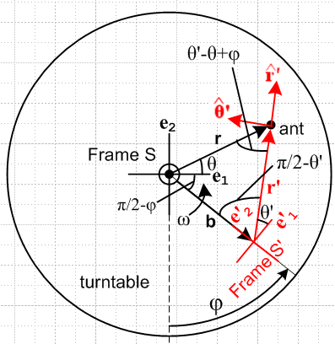 Fig 15.1

When φ = 0, red Frame S' lies directly under black Frame S and the axes "line up". For any angle φ one has b = -b e'2. Since the rotation axis goes through the origin of Frame S, the turntable problems fall into special case #1 of Section 4 (d). Basis vectors e3 = e'3 point to the viewer as does the ω vector for ω>0. The relation between the three angles θ, θ' and φ is complicated and can be indirectly obtained by writing the laws of sines and cosines for the triangle shown. We show all the angles, but none of this geometric detail will be needed below.

Another reasonable way to "instrument" the turntable would have been to place Frame S' to the right of Frame S with axes lining up when φ = 0 with φ defined in a more conventional manner. In this case b = +be'1. This path was not taken because it clutters up quadrant one where we want to draw things.

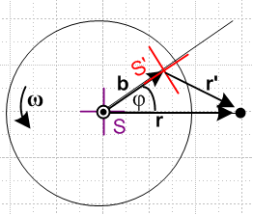 // picture not used.

In the first two Problems considered below, an ant executes some crawling motion on the turntable as described by certain r', v', and a' in Frame S'. Our task in each problem is to use our Section 12 summary results to compute r, v, and a as seen in Frame S and to plot some trajectories r(t).

In the third problem, the ant becomes a flying ant doing a straight-line fly-by at constant velocity in Frame S just over the turntable surface, which fly-by is described by some r, v, and a. This is an example of the Inverse Problem discussed in Section 13 and our goal here is to compute r', v', and a' in Frame S' using the equations provided in Section 13 (c).

Since we want to make Cartesian plots of certain results, we choose Cartesian coordinates for Frame S. The ant's crawling motions we have in mind are most easily expressed in cylindrical coordinates, so we choose cylindrical (basically polar) coordinates for Frame S'. Therefore, in the notation of Section 14,

ri = x,y,z for Frame S basis vectors ei = , ,
ξ'i = r',θ',z' for Frame S' basis vectors 'i = ' , ' , ' . (15.1)

What do we know about all the basis vectors?

From the picture one sees that, for the Cartesian unit vectors,

e'i = Rz(φ) ei for example e'1 = Rz(φ) e1 (15.2)

where φ is the angle describing the orientation of Frame S' relative to Frame S at time t.

Meanwhile, the cylindrical unit vectors can be expressed in terms of the Cartesian ones as follows (just stare at the picture)

'i = Rz(θ') e'i or ' = Rz(θ') e'1 (15.3)
' = Rz(θ') e'2
' = Rz(θ') e'3 // = e'3 .

Equations (15.2) and (15.3) can be combined to give

'i = Rz(θ') e'i = Rz(θ') [Rz(φ) ei]
= Rz(θ'+φ) ei . (15.4)

At this point, it is useful to recall the theorem of (1.1) and (1.2) which says,

ei = R e'i ⇔ ei = (R-1)ij e'j (1.1)+(1.2)

Application to (15.2) and (15.4) first with R = Rz(-φ) and then with R = Rz(-θ'-φ) gives

ei = Rz(-φ) e'i ⇔ ei = [Rz(φ)]ij e'j (15.2a)

ei = Rz(–θ'– φ) 'i ⇔ ei = [Rz(θ' + φ)]ij 'j (15.4a)

Since we know that the matrix which does an active Rz(ψ) rotation of a vector is given by

Rz(ψ) = $\left(\begin{matrix}cosψ & -sinψ & 0 \\ sinψ & cosψ & 0 \\ 0 & 0 & 1\end{matrix}\right)$,

we can invert the right equation in (15.4a) to get

= Rz(-θ' - φ) $\left(\begin{matrix}e1 \\ e2 \\ e3\end{matrix}\right)$ = $\left(\begin{matrix}cos(θ'+φ) & sin(θ'+φ) & 0 \\ -sin(θ'+φ) & cos(θ'+φ) & 0 \\ 0 & 0 & 1\end{matrix}\right)$$\left(\begin{matrix}e1 \\ e2 \\ e3\end{matrix}\right)$
or
= $\left(\begin{matrix}cos(θ'+φ) & sin(θ'+φ) & 0 \\ -sin(θ'+φ) & cos(θ'+φ) & 0 \\ 0 & 0 & 1\end{matrix}\right)$

which says

' = cos(θ'+φ) + sin(θ'+φ)
' = - sin(θ'+φ) + cos(θ'+φ)
' = . (15.5)

Similarly we can invert the right equation in (15.2a) to get

$\left(\begin{matrix}e'1 \\ e'2 \\ e'3\end{matrix}\right)$ = Rz(-φ)$\left(\begin{matrix}e1 \\ e2 \\ e3\end{matrix}\right)$ = $\left(\begin{matrix}cosφ & sinφ & 0 \\ -sinφ & cosφ & 0 \\ 0 & 0 & 1\end{matrix}\right)$$\left(\begin{matrix}e1 \\ e2 \\ e3\end{matrix}\right)$
so
' = cosφ + sinφ
' = -sinφ + cosφ // e'2 = - sinφ e1 + cosφ e2
' = (15.6)

Relation between Frame S and Frame S'

Assume at time t = 0 we have φ = φ0 in Fig 15.1.

If the rotation follows some angular velocity profile ω = ω(t), and since ω = dφ/dt, we have

dφ/dt = ω(t) => φ(t) = φ0 + $^{\int_{0}^{t}{}}$ ω(τ)dτ . (15.7)

For simplicity, we shall assume constant ω in which case we have

φ(t) = φ0 + ωt . (15.8)

Motion of vector b

From the picture and from (15.6) we have,

b(t) = -b e'2 = -b [- sinφ + cosφ ] = bsinφ – b cosφ . (15.9)

(b) Problem 1: Ant crawls at constant speed V to the Origin of Frame S'

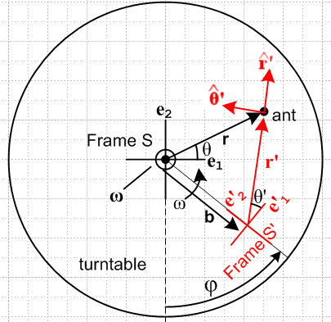 Fig 15.2

Ant's Motion in Frame S'.

Assume the ant starts at some (r'0,θ'0) at t = 0 and crawls with this velocity toward the S' origin,

v' = -V' . (15.10)

We can integrate this within Frame S' (where ' is fixed) to get

r'(t) = r'0 -Vt ' r'0 = r'0' = (r'0)x + (r'0)y = x'0 + y'0 (15.11)

The magnitude of r'(t) is given by

r' = r'0 - Vt (15.12)

and we shall only be interested in times small enough so r' > 0. The angle θ' never changes, so

θ' = θ'0 . (15.13)

Finally, since V = constant, the acceleration is

a' = 0 . (15.14)

Thus, in line with our Forward Problem statement, these are the given quantities in Frame S' ,

r' = r'0 – Vt '
v' = –V '
a' = 0 . (15.15)

Our goal is to compute r, v and a as seen in Frame S.

Using (15.5) for ', we can write (15.10) for v' in another way which will be used below,

v' = –Vcos(θ'+φ) – Vsin(θ'+φ) (15.16)

Trajectory r(t) of the ant in Frame S

Above we found that

b(t) = bsinφ – b cosφ (15.9)

' = cos(θ'+φ) + sin(θ'+φ) (15.5)

which tells us

r' = r' ' = r'cos(θ' + φ) + r'sin(θ' + φ) .

From our Section 12 summary (or just from looking at the picture) we have

r = b + r' (6.1)

Therefore from (15.9) and (15.5) (first line) we can write

r(t) = ( bsinφ – b cosφ ) + r' (cos(θ'+φ) + sin(θ'+φ) )

= [bsinφ + r'cos(θ'+φ)] + [– b cosφ + r'sin(θ'+φ)] .

Since r' = (r'0 - Vt) (15.12) and φ = φ(t) (15.8) as found by integrating ω(t), we get

r(t) = [ bsinφ + (r'0 - Vt)cos(θ'+φ)] + [ –b cosφ + (r'0 - Vt) sin(θ'+φ)]
or
r(t) = x + y
where (15.17)
x = bsinφ + (r'0 – Vt)cos(θ'+φ)
y = – bcosφ + (r'0 – Vt)sin(θ'+φ) .

This r(t) then is the trajectory of the ant in Frame S.

Velocity v(t) of the ant in Frame S

Since the turntable falls into our Special Case #1 of Section 4 (d) (ω through origin of Frame S), we know that S' = 0 (vector b is soldered to the Frame S' unit vectors). From the summary in Section 12, we select (6.6c)

v = v' + ω x r + S' (6.6c)
which then says, setting S' = 0,

v = v' + ω x r . (15.18)

From (15.16) we have [ θ' = θ'0 everywhere says (15.13) ]

v' = –Vcos(θ'+φ) – Vsin(θ'+φ) (15.16)

ω x r = [ω] x [x + y ] = ωx – ωy (15.19)

Therefore (15.18) says

v = [ –Vcos(θ'+φ) – Vsin(θ'+φ) ] + ωx – ωy

= [–V cos(θ'+φ) – ωy ] + [–V sin(θ'+φ) + ωx]

or
v = vx + vy
where (15.20)
vx = –Vcos(θ'+φ) – ωy
vy = –Vsin(θ'+φ) + ωx

where x,y are given in (15.17). We can go ahead and insert x and y to get

– ωy = -ω[– bcosφ + (r'0 – Vt)sin(θ'+φ)] = ωbcosφ – ω(r'0 – Vt)sin(θ'+φ)

ωx = ω[ bsinφ + (r'0 – Vt)cos(θ'+φ)] = ωbsinφ + ω(r'0 – Vt)cos(θ'+φ)
so
vx = –Vcos(θ'+φ) + ωbcosφ – ω(r'0 – Vt)sin(θ'+φ)
vy = –Vsin(θ'+φ) + ωbsinφ + ω(r'0 – Vt)cos(θ'+φ) . (15.21)

Acceleration a(t) of the ant in Frame S

From the summary in Section 12 we start with

a = a' + x r + 2 ω x v' + ω x (ω x r) + 2ω x S' + S' (7.6b)

but in this Special Case #1 problem we have S' = 0 and S' = 0 so

a = a' + x r + 2 ω x v' + ω x (ω x r) . (15.22)

We shall ponder the terms one at a time.

As noted in (15.14), a' = 0.

Our turntable is restricted to have = so, similar to (15.19) above, we find

x r = x – y . (15.23)

Next, we install (15.16) for v' to get

ω x v' = [ω] x [–Vcos(θ'+φ) – Vsin(θ'+φ) ] = -ωV cos(θ'+φ) + ωV sin(θ'+φ)

= ωVsin(θ'+φ) – ωVcos(θ'+φ) . (15.24)

With (15.19) the last term of (15.22) becomes

ω x (ω x r) = [ω] x [ωx – ωy] = -ω2x – ω2y // = -ω2 r, centripetal accel. (15.25)

Combining all the terms then gives

a = a' + x r + 2 ω x v' + ω x (ω x r)

= 0 + (x – y) + 2ωVsin(θ'+φ) - 2ωVcos(θ'+φ) -ω2x – ω2y

= [– y + 2ωVsin(θ'+φ) – ω2x] + [x – 2ωVcos(θ'+φ) – ω2y]

or
a = ax + ay
where (15.26)
ax = – y + 2ωVsin(θ'+φ) – ω2x
ay = x – 2ωVcos(θ'+φ) – ω2y

where x,y are given by (15.17).

Summary of the Solution to Problem 1

r(t) = x + y
where (15.17)
x = bsinφ + (r'0 – Vt)cos(θ'+φ)
y = – bcosφ + (r'0 – Vt)sin(θ'+φ)

v = vx + vy
where (15.20)
vx = – Vcos(θ'+φ) – ωy
vy = – Vsin(θ'+φ) + ωx

a = ax + ay
where (15.26)
ax = – y + 2ωVsin(θ'+φ) – ω2x
ay = x – 2ωVcos(θ'+φ) – ω2y

and
φ(t) = φ0 + $^{\int_{0}^{t}{}}$ ω(τ)dτ = φ0 + ωt for constant ω (15.8)

The x and y in equations (15.20) and (15.26) are given by (15.17), and θ' = θ'0 by (15.13).

Selected Plots

We set φ0 = 0 so Frame S' starts directly below Frame S and is aligned with it, so then φ = ωt.
We set θ'0 = θ' = 0 so ant approaches the Frame S' origin along the e'1 axis.
With these assumptions (15.17) becomes

r(t) = x + y
where (15.27)
x = bsin(ωt) + (r'0 – Vt)cos(ωt)
y = – bcos(ωt) + (r'0 – Vt)sin(ωt) ,

Each plot is finite because the trip is over when the ant reaches the S' origin at tmax = r'0/V.
We set b = 0.5, r'0 = 1, V = 0.1. The ant therefore starts 1/2 unit down and 1 unit to the right. Here are trajectory plots for various values of ω

ω = 1/2 ω = 1 ω = 3
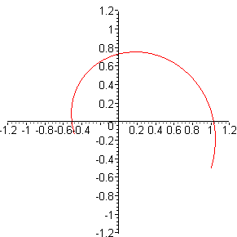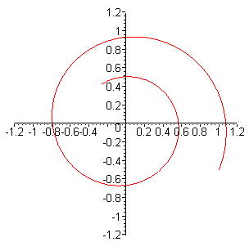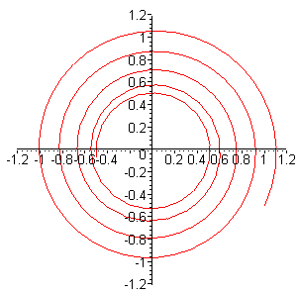
Fig 15.3

All plots start at the same place and spiral in. The trajectory ends when the ant reaches the S' origin.

The middle plot was generated by the following Maple code :

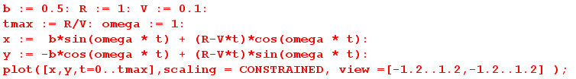

If we set b = 0, we get these more traditional plots ( Frame S and Frame S' origins coincide )

ω = 1/2 ω = 1 ω = 3
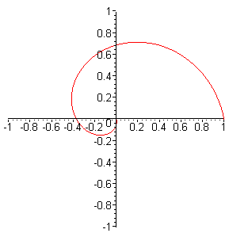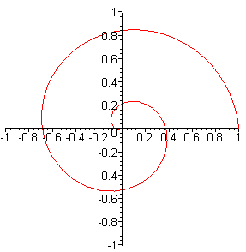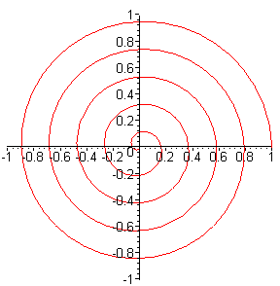
Fig 15.4

Next we plot the velocity v from (15.20) only for the middle ω = 1 case above on the right below, with the corresponding trajectory plot r on the left:

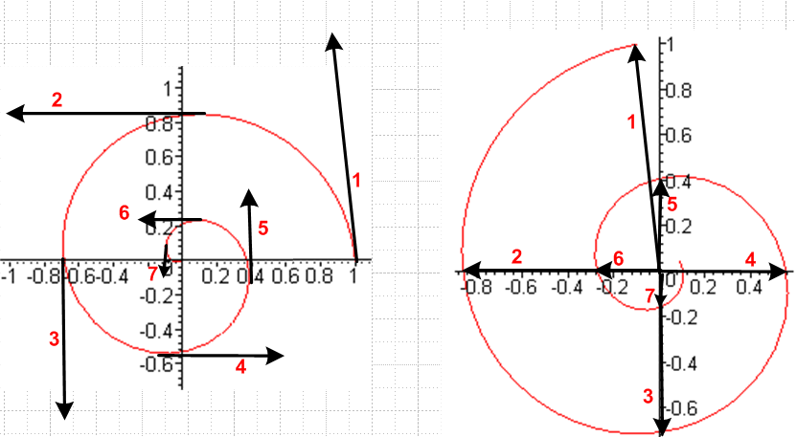 Fig 15.5

ω = 1 plot of r(t) ω = 1 plot of v(t)

For seven different (but unknown) times, we draw the velocity vector on the right and then transfer it to where we think it ought to go on the trajectory plot on the left. Things at least seem reasonable. A proper visual check would require a program to automate the above process.

Next we plot the acceleration a on the right below using (15.26), again for ω = 1 , with the corresponding trajectory plot r on the left:

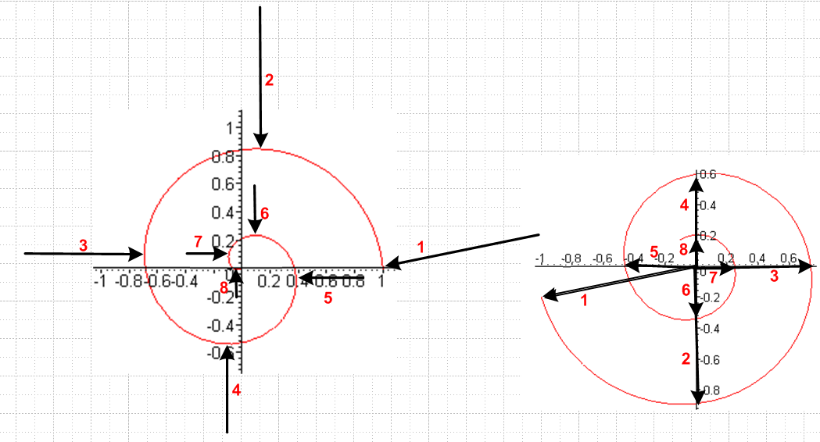
Fig 15.6

For the same seven (still unknown) times plus one more, we draw the acceleration vector on the right and transfer it to where we think it ought to go on the left. Again, this is just a sanity check to make sure things seem reasonable.

Exercise for the Reader: From (15.10) we have v' = -V' so that

v'r = v' • = -V' • = -V cos(θ'-θ+φ)

according to Fig 15.1, where v'r is the radial component of the ant velocity v' in cylindrical coordinates. On the other hand, the radial component of v is given by

vr = • v = • [vx + vy ] = vx • + vy • = vx cosθ + vysinθ
where
vx = –Vcos(θ'+φ) + ωbcosφ – ω(r'0 – Vt)sin(θ'+φ)
vy = –Vsin(θ'+φ) + ωbsinφ + ω(r'0 – Vt)cos(θ'+φ) . (15.21)

Looking at the above expressions for v'r and vr, it seems unlikely that they could be equal since vr involves terms linear in time t and is a function of ω, b, and r'0, whereas v'r does not seem to involve these terms and parameters at all. Yet equation (14.14), which applies to any Special Case #1 problem like Problem 1, claims vr = v'r . The Exercise is to show that in fact vr = v'r.

Hint: sin(π/2 - φ + θ)/ r' = sin(θ'+φ-θ)/b.

Some results to be used in the next problem.

In the case that b = 0, = 0, φ0 = 0 and θ'0 = θ = 0 ( which applies to the last triplet of trajectory plots shown above) we can summarize our results as follows:

r(t) = x + y
where (15.17)
x = (r'0 – Vt)cos(ωt)
y = (r'0 – Vt)sin(ωt)

v = vx + vy
where (15.20)
vx = –Vcos(ωt) – ω(r'0 – Vt)sin(ωt)
vy = –Vsin(ωt) + ω(r'0 – Vt)cos(ωt) (15.21)

a = ax + ay
where (15.26)
ax = + 2ωVsin(ωt) – ω2 (r'0 – Vt)cos(ωt)
ay = – 2ωVcos(ωt) – ω2 (r'0 – Vt)sin(ωt)

(c) Problem 2: Ant spirals in at constant V and Ω to the Origin of Frame S'

Ant's Motion in Frame S'

In order to challenge our formalism a bit, the ant now crawls on the turntable in a more complicated manner. The ant in Frame S' starts at r'0 = r'0 ' and crawls in a spiral path toward the S' origin. This spiral path is the output of Problem 1 with the Problem 1 parameters set to b = 0, = 0, φ0 = 0 and θ'0 = 0. The ant moves at constant radial speed V toward the S' origin while at the same time rotating at constant Ω about that origin. In order to find r', v' and a' for this problem, we merely adjust the results stated at the end of the previous section by taking ω → Ω and priming appropriate objects.

r'(t) =(r')'x ' + (r')'y ' // = (r')'ie'i
where (15.29a)
(r')'x = (r'0 – Vt)cos(Ωt) // = (r')'1
(r')'y = (r'0 – Vt)sin(Ωt)

v' = (v')'x ' + (v')'y '
where (15.30a)
(v')'x = –Vcos(Ωt) – Ω (r'0 – Vt)sin(Ωt) // = (v')'1
(v')'y = –Vsin(Ωt) + Ω (r'0 – Vt)cos(Ωt)

a' = (a')'x ' + (a')'y '
where (15.31a)
(a')'x = 2ΩVsin(Ωt) – Ω2(r'0 – Vt)cos(Ωt) // = (a')'1
(a')'y = – 2ΩVcos(Ωt) – Ω2(r'0 – Vt)sin(Ωt)

Note: In the above equations we could have used these "natural" Frame S' designations

(r')'1 = r'1 = x' (v')'1 = v'1 = v'x (a')'1 = a'1 = a'x
(r')'2 = r'2 = y' (v')'2 = v'2 = v'y (a')'2 = a'2 = a'y

but we stuck with the full bore notation. The main reason is that in the "b" equations below, there is no "natural" notation for the objects they contain.

In the above "a" equations we next use (15.6) to replace ' and '

' = cosφ + sinφ
' = -sinφ + cosφ (15.6)

because we want to have Frame S unit vectors. The results are,

r'(t) = (r')x + (r')y // = (r')iei
where (15.29b)
(r')x = (r'0 – Vt)cos(φ + Ωt) // = (r')1
(r')'y = (r'0 – Vt)sin(φ + Ωt)

v' = (v')x + (v')y
where (15.30b)
(v')x = –Vcos(φ + Ωt) – Ω (r'0 – Vt)sin(φ + Ωt) // = (v')1
(v')y = –Vsin(φ + Ωt) + Ω (r'0 – Vt)cos(φ + Ωt)

a' = (a')x + (a')y
where (15.31b)
(a')x = 2ΩVsin(φ + Ωt) – Ω2(r'0 – Vt)cos(φ + Ωt) // = (a')1
(a')y = – 2ΩVcos(φ + Ωt) – Ω2(r'0 – Vt)sin(φ + Ωt)

Comments:

1. Much algebra is involved in obtaining these "b" equation versions from the "a" equations, involving the usual identities such as sin(Ωt) cosφ + cos(Ωt) sinφ = sin(φ + Ωt). After doing all this, one sees that the "b" results can be obtained from the "a" results simply by making the replacement Ωt → φ + Ωt in all the trig functions. Since e'i = Rz(φ) ei as in (15.2), the effect of changing bases adds a phase φ to all trig arguments.

2. The reader is encouraged to take note of the careful placement of primes on components in all six equation sets above.

Trajectory r(t) of the ant in Frame S

According to (15.29b),

r'(t) = (r'0 – Vt) [ cos(φ + Ωt) + sin(φ + Ωt) ] . (15.32)

Using these previous facts,

r = b + r' (6.1)

b(t) = bsinφ – b cosφ (15.9)

we obtain

r(t) = x + y
where (15.33)
x = bsinφ + ( r'0 – Vt)cos(φ + Ωt)
y = – bcosφ + (r'0 – Vt)sin(φ + Ωt) .

The Ω = 0 limit of this result agrees with the θ' = 0 limit of (15.17), the Problem 1 trajectory.

Velocity v(t) of the ant in Frame S

We start with two equations used in Problem 1,

v = v' + ω x r (15.18)

ω x r = [ω] x [x + y ] = ωx – ωy (15.19)

Then using v' from (15.30b) in (15.18) just above we get

v = vx + vy
where (15.34)
vx = –Vcos(φ + Ωt) – Ω (r'0 – Vt)sin(φ + Ωt) – ωy
vy = –Vsin(φ + Ωt) + Ω (r'0 – Vt)cos(φ + Ωt) + ωx

Inserting (15.33) for x and y then gives

vx = –Vcos(φ + Ωt) – Ω (r'0 – Vt)sin(φ + Ωt) – ω[– bcosφ + (r'0 – Vt)sin(φ + Ωt)]
vy = –Vsin(φ + Ωt) + Ω (r'0 – Vt)cos(φ + Ωt) + ω[bsinφ + ( r'0 – Vt)cos(φ + Ωt)]
or
vx = –Vcos(φ + Ωt) – (ω + Ω) (r'0 – Vt)sin(φ + Ωt) + ωbcosφ
vy = –Vsin(φ + Ωt) + (ω + Ω) (r'0 – Vt)cos(φ + Ωt) + ωbsinφ (15.34a)

The Ω = 0 limit of these last equations gives the θ' = 0 limit of (15.21).

Acceleration a(t) of the ant in Frame S

We start again with (15.22)

a = a' + x r + 2 ω x v' + ω x (ω x r) (15.22)

The first term is of course given by (15.31b)

a' = (a')x + (a')y
where (15.31b)
(a')x = 2ΩVsin(φ + Ωt) – Ω2(r'0 – Vt)cos(φ + Ωt) // = (a')1
(a')y = – 2ΩVcos(φ + Ωt) – Ω2(r'0 – Vt)sin(φ + Ωt)

The 2nd and 4th terms we can obtain by quoting these results from the previous problem

x r = x – y . (15.23)

ω x (ω x r) = [ω] x [ωx – ωy] = -ω2x – ω2y // = -ω2 r, centripetal accel. (15.25)

The third term involves

ω x v' = [ω] x [(v')x + (v')y ] = ω(v')x – ω (v')y

Adding these terms we get

a = ax + ay
where (15.35)
ax = 2ΩVsin(φ + Ωt) – Ω2(r'0 – Vt)cos(φ + Ωt) – y – ω2x – 2ω (v')y
ay = – 2ΩVcos(φ + Ωt) – Ω2(r'0 – Vt)sin(φ + Ωt) + x – ω2y + 2ω(v')x
where
x = bsinφ + ( r'0 – Vt)cos(φ + Ωt) (15.33)
y = – bcosφ + (r'0 – Vt)sin(φ + Ωt)
and
(v')x = –Vcos(φ + Ωt) – Ω (r'0 – Vt)sin(φ + Ωt)
(v')y = –Vsin(φ + Ωt) + Ω (r'0 – Vt)cos(φ + Ωt) (15.30b)

The result is admittedly a bit complicated, but the point is that we were able to obtain the result using our Section 12 summary equations without too much effort. [ See "The Hard Way" in section (e) below. We have not dealt with any differential equations in obtaining the above results. ]

Trajectory Plots

We set φ0 = 0 so Frame S' starts directly below Frame S and aligned with it, and then φ = ωt. Equation (15.33) then reads

r(t) = x + y
where (15.36)
x = bsin(ωt) + ( r'0 – Vt)cos(ωt + Ωt)
y = – bcos(ωt) + (r'0 – Vt)sin(ωt + Ωt) .

Again, each plot is finite because the trip is over when the ant reaches the S' origin at tmax = r'0/V. The blue circles have radius b (origin of Frame S'), the green have radius b+r'0, the ant always starts at (r'0,-b).

b = 3, r'0 = 2, V = 0.4, ω = 1, and :

Ω = 6 Ω = 10 Ω = 20
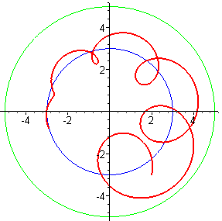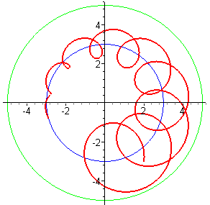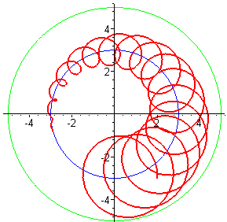
Fig 15.7

These trajectories should seem quite reasonable to the reader, knowing what that ant is up to. The middle plot was created using this Maple code,

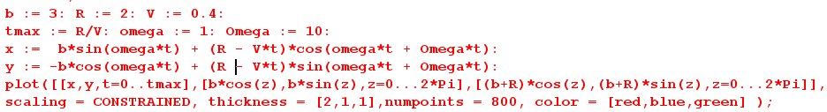

When ω and Ω have opposite sign, things can look quite different,

Ω = -2 Ω = -3 Ω = -3.6
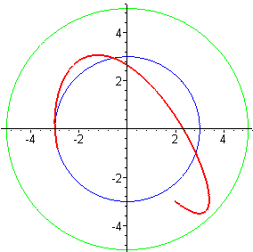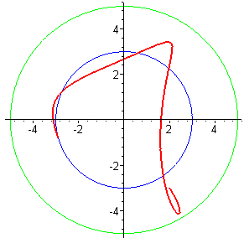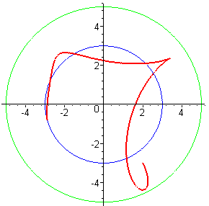
Fig 15.8

Finally, here are some trajectories with V = 0,

r'0 = 0.7, b = 3, V = 0, ω = 1 and :

Ω = 3.5 Ω = -7 Ω = 25.1
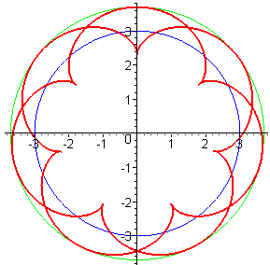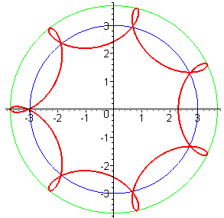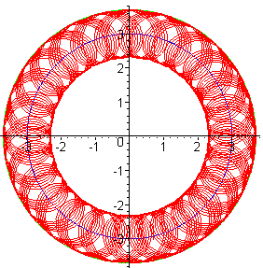
Fig 15.9

Using the parameters of the third plot, if one were to space 10,000 ants evenly on the turntable, and have each one carry a grain of sand on its back, one would have constructed a random orbital sander. The closure of the plots occurs whenever Ω/ω is a ratio of integers, but that could take many revolutions if those integers are large.

(d) Problem 3: Inverse Problem: Ant flies in Frame S at constant velocity V

A flying ant starting at position r0 flies just above the turntable surface in Frame S in a straight line at constant velocity V and at angle θ relative to the x axis. First state r,v,a and then compute r',v',a' and plot the trajectory r' of the particle in Frame S'. Use the same Frame S / Frame S' setup as in the previous problems.

We use these notations interchangeably: e'1 = ' , e'2 = ', e'3 = '

Ant's Motion in Frame S

The flying ant starts at location r0 and has velocity V = V with V constant, so

v = V
r = Vt + r0
a = 0 . (15.37)

As noted, the ant flies on a line which has angle θ relative to the e1 axis, so

= Rz(θ) e1 . (15.38)

This angle θ is defined in the usual sense: it is counterclockwise from the positive x axis.

Trajectory r'(t) of the ant in Frame S'

First, we need to write in Frame S' basis vectors. Recall (15.2) which says

e'i = Rz(φ) ei for example e'1 = Rz(φ) e1 . (15.2)

Therefore

= Rz(θ) e1 = Rz(θ) Rz(-φ) e'1 = Rz(θ-φ) e'1 . (15.39)

Second, how does the point r0 in Frame S appear in Frame S' ? Using (15.2) just above gives

r0 = (r0)i ei = (r0)i Rz(-φ)e'i . (15.40)

Third, from (15.9) (or just looking at the drawing) we know that

b = -b e'2 . (15.9)

Now for the trajectory:

r' = r - b // Section 13 (c) Inverse Problem equations

= (Vt + r0 ) + b e'2 // from (15.37) and (15.9)

= Vt Rz(θ-φ) e'1 + (r0)i Rz(-φ)e'i + b e'2 // from (15.39) and (15.40)
so
r' = Vt Rz(θ-φ) e'1 + Rz(-φ) [(r0)i e'i] + b e'2 (15.41)

We now use the following notations (these are all "natural" components in sense of Section 1 (h) )

(r0)1 = x0 (r')'1 = x'
(r0)2 = y0 (r')'2 = y'

In Frame S', e'1 = (1,0,0), so we write (15.41) in matrix notation in Frame S' as follows :

$\left(\begin{matrix}x' \\ y' \\ z'\end{matrix}\right)$ = Vt $\left(\begin{matrix}cos(θ-φ) & -sin(θ-φ) & 0 \\ sin(θ-φ) & cos(θ-φ) & 0 \\ 0 & 0 & 1\end{matrix}\right)$ $\left(\begin{matrix}1 \\ 0 \\ 0\end{matrix}\right)$ + $\left(\begin{matrix}cosφ & sinφ & 0 \\ -sinφ & cosφ & 0 \\ 0 & 0 & 1\end{matrix}\right)$$\left(\begin{matrix}x0 \\ y0 \\ 0\end{matrix}\right)$ + b $\left(\begin{matrix}0 \\ 1 \\ 0\end{matrix}\right)$
or
x' = Vt cos(θ-φ) + x0cosφ + y0sinφ
y' = Vt sin(θ-φ) – x0sinφ + y0cosφ + b
z' = 0

so the conclusion is this :

r'(t) = x' ' + y' '
where (15.42)
x' = Vt cos(θ-φ) + x0cosφ + y0sinφ
y' = Vt sin(θ-φ) – x0sinφ + y0cosφ + b
where φ = φ0 + ωt

This then is the trajectory of the flying ant as seen in Frame S'.
Trajectory r'(t) of the ant in Frame S': Alternate Method

Since we are going to have a discrepancy with Thornton and Marion below, it seems healthy to confirm (15.42) by an alternate derivation that does not make use of the matrix notation used above. We start as before,

r' = r - b = (Vt + r0 ) + b e'2 r' = trajectory of ant in Frame S'

Using the theorem (1.1) + (1.2) we find that

= Rz(θ-φ) e'1 = Rz(φ-θ)11 e'1 + Rz(φ-θ)12 e'2 = cos(φ-θ) e'1 - sin(φ-θ) e'2

r0 = (r0)i ei = (r0)i Rz(-φ)e'i = x0 Rz(-φ)e'1 + y0 Rz(-φ)e'2

= x0 { Rz(φ)11 e'1 + Rz(φ)12 e'2 } + y0 { Rz(φ)21 e'1 + Rz(φ)22 e'2 }

= x0 { cos(φ) e'1 – sin(φ) e'2 } + y0 {sin(φ) e'1 + cos(φ) e'2 }

= [x0 cos(φ) + y0 sin(φ)] e'1 + [– x0 sin(φ) + y0 cos(φ)] e'2

and therefore

r' = Vt + r0 + b e'2

= Vt [cos(φ-θ) e'1 - sin(φ-θ) e'2] + [x0 cos(φ) + y0 sin(φ)] e'1 + [- x0 sin(φ) + y0 cos(φ)] e'2 + b e'2

= [Vt cos(φ-θ) + x0 cos(φ) + y0 sin(φ) ]e'1 + [- Vt sin(φ-θ) - x0 sin(φ) + y0 cos(φ) + b]e'2

= [Vt cos(θ-φ) + x0 cos(φ) + y0 sin(φ) ]e'1 + [ Vt sin(θ-φ) - x0 sin(φ) + y0 cos(φ) + b]e'2

and this does agree with (15.42).

Velocity v'(t) of the ant in Frame S'

From the Inverse Problem equations in Section 13 (c) we have

v' = v – ω x r – S' (13.2b)

Since this is a special case #1 problem, we have S' = 0 and then

v' = v – ω x r = v – ω x (r'+b) = v – ω x r' – ω x b // from (6.1) that r' = r - b

= V Rz(θ-φ) ' – ω x [ x' ' + y' '] – ω x [ -b '] // (15.37) v, (15.39) and (15.9) b

= V Rz(θ-φ) ' –ωx' ' + ωy' ' – ωb ' // ω = ω '

Using the following notations,

(v')'1 = v'x'
(v')'2 = v'y'

the above equation in matrix notation in Frame S' is

$\left(\begin{matrix}v'x' \\ v'y' \\ v'z'\end{matrix}\right)$= V $\left(\begin{matrix}cos(θ-φ) & -sin(θ-φ) & 0 \\ sin(θ-φ) & cos(θ-φ) & 0 \\ 0 & 0 & 1\end{matrix}\right)$ $\left(\begin{matrix}1 \\ 0 \\ 0\end{matrix}\right)$ + $\left(\begin{matrix}ωy'-ωb \\ -ωx' \\ 0\end{matrix}\right)$
or
v'x' = V cos(θ-φ) + ω(y'-b)
v'y' = V sin(θ-φ) - ωx'
v'z' = 0

Then using (15.42) for x' and y' we get,

v'(t) = v'x' ' + v'y' '
where (15.43)
v'x' = V cos(θ-φ) + ω[Vt sin(θ-φ) – x0sinφ + y0cosφ]
v'y' = V sin(θ-φ) – ω[Vt cos(θ-φ) + x0cosφ + y0sinφ]
where φ = φ0 + ωt

Acceleration a'(t) of the ant in Frame S'

From the Inverse Problem equations in section 13 (c) we have

a' = a – x r – 2 ω x v + ω x (ω x r) – S' (13.3c)

Setting S'= 0 for our special case #1 problem, and using (15.37) for r, v and a (a = 0) we get

a' = – x [Vt + r0] – 2 ω x [V] + ω x (ω x [Vt + r0])

We shall stop here, but the calculation can be continued in a manner similar to that for r' and v'.

Trajectory Plots

Recall (15.42) from above

r'(t) = x' ' + y' '
where (15.42)
x' = Vt cos(θ-φ) + x0cosφ + y0sinφ
y' = Vt sin(θ-φ) – x0sinφ + y0cosφ + b
where φ = φ0 + ωt

For plotting purposes, we set φ0 = 0 so φ = ωt. Since b merely offsets plots vertically by amount b, we lose no interest by setting b = 0, causing the Frame S and Frame S' origins to coincide. Then

x' = Vt cos(θ-ωt) + x0cos(ωt) + y0sin(ωt)
y' = Vt sin(θ-ωt) – x0sin(ωt) + y0cos(ωt) (15.44)

In all plots below we set ω = 1. In the first three plots the flying ant starts out at r0 = (-1/2,0) and flies north so θ = π/2. We superpose a green circle of radius R = 1 and take note of the time T it takes for the ant to reach the circle. The Maple code used for the left plot is this

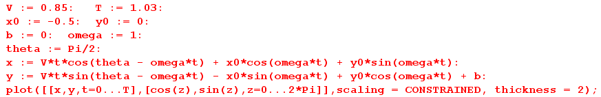

Here then are plots for three decreasing values of V. As the ant flies more slowly, the turntable turns more radians before the ant reaches a distance R = 1 from the turntable center.

V = .85 , T = 1.03 V = 0.3, T = 2.9 V = .061, T = 14

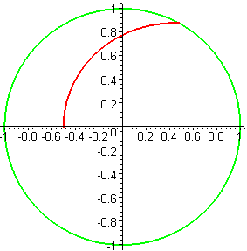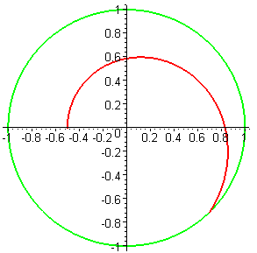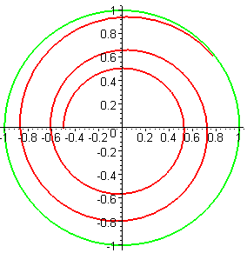
Fig 15.10

These plots may be compared to those appearing in T&M on page 395

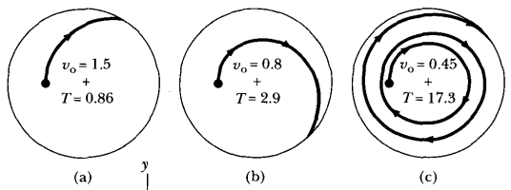
Fig 15.11

Their plotting method is to compute the fictitious force acceleration

a' = – 2 ω x v + ω x (ω x r)

and then to numerically integrate a' twice to get v' and then r' which is then plotted [ Again, see "The Hard Way" in section (e) below.] Although our plots are close to theirs in appearance, our numbers for V and T differ significantly from theirs. Here are the three plots our code generates using the numbers specified in the T&M images above,

V = 1.5 , T = 0.86 V = 0.8, T = 2.9 V = 0.45, T = 17.3
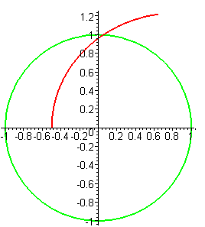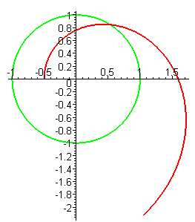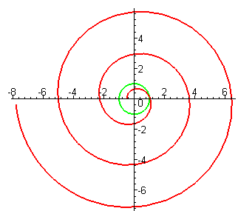
Fig 15.12

(continued on next page)

For the next three plots, the flying ant starts in the same place r0 = (-1/2,0) but flies southeast so θ = -π/4 . Interestingly, we see that it is possible for the ant to execute a loop, a cusp, or a bump soon after taking flight. We first show blowups of these three effects, then the full plots:

Fig 15.13
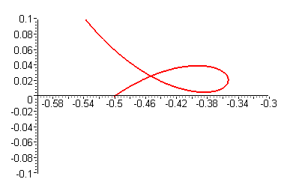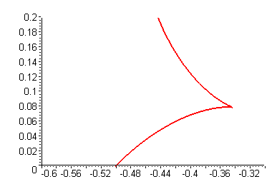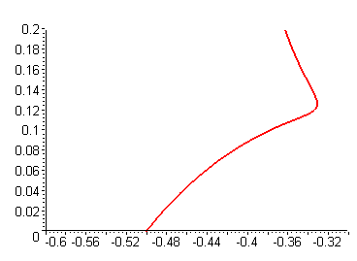

V = 0.42, T = 3.1 V = 0.35, T = 3.7 V = 0.31, T = 4.2

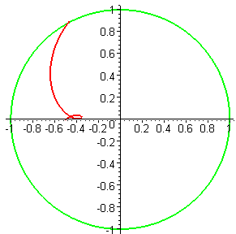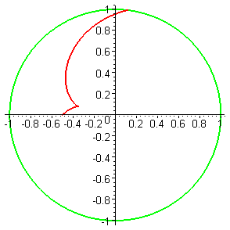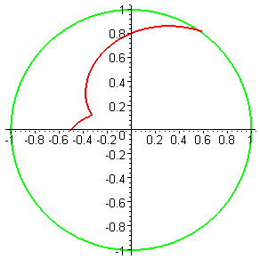
Fig 15.14

The left pair of plots may be compared to two other plots appearing in T&M on page 395

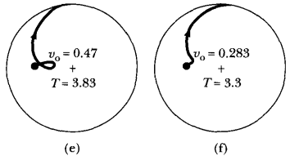 Fig 15.15

Again the plots are similar, but the numbers are different (but in the same ball park).

Using (15.43) we plot the velocity that goes with the second trajectory shown in the first triplet above, and at least things seem reasonable:

r(t) for V = 0.3, T = 2.9 v(t) for V = 0.3, T = 2.9
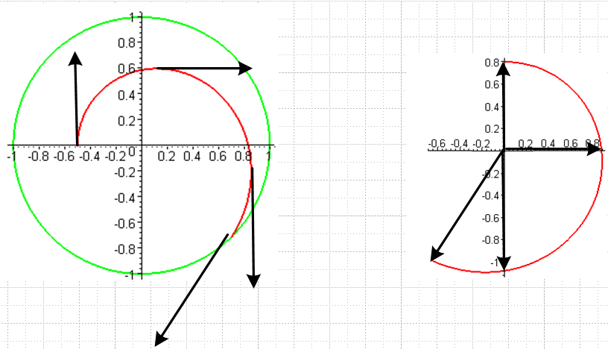 Fig 15.16

Finally, we move the starting position to (-1,-1) and have the ant fly northeast so θ = π/4. This path takes him over the origin of Frame S (and Frame S'), so we expect to see the Frame S' trajectory touch the origin at one point along the trajectory (except in the left plot where V = 0)

V = 0, T = 5 V = 0.11, T = 25 V = 0.2, T = 15
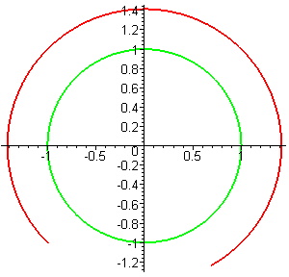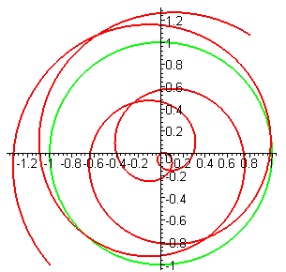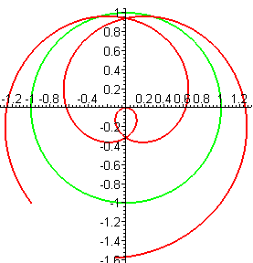
Fig 15.17

Since the turntable is rotating counterclockwise at ω=1, these trajectories run clockwise at all times. When V = 0, the apparent motion of the static fly is circular in Frame S'. In the middle plot we see that the ant spirals in, reaches the origin, the spirals out. In the right plot he does the same thing, but more quickly.

In the 1960's some excellent frames-of-reference movies were produced. One of them involves a frictionless puck moving on a smooth table mounted to a large wooden frame which rotates. Two affable "doctors" are rotating on that frame with the table. Doctor #1 on the left launches the puck, but Doctor #2 has nothing to do since the puck just returns to Doctor #1.
We show two possible Frame S' paths for a puck launched from (x0, y0) = (-1,0) and ω = 1.

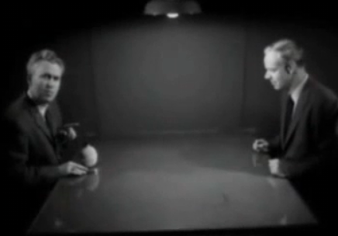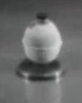

V = 0.6, T = 3.2, θ = 0 Fig 15.18 V = 0.2, T = 5, θ = π/4
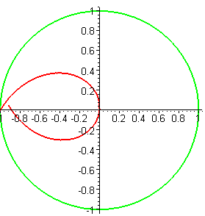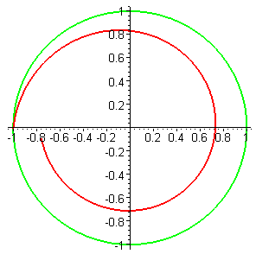

http://www.youtube.com/watch?v=3ug23VTMies

(e) The Projectile Problem of Section 8 (c)

It will be recalled that in Section 8 (c), as a demonstration of the Coriolis force, four projectiles are fired horizontally in four directions as in Figure 8.5. Since each projectile is like one of our flying ants, we already have a complete solution to this problem which we shall plot below. But first, it is very enlightening to approach this problem "the hard way" and then to appreciate the power of the equations which directly relate particle properties in Frame S and Frame S'.

The Hard Way

It was noted near the end of Section 8 (c) that the projectiles (or our flying ant) experience the following fictitious forces

F'fict = mω2r' – 2m ω x v' . (8.6)'
centrifugal Coriolis

Using bogus Newton's Law (8.3) that F'eff = ma' the above equation can be written as

(dv'/dt)S' = ω2r' – 2ω x v' . (15.45)

Since ω is a constant, and working in Frame S', we differentiate once to get

(d2v'/dt2)S' = ω2 (dr'/dt)S' – 2ω x (dv'/dt)S' .

In the abbreviated notation of Section 1 (h) this says

' +2ω x ' - ω2v' = 0 . (15.46)

Now for the rest of this section, we drop all primes just to reduce clutter. Then the above becomes

+2ω x - ω2v = 0 . (15.47)

We then write

v = vx + vy + vz
= x + y + z
= x + y + z

ω x = [ω] x [x + y + z] = ωx - ωy .

Inserting these expansions into (15.46) and isolating the coefficients of the three unit vectors, we get

x - 2ωy - ω2vx = 0
y + 2 ωx - ω2vy
z - ω2vz = 0 . (15.48)

The third equation has obvious solutions, one of which is vz = 0 which is what applies to our turntable problems. That leaves the first two equations,

x - 2ωy - ω2vx = 0
y + 2ωx - ω2vy = 0 (15.49)

This is a system of two coupled, second-order, linear ODE's with constant coefficients. It takes some amount of work to solve such an equation and we will start down that path. Apply a Laplace Transform,

[ s2Vx(s) - s vx (0) - x (0) ] - 2ω[ s Vy(s) - vy(0) ] - ω2 Vx(s) = 0
[ s2Vy(s) - s vy (0) - y (0) ] + 2ω[ s Vx(s) - vx(0) ] - ω2 Vy(s) = 0

(s2-ω2)Vx(s) – 2ωs Vy(s) = s vx (0) + x (0) – 2ω vy(0) // get Vx and Vy on the left
(s2-ω2)Vy(s) + 2ωs Vx(s) = s vy (0) + y (0) + 2ω vx(0)

$\left(\begin{matrix}s2-ω2 & -2ωs \\ 2ωs & s2-ω2\end{matrix}\right)$$\left(\begin{matrix}Vx(s) \\ Vy(s)\end{matrix}\right)$ = // write as matrix equation

$\left(\begin{matrix}Vx(s) \\ Vy(s)\end{matrix}\right)$ = $\left(\begin{matrix}s2-ω2 & 2ωs \\ -2ωs & s2-ω2\end{matrix}\right)$ / (s2+ω2)2 // Maple assists

Vx(s) = { (s2-ω2) [s vx (0) + x (0) – 2ω vy(0)] +2ωs [s vy (0) + y (0) – 2ω vx(0)] }/(s2+ω2)2
Vy(s) = { -2ωs [s vx (0) + x (0) – 2ω vy(0)] + (s2-ω2) [s vy (0) + y (0) – 2ω vx(0)] }/(s2+ω2)2

One can then look up the inverse Laplace transforms of all these functions,

s3/(s2+ω2)2 cos(ωt) - (1/2)ωt sin(ωt)
s2/(s2+ω2)2 [sin(ωt) + atcos(ωt)]/2ω
s/(s2+ω2)2 t sin(ωt)/2ω
1/(s2+ω2)2 [sin(ωt) - atcos(ωt)]/2ω3

and the problem is solved including the initial conditions.

But, we don't have to solve this coupled system of differential equations because we already know the solution, and we didn't have to even look at a differential equation to find it! The solution is (15.43) which we quote

v'(t) = v'x' ' + v'y' '
where (15.43)
v'x' = V cos(θ-φ) + ω[Vt sin(θ-φ) – x0sinφ + y0cosφ]
v'y' = V sin(θ-φ) – ω[Vt cos(θ-φ) + x0cosφ + y0sinφ]
where φ = φ0 + ωt

Changing to our no-primes de-cluttered notation this says

v(t) = vx + vy
where (15.43)swap
vx = V cos(θ-φ) + ω[Vt sin(θ-φ) – x0sinφ + y0cosφ]
vy = V sin(θ-φ) – ω[Vt cos(θ-φ) + x0cosφ + y0sinφ]
where φ = φ0 + ωt

We shall now use Maple to verify that these functions solve the coupled equations (15.49):

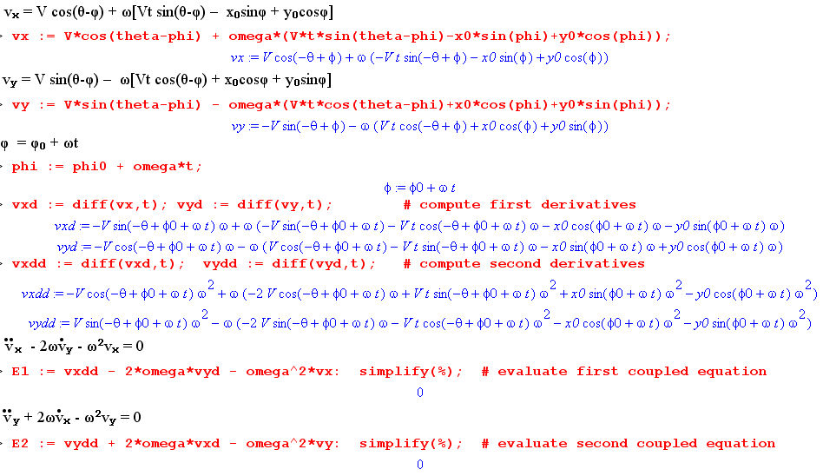
Sometimes, for a given problem in rotational dynamics, there is an easy way and a hard way to solve the problem. Another example of a hard way was the numeric integration mentioned after Fig 15.11.

The Four Projectiles

Recall Fig 8.5 which shows the deflecting projectiles on the right.
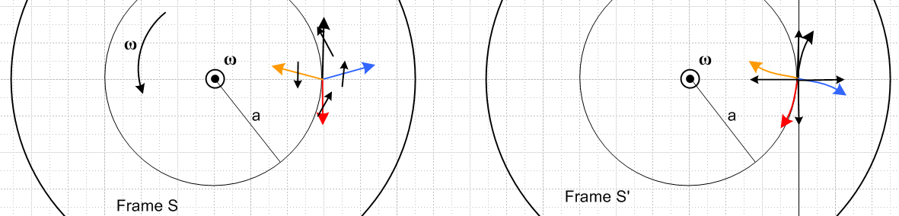

Our trajectories are given by (15.44) where the Frame S and Frame S' origins coincide at the spindle and have aligned axes at time t = 0,

x = Vt cos(θ-ωt) + x0cos(ωt) + y0sin(ωt)
y = Vt sin(θ-ωt) – x0sin(ωt) + y0cos(ωt) . (15.44)

The four projectiles start at (x0,y0) = (a,0) so things simplify a bit more,

x(t) = Vt cos(θ-ωt) + acos(ωt)
y(t) = Vt sin(θ-ωt) – asin(ωt) . (15.44)'

These are very simple expressions indeed, considering the coupled differential equations above.

Recall that in Frame S (where our angle θ is defined as the flying ant's angle), the blue and orange projectiles have vertical velocity adder vt = ωa. Therefore, for these projectiles we have to add

Δθ = tan-1(vt/V) = tan-1(ωa/V), (15.50)

so here are the four projectile launch angles in Frame S,

θblue = Δθ θblack = π/2 θorange = π - Δθ θred = -π/2 . (15.51)

It remains only to have Maple plot the projectile trajectories with these angles installed. First, here is the code,

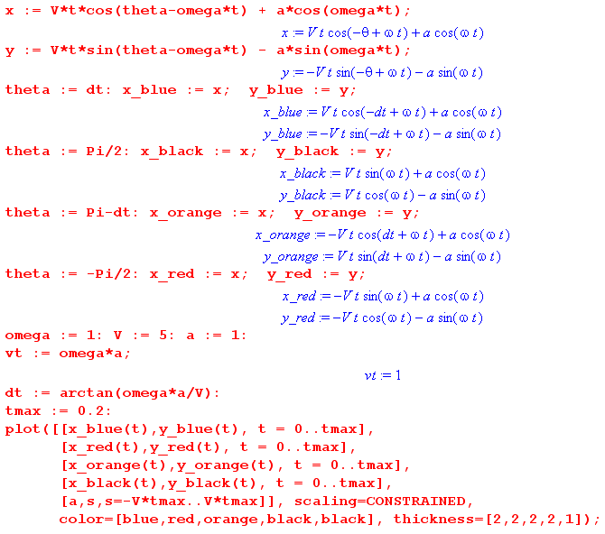

Here are some plots. The first four have the same parameters, just varying durations. The notion of the deflections being roughly circular (end of Section 8 (c)) is not too bad for our chosen parameters.

V = 5, tmax = 0.2 V = 5, tmax = 0.5 V = 5, tmax = 1.0
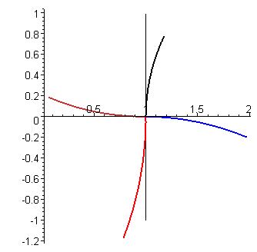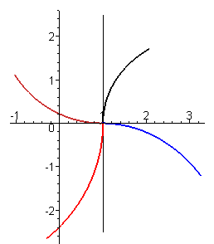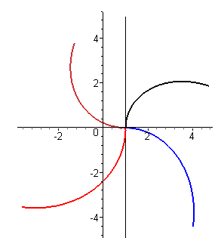

V = 5, tmax = 4 V = 0.7, tmax = 0.2 V = 0.7, tmax = 1.5
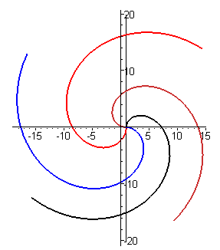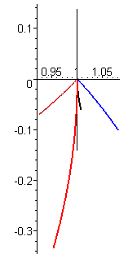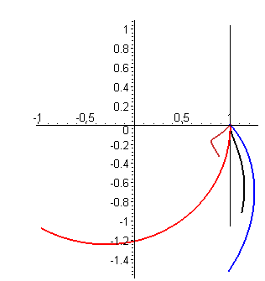

The plots look very different if the launch velocity is on the order of the adder velocity vt which is the case for the last two plots. Note that the black projectile starts out backwards and the orange projectile has the kind of kink we have seen in earlier plots. All six plots have vt = 1.

Appendix A: Derivation of R(ξ) for Spherical Coordinates

Here we derive equations (14.4) through (14.6). First, just for reference, here are the three active rotation matrices used below :

Rx(θ) = $\left(\begin{matrix}1 & 0 & 0 \\ 0 & cosθ & -sinθ \\ 0 & sinθ & cosθ\end{matrix}\right)$ Ry(θ) = $\left(\begin{matrix}cosθ & 0 & sinθ \\ 0 & 1 & 0 \\ -sinθ & 0 & cosθ\end{matrix}\right)$ Rz(θ) = $\left(\begin{matrix}cosθ & -sinθ & 0 \\ sinθ & cosθ & 0 \\ 0 & 0 & 1\end{matrix}\right)$ (A.1)

These are called "active" since they rotate a vector forward (counterclockwise) relative to fixed axes by amount θ according to the right hand rule when the thumb is aligned with the axis in question.

From the usual picture of spherical coordinates,

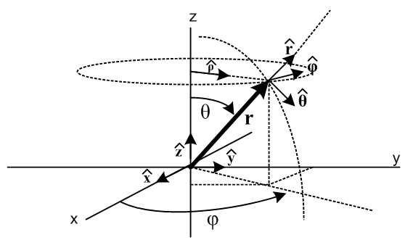 Fig A.1

one can see by staring hard enough that

= Rz(φ) Ry(θ) = R R ≡ Rz(φ) Ry(θ)
= Rz(φ) Ry(θ) = R
= Rz(φ) Ry(θ) = R (A.2)

which we rewrite as

1 = R e3
2 = R e1
3 = R e2 . (A.3)

We can repair the ordering of the basis vectors en on the right using R2 = (,,) as follows

e3 = R2 e1 $\left(\begin{matrix}0 \\ 0 \\ 1\end{matrix}\right)$ = $\left(\begin{matrix}0 & 1 & 0 \\ 0 & 0 & 1 \\ 1 & 0 & 0\end{matrix}\right)$$\left(\begin{matrix}1 \\ 0 \\ 0\end{matrix}\right)$ R2 = $\left(\begin{matrix}0 & 1 & 0 \\ 0 & 0 & 1 \\ 1 & 0 & 0\end{matrix}\right)$
e1 = R2 e2 $\left(\begin{matrix}1 \\ 0 \\ 0\end{matrix}\right)$ = $\left(\begin{matrix}0 & 1 & 0 \\ 0 & 0 & 1 \\ 1 & 0 & 0\end{matrix}\right)$$\left(\begin{matrix}0 \\ 1 \\ 0\end{matrix}\right)$
e2 = R2 e3 $\left(\begin{matrix}0 \\ 1 \\ 0\end{matrix}\right)$ = $\left(\begin{matrix}0 & 1 & 0 \\ 0 & 0 & 1 \\ 1 & 0 & 0\end{matrix}\right)$$\left(\begin{matrix}0 \\ 0 \\ 1\end{matrix}\right)$ (A.4)

Maple tells us that R2-1 = R2T and det(R2) = 1, confirming that R2 is a rotation. So we then have

1 = R R2 e1
2 = R R2 e2
3 = R R2 e3 (A.5)
or
i = R(ξ) ei. (A.6)

Recalling (14.3),

i = R(ξ) ei => ei = R(ξ)ijj or i = [R(ξ)]-1ij ej
'i = R'(ξ') e'i => e'i = R'(ξ ')ij'j or 'i = [R'(ξ ')]-1ij e'j (14.3)

we have therefore found the sought-after matrix R(ξ) appearing in the top left of (14.3).

R(ξ) = R R2 . (A.7)

Specific evaluation gives

R = Rz(φ) Ry(θ) = $\left(\begin{matrix}cosφ & -sinφ & 0 \\ sinφ & cosφ & 0 \\ 0 & 0 & 1\end{matrix}\right)$$\left(\begin{matrix}cosθ & 0 & sinθ \\ 0 & 1 & 0 \\ -sinθ & 0 & cosθ\end{matrix}\right)$ = $\left(\begin{matrix}cosφcosθ & -sinφ & cosφsinθ \\ sinφsinθ & cosφ & sinφsinθ \\ -sinθ & 0 & cosθ\end{matrix}\right)$ (A8)

and then
R(ξ) = R R2 = $\left(\begin{matrix}cosφcosθ & -sinφ & cosφsinθ \\ sinφsinθ & cosφ & sinφsinθ \\ -sinθ & 0 & cosθ\end{matrix}\right)$$\left(\begin{matrix}0 & 1 & 0 \\ 0 & 0 & 1 \\ 1 & 0 & 0\end{matrix}\right)$ = $\left(\begin{matrix}cosφsinθ & cosφcosθ & -sinφ \\ sinφsinθ & sinφcosθ & cosφ \\ cosθ & -sinθ & 0\end{matrix}\right)$ (A.9)

from which we find

[R(ξ)]-1 = [R(ξ)]T = $\left(\begin{matrix}cosφsinθ & sinφsinθ & cosθ \\ cosφcosθ & sinφcosθ & -sinθ \\ -sinφ & cosφ & 0\end{matrix}\right)$. (A.10)

From the top right equation of (14.3) (quoted just above) we can write

i = [R(ξ) ]-1ij ej = [R(ξ) ]-1i1 e1 + [R(ξ) ]-1i2 e2 + [R(ξ) ]-1i3 e3 (A.11)

which can be written in this matrix notation where the column vectors contain vectors as elements,

= $\left(\begin{matrix}cosφsinθ & sinφsinθ & cosθ \\ cosφcosθ & sinφcosθ & -sinθ \\ -sinφ & cosφ & 0\end{matrix}\right)$$\left(\begin{matrix}e1 \\ e2 \\ e3\end{matrix}\right)$ = [R(ξ)]-1 $\left(\begin{matrix}e1 \\ e2 \\ e3\end{matrix}\right)$ (A.12a)
or
= $\left(\begin{matrix}cosφsinθ & sinφsinθ & cosθ \\ cosφcosθ & sinφcosθ & -sinθ \\ -sinφ & cosφ & 0\end{matrix}\right)$ = [R(ξ)]-1 (A.12b)
or
= cosφsinθ + sinφsinθ + cosθ
= cosφcosθ + sinφcosθ - sinθ
= -sinφ + cosφ (A.12c)

which are the well known expressions for the spherical unit vectors in terms of the Cartesian ones. The inverse of the last three equations can be obtained in the following manner (matrix from (A.9))

$\left(\begin{matrix}e1 \\ e2 \\ e3\end{matrix}\right)$ = [R(ξ)] = $\left(\begin{matrix}cosφsinθ & cosφcosθ & -sinφ \\ sinφsinθ & sinφcosθ & cosφ \\ cosθ & -sinθ & 0\end{matrix}\right)$ (A.13a)
or
= [R(ξ)] = $\left(\begin{matrix}cosφsinθ & cosφcosθ & -sinφ \\ sinφsinθ & sinφcosθ & cosφ \\ cosθ & -sinθ & 0\end{matrix}\right)$ (A.13b)
or
= cosφsinθ + cosφcosθ - sinφ
= sinφsinθ + sinφcosθ + cosφ
= cosθ - sinθ (A.13c)

Another useful result is obtained by dotting (A.11) into basis vector ek

i• ek = [R(ξ) ]-1ij ej• ek = [R(ξ) ]-1ij δj,k = [R(ξ) ]-1ik

and therefore we get this matrix of "direction cosines",

••••••••• = $\left(\begin{matrix}cosφsinθ & sinφsinθ & cosθ \\ cosφcosθ & sinφcosθ & -sinθ \\ -sinφ & cosφ & 0\end{matrix}\right)$ = [R(ξ) ]-1 (A.14)

This collection of dot products is also apparent from (A.13c) upon visual inspection.
Finally, the following results can be obtained by differentiating the equations of (A.12c) and then using (A.13c) to replace the Cartesian unit vectors with the spherical ones :

d/dr = 0 d/dθ = d/dφ = sinθ
d/dr = 0 d/dθ = - d/dφ = cosθ
d/dr = 0 d/dθ = 0 d/dφ = -sinθ -cosθ (A.15)

These results can also be obtained by a very careful inspection of Fig A.1 above.

Comment: In the notation of Ref. [6], for an arbitrary curvilinear coordinate system the derivatives of the tangent base vectors (called en in Ref [6]) are determined by the "affine connection" Γ' according to

∂'jen = Γ 'ijn ei . (A.16)

The curvilinear unit basis vectors n are related to the tangent base vectors by en = h'nn, where the h'n are the so-called scale factors. The derivatives of the n are then given by

∂'jn = (1/h'n) [h'i Γ 'ijn – (∂'jh'n)δn,i] i . (A.17)

In the notion of the present paper, we might write the above as

∂n/∂ξj = (1/hn) [hi Γ ijn – (∂hn/∂ξj)δn,i] i . (A.18)

The affine connection is related to the curvilinear metric tensor according to

Γdab = (1/2) gdc [ ∂agbc + ∂bgca – ∂cgab] . (A.19)

For spherical coordinates, one has (using r,θ,φ = 1,2,3 where θ = polar, φ = azimuth)

hr = 1 hθ = r hφ = rsinθ // scale factors
er = eθ = r eφ = rsinθ // tangent base vectors
r = θ = φ = // curvilinear unit basis vectors

gab = $\left(\begin{matrix}1 & 0 & 0 \\ 0 & r2 & 0 \\ 0 & 0 & r2sin2θ\end{matrix}\right)$ gab = invserse(gab) // metric tensors (A.20)

Only 9 of the 27 elements of the affine connection Γdab are non-zero :

Γ 122 = -r Γ 212 = Γ 221 = 1/r // notation example: Γ 122 = Γrθθ
Γ 133 = -r sin2θ Γ 313 = Γ 331 = 1/r
Γ 233 = -cosθsinθ Γ 323 = Γ 332 = cotθ (A.21)

Using (A.17), (A.19) and (A.20), Maple confirms the results shown in (A.15).

Appendix B: Relation to Notation used in Tensor Analysis Ref [6]

Our document "Tensor Analysis and Curvilinear Coordinates"[6] presents a systematic notation for dealing with arbitrary transformations between two spaces called x-space and x'-space. In the context of the present paper, there are two applications of this transformation theory.

Application 1: x-space is the Cartesian space of Frame S, and x'-space is the Cartesian space of Frame S'.

In this application, both x-space and x'-space are Cartesian spaces with metric tensors equal to the unit matrix. This means that raising or lowering a tensor index is "free" so we would just use lower indices. That is to say, contravariant and covariant indices are the same, so Tabcd = Tabcd = Tabcd and so on.
The transformation between the spaces, x' = F(x), is simply a rotation. Using the notation of Section 1 (b) this means that (x)'i = Rij(x)j where R-1 = RT and det(R) = 1. For example, applied to our two position vectors r and r' this says

(r)'i = Rij(r)j
(r')'i = Rij(r')j

and (r)'i ≠ (r')i unless it happens that b = 0 in the relation r = r' + b. Any generic vector a has this same transformation rule (a)'i = Rij(a)j and we say that "a transforms as a vector with respect to rotation R".
So in Application 1, the notation of [6] exactly matches the notation of the present document.

Application 2: Here, x-space is the space of Frame S with Cartesian coordinates, and x'-space is also the space of Frame S but with some curvilinear coordinates. In the notation of [6] x-space has unit basis vectors un while the curvilinear-coordinate unit vectors are called n. These n are the normalized "tangent base vectors" and they exist in x-space along with the un. Then Cartesian coordinates are xi = (x,y,z) whereas the curvilinear coordinates are (for spherical coordinates) x'i = (r,θ,φ). The Cartesian unit vectors are un = , , while the curvilinear ones are n = , , . In the present document we have everywhere referred to the un as en, and in Section 14 we have referred to the n as n. In this Application 2, the x-space metric tensor is the identity matrix, but the x'-space metric tensor g'ij differs from the unit matrix and is specific to one's choice of curvilinear coordinates.

Application 3: Same as Application 2 but applied to Frame S' instead of Frame S.

It should be clear for Applications 2 and 3 the notation of [6] is completely incompatible with the work of this document. The reason is that the prime symbol is overloaded. In [6] the prime symbol is used to distinguish curvilinear coordinates from Cartesian coordinates, whereas in the present document the prime symbol is used to distinguish Frame S' from Frame S.
One could perhaps rescue the compatibility by using a double prime " for curvilinear coordinates in Frame S, and triple prime ''' or some other marking for curvilinear coordinates in Frame S'.
Another alternative would be to change labeling on the two frames of reference. In the rest of this Appendix, we consider this possibility. Taylor[1] labels his frames S0 and S instead of S and S' so that is one possibility, but then every object in Frame S0 must have a 0 label attached to it somewhere.
Here we consider the implications of calling the frames A and B instead of S and S' and then using the exact notation of [6].

this doc this doc rewritten using Frame A and Frame B and notation of [6]

S → A Frame A
S' → B Frame B

∂S → ∂A time derivative in Frame A
∂S' → ∂B time derivative in Frame B

(da/dt)S = (da/dt)S' + ω x a → (da/dt)A = (da/dt)B + ω x a G Rule (2.1)
∂Sa = ∂S'a + ω x a → ∂Aa = ∂Ba + ω x a

So far things look pretty reasonable. We continue :

en → (uAn) Cartesian basis vectors in Frame A
e'n → (uBn) Cartesian basis vectors in Frame B

r → xA Position vector in Frame A
r' → xB Position vector in Frame B

ξ → x'A curvilinear coordinates used in Frame A
ξ' → x'B curvilinear coordinates used in Frame B

vS → (vA)A ≡ vA natural // velocities as in (1.32)
vS' → (vA)B
v'S → (vB)A
v'S' → (vB)B ≡ vB natural

aSS' → (aA)AB // some accelerations as in (1.33)
a'SS' → (aB)AB
a'SS ≡ a'S → (aB)AA ≡ (aB)A
aSS ≡ aS ≡ a → (aA)AA ≡ (aA)A ≡ aA natural
a'S'S' ≡ a'S' ≡ a' → (aB)BB ≡ (aB)B ≡ aB natural

This are still not too bad. But now consider how components must be annotated,

(r)i → (xA)Ai
(r)'i → (xA)Bi
(r')i → (xB)Ai
(r')'i → (xB)Bi
(ξ)i → (x'A)Ai
(ξ)'i → (x'A)Bi
(ξ')i → (x'B)Ai
(ξ')'i → (x'B)Bi

The letter A or B before the index i tells whether this is a vector component in Frame A or in Frame B. We quietly handled that issue in this document with prime or no prime, but now it comes out into the open! The components of the basis vectors are especially interesting,

(en)i → (uAn)Ai // Cartesian unit vectors
(en)'i → (uAn)Bi
(en')i → (uBn)Bi
(en')'i → (uBn)Bi
(n)i → (An)Ai // curvilinear unit vectors = normalized tangent base vectors
(n)'i → (An)Bi
(n')i → (Bn)Bi
(n')'i → (Bn)Bi

Symbol count increases even more if one tries polite labeling such as

(en)i → (u(A)n)(A)i // 5 symbols → 11 symbols

The conclusion is that "it could be done this way". Using the prime notation, we were able to tone down the appearance of the notation considerably. The reader will surely agree that using the A/B notation would have made this document much harder to comprehend, and that is why we did not use it and thus why we gave up on using the exact notation used in [6] for our many objects.
On the other hand, Application 1 is just fine, and we shall use it in the next Appendix.

Appendix C: The G Rule for a Tensor of Rank n.

Tensors and their properties are discussed in great detail in Ref [6]. In this section we continue to use these shorthand operator notations,

∂S = (d/dt)S ∂S' = (d/dt)S' .

So far we know all about the G Rule for tensors of rank 0 and 1 (scalar and vector),

∂SA = ∂S'A // A is a scalar (see Section 1 (i) )

∂SA = ∂S'A + ω x A // A is a vector ( see Section 2 and (2.1))

What happens for tensors of rank 2 or more? We shall consider a rank 3 tensor and it will be clear how things generalize to any rank.

The reader is referred to Appendix E of [6] which discusses the direct product notation used for the expansion of tensors in x-space. Here we shall use similar expansions in x'-space, where we are using Application 1 of Appendix B just above. As noted there, we can take all indices to be lower indices.

In our Section 2 proof of the vector G Rule, we stated a series of obvious "facts" without proof and in a few lines these facts led to the vector G Rule. Since the direct product notation is likely to be less familiar to the reader than simple multiplication, we shall spend more time here deriving the corresponding "facts" as a series of "lemmas" .

Lemma 1: (d[A⊗B]/dt)S = (dA/dt)S ⊗ B + A ⊗ (dB/dt)S S (C.1)
(d[A⊗B]/dt)S' = (dA/dt)S' ⊗ B + A ⊗ (dB/dt)S' S'

This is a Leibniz product rule that is perhaps not totally obvious. The object A⊗B here is a rank-2 tensor created from two vectors (outer product) and its elements are

[A⊗B]ab = AaBb. (C.2)

We shall prove the first line and then proof of the second proceeds just replacing S → S'.

Proof: The first step of the proof says

[(d[A⊗B]/dt)S]ab = [(d[A⊗B]ab/dt)S] . (C.3)

The idea here is that same Commutation Theorem of Section 1 (j) applied in a tensor context. The time derivative is in Frame S and the tensor components are in Frame S, so the operations "take a time derivative" and "take a tensor component" commute. This is true just as in the vector case because the Cartesian basis vectors ei don't change in time. Here is the expansion for tensor A⊗B (implied sum on a and b) on the Cartesian basis vectors en (these vectors are called un in Ref. [6]; the en of Ref. [6] are something different. )

A⊗B = [A⊗B]ab ea ⊗ eb (C.4)

and ea ⊗ eb is constant in time. It follows that (d/dt)S A⊗B = { (d/dt)S [A⊗B]ab } ea ⊗ eb . Staring at this expansion, it must be that [ (d/dt)S A⊗B ]ab = { (d/dt)S [A⊗B]ab } which is (C.3).

We continue the proof of Lemma 1 by looking at the ab component of the left hand side of (C.1)

[ (d[A⊗B]/dt)S]ab = [(d[A⊗B]ab/dt)S] // from (C.3)

= [(d[(AaBb)/dt)S] // from (C.2)

= (dAa/dt) Bb + Aa(dBb/dt) // Leibniz product rule for scalar functions

= [(dA/dt)S]a Bb + Aa[(dB/dt)S]b // from (2.17) used twice

= [ (dA/dt)S ⊗ B]ab + [A ⊗ (dB/dt)S]ab //definition of the direct product (C.2)

We have shown that

[(d[A⊗B]/dt)S]ab = [ (dA/dt)S ⊗ B]ab + [A ⊗ (dB/dt)S]ab

Since this equation is true for every ab component of a rank-2 tensor, it is true as a tensor equation ,

(d[A⊗B]/dt)S = (dA/dt)S ⊗ B + A ⊗ (dB/dt)S QED Lemma 1

The following extension of Lemma 1 is easy to prove in the same manner:

Lemma 2: (C.5)

(d[A⊗B⊗C]/dt)S = (dA/dt)S ⊗ B ⊗ C + A ⊗ (dB/dt)S ⊗ C + A ⊗ B ⊗ (dC/dt)S S
(d[A⊗B⊗C]/dt)S' = (dA/dt)S'⊗ B ⊗ C + A ⊗ (dB/dt)S'⊗ C + A ⊗ B ⊗ (dC/dt)S' S'

Next, we can throw in a scalar function u to get another easy-to-prove lemma

Lemma 3: (C.6)

(d[uA⊗B⊗C]/dt)S
= (du/dt) A ⊗ B ⊗ C + u (dA/dt)S ⊗ B ⊗ C + u A ⊗ (dB/dt)S ⊗ C + u A ⊗ B ⊗ (dC/dt)S

(d[uA⊗B⊗C]/dt)S'
= (du/dt) A ⊗ B ⊗ C + u (dA/dt)S' ⊗ B ⊗ C + u A ⊗ (dB/dt)S' ⊗ C + u A ⊗ B ⊗ (dC/dt)S'

Derivation of the G Rule for a Tensor of Rank 3

Expand the rank-3 tensor A in Frame S' (see Ref. [6] App E (b), but we are expanding here in x'-space),

A = A'ijk (e'i⊗e'j⊗e'k) . (C.7)

where there is an implied sum on the three repeated indices i,j,k. A particular component abc of the above expansion looks like this

Aabc = A'ijk (e'i⊗e'j⊗e'k)abc where (e'i⊗e'j⊗e'k)abc = (e'i)a(e'j)b(e'k)c . (C.8)

Differentiate tensor A in Frame S,

(dA/dt)S = (d[A'ijk (e'i⊗e'j⊗e'k)]/dt)S .

Apply Lemma 3 with u = A'ijk , A = e'i, B = e'j and C = e'k to get

(dA/dt)S = (dA'ijk/dt) e'i ⊗ e'j ⊗ e'k

+ A'ijk (de'i/dt)S ⊗ e'j ⊗ e'k + A'ijke'i ⊗ (de'j/dt)S ⊗ e'k + A'ijk e'i ⊗ e'j ⊗ (de'k dt)S .

Now use (1.25) that (de'n/dt)S = ω x e'n in three places, so

(dA/dt)S = (dA'ijk/dt) e'i ⊗ e'j ⊗ e'k (C.9)

+ A'ijk [ω x e'i] ⊗ e'j ⊗ e'k + A'ijk e'i ⊗ [ω x e'j] ⊗ e'k + A'ijk e'i ⊗ e'j ⊗ [ω x e'k] .

Start over and this time apply ∂S' to A and use the S' version of Lemma 3 to get

(dA/dt)S' = (dA'ijk/dt) e'i ⊗ e'j ⊗ e'k

+ A'ijk (de'i/dt)S' ⊗ e'j ⊗ e'k + A'ijke'i ⊗ (de'j/dt)S' ⊗ e'k + A'ijk e'i ⊗ e'j ⊗ (de'k dt)S'

Now use (1.26) that (de'n/dt)S' = 0 three times and the last terms all go away so that

(dA/dt)S' = (dA'ijk/dt) e'i ⊗ e'j ⊗ e'k . (C.10)

Replace the first term on the RHS of (C.9) by (C.10) to get

(dA/dt)S = (dA/dt)S' + (C.11)

+ A'ijk [ω x e'i] ⊗ e'j ⊗ e'k + A'ijk e'i ⊗ [ω x e'j] ⊗ e'k + A'ijk e'i ⊗ e'j ⊗ [ω x e'k] .

This is starting to look like a Tensor G Rule. In the vector case we were able to move the coefficients (a')i in and obtain a simple ω x a second term, but now the coefficients A'ijk are linked to all the three basis vectors in the direct product, so that simple move is not possible.

Now consider the abc component of first term on the second line of (C.11)

[A'ijk [ω x e'i] ⊗ e'j ⊗ e'k]abc

= A'ijk[ω x e'i]a(e'j)b(e'k)c

= A'ijk εarsωr (e'i)s(e'j)b(e'k)c

= A'ijk εarsωr (e'i ⊗ e'j ⊗ e'k)sbc

= εarsωr { A'ijk(e'i ⊗ e'j ⊗ e'k)sbc }

= εarsωr {Asbc } (C.12)

Next, consider the second term:

[A'ijk e'i ⊗ [ω x e'j] ⊗ e'k]abc

= A'ijk(e'i)a [ω x e'j]b (e'k)c

= A'ijk(e'i)a εbrs ωr(e'j)s (e'k)c

= εbrs ωr A'ijk(e'i)a (e'j)s (e'k)c

= εbrs ωr Aasc (C.13)

Similarly, the third term gives

A'ijk e'i ⊗ e'j ⊗ [ω x e'k]

= εcrs ωr Aabs (C.14)

Here then is the rank-3 G Rule written out in for component abc,

[(dA/dt)S]abc = [(dA/dt)S']abc + εarsωrAsbc + εbrs ωr Aasc + εcrs ωr Aabs (C.15)

Suppose we now define some rank-3 "correction tensors" as follows

A(1)abc = εars ωr Asbc
A(2)abc = εbrs ωr Aasc
A(3)abc = εcrs ωr Aabs (C.16)

Then (C.15) reads

[(dA/dt)S]abc = [(dA/dt)S']abc + A(1)abc + A(2)abc + A(3)abc

and then we may remove the component labels to get our final G Rule for a rank-3 tensor

(dA/dt)S = (dA/dt)S' + A(1) + A(2) + A(3) . (C.17)

This then is the G Rule for a rank-3 tensor stated as a tensor equation.

G Rule for a Tensors of Other rank

The pattern for any rank should be clear based on the above work. Here we write the G rule in component form for tensors of rank 4,3,2,1 and 0

(∂SA)abcd = (∂S'A)abcd + εarsωrAsbcd + εbrsωrAascd + εcrsωrAabsd + εdrsωrAabcs 4

(∂SA)abc = (∂S'A)abc + εarsωrAsbc + εbrsωrAasc + εcrsωrAabs 3

(∂SA)ab = (∂S'A)ab + εarsωrAsb + εbrsωrAas 2

( ∂SA)a = (∂S'A)a + εarsωrAs 1

(∂SA) = (∂S'A) 0

Here then is the general rank-n rule, where x stands for the nth letter of the alphabet,

(∂SA)abc...x = (∂S'A)abc...x
+ εarsωrAsbc...x + εbrsωrAasc...x + ..... + εxrsωrAabc...s (C.18)

The correction tensors are defined in this general case as

A(1)abc...x = εarsωrAsbc...x
A(2)abc...x = εbrs ωr Aasc...x
...
A(n) abc...x = εxrs ωr Aabc...s (C.19)

and then the rank-n G rule may be written as

∂SA = ∂S'A + A(1) + A(2) + .... + A(n) . (C.20)

so there are then n correction tensors that account for the change of reference frame.

G Rule for a Tensors of Rank 2

Since this is an important case, we just write out the details,

(∂SA)ab = (∂S'A)ab + εarsωrAsb + εbrsωrAas

∂SA = ∂S'A + A(1) + A(2)

A(1)ab = εarsωrAsb
A(2)ab = εbrsωrAas . (C.21)

This would be appropriate for a tensor Aab like the strain and stress tensors of continuum mechanics.

G Rule for a Tensors of Rank 1

We certainly hope to recover the result of Section 2. From the list above

( ∂SA)a = (∂S'A)a + εarsωrAs 1

A(1)a = εarsωrAs = [ω x A]a

(∂SA)a = (∂S'A)a + A(1)a

(∂SA) = (∂S'A) + A(1)

(∂SA) = (∂S'A) + ω x A (C.22)

which is (2.1), so all is well that ends well.

Appendix D: The Foucault Pendulum

This subject is usually treated in the small angle limit in Cartesian coordinates (see Refs 1-3). Applying Newton's Law F = ma including the Coriolis force one quickly obtains a pair of coupled ODE's which in our notation would be

– 2ωcosβ + Ω2x = 0 ω = rotation rate of the earth, β = polar angle from North Pole
+ 2ωcosβ + Ω2y = 0 Ω = $\sqrt{g/l}$ = pendulum swing rate

Setting η = x + iy the complex solution is found to be

η(t) = A e-i(ωcosβ)t cos(Ωt)

which indicates that the pendulum precesses at an azimuthal rate of ωcosβ, so problem solved.
The treatment below does not assume small angle swinging of the pendulum and is carried out in curvilinear (spherical) coordinates for both Frame S and Frame S', though only Frame S is significant. The pendulum is thus treated as a full-blown "spherical pendulum" which is perturbed by the rotation of the earth. It is just an exercise in using some of the machinery presented earlier in this document.

(a) Drawings, Notation, and Coordinates

Fig. 4.9 showed a typical earth problem kinematic situation in the "non-swap" notation where Frame S' is the rotating frame. Here, we choose instead to use the "swap" notation where Frame S is the rotating frame, since this eliminates the need for scores of prime symbols which would otherwise clutter the equations. So now Frame S' is at the center of the earth and is an inertial frame, and Frame S is on the surface of the earth and is a non-inertial frame. This use of primes is then in accordance with the Goldstein and Marion references discussed in Sections 9 and 10.
In addition to this S↔S' swap, we make a few other changes compared to Fig 4.9.
First, we select the basis vectors en differently. Since we are going to be dealing with a spherical pendulum, we would like the angle between the pendulum string and local vertical to be the polar angle of a spherical coordinate system for Frame S. This means that we want the = e3 axis associated with this spherical system to be pointed toward the center of the earth, rather than pointing "up". This then suggests that we take = e1 as pointing "north", and = e2 as pointing "east" and then the resulting vectors en form a right-handed coordinate system.
Second, we place the origin of Frame S at a height l above the surface of the earth, where l is the length of the spherical pendulum's string. Then the length of vector b is b = Re + l, where Re is the radius of the earth. The Frame S origin is then at the pendulum pivot point.
The new kinematic picture is then,

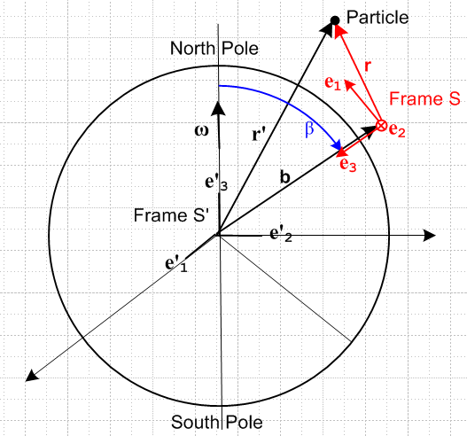 Fig D.1

The next step is to use spherical curvilinear coordinates in both Frames S and S'.
For Frame S', with origin at the center of the earth and fixed relative to distant stars, we select spherical coordinates, so r' = (r',θ',φ'). We shall assume that the origin of Frame S is located at b = (b, β, α) where β is the polar angle measured down from the North Pole (colatitude, range 0 to π), α is the origin's azimuth (longitude), and b = Re+l where Re is the radius of the earth and l is the length of the pendulum string (picture coming soon). Parameters α and b will play no role in what follows.
For Frame S, with origin distance l above the surface of the earth (red, shown in the northern hemisphere), we select another set of spherical coordinates r = (r,θ,φ) as will be described momentarily.
Note that ω = ωe'3 with ω > 0 since the earth rotates counterclockwise as viewed from above the North Pole, causing the sun to rise in the east. The same earth, viewed looking upward from beneath the South Pole, appears to rotate clockwise (and the sun still rises in the east).

The Cartesian unit basis vectors en of Frame S can be expressed in terms of the Frame S' spherical unit basis vectors ', ', ' evaluated at the position r' = b = (b, β, α) as follows,

e1 = -' = "north" =
e2 = ' = "east" =
e3 = - ' = "down" =

According to the picture above, ω = ωe'3 can be expanded on these Frame S basis vectors,

ω = - ωcosβ e3 + ωsinβ e1 . (D.1)

As noted, the origin of Frame S is located distance l above the surface of the earth. If we position ourselves at this origin and gaze down onto the earth's surface we see what is shown on the left below. A side view is presented on the right, and a 3D view below:

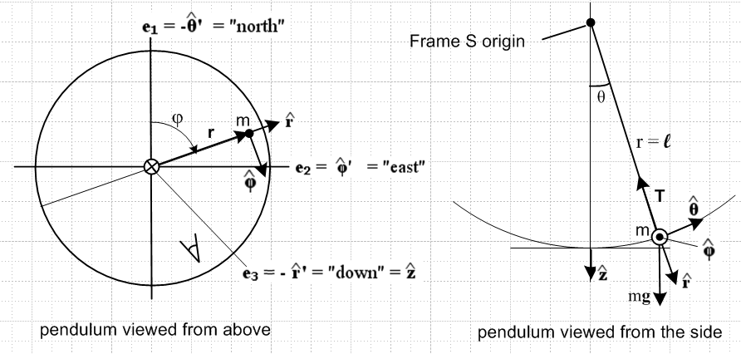
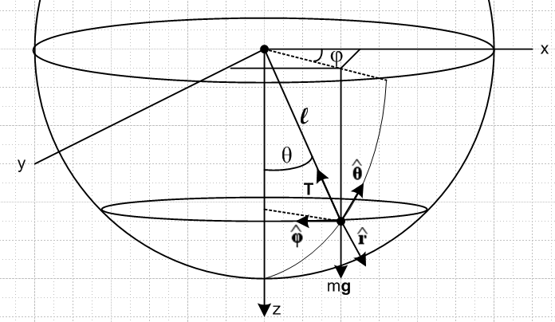 Fig D.2

The meaning of the Frame S spherical coordinates r,θ,φ should be clear. These are the standard coordinates one would use to study a spherical pendulum in the absence of the Coriolis force.
The Cartesian basis vectors en for Frame S are related to the curvilinear ones for Frame S as follows (see (A.13c)),

e1 = = cosφsinθ + cosφcosθ - sinφ
e2 = = sinφsinθ + sinφcosθ + cosφ
e3 = = cosθ - sinθ (D.2)

(b) Qualitative Solution

On each swing the pendulum veers a little "to the right" in the northern hemisphere due to the Coriolis fictitious force -2m ω x v, so the problem is to compute the time for a full 360 degree rotation. Here we show the first four swings of the pendulum,

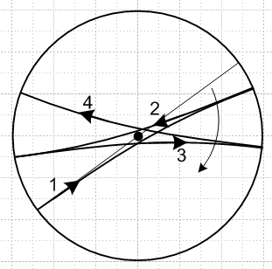 Fig D.3

The net effect is that the plane of the swinging pendulum precesses clockwise. The amount of veering shown in the drawing is highly exaggerated since we know that when the pendulum is located at the North Pole the period will be one sidereal day ( ≈ 23 hours 56 minutes). If each swing takes 10 seconds, that would be about 24*3600/10 = 8,640 swings for a full revolution, so each swing would show only 360/8640 ≈ .04 degrees of precession. Away from the North Pole we know the precession rate will be even slower, at the equator it will be infinite, and in the southern hemisphere the pendulum will precess in the opposite direction. These qualitative facts may be deduced from the direction and magnitude of the Coriolis force as discussed in Section 8 (c).

(c) The Equations of Motion for a Foucault Pendulum

In our "swap" notation context, the bogus Newton's law for non-inertial Frame S is,

Feff = ma . (8.3)s (D.3)

The effective force Feff consists of real forces and fictitious forces, and at the end of Section 8 (e) we showed that, for surface of the earth problems (which are Special Case #1), and in the "swap" notation,

Feff = (mg + possible other real forces) – 2m ω x v , (8.15)s

where force mg already incorporates the effect of the fictitious centrifugal force. In the spherical Foucault pendulum problem, we have "possible other real forces" = T, the tension of the massless pendulum string pulling on the pendulum of mass m. Thus,

Feff = mg + T – 2m ω x v . (D.4)

Although g does not point to the exact center of the earth, we shall assume that it does, so g = g. The directional error in making this assumption is on the order of .003 radians (see below (8.16)) which is insignificant in our analysis of the Foucault pendulum. The error may be even less than this when one considers that the surface of the earth is probably perpendicular to g and not g0, but we don't want to get involved with such fine details. Using g = g in (D.4) and using the latter in (D.3) we find

ma = mg + T – 2m ω x v . (D.5)

which is our vector "equation of motion" for the pendulum. Our task now is to evaluate the terms in (D.5) and then to balance the components on both sides to come up with three scalar equations of motion.

The ω vector (D.1) can be expanded, using (D.2) for e3 and e1,

ω = - ωcosβ e3 + ωsinβ e1

= - ωcosβ[cosθ - sinθ ] + ωsinβ[cosφsinθ + cosφcosθ - sinφ ]

= ω(-cosβcosθ + sinβcosφsinθ) + ω(cosβsinθ + sinβcosφcosθ ) + ω(-sinβ sinφ) (D.6)
The string tension vector may be written as

T = - T . (D.7)

It remains to find expressions for v and a expanded on the spherical unit vectors. Using the equations stated in (A.15), one can easily show that the time derivatives of the Frame S basis vectors are given by

(d/dt)S = = + sinθ
(d/dt)S = = - + cosθ
(d/dt)S = = - sinθ - cosθ . (D.8)

Then (D.8) can be used to show that

r = l
v = = l = l [ + sinθ ]
a = = l(- 2- sin2θ 2) + l( - sinθcosθ 2) + l( 2cosθ + sinθ ) (D.9)

so we now have a viable v and a to use in (D.5). The Coriolis cross product can now be computed,

ω x v =
[ω(-cosβ cosθ + sinβcosφsinθ) + ω(cosβ sinθ + sinβ cosφcosθ ) + ω(-sinβ sinφ) ]
x [l [ + sinθ ]
or
ω x v /(ωl) = (-cosβcosθ + sinβcosφsinθ) x [ + sinθ ]
+ (cosβsinθ + sinβ cosφcosθ ) x [ + sinθ ]
+ (-sinβsinφ) x [ + sinθ ]

= (-cosβcosθ + sinβcosφsinθ) [ - sinθ ]
+ (cosβsinθ + sinβcosφcosθ ) [sinθ ]
+ (-sinβ sinφ) [- ]

= [(cosβsinθ + sinβcosφcosθ )sinθ + sinβ sinφ ]
– [(-cosβcosθ + sinβcosφsinθ)sinθ ]
+ [(-cosβcosθ + sinβcosφsinθ) ] . (D.10)

We can now assemble the pieces from (D.2), (D.10) and (D.9) to write the equation of motion (D.5) divided by m,

a = g + T/m – 2 ω x v , (D.5)
as
l(- 2- sin2θ 2) + l( - sinθcosθ 2) + l( 2cosθ + sinθ )
= g(cosθ - sinθ ) - (T/m)
– 2ωl [(cosβsinθ + sinβcosφcosθ )sinθ + sinβ sinφ ]
+ 2ωl [(-cosβcosθ + sinβcosφsinθ)sinθ ]
– 2ωl [(-cosβcosθ + sinβcosφsinθ) ]

Matching components gives these three equations of motion for the spherical pendulum on the rotating earth (the unit vectors on the right are just reminders of the origin of the equations)

l(- 2- sin2θ 2) = gcosθ – (T/m) – 2ωl [(cosβsinθ + sinβcosφcosθ )sinθ + sinβsinφ ]
l( - sinθcosθ 2) = - g sinθ + 2ωl [(-cosβcosθ + sinβcosφsinθ)sinθ ]
l( 2cosθ + sinθ ) = – 2ωl [(-cosβcosθ + sinβcosφsinθ) ]

which we can simplify slightly to get

2 + sin2θ 2 = -(g/l)cosθ + T/(ml) + 2ω [(cosβsinθ + sinβcosφcosθ )sinθ + sinβsinφ ]
- sinθcosθ 2 = - (g/l) sinθ + 2ω [(-cosβcosθ + sinβcosφsinθ)sinθ ]
2cosθ + sinθ = – 2ω [(-cosβcosθ + sinβcosφsinθ) ] . (D.11)

These are the equations for a spherical pendulum operating on the rotating earth with no approximations other than the modest ones that g does not vary over the small distance l and that g = g.

(d) The Spherical Pendulum

We now digress for a subsection on the spherical pendulum, then in the next subsection we resume discussion on the use of such a pendulum in its "Foucault pendulum" mode.

The equations of motion

If we momentarily turn off the rotation of the earth by setting ω = 0, equations (D.11) become

2 + sin2θ 2 = -(g/l)cosθ + T/(ml)
- sinθcosθ 2 = - (g/l)sinθ
2cosθ + sinθ = 0 (D.12)

These are the equations of motion for a spherical pendulum in the presence of a uniform gravitational field of strength g. It is useful to know something about the solution of these equations before we turn the earth's rotation back on.
Operationally, in the sense of a numerical solution, one can regard the last two equations of (D.12) as a pair of coupled non-linear ODE's for functions θ(t) and φ(t) subject to initial conditions θ0, φ0, 0 and
0. Once these equations are solved (physically we know a unique solution must exist), the first equation may be used to determine T(t), the string tension.
The last two equations are usually obtained as the Euler-Lagrange or Hamilton's equations in a Lagrangian or Hamiltonian formulation of the problem. When ω ≠ 0, such an approach requires obtaining an expression for L or H which includes the effect of the fictitious forces, something we shall not attempt since we already have the equations of motion in (D.11).

Lz as constant of the motion

The last equation in (D.12) may be written in this form

d/dt ( sin2θ ) = 0 (D.13)

which says that sin2θ must be a "constant of the motion". To understand the meaning of this constant, we first compute the torque about the pivot point due to the gravitational force on the mass m,

τ = r x mg = r x mg = mgl x [cosθ - sinθ ] = -mgl sinθ . (D.14)

Since this torque lies in a plane normal to the z axis, we may conclude that the Cartesian torque component τz = 0. The angular version of Newton's Law says τ = dL/dt , and therefore we expect that the quantity Lz will be a constant of the motion. Direct calculation shows that

Lz = L • = m (r x v) • = m ( x r) • v = m lsinθ • (l [ + sinθ ])
= ml2sin2θ (D.15)

where we have made use of (D.2) for and (D.9) for v. Thus, we see that our third equation of motion in (D.12), rewritten as in (D.13), is just the statement that dLz/dt = 0. In the Lagrangian formulation one finds that Lz is one of the canonical momenta which is constant because φ is a cyclic coordinate, meaning it does not appear in the Lagrangian.
In terms of the spherical unit vectors, one finds that the vector angular momentum of the pendulum mass is given by

L = m r x v = ml2 [ - sinθ ] (D.16)

and then application of τ = dL/dt with τ as in (D.14) and unit-vector change rates as in (D.8) simply reproduces the last two equations of motion in (D.12).
So we conclude that

h ≡ Lz/(ml2) = sin2θ (D.17)

is a constant of the motion of the spherical pendulum.

E as constant of the motion

Another constant of the motion is the total energy E which may be regarded as E = T + V = kinetic energy + potential energy,

E = (1/2)mv2 - mglcosθ = (1/2) m l2(2+ sin2θ2) – mglcosθ (D.18)

where v2 = l2(2+ sin2θ 2) according to (D.9) for v. We have set the zero of potential energy at the pendulum pivot point which is the origin of Frame S. By rescaling, we can take this constant of the motion to be

E = 2/2 + sin2θ2/2 – (g/l)cosθ E = m l2E (D.19)

Using (D.17) to eliminate we get

E = 2/2 + (h2/2sin2θ) – (g/l)cosθ
or
E = 2/2 + Ve(θ) where Ve(θ) ≡ (h2/2sin2θ) – (g/l)cosθ (D.20)

Closed form solution to the spherical pendulum problem (outline)

Equation (D.20) is a first order non-linear ODE for θ(t) which we know how to solve:

= (2E - 2Ve(θ) )1/2 => dθ = (2E - 2Ve(θ) )1/2dt

=> dt = (2E - 2Ve(θ) )-1/2 dθ

=> t(θ) = $^{\int_{θ0}^{θ}{}}$dθ' $\sqrt{2E - (h2/sin2θ') + (2g/l)cosθ'}$ (D.21)

Letting z' = cosθ', so dz' = - $\sqrt{1-z'2}$dθ', this integral can be written as

t(θ) = $^{\int_{z}^{z0}{}}$dz' $\sqrt{2E [1-z'2] - h2 – (2g/l)z'[1-z'2]}$ // z = cosθ, z0 = cosθ0

= $^{\int_{z}^{z0}{}}$dz' $\sqrt{(2g/l) [ z'3 - (El/g) z'2 - z' + (l/g) (E- h2/2) ]}$

= $\sqrt{l/(2g)}$ $^{\int_{z}^{z0}{}}$dx $\sqrt{(x-a)(x-b)(x-c)}$

where a,b,c are the roots of the cubic equation x3 - (El/g) x2 - x + (l/g) (E-h2/2 ) = 0. The dimensionless integral appearing on the last line can be evaluated in closed form using this indefinite integral,

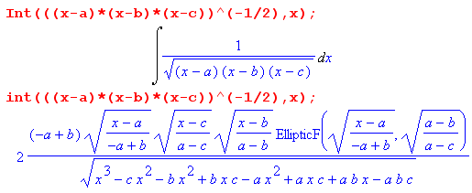

where EllipticF is the incomplete elliptic integral of the first kind,

EllipticF(sin(φ),k) = $^{\int_{0}^{sin(φ)}{}}$dt $\sqrt{(1-t2)(1-k2t2)}$ = F(φ,k) = F(φ|m) = F(φ\α) = sn-1(sinφ,k)

where k = sinα , m = k2 and sn-1 is the inverse Jacobi sn function. Therefore, in principle we have a closed form result for t(θ) which can then be inverted to obtain a solution for θ(t). Then from (D.17) we get

= h/sin2(θ(t)) => φ(t) = φ0 + h $^{\int_{0}^{t}{}}$dt' /sin2(θ(t')) (D.22)

and the problem of the spherical pendulum is completely solved in closed form.

The nature of the general solution

Differentiation of (D.20) tells us that (E is a constant),

0 = + Ve'(θ) // Ve'(θ) ≡ dVe(θ)/dθ

so that

= – Ve'(θ) . (D.23)

Now recall (D.20), which one regards as kinetic plus potential energy for an imagined particle,

E = 2/2 + Ve(θ) where Ve(θ) ≡ (h2/2sin2θ) – (g/l)cosθ . (D.20)

The effective potential Ve(θ) has the following shape (plotted here for h2/2 = .3 and (g/l) = 1)

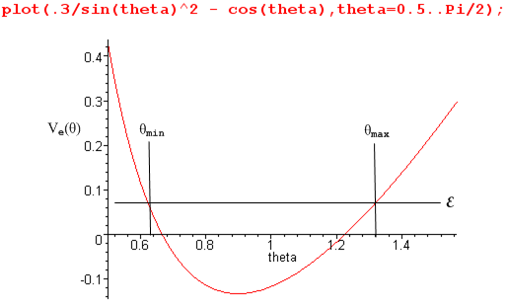 Fig D.4

Looking at this curve and at (D.23), one sees that acceleration is always directed away from the turning points θmin and θmax so the solution θ(t) oscillates in some manner between these two turning point angles. At each turning point the θ kinetic energy is zero, = 0. So, the motion of the pendulum is constrained on the spherical surface r = l between two horizontal circles of angles θmin and θmax and hits both these angles once per "oscillation".
Meanwhile, from (D.22) the action in the φ dimension of the problem is controlled by

= h/sin2(θ(t)) => φ(t) = φ0 + h $^{\int_{0}^{t}{}}$dt' /sin2(θ(t')) (D.22)

so as θ(t) does the oscillation just discussed between θmin and θmax, φ(t) increases as shown in its own complicated functional manner. Since h is an arbitrary constant of the motion, it seems pretty clear that the angular rotation rate in the φ direction is "decorrelated" from that in the θ direction. If, for example, one randomly launches a spherical pendulum in a modest thin elliptical orbit (small h), that orbit precesses fairly quickly about the vertical axis because and are not related in any simple way. A perturbation analysis shows that such a thin elliptical orbit processes in the direction of the elliptical motion (try it with a string and weight). This precession of course has nothing to do with the rotation of the earth since the spherical pendulum being discussed has nothing to do with the rotating earth, it is just a mass on a string in a uniform g field.
The lack of correlation between and exists whether or not the angle θ is small during the motion, so even for small angle motion there is precession of the orbit.

Conclusion: In order to use a spherical pendulum as a "Foucault" pendulum (to be discussed below), one must launch the spherical pendulum with a sufficiently small value of h (~ Lz) so that the precession rate = h/sin2(θ(t)) is much smaller than the precession rate induced by the rotation of the earth. In theory, perhaps by using the "burned string" launch method, one can have h = 0 so = 0 exactly and then the spherical pendulum becomes a plane pendulum moving in the plane φ = φ0.

Comment: A quick tour of web animations of the spherical pendulum shows the amazing complexity of the possible motions. If the string is replaced with a massless stiff rod, over the top motions are included. Some examples (search youtube if these are dead links)

http://www.youtube.com/watch?v=6hCLkTENfSA .
http://www.youtube.com/watch?v=VS1dU5HpfOM&feature=relmfu

The spherical pendulum for small θ is still complicated unless h is very small

Setting sinθ = θ and cosθ = 1, the equations of motion (D.12) become

2 + θ2 2 = -(g/l) + T/(ml)
- θ 2 = - (g/l) θ
2 + θ = 0 (D.24)

Since in general 2 is not small relative to (g/l), one cannot trivially solve the second equation to find simple harmonic motion for θ. If one assumes that 2 << (g/l) ( meaning very small h) and then neglects the 2 term in the second equation, one obtains θ(t) = θ0 cos(Ωt) where Ω = $\sqrt{g/l}$ which is the usual angular frequency for a small-angle plane pendulum.

The Conical Motion solution

The spherical pendulum has an obvious simple solution where θ = θ0 = constant, so the string motion traces out a cone. In this case the equations of motion (D.12) become

sin2θ0 2 = -(g/l)cosθ0 + T/(ml)
cosθ0 2 = (g/l)
= 0 (D.25)

The second equation says ωφ ≡ = $\sqrt{(g/l)secθ0}$. Since this is a constant, the third equation is satisfied as well, and then the first says T = mg secθ0. In the small angle limit for θ0, ωφ slows down to its smallest possible value ωφ ≡ $\sqrt{g/l}$ = Ω which is the frequency of a small angle plane pendulum. Conversely, as we try to achieve θ0 → π/2, secθ0→ ∞ and both ωφ and tension T become infinite, which seems pretty reasonable. This solution can of course be obtained by elementary methods as well.

(e) The Foucault Pendulum

The equations of motion for the spherical pendulum on the rotating earth were stated in (D.11),

2 + sin2θ 2 = -(g/l)cosθ + T/(ml) + 2ω [(cosβsinθ + sinβcosφcosθ )sinθ + sinβsinφ ]
- sinθcosθ 2 = - (g/l) sinθ + 2ω [(-cosβcosθ + sinβcosφsinθ)sinθ ]
2cosθ + sinθ = – 2ω [(-cosβcosθ + sinβcosφsinθ) ] . (D.11)

Recall that the first equation serves only to determine string tension T when θ(t) and φ(t) are known, so we ignore this equation for the time being. We launch the pendulum as a "plane pendulum" with (t=0) = 0 = 0, but right away on the first half-swing the Coriolis deflection generates a small ≠ 0. It is then assumed that remains small enough that we may neglect it in the second equation. In the third equation, we neglect which we expect to be smaller than . We will check these assumptions after the fact. The equations of motion then become,

= - (g/l) sinθ
= ω (cosβ - sinβcosφtanθ) (D.26)

At this point, we have two options, both of which involve approximations.

Option 1. (arm waving) We imagine that the pendulum is launched from θ0 which is not a small angle, so that θ(t) is not a small angle. The first equation in (D.26) is decoupled and is the usual equation which describes a large-swing plane pendulum. The exact solution θ(t) can be expressed in terms of the Jacobi sn function,

sin(θ/2) = sin(θ0/2) sn(Ωt; k=sin(θ0/2)) Ω = $\sqrt{g/l}$ .

The second equation in (D.26) is not decoupled, since both θ and φ appear, but we then make the following wobbly argument. The pendulum follows some path as suggested in Fig D.3 which winds around the axis so that angle φ(t) monotonically increases in some non-linear but oscillatory manner. We conjecture that the long term average (many swings) of cosφ is therefore 0. Going even further out on this limb, we might conjecture that the long term time average of the product cosφ tanθ also vanishes as well. This would take some effort to study, so it is just an arm-waving conjecture which is the basis of Option 1. Then one finds that

<> = ω (cosβ - sinβ <cosφ tanθ>) = ω cosβ

so the effective version of (D.26) is this

+ (g/l) sinθ = 0
<> = ω cosβ (D.27)

which says that the Foucault pendulum precesses on average at ωcosβ even if it has a large swing angle.

Option 2. Here we are on firmer ground by assuming that θ0 and therefore θ(t) are small angles. In this case, setting sinθ = tanθ = θ and cosθ = 1, (D.26) becomes

= - (g/l)θ
= ω (cosβ - sinβcosφ θ ) (D.28)

Unless we are extremely close to the equator of the earth where cosβ = 0, the second term in parentheses is much smaller than the first, and we then have

+ (g/l)θ = 0
= ω cosβ (D.29)

The solution of the first equation is θ(t) = θ0cos(Ωt) where Ω = $\sqrt{g/l}$, the usual frequency of the small angle plane pendulum. The second equation then gives the precession rate of the Foucault pendulum. This is the main result of this Appendix.
If the pendulum is located at the North Pole, since the earth rotates counterclockwise when viewed from above the North Pole, we expect the Foucault pendulum to rotate clockwise in non-inertial Frame S. Equation (D.29) in this case says = ω. Recall that ω > 0 for the earth in Fig D.1 so > 0. According to the left side of Fig D.2, > 0 does in fact imply clockwise rotation.
If the pendulum is located at the South Pole, since the earth rotates clockwise when viewed from beneath the South Pole, we expect the Foucault pendulum to rotate counterclockwise in non-inertial Frame S, so we expect < 0. This is the case since cos(π) = -1.
In terms of the period of the precession, = ω cosβ may be written as (ignoring direction)

(2π/Tprec) = (2π/Tsday) |cosβ| = (2π/Tsday) |sin(θLAT)|

=> Tprec = Tsday/ |sin(θLAT)| (D.30)

and this is the fundamental Foucault precession result.
The sidereal day (rotation relative to the stars) is 23.93447 hours. The Foucault pendulum at the Pantheon in Paris should have this precession period :

Tprec = 23.9344696/ sin(48.846285°) = 31.787731 hours = 31 hours 47.26 minutes

http://www.thegpscoordinates.com/france/paris/pantheon/ // latitude

Swing Period = 2π/Ω = 2π/ $\sqrt{g/l}$ ≈ 16.4 sec l = 67 m

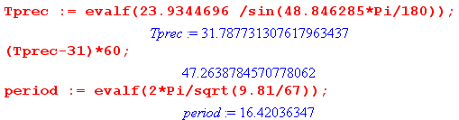
Justification of assumptions

In the second of equations (D.11) we neglected both terms. Was this justified?

| sinθcosθ 2| ≈ θ 2 ≈ θω2 cosβ ~ θ ω2

|– 2ω [(-cosβcosθ + sinβcosφsinθ)sinθ ] | ≈ |2ω cosβ θ ω (cosβ)| ~ θ ω2

Both these terms are far smaller than the non-neglected term

| (g/l) sinθ | ~ Ω2θ

since ω2 << Ω2. For a typical Foucault pendulum

Ω = 2π/TΩ ω = 2π/Tday
Tday2 >> TΩ2 ?
(24*3600)2 >> (16.4)2 ? // Pantheon
7.46 x 109 >> 269 yes

References

Web addresses do change, but a search on the titles below should reveal new locations.

[1] J.R. Taylor, Classical Mechanics ( University Science Books, Mill Valley, CA, 2005)

[2] J.B. Marion, Classical Dynamics of Particles and Systems, 2nd Ed. (Academic Press, New York, 1970).

[3] S.T. Thornton and J.B. Marion [T&M], Classical Dynamics of Particles and Systems, 5th Ed., (Thomson-Brooks/Cole, Belmont, CA, 2003). This textbook carries on the legacy of the founding author of the first two editions 1965 and 1970 (Jerry B. Marion 1929-1981).

[4] H. Goldstein, Classical Mechanics (Addison-Wesley, Boston, 1950).

[5] H. Goldstein, C. Poole, J. Safko [GPS], Classical Mechanics, 3rd Ed. (Addison-Wesley, Boston, 2001). Herbert Goldstein (1922-2005) was the sole author of the first two editions 1950 and 1980.

[6] P. Lucht, Tensor Analysis and Curvilinear Coordinates (http://rimrockinteractive.net/plucht/ , 2012) This document is segmented into two PDF files, the second containing a set of Appendices.

[7] G-G Coriolis, "Sur les équations du mouvement relatif des systèmes de corps". J. De l'Ecole royale polytechnique 15: 144–154 (1835). This and many other historical papers may be found at this link:
http://www.aos.princeton.edu/WWWPUBLIC/gkv/history/general.html

[8] M.J. Crowe, A History of Vector Analysis ( Dover Books, Mineola, NY, 2011)

[9] M.J. Crowe, talk related to his book A History of Vector Analysis .
www.math.ucdavis.edu/~temple/.../Crowe_History-of-Vectors.pdf.

[10] E.B. Wilson (notes of J.W. Gibbs), Vector Analysis (Dover, New York, 1960). This book may be downloaded from Google books.

[11] R.E. Hunt, Lecture Notes for the Mathematical Tripos (Cambridge University, 2007), Chapter 7 on Rotating frames, see http://www.damtp.cam.ac.uk/user/reh10/lectures/ .

[12] M.L. Cosmo and E.C. Lorenzini, Tethers in Space Handbook, 3rd Ed. (Smithsonian, 1997). Available at www.tethers.com/papers/tethersinspace.pdf .

[13] E. I. Butikov, "A dynamical picture of the ocean tides" (2002),
http://faculty.ifmo.ru/butikov/Oceanic_Tides.pdf .

[14] M. Lai, E. Krempl and D. Ruben, Introduction to Continuum Mechanics, 4th Ed. (Elsevier, Amsterdam, 2009). This book has had the same three authors since its first edition in 1974.

