Foucault Cartesian PhL 1.23.17

This has been installed, to not edit here!

C.6 Cartesian Equations of Motion for the Foucault Pendulum 1
C.7 Verification of the Cartesian equations of motion and string tension 2
C.8 Numerical solutions of the equations of motion (Cartesian Coordinates) 6

C.6 Cartesian Equations of Motion for the Foucault Pendulum

We start with the vector equation (C.2.3), which is Newton's Law in non-inertial Frame S,

ma = mg + T – 2m ω x v . (C.2.3) (C.6.1)

From (C.2.4) and (C.1.4) ω can be written

ω = - ωcosβ e3 + ωsinβ e1 = - ω[cosβ + sinβ ] , (C.6.2)

so
– 2m ω x v = -2mω [ - cosβ + sinβ ] x [vx + vy + vz ]

= -2mω [ - cosβ(vx - vy) + sinβ(vy - vz)]

= -2mω [ cosβvy - (cosβvx+ sinβvz) + sinβvy] . (C.6.3)

From (C.2.5) the string tension is (we use both r and l to indicate the string length)

T = - T = -(T/r)(x + y + z) . // r = l = $\sqrt{x2+y2+z2}$ (C.6.4)

The three equations of motion from (C.6.1) are then

max = -(T/r)x -2mωcosβvy
may = -(T/r)y +2mω (cosβvx+ sinβvz)
maz = mg -(T/r)z -2mωsinβvy (C.6.5)
or
= -(T/mr)x - 2ωcosβ
= -(T/mr)y + 2ω (cosβ+ sinβ)
= g -(T/mr)z -2ωsinβ . (C.6.6)

Eliminate T from the first two equations :

y = -(T/mr)xy -2ωycosβ
x = -(T/mr)xy +2ωx(cosβ+ sinβ)

y - x = -2ωycosβ - 2ωx(cosβ+ sinβ) . (C.6.7)

Do this again for the first and third equations of (C.6.6) :

z = -(T/mr)xz -2ωzcosβ
x = xg -(T/mr)xz -2ωxsinβ

z - x = -xg -2ωzcosβ + 2ωxsinβ . (C.6.8)

We then have these three equations of interest

1 y - x = -2ωycosβ - 2ωx(cosβ+ sinβ)

2 z - x = -xg -2ω(zcosβ - xsinβ )

3 x2+y2+z2 = r2 (C.6.9)

where r is the length of the pendulum string. These are the equations of motion for the Foucault pendulum in Cartesian coordinates. We can in theory solve for x(t), y(t) and z(t) given some initial conditions.

Once these three equations are solved for x(t), y(t) and z(t), we can find the tension T(t) from (say) the first equation of (C.6.6) :

= -(T/mr)x - 2ωcosβ ⇒ (T/mr)x = - 2ωcosβ - ⇒

T = - mr(2ωcosβ + )/x . (C.6.10)

C.7 Verification of the Cartesian equations of motion and string tension

The algebra above is quite complex so we want to be sure that our Cartesian equations of motion are correct. First, here are the last two angular equations of motion from (C.2.9) with l set to r,

eq1 - sinθcosθ 2 = - (g/r) sinθ - 2ωsinθ (cosβcosθ - sinβcosφsinθ)
eq2 2cosθ + sinθ = 2ω (cosβcosθ - sinβcosφsinθ) . (C.2.9) (C.7.1)

Meanwhile, here are the Cartesian equations of motion from (C.6.9),

eq3 z - x = -xg -2ω(zcosβ - xsinβ )
eq2 y - x = -2ωycosβ - 2ωx(cosβ+ sinβ) . (C.6.9) (C.7.2)

Below we shall show that :

Task (a): eq2 of (C.7.2) ⇒ eq2 of (C.7.1)

Task (b): eq3 + (cosθsinφ)eq2 of (C.7.2) ⇒ eq1 of (C.7.1)

That is to say, angular eq1 of (C.7.1) is a certain linear combination of eq3 and eq2 of (C.7.2). If we can show Task (a) and Task (b) above, then we have shown that (C.7.2) ⇔ (C.7.1), and this then serves as verification of (C.7.2).

Maple must replace x,y,z and derivatives with r,θ,φ and derivatives. For coordinates and first derivatives,

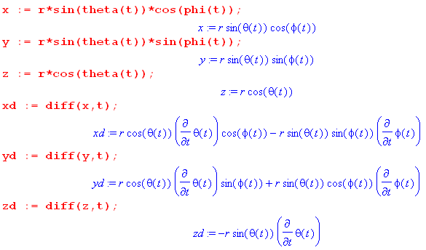 (C.7.3)
The second derivatives are messier, but Maple is happy to do the calculations,

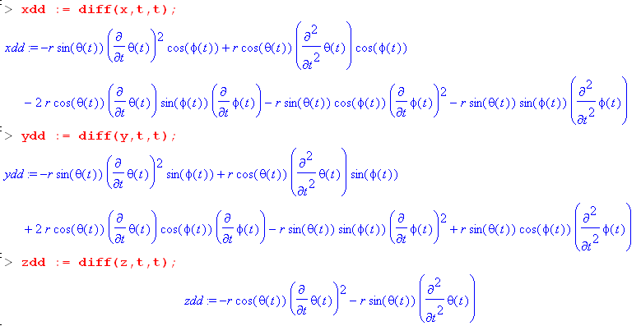 (C.7.4)
Task (a): Show that eq2 of (C.7.2) ⇒ eq2 of (C.7.1)

We enter eq2 of (C.7.2) and do some manipulations, suppressing the output except for the last step :

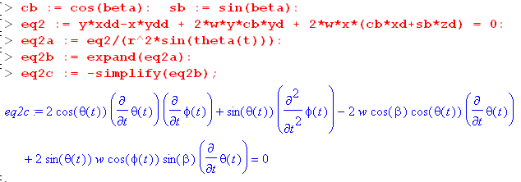 (C.7.5)
We manually transcribe the resulting equation,

2cosθ + sinθ -2ωcosβcosθ + 2ωsinθcosφsinβ = 0
or
2cosθ + sinθ = 2ωcosβcosθ - 2ωsinθcosφsinβ
or
2cosθ + sinθ = 2ω(cosβcosθ - sinθcosφsinβ) . (C.7.6)

This is a match for eq2 of (C.7.1) so we have accomplished Task (a).

Task (b): eq3 + (cosθsinφ)eq2 of (C.7.2) ⇒ eq1 of (C.7.1)

The code continues from that shown above. Equation eq2 is already entered, so we now enter eq3, form the linear combination for eq1, then process the results with a series of typical tortuous Maple steps,

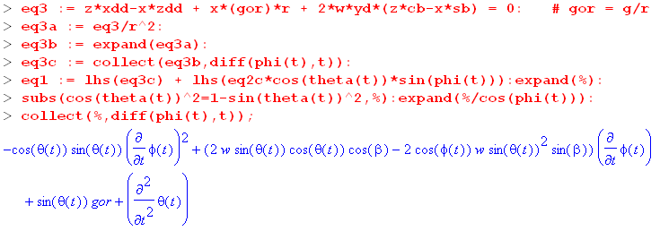 (C.7.7)
We again manually transcribe the resulting equation,

-cosθsinθ 2 + (2ωsinθcosθcosβ - 2ωsin2θcosφsinβ) + sinθ(g/r) + = 0
or
- cosθsinθ 2 = – sinθ(g/r) - 2ωsinθ(cosθcosβ - sinθcosφsinβ) . (C.7.8)

This is a match for eq1 of (C.7.1) so we have accomplished Task (b).

Tension equation verification

Using the angular equations of motion (C.7.1), we now show that the following two tension expressions are equivalent (the second is Cartesian (C.6.10) while the first is angular (C.2.9))

T/mr = 2 + sin2θ 2 + (g/r)cosθ - 2ω [(cosβsinθ + sinβcosφcosθ )sinθ + sinβsinφ ]
T/mr = - (2ωcosβ + )/x . (C.7.9)

Our task of showing (C.7.9) is the same as showing that

x{2 + sin2θ 2 + (g/r)cosθ - 2ω [(cosβsinθ+sinβcosφcosθ )sinθ + sinβsinφ ]} = -(2ωcosβ + )
or
LHS = RHS . (C.7.10)

We first get the complicated left hand side LHS entered:

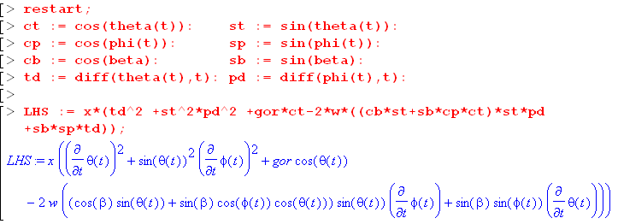 (C.7.11)

We then compute RHS = -(2ωcosβ + ),

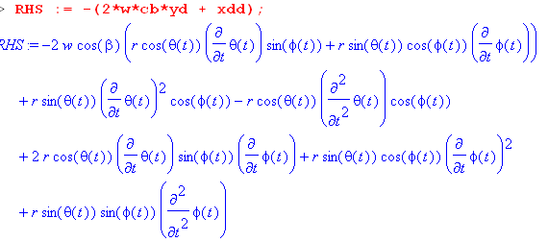 (C.7.12)
Notice that RHS contains second derivatives and . We shall eliminate these derivatives by manually solving the angular equations of motion (C.7.1) for Tdd = and Pdd = :

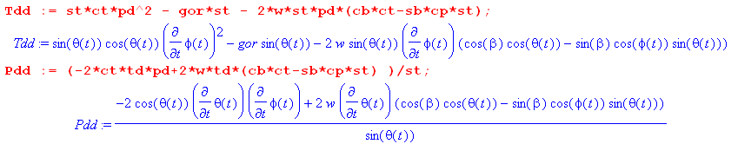
(C.7.13)
To show that LHS = RHS, we define d = LHS-RHS and show that d = 0:

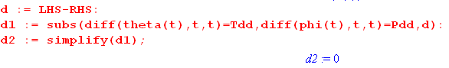 (C.7.14)
Thus d = 0 and LHS = RHS and the two expressions for T in (F.9.9) are equivalent.

C.8 Numerical solutions of the equations of motion (Cartesian Coordinates)

Our task is to solve the set of equations (C.6.9) (eq1 now has a new meaning) :

eq1 x2+y2+z2 = r2
eq2 y - x = -2ωycosβ - 2ωx(cosβ + sinβ)
eq3 z - x = -xg -2ω(zcosβ - xsinβ ) (C.6.9) (C.8.1)

We enter eq2 and eq3 writing derivatives for example as = xdd :

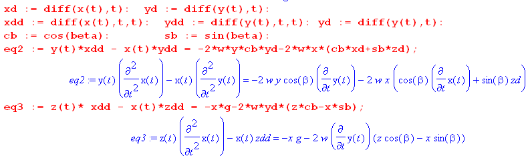
(C.8.2)
At this point zd = and zdd = are unspecified. We use eq1 to compute and in terms of x and y, using eq1 above:

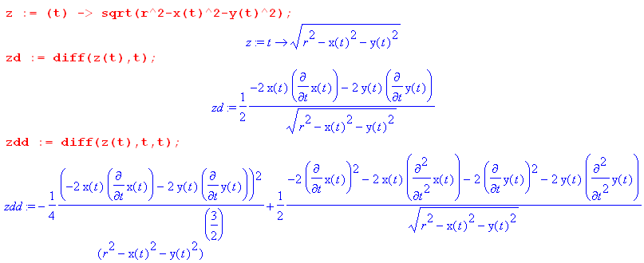
(C.8.3)

When these expressions are installed, eq2 and eq3 becomes these formidable-looking equations which contain two unknown functions x(t) and y(t) and constants r = l, β and ω = w :

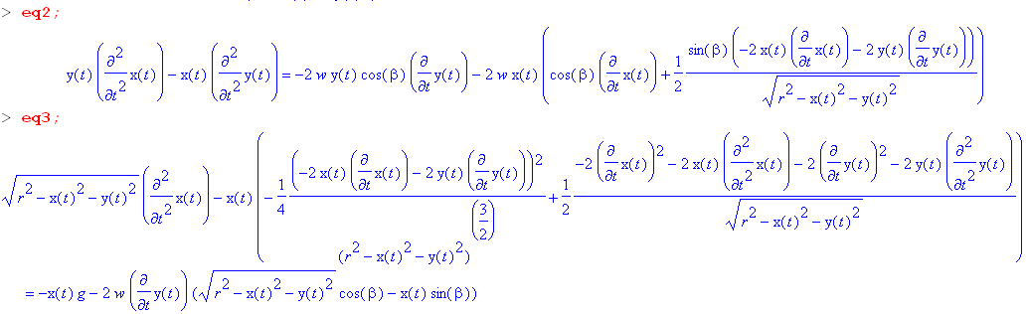
(C.8.4)

The Foucault Pendulum at the Pantheon in Paris

For our first plot, we consider the actual Foucault pendulum set up in the Pantheon. Numbers are entered as follows:

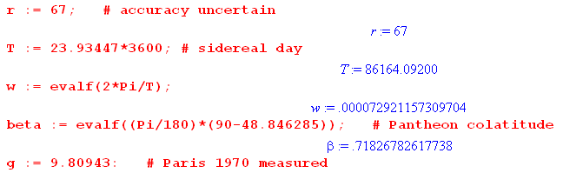 (C.8.5)

The Maple code to invoke a solution is as follows:

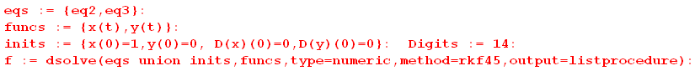
(C.8.6)
We have initialized the pendulum at x(0) = 1m. Here is a plot of the first few swings,

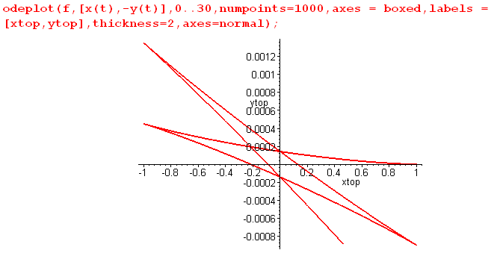 (C.8.7)

Notice that the vertical scale is highly magnified, so really these swings are very close to the x axis.

We want to view the orbits from above, not from below. Since the z axis points down, and since we are viewing from above, we negate the original y axis to get a new y axis appropriate for our plots viewed from the top. This negation is done in the odeplot call seen above.

As expected, and as shown earlier in (C.2.1), the Coriolis force deflects each half-swing to the right (as seen from above!).

In order to plot functions like x(t) more generally, we extract our functions of interest from the Maple dsolve environment as follows,

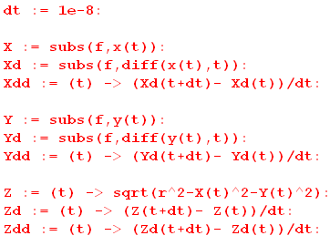 (C.8.8)

Here functions like X(t) are taken directly from the dsolve listprocedure output structure while unavailable derivatives such as Xdd = are manually approximated. For details on how this works and other information on dsolve (including a debugger's guide), see the author's Maple User Guide. We can now make a plot of the three functions x(t),(t) and (t) for the first swing,

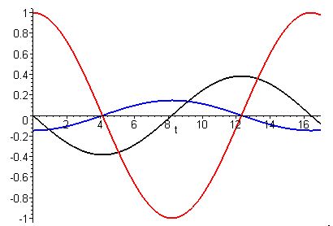 (C.8.9)

The shape of red x(t) appears to be sinusoidal as predicted by the small angle model. The black curve vx(t) = (t) seems to cross the x axis around 16.4 suggesting that this is the period of the first swing of the pendulum, in agreement with (C.5.9). We can zoom in on the crossing to get a better view,

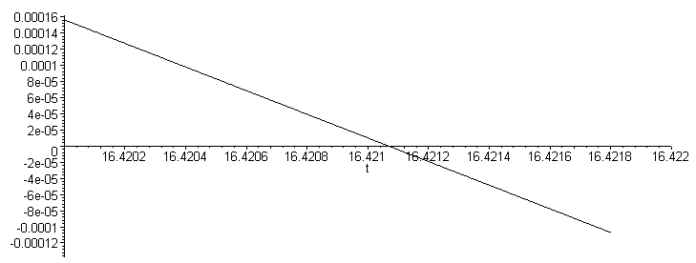
(C.8.10)
This indicates that the period is about 16.4211 sec.

Foucault Pendulum on a fast-rotating Earth

We now drastically decrease the Earth's rotation period from 24 hours to 58 seconds. With equally-scaled axes we get this Foucault path for a duration of 90.3 seconds,

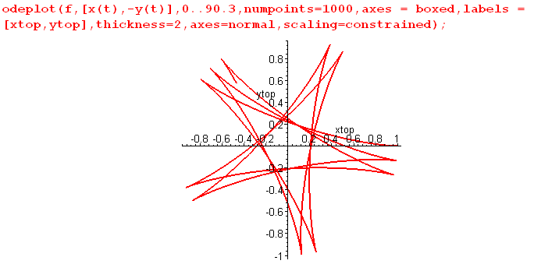 (C.8.11)

Next, when the pendulum is released at x = 1m, it is given a small vy velocity of -0.1 m/s, which means that vytop = +0.1 m/s :

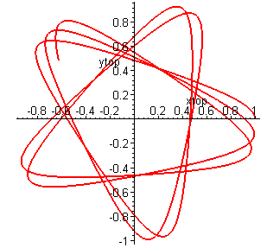 (C.8.12)

The sharp cusps of the previous orbit are now smoothed out. Conversely, if we apply vy = +0.1 m/s so that vytop = -0.1 m/s :

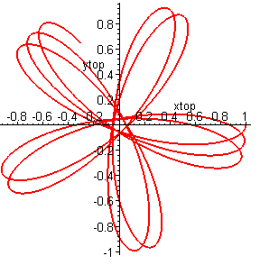 (C.8.13)

Desktop Spherical Pendulum

Here we set l = 1 m and turn off the Earth's rotation completely with ω = 0, so our Foucault pendulum becomes a spherical pendulum. We start it moving with these initial conditions :

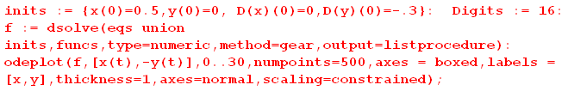

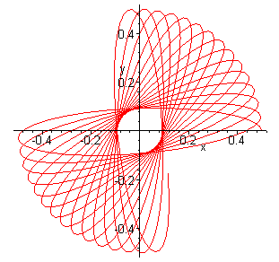 (C.8.14)

In 30 seconds the orbit precesses as shown. This effect has nothing to do with the Earth's rotation, and turning ω back on makes no change in the above picture.

Reader Exercise:

(1) Construct the above pendulum with 1 meter of button thread and a small lead fishing weight hung from a ceiling lamp fixture. With x ~ 1/2m start an elliptical motion of the shape shown above. Count the number of swings it takes for the orbit to precess 90 degrees and compare to the above figure.

(2) Come up with an approximate expression for the precession rate of such a pendulum.

If we change the initial position to x(0) = 0.9 to get more swing, here is the orbit out to t = 10:

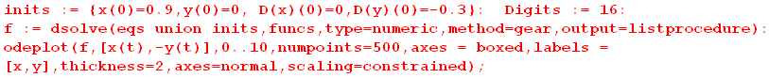

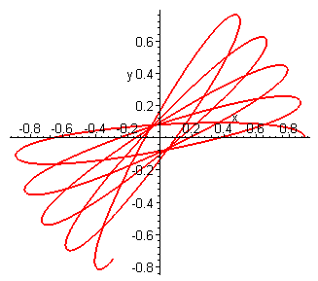 (C.8.15)

It appears that the higher starting point has increased the precession rate.

Here are some 3D plots of the above solution trajectory :

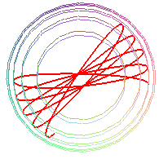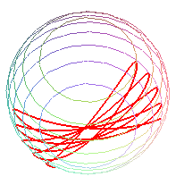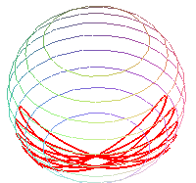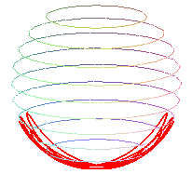
(C.8.16)

In the left image, the camera is looking down from the pivot point of the pendulum so the previous 2D picture is roughly replicated. Then the camera moves down to lower viewing angles.

