installed on 1.29.17 do not edit here

C.4 The Simple Pendulum

In this section we temporarily turn off the rotation of the Earth to study the behavior of pendulum without that complication. Setting ω = 0 in (C.3.9) the pendulum equations of motion become

2 + sin2θ 2 = -(g/l)cosθ + T/(ml)
- sinθcosθ 2 = - (g/l)sinθ
2cosθ + sinθ = 0 . (C.4.1)

We now seek a solution of (C.4.1) for which = 0. In this case the last equation requires = 0 and we are left with just two equations,

2 = -(g/l)cosθ + T/(ml)
= - (g/l)sinθ . (C.4.2)

These equations describe a pendulum that seems to swing in the plane φ = constant and so this is an example of a plane pendulum, also known as a simple pendulum. One can solve the second equation for θ(t), and then the first equation gives the tension T(t).
If the pendulum is started at some polar angle θ0 and released perfectly so φ = φ0 and = 0, the pendulum swings in a plane, but at it swings through θ = 0 the coordinate φ = φ0 discontinuously jumps to φ = φ0+π, so there is a continuity issue for φ at θ = 0. We could treat this technically using Heaviside and delta functions, but shall not go down that road. It is a simple fact that, for spherical coordinates, points on the z-axis where θ = 0 have an undefined value of φ.

For small angles the θ one finds for the above initial condition that

+(g/l)θ = 0 ⇒ θ(t) = θ0cos(Ωt) Ω ≡ $\sqrt{g/l}$ {θ(0) = θ0 .(0) = 0} (C.4.3)

On the other hand, if the pendulum is initialized with θ = 0 and some velocity sufficient to take it up to a maximum angle θ0 we get

+(g/l)θ = 0 ⇒ θ(t) = θ0sin(Ωt) Ω ≡ $\sqrt{g/l}$ {θ(0) = 0, θmax = θ0 } (C.4.4)

Exact Solution for the Simple Pendulum

We provide this detailed solution because it does not generally appear in textbooks.

For larger θ0 the simple pendulum equation + (g/l)sinθ = 0 falls into a class of second order non-linear ODE's which have the form = f(x) where means ∂t2x and we seek x(t). The solution is not hard to obtain, as we now outline. The first step is to define v ≡ :

v ≡ ⇒ = (dv/dt) = (dv/dx)(dx/dt) = (dv/dx)v ⇒ (dv/dx)v = f(x)

⇒ vdv = f(x)dx ⇒ (v2/2) = $^{\int_{}^{x}{}}$f(x')dx' + C

⇒ (dx/dt) = $\sqrt{2}$ $^{\int_{}^{x}{}}$ ⇒ dt = $\sqrt{2}$ $^{\int_{}^{x}{}}$

⇒ t(x) = ( $\sqrt{2}$$^{\int_{}^{x}{}}$ $^{\int_{}^{x"}{}}$) + C' (C.4.5)

where integration constants C and C' are determined by initial conditions. This solution gives t = t(x) which one must then "invert" to obtain x = x(t).

If we take f(x) = - Ω2sinx and then x→ θ the (v2/2) result in (C.4.5) becomes

(2/2) = $^{\int_{}^{θ}{}}$f(θ')dθ' + C = - Ω2$^{\int_{}^{θ}{}}$sin(θ')dθ' + C = Ω2cosθ + C . (C.4.6)

We set the zero of potential energy for the pendulum at the bottom, θ = 0. At angle θ the pendulum has risen a height h = l - lcosθ so the potential energy at θ is then V = mgh = mgl(1-cosθ).
We shall now apply the boundary conditions of (C.4.4). At t = 0 the pendulum is at θ = 0 and we give it a kick in the +φ direction with some initial velocity l(0). We assume that this causes the pendulum to rise up to some max angle θ0 < π. A too-large kick results in over-the-top behavior which we exclude.
At t = 0 the total pendulum energy is (1/2)m[ l(0)]2 .
At the top of the swing the total energy is mgl(1-cosθ). Therefore from energy conservation,

(1/2)m[ l(0)]2 = mgl(1-cosθ)
or
(1/2)[ (0)]2 = (g/l)(1-cosθ0) = Ω2(1-cosθ0) . (C.4.7)

Evaluating (C.4.6) at t = 0 gives

(1/2)[ (0)]2 = Ω2cos(0) + C = Ω2 + C

Comparing these last two equations one concludes that.

C = -Ω2cosθ0 . (C.4.8)

From (C.4.5) the solution for t(θ) is then

⇒ t(θ) = ( $\sqrt{2}$$^{\int_{}^{θ}{}}$ $^{\int_{}^{θ"}{}}$) + C' = ( $\sqrt{2}$$^{\int_{}^{θ}{}}$ $\sqrt{Ω2cosθ" + C}$) + C'

= ( $\sqrt{2}$$^{\int_{}^{θ}{}}$ $\sqrt{cosθ" - cosθ0}$) + C' (C.4.9)

The integral of interest appears on page 179 of GR7 (where we shall use the second form),

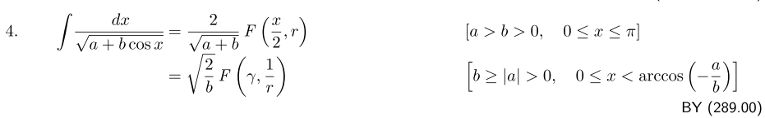
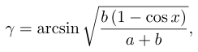 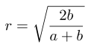 (C.4.10)

and where F(φ,k) is "the elliptic integral of the first kind". In our case b = 1 and a = -cosθ0 so

r = $\frac{2}{a+1}$= $\frac{2}{1-cosθ0}$ = $\frac{1}{sin(θ0/2)}$

γ = sin-1[ $\frac{1-cosθ}{1-cosθ0}$ ] = sin-1 [ $\frac{sin(θ/2)}{sin(θ0/2)}$] . (C.4.11)

Therefore,

t(θ) = $\frac{1}{Ω}$ F( sin-1 [ $\frac{sin(θ/2)}{sin(θ0/2)}$], sin(θ0/2) ) + C'

= $\frac{1}{Ω}$ F(φ, k) + C' where φ = sin-1 [ $\frac{sin(θ/2)}{k}$] , k = sin(θ0/2) (C.4.12)

The function F is defined in GR7 on page 860,

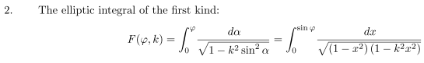 (C.4.13)
from which we see that F(0,k) = 0. Recall our boundary condition that θ(0) = 0 with some (0) > 0. From (C.4.12) we find at t = 0 and θ = 0 that

0 = $\frac{1}{Ω}$ F(0, k) + C' = 0 + C' ⇒ C' = 0 . (C.4.14)

Our final solution before inversion is then

t(θ) = $\frac{1}{Ω}$ F(φ, k) where φ = sin-1 [ $\frac{sin(θ/2)}{k}$] , k = sin(θ0/2), Ω ≡ $\sqrt{g/l}$ (C.4.15)

The Jacobi elliptic function sn(u) is usually defined in this rather obscure manner,

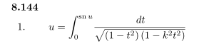 (C.4.16)

If one writes sn(u) = sin(φ), then the right sides of (C.4.13) and (C.4.16) are the same, so

F(φ,k) = u = sn-1(sinφ) or sn(F(φ,k)) = sinφ . (C.4.17)

We now apply this last equation to (C.4.15) as follows:

sn(F(φ,k)) = sinφ
or
sn(Ωt) = sin { sin-1 [ $\frac{sin(θ/2)}{k}$] } = $\frac{sin(θ/2)}{k}$
so
sin(θ/2) = k sn(Ωt) k = sin(θ0/2)
and
θ(t) = 2 sin-1( k sn(Ωt) ) k = sin(θ0/2) (C.4.18)

and the inversion of (C.4.15) is now complete. Following the convention of GR7, since sn(u) has an implicit parameter k, we make it explicit by writing sin(u) = sin(u,k) and then our solution is

sin(θ/2) = k sn(Ωt,k) k = sin(θ0/2)
θ(t) = 2 sin-1( k sn(Ωt,k) ) k = sin(θ0/2) (C.4.19)
or

sin(θ/2) = sin(θ0/2) sn(Ωt, sin(θ0/2))
θ(t) = 2 sin-1[ sin(θ0/2) sn(Ωt, sin(θ0/2)) ] (C.4.20)

When k is not too large, one has sn(x,k) ≈ sin(x). If θ0 is small, then so is θ and the first line of (C.4.20) reads,

θ/2 ≈ (θ0/2) sin(Ωt) ⇒ θ(t) = θ0 sin(Ωt) (C.4.21)

which is the correct small-angle solution for θ(0) = 0 and max angle θ0 as was stated in (C.4.4).

Here is a Maple plot of θ(t) from (C.4.20) with a selection of peak angles θ0 with Ω = 2πso that the small-angle period is T = 2π/Ω = 1 :

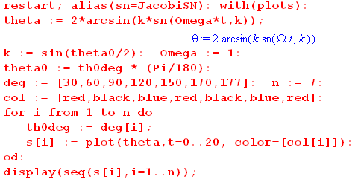

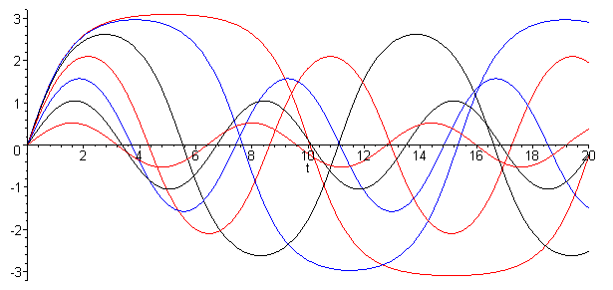 (C.4.22)

For small θ0 the function θ(t) is very sine-like with period T = 1, but for larger θ0 the period increases and the top flattens out. For θ0 = 177o the top is quite flat, indicating a long "hang time" when the pendulum (on its rigid massless stick) lingers in the near-vertical position.

The complete elliptic integral of the first kind is defined by (some sources capitalize the letter K),

K(k) = F(π/2,k) = $^{\int_{0}^{π/2}{}}$ $\sqrt{1-k2sin2α}$ // see (C.4.13). (C.4.23)

Since sn(u) = sin(φ) as shown above (C.4.17), we know that the peak value of sn(u) is 1 and this occurs one quarter of a wave into the sn(u) waveform. From (C.4.17) we know that

sn(F(φ,k)) = sinφ ⇒ sn(F(π/2,k)) = 1 ⇒ sn(K(k)) = 1 (C.4.23)

Thus, a quarter period of the function sn(u,k) along the real u axis is just K(k) and so the full period is then T = 4K(k). Here is a plot of 4K(k) showing how it increases from 2π to larger values slowly approaching the limit 4K(∞) = ∞ :

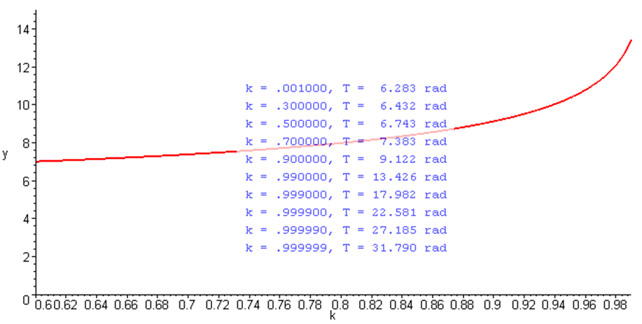 (C.4.24)

A quarter period of sn(Ωt,k) is then K(k)/Ω. For the more standard boundary conditions shown in (C.4.3) where θ(0) = θ0 and .(0) = 0, the solution is obtained by shifting (C.4.20) ahead by a quarter period, which means taking t → t + K(k)/Ω or Ωt → Ωt + K(k) . The result is then, with k = sin(θ0/2),

sin(θ/2) = sin(θ0/2) sn(Ωt + K(sin(θ0/2)), sin(θ0/2))
θ(t) = 2 sin-1[ sin(θ0/2) sn(Ωt + K(sin(θ0/2)), sin(θ0/2)) ] θ(0) = θ0 (0) = 0 (C.4.25)

Now for small angles the first line gives

θ/2 ≈ θ0/2 sin(Ωt+π/2) = θ0/2 cos(Ωt) ⇒ θ(t) = θ0 cos(Ωt) (C.4.26)

in agreement with (C.4.3)

Conventions: We have adopted the notation for K(k) and sn(u,k) which is used by the 2010 NIST Handbook of Mathematical Functions, by Gradshteyn and Ryzhik 7th edition (2007), and by the Bateman Manuscript Project (1953), though the last two sources write K as K. The reader is warned that there is another common convention which appears in the precursor to the NIST Handbook, namely the heavily-used 1964 Handbook of Mathematical Functions of Abramowitz and Segun (AS). The connection is this

K(k) = KAS(k2) // k2 = m
sn(u,k) = snAS(u,k2) = sn(u | k2) // sometimes = sn(u; k2) (C.4.27)

In using these functions one must be very careful to learn the convention used by a given source. For example, ancient Maple V states that (notice the k2 in the integral but k in the argument),

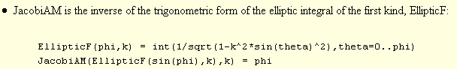

So this version of Maple is using our "modern" NIST 2010 notation for argument k.

