This has been installed, do not edit here!

(l) General Numerical Orbits of the Spherical Pendulum

In Section C.6 below we derive the spherical pendulum equations of motion directly in Cartesian coordinates and then in Section C.8 we plot various pendulum trajectories in Cartesian space. As long as one avoids hitting the singular point θ = 0, one can do this directly from the angular equations of motion as we now show. This method has an advantage over that of Section C.8 in that negative values of z here are allowed, meaning motion of the pendulum bob in the upper hemisphere is permitted.

The spherical pendulum equations of motion are given in (C.5.1),

2 + sin2θ 2 = -(g/l)cosθ + T/(ml)
- sinθcosθ 2 = - (g/l)sinθ
2cosθ + sinθ = 0 . (C.5.1) (C.5.38)

We enter into Maple the last two equations as was shown in (C.5.22), and have dsolve find solutions as in (C.5.23). Here is a simple example where we give the pendulum a good kick at t = 0,

θ(0) = 0.5 φ(0) = 0 (0) = 1.7 (0) = 0.5 (C.5.39)

We then extract θ(t) and φ(t) and plot them :

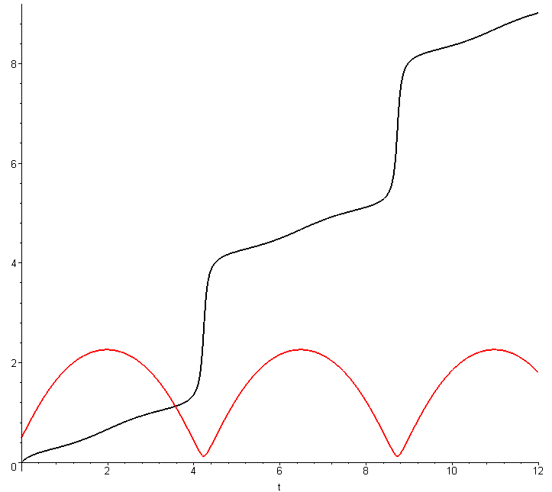 (C.5.40)

Alternatively, one can plot the trajectory in (θ,φ) space where φ winds up vertically and θ bounces,

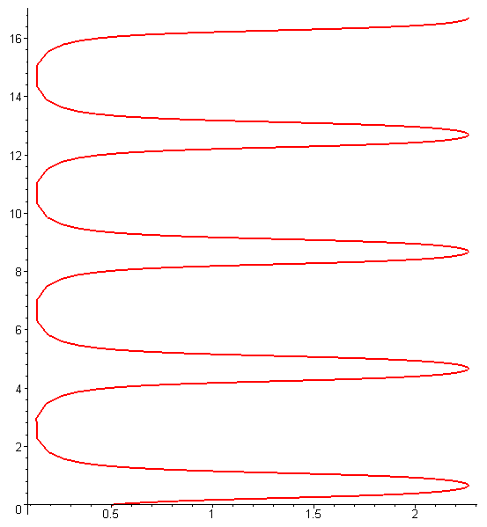 (C.5.41)

We then generate Cartesian coordinates (l = 1),

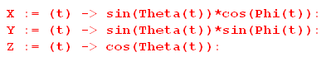 (C.5.42)

and plot the trajectory in these coordinates,

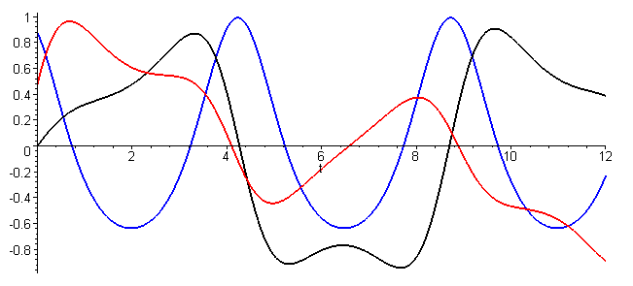 (C.5.43)

We can make a 3D plot of the trajectory as follows,

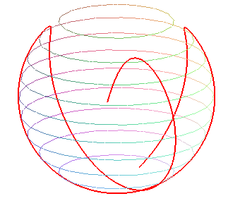 (C.5.44)

Solving the first equation in (C.5.1) for T, and using m = 1 kg and g = 9.8 m/s2, we can plot the string tension for the above trajectory,

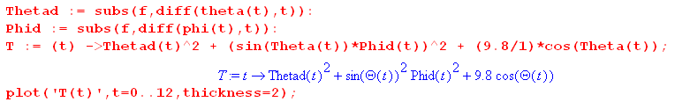

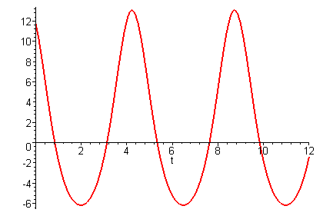 (C.5.45)

Since the string tension goes negative in this example, the pendulum just have a massless stick instead of a string.

