Section C_5 rewrite PhL 1.28.17

This was installed on 1.29.17 do not edit here.

C.5 The Spherical and Foucault Pendulums

Having studied the simple pendulum, we now return the more general spherical pendulum and at the end we look at the Foucault mode of this pendulum. Since there are many subsections below, here is a list of their headings:

(a) The equations of motion
(b) Lz as constant of the motion
(c) E as another constant of the motion
(d) Exact solution to the spherical pendulum problem (outline)
(e) The nature of the general solution
(f) The Conical Motion solution
(g) The thin ellipse scenario
(h) The Intrinsic Airy Precession
(i) The Foucault Mode of the Spherical Pendulum
(j) Interference between the intrinsic and Foucault precession
(k) The Foucault Pendulum at the Pantheon in Paris

(a) The equations of motion

As before, we turn off the rotation of the Earth by setting ω = 0, so equations (C.3.9) become

2 + sin2θ 2 = -(g/l)cosθ + T/(ml)
- sinθcosθ 2 = - (g/l)sinθ
2cosθ + sinθ = 0 . (C.5.1)

These are the equations of motion for a spherical pendulum in the presence of a uniform gravitational field of strength g. It is useful to know something about the solution of these equations before we turn the Earth's rotation back on.
Operationally, in the sense of a numerical solution, one can regard the last two equations of (C.5.1) as a pair of coupled second-order non-linear ODE's for functions θ(t) and φ(t) subject to initial conditions θ0, φ0, 0 and 0. Once these equations are solved (physically we know a unique solution must exist), the first equation may be used to determine T(t), the string tension. In practice, there are some difficulties with numerical integration since, as already noted, θ = 0 is a singular point in spherical coordinates (φ is undefined there). This is discussed a bit in Section F.7 for the dumbbell satellite which has similar equations of motion.

(b) Lz as constant of the motion

The last equation in (C.5.1) may be written in this form

d/dt ( sin2θ ) = 0 (C.5.2)

which says that sin2θ must be a "constant of the motion". To understand the meaning of this constant, we first compute the torque about the pivot point due to the gravitational force on the mass m,

N = r x mg = r x mg = mgl x [cosθ - sinθ ] = -mgl sinθ . (C.5.3)

Since this torque lies in a plane normal to the z axis, we may conclude that the Cartesian torque component Nz = 0. The angular version of Newton's Law says N = dL/dt , and therefore we expect that the quantity Lz will be a constant of the motion. Direct calculation shows that

Lz = L • = m (r x v) • = m ( x r) • v = m lsinθ • (l [ + sinθ ])
= ml2sin2θ (C.5.4)

where we have made use of (C.1.4) for and (C.3.7) for v. Thus, we see that our third equation of motion in (C.5.1), rewritten as in (C.5.2), is just the statement that dLz/dt = 0. In the Lagrangian formulation one finds that Lz is one of the canonical momenta which is constant because φ is a cyclic coordinate, meaning it does not appear in the Lagrangian.
In terms of the spherical unit vectors, one finds (again using (C.3.7) for v) that the vector angular momentum of the pendulum mass is given by

L = m r x v = ml2 [ - sinθ ] . (C.5.5)

Then application of N = dL/dt, with N as in (C.5.3) and unit-vector change rates as in (C.3.6), simply reproduces the last two equations of motion in (C.5.1).
So we conclude that :

h ≡ Lz/(ml2) = sin2θ (C.5.6)

is a constant of the motion of the spherical pendulum.

(c) E as another constant of the motion

We have shown in (C.5.6) that = h/sin2θ. It this is substituted into the second equation of (C.5.1) one obtains

- h2cosθ /sin3θ + (g/l)sinθ = 0 (C.5.7)

and we just put this equation on hold for a moment, noting that it is a second-order non-linear ODE.

Another constant of the motion is the total energy E which may be regarded as E = T + V = kinetic energy + potential energy (here the zero point of potential is put at the pendulum pivot point),

E = (1/2)mv2 - mglcosθ = (1/2) m l2(2+ sin2θ2) – mglcosθ (C.5.8)

where v2 = l2(2+ sin2θ 2) according to (C.3.7) for v. By rescaling the energy, we can take this constant of the motion to be

E = 2/2 + sin2θ2/2 – (g/l)cosθ . E = m l2E (C.5.9)

Using (C.5.6) to eliminate gives,

E = 2/2 + (h2/2sin2θ) – (g/l)cosθ
or (C.5.10)
E = 2/2 + Ve(θ) where Ve(θ) ≡ (h2/2sin2θ) – (g/l)cosθ .

Unlike (C.5.7), equation (C.5.10) is a first-order ODE so we prefer it to (C.5.7). In fact, if one multiplies (C.5.7) by and notes that = (1/2) ∂t(2) and does a few easy integrals, one obtains an equation of the form ∂t[stuff] = 0 so then stuff = constant. That "stuff" is the right side of (C.5.10) and we have then provided an interpretation for the constant (energy) [ is an "integrating factor" for (C.5.7) ].

(d) Exact solution to the spherical pendulum problem (outline)

Equation (C.5.10) is a first order non-linear ODE for θ(t) which we know how to solve:

= (2E - 2Ve(θ) )1/2 => dθ = (2E - 2Ve(θ) )1/2dt

=> dt = (2E - 2Ve(θ) )-1/2 dθ

=> t(θ) = $^{\int_{θ0}^{θ}{}}$dθ' $\sqrt{2E - (h2/sin2θ') + (2g/l)cosθ'}$ . // t(θ0) = 0 so θ(0) = θ0 (C.5.11)

Letting z' = cosθ', so dz' = -sinθ' dθ' = - $\sqrt{1-z'2}$dθ' one finds

$\sqrt{2E - (h2/sin2θ') + (2g/l)cosθ'}$ = - $\sqrt{1-z'2}$ $\sqrt{2E - (h2/[1-z'2]) + (2g/l)z'}$

= - $\sqrt{2E [1-z'2] - h2 – (2g/l)z'[1-z'2]}$ = - $\sqrt{2E -2Ez'2 - h2 – (2g/l)z'+ (2g/l) z'3]}$

= - $\sqrt{(2g/l) [ z'3 - (El/g) z'2 - z' + (l/g) (E- h2/2) ]}$ . (C.5.12)

Therefore

t(θ) = $^{\int_{z}^{z0}{}}$dz' $\sqrt{(2g/l) [ z'3 - (El/g) z'2 - z' + (l/g) (E- h2/2) ]}$ // z = cosθ, z0 = cosθ0

= $\sqrt{l/(2g)}$$^{\int_{z}^{z0}{}}$dx $\sqrt{(x-a)(x-b)(x-c)}$ (C.5.13)

where a,b,c are the roots of the cubic equation x3 - (El/g) x2 - x + (l/g) (E-h2/2 ) = 0. The dimensionless integral appearing on the last line can be evaluated in closed form using this indefinite integral,

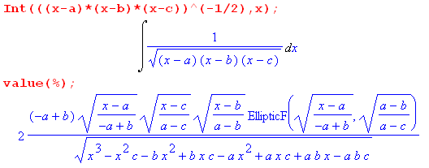 . (C.5.14)

Here EllipticF is the incomplete elliptic integral of the first kind as was defined in (C.4.13) and (C.4.17),

EllipticF(sin(φ),k) = $^{\int_{0}^{sin(φ)}{}}$dt $\sqrt{(1-t2)(1-k2t2)}$ = F(φ,k) = sn-1(sinφ,k) . (C.5.15)

Therefore, we have a closed form result for t(θ) which can then be "inverted" to obtain a solution for θ(t). Then from (C.5.6) we get

= h/sin2(θ(t)) => φ(t) = φ0 + h $^{\int_{0}^{t}{}}$dt' /sin2(θ(t')) (C.5.16)

and the problem of the spherical pendulum is completely solved more or less in closed form. The string tension is then determined by the first equation in (C.5.1).

(e) The nature of the general solution

Recall (C.5.10) where E is the total scaled energy for the pendulum mass,

E = 2/2 + Ve(θ) where Ve(θ) ≡ (h2/2sin2θ) – (g/l)cosθ . (C.5.10)

The effective potential Ve(θ) has the following shape (plotted here for h2/2 = .3 and (g/l) = 1)

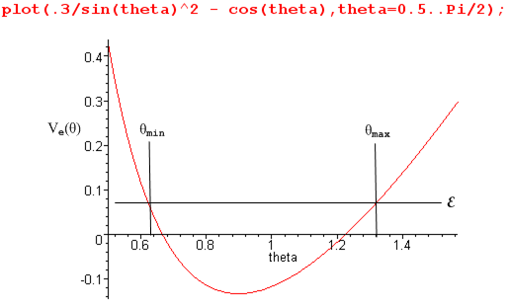 (C.5.17)

Since 2/2 = (E - Ve(θ)) must be positive, one must have Ve(θ) ≤ E which is valid only between θmin and θmax as shown. These are the "turning points" where = 0. Differentiation of (C.5.10) tells us that,

0 = + Ve'(θ) // Ve'(θ) ≡ dVe(θ)/dθ
or
= – Ve'(θ) . (C.5.18)

At the right turning point the slope Ve'(θ) is positive so < 0 which accelerates the particle to the left. At the left turning point the slope Ve'(θ) is negative so > 0 which accelerates the particle to the right. The particle therefore bounces back and forth between these two turning points in some manner. Thus the motion of the pendulum is constrained on the spherical surface r = l between two horizontal circles of angles θmin and θmax and hits both these angles once per "oscillation".
Meanwhile, from (C.5.16) the action in the φ dimension of the problem is controlled by

= h/sin2(θ(t)) => φ(t) = φ0 + h $^{\int_{0}^{t}{}}$dt' /sin2(θ(t')) (C.5.16) (C.5.19)

so as θ(t) does the oscillation just discussed between θmin and θmax, φ(t) increases as shown in its own complicated functional manner.
A quick tour of web animations of the spherical pendulum shows the amazing complexity of the possible motions. If the string is replaced with a massless stiff rod, over-the-top motions are included. Some examples (search youtube if these are dead links) :

http://www.youtube.com/watch?v=6hCLkTENfSA .
http://www.youtube.com/watch?v=VS1dU5HpfOM&feature=relmfu

Both animations demonstrate the θmin ≤ θ ≤ θmax idea, though it takes a while to see in the first animation.

(f) The Conical Motion solution

The spherical pendulum has an obvious simple solution where θ = θ0 = constant, so the string motion traces out a cone. In this case the equations of motion (C.5.1) become

sin2θ0 2 = -(g/l)cosθ0 + T/(ml)
cosθ0 2 = (g/l)
= 0 . (C.5.20)

The second equation says ωφ ≡ = $\sqrt{(g/l)secθ0}$. Since this is a constant, the third equation is satisfied as well, and then the first says T = mg secθ0. In the small angle limit for θ0, ωφ slows down to its smallest possible value ωφ ≡ $\sqrt{g/l}$ = Ω which is the frequency of a small-angle plane pendulum. Conversely, as we try to achieve θ0 → π/2, secθ0→ ∞ and both ωφ and tension T become infinite, which seems pretty reasonable. This solution can of course be obtained by elementary methods as well.
ok to here

(g) The thin ellipse scenario

We now return to the general spherical pendulum equations

2 + sin2θ 2 = -(g/l)cosθ + T/(ml)
- sinθcosθ 2 = - (g/l)sinθ
2cosθ + sinθ = 0 . (C.5.1) (C.5.21)

In the plane pendulum analysis of Section C.4 we set = 0 to simplify these equations. However, once the plane swing path is opened even slightly into a thin elliptical path, the φ(t) function becomes just as active as the θ(t) function. For such a thin ellipse, θ bounces between the θmax and θmin turning points and θmin will be very small. Roughly speaking, for each full elliptical swing cycle of θ, φ(t) wraps 2π about the origin, so the functions have similar "frequencies". From (C.5.16) the velocity = h/sin2(θ(t)) is very uneven and will have large peaks when θ is near θmin.
It is useful to look at an actual simulation to see the action of the two angle variables. We start by entering the equations,

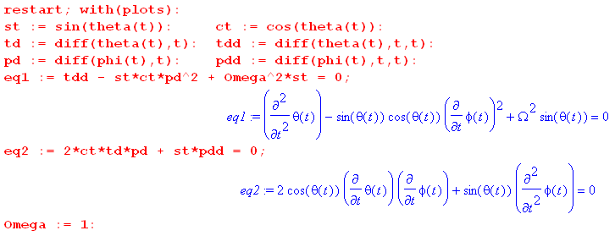 (C.5.22)

Then we set in some initial conditions and create the simulation. Here we start at θ(0) = 90o and some small amount of (0) = 0.4 which results in an ellipse that is thin but not very thin :

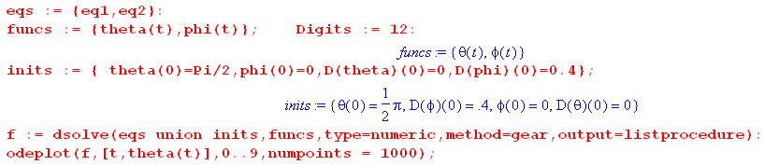
(C.5.23)
Next we extract the four solution functions of interest which are θ(t),φ(t),(t) and (t) [ see our Maple User's Guide ] ,

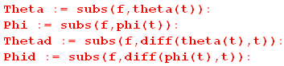 (C.5.24)

We are now ready to make plots:

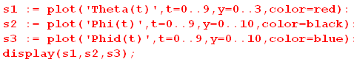

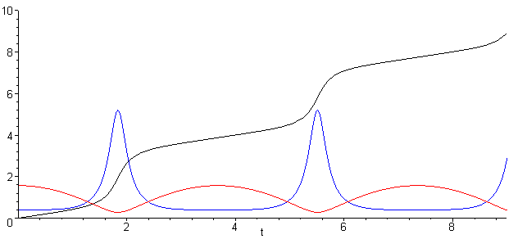 (C.5.25)
θ = red φ = black = blue

We see in red the expected θ(t) bouncing between θmax= π/2 and θmin ≈ 0.3. The blue (t) has peaks when θ is small, as noted above. The black φ just winds around to ever-increasing φ as the pendulum bob goes in its elliptical path (not an exact ellipse).
We conjecture that for a thin elliptical orbit, the behavior of the pendulum for small or large θmax is very similar to what we saw for the plane pendulum in Section C.4. In particular if we set θmax very close to π, we expect to see the top of the red θ curve become flat, corresponding to the long hang time mentioned in that Section. Here we set θmax = 0.995*π :

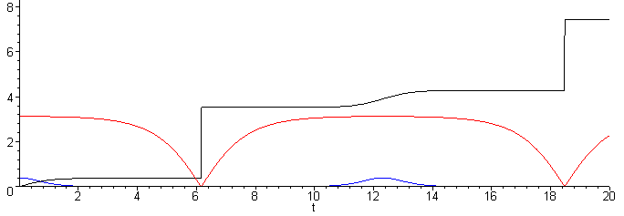
θ = red φ = black = blue (C.5.26)

The period of the θ motion is correspondingly increased.
We have no similar conjecture to make about the φ(t) behavior of the pendulum!

(h) The Intrinsic Airy Precession

Consider again the two equations of motion.

- sinθcosθ 2 = - Ω2 sinθ
2cosθ + sinθ = 0 . (C.5.1) (C.5.27)

A pair of equivalent equations was noted earlier,

- h2cosθ /sin3θ + Ω2sinθ = 0
= h/sin2(θ(t)) (C.5.28)

With the second pair, one solves the first for θ(t) and uses that in the second to get φ(t).
In all these equations the terms are of similar size, so nothing can be neglected in an attempt to make any approximation for a "thin orbit". For this reason it is difficult to come up with an arm-waving explanation of the fact that the orbit processes due to the relation between the θ and φ behavior. It turns out that, when θmax is not too large, for each period of the θ motion, the azimuth φ wraps around a little less than 2π and this causes the orbit to precess as the pendulum swings (this has nothing to do with Earth rotation which is turned off). Here we demonstrate this effect using θ(0) = 1 radian and doing mod(φ,2π) in the plot of φ:

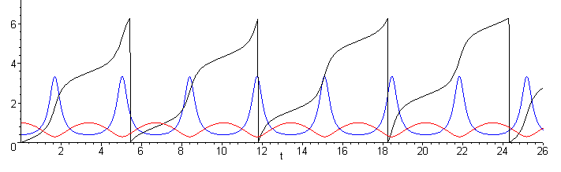
θ = red mod(φ,2π) = black = blue (C.5.29)

The vertical edge of the black φ curve is slipping to the left relative to the red and blue curves.
In his 1851 paper Airy (see Refs.) derived an expression for this "intrinsic apsidal precession rate" of the spherical pendulum doing thin elliptical orbits which our numerical solution above demonstrates. His formula is (now called "the Airy precession")

ωairy/ωswing = Tswing/Tairy = (3/8)(ab/l2) = (3/8π)(πab/l2) = (3/8π)(A/l2) . (C.5.30)

In this approximate formula, a and b are the semimajor and semiminor axes of the narrow ellipse which is slowly precessing, and l is the length of the string (A = πab is the area of the ellipse). This formula is most accurate for small oscillations and gets less precise for larger ones, requiring correction terms. The orbit processes in the same direction that the bob rotates around the ellipse (see Fig. (C.8.14) ).
The derivation in Airy's paper is quite involved. An alternate derivation appears in the text of Synge and Griffith, pp 373-381. The result appears on p 381 in the form δφ = (3A/4l2) where δφ is the amount of precession during one full swing of the pendulum. Then it takes N = δφ/2π swings to get 2π of precession and so 1/N = 2π/δφ = (3/8π)(A/l2) in agreement with ** above.
We shall return to this precession in the next section and when we plot orbits in Section C.8.

(i) The Foucault Mode of the Spherical Pendulum

We now turn the Earth's rotation back on and are faced with the full equations of motion from (C.3.9),

2 + sin2θ 2 = -(g/l)cosθ + T/(ml) + 2ω [(cosβsinθ + sinβcosφcosθ )sinθ + sinβsinφ ]
- sinθcosθ 2 = - (g/l) sinθ - 2ωsinθ (cosβcosθ - sinβcosφsinθ)
2cosθ + sinθ = 2ω (cosβcosθ - sinβcosφsinθ) . (C.3.9)

We seek a planar-like solution where ω, and are all very small. It is still true that φ must wind roughly 2π for each θ swing, but most of the time (away from the low point) is very small since the assumed orbit is nearly planar. The equations then reduce to the following,

2 = -(g/l)cosθ + T/(ml) + 2ω [sinβsinφ ]
= - (g/l) sinθ
2cosθ = 2ω (cosβcosθ - sinβcosφsinθ) . (C.5.31)
The second equation is the standard equation for the general-amplitude plane pendulum. This problem was exactly solved in Section C.4 for the initial conditions θ(0) = θ0 and (0) = 0,

θ(t) = 2 sin-1[ sin(θ0/2) sn(Ωt + K(sin(θ0/2)), sin(θ0/2)) ] θ(0) = θ0 (0) = 0 (C.4.25)

The third equation can be written as

2 = 2ω (cosβ - sinβcosφtanθ) (C.5.32)

For small oscillations we drop the second term to get

= ωcosβ (C.5.33)

In our arrangement of the spherical coordinates with pointing down, this indicates a clockwise precession of the pendulum when it is viewed from above, and so is consistent with our initial Foucault calculation (C.5) .

(j) Interference between the intrinsic and Foucault precession

We have found that for small-angle motion of a spherical pendulum on the Earth's surface,

ωF = 2ωcosβ // Foucault precession, ω = rotation rate of the Earth

ωI ≈ Ω(3/8π)(A/l2) // Intrinsic precession, Ω = $\sqrt{g/l}$ = pendulum swing frequency

where ω ≈ Ω = $\sqrt{g/l}$ is the small-angle pendulum frequency. The ratio is then

ωI/ωF = Ω(3/8π)(A/l2) / (2ωcosβ) = (3/16π) ($\sqrt{g/l}$/ω) (A/l2) secβ // dimensionless

= (3/16π) $\sqrt{g}$A ω-1 l-5/2 secβ (C.5.34)

We would like the intrinsic precession frequency to be much less than the Foucault frequency so that one can then ignore the intrinsic effect. To make this ratio small, one of course wants to make the ellipse area A as small as possible, one wants to stay away from the Earth's equator where β = π/2 and secβ = ∞, and one wants a large l .
This subject gets a good treatment in Schumacher and Tarbet (2009), where the Airy formula appears as equation (2). These authors propose an electronic device to neutralize the intrinsic precession to allow for a much shorter string on a Foucault pendulum.

(k) The Foucault Pendulum at the Pantheon in Paris

According to Google Maps

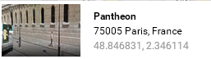

the Pantheon is located at latitude 48.8468 degrees, so β = 90-48.8468= 41.1532 degrees.
The length of the pendulum is purported to be 67 meters which we assume is the exact distance from the pivot point to the center of mass of the swinging weight.
Wiki https://en.wikipedia.org/wiki/Gravity_of_Earth says g = 9.81 m/sec2 in Paris.
According to https://en.wikipedia.org/wiki/Sidereal_time the Earth's sidereal (relative to the stars) rotation period is 23.9344699 hours.
We now have Maple do a few calculations. First we compute the pendulum period (w used for ω, and the function evalf means "evaluate to a floating point number") :

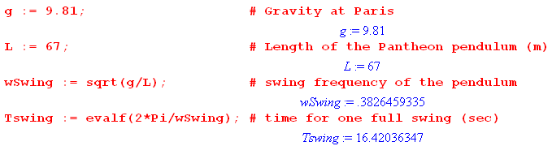 (C.5.35)

The full-cycle period is therefore Tswing = 16.42 seconds. Stopwatch measurements for the first full swing in this video https://www.youtube.com/watch?v=59phxpjaefA were 16.37, 16.38. 16.36 which average to 16.37, pretty close. One is never sure that video speeds are reproduced in real time.

Next we compute the Foucault rotation period using ωFouc = ωEarthcosβ from (C.5.33) or (C.5) :

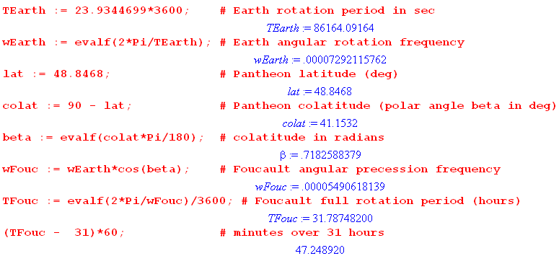
(C.5.36)
The period is then 31.787 hours or 31 hours and 47.2 minutes.
The site https://en.wikipedia.org/wiki/List_of_Foucault_pendulums#France claims 31 hours and 50 minutes, but that is probably a calculated and not a measured value. Says m = 28 kg so this pendulum does not blow around much in the breeze.
Next we estimate the effect of the Airy precession, assuming the swing is about 2 meter long and the ellipse width is 2 cm (hopefully it is smaller than that). The ratio_Airy is taken from (C.5.30)

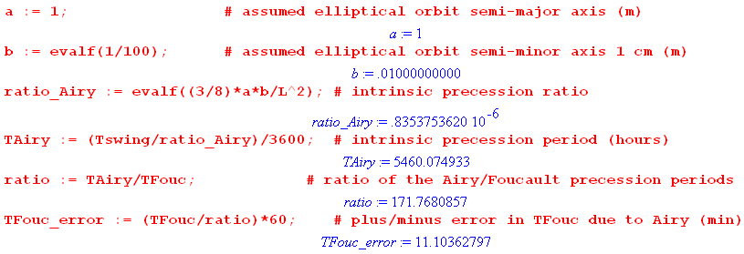
(C.5.37) \
Thus suggests that we get one Airy precession for every 171.76 Foucault precessions. The direction of the Airy precession depends on which way the ellipse path is traversed. The error induced in the Foucault period is then about ± 11 minutes, assuming the a and b values shown. One would think that with a careful "burned string" launch of the pendulum, one could get "a" down to maybe 1 mm, which would reduce the 32 hour period error to ± 1 minute.

