This is the Title PhL 1.11.15

Here is my Foucault in Cartesian coordinates.

= -(T/mr)x - 2ωcosβ
= -(T/mr)y + 2ω (cosβ+ sinβ)
= g -(T/mr)z -2ωsinβ . (C.6.6)

If I turn off the earth, seems that here is the spherical pendulum,

= -(T/mr)x
= -(T/mr)y
= g -(T/mr)z . (C.6.6)ω=0

Eliminating T the equations are

1 y - x = -2ωycosβ - 2ωx(cosβ+ sinβ)

2 z - x = -xg -2ω(zcosβ - xsinβ )

and

1 y - x = 0

2 z - x = -xg

This is too simple! What happened here? Have I omitted some fictional force? I think I have messed up the centrifugal force somehow! I said it was taken care of by g, but maybe that is wrong. The above says you have independent simple harmonic motion even for large amplitudes. [ wrong! it only says this for small oscillations in which case T ≈ mg. ]

Who does a good basic treatment of "the spherical pendulum"? Time for a serious search, I need some external verification of things.

Taylor: 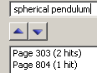 Page 303 is a problem 7.40 setup but quotes no results. Wants us to use Lagrangian. Has three stars on the problem. Page 804 is this hit in the index. So nada.

Goldstein original. Only simple pendulum appears in the index.

Goldstein et al. This is djvu non-searchable I have no PDF. Index shows for spherical pendulum. P 83 comments on Lissajouz figures for small amplitude spherical pend. Page 428 says to set up the problem in Hamiltonian, just a problem. 9.37. So nothing here.

Osgood. Page 183 mentions small oscillations and ellipse. Full treatment topic on page 306. Writes T and U and then Lagrange equations of motion, his z is opposite mine. He gets these equations,

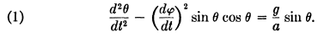

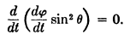

These are the same as mine in (C.4.1). Osgood implies these apply to NOT just small angles. He combines the two equations to get
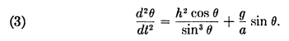

Which is an equation involving only θ. I have a similar equation which is

2E = 2 + (h2/sin2θ) – 2(g/l)cosθ E = m l2E (C.4.9)

But if I now replace θ → π-θ to convert to his system, then cos(θ) → cos(π-θ) = -cosθ. sinθ→-sinθ, so if I translate his equation I would get

2E = 2 + (h2/sin2θ) + (g/2l)cosθ

But this is very different from his equation! Start over. Here are my equations:
2 + sin2θ 2 = -(g/l)cosθ + T/(ml)
- sinθcosθ 2 = - (g/l)sinθ
2cosθ + sinθ = 0 . (C.4.1)

where the last equation says

d/dt ( sin2θ ) = 0 or sin2θ = h or = h/sin2θ

If I install this into my second equation, I get

- sinθcosθ [h/sin2θ]2 = - (g/l)sinθ
or
- sinθcosθ h2/sin4θ = - (g/l)sinθ
or
- cosθ h2/sin3θ = - (g/l)sinθ
or
= cosθ h2/sin3θ - (g/l)sinθ

which compare to Osgood

Now the change θ→π-θ makes the two equations the same. So this is a simple way to get an ODE for θ for the spherical pendulum. My energy approach is a different path. Not clear what HIS (3) looks like for small θ.
OK, let's continue with Osgood and yes, he is NOT doing only small angles. He then switches to my θ angle calling it θ' and he gets

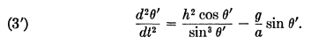

which then matches my equation. He then finishes off by saying

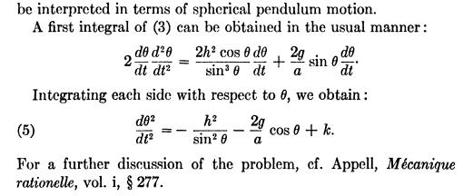

So he bails out at this point.

So there are two different θ equations one can work with. In my notation

2E = 2 + (h2/sin2θ) – 2(g/l)cosθ E = m l2E (C.4.9)

= cosθ h2/sin3θ - (g/l)sinθ h ≡ Lz/(ml2) // above

Recall that

h ≡ Lz/(ml2) = sin2θ

Therefore

0 = 2sinθcosθ + sin2θ

Now my angular equations are

2 + sin2θ 2 = -(g/l)cosθ + T/(ml)
- sinθcosθ 2 = - (g/l)sinθ
2cosθ + sinθ = 0 . (C.4.1)

where the third I have just derived again.

Comment: Osgood has confirmed my θ,φ equations for non-small motions! At least the last two of (C.4.1). I obtained these equations from ma = mg + T – 2m ω x v where ω was Earth rotation, and then I set ω = 0. This says

ma = mg + T
or
ma = mg - T

There are NO OTHER FORCES ??? With no earth rotation, Frame S of mine is an inertial frame, and these are the correct equations! These correct equations give

2 + sin2θ 2 = -(g/l)cosθ + T/(ml)
- sinθcosθ 2 = - (g/l)sinθ
2cosθ + sinθ = 0 . (C.4.1)

and Osgood has verified the last two equations.

Now go to Cartesian coordinates: I start from the same inertial-frame equation (if I set ω = 0)

ma = mg - T

and this results in

= -(T/mr)x
= -(T/mr)y
= g -(T/mr)z (C.6.6)

But beware that T is not a constant except for small oscillations!! My later equations are then

1 y - x = 0

2 z - x = -xg

3 x2+y2+z2 = r2

where T is eliminated. Do these have some simple solution? Try this on the first two equations

zy - zx = 0

yz - yx = -xyg

so subtract to get

- zx + yx = xyg
or
- z + y = yg
or
y - z = yg

This does not really help. So the three variables x,y,z are entangled and it is unclear how you would get a solution! I have these equations then

y - x = 0

z - x = -xg

y - z = yg

So in fact spherical coordinates is much better in terms of trying to state an ODE!!

Conclusions at this point

1. For small oscillations, if we can say T ≈ mg, then the Cartesian equations for the spherical pendulum are these:

= -(g/l)x
= -(g/l)y
= g - (g/l)z = g [ 1-z/l ] . (C.6.6)ω=0

The last equation can be interpreted as = g which is reasonable.
So in this limit, you get:

x(t) = Acos(Ωt+φ1) Ω = $\sqrt{g/l}$
y(t) = Bcos(Ωt+φ2)

We now have

(x/A)2 = cos2(Ωt+φ1)
(y/B)2 =cos2(Ωt+φ2)

I think we have a rotated ellipse. What is the equation of same? Start with this

x2/C2 + y2/D2 = 1

Now rotate by an angle α which then means

$\left(\begin{matrix}x' \\ y'\end{matrix}\right)$ = $\left(\begin{matrix}cosα & -sinα \\ sinα & cosα\end{matrix}\right)$$\left(\begin{matrix}x \\ y\end{matrix}\right)$ r' = Rr

$\left(\begin{matrix}x \\ y\end{matrix}\right)$ = $\left(\begin{matrix}cosα & sinα \\ -sinα & cosα\end{matrix}\right)$$\left(\begin{matrix}x' \\ y'\end{matrix}\right)$ r' = Rr

x = cosα x' + sinα y'

y = -sinα x' + cosα y'

Then the equation of the rotated ellipse centered at the origin is this

[ cosα x' + sinα y']2/C2 + [-sinα x' + cosα y']2/D2 = 1

Now switch back to x y

[ cosα x + sinα y]2/C2 + [-sinα x + cosα y]2/D2 = 1

and this is then a rotated ellipse. Compare to what I have which is

x(t) = Acos(Ωt+φ1) Ω = $\sqrt{g/l}$
y(t) = Bcos(Ωt+φ2)

Can you find α, C and D as functions of A,B,φ1.φ2 which cause this to be an ellipse? It is pretty messy, but Maple makes it look like an ellipse. The equation to solve is then this

[ cosα Acos(Ωt+φ1) + sinα Bcos(Ωt+φ2)]2/C2 + [-sinα Acos(Ωt+φ1) + cosα Bcos(Ωt+φ2)]2/D2 = 1

and you want to solve for α,C,D. I tried this in Maple, and I got nowhere.

Go back to

x(t) = Acos(Ωt+φ1) Ω = $\sqrt{g/l}$
y(t) = Bcos(Ωt+φ2)

Why might this be an ellipse?

I have done this somewhere before!!! Maybe ocean wave particle motion? How can I find my document on this. Ransack on ellipse AND ocean gives 33 hits in physics. It is in lines doc and here is my claim there:

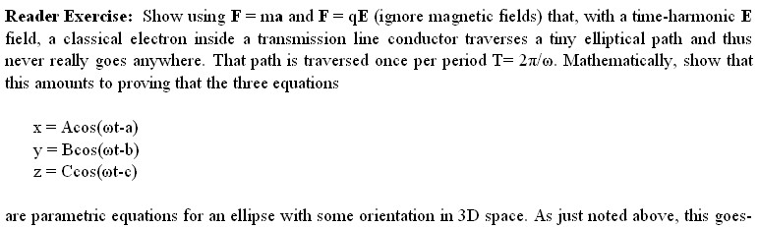

So did I actually do this somewhere?? Search Acos AND Bcos in physics get 18 hits. But not here. But in math I finally found it:

D:\Work\My Interests\Math\Geometry\Rotated Ellipse Stuff of Dec 2013

and I have a whole doc on exactly this subject!!! Specifically in Section 6! I do in fact prove there that the two equations shown above define an ellipse. Here is what I show:

x = A' cos(t-a)
y = B' cos(t-b)

The ellipse has major and minor axes A,B and is at fixed angle θ where

A-2, B-2 = (1/2) csc2(b-a) $\frac{1}{A'2B'2}$ [ A'2+ B'2 ± $\sqrt{A'4 + B'4 - 2A'2B'2[1 + cos(b-a)]}$ ]

θ = (1/2)tan-1[2cos(b-a)(A'B'), A'2-B'2 ]

And Maple has proven this as well, so let's now move on:

Conclusions at this point (restarted)

1. For small oscillations, if we can say T ≈ mg, then the Cartesian equations for the spherical pendulum are these:

= -(g/l)x
= -(g/l)y
= g - (g/l)z = g [ 1-z/l ] . (C.6.6)ω=0

The last equation can be interpreted as = g which is reasonable. So in this limit, you get:

x(t) = Acos(Ωt+φ1) Ω = $\sqrt{g/l}$
y(t) = Bcos(Ωt+φ2)

The orbit here in the x,,y plane is a rotated ellipse at a fixed angle, so there is no precession for small oscillations for the spherical pendulum.

Fact 1: There is no precession for small oscillations for the spherical pendulum.

2. For large oscillations the Cartesian equations of motion look very difficult to solve. One gets these equations either of which can be studied to obtain θ(t) :

- h2cosθ /sin3θ + (g/l)sinθ = 0 h = Lz/(ml2)

E = 2/2 + (h2/2sin2θ) – (g/l)cosθ E = m l2E

Osgood directs us to

for a discussion of the first equation. I can access this book in google books! But I need "volume i ? ?? I was able to download this item,

I will take a look at these pages: The cycloid is some weird thing and the simple has friction.

S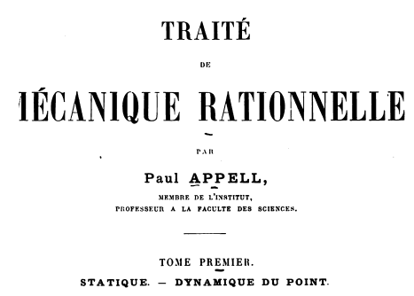

Wiki lists his pubs

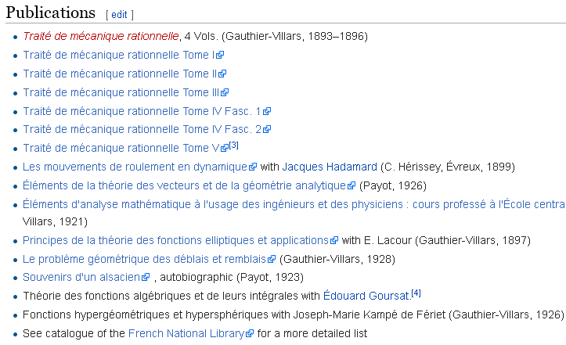

Osgood earlier has

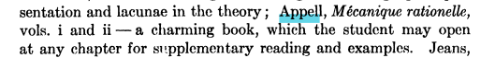

So I really have vol 1 and it really does have a spherical pendulum section 277 on page 499 of PDF.

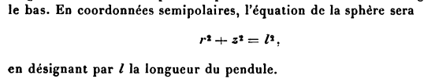

so l is the string and I guess r2 = x2+y2. It is a very long piece, but I don't see the Osgood equation mentioned. It is on topic yes, but not helpful, too bad, a canoe path that did not pan out.

Let's continue the search.

Marion. On page 355 he gets equations of motion but he is doing Foucault. He gets my (C.6.14) as his (9) on page 355. He does the same complex solution I do. Nothing new here.

Landau & Lip. page 60 sees some action. he does my energy equation approach I think

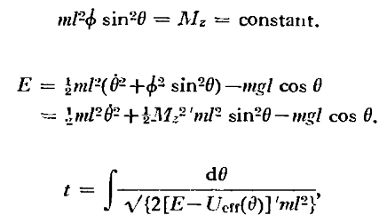

Nothing on the 2nd order equation.

Web hit #1 PDF.

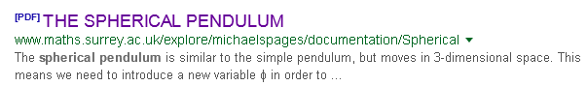

Nothing useful.

Web hit #2 PDF.

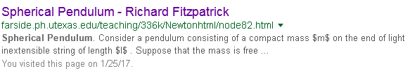

z is neg of mine. He writes the 2nd order equation

Suppose, finally, that the motion is almost conical: i.e., the value of remains close to the value . Let

So here is treating a slightly tipped circular orbit, tipped by δφ and he gets precession in this case with a formula. But nothing more.

Web hit #3 PDF.



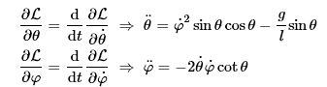

Has nice orbit plot numerique but nothing helpful

___________________________

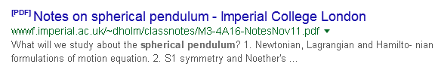
No good

_______________________

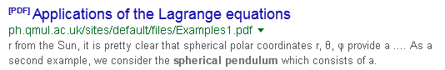
No good
___________________________



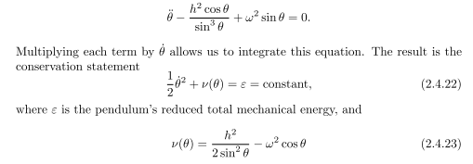

So how does that integration work exactly ? Start with

- h2cosθ /sin3θ + (g/l)sinθ = 0 h = Lz/(ml2)

- h2cosθ /sin3θ + (g/l)sinθ = 0 h = Lz/(ml2)

(1/2)∂t()2- h2(∂tθ)cosθ /sin3θ + (∂tθ)(g/l)sinθ = 0

In the second term I want

∂t(f) = cosθ/sinθ3 (∂tθ)

df/dt = cosθ/sinθ3 dθ/dt

df = cosθ/sinθ3 dθ

f = -(1/2) 1/sin2θ + C // says Maple

In the third term I want

∂t(g) = sinθ(∂tθ)

dg/dt = sinθ dθ/dt

dg = sinθdθ

g = -cosθ + C

Then my equation says

(1/2)∂t()2- h2∂t[-(1/2) 1/sin2θ + C] + (g/l)∂t[ -cosθ + C'] = 0

which then says

(1/2)∂t()2- h2∂t[-(1/2) 1/sin2θ ] + (g/l)∂t[ -cosθ] = 0
or
∂t { (1/2)()2- h2[-(1/2) 1/sin2θ ] + (g/l)[ -cosθ] } = 0
or
{ (1/2)()2- h2[-(1/2) 1/sin2θ ] + (g/l)[ -cosθ] } = constant
or
(1/2)()2 + (1/2)h2/sin2θ - (g/l)cosθ = constant
or

2/2 + h2/(2sin2θ) - (g/l)cosθ = constant = E

So he is exactly correct in his observation! So nobody is every going to mess with the 2nd order equation. He does add this perhaps useful result

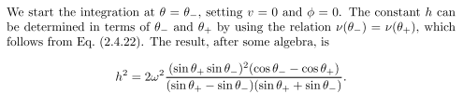
But no mention of precession!

So my web search is turning up very little. If I add precession to "spherical pendulum".



This is a very complicated paper, but at least uses my variables θ and φ.

ISP = Ideal Spherical Pendulum

apsidal precession = Airy's precession

Aha! Airy wrote a paper on this in 1851 and here is the title

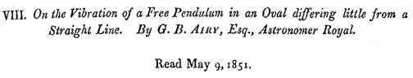

That is exactly what I am looking for. He starts with these equations

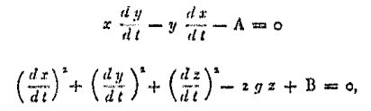

where the first says Lz is constant while the second says energy = constant. Very good. He uses ψ(t) as the precessing angle of interest.

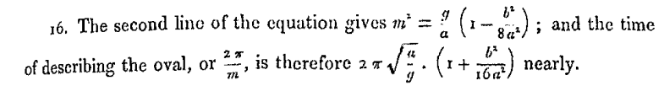

His big conclusion is this

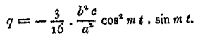

But I don't know what q is because it is defined in Article 5 which he write earlier. m is the base frequency I think.
a = string length.

b and c are defined by the assumed form of the basic ellipse.

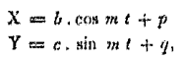

Now here is what Article 5 is -- it is in his Published Memoirs, but where are they. I have this,

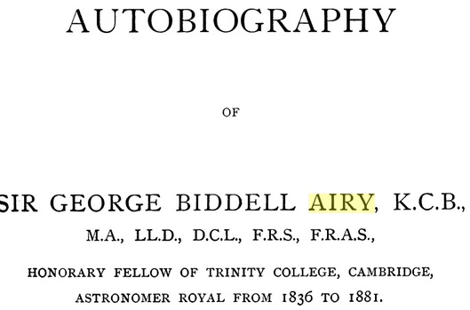

He was an astro guy.
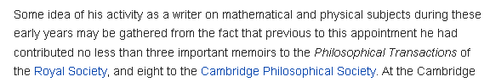

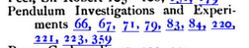

https://books.google.com/books?id=-mUSAAAAIAAJ&pg=PA342&dq=edward+maunder+astronomer&hl=en#v=onepage&q&f=false

This has a list of all his papers and books near the end page 369.

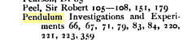

The item 1851 is all I see in this index related to the topic, and that is the article I have. He says in this paper that is earlier paper was in "the 11th volume of the memoirs". So how do I find that article. I am sure it is the Royal Astronomical Society.

https://catalog.hathitrust.org/Record/000519124 has full view vol 11 two items

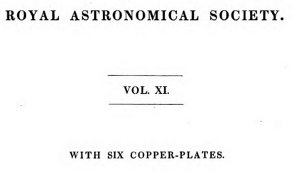

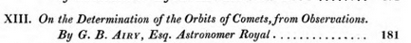

But the claimed paper is not there, only the above paper.

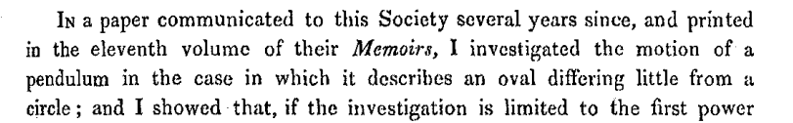

But it is just not there. Not in vol 12 either.

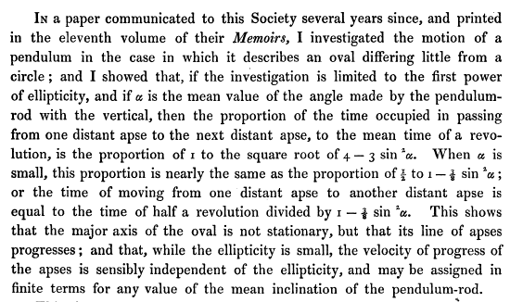

So α = the mean value of θ and he is claiming

Tprecession / Tswing = 4 - 3sin2α // maybe factor of 2, what is apse?

but he says this is not very good if thin ellipse.

Maybe this is his 1851 rsult

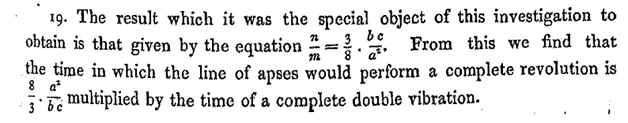

OK, here he is saying

Tprecession = (8/3)(a2/bc) Tosc

where a = length of string, b and c are what appear in the ellipse equations

Here p and q are small correction functions, they are not phases.

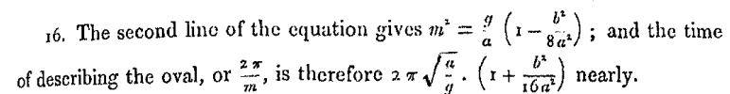

So notice that m is not quite what you think if b is large.

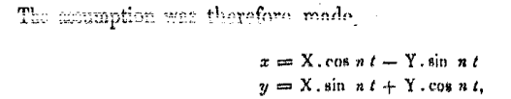

I think n is his precession frequency.

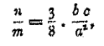

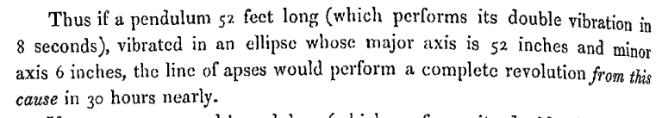

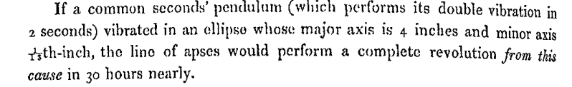

He is giving the full major axes, while the formula wants the semi-major axes , so

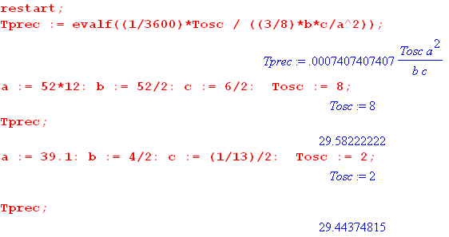

Now that I know about his pioneering study of "Airy precession", there MUST be some contemporary discussion of this in the open world.

I try for the Olsson reference but I am blocked by paywalls,

olsson "the precessing spherical pendulum"

But then here is a good hit, look at the date!!

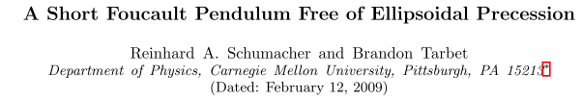

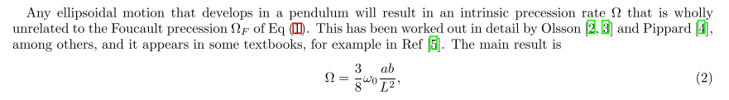

They also quote this adjusting factor for the swing frequency

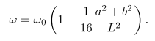
Textbook ref [5] is

I have a 1949 copy of this thing, and it has a LOT of mention of the word pendulum! The analysis of the simple case begins on page 370. The spherical starts on page 373! They do small osc, then conical, then general motion. They use R,z,φ as cylindrical coordinates! They then have the following u coordinate,

The ODE of interest is then

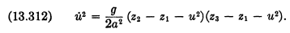

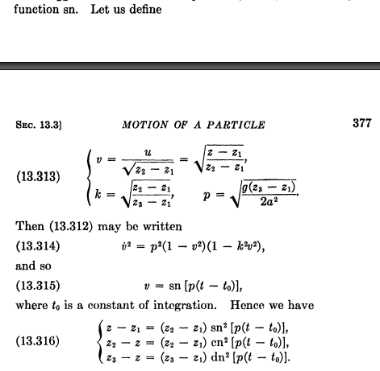

On it goes. Finally comes precession

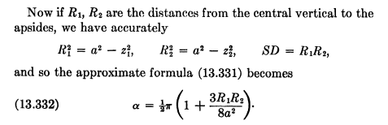

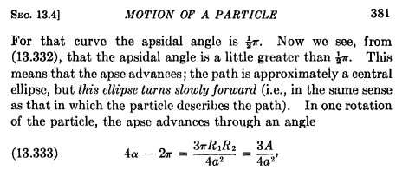

You see the Airy formula above the 381. I will try to process this final claim.

"In period Tosc we have dφ = (3π/4)(R1R2/a2) for the precession. It must then take this number of periods Tosc to get a full precession period

N = 2π/dφ = 2π/{(3π/4)(R1R2/a2)}

Inverting

1/N = (3π/4)(R1R2/a2) / 2π = (3/8)(R1R2/a2)

and there you have it! Their method using z is rather obscure but probably better than Airy's method which got the same result.
I wonder if the 1959 edition is better on this? $5 from Amazon. Book is well protected.

So OK I am done with this little effort. I have a formula for the precession and it is valided in a 2009 reference that I can in fact provide a link to.

How would I apply this idea in my frames doc near (C.8.14) ?

For that figure I estimate

b =

