Appendix D: Center of gravity and torque for a tethered satellite 1
D.1 Definition of Center of Gravity 1
D.2 Center of Gravity for a 2-mass Tethered Satellite 4
D.3 Tethered Satellite : General masses, but θ = 0 9
D.4 Tethered Satellite : General masses, but θ = π/2 12
D.5 The single sphere satellite 15

Appendix D: Center of gravity and torque for a tethered satellite

D.1 Definition of Center of Gravity

The phrase "center of gravity" is often used as a synonym for "center of mass" which complicates searching for information about the former concept. The "center of mass" of a system of particles is well known to be

rcms = $\frac{Σimiri}{Σimi}$ = $\frac{1}{M}$ Σimiri M = Σimi // discrete
rcms = $\frac{∫dVρ r}{∫dVρ}$ = $\frac{1}{M}$ ∫dV ρ r M =∫dV ρ // continuous (D.1.1)

We use "cms" to mean center of mass even though "com" might be more reasonable. Notice that rcms is measured with respect to the same origin used for the ri or r. For a rigid object, the center of mass is a definite point that does not move around relative to the object. It is completely determined by the spatial mass distribution of the object.
The center of gravity is a completely different animal, though it happens to align with the center of mass for a uniform gravitational field. For that reason one never deals with a distinct center of gravity concept for human-scale engineering objects on the earth's surface.
Consider a system of masses mi each of which experiences some force Fi. We define

F = ΣiFi N(R) = Σi (ri-R)xFi N(0) = ΣirixFi . (D.1.2)

Here F is the sum of the forces acting on all the masses mi, N(R) is the total torque on the system with respect to some arbitrary point R, and N(0) is the total torque with respect to the selected origin. An obvious theorem is that

N(R) = Σi (ri-R)xFi = ΣirixFi - Rx ΣiFi

= N(0) - R x F (D.1.3)

which shows how the two torques are related. If F = 0, which is often the case, then the torque is the same with respect to any point.
One characteristic of a center of gravity point rcog is that the total torque on a system measured with respect to point rcog vanishes, so N(r$_{cog}$) = 0. From (D.1.3) we see that this is the same as saying N(0) = rcog x F , so

N(r$_{cog}$) = 0 ⇔ N(0) = rcog x F rcog = "center of gravity" . (D.1.4)

The significance of rcog is that it is a point which allows the relation between the total system torque N(0) and the total system force F to have the same form as Ni = ri x Fi for a single point particle. It is not obvious that such a point rcog exists for some arbitrary system of particles.
So far this notion of "center of gravity" has nothing to do specifically with gravity, but we shall below add an additional part of the definition which does bring in gravity.
Unlike the center of mass, the center of gravity (if it exists) may not be unique and it generally moves around in an object as the object changes orientation in an external force field If we dot N(0) = rcog x F with the vector F we find

N(0)• F = 0 . (D.1.5)

As shown above, N(0) and F are well-defined computable quantities and if N(0)• F ≠ 0, then rcog cannot possibly exist (because if it did exist one must have N(0)• F = 0). So (D.1.5) is a condition for the existence of rcog.
Here is a method for locating rcog, a variation of Symon p 258 which we present in the context of an asteroid of mass M near the Earth. This description includes the second characteristic of the center of gravity point which is that it is point at which gravitational action is effectively focused.
One first computes the total gravitational force F = ΣiFi (summed over all points in the asteroid) and one then knows the direction of the sum vector F. One creates a line along F and then translates that line parallel to F until the line passes through the center of the Earth. The center of gravity of the asteroid lies on that translated line a distance rcog from the center of the Earth where rcog is determined by,

GMEM/rcog2 = F ⇒ rcog = $\sqrt{GMEM/F}$

rcog = rcog (-) F = F . (D.1.6)

Here is an illustration,

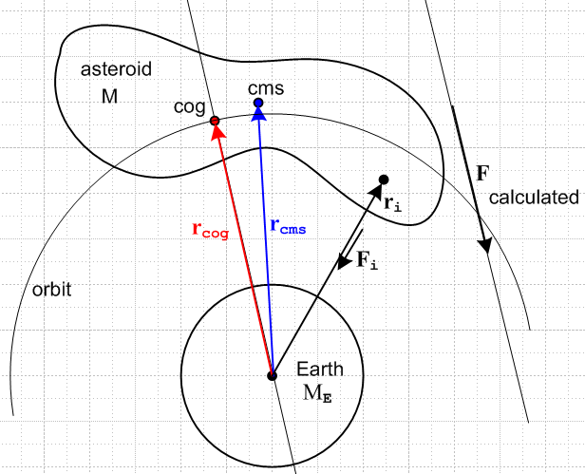 (D.1.7)

From the Earth's point of view, one could replace the entire asteroid with a point mass M at location rcog and the Earth would feel the same gravitational pull from that point mass as it does from the asteroid. Furthermore, if the asteroid were in a circular orbit around the earth keeping its same aspect facing the earth (not very likely), then the orbiting characteristics of the asteroid would be the same as for its replacement point mass, and one would have for example RMEM/rcog2 = Mω2rcog as the balance between gravitational and centrifugal force. If the asteroid does not rotate or tumbles in some manner, at any point in its orbit rcog will lie on the orbit shown, but the location of that point within the asteroid changes so that the new rcog computed for a new position and orientation still equals the orbit radius. In this case the rcog position will change relative to the asteroid, whereas the cms point always has the same position relative to the asteroid. Here we enhance the above drawing by adding another position of the tumbling asteroid in its orbit,

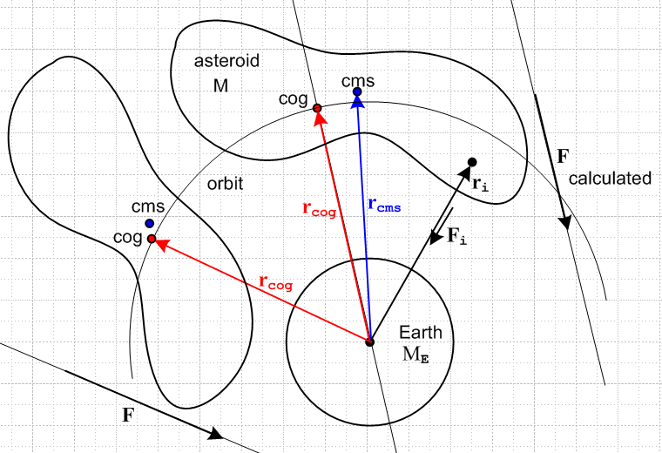 (D.1.8)

One implication is that, for any orientation of the asteroid in orbit, there exists a position of the asteroid such that the total force F will have the same magnitude as at any other position, since rcog is the same.

One might wonder what Symon's operational prescription for computing rcog has to do with our opening section about torque. First, for each point in the asteroid we know that rix Fi = 0 (ri tails are at Earth center) because each ri to mass mi is parallel to the force Fi to mass i. Thus according to (D.1.2) we have N(0) = 0. Therefore the condition (D.1.5) that N(0)• F = 0 is trivially satisfied. Then rcog exists and is a vector which satisfies the center of gravity definition (D.1.4) that N(0) = rcog x F. This equation is satisfied by Symon's computed rcog because rcog is parallel to F, so the equation says 0 = 0. From (D.1.4) we then see that the N(R$_{cog}$) = 0 so rcog is a point with respect to which the total torque on the asteroid (due to gravitational forces from the Earth) is 0. In this example it happens that any point R along the rcog line satisfies N(0) = R x F and any such point R therefore is a point of zero total torque N(R) = 0. But only one point on this line gives the concentration point of the gravitational force such that GMEM/rcog2 = F .
We shall now consider a 2-mass tethered satellite as a relatively simple example where we can compute the cog point and then watch it move relative to the cms point.

D.2 Center of Gravity for a 2-mass Tethered Satellite

Consider this sketch of the satellite :

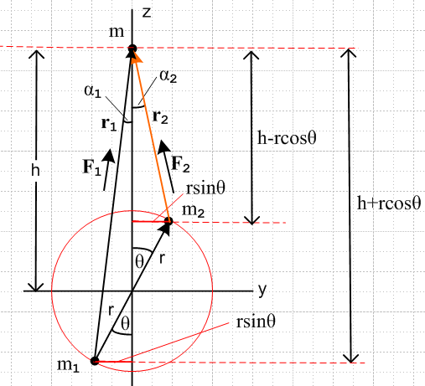 (D.2.1)

The satellite consists of two masses m1 and m2 which are connected by a rigid massless stick of length 2r (sometimes called a "dumbbell satellite"), As long as there is tension in the stick one can replace the stick with a rope tether, and this is usually the case.

The two masses are taken to lie on the red circle (radius r) as shown so they are symmetrically located relative to the drawing origin. A test mass m is located a distance h up the z axis, and one can regard this as the center of the Earth. We have in mind that the satellite is not embedded in molten lava but is in fact outside the earth, so h - r > RE. In general one will have h >> r, but we don't make that assumption in what follows. The purpose of the complicated drawing is to allow the tethered masses to assume an arbitrary orientation in space. Whatever that orientation might be, the two masses and the center of the Earth define a plane, and that then is the plane of paper. Notice in the drawing the vectors r, r1 and r2 and their directions. Mass m2 is located at polar angle θ, and various other angles and distances are marked. We draw the y axis to the right, the z axis up, and then the x axis points toward the viewer.
We now enumerate the two forces which the Earth exerts on the two satellite masses,

F1 = (Gmm1/r21) 1 = (Gmm1/r31) r1
F2 = (Gmm2/r22) 2 = (Gmm2/r32) r2 . (D.2.2)

These are not the total forces acting on the masses because the stick applies some tension/compression force to each mass. We can write T1 = T and T2 = -T and add these to the above, but our interest below is in the sum of these two forces, so the tension force will cancel out.

The unit vectors i point generally upwards in the drawing, and the forces are pulling the satellite masses toward Earth center.

Notice in (D.2.1) that the upper red line segment has length rsinθ but also has length r2sinα2. The length of the lower red segment is the same, but it is both rsinθ and r1sinα1.
For a right triangle which includes r1 one sees that r12 = (rsinθ)2+(h+rcosθ)2 and r1cosα1 = h + rcosθ.
For a right triangle which includes r2 one sees that r22 = (rsinθ)2+(h-rcosθ)2 and r2cosα2 = h - rcosθ.
So we arrive at these useful relations:

r1sinα1 = rsinθ r12 = (rsinθ)2 + (h+rcosθ)2 r1cosα1 = h + rcosθ
r2sinα2 = rsinθ r22 = (rsinθ)2 + (h-rcosθ)2 r2cosα2 = h - rcosθ . (D.2.3)

By inspecting (D.2.1) one sees that

1 • = cosα1 1 • = cos(π/2-α1) = + sinα1
2 • = cosα2 2 • = cos(π/2+α2) = – sinα2 . (D.2.4)

Thus :

F1y = F1• = (Gmm1/r21)1• = (Gmm1/r21) sinα1 = (Gmm1/r31) r1sinα1 = (Gmm1/r31) rsinθ
F1z = F1• = (Gmm1/r21)1• = (Gmm1/r21) cosα1 = (Gmm1/r31) r1cosα1 = (Gmm1/r31) (h + rcosθ)

F2y = F2• = (Gmm2/r22)2• = -(Gmm2/r22) sinα2 = - (Gmm2/r32) r2sinα2 = -(Gmm2/r32) rsinθ
F2z = F2• = (Gmm2/r22)2• = (Gmm2/r22) cosα2 = (Gmm2/r32) r2sinα2 = (Gmm2/r32) (h - rcosθ)

which we summarize as

F1y = (Gmm1/r31) rsinθ F2y = -(Gmm2/r32) rsinθ
F1z = (Gmm1/r31) (h + rcosθ) F2z = (Gmm2/r32) (h - rcosθ) (D.2.5)
so
F1 = (Gmm1/r31) rsinθ + (Gmm1/r31) (h + rcosθ)
F2 = -(Gmm2/r32) rsinθ + (Gmm2/r32) (h - rcosθ) . (D.2.6)

The total force acting on the satellite is then F = F1+ F2 so

F = (Gm)[ rsinθ(m1/r31 - m2/r32)] + (Gm)[ (h+rcosθ)m1/r31 + (h-rcosθ)m2/r32 ]
and (D.2.7)
Fy = (Gm)[ rsinθ(m1/r31 - m2/r32)]
Fz = (Gm)[ (h+rcosθ)m1/r31 + (h-rcosθ)m2/r32 ] .

The center of gravity vector is then given by

rcog = rcog (-) = rcog (-$\frac{F}{F}$)

F = $\sqrt{Fx2+Fy2}$

rcog = $\frac{Gm(m1+m2)}{F}$ (D.2.8)

Even in this very simple problem involving only two masses, the expression for the center of gravity point rcog is very complicated.

Meanwhile, we can write a center of mass vector (vectors all relative to the origin),

Rcms = $\frac{m2r + m1(-r)}{m1+m2}$ = $\frac{m2 - m1}{m1+ m2}$r ≡ (μ2-μ1) r μi ≡ mi/(m1+m2) (D.2.9)

where we note that μ1 + μ2 = 1. To obtain a cms vector relative to the mass m point, we add -h as shown in (a) of Fig (D.2.11) below. Then

rcms = - h + Rcms = - h + (μ2-μ1) r = - h + (μ2-μ1)[ y + z ]

= - h + (μ2-μ1)[ rsinθ + rcosθ ]

= (μ2-μ1) rsinθ + [ (μ2-μ1) rcosθ - h]

= $\frac{m2 - m1}{m1+ m2}$ rsinθ + [$\frac{m2 - m1}{m1+ m2}$ rcosθ - h]

= $\frac{(m2-m1)rsinθ}{m1+m2}$ + $\frac{(m2-m1)rcosθ - h(m1+m2)}{m1+m2}$ . (D.2.10)

We now draw the vectors rcog (D.2.8) and rcms (D.2.10) in our general diagram in (b) below,

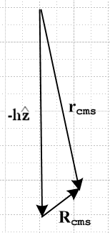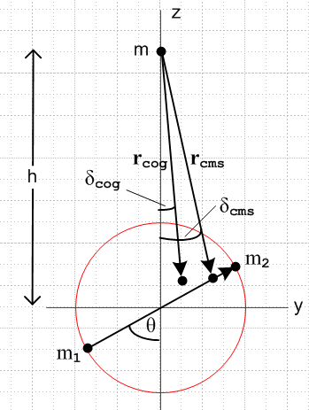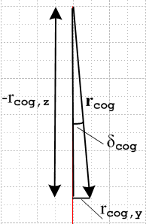

(a) (b) (c) (D.2.11)
The drawing is appropriate for m2 >> m1 so rcms lies on the line segment between the masses, but toward the m2 end. We are not sure where rcog lies, so we show it at some arbitrary point.

The angles δcog and δcms show the angles between rcog and rcms and the vertical z axis and are given by

tan(δcog) = rcog,y / (-rcog,z) = Fy / (-Fz)
tan(δrms) = rcms,y / (-rcms,z) . // see drawing (c) above (D.2.12)

Using (D.2.7) for F and (D.2.10) for rcms we then find

tan(δcog) = $\frac{rsinθ (m2r13 - m1r23)}{[m1r23(h + rcosθ) + m2r13(h - rcosθ)]}$

tan(δcms) = $\frac{(m2-m1)rsinθ}{(m1+m2)h-(m2-m1)rcosθ}$ (D.2.13)

In general, these angles are not the same, being different dimensionless functions of m1,m2,r,h and θ . So in general, the line from m to the center of gravity is different from the line from m to the center of mass. And then of course the points rcog and rcms must be different. Earlier we claimed these facts without any evidence, but here we see it in a specific example.

We shall now examine some special cases of the above description.

D.3 Tethered Satellite : General masses, but θ = 0

When θ = 0 the two masses are vertically aligned and we have r1 = h+r and r2 = h-r. Then,

F = (Gm)[ rsinθ(m1/r31 - m2/r32)] + (Gm)[ (h+rcosθ)m1/r31 + (h-rcosθ)m2/r32 ]

= (Gm)[ (h+r)m1/r31 + (h-r)m2/r32 ]

= (Gm)[ m1/r21 + m2/r22 ] . (D.3.1)

Then F = Fz where

F = (Gm)[ m1/r21 + m2/r22 ] = (Gm)[ m1r22 + m2r12 ] /(r12r22)

= (Gm)[ m1(h-r)2 + m2(h+r)2 ] /([h+r]2[h-r]2)

= (Gm)[ (m1+m2)(h2+r2) + (m2-m1)2hr ] / (h2-r2)2 (D.3.2)

From (D.2.8) the center of gravity is then,

rcog = $\frac{Gm(m1+m2)}{F}$ = $\frac{(m1+m2) (h2-r2)2}{(m1+m2)(h2+r2) + (m2-m1)2hr}$

= $\frac{(h2-r2)2}{(h2+r2) + 2hr(μ2-μ1)}$.

rcog = rcog (-) = rcog (-) . (D.3.3)

The center of mass on the other hand is,

rcms = $\frac{(m2-m1)rsinθ}{m1+m2}$ + $\frac{(m2-m1)rcosθ - h(m1+m2)}{m1+m2}$

= $\frac{(m2-m1)r - h(m1+m2)}{m1+m2}$ = [ h - (μ2-μ1)r ] (- ) (D.3.4)
To summarize:

rcog = $\frac{(h2-r2)2}{(h2+r2) + 2hr(μ2-μ1)}$ (-) rcog = $\frac{(h2-r2)2}{(h2+r2) + 2hr(μ2-μ1)}$

rcms = [ h - (μ2-μ1)r ] (- ) rcms = [ h - (μ2-μ1)r ] (D.3.5)

We claim that in this situation, the center of gravity is closer to the Earth than the center of mass, which is to say, we claim that rcms ≥ rcog . This fact is not particularly obvious, so we prove it :

Proof:

rcms ≥ rcog ?

[ h - (μ2-μ1)r ] ≥ $\frac{(h2-r2)2}{(h2+r2) + 2hr(μ2-μ1)}$ ?

[ h - (μ2-μ1)r ]2 [ (h2+r2) + 2hr(μ2-μ1) ] ≥ (h2-r2)2 ?

Now define a variable x ≡ μ1-μ2 which has the legal range-1 ≤ x ≤ 1. We continue :

[ h - rx ]2 [ (h2+r2) + 2hrx ] ≥ (h2-r2)2 ?

Let the left side by f(x) so we ask

f(x) ≥ (h2-r2)2 -1 ≤ x ≤ 1 ? (D.3.6)

If we can show that the min[f(x)] ≥ (h2-r2)2, our proof is done because then we will have f(x) ≥ (h2-r2)2 for every other value of x.

To see if this is in fact the case we turn to the ever-eager Maple :

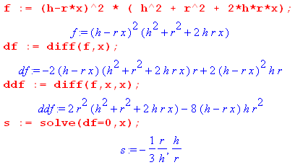 (D.3.7)

Maple notes two locations of zero slope of f(x), but since h/r > 1 it is out of range -1 ≤ x ≤ 1 so only the first zero slope location counts. At this location x = - r/(3h) we have Maple compute the curvature,

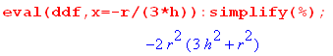 (D.3.8)

Since f(x) is cupping down at this point, it is a maximum and is of no interest since we want min[f(x)]. Since there are no minimums in the range -1 ≤ x ≤ 1, the minimum must occur at one or the other of the endpoints, so we check this out:

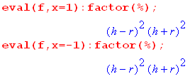 (D.3.9)

So we get the same minimum at both endpoints and that minimum value is just (h2-r2)2. Thus we have shown that min[(f(x)] = (h2-r2)2 and thus we know that f(x) ≤ (h2-r2)2 and our proof is done.

Here is a plot of f(x) for some random parameter values,

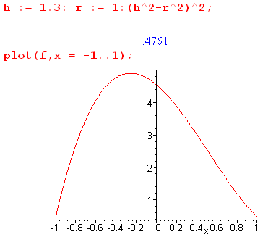 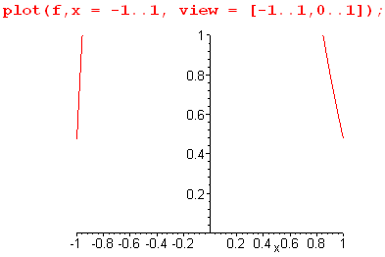(D.3.10)

Fact: For a vertically aligned tethered satellite, rcms > rcog and these will only be equal if one of the masses is zero. (D.3.11)

Here is a drawing of this situation,

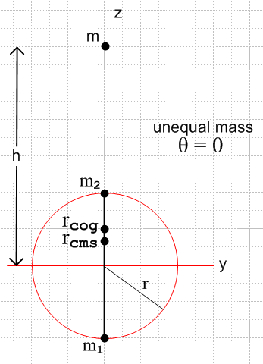 (D.3.12)

If the masses are equal then

rcog = $\frac{(h2-r2)2}{(h2+r2) + 2hr(μ2-μ1)}$ = $\frac{(h2-r2)2}{(h2+r2)}$= $\sqrt{h2+r2}$

rcms = [ h - (μ2-μ1)r ] = h (D.3.13)

Just as a check, we make sure that rcms > rcog :

rcms > rcog ?

h > $\frac{(h2-r2)2}{(h2+r2)}$ ?

1 > $\frac{(1-(r/h)2)2}{(1+(r/h)2)}$ ? // yes, RHS is < 1

D.4 Tethered Satellite : General masses, but θ = π/2

Now the two masses are at the same distance from mass m, so r1 = r2 and r12 = h2+r2 . Then the force F in (D.2.7) simplifies,

F = (Gm)[ rsinθ(m1/r31 - m2/r32)] + (Gm)[ (h+rcosθ)m1/r31 + (h-rcosθ)m2/r32 ]

= (Gm)[ r(m1/r31 - m2/r31)] + (Gm)[ (h)m1/r31 + (h)m2/r31 ]

= (Gmr1-3)[ r(m1 - m2)] + (Gmr1-3)[h(m1+ m2) ] (D.4.1)

with magnitude

F = (Gmr1-3) $\sqrt{r2(m1-m2)2 + h2(m1+m2)2}$ (D.4.2)

so that

rcog = $\frac{Gm(m1+m2)}{F}$ = $\frac{Gm(m1+m2)}{F}$ = $\sqrt{r2(m1-m2)2 + h2(m1+m2)2}$

= $\sqrt{r2(μ1-μ2)2 + h2}$ = (r1)3/2 [h2+ (μ1-μ2)2r2]-1/4

= ( $\frac{(h2+r2)3}{h2+ (μ1-μ2)2r2}$ )1/4 rcog = rcog (-) . (D.4.3)

This distance is clearly maximal when m1= m2.

The center of mass expression (D.2.10) also simplifies,

rcms = (μ2-μ1) rsinθ + [ (μ2-μ1) rcosθ - h] = (μ2-μ1) r + [- h]

rcms = $\sqrt{h2 + (μ1- μ2)2r2}$ . (D.4.4)

For this position of the satellite masses, we claim that the center of gravity is farther from the Earth center then is the center of mass, the opposite of the conclusion for the vertically aligned masses. We now show this:

rcog ≥ rcms ?

( $\frac{(h2+r2)3}{h2+ (μ1-μ2)2r2}$ )1/4 ≥ $\sqrt{h2 + (μ1- μ2)2r2}$ ?

$\frac{(h2+r2)3}{h2+ (μ1-μ2)2r2}$ ≥ [h2 + (μ1- μ2)2r2]2 ?

(h2+r2)3 ≥ [h2 + (μ1- μ2)2r2]3 ? (D.4.5)

The maximum of the right side occurs when μ1-μ2 = 1 and at this point it equals the left side. Thus, for other values of μ1-μ2 the right side will be smaller than the left side.

Fact: For a horizontally aligned tethered satellite, rcms < rcog . This is the reverse of (D.3.11) concerning the vertically aligned satellite. (D.4.6)

We look now at the δ angles of Figure (D.2.11) (b) . From (D.2.13)

tan(δcog) = $\frac{rsinθ (m2r13 - m1r23)}{[m1r23(h + rcosθ) + m2r13(h - rcosθ)]}$ = $\frac{r(m2r13 - m1r23)}{[m1r23(h) + m2r13(h)]}$ = $\frac{r(m2-m1)}{h(m1+m2)}$

tan(δcms) = $\frac{(m2-m1)rsinθ}{(m1+m2)h-(m2-m1)rcosθ}$ = $\frac{(m2-m1)r}{(m1+m2)h}$ = (μ2-μ1)(r/h) (D.4.7)

Thus we find that δcog = δcms = δ so rcog and rcms lie on the same line. Here is a picture : :

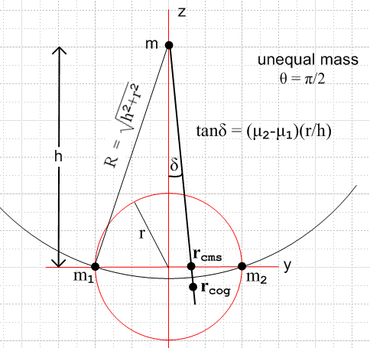 (D.4.8)

In the above drawing we have added a partial circle centered of radius R = r1 = r2 = $\sqrt{h2+r2}$. The point rcog always lies below this circle, as we now show:

rcog > R ?

( $\frac{(h2+r2)3}{h2+ (μ1-μ2)2r2}$ )1/4 > $\sqrt{h2+r2}$ ?

( $\frac{(h2+r2)3}{h2+ (μ1-μ2)2r2}$ ) > (h2+r2)2 ?

( $\frac{h2+r2}{h2+ (μ1-μ2)2r2}$ ) > 1 yes (D.4.9)

The minimum of the left side occurs when |μ1-μ2| = 1 (either μi= 1) in which case the left side is 1, so the equation is then valid for any other value of (μ1-μ2). We have now shown that,

Fact: For a horizontally aligned tethered satellite rcog >R. (D.4.10)

If the masses are equal, then

rcog = ( $\frac{(h2+r2)3}{h2+ (μ1-μ2)2r2}$ )1/4 = ( $\frac{(h2+r2)3}{h2}$ )1/4 = h ( $\frac{(h2+r2)3}{h6}$ )1/4 = h [ 1 + (r/h)2 ]3/4

rcms = $\sqrt{h2 + (μ1- μ2)2r2}$ = h (D.4.11)

and the picture is the above with δ = 0. We confirm that rcog > R for this case:

rcog > R ?

( $\frac{(h2+r2)3}{h2}$ )1/4 > $\sqrt{h2+r2}$ ?

$\frac{(h2+r2)3}{h2}$ > (h2+r2)2 ?

$\frac{(h2+r2)}{h2}$ > 1 yes (D.4.12)

D.5 The single sphere satellite

For the vertically aligned tether, we found that rcog < rcms. People argue that this is so because gravity acts more strongly on the closer mass. This argument does not help much, however, for the horizontally aligned satellite where instead one has rcog > rcms and neither mass is closer than the other to the Earth. One wonders if one can assemble a rigid satellite from a finite number of masses such that these two opposite effects cancel out, resulting in rcog = rcms, at least for some orientation of the masses. Could such a solution be found that works for any orientation of the rigid satellite? We leave these questions to the reader and return instead to the above "argument".
The argument applied to a sphere gives a wrong answer. One would argue for a spherical satellite that the near half of the sphere is closer to the Earth (where gravity is stronger) than the far half, so the center of gravity should be offset toward the Earth from the center of mass. As the reader no doubt knows, a uniform sphere or spherical shell is in fact an "assembly of masses" for which rcog = rcms. So in such an object, the two effects found for the vertically and horizontally aligned satellites do in fact exactly cancel out.
Here we demonstrate that rcog = rcms for a uniform shell or sphere by two basic methods.

Method A. In electrostatics one of Maxwell's equations says divE = 4πρ (cgs units). One applies the integral form of this law ∫E • dA = 4π∫ρ V = 4πQ to show that the electric field outside a uniform spherical shell of charge is independent of the radius of the shell and thus is the same as if the charge were all concentrated at the center of the shell. The argument is that, due to rotational invariance (or "symmetry"), the direction of the electric field can only be radial, so then ∫E • dA = E * 4πR2 and one then finds that E = Q/R. The same argument can be applied to a uniform shell of mass so that the gravitational field must be in the radial direction and is independent of the shell radius R, so the shell acts as a point mass at its center. If this shell is a satellite then the Earth cannot tell from gravity alone what is the radius of that satellite, so one can replace the satellite by a point mass at its center and the Earth never knows, and nothing changes in an orbit. But for the point mass certainly rcog = rcms so this applies as well to any uniform spherical shell or sphere satellite.

Method B. The brute force method. This method is more direct, and essentially is found in high-school physics texts, though the integral we obtain below is not. Using pictures similar to the above, we analyze a satellite which is a spherical shell of 2D mass density σ and total mass Mshell = 4πr2σ. Once we demonstrate the result for shell, it certainly applies to any assembly of shells including a solid sphere.

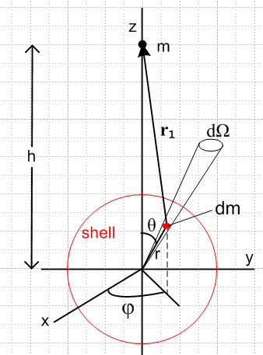

Quantity dm is a tiny patch of mass on the spherical shell of radius r with

dm = σdA = σ (r2dΩ) = σ r2sinθdθdφ .

The force experience by this mass dm due to mass m is given by

dF = (Gmdm/r12)1 = (Gmdm/r13)r1

where

r1 = rsinθcosφ + rsinθsinφ + (h-rcosθ) // see drawing

r12 = r2 + h2 - 2rhcosθ . // law of cosines

Then,

dFx = (Gm/r13) σr2sinθdθdφ* rsinθcosφ

dFy = (Gm/r13) σr2sinθdθdφ* rsinθsinφ

dFz = (Gm/r13) σr2sinθdθdφ * (h-rcosθ) .

Now integrate dφ from 0 to 2π to get the force on a ring of mass dθ on the shell at fixed θ. But sinφ has zero integral over this range and so does cosφ, so the first two terms integrate to nothing. We are left with this resulting force all in the z direction,

dFring = (Gm/r13) σr2sinθdθ 2π * (h-rcosθ) .

Now integrate over all rings of the shell to get

Fshell = $^{\int_{0}^{π}{}}$dθ (Gm/r13) σr2sinθ 2π * (h-rcosθ)

= 2πσGm r2 $^{\int_{0}^{π}{}}$dθ $\frac{sinθ (h-rcosθ)}{(r2+h2-2rhcosθ)3/2}$

This is a famous discontinuous integral that can be evaluated using as x = cosθ. Maple gives,

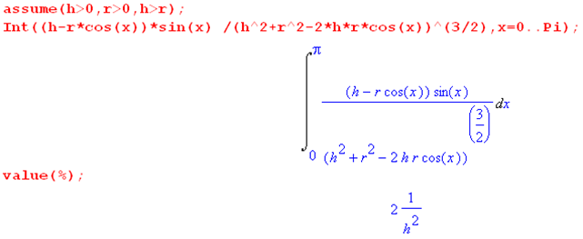

Thus we have shown that

Fshell = 2πσr2Gm * (2/h2) = (4πr2σ) Gm/h2 = G m Mshell / h2 .

But this is the same as the force of the Earth acting on a point mass at the origin of our drawing. Thus we have shown that rcog = h (-) and this is of course the same as rcms.

If the mass m were inside the shell with h < r, Maple gives a different answer

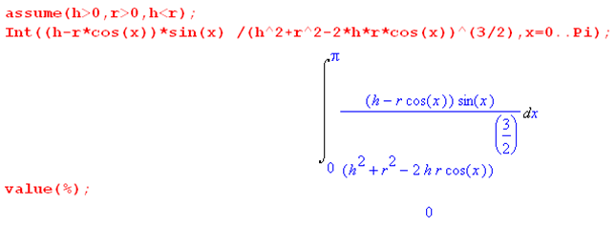

showing that the force experienced by the uniform shell due to a mass m inside the shell is zero.

