Appendix D: Center of gravity and torque for a tethered satellite 1
D.1 Definition of Center of Gravity 1
D.2 Center of Gravity for a 2-mass Dumbbell Satellite 4
D.3 Dumbbell Satellite Center of Gravity with the Far Approximation: Numerical Examples 10
D.4 Dumbbell Satellite Center of Gravity for equal masses and no approximation 14
D.5 Center of Gravity for a single-sphere satellite 18

Appendix D: Center of gravity and torque for a tethered satellite

D.1 Definition of Center of Gravity

The phrase "center of gravity" is often used as a synonym for "center of mass" which complicates searching for information about the former concept. The "center of mass" of a system of particles is well known to be

rcms = $\frac{Σimiri}{Σimi}$ = $\frac{1}{M}$ Σimiri M = Σimi // discrete
rcms = $\frac{∫dVρ r}{∫dVρ}$ = $\frac{1}{M}$ ∫dV ρ r M =∫dV ρ // continuous (D.1.1)

We use "cms" to mean center of mass even though "com" might be more reasonable. Notice that rcms is measured with respect to the same origin used for the ri or r. For a rigid object, the center of mass is a definite point that does not move around relative to the object. It is completely determined by the spatial mass distribution of the object.
The center of gravity is a completely different animal, though it happens to align with the center of mass for a uniform gravitational field. For that reason one never deals with a distinct center of gravity concept for human-scale engineering objects on the earth's surface.
Consider a system of masses mi each of which experiences some force Fi. We define

F = ΣiFi N(R) = Σi (ri-R)xFi N(0) = ΣirixFi . (D.1.2)

Here F is the sum of the forces acting on all the masses mi, N(R) is the total torque on the system with respect to some arbitrary point R, and N(0) is the total torque with respect to the selected origin. An obvious theorem is that

N(R) = Σi (ri-R)xFi = ΣirixFi - Rx ΣiFi

= N(0) - R x F (D.1.3)

which shows how the two torques are related. If F = 0, which is often the case, then the torque is the same with respect to any point.
One characteristic of a center of gravity point rcog is that the total torque on a system measured with respect to point rcog vanishes, so N(r$_{cog}$) = 0. From (D.1.3) we see that this is the same as saying N(0) = rcog x F , so

N(r$_{cog}$) = 0 ⇔ N(0) = rcog x F rcog = "center of gravity" . (D.1.4)

The significance of rcog is that it is a point which allows the relation between the total system torque N(0) and the total system force F to have the same form as Ni = ri x Fi for a single point particle. It is not obvious that such a point rcog exists for some arbitrary system of particles.
So far this notion of "center of gravity" has nothing to do specifically with gravity, but we shall below add an additional part of the definition which does bring in gravity.
Unlike the center of mass, the center of gravity (if it exists) may not be unique and it generally moves around in an object as the object changes orientation in an external force field If we dot N(0) = rcog x F with the vector F we find

N(0)• F = 0 . (D.1.5)

As shown above, N(0) and F are well-defined computable quantities and if N(0)• F ≠ 0, then rcog cannot possibly exist (because if it did exist one must have N(0)• F = 0). So (D.1.5) is a condition for the existence of rcog.
Here is a method for locating rcog, a variation of Symon p 258 which we present in the context of an asteroid of mass M near the Earth. This description includes the second characteristic of the center of gravity point which is that it is point at which gravitational action is effectively focused.
One first computes the total gravitational force F = ΣiFi due to the Earth (summed over all points in the asteroid) and one then knows the direction of the sum vector F. One creates a line along F and then translates that line parallel to F until the line passes through the center of the Earth. The center of gravity of the asteroid lies on that translated line a distance rcog from the center of the Earth where rcog is determined by,

GMEM/rcog2 = F ⇒ rcog = $\sqrt{GMEM/F}$

rcog = rcog (-) F = F . (D.1.6)

Here is an illustration,

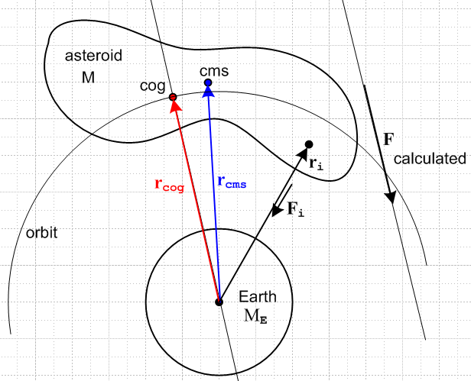 (D.1.7)

From the Earth's point of view, one could replace the entire asteroid with a point mass M at location rcog and the Earth would feel the same gravitational pull from that point mass as it does from the asteroid. Furthermore, if the asteroid were in a circular orbit around the earth keeping its same aspect facing the earth (not very likely), then the orbiting characteristics of the asteroid would be the same as for its replacement point mass, and one would have for example RMEM/rcog2 = Mω2rcog as the balance between gravitational and centrifugal force. If the asteroid does not rotate or tumbles in some manner, at any point in its orbit rcog will lie on the orbit shown, but the location of that point within the asteroid changes so that the new rcog computed for a new position and orientation still equals the orbit radius. In this case the rcog position will change relative to the asteroid, whereas the cms point always has the same position relative to the asteroid. Here we enhance the above drawing by adding another position of the tumbling asteroid in its orbit,

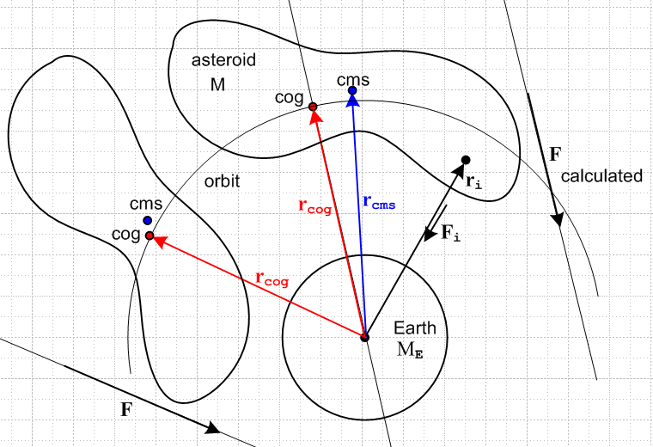 (D.1.8)

One implication is that, for any orientation of the asteroid in orbit, there exists a position of the asteroid such that the total force F will have the same magnitude as at any other position, since rcog is the same.

One might wonder what Symon's operational prescription for computing rcog has to do with our opening section about torque. First, for each point in the asteroid we know that rix Fi = 0 (ri tails are at Earth center) because each ri to mass mi is parallel to the force Fi to mass i. Thus according to (D.1.2) we have N(0) = 0. Therefore the condition (D.1.5) that N(0)• F = 0 is trivially satisfied. Then rcog exists and is a vector which satisfies the center of gravity definition (D.1.4) that N(0) = rcog x F. This equation is satisfied by Symon's computed rcog because rcog is parallel to F, so the equation says 0 = 0. From (D.1.4) we then see that the N(R$_{cog}$) = 0 so rcog is a point with respect to which the total torque on the asteroid (due to gravitational force from the Earth) is 0. In this example it happens that any point R along the rcog line satisfies N(0) = R x F and any such point R therefore is a point of zero total torque N(R) = 0. But only one point on this line gives the concentration point of the gravitational force such that GMEM/rcog2 = F .
We shall now consider a 2-mass tethered satellite as a relatively simple example where we can compute the cog point and then watch it move relative to the cms point.

D.2 Center of Gravity for a 2-mass Dumbbell Satellite

Consider this sketch of the dumbbell satellite :
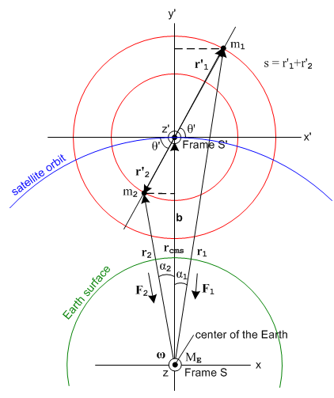 (D.2.1)

Frame S has its origin at the center of the Earth and is assumed fixed relative to the stars.
Frame S' has its origin at the center of mass of the satellite as shown.
The orbit of the satellite lies in the plane of paper.
The vector ω describes the angular velocity of the orbit and has nothing to do with Earth's rotation.

The picture shows things at t = 0. We make a special simplifying assumption that at t = 0 the vectors r1 and r2 lie in the plane of paper which is the plane of the orbit. This means that r1, r2, r'1, r'2 and b all lie in the plane of paper.

Moreover, at t = 0 the axes of both frames line up: = ', = ' and = ' .

The two masses m1 and m2 are connected by a massless rigid stick of length s = r'1+r'2 . Since the masses are assumed to be unequal, mass m1 is restricted to lie on a sphere of radius r'1 in Frame S', while mass m2 lies on a different sphere of radius r'2 (to be computed below). For purposes of the drawing, we have m2 > m1 so that r'2 < r'1.

The polar angle in Frame S' of m1 (and the stick) is θ'. The angles α1 and α2 are positive.

Assumption: We will show below that the center of gravity is very close to the center of mass for any angle θ'. For example, if the stick is 10 m long, the distance between these two centers for a low-Earth orbit is about 3 microns. For this reason, we shall assume that it is the center of mass point rcms which goes in a circular orbit around the Earth, even though we know from Section D.1 that it is really rcog that does this. So as the satellite goes around the earth and θ' varies in time, the point rcog moves a very small amount relative to rcms, and we shall just ignore this tiny motion.
The satellite center of mass point then rotates around the Earth at some rate ω0 = 2π/T0. For a low-Earth orbit, T0 is on the order of 88 minutes. As the satellite moves in this orbit, Frame S' rotates with the satellite while Frame S stays fixed relative to the stars. This means that the Frame S' axis y' always points away from the center of the Earth.
One can generalize the discussion for an elliptical orbit, but things are complicated enough for a circular orbit so we stick with that simplification.

With the above assumption, we may identify rcms with b, our usual vector connecting the two Frame origins, so

b = rcms (D.2.2)

and then from the figure,

b + r'1 = r1
b + r'2 = r2 . (D.2.3)

The Law of Cosines gives,

r12 = r'12 + b2 - 2r'1b cos(π/2+θ') = r'12 + b2 + 2r'1b sinθ'

r22 = r'22 + b2 - 2r'2b cos(π/2-θ') = r'22 + b2 - 2r'2b sinθ' . (D.2.4)

Center of Mass

From (D.1.1) we know that the center of mass of the satellite is given by,

rcms = $\frac{m1r1+m2r2}{m1+m2}$ = b Frame S (D.2.5)

r'cms = $\frac{m1r'1+m2r'2}{m1+m2}$ = 0 . Frame S' (D.2.6)

Due to the constraint of the massless stick one has,

'2 = - '1 . (D.2.7)

so (D.2.6) says

m1r'1 = - m2r'2 ⇒ m1r'1 = m2r'2 , r'2/r'1 = m1/m2 , '2 = – '1 (D.2.8)

Angles

Looking at the right triangles from the center of the Earth to the two dashes lines, one sees that

sinα1 = ( r'1 cosθ') / r1 ⇒ r1sinα1 = r'1cosθ'
sinα2 = ( r'2 cosθ') / r2 ⇒ r2sinα2 = r'2cosθ' . (D.2.9)

The same triangles reveal that

cosα1 = (b + r'1sinθ')/r1 ⇒ r1cosα1 = b + r'1sinθ'
cosα2 = (b - r'2sinθ')/r2 ⇒ r2cosα2 = b - r'2sinθ' . (D.2.10)

We shall need the following dot products,

1 • = sinα1 2 • = - sinα2
1 • = cosα1 2 • = cosα2 (D.2.11)

1 • 2 = cos(α1+α2)

= (r1r2)-1 [( b + r'1sinθ') (b - r'2sinθ') - ( r'1cosθ')(r'2cosθ')]

= (r1r2)-1 [b2 + (r'1-r'2)bsinθ' - r'1r'2 sin2θ' - r'1r'2cos2θ' ]

= (r1r2)-1 [b2 + (r'1-r'2) bsinθ' - r'1r'2 ] . (D.2.12)

Where is Center of Gravity of the Satellite?

The gravitational forces acting on the two satellite masses due to the Earth are.

F1 = - (GMEm1/r12) 1 = - (GMEm1/r13) r1
F2 = - (GMEm2/r22) 2 = - (GMEm2/r23) r2 . (D.2.13)

Note the direction of the "long" vectors r1 and r2 in the drawing.

Following the prescription of Section D.1 for finding the location of the center of gravity, we compute the total gravitational force on the satellite,

F = - (GMEm1/r12) 1 - (GMEm2/r22) 2

= (-GME) [ (m1/r12) 1 + (m2/r22) 2 ] . (D.2.14)

Taking components:

Fx = F • = (-GME) [ (m1/r12) 1• + (m2/r22) 2• ]

= (-GME) [ (m1/r12)sinα1 – (m2/r22) sinα2 ]

= (-GME) [ (m1/r13) r'1cosθ' – (m2/r23) r'2cosθ' ] // now use (D.2.8)

= (-GME) [ (m1/r13) r'1cosθ' – (m1/r23) r'1cosθ' ]

= (-GME) (m1r'1cosθ') [ (1/r13) – (1/r23) ]

Fy = F • = (-GME) [ (m1/r12) 1• + (m2/r22) 2• ]

= (-GME) [ (m1/r12)cosα1 + (m2/r22)(b - r'2sinθ') ]

= (-GME) [ (m1/r13)(b + r'1sinθ') + (m2/r23)(b - r'2sinθ') ] // now use (D.2.8)

= (-GME) [ b { (m1/r13) + (m2/r23) } + m1r'1 sinθ' { (1/r13) - (1/r23)} ]
so

Fx = (-GME) (m1r'1cosθ') [ (1/r13) – (1/r23) ]

Fy =(-GME) [ b { (m1/r13) + (m2/r23) } + m1r'1 sinθ' { (1/r13) - (1/r23)} ] . (D.2.15)

Recall now from (D.1.6) the rule for obtaining rcog :

GMEM/rcog2 = F ⇒ rcog = $\sqrt{GMEM/F}$

rcog = rcog (-) F = F . (D.1.6)

Just to have a picture, we now add rcog to Fig (D.2.1), picking a graphic location for the point which makes things easy to draw (we don't know yet where it actually lies),

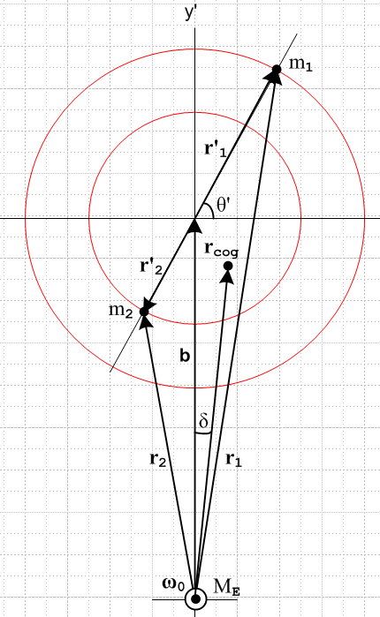 (D.2.16)

The center of gravity point lies a distance rcog (to be computed) along a line which makes some angle δ relative to the vertical axis. Since cog = - , we may write using (D.2.15),

tan(δ) = - Fx/Fy = - (m1r'1cosθ') $\frac{(1/r13) – (1/r23)}{b [ (m1/r13) + (m2/r23) ] + m1r'1 sinθ' [ (1/r13) - (1/r23)]}$

= - (m1r'1cosθ') $\frac{r23 – r13}{b [ (m1r23) + (m2r13) ] + m1r'1 sinθ' [ r23 - r13]}$ . (D.2.17)

If the masses are vertically aligned, meaning θ' = ±π/2, then cosθ' = 0 and we see that δ = 0, as expected.

Since for general masses and angle θ' one does not have r1 = r2, one may conclude:

Fact 1: In general the center of gravity does not lie on the line between the center of the Earth and the center of mass. (D.2.18)

Earlier we conjectured that this was the case, and here we see it in our satellite example.

Next we wish to compute the distance rcog to the center of gravity. Using (D.2.14) and (D.2.12),

F2 = (GME)2 [ (m1/r12)2 + (m2/r22)2 + 2 (m1/r12) (m2/r22) cos(α1+α2) ]

= (GME)2 [ (m1/r12)2 + (m2/r22)2 + 2 (m1/r13) (m2/r23) r1r2cos(α1+α2) ]

= (GME)2 [ (m1/r12)2 + (m2/r22)2 + 2 (m1/r13) (m2/r23)(b2 + (r'1-r'2)bsinθ' - r'1r'2) ]

= (GME)2 [ (m1/r12)2 + (m2/r22)2 + 2 (m1/r13) (m2/r23)[b2 + (r'1-r'2)bsinθ' - r'1r'2] ]
so

F = GME $\sqrt{(m1/r12)2 + (m2/r22)2 + 2 (m1/r13) (m2/r23)(b2 + (r'1-r'2)bsinθ' - r'1r'2)}$ . (D.2.19)

Then, using M = (m1+m2) and μi = mi/M, we find that

rcog = $\sqrt{GMEM/F}$
= $\frac{1}{\{ (μ1/r12)2 + (μ2/r22)2 + 2 (μ1/r13) (μ2/r23)[b2 + (r'1-r'2)bsinθ' - r'1r'2] \}1/4}$ (D.2.20)

which is somewhat more complicated than our expression for rcms,

rcms = b (D.2.2)

We are then led to:

Fact 2: In general the center of gravity does not lie the same distance from the center of the Earth as the center of mass. (D.2.21)

Visual check on (D.2.20) : If m1= 0, then μ1 = 0 and μ2 = 1 and the result is rcog = r2 which is correct.

D.3 Dumbbell Satellite Center of Gravity with the Far Approximation: Numerical Examples

A practical tethered satellite is not going to have Earth-scale dimensions so we shall now make the obvious assumption that r1, r2 and b are much larger than r'1 and r'2. We then define smallness parameters,

ε1 ≡ (r'1/b)
ε2 ≡ (r'2/b) = (r'2/r'1) (r'1/b) = (m1/m2)ε1 = (μ1/μ2)ε1 (D.3.1)

Then

[b2 + (r'1-r'2)bsinθ' - r'1r'2] = b2 [ 1 + (ε1-ε2)sinθ' - ε1ε2] (D.3.2)

so that

rcog = $\frac{1}{\{ (μ1/r12)2 + (μ2/r22)2 + 2 (μ1/r13) (μ2/r23)b2[1 + (ε1-ε2)sinθ' - ε1ε2] \}1/4}$ (D.3.3)

From (D.2.4) we know also that

r12 = r'12 + b2 + 2r'1b sinθ' = b2 [ 1 + 2(r'1/b)sinθ' + (r'1/b)2] = b2 [ 1 + 2ε1sinθ' + ε12]

r22 = r'22 + b2 – 2r'2b sinθ' = b2 [ 1 – 2(r'2/b)sinθ' + (r'2/b)2] = b2 [ 1 – 2ε2sinθ' + ε22]

so then

r1 = b $\sqrt{1 + 2ε1sinθ' + ε12}$
r2 = b $\sqrt{1 – 2ε2sinθ' + ε22}$ . (D.3.4)

So far everything is exact, but we shall now expand rcog as a series in our small parameters. Since ε2 = (μ1/μ2)ε1, we replace ε2 by this expression so there is then only one small parameter ε1. We employ Maple to carry out this task. We first enter our expressions of interest, using θ' = theta,

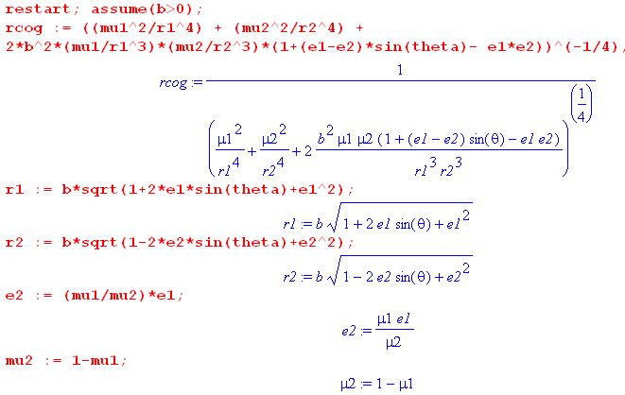 (D.3.5)

We then instruct Maple to expand rcog in a power series around ε1 = 0 and we ask for the first four terms of the expansion,

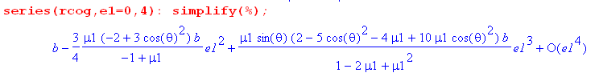 (D.3.6)

A perhaps unexpected result is that there is no term linear in ε1, regardless of the masses. We leave it to the energetic reader to concoct a theoretical explanation of this fact (not all odd terms vanish, just the first odd term). Our conclusion then is, to second order in smallness parameter ε1,

rcog ≈ b [ 1 + $\frac{3}{4}$$\frac{μ1}{1-μ1}$(-2 +3cos2θ') ε12 ] = b [ 1 + $\frac{3}{4}$$\frac{m1}{m2}$(-2 +3{1-sin2θ'}) ε12 ]

= b [ 1 + $\frac{3}{4}$$\frac{m1}{m2}$( 1 - 3 sin2θ' ) $\frac{r1'2}{b2}$ ] = b [ 1 + $\frac{3}{4}$$\frac{r'2}{r'1}$( 1 - 3 sin2θ' ) $\frac{r1'2}{b2}$ ] // (D.2.8)

= b [ 1 + $\frac{3}{4}$( 1 - 3 sin2θ' ) $\frac{r1'r2'}{b2}$ ] (D.3.7)

and then

rcog - rcms = rcog - b ≈ [ $\frac{3}{4}$( 1 - 3 sin2θ' ) $\frac{r1'r2'}{b2}$ ] b (D.3.8)

and

$\frac{rcog - rcms}{rcms}$ ≈ $\frac{3}{4}$( 1 - 3 sin2θ' ) $\frac{r1'r2'}{b2}$. (D.3.9)

Fact 3: If θ' = ± 35.26o, we get rcog = rcms through order ε12, since this angle has sinθ' = 1/$\sqrt{3}$. But the line to the center of gravity does not in general have δ = 0 since in general r1 ≠ r2 at this angle. (D.3.10)

Fact 4: If the masses are vertically aligned, meaning θ' = ± π/2, then sinθ' = 1 and we find that

$\frac{rcog - rcms}{rcms}$ = $\frac{3}{4}$( 1 - 3 ) $\frac{r1'r2'}{b2}$ = - $\frac{3}{2}$$\frac{r1'r2'}{b2}$. (D.3.11)

The center of gravity in this case is closer to the Earth than the center of mass and of course lies on the line to the center of mass.

Fact 5: If the masses are horizontally aligned, meaning θ' = 0,π, then sinθ' = 0 and we find that

$\frac{rcog - rcms}{rcms}$ = $\frac{3}{4}$( 1 - 0 ) $\frac{r1'r2'}{b2}$ = + $\frac{3}{4}$$\frac{r1'r2'}{b2}$ . (D.3.12)

The center of gravity in this case is farther from the Earth than the center of mass. The line to the center of gravity does not have δ = 0 unless m1 = m2.

The above cases show the extremes of the factor ( 1 - 3 sin2θ' ) and hence of rcog - rcms . For a general angle θ' the result lies between the two limiting cases.

Numerical Examples

From (8.7.4) we have RE = 6371 km. If we put our satellite in orbit 200 km above the Earth's surface, then b = 6371+200 = 6571m. A higher orbit of course gives a larger b and a smaller offset between rcms and rcog. We take the maximum displacement between rcog and rcms from Fact 5 to obtain

| $\frac{rcog - rcms}{rcms}$|max = $\frac{3}{4}$$\frac{r1'r2'}{b2}$ (D.3.13)

For a given mass separation (tether length) s = r'1 + r'2 the product r'1r'2 is maximized when r'1= r'2 (easy to show) and this in turn means m1 = m2, so to get the worst case we set r'1 = r'2 = s/2 to get

| $\frac{rcog - rcms}{rcms}$|max = $\frac{3}{4}$$\frac{1}{4}$(s/b)2 = (3/16)(s/b)2 s = stick length = tether length (D.3.14)

We now have Maple compute dr/r = | $\frac{rcog - rcms}{rcms}$|max and dr = | rcog - rcms|max for three cases:

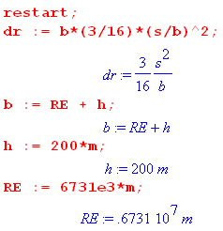 (D.3.15)

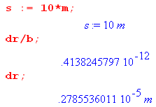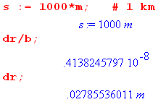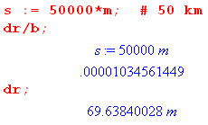

For a s= 10m tether length, the max offset is 2.8 microns which we feel pretty comfortable ignoring.
For a s= 1 km tether length, the max offset is 2.8 cm, still pretty small.
For a s = 50 km tether length, the max offset is about 70m. (D.3.16)

The quantities | $\frac{rcog - rcms}{rcms}$|max for each case are shown as dr/r : 10-12, 10-8 and 10-5.

This justifies our approximation that it is the center of mass point that essentially orbits the Earth, and the variation between rcog and rcms is always very small.

D.4 Dumbbell Satellite Center of Gravity for equal masses and no approximation

(a) Equal Masses and general θ'

Recall the general no-approximation results (D.2.17) and (D.2.20),

tan(δ) = - (m1r'1cosθ') $\frac{r23 – r13}{b [ (m1r23) + (m2r13) ] + m1r'1 sinθ' [ r23 - r13]}$ . (D.2.17)

rcog = $\frac{1}{\{ (μ1/r12)2 + (μ2/r22)2 + 2 (μ1/r13) (μ2/r23)[b2 + (r'1-r'2)bsinθ' - r'1r'2] \}1/4}$ (D.2.20)

where

r12 = r'12 + b2 + 2r'1b sinθ'
r22 = r'22 + b2 - 2r'2b sinθ' . (D.2.4) (D.4.1)

Setting m1 = m2 (which implies r'1 = r'2 = s/2 and also μ1 = μ2 = 1/2) gives these simpler forms,

tan(δ) = - (r'1cosθ') $\frac{r23- r13}{b (r23 + r13) + r'1 sinθ' (r23 - r13)}$

rcog = $\sqrt{2}$

where

r12 = r'12 + b2 + 2r'1b sinθ'
r22 = r'12 + b2 - 2r'1b sinθ' . (D.2.4) (D.4.2)

(b) Equal Masses and θ' = π/2 (vertically aligned)

If we further specify that θ' = π/2 we get δ = 0 and moreover,

r1 = (b+r'1) r2 = (b- r'1) (D.4.3)

b2 = r12 + r'12 - 2r1r'1 ⇒ b2 - r'12 = r1(r1-2r1') (D.4.4)

rcog = $\sqrt{2}$ = $\sqrt{2}$

= $\sqrt{2}$ = $\sqrt{2}$$\sqrt{2}$$\sqrt{b2+ r'12}$ = $\sqrt{b2+ r'12}$ = $\frac{b2}{b}$$\sqrt{1+ (r'1/b)2}$

= b $\sqrt{1+ (r'1/b)2}$ . (D.4.5)
The exact results are then :

tan(δ) = 0 ⇒ δ = 0

rcog = b $\sqrt{1+ (r'1/b)2}$ . // m1= m2 and θ' = π/2 and r'1 = s/2 (D.4.6)

We then find that

rcog - rcms = b [ 1 - $\sqrt{1+ (r'1/b)2}$]

$\frac{rcog - rcms}{rcms}$ = 1 - $\sqrt{1+ (r'1/b)2}$ . (D.4.7)

In this vertically aligned case the center of gravity is closer to the Earth than the center of mass. We showed this earlier using the far-distance approximation, and now we show it with the exact result.

rcog < rcms ?

b $\sqrt{1+ (r'1/b)2}$ < b ?

1 - (r'1/b)2 < $\sqrt{1+(r'1/b)2}$ ?

1 - 2 (r'1/b)2 + (r'1/b)4 < 1 + (r'1/b)2 ?

(r'1/b)4 < 3 (r'1/b)2 ?

(r'1/b) < 3 ?

r'1 < 3b ? yes! . (D.4.8)

This figure summarizes our result (with rcms - rcog exaggerated)

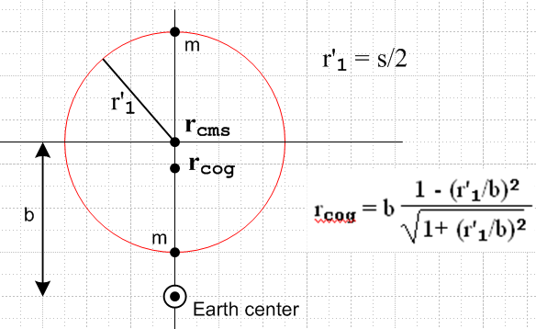 (D.4.9)

Looking back at the force equation (D.2.14), we can confirm result (D.4.6) fairly quickly :

F = - (GMEm1/r12) 1 - (GMEm2/r22) 2 = - [(GMEm1/r12) + (GMEm2/r22) ]

F = GMEm1[ (1/r12) + (1/r22)] = GMEm1[r22 + r12] / [r1r2]2

= GMEm1[(b-r'1)2 +(b+r')2] / [(b+r'1)(b-r'1)]2 =

= GMEm1[2b2 + 2r'12] / (b2-r'12)2 = 2 GMEm1 (b2 + r'12) / (b2-r'12)2

= 2 GMEm1 b-2 (1 + (r'1/b)2) / (1-(r'1/b)2)2
so
rcog = $\sqrt{GME(2m1)/F}$ = b (1-(r'1/b)2) / $\sqrt{1 + (r'1/b)2}$ (D.4.10)

in agreement with (D.4.6).

If we now further assume (r'1/b) << 1 then (D.4.6) becomes

rcog ≈ b (1 - (r'1/b)2) (1 - (1/2) (r'1/b)2 ) = b [ 1 - (3/2)(r'1/b)2] .

$\frac{rcog - rcms}{rcms}$ = $\frac{rcog - b}{b}$ = - (3/2)(r'1/b)2 (D.4.11)

in agreement with (D.3.11).

(c) Equal Masses and θ' = 0 (horizontally aligned)

We start again with (D.4.2) for equal masses,

tan(δ) = - (r'1cosθ') $\frac{r23- r13}{b (r23 + r13) + r'1 sinθ' (r23 - r13)}$
rcog = $\sqrt{2}$

r12 = r'12 + b2 + 2r'1b sinθ' r22 = r'12 + b2 - 2r'1b sinθ' . (D.4.2)

When θ' = 0 we not only have r'1 = r'2 but also r1 = r2 along with sinθ' = 0 and cosθ' = 1. This at once implies that tan(δ) = 0, and for rcog we find

r12 = r'12 + b2 ⇒ - r'12 = b2 - r12 ⇒ [b2 - r'12] = 2b2 - r12

rcog = $\sqrt{2}$ = $\sqrt{2}$ = $\sqrt{2}$

= [$\frac{r16}{b2}$]1/4 = [$\frac{r13}{b}$]1/2 = $\frac{r13}{b}$ (D.4.12)

= [$\frac{r16}{b2}$]1/4 = [$\frac{(b2+ r'12)3}{b2}$]1/4 = b [1 + (r'1/b)2 ]3/4 . (D.4.13)

The exact results are then

tan(δ) = 0

rcog = $\frac{r13}{b}$ = b [1 + (r'1/b)2 ]3/4 // m1= m2 and θ' = 0 and r'1 = s/2

rcog - rcms = b { [1 + (r'1/b)2 ]3/4 – 1 }

$\frac{rcog - rcms}{rcms}$ = [1 + (r'1/b)2 ]3/4 – 1 (D.4.14)

If is obvious by inspection that this last ratio is a positive quantity, so for the horizontally-aligned equal-mass satellite we find that the center of gravity is farther from the center of the Earth than the center of mass, in agreement with our earlier conclusion based on approximation.

This figure summarizes our result (with rcog - rccms exaggerated)

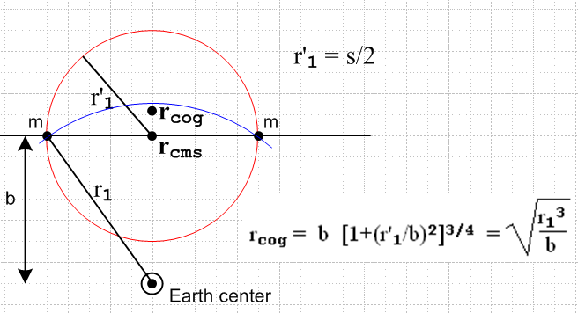 (D.4.15)

We have added in blue a portion of a circle centered at Earth center which passes through the masses. The point rcog lies below this circle, as we now verify

rcog < r1 ?

$\frac{r13}{b}$< r1 ?

r13 < r12 b ?

r1 < b ? yes (D.4.16)

Looking back at the force equations (D.2.15), we can confirm result (D.4.12) very quickly,

Fy = -2GMEm1(b/r13) Fx = 0
rcog = $\sqrt{GME(m1+m2)/F}$ = $\frac{r13}{b}$ . (D.4.17)

If we now further assume (r'1/b) << 1 this becomes

rcog ≈ b [1 + (3/4) (r'1/b)2 ]

$\frac{rcog - rcms}{rcms}$ = $\frac{rcog - b}{b}$ = + (3/4)(r'1/b)2 (D.4.18)

in agreement with (D.3.12).

D.5 Center of Gravity for a single-sphere satellite

For the vertically aligned dumbbell satellite, we found that rcog < rcms. People argue that this is so because gravity acts more strongly on the mass closer to the Earth. This argument does not help much, however, for the horizontally aligned satellite where instead one has rcog > rcms and neither mass is closer than the other to the Earth.
One wonders if one can assemble a rigid satellite from a finite number of masses such that these two opposite effects cancel out, resulting in rcog = rcms, at least for some orientation of the masses. Could such a solution be found that works for any orientation of the rigid satellite? We leave these questions to the reader and return instead to the above "argument".
The argument applied to a sphere gives a wrong answer. One would argue for a spherical satellite that the near half of the sphere is closer to the Earth (where gravity is stronger) than the far half, so the center of gravity should be offset toward the Earth from the center of mass. As the reader no doubt knows, a uniform sphere or spherical shell is in fact a "rigid assembly of masses" for which rcog = rcms. So in such an object, the two effects found for the vertically and horizontally aligned satellites do in fact exactly cancel out.
Here we demonstrate that rcog = rcms for a uniform thin shell by two basic methods.
One this is shown, the result then applies for any symmetric assembly of shells such as a sphere or a thick spherical shell.

Method A. In electrostatics one of Maxwell's equations says divE = 4πρ (cgs units). One applies the integral form of this law ∫E • dA = 4π∫ρ dV = 4πQ to show that the electric field outside a uniform spherical shell of charge is independent of the radius of the shell and thus is the same as if the charge were all concentrated at the center of the shell. The argument is that, due to rotational invariance (or "symmetry"), the direction of the electric field can only be radial, so then ∫E • dA = E * 4πR2 and one then finds that E = Q/R2 which is indeed the electric field of a point charge Q at distance R.
The same argument can be applied to a uniform shell of mass so that the gravitational field must be in the radial direction and is independent of the shell radius R, so the shell acts as a point mass at its center. If this shell is a satellite then the Earth cannot determine from gravity alone the radius of that satellite, so one can replace the satellite by a point mass at its center. The Earth never knows, and nothing changes in the orbit. But for the point mass certainly rcog = rcms , so this fact applies as well to any uniform spherical shell or sphere satellite.

Method B. The ever-popular brute force method. This method is more direct, and is found in high-school physics texts, though the integral we obtain below is not. The drawing below is upside-down relative to our earlier drawings, to be more compatible with usual spherical coordinate notation. So the center of the Earth is now at the top and the center of mass of the satellite is located a distance b from Earth center, as earlier. This particular satellite is a spherical shell of radius r and very thin thickness dr. The mass of the shell is then Mshell = [(4πr2)dr]ρ where ρ is the shell's uniform mass density.

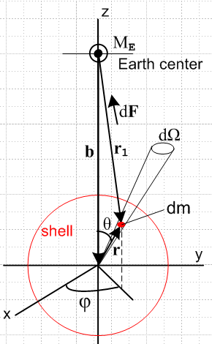 (D.5.1)

Quantity dm is a tiny chunk of mass on the spherical shell of radius r with

dm = ρ(dA)dr = ρ(r2dΩ)dr = ρ (r2sinθdθdφ)dr . (D.5.2)

The force experienced by this mass dm due to mass ME is given by

dF = -(GMEdm/r12)1 = -(GME/r13) dm r1 . (D.5.3)

As usual in spherical coordinates,

r = rsinθcosφ + rsinθsinφ + rcosθ (D.5.4)

so then

r1 = b + r = -b + rsinθcosφ + rsinθsinφ + rcosθ

= rsinθcosφ + rsinθsinφ + (-b+ rcosθ) . (D.5.5)

Therefore,

dF = -(GME/r13) dm r1

= -(GME/r13) dm [rsinθcosφ + rsinθsinφ + (-b+ rcosθ) ] (D.5.6)

Then,

dFx = dF • = -(GME/r13) ρ (r2sinθdθdφ)dr (rsinθcosφ)
dFy = dF • = -(GME/r13) ρ (r2sinθdθdφ)dr (rsinθsinφ)
dFz = dF • = -(GME/r13) ρ (r2sinθdθdφ)dr (-b+rcosθ) . (D.5.7)

Now integrate dφ from 0 to 2π to get the force on a ring of mass of angular width dθ on the shell at fixed θ. But sinφ has zero integral over this range and so does cosφ, so the first two terms integrate to nothing, while the integral of dφ in the last line gives 2π. We are left with this resulting force all, in the z direction,

dFring = (GME/r13) ρ (r2sinθdθ 2π) dr (b-rcosθ) . (D.5.8)

Now integrate over all rings of the shell to get a total force F experienced by the spherical shell satellite,

F =$^{\int_{0}^{π}{}}$dθ (GME/r13) ρ (r2sinθdθ 2π) dr (b-rcosθ)

= 2πρGME r2dr $^{\int_{0}^{π}{}}$dθ $\frac{sinθ (b-rcosθ)}{(r2+b2-2rbcosθ)3/2}$ . (D.5.9)

This is a famous discontinuous integral that we evaluate below, but for now we use Maple. Assuming that r < b which means the Earth center lies outside the shell, Maple says,

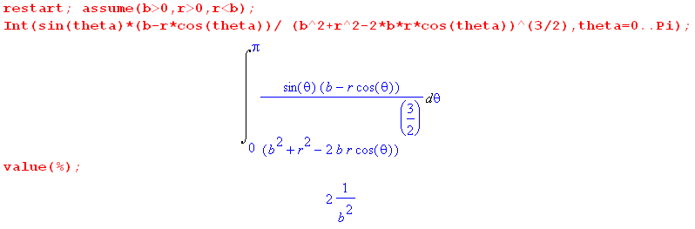
(D.5.10)
where 2/b2 is the value of the integral. Thus we have shown that

F = 2πρGME r2dr $^{\int_{0}^{π}{}}$dθ $\frac{sinθ (b-rcosθ)}{(r2+b2-2rbcosθ)3/2}$ = 2πρGME r2dr (2/b2)

= GME (4πr2dr)ρ /b2 = GMEMshell / b2 . (D.5.11)

We now use the center of gravity definition from (D.1.6) to find,

rcog = $\sqrt{GMEMshell/F}$ = b (D.5.12)

Since rcms = b as well, we conclude that for a spherical shell satellite one has rcog = rcms .

If the mass center ME were inside the shell so b < r, Maple gives a different answer ,

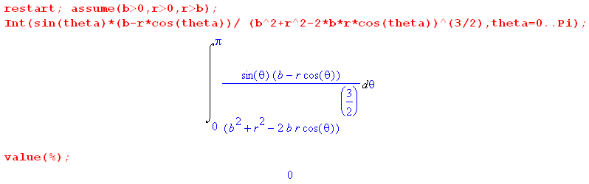
(D.5.13)

showing that the force experienced by the uniform shell due to a mass ME inside the shell is zero.

It seems unsportsmanlike not to actual do the integral to see why it is discontinuous at r = b. Here is a brief tour:

1. Change variables from θ to r1 and look at the endpoints in the new variable,

r12(θ=0) = r2 + b2-2rb(1) = (b-r)2 ⇒ r1(θ=0) = |b-r| ≡ α
r12(θ=π) = r2 + b2-2rb(-1) = (b+r)2 ⇒ r1(θ=π) = b+r ≡ β

It is the absolute value that causes the discontinuous behavior at b = r, as we shall see.

2. Since r12 = r2 + b2 - 2rbcosθ one has sinθdθ = r1dr1/(rb) . (D.5.14)

3. The factor (b - rcosθ) = (b2-r2+r12)/(2b), while the denominator of the integral is just r13.

4. The integral reduces to two elementary power integrals to give

I(r) = $^{\int_{0}^{π}{}}$dθ $\frac{sinθ (b-rcosθ)}{(r2+b2-2rbcosθ)3/2}$ = [ (b2-r2)$^{\int_{α}^{β}{}}$dr1/r12 + $^{\int_{α}^{β}{}}$dr1 1 ] / (2rb2)

= [ (b-r) {$\frac{(b+r) - |b-r|}{|b-r|}$} + (b+r) - |b-r| ] / (2rb2) . (D.5.15)

For b > r one has |b-r| = b-r and the value comes out

I(r) = [ 2r + 2r ] / (2rb2) = 2/b2 (D.5.16)

For b < r one has |b-r| = r-b and the value is

I(r) = [ -2b + 2b ] / (2rb2) = 0 (D.5.17)

The full result is then

I(r) = (2/b2)H(b-r) // Heaviside function (D.5.18)

which has this appearance,
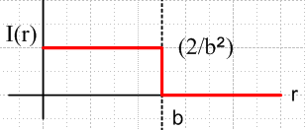 (D.5.19)

On can argue that I(b) = (1/b2) which is the average of the values at the discontinuity.

ok to here

