Center of Gravity PhL 11.29.16

This document is fully reviewed, the main facts are in Section 0 Summary.

0. Long Version Summary (written after the fact on 11.30.16). 1
1. Short Version 2
2. Corroboration 3
3. Application 6
4. Long Version 7
5. The center of mass point 10
6. Show that for the on-earth small situation, r_{cog} = r_{cms}. 11

0. Long Version Summary (written after the fact on 11.30.16).

Here (not thinking of gravity in particular) I consider a system of particles mi having some Fi on each and I ask if there is some point in space R relative to which the system as a whole has zero torque. I set FT = ΣiFi and then I write NT(R) = Σi (ri-R) x Fi and ask if R exists such that NT(R) = 0. Note that NT(0) = Σirix Fi about an Origin point. The problem is thus to find R such that NT(0) = R x FT . In other words, is there some point R such that the total torque on the system (relative to the origin) and the total force on the system are related by an equation which has the traditional torque form τ = r x F?
I thought surely there must always be a solution and I set out to find it. I wrote this out as a Cramer style linear matrix equation hoping to solve for the unknowns Ri, but I ran into the matrix having zero determinant so I could not solve for the solution Ri in the usual way. Dotting NT(0) = R x FT with FT produces the equation FT • NT(0) = 0. If R exists such that NT(0) = R x FT, then one must have FT • NT(0) = 0 so the latter is a condition without which there can be no solution R. Restating: for a problem having the fact FT • NT(0) ≠ 0 there is no solution R. Notice that "gravity" has not yet been mentioned as a possible source of the forces Fi in this discussion. If a solution exists, some authors refer to the solution R as the center of gravity, but in this general scenario the forces Fi might have nothing to do with any "gravity". These authors then define their "center of gravity" R as a point relative to which NT(R) = 0 so there is "zero torque" on the system relative to this point R.

We move now to an "asteroid near Earth" gravity application. Compute FT = ΣiFi(-i) to get the total force on the asteroid as a vector. Note that (-i) is a vector pointing from mi of the asteroid to the center of the Earth, and Fi = GmEmi/ri2. You then know the direction of T in space. Draw a line defined by this direction. Translate this line until it passes through the center of the Earth. Then declare that rcog lies along this line and for any point on this line we know that the vectors rcog and FT are parallel. Then set GmEM/rcog2 = |FT| and this determines rcog for M = asteroid mass. So at point rcog the total force on the asteroid is the same as the force on a concentrated point mass M at that point. This discussion appears in Symon.

Note that for this asteroid problem NT(0) = Σirix Fi = 0 because each ri is parallel to its Fi, both pointing to Earth center as the Origin. The condition FT • NT(0) = 0 is therefore met, and thus solution(s) of NT(0) = R x FT may exist. One solution is R = 0 since NT(R=0) = 0. Had the determinant of the matrix not vanished, there could have been only one solution.

We claim that the point rcog is another solution to NT(0) = R x FT, so NT(0) = rcog x FT . How do we know this is so? Well we just stated above that NT(0) = 0 and that rcog is parallel to FT so rcog x FT = 0. Thus, using the point R = rcog the equation NT(0) = rcog x FT is valid, since it just says 0 = 0. Remember from above that any solution R to NT(0) = R x FT also solves NT(R) = 0 and is thus a point relative to which the total torque on the system is 0. Therefore both R = 0 and R = rcog are points relative to which the total torque on the system (the asteroid) is 0.

If we define "center of gravity" R in the general sense of "torque of system relative to R vanishes", then in the asteroid application we find that rcog is such a "center of gravity". In this application the words of the phrase "center of gravity" make sense, but in the general definition they really don't make sense.

1. Short Version

Here I quickly get to the fact that there is a condition which must be satisfied for R to exist.

Suppose you have a system of masses mi each of which has a certain force Fi acting on it. The total force on this system is then

F = ΣiFi .

If the masses are located at ri, then the total torque relative to some point R is given by

N(c) = Σi (ri-R) x Fi

Can one find a location R for which N(R) = 0? That would require

Σi (ri-R) x Fi = 0

That would require that

Σi ri x Fi = R x Σi Fi

or simply

N(0) = R x F .

Can you solve this for R ? I am not sure. But suppose we dot both sides with F. We know that the object

R x F • F = F x R • F = F x F • R = 0

Thus we end up with a condition which, if not true, means there can be no solution:

F • N(0) = 0

For some arbitrary forces and an arbitrary origin, this will not be true, so there will be no solution.

The equation N(0) = R x F asks this question: if you compute the total F and total torque τ acting on a system, can you find a point r at which the equation τ = r x F applies at the system level?

2. Corroboration

Here I finally found web and textbook support for my center of gravity concepts expressed above.

After much wasted searching, I found the above discussion corroborated at this site

https://en.wikipedia.org/wiki/Centers_of_gravity_in_non-uniform_fields

As the Talk page shows, there is much confusion regarding this topic!

Big Problem: The web search problem is that 95% of sites use the phrase "center of gravity" to be a synonym for the phrase "center of mass", so using the first as a search handle is ineffective. I found the above site by adding the phrase "non-uniform" to the search.
The wiki page has some references, and I am trying to track them down.

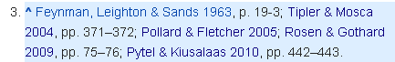

The Feynman Vol 1 refers to "center of gravity" 5 times, and notes there is a distinction. But almost all references in the three volumes are in the "center of mass" sense.

The Tipler and Mosca I have up. Here is their definition

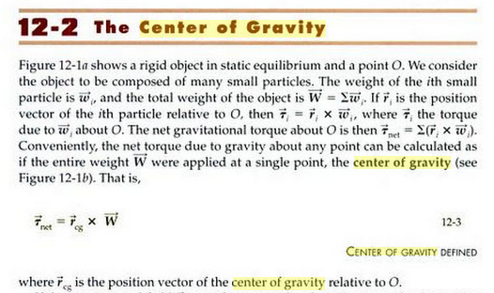

In this paragraph, if one replaces the phrase "weight wi" with "force Fi" and similarly W by FT, then you duplicate my Summary situation described above. However Tipler and Mosca make no comments about whether or not there is a solution. They might have added the condition as τnet • W = 0 .

The geology reference Pollard and Fletcher has nothing.

Rosen and Gothard Encyclopedia of Physical Science seems an unlikely source.

Pytel and Kiusalaas engineering mechanics Statics is in google books. I realized belatedly that this is the Statics book I picked up for $1 at the last library sale! They claim this
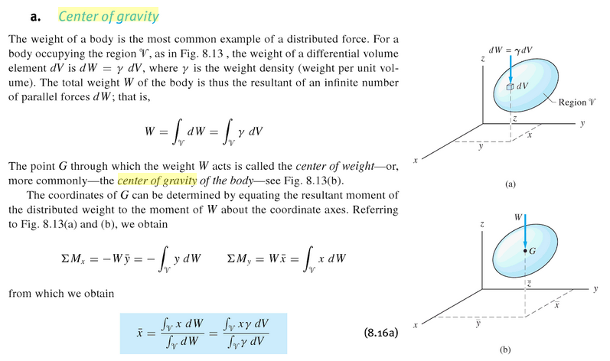

Again, if I replace the "weight = dW = γ dV (for me, both W and γ are then vectors)" with "force = Fi" then things make sense. But they seem to have W and φ being scalars which rules out a non-uniform g field. For the non-uniform situation, their integrals don't make sense. They are just equations for finding the center of mass of an object.

Now back to our initial web page. They say

"Textbooks such as the The Feynman Lectures on Physics characterize the center of gravity as a point about which there is no torque. "

But I have now downloaded all three volumes of the lectures and have made them searchable, and none of them mentions "center of gravity" anywhere.

The fact that the equation might not have a solution is linked to

Symon, Keith R. (1971), Mechanics, Addison-Wesley, ISBN 978-0-201-07392-8

I have this book now (and added OCR). On page 258 there is a reasonable discussion of "center of gravity" which seems to have nothing to do with any torques. Here is what it says:

Symon. You have a distribution of masses mi which forms some weird body of total mass M. You are observing this body from an external point test mass m located at a point r0. You then compute total F acting on your test mass m as follows,

F = Σi (mimG/ri02) i0 where ri0 ≡ ri- r0 , points to ri.
or
F = mG Σi (mi/ri02) i0 = F

This is a completely well defined sum (or integral) and you end up with some F. This is along some line in the direction. You then need to translate this line parallel to itself until it passes through the origin of the Earth. Then the COG lies on this line (he claims).

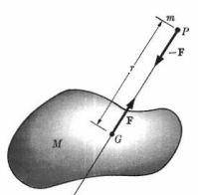

You then define the "center of gravity point G" to be on this line determined by which is a distance s away from test mass m such that

F = (MmG/s2)

So this is something I can actually calculate! The gravitational force on the test mass due to the distributed object is the same as if you put the entire object of mass M into a single point of mass M located at point G. As he notes, if you move your test mass to another point P', G goes to a new point G', so the point G is not like the center of mass which is a property only of the object.

Let's now apply this to the tethered satellite treating the entire earth as the test mass which acts as a point located at its center. We then compute

F = mE G Σi=12(mi/ri02) i0

Separate doc!

Taylor's mechanics book does not include the phrase "center of gravity".

Marion and Thornton have exactly one reference to "center of gravity" and it is in a problem:

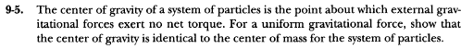

In other words, the total torque on the particles with respect to the center of gravity point is 0. I have the same definition of center of gravity above, but generalized for any forces, and I have then solved this problem below in Section 6.

Landau and Lifshitz has no hits on center of gravity.

Osgood has no hits on center of gravity.

Synge and Griffith have lots of hits, but they are all just in the CMS sense.

I looked earlier at Jim's mechanics books and found nothing useful.

3. Application

This section goes nowhere.

Consider a very large rigid body composed of masses mi in orbit. Each mass has internal Fij and also has Gi due to gravity. For this problem we have

Fi = Gi + Σj≠iFij

The torque about some origin is then

N(0) = Σi ri x Fi = Σi ri x [Gi + Σj≠iFij]

In order for this system to have a "center of gravity" R about which total torque is 0, the above condition must be met. That condition is

F • N(0) = 0
or
Σi[Gi + Σj≠iFij] • Σk [rk x [Gk + Σj≠iFkj] ] = 0
or
Σi,k [Gi + Σj≠iFij] • [rk x (Gk + Σj≠iFkj) ] = 0 // I know Σj Σj≠iFkj = 0

This looks pretty messy, I don't know what to do.

Conclusion: I have no idea what "center of gravity" means. I have no idea how to compute it, and I it seems likely that it does not even exist. And the entire web has nothing to say about it! [ well, I have since learned a bit, see Summary above.]

4. Long Version

Suppose you have a system of masses mi each of which has a certain force Fi acting on it. The total force on this system is then

FT = ΣiFi .

If the masses are located at ri, then the total torque relative to some point R is given by

NT(R) = Σi (ri-R) x Fi

Can one find a location R0 where NT(R0) = 0? That would require

Σi (ri-R0) x Fi = 0 .

Each component must be zero, so then this says

Σi [(ri-R0) x Fi]j = 0 j = 1,2,3
or
Σi εjab(ri-R0)a (Fi)b = 0
or
εjab Σi(ri-R0)a (Fi)b = 0 j = 1,2,3
or
εjab Σi(R0)a (Fi)b = εjab Σi(ri)a (Fi)b

Write out these three equations

j = 1 Σi(R0)2 (Fi)3 - Σi(R0)3 (Fi)2 = Σi(ri)2 (Fi)3 - Σi(ri)3 (Fi)2 and cyclic

Move sum on the left

(R0)2Σi (Fi)3 - (R0)3Σi (Fi)2 = Σi(ri)2 (Fi)3 - Σi(ri)3 (Fi)2 + cyclic

[Σi (Fi)3](R0)2 - [Σi (Fi)2] (R0)3 = Σi(ri)2 (Fi)3 - Σi(ri)3 (Fi)2

Now write out all three equations

[Σi (Fi)3](R0)2 - [Σi (Fi)2] (R0)3 = Σi(ri)2 (Fi)3 - Σi(ri)3 (Fi)2
[Σi (Fi)1](R0)3 - [Σi (Fi)3] (R0)1 = Σi(ri)3 (Fi)1 - Σi(ri)1 (Fi)3
[Σi (Fi)2](R0)3 - [Σi (Fi)3] (R0)2 = Σi(ri)1 (Fi)2 - Σi(ri)2 (Fi)1

This has the form

M R0 = V

which I guess you just solve for R0 . This is a Cramer's Rule simple matrix inversion linear problem.

To simplify the notation, let's make up some symbols

[Σi (Fi)3] = a3 so [Σi (Fi)j] = aj

(R0)3 = x3 so (R0)j = xj

Σi(ri)2 (Fi)3 = A23 so Σi(ri)a (Fi)b = Aab

Then our three equations are

a3x2 - a2x3 = A23- A32
a1x3 - a3x1 = A31- A13
a2x1 - a1x2 = A12- A21

or

0 x1 + a3x2 - a2x3 = A23- A32
- a3x1+ 0 x2 + a1x3 = A31- A13
a2x1 - a1x2 + 0 x3 = A12- A21

or

$\left(\begin{matrix}0 & a3 & -a2 \\ -a3 & 0 & a1 \\ a2 & -a1 & 0\end{matrix}\right)$$\left(\begin{matrix}x1 \\ x2 \\ x3\end{matrix}\right)$ = $\left(\begin{matrix}A23- A32 \\ A31- A13 \\ A12- A21\end{matrix}\right)$

But Maple says this matrix has determinant = 0 so has no inverse. So how solve the problem? The determinant of any 3x3 antisymmetric matrix is 0, easy to show on scratch. The three rows of the matrix are not linearly independent. Fine.

Go back to

a3x2 - a2x3 = V1
a1x3 - a3x1 = V2
a2x1 - a1x2 = V3

Bruce force: eliminate x3 from the first pair

a1a3x2 - a1a2x3 = a1V1
a2a1x3 - a2a3x1 = a2V2

a1a3x2 - a2a3x1 = a1V1+ a2V2 = B1

Then we have two equations left

a2x1 - a1x2 = V3
a2x1 - a1x2 = -B1/a3

The right sides must be the same to make this work, so need

a3V3 = -B1
or
a3V3 = - (a1V1+ a2V2)
or
a • V = 0

Any vector normal to V is a solution. How could I have obtained this result right away?

Start over:

Σi (ri-R0) x Fi = 0 ? // is there a solution R0 ?
or
(Σi ri x Fi) = Σi R0 x Fi = R0 x (ΣiFi)

Define

ri x Fi = Ni(0) and (ΣiFi) = F

Then have

ΣiNi(0) = NTot(0) = R0 x F

Want to find solution R0 to this equation

R0 x F = NTot(0)

where F and NTot(0) are known.

General problem:

r x a = b how solve for r ?

Dot both sides with a? But LHS = 0 so you are forced to a • b = 0 as a condition for solution? In my problem that means

F • NTot(0) = 0

Conclusion: You must have the total force on system being normal to total torque about your selected origin, otherwise there is no solution. If total force = 0 or if total torque = 0 you are OK. Nothing is said about inertial frames here. I have used not equations of motion.

In the tether problem all forces are radial so the total torque is 0. Then R0 x F = 0. But any R0 parallel to F would solve this equation. It is true that any such R0 would yield 0 total torque.

5. The center of mass point

Here I obtain the usual rcms formula using the above COG definition of rcms.

We now have a uniform g field. We have a system of masses mi in some configuration at rest. It is a rigid body with massless sticks connecting the masses. Total gravity force is F = Σimig = Mg . The object is supported by a thread pulling up with -F on point some point rcms. Total force on the object is then FT = ΣiFi = 0. Let's define rcms as a point about which total torque N(rcms) is 0, assuming such a point exists. The thread force makes no torque since its r and F align, so we have only the gravity forces to deal with. So we want to have

N(rcms) = Σi (ri - rcms) x Fi = 0

where the sum can be regarded as only over the grav forces. Write these as Fi = mig so then want

Σi (ri - rcms) x mig = 0
or
[Σi (miri - mircms)] x g = 0

Thus we need to have

Σi (miri - mircms) = 0
or
Σi miri = rcms Σimi

To make this work, we must take

rcms = $\frac{Σi miri}{Σimi}$

which is the usual result. If we take this value as rcms when we will have

N(rcms) = Σi (ri - rcms) x Fi = 0

where the sum can be considered now to be over all forces including the thread force. With this full sum we have ΣiFi = 0 .

Digression Theorem: if ΣiFi = 0, then torque about all reference points is the same.

Proof: NR1 = Σi(ri- R1) x Fi
NR2 = Σi(ri- R2) x Fi ⇒

(NR1 - NR2 ) = Σi(ri- R1) x Fi - Σi(ri- R2) x Fi
= (- R1 - R2) x (ΣiFi) = (- R1 - R2) x 0 = 0 QED

Thus in our rigid body example, since ΣiFi = 0 we know that N(R) = 0 referenced to any point R, and not just to the rcms point. So if you "hang" ("support") a rigid body at its rcms point, the total torque on the rigid body about any reference point is zero.

6. Show that for the on-earth small situation, rcog = rcms.

It is very difficult to show this using the Symon approach due to the large size difference between the long ri and the local surface Ri points in the rigid body. I think you could do it, but you have to work hard with approximations. It is easier to use the first and official definition of the center of gravity, namely, that it is the point R for which you solve NT(0) = R x FT (meaning it is the point with reference to which the total torque NT(R) = 0) .

So here is the argument:

Recall that rcog is defined as the solution of N(0) = rcog x FT or N(rcog) = 0 for a general set of forces Fi.

Recall that rcms is defined as the solution of N(0) = rcms x FT or N(rcms) = 0 but restricted to a situation where all the forces are parallel.

In both cases we can take FT to be the sum over the mi forces Fi and we don't include "the string" force since it makes no contribution to rcms x FT . For rcog we had in mind very general forces Fi which result in general torques rix Fi about the origin. For rcms we had in mind just small objects on the earth where all the forces Fi are parallel. So the cms problem is just a special case of the cog problem. The solution to the cms problem gives the cog solution for that particular problem.

