Center of gravity PhL 12.2.16

This subject just won't go away. I said in frames that the cog point is always closer to the point gravity source than the cms point, but I suspect for a sphere that is not true. Also, I see a better way to set up the 2-mass problem so I will redo that problem right here. I draw the two masses and then instrument the picture with everything I can find

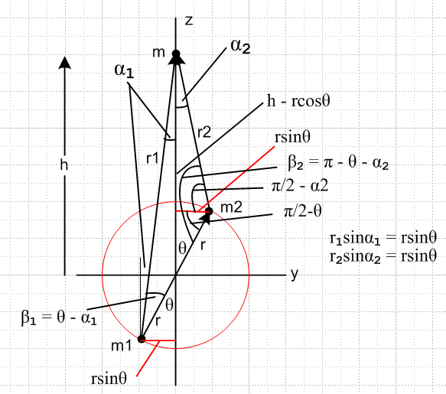

r1sinα1 = rsinθ β1 = θ - α1 r1cosα1 = h + rcosθ
r2sinα2 = rsinθ β2 = π/2 - α2 r2cosα2 = h - rcosθ

tanα1 = rsinθ/(h+rcosθ)
tanα2 = rsinθ/(h-rcosθ)

Given h,r,θ we therefore know the angles α1 and α2 and note that 0 < αi < π/2 as long as h > r.
Then r1 and r2 are determined by

r1 = r sinθ/sinα1 r12 = (rsinθ)2 + (h+rcosθ)2
r2 = r sinθ/sinα2 r22 = (rsinθ)2 + (h-rcosθ)2

Note: The origin is not at the center of mass location.

What is the force on mass m?

Fy = - (Gmm1/r12) sinα1 + (Gmm2/r22) sinα2
Fz = -(Gmm1/r12)cosα1 - (Gmm2/r22)cosα2
or
Fy = - (Gmm1/r13) r1sinα1 + (Gmm2/r23) r2sinα2
Fz = -(Gmm1/r13)r1cosα1 - (Gmm2/r23)r2cosα2
or
Fy = - (Gmm1/r13) rsinθ + (Gmm2/r23) rsinθ
Fz = -(Gmm1/r13)(h + rcosθ) - (Gmm2/r23)(h - rcosθ)
or
Fy = [Gm /(r13r23)] * rsinθ ( m2r13 – m1r23) to right of m2 >> m1
-Fz = [Gm /(r13r23)] * [m1r23(h + rcosθ) + m2r13(h - rcosθ)] down

The total force acting on m is then

F = Fy + Fz = F = a generally downward force on mass m.

F = $\sqrt{Fy2+Fz2}$ = F/F = $\sqrt{Fy2+Fz2}$ + $\sqrt{Fy2+Fz2}$

If m2 >> m1 then the attractive force on m is down and to the right. In this case Fy < 0, Fz < 0 so F and point up and to the left.

We then go a distance R along this direction away from mass m and determine R from

Gm(m1+m2)/rcog2 = F

rcog2 = Gm(m1+m2) / F
so
rcog = $\frac{Gm(m1+m2)}{F}$ = $\sqrt{Gm(m1+m2)}$ F-1/2

Then relative to the location of mass m we have

rcog = rcog = (rcog/F) F = $\sqrt{Gm(m1+m2)}$ F-3/2 [ Fy + Fz ]

which is a vector generally downward from the mass m.

Meanwhile, the center of mass (relative to the origin) is located at,

Rcms = (m2r + m1(-r) / (m1+m2) = $\frac{m2 - m1}{m1+ m2}$r ≡ f r f = $\frac{m2 - m1}{m1+ m2}$ .

Then a vector from mass m down to this center of mass location is,

rcms = - h + Rcms = - h + fr = - h + fy + fz = frsinθ - (h - frcosθ)

We now define two angles away from vertical as in this picture,

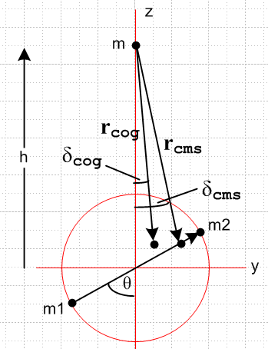

The drawing is appropriate for m2 >> m1 so rcms lies on the line segment between the masses, but toward the m2 end. We are not sure at this point where rcog lies, so we show it at some arbitrary point.
Then the angles δcog and δcms are defined shown in the drawing, both positive as drawn.

tan(δcog(θ)) = rcog,y / (-rcog,z)
tan(δrms(θ)) = rcms,y / (-rcms,z)

Then
tan(δcog(θ)) = rcog,y / (-rcog,z) = Fy/(-Fz) = $\frac{rsinθ (m2r13 - m1r23)}{[m1r23(h + rcosθ) + m2r13(h - rcosθ)]}$

tan(δrms(θ)) = rcms,y / (-rcms,z) = $\frac{frsinθ}{h - frcosθ}$ = $\frac{m2 - m1}{m1+ m2}$$\frac{m2 - m1}{m1+ m2}$ = $\frac{(m2-m1)rsinθ}{(m1+m2)h-(m2-m1)rcosθ}$
We now compare:

tan(δcog(θ)) = $\frac{rsinθ (m2r13 - m1r23)}{[m1r23(h + rcosθ) + m2r13(h - rcosθ)]}$
tan(δcms(θ)) = $\frac{(m2-m1)rsinθ}{(m1+m2)h-(m2-m1)rcosθ}$

As noted above, if m2>> m1 (and h >> r ) then both δ angles are positive, in agreement with the drawing.

In general, these angles are not the same, being different dimensionless functions of m1,m2,r,h and θ . So in general, the line from m to the center of gravity is different from the line from m to the center of mass. And then of course the points rcog and rcms are also different.

If θ = 0 then the lines are the same because then δcog(0) = δcms(0) = 0. In this case rcog and rcms are different but they both lie on the z axis.

Equal mass for general θ. For general θ if m1 = m2 we find

tan(δcog(θ)) = $\frac{rsinθ (r13 - r23)}{[r23(h + rcosθ) + r13(h - rcosθ)]}$

tan(δcms(θ)) = 0

and in this case rcms points to the origin while rcog generally does not. So even in the equal mass case the two lines are different for general θ. In this equal mass case we have from above,

rcog = $\sqrt{Gm(m1+m2)}$ F-3/2 [ Fy + Fz ]

Fy = [Gmm1 /(r13r23)] * rsinθ ( r13 – r23)
-Fz = [Gmm1 /(r13r23)] * [r23(h + rcosθ) + r13(h - rcosθ)]

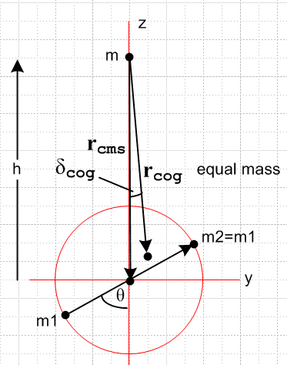

Unequal mass, but θ = 0.

In this case

Fy = 0
-Fz = [Gm /(r13r23)] * [m1r23(h + r) + m2r13(h - r)]

But also

r1 = h+r
r2 = h-r

so
-Fz = $\frac{Gm}{r13r23}$ [m1r23(h + r) + m2r13(h - r)]

= $\frac{Gm}{(h+r)3(h-r)3}$ [m1(h-r)3(h + r) + m2(h+r)3(h - r)]

= $\frac{Gm(h+r)(h-r)}{(h+r)3(h-r)3}$ [m1(h-r)2 + m2(h+r)2]

= $\frac{Gm}{(h+r)2(h-r)2}$ [m1(h-r)2 + m2(h+r)2]

rcog = $\sqrt{Gm(m1+m2)}$ |Fz|-3/2 [ Fz ]

= $\sqrt{Gm(m1+m2)}$ |Fz|-3/2 [ -|Fz| ]

rcog = - $\sqrt{Gm(m1+m2)}$ |Fz|-1/2

|Fz| = $\frac{Gm}{(h+r)2(h-r)2}$ [m1(h-r)2 + m2(h+r)2]

|Fz|-1/2 = $\sqrt{Gm}$ $\sqrt{m1(h-r)2 + m2(h+r)2}$

rcog = - $\sqrt{Gm(m1+m2)}$ $\sqrt{Gm}$ $\sqrt{m1(h-r)2 + m2(h+r)2}$

= - $\sqrt{m1+m2}$$\sqrt{m1(h-r)2 + m2(h+r)2}$

rcog = $\sqrt{m1+m2}$$\sqrt{m1(h-r)2 + m2(h+r)2}$ = $\sqrt{μ1(h-r)2 + μ2(h+r)2}$ // agrees with frames doc

Meanwhile,

rcms = frsinθ - (h - frcosθ) = - (h - fr)

rcms = h - fr f = $\frac{m2 - m1}{m1+ m2}$ = μ2 - μ1 -1 < f < 1

Now can we show that

rcog < rcms ?

According to the tether picture the rcms is farther from the earth, so that means is farther from mass m and that means rcms > rcog . So let's try to verify this tether doc claim.

$\sqrt{μ1(h-r)2 + μ2(h+r)2}$ < h - (μ2- μ1)r ?

(h2-r2)2 < [ h - (μ2- μ1)r]2 [μ1(h-r)2 + μ2(h+r)2] ?

(h2-r2)2 < [ h - (μ2- μ1)r]2 [(μ1+μ2)(h2+r2) + 2(μ2- μ1)hr] ?

(h2-r2)2 < [ h - Δμr]2 [(h2+r2) + 2Δμhr] ?

Let Δμ = x, then

RHS = [ h - rx]2 [(h2+r2) + 2hrx] = f(x)

I would like to figure out the MIN value of f(x) and then if I can show (h2-r2)2 < fmin then I have succeeded in showing rcog < rcms .

So let's have Maple study up on this function:

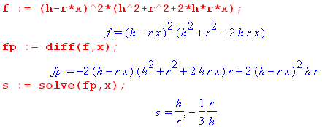

I then test these two points to see if max or min:

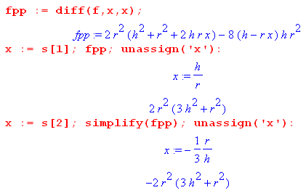
Thus the zero located at s = h/r is a minimum since cups up. But I always have h > r so this zero is out of range anyway.

The zero located at s = -(1/3) r/h on the other hand is a max since it cups down. And since h > r, this zero is always in range. So this is the one I care about. So what is f(x) at this max point?

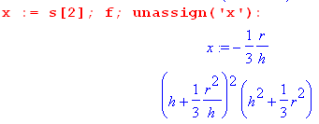

fmax = (1/h)2 (h2 + (1/3)r2)3

But I want fmin!! Since there is a max in range and no min in range, then min will be at one of the endpoints x = 1 or x = -1. So I need to look at both those endpoints.

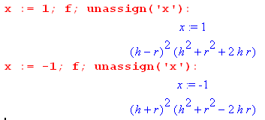

Interestingly these are the same! I have therefore found that

fmin = (h+r)2(h-r)2 = (h2-r2)2

so as long as I avoid the endpoint extremes with x, I have

f < fmin

So now I want to prove that

(h2-r2)2 < f(x) for all x

At the exact min value of the right side equals the left side, but at all other values the left side is less than the right side. That is to say, in order to show rcog ≤ rcms I need to show that

(h2-r2)2 ≤ f(x) for all x.

But I know that

f(x) ≥ fmin = (h2-r2)2

but this is what I want to show, QED. This is harder than I thought. Here is the result'

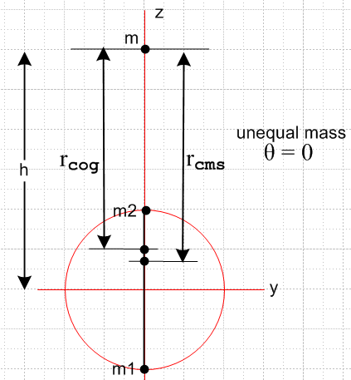

Unequal mass, but θ = π/2.

In this case r1 = r2 . Then,

rcms = - h + Rcms = - h + fr = - h + fy + fz = frsinθ - (h - frcosθ)

= fr - (h)

rcog = $\sqrt{Gm(m1+m2)}$ F-3/2 [ Fy + Fz ]

Fy = [Gm /(r13r23)] * rsinθ ( m2r13 – m1r23)
-Fz = [Gm /(r13r23)] * [m1r23(h + rcosθ) + m2r13(h - rcosθ)]

Fy = [Gm /(r13r23)] * r ( m2r13 – m1r23)
-Fz = [Gm /(r13r23)] * [m1r23(h) + m2r13(h)]

Fy = [Gm /(r13r13)] * r ( m2r13 – m1r13)
-Fz = [Gm /(r13r13)] * [m1r13(h) + m2r13(h)]

Fy = [Gm /(r13)] * r ( m2 – m1) = [GmM /(r13)] r ( μ2 – μ1)
-Fz = [Gm /(r13)] * h (m1+ m2) = [GmM /(r13)] h

F = [GmM /(r13)] [ h2 + r2 ( μ2 – μ1)2]1/2

rcog = $\sqrt{Gm(m1+m2)}$ [GmM /(r13)]-3/2 [ h2 + r2 ( μ2 – μ1)2]-3/4

* [ [GmM /(r13)] r ( μ2 – μ1) - [GmM /(r13)]h ]

= $\sqrt{Gm(m1+m2)}$ [GmM /(r13)]-1/2 [ h2 + r2 ( μ2 – μ1)2]-3/4 [ r ( μ2 – μ1) - h ]

Leading factor is

$\sqrt{Gm(m1+m2)}$ [GmM /(r13)]-1/2 = r13/2

So get

rcog = r13/2[ h2 + r2 ( μ2 – μ1)2]-3/4 [ r ( μ2 – μ1) - h ]

rcms = [ r(μ2 - μ1) - h]

The last brackets are the same! This means they are in the same direction !!!!

rcog = r13/2[ h2 + r2 ( μ2 – μ1)2]-3/4 rcms

In this case r12 = h2+r2 so write as

rcog = $\frac{(h2+ r2)3/4}{(h2+r2(μ2-μ1)2)3/4}$rcms = [ $\frac{h2+r2}{h2+ (μ2-μ1)2r2}$]3/4 rcms

The ratio is > 1 so this says rcog > rcms .

Does this work for test cases? Looks suspicious.

μ2 = 0 μ1= 1

rcog = [ $\frac{h2+r2}{h2+r2}$]3/4 rcms = rcms

Same result for μ2 = 1. If equal mass get

rcog = [ $\frac{h2+r2}{h2}$]3/4 rcms

which seems a very strange result

rcms = [ - h] = tip at the origin.

so I am getting

rcog = [ $\frac{h2+r2}{h2}$]3/4 [ - h]

rcog = [ $\frac{h2+r2}{h2}$]3/4 h = (r2+h2)3/4 /$\sqrt{h}$

and this DOES agree with my direct hand calculation of this equal mass case.

rcog = (r2+h2)3/4 /$\sqrt{h}$ = h3/2 (1 + (h/r)2)3/4 h-1/2 = h (1 + (h/r)2)3/4

rcms = h

Therefore

rcog/ rcms = (1 + (h/r)2)3/4 > 1

**********************original notes below*******************************

The δ angle to this point from the vertical axis is

tan(δcog(θ)) = rcms,y / rcms,z = y/z = tanθ

If we set θ = 0 then obviously δ = 0 since Fy= 0. In this case we have

Gm(m1+m2)/R2 = -Fz = [Gm /(r13r23)] * [m1r23(h + rcosθ) + m2r13(h - rcosθ)]

= [Gm /(r13r23)] * [m1r23(h + r) + m2r13(h - r)]

giving

M/R2 = [m1r1-3(h + r) + m2r2-3(h - r)]

= [m1r1-3(r1) + m2r2-3(r2)]

= [m1r1-2 + m2r2-2]

and then

R2 = q = $\frac{1}{[μ1r1-2 + μ2r2-2]}$

which agrees with my v2 doc. If we replace h in v2 by H, then the connection to that doc for special case is H + 2r = r1 and H = r2 If the masses are the same, the result is

R2 = $\frac{2}{r1-2 + r2-2}$ = $\frac{2r12r22}{r12 + r22}$ so R = $\sqrt{2}$$\sqrt{r12+r22}$

But in this θ = 0 case we have

r1 = h+r
r2 = h-r

so

R2 = $\frac{2(h+r)2(h-r2)}{(h+r)2+(h-r)2}$ = $\frac{(h2- r2)2}{(h2+r2)}$ = h2 $\frac{(1- (r/h)2)2}{(1+(r/h)2)}$ < h2

R = h < h

What happens if θ = π/2? Then r1 = r2 and δ = 0 and

Fy = [Gm /(r13r13)] * r (m1r13 - m2r13)
-Fz = [Gm /(r13r13)] * [m1r13(h) + m2r13(h]
or

Fy = [Gm /(r13)] * r (m1 - m2)
-Fz = [Gm /(r13)] * h (m1 + m2)

F = [Gm /(r13)] $\sqrt{r2 (m1 - m2)2 +h2 (m1 + m2)2}$

In this case I know that r12 = r2 + h2 so

F =$\frac{Gm}{(r2+h2)3/2}$ $\sqrt{r2 (m1 - m2)2 +h2 (m1 + m2)2}$ = GmM/R2

and then

R2 = M $\sqrt{r2 (m1 - m2)2 +h2 (m1 + m2)2}$ = $\sqrt{r2 (μ1 - μ2)2 +h2}$

= M $\sqrt{(r/h)2 (m1 - m2)2 + (m1 + m2)2}$

= Mh2 $\sqrt{(r/h)2 (m1 - m2)2 + (m1 + m2)2}$

= Mh2 $\sqrt{M2 + (r/h)2 (m1 - m2)2}$

= h2 $\sqrt{1 + (r/h)2 ((m1 - m2)/M)2}$

= h2 $\sqrt{1 + (r/h)2 (μ1 - μ2)2}$

If the masses are equal we get

R2 = h2 (1 + (r/h)2)3/2

R = h (1 + (r/h)2)3/4 > h

If the masses are equal, then R > h so my claim that "always closer" is wrong!!!! If μ1 = 0 then μ2 = 1 and the result is then

R2 = h2 $\sqrt{1 + (r/h)2}$ = h2 (1 + (r/h)2) = h2 + r2 = r12

the obvious result in this case, and again R > h.

Go back to the general result

Fy = [Gm /(r13r23)] * rsinθ (m1r23 - m2r13)
-Fz = [Gm /(r13r23)] * [m1r23(h + rcosθ) + m2r13(h - rcosθ)]

r12 = (rsinθ)2 + (h+rcosθ)2
r22 = (rsinθ)2 + (h-rcosθ)2

F = $\sqrt{Fx2+Fy2}$ = [Gm /(r13r23)] *
{ r2sin2θ (m1r23 - m2r13)2 + [m1r23(h + rcosθ) + m2r13(h - rcosθ)]2 }1/2

F = $\sqrt{Fx2+Fy2}$ = [Gm] * 1/ (r16r26)1/2
{ r2sin2θ (m1r23 - m2r13)2 + [m1r23(h + rcosθ) + m2r13(h - rcosθ)]2 }1/2

F = $\sqrt{Fx2+Fy2}$ = [Gm]
{ r2sin2θ (m1r23 - m2r13)2/ (r16r26) + [m1r23(h + rcosθ) + m2r13(h - rcosθ)]2/(r16r26) }1/2

F = $\sqrt{Fx2+Fy2}$ = [Gm]
{ r2sin2θ (m1r23 - m2r13)2/ (r13r23)2 + [m1r23(h + rcosθ) + m2r13(h - rcosθ)]2/(r13r23)2 }1/2

F = $\sqrt{Fx2+Fy2}$ = [Gm]
{ r2sin2θ (m1r1-3 - m2r2-3)2 + [m1r1-3(h + rcosθ) + m2r2-3(h - rcosθ)]2 }1/2

F = $\sqrt{Fx2+Fy2}$ = [Gm]
{ r2sin2θ (m1r1-3 - m2r2-3)2 + [h(m1r1-3+ m2r2-3) + rcosθ(m1r1-3 - m2r2-3) ]2 }1/2

Define

A = m1r1-3 - m2r2-3 dim(rA) = kg * m-2 = dim(hB)
B = m1r1-3 + m2r2-3

Then

F = $\sqrt{Fx2+Fy2}$ = [Gm] { r2sin2θA2 + [hB + rcosθA ]2 }1/2

= [Gm] { r2sin2θA2 + h2B2 + r2cos2θA2 + 2hrABcosθ }1/2

= [Gm] { r2A2 + h2B2 + 2hrABcosθ }1/2

= [Gm] { (rA)2 + (hB)2 + 2 (rA) (hB)cosθ }1/2

= GmM/R2

The general result is then

R2 = M / { (rA)2 + (hB)2 + 2 (rA) (hB)cosθ }1/2 = kg / ( kg * m-2) = m2
or

R2 = $\frac{M}{[(rA)2 + (hB)2 + 2 (rA) (hB)cosθ]1/2}$

A = m1r1-3 - m2r2-3
B = m1r1-3 + m2r2-3 M = m1+m2

Let's recheck the two special cases:

1) aligned θ = 0 then

R2 = $\frac{M}{[(rA)2 + (hB)2 + 2 (rA) (hB)]1/2}$ = $\frac{M}{rA + hB}$

But r1 = h+r and r2 = h-r so

rA =(r1-h)[ m1r1-3 - m2r2-3]

hB = h[m1r1-3 + m2r2-3]

rA+hB = (r1-h)[ m1r1-3 - m2r2-3] + h[m1r1-3 + m2r2-3]

= m1r1-2 - m2r1r2-3 - hm1r1-3 + hm2r2-3 + hm1r1-3 + hm2r2-3

= m1r1-2 - m2r1r2-3 + 2hm2r2-3

This does not look like the previous answer

R2 = $\frac{M}{[m1r1-2 + m2r2-2]}$

But it would be the same answer if we could show that

- m2r1r2-3 + 2hm2r2-3 = m2r2-2
or
- r1r2-3 + 2hr2-3 = r2-2
or
- r1r2-1 + 2hr2-1 =1
or
- r1 + 2h = r2
or
r1 = 2h-r2

We do know in our special case that

But we know in this θ = 0 case that

r1 = r2+2r
r1 = h + r
r2 = h - r

So the last two items tell us that

r1+r2 = 2h

and thus I have shown that the special case here does replicate the previous result.

Now go back to the general claim

R2 = $\frac{M}{[(rA)2 + (hB)2 + 2 (rA) (hB)cosθ]1/2}$

A = m1r1-3 - m2r2-3
B = m1r1-3 + m2r2-3 M = m1+m2

For θ = π/2 this gives

R2 = $\frac{M}{[(rA)2 + (hB)2]1/2}$

and in this case we know that r1 = r2 and also r12 = h2+ r2

rA = r[m1r1-3 - m2r2-3] = r r1-3(m1-m2)

hB = h[m1r1-3 + m2r2-3] = hr1-3(m1+m2)

Then

(rA)2+ (rB)2 = r1-6 [ r2(m1-m2)2 + h2M2] = r1-6 M2 [ r2(μ1-μ2)2 + h2]

Then

R2 = $\sqrt{r2(μ1-μ2)2 + h2}$ = $\sqrt{r2(μ1-μ2)2 + h2}$

and this does match a form of my previous result. Another way to write this'

R2 = $\sqrt{(r12-h2)(μ1-μ2)2 + h2}$

If the masses are equal you get

R2 = r13/h ⇒ R = r1 $\sqrt{r1/h}$ > r1

I think that is enough on this problem.

What is the torque?

Relative to the sphere center, the torque on mass m2 is (forces are on the test mass m)

Define

F1 = the force acting on mass m1 due to mass m (points roughly up)
F2 = the force acting on mass m2 due to mass m (points roughly up)

These are torques about the origin, not about cms or cog!

N2 = r x F2 F2 = (Gmm2/r22) 2 2 points from m2 up to m

N1 = (-r) x F1 F1 = (Gmm1/r12) 1 1 points from m1 up to m

Earlier I wrote these forces acting on mass m

Fy = -(Gmm1/r13) rsinθ + (Gmm2/r23) rsinθ repaired
Fz = -(Gmm1/r13)(h + rcosθ) - (Gmm2/r23)(h - rcosθ)

which I can break down to be

F1y = -(Gmm1/r13) rsinθ F2y = (Gmm2/r23) rsinθ repaired

F1z = -(Gmm1/r13)(h + rcosθ) F2z = - (Gmm2/r23)(h - rcosθ)

But now I want the first force to act on m1 and the second to act on m2, so negate all

F1y = (Gmm1/r13) rsinθ F2y = -(Gmm2/r23) rsinθ repaired

F1z = +(Gmm1/r13)(h + rcosθ) F2z = + (Gmm2/r23)(h - rcosθ)

Since r and Fi are in the plane, we know that both torques are normal to paper. Staring at the picture shows that

r x r1 = r1rsin(θ-α1)
r x r2 = r2rsin(θ+α2)

Then

N2 = r x F2 = r x [ (Gmm2/r23) r2 ] = (Gmm2/r23) r x r2 = (Gmm2/r23) r2rsin(θ+α2)

N1 = - r x F1 = - r x [ (Gmm1/r13) r1 = - (Gmm1/r13) r x r1 = - (Gmm1/r13) r1rsin(θ-α1)

Summary:

N1 = - (Gmm1/r12) rsin(θ-α1)

N2 = (Gmm2/r22) rsin(θ+α2) units are r and force, OK

Then

N = N1+ N2 = Gmr [ - (m1/r12)sin(θ-α1) + (m2/r22)sin(θ+α2) ]

Let's try another way to get this result. Using the second set of forces above,

F1 = (Gmm1/r13) rsinθ + (Gmm1/r13)(h + rcosθ)

F2 = - (Gmm2/r23) rsinθ + (Gmm2/r23)(h - rcosθ) repaired

Then

N = r x (F2 - F1)

But

F2 - F1 = -(Gmm2/r23) rsinθ + (Gmm2/r23)(h - rcosθ)
- { (Gmm1/r13) rsinθ + (Gmm1/r13)(h + rcosθ)} repaired

= -(Gmm2/r23) rsinθ + (Gmm2/r23)(h - rcosθ) repaired
- (Gmm1/r13) rsinθ - (Gmm1/r13)(h + rcosθ)

= [ -(Gmm2/r23) rsinθ - (Gmm1/r13) rsinθ ] repaired
+ [ (Gmm2/r23)(h - rcosθ) - (Gmm1/r13)(h + rcosθ) ]

= - Gm rsinθ [m2/r23 + m1/r13] repaired
+ Gm [ (m2/r23)(h - rcosθ) - (m1/r13)(h + rcosθ)]

= GmC C = - r sinθ (m2/r23 + m1/r13) repaired, red minus
+ GmD D = (m2/r23)(h - rcosθ) - (m1/r13)(h + rcosθ)

Next write

r = y + z = rsinθ + rcosθ

Then

N = r x (F2 - F1)

= [ rsinθ + rcosθ ] x [ GmC + GmD ]

= Gmr [ sinθ + cosθ ] x [ C + D ]

= Gmr { sinθD x + cosθ C x }

= Gmr { sinθD x - cosθCx }

= Gmr { sinθD - cosθC}

= Gmr { Dsinθ - Ccosθ}

= Gmr { [(m2/r23)(h - rcosθ) - (m1/r13)(h + rcosθ)]sinθ + [ r sinθ(m2/r23 + m1/r13)]cosθ}

= Gmr { [ (m2/r23)(h - rcosθ) - (m1/r13)(h + rcosθ) ]sinθ
+ [ r sinθcosθ(m2/r23) + r sinθcosθ(m1/r13)]}

= Gmr { [ ( (m2/r23) - (m1/r13) )h - ( (m2/r23) +(m1/r13))rcosθ ]sinθ
+ [ r sinθcosθ(m2/r23) + r sinθcosθ(m1/r13)]}

= Gmr { [ ( (m2/r23) - (m1/r13) )hsinθ - ( (m2/r23) +(m1/r13)) rsinθcosθ
+ [ r sinθcosθ(m2/r23) + r sinθcosθ(m1/r13)]}

= Gmr { [ ( (m2/r23) - (m1/r13) )hsinθ - ( (m2/r23) +(m1/r13)) rsinθcosθ
+ r sinθcosθ(m2/r23) - r sinθcosθ(m1/r13)]}

= Gmr { ( (m2/r23) - (m1/r13) )hsinθ - ( (m2/r23) +(m1/r13)) rsinθcosθ
+ r sinθcosθ ( (m2/r23) + (m1/r13) ) } repaired

= Gmr { ( (m2/r23) - (m1/r13) )hsinθ } repaired

= - Gmr { ( (m1/r13) - (m2/r23) )hsinθ } repaired

This is a fairly compact result. Now use earlier definitions,

A = m1r1-3 - m2r2-3 dim(rA) = kg * m-2 = dim(hB)
B = m1r1-3 + m2r2-3

and then we have

N = -Gmr [ hsinθA ]

= -Gmr [hAsinθ ]

= -Gmrsinθ [hA ] repaired

Here is my answer for total torque about the origin applied by m to the two-mass system:

N = - Gmrsinθ [ hA ]

A = m1r1-3 - m2r2-3
B = m1r1-3 + m2r2-3 repaired

Let's now try some special cases. For θ = π/2,

N = - Gmr [ hA ]

= - GmrhA = - Gmrh [ m1r1-3 - m2r2-3 ]

= - Gmrhr1-3(m1 - m2)

If the masses are equal, then get N = 0 as expected.

For θ = 0 we get

N = - Gmr 0 [ hA ] = 0

so there is zero torque regardless of all other parameters. This is because each r x F = 0

Now go back to the general answer

N = - Gmrsinθ [ hA ]

= - Gmrsinθ { h[ m1r1-3 - m2r2-3] } repaired

For general masses, you cannot say which term is larger. For equal masses we have

= - Gmm1rhsinθ { r1-3 - r2-3 } correct as was

Since r1 > r2, then first term is smaller and we get

N = + sinθ * (positive)

Thus, if θ > 0 as I have drawn it, N points out of paper. This is the "restoring force" I have been looking for. if θ < 0, then N restores the other way. [ restoring notion survived repair! ]

At some point I will no doubt write this up in a better order.

Update 12.3.16.

I have shown that

N(O) = - Gmrhsinθ ( m1/r13 - m2/r23 )

This is the torque about the origin of my picture, it is not the torque about the cms or cog points!

The torque rule is this

N(O) = Σ Ri x Fi vectors rel to origin

N(a) = Σi (Ri - a) x Fi = N(O) - a x (ΣiFi)

where Fi is the force acting on mass i of the 2-mass system. In my case I have

F1y = (Gmm1/r13) rsinθ F2y = - (Gmm2/r23) rsinθ repaired

F1z = +(Gmm1/r13)(h + rcosθ) F2z = + (Gmm2/r23)(h - rcosθ)

Then

F1 = (Gmm1/r13) rsinθ + (Gmm1/r13)(h + rcosθ)
F2 = - (Gmm2/r23) rsinθ + (Gmm2/r23)(h - rcosθ)

F = ΣiFi = F1+ F2

Thus if I want to know the torque about the cog point I had to do this

N(cog) = N(O) - rcog x F

= - Gmrhsinθ ( m1/r13 - m2/r23 ) - rcog x F

where both rcog and F are fairly complicated functions. F is shown just above, and

rcog = rcog = (rcog/F) F = $\sqrt{Gm(m1+m2)}$ F-3/2 [ Fy + Fz ]

But the meaning here of Fy is the force acting on m, so I do the same repair as above to get

rcog = - $\sqrt{Gm(m1+m2)}$ F-3/2 [ Fy + Fz ]

But of course you can now write this as

rcog = - $\sqrt{Gm(m1+m2)}$ F-3/2 F

where F is the force shown above . But then

rcog x F = - $\sqrt{Gm(m1+m2)}$ F-3/2 F x F = 0 !!!!!

So back up again to this

N(a) = Σi (Ri - a) x Fi = N(O) - a x F

As you change your reference point, the torque does not change if a is aligned with F. But by the definition of rcog we know that rcog lines up with F exactly. Hurray. I now know that

N(cog) = N(O) = - Gmrhsinθ ( m1/r13 - m2/r23 )

which then is the restoring force relative to rcog which is what we want!

