Find center of gravity of a sphere PhL 12.2.16

When you casually think about this problem, you might think the center of gravity lies toward the gravity source and does not line of with the center of mass. First, here is the picture.

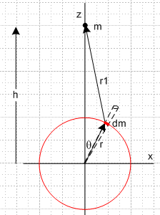

where dm is the tiny mass of a spherical shell located at θ with solid angle tube dΩ, so

dm = σdA = σr2dΩ = σr2sinθdθdφ

One feels that the upper half of the sphere (or in this case shell) is closer to the mass m and so the pull on the upper half should be larger than on the lower half and that this should offset the center of gravity point so it lies above the origin in the above picture. And if h is very large, then this cog should approach the cms point. This is after all what happens in the vertical tethered satellite problem.
But as I will show two ways below, the cog is always exactly at the cms for a shell or sphere, so something is wrong with one's intuition. It helps to recall that if the tethered satellite is horizontal, then the cog is in fact farther away than distance h, so maybe the sphere combines these two effects.

Two equal mass with θ = 0: R = h < h cog closer

Two equal mass with θ = π/2: R = h (1 + (r/h)2)3/4 > h cog farther

So here you see how you can get offsetting effects for a set of 4 masses at the compass points. This is what must be happening in the integration.

You cannot have cancellation in any other case. For example, I wrote the sum of an upper and lower ring, but they together do not have a cog at the cms point. Only the full shell is spherically symmetric, so it can be replaced by a mass at its center which mass of course has a symmetric force field.

Derivation #1.

Gauss's Law:

divE = 4πρ ⇔ ∫V (4πρ)dV = ∫S E • dS

so get

4πQ = Er 4πr2 ⇒ Er = Q/r2

For gravity have ρ = mass density and

divF = 4πGρ ⇔ ∫V (4πGρ)dV = ∫S F • dS

so get

4πGM = 4πr2Fr ⇒ Fr = GM/r2

The idea is simply stated. Outside a shell of uniform mass density, the Fr field must be symmetric. Thus it can be modeled by a point mass at the cms point. If you are outside such a shell, you cannot tell that it is not a point mass. No matter how close you put a test mass, the shell still acts as a point M. To cog is the same as cms.

Derivation #2.

This integration is done in Halliday and Resnick in a simple form, but I will do it in a messier form that is perhaps more standard. Repeat the above picture

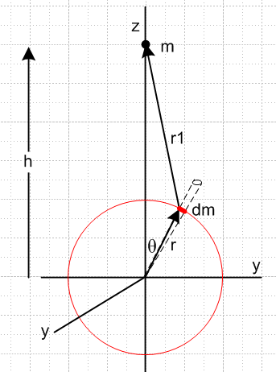

Let dF be the force of m acting on dm. Then

dF = (Gmdm/r12)1 = (Gmdm/r13)r1 dm = σr2sinθdθdφ

But (picture should show dm at more general point r,θ,φ )

r1 = rsinθcosφ + rsinθsinφ + (h-rcosθ)

r12 = r2 + h2 - 2rhcosθ

Then

dFx = (Gm/r13) σr2sinθdθdφ* rsinθcosφ

dFy = (Gm/r13) σr2sinθdθdφ* rsinθsinφ

dFz = (Gm/r13) σr2sinθdθdφ * (h-rcosθ)

Now integrate dφ from 0 to 2π to get a ring of mass on the shell. But sinφ has zero integral over this range and so does cosφ, so the first two terms integrate to nothing. We are left with

dFz = (Gm/r13) σr2sinθdθ 2π * (h-rcosθ)

Then

dFz = (mG/2) (4πr2σ) dθ sinθ (h-rcosθ)/r13

= (mG/2) M dθ $\frac{sinθ (h-rcosθ)}{(r2+h2-2rhcosθ)3/2}$

and finally

Fz = (1/2) (GMm) $^{\int_{0}^{π}{}}$dθ $\frac{sinθ (h-rcosθ)}{(r2+h2-2rhcosθ)3/2}$

We throw this integral into Maple:

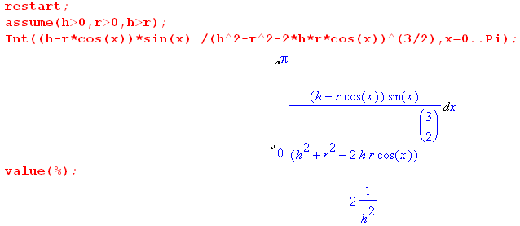

and conclude then that

Fz = (1/2) (GMm) * *2/h2 = (GMm)/h2

But this is the same force that mass m would experience from a point charge at the origin which has the mass of the shell. This the cog is at the origin, and the cog coincides with the cms point for all h > r. If h is < r, you get
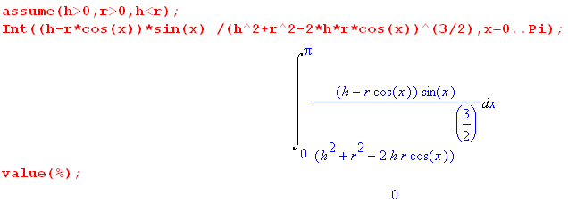

so in this case the test charge m experiences no force at all. This is one of those famous discontinuous integrals. Hal and Res shows in a simpler way how this all works.
Here is a quote from Symon

