This was installed on 1.29.17, do not edit here.

E.1 Angle Conventions 1
E.2 Matrix Approach 1
E.3 The motion of a particle in spherical coordinates 5
E.4 Curvilinear coordinates approach 6
E.5 Polar Coordinates 7

Appendix E: Spherical Coordinates and Unit Vectors

E.1 Angle Conventions

Here is our "physics" convention for spherical coordinates angles θ and φ :

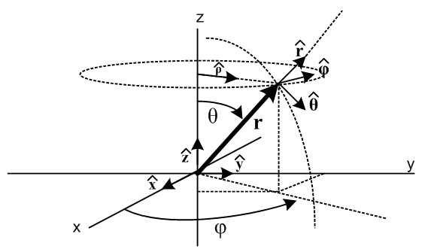 (E.1.1)

The reader is advised that the results below are often quoted in the literature with θ↔φ which is the "math" convention (eg, Wolfram, left below). Sometimes after doing θ↔φ some sources replace polar angle φ with latitude π/2 - φ (right below) :

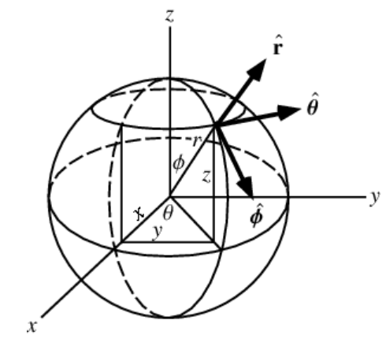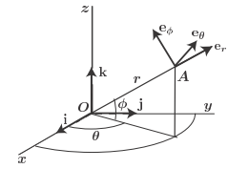
Two spherical angle conventions we do not use.

In the right picture, φ and θ might be longitude and latitude, or right ascension and declination.

If you are in charge of getting a spacecraft to Vulcan, please pay attention to these conventions.

E.2 Matrix Approach

The usual matrices for actively rotating a vector about the x, y, or z axis are these:

Rx(θ) = 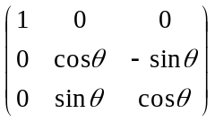 Ry(θ) = 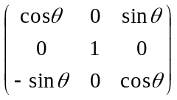 Rz(θ) = 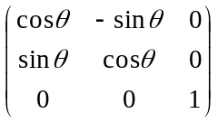 .
(E.2.1)
The Cartesian unit vectors , . can be rotated into the spherical unit vectors , , as follows

= Rz(φ) Ry(θ) = 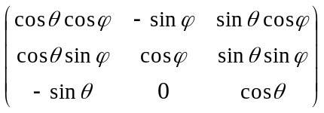$\left(\begin{matrix}1 \\ 0 \\ 0\end{matrix}\right)$ = $\left(\begin{matrix}cosθcosφ \\ cosθsinφ \\ -sinθ\end{matrix}\right)$ = •••

= Rz(φ) Ry(θ) = $\left(\begin{matrix}0 \\ 1 \\ 0\end{matrix}\right)$ = $\left(\begin{matrix}-sinφ \\ cosφ \\ 0\end{matrix}\right)$
= Rz(φ) Ry(θ) = $\left(\begin{matrix}0 \\ 0 \\ 1\end{matrix}\right)$ = $\left(\begin{matrix}sinθcosφ \\ sinθsinφ \\ cosθ\end{matrix}\right)$ . (E.2.2)

One can interpret the elements of the vectors on the right as dot products as we show on the first line. Notice that these three vectors on the right are just the columns of the matrix shown, so one can say

( ) = = Rz(φ) Ry(θ) ≡ R . (E.2.3)

It is then obvious that

••••••••• = = Rz(φ) Ry(θ) = R (E.2.4)

from which one can read off any desired dot product. As verification, consider an example,

Example: • = • (R) = Σi ()i(R)i = Σij()iRij()j = Σijδ2iRijδ1j = R21.

Looking at the last equation of (E.2.2) multiplied by r, since r = r one sees that

x = rsinθcosφ
y = rsinθsinφ
z = rcosθ (E.2.5)

which is the "inverse transformation" associated with spherical coordinates. See Section E.4 below.

The three equations (E.2.2) can be trivially written out as follows (changing to a standard r,θ,φ order)

= sinθcosφ + sinθsinφ + cosθ
= cosθcosφ + cosθsinφ - sinθ
= -sinφ + cosφ (E.2.6)

which can be inverted to give

= sinθcosφ + cosθcosφ - sinφ
= sinθsinφ + cosθsinφ + cosφ
= cosθ - sinθ . (E.2.7)

For those not wanting to invert the 3x3 matrix R, (E.2.7) can be quickly verified by looking at the unit vector dot products in (E.2.4). Eq. (E.2.6) can be similarly verified .

The spherical unit vectors are orthogonal due to their construction in (E.2.3).

Example: • = (R ) • (R ) = • (RTR) = • = 0

Example: • = (R ) • (R ) = • (RTR) = • = 1

Here R ≡ Rz(φ) Ry(θ) has the property RTR = 1 since it is a rotation. So

• = • = • = 0 . (E.2.8)

The spatial derivatives of the spherical unit vectors are easy to compute (∂θ means ∂/∂θ ),

∂r = 0 ∂θ = ∂φ = sinθ
∂r = 0 ∂θ = - ∂φ = cosθ
∂r = 0 ∂θ = 0 ∂φ = -sinθ -cosθ . (E.2.9)

Example: ∂θ = ∂θ $\left(\begin{matrix}cosθcosφ \\ cosθsinφ \\ -sinθ\end{matrix}\right)$ = $\left(\begin{matrix}-sinθcosφ \\ -sinθsinφ \\ -cosθ\end{matrix}\right)$ = - .

In Fig (E.1.1) one can see for example that ∂θ = . Often one draws a little triangle to verify an equation like this:
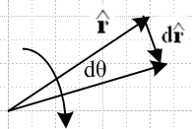 (E.2.10)

d = dr ≈ 1*dθ = dθ ⇒ d = dθ ⇒ = d/dθ = ∂θ .

Time derivatives of the unit vectors are then obtained by the chain rule ( ∂t means d/dt ),

∂t = + sinθ
∂t = – + cosθ
∂t = – sinθ – cosθ . (E.2.11)

Example: ∂t = (∂r) + (∂θ) + (∂φ) = 0 + + sinθ .

Note: If we regard r,θ,φ as coordinates of Frame S, then ∂t = (d/dt)S = ∂S as in Section 1.7 and 1.8.

The cross products of the spherical unit vectors follow the right hand rule, so looking at Fig (E.1.1):

x = x = x = (E.2.12)

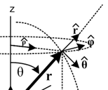

The first cross product has ordering r,θ,φ and the last two are cyclic permutations. Here are some other cross products:

x = [sinθcosφ + cosθcosφ - sinφ ] x = - cosθcosφ - sinφ
x = [sinθcosφ + cosθcosφ - sinφ ] x = sinθcosφ + sinφ
x = [sinθcosφ + cosθcosφ - sinφ ] x = -sinθ cosφ + cosθcosφ (E.2.13)

x = [ sinθsinφ + cosθsinφ + cosφ ] x = -cosθsinφ + cosφ
x = [ sinθsinφ + cosθsinφ + cosφ ] x = sinθsinφ - cosφ
x = [ sinθsinφ + cosθsinφ + cosφ ] x = - sinθsinφ + sinθsinφ (E.2.14)

x = [cosθ - sinθ ] x = sinθ
x = [cosθ - sinθ ] x = cosθ
x = [cosθ - sinθ ] x = -cosθ - sinθ (E.2.15)

E.3 The motion of a particle in spherical coordinates

The equations below are easily derived from (E.2.11):

r = r // position (E.3.1)

v = vr + vθ + vφ // velocity
vr =
vθ = r
vφ = r sinθ (E.3.2)

a = ar + aθ + aφ // acceleration
ar = - r2 – r 2 sin2θ
aθ = 2 + r - r 2 sinθ cosθ
aφ = 2 sinθ + 2 r cosθ + rsinθ . (E.3.3)

Example: v = = ∂t(r) = + r(∂t) = + r[ + sinθ ] = + r + rsinθ .

Notice that r ≠ ar and similarly for other components.

If for some reason particle motion is restricted to a spherical surface of radius r (such as in our dumbbell satellite), we can set = = 0 in the above equations to get

r = r // position (E.3.4)

v = vθ + vφ // velocity is tangent to the sphere : r • v = 0
vθ = r
vφ = r sinθ (E.3.5)

a = ar + aθ + aφ // acceleration
ar = - r2 – r 2 sin2θ
aθ = r - r 2 sinθ cosθ
aφ = 2 r cosθ + rsinθ . (E.3.6)

From these equations many other useful results can be obtained, for example,

x v = vθ x + vφ x = vθ – vφ

x a = aθ x + aφ x = aθ – aφ (E.3.7)

E.4 Curvilinear coordinates approach

Spherical coordinates are defined by the "inverse transformation" on the left below:

inverse transformation transformation
x = rsinθcosφ r = +$\sqrt{x2+y2+z2}$ 0 ≤ r < ∞
y = rsinθsinφ cosθ = z/r 0 ≤ θ ≤ π -1 ≤ cosθ ≤ 1
z = rcosθ sinθ = +$\sqrt{1-(z/r)2}$ 0 ≤ sinθ ≤ 1
sinφ = y/(rsinθ) -1 ≤ sinφ ≤ 1
cosφ = x/(rsinθ) 0 ≤ φ < 2π -1 ≤ cosφ ≤ 1 (E.4.1)

We quote now a set of results from our Tensor document which won't be needed but which we include for "completeness". Equation numbers (...)T refer to that document.

Spherical coordinates are just an example of curvilinear coordinates which fit into a general formalism:

x = (x1, x2, x3 ) = (x,y,z) // x-space coordinates
x' = (x1', x2',x3') = (r,θ,φ) // x'-space coordinates

x = F-1(x') ↔ x = rsinθcosφ // a non-linear inverse transformation
y = rsinθsinφ
z = rcosθ . (1.6)T

The linearized transformation local to a point defines certain R and S matrices (the "differentials") :
dx' = R(x) dx Rik(x) ≡ (∂x'i/∂xk) R = S-1 // dx'i = Rij dxj
dx = S(x') dx' Sik(x') ≡ (∂xi/∂x'k) S = R-1 // dxi = Sij dx'j . (2.1.6)T

S = $\left(\begin{matrix}sinθcosφ & rcosθcosφ & -rsinθsinφ \\ sinθsinφ & rcosθsinφ & rsinθcosφ \\ cosθ & -rsinθ & 0\end{matrix}\right)$ // compute from above definition of Sij (3.4.4)T

' = STS = $\left(\begin{matrix}1 & 0 & 0 \\ 0 & r2 & 0 \\ 0 & 0 & r2sin2θ\end{matrix}\right)$, det(') = r4sin2θ // metric tensor and its determinant (5.13.14)T

J(r,θ,φ) = det(S) = = r2sinθ . // Jacobian (5.13.16)T

(ds)2 = Σij'ij dx'i dxj = (dr)2 + r2(dθ)2 + r2sin2(dφ)2 // distance (5.13.18)T

Because the metric tensor ' is diagonal, the coordinates r,θ.φ are orthogonal.

E.5 Polar Coordinates

Here we use a notation common for two of the cylindrical coordinates (ρ,φ,z),

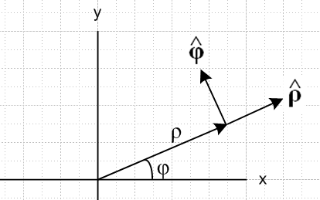 (E.5.1)

x = ρcosφ
y = ρsinφ (E.5.2)

= cosφ + sinφ = Rz(φ)
= -sinφ + cosφ = Rz(φ) (E.5.3)

= cosφ – sinφ = Rz(-φ)
= sinφ + cosφ = Rz(-φ) (E.5.4)

• = cosφ • = sinφ
• = -sinφ • = cosφ (E.5.5)

=
= - (E.5.6)

Proof of (E.5.6) :

= d/dt = d/dt(cosφ + sinφ ) = -sinφ + cosφ
= -sinφ [cosφ – sinφ ] + cosφ [ sinφ + cosφ ]
=

= d/dt = d/dt( -sinφ + cosφ ) = -cosφ - sinφ
= -cosφ [cosφ – sinφ ] - sinφ [ sinφ + cosφ ]
= -

E.6 The Affine Connection

Recall from above the claim that

∂r = 0 ∂θ = ∂φ = sinθ
∂r = 0 ∂θ = - ∂φ = cosθ
∂r = 0 ∂θ = 0 ∂φ = -sinθ -cosθ . (E.2.9) (E.6.1)

We wish to put these equations into a more general framework.

In the notation of our Tensor Analysis document, for an arbitrary curvilinear coordinate system x' the derivatives of the tangent base vectors (called en in that document) are written

∂'jen = ΣiΓ 'ijn ei . (E.6.2)

This just says that the change in a basis vector obtained by moving a small amount in some direction is (and of course must be) some linear combination of the basis vectors. The coefficients of the linear combination are known as the affine connection (or Levi-Civita connection) Γ 'cab = Γ 'cba. The reason for the primes is that Cartesian coordinates are thought of as x, while curvilinear ones of some particular type are x'. In Cartesian x-space one has Γcab = 0 because basis vectors don't vary in space. Then Γ'cab is the affine connection in x'-space. For example, in spherical coordinates one has

x = (x1,x2,x3) = (x,y,z)
x' = (x'1,x'2,x'3) = (r,θ,φ) (E.6.3)

and the inverse transformation (E.2.5) is x = F-1(x'). As shown below, e1(x') = e1(r,θ,φ) = and then as an example of (E.6.2) we write (for j=2 and n=1, and the linear combination has only one non-zero term):

∂'2e1 = ∂x$_{2}$'e1 = ∂θe1(r,θ,φ) = ∂θ(r,θ,φ) = = (1/r)eθ = (1/r)e2 = Γ' 221 e2 = Γθθr eθ . (E.6.4)

The curvilinear unit basis vectors n are related to the tangent base vectors by n = (1/h'n) en where the h'n = |en| are the so-called scale factors. The derivatives of the n are then given by :

∂'jn = ∂'j(h'n-1en) = (∂'jh'n-1)en + h'n-1(∂'jen)

= - h'n-2 (∂'jh'n) en + h'n-1( ΣiΓ 'ijn ei)

= - h'n-1 (∂'jh'n) n + h'n-1( ΣiΓ 'ijn h'i i)

= (1/h'n) [Σi h'i Γ 'ijni – (∂'jh'n) n] . (E.6.5)

In Tensor the Cartesian basis vectors of x-space are called ui, but in this document they are called ei so we need a different symbol ei for the tangent base vectors. In Section 14 we use these ei with i as the unit tangent base vectors, ξ = (ξ1,ξ2,ξ3) in place of x' = (x'1,x'2,x'3), and Γ' = Γ with no prime since ξ has no prime (trying not to confuse Γ = 0 of x-space with Γ ≠ 0 of ξ-space). In this notation (E.6.5) would appear as

(∂n/∂ξj) = (1/hn) [Σi(hiΓ ijni) - (∂hn/∂ξj)n] . (E.6.6)

Going back to the Tensor notation, the affine connection for a coordinate system is related to the system's metric tensor g according to

Γdab = (1/2) gdc [ ∂agbc + ∂bgca – ∂cgab] = 0 since gij = δij x-space (Cartesian)

Γ'dab = (1/2) g'dc [ ∂'ag'bc + ∂'bg'ca – ∂'cg'ab] . x'-space (E.6.7)

For spherical coordinates, one has (using r,θ,φ = 1,2,3 where θ = polar, φ = azimuth)

1 2 3
hr = 1 hθ = r hφ = rsinθ // scale factors (h'1= hr)
er = eθ = r eφ = rsinθ // tangent base vectors (e1 = er)
r = θ = φ = // curvilinear unit basis vectors

g'ab = $\left(\begin{matrix}1 & 0 & 0 \\ 0 & r2 & 0 \\ 0 & 0 & r2sin2θ\end{matrix}\right)$ g'ab = inverse(g'ab) // metric tensor (E.6.8)

where for example g'33 = gφφ = r2sin2θ. For spherical coordinates only 9 of the 27 elements of Γ'dab are non-zero (computed from (E.6.7)) :

Γ' 122 = - r Γ' 212 = Γ' 221 = 1/r // notation example: Γ' 122 = Γrθθ
Γ' 133 = - r sin2θ Γ' 313 = Γ' 331 = 1/r
Γ' 233 = - cosθsinθ Γ' 323 = Γ' 332 = cotθ . (E.6.9)

Example done in Section 14 notation with (E.6.6) :

(∂n/∂ξj) = (1/hn) [Σi(hiΓ ijni) - (∂hn/∂ξj)n]

(∂3/∂ξ2) = (1/h3) [Σi(hiΓ i23i) - (∂h3/∂ξ2)3]

(∂/∂θ) = (1/rsinθ) [(h3Γ 3233) - (∂[rsinθ]/∂θ)3]

= (1/rsinθ) [(rsinθ * cotθ * ) - rcosθ * ]

= (1/rsinθ) [rcosθ - rcosθ ]

= 0 (E.6.10)

and with some effort we have verified that ∂θ = 0 as appears in (E.6.1). This fact is of course obvious just looking at Fig (E.1.1), but things can be less obvious in obscure coordinate systems.

