Show that Cartesian EOM give Angular EOM PhL 1.13.17

• In Section F.5 I use the torque equations to obtain angular equations of motion as follows

+ sinθcosθ(3ω2 - 2) + ωsinθcosφ (ω cosθ cosφ - 2sinθ ) = 0 //
+ 2 cotθ – ωcosφ (ωsinφ -2) = 0 // (*) (F.5.7)

• In Section F.6 I use force equations to verify each of the above equations.

• In Section F.8 I derive two EOM directly in Cartesian coordinates, they are

1 y - x = - ω2xy - 2ωx // when converted to θ,φ this matches (F.5.7)
2 z - x = (ω2b3/r'13)bx - ω2(b+z)x + 2ωx where r'12 = r12 + b2 + 2bz (**)

• In Maple "show cart EOM equals ang EOM.mws" I show the first equation of (**) replicates the second equation of (*), giving then a triple derivation of this equation.

I think that the first equation of (*) is a certain linear combination of the two equations in (**). When I have Maple apply this linear combination, I obtain the first equation of (*) BUT the red term is missing. This term is part of the "constant" in that equation. I spent about 2 hours yesterday trying to find the error but failed, so today I will resume.

One bedtime idea is to write all equations assuming velocities are all 0, which should bring a focus on the constant terms! So start with (F.8.1) and examine only constant terms:

Feff,1 = m1 a1 (F.6.5) (F.8.1)
≈ - (GMEm1/r'13)r'1 - T 1 – m1S' – m1ω x (ω x r1) – 2m1 ω x v1 – m1 x r1 .
1 2 3 4 5 6

Term 1: - (GMEm1/r'13)r'1 = - (GMEm1/r'13)(b + r1)

= - (GMEm1/r'13) [ b + x + y + z ]

= - (GMEm1/r'13) [ x + y + (b+z) ] (F.8.3)

Term 2: - T 1 = -(T/r1)r1 = -(T/r1) [ x + y + z] (F.8.4)

Term 3: – m1S' = – m1 x b - m1 ω x (ω x b) // (F.6.3)

= - m1ω x (ω x b) // satellite in circular orbit, = 0

= - m1(ω•b)ω + m1ω2b //- A x (A x C) = -(A•C)A + A2C

= m1ω2b = m1ω2b (F.8.5)

Term 4: – m1ω x (ω x r1) = -m1(ω•r1)ω + m1ω2r1 // identity shown above

= -m1ω2(•r1) + m1ω2r1 = -m1ω2(x) + m1ω2 [ x + y + z]

= m1ω2 [ y + z] (F.8.6)

Terms 5 and 6 make no contribution. So unfortunately MOST terms contribute to the constant part.

I now assemble the equations

Feff,1 = m1 a (F.8.1)
≈ - (GMEm1/r'13)r'1 - T 1 – m1S' – m1ω x (ω x r1) – 2m1 ω x v1 – m1 x r1
1 2 3 4 5 6

: m1 ax = - (GMEm1/r'13) x - (T/r1)x ok
1 2
: m1 ay = - (GMEm1/r'13) y - (T/r1)y + m1ω2y + 2m1ωvz ok
1 2 4
: m1 az = - (GMEm1/r'13) (b+z) - (T/r1)z + m1ω2b + m1ω2z - 2m1ωvy ok (F.8.9)
1 2 3 4

I then rewrite the three equations :

= - [(ω2b3/r'13) + (T/m1r1)]x ok

= - [(ω2b3/r'13) + (T/m1r1) - ω2]y + 2ωvz ok

= - [(ω2b3/r'13) - ω2](b+z) - (T/m1r1)z - 2ωvy ok

I then define

A ≡ (ω2b3/r'13)
B ≡ (T/m1r1) // rescaled tension

and equations become

1 = - (A + B)x ok

2 = - (A + B - ω2)y + 2ωvz ok

3 = - (A - ω2)(b+z) - Bz - 2ωvy ok

I eliminate B from the first two equations and end up with

y - x = -ω2xy - 2ωzvz

When this equation is "converted to θ,φ" I get exactly the second equation of (F.5.7) so I don't have doubts about the above elimination.

I then eliminate B from the first and third equations

1*z z = - (A + B)xz ok

3*x x = - (A - ω2)(b+z)x - Bxz - 2ωxvy ok

= -Abx -Azx +ω2(b+z)x - Bxz- 2ωxvy ok

= - (A + B)xz - Abx +ω2(b+z)x- 2ωxvy ok

Subtract so that the -(A + B)xy terms cancel,

z - x = Abx - ω2(b+z)x + 2ωxvy (F.8.14)

At this point then the two Cartesian equations are

1 y - x = - ω2xy // when converted to θ,φ this matches (F.5.7)

2 z - x = (ω2b3/r'13)bx - ω2(b+z)x + 2ωxvy

A supporting equation is this

r'12 = (r1+b)2 = r12 + b2 + 2 r1• b = r12 + b2 + 2 r1• [b] = r12 + b2 + 2bz . ok (F.8.11)

I then do the far approximation for the first term in 2 :

r'12 = r12 + b2 + 2bz = b2 [ 1 + (r1/b)2 + 2(z/b)] ≈ b2[ 1 + 2(z/b) ] ok

r'1-2 ≈ b-2 [1-2(z/b)] ok

r'1-3 ≈ b-3 [1-2(z/b)]3/2 ≈ b-3 [ 1 +(3/2)(-2(z/b)] = b-3 [ 1 - 3(z/b)] ok
so
(b/r'1)3 = 1 - 3(z/b) ok

Equation 2 above then becomes

z - x = (ω2b3/r'13)bx - ω2(b+z)x+ 2ωxvy ok

= ω2[1 - 3(z/b) ]bx - ω2(b+z)x+ 2ωxvy ok

= ω2bx - 3(z/b)ω2bx - ω2bx - ω2zx+ 2ωxvy ok

= - 3(z/b)ω2bx - ω2zx+ 2ωxvy ok

= - 3ω2xz - ω2zx+ 2ωxvy ok

= - 4ω2xz+ 2ωxvy ok

My two equations in the far approximation are then

2 y - x = - ω2xy - 2ωzvz // when converted to θ,φ this matches (F.5.7)

1 z - x = - 4ω2xz + 2ωxvy // renumber equations here!

I now see that I must include the velocity terms after all because they will contribute when I convert to the θ and φ coordinates! These come only from Term 5.

Term 5: -2m1 ω x v1 = -2m1 [ω] x ( vx + vy + vz)

= -2m1ω [ vy - vz] (F.8.7)

so these add terms to the z and y equations above. Go install these now in blue. Done.

I now go to "show cart EOM....mws" and I enter equations which will do the conversion of these EOM's from Cart to Spher coordinates:

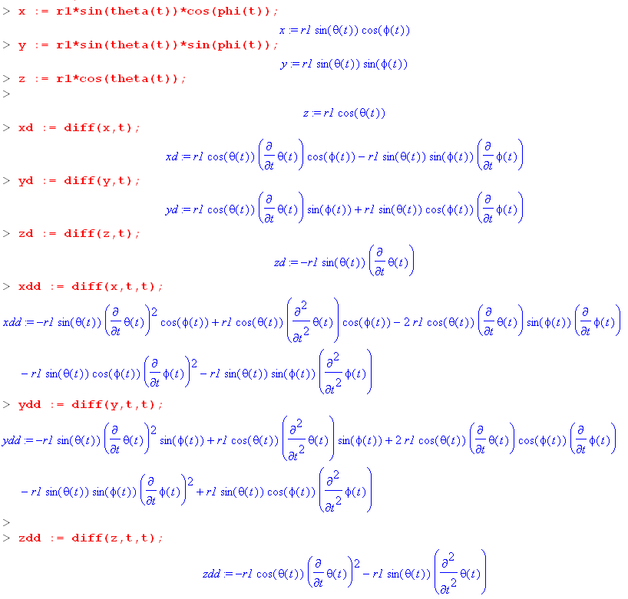

I then use these objects in my entry of the two equations of interest.

Here is how I process equation 2

2 y - x = - ω2xy - 2ωzvz

First you see it properly entered as eq2. I divide by r12 , make a subs

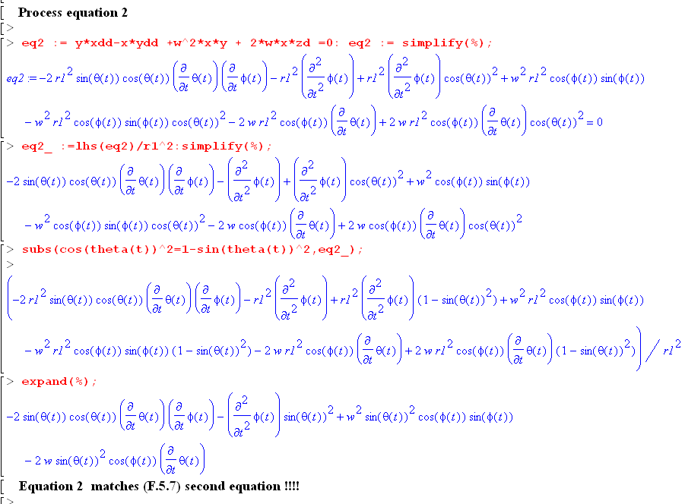

I want to compare this equation to

+ 2 cotθ – ωcosφ (ωsinφ -2) = 0

For comparison, multiply the above equation by -sin2θ

-sin2θ - 2 cosθsinθ + sin2θωcosφ (ωsinφ -2) = 0
or
-sin2θ - 2 cosθsinθ + ω2sin2θcosφ sinφ -sin2θωcosφ 2 = 0

Now reorder the terms

- 2 cosθsinθ -sin2θ + ω2sin2θcosφ sinφ - 2ωsin2θcosφ = 0

This agrees exactly with the last blue Maple equation above, so I conclude that the Cart equation 2 is exactly the same as the angular equation 2.

Now look at eq1.

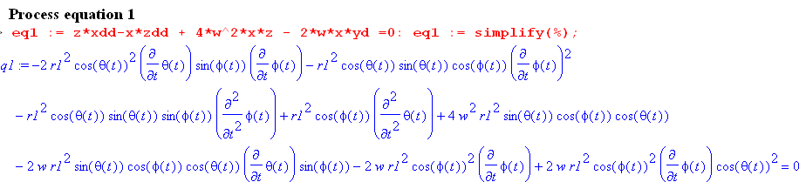
(1)

You can see that I have properly entered my equation 1 which is this

1 z - x = - 4ω2xz + 2ωxvy (2)

Here is the equation I am aiming for, taken from (*) above,

+ sinθcosθ(3ω2 - 2) + ωsinθcosφ (ω cosθ cosφ - 2sinθ ) = 0 (3)

This target equation (3) has no term, but Maple (*) for eq1 does have such a term. This tells me that in order to get (3), I will have to do a linear combination of Maple eq2 and eq1 so as to cancel the term.

So at this point in Maple we have

eq1 := -2r12cos2θ sinφ + stuff

eq2: = -2r12sinθcosθ + stuff

Consider now

eq1 * sinθ = -2r12sinθ cos2θ sinφ + stuff

eq2 * cosθsinφ = -2r12sinθcos2θ sinφ + stuff

Therefore this should cancel if I make this definition

eq3 := sinθ * lhs(eq1) - cosθsinφ * lhs(eq2)

I will now try this linear combination in Maple :

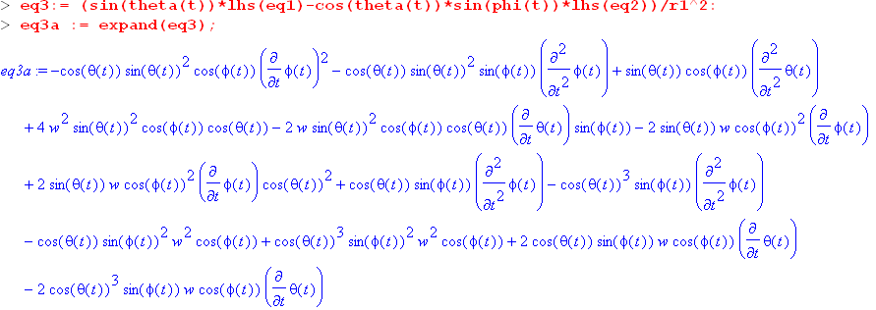

Looking through the terms we see that there is no term, so the desired cancellation has been achieved. A guiding term here is sinθ cosφ . Now we need to simplify getting rid of cos3(θ):

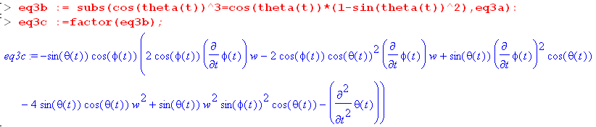

Next divide out the leading factor sinθcosφ and then do another subs:

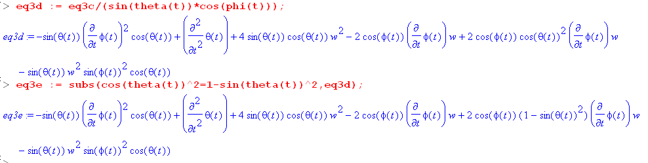

I will now manually translate the final result of 6 terms

-sinθcosθ 2 + + 4ω2sinθcosθ - 2ωcosφ + 2ωcos2θ cosφ - ω2sinθcosθsin2φ

and I now reorder these terms

- sinθcosθ 2 + 4ω2sinθcosθ - ω2sinθcosθsin2φ +2ωcosφ (cos2θ - 1)
or
- sinθcosθ 2 + 4ω2sinθcosθ - ω2sinθcosθsin2φ - 2ωcosφsin2θ A = Maple

Now the target here is this from (*) above

+ sinθcosθ(3ω2 - 2) + ωsinθcosφ (ω cosθ cosφ - 2sinθ ) = 0
or
- sinθcosθ 2 + 3ω2sinθcosθ + ω2sinθcosθcos2φ - 2ωsin2θcosφ B = target
ok ok ok

If I can show that the "constant terms" are the same, then the game is won!

4ω2sinθcosθ - ω2sinθcosθsin2φ = 3ω2sinθcosθ + ω2sinθcosθcos2φ ?

4ω2cosθ - ω2cosθsin2φ = 3ω2cosθ + ω2cosθcos2φ ?

4ω2cosθ - ω2cosθ(1-cos2φ) = 3ω2cosθ + ω2cosθcos2φ ?

4ω2cosθ - ω2cosθ + ω2cosθcos2φ = 3ω2cosθ + ω2cosθcos2φ ?

3ω2cosθ + ω2cosθcos2φ = 3ω2cosθ + ω2cosθcos2φ yes !!!!!!!

So finally it works, hurray hurray !!!!!!

Now how can I do all this more efficiently! here again is the target equation:

+ sinθcosθ(3ω2 - 2) + ωsinθcosφ (ω cosθ cosφ - 2sinθ ) = 0

+ 3ω2sinθcosθ -sinθcosθ 2 + ω2sinθcosθcos2φ - 2ωsin2θcosφ

- sinθcosθ 2 + [3ω2sinθcosθ + ω2sinθcosθcos2φ ] - 2ωsin2θcosφ

- sinθcosθ 2 + ω2sinθcosθ[3 + cos2φ ] - 2ωsin2θcosφ

- sinθcosθ 2 - 2ωsin2θcosφ + ω2sinθcosθ(3 + cos2φ)

- sinθcosθ 2 +ωsinθ( -2sinθcosφ + ωcosθ(3+cos2φ))

Nothing is very elegant.

