New Tether Torque Work PhL 12.13.16

At this point I have fully updated frames doc to be new frames doc with new eq nums and various changes. I think all the torque stuff is correct now. I have also written new App D and I think it is OK too. So now I return to the problem of the motion of the satellite. I will do it scratch here and then write a final section on this topic for App D.

Here is the current App D picture. I am now happy that the thing will in effect rotate about the CMS.

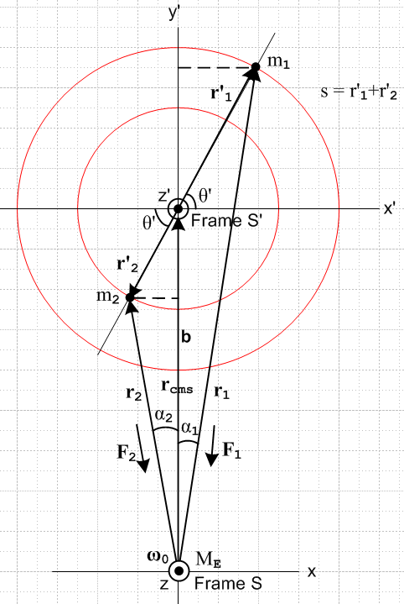

So let's start as if there were no fictitious forces in Frame S'. By the way, Frame S' is going to rotate, so its axes are going to move relative to the Frame S axes, they just line up at t = 0. I just added notes to that effect in Section D.2.

OK, here we go inside Frame S'. Start with

L'(c')S' ≡ (r'-c') x mv'S' = (r'-c') x mv' = (r'-c') x p' ≡ L'(c') (1.9.3)

But we are going to use c' = 0 so the torque ref point is Frame S' origin. Then

L'(0)S' ≡ r' x mv'S' = r' x mv' = r' x p' ≡ L'(0) (1.9.3)

For mass m1 we have

L'(0)1 = r1' x m1v'1

where we don't really know much about v'1, it might not be in the plane of paper. But fine. And

L'(0)2 = r2' x m2v'2

I do know that

m1r'1 = m2r'2 or r'2/r'1 = m1/m2 or m1r'1 = - m2r'2 . (D.2.8)

and it seems likely that we can apply ∂S' to get

m1v'1 = - m2v'2

so therefore

L'(0)1 = m1r1' x v'1

STOP and resolve this paradox: Based on the above we get

'(0)1 = m1v1' x v'1 + m1r1' x a'1 = m1r1' x a'1

Suppose Frame S' is at rest and suppose m1 is doing planar circular motion. Then

a'1 = - ω'2r'1

and this then says '(0)1 = 0. I guess by assuming circular motion, you are assuming no torque! So maybe instead (assuming planar v'1)

v'1 = ω'(t) r'1 ' // which would be true for circular motion

a'1 = '(t) r'1 ' + ω'(t) r'1 (∂S'')

I think that

(∂S'') = -ω' '

so then we get

a'1 = '(t) r'1 ' - ω'(t)2 r'1 1'

and then

'(0)1 = m1r1' x a'1 = m1r1' x [ '(t) r'1 '1] = m1r'1'(t) r1'x '1 = m1r'12'(t) 1'x '1

and the paradox is resolved. Torque on this particle in forced circular motion changes ω' . The other particle will have

'(0)2 = m2r'2'(t) r2'x '2
= m1r'1'(t) r'2 2'x '2
= m1r'1'(t) (m1/m2)r'1 (-'1)x (-'1)
= m1r'12'(t) (m1/m2) 1'x '1

So add to get

'(0) = '(0)1 + '(0)2 = m1r'12'(t) 1'x '1 + m1r'12'(t) (m1/m2) 1'x '1

= m1r'12'(t) [ 1 + (m1/m2) ] 1'x '1

= (m1/m2) M r'12'(t) 1'x '1

= (m1/m2) M r'12'(t) '

= (m1/m2) M r'12'(t) '

and finally we have our ' ODE quantity.

The total ang mom of our little satellite system inside Frame S' is given by

L'(0) = L'(0)1 + L'(0)2

= m1r1' x v'1 + (m12/m2) r'1 x v'1

= [ m1 + (m12/m2)] r1' x v'1 = m1 [ 1 + (m1/m2)] r1' x v'1

= m1 [(m1+m2)/m2] r1' x v'1 = M(m1/m2) r1' x v'1

This result does not assume v'1 is planar.

Conclusion: The total satellite angular momentum in Frame S' is given by

L'(0) = (m1/m2) M r1' x v'1 M = m1+ m2

Since v'1 might not be in the plane of paper, L'(0) might not be perp to paper, so that is certainly a complication. If we make the ansatz of planar v'1 then we get

r1' x v'1 = r'1v'1 ' = ω' r'12 ' so in that case

L'(0) = (m1/m2) M ω' r'12 '

Then it is pretty obvious that

'(0) = (m1/m2) M ' r'12 ' = (m1/m2) M r'12' '

in agreement with the above.

Then in Frame S' we can say

N'(b)eff = '(0) = (m1/m2) M r'12' ' .

where the b is our convention for labeling the effective torque.

Now we also have,

N'(0)eff = N(b) + N'(0)fict // defines N'(c')fict (11.3.5)

N'(c')fict = - (r'-c') x [ mS +mω x (ω x r') + 2m ω x v' + m x r']
+ m(' + ω x c' + S) x ( v' + ω x r' + S) – m' x v' (11.3.10)

N'(0)fict = - (r'-0) x [ mS +mω x (ω x r') + 2m ω x v' + m x r']
+ m(0+ ω x 0 + S) x ( v' + ω x r' + S) – m0 x v' (11.3.10)

N'(0)fict = - r' x [ mS +mω x (ω x r') + 2m ω x v' + m x r']
+ m S x ( v' + ω x r') (11.3.10)

Now what is N(b), the torque referenced to point b = rcms in Frame S?

N(b) = r'1 x F1 + r'2 x F2

where all four of these vectors are shown in the figure. Recall that

F1 = - (GMEm1/r12) 1 = - (GMEm1/r13) r1
F2 = - (GMEm2/r22) 2 = - (GMEm2/r23) r2 . (D.2.13)

Note that we really should include the stick tension/compression T since these are supposed to be total forces, but luckily r'1 x T = r'2 x T = 0 so we can ignore T !

Now looking at our figure

r'1 x F1 = r'1 x [ - (GMEm1/r13) r1 ] = - (GMEm1/r13) r'1 x r1

r'2 x F2 = r'2 x [ - (GMEm2/r23) r2 ] = - (GMEm2/r23) r'2 x r2

so we are going to need these two cross products! This is then going to require more angle information, so I will rebuild my more complicated original figure. I need to add the two angles β1 and β2 which I try to define in a compatible manner, so

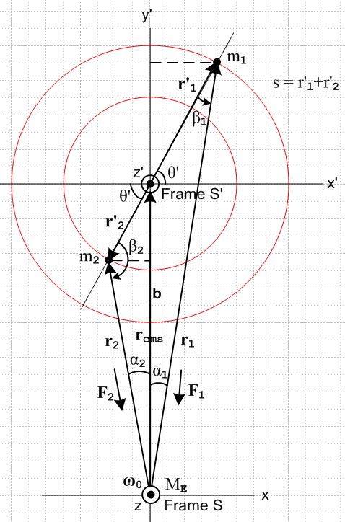

Then having done this, I can say

r'1 x r1 = r'1r1 sinβ1 '

r'2 x r2 = r'2r2 sinβ2 (-')

I added some small light guidelines to help one to confirm the above two equations.

Now we get to the angle stuff which I did not display early-on:

β1 + (θ'+π/2) + α1 = π
β2 + (π/2 - θ') + α2 = π

These are very easy to read off the picture and then we have

β1 + θ' + α1 = π/2 α1+θ' = π/2 - β1
β2 - θ' + α2 = π/2 α2- θ' = π/2 - β2

and

β1 = π/2 - [α1+θ']
β1 = π/2 - [α1-θ']

sinβ1 = sin{π/2 - [α1+θ']} = cos(α1+θ')
sinβ2 = sin{π/2 - [α2- θ']} = cos(α2- θ')

Thus we may write

r'1 x r1 = r'1r1 cos(α1+ θ') '
r'2 x r2 = r'2r2 cos(α2- θ')(-')

and then

r'1 x F1 = - (GMEm1/r13) r'1 x r1 = - (GMEm1/r13) r'1r1 cos(α1+ θ') '
r'2 x F2 = - (GMEm2/r23) r'2 x r2 = - (GMEm2/r23) r'2r2 cos(α2 - θ')(-')

This fine, but really the αi are "derived angles" and we already know that

sinα1 = ( r'1 cosθ') / r1 ⇒ r1sinα1 = r'1cosθ'
sinα2 = ( r'2 cosθ') / r2 ⇒ r2sinα2 = r'2cosθ' . (D.2.9)

cosα1 = (b + r'1sinθ')/r1 ⇒ r1cosα1 = b + r'1sinθ'
cosα2 = (b - r'2sinθ')/r2 ⇒ r2cosα2 = b - r'2sinθ' . (D.2.10)

Thus I could write things all out in a very complicated manner since

cos(α1 + θ') = cosα1cosθ' - sinα1sinθ'
cos(α2 - θ') = cosα2cosθ' + sinα2sinθ'
so
r1cos(α1 + θ') = r1cosα1cosθ' - r1sinα1sinθ'
r2cos(α2 - θ') = r2cosα2cosθ' + r2sinα2sinθ'

and then

r1cos(α1 + θ') = ( b + r'1sinθ')cosθ' - r'1cosθ'sinθ'
r2cos(α2 - θ') = (b - r'2sinθ')cosθ' + r'2cosθ'sinθ'
or
r1cos(α1 + θ') = bcosθ' + r'1cosθ'sinθ' - r'1cosθ'sinθ' = bcosθ'
r2cos(α2 - θ') = bcosθ' - r'2cosθ'sinθ' + r'2cosθ'sinθ' = bcosθ'

Oops, there must be a simpler way! Stare at the drawing. I can see that

b • r'1 = br'1cos(π/2-θ') = br'1sinθ'
b x r'1 = br'1sin(π/2-θ')(-') = br'1cosθ'

Not too helpful. I cannot see a simple to get the above, so maybe the above is wrong. But I checked and it seems right. So continue on:

I have now shown that

r1cos(α1 + θ') = bcosθ'
r2cos(α2 - θ') = bcosθ'

Therefore

r'1 x F1 = - (GMEm1/r13) r'1r1 cos(α1+ θ') ' = - (GMEm1/r13) r'1 bcosθ' '
r'2 x F2 = - (GMEm2/r23) r'2r2 cos(α2 - θ')(-') = - (GMEm2/r23) r'2 bcosθ' (-')

Finally we arrive at

N(b) = r'1 x F1 + r'2 x F2

= - (GMEm1/r13) r'1 bcosθ' ' - (GMEm2/r23) r'2 bcosθ' (-')

= -GMEbcosθ' [ (m1/r13) r'1 - (m2/r23) r'2 ] '

= GMEbcosθ' [ (m2 r'2/r23) - (r'1m1/r13) ] '

But now use

m1r'1 = m2r'2 or r'2/r'1 = m1/m2 (D.2.8)

and then

N(b) = GMEbcosθ' [ (m1r'1/r23) - (r'1m1/r13) ] '

= GMEbcosθ' m1r'1 [ (1/r23) - (1/r13) ] '

= GMEbcosθ' m1r'1 $\frac{r13 - r23}{r13r23}$ '

which might be reasonable! If the masses are equal, then r1 = r2 and we expect 0 torque. If the masses are not equal, then r1 ≠ r2 in the drawing, and then there is not zero torque! Also, if θ' = ±π/2 for vertical positions, then cosθ' = 0 and there is zero torque, so those positions might be stable.
I think this is a big step forward (if it is correct). I could of course do my Maple expansion on this for small parameter ε1. It is hard to say just how strong this torque is relative to the fictitious torque that I will have to deal with soon.

Dealing with the Fictitious Torque.

N'(0)fict = - r' x [ mS +mω x (ω x r') + 2m ω x v' + m x r']
+ m S x ( v' + ω x r') (11.3.10)

Now digress to quote some Special Case #1 results, since the satellite is Special Case #1:

Torque Stuff for Special Case #1

S ≡ (db/dt)S = ω x b . // Special Case #1 (4.4.3)
or
S = ω x b = ω x(r – r') = ω x r – ω x r' (6.10)

And also we have

S = x b + ω x (ω x b) . Special Case #1 (7.13)

Aside: Can I replace ω x (ω x b) ?

ω x (ω x b) = (ω • b)ω – ω2b // vector ident

In general Special Case #1 we don't know that ω • b = 0 (see Fig 1 in Overview). But for the satellite problem we do know that ω • b = 0 so we can then say

S = x b – ω2b Satellite Case (7.12)

So for the satellite problem we have

S = ω x b

S = x b – ω2b

So insert this into fictitious torque above to get

N'(0)fict = - r' x [ mS +mω x (ω x r') + 2m ω x v' + m x r']
+ m S x ( v' + ω x r') (11.3.10)

N'(0)fict = - r' x [ m{ x b – ω2b} +mω x (ω x r') + 2m ω x v' + m x r']

+ m (ω x b) x ( v' + ω x r') (11.3.10)

Now drop all Euler terms and restate

N'(0)fict = - r' x [ -mω2b + mω x (ω x r') + 2m ω x v']

+ m (ω x b) x ( v' + ω x r') (11.3.10)

Try to simplify. Write

ω x (ω x r')

ω x (ω x r') = (ω • r')ω – ω2r'

For the satellite at t = 0 ω is perp to paper and r' for each particle is in paper, so

ω x (ω x r') = – ω2r' Satellite

so put that in to get

N'(0)fict = - r' x [ -mω2b – mω2r' + 2m ω x v'] + m (ω x b) x ( v' + ω x r')

At least I can now write it on one line. This is just for one of our two particles. How about that last term

(ω x b) x (ω x r') = [ω,b,r'] ω

so at least I know its direction. Also I know that b + r' = r . So insert these two things

N'(0)fict = - r' x [ -mω2r + 2m ω x v'] + m (ω x b) x v' + m [ω,b,r'] ω

I don't have any idea about the direction of v', though I could insist it is planar at t = 0. That would be an assumption that might be hard to justify. How would you get it into that state?

What I really need to do is show this whole thing is somehow small perhaps because ω is small. I probably got to this same point last time I tried this. Write this out for the two particles

N'(0)fict,1 = - m1r1' x [ -ω2r1 + 2 ω x v'1] + m1 (ω x b) x v'1 + m1 [ω,b,r'1] ω
N'(0)fict,2 = - m2r2' x [ -ω2r2 + 2ω x v'2] + m2 (ω x b) x v'2 + m2 [ω,b,r'2] ω

Now recall that

m1r'1 = m2r'2 or r'2/r'1 = m1/m2 or m1r'1 = - m2r'2 . (D.2.8)

If I differentiate this last equation in Frame S' then in terms of naturals: m1v'1 = - m2v'2

So how we can write

N'(0)fict,1 = - m1r1' x [ -ω2r1 + 2 ω x v'1] + m1 (ω x b) x v'1 + m1 [ω,b,r'1] ω
N'(0)fict,2 = + m1r'1 x [ -ω2r2 + 2ω x v'2] – m1 (ω x b) x v'1 - m1 [ω,b,r'1] ω

If I add these, the last two terms cancel!!! If correct, that would be a major "break" for me. Then

N'(0)fict = m1r'1 x [ -ω2r2 + 2ω x v'2 + ω2r1 – 2 ω x v'1 ]

= m1r'1 x [ ω2(r1-r2) - 2 ω x (v'1 - v'2) ]

Now I know that

r1 = b + r'1
r2 = b + r'2

r1-r2 = r'1 - r'2 = (r'1 + r'2) '1 = s '1

Also we know that

v'2 = - (m1/m2) v'1

Then we have

N'(0)fict = m1r'1 x [ ω2 s '1 - 2 ω x (v'1 + (m1/m2) v'1) ]

= m1r'1 x [ ω2 s '1 - 2 ω x v'1 (1 + (m1/m2) ) ]

= m1r'1 x [ ω2 s '1 - (2/μ2) ω x v'1 ]

But now r'1 x '1 = 0, so only the second term survives! (I don't believe any of this) so

N'(0)fict = - 2(m1/μ2) r'1 x (ω x v'1)

that is an amazing simplification if correct. No approximations have been made!!

r'1 x (ω x v'1) = (r'1•v'1)ω - (r'1•ω)v'1

But at t = 0 we have (r'1•ω) = 0 so get

r'1 x (ω x v'1) = (r'1•v'1) ω

and then

N'(0)fict = - 2(m1/μ2) (r'1• v'1) ω
or
N'(0)fict = - 2(m1/μ2) (r'1• v'1) ω '

Compare this then with

N(b) = GMEbcosθ' m1r'1 $\frac{r13 - r23}{r13r23}$ '

Could this be all more simply done just using fictitious forces?

Question: can you say that N'eff = r' x F'eff ?

*****************

I guess I can do the usual steps here. For usual circular motion in Frame S with radius vector b we get

b = b
S = b = b ω
S = -b2 = -bω2

and we usually write

mω x (ω x r') = -mω2r' '

where and are Frame S spherical unit vectors (polar). Then insert to get

N'(0)fict = - r' x [ mS +mω x (ω x r') + 2m ω x v' + m x r']
+ m S x ( v' + ω x r') (11.3.10)

N'(0)fict = - r' x [ -mbω2 -mω2r' ' + 2m ω x v' ]
+ mb ω x ( v' + ω x r') (11.3.10)

where I dumped the Euler term. The result is still quite messy and hence a little scary.

Now is to the left at t = 0 as my picture is drawn. It is - at t = 0, and it is -' all the time. The direction the satellite is going. Meanwhile ω x r' is also in the plane of paper, so cannot kill last term, and v' could be anything.
Is this a Special Case #1 for torque? I should have said something about that in frames doc, then I would now have to do that here.

