Appendix F v1 PhL

D.6 Equation of Motion for the Dumbbell Satellite in Frame S'

Here again is the satellite where we have added angles β1 and β2 along with velocities v'1 and v'2.

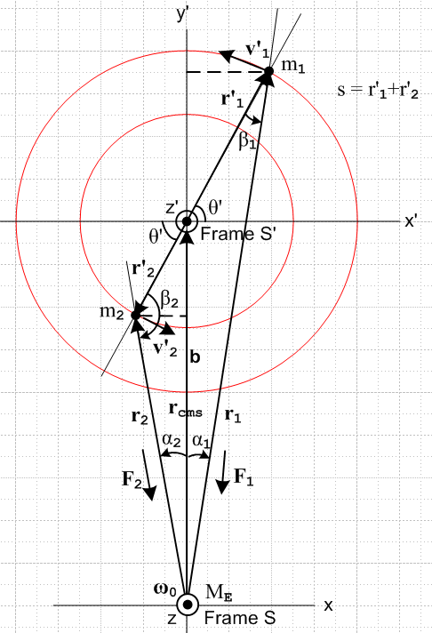 (D.6.1)

Recalling (D.2.8),

m1r'1 = - m2r'2 ⇒ m1r'1 = m2r'2 , r'2/r'1 = m1/m2 , '2 = – '1 (D.2.8)

we apply time derivative ∂S' once and then again to obtain two new sets of facts,

m1v'1 = - m2v'2 ⇒ m1v'1 = m2v'2 , v'2/v'1 = m1/m2 , '2 = – '1 (D.6.2)

m1a'1 = - m2a'2 ⇒ m1a'1 = m2a'2 , a'2/a'1 = m1/m2 , '2 = – '1 (D.6.3)

Then (D.6.2) shows that if v'1 lies in the plane of paper, so does v'2 and then mass m2 is doing circular motion around the inner red circle.

For angular momentum we take our reference point to be c' = 0 in Frame S' and thus c = b in Frame S. Then

L'(0) = m1r'1x v'1 + m2r'2x v'2 = {m1r'1v'1 + m2r'2v'2} ' (D.6.4)

Taking a ∂S' time derivative gives,

'(0) = m1 [ r'1x a'1 + v'1x v'1 ] + m2 [ r'2x a'2 + v'2x v'2 ]

= m1 r'1x a'1+ m2 r'2x a'2 . (D.6.5)

END

___________________________________________________________________

For circular motion we shall make use of polar coordinate unit vectors '1 and '1. Due to the stick constraint on the masses, ω'1 = ω'2 = ω' ≡ (dθ'/dt)S'. It is also true that '2 = - '1 and '2 = - '1 .

For the circular motion of mass m1 we know that

v'1 = ω'r'1 '1
so
a'1 = 'r'1 '1 + ω'r'1 (∂S''1) = 'r'1 '1 + ω'r'1 (- ω' '1) = 'r'1 '1 - ω'2r'1'1 .

Therefore,

r'1x a'1 = r'1x [ 'r'1 '1 - ω'2r'1'1 ] = r'1x [ 'r'1 '1] = ' r'12 '1 x '1 = ' r'12 '

These same equations apply to m2, so we summarize the above as

v'1 = ω'r'1 '1 a'1 = 'r'1 '1 - ω'2r'1'2 r'1x a'1 = ' r'12 '
v'2 = ω'r'2 '2 a'2 = 'r'2 '2 - ω'2r'2'2 r'2x a'2 = ' r'22 ' . (D.6.6)

Therefore from (D.6.5),

'(0) = m1 ' r'12 ' + m2 ' r'22 ' = ' [m1 r'12 + m2 r'22 ] '

= ' [m1 r'12 + m2 r'22 ] ' . (D.6.7)

The equation of motion for the satellite within Frame S' is given by (11.3.4),

N'(0)eff = '(0) = ' [m1 r'12 + m2 r'22 ] ' . (11.3.4) (D.6.8)

Our next task then is to compute the total effective torque on the satellite in Frame S' which from (11.3.5)
is

N'(0)eff = N(b) + N'(0)fict (11.3.5) (D.6.9)

Here N(b) is the Frame S torque on the satellite relative to point b in Frame S, and N'(0)fict is the fictitious torque that arises because Frame S' is a rotating frame of reference.

D.7 The true torque on the Dumbbell Satellite in Frame S

In this section we assume that Fig ** is correct at t = 0 so r'1 is in the plane of paper, but we make no assumption about the direction of v'1. We repeat the previous drawing.

(D.6.1)

The total torque in Frame S on the satellite is given by

N(b) = r'1 x F1 + r'2 x F2 (D.7.1)

where all four of these vectors are shown in the figure. Recall from (D.2.13) that

F1 = - (GMEm1/r12) 1 = - (GMEm1/r13) r1
F2 = - (GMEm2/r22) 2 = - (GMEm2/r23) r2 . (D.2.13)

We really should include the stick tension/compression T since these are supposed to be total forces, but since r'1 x T = r'2 x T = 0 so we can ignore T. Therefore

r'1 x F1 = r'1 x [ - (GMEm1/r13) r1 ] = - (GMEm1/r13) r'1 x r1

r'2 x F2 = r'2 x [ - (GMEm2/r23) r2 ] = - (GMEm2/r23) r'2 x r2 (D.7.2)

Looking at the drawing we see that the two cross products may be written.

r'1 x r1 = r'1r1 sinβ1 '
r'2 x r2 = r'2r2 sinβ2 (-') (D.7.3)

The Law of Sines applied to the right and left triangles says

$\frac{sinβ1}{b}$ = $\frac{sinα1}{r'1}$= $\frac{sin(π/2+θ')}{r1}$ = $\frac{cosθ'}{r1}$
$\frac{sinβ2}{b}$ = $\frac{sinα2}{r'2}$= $\frac{sin(π/2–θ')}{r2}$ = $\frac{cosθ'}{r2}$ (D.7.4)

from which we conclude that

r1 sinβ1 = bcosθ'
r2 sinβ2 = bcosθ' (D.7.5)
so then

r'1 x r1 = r'1r1 sinβ1 ' = r'1 bcosθ' '
r'2 x r2 = r'2r2 sinβ2 (-') = - r'2 bcosθ' ' . (D.7.6)

The total torque is then

N(b) = r'1 x F1 + r'2 x F2 = - (GMEm1/r13) r'1 x r1 - (GMEm2/r23) r'2 x r2

= - (GMEm1/r13) r'1 bcosθ' ' + (GMEm2/r23) r'2 bcosθ' '

= GMEbcosθ' [ ( r'2m2/r23) - (r'1m1/r13) ] '

= GMEbcosθ' [ ( r'1m1/r23) - (r'1m1/r13) ] ' // (D.2.8)

= GMEbcosθ'm1r'1 [ (1/r23) - (1/r13) ] '

this then is the total torque on the satellite due to the gravitational force of the Earth evaluated in the inertial fixed Frame S. We restate this result as

N(b) = (GMEm1r'1b) cosθ' [ (1/r23) - (1/r13) ] ' (D.7.7)

where
r12 = r'12 + b2 + 2r'1b sinθ'
r22 = r'22 + b2 - 2r'2b sinθ' . (D.2.4)

Quick checks:

• If the satellite is vertically aligned, θ' = ±π/2, cosθ'=0 and N(b) = 0 as expected (no moment arms).

• If the satellite is horizontally aligned and m1= m2, then r1= r2 so N(b) = 0 (balanced moment arms).

• If m2> m1, then r'2< r'1 so for horizontal alignment one has r2<r1 so [ (1/r23) - (1/r13) ] > 0. Then if m1 is on the right, we have θ' = 1 and cosθ' = 1 and then (D.7.7) has N(b) = (positive)'. Here is a picture,

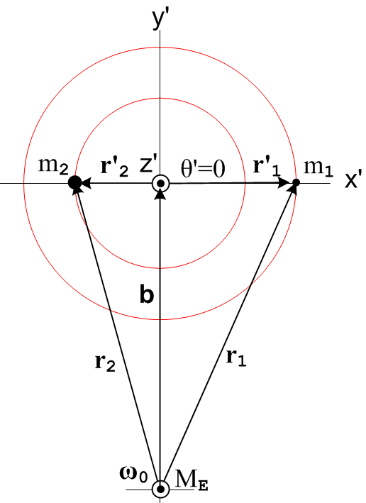 (D.7.8)

In this case the lever arms balance in the sense that m2r'2 = m1r'1, but m2 is closer to Earth center so it feels the stronger force and so we expect N(b) = (positive)'

If we now assume as before that r1,r2,b >> r'1, r'2 we can approximate [ (1/r23) - (1/r13) ] by adding on to the Maple code shown in (D.3.5) to get

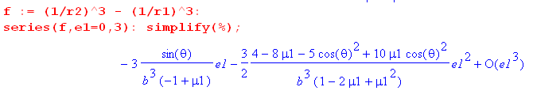

where recall e1 = ε1 ≡ (r'1/b). This time there is a leading linear term in ε1 so then

(1/r23) - (1/r13) ≈ -3 $\frac{sinθ'}{b3(-μ2)}$(r'1/b) = 3r'1sinθ'/ (μ2b4) (D.7.9)

Then

N(b) = (GMEm1r'1b) cosθ' [ (1/r23) - (1/r13) ] ' ≈ (GMEm1r'1b) cosθ' 3r'1sinθ'/ (μ2b4) '

= (GMEm1r'12b-3μ2-1) 3sinθ'cosθ' ' (D.7.10)

To this order of approximation, the torque N(b) vanishes when the satellite is horizontally aligned as well as when it is vertically aligned, and this is due to r1 ≈ r2 in the horizontal case.

D.8 The fictitious torque on the Dumbbell Satellite in Frame S'

At t = 0 the two masses are in the plane of paper in Fig (D.6.1) so r'1 (and thus r'2) are in the plane of paper and are thus normal to ω and . Nothing is assumed about the direction of v'1 (and v'2) other than the fact that these velocities must be tangent to the spheres of radius r'1 and r'2 to which their masses are constrained in Frame S'.

Recall the general fictitious torque expression given in (11.3.10), acting on a single particle of mass m,

N'(c')fict = - (r'-c') x [ mS +mω x (ω x r') + 2m ω x v' + m x r']
+ m(' + ω x c' + S) x ( v' + ω x r' + S) – m' x v' . (11.3.10) (D.8.1)

Here ω is the angular rotation rate of the satellite about the Earth.

Our application has the torque center at c' = 0 (and c = b) so this simplifies somewhat to

N'(0)fict = - mr' x [ S +ω x (ω x r') + 2ω x v' + x r'] + S x ( mv' + ω x [mr']) . (D.8.2)
frame centrifugal Coriolis Euler

Recall from (8.1.8) that the square bracket in the above is - F'fict/m so we trace the origin of the terms.

Now write this separately for each of the two masses of our satellite,

N'(0)f,1 = - m1r'1 x [ S +ω x (ω x r'1) + 2ω x v1' + x r'1] + S x ( m1v'1 + ω x[ m1r'1])
N'(0)f,2 = - m2r'2 x [ S +ω x (ω x r'2) + 2ω x v'2 + x r'2] + S x ( m2v'2 + ω x [m2r'2]) .
(D.8.3)

In the second line, use (D.2.8) to replace m2r'2 = - m1r'1 and (D.6.2) to replace m2v'2 = - m1v'1 :

N'(0)f,2 = + m1r'1 x [ S +ω x (ω x r'2) + 2ω x v'2 + x r'2] + S x ( -m1v'1 + ω x [-m1r'1]) .
(D.8.4)
Next, add the two torques to get the total fictitious torque on the satellite,

N'(0)fict = N'(0)f,1 + N'(0)f,2

= - m1r'1 x [ S +ω x (ω x r'1) + 2ω x v1' + x r'1] + S x ( m1v'1 + ω x[ m1r'1])
+ m1r'1 x [ S +ω x (ω x r'2) + 2ω x v'2 + x r'2] + S x ( -m1v'1 + ω x [-m1r'1])

= - m1r'1 x { ω x (ω x [r'1- r'2]) + 2ω x [v1'-v'2] + x [r'1- r'2] } . (D.8.5)
centrifugal Coriolis Euler

All terms involving S and S have cancelled out. Since [r'1- r'2] lies in the plane of paper, we know from

A x (A x C) = (A•C)A - A2C

that
ω x (ω x [r'1- r'2]) = (ω•[r'1- r'2])ω - ω2[r'1- r'2] = - ω2[r'1- r'2] = - ω2[1 + $\frac{m1}{m2}$]r'1 . (D.8.6)

Since r'1 x r'1 = 0 the first term in (D.8.5) vanishes, leaving

N'(0)fict = - m1r'1 x { 2ω x [v1'-v'2] + x [r'1- r'2] } (D.8.7)
Coriolis Euler

The Euler term can be written

x [r'1- r'2] = x [r'1+ $\frac{m1}{m2}$r'1] = x r'1 (1 +$\frac{m1}{m2}$)

Then A x (A x C) = (A•C)A - A2C
- r'1 x ( x r'1) = r'1 x (r'1 x ) = (r'1•) r'1 - r'12

Since we only deal with a circular satellite orbit, we know that = 0, but for an elliptical orbit this would not be the case ("equal areas in equal times") and a

We now set = 0 for the satellite orbit so only the Coriolis-induced term survives,

N'(0)fict = - 2m1r'1 x [ ω x (v1'-v'2) ] = - 2m1r'1 x [ ω x (v1' + $\frac{m1}{m2}$v'1) ]

= - 2m1r'1 x (ω x v1') (1 +$\frac{m1}{m2}$) = - 2m1r'1 x (ω x v1') (1 +$\frac{μ1}{μ2}$)

= - 2(m1/μ2) r'1 x (ω x v1') . (D.8.8)

But now the vector identity

A x (B x C) = (A•C)B - (A•B)C
says
r'1 x (ω x v1') = (r'1•v1')ω - (r'1•ω)v1' = (r'1•v1')ω = (r'1•v1')ω ' . (D.8.9)

where we used the fact that r'1•ω = 0, so at this point

N'(0)fict = - 2(m1/μ2) (r'1•v1')ω ' .

But since r'1 is constrained by the stick to lie on a sphere of radius r'1 (a cross section of which is shown in red in Fig D.6.1), the velocity v1' must be tangent to that sphere, so (r'1•v1') = 0. We then end up our final elaborate result :

N'(0)fict = 0 . (D.8.10)

How might one interpret this simple result?

We examine the pieces of N'(0)fict= 0:

(a) the "frame effects" due to the motion of b (S and S) are equal and opposite for the two masses because the origin of Frame S' is at the center of mass causing m2r'2 = - m1r'1, as shown in (D.8.5).

(b) within Frame S', the centrifugal acceleration term ω x (ω x r'1) = -ω2r'1 tries to push m1 to a larger radius. But r'1 is constrained to lie on a sphere of radius r'1 so m1 cannot go to a larger radius. This centrifugal acceleration is neutralized by part of the tension in the stick which we avoided talking about.
This centrifugal term, by the way, involves "the short vector" r'1 and not the long vector r1. We discussed this situation in Section 8.2 for an Earth-based Frame S'. In our current context, the picture that corresponds to Fig (8..2.8) is the following
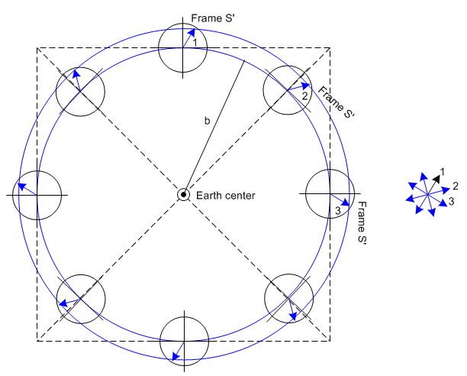 (D.8.11)

The arrow in each location during the orbit represents the vector r'1 where we assume that other effects are turned off so r'1 stays fixed in Frame S'. When these arrows are transferred to the picture on the right with common tails, we see that r'1 does in fact go around in a circle of radius r'1 and that is why the corresponding centrifugal force acting on m1 is -ω2r'1 .

(c) Within Frame S', the Coriolis force - 2m1 ω x v1' tries to deflect mass m1 "to the right" in Fig (D.6.1). But again, r'1 is constrained to lie on a sphere of radius r'1 so m1 cannot deflect to a different radius. This Coriolis force is neutralized by the rest of the tension in the stick.

D.9 The total torque on the Dumbbell Satellite in Frame S'

After much effort, we have arrived at this set of results for the satellite :

N(b) = (GMEm1r'1b) cosθ' [ (1/r23) - (1/r13) ] ' // true torque (D.7.7)

N(b) ≈ (GMEm1r'12b-3μ2-1) 3sinθ'cosθ' ' // far approximation (D.7.10)

N'(0)fict = 0 . // fictitious torque (D.8.10)

'(0) = m1 r'1x a'1+ m2 r'2x a'2 . (D.6.5)

N'(0)eff = N(b) + N'(0)fict = '(0) . (11.3.6)

So far we have assumed nothing about directions of v1' and a'1.

Here is a possible equation:

N(b) • ' = [m1 r'1x a'1+ m2 r'2x a'2 ] • ' = (GMEm1r'12b-3μ2-1) 3sinθ'cosθ'

Now

(r'1x a'1) • ' = cyclic = ('x r'1) • a'1

I know that v'1 must be tangent to its sphere. I think this means that dv'1 must point to sphere center. But how do you do this at some general point on a sphere.

Think totally independent spherical coordinates r,θ,φ having nothing to do with Frame S or Frame S'. I have the point r'1 lying somewhere on a sphere and I refer to this as r. Let v be the velocity of a particle at that point, and let a be its acceleration. We can write

r = r

v = vθ + vφ // a most general form for v which is tangent to the sphere

What then can we say about acceleration a ?

a = θ + vθ + φ + vφ

= d/dt = (d/dθ)(dθ/dt) +(d/dφ)(dφ/dt)

= - + cosθ

θ φ

