Appendix F v4 PhL 12.18.16

Appendix F

The purpose here is to exercise our main text expressions for fictitious forces and torques, and to obtain equations of motion for a relatively simple example of a dumbbell satellite. The fictitious forces are reviewed in Section 8.1 and the fictitious torques in Section 11.3. We say "relatively" simple because even with the stick constraint, this is still a 3-body problem and such problems are never simple.

F.1 Kinematics for the Dumbbell Satellite in Frame S

This section uses the "swap notation" described in Section *** where the rotating frame is Frame S and the non-rotating frame is Frame S'. We do this to reduce the number of primes since most activity will be in the rotating satellite Frame S.

We now place the dumbbell satellite in a more general orientation than it was in Appendix D :

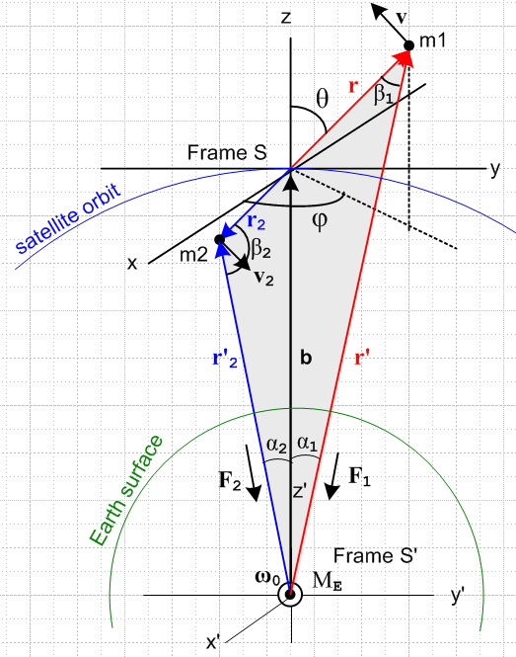 (F.1.1)

Description of the Figure

Half the battle is having a clear picture of what is going on and we shall expend many words to describe the above picture which is admittedly not as good as it could be. It shows the dumbbell satellite in orbit in a completely arbitrary orientation. The two masses m1 and m2 are connected by a massless stick of length r+r2 = s (not shown). If we find that this stick is always in tension for some situation, we can replace it in that situation with a non-stretching massless tether. If the stick were to go into compression, the replacement tether would lose its linear shape and we don't want to deal with that problem.
The gray fill shows a part of the plane φ = constant which has normal vector . This grey fill consists of a red triangle and a blue triangle, neither of which is a right triangle. The red triangle on the right side has internal angles α1 and β1 as shown, while the blue triangle on the left side has angles α2 and β2.
Frame S' is an inertial frame whose center is the center of the Earth and which is assumed fixed with respect to the stars.
Frame S is a non-inertial frame whose center is located at the satellite center of mass point. We make the assumption discussed in Section D.* that we can ignore the tiny offset between the center of mass and center of gravity of the satellite, so we then regard the Frame S origin as travelling in a circular orbit around the Earth. Recall from ** that this offset is about 6 microns for s = 10 meters.
At time t = 0, the axes of both Frames align with each other. At any time, axes y,z and y',z' are in the plane of paper. The axis z' always points to the center of mass point which is the origin of Frame S. Thus b = b' = b at any time. The axes x,x' always point directly out of the plane of paper.
The orbital rotation vector ω0 also points out of the plane of paper and recall that ω0 = 2π/T0 where T0 is about 88 minutes for a low-Earth orbit, although we have in mind an orbit at any altitude.
In Frame S mass m1 has spherical coordinates r,θ,φ defined in the usual "physics" convention as shown: angle θ is the polar angle down from the "vertical" z axis, φ is the azimuthal angle measured from the x axis toward the y axis. See Appendix E regarding conventions. Formally we should say that mass m1 has coordinates r1,θ1,φ1 while mass m2 has coordinates r2,θ2,φ2, but to reduce clutter we shall refer to the coordinates of mass m1 as r,θ,φ. Note from (F.1.1) that θ2 = π-θ1 = π-θ, and φ2 = φ1+π = φ + π. Since the Frame S origin is the center of mass frame for the two masses, one has m2r2 = m1r1 = m1r. The vectors r1 and r2 are of course collinear and therefore 2 = - 1 = - . To summarize,

r = (x,y,z) = (r,θ,φ) = coordinates of mass m1 velocity = v
r2 = (x2,y2,z2) = (r2,θ2,φ2) = coordinates of mass m2 velocity = v2

θ2 = π-θ φ2 = φ+π r2 = (m1/m2) r 2 = - (F.1.2)

Mass m1 has Frame S position r1≡ r and Frame S' position r'1≡ r'. These two vectors as drawn lie on the viewer's side of the plane of paper and we show them in red. The corresponding vectors r2 and r'2 lie to the back of the plane of paper and are shown in blue. So red is near, blue is far.
In Frame S mass m1 is constrained to lie on a sphere of radius r, while mass m2 is constrained to lie on a sphere of radius r2. The picture assumes m1 < m2 so r1 > r2. If m1 lies at a point on its sphere, m2 lies on the inverse point but on its sphere, as the spherical coordinates above show. If the masses are the same, the two spheres coincide.
Due to these constraints on the vectors r and r2, the corresponding velocity vectors v and v2 of the two masses must be tangential to their respective spheres. Thus, for example, for mass m1 we can write

v = vθ + vφ , whereas r = r . (F.1.3)

See Appendix ** regarding the unit vectors , and .
The circled dot at the bottom is the center of the Earth (mass ME) and we have drawn the Earth surface in green. The blue circle is the orbit of the center of mass of the satellite (the Frame S origin) and it lies in the plane of paper. Note that ω0 is for the orbit and has nothing whatsoever to do with the rotation of the Earth. The above picture is the same whether or not the Earth rotates at its 24 hour ω1 rate about some obscure 1 axis (not shown!).

Some Basic Kinematic Facts

The internal angles of the red triangle (not in the plane of paper) are β1, α1 and π-θ at the origin. Thus we know from one of the three laws of cosines that

r'2 = b2 + r2 - 2brcos(π-θ) = b2 + r2 + 2brcosθ .

The internal angles of the blue triangle (not in the plane of paper) are β2, α2 and θ at the origin. Thus we know that

r'22 = b2 + r22 - 2br2cosθ .

The three laws of sines for the two triangles tells us that

$\frac{sinβ1}{b}$ = $\frac{sinα1}{r}$= $\frac{sin(π-θ)}{r'}$ = $\frac{sinθ}{r'}$ // red triangle

$\frac{sinβ2}{b}$ = $\frac{sinα2}{r2}$= $\frac{sinθ}{r'2}$ . // blue triangle

Looking at the drawing it is clear that b + r2 = r'2 and b + r = r', so one can write

r'2 - r2 = r' - r .

Recall the center of mass condition from (D.2.8) that

m1r = - m2r2 ⇒ m1r = m2r2 , r2/r = m1/m2 , 2 = – . (D.2.8)

Applying the Frame S time derivative ∂S gives similar results for r → v and r → a, see below (velocity and acceleration).

Summary:

r'2 = b2 + r2 + 2brcosθ (F.1.4)
r'22 = b2 + r22 - 2br2cosθ (F.1.5)

$\frac{sinβ1}{b}$ = $\frac{sinα1}{r}$= $\frac{sin(π-θ)}{r'}$ = $\frac{sinθ}{r'}$ // red triangle (F.1.6)
$\frac{sinβ2}{b}$ = $\frac{sinα2}{r2}$= $\frac{sinθ}{r'2}$ // blue triangle (F.1.7)

r'2 - r2 = r' - r r'2 = b + r2 r' = b + r (F.1.8)

m1r = - m2r2 ⇒ m1r = m2r2 , r2/r = m1/m2 , 2 = – (F.1.9)

m1v = - m2v2 ⇒ m1v = m2v2 , v2/v = m1/m2 , 2 = – (F.1.10)

m1a = - m2a2 ⇒ m1a = m2a2 , a2/a = m1/m2 , 2 = – (F.1.11)

F.2 Angular momentum and its time derivative in Frame S

For angular momentum (and later torque) we take our reference point to be c = 0 in Frame S (the origin) and thus c' = b in Frame S'. Then.

L(0) = r x p + r2x p2 = m1 r x v + m2 r2 x v2 // dim = ML2/T

= m1r x v + m2[-(m1/m2)r] x [-(m1/m2)v] // (F.1.9) and (F.110)

= m1r x v + [m1r] x [(m1/m2)v] = m1{ r x v + (m1/m2) r x v }

= m1[ 1 + (m1/m2) ] r x v = m1[ (m2+m1)/m2 ] r x v

= (m1/m2) M r x v = (m1/m2) Mr x v // M ≡ m1+m2 (F.2.1)

= (m1/m2) M r (vθ – vφ ) // (E.3.7)

= (m1/m2) M r2 ( – sinθ ) . // (E.3.5) dim=ML2/T (F.2.2)

The dumbbell has no angular momentum around the axis which seems very reasonable since it consists of two point masses aligned with .

Taking a ∂S time derivative gives the rate of change of angular momentum in Frame S (all variables here are the "natural" ones in Frame S ),

(0) = ∂S{ (m1/m2) M r x v } // (F.2.1)

= (m1/m2) M (v x v + r x a )

= (m1/m2) Mr ( x a )

= (m1/m2) Mr [ aθ – aφ ] // (E.3.7) and then (E.3.6) below

= (m1/m2) Mr2 [ (- 2 sinθ cosθ) – (2 cosθ + sinθ) ] . (F.2.3)

Here are the conclusions so far:

L(0) = (m1/m2) M r2 ( – sinθ ) (F.2.2)

(0) = (m1/m2) Mr2 [ (- 2 sinθ cosθ) – (2 cosθ + sinθ) ] . (F.2.3)

One obvious statement can be made looking at these equations: there is no angular momentum about the axis and this vanishing angular momentum never changes.

The equation of motion for the satellite within Frame S is given by (11.3.4), but converted to swap notation,

N(0)eff = (0) . (11.3.4)s (F.2.4)

Our next task then is to compute the total effective torque on the satellite in Frame S which from (11.3.5)
is (again converted to swap notation),

N(0)eff = N'(b) + N(0)fict . (11.3.5)s (F.2.5)

Here N'(b) is the Frame S' torque on the satellite relative to point b in Frame S', and N(0)fict is the fictitious torque that arises because Frame S is a rotating frame of reference.

ok to here, again ok to here on 1.2.17

F.3 The torque on the Dumbbell Satellite in Frame S'

The torque (in Frame S') of the Earth on the satellite (relative to the Frame S origin) is given by

N'(b) = r x F1 + r2 x F2 // dim = L3 M /T (F.3.1)

where all four of these vectors are shown in Fig (F.1.1). Recall from (D.2.13) that

F1 = - (GMEm1/r'2) ' = - (GMEm1/r'3) r' F1 ≡ |F1| = (GMEm1/r'2)
F2 = - (GMEm2/r'22) '2 = - (GMEm2/r'23) r'2 F2 ≡ |F2| = (GMEm2/r'22) . (F.3.2)

// The stick tension T exerts no torque on the satellite masses since T is collinear with r and r2.

Therefore,

r x F1 = r x [ - (GMEm1/r'3) r' ] = - (GMEm1/r'3) r x r'

r2 x F2 = r2 x [- (GMEm2/r'23) r'2] = - (GMEm2/r'23) r2 x r'2 . (F.3.3)

Using (F.1.8) we evaluate the cross products making use of the first line of (E.2.15),

r x r' = r x (b + r) = r x b = rb x = rb (-sinθ ) = -rbsinθ

r2 x r'2 = r2 x (b + r2) = r2 x b = [-r2] x [b] = -r2b x = -r2b(-sinθ ) = r2bsinθ . (F.3.4)

Then inserting (F.3.4) into (F.3.3),

r x F1 = (GMEm1/r'3) rb sinθ (F.3.5)

r2 x F2 = - (GMEm2/r'23) r2bsinθ

= - (GMEm1/r'23) rbsinθ . // (F.1.9) (F.3.6)

Thus the torque on the satellite in Frame S' is,

N'(b) = r x F1 + r2 x F2 = (GMEm1/r'3) rb sinθ - (GMEm1/r'23) rbsinθ

= (GMEm1brsinθ) (1/r'3 - 1/r'23) . (F.3.7)

We can confirm the two torque contributions by computing them geometrically from Fig (F.1.1) using these right-hand-rule helper drawings:

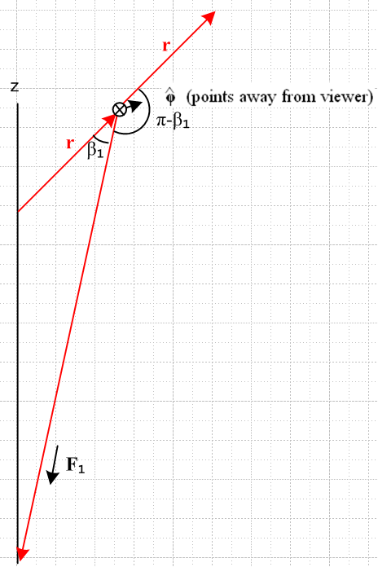 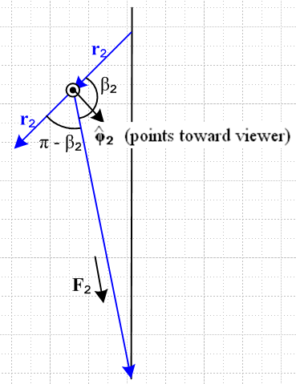 (F.3.8)

Then:

r x F1 = rF1 sin(π-β1) = rF1sinβ1 = rF1(bsinθ/r') // (F.1.6) then (F.3.2)

= r(GMEm1/r'2)(bsinθ/r') = (GMEm1/r'3) rb sinθ // agrees with (F.3.5)

r2 x F2 = r2F2 sin(π-β2) 2 = r2F2 sinβ2 2 = r2F2 sinβ2 [ - ]

= r2F2 (bsinθ/r'2) [ - ] = r2(GMEm2/r'22) (bsinθ/r'2) [ - ] // (F.1.7) and (F.3.2)

= r(GMEm1/r'22) (bsinθ/r'2) [ - ] // (F.1.9)

= - (GMEm1/r'23) rbsinθ // agrees with (F.3.6)

where we have used the fact that 2 = - 1 = - .

There is a third way to compute the above torque, based on the torque theorem (D.1.3) which says that N(R) = N(0) - R x F . In our current context of working in Frame S' this reads

N'(b) = N'(0) - b x F . (F.3.9)

The torque N'(0) relative to the Frame S' origin is exactly 0

N'(0) = r' x F1 + r'2 x F2 = 0 + 0 = 0

since r' is collinear with F1 and r'2 is collinear with F2 as shown in Fig (F.1.1). Again we should include the stick tension/compression T, but (r' - r'2) x T = (r - r2) x T = 0 so again T can be ignored. Thus we find from (F.3.9) that

N'(b) = - b x (F1+ F2) = - b x[ - (GMEm1/r'3) r' - (GMEm2/r'23) r'2 ]

= (GMEm1/r'3) b x r' + (GMEm2/r'23) b x r'2

= (GMEm1/r'3) (r'-r) x r' + (GMEm2/r'23) (r2' - r2) x r'2

= - (GMEm1/r'3) r x r' - (GMEm2/r'23) r2 x r'2

= - (GMEm1/r'3)[-rbsinθ ] - (GMEm2/r'23) [ r2bsinθ ]

= (GMEm1brsinθ) (1/r'3 - 1/r'23) (F.3.10)
in agreement with (F.3.7).

Here are some quick checks on (F.3.10) or (F.3.7) :

• If the satellite is vertically aligned, θ = 0,π, then sinθ=0 and N'(b) = 0 as expected (no moment arms).

• If the satellite is horizontally aligned and m1= m2, then r' = r'2 so N'(b) = 0 (balanced moment arms).

• If m2> m1, then r2< r so for horizontal alignment one has r'2<r' so [ (1/r'3) - (1/r'23) ] < 0. Then if m1 is on the right, we have θ = π/2 and sinθ = 1 and then (F.3.10) has N(b) = -(positive). But for this orientation = - so N(b) = (positive)

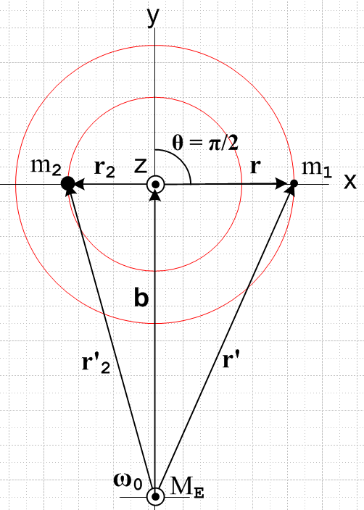 (F.3.11)

In this case the lever arms balance in the sense that m2r2 = m1r, but m2 is closer to Earth center so it feels the stronger force and so we expect N'(b) = (positive) .

ok to here as of 6 PM Sat 12/31/16 , and again as of 4:15 PM 1.2.17

If we now assume as before that r',r'2,b >> r, r2 we can approximate [ (1/r'3) - (1/r'23) ] by adding on to the Maple code shown in (D.3.5) to get

DEFER THIS TILL LATER, I AM STILL TESTING THE NEW NOTATION

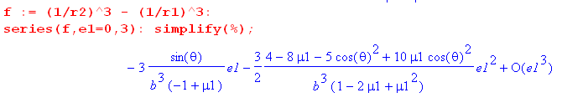

where recall e1 = ε1 ≡ (r'1/b). This time there is a leading linear term in ε1 so then

(1/r23) - (1/r13) ≈ -3 $\frac{sinθ'}{b3(-μ2)}$(r'1/b) = 3r'1sinθ'/ (μ2b4) (D.7.9)

Then

I think the result will be

(1/r23) - (1/r13) ≈ 3r'1cosθ'/ (μ2b4)

so then

N(b) = GMEm1b r'1sinθ' [ (1/r13) - (1/r23)] '

≈ - GMEm1b r'1sinθ' ( 3r'1cosθ'/ (μ2b4) ) '

= - 3GME(m1/μ2) b-3r'12sinθ'cosθ' ' a guess for now (F.3.12)

To this order of approximation, the torque N(b) vanishes when the satellite is horizontally aligned as well as when it is vertically aligned, and this is due to r' ≈ r'2 in the horizontal case.

F.4 The fictitious torque on the Dumbbell Satellite in Frame S

Recall the general fictitious torque expression given in (11.3.10), acting on a single particle of mass m,

N'(c')fict = - (r'-c') x [ mS +mω x (ω x r') + 2m ω x v' + m x r' ]
+ m(' + ω x c' + S) x ( v' + ω x r' + S) – m' x v' . (11.3.10)

Converting to swap notation this says

N(c)fict = - (r-c) x [ mS' +mω x (ω x r) + 2m ω x v + m x r ]
+ m( + ω x c + S') x ( v + ω x r + S') – m x v . (11.3.10)s (F.4.1)

Here ω is the angular rotation rate of the satellite about the Earth.

Our application has the torque center at c = 0 (and c' = b) so this simplifies somewhat to

N(0)fict = - mr x [ S' +ω x (ω x r) + 2 ω x v + x r] + S' x ( mv + ω x [mr] ) (F.4.2)
frame centrifugal Coriolis Euler

Recall from (8.1.8) that the square bracket in the above is - Ffict/m so we can trace the origin of the terms.

Now write this separately for each of the two masses of the satellite :

N(0)f,1 = - m1r x [ S' + ω x (ω x r) + 2ω x v + x r] + S' x ( m1v + ω x[ m1r])
N(0)f,2 = - m2r2 x [ S' +ω x (ω x r2) + 2ω x v2 + x r2] + S' x ( m2v2 + ω x [m2r2]) . (F.4.3)

In the second line, use (F.1.9) to replace m2r2 = - m1r1 and (F.1.10) to replace m2v2 = - m1v :

N(0)f,2 = + m1r x [ S' +ω x (ω x r2) + 2ω x v2 + x r2] + S' x ( -m1v + ω x [-m1r]) . (F.4.4)

Next, add the two torques to get the total fictitious torque on the satellite seen in Frame S,

N(0)fict = N(0)f,1 + N(0)f,2

= - m1r x [ S' + ω x (ω x r) + 2ω x v + x r] + S' x ( m1v + ω x[ m1r])
+ m1r x [ S' + ω x (ω x r2) + 2ω x v2 + x r2] + S' x ( -m1v + ω x [-m1r])

= - m1r x { ω x (ω x [r- r2]) + 2ω x [v-v2] + x [r- r2] }
centrifugal Coriolis Euler

= - m1r x { ω x (ω x [r + $\frac{m1}{m2}$r]) + 2ω x [v + $\frac{m1}{m2}$v] + x [r + $\frac{m1}{m2}$r] }

= - m1 (1+$\frac{m1}{m2}$)r x { ω x (ω x r) + 2ω x v + x r }

= - $\frac{m1}{m2}$M r x { ω x (ω x r) + 2ω x v + x r } . (F.4.5)

All terms involving S' and S' have cancelled out. For the Earth orbit we have = 0 and ω = ω.

Now consider this vector identity:

C x [A x (A x C)] = C x [ (A•C)A - A2C ] = (A•C) C x A = – (A•C) A x C . (F.4.6)

Then

r x [ ω x (ω x r) ] = – (ω•r) (ω x r)

= - ω2r2 ( • )( x ) // use (E.2.4) for • and (E.2.13) for x

= - ω2r2 ( sinθcosφ )(- cosθcosφ - sinφ )

= ω2r2 sinθcosφ (cosθcosφ + sinφ ) . (F.4.7)

Next, the Coriolis term involves,

r x (ω x v) = (r•v)ω - (r•ω)v // A x (B x C) = (A•C)B - (A•B)C . (F.4.8)

But v is tangent to the radius-r sphere to which m1 is constrained, so (r•v) = 0. Then

r x (ω x v) = - (r•ω)v = - rω (•)v = - rω sinθcosφ v (F.4.9)

We now have a somewhat complicated expression for N(0)fict :

N(0)fict = - (m1/m2)M r x [ ω x (ω x r) + 2ω x v ]

= - (m1/m2)M { r x [ω x (ω x r)] + 2 r x (ω x v) }

= - (m1/m2)M { ω2r2 sinθcosφ [ cosθcosφ + sinφ ] - 2rω sinθcosφ v } (F.4.10)

Now using (E.3.5),

v = vθ + vφ = r + r sinθ (E.3.5)

we then have

N'(0)fict = - (m1/m2)M { ω2r2 sinθcosφ [ cosθcosφ + sinφ ]

- 2rω sinθcosφ ( r + r sinθ ) }

= - (m1/m2)M * {A + B } (F.4.11)

where

A = ω2r2 sinθcosφsinφ - 2r2ωsinθcosφ

= ωr2 sinθ cosφ (ωsinφ -2)

B = ω2r2 sinθcosφ cosθcosφ - 2r2ωsinθcosφ sinθ

= ωr2sinθcosφ (ω cosθ cosφ - 2sinθ ) . (F.4.12)

Restate the result :

N(0)fict = - (m1/m2)M * {A + B }

= - (m1/m2)M {ωr2 sinθ cosφ (ωsinφ -2) + ωr2sinθcosφ (ω cosθ cosφ - 2sinθ ) }

= - (m1/m2)Mωr2 sinθcosφ [ (ωsinφ -2) + (ω cosθ cosφ - 2sinθ ) ] (F.4.13)

How might one interpret this simple result?

We examine the pieces of N(0)fict= 0 as they appear in (F.4.10).

(a) the "frame effects" due to the motion of b (S' and S') are equal and opposite for the two masses because the origin of Frame S is at the center of mass causing m2r2 = - m1r, as shown in (D.8.5).

(b) within Frame S, the centrifugal acceleration term ω x (ω x r) = -ω2r tries to push m1 to a larger radius. But r is constrained to lie on a sphere of radius r so m1 cannot go to a larger radius. This centrifugal acceleration is neutralized by part of the tension in the stick which we avoided talking about.
This centrifugal term, by the way, involves "the short vector" r and not the long vector r'. We discussed this situation in Section 8.2 for an Earth-based Frame S'. In our current context, the picture that corresponds to Fig (8.2.8) is the following

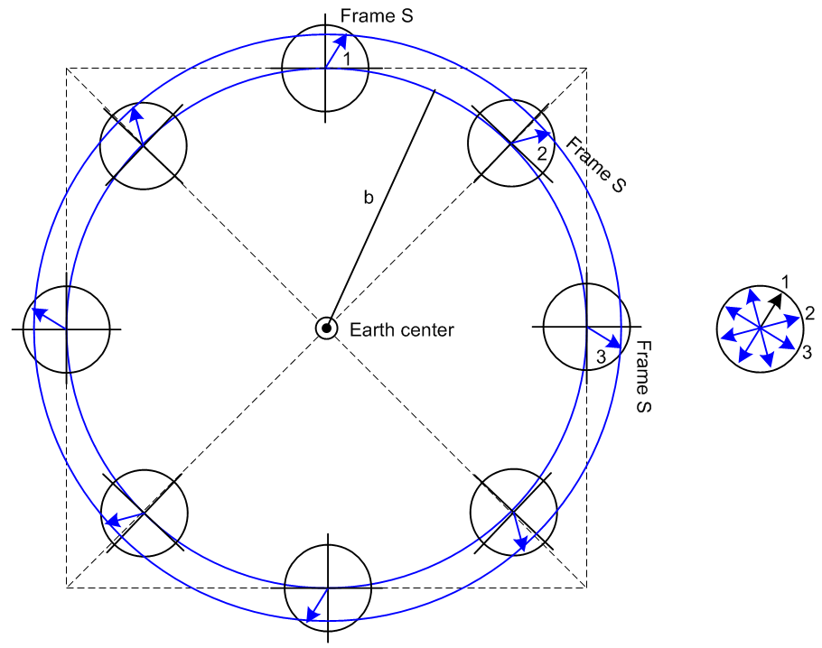 (F.4.14)

The arrow in each location during the orbit represents the position vector r of mass m1 where we assume that other effects are turned off so r stays fixed in Frame S. When these arrows are transferred to the picture on the right with common tails, we see that r does in fact go around in a circle of radius r and that is why the corresponding centrifugal force acting on m1 is -ω2r .

(c) Within Frame S, the Coriolis force - 2m1 ω x v tries to deflect mass m1 "to the right" in Fig (D.6.1). But again, r is constrained to lie on a sphere of radius r so m1 cannot deflect to a different radius. This Coriolis force is neutralized by the rest of the tension in the stick.

ok to here Dec 31, 2016.

F.5 The total torque on the Dumbbell Satellite in Frame S

After much effort, we have arrived at this set of results for the satellite :

L(0) = (m1/m2) M r2 ( – sinθ ) (F.2.2)

(0) = (m1/m2) Mr2 [ (- 2 sinθ cosθ) – (2 cosθ + sinθ) ] . (F.2.3)

N'(b) = (GMEm1brsinθ) (1/r'3 - 1/r'23) (F.3.7)

r'2 = b2 + r2 + 2brcosθ (F.1.4)
r'22 = b2 + r22 - 2br2cosθ (F.1.5)

N(0)fict = - (m1/m2)Mωr2 sinθcosφ [ (ωsinφ -2) + (ω cosθ cosφ - 2sinθ ) ] (F.4.13)

Using the orbit equation (8.6.7) applied to the current situation,

GME = ω2b3 large b means small ω (F.5.1)

we can rewrite the true torque as

N'(b) = (ω2b4m1rsinθ) (1/r'3 - 1/r'23) . (F.5.2)

The equations of satellite motion are given by (F.2.4) and (F.2.5)

N(0)eff = N'(b) + N(0)fict = (0) (11.3.5)s (F.5.3)

There is no component as the above results show, so we end up with these two equations of motion:

(ω2b4m1rsinθ) (1/r'3 - 1/r'23) - (m1/m2)Mωr2 sinθcosφ(ω cosθ cosφ - 2sinθ )

= (m1/m2) Mr2 (- 2 sinθ cosθ) // the equation (F.5.4)

- (m1/m2)Mωr2 sinθcosφ (ωsinφ -2)

= – (m1/m2) Mr2 (2 cosθ + sinθ) // the equation (F.5.5)

Factors cancel in (F.5.5) to give this simpler result,

ωsinθcosφ (ωsinφ -2) = 2 cosθ + sinθ (F.5.6)

We multiply the first equation (F.5.4) by factor [(m1/m2)Mr2]-1 and the first coefficient becomes

[(m1/m2)Mr2]-1(ω2b4m1rsinθ) = (ω2b4(m2/M)sinθ/r) = (ω2b4μ2sinθ/r)

where μ2 = m2/(m1+m2) is the fractional mass of m2. Then (F.5.4) becomes

(ω2b4μ2sinθ/r) (1/r'3 - 1/r'23) - ω sinθcosφ(ω cosθ cosφ - 2sinθ ) = - 2 sinθ cosθ (F.5.7)

We then summarize the equations of motion for the dumbbell satellite:

sinθ + 2cosθ - ωsinθcosφ (ωsinφ -2) = 0

- sinθ cosθ 2 - (ω2b4μ2sinθ/r) (1/r'3 - 1/r'23) + ω sinθcosφ(ω cosθ cosφ - 2sinθ ) = 0 (F.5.8)

These are two ordinary differential equations with time t as the variable. The equations are second order in both θ(t) and φ(t) and they are non-linear due to terms like and 2 . Finally, the equations are coupled, so they form a system of coupled, non-linear, ordinary differential equations.

The acceleration of mass m1 is given from (E.3.6),

a = ar + aθ + aφ // acceleration
ar = - r2 – r 2 sin2θ
aθ = r - r 2 sinθ cosθ
aφ = 2 r cosθ + rsinθ (E.3.6)

The radial acceleration ar of mass m1 must be offset by the tension T = -T in the stick so one has

T = m1ar // but I am assuming F = ma in Frame S to write this.
or
-T = m1[ - r2 – r 2 sin2θ ]
or
T = m1r( 2 + 2 sin2θ) // = m1(vθ2+vφ2)/r = m1v2/r

Once the two ODE's are solved for θ(t) and φ(t), the tension T(t) is then determined.

1. Does this mean the stick is always under tension and never compression???

2. If it just sits vertically aligned with =0 and = 0, does the tether have 0 tension??? that just seems wrong to me. I guess I am assuming Newton's Law in Frame S.

It has taken a LONG TIME to get this point on 12.16.16,

Now use the orbit equation (8.6.7) applied to the current situation,

GME = ω2b3 large b means small ω

Then we have

N'(b) = (ω2b4m1rsinθ) (1/r'3 - 1/r'23)

N(0)fict = - (m1/m2)Mωr2 sinθcosφ [ (ωsinφ -2) + (ω cosθ cosφ - 2sinθ ) ]

What is the relative size of these terms?

Maybe write this way:

N(b) = ω2b4m1r'1sinθ' [ (1/r13) - (1/r23)] ' T-2L5M/L3 = ML2/T2 ok

N'(0)fict = - (m1/μ2)ω2r'12 sinθ'cosφ' [ ( sinφ' - 2('/ω) ) ' + ( cosφ'cosθ' - 2('/ω) sinθ' ) ']

Magnitudes?

N(b)2 = (ω2b4m1r'1sinθ')2 [ (1/r13) - (1/r23)]2

N'(0)fict2 = [(m1/μ2)ω2r'12 sinθ'cosφ']2 { ( sinφ' - 2('/ω) )2+ ( cosφ'cosθ' - 2('/ω) sinθ' )2 }

The ratio is then

N'(0)fict/ N(b)

= $\frac{(m1/μ2)ω2r'12 sinθ'cosφ'}{ω2b4m1r'1sinθ'}$ / [ (1/r13) - (1/r23)]

= $\frac{(1/μ2)r'1 cosφ'}{b4}$ / [ (1/r13) - (1/r23)]

So two glaring issues: dealing with the difference in the denom, the with ω ratios in the num. So I don't really have much to say yet about the relative size of these terms.

The Equations of Motion

Start with

'(0) = (m1/m2) M r'12 [ (' - '2 sinθ' cosθ') ' – (2''cosθ' + 'sinθ' ) ' ]

N(b) = ω2b4m1r'1sinθ' [ (1/r13) - (1/r23)] '

≈ ω2b4m1r'1sinθ' [ (1/r13) - (1/r23)] '

≈ ω2b4m1r'1sinθ' [ -3r'1cosθ'/ (μ2b4)] '

≈ -3ω2(m1/μ2)r'12sinθ' cosθ' '

N'(0)fict = - (m1/m2)Mωr'12sinθ'cosφ' [ ( ωsinφ' -2' ) ' + ( ω cosφ'cosθ' - 2' sinθ' ) ']

Is there some limit where one or the other torque dominates?

Write again as

N(b) ≈ -3ω2(m1/μ2)r'12sinθ' cosθ' '

N'(0)fict = - (m1/μ2)ωr'12sinθ'cosφ' [ ( ωsinφ' -2' ) ' + ( ω cosφ'cosθ' - 2' sinθ' ) ']

The magnitude ratio factor is

[ -3ω2(m1/μ2)r'12sinθ' cosθ' / - (m1/μ2)ωr'12sinθ'cosφ' ]

= [ 3ωcosθ' / cosφ' ]

and then

Nfict/Ntrue = (cosφ'/3ωcosθ')

= (cosφ'/3cosθ')

I want an argument that makes this small. Only if φ' = π/2 and it is planar is this small!

Case 1: vertically aligned. Then cosθ' = 1 and sinθ' = 0 and the above gives

Nfict/Ntrue = (cosφ'/3ω)

Not sure what that means.

Limit #1: Let b → ∞ so that ω → 0. Then both torques vanish and the result is no torque at all.

But in the limit not quite there we might say

N(b) ≈ -3ω2(m1/μ2)r'12sinθ' cosθ' '

N'(0)fict = - (m1/μ2)ωr'12sinθ'cosφ' [ ( -2' ) ' + ( - 2' sinθ' ) ']

and then the fictional force dominates! We then have in the ω→0 limit,

'(0) = (m1/μ2) r'12 [ (' - '2 sinθ' cosθ') ' – (2''cosθ' + 'sinθ' ) ' ]

N'tot ≈ - (m1/μ2)ωr'12sinθ'cosφ' [ ( -2' ) ' + ( - 2' sinθ' ) ']

This gives in this limit two equations of motion

(m1/μ2) r'12 [ (' - '2 sinθ' cosθ') ] = - (m1/μ2)ωr'12sinθ'cosφ' ( - 2' sinθ' ) '
- (m1/μ2) r'12 (2''cosθ' + 'sinθ' ) = - (m1/μ2)ωr'12sinθ'cosφ' ( -2' ) '
or
[ (' - '2 sinθ' cosθ') ] = -ωsinθ'cosφ' ( - 2' sinθ' ) '
- (2''cosθ' + 'sinθ' ) = - ωsinθ'cosφ' ( -2' ) '
or

' - '2 sinθ' cosθ' = +2ωsin2θ'cosφ' ' '
2''cosθ' + 'sinθ' = - ωsinθ'cosφ' ( 2' ) '
or

' -sinθ' cosθ' '2 - 2ωsin2θ'cosφ' ' = 0

sinθ' ' + 2cosθ''' + 2 ωsinθ'cosφ'' = 0

They are very ugly, but for the very first time ever I have something I can write down!! The equations are horribly coupled. Maybe in my limit I can ignore the last terms as ω→0, huge high orbit. Then

' -sinθ' cosθ' '2 = 0

' + 2cotθ''' = 0

but these equations are inscrutable. Suppose instead I assume close to vertical. Then

' -sinθ' cosθ' '2 - 2ωsin2θ'cosφ' ' = 0
sinθ' ' + 2cosθ''' + 2 ωsinθ'cosφ'' = 0

' - θ' '2 - 2ωθ'2cosφ' ' = 0
θ' ' + 2 '' + 2 ωθ'cosφ'' = 0

Suppose we try ansatz that φ = constant. Then we get

' = 0
2 ωθ'cosφ'' = 0

It then just sits there with ' = ' = 0, not very exciting.

Let's instead try the large-ω limit and see what happens there. Start over with

N(b) ≈ -3ω2(m1/μ2)r'12sinθ' cosθ' '

N'(0)fict = - (m1/μ2)ωr'12sinθ'cosφ' [ ( ωsinφ' -2' ) ' + ( ω cosφ'cosθ' - 2' sinθ' ) ']

Now just assume N(b) dominates because it has ω2 sitting there. Then we get

'(0) = (m1/m2) M r'12 [ (' - '2 sinθ' cosθ') ' – (2''cosθ' + 'sinθ' ) ' ]

N ≈ -3ω2(m1/μ2)r'12sinθ' cosθ' '

This says that we don't change the ang mom about the ' which is the "dipping" axis.

The two equations of motion now are

(m1/m2) M r'12 [ (' - '2 sinθ' cosθ') = -3ω2(m1/μ2)r'12sinθ' cosθ'
(2''cosθ' + 'sinθ' ) = 0

or

(' - '2 sinθ' cosθ') = -3ω2sinθ' cosθ'
2''cosθ' + 'sinθ' = 0

Now do ansatz where φ = constant. Then 2nd equation is happy and first says

' = -3ω2sinθ' cosθ'

NOW also assume small angle to get

' = -3ω2θ'
or
' +3ω2θ' = 0

Finally we get some oscillation which involves ω and involves a factor of 3. What did my PDF say about this? Here from p 124,

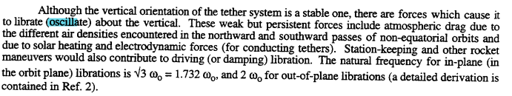

So they are saying

ωlibration = $\sqrt{3}$ω

and that agrees with my equation, hurray!!!

So you have to ignore the fictitious force to get this result! What is the condition for doing that? I show above that φ' = π/2 would do it, the planar case only!

What is the Ref 2 above?

D.10 Force analysis of the Dumbbell Satellite in Frame S'

A. COMPUTE TRUE FORCES

The only forces on a dumbbell mass are gravity and stick tension T. From ** we then write

F1 = - (GMEm1/r13) r1 - T '1 = - (GMEm1/r13)( b + r'1) - T '1
F2 = - (GMEm2/r23) r2 - T '2 = - (GMEm2/r23)( b + r'2) - T '2

Given that b is the distance to CMS, the above equations are exact no matter where COG lies.

B. COMPUTE FICTITIOUS FORCES

We must now compute the fictitious force on each mass.

F'fict,1 ≈ – m1S – m1ω x (ω x r'1) – 2m1 ω x '1 – m1 x r'1
F'fict,2 ≈ – m2S – m2ω x (ω x r'2) – 2m2 ω x '2 – m2 x r'2

What is the meaning of ω here? I have assumed that the CMS is in orbit! So the above equations are not exactly true.

C. TOTAL FORCES and EQUATIONS OF MOTION

We then know that,

F'eff,1 = m1 '1
≈ - (GMEm1/r13)(b + r'1) - T '1 – m1S – m1ω x (ω x r'1) – 2m1 ω x '1 – m1 x r'1

F'eff,2 = m2'2 = - m1'1
≈ - (GMEm2/r23)(b + r'2) - T '2 – m2S – m2ω x (ω x r'2) – 2m2 ω x '2 – m2 x r'2

We also know that

b = b = b = b' // = bcosθ' '1 - bsinθ' '

r12 = b2 + r'12 + 2br'1cosθ' r'2 = -(m1/m2)r'1
r22 = b2 + r'22 - 2br'2cos θ'

S = x b - ω2b ' GME = ω2b3

Now since our setup is a Special Case #1 problem, we can write

S = x b + ω x (ω x b) = x b + (ω•b)ω ' - ω2b

But (ω•b) = 0 from Fig 1, and = = ' so

S = x b - ω2b '

The following items are givens: ω, , m1, m2, b, GME

The following items are the unknowns: r'1(t), T = 4 unknowns

So we seem to have a system of 6 2nd-order differential equations in 4 unknowns, so the ODE's must not all be linearly independent.

The Sum Equation : What happens if you add the two ODE's (so the right sides cancel out):

- (GMEm1/r13)(b + r'1) - T '1 – m1S – m1ω x (ω x r'1) – 2m1 ω x '1 – m1 x r'1
- (GMEm2/r23)(b + r'2) - T '2 – m2S – m2ω x (ω x r'2) – 2m2 ω x '2 – m2 x r'2 ≈ 0

In the second line make the obvious replacements to get m2r'2 = - m1r'1

- (GMEm1/r13)(b + r'1) - T '1 – m1S – m1ω x (ω x r'1) – 2m1 ω x '1 – m1 x r'1
- (GMEm2/r23)(b + r'2) + T '1 – m2S + m1ω x (ω x r'1) + 2m1 ω x '1 + m1 x r'1 ≈ 0

or
- (GMEm1/r13)(b + r'1) – m1S
- (GMEm2/r23)(b + r'2) – m2S ≈ 0

or
- (ω2b3m1/r13)(b + r'1) - (ω2b3m2/r23)(b + r'2) ≈ (m1+m2)S
or
- (m1/r13)(b + r'1) - (m2/r23)(b + r'2) ≈ (m1+m2)S /(ω2b3)
or
- (1/r13)(m1b + m1r'1) - (1/r23)(m2b +m2 r'2) ≈ (m1+m2)S /(ω2b3)
or
(1/r13)(m1b + m1r'1) + (1/r23)(m2b - m1r'1) ≈ -(m1+m2)S /(ω2b3)
or
b[ (m1/r13) + (m2/r23)] + m1r'1 [ (1/r13) - (1/r23)] ≈ -(m1+m2)S /(ω2b3)

where S = x b - ω2b ' b = b'

Suppose = 0. Then our sum equation becomes

b'[ (m1/r13) + (m2/r23)] + m1r'1 [ (1/r13) - (1/r23)] ≈ (m1+m2)ω2b ' /(ω2b3)
or
[ b(m1/r13) + b(m2/r23)]' + m1r'1 [ (1/r13) - (1/r23)]'1 ≈ M ' /b2
or
[ b(m1/r13) + b(m2/r23) - (M/b2)]' + m1r'1 [ (1/r13) - (1/r23)]'1 ≈ 0

But ' and '1 can be regarded as two linearly independent vectors (if θ' ≠ 0) so then

b(m1/r13) + b(m2/r23) ≈ (M/b2)

(1/r13) ≈ (1/r23)

Idea: I have assumed that CMS is COG and maybe this assumption is forcing these results? I think that is in fact the case. Putting r1 = r2 = b into the first equation gives an identity.

So does this mean that this whole method is dead in the water? All it really says is that we don't get a contradiction from the sum equation, given that it is the sum of approximate equations.

So I think it is OK to move on. The sum equation is approximately valid, so maybe that means that only one of the two vector equations of motion is linearly independent so there are then 3 equations.

Let's restate the equations with b = b' and S = - ω2b both installed : (no Euler term)

F'eff,1 = m1 '1
≈ - (GMEm1/r13)(b' + r'1) - T '1 + m1 ω2b – m1ω x (ω x r'1) – 2m1 ω x '1

F'eff,2 = m2'2 = - m1'1
≈ - (GMEm2/r23)(b' + r'2) - T '2 +m2ω2b – m2ω x (ω x r'2) – 2m2 ω x '2

So we only need to study the first equation:

F'eff,1 = m1 '1
≈ { - (GMEm1/r13)(b' + r'1) - T '1 + m1 ω2b} – m1ω x (ω x r'1) – 2m1 ω x '1

The following items are givens: ω, b, m1, m2, r'1

The following items are the unknowns: '1(t), T = 3 unknowns ( so 3 in 3, good).

Consider its first three terms which are in the {...} brackets,

- (GMEm1/r13)(b' + r'1) - T '1 + m1 ω2b

- (ω2b3m1/r13)(b' + r'1) - T '1 + m1 ω2b

- (ω2b3m1/r13)(b') - (ω2b3m1/r13) r'1 - T '1 + m1 ω2b

- (ω2b3m1/r13)(b') - (ω2b3r'1m1/r13) '1 - T '1 + m1 ω2b

[ - (ω2b3m1/r13)b + m1 ω2b ] + [ - (ω2b3r'1m1/r13) - T ] '1

ω2bm1[ - (b3/r13) + 1 ] - [ (ω2b3r'1m1/r13) + T ] '1

But we know that

' = cosθ' '1 - sinθ' '

so the first three terms are

ω2bm1[ - (b3/r13) + 1 ] [ cosθ' '1 - sinθ' '] - [ (ω2b3r'1m1/r13) + T ] '1

= { ω2bm1 ( - (b3/r13) + 1) cosθ' - [ (ω2b3r'1m1/r13) + T ] } '1 + [- ω2bm1 ( -(b3/r13) + 1) sinθ'] '

I am wondering whether you should just say b ≈ r1 to clear this first term, to our level of approx? Well consider

1 - (b3/r13) = (r13 - b3) / r13 = (r1- b)(r12 +r1b+ b2)/r13 ≈ (r1- b)(3b2/b3) = 3 (r1- b)/b

So this factor is linear in (r1-b). Now since r12 = b2 + r'12 + 2br'1cosθ' I have shown on scratch that

r1-b ≈ r'1cosθ'

So then I claim that

1 - (b3/r13) ≈ 3 r'1cosθ'/b

So rather than dropping the first term, I will use the above approximation.

Let's next to the centrifugal term:

ω x (ω x r'1)

= (ω•r'1)ω - ω2 r'1

= (ω '•r'1)ω ' - ω2r'1 '1

= ω2r'1('•'1) ' - ω2r'1 '1

= ω2r'1sinθ'cosφ' ' - ω2r'1 '1

= ω2r'1sinθ'cosφ'[ cosφ'sinθ' '1 + cosφ'cosθ' ' - sinφ' '] - ω2r'1 '1

= ω2r'1sinθ'cosφ'cosφ'sinθ' '1 + ω2r'1sinθ'cosφ'cosφ'cosθ' ' -ω2r'1sinθ'cosφ' sinφ' '- ω2r'1 '1

= ω2r'1sin2θ'cos2φ' '1 + ω2r'1sinθ'cosθ'cos2φ' ' -ωr'12sinθ'cosφ' sinφ' '- ω2r'1 '1

= [ω2r'1sin2θ'cos2φ' - ω2r'1] '1 + [ω2r'1sinθ'cosθ'cos2φ'] ' + [- ω2r'1sinθ'cosφ' sinφ'] '

= ω2r'1 { [sin2θ'cos2φ' - 1] '1 + [sinθ'cosθ'cos2φ'] ' + [- sinθ'cosφ' sinφ'] '}

This certainly is an ugly result. Now move on the Coriolis term factor which is

ω x v'1 = ω' x [v'θ1' + v'φ1 ']

= ωv'θ1 ' x ' + ω v'φ1 ' x '

= ωv'θ1 [cosφ'sinθ' ' + sinφ' '1 ]+ ω v'φ1 [- cosφ'sinθ' ' + cosφ'cosθ' '1]

= ω[ v'θ1sinφ' + v'φ1 cosφ'cosθ'] '1 + ω[- v'φ1cosφ'sinθ'] ' + ω[ v'θ1cosφ'sinθ'] '

where
v'θ1 = '
v'φ1 = r'1 ' sinθ'
so
= ωr'1[ 'sinφ' + ' sinθ' cosφ'cosθ'] '1 + ωr'1[- ' sin2θ'cosφ'] ' + ω r'1[ 'cosφ'sinθ'] '

= ωr'1{ [ 'sinφ' + ' sinθ' cosφ'cosθ'] '1 + [- ' sin2θ'cosφ'] ' + [ 'cosφ'sinθ'] '

= ωr'1{ [ 'sinφ' + ' sinθ' cosθ' cosφ'] '1 + [- ' sin2θ'cosφ'] ' + [ 'sinθ'cosφ'] '

Here are the conclusions so far

ω x (ω x r'1) =
= ωr'1 { [ωsin2θ'cos2φ' - ω] '1 + [ωsinθ'cosθ'cos2φ'] ' + [- ωsinθ'cosφ' sinφ'] '}

ω x v'1 =
= ωr'1{ [ 'sinφ' + ' sinθ' cosθ' cosφ'] '1 + [- ' sin2θ'cosφ'] ' + [ 'sinθ'cosφ'] '

Then

-m1ω x (ω x r'1)
= -m1ωr'1 { [ωsin2θ'cos2φ' - ω] '1 + [ωsinθ'cosθ'cos2φ'] ' + [- ωsinθ'cosφ' sinφ'] '}

-2m1ω x v'1 =
= -2m1ωr'1{ [ 'sinφ' + ' sinθ' cosθ' cosφ'] '1 + [- ' sin2θ'cosφ'] ' + [ 'sinθ'cosφ'] '}

The sum of these terms will be

sum = -m1ωr'1Q

where

Q = [ωsin2θ'cos2φ' - ω] '1 + [ωsinθ'cosθ'cos2φ'] ' + [- ωsinθ'cosφ' sinφ'] '

+ [ 2'sinφ' + 2' sinθ' cosθ' cosφ'] '1 + [- 2 ' sin2θ'cosφ'] ' + [ 2'sinθ'cosφ'] '

= [ ωsin2θ'cos2φ' - ω + 2'sinφ' + 2' sinθ' cosθ' cosφ' ] '1

+ [ ωsinθ'cosθ'cos2φ' - 2 ' sin2θ'cosφ' ] '

+ [ - ωsinθ'cosφ' sinφ' + 2'sinθ'cosφ' ] '

= [ ωsin2θ'cos2φ' - ω + 2'sinφ' + 2' sinθ' cosθ' cosφ' ] '1

+ sinθ'cosφ'[ ωcosθ'cosφ' - 2 ' sinθ' ] '

+ sinθ'cosφ' [ - ωsinφ' + 2' ] '

Finally we can assemble all the terms:

F'eff,1 = m1 '1

= { ω2bm1 ( - (b3/r13) + 1) cosθ' - [ (ω2b3r'1m1/r13) + T ] } '1 + [- ω2bm1 ( -(b3/r13) + 1) sinθ'] '

-m1ωr'1Q

Take it one component at a time. First the '1 component:

{ ω2bm1 ( - (b3/r13) + 1) cosθ' - [ (ω2b3r'1m1/r13) + T ] }
-m1ωr'1 {[ ωsin2θ'cos2φ' - ω + 2'sinφ' + 2' sinθ' cosθ' cosφ' ]}

≈ { ω2bm1 (3 r'1cosθ'/b) cosθ' - [ (ω2b3r'1m1/r13) + T ] } // approx from above
-m1ωr'1 {[ ωsin2θ'cos2φ' - ω + 2'sinφ' + 2' sinθ' cosθ' cosφ' ]}

≈ { ω2m1 3 r'1cos2θ' - [ (ω2b3r'1m1/r13) + T ] }
-m1ωr'1 {[ ωsin2θ'cos2φ' - ω + 2'sinφ' + 2' sinθ' cosθ' cosφ' ]}

≈ { ω2m1 3 r'1cos2θ' - [ (ω2r'1m1) + T ] } // set r1 ≈ b in ratio
-m1ωr'1 {[ ωsin2θ'cos2φ' - ω + 2'sinφ' + 2' sinθ' cosθ' cosφ' ]}

≈ { ω2m1 3 r'1cos2θ' - ω2r'1m1 - T ] } // set r1 ≈ b in ratio
-m1ωr'1 {[ ωsin2θ'cos2φ' - ω + 2'sinφ' + 2' sinθ' cosθ' cosφ' ]}

≈ { ω2m1 r'1(3cos2θ'-1) - T ] } // set r1 ≈ b in ratio
-m1ωr'1 {[ ωsin2θ'cos2φ' - ω + 2'sinφ' + 2' sinθ' cosθ' cosφ' ]}

≈ ω2m1 r'1(3cos2θ'-1) - T -m1ωr'1 {[ ωsin2θ'cos2φ' - ω + 2'sinφ' + 2' sinθ' cosθ' cosφ' ]}

This is going to get set equal to m1a'1 which has this '1 component

m1r'1[ - '2 – '2 sin2θ' ]

So here is the equation of motion in the '1 component:

- [ ω2(3cos2θ'-1) + T/(m1r'1) ] - ω {[ ωsin2θ'cos2φ' - ω + 2'sinφ' + 2' sinθ' cosθ' cosφ' ]}

= - [ '2 + '2 sin2θ' ]
or

ω2(3cos2θ'-1) + T/(m1r'1) + ω [ωsin2θ'cos2φ' - ω + 2'sinφ' + 2' sinθ' cosθ' cosφ' ] - '2 - '2 sin2θ' = 0

ω2(3cos2θ'-2) + T/(m1r'1) + ω [ωsin2θ'cos2φ' + 2'sinφ' + 2' sinθ' cosθ' cosφ' ] - '2 - '2 sin2θ' = 0

The unknowns here are: θ'(t), φ'(t), T(t)

This ODE has the θ' and φ' stuff cross coupled, and it is non-linear because it has '2 .

Let's get the other two equations at least written down. First here is the ' component:

[- ω2bm1 ( -(b3/r13) + 1) sinθ'] -m1ωr'1 sinθ'cosφ'[ ωcosθ'cosφ' - 2 ' sinθ' ]

= m1 r'1 [ ' - '2 sinθ' cosθ' ]

I will approx the first term as before, leaving then

- ω2m13 r'1cosθ' sinθ' -m1ωr'1 sinθ'cosφ'[ ωcosθ'cosφ' - 2 ' sinθ' ]
= m1 r'1 [ ' - '2 sinθ' cosθ' ]

- ω23 cosθ' sinθ' -ω sinθ'cosφ'[ ωcosθ'cosφ' - 2 ' sinθ' ] = ' - '2 sinθ' cosθ'

What happens here if θ' is very small?

-3ω2 θ' - ωθ'cosφ' [ ωcosφ' - 2 ' θ'] = ' - '2 θ'

-3ω2 θ' - [ ωθ'cosφ' ωcosφ' - ωθ'cosφ' 2 ' θ'] = ' - '2 θ'

-3ω2 θ' - [ ω2θ'cos2φ' -order(θ')2] = ' - '2 θ'

-3ω2 θ' - ω2θ'cos2φ' = ' - '2 θ'

0 = ' - '2 θ' + 3ω2 θ' + ω2θ'cos2φ'

' + [ 3ω2 - '2 + ω2cos2φ'] θ' = 0

Now make the ansatz that φ' = π/2 so we have a fixed planar situation in paper. Then cosφ' = 0 so

' + [ 3ω2] θ' = 0

and this agrees with what I got in the torque analysis! But there I had to assume ω large I think. But this basic resulting is still lurking in the works !

What about the ' equation just to fill this out. Only Q has such a component and we get

F'eff,1 • ' = -m1ωr'1Q• ' = -m1ωr'1 sinθ'cosφ' [ - ωsinφ' 2' ]

and the right side is m1a'φ1 so we get

-m1ωr'1 sinθ'cosφ' [ - ωsinφ' + 2' ] = m1r'1 [ 2 ' ' cosθ' + 'sinθ']

-ωsinθ'cosφ' [ - ωsinφ' + 2' ] = [ 2 ' ' cosθ' + 'sinθ']

- [ - ωsinθ'cosφ'ωsinφ' + ωsinθ'cosφ'2' ] = [ 2 ' ' cosθ' + 'sinθ']

ω2sinθ'cosφ'sinφ' - ωsinθ'cosφ'2' = 2 ' ' cosθ' + 'sinθ'

'sinθ' + 2 ' ' cosθ' + ωsinθ'cosφ'2' - ω2sinθ'cosφ'sinφ' = 0

What does this one do for small θ' ?

'θ' + 2 ' '+ ωθ'cosφ'2' - ω2θ'cosφ'sinφ' = 0

' + 2 ('/θ') '+ ωcosφ'2' - ω2cosφ'sinφ' = 0

Suppose again that φ' = π/2 , then it says

' + 2 ('/θ') ' = 0

and φ' = constant is a fine solution to this equation. So we have a self-consistent solution. Now recall

θ' = Asin(ω't + α) ' = Aωcos(ω't+α) ('/θ') = ωcos(ω't+α)/ sin(ω't + α)

Then

sin(ω't + α) ' + 2 ωcos(ω't+α) ' = 0

which is some strange but well defined first order ODE for ' .

Summary of resulting Equations of Motion (the order is r,θ,φ)

ω2(3cos2θ'-1) + T/(m1r'1) +ω [ωsin2θ'cos2φ' - ω+ 2'sinφ' +2' sinθ' cosθ' cosφ' ] = '2 + '2 sin2θ'

- ω23 cosθ' sinθ' -ω sinθ'cosφ'[ ωcosθ'cosφ' - 2 ' sinθ' ] = ' - '2 sinθ' cosθ'

ω2sinθ'cosφ'sinφ' - ωsinθ'cosφ'2' = 2 ' ' cosθ' + 'sinθ'

What does the first equation say for small θ' ?

ω2(3-2) + T/(m1r'1) +ω [ωθ'2cos2φ'+ 2'sinφ' +2'θ' cosφ' ] = '2 + '2θ'

ω2 + T/(m1r'1) +ω [2'sinφ' +2'θ' cosφ' ] = '2 + '2 θ'

2ω2 + T/(m1r'1) + 2ω'sinφ' +2ω'θ' cosφ' = '2 + '2 θ'

ω2 + T/(m1r'1) + 2ω'sinφ' = '2 + ['2 -2ω' cosφ'] θ'

Suppose it is static. Then equation says

ω2 + T/(m1r'1) = 0

T = -m1r'1ω2 what I get here

This is the first time I have had any estimate for T. But what happened to

T = 3 (mMG/r03)(Δr) . (8.6.9)

If I set Δr = r'1 for mass m1 and r0 = b, this says

T = 3 (m1r'1MEG/b3) .

But as usual

GME = ω2b3

so my main text says

T = 3 (m1r'1 ω2) what I get in the main text

and things are not right, though dimensions are correct.

Start again with the r equation

ω2(3cos2θ'-1) + T/(m1r'1) +ω [ωsin2θ'cos2φ' - ω+ 2'sinφ' +2' sinθ' cosθ' cosφ' ] = '2 + '2 sin2θ'

Set θ' = 0 and ' = 0 to get

2ω2 + T/(m1r'1) +ω [ - ω ] = 0

ω2 + T/(m1r'1) = 0

Same bad result. I think T has to be positive, so I have a bug in the r equation which of course is the messiest. I will review this tomorrow and hope it repairs itself.

