Can Maple Solve the dumbbell satellite equations of motion? PhL 1.4.17

Here are the two equations from Appendix F v6.doc of frames doc:

sinθ + 2cosθ - ωsinθcosφ (ωsinφ -2) = 0

- sinθ cosθ 2 + 3ω2sinθcosθ + ω sinθcosφ(ω cosθ cosφ - 2sinθ ) = 0 (F.5.9)

I will change notation so θ = x and φ = y while experimenting. Then

sinx + 2cosx - ωsinxcosy (ωsiny -2) = 0

- sinx cosx 2 + 3ω2sinxcosx + ω sinxcosy(ω cosx cosy - 2sinx ) = 0 (F.5.9)

I first try to solve analytically. Here is the code and the result:

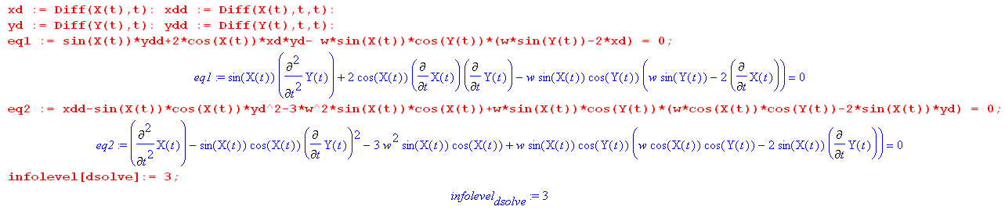

I enter the two equations as shown above, set the infolevel up so I can see what it is thinking. Then:

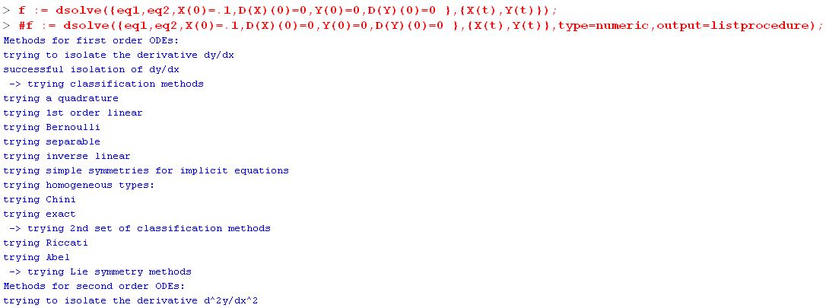
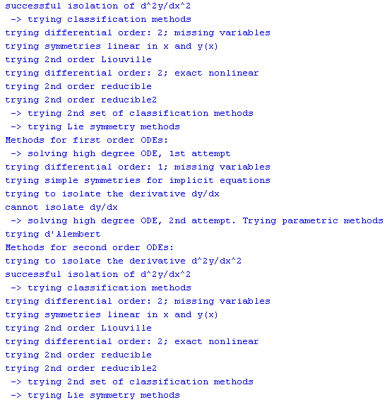

It tries every way it know to try to get an analytic solution, but it cannot of course do it, so we are left with a final result which says f: = blank.

Next, I try so solve numerically. Same setup just a different dsolve call:

It seems that Maple can only solve a "system" of ODE's if it can convert that system to a first order system. But it seems unable to do that conversion, so it gives up at once.

Maybe I can make my own "system". Here are the starting equations

sinx + 2cosx - ωsinxcosy (ωsiny -2) = 0

- sinx cosx 2 + 3ω2sinxcosx + ω sinxcosy(ω cosx cosy - 2sinx ) = 0 (F.5.9)

Now write this as

sinx + 2cosx - ωsinxcosy (ωsiny -2) = 0

- sinx cosx 2 + 3ω2sinxcosx + ω sinxcosy(ω cosx cosy - 2sinx ) = 0 (F.5.9)

=

=

But integrate the last two equations by hand to get

sinx + 2cosx - ωsinxcosy (ωsiny -2) = 0

- sinx cosx 2 + 3ω2sinxcosx + ω sinxcosy(ω cosx cosy - 2sinx ) = 0 (F.5.9)

vx =

vy =

1 + 2cotx vx vy - ωcosy (ωsiny -2vx) = 0

2 - sinx cosx vy2 + 3ω2sinxcosx + ω sinxcosy(ω cosx cosy - 2sinx vy) = 0 (F.5.9)

3 vx =

4 vy =

Seems to me this is a system of four first order ODEs with 4 functions to solve for. Let's try entering it this way and see what Maple has to say about that. Maple gets a little further:

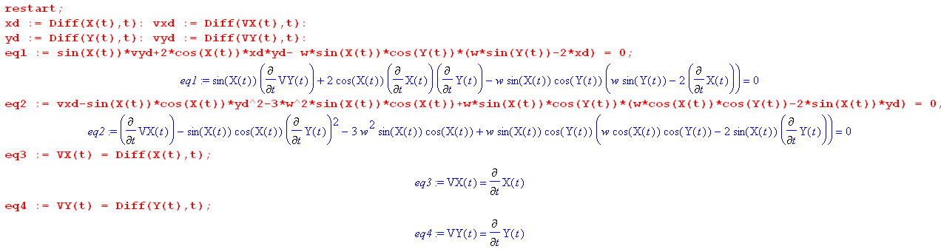

Maybe it has a solution waiting for me to view!

There are my four functions. So how do I look at something? WOW! We get plots!

The upper is θ(t) where I started it at θ = 0.1 and vθ = 0.
Lower is φ(t) where I started it at φ = 0 and vθ = 0.

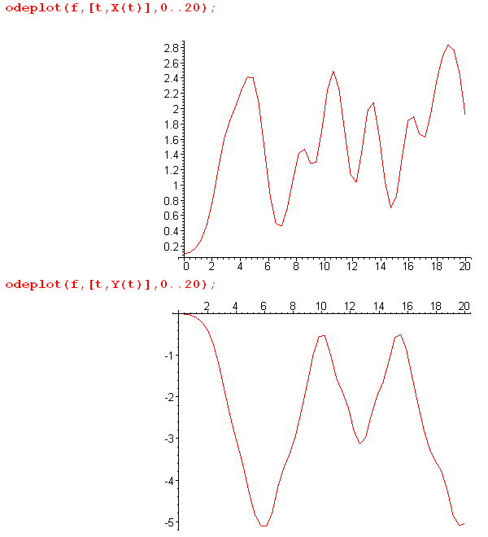

Note that both angles at least stay in angle range. I'm sure this is garbage so far, but at least there is hope!

Something is wrong here because I am not getting a stable tether. For example, set θ = .001 and everything else 0 at the start and you get this for θ. Where is that restoring force that keeps θ small?

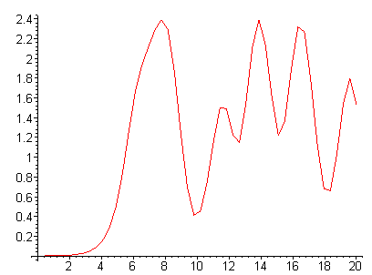

I found the sign error!! Here are the new plots:

f := dsolve({eq1,eq2,eq3,eq4,X(0)=0.01,VX(0)=0,Y(0)=Pi/2,VY(0)=0 }

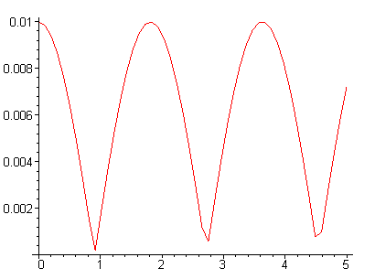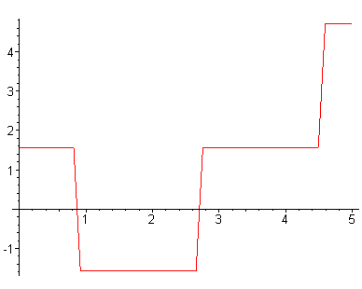
plot of θ(t) plot of φ(t)

The solution looks very good at the start. You see the restoring force pulling θ toward 0, but then something bad happens. Here are both plots together with first magnified,

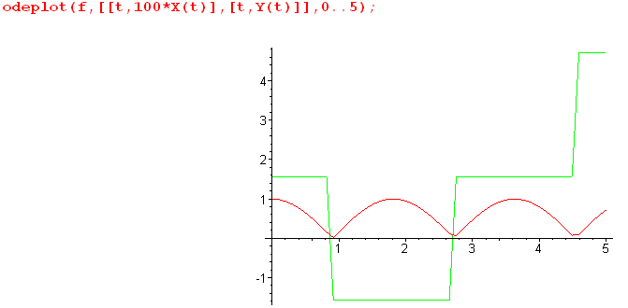

The function θ(t) = X(t) has trouble passing through the 0 value to make the desired sign wave. This is some quirk that I have to work on, but you can see that the basic restoring force idea is there!

Can I get control over the range of variables?? Let's look at dsolve options a bit. I can try some other "methods" instead of just the default. Bang, the classical method worked!!!

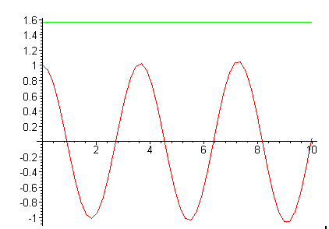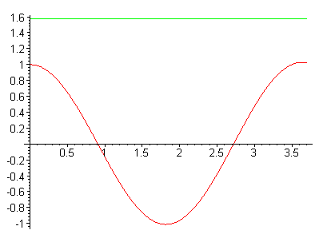

Note that the period is about 3.7 and I set ω = 1. So ωosc= 2π/T = 2π/3.7 = 1.7 and recall you are supposed to get ωosc = $\sqrt{3}$ω = 1.73, so I have replicated a very much desired result!

Let's try some larger starting angles. I seem to get trouble at t = 1. Set ω = 1 in equations:

sinx + 2cosx - sinxcosy (siny -2) = 0

- sinx cosx 2 + 3sinxcosx + sinxcosy(cosx cosy - 2sinx ) = 0 (F.5.9)

I start with

which seem very reasonable starting positions, nothing radical. But as t approaches 1, vy increases very rapidly to numbers that are must unreasonably large. What is causing this?

sinx + 2cosx - sinxcosy (siny -2) = 0

- sinx cosx 2 + 3sinxcosx + sinxcosy(cosx cosy - 2sinx ) = 0 (F.5.9)

vx =

vy =

The first thing to get large is vy.

sinx + 2cosx vx vy - sinxcosy (siny -2vx) = 0

- sinx cosx vy2 + 3sinxcosx + sinxcosy(cosx cosy - 2sinx vy) = 0 (F.5.9)

vx =

vy =

Start Over. Here are my four equations:

1 + 2cotx vx vy - ωcosy (ωsiny -2vx) = 0

2 - sinx cosx vy2 + 3ω2sinxcosx + ω sinxcosy(ω cosx cosy - 2sinx vy) = 0 (F.5.9)

3 vx =

4 vy =

The problem is this: If I start x = θ at 0, then cot(x) = ∞ there in equation 1. This is just not possible, so I think I have an error in equation 1? But I checked and see no error.

The General Problem:

Imagine you have some ODE's describing a system in the region of θ = 0. At θ = 0, the φ coordinate is very singular! A point having θ = 0 has no valid number for φ, so how can you expect a set of equations to describe things near that point.

So why don't we get this same problem for the spherical pendulum? Well my equations for that problem are these.

2 + sin2θ 2 = -(g/l)cosθ + T/(ml) + 2ω [(cosβsinθ + sinβcosφcosθ )sinθ + sinβsinφ ]
- sinθcosθ 2 = - (g/l) sinθ + 2ω [(-cosβcosθ + sinβcosφsinθ)sinθ ]
2cosθ + sinθ = – 2ω [(-cosβcosθ + sinβcosφsinθ) ] . (C.2.9)

and you see the problem sitting in that last equation. But the trick here is that the pendulum never passes through the vertical axis as it swings, so it never hits θ = 0, so φ is always well defined.

So can I get the dumbbell to do some motion like the pendulum and avoid the origin?

