This is the Title PhL 1.11.15

This was installed 1.14.17, do not edit here!

F.7 Numerical Solution of Satellite Angular Equations of Motion

The angular equations of motion for mass m1 of the dumbbell (or tether) satellite are stated in (F.5.7) which we replicate here,

+ sinθcosθ(3ω2 - 2) + ωsinθcosφ (ω cosθ cosφ - 2sinθ ) = 0
+ 2 cotθ – ωcosφ (ωsinφ -2) = 0 (F.5.7) (F.7.1)

The first step is to enter these equations into Maple and set constants (here just ω = 1) :

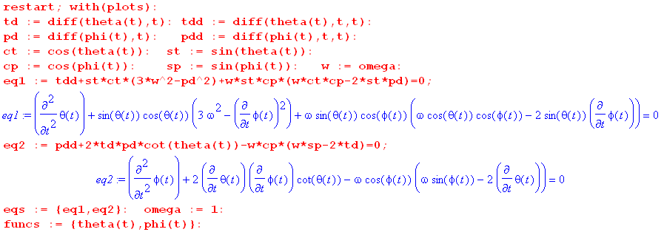

(F.7.2)
For illustration purposes we have set the satellite orbit frequency to ω = 1 sec-1 so

ω = 1 ⇒ T = 2π = 6.28 sec

Verification of in-plane libration

The initial conditions are taken to be

θ = 0.2 φ = π/2 = 0 = 0 . (F.7.3)

We now call Maple's ODE solver routine dsolve and plot 10θ(t) in red and φ(t) in black,

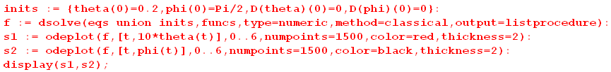

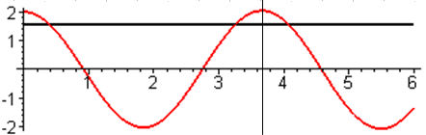 (F.7.4)

The azimuth φ(t) holds at π/2 while θ(t) oscillates. From (F.5.10) for in-plane libration one predicts,

Tocs1 = T/$\sqrt{3}$ = 6.28/1.73 = 3.63 sec (F.7.5)

which is verified by the vertical line in the figure.

Verification of out-of-plane libration

The initial conditions are taken to be

θ = 0.2 φ = 0 = 0 = 0 . (F.7.6)

We then rerun the above code with a different set of "inits" :

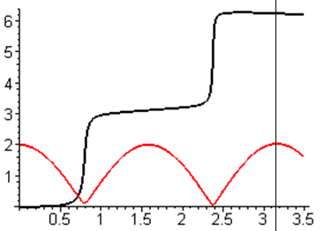 (F.7.7)

Maple has chosen to show the oscillation by keeping θ(t) positive and having φ(t) jump by π at each zero crossing of θ. This is just another way to represent a cosine function. As suggested below (F.5.13), one cannot maintain φ(t) = 0 for the out-of-plane case and one sees φ(t) creeping up from 0 around t = 0.5 sec.

From (F.5.13) for out-of-plane libration one predicts,

Tocs2 = T/2 = 6.28/2 = 3.14 (F.7.8)

which is verified by the vertical line in the figure.

Maple can also plot (t) and (t) and here is a plot showing
all four curves 10θ,φ,, = red,black,green,blue :

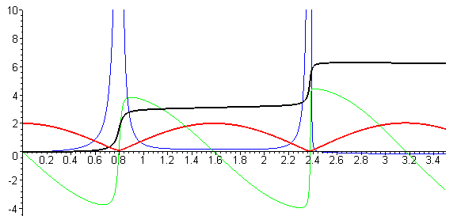 (F.7.9)

This plot hints at a technical problem with the angular ODE system of equations as entered above. The second equation contains a factor cot(θ) which blows up at θ = 0,

+ 2 cotθ – ωcosφ (ωsinφ -2) = 0, (F.7.1)

so whenever the red θ(t) curve approaches 0, one sees getting very large ( is the slope of the blue curve ). Unless ≡ 0 or ≡ 0, the solution cannot pass through θ = 0. The problem is that θ = 0 is a singular point in spherical coordinates where azimuth φ is undefined. One solution to this problem might be to convert the differential equations from spherical coordinates θ and φ to Cartesian coordinates x,y,z where

x = rsinθcosφ
y = rsinθsinφ
z = rcosθ . (E.2.5)

Rather than carry out this conversion, we shall quickly obtain Cartesian equations of motion directly in Section F.8 below and then solve those equations with Maple in Section F.9.

A more general solution

Here in addition to starting with θ(0) = 0.2 and φ(0) = 0, we provide a push in the azimuthal direction so that mass m1 of the dumbbell satellite then swings around in azimuth while it oscillates in θ :

θ = 0.2 φ = 0 = 0 = 2 . (F.7.10)

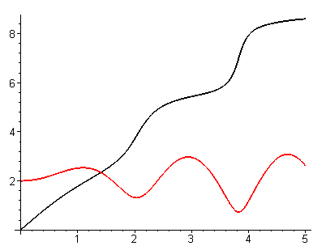 (F.7.11)

Notice that the azimuthal velocity slows down near the peaks of red θ(t). Energy is transferred back and forth between the θ and φ degrees of freedom in this system.

One can use the same odeplot routine used above to make "orbital" plots in angle space,

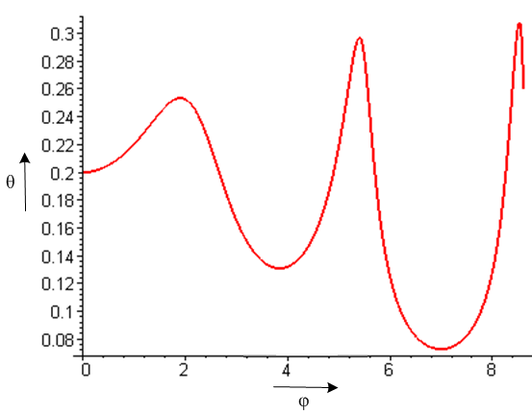 (F.7.12)

Rather than produce more plots here, we shall defer to Section F.9 where we shall plot x(t) and y(t) instead of θ(t) and φ(t) and we then no longer have the θ = 0 singularity problem (which we have carefully hidden from the viewer in this section).

