These three sections were installed 1.14.17, do not edit here!

F.8 Force analysis of the Dumbbell Satellite in Frame S' in Cartesian Coordinates

Section F.6 developed equations of motion for the dumbbell satellite in spherical coordinates. Here we repeat that development but in Cartesian coordinates where things are in many ways simpler. We follow Section F.6 down Newton's Law (F.6.5) ,

Feff,1 = m1 a1 (F.6.5) (F.8.1)
≈ - (GMEm1/r'13)r'1 - T 1 – m1S' – m1ω x (ω x r1) – 2m1 ω x v1 – m1 x r1 .
1 2 3 4 5 6

As a reminder, this is Newton's Law (Feff = ma) for mass m1 of the satellite in Frame S where fictitious forces are included. Although this mass has coordinate r1 in Frame S, we shall refer to its components without 1 subscripts, so r1 = (x,y,z). This is similar to how we used r1 = (r1,θ,φ) in spherical coordinates where θ and φ had implied "1" subscripts. We also write v1 = v and a1 = a to reduce clutter. The quantity T is the tension in the stick (or tether).

We now evaluate the six terms of (F.8.1) in Cartesian coordinates, mimicking (F.6.9) through (F.6.14):

Left side of (F.8.1): m1a1 = m1a = m1(ax + ay + az ) (F.8.2)

Term 1: - (GMEm1/r'13)r'1 = - (GMEm1/r'13)(b + r1)

= - (GMEm1/r'13) [ b + x + y + z ]

= - (GMEm1/r'13) [ x + y + (b+z) ] (F.8.3)

Term 2: - T 1 = -(T/r1)r1 = -(T/r1) [ x + y + z] (F.8.4)

Term 3: – m1S' = – m1 x b - m1 ω x (ω x b) // (F.6.3)

= - m1ω x (ω x b) // satellite in circular orbit, = 0

= - m1(ω•b)ω + m1ω2b //- A x (A x C) = -(A•C)A + A2C

= m1ω2b = m1ω2b (F.8.5)

Term 4: – m1ω x (ω x r1) = -m1(ω•r1)ω + m1ω2r1 // identity shown above

= -m1ω2(•r1) + m1ω2r1 = -m1ω2(x) + m1ω2 [ x + y + z]

= m1ω2 [ y + z] (F.8.6)

Term 5: -2m1 ω x v1 = -2m1 [ω] x ( vx + vy + vz)

= -2m1ω [ vy - vz] (F.8.7)

Term 6: – m1 x r1 = 0 because we assume = 0 (F.8.8)

Having all the bits and pieces, we now assemble the three component equations of (F.8.1). The numbers show the Term above associated with each piece:

Feff,1 = m1 a (F.8.1)
≈ - (GMEm1/r'13)r'1 - T 1 – m1S' – m1ω x (ω x r1) – 2m1 ω x v1 – m1 x r1
1 2 3 4 5 6

: m1 ax = - (GMEm1/r'13) x - (T/r1)x
1 2
: m1 ay = - (GMEm1/r'13) y - (T/r1)y + m1ω2y + 2m1ωvz
1 2 4 5
: m1 az = - (GMEm1/r'13) (b+z) - (T/r1)z + m1ω2b + m1ω2z - 2m1ω vy (F.8.9)
1 2 3 4 5

We now rewrite the three equations dividing by m1 and using (F.5.1) that GME = ω2b3 . At the same time we replace velocity and acceleration components with dot notation components like and :

= - [(ω2b3/r'13) + (T/m1r1)]x

= - [(ω2b3/r'13) + (T/m1r1) - ω2]y + 2ω

= - [(ω2b3/r'13) - ω2] (b+z) - (T/m1r1)z - 2ω

x2+y2+z2 = r12 (F.8.10)

where

r'12 = (r1+b)2 = r12 + b2 + 2 r1• b = r12 + b2 + 2 r1• [b] = r12 + b2 + 2bz . (F.8.11)

Eq. (F.8.10) is a system of 4 equations in 4 unknowns x,y,z,T . To simplify manipulations below, define

A ≡ (ω2b3/r'13)
B ≡ (T/m1r1) // rescaled tension

so the system of equations becomes

1 = - (A + B)x

2 = - (A + B - ω2)y + 2ω

3 = - (A - ω2) (b+z) - Bz - 2ω

4 x2+y2+z2 = r12 (F.8.12)

We now wish to eliminate the rescaled tension B from the equation set. We first eliminate B between equations 1 and 2 :

1*y y = - (A + B)xy

2*x x = - (A + B - ω2)xy + 2ωx .

Subtract so that the -(A + B)xy terms cancel,

y - x = -ω2xy - 2ωx . (F.8.13)

Next, we eliminate B between equations 1 and 3:

1*z z = - (A + B)xz

3*x x = - (A - ω2)(b+z)x - Bxz - 2ωx

= -Abx -Azx +ω2(b+z)x - Bxz - 2ωx

= - (A + B)xz - Abx +ω2(b+z)x - 2ωx .

Subtract so that the -(A + B)xy terms cancel,

z - x = Abx -ω2(b+z)x + 2ωx . (F.8.14)

We now have a system of 3 equations in three unknowns x,y,z, where we now restore A = (ω2b3/r'13)

1 y - x = - ω2xy - 2ωx

2 z - x = (ω2b3/r'13)bx - ω2(b+z)x + 2ωx where r'12 = r12 + b2 + 2bz

3 x2+y2+z2 = r12 (F.8.15)

For convenience, we now reorder and rename equations 1 and 2 of this set as follows:

eq3 z - x = (ω2b3/r'13)bx - ω2(b+z)x + 2ωx

eq2 y - x = - ω2xy - 2ωx (F.8.16)

Now apply the far approximation in equation eq3. Start with

r'12 = r12 + b2 + 2bz = b2 [ 1 + (r1/b)2 + 2(z/b)] ≈ b2[ 1 + 2(z/b) ]

r'1-2 ≈ b-2 [1-2(z/b)]

r'1-3 ≈ b-3 [1-2(z/b)]3/2 ≈ b-3 [ 1 +(3/2)(-2(z/b)] = b-3 [ 1 - 3(z/b)]
so
(b/r'1)3 = 1 - 3(z/b)
and
A ≡ (ω2b3/r'13) ≈ ω2[1 - 3(z/b) ] (F.8.17)

Equation eq3 above then becomes

z - x = (ω2b3/r'13)bx - ω2(b+z)x + 2ωx

= ω2[1 - 3(z/b) ]bx - ω2(b+z)x + 2ωx = ω2bx - 3(z/b)ω2bx - ω2bx - ω2zx + 2ωx

= - 3(z/b)ω2bx - ω2zx + 2ωx = - 3ω2xz - ω2zx + 2ωx

= - 4ω2xz + 2ωx . (F.8.18)

This in the far approximation the equations of motion of mass m1 of the dumbbell are

eq3 z - x = - 4ω2xz + 2ωx

eq2 y - x = - ω2xy - 2ωx

x2+y2+z2 = r12 (F.8.19)

Once these three equations are solved for x(t), y(t) and z(t), we can find the tension T(t) from (say) the first equation of (F.8.12) :

/x +A+B = 0 ⇒ B = - /x - A ⇒ (T/m1r1) = - /x - (ω2b3/r'13)
so
T = - m1r1[ /x + (ω2b3/r'13) ]
so
T = - m1r1[ /x +ω2(1 - 3(z/b)) ] . // far approximation (F.8.17) (F.8.20)

F.9 Verification of the Cartesian equations of motion

The algebra above is quite complex so we want to be sure that our Cartesian equations of motion are correct. First, here are the angular equations of motion from (F.5.7),

eq1 + sinθcosθ(3ω2 - 2) + ωsinθcosφ (ω cosθ cosφ - 2sinθ ) = 0
eq2 + 2cotθ – ωcosφ (ωsinφ -2) = 0 . (F.5.7) (F.9.1)

These were computed using the effective torque method in (F.5.7) and were then verified using the effective force method in (F.6.26) and (F.6.23).

Meanwhile, here are the Cartesian equations of motion from Section F.8,

eq3 z - x = - 4ω2xz + 2ωx
eq2 y - x = - ω2xy - 2ωx . (F.8.19) (F.9.2)

Below we shall show that

Task (a): eq2 of (F.9.2) ⇒ eq2 of (F.9.1)

Task (b): (sinθ)eq3 - (cosθsinφ)eq2 of (F.9.2) ⇒ eq1 of (F.9.1)

That is to say, angular eq1 of (F.9.1) is a certain linear combination of eq3 and eq2 of (F.9.2). If we can show Task (a) and Task (b) above, then we have shown that (F.9.2) ⇔ (F.9.1), and this then serves as verification of (F.9.2).

Maple must replace x,y,z and derivatives with r1,θ,φ and derivatives. For coordinates and first derivatives,

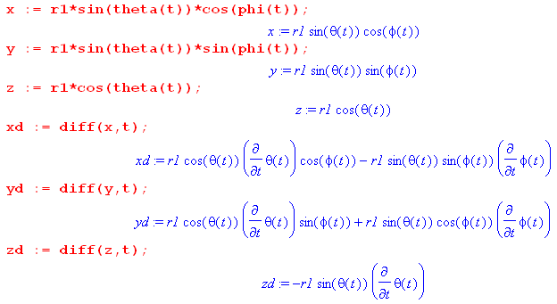 (F.9.3)
The second derivatives are messier, but Maple is happy to do the calculations,

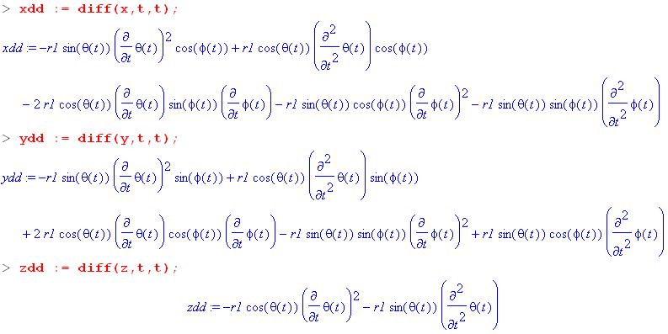 (F.9.4)

Task (a): Show that eq2 of (F.9.2) ⇒ eq2 of (F.9.1)

We enter eq2 of (F.9.2) and do some manipulations, suppressing the output except for the last step :

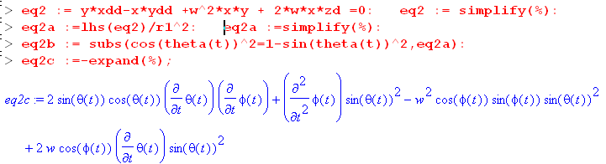 (F.9.5)

On the first red code line we enter eq2 of (F.9.2) and then divide the result by r12. We then replace occurrences of cos2θ by 1-sin2θ. We use lhs = "left hand side" so we end up only with the left side of an equation which says stuff = 0. Symbol % refers to the last computed quantity. The blue result can be manually transcribed as

2sinθcosθ + sin2θ - ω2sin2θ cosφsinφ + 2ωsin2θ cosφ = 0

Now divide by sin2θ and reorder the four terms to get

+ 2cot(θ) - ω2cosφsinφ + 2ωcosφ = 0
or
+ 2cot(θ) - ωcosφ(ωsinφ - 2) = 0 (F.9.6)

This is a match for eq2 of (F.9.1) so we have accomplished Task (a).

Task (b): (sinθ)eq3 - (cosθsinφ)eq2 of (F.9.2) ⇒ eq1 of (F.9.1)

The code continues from that shown above. Equation eq2 is already entered, so we now enter eq3, form the linear combination for eq1, then process the results with a series of typical tortuous Maple steps,

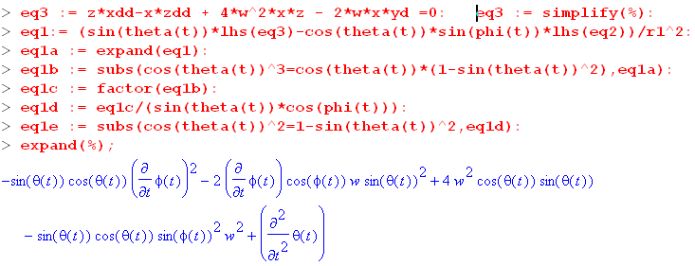 (F.9.7)

We again manually transcribe the result

-sinθcosθ 2 - 2ωsin2θcosφ +4ω2sinθcosθ - ω2sinθcosθsin2φ +
or
-sinθcosθ 2 - 2ωsin2θcosφ +3ω2sinθcosθ +ω2sinθcosθ - ω2sinθcosθsin2φ +
or
+ sinθcosθ 3ω2 -sinθcosθ 2 + ω2sinθcosθ - ω2sinθcosθsin2φ - 2ωsin2θcosφ
or
+ sinθcosθ( 3ω2 - 2) + ω2sinθcosθ(1-sin2φ) - 2ωsin2θcosφ
or
+ sinθcosθ( 3ω2 - 2) + ω2sinθcosθcos2φ - 2ωsin2θcosφ
or
+ sinθcosθ( 3ω2 - 2) + ωsinθcosφ (ω cosθ cosφ - 2sinθ ) (F.9.8)

and after "pulling teeth" we do end up with eq1 of (F.9.1) so Task (b) is accomplished.

F.10 Maple numerical solutions of the Cartesian equations of motion

We have done a lot of "work" in this Appendix F, and now it is time to "play", making use of our hard-won Cartesian equations of motion which don't have the singularity problems had by the angular equations at θ = 0.

Our task is to solve the set of equations (F.8.19) (eq1 now has a new meaning) :

eq1 x2+y2+z2 = r12
eq2 y - x = - ω2xy - 2ωx
eq3 z - x = - 4ω2xz + 2ωx (F.8.19) (F.10.1)

These equations describe the motion of mass m1 of the dumbbell satellite in rotating Frame S as depicted in Fig (***). The position of mass m1 is (x,y,z) where x2+y2+z2 = r12. The motion of mass m2 is then determined by (D.2.8) m1r1 = - m2r2 so (x2,y2,z2) = - (m1/m2)(x,y,z). The length of the stick of the dumbbell satellite is s = r1+ r2 = r1+ (m1/m2)r1 = [1 + (m1/m2] r1.

We enter eq2 and eq3 writing derivatives for example = xdd :

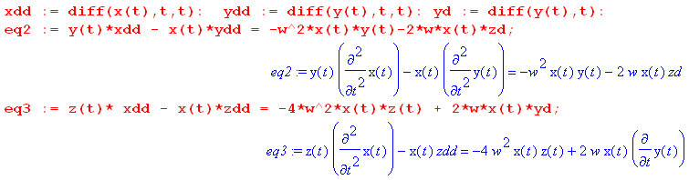
At this point zd = and zdd = are unspecified. We use eq1 to compute and in terms of x and y, using eq1 above:

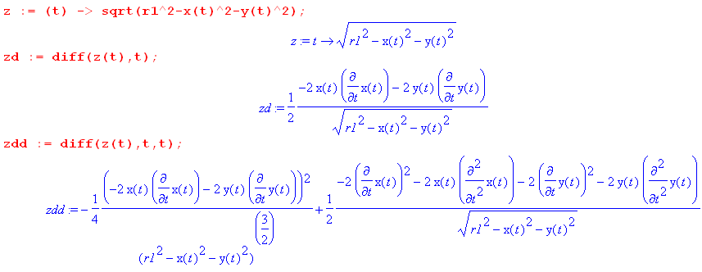
When these expressions are installed, eq2 and eq3 becomes these formidable-looking equations which contain two unknown functions x(t) and y(t) and constants r1 and ω :

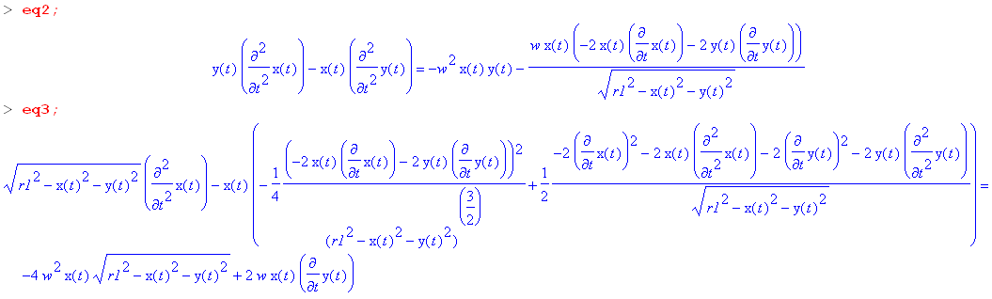

The reader is reminded of the geometry of Fig (F.1.1) where z points up, away from Earth center, y points to the right and is in the plane of the satellite orbit, while x is perpendicular to the plane of the satellite.

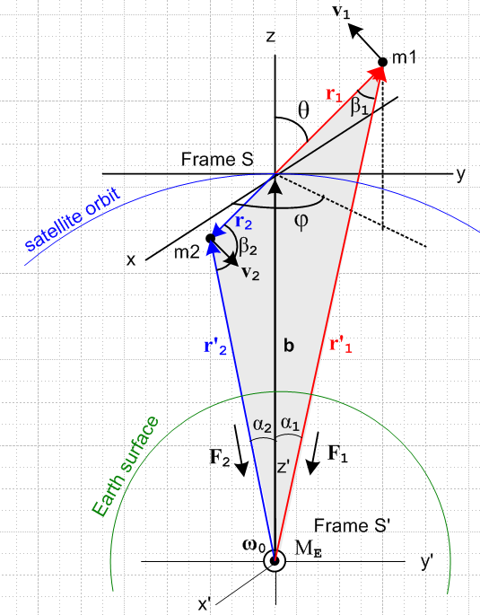

Our plots below in the (x,y) plane are what a viewer would see looking at mass m1 "from above", that is, from a point perhaps z = +2b on the z axis in the above figure.

In-Plane Libration

As our first test, we shall look for the "in-plane libration" behavior. We examined this behavior earlier in (F.7.3) in angular coordinates, and we now look in Cartesian coordinates. The initial conditions are:

x(0) = 0 y(0) = 1 (0) = 0 (0) = 0

With ω = 1, we expect to get a simple swinging back on the y axis with period T = 3.63 sec as shown in (F.7.5). A half period is then 1.82 seconds.

The Maple code to invoke a solution is as follows (for a numerical integration from t = 0 to t = 1.82 sec):

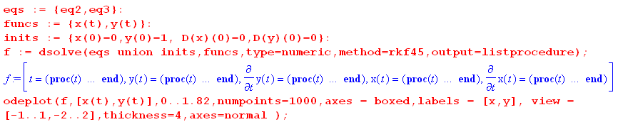

We show the result below on the left, and then from t = 0 to t = 0.91 (quarter period) on the right :

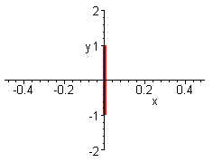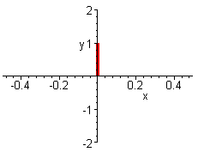

Thus the "orbit" and the period for in-plane libration is confirmed. If we run from t = 0 to t = 10, the graph is as on the left above since mass m1 just swings back an forth in the same orbit, never leaving the y-axis.

Out-of-Plane Libration

We examined this behavior earlier in (F.7.6) in angular coordinates, and we now look in Cartesian coordinates. The initial conditions are now,

x(0) = 1 y(0) = 0 (0) = 0 (0) = 0

With ω = 1, we expect to get a swinging back on the x axis with period T = 3.14 sec as shown in (F.7.8). Here is what Maple has to say:

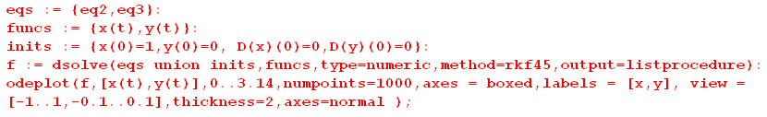

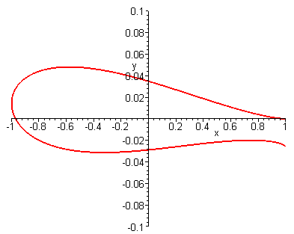

The period looks right since mass m1 swings back close to its initial position after 3.14 seconds, but one sees that the motion is not quite all on the x axis, so out of plane libration is an approximate concept as we noted earlier below (F.5.13). Note in the figure the fine scale of the vertical axis.

Here are orbits for a selection of final integration times:

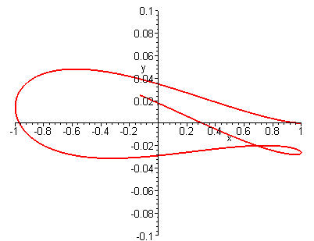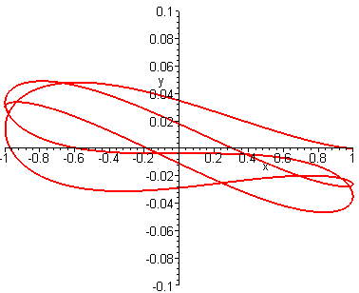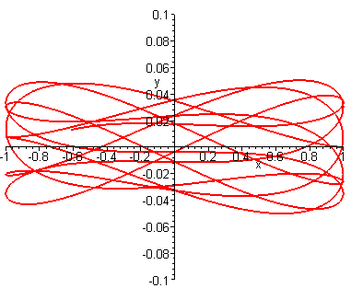
t = 4 t = 8 t = 16

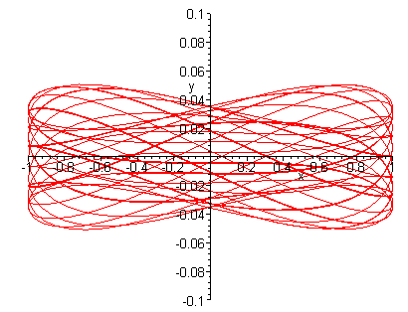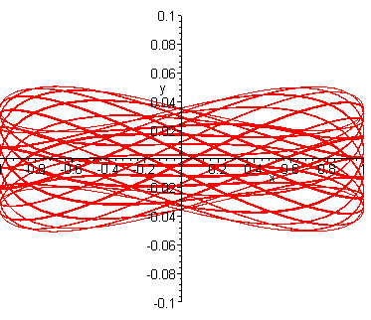
t = 64 t = 500

It does seem that the out-of-plane libration stays within a certain band of deviation in the y direction which we shall leave to the reader to theoretically calculate. The author is reminded of a lecture given by Shelly Glashow on the question: What can be said about orbits on a convex-shaped billiard table? Do they eventually close on themselves, or might they never close?

In the examples above r1 = 10 and we have used x(0) = 1 or y(0) = 1 to obtain "small oscillation". If in the in-plane libration case we use y(0) = 9, there is no change in the orbit, but the oscillation period is slightly altered. If in the out-of-plane libration case we use x(0) = 9, the orbit no longer maintains the narrow band as in the above examples. For example, going again to t = 64 seconds with x(0) = 9,

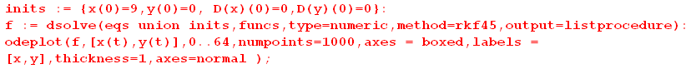

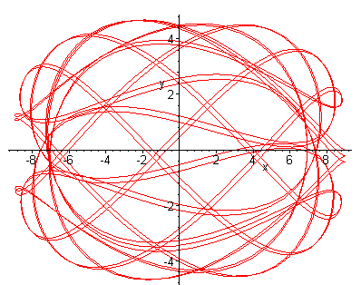

Starting with a diagonal initial position

x(0) = 1 y(0) = 1 (0) = 0 (0) = 0

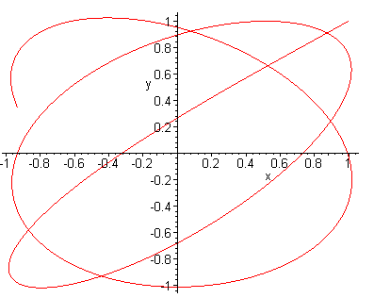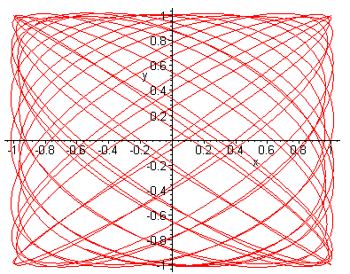
t = 8 t = 64

The t=64 result is reminiscent of a Lizzajous pattern on an oscilloscope screen when the x and y axes are driven by different frequency sine ways.

Attempting a Circular Orbit

