Scraps 1.14.17

It has taken a LONG TIME to get this point on 12.16.16,

Finally we get some oscillation which involves ω and involves a factor of 3. What did my PDF say about this? Here from p 124,

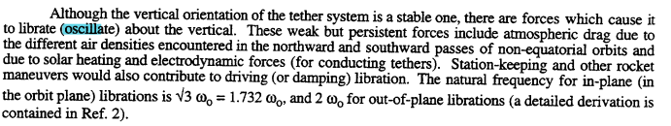

So they are saying

ωlibration = $\sqrt{3}$ω

and that agrees with my equation, hurray!!!

So you have to ignore the fictitious force to get this result! What is the condition for doing that? I show above that φ' = π/2 would do it, the planar case only!

What is the Ref 2 above?

******************************************

Maple Problem: Enter eq1 and eq2, eliminate z as usual, and see if Maple can do a numerical solution. Do this in "satellite in Cartesions v5.mws".

I am able to get it to fly, but the odeplot runs out of memory. Here is my code:

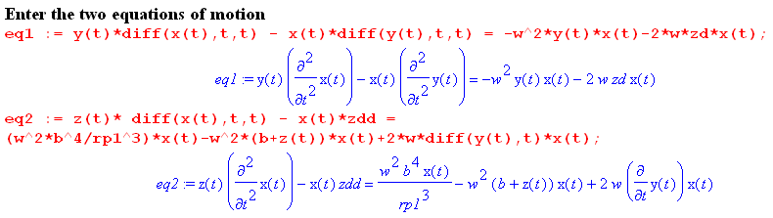

Are these correctly entered? Yes they are. Next, here is how to eliminate z:

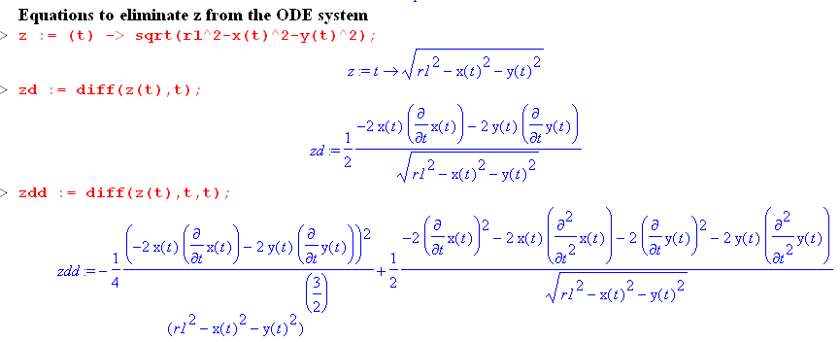

Next we have

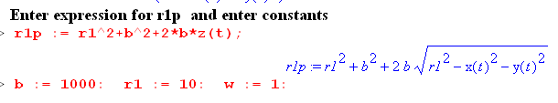
This all looks good. Now we come to the dsolve call:

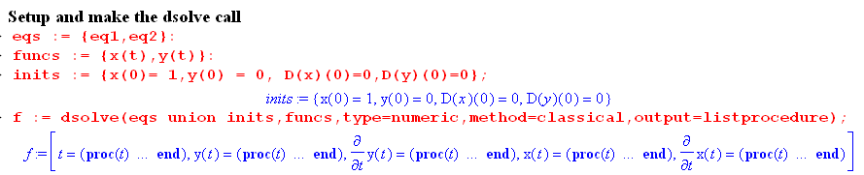

There are only two equations, functions unknown are x(t) and y(t), and there are the inits. I start m1 at location x = 0 and y = 0 and no velocity.

But then I ask if for f(0.1) and it locks up! So maybe I can try some other methods now. I started with classical and it hangs on f(0.1). I try rfk45 and get this

My error was that I had rp1 and r1p both present. Now it works better.

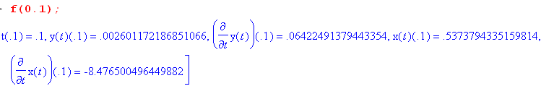

and I get finally some kind of semi-reasonable (perhaps) plot,

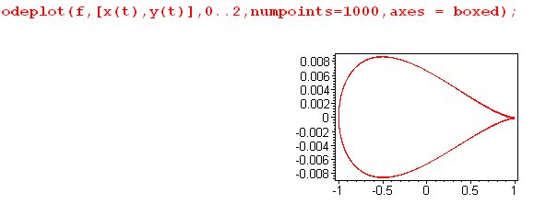

It starts at the right cusp and goes round the loop and repeat Here is just less than one loop

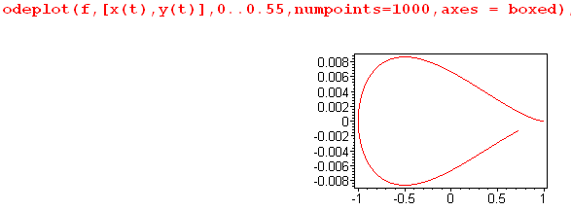

I think as it starts to move, there is Coriolis pushing it to the right. This is I think a big breakthrough in my Cartesian satellite plotting efforts, even though I don't understand the result and I may have lots of math errors still. But it is a reasonable motion! This would be my "out of plane" motion, and I do expect a deviation.

Let's try x(0) = 0 and y(0) = 1, then I expect to get the "in plane" motion:

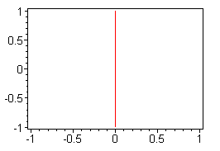

Here it stays in the x = 0 plane and swings back and forth. This looks VERY good, I will now take a break, it is 2:30 PM.

Now let's try for a circular path?

*******************

r'12 = r12 + b2 + 2bz = b2 [ 1 + 2(z/b) + (r1/b)2]

r'1-2 = b-2 [ 1 + 2(z/b) + (r1/b)2]-1

r'1-3 = b-3 [ 1 + 2(z/b) + (r1/b)2]-3/2 x = [2(z/b) + (r1/b)2]

Now use

(1+x)n = 1 + nx + n(n-1)/2 x2 + ....

(1+x)-3/2 = 1 +(-3/2) x + (-3/2) (-5/2)/2 x2 + ....

(1+[2(z/b) + (r1/b)2])-3/2 = 1 +(-3/2) [2(z/b) + (r1/b)2] + (-3/2) (-5/2)/2 [2(z/b) + (r1/b)2]2 + ...

= 1 +(-3/2) 2(z/b) + (-3/2) (r1/b)2 + (15/8) * 4(z/b)2

= 1 -3(z/b) -(3/2) (r1/b)2 + (15/2)(z/b)2

so
(b/r'1)3 = 1 -3(z/b) -(3/2) (r1/b)2 + (15/2)(z/b)2
and
A ≡ (ω2b3/r'13) ≈ ω2[1 -3(z/b) -(3/2) (r1/b)2 + (15/2)(z/b)2]

This is accurate for A through second order!!

With full A I get this

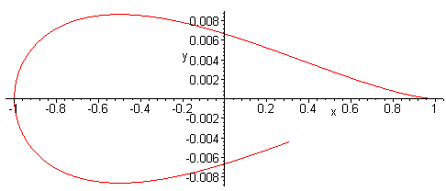

With first order approx A I get this

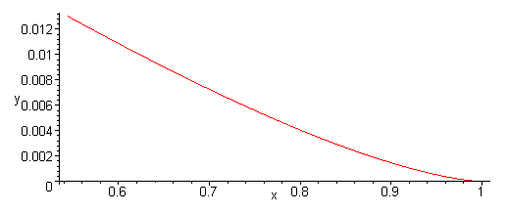

With second order approx A I get this

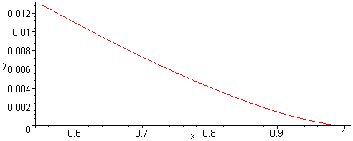

There must be something wrong with my approximation for A!!!

r1p := r1^2+b^2+2*b*z(t);

Yes indeed, this is the wrong expression for r1p.

I am now keeping "the next term" for the moment. Then

z - x = (ω2b3/r'13)bx - ω2(b+z)x + 2ωx

= ω2[1 - 3(z/b) - (3/2)(r1/b)2]bx - ω2(b+z)x + 2ωx

= [ω2 - 3ω2(z/b) - (3/2)ω2(r1/b)2]bx - ω2(b+z)x + 2ωx

= ω2bx - 3ω2(z/b)bx - (3/2)ω2(r1/b)2bx - ω2(b+z)x + 2ωx

= ω2bx - 3ω2zx - (3/2)ω2(r12/b)x - ω2bx - ω2zx + 2ωx

= - 4ω2zx - (3/2)ω2(r12/b)x + 2ωx

= - 4ω2zx + 2ωx - (3/2)ω2(r12/b)x

So there
\
****************88

I am messing in v5 of the mws (OINLY!). With the full-bore A I get this

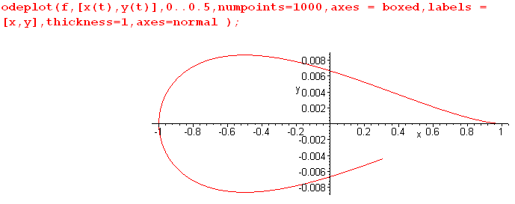

With the approximate A I get this

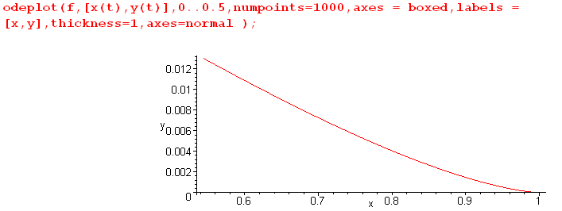

which is just the start of the previous curve. Why are these so very different? I thought my approximation for A was pretty good, but here it makes a huge difference in a trajectory!

v6:

