Appendix H: The Euler Angles and Computation of ω 1
H.1 Euler Angles, Intermediate Rotations, and Unit Vectors 1
H.2 Theorem 3: Elimination of the Intermediate Rotations 7
H.3 Euler Angles : Triple Concatenation and Transformation of Vectors 8
H.4 Euler angles which change in time: computation of ω (Method 1) 13
H.5 Computation of ω (Method 2) 17
H.6 The connection between Euler Angles and Spherical Coordinates 28

This has been installed, do not edit here.

Appendix H: The Euler Angles and Computation of ω

H.1 Euler Angles, Intermediate Rotations, and Unit Vectors

As the reader no doubt knows, it is possible to specify an arbitrary rotation in terms of three Euler angles,

Rz(φ)Rx(θ)Rz(ψ) . (H.1.1)

As shown below, the matrix shown in (H.1.1) will be identified with R-1 of our Section 1 formalism so that

R-1 = Rz(φ)Rx(θ)Rz(ψ) R = Rz(-ψ)Rx(-θ)Rz(-φ) . (H.1.2)

Some authors use other letters for the angles, and some put Ry in the middle in place of Rx.

In this Appendix we are going to strictly use the Euler angles as they are presented in Goldstein (p 107) and GPS (p 152). Similar Euler angle pictures appear in Marion (p 385) and T&M (p 441). Both author groups use the same names for the Euler angles. However, the Goldstein authors start with (x,y,z) and end up with (x',y',z') while the Marion authors start with (x'1,x'2,x'3) and end up with (x1,x2,x3).

The reader will notice in (H.1.1) that we have italicized the Euler angle φ but not θ and ψ. This italic φ is used throughout this Appendix as one of the Euler angles. Eventually in Section H.6 we shall explain why the italic is used, but we can preview that discussion right here. We use the symbols r,θ,φ to represent spherical coordinates (no italic on φ), as for example in Appendix A and Appendix E. As shown there, the rotation Ry(θ) is natural to use to define spherical unit vectors, whereas Goldstein uses Rx(θ) in (H.1.1) above. It turns out that if we want the Goldstein ' unit vector to align with of spherical coordinates, then the connection between spherical coordinate angle φ and Goldstein Euler angle φ is φ = φ+π/2. We like to think of = ' as defining the symmetry axis (figure axis) for a rotating object such as the top treated in Section I.1. If there were no heavy-duty precedents for Euler angles, one might use Ry(θ) in place of Rx(θ) in (H.1.1), and this is the approach of Taylor (p 401) and others. The main issue is this: for the Goldstein and Marion authors, if φ = 0 then the "tipped down by θ" z' axis lies over the negative y axis which is φ = -π/2. If Ry(θ) were used instead, then the tipped down z' axis would lie over the positive x axis and would have φ = 0, and this is the way things work for spherical coordinates as shown in Appendix E.

We have in mind that the matrices shown in (H.1.1) are specifically the active rotation matrices shown in (A.1),

Rx(θ) = $\left(\begin{matrix}1 & 0 & 0 \\ 0 & cosθ & -sinθ \\ 0 & sinθ & cosθ\end{matrix}\right)$ Ry(θ) = $\left(\begin{matrix}cosθ & 0 & sinθ \\ 0 & 1 & 0 \\ -sinθ & 0 & cosθ\end{matrix}\right)$ Rz(θ) = $\left(\begin{matrix}cosθ & -sinθ & 0 \\ sinθ & cosθ & 0 \\ 0 & 0 & 1\end{matrix}\right)$ . (H.1.3)

To get Maple warmed up for activities below, we enter the three matrices of (H.1.3),

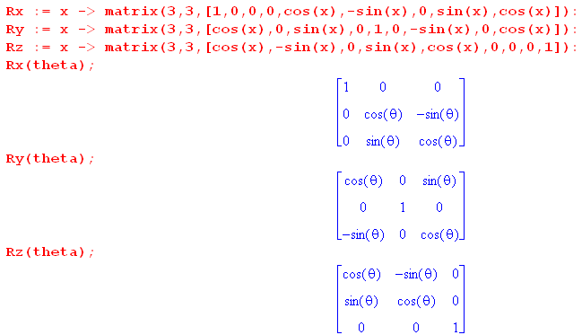

These (H.1.3) matrices are "active" because, using the right-hand-rule, they rotate a vector forward by angle θ in the Active View described at the start of Section 1.3. For example, for small θ the rotation Rz(θ) acting on produces a vector in the first quadrant of the x-y plane:

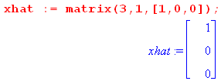 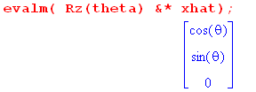 (H.1.4)

Here now is Goldstein's Euler Angle picture (G p 107, GPS p152), enhanced a bit for readability,

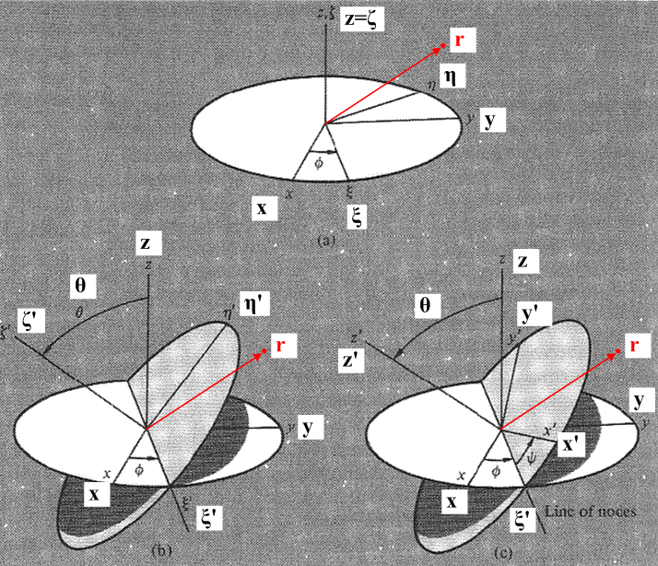 (H.1.5)

Astronomy Footnote: Imagine that the white disk is a "reference plane" (perhaps the equatorial plane of the Earth) and the grey disk perimeter denotes the orbit of some object about another (perhaps the Moon about the Earth). That orbiting object crosses the reference plane in two places called "nodes" (ascending and descending by some convention). The intersection of the two planes is called the "line of nodes". In Goldstein's drawing this coincides with the ξ' axis. In this application, the Euler angles θ,φ define the plane of the Moon's orbit, and Euler angle ψ shows the progress of the Moon in this orbit. As noted in Section 8.8, the Moon's orbital plane precesses, so the line of nodes rotates in the white disk plane.

Fig (H.1.5) shows how one can start with x,y,z axes at the top, and end up with x',y',z' axes on the lower right. There are really three sequential transformations occurring here, and we can just read off the effects on unit vectors by looking at the pictures: ( ξ = xi = "zeye", η = eta = "ate'uh, ζ = zeta = "zee'ta")

top (,,) = Rz(φ) (,,) where =

left (',',') = Rξ(θ) (,,) where ' =

right (',',') = Rζ'(ψ)(',',') where ' = ' (H.1.6)

For example, the first of these nine equations says = Rz(φ) which seems clear from the top picture. The rotation Rξ(θ) is an active rotation of θ about the axis, and similarly for Rζ'(ψ).

We can combine transformations in various obvious ways :

(,,) = Rz(φ) (,,) // each equation is like e'n = R-1en

(',',') = Rξ(θ) (,,) = Rξ(θ) Rz(φ) (,,)

(',',') = Rζ'(ψ) (',',') = Rζ'(ψ) Rξ(θ) (,,) = Rζ'(ψ) Rξ(θ) Rz(φ) (,,) . (H.1.7)

For example, ' = Rζ'(ψ)' = Rζ'(ψ) Rξ(θ) = Rζ'(ψ) Rξ(θ)Rz(φ) .

These equations are all of the template form e'n = (R-1)en appearing in our Basis Theorem (1.1.30). The meaning is |e'n> = R-1|en> = |R-1en>. If one takes Frame S components of these equations, then in e'n = (R-1)en one can interpret (R-1) as a matrix. For example, for = Rz(φ) one can write ()i = [Rz(φ)]ij()i in which case [Rz(φ)]ij is the matrix shown in (H.1.3).

In going all the way from the Frame S basis en to the Frame S' basis e'n we see from the last line in (H.1.7) that in order to interpret this last line as e'n = (R-1)en, we must make the identification

R-1 = Rζ'(ψ) Rξ(θ) Rz(φ) . (H.1.8)

The R symbol here is the R that appears in our Section 1 formalism. In particular, recall the Basis Theorem (1.1.29) and (1.1.30), and the alternate notation of (1.1.32),

e'n = R-1en ⇔ e'n = Rnm em or $\left(\begin{matrix}e'1 \\ e'2 \\ e'3\end{matrix}\right)$ = R $\left(\begin{matrix}e1 \\ e2 \\ e3\end{matrix}\right)$ . (1.1.29,30) + (1.1.32)

Define Q ≡ R-1 and rewrite the Basis Theorem as,

e'n = Qen ⇔ e'n = (Q-1)nm em or $\left(\begin{matrix}e'1 \\ e'2 \\ e'3\end{matrix}\right)$ = [Q]-1 $\left(\begin{matrix}e1 \\ e2 \\ e3\end{matrix}\right)$ . (H.1.9)

This form of the Basis Theorem then serves as a template with which we can convert the equations of (H.1.7) to the corresponding linear combination equations of basis vectors :

= [Rz(φ)]-1 = Rz(-φ) Q = Rz(φ)

= [Rξ(θ) Rz(φ)]-1 = Rz(-φ) Rξ(-θ) Q = Rξ(θ) Rz(φ)

= [Rζ'(ψ) Rξ(θ)Rz(φ)]-1 = Rz(-φ) Rξ(-θ)Rζ'(-ψ) . (H.1.10)

We constantly use facts like [ABC]-1 = C-1B-1A-1 and R-1s(α) = Rs(-α).

These equations can be inverted in the obvious manner. The last one would give

= Rζ'(ψ) Rξ(θ)Rz(φ) . (H.1.11)

If we install this equation on the right of the first two equations in (H.1.10), the results are

= Rz(-φ) = Rz(-φ) Rζ'(ψ) Rξ(θ)Rz(φ)

= Rz(-φ) Rξ(-θ) = Rz(-φ) Rξ(-θ) Rζ'(ψ) Rξ(θ)Rz(φ) . (H.1.12)

We know all about the rotations Rx, Ry and Rz since they are specifically stated in (H.1.3). But what about the strange rotations Rξ and Rζ' which dot the landscape above? In Theorem 3 below we shall show that each of these rotations may be written as a certain product of the Rx, Ry and Rz. Specifically, in Theorem 3 we shall prove the first three results below :

(1) Rξ(θ) = Rz(φ) Rx(θ) Rz(-φ)

(2) Rζ'(ψ) = Rz(φ) Rx(θ)Rz(ψ)Rx(-θ)Rz(-φ)

(3) Rζ'(ψ) Rξ(θ) Rz(φ) = Rz(φ)Rx(θ)Rz(ψ) = R-1

Using these equations one can clear out all the strange rotations from (H.1.10,11,12) as follows :
(1)
(4) Rz(-φ) Rξ(-θ) = Rz(-φ) [Rz(φ) Rx(-θ) Rz(-φ)] = Rx(-θ) Rz(-φ)
(3)
(5) Rz(-φ) Rξ(-θ)Rζ'(-ψ) = [Rζ'(ψ) Rξ(θ) Rz(φ)]-1 = [Rz(φ)Rx(θ)Rz(ψ)]-1 = Rz(-ψ)Rx(-θ)Rz(-φ)
(2) (1)
(6) Rz(-φ) Rζ'(ψ) Rξ(θ)Rz(φ) = Rz(-φ) [Rz(φ) Rx(θ)Rz(ψ)Rx(-θ)Rz(-φ)] [Rz(φ) Rx(θ) Rz(-φ)]Rz(φ)
= Rx(θ)Rz(ψ) // use Rz(-φ)Rz(φ) = 1 in three places, then Rx(-θ)Rx(θ) = 1

(7) Rz(-φ) Rξ(-θ) Rζ'(ψ) Rξ(θ)Rz(φ)
= Rz(-φ) [Rz(φ) Rx(-θ) Rz(-φ)] [Rz(φ) Rx(θ)Rz(ψ)Rx(-θ)Rz(-φ)][Rz(φ) Rx(θ) Rz(-φ)]Rz(φ)
= Rz(ψ) (1) (3) (1)
(H.1.13)
One can then rewrite (H.1.10,11,12) as

(a) = Rz(-φ)

(b) = Rx(-θ) Rz(-φ) // using (4)

(c) = Rz(-ψ)Rx(-θ)Rz(-φ) // using (3)

(d) = Rz(φ)Rx(θ)Rz(ψ) // using (5)

(e) = Rx(θ)Rz(ψ) // using (6)

(f) = Rz(ψ) . // using (7) (H.1.14)

Using these equations, one has explicit formulas for writing any of the nine basis vectors either as a linear combination of ,, or as a linear combination of ',',' .
By inspection one can rewrite the above six equations in the form shown on the right side of the Basis Theorem (H.1.9),

$\left(\begin{matrix}e'1 \\ e'2 \\ e'3\end{matrix}\right)$ = [Q]-1 $\left(\begin{matrix}e1 \\ e2 \\ e3\end{matrix}\right)$ ⇔ e'n = Qen (H.1.9)

Therefore,

(a) (,,) = Rz(φ) (,,)

(b) (',',') = Rz(φ)Rx(θ) (,,)

(c) (',',') = Rz(φ)Rx(θ)Rz(ψ) (,,)

(d) (,,) = Rz(-ψ)Rx(-θ)Rz(-φ) (',',')

(e) (,,) = Rz(-ψ)Rx(-θ) (',',')

(f) (',',') = Rz(-ψ) (',',') . (H.1.15)

We shall now prove the three facts quoted above as (H.1.13) (1), (2) and (3), and then we shall resume our discussion of the Euler Angles .

H.2 Theorem 3: Elimination of the Intermediate Rotations

Theorem 3 : The following claims are made : (H.2.1)

(1) Rξ(θ) = Rz(φ) Rx(θ) Rz(-φ)

(2) Rζ'(ψ) = Rz(φ) Rx(θ)Rz(ψ)Rx(-θ)Rz(-φ)

(3) Rζ'(ψ) Rξ(θ) Rz(φ) = Rz(φ)Rx(θ)Rz(ψ) = the Euler angle rotation R-1 of (H.1.8)

Recall from (G.1.1) that a rotation of α about axis may be written R(α) = exp(-i α n • J) .

Proof of (1) :

Recall Theorem 2 of (G.4.7) which says,

R exp(-iθn•J) R-1 = exp(-iθn'•J) where n' = Rn . (G.4.7)

Note from line 1 of (H.1.6) that = Rz(φ) . We take n' = , R = Rz(φ), n = to get

Rz(φ) exp(-iθ•J) Rz(-φ) = exp(-iθ•J)

or
Rξ(θ) = exp(-iθ•J) = Rz(φ) Rx(θ) Rz(-φ) . QED (1)

and we have thus proved item (1).
One can see intuitively how this works, as in our example of (G.4.14). Instead of rotating θ about the axes, we first back-rotate around by -φ, use the aligned Rx(θ) to create a tilted disk in the top drawing of Fig (H.1.5), then forward rotate that result by Rz(φ) to get the tilted disk in the left picture. The good news is that we don't have to rely on such visualizations to get the result right.

Proof of (2) :

Recall again Theorem 2 of (G.4.7) which says (now with dummy argument θ → ψ),

R exp(-iψn•J) R-1 = exp(-iψn'•J) where n' = Rn . (G.4.7)

Note from lines 2,1 of (H.1.6) that that ' = Rξ(θ) = Rξ(θ). We take n' = ', R = Rξ(θ), n = to get

Rξ(θ)exp(-iψ•J)Rξ(-θ) = exp(-iψ'• J) = Rζ'(ψ) .

Therefore

Rζ'(ψ) = Rξ(θ)Rz(ψ)Rξ(-θ) .

Then installing result (1) twice we get

Rζ'(ψ) = [Rz(φ) Rx(θ) Rz(-φ)] Rz(ψ) [Rz(φ) Rx(-θ) Rz(-φ)]

= Rz(φ) Rx(θ) Rz(ψ) Rx(-θ) Rz(-φ) QED (2)

and we have thus proved item (2).

Reader Exercise: Interpret this result in terms of back-rotations and Fig (H.1.5).

Proof of (3) :
(2) (1)
Rζ'(ψ) Rξ(θ) Rz(φ) = [Rz(φ) Rx(θ)Rz(ψ)Rx(-θ)Rz(-φ)] [Rz(φ) Rx(θ) Rz(-φ)] Rz(φ)

= Rz(φ) Rx(θ) Rz(ψ) Rx(-θ) Rz(-φ) Rz(φ) Rx(θ) Rz(-φ) Rz(φ)

= Rz(φ) Rx(θ) Rz(ψ) Rx(-θ) Rx(θ)

= Rz(φ) Rx(θ) Rz(ψ) . QED (3)

H.3 Euler Angles : Triple Concatenation and Transformation of Vectors

Comparison with Goldstein and GPS

Resuming the Euler angle discussion, from (H.1.8) and Theorem 3 (3) we know that

R-1 = Rζ'(ψ) Rξ(θ) Rz(φ) = Rz(φ) Rx(θ) Rz(ψ)
so
R = Rz(-ψ) Rx(-θ) Rz(-φ) . (H.3.1)
On Goldstein p 109 (GPS p 153) this last equation R = Rz(-ψ)Rx(-θ)Rz(-φ) appears as A = BCD which is written out in detail in (4-46) (GPS 4.46), and which Maple verifies,

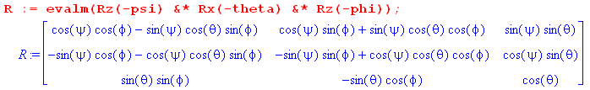 (H.3.2)

The transpose R-1 = RT then appears in Goldstein (4-47) (GPS 4.47) .

Interpretation of the Goldstein's Triple Concatenation

In our Section 1 formalism, we discuss the idea of three concatenated transformations near (1.1.41). We can compare the equations there to those of (H.1.6),

e"'n = U-1e''n e"n = S-1e'n e'n = R-1en (H.3.3)

(',',') = Rζ'(ψ) (',',') (',',') = Rξ(θ) (,,) (,,) = Rz(φ) (,,) .

It follows that the three "back-rotations" are

U-1 = Rζ'(ψ) S-1 = Rξ(θ) R-1 = Rz(φ) . (H.3.4)

In Fig (1.3.4) we show an example where R-1 = Rz(-α) = "back-rotation" and we draw the figure for some small α > 0. In Goldstein's back rotations, the role of α is played by -ψ ,-θ and -φ. Figure (H.1.5) shows that the basis vector "back rotations" are really forward rotations by ψ, θ and φ.

Doing the triple concatenation one gets,

e"'n = U-1S-1R-1en = Rζ'(ψ)Rξ(θ) Rz(φ)en
or
(',',') = Rζ'(ψ) Rξ(θ) Rz(φ) (,,) (H.3.5)

in agreement with (H.1.7).

Transformation of Kinematic Vectors

The corresponding Passive View transformations of Kinematic Vectors for the three concatenations are,

(V)''' = UV" (V)" = SV' (V)' = RV . (H.3.6)

Doing the concatenation and then changing the Section 1 triple-prime to Goldstein's single-prime, we get

(V)' = USR V

= Rζ'(-ψ)Rξ(-θ)Rz(-φ) V . (H.3.7)

If we now redefine R to be our notation for Goldstein's overall transformation, we get

(',',') = R-1(,,) R-1 = Rζ'(ψ) Rξ(θ) Rz(φ)
= Rζ'(ψ) Rξ(θ) Rz(φ) (,,)

(V)' = R V R = [Rζ'(ψ) Rξ(θ) Rz(φ)]-1
= [Rζ'(ψ) Rξ(θ) Rz(φ)]-1 V . (H.3.8)

We can rewrite the above lines making use of Theorem 3 item (3) to get

(',',') = R-1(,,) R-1 = Rz(φ)Rx(θ)Rz(ψ)
= Rz(φ)Rx(θ)Rz(ψ) (,,)

(V)' = R V R = [ Rz(φ)Rx(θ)Rz(ψ)]-1
= [ Rz(φ)Rx(θ)Rz(ψ)]-1 V

= Rz(-ψ)Rx(-θ)Rz(-φ) V . (H.3.9)

This last item is the rule for finding the Frame S' components (V)'i of a vector V in terms of its Frame S components Vi .

Figure (H.1.5) shows the Kinematic Vector V = r which is the position of some point in Frame S .

Exercise 1:

Compute the Frame S' components of the vector r which in Frame S has components (x,y,z) .

(r)' = R r = Rz(-ψ)Rx(-θ)Rz(-φ) r (H.3.10)

(H.3.11)

Therefore
(r)' = $\left(\begin{matrix}x' \\ y' \\ z'\end{matrix}\right)$ = R$\left(\begin{matrix}x \\ y \\ z\end{matrix}\right)$
and so

x' = (cosψcosφ - sinψcosθsinφ) x + (cosψsinφ + sinψcosθcosφ) y + sinψsinθ z

y' = (- sinψcosφ - cosψcosθsinφ) x + (-sinψsinφ + cosψcosθcosφ) y + cosψsinθ z

z' = sinθsinφ x - sinθcosφ y + cosθ z . (H.3.12)

Application: What are the Frame S' components of ?

Apply the previous equation to (x,y,z) = (1,0,0):

x' = cosψcosφ - sinψcosθsinφ = ()'1
y' = - sinψcosφ - cosψcosθsinφ = ()'2
z' = sinθsinφ = ()'3 (H.3.13)

Inspect the basis vector in the lower right drawing of Fig (H.1.5). For the small Euler angles used in the figure, appears to have positive x' and z' components, but a negative y' component. This is confirmed by looking at (H.3.13).

We now reverse Exercise 1 to get Exercise 2.

Exercise 2:

Compute the Frame S components of the vector r which in Frame S' has components (x',y',z') .

r = R-1(r)' = Rz(φ)Rx(θ)Rz(ψ)(r)' . (H.3.14)

The matrix R-1 = RT is just the transpose of the matrix shown above; Maple computes it anyway,

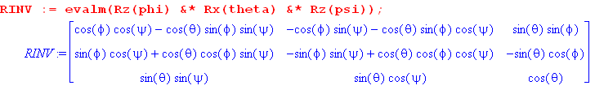 (H.3.15)
Therefore
r = $\left(\begin{matrix}x \\ y \\ z\end{matrix}\right)$ = R-1$\left(\begin{matrix}x' \\ y' \\ z'\end{matrix}\right)$
and so

x = (cosφcosψ-cosθsinφsinψ) x' + (-cosφsinψ-cosθsinφcosψ) y' +sinθsinφ z'

y = (sinφcosψ + cosθcosφsinψ) x' + (-sinφsinψ+cosθcosφcosψ) y' - sinθcosφ z'

z = sinθsinψ x' + sinθcosψ y' + cosθ z' . (H.3.16)

Application: What are the Frame S components of ' ?

Apply the previous equation to (x',y',z') = (1,0,0):

'x = cosψcosφ - sinψcosθsinφ = (')1
'y = sinφcosψ + cosθcosφsinψ = (')2
'z = sinθsinψ = (')3 (H.3.17)

Inspect the basis vector ' in the lower right drawing of Fig (H.1.5). For the small Euler angles used in the figure, ' appears to have positive x,y and z components. This is confirmed in (H.3.17).

Exercise 3: Express (,,) in terms of (',',') .

According to (H.1.14) (d) we know that

= Rz(φ)Rx(θ)Rz(ψ) // = R-1 (H.1.14) (d)

where Maple computes the matrix,

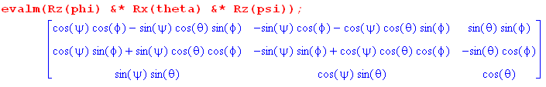 .

Therefore

= (cosψcosφ - sinψsinφcosθ) ' + (-sinψcosφ - cosψsinφcosθ)' + (sinφsinθ) '

= (cosψsinφ + sinψcosφcosθ) ' + (-sinψsinφ + cosψcosφcosθ)' + (-cosφsinθ) '

= (sinψsinθ)' + (cosψsinθ)' + (cosθ) ' . (H.3.18)

And now we go the other direction:

Exercise 4: Express (',',') in terms of (,,)

Inverting (H.1.14) (d) quoted just above we find

= Rz(-ψ)Rx(-θ)Rz(-φ) // = R (H.1.14) (d) inverse

We can then use the Exercise 3 result with φ,θ,ψ → -ψ,-θ,-φ. But to avoid errors, we just use Maple again to get

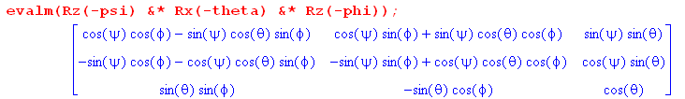

Therefore,

' = (cosψcosφ - sinψsinφcosθ) + (cosψsinφ + sinψcosφcosθ) + (sinθsinψ)

' = (-sinψcosφ - cosψsinφcosθ) + (-sinψsinφ + cosψcosφcosθ) + (sinθcosψ)

' = (sinφsinθ) + (-cosφsinθ) + (cosθ) . (H.3.19)

Exercise 5: Compute the unit vectors , , .

Looking at the polar coordinates equation (E.5.3), and then looking at Fig (H.1.5), we can read off

= -sinφ +cosφ

= -sinψ '+cosψ '

= -sinθ +cosθ . (H.3.20)

We could then use results (H.3.18) or (H.3.19) to express these all in terms of (,,) or (',',') .

H.4 Euler angles which change in time: computation of ω (Method 1)

Suppose now that all the Euler angles are changing in time. The combination of all these movements creates an overall ω angular rotation vector relating the relative motion of the two Frames (as in Fig 1). Looking at Fig (H.1.5) we see that ω will have three contributions, one from each Euler angle movement,

ωφ =
ωθ = '
ωψ = ' . (H.4.1)

If we want to know these contributions in Frame S components, we have to replace ' and ' with their appropriate linear combinations of , and . From (H.1.14b),

= Rx(-θ) Rz(-φ) (H.1.14b)

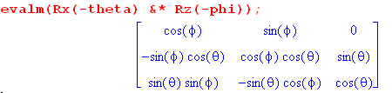
Therefore,

' = cosφ + sinφ . // this particular fact is obvious from Fig (H.1.5) top (H.4.2)

From (H.3.19),

' = sinθsinφ - sinθcosφ + cosθ . (H.3.19)

Inserting these last two results into (H.4.1) gives,

ωφ =
ωθ = cosφ + sinφ
ωψ = sinθsinφ - sinθcosφ + cosθ . (H.4.3)

Add up to get

ω = ωφ + ωθ + ωψ
= [ sinθsinφ + cosφ] + [- sinθcosφ + sinφ ] + [ cosθ + ]
or
(ω)x = sinθsinφ + cosφ
(ω)y = - sinθcosφ + sinφ
(ω)z = cosθ + . // Frame S (H.4.4)

These then are the Frame S components of the ω vector.

Conversely, suppose we want (as Goldstein does want) the components of ω in Frame S' components, Frame S' being the rotating frame in which a "rigid body" might lie. From (H.1.14e),

= Rx(θ)Rz(ψ) (H.1.14e)

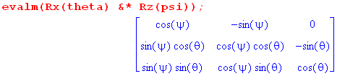
Therefore

' = = cosψ ' - sinψ ' . (H.4.5)

This fact can be verified by staring for a while at the lower right drawing in Fig (H.1.5). There we see that ' = Rz'(-ψ)' which implies the above. The author is prone to making errors staring at drawings and for this reason prefers the bulletproof Maple approach to computing things.

From (H.3.18),

= sinθsinψ ' + sinθcosψ ' + cosθ ' . (H.3.18)

Inserting these last two results into (H.4.1) gives,

ωφ = = sinθsinψ ' + sinθcosψ ' + cosθ '
ωθ = ' = cosψ ' - sinψ '
ωψ = ' . (H.4.6)

Add up to get

ω = ωφ + ωθ + ωψ
= [ sinθsinψ + cosψ ] ' + [ sinθcosψ - sinψ] ' + [ cosθ + ] '
or
(ω)'x = sinθsinψ + cosψ ≡ ωx'
(ω)'y = sinθcosψ - sinψ ≡ ωy'
(ω)'z = cosθ + . ≡ ωz' // Frame S' (H.4.7)

These then are the Frame S' components of the ω vector.

This result is in agreement with Goldstein page 134 (GPS page 174),

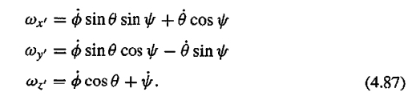

A quick verification of (H.4.4)

From (H.3.1) we have

R = Rz(-ψ)Rx(-θ)Rz(-φ) . (H.3.1)
The rule for transformation of a kinematic vector is given by (1.3.3) as

ω' = (ω)' = Rω (H.4.8)

which from (1.3.10) we can write as

(ω')i = (ω)'i = Rij(ωj) = [ Rz(-ψ)Rx(-θ)Rz(-φ) ]ij(ωj) . (H.4.9)

Inverting,

(ω)i = [ Rz(φ)Rx(θ)Rz(ψ)]ij (ω)'j . (H.4.10)

We enter the (ω)'j components (H.4.7) into Maple and then compute the (ω)i using (H.4.10),

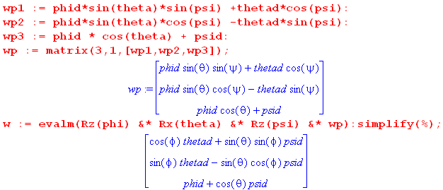 (H.4.11)

Transcribing the result gives,

(ω)x = cosφ + sinθsinφ
(ω)y = sinφ - sinθcosφ
(ω)z = + cosθ . (H.4.12)

This agrees with (H.4.4) above, providing some verification for our Frame S components of ω.

H.5 Computation of ω (Method 2)

In this section our approach to computing ω for the Euler Angle rotation is to find an equation which involves ω and solve it for ω! More or less at random, we choose (1.7.4),

(den/dt)S' = – ω x en . (1.7.4) (H.5.1)

Unlike our Method 1 computation of ω in the previous section, here we shall have no need for Goldstein's geometric Figure (H.1.5) or intermediate angles like ξ and ζ. We will, however, need various algebraic results developed in Section G.3.

This calculation is a bit slippery and requires care and precision in the use of notation -- it is easy to go astray. We shall use both matrix and Section 1.1 Dirac notations as seem convenient. A silver lining is that we shall be able to apply many of the results derived earlier in this document.

Recall from (H.3.1) that the Goldstein Euler angle rotation is given by

R = Rz(-ψ)Rx(-θ)Rz(-φ) . (H.3.1) (H.5.2)

In order to avoid a hundred minus signs, we shall temporarily negate all three angles. Then when we are done, we will undo this negation. We therefore temporarily take R to be,

R(ψ,θ,φ) = Rz(ψ)Rx(θ)Rz(φ) ≡ R(Φ) = exp(-i Φ • J) . // temp (H.5.3)

Comment: To find Φ we could write out the matrix Rz(ψ)Rx(θ)Rz(φ),

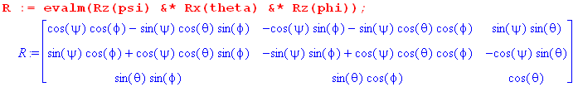

and decompose it into its symmetric and antisymmetric components S and A. In theory we could then compute Φ (=θ) and (=) from (G.2.14) and come up with an explicit expression for Φ = Φ. The reader is just reminded that this is mechanically possible, but luckily we have no need for the result (which is quite complicated). We could also compute dΦ from the following

R(ψ+dψ,θ+dθ,φ+dφ) = R(Φ+dΦ) = exp(-i [Φ+dΦ]• J)

but again there is no need to do this. Note that Φ and dΦ will generally not be in the same direction.

We now set about constructing the left side of (H.5.1) starting with our fundamental equation from (1.1.29) which relates the Frame S and Frame S' basis vectors,

en(Φ) = R(Φ)e'n or |en(Φ)> = |R(Φ)e'n> = R(Φ) |e'n> . (H.5.4)

Since we have in mind that Φ = Φ(t), showing how the Frame S basis vectors change in time as viewed from Frame S'. In contrast, the basis vectors e'n are static. The basis vectors |en(Φ)> are complete at time t so we can write, in analogy with (1.1.20),

1 = |en(Φ)><en(Φ)| completeness of the en at time t (a)

1 = |en(Φ+dΦ)><en(Φ+dΦ)| completeness of the en at time t+dt (b)

1 = |e'n><e'n| . completeness of the e'n at any time (c) (H.5.5)

In (b) the rotation vector has changed from Φ to some Φ+dΦ as time moved from t to d+dt. A key point is that the en basis vectors are complete at any point in time. The rotation operator R(Φ) similarly is real orthogonal at any time, analogous to (1.1.37),

RT(Φ) = R-1(Φ) and similarly for matrices RT(Φ) = R-1(Φ) . (H.5.6)

Now we close the Dirac equation in (H.5.4) on the left with <e'm| to get

<e'm| en(Φ) > = <e'm|R(Φ) |e'n> = [R(Φ)]'mn . (H.5.7a)

Since this is true for any Φ, one also has

<e'm| en(Φ+dΦ) > = <e'm|R(Φ+dΦ) |e'n> = [R(Φ+dΦ)]'mn . (H.5.7.b)

Recall from (1.1.35) that (R)'ij = Rij. Here we confirm that fact in the current fancier notation,

[R(Φ)]mn = <em(Φ)| R(Φ) |en(Φ)>

= <em(Φ) |e'i><e'i| R(Φ) |e'j><e'j|en(Φ)> = [R(Φ)]'im [R(Φ)]'ij[R(Φ)]'jn

= [ RT(Φ)R(Φ)R(Φ)]'mn = [ R-1(Φ)R(Φ)R(Φ)]'mn = [R(Φ)]'mn . (H.5.8a)

Since this is true for any Φ, one also has

[R(Φ+dΦ)]mn = [R(Φ+dΦ)]'mn . (H.5.8b)

DETERMINATION OF THE FRAME S' COMPONENTS OF ω

First expression for: [(den/dt)S']'i

We now examine (from Frame S') a small change in the basis vector en(Φ) ,

|(den(Φ))S'> ≡ |en(Φ+dΦ)> - |en(Φ)>

= |e'i><e'i|en(Φ+dΦ)> - |e'i><e'i|en(Φ)> // completeness twice

= |e'i> [R(Φ+dΦ)]'in - |e'i>[R(Φ)]'in // (H.5.7b,a)

= ( [R(Φ+dΦ)]'in - [R(Φ)]'in ) |e'i> // reorder

= ( [R(Φ+dΦ)]in - [R(Φ)]in ) |e'i> // (H.5.8b,a) to remove primes

= ( R(Φ+dΦ) - R(Φ) )in |e'i>

= ( RT(Φ+dΦ) - RT(Φ) )ni |e'i> . (H.5.9)

The next step is to replace |e'i> as follows

|e'i> = |ej(Φ)><ej(Φ) | e'i> = |ej(Φ)>[R(Φ)]'ij = [R(Φ)]ij |ej(Φ)> . (H.5.10)

Then

|(den(Φ))S'> = ( RT(Φ+dΦ) - RT(Φ) )ni[R(Φ)]ij |ej(Φ)>

= ( RT(Φ+dΦ)R(Φ) - RT(Φ)R(Φ) )nj |ej(Φ)>

= ( RT(Φ+dΦ)R(Φ) - 1 )nj |ej(Φ)> . (H.5.11)

We then add dt/dt to the left side to get

dt |(den(Φ)/dt )S'> = ( RT(Φ+dΦ)R(Φ) - 1 )nj |ej(Φ)> . (H.5.12)

We wish to evaluate the above vector equation in Frame S' components. To do this, we close both sides with <e'i |, obtaining

dt <e'i |(den(Φ)/dt )S'> = ( RT(Φ+dΦ)R(Φ) - 1 )nj <e'i |ej(Φ)>
or
dt [(den/dt)S']'i = ( RT(Φ+dΦ)R(Φ) - 1 )nj R(Φ)ij

= ( RT(Φ+dΦ)R(Φ) - 1 )njRT(Φ)ji = [( RT(Φ+dΦ)R(Φ) - 1 )RT(Φ)]ni

= [ RT(Φ+dΦ) - RT(Φ) ]ni = [ R(Φ+dΦ) - R(Φ) ]in

≡ (dR)in where dR ≡ R(Φ+dΦ) - R(Φ) . (H.5.13)

Divide both sides by dt to obtain

[(den/dt)S']'i = (dR/dt)in dR ≡ R(Φ+dΦ) - R(Φ) . (H.5.14)
Second expression for: [(den/dt)S']'i

Recall (H.5.1),

(den/dt)S' = – ω x en . (1.7.4) (H.5.1)

We evaluate the above vector equation in Frame S' components,

[(den/dt)S']'i = - εikc(ω)'k(en)'c = - εikc(ω)'k [R(Φ)]'cn = -εikc(ω)'k [R(Φ)]cn . (H.5.15)

Equate the two expressions for: [(den/dt)S']'i

At this point we have shown that doing component evaluations of (den/dt)S' in Frame S' gives,

[(den/dt)S']'i = (dR/dt)in dR ≡ R(Φ+dΦ) - R(Φ) (H.5.14)

[(den/dt)S']'i = - εikc(ω)'k [R(Φ)]cn . (H.5.15)

Setting the right sides equal, one obtains,

- εikc(ω)'k [R(Φ)]cn = (dR/dt)in .

Multiply both sides on the right by [R-1(Φ)]nj to get

- εikc(ω)'k [R(Φ)]cn [R-1(Φ)]nj = (dR/dt)in [R-1(Φ)]nj
or
- εikc(ω)'kδcj = [ (dR/dt)R-1(Φ) ]ij
or
- εikj(ω)'k = [ (dR/dt)R-1(Φ) ]ij
or
εijk(ω)'k = Aij where A ≡ (dR/dt)R-1(Φ) . (H.5.16)

It seems that the object Aij must be antisymmetric in its two indices, so the matrix Aij has only three significant elements. Setting ijk = 231 gives the first line below, then the next two lines follow from cyclic permutation :

(ω)'1 = A23
(ω)'2 = A31
(ω)'3 = A12 . (H.5.17)

Thus we have succeeded in solving for the components of ω in Frame S' . Recall that Frame S' is rotating at rate ω relative to Frame S as in Fig 1. It remains to compute the three Aij matrix elements so we can learn the specific expressions for the (ω)'i in terms of Euler Angles.

Computation of A and Statement of Final Result

Our task is to compute A ≡ (dR/dt)R-1(Φ) where our "temporary" R(Φ) is given by

R(Φ) = Rz(ψ)Rx(θ)Rz(φ) (H.5.3)

and where

dR = R(Φ+dΦ) - R(Φ) . (H.5.13)

The first step is to compute dR in terms of the Euler angles. We make use of the obvious fact that
Ri(α +dα) = Ri(α)Ri(dα) and then the fact (1.5.6) that Ri(dα) ≈ 1 - idα Ji for small dα. Keeping only terms of first order in the differential angles, one finds

dR = R(Φ+dΦ) - R(Φ)

= Rz(ψ+dψ) Rx(θ+dθ) Rz(φ+dφ) - Rz(ψ) Rx(θ) Rz(φ)

= Rz(ψ) Rz(dψ) Rx(θ) Rx(dθ) Rz(φ) Rz(dφ) - Rz(ψ) Rx(θ) Rz(φ)

= Rz(ψ){1-idψJ3}Rx(θ){1-idθJ1}Rz(φ){1-idφJ3} - Rz(ψ) Rx(θ) Rz(φ)

= -idψ Rz(ψ)J3Rx(θ)Rz(φ) - idθ Rz(ψ) Rx(θ)J1Rz(φ) - idφ Rz(ψ) Rx(θ)Rz(φ)J3 (H.5.18)

where the leading terms exactly cancel. Dividing by dt one then has

(dR/dt) = -i Rz(ψ)J3Rx(θ)Rz(φ) - i Rz(ψ)Rx(θ)J1Rz(φ) - i Rz(ψ)Rx(θ)Rz(φ)J3 . (H.5.19)

The next step is to compute A ≡ (dR/dt)R-1(Φ) using R-1(Φ) = Rz(-φ)Rx(-θ)Rz(-ψ). In doing so, we shall three times in blue use the fact that Ji commutes with Ri as formally stated in (G.3.6) :

A ≡ (dR/dt) R-1(Φ)

= [ -i Rz(ψ)J3Rx(θ)Rz(φ) - i Rz(ψ)Rx(θ)J1Rz(φ) - i Rz(ψ)Rx(θ)Rz(φ)J3] Rz(-φ)Rx(-θ)Rz(-ψ)

= [ -i Rz(ψ)J3 Rx(θ) - i Rz(ψ) Rx(θ)J1 - i Rz(ψ) Rx(θ)Rz(φ)J3Rz(-φ) ] Rx(-θ) Rz(-ψ)

= [ -i Rz(ψ)J3 Rx(θ) - i Rz(ψ) Rx(θ)J1 - i Rz(ψ) Rx(θ)J3 ] Rx(-θ) Rz(-ψ)

= [ -i Rz(ψ)J3 - i Rz(ψ) Rx(θ)J1Rx(-θ) - i Rz(ψ) Rx(θ)J3Rx(-θ) ] Rz(-ψ)

= [ -i Rz(ψ)J3 - i Rz(ψ) J1 - i Rz(ψ) Rx(θ)J3Rx(-θ) ] Rz(-ψ)

= [ -i Rz(ψ)J3 Rz(-ψ) - i Rz(ψ) J1 Rz(-ψ) - i Rz(ψ) Rx(θ)J3Rx(-θ) Rz(-ψ) ]

= [ -i J3 - i Rz(ψ) J1 Rz(-ψ) - i Rz(ψ) Rx(θ)J3Rx(-θ) Rz(-ψ) ]

= [ -i J3 - i M1 - i M2 ]

where (H.5.20)

M1≡ Rz(ψ) J1Rz(-ψ) = [ R3(ψ) J1R3(-ψ)]

M2 ≡ Rz(ψ) Rx(θ)J3Rx(-θ)Rz(-ψ) = R3(ψ) [ R1(θ)J3R1(-θ) ] R3(-ψ) .

We now call upon our non-trivial sandwich formulas in (G.3.8) to simplify thing further :

M1 = R3(ψ) J1R3(-ψ) = cosψJ1 + sinψ J2 // (G.3.8) line 5

M2 = R3(ψ) [ R1(θ)J3R1(-θ) ] R3(-ψ)

= R3(ψ) [ cosθ J3 - sinθ J2 ] R3(-ψ) // (G.3.8) line 2

= cosθ [ R3(ψ) J3 R3(-ψ)] - sinθ [R3(ψ)J2R3(-ψ)]

= cosθ J3 - sinθ (cosψJ2 - sinψ J1) // (G.3.6) and (G.3.8) line 6

= sinθsinψJ1 - sinθcosψJ2 + cosθ J3 . (H.5.21)

Then,

A = [ -i J3 - i M1 - i M2 ]

= [ -i J3 - i (cosψJ1 + sinψ J2) - i (sinθsinψJ1 - sinθcosψJ2 + cosθ J3) ]

= [ -i J3 - i cosψJ1 - i sinψ J2 - i sinθsinψJ1 + i sinθcosψJ2 - i cosθ J3 ]

= (-i)[ J3 + cosψJ1 + sinψ J2 + sinθsinψJ1 - sinθcosψJ2 + cosθ J3 ]

= (-i)[ ( cosψ + sinθsinψ)J1 + ( sinψ - sinθcosψ)J2 + ( + cosθ)J3 ]

= - [ ( cosψ + sinθsinψ)(iJ1) + ( sinψ - sinθcosψ)(iJ2) + ( + cosθ)(iJ3) ] . (H.5.22)

We now take the ij element of this matrix using the fact (G.1.3) that (iJk)ij = εkij ,

Aij = - [ ( cosψ + sinθsinψ)ε1ij + ( sinψ - sinθcosψ)ε2ij + ( + cosθ)ε3ij ] . (H.5.23)

The tensor εkij is antisymmetric in i↔j and therefore the entire matrix A is antisymmetric (as conjectured earlier) and thus has only three distinct matrix elements. They are:

A23 = - ( cosψ + sinθsinψ)ε123 = - ( cosψ + sinθsinψ)

A31 = - ( sinψ - sinθcosψ)ε231 = - ( sinψ - sinθcosψ)

A12 = - ( + cosθ) ε312 = - ( + cosθ) . (H.5.24)

From (H.5.17) we then conclude that

(ω)'1 = A23 = - ( cosψ + sinθsinψ)
(ω)'2 = A31 = - ( sinψ - sinθcosψ)
(ω)'3 = A12 = - ( + cosθ) . // angles still negated

We now undo the temporary negation of the angles ψ,θ,φ enacted below (H.5.2). The velocities and sines then negate. Our final result for the Frame S' components of ω is then,

(ω)'1 = sinθsinψ + cosψ ≡ ωx'
(ω)'2 = sinθcosψ - sinψ ≡ ωy'
(ω)'3 = cosθ + ≡ ωz' . (H.5.25)

This is in agreement with our Method 1 calculation (H.4.7) and with Goldstein's result which we again quote from Goldstein page 134 (GPS page 174),

DETERMINATION OF THE FRAME S COMPONENTS OF ω

Here we shall review three different Plans for computing the Frame S components of ω.

Plan A: Since we just computed the (ω)'i in Frame S', we just use ω = R-1(ω)' to get the Frame S components. This was done at the end of Section H.4 with the result stated in (H.4.12).

Plan B: Start with (1.7.1) that (de'n/dt)S = ω x e'n in place of (H.5.1) that (den/dt)S' = – ω x en, which adds an overall minus sign to the result. The new (H.5.4) becomes e'n(Φ) = R-1(Φ)en with en = constant in Frame S. Things go through as presented above, but since R(Φ) → R-1(Φ) and since R(Φ) = Rz(ψ)Rx(θ)Rz(φ), one has R-1(Φ) = Rz(-φ)Rx(-θ) Rz(-ψ). Thus, to convert the result (H.5.25) to the Frame S result, we have to make these changes: (1) φ, ψ, θ → -ψ, -φ , -θ ; (2) add the overall minus sign just noted. We do that right here:
φ, ψ, θ → -ψ, -φ , -θ
(ω)'1 = sinθsinψ + cosψ ≡ ωx'
(ω)'2 = sinθcosψ - sinψ ≡ ωy'
(ω)'3 = cosθ + ≡ ωz' . (H.5.25)
→
-(ω)1 = [-][-sinθ][-sinφ] + [-] cosφ ⇒ ω1 = sinθsinφ +cosφ
-(ω)2 = [-][-sinθ]cosφ - [-][-sinφ] ⇒ ω2 = - sinθcosφ + sinφ
-(ω)3 = [-] cosθ + [-] ⇒ ω3 = cosθ + (H.5.26)

and this agrees with (H.4.12).

Plan C: Compute the ωi directly using the machinery developed earlier in this section, but take Frame S components instead of Frame S' components. We regard this as a "stress test" of the machinery.

First expression for: [(den/dt)S']i

Start with (H.5.11)

|(den(Φ))S'> = ( RT(Φ+dΦ)R(Φ) - 1 )nj |ej(Φ)> . (H.5.11)

Instead of closing on the left with <e'i | to get Frame S' components, this time close on the left with <ei | to get Frames S components,

[(den)S']i = <ei |(den(Φ))S'> = ( RT(Φ+dΦ)R(Φ) - 1 )nj <ei(Φ) |ej(Φ)>

= ( RT(Φ+dΦ)R(Φ) - 1 )nj δji // (1.1.14)

= ( RT(Φ+dΦ)R(Φ) - 1 )nj (R-1(Φ)R(Φ))ji = [( RT(Φ+dΦ)R(Φ) - 1 )R-1(Φ)R(Φ)]ni

= [( RT(Φ+dΦ) - RT(Φ) ) R(Φ)]ni = [RT(Φ)( R(Φ+dΦ) - R(Φ) )]in

= [RT(Φ)(dR)]in = [RT(Φ)(dR) R-1(Φ)R(Φ)]in .

Divide by dt,

[(den/dt)S']i = [RT(Φ)(dR/dt)R-1(Φ) R(Φ)]in = [RT(Φ)A R(Φ)]in (H.5.27)

where recall that A ≡ (dR/dt)R-1(Φ) from (H.5.16).

Second expression for: [(den/dt)S']i

Recall (H.5.1),

(den/dt)S' = – ω x en . (1.7.4) (H.5.1)

We evaluate the above vector equation in Frame S components,

[(den/dt)S']i = - εikcωk(en)c = - εikcωkδnc = - εiknωk . (H.5.28)

Equate the two expressions for: [(den/dt)S']i

At this point we have shown that doing component evaluations of (den/dt)S' in Frame S gives,

[(den/dt)S']i = [RT(Φ)A R(Φ)]in . (H.5.27)

[(den/dt)S']i = - εiknωk . (H.5.28)

Setting the right sides equal, we obtain

- εiknωk = [RT(Φ)A R(Φ)]in ≡ Bin
or
εinkωk = Bin
or
εijkωk = Bij B = RT(Φ)A R(Φ) . (H.5.29)

Thus we arrive at (H.5.16) with (ω)'i replaced by ωi and with A replaced by B,

ω1 = B23
ω2 = B31
ω3 = B12 . (H.5.30)

It remains only to compute the Bij.

Computation of B and Statement of Final Result

Recall from (H.5.22) that

A = - [ ( cosψ + sinθsinψ)(iJ1) + ( sinψ - sinθcosψ)(iJ2)+ ( + cosθ)(iJ3) ] . (H.5.22)

We may write this as

A = aiJi

where (H.5.31)
a1 = - i( cosψ + sinθsinψ)
a2 = - i( sinψ - sinθcosψ)
a3 = - i( + cosθ) .

Entering into Maple,

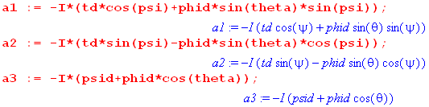. (H.5.32)
Then the matrix B in (H.5.29) can be written,

B = R-1(Φ)A R(Φ) = R-1(Φ)[aiJi] R(Φ)

= ai [R-1(Φ)JiR(Φ)[ = aiR(Φ)ijJj // Theorem 1 of (G.4.1) with R→R-1

= aiQi where Qi ≡ R(Φ)ijJj . (H.5.33)

Using our "temporary" R(Φ) in (H.5.3) we compute the vector Q as follows (a vector of matrices),

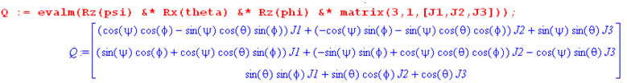
(H.5.34)
The quantity B = aiQi is then,

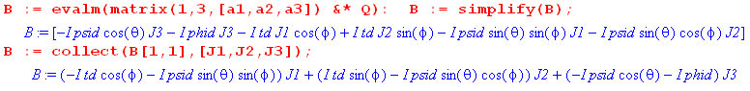
(H.5.35)
We move the factors of i (Maple I) next to the Jk and transcribe the last line above:

B = (- cosφ - sinθsinφ)(iJ1) + (sinφ - sinθcosφ)(iJ2) + (- cosθ - )(iJ3) . (H.5.36)

Using (G.1.3) that (iJk)ij = εkij the matrix elements of B are then,

Bij = (- cosφ - sinθsinφ)ε1ij + (sinφ - sinθcosφ)ε2ij + (-cosθ - )ε3ij . (H.5.37)

Therefore,

B23 = - cosφ - sinθsinφ
B31 = sinφ - sinθcosφ
B12 = -cosθ - . (H.5.38)

Then from (H.5.30),

ω1 = B23 = - cosφ - sinθsinφ
ω2 = B31 = sinφ - sinθcosφ
ω3 = B12 = -cosθ - . // angles still negated

We now undo the temporary negation of the Euler angles ψ,θ,φ enacted below (H.5.2). The velocities and sines then negate. Our final result for the Frame S components of ω is then,

ω1 = B23 = cosφ + sinθsinφ
ω2 = B31 = sinφ - sinθcosφ
ω3 = B12 = cosθ + . (H.5.39)

This is in agreement which (H.4.12) which we now quote,

(ω)x = cosφ + sinθsinφ
(ω)y = sinφ - sinθcosφ
(ω)z = + cosθ (H.4.12)

Review of this Section

Frame S and Frame S' are related by some angular velocity ω as shown in Fig 1. The actual rotation relating the two frames is R = Rz(-ψ)Rx(-θ)Rz(-φ) as in (H.5.2) and (H.1.17a). If the three Euler angles are all static, ω would be 0. It is the fact that one or more of these Euler angles varies in time which causes ω to be non-zero.

Our task was to solve the following equation for ω

(den)S' = – ω x en dt . (1.7.4) (H.5.1)

Acting as an Observer in Frame S', we studied the change in the basis vectors (den)S' caused by the time-varying Euler angles. In (H.5.11) we obtained the following vector equation for this change,

(den)S' = [ RT(Φ+dΦ)R(Φ) -1 ]nj ej . (H.5.11)

Equating the right sides of the above two equations, we obtained the following vector equation,

– ω x en dt = ( RT(Φ+dΦ)R(Φ) -1 )nj ej . (H.5.40)

We found that, to lowest order, the quantity (RT(Φ+dΦ)R(Φ) -1 )nj was linear in the differential angles dψ,dθ and dφ and when both sides were divided by dt, these became rates , and .

Although we were observing things from Frame S', we were allowed to take components of any vector equation in either Frame S or in Frame S'.

By taking the Frame S' components of (H.5.40) we obtained the Frame S' components of ω as in (H.5.25).

By taking the Frame S components of (H.5.40) we obtained the Frame S components of ω as in (H.5.39).

Along the way we got to exercise some earlier results of this Appendix: the sandwich formulas (G.3.6) and (G.3.8) in the computation of A, Theorem 1 of (G.4.1) saying RJiR-1= R–1ijJj in the computation of B, and the rotation generator matrix representations of (G.1.3). Finally, we were able to exercise the Dirac notation of Section 1.1. The approach of this section made use of the "linear combination" side of the Basis Theorem (1.1.29) rather than the "operator" side, so matrices appeared right from the get-go.

H.6 The connection between Euler Angles and Spherical Coordinates

Appendix E presents the spherical coordinates unit vectors in the following manner,

= Rz(φ) Ry(θ)
= Rz(φ) Ry(θ)
= Rz(φ) Ry(θ)
or (H.6.1)
(, , ) = Rz(φ) Ry(θ) (, , ) .

This can be "derived" basically by staring at this picture and using one's right hand,

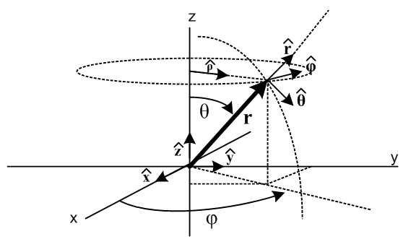. (H.6.2)

In order to use the Euler angles shown in Fig (H.1.5) to describe things like spinning tops, and then to be able to use spherical coordinates to describe the location of the top symmetry axis, we want the unit vector ' to be the same as in the above spherical coordinates picture. From (H.1.15c) we know that

(',',') = Rz(φ)Rx(θ)Rz(ψ) (,,) (H.6.3)

and in particular

' = Rz(φ)Rx(θ)Rz(ψ) . // = R-1 (H.6.4)

Comparing this to (H.6.1), in order to get ' = we must have

Rz(φ)Rx(θ)Rz(ψ) = Rz(φ)Ry(θ) . (H.6.5)

This requires that

Rz(φ)Rx(θ)Rz(ψ) = Rz(φ)Ry(θ)Rz(α) (H.6.6)

where α is an arbitrary angle, since Rz(α)= . From (G.4.13) we know that

Rz(π/2)Rx(θ)Rz(-π/2) = Ry(θ) // Rz(-π/2)Ry(θ)Rz(π/2) = Rx(θ) (H.6.7)

so our requirement becomes

Rz(φ)Rx(θ)Rz(ψ) = Rz(φ) [Rz(π/2)Rx(θ)Rz(-π/2)]Rz(α)
or
Rz(φ)Rx(θ)Rz(ψ) = Rz(φ+π/2)Rx(θ)Rz(-π/2+α) . (H.6.8)

These two 3x3 matrices will be equal provided we set

φ = φ+π/2 and ψ = α - π/2 . (H.6.9)

Since α is arbitrary, we can always set α = ψ + π/2, but the first equation is more significant. As long as φ = φ+π/2, we will have ' = , the rigid body symmetry axis can be identified with , and the "top" is then spinning about this axis at angular rate . Here is a look at Fig (I.7.1) to come,

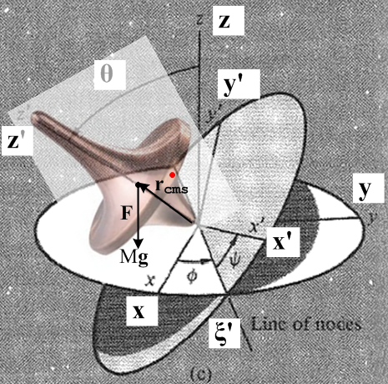 (H.6.10)

So we have lined up ' = . What happens to the other Goldstein unit vectors? From (H.6.6) and (H.6.9),

' = R-1 = Rz(φ)Rx(θ)Rz(ψ) = Rz(φ)Ry(θ)Rz(α) = Rz(φ)Ry(θ)Rz(ψ+π/2)

' = R-1 = Rz(φ)Rx(θ)Rz(ψ) = Rz(φ)Ry(θ)Rz(α) = Rz(φ)Ry(θ)Rz(ψ+π/2) . (H.6.11)

Setting ψ = -π/2 on the figure axis, one finds

' = Rz(φ)Ry(θ) =

' = Rz(φ)Ry(θ) =

and we end up with the simple result

(', ', ') = (, , ) . (H.6.12)

Next, notice that

φ = φ+π/2 ⇒ sinφ = sin(φ+π/2) = cosφ and cosφ = cos(φ+π/2) = -sinφ

so that

sinφ = cosφ
cosφ = -sinφ . (H.6.13)

Example 1:

For a kinematic vector, we can think of transformations in two ways (ignoring the prime name overload problem). The first line below is (H.3.9) which is the Passive View transformation giving the coordinates of vector V in Frame S', while the second line is the Active View transformation giving a new vector V' in Frame S. Rotation R-1 = Rz(φ)Rx(θ)Rz(ψ) from (H.1.2), so

(V)' = R V // passive
V' = R-1V . // active // R-1 = Rz(φ)Rx(θ)Rz(ψ) (H.6.14)

In particular, we can apply these rules to a position vector r,

(r)' = R r // passive
r' = R-1r . // active (H.6.15)

Specifically, we have Maple generate the last equation r' = R-1r = Rz(φ)Rx(θ)Rz(ψ) r :

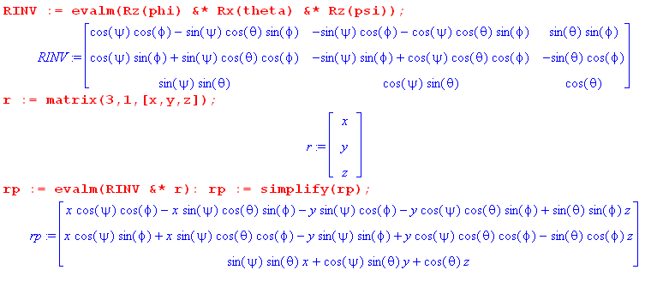

Transcribing the result, one obtains

x' = (cosψcosφ - sinψcosθsinφ)x + (-sinψcosφ - cosψcosθsinφ)y + (sinθsinφ) z

y' = (cosψsinφ + sinψcosθcosφ)x + (-sinψsinφ + cosψcosθcosφ)y + (-sinθcosφ) z

z' = (sinψ sinθ)x + (cosψsinθ)y + (cosθ)z . (H.6.16)

Applying this to = (0,0,1) gives

x' = sinθsinφ
y' = -sinθcosφ
z' = cosθ . (H.6.15)

Then applying the rules (H.6.13) one finally gets, in terms of spherical coordinate angles θ and φ,

x' = sinθcosφ
y' = sinθsinφ
z' = cosθ (H.6.17)

This one recognizes as the vector (E.2.6) of spherical coordinates. These last equations are the same as

= Rz(φ) Ry(θ) = 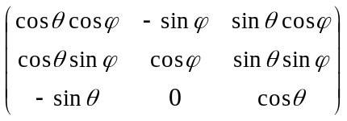$\left(\begin{matrix}0 \\ 0 \\ 1\end{matrix}\right)$ = $\left(\begin{matrix}sinθcosφ \\ sinθsinφ \\ cosθ\end{matrix}\right)$ . (E.2.2)

One might ask why we are making a big deal about the minor issue of φ = φ+π/2 ? The reason is that when one does calculations for some problems, this can make a big difference.

Example 2:

Recall the equations describing the ω vector in Frame S coordinates:

ω1 = sinθsinφ + cosφ
ω2 = - sinθcosφ + sinφ
ω3 = cosθ + . // Frame S (H.4.4)

If one is using spherical coordinates r,θ,φ to describe a rigid body, these equations must be rewritten as

ω1 = sinθcosφ - sinφ
ω2 = sinθsinφ + cosφ
ω3 = cosθ + . // Frame S (H.6.18)

For example, if some object with ψ = constant is whirling around in the xz plane of Fig (H.6.2) (so φ = 0), this last result says

ω = (0,,0) ⇒ ω2 =

which is the correct result. If one inadvertently set φ = φ in (H.4.4), one would instead get ω = (,0,0) which is not the correct result.

Example 3:

Recall the equations describing the ω vector in Frame S' coordinates (body frame):

(ω)'1 = sinθsinψ + cosψ
(ω)'2 = sinθcosψ - sinψ
(ω)'3 = cosθ + // Frame S' (H.4.7)

For these equations, the fact that φ = φ+π/2 merely says = so the π/2 adder makes no difference and one then has,

(ω)'1 = sinθsinψ + cosψ
(ω)'2 = sinθcosψ - sinψ
(ω)'3 = cosθ + // Frame S' (H.6.19)

