Paradox with the vector ω PhL 2.12.17

I think this paradox gets resolved within this doc, so no paradox.

On the One Hand:

Consider this picture

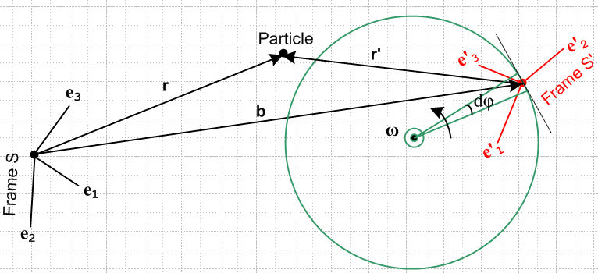

where Frame S is inertial. Suppose it happened that e1 is coming out of the plane of paper on the left. Then you would write ω = ωe1 and then ω = (ω,0,0) and these are the components of ω in Frame S.

If you treat ω like any other vector, you could ask:
"What are the components of ω as measured in Frame S' "?

Since the axes of Frame S' are at some weird orientation, the answer will be:
"the components of vector ω as seen from Frame S' are complicated".

More formally, suppose ei = R(Φ)e'i and suppose ω = ωe1 . Then

(ω)'i = ω • e'i = ω • [R(Φ)-1ei] = [R(Φ)ω] • ei = [R(Φ)ω]i = [R(Φ)]ij ωj

= [R(Φ)]ij ω δj,1 = ω [R(Φ)]i1

and in general this is some complicated expression for each of the (ω)'i components.

On the Other Hand:

Start again with the above picture

Here you would say: The axes of Frame S' are rotating at ω = (ω,0,0) as seen from Frame S.

Now hop onto a camera platform which is rotating CCW at ω about the same axis and this picture becomes
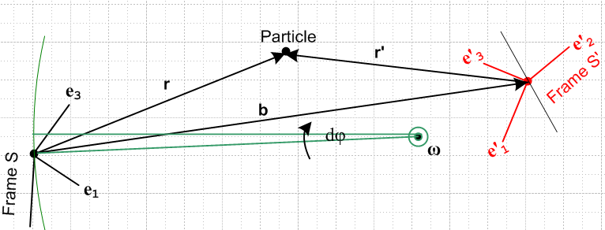

Now Frame S' is at rest and Frame S is rotating in effect at -ω . So you would say

The axes of Frame S as seen from Frame S' are rotating at -ω = (-ω,0,0)

Resolution:

The second item I think is valid, and you end up with the statement as claimed,

The axes of Frame S as seen from Frame S' are rotating at -ω = (-ω,0,0).

However, the components shown of -ω = (-ω,0,0) are still Frame S components, not Frame S' components. The Frame S' components are still something messy.

I jump to Goldstein rigid body here because he is going to use ω components in Frame S' !!
I work further with this stuff in some other doc.

What is the meaning of the ωi in the GPS presentation of rotating objects?

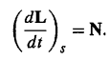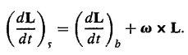

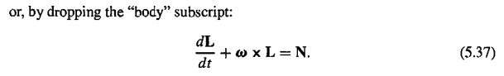

So what is the meaning of ω in this equation (5.37) ? The equation says

(dL/dt)S' + ω x L = N

Since this is a vector equation, we have not yet talked about "components", so we keep going. Now GPS is going to take the components of the above equation!!! This is a tricky operation. If we do this within Frame S' (the rotating frame) then my Commutation Theorem (1.11.1) shows that things commute, so you can say

(∂S'L)'i = ∂S'[ (L)'i] = ∂t(L)'i // using below 1.11.1

Then we really should write rigid body doc

∂t(L)'i + [ ω x L]'i = N'i
or
d(L)'i/dt + εijk(ω)'j(L)'k = (N)'i

and indeed it is the Frame S' components that you want!! This last equation appears as

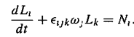

and you see how they are using a very compact notation. But I agree, their ωi really are the Frame S' components!!!

