Connection between Goldstein Euler angles and spherical coordinates PhL 3.28.17

I have now done a very complete writeup of Goldstein's Euler angles AND of spherical coordinates, and the time has come to see how angles are related. One sign of possible trouble is that he uses Rx(θ) in his work, whereas I use Ry(θ) in my spherical coordinates work.

1. As a starting point, consider my frames doc App E where I do this:

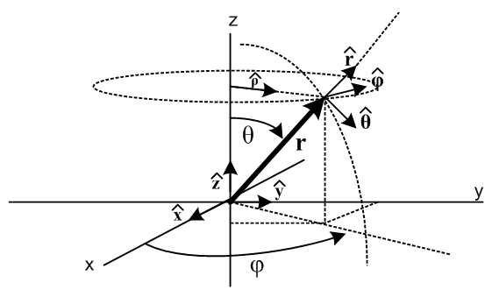

= Rz(φ) Ry(θ) = 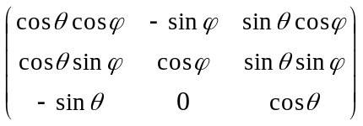$\left(\begin{matrix}1 \\ 0 \\ 0\end{matrix}\right)$ = $\left(\begin{matrix}cosθcosφ \\ cosθsinφ \\ -sinθ\end{matrix}\right)$ = •••

= Rz(φ) Ry(θ) = $\left(\begin{matrix}0 \\ 1 \\ 0\end{matrix}\right)$ = $\left(\begin{matrix}-sinφ \\ cosφ \\ 0\end{matrix}\right)$
= Rz(φ) Ry(θ) = $\left(\begin{matrix}0 \\ 0 \\ 1\end{matrix}\right)$ = $\left(\begin{matrix}sinθcosφ \\ sinθsinφ \\ cosθ\end{matrix}\right)$ . (E.2.2)

I can summarize these equations as

(, , ) = R (, , ) R = Rz(φ) Ry(θ)

To create the vector from the vector I take and rotated it down using Ry(θ), and just doing this much puts into a position where it has φ = 0. This is an idea I like a lot. Then I rotate it out to any desired azimuth φ using Rz(φ). The other unit vectors follow the same transformation and end up in exactly the right place. We end up with

= sinθcosφ + sinθsinφ + cosθ

which all authors would agree with as the basis of spherical coordinates.

2. Now a question: What do Goldstein Euler angles have to do with spherical coordinates as discussed above? The Euler angles are used to describe the relation between two frames of reference which Goldstein and I would both happily call Frame S (coordinates x,y,z) and Frame S' (coordinates x',y',z' ). Goldstein does not talk about unit vectors the way I like to do.
Goldstein's famous picture, nevertheless, is all about what I call the "back rotation of axes", except for him he "forward rotates the axes". For both of us, I think this means we are taking the Passive View. In contrast, in item 1 above I do active rotations to get from .
In Section H.3 I have a heading "transformation of vectors" which is combined unfortunately with the triple concatenation discussion. But I do get around to saying

(',',') = R-1(,,) R-1 = Rz(φ)Rx(θ)Rz(ψ)
= Rz(φ)Rx(θ)Rz(ψ) (,,)

(V)' = R V R = [ Rz(φ)Rx(θ)Rz(ψ)]-1
= [ Rz(φ)Rx(θ)Rz(ψ)]-1 V

= Rz(-ψ)Rx(-θ)Rz(-φ) V . (H.3.9)

which does show the transformation of a vector V using his fancy rotation axes.
So how do I connect this (H.3.9) with the idea that = Rz(φ) Ry(θ) for spherical coordinates?? This is really the main question and I am very unsure how to answer this question right now.
It is now time for his picture:

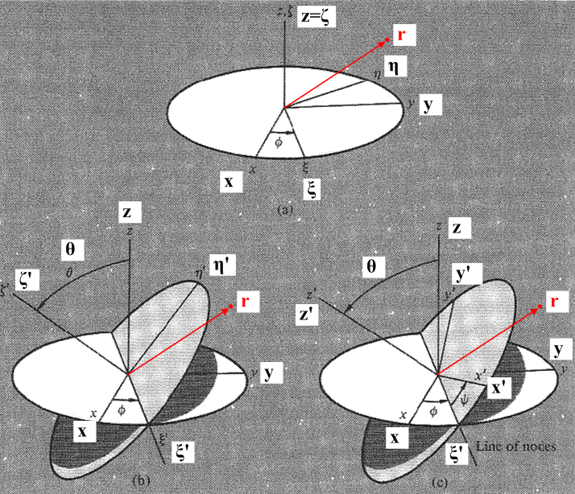

Let's start here by comparing my sphere coords transformation and his full transformation :

(, , ) = R (, , ) R = Rz(φ) Ry(θ)

(H.1.15c) (H.3.1)
(',',') = R-1(,,) R-1 = Rz(φ)Rx(θ)Rz(ψ)

Desire A. In my pondering of a body frame embedded into a rigid body, I rather like to think of the symmetry axis of the body as pointing in the spherical coordinates direction, so the symmetry axis is then described by spherical coordinates angles θ and φ. Here for example is my picture of the top,

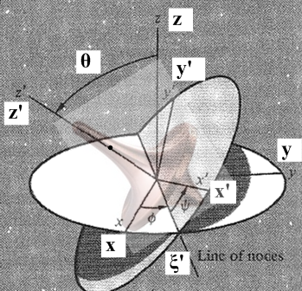

where I line the top up with the z' axis with unit vector ' . Then ψ is rotation about this symmetry axis, no confusion about that idea.
Now if I want to make the identification ' = , what does that imply? From the above I have

= R
' = R-1

To get = ' we must have this be true

R = R-1
or
Rz(φ) Ry(θ) = Rz(φ)Rx(θ)Rz(ψ)

This requires that

R = R-1 * Rz(α) where Rz(α) does nothing to so α is arbitrary
or
Rz(φ) Ry(θ) = Rz(φ)Rx(θ)Rz(ψ)Rz(α)
or
Ry(θ) = Rx(θ)Rz(ψ+α)

Now call to the stand,

Rz(π/2)Rx(θ)Rz(-π/2) = Ry(θ) . (G.4.13)

Then to get my equality you need to have

Rz(π/2)Rx(θ)Rz(-π/2) = Rx(θ)Rz(ψ+α)

I don't think this equation has a solution! Go back to the first equation

Ry(θ) = Rx(θ)Rz(ψ+α)

To show this equation is not valid, just apply it to . It then says

Ry(θ) = Rx(θ)

and this is definitely not true, and this I think is the essence of my problem.

Desire A, Simpler Case

Suppose spherical φ = 0. I then write

= R R = Rz(φ=0) Ry(θ) = Ry(θ)
so
= Ry(θ)

On the other hand, in this case we have

' = R-1 R-1 = Rz(φ=0)Rx(θ)Rz(ψ) = Rx(θ)Rz(ψ)
so
' = Rx(θ)

So we do NOT GET the desired result that = ' .

So how might I "fix up this problem" ?

Plan A Suppose I write Goldstein's angle φ in italics, so it is φ . And I write the standard (for everyone) spherical coordinate angle as φ non-italic. Then in order to get desire ' = I would need to have

Rz(φ) Ry(θ) = Rz(φ)Rx(θ)Rz(ψ)Rz(α) . any α will do to get

Now use the fact that Rz(π/2)Rx(θ)Rz(-π/2) = Ry(θ) and this becomes

Rz(φ) Rz(π/2)Rx(θ)Rz(-π/2) = Rz(φ)Rx(θ)Rz(ψ)Rz(α)

or

Rz(φ+π/2) Rx(θ)Rz(-π/2) = Rz(φ)Rx(θ)Rz(ψ+α)

This matrix equation DOES have a solution which is this

φ = φ+π/2 and ψ+α = -π/2

In the second equation any constant α is allowed, so it is not much of a condition on anything.

It does seem then that with this φ = φ+π/2 idea, I can obtain the goal = ' so that my top picture then makes sense with the top pointing in the direction.

Note in passing that

Rz(π/2)Rx(θ)Rz(-π/2) = Ry(θ)

Rz(-π/2)Ry(θ)Rz(π/2) = Rx(θ)

What happens to the other unit vectors? Let's back up now to our starting point and put in italic φ where it goes.

(, , ) = R (, , ) R = Rz(φ) Ry(θ)

(H.1.15c) (H.3.1)
(',',') = R-1(,,) R-1 = Rz(φ)Rx(θ)Rz(ψ)

Then I can write

R-1 = Rz(φ)Rx(θ)Rz(ψ) = Rz(φ)Rz(-π/2)Ry(θ)Rz(π/2)Rz(ψ)

= Rz(φ-π/2)Ry(θ)Rz(π/2+ψ)

= Rz(φ)Ry(θ)Rz(π/2+ψ)

R = Rz(φ) Ry(θ)

In this case we have

R-1 = Rz(φ) Ry(θ) Rz(π/2+ψ)

Now consider the three equations of spherical coordinates,

= Rz(φ) Ry(θ)
= Rz(φ) Ry(θ)
= Rz(φ) Ry(θ)

and our three Goldstein Euler equations

' = R-1 = Rz(φ)Ry(θ)Rz(π/2+ψ)
' = R-1 = Rz(φ)Ry(θ)Rz(π/2+ψ)
' = R-1 = Rz(φ)Ry(θ)Rz(π/2+ψ)

If we make the choice ψ = -π/2, we then get

' = R-1 = Rz(φ)Ry(θ) =
' = R-1 = Rz(φ)Ry(θ) =
' = R-1 = Rz(φ)Ry(θ) =

and then we got alignment on all three unit vectors! I think I like this!

Does this connection solve my Maple electric dipole dumbbell problem?

We then have

φ = φ+π/2

sinφ = sin(φ+π/2) = cosφ

cosφ = cos(φ+π/2) = -sinφ

Now here are the Goldstein Frame S equations where I now use italics

(ω)x = sinθsinφ + cosφ
(ω)y = - sinθcosφ + sinφ
(ω)z = cosθ + . // Frame S (H.4.4)

Convert this to spherical coordinates to get

(ω)x = sinθ cosφ - sinφ
(ω)y = sinθsinφ + cosφ
(ω)z = cosθ + . // Frame S (H.4.4)

If = 0 for our electric dipole, we get

ω = (- sinφ, cosφ, )

Suppose the dumbbell is rotating in the xz plane perp to y so that φ = 0. Then = 0 and get

ω = (0, , 0 ) or ωy =

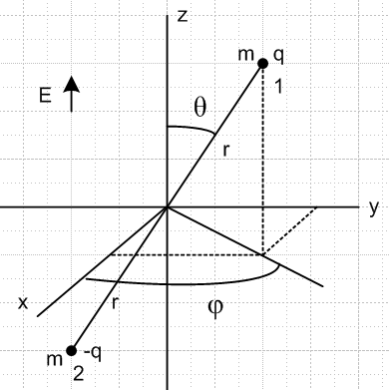

If it is rotating by right hand rule, then yes ω points to the right and > 0. So I have finally cleaned up this confusion of yesterday!!

But what happens to the Maple calculation? YES! If repairs the whole thing perfectly! Amazing!

Now what about "transformation of kinematic vectors" ??

Let's add italic φ and quote

(V)' = R V R = [ Rz(φ)Rx(θ)Rz(ψ)]-1
= [ Rz(φ)Rx(θ)Rz(ψ)]-1 V

= Rz(-ψ)Rx(-θ)Rz(-φ) V . (H.3.9)

This is a passive rotation. The active rotation would be

V' = R-1V R-1 = Rz(φ)Rx(θ)Rz(ψ)

Look now at Exercise 1 of (H.3.10). It reads,

(r)' = R r

and writes out the full results. Now the Active View rotation would say

r' = R-1r = Rz(φ)Rx(θ)Rz(ψ)r

Let's add this to Maple Euler3 mws and see what happens

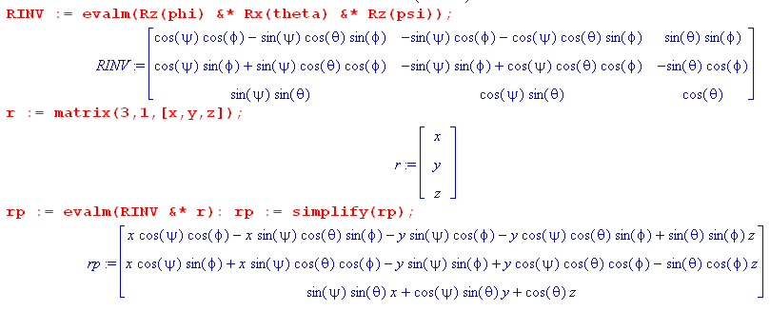

And I could write this out as

x' = (cosψcosφ - sinψcosθsinφ)x + (-sinψcosφ - cosψcosθsinφ)y + (sinθsinφ) z

y' = (cosψsinφ + sinψcosθcosφ)x + (-sinψsinφ + cosψcosθcosφ)y + (-sinθcosφ) z

z' = (sinψ sinθ)x + (cosψsinθ)y + (cosθ)z

then I can apply this active transformation to the = (0,0,1) vector to get

x' = sinθsinφ
y' = -sinθcosφ
z' = cosθ

Now I use my italic rules

sinφ = sin(φ+π/2) = cosφ
cosφ = cos(φ+π/2) = -sinφ

and the result becomes

x' = sinθscosφ
y' = sinθsinφ
z' = cosθ

and these are the correct spherical coordinates of .

φ φ ϕ last is Arial

