This has been installed into App G v2, do not edit here.

G.5 Goldstein's Euler Angles

Euler Angle Kinematics

As the reader no doubt knows, it is possible to specify an arbitrary rotation in terms of three Euler angles,

Rz(φ)Rx(θ)Rz(ψ) . (G.5.1)

Some authors use other letters for the angles, and some put Ry in the middle in place of Rx. We have in mind that the matrices shown are specifically the active rotation matrices shown in (A.1).

Rx(θ) = $\left(\begin{matrix}1 & 0 & 0 \\ 0 & cosθ & -sinθ \\ 0 & sinθ & cosθ\end{matrix}\right)$ Ry(θ) = $\left(\begin{matrix}cosθ & 0 & sinθ \\ 0 & 1 & 0 \\ -sinθ & 0 & cosθ\end{matrix}\right)$ Rz(θ) = $\left(\begin{matrix}cosθ & -sinθ & 0 \\ sinθ & cosθ & 0 \\ 0 & 0 & 1\end{matrix}\right)$ . (G.5.2)

To be compatible with our earlier notation ei = R e'i of (1.1.29), we shall define

R-1 = Rz(φ)Rx(θ)Rz(ψ) . (G.5.3)

Then our Frame S' and Frame S basis vectors (shown in Fig 1) are related in this manner

e'i = R-1ei
or
' = Rz(φ) Rx(θ) Rz(ψ)
' = Rz(φ) Rx(θ) Rz(ψ)
' = Rz(φ) Rx(θ) Rz(ψ) . (G.5.4)

To get Maple warmed up for activities below, we enter the three matrices of (G.5.2),

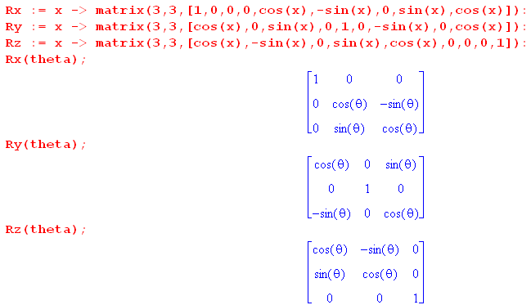

Here now is Goldstein's Euler Angle picture (G p 107, GPS p152), enhanced a bit for readability,

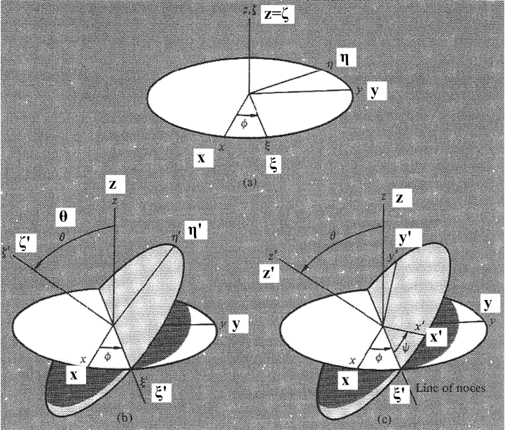 (G.5.5)

This picture shows how one can start with x,y,z axes at the top, and end up with x',y',z' axes on the lower right. There are really three sequential transformations occurring here, and we can just read off the effects on unit vectors by looking at the pictures: ( ξ = xi = "zeye", η = eta = "ate'uh, ζ = zeta = "zee'ta")

top (,,) = Rz(φ) (,,) where =

left (',',') = Rξ(θ) (,,) where ' =

right (',',') = Rζ'(ψ)(',',') where ' = ' (G.5.6)

For example, one of the three equations on the last line is ' = Rζ'(ψ)' . Rξ(θ) means an active rotation of θ about the axis, and similarly for Rζ'(ψ).

We can combine transformations in various obvious ways :

(,,) = Rz(φ) (,,) // each equation is like e'n = R-1en

(',',') = Rξ(θ) (,,) = Rξ(θ) Rz(φ) (,,)

(',',') = Rζ'(ψ) (',',') = Rζ'(ψ) Rξ(θ) (,,) = Rζ'(ψ) Rξ(θ)Rz(φ) (,,) (G.5.7)

For example, ' = Rζ'(ψ)' = Rζ'(ψ) Rξ(θ) = Rζ'(ψ) Rξ(θ)Rz(φ) .

These equations are all of the template form e'n = (R-1)en appearing in (1.1.30). The meaning is |e'n> = R-1|en> = |R-1en>. If one takes Frame S components of these equations, then in e'n = (R-1)en one can interpret (R-1) as a matrix. For example, for = Rz(φ) one can write ()i = [Rz(φ)]ij()i in which case [Rz(φ)]ij is the matrix shown in (G.5.2). But in Frame S' coordinates, one has ()'i = [R'z(φ)]ij()'i where R'z(φ) is a different matrix. See the discussion in Section 1.1 about this delicate subject. Luckily, we shall not do computations with the equations in (G.5.6) or (G.5.7).

Recall the Basis Theorem (1.1.29) and the alternate notation of (1.1.32),

e'n = R-1en ⇔ e'n = Rnm em or $\left(\begin{matrix}e'1 \\ e'2 \\ e'3\end{matrix}\right)$ = R $\left(\begin{matrix}e1 \\ e2 \\ e3\end{matrix}\right)$ . (1.1.29) + (1.1.32)

Define A ≡ R-1 and rewrite the above as,

e'n = Aen ⇔ e'n = (A-1)nm em or $\left(\begin{matrix}e'1 \\ e'2 \\ e'3\end{matrix}\right)$ = [A]-1 $\left(\begin{matrix}e1 \\ e2 \\ e3\end{matrix}\right)$ . (G.5.8)

This form of the Basis Theorem then serves as a template with which we can convert the equations of (G.5.7) to the corresponding linear combination equations of basis vectors :

= [Rz(φ)]-1 = Rz(-φ) A = Rz(φ)

= [Rξ(θ) Rz(φ)]-1 = Rz(-φ) Rξ(-θ) A = Rξ(θ) Rz(φ)

= [Rζ'(ψ) Rξ(θ)Rz(φ)]-1 = Rz(-φ) Rξ(-θ)Rζ'(-ψ) . (G.5.9)

We constantly use facts like [ABC]-1 = C-1B-1A-1 and R-1s(α) = Rs(-α).

These equations can of course be inverted in the obvious manner. The last one would give

= Rζ'(ψ) Rξ(θ)Rz(φ) . (G.5.10)

If we install this equation on the right of the first two equations in (G.5.9), the results are

= Rz(-φ) = Rz(-φ) Rζ'(ψ) Rξ(θ)Rz(φ)

= Rz(-φ) Rξ(-θ) = Rz(-φ) Rξ(-θ) Rζ'(ψ) Rξ(θ)Rz(φ) . (G.5.11)

We know all about the rotations Rx, Ry and Rz since they are specifically stated in (G.5.2). But what about the strange rotations Rξ and Rζ' which dot the landscape above? In Theorem 3 below we shall show that each of these rotations may be written as a certain product of the Rx, Ry and Rz. Specifically, we shall prove the first three results below :

(1) Rξ(θ) = Rz(φ) Rx(θ) Rz(-φ)

(2) Rζ'(ψ) = Rz(φ) Rx(θ)Rz(ψ)Rx(-θ)Rz(-φ)

(3) Rζ'(ψ) Rξ(θ) Rz(φ) = Rz(φ)Rx(θ)Rz(ψ) = the Euler angle rotation (G.5.3)

Using these equations we can clear out all the strange rotations from (G.5.9,10,11) as follows :
(1)
(4) Rz(-φ) Rξ(-θ) = Rz(-φ) [Rz(φ) Rx(-θ) Rz(-φ)] = Rx(-θ) Rz(-φ)
(3)
(5) Rz(-φ) Rξ(-θ)Rζ'(-ψ) = [Rζ'(ψ) Rξ(θ) Rz(φ)]-1 = [Rz(φ)Rx(θ)Rz(ψ)]-1 = Rz(-ψ)Rx(-θ)Rz(-φ)
(2) (1)
(6) Rz(-φ) Rζ'(ψ) Rξ(θ)Rz(φ) = Rz(-φ) [Rz(φ) Rx(θ)Rz(ψ)Rx(-θ)Rz(-φ)] [Rz(φ) Rx(θ) Rz(-φ)]Rz(φ)
= Rx(θ)Rz(ψ) // use Rz(-φ)Rz(φ) = 1 in three places, then Rx(-θ)Rx(θ) = 1

(7) Rz(-φ) Rξ(-θ) Rζ'(ψ) Rξ(θ)Rz(φ)
= Rz(-φ) [Rz(φ) Rx(-θ) Rz(-φ)] [Rz(φ) Rx(θ)Rz(ψ)Rx(-θ)Rz(-φ)][Rz(φ) Rx(θ) Rz(-φ)]Rz(φ)
= Rz(ψ) (1) (3) (1)
(G.5.12)
Then we can rewrite (G.5.9,10,11) as

(a) = Rz(-φ)

(b) = Rx(-θ) Rz(-φ) // using (4)

(c) = Rz(-ψ)Rx(-θ)Rz(-φ) // using (3)

(d) = Rz(φ)Rx(θ)Rz(ψ) // using (5)

(e) = Rx(θ)Rz(ψ) // using (6)

(f) = Rz(ψ) // using (7) (G.5.13)

Using these equations, we have explicit formulas for writing any of the nine basis vectors either as a linear combination of ,, or as a linear combination of ',',' . We shall see examples below showing why this is useful information.
By inspection we can rewrite the above six equations in the form shown on the left side of the Basis Theorem (1.2.29),

(a) (,,) = Rz(φ) (,,)

(b) (',',') = Rz(φ)Rx(θ) (,,)

(c) (',',') = Rz(φ)Rx(θ)Rz(ψ) (,,)

(d) (,,) = Rz(-ψ)Rx(-θ)Rz(-φ) (',',')

(e) (,,) = Rz(-ψ)Rx(-θ) (',',')

(f) (',',') = Rz(-ψ) (',',') . (G.5.14)

Two examples from this list: =Rz(φ) and = Rz(-ψ)Rx(-θ)Rz(-φ) ' .

We shall now prove the three facts quoted above as (G.5.12) (1), (2) and (3).

Theorem 3 : (G.5.15)

(1) Rξ(θ) = Rz(φ) Rx(θ) Rz(-φ)

(2) Rζ'(ψ) = Rz(φ) Rx(θ)Rz(ψ)Rx(-θ)Rz(-φ)

(3) Rζ'(ψ) Rξ(θ) Rz(φ) = Rz(φ)Rx(θ)Rz(ψ) = the Euler angle rotation R-1 of (G.5.3)

Recall from (G.1.1) that a rotation of α about axis may be written R(α) = exp(-i α n • J) .

Proof of (1) :

Recall Theorem 2 of (G.4.7) which says,

R exp(-iθn•J) R-1 = exp(-iθn'•J) where n' = Rn . (G.4.7)

Note from line 1 of (G.5.6) that = Rz(φ) . We take n' = , R = Rz(φ), n = to get

Rz(φ) exp(-iθ•J) Rz(-φ) = exp(-iθ•J)

or
Rξ(θ) = exp(-iθ•J) = Rz(φ) Rx(θ) Rz(-φ) . QED (1)

and we have thus proved item (1).
One can see intuitively how this works, as in our example of (G.4.14). Instead of rotating θ about the axes, we first back-rotate around by -φ, use the aligned Rx(θ) to create a tilted disk in the top drawing of Fig (G.5.5), then forward rotate that result by Rz(φ) to get the tilted disk in the left picture. The good news is that we don't have to rely on such visualizations to get the result right.

Proof of (2) :

Recall again Theorem 2 of (G.4.7) which says (now with dummy argument θ → ψ)

R exp(-iψn•J) R-1 = exp(-iψn'•J) where n' = Rn . (G.4.7)

Note from lines 2,1 of (G.5.6) that that ' = Rξ(θ) = Rξ(θ). We take n' = ', R = Rξ(θ), n = to get

Rξ(θ)exp(-iψ•J)Rξ(-θ) = exp(-iψ'• J) = Rζ'(ψ) .

Therefore

Rζ'(ψ) = Rξ(θ)Rz(ψ)Rξ(-θ) .

Then installing result (1) twice we get

Rζ'(ψ) = [Rz(φ) Rx(θ) Rz(-φ)] Rz(ψ) [Rz(φ) Rx(-θ) Rz(-φ)]

= Rz(φ) Rx(θ) Rz(ψ) Rx(-θ) Rz(-φ) QED (2)

and we have thus proved item (2).

Reader Exercise: Interpret this result in terms of back-rotations and Fig (G.5.5).

Proof of (3) :
(2) (1)
Rζ'(ψ) Rξ(θ) Rz(φ) = [Rz(φ) Rx(θ)Rz(ψ)Rx(-θ)Rz(-φ)] [Rz(φ) Rx(θ) Rz(-φ)] Rz(φ)

= Rz(φ) Rx(θ) Rz(ψ) Rx(-θ) Rz(-φ) Rz(φ) Rx(θ) Rz(-φ) Rz(φ)

= Rz(φ) Rx(θ) Rz(ψ) Rx(-θ) Rx(θ)

= Rz(φ) Rx(θ) Rz(ψ) . QED (3)

Euler angles which change in time : computation of ω

Suppose now that all the Euler angles are changing in time. The combination of all these movements creates an overall ω angular rotation vector relating the relative motion of the two Frames (as in Fig 1). Looking at Fig (G.5.5) we see that ω will have three contributions, one from each Euler angle movement,

ωφ =
ωθ = '
ωψ = ' . (G.5.16)

If we want to know these contributions in Frame S components, we have to replace ' and ' with their appropriate linear combinations of , and . From (G.5.13b)

= Rx(-θ) Rz(-φ)

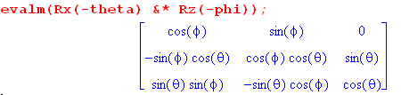 // Maple
Therefore

' = cosφ + sinφ . // this particular fact is obvious from Fig (G.5.5) top (G.5.17)

Next, from (G.5.13c),

= Rz(-ψ)Rx(-θ)Rz(-φ)

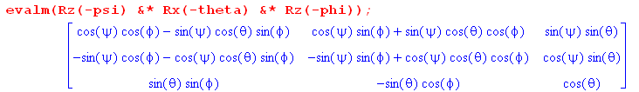
Therefore,

' = sinθsinφ - sinθcosφ + cosθ . (G.5.18)

Inserting these last two results into (G.5.16) gives,

ωφ =
ωθ = cosφ + sinφ
ωψ = sinθsinφ - sinθcosφ + cosθ . (G.5.19)

We add up to get

ω = ωφ + ωθ + ωψ
= [ sinθsinφ + cosφ] + [- sinθcosφ + sinφ ] + [ cosθ + ]
or
ωx = sinθsinφ + cosφ
ωy = - sinθcosφ + sinφ
ωz = cosθ + . // Frame S (G.5.20)

These then are the Frame S components of the ω vector.

Conversely, suppose we want (as Goldstein does want) the components of ω in Frame S' components, Frame S' being the rotating frame in which a rigid body might lie. From (G.5.13e),

= Rx(θ)Rz(ψ)

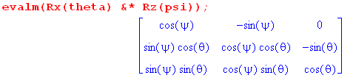
Therefore

' = = cosψ ' - sinψ ' . (G.5.21)

This fact can be verified by staring for a while at the lower right drawing in Fig (G.5.5). There we see that ' = Rz'(-ψ)' which implies the above. The author is prone to making errors staring at drawings and for this reason prefers the bulletproof Maple approach to computing things.

Next, from (G.5.13d),

= Rz(φ)Rx(θ)Rz(ψ)

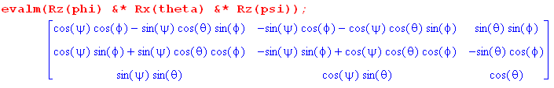
Therefore,

= sinθsinψ ' + sinθcosψ ' + cosθ ' . (G.5.22)

Inserting these last two results into (G.5.16) we get

ωφ = = sinθsinψ ' + sinθcosψ ' + cosθ '
ωθ = ' = cosψ ' - sinψ '
ωψ = ' . (G.5.23)

We add up to get

ω = ωφ + ωθ + ωψ
= [ sinθsinψ + cosψ ] ' + [ sinθcosψ - sinψ] ' + [ cosθ + ] '
or
(ω)'x = sinθsinψ + cosψ
(ω)'y = sinθcosψ - sinψ
(ω)'z = cosθ + // Frame S' (G.5.24)

These then are the Frame S' components of the ω vector.

We can now compare (G.5.24) to Goldstein page 134 (GPS page 174),

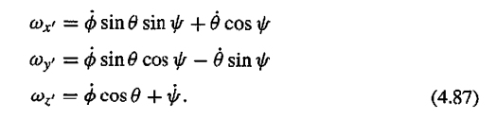

A quick verification

From (G.5.3) we have

R = Rz(-ψ)Rx(-θ)Rz(-φ) . (G.5.25)
The rule for transformation of a normal vector is given by (1.3.2) as

ω' = Rω (G.5.26)

which from (1.3.4) we can write as

(ω')i = (ω)'i = Rij(ωj) = [ Rz(-ψ)Rx(-θ)Rz(-φ) ]ij(ωj) . (G.5.27)

Inverting,

(ω)i = [ Rz(φ)Rx(θ)Rz(ψ)]ij (ω)'j . (G.5.28)

We enter the (ω)'j components (G.5.24) into Maple and then compute the (ω)i from (G.5.28),

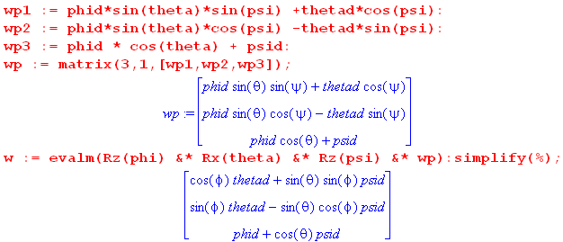

Transcribing the result gives,

(ω)x = cosφ + sinθsinφ
(ω)y = sinφ - sinθcosφ
(ω)z = + cosθ (G.5.29)

This agrees with (G.5.20) above, providing some verification for our Frame S components of ω.

