Confusion about Williams' torque formula kinematics PhL 4.1.17

For a while I thought maybe I was interpreting this Williams formula incorrectly, but in the end I had it right from the start. The angles really are standard spherical angles of a specific orbit point, and the "inclination" of the orbit does not appear in the torque formula. Also for a while I thought the tangent vector of interest was tangent to the orbit, not so. This same stuff shows up in sun earth kinematics but I did not bother to look there.
So here is what I do below. (it is quite a lot, actually, and I know quote the equations of motion from item 3 in frames doc without deriving it.

1. I first get the picture drawn right and add the notion of inclination to the picture which I call θ' because that will match what I do in my next document.

2. I study up on the GPS version of this subject, learning their angle names.

3. I write equations of motion for the torqued planet M, one of which matches the pendulum but the other does not in θ form. But both equation sets have hidden precession in them somehow, for the pendulum it was the Airy precession, while for the planet M it is the precession of the equinoxes.

4. I compute the orbit normal n and write out in hopes of "seeing" the precession of this vector, but I don't see it.

5. I make a rough attempt to compute <P2(cosθ)> and get something close to the GPS result for small inclinations.

Consider that the torque on the mass M is given by,

N = - 3GM b-3(I3 - I1) sinδ cosδ $\left(\begin{matrix}-sinα \\ cosα \\ 0\end{matrix}\right)$ (I.8.7)

Here is the picture I have in frames doc, based on what Williams says in his words,

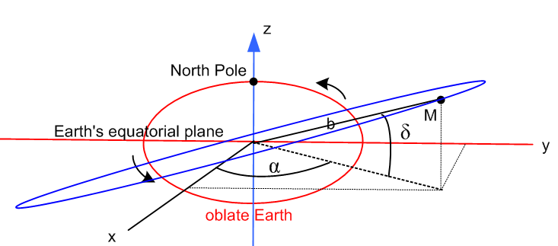

Question 1. What is the column vector he shows? Can I give it a name and add it to the picture?

Suppose I "think of" α as being a spherical coordinates azimuth angle. I know that

= -sinφ + cosφ (E.2.6)

So in the above picture, I could think of

= -sinα + cosα

Here I think is a better picture

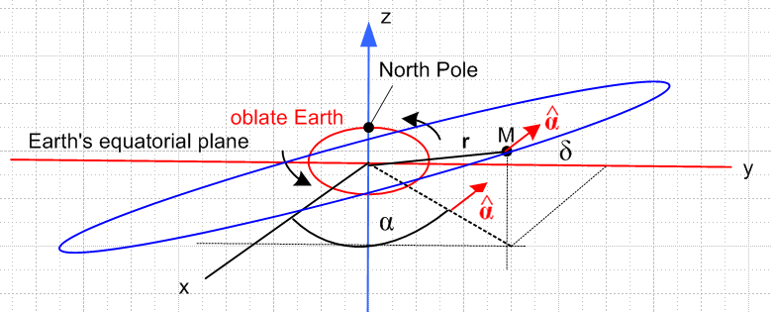

and now I change the angle names to get

This is the kind of picture I finally went with
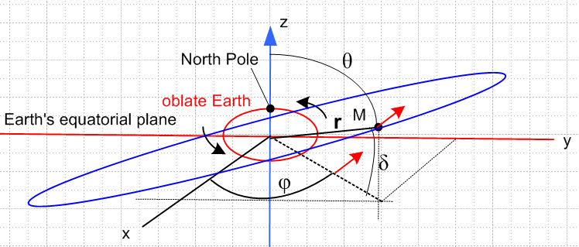

So in this spherical coordinate system, as the mass M orbits, θ,δ,φ all change, Fine!

Let me assume now that that the blue orbit is such that its highest point in z lies over the y axis. I don't think we lose any "generality" in doing that, since the oblate Earth is axially symmetric. In that case, I then claim that both vectors r and lie in the orbital plane because the plane of the orbit is really perpendicular to the plane of paper so its "nodes" are on the x axis. In this case I know that both r and lie in the orbital plane, so I can construct a normal in this manner

I can then construct a normal to the orbital plane in this manner,

n = x = cosθcosφ + sinθ

Now I want to define a NEW coordinate system in which the orbit lies in the x',y' plane and

Question: What is the inclination of the blue orbit relative to the axis

Answer: This is not specified in the above picture, it could be anything! We have δ(φ) and you could say that the inclination then was δ(π/2), based on my assumptions above.

Plan A: Let's specify now that the inclination angle is something I will call θ'. I think I can then add this angle into my picture:

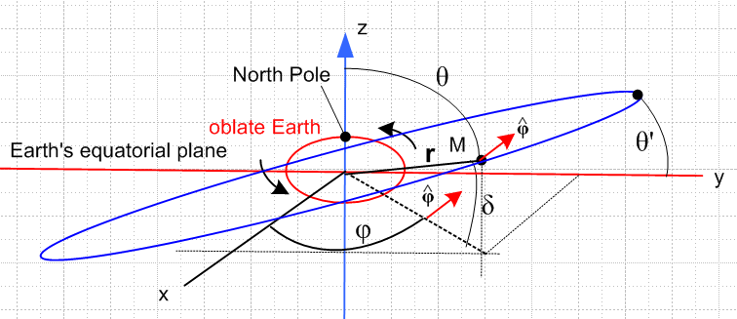

What exactly is the meaning of δ in this picture??

Let r be the vector origin to mass M. Then δ is the elevation of this point relative to the x,y plane. As mass M moves, δ changes! For example, when M is on the positive x axis, δ = 0. This seems to be the meaning that Williams intends:

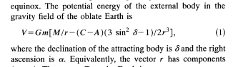

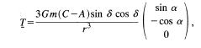

The inclination of an orbit is the maximum declination for something travelling on that orbit, in my opinion, though I cannot get the web to verify this claim. That inclination is shown as θ' in my drawing.

Let's look at GPS on this issue.

Their angles are completely different from mine, here I decipher what they are doing.

They have lots of angle names, I will try to nail each one down.

ψi is shown figure on their page 224. They then say

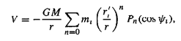
so I can then think of ψi as a polar angle θi relative to point M to the right on the z axis. Then later this becomes ψ in their continuous integral.

γ is part of α,β,γ which are "direction cosines of vector r relative to the principal axes." So I would then say

α = • = sinθcosφ

β = • = sinθsinφ

γ = • = cosθ

This γ is their key angle but they never call it cosθ because they reserve θ for a different use.

So I think then I can just say that γ = cosθ. Then they obtain this result

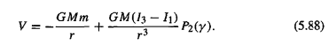

which I can compare to my own calculation,

V(r) ≈ - GME/r + G (I3-I1) P2(cosθ)/r3. (I.9.31)

So I do not think that the GPS γ is anything other than γ = cosθ. [correct] But what then is θ ? It is the polar angle of vector r in spherical coordinates. If r goes out to planet M in my picture above, then θ varies during the orbit and θ+δ = π/2 as I claimed in my doc.

But GPS are not done yet!! Here are some good words,

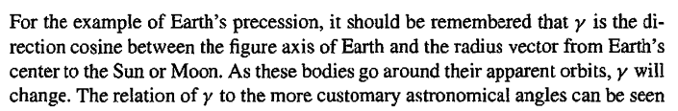

Here they are just verifying that my θ angles varies as the planet moves.

So yes, we agree that both δ and θ change as M moves on its orbit. I am certainly allowed define φ = α and θ = π/2 - δ for this picture, where my definition is that θ and φ are the spherical angles of the vector r at the time instant shown.

Here is the Williams torque formula in my picture's notation and picture that goes with it,

N = - 3GM b-3(I3 - I1) sinθ cosθ = $\left(\begin{matrix}-sinφ \\ cosφ \\ 0\end{matrix}\right)$ [correct] (I.8.7)

The column vector now comes from this,

= -sinφ + cosφ [correct] (E.2.6)

Now let's try to do a calculation of motion:

What is L for mass M?

L = r x Mv ok

= x Mv + r x M = r x M = r x Ma // in inertial Frame S

= M r x [ ar + aθ + aφ ]

= Mr[ aθ x + aφ x ]

= Mr[ aθ - aφ ] ok

a = ar + aθ + aφ // acceleration
ar = - r2 – r 2 sin2θ
aθ = 2 + r - r 2 sinθ cosθ
aφ = 2 sinθ + 2 r cosθ + rsinθ . ok (E.3.3)

If I now use

N =

I then get these two equations of motion. Here the torque effect is the left side of the first equation.

- 3GM b-3(I3 - I1) sinθ cosθ = Mr [2 + r - r 2 sinθ cosθ]

0 = 2 sinθ + 2 r cosθ + rsinθ

Recall that θ and φ are both changing by large amounts as the planet M orbits, so you cannot set θ = constant here, nor is φ = constant. If I assume a circular orbit, then = 0 and we get instead

- 3GM b-3(I3 - I1) sinθ cosθ = Mr2 [ - 2 sinθ cosθ]
0 = 2 cosθ + sinθ

Just for fun, here are the spherical pendulum equations:

- sinθcosθ 2 = - (g/l)sinθ
2cosθ + sinθ = 0 . (C.5.1)

Here you see that the second equations are the same, the conserved Lz, but the first equations have a different angular form for the driving term, pendulum is sinθ, oblate is sinθcosθ. But both equation sets have this sort of "hidden" precession effect, for the pendulum it was the Airy precession

Now GPS claim that the orbit precesses in a long term average manner with this result

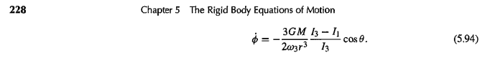
Their result has these units

dim(RHS) = M-1L3 T-2 * M * L-3 * T = T-1 which is correct

They have ω3 sitting there which I don't have anywhere, why is that?

What other equation do I get using the above method?

aφ = 2 sinθ + 2 r cosθ + rsinθ = 0

If θ = constant and r = constant this gives 0 = 0 if = constant.

So maybe assuming θ = constant is wrong here. [ it is very wrong] Where does ω3 fit into this picture? One thing that GPS did and which I maybe should do is this:

= $\frac{b-acosθ}{sin2θ}$ . (I.7.9)

Well, they get an average for in their [ but this is for a special fast top mode I think with lots of detail needed to support it. They plant this result early then use it later for the equinox precession problem ]

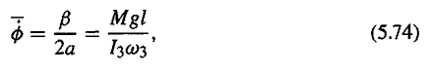

But this is for a special mode of the top, not a general average result. Suppose I know that the nutation were very small. Maybe I could approximate θ as linear in time. But I cannot average my expression because the integral of the first term is infinite.

Now go back to my equations

- 3GM b-3(I3 - I1) sinθ cosθ = Mr [r - r 2 sinθ cosθ]

0 = 2 cosθ + sinθ

The second is the one which says Lz = constant for the spherical pendulum! [correct] See (C.5.2) and following data.

I want to show that the normal to the orbit plane is precessing at some super slow rate.

[ Yes, that really is the problem, but I could find no simple obvious way to show it, think it is like the hidden Airy precession of the pendulum, it needs some special thread to be brought out which I don't have time to invent. ]

The normal vector is

n = x = - cosθcosφ - sinφ

Then

= lots of terms

= sinθcosφ + cosθsinφ - cosθcosφ∂t - cosφ - sinφ∂t

= sinθcosφ + cosθsinφ - cosθcosφ[ - sinθ - cosθ ] - cosφ - sinφ[ - + cosθ ]

= [ cosθcosφ sinθ + sinφ ] + [cosθcosφ cosθ - cosφ ]

+ [ sinθcosφ + cosθsinφ - sinφ cosθ ]

= [ cosθcosφ sinθ + sinφ ] + cosφ [cos2θ - 1 ]

+ [ sinθcosφ ]

= [ cosθcosφ sinθ + sinφ ] + [-sin2θcosφ ] + [ sinθcosφ ]

I don't see any way to do averaging here because φ and θ have large scale motion all the time. I think this is like the Airy precession being hidden in the equations. I think this is not a probably I want to pursue!

What about the GPS idea of averaging the potential? I do have the result that

V(r) ≈ - GME/r + G (I3-I1) P2(cosθ)/r3. (I.9.31)

It is true that θ varies between θ = π/2 - α to θ = π/2 + α where α is the inclination, so it is true that the average value of θ is 0.

This was a quick idea that did not pan out, an attempt to do the averaging. But it gives something close.

Maybe I could write (here I use α for the inclination)

θ(t) = A + Bt during one orbit

Then suppose θ(0) = π/2+α on the left end of the blue ellipse at t=0. That says A = π/2+α so have

θ(t) = π/2+α + Bt

At a half period T/2 we have the high value on the top right, so

θ(T/2) = π/2+α + B(T/2) = π/2-α ⇒ B(T/2) = -2α B = -4α/T

Then have

θ(t) = π/2+α - (4α/T) t = π/2 + α [1 - 4 (t/T) ]

Then maybe you could average

< P2(cosθ)> = (1/2) <3 cos2θ - 1> = (3/2)<cos2θ>- (1/2)

Then

<cos2θ> = (2/T)$^{\int_{0}^{T/2}{}}$cos2( π/2 + α [1 - 4 (t/T) ] ) dt

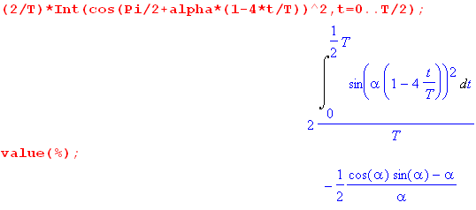

So I guess this says

<cos2θ> = (1/2) [ α - sinαcosα]/α α = the inclination of the orbit

Now consider

< P2(cosθ)> ≈ (3/2)<cos2θ>- (1/2) = (3/4)[ α - sinαcosα]/α - (1/2)

= (3/4) - (1/2) - (3/4)sinαcosα/α = 1/4 - (3/4)sinαcosα/α

But the result that GPS get is this

< P2(cosθ)> = -(1/2) P2(cosα) = -(1/2)(1/2)[ 3cos2α - 1 ] = -(1/4)[ 3cos2α - 1 ]

= 1/4 - (3/4) cos2α

so my crude result is perhaps in the general ballpark. For small α we can compare sinαcosα/α to
cos2α :

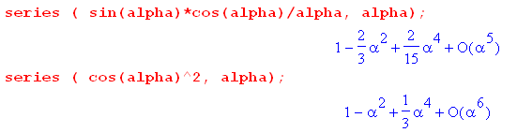
They are pretty close for small α.

