I.10 Motion of an electric dipole dumbbell in a uniform E field 1
I.11 Rotors involving electric or magnetic dipoles 9

This has been installed, do not edit here!

I.10 Motion of an electric dipole dumbbell in a uniform E field

The kinematic setup is similar to that for the dumbbell satellite shown in Fig (F.1.1), but here we simplify so that r1 = r2 = r and m1 = m2 = m, so the picture is this,

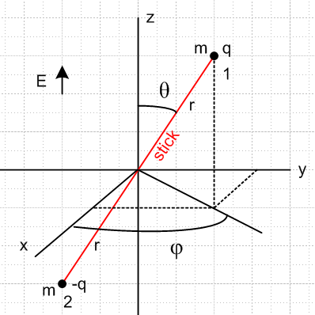 (I.10.1)

Two equal point masses m are separated by a massless stick of length 2r which has a universal pivot point at the origin, allowing the dumbbell to rotate freely in θ and φ. One mass has charge q and the other -q. The pivot point won't really be needed but it helps to think about the problem. Instead of the gravitational field of the Earth, this dumbbell is immersed in a uniform electric field E in the z direction. As we shall see, this problem is a hybrid of the dumbbell satellite and the spherical pendulum, though the latter will soon be declared the winner.

Force and Torque

In the dumbbell satellite problem both masses were attracted to the Earth, but here one mass is pushed up and the other is pushed down. In fact, letting T be the tension in the stick,

F1 = qE + T = qE + T

F2 = (-q)E - T = -qE - T = - F1 r2 = - r1 = - r

F = F1 + F2 = 0 (I.10.2)

so the center of mass does not move (hence no pivot needed).

The torques on the two masses about the origin are (same as about any point since F = 0),

N1 = r1x F1 = [r] x [ qE] = rqE x = rqE [ -sinθ ] = -rqEsinθ

N2 = r2x F2 = (-r1)x (-F1) = N1 . (I.10.3)

Here we ignored the stick tension forces since r1 x r = r2 x r = 0. The total torque is then,

N = N1+ N2 = 2N1 = -2rqEsinθ . (I.10.4)

Now define the dipole moment p as

p ≡ (2r)q p ≡ 2rq . (I.10.5)

Then using (E.2.15) that x = sinθ we may write,

N = -2rqEsinθ = -2rqEsinθ [ x /sinθ ] = 2rqE x

= [ 2rq ] x [E ] = p x E (I.10.6)

which is the classic result for the torque on a dipole in an electric field.

Newton's Angular Law and Equations of Motion

Newton tells us that (in inertial Frame S),

N = , (I.10.7)

so we have the following vector equation of motion for the dipole dumbbell,

= p x E = -2rqEsinθ = -pEsinθ . (I.10.8)

Here θ,φ refer to the angular position of the stick in (I.10.1). The three equations of motion are therefore

()r = 0
()θ = 0
()φ = -pEsinθ . (I.10.9)

But from (F.2.2) and (F.2.3) we know that

L = 2mr2 ( – sinθ ) (F.2.2)
= 2mr2 [ (- 2 sinθ cosθ) – (2 cosθ + sinθ) ] . (F.2.3) (I.10.10)

The three equations of motion are then

()r = 0 = 0 // nothing very interesting here
()φ = -pEsinθ = 2mr2 (- 2 sinθ cosθ)
()θ = 0 = – 2mr2(2 cosθ + sinθ) . (I.10.11)

Thus, there are really only two equations of motion :

- 2 sinθ cosθ + [pE/2mr2] sinθ = 0
2 cosθ + sinθ = 0 . (I.10.12)

Let [pE/2mr2] = a, so we then have

- 2 sinθ cosθ + a sinθ = 0 a = pE/2mr2 = (2qr)E/2mr2 = qE/mr
2 cosθ + sinθ = 0 . (I.10.13)

The tension on the stick can be evaluated by going to the rest frame of mass #1 (the body frame). That mass has a true electrostatic force and a fictitious centrifugal force. These forces are

qE = qE [ cosθ - sinθ ] ⇒ Fr,elec = qEcosθ

Fr,cent = mv2/r where v2 = vθ2 + vφ2 . (I.10.14)

From (E.3.5) we know that vθ = r and vφ = r sinθ . Thus

Fr,cent = (m/r) (vθ2 + vφ2) = (m/r) (r2 2 +r2 2 sin2θ) = mr( 2 + 2 sin2θ ) . (I.10.15)

The stick tension is then

T = mr( 2 + 2 sin2θ ) + qEcosθ
so
T/mr = ( 2 + 2 sin2θ ) + [qE/mr]cosθ = 2 + 2 sin2θ + a cosθ . (I.10.16)

Including this with the equations of motion (I.10.13), one gets

T/mr = 2 + 2 sin2θ + a cosθ
- 2 sinθ cosθ + a sinθ = 0 a = qE/mr
2 cosθ + sinθ = 0 . (I.10.17)

Compare these equations to those for the spherical pendulum found in Appendix C,

2 + sin2θ 2 = -(g/l)cosθ + T/(ml)
- sinθcosθ 2 = - (g/l)sinθ
2cosθ + sinθ = 0 . (C.5.1)

If we make the associations l = r and (g/l) = a, these equation sets are identical. Then,

g = la = ra = r qE/mr = qE/m . (I.10.18)

It is not surprising that the equations of motion are the same, since both problems have a uniform force field in the z direction. The spherical pendulum has a mass swinging on a stick whose other end is fixed, while our current problem has a free-floating dumbbell consisting of two oppositely charged masses on a stick.

With the above identification, anything said about the spherical pendulum solution applies to our dipole dumbbell problem. For example we then know from (C.5.2) and (C.5.4) that Lz = (2m)r2sin2θ is a constant of the motion. The problem may be solved exactly as shown in Section C and has numerical solutions as shown there, such as shown in (C.5.44).

Conical motion solution

In particular, there is a conical motion solution which has θ = constant. In this case the equations (I.10.17) become

T/mr = 2 sin2θ + a cosθ
- 2 sinθ cosθ + a sinθ = 0 a = qE/mr
sinθ = 0 . (I.10.19)

The second equation says

2 = a/cosθ = qE/(mrcosθ) . (I.10.20)

Recall from (I.10.4) the torque on the dumbbell,

N = -2rqEsinθ (I.10.4)

so we expect the dumbbell to precess clockwise around its cone, and therefore from (I.10.20),

= - $\sqrt{qE/(mrcosθ)}$. (I.10.21)

The third equation of (I.10.19) is then satisfied since is a constant, and the tension T is

T = mr[ (a/cosθ) sin2θ + a cosθ ] = mra ( sin2θ + cos2θ)/ cosθ

= qE/cosθ . (I.10.22)

From (I.10.10) and (I.10.21) one then has,

L = –2mr2 sinθ = 2mr2 || sinθ

= 2mr2 $\sqrt{qE/(mrcosθ)}$sinθ . (I.10.23)

From (I.10.28) obtained below one finds the obvious result that,

ω = (0, 0, ) . (I.10.24)

Here then is the "cone picture" showing this special solution for the electric dipole dumbbell,

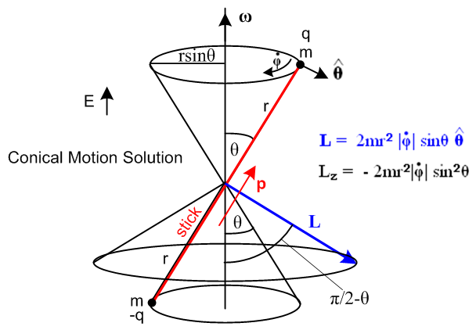 (I.10.25)

The direction of angular momentum L seems unusual, but it is in the direction of r x mv for either mass. Vector L is perpendicular to the stick and is in the direction. This example provides dramatic evidence of L (= Iω) and ω not being in the same direction. We shall in fact compute I below and show that L = Iω is in the direction shown above and as shown in (I.10.23).

The kinetic energy for this conical solution is just 2 * (1/2)mv2 with v = rsinθ so

KE = mv2 = m r2sin2θ 2 = m r2sin2θ qE/(mrcosθ) = rqEsinθ tanθ . (I.10.26)

One can regard θ as being set by the magnitude of L or by the kinetic energy.

Notice that as θ→π/2, the following items become infinite: KE, L , tension T, , ω, v. The dumbbell has to spin around infinitely fast to maintain a circular path in the xy plane, because the electric field wants to line the dumbbell up with the z axis. Only an infinite centrifugal force can offset the E field's influence.

We now return to the general solution context.

Angular Velocity ω

The "Frame S" angular velocity ω of the dipole dumbbell is given by (H.6.18) [ here is a place where it is important to distinguish spherical coordinate φ from Euler angle φ = φ+π/2 ],

ωx = sinθcosφ - sinφ
ωy = sinθsinφ + cosφ
ωz = cosθ + . // Frame S (H.6.18) (I.10.27)

Since the dumbbell has no moment of inertia on its symmetry axis (I'3= 0), coordinate ψ is not relevant and we just set ψ = constant so the above equations become

ω = (- sinφ, cosφ, ) . (I.10.28)

Inertia tensor I

From (I.1.6),

Li = Iij (ω)j Iij = Σαmα [ rα2δij - (rα)i(rα)j ] // rα2 = (rα)i(rα)i (I.1.6)

Since we have done no examples of computing inertia tensors in the space frame, we do it here. This is a special case I where there are two equal terms in the particle sum Σα . The reason is that one mass is at location r, and the other at -r, and all the inertia terms for the second mass are the same as for the first mass since each term is invariant under r → -r. We use the standard spherical coordinate components,

x = rsinθcosφ
y = rsinθsinφ
z = rcosθ (E.2.5)

and compute the entire tensor as follows:

I11 = 2m(r2 - x2) = 2m(r2 - r2sin2θcos2φ) = 2mr2 (1 - sin2θcos2φ)

I22 = 2m(r2 - y2)= 2mr2 (1 - sin2θsin2φ)

I33 = 2m(r2 - z2) = 2m(r2 - r2cos2θ ) = 2mr2sin2θ

I12 = 2m(-xy) = -2mr2sin2θcosφsinφ

I13 = 2m(-xz) = -2mr2sinθcosθcosφ

I23 = 2m(-yz) = -2mr2sinθcosθsinφ . (I.10.29)

Thus, the symmetric I tensor is this

I = 2mr2 $\left(\begin{matrix}1 - sin2θcos2φ & -sin2θcosφsinφ & -sinθcosθcosφ \\ -sin2θcosφsinφ & 1 - sin2θsin2φ & -sinθcosθsinφ \\ -sinθcosθcosφ & -sinθcosθsinφ & sin2θ\end{matrix}\right)$. (I.10.30)
Angular momentum L

Recall now a result quoted in (I.10.10) above,

L = 2mr2 ( – sinθ ) . (I.10.10)
Since L = Iω from (I.1.4), it would be interesting to compute ω from ω = I-1L and see if we get result (I.10.28). It happens, however, that this particular inertia tensor has zero determinant and so has no inverse.

Reader Exercise: Assuming Iij = r2δij - xixj, show that det(I) = 0 (a single-term inertia tensor) .

Hint: det(I) = εijkI1iI2jI3k = εijk(r2δ1i - x1xi)(r2δ2j - x2xj)(r2δ3k - x3xk) .

Since we cannot compute ω = I-1L, we shall instead assume ω as in (I.10.28) and compute L = Iω and verify that this produces the result (I.10.10). We write the inertia tensor in (I.10.30) as I = 2mr2M and enter matrix M into Maple,

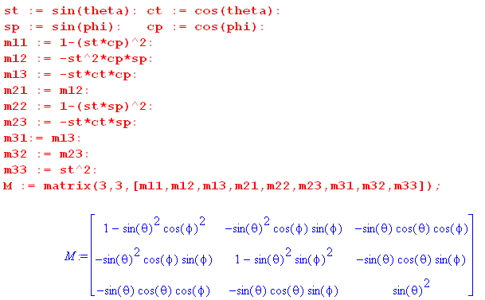 (I.10.31)

We verify as noted above that detM = 0,

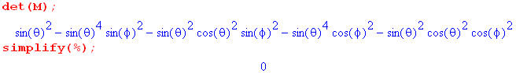
Finally we enter ω from (I.10.28) (td = and pd = )

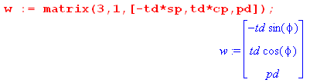
and then compute L = Iω :

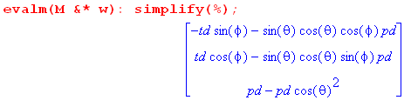

Transcribing the result and adding back the factor 2mr2,

Lx = 2mr2(- sinφ - sinθcosθcosφ )
Ly = 2mr2( cosφ - sinθcosθsinφ )
Lz = 2mr2( sin2θ) . (I.10.32)

Meanwhile, from (I.10.10) one has,

L = 2mr2 ( – sinθ ) // next step uses (E.2.7):

= 2mr2 ( [-sinφ + cosφ ] – sinθ [cosθcosφ + cosθsinφ - sinθ ])

= 2mr2 { (- sinφ - sinθcosθcosφ ) + ( cosφ - sinθcosθsinφ) + ( sin2θ) } (I.10.33)

and this does agree with (I.10.32) .

Reader Exercises:

1. Redo this problem using the Lagrangian approach.

2. Redo this problem with the point masses replaced by uniform density spheres of radius R assuming that the charge is uniformly distributed on the sphere surfaces ("sticky charge"). Is this new problem trivial, or does it require work? What if the charge is allowed to move freely on the conducting sphere surfaces?

3. Compute the radiation pattern for the point-mass conical dipole dumbbell solution. One does expect accelerating charges to radiate, see Jackson Chapter 9. This would be a classical model for radiation from an isolated dipole molecule executing conical motion in a uniform E field.

I.11 Rotors involving electric or magnetic dipoles

We consider here three final rigid body rotation problems. The first two problems are isomorphic to the gravity top, while the third is somewhat in a class by itself and has a massive engineering significance.

1. Spherical top with fixed embedded electric dipole in a uniform E field
2. Spherical top with fixed embedded magnetic dipole in a uniform B field
3. Rigid charged rotor which creates its own magnetic dipole moment, in a uniform B field .

1. rotor with fixed embedded electric dipole in a uniform E field

The rotor has some axisymmetric shape, perhaps it is spherical. This rotor is operating in zero-gravity space and here we take the uniform electric field to be E = -E. Consider then the torques involved in the gravity top problem of Section I.7 compared with the dipole top problem considered here,

gravity top: N = rcms x F F = -mg

fixed dipole top: N = p x E E = -E . (I.11.1)

The two torques can be written,

gravity top: N = [rcms] x[ -mg] = - rcmsmg x

fixed dipole top: N = [p] x [ -E] = - pE x . (I.11.2)

The torques have the exact same form and are identical with this association

rcmsmg = pE . (I.11.3)

The force situation is a bit different. For the gravity top, F = 0 because the down gravity force is balanced by the pivot point force up. For the fixed dipole top, F = 0 without a pivot point. The dipole top in effect pivots about its center of mass.

Consider the potential energy situation for these two systems,

V = mgrcmscosθ gravity top max when θ = 0, top vertical

V = pEcosθ dipole top max when θ = 0, top anti-aligned with E (I.11.4)

Again the connection is seen to be rcmsmg = pE.

The upshot is that the problem of a fixed electric dipole top operating in a uniform E field and no gravity is isomorphic to the gravity top problem discussed in Section I.7. We expect solutions which precess and nutate as shown in Fig (I.7.19). As noted there, having the top be spherical does not simplify the general nature of these complicated solutions.

2. rotor with fixed embedded MAGNETIC dipole in a uniform B field

We arrive at this problem by making the changes E → B and p → μ where μ is a fixed magnetic dipole (a chunk of magnet) embedded into a top along the symmetry axis. The torque here is N = μ x B instead of N = p x E, see Jackson (5.1). Thus, the fixed magnetic moment top is isomorphic with the gravity top with this association,

rcmsmg = μB . (I.11.5)

As with the electric dipole top above, this magnetic system has the same solution complexity as the gravity top system.

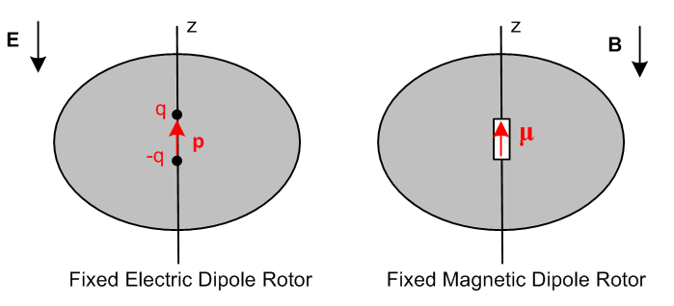 (I.11.6)

3. THE CHARGED ROTOR AND LARMOR PRECESSION

This problem is similar to the magnetic dipole rotor discussed just above, but here the magnetic moment is not fixed but is self-generated by charge embedded in the rotor. To keep things simple, consider a very thin round "wagon wheel rotor" (radius a) which is made of "charged matter" and has massless spokes to hold it in shape, and a massless axle. Here we show the wheel tilted so its axis points in the direction,

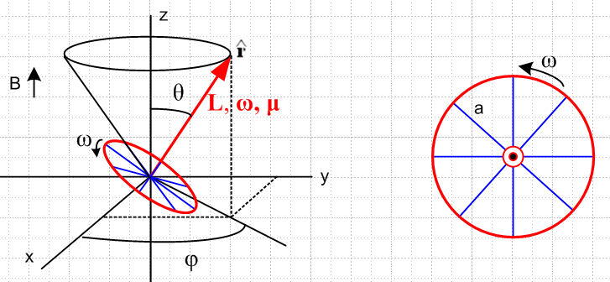 (I.11.7)
We anticipate a conical motion solution so a cone is displayed in black.

Assume that the red ring is made of particles of mass m and electric charge q. These particles are glued down to a massless wheel substrate that prevents them from flying away. We assume the particles are uniformly distributed on the ring. The linear charge density is λ and the linear mass density is ρ. Thus,

M = 2πaρ total mass of ring

Q = 2πaλ total charge of ring

I = Ma2 moment of inertial of ring

λ/ρ = Q/M = q/m . ratio of linear densities (I.11.8)

The wheel is going to precess, but we assume that it spins much faster than it precesses, so we can ignore the resulting precession when computing ω and L. Then,

ω = ω

L = Iω = (Ma2)ω = (Ma2ω) . (I.11.9)

As shown in Jackson (5.5.7), when an electric current i circulates in a closed planar loop of wire of any shape but of area A, a magnetic dipole moment is generated by the current which is normal to the loop (by the right hand rule with the current), and has magnitude μ = iA. Our rotating ring of charge constitutes a current of i = aωλ, and the area is A = πa2. To obtain the current, note that the amount of charge which passes through a radial line in time dt is dq ≈ (adθ)λ so i = dq/dt = (adθ)λ/dt = aλ(dθ/dt) = aλω. Thus,

μ = iA = [aωλ][ πa2] = (πωλa3) . (I.11.10)

Comparing the last two equations, one sees that μ and L are related as follows,

μ = (πωλa3) = [ (πωλa3) / (Ma2ω) ] L = (πλa/M) L

= (πλa/2πaρ) L = (1/2)(λ/ρ) = (1/2) q/m L = (q/2m) L
or

μ = γc L γc ≡ q/(2m) = " the classical gyromagnetic ratio" (I.11.11)

(sometimes called the magnetogyric ratio). The torque on the ring is

N = μ x B = [ πλωa3 ] x [B] = πλωa3 Bx = πλωa3B [-sinθ]

= - πλωa3Bsinθ . (I.11.12)

Alternatively one can use (I.11.11) to write

N = μ x B = γc L x B . (I.11.13)

Since Newton's Law says

= N = - πλωa3Bsinθ (I.11.14)

we end up with this equation of motion

= γc L x B . (I.11.15)

This says that in time dt, dL is perpendicular to L and B which indicates conical motion. In more detail, recall from (I.11.9) above that

L = (Ma2ω) (I.11.9)
so
= (Ma2ω)∂t = (Ma2ω)( + sinθ ) // (E.2.11) (I.11.16)

where we assume that for our fast-spinning wheel ω ≈ constant. Comparing (I.11.16) with (I.11.14) gives

= 0

(Ma2ω) sinθ = - πλωa3Bsinθ . (I.11.17)

The first equation confirms conical motion θ = constant, while the second gives an expression for the precession rate ,

(M) = - πλaB

⇒ = - πλaB/M = - πλaB/(2πaρ) = - λB/(2ρ) = - (λ/2ρ)B = - (q/2m)B

with result

= - (q/2m)B = - γc B γc = (q/2m) . (I.11.18)

This = ωL is called the Larmor precession frequency (Joseph Larmor, 1897, yet another Lucasian Professor at Cambridge). For a given charge/mass ratio q/m and a given B, is a constant, so one can at least imagine that can be neglected in the assumption we made above that that ω ≈ ω, given a large enough ω. If ω is not "large", then the cone motion will incur some small nutation as in the top solution, a fact Goldstein points out in the last sentence of his Chapter 5 (not mentioned in GPS) with a reference to a paper he published in 1951.

Significantly, the Larmor precession rate = - γcB is independent of the radius "a" of our ring of particles. Thus the conclusion = - γcB certainly applies to anything that can be made from a set of rings, such as a cylinder or a spherical shell or a solid sphere of particles (or particle matter).

Also significantly, the Larmor precession frequency is independent of the θ angle of the precession cone. Classically, a set of protons with angular momentum L, if placed in a uniform magnetic field B = B, would be precessing at random cone values θ, but all at the same Larmor frequency.

A classical electron can be modeled as a spinning sphere (of some very small radius) of uniform charge and mass distribution, and in this model it was just shown that γc = e/2m.

Enter Quantum Mechanics

However, an electron or proton is a quantum object and not a classical object, so the above two paragraphs have little meaning.
For an electron (or any spin-1/2 particle), the relation between its magnetic moment μ and its "spin" angular momentum L is given by ( = h/2π where h is Planck's constant and is called "h bar"),

μ = γ L, Lz = ± /2 for quantum states up = $\left(\begin{matrix}1 \\ 0\end{matrix}\right)$ and down = $\left(\begin{matrix}0 \\ 1\end{matrix}\right)$ (I.11.19)

and for the quantum electron one finds experimentally that,

γ ≈ 2γc = 2(e/2m) . (I.11.20)

Traditionally one defines the dimensionless "g-factor" (g maybe for "gyro") as

g ≡ γ/γc (I.11.21)

so for the classical electron g = 1 as computed above, but for the quantum electron g ≈ 2.

Comment 1 : In this context, L is usually called S, the "intrinsic spin" of a particle. The reader may recall from Section G.5 that the mass and spin of a particle are related to the two invariant Casimir operators of the Poincare Group which is a basic symmetry group of nature. In a sense, this group predicts that particles should have a well-defined mass and a well-defined spin.

Comment 2: Due to a quantum electrodynamics (QED) correction (a Feynman diagram calculation which is actually doable), one finds that g ≈ 2.002 but this depends on the value of the QED "coupling constant" α. Experimentally one finds g/2 = 1.001 159 652 180 85 (76), this being a 2007 experiment and (76) indicating the ± error in the 85. This is an astonishingly high-precession experiment and implies a similarly astonishingly precise value for the famous α ≈ 1/137 coupling constant of QED.
See https://en.wikipedia.org/wiki/Precision_tests_of_QED .

All charged particles with spin > 0 have magnetic moments and g-factors, such as electrons, muons, protons and atomic nuclei.

As a fairly meaningless but entertaining calculation, in light of the Lz value shown in (I.11.19), and using a nebulous number known as the classical electron radius re, we can calculate the classical value of ω and see if it is in fact much larger than the Larmor precession rate ωL = . In SI units,

re = 2.8 x 10-15 m = 6.6 x 10-34 me = 9.1 x 10-31 e = 1.6 x 10-19 .

Then from (I.11.9) we have

Lz = mere2ω = /2 ⇒ ω = /(2mere2)

whereas (ignoring signs)

ωL = γB ≈ (e/m)B . // B = 3 Tesla is found in a good MRI machine

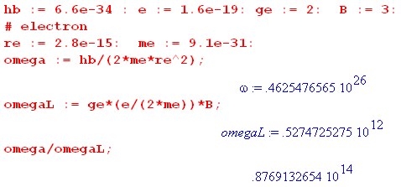

So this toy calculation suggests that ω ~ 1014 ωL , "justifying" our assumption made earlier that we could ignore = ωL relative to ω in computing ω. The numbers for a proton are

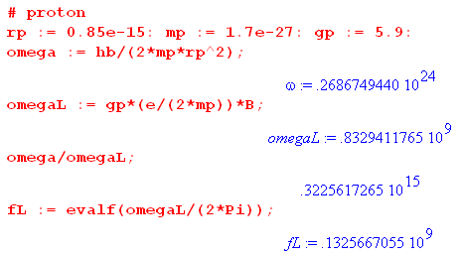

so in this case ω ~ 1014 ωL as well. The last line shows that in a 3 Tesla MRI machine, the nominal Larmor frequency is around 132 MHz. Earlier machines were 1.5T and 66 MHz.

In the quantum picture there is no classical μ vector for a proton magnetic moment doing conical motion as in Fig (I.11.7). Instead, there is a 2-component state vector |ψ(t)> which evolves in time. The analog of μ is the "expectation value" of a magnetic moment "operator" μ in state |ψ(t)>, μ(t) = <ψ(t)| μ |ψ(t)>. This concept is refined using a tool called the density matrix to account for the statistics of a large number of particles which have thermal motion. The resulting quantity of interest is called the magnetization M(t).

MRI Machines (Magnetic Resonance Imaging)

For MRI the spinning particles of interest are protons which are the nuclei of hydrogen atoms which permeate the human body, mostly in the form of water. The proton spins (and thus magnetic moments) naturally tend to align with the large B = B field of an MRI machine's superconducting magnet, causing M(t) to point statically in the direction. An RF pulse having a By field component is then applied, which causes M(t) to precess about . If the RF pulse is applied for 1/4 of the y-direction Larmor period, M(t) moves from to and then precesses in the x-y plane around the huge static B field at the z-direction Larmor rate. M(t) then spirals around ending up after some long time T1 back in the direction due to "friction" effects. But before this can happen, the many protons in a sample "dephase" in time T2 due to small local variations in B, killing off the transverse M(t) signal. The time for this to happen depends on physical characteristics of the sample being scanned (fat, bone, water) and this is one tool that is used to get "contrast" at different points in an MRI image. Injected Gadolinium "dye" affects T2, thus affecting the contrast. The main contrast effect is that the B field actually seen by a proton is reduced by that proton's environment, causing a "chemical shift" in the Larmor frequency for that sample point.
The precessing M(t) radiates an RF signal that is received by the MRI machine's receiver coil and is analyzed and stored. The method by which an image is constructed is extremely clever and is beyond the scope of our discussion here, but we can give a crude outline. Here is one type of "pulse sequence" called spin-echo :

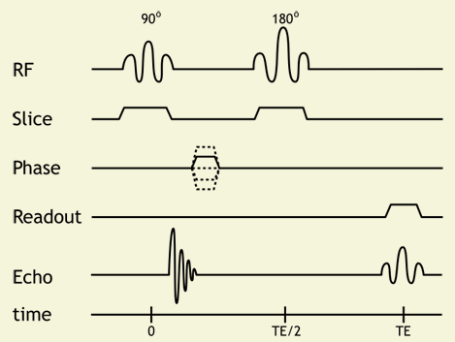

http://xrayphysics.com/sequences.html

The initial 900 By RF pulse moves M(t) from to the direction, but M(t) quickly dephases and the signal on the Echo line quickly fades away, perhaps before the MRI hardware can be ready to receive the signal. But after time TE/2 a double-length By RF pulse is applied (1/2 the y-Larmor period) which in effect causes all the dephasing to run backwards so that at time TE, the M(t) is momentarily restored (this is the echo), during which time it is "read" by the receiver. All this happens in a time smaller than T1 during which M(t) naturally fades away.
Here is a simple animation of spin-echo: https://www.youtube.com/watch?v=yKmEbCPV4Cg .
The other plots in the graph relate to spatial localization of the signal. During applied RF pulses, a Bz gradient magnet is turned on, causing the RF pulses to activate only a slice of the sample. By tuning this frequency, any axial slice (think head to feet) can be selectively activated because the Larmor frequency only of protons in that slice resonates with the applied RF pulse. So M(t) tips down from to only in that slice. The static M(t) in the direction in all other slices makes no signal. That is the meaning of the trace labeled Slice in the above waveform.
In order to create an image in the x direction of the activated z slice, a Bx field gradient magnet is turned on while the signal is read by the receiver. This causes protons at different values of x to radiate at different frequencies, and the signal is then Fourier-analyzed to get an amplitude for each location x (perhaps there are 256 frequency bins so the x-resolution of the image is 256 pixels). This is the meaning of the trace labeled Readout.
Localization in the final y direction is then done by running the above sequence perhaps 256 times each with a different amplitude (or length) By field gradient pulse on the Phase trace. For each run, the phase of the received signal is compared to some fixed reference, and the signal is then partitioned into phase bins which can be Fourier inverted to provide signals at 256 different y positions. The frequency and phase data comprises a data array in "K-space" and when this data is run through a 2D fast Fourier transform, out pops the x-y image for that z slice. The entire process is then repeated for different z slices spaced a few mm apart.
Each time a gradient magnet is switched on or off in the presence of the huge constant superconducting-magnet B field, there is a large force on the gradient coil causing it to "bang" loudly against its housing. The period of the repeated RF pulse sequences is on the order of some milliseconds, causing the characteristic cacophony the patient hears while in the machine.
Levitt's book gives an excellent and systematic explanation of how NMR (nuclear magnetic resonance) works. It is a large and fascinating subject, and there are many web resources available.

******************************** end *********************************

Old stuff showing problems I had when I did not clear up the italic φ problem.

Although we already know L from ***, we shall compute it from ** which says

L = Iω

Since we have never computed an inertia tensor in the non-rotating frame (in which it is diagonal), we shall demonstrate that task here and we expect Iij to be non-diagonal.

ω = (0,0,)

which also seems reasonable.

As for L, I can use this result

L = 2mr2 ( – sinθ )

which is extremely simple, but if you blow out the unit vectors it becomes

L = 2mr2 ( [-sinφ + cosφ ]
– sinθ [ cosθcosφ + cosθsinφ - sinθ ])

= 2mr2 { [-sinφ – sinθ cosθcosφ ] + [cosφ - sinθcosθsinφ ] + [ sin2θ ] }

But when I compute this as L = Iω in Maple I get 2mr2 times this column vector,

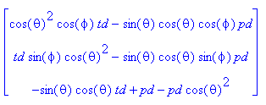

The terms all agree, but the terms all disagree! So something is wrong here. For example, the first component has

me = -sinφ

Maple = cos2θ cosφ

Therefore, one of these things is wrong;

(1) the inertia tensor is computed wrong
(2) ω as stated is wrong (most likely to be wrong I think)
(3) L as stated is wrong
(4) L = Iω is wrong

Suppose = 0. then we have

L = 2mr2 = 2mr2 [-sinφ + cosφ ]

ω = (cosφ, sinφ, 0)

Maple gives

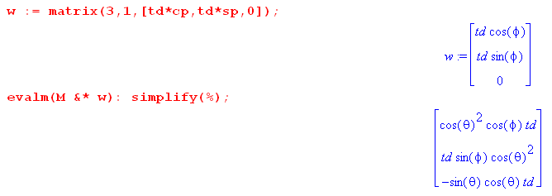

Maple says that L = Iω has a Lz component. But above Lz = mr2sin2θ , so if = 0 should have Lz= 0 as the (F.2.2) predicts, but L = Iω is saying the wrong thing.

Repeat super simple example.

Dumbbell is rotating in the xz plane perp to y which means φ = 0. Then = 0. In this case one has

ω = (cosφ, sinφ, ) = (, 0, 0)

But that seems wrong, we are rotating about the y axis. This is a disaster!!

The prediction of the F.2.2 L formula says

L = 2mr2 [-sinφ + cosφ ] = 2mr2 huh???

This should be about the x axis, not

BIG PROBLEM

In the Euler picture (H.1.5), suppose φ = 0. In this case, the unit vector Goldstein would call would have no x component. It would be in the y-z plane.

In my Appendix E, if φ = 0, then what I call lies in the xz plane and has no y component.

This is a huge disaster. That is why the above ω thing is coming out wrong.

I really have to do it MY WAY because my entire universe of spherical coordinates is based that way.
I think the repair has to be this:

φGold = φme + π/2

Question for Study: How do Goldstein's Euler angles he calls φ,θ,ψ relate to my spherical coordinate angles I call θ,φ ??

