Does an electric dipole in a uniform E field precess? Version 1 PhL 3.24.17

Basically no web hits on this subject, lots on mag dipole in B field.

Statement of Problem: You have a dumbbell of two charges q and -q, each of mass m, connected by a rigid stick. There is a uniform external field E in the z direction. Find equations of motion for the dumbbell.

Note that the total force on the system is 0, so the CMS does not move, so we take the CMS as the origin of Frame S.

1. Use spherical coordinates to set things up, similar to the dumbbell satellite in its Frame S.

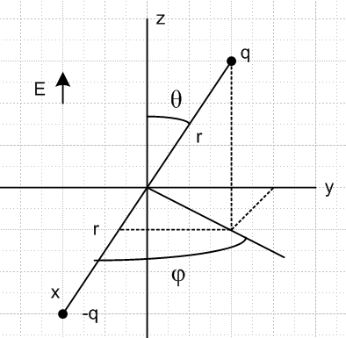

Upper right is 1, lower left is 2. Then φ

F1 = qE = qE

F2 = (-q)E = -qE = - F1 r2 = - r1

N1 = r1x F1 = [r] x [ qE] = rqE x = rqE [ -sinθ ] = -rqEsinθ

N2 = r2x F2 = (-r1)x (-F1) = N1

We have a massless stick connecting the charges. The total torque on this dumbbell is (about origin)

N = N1+ N2 = 2N1 = -2rqEsinθ

Right hand shows that this torque is trying to align the dipole. Good.

Now define the dipole moment p as

p ≡ 2rq p ≡ 2rq

Then

N = 2rqE x = [ 2rq ] x [E ] = p x E

which is our first major result! You can imagine increasing q and decreasing r in a way that the product is constant, then you could have p very close to the origin.

So we know that there is a torque on a dipole in an electric field given by N = p x E . This will be true in general, not just for the above picture.

2. Now we add into the above situation some "mechanics" by giving each charge a mass m. What is the angular momentum of the dumbbell?

L1 = r1x mv1

We know that v1 is constrained to a sphere, so we know that

v1 = vθ + vφ = -v2

Then we have

L1 = r1x mv1 = m [r]x [vθ + vφ ]

= mr( vθ - vφ)

L2 = r2x mv2 = (-r1)x (-mv1) = L1

Then the dumbbell has total L of

L = L1 + L2 = 2L1 = 2mr( vθ - vφ) // agrees with below (F.2.1)

Note added: What is L2 ?

L2 = (2mr)2(vθ2 +vφ2) = (2mr)2 ( [r ]2 + [ r sinθ]2)

= (2mr2)2 ( 2 + sin2θ )2 .

Now back up and just write

L = 2r1x mv1

Then we know that

= 2rx m = 2rx ma = 2mr x a

and we read off for our constrained case,

a = ar + aθ + aφ // acceleration
ar = - r2 – r 2 sin2θ
aθ = r - r 2 sinθ cosθ
aφ = 2 r cosθ + rsinθ . (E.3.6)

Now do the cross product :

x a = x [ar + aθ + aφ ] = aθ - aφ

So then we have

= 2mr( aθ - aφ ) // agrees with above (F.2.2)

Now comes Newton's Law in our inertial Frame S

N =

and here then is our dipole dumbbell equation of motion

-2rqEsinθ = 2mr( aθ - aφ ) ok

The first thing we learn is

aφ = 0 ⇒ 2 r cosθ + rsinθ = 0 ok // (E.3.6)

so the particle 1 is not accelerating in the azimuthal direction (consistent with uniform precession! ) And then we have

-2rqEsinθ = 2mr aθ

-qEsinθ = maθ = m [ r - r 2 sinθ cosθ]

So we arrive then at these two equations of motion

2 r cosθ + rsinθ = 0

-qEsinθ = m [ r - r 2 sinθ cosθ]

or

2 cosθ + sinθ = 0

-(qE/mr)sinθ = - 2 sinθ cosθ]

somewhat similar to the fact that the mass dumbbell had two equations of motion. This suggests generally complicated solution motions. Rewrite

- 2 sinθ cosθ + (qE/mr)sinθ = 0
+ 2 cotθ = 0

Suppose I were to turn off the E field, so then no torque, so should have a trivial solution. Get

- 2 sinθ cosθ = 0
sinθ + 2 cosθ = 0 E = 0

What solution do I expect? The dumbell just swings around in some plane. Suppose I assume that φ = 0 so in that plane. Then get

= 0
0 = 0

and just says θ = At, so that would be circular motion in the plane φ = 0.

Suppose instead θ = π/2. Then

2 sinθ cosθ = 0
sinθ = 0

These both say = 0 so φ = At and just goes around in THAT circle.

It would take me some work to figure out for a general plane. consider motion where the cross section of the circle is the -q to q line segment in the above figure. How do you characterize that plane? Well there is no single such plane. I am thinking a plane though origin and the two particles, but that only specifies a line and there would be lots of planes, so let's forget this. In sphericals, the equation of an arbitrary circle is complicated.

Go back now to the general result with E on:

- 2 sinθ cosθ + (qE/mr)sinθ = 0
+ 2 cotθ = 0

I now seek a precession solution where θ = constant. Then we need to have

- 2 sinθ cosθ + (qE/mr)sinθ = 0
= 0

The first equation says

-2 cosθ + (qE/mr)= 0

2 = (qE/mrcosθ)

So there is your precession solution! For any θ you specify, there is a solution. For θ = 0 you get

2 = (qE/mr)

and it just spins around on the z axis. That seems weird. What makes it spin? Start over:

- 2 sinθ cosθ + (qE/mr)sinθ = 0
sinθ + 2 cosθ = 0

Set θ ≡ 0 and look for a solution

0 - 0 + 0 = 0
0 + 0 = 0

So I guess this says a static θ = 0 is in fact a solution.

Now try a static θ = θ0

- 2 cosθ0 + (qE/mr) = 0 ⇒ 2 = (qE/mrcosθ0)
sinθ0 = 0 ⇒ = constant

= $\sqrt{qE/(mrcosθ0)}$ p ≡ 2rq

φ(t) = $\sqrt{qE/(mrcosθ0)}$t + φ0

If you try for θ0 = π/2, it has to spin infinitely fast to not deviate??? If it spun slowly, the torque would affect it.

So I think I have shown that there is a precession solution.

Dimension check

2 = (qE/mrcosθ) RHS = force/ML = MLT-2 /ML = T-2 correct

Express the result in terms of p:

2 = (qE/mrcosθ) p ≡ 2rq q = p/2r

2 = (pE/2mr2cosθ)

so it still depends on r. But recall that

L2 = (2mr2)2 ( 2 + sin2θ 2) .

so in our simple case we get

L2 = (2mr2)2 sin2θ 2
so
L = (2mr2) sinθ // if > 0

This L would be a constant of this precession motion.

What does L do in this precession case?

L = 2mr( vθ - vφ) = 2mr( [r ] - [ r sinθ])

= - 2mr2 sinθ

Now that seems a weird direction for , but looking at r x p that is correct. This direction is moving, so we are not zero torque. So this L is going on a cone! What do we know about this cone?

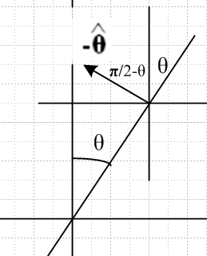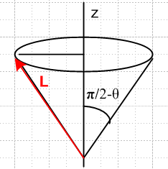

So since

L = 2mr2 sinθ0 (-)

I conclude that L moves on a cone whose half angle is π/2-θ, shown on the right above. I can compute then that

Lz = L• = 2mr2 sinθ0 (-)• = 2mr2 sinθ0 (sinθ0) = 2mr2 sin2θ0

Lx = L• = 2mr2 sinθ0 (-)• = - 2mr2 sinθ0 (cosθcosφ ) =

Ly = L• = 2mr2 sinθ0 (-)• = - 2mr2 sinθ0 (cosθsinφ ) =

Lρ = 2mr2 sinθcosθ = mr2 sin(2θ)

So the dimensions on the cone are these

height = Lz = 2mr2 sin2θ

radius = Lρ = mr2 sin(2θ)

I also know that

L2 = [2mr2 sinθ0]2 =(2mr2)2 2 sin2θ0

L = 2mr2sinθ

So this is new to me really.

What do I know about ω ? What is the definition of ω ? You would think that would be a simple question for someone who just wrote 402 pages on frames of reference! See page 366 of Marion. If I think of Frame S' as embedded in the rotating sticks, then ω is how Frame S' moves relative to Frame S. The Frame S' axes e'n are rotating about the z axis. So ω must be along z. This is what Marion claims on page 366. So let's try that

ω = ω

Then what happens to L = Iω? Consider time instant where position as shown in my first picture above. Then we have a mass at distance rsinθ from the rotation axis, so I = mr2sin2θ . But what is the inertia tensor? For the upper mass, it is at location

x = rsinθcosφ
y = rsinθsinφ
z = rcosθ

Then

Iij ≡ Σαmα [ rα2δij - (rα)i(rα)j ]

I11 = m(r2- x2) = m(r2- r2sin2θcos2φ) = mr2(1- sin2θcos2φ)

I22 = mr2(1- sin2θsin2φ)

I33 = mr2(1- cos2θ)

I12 = m(-xy) = - m( rsinθcosφ rsinθsinφ ) = -mr2sin2θ cosφsinφ

I13 = m(-xz) = - m( rsinθcosφ rcosθ ) = -mr2sinθcosθcosφ

I23 = m(-yz) = -mr2sinθcosθsinφ

Wow. So then we have (for one of the two particles)

I = mr2$\left(\begin{matrix}1- sin2θcos2φ & -sin2θ cosφsinφ & -sinθcosθcosφ \\ -sin2θ cosφsinφ & 1- sin2θsin2φ & -sinθcosθsinφ \\ -sinθcosθcosφ & -sinθcosθsinφ & 1- cos2θ\end{matrix}\right)$

For particle #2, located at the mirror image point, we know x,y,z→-x,-y,-z so Iij for that particle is the same as for particle 1. Then

I = 2mr2$\left(\begin{matrix}1- sin2θcos2φ & -sin2θ cosφsinφ & -sinθcosθcosφ \\ -sin2θ cosφsinφ & 1- sin2θsin2φ & -sinθcosθsinφ \\ -sinθcosθcosφ & -sinθcosθsinφ & 1- cos2θ\end{matrix}\right)$

So let's then try to compute L from L = Iω :

L = 2mr2ω$\left(\begin{matrix}1- sin2θcos2φ & -sin2θ cosφsinφ & -sinθcosθcosφ \\ -sin2θ cosφsinφ & 1- sin2θsin2φ & -sinθcosθsinφ \\ -sinθcosθcosφ & -sinθcosθsinφ & 1- cos2θ\end{matrix}\right)$ $\left(\begin{matrix}0 \\ 0 \\ 1\end{matrix}\right)$

= 2mr2ω $\left(\begin{matrix}- sinθcosθcosφ \\ - sinθcosθsinφ \\ sin2θ\end{matrix}\right)$

Now I think ω = . So here is the first thing to check:

L2 = (2mr2)22 [ (sinθcosθcosφ)2 + (sinθcosθsinφ)2 + (sin2θ)2 ]

= (2mr2)22[ sin2θcos2θ + (sin2θ)2]

= (2mr2)22 sin2θ [cos2θ +sin2θ]

= (2mr2)22 sin2θ

Earlier I got

L2 = [2mr2 sinθ0]2 =(2mr2)2 2 sin2θ0

so this works!!! Now having done this check, write out in more detail

L = 2mr2ω[ - sinθcosθcosφ - sinθcosθsinφ + sin2θ ]

= 2mr2ωsinθ [ - cosθcosφ - cosθsinφ + sinθ ]

= - 2mr2ωsinθ [ cosθcosφ + cosθsinφ - sinθ ]

Now quote from App E

= cosθcosφ + cosθsinφ - sinθ (E.2.6)

Therefore

L = - 2mr2ωsinθ

and above I got

L = 2mr2 sinθ0 (-)

So I have verified that L = Iω actually works in this sample problem. Constant checking!!

Meanwhile, here is more about the L cone

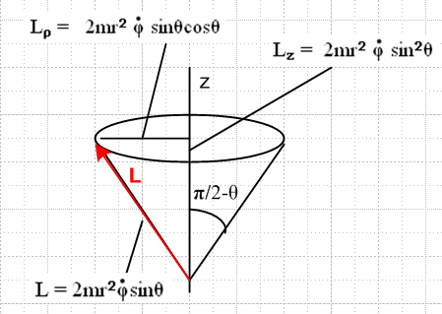

The precession motion of L is then

Lx = 2mr2sinθ cosθ sin(t) 2 = (qE/mrcosθ)
Ly = 2mr2sinθ cosθ cos(t)
Lx = 2mr2sinθ sinθ sin(t)

Verify the cone half-angle

sin(π/2-θ) = Lρ/L = 2mr2 sinθcosθ / 2mr2sinθ = cosθ // yes!

So this is a very strange problem. The figure axis is on a different cone of angle θ.

Here is one conclusion

= ω = $\sqrt{qE/mrcosθ}$

Note that for this problem we have

L = 2mr2 sinθ0 (-)

p = 2qr = dipole moment.

Note that L and p are NOT in the same direction.

What is the corresponding magnetic problem?

The force is different in nature going from E to B. And there are no magnetic monopoles to put on the end of a stick. So I guess I have to put a bar magnet of some sort. It really seems to be a totally different problem. What exactly is the problem?

We know from Bleaneys that

N = μ x B

where μ is the magnetic moment of the dipole I guess made of two magnetic monopoles, but probably you could make a real magnet with a thin waist to do this?? The thing would precess like so

2 = (μB/2mr2cosθ)

L = (2mr2) sinθ

But here is what we learn on the web

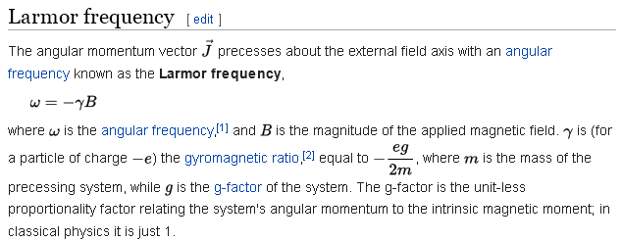

They are saying that

ω = (q/2m)B

But my model above is giving

ω = $\sqrt{qE/mrcosθ}$

These results are not even close!!! How do you explain that ???

Site also says

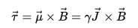

suggesting that

μ = γ J

Magnetic Model Start Over

OK, we have a sphere of mass m and Frame S and Frame S' have their origins at the sphere center. The sphere has a magnetic moment μ fixed to itself, it is a little round magnet at the origin. It is like the Earth hanging in space. Without a B field this sphere would do torque-free precession as it rotates, as the Earth does. Is that possible with all inertia moments the same? [ but if round, no precession ]

Look at the Section I.6 solution if a sphere. What happens in this case?

1. Ω' ≡ (ω)'3 (I'3-I'1)/I'1 = 0. So here is what ω does in Frame S'

(ω)'1 = ωsinα Ω' = ωcosα (I'3-I'1)/I'1 = 0
(ω)'2 = 0
(ω)'3 = ωcosα . α = cone half-angle, 0 ≤ α ≤ π (I.6.7)

It just sits in one spot. Next,

(L)'1 = I'1ωsinα
(L)'2 = 0
(L)'3 = I'1ωcosα . (I.6.8)

Obviously we have L = I'1ω.

It just sits there too (of course). You can see that L2 = I'12ω2 here and 2T = I'1ω2. Euler angles do this

θ = tan-1[ (I'1/I'3) tanα ] = α // θ(t) = constant
ψ(t) = π/2 = 0
φ(t) = (L/I'1)t = L/I'1 .

I guess this means that it does not spin on its axis, but it does still precess. Is that possible?? What happens in Frame S components?

ω1 = ω sin(θ-α) cos[(L/I'1)t ]
ω2 = ω sin(θ-α) sin[(L/I'1)t ]
ω3 = ω cos(θ-α) . (I.6.29)

What is this sphere doing? Look at Fig (I.6.30). Since θ-α = 0, both ω and L are straight up.

Question: If you slowly take I'3 → I'1, what happens in (I.6.30)?

1. The ω cone narrows and approaches nothing, just ω vertical. [yes]

2. θ → α. and Ω'→ 0, so no rotation in the body frame. The ω vector does not move on the body cone, so you get a version of (I.6.30) where ω and L are aligned vertically, you can draw the body cone but it does nothing, ω just points up. The sphere just sits there and spins about the vertical axis.

Fact: a perfectly round sphere does not have any torque-free precession, it just sits and spins in some direction, as you would expect.

SO, I don't have to worry about such precession in my little spherical magnet deal.

Go back to dipole problem again.

Suppose you have a little sphere of mass M with a dipole moment p that is fixed. I think this is a different problem than my original electric dipole problem above. How are things different? Now the torque acts on a sphere, not on a dumbbell. I could integrate over differential dumbbells I suppose. But suppose we just say that N = p x E and that torque acts on the sphere of mass M. I think we get similar result,

N = -pEsinθ

if p is mounted in my picture of the dumbbell. Equations of motion (I.4.3) seem pretty simple now

(N)'1 = I'1 ()'1
(N)'2 = I'2 ()'2
(N)'3 = I'3 ()'3

But inertia is diagonal right in Frame S, so why not just write

N1 = I1 1
N2 = I1 2
N3 = I1 3 ⇒ N = I1 I1 = (2/5)MR2 I think. (yes, wiki)

Then equation of motion is this

p x E = I1

or
-pEsinθ = I1 [ note that θ and describe vector r, the spin axis ]

That seems to say that

= -(pEsinθ/I1)

I think this alone means conical motion, but let's get it into Cartesian: [ be careful! ]

= -sinφ + cosφ

So then have

= -(pEsinθ/I1) [ -sinφ + cosφ ] = dω/dt

Write

ω = ωx + ωy

= x + y

Then have

x + y = -(pEsinθ/I1) [ -sinφ + cosφ ]

from which conclude that

x = (pEsinθ/I1)sinφ
y = -(pEsinθ/I1)cosφ
z = 0

This does say that

x = (pEsinθ/I1)cosφ = -y [ how do you know θ.φ are constants? ]
y = (pEsinθ/I1)sinφ = x

Why am I having so much trouble integrating a trivial equation? The problem is that I don't really know what the symbol ω means. For Euler angles I know that

ω1 = sinθcosφ - sinφ
ω2 = sinθsinφ + cosφ
ω3 = cosθ + . // Frame S (H.6.18)

I think in this problem that = 0 so we then have

(ω)x = sinφ = 0
(ω)y = cosφ = 0 θ = constant ansatz
(ω)z = (H.4.12)

So maybe I can combine that with

So I end up with nothing but ω = ω and then contradiction:

x = (pEsinθ/I1)sinφ
y = -(pEsinθ/I1)cosφ

but
(ω)x = 0
(ω)y = 0

Back up and leave in there to get

(ω)x = sinθsinφ =
(ω)y = - sinθcosφ
(ω)z = + cosθ . (H.4.12)\

I am flailing away here!!! Go back to

= -(pEsinθ/I1)

x = (pEsinθ/I1)sinφ
y = -(pEsinθ/I1)cosφ

Just assume the φ = αt and see what happens

x = (pEsinθ/I1)sin(αt)
y = -(pEsinθ/I1)cos(αt)

ωx = - (pEsinθ/I1)(1/α) cos(αt)
ωy = - (pEsinθ/I1)(1/α) sin(αt)
ωz = ωz = some constant.
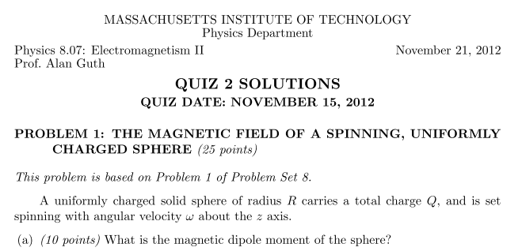

And here is the answer:

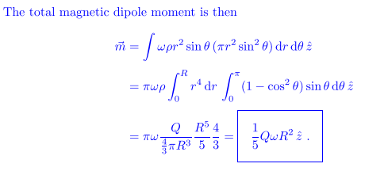

So if you model an electron in this manner, you get

μ = (1/5) q ω R2

I have shown on the board that the precession rate is

= -μB/I1 = - B[ (1/5)QωR2]/[ (2/5)mR2 ] = - (1/2)(Q/m) B

Wiki is saying that

= -γB where γ = gyromagratio = -(Q/2m)g = -(Q/2m)

where g = 1 for classical calculation. So I think I am finally onto it!

Pieces are slowly assembling now.

[ I don't think anything below is right, start over on this problem! ]

Sub problem: Suppose you are told that

= K [ be careful !!! ]

How do you solve this equation for ω ? This was puzzling me for quite a while, but now I know how to do it.

First, you think about spherical coordinates in ω-space. The radius vector usually called r is ω. Then

ω = ω [ but this assumes that ω points in the r direction! ]

= + ω∂t = + ω ( + sinθ )

So now you just equate

= K = + ω ( + sinθ )

and you conclude that

= 0 = 0 K = ωsinθ

So the length of the ω vector does not change, it sits at a fixed polar angle, and it rotates at

= K/(ωsinθ).

This is "cone motion". Now in the case above I have

= -(pEsinθ/I1) so K = -(pEsinθ/I1)

The solution is then conical motion with

= K/(ωsinθ) = -(pEsinθ/I1) / (ωsinθ) = -(pE/ωI1)

Now for a sphere we know that I1 = (2/5)mR2 so you end up with your dipoled sphere doing

= -pE/ [ ω(2/5)mR2 ] = -(5/2)pE/(ωmR2)

The precession rate is proportional to E. Units are Q L F/Q / (ML2) = F/(ML) = MLT-2/ ML = T-2

NOW, for a magnetic dipole you would since torque is μ x B instead of p x E you get

= -(5/2)μB/(ωmR2)

It is easy to show that if you have a uniform sphere of rotating charge you have

μ = (1/5)ωQR2

You then get

= -(5/2)[(1/5)ωQR2]B/(ωmR2) = - (1/2) QB/m = - (Q/2m) B

and I think this is the Larmor situation for classical charged particles. This is a famous result and I have finally gotten it right. Recall from above.

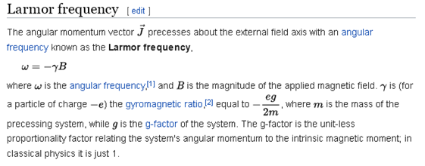

We also know that

L = I1ω = (2/5)mR2 ω

so L goes around the cone with ω . The seems to be independent of θ, so it precesses at this rate no matter what initial θ you give it.

So now in this writeup I have solved three different problems, two being very close.

