Rotate Williams picture so orbit in x'y' plane PhL 4.1.17

Here I define Frame S' in which the orbit normal points in the ' direction. This is the right thing to do to make the connection to the work of GPS. I am able to produce many equations relating θ,φ,θ',φ' two of which seem especially useful. At the end I show how to relate θ' and φ' to GPS angles θ and η. I quote the two key equations in frames doc without deriving them, the derivations are below.

Problem for the Day: How do I take my Williams x,y,z orbiting planet picture and convert it to a picture in x',y',z' where the orbit then lies in the x', y' plane?

Comment: This sounds like a trivial problem for the Rotation Grand Master, but after 8 hours of fiddling I have been unable to carry out the task, hence this new document focused only on this task.

Here is my Williams picture of interest,

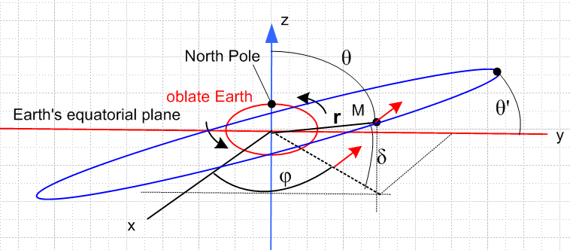 (1)

I want to define a new coordinate system x',y,'z' where the blue orbit lies in the x'y' plane, hence,

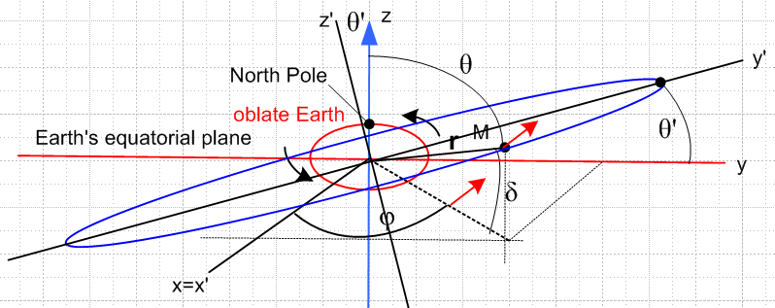 (2)

Clarification of the Figure (1).

• I assume the blue orbit is circular at least for now.
• I assume that when the planet M is at the "highest point" on its orbit, the declination δ reaches a maximum value of θ'. This is the "inclination" of the blue orbit relative to the Earth eq plane.
• I assume that this occurs at a point on the blue orbit which lies above the y axis as picture suggests
• In Fig (2) the z axis lies in the plane of paper,

Approach Plan A

It seems very clear looking at the above pictures that.

' = Rx(θ') = $\left(\begin{matrix}1 & 0 & 0 \\ 0 & cosθ' & -sinθ' \\ 0 & sinθ' & cosθ'\end{matrix}\right)$$\left(\begin{matrix}0 \\ 0 \\ 1\end{matrix}\right)$ = $\left(\begin{matrix}0 \\ -sinθ' \\ cosθ'\end{matrix}\right)$ = - sinθ' + cosθ'
' = Rx(θ') =
' = Rx(θ') = $\left(\begin{matrix}1 & 0 & 0 \\ 0 & cosθ' & -sinθ' \\ 0 & sinθ' & cosθ'\end{matrix}\right)$$\left(\begin{matrix}0 \\ 1 \\ 0\end{matrix}\right)$ = $\left(\begin{matrix}0 \\ cosθ' \\ sinθ'\end{matrix}\right)$ = cosθ' + sinθ' (3)

which I can represent this way

e'i = R-1 ei R-1 = Rx(θ') (4)

Now use this passive transformation form (1.3.3),

(r)' = R r = Rx(-θ')r (5)

Then the coordinates of vector r in Frame S' is

$\left(\begin{matrix}x' \\ y' \\ z'\end{matrix}\right)$ = $\left(\begin{matrix}1 & 0 & 0 \\ 0 & cosθ' & sinθ' \\ 0 & -sinθ' & cosθ'\end{matrix}\right)$$\left(\begin{matrix}x \\ y \\ z\end{matrix}\right)$ (6)
or
x' = x
y' = cosθ' y + sinθ' z
z' = - sinθ' y + cosθ' z (7)

Now in Frame S we had spherical coordinates for vector r as follows,

x = rsinθ cosφ
y = rsinθ sinφ
z = rcosθ (8)

Thus we can write

x' = rsinθ cosφ
y' = cosθ' rsinθ sinφ + sinθ' rcosθ
z' = - sinθ' rsinθ sinφ + cosθ' rcosθ (9)

Now why have I done this, of what use is it? I wanted to get z' = 0, but instead I get some strange expression which seems then to say this

- sinθ' rsinθ sinφ + cosθ' rcosθ = 0

sinθ' rsinθ sinφ = cosθ' rcosθ

tanθ sinφ = cotθ' (10)

Suppose φ = π/2, then we get tanθ = cotθ' . I expect to have θ+θ' = π/2. Is this borne out?

cotθ' = cot(π/2-θ) = tanθ yes!!! Something has finally worked, first time today!

Conclusion: It seems that points on the Fig 1 orbit must have θ and φ related by

tanθ sinφ = cotθ'

Target Goal: I would like to learn something about φ', the azimuth of point r on the orbit in Fig 2. If the orbit is a circle, I should have

r' = (x',y',0) = (rcosφ', rsinφ',0) (11)

if the azimuth starts at the x = x' axis. If I combine this with (9) I get two more equations

rcosφ' = x' = rsinθ cosφ

rsinφ' = y' = cosθ' rsinθ sinφ + sinθ' rcosθ (12)

STOP. Let's try going in the other direction like this:

$\left(\begin{matrix}x \\ y \\ z\end{matrix}\right)$ = $\left(\begin{matrix}1 & 0 & 0 \\ 0 & cosθ' & -sinθ' \\ 0 & sinθ' & cosθ'\end{matrix}\right)$$\left(\begin{matrix}x' \\ y' \\ z'\end{matrix}\right)$
or
x = x'
y = cosθ' y' - sinθ' z'
z = sinθ' y' + cosθ' z' (13)

Now assume as above that

r' = (x',y',0) = (rcosφ', rsinφ',0)

I then find,

x = rcosφ'
y = cosθ' rsinφ'
z = sinθ' rsinφ' (14)

Now for point in Fig 1 on the orbit, I can surely describe that point by

x = rsinθ cosφ
y = rsinθ sinφ
z = rcosθ (15)

I then get these three equations which seem to relate the two sets of spherical angles

cosφ' = sinθ cosφ

cosθ' sinφ' = sinθ sinφ

sinθ' sinφ' = cosθ (16)

Are these three equations "reasonable" or are they junk?

Test #1: At φ = π/2 they say (17)

cosφ' = 0 reasonable since expect that φ' = π/2 as well

cosθ' sinφ' = sinθ says cosθ' = sinθ: cos(π/2-θ) = sinθ check!

sinθ' sinφ' = cosθ says sinθ' = cosθ: sin(π/2-θ) = cos(θ) check!

Test #2: At φ = 0 they say (18)

cosφ' = sinθ reasonable since expect φ'= 0 so 1 = sin(θ) θ = π/2 check!

cosθ' sinφ' = 0 says 0 = 0 check

sinθ' sinφ' = cosθ says 0 = cos(π/2) = 0, check

What can I do with my three equations which at least work at the two test points?

cosφ' = sinθ cosφ

cosθ' sinφ' = sinθ sinφ

sinθ' sinφ' = cosθ (16)

Ratio of 2/1 says

cosθ' tanφ' = tanφ // important result #1
So given θ' as a fixed angle (orbit inclination you have

tanφ = cosθ' tanφ' (19a)

and this confirms that φ' = 0 ⇒ φ = 0 and that φ' = π/2 ⇒ φ = π/2. Write again

tanφ' = (1/cosθ') tanφ (19b)

So THIS tells you all about the new in-plane azimuth φ'. It is a function ONLY of φ and the constant inclination θ'

Recall that GPS says

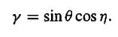

Looking up at (16) this is very close to my third equation which says

cosθ = sinθ' sinφ' // important result #2

Here is a proposed connection between their angles and my angles :

GPS me
γ cosθ // angle which appears in potential P2(γ)

θ θ' // the figure axis tilt-down angle

η φ'- π/2 // then cosη = cos(π/2- φ') = sinφ'
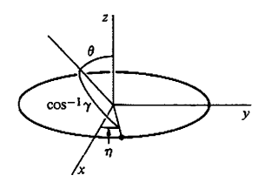

whereas I had the highest point of the orbit over the y axis at φ' = π/2, they have the highest point of their orbit over the x axis at η = 0, which is what I think this picture shows. So φ' = π/2 corresponds to η = 0 which is compatible with η = φ' - π/2 as in my table above!

Conclusion: I have finally explained GPS page 226, Fig 5.13

Why do they do all this work? They want to average their potential over η. THAT is the whole reason for doing this.

