This is the Title PhL 1.11.15

This has been installed into Appendix I. do not edit here.

I.5 Zero-torque motion of a Rigid Body : Ellipsoids and Poinsot

There are various geometric constructions involving ellipsoids that are used to interpret torque-free motion of a rigid body. If the e'i are the principal axes of a rigid body in Frame S', one may write from (I.1.9) and (I.1.4),

2T = ω•I•ω = (I)'i(ω)'i2 ⇒ 1 = $\frac{(ω)'12}{2T/ (I)'1}$ + $\frac{(ω)'22}{2T/ (I)'2}$ + $\frac{(ω)'32}{2T/ (I)'3}$ // T-ellipsoid (inertia)

L2 = Iω • Iω = (I)'i2(ω)'i2 ⇒ 1 = $\frac{(ω)'12}{L2/ (I)'12}$ + $\frac{(ω)'22}{L2/ (I)'22}$ + $\frac{(ω)'32}{L2/ (I)'32}$. // L-ellipsoid (I.5.1)

The T-ellipsoid is historically known as "the inertia ellipsoid". A torque-free isolated system will have fixed values for the rotational kinetic energy T and angular momentum L2 quantities. One can then regard each of the above equations as an axis-aligned ellipsoid centered at the origin of ω-space with axes e'i. The denominators shown are the squares of the three semi-axes of each ellipsoid. Since rigid body problems do have solutions, we know that the ellipsoids must intersect. In general, the intersection of two axis-aligned ellipsoids is a set of two non-planar curves which are mirror images of each other. In the solution of a torque-free rigid body problem the tip of the ω vector must move along one of these curves! One can thus regard such a curve as a closed "orbit" for the ω vector in Frame S'. This is somewhat analogous to finding the orbit r(θ) for the polar coordinate position r of a planet without actually solving for the detailed r(t) and θ(t) of the planet's motion.
Finding the equation of a curve that is the intersection of two ellipsoids is not easy, even when the ellipsoids are axis-aligned, but it is easy to graphically display the curved orbits.
In the Maple code below we enter three different ellipsoids Red, Blue and Green, where the Green one is a sphere. One should think of [x,y,z] as [(ω)'1 ,(ω)'2,(ω)'3] = ω in Frame S' components.

We first plot the Red and Green surfaces:

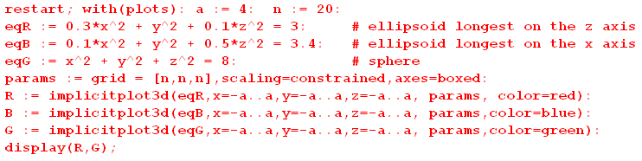

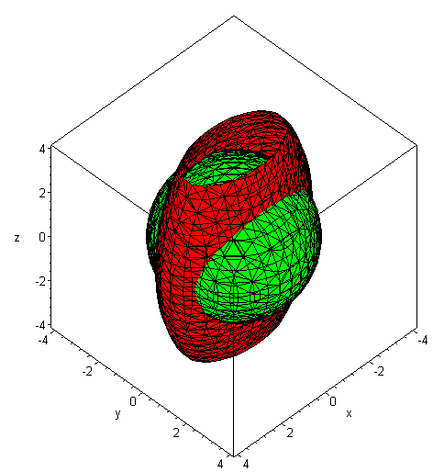 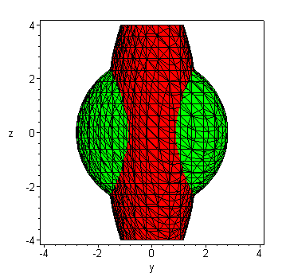 (I.5.2)

One can see that the intersection curves are distinctly warped like a potato chip. Nevertheless, in this example the length of the ω vector is constant on each orbit curve, since one ellipsoid is a sphere.

We now look at the Red and Blue ellipsoids,

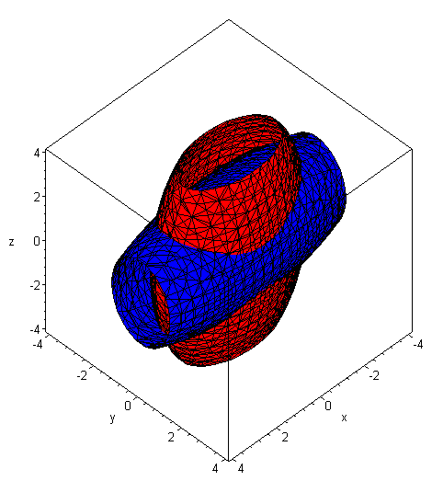 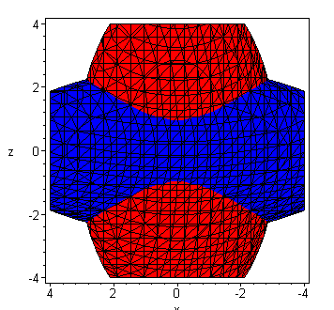 (I.5.3)

Again, the intersection curves are non-planar. We then ask: it is possible the ω has a constant magnitude on these Red/Blue intersection curves? If so, then the curves must also lie on a sphere. We now add the Green sphere into the above picture :

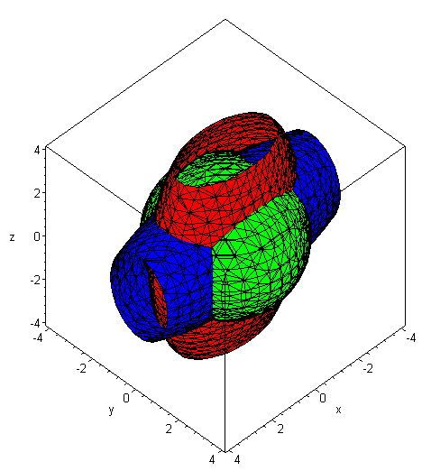 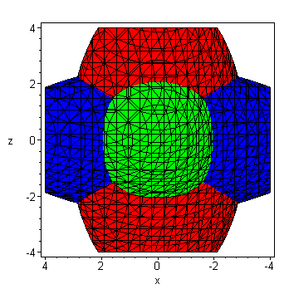 (I.5.4)

Although one knows that the Red/Green intersection curves are warped, one can see that their shape is never going to match the shape of the Red/Blue intersection curves no matter what radius is selected for the Green sphere:

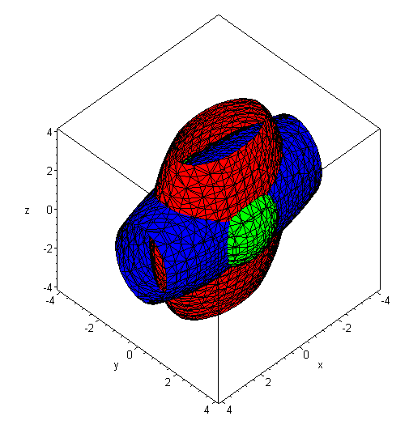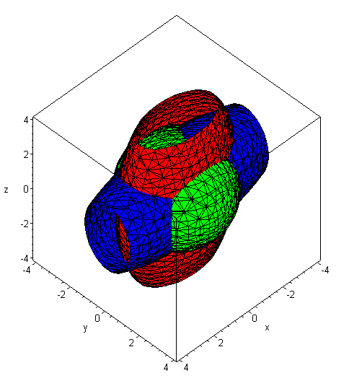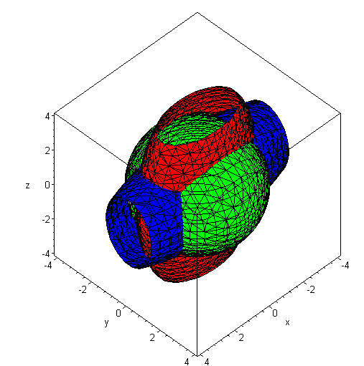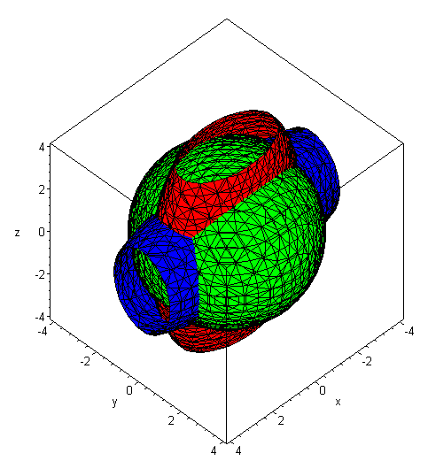

We therefore reach a conclusion that is perhaps obvious:

Fact: When the torque-free equations ** are solved, the orbit of the solution vector ω(t) is such that the magnitude ω is (in general) not constant.

In our final example, suppose the rigid body is axisymmetric so I'1 = I'2. We adjust the example above so that

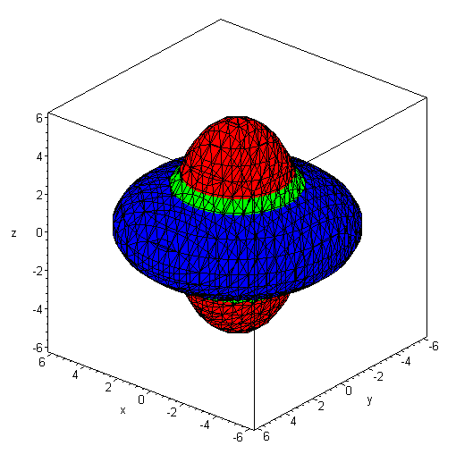 (I.5.5)

Here we selected the green sphere radius so the Green sphere is just visible. It seems clear in this situation that the Red/Blue intersection curves are no longer warped, but are just circles perpendicular to the z axis on which ω moves, this z axis being the (ω)'3 axis. As we shall see below, in this case the ω vector rotates at a uniform rate about one of the circles resulting in uniform-rate precession.

An ellipsoid intersection curve of the type seen in the above examples is called a polhode (a pole path),

polhode: mod. f. Gr. □ pole +  way, path (Poinsot 1852) // OED2

For a given choice if the (I)'i moments, if one keeps T fixed and varies L in (I.5.1), one generates a family of polhode intersection curves on the inertia ellipsoid, as shown here (Arnold and Maunder p 111, moments A,B,C )

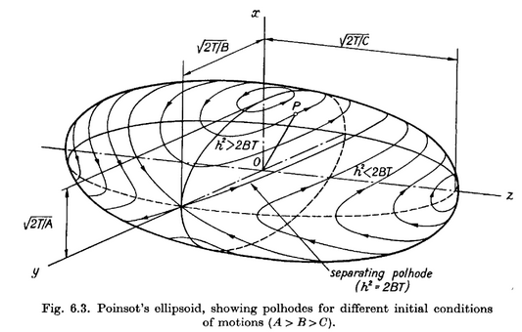 (I.5.6)

Poinsot's ellipsoid is actually drawn in ρ-space where ρ = ω/$\sqrt{2T}$, so it is a scaled version of the inertia ellipsoid where 1 = ρ • I • ρ. The solution vector ω(t) always rides along a polhode, as noted above. The drawing shows that for the largest and smallest inertia axes, the extremal polhodes are circular, suggesting a possible slightly circular motion of a rigid body axis set to rotate close to one of these axes. There are no such circles for the intermediate axis, which is why that axis is unstable against perturbation as was noted above. Any tiny variation away from the exact axis point causes the solution to run off on a large polhode which encircles the ellipsoid.

The conclusion so far is that, for torque-free motion of a rigid body, the ω(t) vector in Frame S' (the body frame) moves on some relatively simple closed polhode path which is in general non-planar.

What does one of these potato-chip warped polhode paths look like when viewed from Frame S?

Perhaps surprisingly, one thing we do know is that in Frame S the path of ω lies in a plane, so the potato chip polhodes are de-warped in their transformation from Frame S' to Frame S.

The reason for this planarity is simple. In Frame S we know that the vector L is fixed in space (since no torque), and one has

• ω = (1/L) L • ω = (1/L) (Iω) • ω = (1/L) ω • I • ω = (1/L)(2T) = 2T/L .

Now in E3 space the equation • r = d describes a plane with normal vector lying distance d from the origin (d is the closest distance from plane to origin). Thus, in ω-space the vector ω always lies on a plane with normal which lies distance 2T/L from the origin. Since this plane is fixed in Frame S, it is called "the invariable plane".
At any time t, the solution ω(t) lies both on the inertia ellipsoid and on the invariable plane, so the inertia ellipsoid viewed in Frame S must be tangent to the invariable plane at any time t. Here is the picture at some time t,

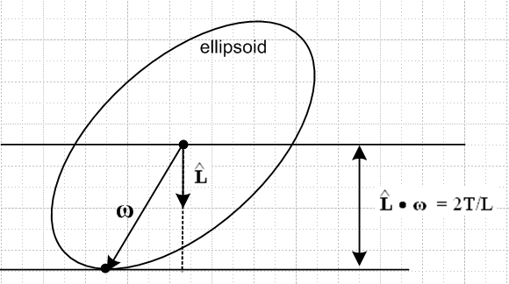 (I.5.7)

If the ellipsoid were an ellipse and if the above were a 2D picture, the ellipse would be unable to roll on the invariable plane, since any such rolling would change the height of the ellipse center above the plane. But in the 3D picture with an ellipsoid, such rolling is possible. If the ellipsoid were axisymmetric, it could roll around a vertical axis, thus inscribing a circle on the invariable plane, and that is all the rolling it could do. That, we shall see, is the solution found in the next section. If the ellipsoid is more general in shape, then the allowed motion of the ellipsoid produces some complicated path going around and around on the invariable plane. This path is called a herpolhode (a snaky pole path) and is generally a path which does not close on itself, but which is confined between two radii in the invariable plane. Here is a sample numerically-generated herpolhode (Arnold and Maunder p 111 )

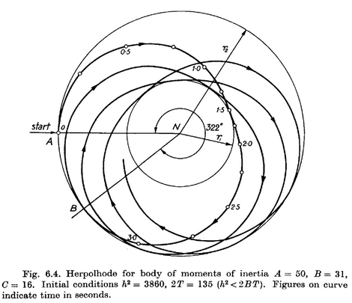 (I.5.8)

If the ellipsoid in Fig ** were covered in ink and if the invariable plane were paper, the rolling ellipsoid would inscribe the herpolhode on the invariable plane. Conversely, if the ellipsoid were paper and the invariable plane were coated with ink, the invariable plane would inscribe on the ellipsoid one of our closed, non-planar polhode paths.
In general, this geometric view of the ω vector motion is called "Poinsot's construction" (Louis Poinsot 1777 –1859). It is briefly described in Goldstein p 159 (GPS p 201).
Here is an excellent ellipsoid animation showing both polhode and herpolhode for a case where the latter is also a closed curve: https://www.youtube.com/watch?v=BwYFT3T5uIw .

*************************

R.N Arnold and L. Maunder, Gyrodynamics and Its Engineering Applications (Academic Press/ Elsevier, Amsterdam, 2014). See Google Books.

V. Zemstov, Evolution of Rotation Structures in the Earth/s Geological History (Intech, 2011).
DOI: 10.5772/21305 , http://www.intechopen.com/download/pdf/17105

