The free precession picture PhL 3.14.17

For a rigid object that is axially symmetric, the symmetry axis is a principal axis and the other two orthonormal principal axes can be selected in any manner to lie in the plane perpendicular to the symmetry axis. For a pancake, this symmetry axis has the largest principal moment, while for a pencil it has the smallest principal moment. The other two principal moments are equal. If e'3 is the symmetry axis, then I'1 = I'2 and the last of equations (G.8.18) reads 0 = I'3()'3 , so (ω)'3 = constant. The other two equations (G.8.18) are then easily solved. Write them out,

()'1 = (ω)'3 (ω)'2(I'1 - I'3)/ I'1 = Ω'(ω)'2 where Ω' ≡ (ω)'3 (I'1-I'3)/I'1
()'2 = - (ω)'3 (ω)'1 (I'1 - I'3)/I'1 = - Ω'(ω)'1 (G.8.18)

Then

()'1 = Ω'()'2 = - Ω'2 '(ω)'1

Selecting an arbitrary time origin, we can write the solution as

(ω)'1 = A sin(Ω't)
(ω)'2 = ()'1 / Ω' = Acos(Ω't) . (G.8.20)

The Frame S ω vector (showing Frame S' components) is thus doing conical motion:

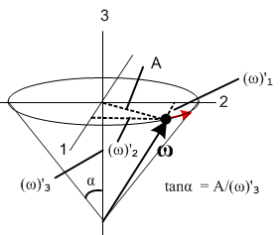

The kinetic energy of this rigid object is (with diagonal I)

T = (1/2) ω • I • ω = (1/2) (ω)'i(I)'ij(ω)'j = (1/2) I'i(ω)'i2

= (1/2)I'1[(ω)'12+ (ω)'22] + (1/2)I'1(ω)'32

= (1/2)I'1 A2 + (1/2)I'1(ω)'32 (G.8.21)

If the rigid body has kinetic energy T, then the precession amplitude is given by solving the above for A,

A = (2T/I'1) - (ω)'32 (G.8.22)

What are the angular momentum components in Frame S' ??

(L)'1 = I'1 (ω)'1 = I'1 A sin(Ω't)
(L)'2 = I'1 (ω)'2 = I'1 A cos(Ω't)
(L)'3 = I'3 (ω)'3 = I'3 (ω)'3

The first two components are changing in time. But it seems that since N = and N = 0 in Frame S, we should have L = constant. How does this fit with the moving L components above?

Just for interest, angular momentum magnitude squared for this rigid body is

L2 = (L)'i (L)'i = I'i (ω)'i I'i (ω)'i = I'i2(ω)'i2 =

= I'12[(ω)'12+ (ω)'22] + I'32(ω)'32

= I'12A2 + I'32(ω)'32 (G.8.23)

and is thus distributed some into the spinning direction and some into the precession directions.

Imagine the L vector fixed in Frame S and I make its components be

L1 = 0
L2 = 0
L3 = L3 L = L3

What are the Frame S' components of this L ?

(L)'1 = L • ' = L3 • ' = L3

= (sinψsinθ)' + (cosψsinθ)' + (cosθ) ' (G.5.32)

• ' = sinψsinθ

So I conclude that

(L)'x = L3sinψsinθ = L3sinψ(t)sinθ = I'1 A sin(Ω't)

(L)'y = L3cosψ(t)sinθ = I'1 A cos(Ω't)

(L)'z = L3cosθ = I'3 (ω)'3

These equations seem inconsistent. The only solution is to have ψ(t) = Ω't but I thought we had ψ(t) being rotation about the figure axis which is more like ψ(t) = (ω)'3t which is a large number.

Let's try brute force to compute the Frame S components of ω . What I have in Frame S' is this

(ω)'1 = A sin(Ω't) = sinθsinψ + cosψ
(ω)'2 = ()'1 / Ω' = Acos(Ω't) = sinθcosψ - sinψ
(ω)'3 = K = cosθ +

I know that

(ω)' = Rω so ω = R-1(ω)'

ωi = (R-1)ij (ω)'j

But what is R? Should I use the Euler angles R to relate body frame to space frame? Let's try that. Then

R = Rz(-ψ)Rx(-θ)Rz(-φ)

R-1 = Rz(φ)Rx(θ)Rz(ψ)

Here it is

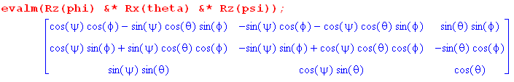

Well, I can just use (G.5.30) I think, so I get

ω1 = (cosφcosψ-cosθsinφsinψ) A sin(Ω't) + (-cosφsinψ-cosθsinφcosψ) Acos(Ω't) +sinθsinφ (ω)'3
ω2 = (sinφcosψ + cosθcosφsinψ) A sin(Ω't) + (-sinφsinψ+cosθcosφcosψ) Acos(Ω't) - sinθcosφ (ω)'3
ω3 = sinθsinψ A sin(Ω't) + sinθcosψ Acos(Ω't) + cosθ (ω)'3.

How would I show this is conical motion? It just seems a total mess. At is at least moving. If this is supposed to match the picture of Marion on page 392 it seems that if L is in the direction I would expect to see that ω3 = constant. But that seems very unlikely looking at the last line above. Unless

ψ(t) = Ω't

But how would I justify that? Well go back and add new information:

(ω)'1 = A sin(Ω't) = sinθsinψ + cosψ
(ω)'2 = ()'1 / Ω' = Acos(Ω't) = sinθcosψ - sinψ
(ω)'3 = K = cosθ +

So I really have these three equations never yet looked at

A sin(Ω't) = sinθsinψ + cosψ
A cos(Ω't) = sinθcosψ - sinψ
K = cosθ +

OK, the first two imply that

A2 = [ sinθsinψ + cosψ]2 + [ sinθcosψ - sinψ]2

Cross terms cancel, leaving just the 4 main terms. Then

A2 = 2sin2θ + 2

So now I have these two equations

A2 = 2sin2θ + 2
K = cosθ +

Not going anywhere fast. Go back to the first two

A sin(Ω't) = sinθsinψ + cosψ
A cos(Ω't) = sinθcosψ - sinψ
so
sinψA sin(Ω't) = sinθsin2ψ + cosψsinψ
cosψA cos(Ω't) = sinθcos2ψ - sinψcosψ

Add these to get

sinψA sin(Ω't) + cosψA cos(Ω't) = sinθ

Do it differently now to cancel the other term

cosψA sin(Ω't) = sinθsinψcosψ + cos2ψ
-sinψA cos(Ω't) = - sinθsinψcosψ + sin2ψ

Then

cosψA sin(Ω't) - sinψA cos(Ω't) =

So we have at least two new and interesting equations

sinψA sin(Ω't) + cosψA cos(Ω't) = sinθ
cosψA sin(Ω't) - sinψA cos(Ω't) =

Write as
Acos(ψ-Ω't) = sinθ
Asin(Ω't- ψ) =

So I now have four interesting equations

Acos(ψ-Ω't) = sinθ
Asin(ψ-Ω't) = -
A2 = 2sin2θ + 2
K = cosθ +

There are four unknowns here: , θ, , so maybe I can somehow solve. I want to show = 0 I think, but not clear how to do that. All four are not independent since third is sum of squares of 1 and 2.

Ansatz: Just try to find a solution with = 0. The equations then say

Acos(ψ-Ω't) = sinθ
Asin(ψ-Ω't) = 0
A2 = 2sin2θ
K = cosθ +

The 2nd seems to say that ψ = Ω't. The other info left is only this

A = sinθ
K = cosθ + Ω'

Recall that

A = (2T/I'1) -K2

not very useful. Instead process

Acosθ = sinθcosθ
Ksinθ = cosθsinθ + Ω'

Acosθ - Ksinθ = -Ω' = - K (I'1-I'3)/I'1

(A/K) cosθ - sinθ = - (I'1-I'3)/I'1

This must be how θ gets determined? Maple at least gives solutions although ugly.

Let's now go back to the brute force result:

ω1 = (cosφcosψ-cosθsinφsinψ) A sin(Ω't) + (-cosφsinψ-cosθsinφcosψ) Acos(Ω't) +sinθsinφ (ω)'3
ω2 = (sinφcosψ + cosθcosφsinψ) A sin(Ω't) + (-sinφsinψ+cosθcosφcosψ) Acos(Ω't) - sinθcosφ (ω)'3
ω3 = sinθsinψ A sin(Ω't) + sinθcosψ Acos(Ω't) + cosθ (ω)'3.

But now set Ω't = ψ to get some simplification maybe,

ω1 = (cosφcosψ-cosθsinφsinψ) A sinψ + (-cosφsinψ-cosθsinφcosψ) Acosψ +sinθsinφ K
ω2 = (sinφcosψ + cosθcosφsinψ) A sinψ + (-sinφsinψ+cosθcosφcosψ) Acosψ - sinθcosφK
ω3 = sinθsinψ A sinψ + sinθcosψ Acosψ + cosθK.

Simplify them one at a time:

ω1 = A { cosφcosψsinψ-cosθsinφsin2ψ - cosφsinψcosψ-cosθsinφcos2ψ } + sinθsinφ K

= A{ -cosθsinφsin2ψ - cosθsinφcos2ψ } + sinθsinφ K

= Acosθ{ -sinφsin2ψ - sinφcos2ψ } + sinθsinφ K

= -Acosθsinφ + sinθsinφ K

= (-Acosθ + Ksinθ )sinφ ok

ω2 = (sinφcosψ + cosθcosφsinψ) A sinψ + (-sinφsinψ+cosθcosφcosψ) Acosψ - sinθcosφK

= A{sinφsinψcosψ + cosθcosφsin2ψ -sinφsinψcosψ+cosθcosφcos2ψ } - sinθcosφK

= A{cosθcosφsin2ψ+cosθcosφcos2ψ } - sinθcosφK

= A{cosθcosφ} - sinθcosφK

= Acosθcosφ - sinθcosφK

= (Acosθ - Ksinθ)cosφ

ω3 = sinθsinψ A sinψ + sinθcosψ Acosψ + cosθK

= sinθsin2ψ A + sinθcos2ψ A + Kcosθ

= Asinθ + Kcosθ

Here then are my "brute force" results where I inserted ψ(t) = Ω't :

ω1 = (-Acosθ + Ksinθ )sinφ

ω2 = ( Acosθ - Ksinθ)cosφ

ω3 = Asinθ + Kcosθ

Now recall from above that

A = sinθ ⇒ = A/sinθ ⇒ φ = (A/sinθ) t

The results are now

ω1 = - (A'cosθ - Ksinθ )sin[(A'/sinθ) t]

ω2 = (A'cosθ - Ksinθ)cos[(A'/sinθ) t]

ω3 = A'sinθ + Kcosθ

This does show precession! The amplitude and frequency seem strange.

ω1 = - A sin[Ω t] A = A'cosθ - Ksinθ

ω2 = Acos[Ω t] Ω = (A'/sinθ)

ω3 = A'sinθ + Kcosθ

I think it goes backwards?

How can I verify this result somewhere? I think it has to be a textbook somewhere.

I have found a few things. going back to my picture

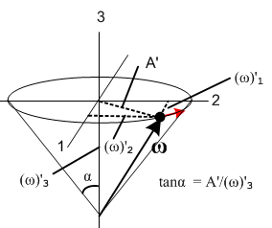

Note the angle α. It seems clear that

tanα = A'/K

sinα = A'/ω

Then my result above can be written

= A'/sinθ = ωsinα/sinθ φ = (ωsinα/sinθ)t

and I do see this in a paper I am looking at

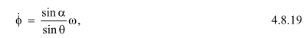

so there at least is some kind of confirmation of what I am doing.

But he also makes this claim:

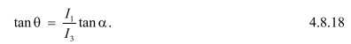

I can write my body frame stuff as

(ω)'1 = ωsinα sin(Ω't)
(ω)'2 = ωsinαcos(Ω't) . (G.8.20)
(ω)'3 = K

How about this idea

ω2 = (ω)'i2 = ω2sin2α + K2

which says

ω2(1-sin2α) = K2

ω2 cos2α = K

Then nice result is

K = ω cosα

So now I have

A' = ωsinα
K = ωcosα

A'/K' = tanα which I already knew.

A'2 + K2 = ω2 obvious from picture, but still new to me.

Now my author is claiming that

ωsinα = ωy' A'

ωcosα = ωz' K

He claims also this

where is that coming from? These are "intermediate axes" for Euler I think. The ξ' and η' guys.

Lξ' = 0 Lη' = Lsinθ Lz' = Lcosθ

Looking at my EA picture I think the above are correct. I agree that

Lη'/ Lz' = tanθ

But he is claiming next that

Lη'= I'1 ωη' Lz'= I'3 ωz'

He is somehow using those intermediate angles. The right one here seems OK.

I get some hints here, but just not very systematic!

Go back to

ω1 = (-A'cosθ + Ksinθ )sinφ

ω2 = ( A'cosθ - Ksinθ)cosφ

ω3 = A'sinθ + Kcosθ

and use

A' = ωsinα
K = ωcosα

Then these say

ω1 = (- ωsinαcosθ + ωcosαsinθ )sinφ
ω2 = ( ωsinαcosθ - ωcosαsinθ)cosφ
ω3 = ωsinαsinθ + ωcosαcosθ

or

ω1 = -ω (sinαcosθ + cosαsinθ )sinφ
ω2 = ω( sinαcosθ - cosαsinθ)cosφ
ω3 = ω(sinαsinθ + cosαcosθ)

Now

sinαcosθ - cosαsinθ = sin(α-θ)
sinαsinθ + cosαcosθ = cos(α-θ)

Then have

ω1 = -ω sin(α-θ)sinφ φ = (ωsinα/sinθ)t
ω2 = ω sin(α-θ)cosφ
ω3 = ω cos(α-θ)

L = Le3

Getting pretty simple now! It seems like the Frame S cone angle is not θ, but is α-θ.

Here is a picture the guy draws,

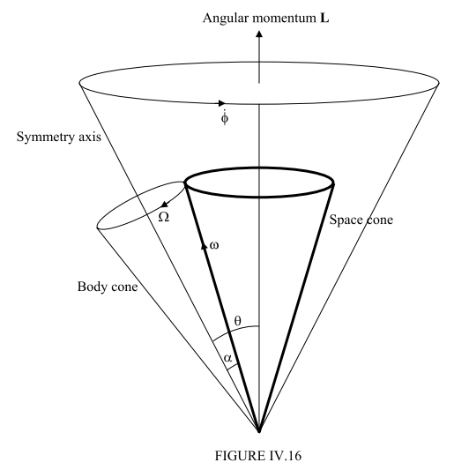

You see that indeed the space cone has half angle θ - α, so confirmation. Not sure what the Big Cone is in this picture.
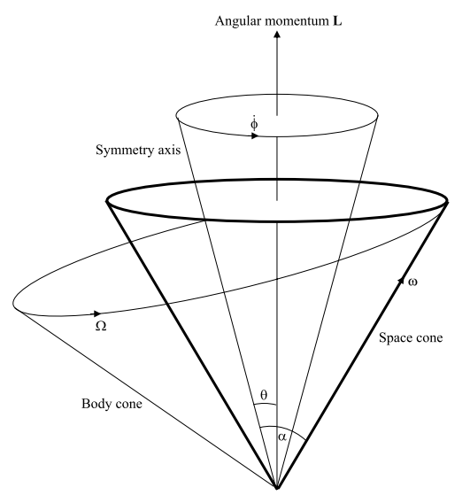

Again the space cone has α-θ as its half angle. What is that other cone??

New idea 3.15.17.

What happens if I back map L from Frame S' to Frame S and require it be z-aligned in Frame S? Maybe better to use the forward map which is

x' = (cosψcosφ - sinψcosθsinφ) x + (cosψsinφ + sinψcosθcosφ) y + sinψsinθ z
y' = (- sinψcosφ - cosψcosθsinφ) x + (-sinψsinφ + cosψcosθcosφ) y + cosψsinθ z
z' = sinθsinφ x - sinθcosφ y + cosθ z . (G.5.26)

Write as

(L')1 = (cosψcosφ - sinψcosθsinφ) L1 + (cosψsinφ + sinψcosθcosφ) L2 + sinψsinθ L3
(L')2 = (- sinψcosφ - cosψcosθsinφ) L1 + (-sinψsinφ + cosψcosθcosφ) L2 + cosψsinθ L3
(L')3 = sinθsinφ L1 - sinθcosφ L2 + cosθ L3 . (G.5.26)

Then require that L1 = L2 = 0 in Frame S to get

(L')1 = sinψsinθ L3
(L')2 = cosψsinθ L3
(L')3 = cosθ L3. (*)

But then we know that

(L')1 = I'1(ω)'1 = I'1 ωsinα sin(Ω't)
(L')2 = I'1(ω)'2 = I'1 ωsinα cos(Ω't)
(L')3 = I'1(ω)'3 = I'3 ω cosα (**)

Compare this to

(ω)'1 = ωsinα sin(Ω't)
(ω)'2 = ωsinαcos(Ω't) . (G.8.20)
(ω)'3 = ω cosα

So viewed in Frame S', the vectors L and ω are different, but they both precess in Frame S'.

Meanwhile, from (*) and (**) we have this possibly new information

I'1 ωsinα sin(Ω't) = sinψsinθ L3 = sin(Ω't)sinθ L3
I'1 ωsinα cos(Ω't) = cosψsinθ L3 =cos(Ω't)sinθ L3
I'3 ω cosα = cosθ L3

or // here I assume that ψ = Ω't

I'1 ωsinα = sinθ L3
I'1 ωsinα = sinθ L3
I'3 ωcosα = cosθ L3

Divide the last two equations to get

(I'1/I'3) tanα = tanθ

which compare to the PDF claim

So I have finally obtained this key result. It relates the angles θ and α for the first time. I think that θ is the cone half angle for the Frame S precession! This also says θ = constant, something I was looking for! At this point this is what I know about Frame S viewing

ω1 = -ω sin(α-θ)sinφ φ = (ωsinα/sinθ)t
ω2 = ω sin(α-θ)cosφ
ω3 = ω cos(α-θ)
L = Le3

I also know that L is same in both frames as a mag, and I already computed,

L2 = I'12A'2 + I'32(ω)'32 = (I'1ωsinα)2 + ( I'3ωcosα)2 = a nice expression

L2 = ω2 [ (I'1sinα)2 + ( I'3cosα)2 ]

so L and ω are locked to each other in this simple manner.

Summary of what I now know:

1. α is the cone angle for ω motion viewed in Frame S'.

2. In Frame S' the motion of the ω vector is this (cone angle α)

(ω)'1 = ωsinα sin(Ω't)
(ω)'2 = ωsinα cos(Ω't)
(ω)'3 = ωcosα

Given the above, we would compute the cone angle this way

tan(cone half angle) = (ω)'1 coefficient / (ω)'3 = ωsinα / ωcosα = tanα

and therefore : cone half angle = α

2. In Frame S' the motion of the L vector is this,

(L')1 = I'1 ωsinα sin(Ω't)
(L')2 = I'1 ωsinα cos(Ω't)
(L')3 = I'3 ω cosα

tan(cone half angle) = (L')1 coefficient / (L')3 = I'1 ωsinα / I'3 ω cosα = ( I'1/I'3) tan α

3. I have shown also that (I'1/I'3) tanα = tan θ.

Combining this with the previous shows that the L precession half angle is just θ !!

I think I then know about all three cones in the guy's pictures.

Update 3.15.17

I have tried to write some of this up in line in "draft of G.8" but it is a bit messy. I solve for the Euler angle and get what appears to be conical motion of the rotor. But what are my conclusions about the ω and the L vector in Frame S? I know that L is fixed in the z direction, yes. I know that the rotor figure axis is connected to the Euler angles. But what is the ω vector doing? Maybe I just use these results,

(ω)x = sinθsinφ + cosφ
(ω)y = - sinθcosφ + sinφ
(ω)z = cosθ + . // Frame S ok (G.6.4)

which I can rewrite as [ using

(ω)x = Ω' sinθsin[ (L/I'1)t]
(ω)y = - Ω' sinθcos[(L/I'1)t]
(ω)z = Ω' cosθ + (L/I'1) .

since

θ(t) = tan-1([I'1/I'3]tanα) // = constant
ψ(t) = Ω't // Ω' = ωcosα (I'1-I'3)/I'1
φ(t) = (L/I'1)t

Does the mag of ω work out right or not? It looks a bit fishy,

ω2 = Ω'2sin2θ + (Ω' cosθ + (L/I'1) )2 ??

ω2 = Ω'2sin2θ + Ω'2cos2θ + (L/I'1)2 + 2 (L/I'1)Ω' cosθ ??

ω2 = Ω'2 + (L/I'1)2+ 2 (L/I'1)Ω'cosθ ??

I know that

cosθ L = I'3ωcosα

so I can eliminate that to get

ω2 = Ω'2 + (L/I'1)2 + 2 (1/I'1)Ω' I'3ωcosα ??

But I know that

Ω' = ωcosα (I'1-I'3)/I'1

So then have

ω2 = ω2cos2α (I'1-I'3)2/I'12 + (L/I'1)2 + 2 (I'3/I'1){ωcosα (I'1-I'3)/I'1}ωcosα ??

ω2 = ω2cos2α (I'1-I'3)2/I'12 + (L/I'1)2 + 2 (I'3/I'1)ω2cos2α (I'1-I'3)/I'1 ??

I'12 ω2 = ω2cos2α (I'1-I'3)2 + L2 + 2 I'3ω2cos2α (I'1-I'3) ??

I also know that

L2 = ω2 [( I'1sinα)2 +( I'3cosα)2] = ω2 I'12sin2α + ω2 I'32cos2α

so put that in as well to get

I'12 ω2 = ω2cos2α (I'1-I'3)2 + ω2 I'12sin2α + ω2 I'32cos2α + 2 I'3ω2cos2α (I'1-I'3) ??

I'12 = cos2α (I'1-I'3)2 + I'12sin2α + I'32cos2α + 2 I'3cos2α (I'1-I'3) ??

I'12 = cos2α (I'1-I'3)2 + I'12 - I'12cos2α + I'32cos2α + 2 I'3cos2α (I'1-I'3) ??

0 = cos2α (I'1-I'3)2 - I'12cos2α + I'32cos2α + 2 I'3cos2α (I'1-I'3) ??

0 = (I'1-I'3)2 - I'12+ I'32 + 2 I'3(I'1-I'3) ??

0 = I'12 + I'32 - 2 I'1 I'3 - I'12+ I'32 + 2 I'3I'1 - 2 I'32 ??

0 = I'32 - 2 I'1 I'3 + I'32 + 2 I'3I'1 - 2 I'32 ??

0 = - 2 I'1 I'3 + 2 I'3I'1 ??

0 = 0 YES!! ??

Now go back to

(ω)x = Ω' sinθsin[ (L/I'1)t] Ω' = ωcosα (I'1-I'3)/I'1
(ω)y = - Ω' sinθcos[(L/I'1)t]
(ω)z = Ω' cosθ + (L/I'1) .

I don't like this form much. Go back to

x = (cosφcosψ-cosθsinφsinψ) x' + (-cosφsinψ-cosθsinφcosψ) y' +sinθsinφ z'
y = (sinφcosψ + cosθcosφsinψ) x' + (-sinφsinψ+cosθcosφcosψ) y' - sinθcosφ z'
z = sinθsinψ x' + sinθcosψ y' + cosθ z' . (G.5.30)

Apply this to the ω vector to get

ω1 = (cosφcosψ-cosθsinφsinψ) (ω)'1+ (-cosφsinψ-cosθsinφcosψ) (ω)'2 + sinθsinφ (ω)'3
ω2 = (sinφcosψ + cosθcosφsinψ) (ω)'1 + (-sinφsinψ+cosθcosφcosψ) (ω)'2 - sinθcosφ (ω)'3
ω3 = sinθsinψ (ω)'1 + sinθcosψ (ω)'2 + cosθ (ω)'3 .

Now insert our Frame S' solutions which were

(ω)'1 = ωsinα sinψ
(ω)'2 = ωsinα cosψ
(ω)'3 = ωcosα α = cone half-angle

****************************
Our Frame S' solution for (ω)' was

(ω)' = $\left(\begin{matrix}ωsinα sinψ \\ ωsinα cosψ \\ ωcosα\end{matrix}\right)$

To obtain the Frame S components of ω we have Maple compute ω = R-1(ω)' :

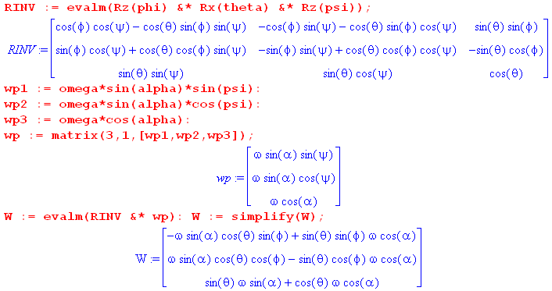

where W = ω . The resulting vector can be simplified by combining the trig terms:

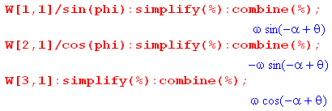

The final result is then

ω1 = ω sinφ sin(θ-α)
ω2 = - ωcosφ sin(θ-α)
ω3 = ωcos(θ-α)

Using φ = (L/I'1)t this becomes

ω1 = ω sin(θ-α)sin[(L/I'1)t ]
ω2 = - ω sin(θ-α)cos[(L/I'1)t ]
ω3 = ω cos(θ-α)

This set of equations describes the precession in Frame S components of the vector ω at rate
φ = (L/I'1)t with a cone half-angle of θ-α.

Verify the minus sign:

ω sinα cosθcosφ - sinθcosφωcosα

= ωcosφ (sinα cosθ - cosαsinθ) =

= ωcosφ sin(α-θ)

= - ωcosφ sin(θ-α)

First line is

sinθcosα - sinαcosθ = sin(θ-α)

signs are correct! Ω' figure axis

**********************

sinθ L = I'1ωsinα ?

sin2θ ω2 [( I'1sinα)2 +( I'3cosα)2] = I'12ω2sin2α ?

sin2θ [( I'1sinα)2 +( I'3cosα)2] = ( I'1sinα)2 ?

sin2θ [1 +( [I'3/I'1]cotα)2] = 1 ?

[1 +( [I'3/I'1]cotα)2] = csc2θ = 1 + cot2θ ?

≡ cotθ = [I'2/I'1]cotα yes! same as ***

***************

L2 = ω2 ( I'12sin2α + I'32cos2α )

2T = ω2 ( I'1sin2α + I'3cos2α )

2TI'1 = ω2 ( I'12sin2α + I'3 I'1cos2α )

2TI'1 - L2 = ω2 ( I'12sin2α + I'3 I'1cos2α ) - ω2 ( I'12sin2α + I'32cos2α )

= ω2 [ I'3 I'1cos2α - I'32cos2α ]

= ω2cos2α I'3(I'1-I'3)

which says

ω2cos2α = (2TI'1 - L2) / [I'3(I'1-I'3)]

Do it again this way

L2 = ω2 ( I'12sin2α + I'32cos2α )
2TI'3 = ω2 ( I'1I'3sin2α + I'32cos2α )

2TI'3 - L2 = ω2 ( I'1I'3sin2α - I'12sin2α ) = ω2I'1 ( I'3 - I'1)sin2α

which says

ω2sin2α = (2TI'3 - L2) / I'1( I'3 - I'1)

So at this point we have

ω2cos2α = (2TI'1 - L2) / [I'3(I'1-I'3)]
ω2sin2α = (2TI'3 - L2) / I'1( I'3 - I'1)

ω2cos2α = $\frac{|2TI'1 - L2|}{I'3|I'1-I'3|}$ ω2sin2α = $\frac{|2TI'3 - L2|}{I'1|I'1 - I'3|}$

Divide to get

tan2α = $\frac{|2TI'3 - L2|}{I'1|I'1 - I'3|}$ / $\frac{|2TI'1 - L2|}{I'3|I'1-I'3|}$ = (I'3/I'1) $\frac{|2TI'3 - L2|}{|2TI'1 - L2|}$

ω2 = $\frac{|2TI'1 - L2|}{I'3|I'1-I'3|}$ + $\frac{|2TI'3 - L2|}{I'1|I'1 - I'3|}$

As verification, let I'1 = a and I'3 = b so that

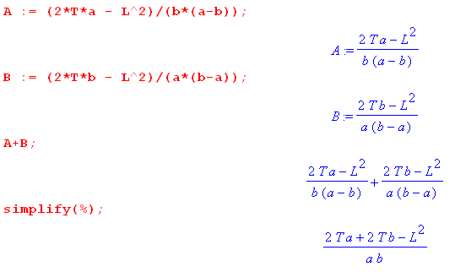

I then get this result from adding the two equations

ω2 = [2T(a+b)-L2]/ab

But I started with

L2 = ω2 ( a2sin2α +b2cos2α )

2T = ω2 ( asin2α + bcos2α )

I would then like to show that

ω2 = [ω2 ( asin2α + bcos2α )(a+b) - ω2 ( a2sin2α +b2cos2α )] /ab
or
1 = [( asin2α + bcos2α )(a+b) - ( a2sin2α +b2cos2α )] /ab
or
( asin2α + bcos2α )(a+b) - ( a2sin2α +b2cos2α ) = ab ?

sin2α(a2+ab - a2) + cos2α(ab+b2 - b2) = ab?

sin2α ab + cos2α ab = ab OK

So my solution is

ω2sin2α = (2TI'3 - L2) / [I'1( I'3 - I'1)]
ω2cos2α = (2TI'1 - L2) / [I'3(I'1-I'3)]

tan2α = (2TI'3 - L2) / I'1( I'3 - I'1) // (2TI'1 - L2) / [I'3(I'1-I'3)]

= - (2TI'3 - L2) / I'1 // (2TI'1 - L2) / I'3

= - (I'3/I'1) (2TI'3 - L2) / (2TI'1 - L2)

