Inertial moments of an oblate spheroid (approx) PhL 3.19.17

Texas reference:

http://farside.ph.utexas.edu/teaching/336k/Newtonhtml/node109.html

http://farside.ph.utexas.edu/teaching/336k/Newtonhtml/node108.html

Here is the picture

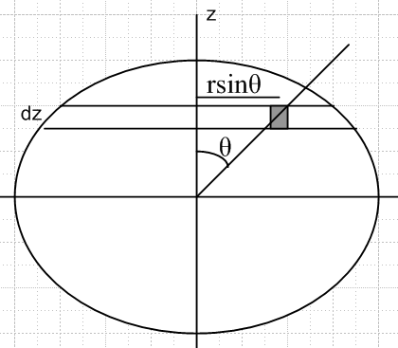

Use spherical coordinates (r,θ,φ), Assume unit mass density ρ. Then

dm = dV = ρr2drdφsinθdθ.

Note that

z = rcosθ

The moment of inertia of dm is given by

dI = dm(rsinθ)2 = [ρr2drdφsinθdθ](rsinθ)2

The boundary of the oblate spheroid is assumed to be this, where ε << 1

R(θ) = a[1 - (2/3)ε P2(cosθ)]

Here then is the moment of inertial about the vertical axis

I3 = ρ $^{\int_{0}^{2π}{}}$dφ $^{\int_{0}^{π}{}}$dθ sin3θ $^{\int_{0}^{R(θ)}{}}$r4

= 2πρ $^{\int_{0}^{π}{}}$dθ sin3θ $^{\int_{0}^{R(θ)}{}}$r4

= (2πρ/5) $^{\int_{0}^{π}{}}$dθ sin3θ R5(θ)

Now

R(θ) = a[1 - (2/3)ε P2(cosθ)]

R5(θ) ≈ a5 [1 - (10/3)ε P2(cosθ)]

Then

I3 ≈ (2πρ/5) a5 $^{\int_{0}^{π}{}}$dθsin3θ [1 - (10/3)ε P2(cosθ)]

The first integral is this

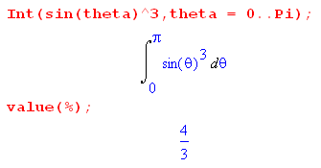

We know that P2(cosθ) = (1/2)(3cos2θ-1)

Then we want

$^{\int_{0}^{π}{}}$dθsin3θ P2 = (1/2) $^{\int_{0}^{π}{}}$dθsin3θ (3cos2θ-1)

Maple says

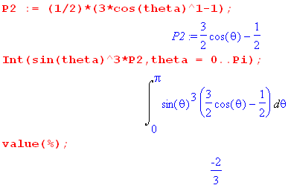

Therefore

I3 ≈ (2πρ/5) a5 $^{\int_{0}^{π}{}}$dθsin3θ [1 - (10/3)ε P2(cosθ)]

= (2πρ/5) a5 [ (4/3) - (10/3)ε (-2/3) ]

= (2πρ/5) a5 [ (4/3) + (20/9)ε ]

= (2πρ/5) (4/3) a5 [ 1 + (5/3)ε ]

= ρ (8π/15) a5 [ 1 + (5/3)ε ]

Now approximate that

M = (4/3)πa3ρ ⇒ ρ = (3/4) M/(πa3)

Then have

I3 ≈ (3/4) M/(πa3) * (8π/15) a5 [ 1 + (5/3)ε ]

= (3/4) M (8/15) a2 [ 1 + (5/3)ε ]

= (2/5) M a2 [ 1 + (5/3)ε ]

I now go check the list of inertias on wiki,

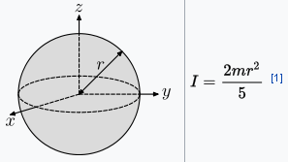

So that is good and we the correction for oblateness to first order in ε.

But now I back up because I see this result in that list

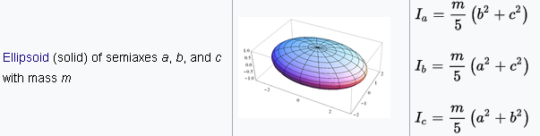

If we have spheroid, set A = B and you then get

I3 = (m/5) (A2+C2)

I1 = (m/5) (2A2)

Thus we have

I3 - I1 = (m/5) (A2+C2) - (m/5) (2A2)

= (m/5) ( C2-A2)

In our model we have

R(θ) = a[1 - (2/3)ε P2(cosθ)]

Therefore

C = a[1 - (2/3)ε P2(0)] = a[1 - (2/3)ε (-1/2)] = a [1 +ε/3]

A = a[1 - (2/3)ε P2(1)] a[1 - (2/3)ε 1] = a[1 - 2ε/3]

C+A ≈ 2a

C-A = εa

since

P2(cosθ) = (1/2)(3cos2θ-1).

Then

I3 - I1 = (m/5)(C+A)(C-A) ≈ (m/5)(2a)(εa) = (2/5)mεa2

THAT took a long time for me to get!!

******************************

On scratch I have showed that the torque on an oblate Earth is given by

N = 3(2/5) GMa2ε/r3cosθsinθ $\left(\begin{matrix}sinφ \\ -cosφ \\ 0\end{matrix}\right)$

= 3{(2/5)Mεa2 } G/r3cosθsinθ $\left(\begin{matrix}sinφ \\ -cosφ \\ 0\end{matrix}\right)$

= 3{I3 - I1} G/r3cosθsinθ $\left(\begin{matrix}sinφ \\ -cosφ \\ 0\end{matrix}\right)$

Compare this to Williams result

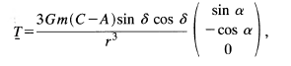

I think I am on to it finally. Note that

cosθsinθ = cos(π/2-δ)sin(π/2-δ) = sinδ cosδ

So I have lost a mass somewhere.

*********************** Here is the calculation of the torque on the Earth *************

STEP 1

Away from sources of charge, the electrostatic potential must satisfy the Laplace equation. The same is true for the gravitational potential away from mass sources. In general any such potential can be expressed as a sum over the "atomic forms" (harmonics) of a given coordinate system. For spherical coordinates the atomic forms can be taken as

[rn , r-n-1] [ Pnm(z), Qnm(z) ] [eimφ, e-imφ] z = cosθ

where n and m are non-negative integers. These are appropriate for regions of space which have the full range of angle φ. In such a region, for the potential to be single valued in azimuth one must have m = integer so exp(im(φ+2π)) = exp(imφ). This in turn forces n to be an integer, and m ≤ n. If θ = 0 is part of the range of interest, one cannot have Qnm(z) terms since they blow up at z = 0. In this case one has

[rn , r-n-1] [ Pnm(z)] [eimφ, e-imφ] z = cosθ

which gives the familiar spherical harmonics expansion of a potential. If the potential is azimuthally symmetric, one must have m = 0 reducing the atomic form set to

[rn , r-n-1] Pn(z)

If a region of interest extends to r = ∞, only the r-n-1 powers are allowed. We then arrive at this expansion for the gravitational potential outside an azimuthally symmetric mass distribution.

V(r,θ) = Σn=0∞ Vn r-m-1 Pn(cosθ)

If the potential is also symmetric under z reflections, only even n contribute in the sum, and this is the situation for the potential of an oblate spheroid with z as the symmetry axis. If the spheroid is only very slightly oblate, we keep just the first two terms to get

V(r,θ) = V0/r + V2 r-3 P2(cosθ)

STEP 2

Consider an ellipse of the form x2/A2 + z2/B2 = 1. If we measure polar angle θ down from the z axis, then x = rsinθ and z = rcosθ and the ellipse equation becomes

r2 = $\frac{A2B2}{B2sin2θ+A2cos2θ}$

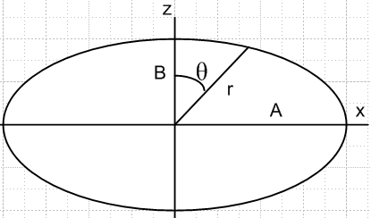

For an "oblate" (wide) ellipsoid we have A > B. If the ellipse is only slightly oblate, write A = B+δ

In this case we get

r2 = $\frac{A2B2}{B2sin2θ+(B+δ)2cos2θ}$ ≈ $\frac{A2B2}{B2 + 2Bδcos2θ}$ ≈ $\frac{A2}{1+ 2(δ/B)cos2θ}$

≈ A2 [ 1-2(δ/B)cos2θ ] ≈ A2 [ 1-2(δ/A)cos2θ ]

Then

r ≈ A [ 1-(δ/A)cos2θ ]

The eccentricity of the ellipse is

ε2 = (A2-B2)/A2 = (A+B)(A-B)/A2 ≈ 2Aδ/A2 = 2δ/A

Then have

r = A [ 1- (1/2)(2δ/A)cos2θ ] = [ 1- (1/2)ε2cos2θ ]

STOP. My Texas document claims

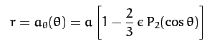

and you see the ε is not squared, and is called ellipticity which other sides say is the usual eccentricity

Now write

P2 = (1/2) (3cos2θ - 1) ≡ 2P2 = 3cos2θ -1 ⇒ 3cos2θ = 2P2 + 1

so cos2θ = (1/3)(2P2+ 1)

Then have

r = [ 1- (1/2)ε2cos2θ ] = [ 1- (1/6)ε2(2P2+ 1) ]

How am I ever doing to get this result:

Try to do it:

r = 1 - (1/3)ε2P2 - (1/6)ε2

= (1- (1/6)ε2) - (1/3)ε2P2

= (1- (1/6)ε2) [ 1 - (1/3)ε2P2 / (1- (1/6)ε2) ]

= d [ 1 - (1/3)ε2P2 /d ] d = (1- (1/6)ε2)

≈ d [ 1 - (1/3)ε2P2 ]

So the fraction is wrong and the power of ε is wrong!

What is the "mean radius" of this oblate spheroid? Go back to

r = [ 1- (1/2)ε2cos2θ ]

Then

<r> = [ 1- (1/2)ε2<cos2θ> ]
= [ 1- (1/2)ε2(1/3)] if I did it right

= [ 1- (1/6)ε2] if I did it right

= a of Texas author

But this is exactly my d from above!

Conclusion: ether the Texas author has goofed up, or I have goofed up royally.

I now need another source on the Texas claim which is the STARTING point of his presentation:

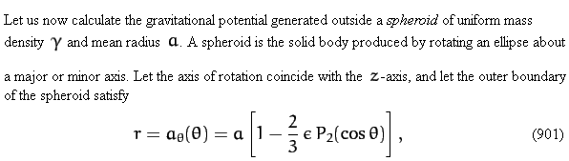

I found a doc which says this:

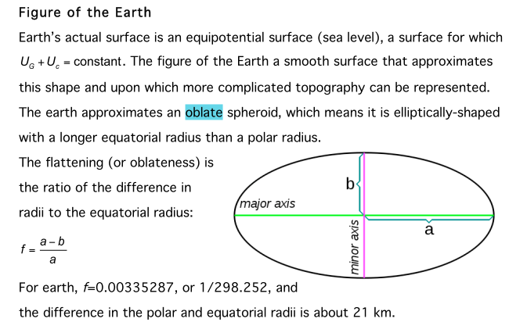

This author is using the "flatness" factor f. If I go back to

r ≈ A [ 1-(δ/A)cos2θ ]

then

f = (A-B)/A = δ/A

which compare to

ε2 = (A2-B2)/A2 = (A+B)(A-B)/A2 ≈ 2Aδ/A2 = 2δ/A

Thus

ε2 = 2f

and then my result is

r = d [ 1 - (1/3)ε2P2 ] = d [ 1 - (1/3)2fP2 ] = d[ 1 - (2/3) f P2 ]

so the Texas offer is using symbol f to be "flatness", not eccentricity. That would explain it!

In fact, later Texas does say this. confirming that his ε is really the flattening factor
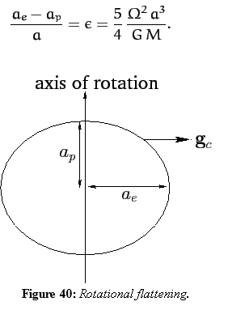

This same new author says

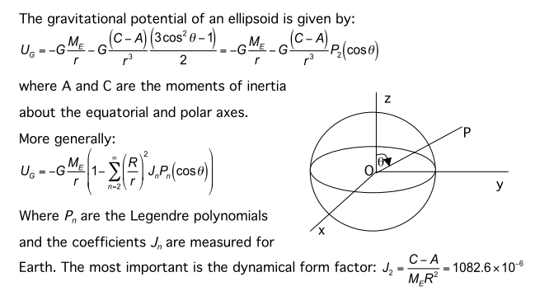
*******************************************

Another approach: in curvilinear /sphericals I have

V(r,θ,φ) = Σn=0∞ Σm=-nn anm(r) Pnm(cosθ) eimφ
anm(r) = (2n+1) f(n,-m) (1/4π) ∫dΩ V(r,θ,φ) e-imφ Pnm(z)

If V goes not depend on φ, only m = 0 can contribute in the projection so

an0(r) = (2n+1) f(n,0) (1/4π) ∫dΩ V(r,θ)Pn(z)

V(r,θ) = Σn=0∞ an0(r) Pn(cosθ)

In this case just write as

an(r) = (2n+1)f(n,0) (1/4π) ∫dΩ V(r,θ)Pn(z)
V(r,θ) = Σn=0∞ an(r) Pn(cosθ)

Note that

Pnm(z) = f(n,m) Pn-m(z)

f(n,m) = Γ(n+m+1)/(n-m+1) f(n,0) = Γ(n+1)/(n+1) = 1

So here we are

vn(r) = (2n+1) (1/4π) ∫dΩ V(r,θ)Pn(z)
V(r,θ) = Σn=0∞ vn(r) Pn(cosθ) ≈ V0/r + V2 r-3 P2(cosθ)

Now above I said that

V(r,θ) = V0/r + V2 r-3 P2(cosθ)

Now are things connected here? I guess it is this

v0(r) = V0/r v2(r) = V2/r3

Then for example

v0(r) = (1/4π) ∫dΩ V(r,θ)P0(z) = (1/4π) ∫dΩ V(r,θ)

But this is not helping because I want a different thing. Start over:

V(r) = ∫dV' ρ(r') / |r-r'| Jackson scale electrostatics

1/R = Σn=0∞ Σm=0∞ εm f(n,-m) (r<)n(r>)-n-1 Pnm(z) Pnm(z') cos[m(φ-φ')] (**)

If mass density ρ(r') does not depend on φ', only the m=0 terms survive so in effect

1/R = Σn=0∞ ε0 f(n,0) (r<)n(r>)-n-1 Pn(z) Pn(z')

= Σn=0∞ (r<)n(r>)-n-1 Pn(z) Pn(z')

Then put this in to get

V(r) = ∫dV' ρ(r') Σn=0∞ (r<)n(r>)-n-1 Pn(z) Pn(z')

Now if r is outside the entire mass distribution, r> = r and you have

V(r) = ∫dV' ρ(r') Σn=0∞r'nr-n-1 Pn(z) Pn(z')

= Σn=0∞ r-n-1 Pn(z) ∫dV' r'nρ(r') Pn(z')

= Σn=0∞ r-n-1 Pn(z) { 2π ∫r'2+ndr' ∫sinθ'dθ' ρ(r',cosθ') Pn(z') }

= Σn=0∞ r-n-1 Pn(z) { 2π∫r'2+ndr' ∫dz' ρ(r',z') Pn(z') }

Add factor -G on the right to get

V(r) = Σn=0∞ r-n-1 Pn(z) { -2πG∫r'2+ndr' ∫dz' ρ(r',z') Pn(z') }

= Σn=0∞ r-n-1 Pn(z) Vn

where

Vn = -2πG∫r'2+ndr' ∫dz' ρ(r',z') Pn(z')

So I am now agreeing with Texas who says

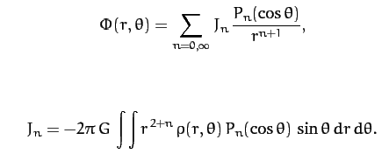

So I could do the rest of his page and conclude as he does that

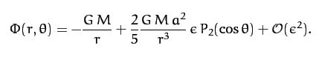

So I think I can derive this given his oblate form
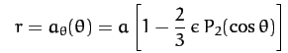

where I have shown that ε is really the flatness.

I would next like to show now the projection integrals relate to moments!

Vn = -2πG∫r'2+ndr' ∫dz' ρ(r',z') Pn(z')

V0 = -2πG∫r'2dr' ∫dz' ρ(r',z') = -GM M = total mass

V2 = -2πG∫r'4dr' ∫dz' ρ(r',z') P2(z') = ???

Remember that z' = cosθ, it is not a Cartesian z'. I think the inertial radius is R = r' sinθ'

I33 ≡ ∫dxdydz ρ(x)[ r2 - z2]

I11 ≡ ∫dxdydz ρ(x)[ r2 - x2]

I33 - I11 = ∫dxdydz ρ(x) [x2-z2]

In sphericals maybe have x = rsinθcosφ and z = rcosθ. Then

I33 - I11 = ∫dφ ∫sinθdθ ∫r2dr ρ(x) [ r2sin2θcos2φ - r2cos2θ ]

Now go from the Cartesian z to the spherical z and write this as

I33 - I11 = ∫dφ ∫dz ∫r4dr ρ(x) [ (1-z2)cos2φ - z2 ]

Then use ∫dφ cos2φ = π to get

I33 - I11 = ∫dz ∫r4dr ρ(x) [ π(1-z2)cos2φ - 2πz2 ]

= π ∫dz ∫r4dr ρ(x) [ (1-z2)- 2z2 ]

= π ∫dz ∫r4dr ρ(x) [ (1-3z2) ]

But P2 = (1/2) (3cos2θ - 1 so P2(z) = (1/2)(3z2-1) so

(1-3z2) = -2P2(z)

and then I get

I33 - I11 = -2π ∫dz ∫r4dr ρ(x)P2(z)

Compare this to result above

V2 = -2πG∫r'4dr' ∫dz' ρ(r',z') P2(z')

Therefore I think

V0 = -GM

V2 = G (I33 - I11)

Then I get

V(r,θ) = V0/r + V2 r-3 P2(cosθ)

= -GM/r + G (I33 - I11) P2(cosθ)/ r3

This agrees with
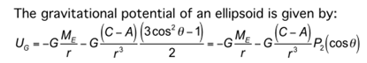

so I guess I have obtained this thing two ways now. The C and A are inertia moments. Then all you have to do is compute the torque on this as I have already done on scratch.

