This is the Title PhL 1.11.15

G.8 Equations of Rigid Body Motion and a few Applications

Assume that Frame S' is embedded into a rigid body, so that Frame S' and that rigid body are rotating at angular velocity ω relative to an inertial Frame S. This is the situation of our "non-swap notation". Goldstein uses the appropriate term "body frame" for such a Frame S'.

In Frame S' the rigid body is at rest, so the Frame S' velocity v'α of any particle α of the rigid body vanishes, v'α = 0. For particle α we also have p'α = mαv'α = 0 and L'α = r'α x p'α = 0. In particular, the total Frames S' angular momentum of the rigid body L' = ΣαL'α = 0. These facts are quite obvious but we state them anyway. Note that α here is a label and not a component index. We shall use α in this manner as a particle label, and the usual i,j,k indices as component indices.

In Frame S, however, the rigid body has some non-vanishing angular momentum L = Σα rα x mvα .

In what follows, we shall be very careful with the use of "primes" to clearly show what objects are the natural objects in what frames, and what frame components are being evaluated. As noted in Section 1.3, in order to mark our "natural" objects with primes or no primes depending on whether they are associated with Frame S' or Frame S, we must use the Passive View of rotation transformations. For vectors this means (V)' = RV and for rank-2 tensors (T)' = RTR-1.

Angular Momentum, the Inertia Tensor, and Kinetic Energy

If we assume that Frame S and Frame S' have a common origin, we are in Special Case #4 discussed in Section 10 and summarized below Fig (12.1.7). In Special Case #4 the vector b of Fig 1 is 0, so r' = r.

In this case, for a rigid body particle α one has from (12.1.8b),

vα = v'α + ω x r'α = 0 + ω x r'α = ω x rα . (12.1.8b) (G.8.1)

Then the total Frame S angular momentum of the rigid body is

L = Σα rα x pα = Σα rα x mαvα = Σimα rα x (ω x rα)

= Σα mα [ rα2ω - (rα • ω) rα ] . //A x (B x C) = (A•C)B - (A•B)C (G.8.2)

Taking Frame S components,

Li = Σα mα [ rα2ωi - (rα • ω) (rα)i ]

= Σα mα [ rα2Σjωjδij - Σj(rα)jωj (rα)i ]

= Σα mα Σj[ rα2δij - (rα)i(rα)j ] ωj

= Σk { Σαmα [ rα2δij - (rα)i(rα)j ] } ωj

= Σj Iijωj
where
Iij ≡ Σαmα [ rα2δij - (rα)i(rα)j ] = the inertia tensor . (G.8.3)

We rewrite (G.3.8) as a vector equation,

L = Iω (G.8.4)
Exercise: Write an expression for the Dirac inertia operator I (script I, not T) :

<ei| I | ej> = Iij = Σαmα [ rα2δij - (rα)i(rα)j ]

= Σαmα [ rα2<ei|ej> - <ei|rα><rα|ej> = <ei| { Σαmα [ rα2 1 - |rα><rα| } |ej>

⇒ I = Σαmα ( rα21 - |rα><rα| ) . (G.8.5)

In equation (G.8.2) L, I and ω are all associated with a Frame S observer. L is the angular momentum of the rigid body as seen in Frame S, and ω is the angular velocity of Frame S' (and its rigid body) as seen from Frame S. Finally Iij are the inertia tensor components viewed from Frame S.

Although L = Iω is a Frame S equation, as with any vector equation one can take components of the equation in either Frame S or Frame S' :

Li = Iij (ω)j Iij = Σαmα [ rα2δij - (rα)i(rα)j ] // rα2 = (rα)i(rα)i
(G.8.6)
(L)'i = (I)'ij (ω)'j (I)'ij = Σαmα [ r'α2δij - (rα)'i(rα)'j ] // r'α2 = (rα)'i(rα)'i

Notice in (I)'ij that (rα)'i = <e'i| rα > is constant in time. The components of a vector static in Frame S' do not change in time, although Frame S' moves relative to Frame S. Thus ∂t(rα)'i = 0. The magnitude of the vector rα is obviously constant in time, but we verify: ∂tr'α2 = ∂t[(rα)'i(rα)'i] = (rα)'∂t[(rα)'i] = 0. Therefore ∂t(I)'ij = 0 for the entire tensor (I').

Exercise: Verify that (I)' = RIR-1, thus showing that I is a rank-2 tensor (in the Passive View) :

(I)'ij = RiaIabR-1bj = Ria[ Σαmα ( rα2δab - (rα)a(rα)b )]R-1bj

= Σαmα (rα2 RiaδabR-1bj - Ria(rα)aR-1bj(rα)b )

= Σαmα (rα2RiaR-1aj - [Ria(rα)a][Rjb(rα)b] )

= Σαmα (rα2 δij - (rα)'i(rα)'j) QED

The total Frame S kinetic energy T of the rigid body is given by

T = Σα(1/2)mαvα2 = Σα(1/2)mα vα • (ω x rα) = Σα(1/2)mα ω • (rα x vα) // cyclic rule

= Σα (1/2) ω • (rα x mαvα) = (1/2) ω • Σα rα x pα = (1/2) ω • L

= (1/2) ω • (Iω) . // (G.8.4) (G.8.7)

We pause to note the various notations one can use for this dot product :

ω • (Iω) = ωTIω (matrix notation) = ωiIijωj = ωiωjIij (all Frame S components)

= <ω | I | ω> (Dirac notation, where I is the abstract inertia operator

= <ω |ei><ei| I |ej><ej| ω> = ωi Iij ωj // completeness (1.1.20)

= ω • I • ω (Goldstein p 149 5-15) = ωω = ωIω . (G.8.8)

Comments: We feel it is useful to keep stressing these notational issues:

• The Frame S' kinetic energy T' = (1/2) ω' • I' • ω' = 0 because ω' = 0, meaning (ω')i= 0. This is so because the rigid body is at rest in Frame S' -- nothing is moving in Frame S' !

• The Frame S kinetic energy T = (1/2)ω•I•ω can be written out in either Frame S or Frame S' components.

T = (1/2) ω•I•ω = (1/2) ωiωjIij = (1/2) (ω)'i(ω)'j(I)'ij . (G.8.9)

Proof: In Dirac notation,

T = (1/2) <ω | I | ω> = (1/2) <ω |ei><ei| I |ej><ej| ω> = (1/2) ωiIijωj

T = (1/2) <ω | I | ω> = (1/2) <ω |e'i><e'i| I |e'j><e'j| ω> = (1/2)(ω)'i(I)'ij (ω)'j .

Using the Goldstein notation, kinetic energy can be rewritten as

T = (1/2) ( • I • ) ω2 = (1/2) I ω2 where I ≡ • I • (G.8.10a)

in analogy with T = (1/2)mv2 for linear motion. The scalar object I is called the moment of inertia of the rigid body about the axis,

I ≡ • I • = ijIij = ij Σαmα [ rα2δij - (rα)i(rα)j ]

= Σαmα [ rα2ijδij - (rα)i i(rα)jj ]

= Σαmα [ rα2 - (rα • )2] = Σαmα [ rα2 - (rα)||2]

= Σαmα (rα)⊥2, (G.8.10b)

where (rα)⊥ is the perpendicular distance of particle α from the ω rotation axis,

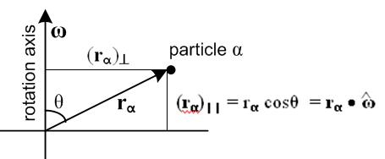 (G.8.10c)

Rigid Body equations of Motion

From (11.3.2) Newton's Second Law (angular motion) applied in inertial Frame S states,

N = // = ∂SL = (dL/dt)S (G.8.11)

where we set the torque and angular momentum reference point to the common Frames' origin. This law is valid because Frame S is an inertial frame so there are no fictitious torques. N is the Frame S torque, and is the natural time derivative of L in Frame S (see (1.8.4) and (1.9.3)).

Using the G Rule (2.1) one finds (notation of (1.8.3)),

≡ ∂SL = ∂S'L + ω x L (2.1)

so Newton says

(∂S'L) + ω x L = N . (G.8.12)

Note that (∂S'L) is not a "natural" object in the sense of Section 1.8 since L is a Frame S object, but the time derivative taken in Frame S', the body frame.

Inserting L = Iω and noting (2.6) that ∂S'ω = ∂Sω = ∂tω = , the vector equation of motion becomes

N = I + ω x (Iω) . (G.8.13)

Taking components in Frame S' (the body frame) one finds

(N)'i = (I)'ij ()'j + εijk(ω)'j(I)'ka (ω)'a . (G.8.14)

Diagonalization of the Inertia Tensor in Frame S'.

So far we have not paid much attention to the manner in which the Frame S' basis vectors are selected, and so far we have called them e'i. One is of course free to define new orthonormal Frame S' basis vectors e"i according to

e"i ≡ Qij e'j or | e"i> ≡ Qij | e'j> ⇒ <e'k | e"i> = Qik

where Q is some arbitrary rotation matrix (Q-1 = QT). Then in this new basis the inertia tensor is

(I)"ij = <e"i| I | e"j> = <e"i |e'a><e'a| I |e'b><e'b| e"j> =

= Qia(I)'abQjb = [Q(I)'Q-1]ij // (I)" = Q(I)Q-1

Note that (I)'ij = Σαmα [ r'α2δij - (rα)'i(rα)'j ] is a symmetric matrix, (I)'ij = (I)'ji.

A staple matrix theorem is than any real symmetric matrix M can be brought to diagonal form by a "similarity transformation" with some real orthogonal matrix S, so Λ = S-1MS where Λ is diagonal. There is a specific method for determining a suitable matrix S that does this diagonalization task. If we then select Q = S-1, the matrix (I)" = Q(I)Q-1 will be diagonal in the e"i basis. The basis vectors e"i are called "the principal axes" of the rigid body in question, and Q = S-1 is "the principal axis transformation". Note that the principle axes are fixed to a rigid body and do not change relative to the body as the body is reoriented (like the center of mass, and unlike the center of gravity, as both discussed in Appendix D).

Realizing this fact, we might as well start off selecting e'i to be a set of principle axes. From now on, then, we shall assume that the e'i have been so selected and thus that the Frame S' inertia tensor is diagonal.

Comments: In general, any real symmetric matrix M can be diagonalized by some real orthogonal matrix S to become the diagonal matrix Λ = S-1MS where then Λ = diag(λ1,λ2,λ3). Suppose the matrix M has some eigenvectors vi with eigenvalues μi so that Mvi = μivi. Then since M = S-1MS one gets,

(SΛS-1)vi = μivi ⇒ Λ(S-1vi) = μi(S-1vi)

⇒ Λwi = μiwi , // wi ≡ S-1vi

But the eigenvalues of a diagonal matrix are those diagonal elements, so we identify λi = μi and conclude that when M is diagonalized to Λ, the diagonal elements are the eigenvalues of M. The eigenvalues can be found by writing the eigenvalue equation as (M - μi1)vi = 0. If det(M-μi1) ≠ 0 one can invert this equation to conclude that vi = 0 which is wrong, so one must have det(M-μi1) = 0. This so-called "secular equation" ("characteristic equation") is then a cubic in variable μi which can be solved for three values of μi (the three roots of the secular equation).
In the complex world, the claim is that any Hermitian matrix H can be diagonalized by a unitary transformation U. A matrix H is Hermitian if H†= H( HT* = H), and a matrix U is unitary if U†U = 1 so U† = U-1. Then one has Hd = U-1HU. As above, the diagonal elements of Hd are the eigenvalues of H. It is easy to show that the eigenvalues of H (which are the diagonal elements of Hd) are real:

Hd* = U*-1H*U* = UT* HT*U*-1T = U† H†U-1† = U-1HU = Hd.

In quantum mechanics, all observable quantities X are represented by Hermitian operators (matrices) and the diagonal elements of the diagonalized Xd (the eigenvalues of X) are the possible physical values the observable can take.

Given that the e'i are selected as a set of principal axes for a rigid body, the diagonal elements of the diagonal inertia tensor can be written I'i and are called the principal moments of inertia. So

(I)'ij = I'i δij . (G.8.15)

We maintain a prime on I'i as a reminder that these are associated with Frame S' where the inertia tensor has been made diagonal by selection of the e'i basis vectors of Frame S'.

We now insert this diagonal form for (I)'ij into our equations of motion (G.8.13b) to get

(N)'i = I'i δij ()'j + εijk(ω)'j I'k δka (ω)'a

= I'i ()'i + εijk(ω)'j I'k(ω)'k

= I'i ()'i + εijk(ω)'j(ω)'k I'k . (G.8.16)

Setting i =1 gives

(N)'1 = I'1 ()'1 + ε1jk(ω)'j(ω)'k I'k

= I'1 ()'1 + ε123(ω)'2(ω)'3 I'3 + ε132(ω)'3(ω)'2 I'2

= I'1 ()'1 + (ω)'2(ω)'3 I'3 - (ω)'3(ω)'2 I'2

= I'1 ()'1 - (ω)'2(ω)'3 (I'2 - I'3) . (G.8.17)

Examining the other components (or just doing cyclic permutations), we may state the three component rigid-body equations of motion as follows,

(N)'1 = I'1 ()'1 - (ω)'2(ω)'3 (I'2 - I'3)
(N)'2 = I'2 ()'2 - (ω)'3(ω)'1 (I'3 - I'1)
(N)'3 = I'3 ()'3 - (ω)'1(ω)'2 (I'1 - I'2) (G.8.18)

These equations appear in Goldstein p 158 (5-34). At this point Goldstein uses our swap notation so there are no primes on any of the quantities.

THE ZERO_TORQUE MOTION OF A SPINNING RIGID BODY ("ROTOR", "TOP")

One might naively think that an arbitrary rigid body floating in space which is initialized to rotate about some rotation axis with some ω might continue to do so. If it happens that the initialized ω points in the direction of the largest or the smallest principal axis of inertia of the rigid body, this is in fact what happens. Otherwise the rigid body tumbles in a complicated manner in order to satisfy equations (G.8.18) with left hand sides set to zero.

Suppose the principle moments of inertia are such that I'3 > I'2 > I'1 . If rotation is initialized such that ω = ωe'2 so that only (ω)'2 ≠ 0, one finds that the three equations (G.8.18) are in fact satisfied by solution (ω)'2 = constant. However, as shown for example in Marion p 300 (M&****), the tiniest perturbation causes the rigid body to lose its simple motion and to tumble in a complicated manner. This is traditionally demonstrated by initializing a rubber-banded book or tennis racket to rotate about its middle principle axis while tossing the object a few feet into the air. Even in this short time, the axis rotation cannot be maintained and the object tumbles. In contrast, rotation is stable about the other two principal axes.

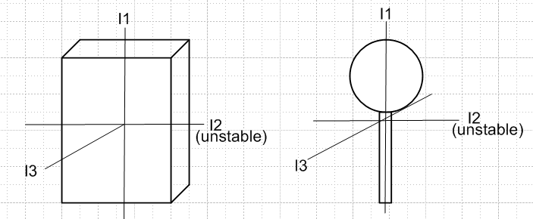 (G.8.19)

If the e'i are the principal axes of a rigid body in Frame S', one may write

2T = ω•I•ω = (I)'i(ω)'i2 ⇒ 1 = $\frac{(ω)'12}{2T/ (I)'1}$ + $\frac{(ω)'22}{2T/ (I)'2}$ + $\frac{(ω)'32}{2T/ (I)'3}$

L2 = Iω • Iω = (I)'i2(ω)'i2 ⇒ 1 = $\frac{(ω)'12}{L2/ (I)'12}$ + $\frac{(ω)'22}{L2/ (I)'22}$ + $\frac{(ω)'32}{L2/ (I)'32}$

A torque and force-free isolated system will have a fixed value of T and L2. One can then regard each of the above equations an axis-oriented ellipsoid centered at the origin of ω'-space. The denominators are the squares of the three semi-axes of each ellipsoid. Two such ellipsoids can intersect in zero or two generally non-planar curves, ignoring degenerate single points of intersection. In the solution of a torque and force-free rigid body problem the tip of the ω vector must move along one of these curves. This fact is helpful in solving problems for which the three principal moments of inertia are different, where the method described below cannot be used. See for example Chapter 4 of the classical mechanics notes of J.B.Tatum.

Ref J.B. Tatum, Classical Mechanics Notes, http://astrowww.phys.uvic.ca/~tatum

Finding ω in Frame S'

Here we specialize to rigid objects for which two of the principal moments of inertia are equal, and we shall take the two equal moments to be I'1 = I'2. A rigid objects which is a solid of revolution falls into this class, where the symmetry axis will be the axis with I'3. The other two orthonormal principal axes can be selected in any manner to lie in the plane perpendicular to the symmetry axis. For a pancake, the symmetry axis has the largest principal moment, while for a pencil it has the smallest principal moment.
Less symmetric objects can have I'1 = I'2 as well, such as a rod whose cross section is a regular polygon with an even number of faces. For such a rod, the two transverse principal axes can be any two orthonormal axes which are also symmetry axes of the rod cross section. All objects having the same values of I'3 and I'1 = I'2 tumble in exactly the same manner, regardless of their shape.

If e'3 is the symmetry axis and I'1 = I'2, the last of equations (G.8.18) reads 0 = I'3()'3 , so (ω)'3 = constant. The other two equations (G.8.18) are then easily solved. Writing them out,

()'1 = (ω)'3 (ω)'2(I'1 - I'3)/ I'1 = - Ω'(ω)'2 where Ω' ≡ (ω)'3 (I'3-I'1)/I'1
()'2 = (ω)'3 (ω)'1(I'3 - I'1)/I'1 = Ω'(ω)'1 (G.8.18)

Then

()'1 = - Ω'()'2 = - Ω'2 '(ω)'1 .

A simple solution to his harmonic motion ODE is as follows,

(ω)'1 = A' cos(Ω't) (ω)'2 = - ()'1 / Ω' = A'sin(Ω't) . (ω)'3 = K

Without loss of generality, we take A' > 0 and so A' = $\sqrt{(ω)'12+(ω)'22}$. This solution describes "conical motion" (see **) of the ω vector where the cone half-angle α is determined by

sinα = A'/ω cosα = K/ω tanα = A'/K .

For (ω)'3 = K > 0, α lies in the range (0,π/2), and for (ω)'3 = K < 0, α lies in the range (π/2,π) .

Thus we have this simple precession solution for the Frame S' components of the ω vector for zero-torque rotation of a rigid body :

(ω)'1 = ωsinα cos(Ω't) Ω' = ωcosα (I'3-I'1)/I'1
(ω)'2 = ωsinα sin(Ω't)
(ω)'3 = ωcosα α = cone half-angle, 0 ≤ α ≤ π

The direction of the precession depends on the sign of cosα and on the sign of I'3-I'1. For a "fat" rotor (oblate), the symmetry axis will have the larger moment, so I'3 > I'1. For α < π/2 this means Ω' > 0, and the precession is CCW about the cone axis as viewed from the disk end of the cone.

One can then ask about the behavior of the L vector in Frame S'. Since (L)'i = I'i(ω)'i one has,

(L)'1 = I'1ωsinα cos(Ω't) Ω' = ωcosα (I'3-I'1)/I'1
(L)'2 = I'1ωsinα sin(Ω't)
(L)'3 = I'3ωcosα .

Notice that for a "very fat rotor" (oblate) where I'3 >> I'1, most of the angular momentum is in the (L)'3 component. But for a "very thin rotor" (prolate) where I'3 << I'1 , most of the angular momentum is in the transverse precession components (L)'1 and (L)'2 .
From this last set of equations one finds that

L2 = ω2 ( I'12sin2α + I'32cos2α )

where L is the magnitude of L. The kinetic energy T of the rigid body is determined by

2T = ω • I • ω = I'i(ω)'i2 = I'1[ ωsinα cos(Ω't)]2 +I'2[ ωsinα sin(Ω't)]2 + I'3 [ ωcosα]2

= I'1 ω2sin2α + I'3ω2cos2α

= ω2 ( I'1sin2α + I'3cos2α ) .

Therefore,

L2 = ω2 ( I'12sin2α + I'32cos2α )

T = (1/2) ω2 ( I'1sin2α + I'3cos2α ) . (**)

If ω and α are specified, then L and T are determined by these equations. Conversely, if L and T are specified one can determine values for α and ω.

Reader Exercise: Show that the solutions for α and ω are given by

tan2α = (I'3/I'1) $\frac{|2TI'3 - L2|}{|2TI'1 - L2|}$ ω2 = $\frac{|2TI'1 - L2|}{I'3|I'1-I'3|}$ + $\frac{|2TI'3 - L2|}{I'1|I'1 - I'3|}$

Returning now to the L equations **.

(L)'1 = I'1ωsinα cos(Ω't) Ω' = ωcosα (I'3-I'1)/I'1 < 0
(L)'2 = I'1ωsinα sin(Ω't)
(L)'3 = I'3ωcosα .

we see that the L vector (in Frame S') precesses on a cone at the same rate Ω' that ω precesses. However, for L the cone half-angle β is determined by

sinβ = I'1ωsinα /L cosβ = I'3ωcosα/L tanβ = (I'1/I'3) tan α

In all the figures bellow we assume that 0 < α < π/2 so cosα > 0.

The size of β relative to α depends on whether the inertia moment ratio (I'1/I'3) is > 1 or < 1.
If the rotor is "thin" (prolate), then I'1 > I'3 and (I'1/I'3) > 1. Therefore β > α and
Ω' = ωcosα (I'3-I'1)/I'1 < 0. This is shown in the left figure below.
If the rotor is "fat" (oblate), then I'1 < I'3 and (I'1/I'3) < 1. Therefore β < α and
Ω' = ωcosα (I'3-I'1)/I'1 > 0. This is shown in the right figure below.
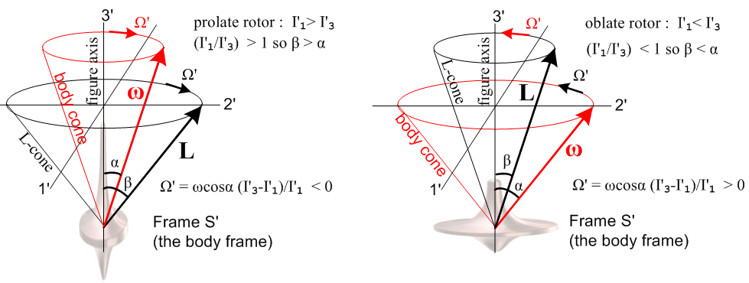

In either case, the ω and L vectors rotate in the same direction. The dizzy Frame S' Observer of course sees the rigid body rotor at complete rest with its symmetry axis ("figure axis") pointing in the ' = e'3 direction ("up"). Frame S and any objects at rest in Frame S are seen to be violently rotating about this Frame S' Observer. The vector L is the Frame S angular momentum of the rigid body, but we are just showing it in Frame S' coordinates. The Frame S' angular momentum L' of the rigid body is of course 0. The Observer can note that -ω is the angular velocity of Frame S relative to Frame S'. The Figures are not particularly interesting, but they do show the solution to the problem in Frame S' coordinates. Soon we shall show that β = θ, an Euler angle of the rigid body in Frame S.

The behavior of the Rigid Rotor in Frame S : solving for the Euler angles

Of much more interest is what things look like to an Observer in inertial Frame S. This takes a bit more work.

First, we shall assume that the position of the symmetric rigid rotor is described by the Euler angles (φ,θ,ψ) of Fig (G.5.5), so in Frame S one has

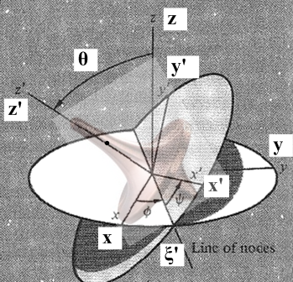

Frame S has axes x,y,z while Frame S' has axes x',y',z'. Recall the transformation for a vector r going from Frame S to Frame S',

x' = (cosψcosφ - sinψcosθsinφ) x + (cosψsinφ + sinψcosθcosφ) y + sinψsinθ z
y' = (- sinψcosφ - cosψcosθsinφ) x + (-sinψsinφ + cosψcosθcosφ) y + cosψsinθ z
z' = sinθsinφ x - sinθcosφ y + cosθ z . (G.5.26)

In Frame S where N = and N = 0, L must be a constant vector. We arbitrarily put this in the +z direction, so that L = L in Frame S. If we then apply the above transformation to L instead of r, we get

(L)'1 = sinθsinψ L
(L)'2 = sinθcosψ L
(L)'3 = cosθ L .

But our Frame S' problem solution ** with** gives

(L)'1 = Lsinβ cos(Ω't) Ω' = ωcosα (I'3-I'1)/I'1
(L)'2 = Lsinβ sin(Ω't)
(L)'3 = Lcosβ

Therefore we must have

sinθsinψ = sinβ cos(Ω't) so: cos(π/2-ψ) = sinψ = cos(Ω't)
sinθcosψ = sinβ sin(Ω't) sin(π/2-ψ) = cosψ = sin(Ω't) ⇒ Ω't = π/2-ψ
cosθ = cosβ

The solution to these equations is

θ = β // note that θ is a constant, tanθ = tanβ = (I'1/I'3) tan α
ψ = - Ω't +π/2
= - Ω'

This says that Euler angle θ is a constant, and also from ** that

sinθ = I'1ωsinα /L cosθ = I'3ωcosα/L tanθ = (I'1/I'3) tan α

We now rewrite *** as

(ω)'1 = ωsinα sinψ
(ω)'2 = ωsinα cosψ
(ω)'3 = ωcosα

Now if we set = 0 in our Frame S' Euler-angle evaluation of the (ω)'i given in (G.6.7). we find

(ω)'1 = sinθsinψ // ψ = Ω't, = Ω'
(ω)'2 = sinθcosψ
(ω)'3 = cosθ + = cosθ - Ω' (G.6.7)

Comparison shows that

sinθ = ωsinα
cosθ - Ω' = ωcosα .

From the first line above and then using ** we find,

= ωsinα/sinθ = L/I'1 ⇒ φ(t) = (L/I'1) t

We have now solved for the behavior of all the Euler angles which describe the orientation of our rigid rotor in Frame S:

θ(t) = tan-1[ (I'1/I'3) tanα ] // θ(t) = constant
ψ(t) = - Ω't + π/2 // Ω' = ωcosα (I'3-I'1)/I'1
φ(t) = (L/I'1)t

With regard to Fig **, the rigid rotor spins at rate -Ω' about its symmetry axis. While this happens, the symmetry axis precesses CCW at rate = (L/I'1) about the z axis. There is no nutation since the polar angle θ is a constant. The precession is CCW because we assumed that L = L where L = |L| . (If the rotor is a cube, since I'3 = I'1 one has = 0 since Ω' = 0. )

The behavior of the Rigid Rotor in Frame S : solving for ω

Recall the Frame S' solution for ω shown in ***,

(ω)' = $\left(\begin{matrix}ωsinα sinψ \\ ωsinα cosψ \\ ωcosα\end{matrix}\right)$ // sinψ = cos(Ω't) and cosψ = sin(Ω't)

To obtain the Frame S components of ω we have Maple compute ω = R-1(ω)' :

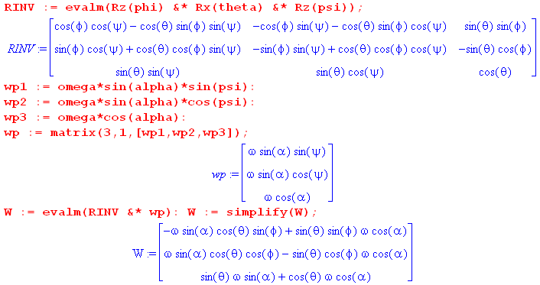

where W = ω . The resulting vector can be simplified by combining the trig terms:

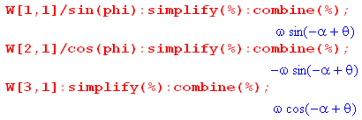

The final result is then

ω1 = ωsin(θ-α)sinφ
ω2 = - ωsin(θ-α)cosφ
ω3 = ωcos(θ-α)

Using φ = (L/I'1)t from *** this becomes

ω1 = ω sin(θ-α)sin[(L/I'1)t ]
ω2 = - ω sin(θ-α)cos[(L/I'1)t ]
ω3 = ω cos(θ-α) .
or
ω1 = ω sin(θ-α)cos[(L/I'1)t -π/2]
ω2 = ω sin(θ-α)sin[(L/I'1)t -π/2]
ω3 = ω cos(θ-α) .

If 0 < θ-α < π, then sin(θ-α) > 0. In this case, these equations describe, in Frame S, the counterclockwise precession at rate(L/I'1) of the vector ω.

Here for the prolate case is the famous picture traditionally used to torture students of rotational dynamics, where one should momentarily ignore the red cone :
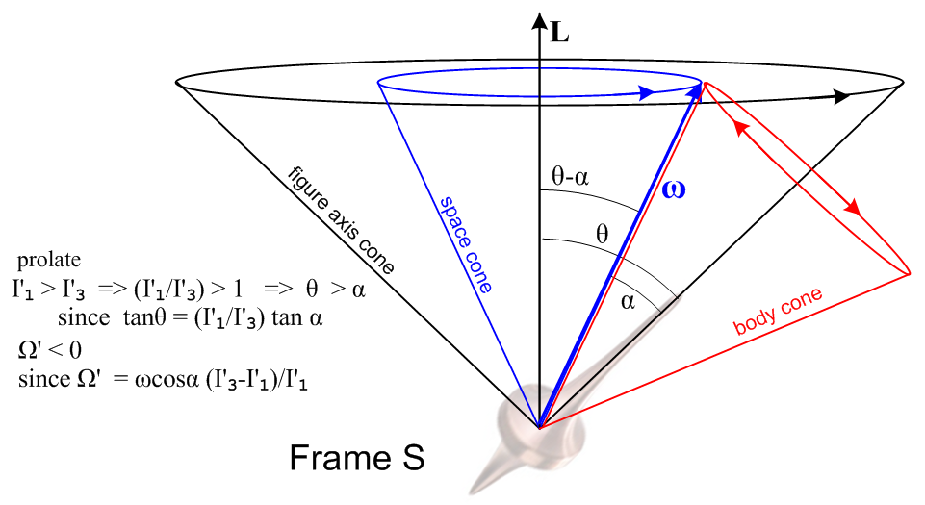

As just noted, ω does CCW conical motion at rate (L/I'1) on a cone of half-angle θ-α, shown in blue. The rigid rotor's symmetry axis meanwhile moves on the black θ cone and precesses along with ω at the same rate (L/I'1).
The is really the end of the Frame S story since it tells how the rotor figure axis moves, how its ω vector moves, and how L is fixed in the vertical direction since this is a torque-free system in Frame S.
One can (if one wants) superpose the red body cone from our Frame S' picture ***. Since there is only one ω vector, the body cone must be at a position like that shown. As blue ω rotates around on its fixed space cone, the red body cone must roll without slipping around the perimeter of the blue cone to maintain ω on the intersection of the two cones. Notice that the red direction arrows on the body cone match the rotation sense of the red arrow in the left drawing in **. To see why this corresponds to rolling without slipping, one must physically play with two cones. A substitute is two coins where one holds the left one fixed and rotates the right one about the boundary of the left one. Only then does one understand the red arrows! It is too difficult to put into words.
One can see that when the red cone is made narrower (smaller α), the angular rate of motion of ω on the red cone perimeter increases relative to the angular rate of ω on the blue cone. The blue rate is (L/I'1) while the red rate is Ω' = ωcosα (I'3-I'1)/I'1.
At this point, as an illustration of the above figure, the reader is invited to view Eric Johnson's short video https://www.youtube.com/watch?v=s9wiRjUKctU showing the motion of a prolate rotor. One sees how his purple L vector (called H) says fixed, and how the blue ω vector moves on its cone, and how the figure axis moves on a larger cone.
An American football in flight is a good example of a prolate rotor, see Horn and Fearn.

C. Horn and H. Fearn, "On the Flight of the American Football" (2013), https://arxiv.org/pdf/0706.0366

On the other hand, if the rotor is fat or oblate in shape with I'1< I'3, then Ω' > 0 and θ < α. The corresponding figure is shown below, where the blue and black cones of Frame S have not changed :

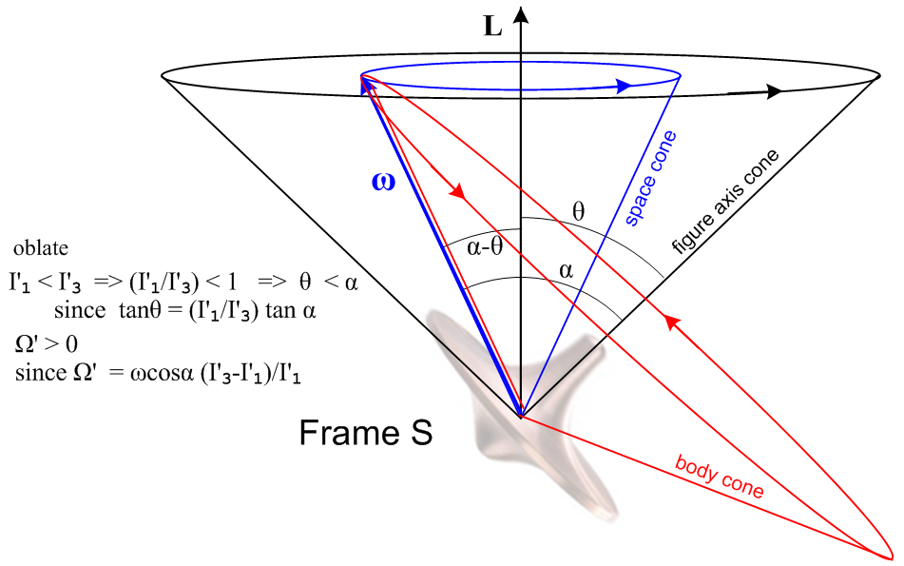

Now the red arrows on the body cone have the same directional sense as the right drawing in ** .

Reader exercise: Use two coins or two drink coasters to verify the direction of the red arrows.

Eric Johnson's oblate rotor video is here: https://www.youtube.com/watch?v=PDLXVSkDFVk .
Again the purple L = H vector is fixed, but now the figure axis cone lies outside the ω cone.

See https://www.youtube.com/watch?v=WUkUL3Hp67A for an animation of the prolate case body cone rolling around the space cone.

The Earth as an oblate rigid rotor

An overly ideal model of the Earth is that it is a rigid body that is slightly oblate near the equator due to the centrifugal force on the slightly elastic matter of the Earth (and its water) pulling matter out to a radius larger than the average radius of the Earth as one approaches the equator. As Goldstein notes on p 163, the moment ratio appearing in Ω' is about .0033 which predicts a precession rate of Ω ≈ (ω)'3/300 or T ≈ 300 days. Various inadequacies in this idealized model (Earth is not rigid, nor is it an exact oblate spheroid) are blamed for the fact that the precession period seems to be more like 434 days. Due to this precession the North pole moves in a circle of radius about 6 m. The precession cone half angle is a tiny 2" = 2/3600 degree. This effect is called the "free precession of the Earth" and is also known as the Chandler Wobble (S.C. Chandler 1891). Sometimes this precession is called a nutation since it is superposed on longer timescale precessions due to the torque of the Sun and Moon acting on the Earth as described below. (In fine detail, there are many factors which contribute to the Earth's axis wobble which in its aggregate is called the Chandler Wobble.)

Note that the free precession effect of the spinning Earth would occur if the Earth were completely isolated in space. It has nothing to do with external torques acting on the Earth.

Motion of a Rigid Body with External Torque : Spinning Symmetric Top

In this problem Frames S and S' have their origins co-sited at the top's point of contact with a "table". Frame S is the inertial frame of the table, with z pointing up. Frame S' is embedded in the spinning top. We assume that the top is symmetric and is spinning about its symmetry axis e'3 = ' and then I'1 = I'2. If we put a red paint dot on the top at some value of ψ, we can describe the position of the top at some time t by the Euler angles φ,θ,ψ of Section G.5 :

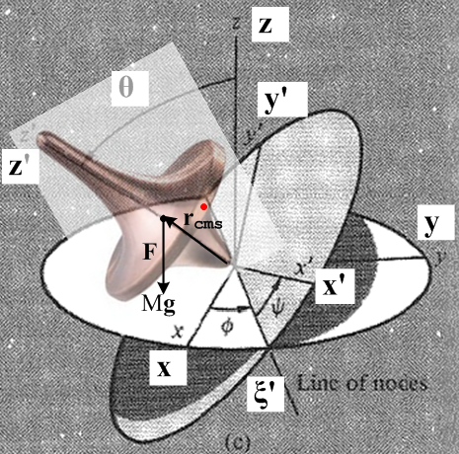

Gravity g = -g creates a downward force F = Mg = -Mg acting on the center of mass of the top, which lies at point rcms on the top's symmetry z' axis, some distance rcms up from the pivot point. Since F is parallel to while rcms is parallel to ', the torque N = rcms x F (referred to the common origin) must be perpendicular to both and '. The locus of points perpendicular to and ' is the line of nodes in the figure, the intersection of the two discs, so N points toward the viewer along the ' axis. The fact that the torque is perpendicular to the and ' axis reveals that the angular momenta associated with angles φ and ψ are constant. Those angular momenta are Lz = L3 for φ, and (L)'z = (L)'3 for ψ.

In Lagrangian language, this means that the coordinates φ and ψ do not appear in L and are therefore cyclic, so their generalized momenta pψ = (L)'z and pφ = (L)z are constants of the motion. In fact, from ** the kinetic energy

T = (1/2) (ω)'i(ω)'j(I)'ij = (1/2)(ω)'i2 I'i = (1/2)[ (ω)'12 + (ω)'22 ] I'1 + (1/2)(ω)'32 I'3

Recall from (G.6.7) that

(ω)'1 = sinθsinψ + cosψ
(ω)'2 = sinθcosψ - sinψ
(ω)'3 = cosθ + // Frame S' (G.6.7)

so that

(ω)'12 + (ω)'22 = [ sinθsinψ + cosψ]2 + [ sinθcosψ - sinψ]2

= 2 sin2θ + 2 . // cross terms cancel

Thus

T = (1/2)(2 sin2θ + 2) I'1 + (1/2)( cosθ + )2 I'3

If the zero of potential is set at z = 0, the Lagrangian is then

L = T - V = (1/2)(2 sin2θ + 2) I'1 + (1/2)( cosθ + )2 I'3 - Mgrcmscosθ .

The two constant generalized momenta are (constant since ∂L/∂φ = 0 and ∂L/∂ψ = 0),

pψ = ∂L/∂ = ( cosθ + )I'3 ≡ aI'1 // = (ω)'3I'3

pφ = ∂L/∂ = sin2θ I'1 + ( cosθ + )cosθ I'3 = (sin2θ I'1 + cos2θ I'3) + cosθ I'3 ≡ bI'1

Since (ω)'3 = cosθ + , we see that

(ω)'3 = (aI'1/I'3)

so (ω)'3 is a constant, consistent with the claim above that there is no torque about the z' axis. In other words, the spin rate of the top is constant (although in a real top it slows down due to friction).

Exercise: Show directly that the constants of the motion (L)'z and (L)z are the same as the generalized momenta pψ and pφ stated above.

(a) From L = Iω we know that (L)'z = (L)'3 = I'3 (ω')3 = I'3 ( cosθ + ), thus (L)'z = pψ.

(b) Write (L)z = L • = L • [(sinψsinθ)' + (cosψsinθ)' + (cosθ) ' ] using (G.5.32). Then

(L)z = sinψsinθ(L')1 + cosψsinθ(L')2 + cosθ(L')3

= sinψsinθ I'1(ω)'1 + cosψsinθ I'2(ω)'2 + cosθ I'3(ω)'3

= sinψsinθ I'1[ sinθsinψ + cosψ] + cosψsinθ I'2[ sinθcosψ - sinψ] + cosθ I'3[ cosθ + ]

= [sin2θI'1 + cos2θI'3 ] + cosθ I'3 since I'1 = I'2, thus (L)z = pφ .

We are closely following Goldstein page 165 where the constants of the motion (L)'z and (L)z are replaced by constants a and b. The equations of interest are then

I'3 cosθ + I'3 = aI'1
(sin2θ I'1 + cos2θ I'3) + cosθ I'3 ≡ bI'1

Multiply the first equation by cosθ and subtract 2nd - 1st to get

(sin2θ I'1 + cos2θ I'3) - I'3 cos2θ = bI'1 - cosθ aI'1
sin2θ I'1 = bI'1 - cosθ aI'1
sin2θ = b - cosθ a
so
= $\frac{b-acosθ}{sin2θ}$ .

Now put this into the first equation of ** to get

I'3[( b - cosθ a)/sin2θ] cosθ + I'3 = aI'1

( b - cosθ a)/sin2θ] cosθ + = a (I'1/I'3)

= a (I'1/I'3) - cosθ( b - cosθ a)/sin2θ

Once θ(t) is determined as outlined below, one can integrate ** and ** to get φ(t) and ψ(t).

A third constant of the motion is the total energy of the top,

E = T + V = (1/2)(2 sin2θ + 2) I'1 + (1/2)( cosθ + )2 I'3 + Mgrcmscosθ .

The second term in E is just a constant .

(1/2)( cosθ + )2 I'3 = (1/2)(ω'3)2 I'3 = (1/2)(aI'1/I'3)2 I'3 = (1/2)a2(I'12/I'3) = K

so we define E' = E - K as a re-zeroed energy to get,

E' = (1/2)(2 sin2θ + 2) I'1+ Mgrcmscosθ

Multiply by (2/I'1),

(2E'/I'1) = (2 sin2θ + 2) + (2Mgrcms/I'1) cosθ
or
α = (2 sin2θ + 2) +β cosθ α ≡ (2E'/I'1) β ≡ (2Mgrcms/I'1)
or
α sin2θ = 2 sin4θ + sin2θ 2 + βcosθsin2θ .

From ** replace 2 sin4θ by (b-acosθ)2

α sin2θ =(b-acosθ)2 + sin2θ 2 + βcosθsin2θ

and rearrange to get

sin2θ 2 = sin2θ(α - βcosθ) - (b-acosθ)2 .

Set u = cosθ so = -sinθ and then sin2θ 2 = 2, so the ODE becomes

2 = (1-u2)(α-βu) - (b-au)2 = α - u2α - βu +βu3- b2 +2abu - a2u2

= βu3 - (α+a2)u2 + (2ab-β)u + (α-b2)

= β(u-A)(u-B)(u-C)

where one can write A,B,C in terms of a,b,α,β. This is a solvable non-linear first-order ODE. Write

du/dt = $\sqrt{β(u-A)(u-B)(u-C)}$

and so

dt = du/$\sqrt{β(u-A)(u-B)(u-C)}$ and then

t(u) = (1/$\sqrt{β}$) $^{\int_{u0}^{u}{}}$dx $\sqrt{(x-A)(x-B)(x-C)}$ .

This is the exact same elliptic integral we encountered with the spherical pendulum in (C.5.13). One does the integral to get t(u) = (1/$\sqrt{β}$) [ f(A,B,C,u) - f(A,B,C,u0) ] and then one "inverts" to get u = u(t) and those one has found θ(t) = cos-1u(t). Functions φ(t) and ψ(t) are then found by integrating * and *.

From ** we may write

E' = (1/2)I'12 + { (1/2)I'1$\frac{(b-acosθ)2}{sin2θ}$+ Mgrcmscosθ }
or
α = 2 + {$\frac{(b-acosθ)2}{sin2θ}$+ βcosθ } = 2 + Ve(θ) α = 2E'/I'1, β = 2Mgrcms/I'1

where Ve(θ) is the effective potential for the top problem. We can then carry out the same qualitative turning point analysis as shown in Fig (C.5.17) and we find that θ(t) bounces back and forth between two angles θ1 and θ2. The tip of the top then has these typical motion patterns depending on the size of the four parameters a,b,α,β.

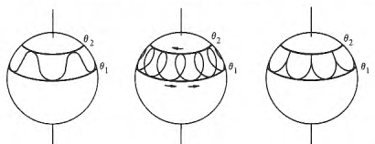

When the top has a large kinetic energy relative to its potential energy (it is spinning fast), the angles θ1 and θ2 are close together and the figure axis of the top precesses with a superposed small up and down motion called nutation, as in the leftmost drawing above.

Motion of a Rigid Body with External Torque : Example 2

Gravitational Torque on an oblate Earth

As a preliminary exercise, we consider the gravitational torque due to a large distant mass M on an circle of equally-spaced point masses m (only 4 are shown), with everything lying in a plane The masses m are glued to the rigid circle and we ignore their gravitational attraction to each other. The large distance from mass M to the circle center is b.

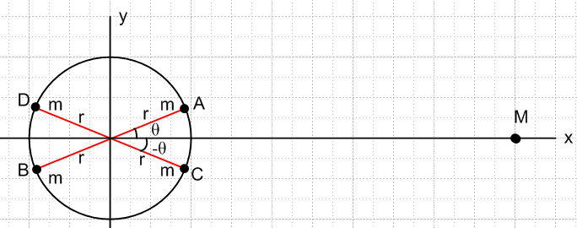

We can consider the mass pair AB to be a "dumbbell" of masses, and we have already computed in (F.3.13) the torque (about the circle center) on this dumbbell due to mass M, assuming b >> r,

NAB = - 6GMmb-3r2sinθcosθ . // μ2 = 1/2 (F.3.13) (**)

Because the mass A is closer to M than the mass B, the torque on mass A going into the plane of paper (right hand rule N = r x F ) is larger than the torque on mass B going out of the plane of paper, and the resultant torque on the dumbbell AB is into the plane of paper. This torque wants to restore the dumbbell AB to an aligned orientation, just as it does for any dumbbell satellite. However, the torque on the dumbbell CD is just the opposite of the torque on AB :

NAB = - 6GMmb-3r2sinθcosθ

NCD = - 6GMmb-3r2sin[-θ]cos[-θ] =
= + 6GMmb-3r2sinθcosθ
so
NAB + NCD = 0 .

When we sum over all pairs of masses on the circle, the net result is that mass M exerts zero torque on the circle of masses.

Consider now a tilted ellipse of equal point masses:

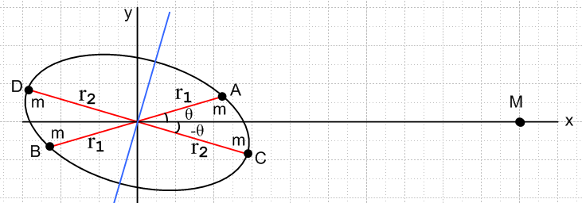

We now have

NAB = - 6GMmb-3r12sinθcosθ

NCD = - 6GMmb-3r22sin[-θ]cos[-θ] =
= + 6GMmb-3r22sinθcosθ

NAB + NCD = 6GMmb-3( r22 - r12) sinθcosθ

Since r2 > r1, the torque exerted by M on the pairs AB and CD is non-zero and is directed toward the viewer. When we sum over all pairs of masses on the ellipse, the net result is that mass M exerts a torque toward the viewer which wants to restore the ellipse of masses to an aligned position with the long ellipse axis lying along the x axis.

With this planar example as motivation, it seems reasonable that if the ellipse in Fig *** is a side view of an Earth which is oblate at the equator, mass M will exert a torque on the Earth which points out of the plane of paper and tries to bring the Earth into an aligned position with the equator in a plane normal to the y axis. It is helpful to redraw the picture with the Earth's blue rotation arrow ("figure axis") pointing up,

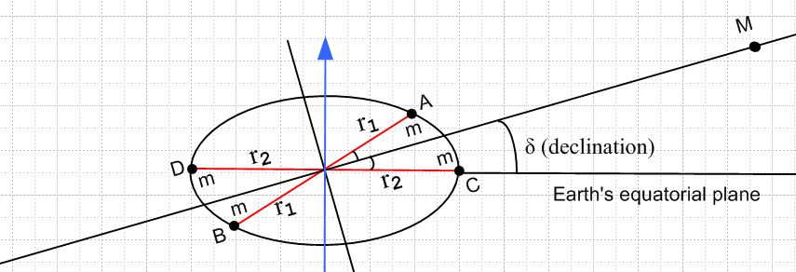

The reader will notice that we happened to pick the CD line segment to lie in the Earth's equatorial plane. This being the case, we replace our angle θ by δ, which is the "declination" (latitude) of mass M on the Earth's celestial sphere. If mass M is the Sun, then mass M has an apparent orbit around the Earth in a plane normal to paper which includes the long line segment (the ecliptic). The azimuthal coordinate of M is α, the right ascension (longitude on the celestial sphere), and at the instant shown above we have α = π/2 where the Earth's north pole is maximally tipped toward the Sun (summer solstice, June 21). At this time the Sun's declination reaches its maximal positive value of δ = 23.4o.
Going back to Fig **. as the Sun M moves around the oblate Earth, we can think of the Sun as staying put on the right (view from a special camera platform) but the oblate Earth wobbles with its blue rotation axis moving on a cone

gradually tips to the left and then back to the right over a period of a year. As this happens, one can see that the torque on the Earth is maximal out of the plane of paper at the time shown in the Figure. As the Earth tips to the left with M staying put, this torque maintains its direction (out of our paper plane), but its magnitude reduces to 0 when α = π. The torque then increases into the plane of paper as α continues to increase, reaching a maximum value into paper at α = 3π/2. There is never any torque in the direction of the Earth's blue rotation arrow which we shall now call direction z, while x and y are the other two celestial sphere axes.

The actual torque N is stated by Williams to be

N = $\left(\begin{matrix}Nx \\ Ny \\ Nz\end{matrix}\right)$ = 3GM b-3(I3 - I1) sinδ cosδ $\left(\begin{matrix}sinα \\ cosα \\ 0\end{matrix}\right)$

where I3 is the maximum principal moment of inertia about the Earth's rotation axis, and I1 = I2 are the other two equal moments. One can see at α = π/2 that Nx = 3GM b-3(I3 - I1) sinδ cosδ which is similar to our dumbbell expressions above.

Precession of the equinoxes

We think now of Frame S as an inertial frame associated with the Sun, and rotating Frame S' as being embedded in the Earth. When William's torque is inserted into our equations ***, one finds that the Earth's ω vector can precess relative to the stars with its cone half-angle of 23.4o and a period of about 81,000 years. But the Moon also orbits the oblate Earth, and causes the Earth to precess as well. As with the tides, the Moon's effect on precession is about twice that of the Sun's. The net result of the Sun and the Moon is that the Earth's rotation axis precesses with a period of around 26,000 years. These precession periods are long because the Earth is only slightly oblate and the resulting gravitational torques are relatively small. The net effect is known as "axial precession" and historically as "the precession of the equinoxes" since the seasons of the year slide about one degree per 72 years (~ 26,000/365).

