This is the Title PhL 1.11.15

The reader must now be inventive with the two coins in order to verify these red arrows, a good reader spatial geometry and hand dexterity exercise!

Now the red body cone brushes against the inner surface of the blue space cone

which can have either sign. When Ω' is positive, the picture is as shown above with the red cone outside the blue cone. If α is much smaller than θ, the red cone rolls quickly as appropriate for Ω' > L/I'1 . If Ω' is negative, the red cone lies on the inside of the blue cone as below,

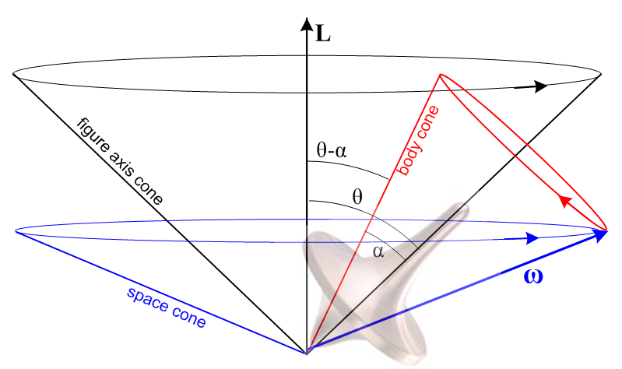

Rate Ω' is positive for α < π/2 if I'1 > I'3 which means the rigid rotor is narrow (prolate) with a small axial moment I'3 . A rotor which is fat and squat (oblate) will have a large I'3 so Ω' < 0 and the second figure applies.

