This has been installed, do not edit here

Appendix J : Relation between this document and Tensor Analysis and Curvilinear Coordinates

Although we use covariant notation in this Appendix, a reader unfamiliar with that subject should not be put off , and can perhaps peruse the document mentioned for an explanation.

In our document Tensor Analysis and Curvilinear Coordinates there is a general transformation x' = F(x) with dx' = Rdx where Rik(x) ≡ (∂x'i/∂xk) is the "differential" of the transformation F, and S = R-1 with Sik(x') ≡ (∂xi/∂x'k). This transformation is represented by "Picture A",

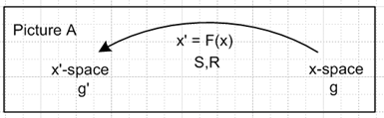 (J.1)

Each space has its own covariant metric tensor: gij for x-space and g'ij for x'-space.

If we let X = x-space and X' = x'-space, then F is a mapping F: X→ X' and F: x → x' = F(x) .

A contravariant vector V transforms under x' = F(x) as V'a = RabVb.

There are axis-aligned basis vectors in x-space called un. Also in x-space are the tangent base vectors en which are tangent to the coordinate lines in x-space, en = ∂'nx = (∂x/∂x'n). In general the en are not unit vectors, and in general they are not orthogonal to each other. In our polar coordinate example below, they happen to be orthogonal because polar coordinates is an orthogonal curvilinear coordinate system.

Notice that

(en)i = (∂xi/∂x'n) = Sin (J.2)

so the tangent base vectors en are the columns of the matrix S. Note also that

(en)i = Sin = Sim δmn = Sim (un)m = (R-1)im(un)m = [R-1un]i
so
en = R-1un (J.3)

One can expand a vector V onto either of these basis vector sets,

V = Vi ui = V'i ei . (J.4)

Picture A thus has a simple Passive View interpretation : There is a single vector V whose components in the ui basis are Vi, and whose components in the ei basis are V'i The components are related by the equation V'a = RabVb. In the Passive View, we can express this equation as (V)'a = RabVb to stress the fact that there is only one vector V. As a shorthand, we can then say (V)' = RV .

In the Active View we write the vector transformation equation as (V')a = RabVb to suggest that R acts on the vector V to create a new vector V' whose components are (V')a = RabVb . The original vector V lies in x-space, while the new vector V' lies in x'-space. We have R: X → X' and R: V → V' = RV .

In Tensor there is no "other meaning" for the vector V', so we can write (V)'a = (V')a = V'a .

With respect to the underlying transformation x' = F(x) (having differential matrix R), the transformation rules for tensors of rank 0,1,2,3 are

Passive View Active View Generic View (J.5)

0 (s)' = s (s') = s s' = s

1 (V)'a = RaiVi (V')a = RaiVi V'a = RaiVi

2 (T)'ab = Rai RbjTij (T')ab = Rai RbjTij T'ab = Rai RbjTij

3 (T)'abc = RaiRbjRcbTijk (T')abc = RaiRbjRcbTijk T'abc = RaiRbjRcbTijk

Example 1: The Transformation from Cartesian to Polar Coordinates

Let x' = F(x) be the non-linear transformation connecting Cartesian x,y and polar θ,r coordinates:

x1 = x2' cos(x1') or x = rcosθ // x = F-1(x') (J.6)
x2 = x2' sin(x1') or y = rsinθ .

The differential matrix R and its inverse S = R-1 are easily computed using the definitions above,

Sij = $\left(\begin{matrix}-rsinθ & cosθ \\ rcosθ & sinθ\end{matrix}\right)$ Rij = (S-1)ij = $\left(\begin{matrix}-sinθ/r & cosθ/r \\ cos(θ) & sinθ\end{matrix}\right)$ . (J.7)

Space X is Cartesian with metric tensor gij = δij and basis vectors

u1 = (J.8)
u2 = .

The tangent base vectors can be computed using en = ∂x/∂x'n and one finds that

e1 = eθ = r // note that e1 is not a unit vector
e2 = er = . // but e1 and e2 are orthogonal (J.9)

This is almost obvious recalling that the en are the columns of Sij.

The metric tensor in space X' is determined by g'ij = ei • ej so one finds that

g'ij = $\left(\begin{matrix}r2 & 0 \\ 0 & 1\end{matrix}\right)$ ≠ δij . (J.10)

Picture A for this example appears this way,

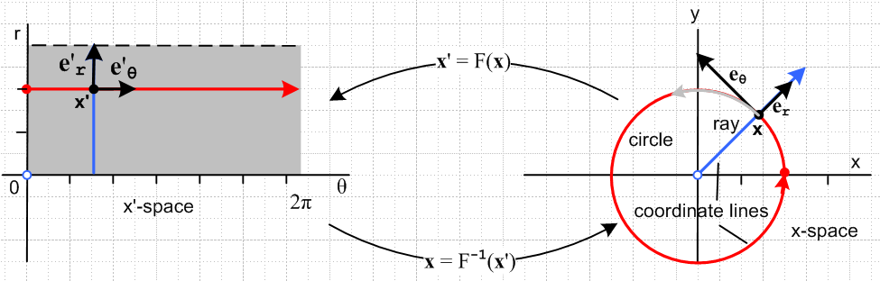
(J.11)

The blue locus on the right is the "r coordinate line" obtained by varying r and holding other components constant. The tangent base vector er is tangent to the blue coordinate line at point x. Similarly, the tangent base vector eθ is tangent to the red coordinate "line" at point x .

The position vector x = F-1(x') does not transform as a vector so x' ≠ Rx. But one always has dx' = Rdx so we know that velocity v = dx/dt transforms as a vector. Thus, v' = Rv. We can then expand a velocity vector in the two ways shown above.

v = vi ui = vx + vy

v = v'i ei = v'1e1 + v'2e2 = v'1( r ) + v'2() = r + ≡ vθ+ vr . (J.12)

In the Passive View there is only one velocity v, and we can determine its components in either basis. The components in the two basis are related by v' = Rv so

v'i = Rijvj // note that R is not a rotation matrix
or
$\left(\begin{matrix}v'1 \\ v'2\end{matrix}\right)$ = R $\left(\begin{matrix}v1 \\ v2\end{matrix}\right)$ = $\left(\begin{matrix}-sinθ/r & cosθ/r \\ cos(θ) & sinθ\end{matrix}\right)$$\left(\begin{matrix}vx \\ vy\end{matrix}\right)$ (J.13)
so
v'1 = -(sinθ/r)vx + (cosθ/r)vy ⇒ r v'1 = -sinθvx+ cosθvy = vθ = r
v'2 = cosθ vx + sinθ vy ⇒ v'2 = cosθ vx + sinθ vy = vr = (J.14)

Example 2: Lorentz Transformations

For the special case that x' = F(x) is a linear transformation, one can write x' = Fx where F is a matrix, and in this case R = F. A special case of this special case occurs when spaces X and X' are the same space. We can then regard F: X → X' to be a mapping F : X → X so that space X' (our x'-space) is completely unnecessary. Picture A above then becomes

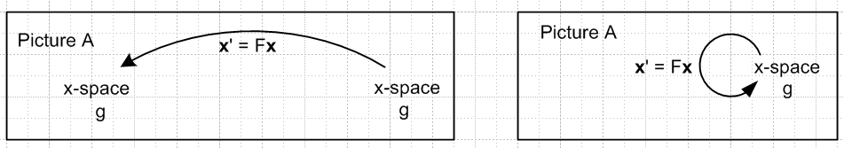 (J.15)

A further special case occurs when the elements of Fij are constants and don't depend on position x. This is the situation for Lorentz transformations in Minkowski space (spacetime).

For Lorentz transformations, the space X is a four dimensional space of 4-vectors. One has

x' = Fx F: x → x' x = (x1,x2,x3,x4) = (x,y,z,ct)
x' = (x'1,x'2,x'3,x'4) = (x',y',z',ct') (J.16)

where c is the speed of light and where we show the contravariant components of x. The metric tensor is gij = diag(1,1,1,-1) so that x•x = gijxixj = x2+y2+z2-c2t2. The Lorentz transformations are restricted by the requirement that x•x = x'•x' which makes them be rotations or boosts (velocity transformations). For example, Rz(θ) which rotates the (x,y) components into (x',y') and leaves (t,z) unchanged is a rotation, whereas Bx(u) which changes (t,x) into (t',x') and leaves (y,z) unchanged is a boost.
One speaks of the coordinates xi as being those in Frame S and x'i being those for Frame S', but both these frames are in the same space X. The idea behind x•x = x'•x' is that all reference frames related by boosts or rotations should be equivalent, none is special (there is no "ether").

For either type of Lorentz transformation (or for any combination), we can talk about an Active View:

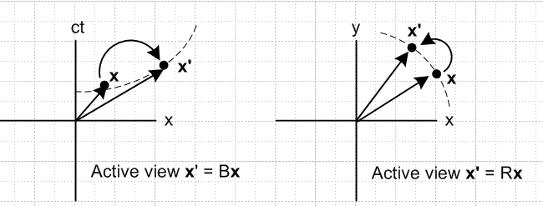 (J.17)

For either a boost or a rotation, the transformation x' = Fx starts with x in X and generates a new vector x' in the same space X. Because our pictures are both drawn in Cartesian space, it is not very easy to see that the quantity x•x = x'•x' for the boost picture on the left. The dotted curve represents x2-c2t2 = K < 0, and so it is in fact true that x•x = x2+y2+z2-c2t2 = x'2+y2+z2-c2t'2 = x'•x'.
We can redraw the above pictures replacing the 4-vector x by some generic 4-vector V to get

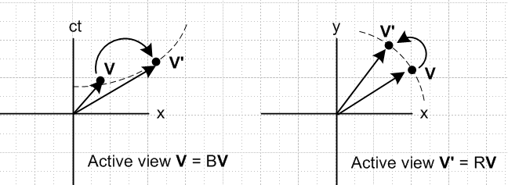 (J.18)

The meaning of the axis labels is this: in either picture, the horizontal component of V is Vx .

A typical vector Vμ would be the momentum of a particle pμ in which case p•p = pμpμ = -m2c2 where m is the particle mass, pμ = (px, py, pz, E/c) and p•p = px2 + py2 + pz2 - E2/c2. If the particle is at rest, one finds that -E2/c2 = -m2c2 or E = mc2.

In the Active View, one maps a vector V into a new vector V' whose components are (V')a = RabVb.

The axis-aligned unit basis vectors ui for space X are the expected , , , .

For any specific Lorentz transformation x' = Fx we have tangent base vectors en = ∂x/∂x'n ,

(en)i = (∂xi/∂x'n) = (∂[(F-1)ijx'j]/∂x'n) =(F-1)ij(∂x'j/∂x'n) = (F-1)ij δjn = (F-1)in . (J.19)

Unlike the case for polar coordinates, these en are the same at all points in X. We can expand V as noted earlier

V = Vi ui = V'i ei (J.20)

and we can then take the Passive View that there is one 4-vector V and it has coordinates Vi in the ui basis and V'i = (V)'i in the ei basis.

In many special relativity discussions, one writes x = (x0, x1, x2, x3) = (t, x, y, z) where units are selected to make the speed of light be c = 1. The metric tensor is gij = diag(-1,1,1,1) and then one has pμpμ = +m2c2 = m2. Component indices are Greek letters and a Lorentz transformation is written x'μ = Λμνxν .

Example 3: Rotations

This is a subcase of the previous case where now we ignore boosts and the only transformations are rotations. There is still of course an Active and Passive View and this is described in Section 1.3. For rotations there is no need to use covariant up and down indices since gij = δij, so we use only down indices in that Section and below.

For rotations, the vector x is a "tensorial" vector (unlike x in the polar coordinates example), and we can write x' = Rx where R is both the transformation matrix F and the differential matrix R. The tangent base vectors un span Frame S in space X, while the tangent base vectors en span Frame S' in the same space. Since R is a rotation, both the un and the en are orthonormal basis vectors.

Recall that the en are the columns of S. Since S = R-1 = RT for a rotation, this means the en are also the rows of R. Consider the specific rotation Rz(α) of (A.1) and we look only at the x and y axis. The R matrix is

R = Rz(α) = $\left(\begin{matrix}cosα & -sinα \\ sinα & cosα\end{matrix}\right)$ . (J.21)

Thus, the tangent base vectors are

e1 = cosα - sinα
e2 = sinα + cosα (J.22)
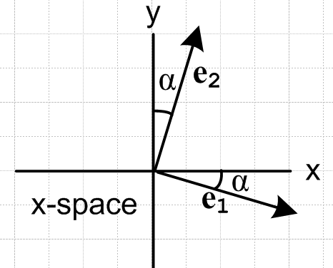 (J.23)

Notice that these basis vectors are versions of and that are "back-rotated" by α.

With respect to the underlying rotation x' = Rx having differential matrix R, the transformation rules for tensors of rank 0,1,2,3 are

Passive View Active View Generic View (J.24)

0 (s)' = s (s') = s s' = s

1 (V)'a = RaiVi (V')a = RaiVi V'a = RaiVi

2 (T)'ab = Rai RbjTij (T')ab = Rai RbjTij T'ab = Rai RbjTij

3 (T)'abc = RaiRbjRcbTijk (T')abc = RaiRbjRcbTijk T'abc = RaiRbjRcbTijk

As noted in Section 1.3, because the prime symbol has another meaning in our document's treatment of rotations, we use the Passive View to avoid overloading the meaning of objects like V'a and T'ab.

It happens that, for the rank 1 and rank 2 cases (only), matrix notation may be used to make the statements more compact. This is obvious for the vector case. For the rank-2 tensor T one has,

T'ab = Rai RbjTij = RaiTijRbj = RaiTijRTjb = (RTRT)ab = (RTR-1)ab . (J.25)

Thus we can rewrite rows 1 and 2 of the above table as

Passive View Active View Generic View

1 (V)' = RV (V') = RV V' = RV

2 (T)' = RTR-1 (T') = RTR-1 T' = RTR-1 (J.26)

Key Fact: The connection between this Appendix and our main document is as follows:

Basis Vectors Basis Vectors
This Appendix Main document Relation

Frame S un en en = R-1un
Frame S' en e'n e'n = R-1en (J.27)

It is unfortunate that the symbol en has a different meaning in the two systems.

Footnote: Tensor has other basis vectors it refers to as e'n and u'n which are axis-aligned and tangent base vectors for x'-space. Since these are associated with X' = x'-space. and since this space X' is not used in the rotation analysis, these basis vectors can be ignored.

