Rotating Frames of Reference
Phil Lucht
Rimrock Digital Technology, Salt Lake City, Utah 84103
last update: April 5, 2017
Overview 5
Summary 6
1. Notation, important role of the Prime Symbol, and other Preliminaries 10
1.1 Basis vectors e_{n} , e'_{n} , rotation R, Dirac notation, the Basis Theorem, and Concatenation 10
1.2 Expansions of a vector and use of primes and parentheses 23
1.3 Active and Passive Views of rotation, and a review of dot products 24
1.4 When are two vectors equal? 28
1.5 The small rotation of a vector about an axis 29
1.6 The time rate of change of a rotating vector 31
1.7 Rate of change of the basis vectors 33
1.8 Notations for the many time derivatives of vectors r, r', b and L 33
1.9 Angular momentum 37
1.10 No frame label is needed for d/dt of a scalar function 38
1.11 When do operations d/dt and taking a component "commute" ? 39
2. The G Rule for arbitrary vector a and its derivation 41
3. The Apparatus and its Observer at Rest in Frame S' 44
4. The Relationship between the Two Frames S and S' 46
4.1 Explanation of Fig (4.1.1): Frame S in the plane of paper 46
4.2 Explanation of Fig (4.2.1) : Vector ω pointing directly out of paper 47
4.3 Comments on _{S} and _{S'} 47
4.4 Special Case #1 : ω axis through Frame S origin 48
4.5 Special Case #2 : ω axis through Frame S' origin 49
4.6 The Turntable 50
4.7 The Earth 51
4.8 The Flying Camera Platform 52
5. The Goal of the next two sections 53
6. Determination of velocities 54
6.1 Velocity v_{S'} 54
6.2 Velocity v ≡ v_{S} 54
6.3 Velocity v'_{S} 55
6.4 Velocity Summary 55
6.5 Velocities for Special Cases 55
6.6 Comments 56
7. Determination of accelerations 58
7.1 Acceleration a'_{S} 58
7.2 Acceleration a ≡ a_{S} 59
7.3 Acceleration a_{S'} 60
7.4 Acceleration Summary 60
7.5 Relation between _{S} and _{S'} 60
8. The Fictitious Forces 62
8.1 Development of the Fictitious Forces 62
8.2 Interpretation of the Centrifugal and Euler Fictitious Forces 62
8.3 Interpretations of the Coriolis Fictitious Force 65
8.4 Special Case #1 Problems 69
8.5 Problems on the surface of the Earth 70
8.6 Tethered satellites and Tidal Forces 72
8.7 Special Case #3 77
8.8 Tides on the Earth 79
9. Notation comparison with Marion (1970) and Thornton & Marion (2003) 103
10. Notation comparison with Goldstein (1950) and Goldstein, Poole and Safko (2001) 105
11. Angular Momentum and Fictitious Torques; the Reynolds Transport Theorem 108
11.1 Introduction 108
11.2 Expression of L^{(c)} and ^{(c)} in terms of Frame S' objects 110
11.3 Fictitious Torques and Newton's Rotational Law in a non-inertial frame 112
11.4 Application: Fictitious Torques in Fluid Dynamics 113
11.5 Application: Fictitious Forces in Fluid Dynamics 115
11.6 Comments on the Reynolds Transport Theorem 116
12. Summary of the Forward Problem Solution 120
12.1 Summary of the Forward Problem equations (non-swap notation) 120
12.2 Summary of the Forward Problem equations (swap notation) 123
13. The Inverse Problem 126
13.1 Brute Force Method 126
13.2 Swap Rules Method 127
13.3 Summary of the Inverse Problem Equations (non-swap notation) 129
13.4 Summary of the Inverse Problem Equations (swap notation) 131
13.5 Why the Swap Rules Work 133
14. Rotating Frames in Curvilinear Coordinates 136
15. Ant on Turntable Problems 139
Kinematics common to all Ant Problems 139
15.1 Problem 1: Ant crawls at constant speed V to the Origin of Frame S' 144
15.2 Problem 2: Ant spirals in at constant V and Ω to the Origin of Frame S' 153
15.3 Problem 3: Inverse Problem: Ant flies in Frame S at constant velocity V 160
15.4 Problem 4: The Projectile Problem of Section 8.3 169
Appendix A: Derivation of R(ξ) and Properties of Rotation Matrices 175
Appendix B: The G Rule for a Tensor of Rank n 179
Appendix C: The Foucault Pendulum 185
C.1 Drawings, Notation, Coordinates and Basis Vectors 186
C.2 Qualitative Solution 189
C.3 Equations of Motion for the Foucault Pendulum (Spherical Coordinates) 189
C.4 The Simple Pendulum 192
C.5 The Spherical and Foucault Pendulums 199
C.6 Equations of Motion for the Foucault Pendulum (Cartesian Coordinates) 214
C.7 Verification of the Cartesian equations of motion and string tension 216
C.8 Numerical solutions of the equations of motion (Cartesian Coordinates) 220
Appendix D: Center of gravity and torque for a tethered satellite 229
D.1 Definition of Center of Gravity 229
D.2 Center of Gravity for a 2-mass Dumbbell Satellite 232
D.3 Dumbbell Satellite Center of Gravity with the Far Approximation: Numerical Examples 238
D.4 Dumbbell Satellite Center of Gravity for equal masses and no approximation 241
D.5 Center of Gravity for a single-sphere satellite 246
Appendix E: Spherical Coordinate Unit Vectors and Particle Kinematics 251
E.1 Angle Conventions 251
E.2 Matrix Approach 251
E.3 The motion of a particle in spherical coordinates 255
E.4 Curvilinear coordinates approach 256
E.5 Polar Coordinates 257
E.6 The Affine Connection 258
Appendix F : The Dumbbell (Tethered) satellite as an example of rotating frame analysis 261
F.1 Kinematics of the satellite in rotating Frame S 262
F.2 Angular momentum of the satellite and its time derivative in Frame S 265
F.3 The torque on the satellite in Frame S' 267
F.4 The fictitious torque on the satellite in Frame S 271
F.5 Equations of Motion for the satellite in Frame S (Spherical Coordinates) 274
F.6 Force analysis of the satellite in Frame S (Spherical Coordinates) 278
F.7 Numerical solutions of the equations of motion (Spherical Coordinates) 285
F.8 Force analysis of the satellite in Frame S (Cartesian Coordinates) 289
F.9 Verification of the Cartesian equations of motion and stick tension 293
F.10 Numerical solutions of the equations of motion (Cartesian Coordinates) 298
Appendix G: Rotation Matrices and Related Theorems 309
G.1 Generators and finite rotation matrices 309
G.2 About the general rotation matrix 311
G.3 The Baker-Campbell-Hausdorff and Sandwich Formulas 314
G.4 Two more theorems for the rotation matrix toolbox 316
G.5 Generalizations of the Rotation Group 319
Appendix H: The Euler Angles and Computation of ω 325
H.1 Euler Angles, Intermediate Rotations, and Unit Vectors 325
H.2 Theorem 3: Elimination of the Intermediate Rotations 331
H.3 Euler Angles : Triple Concatenation and Transformation of Vectors 333
H.4 Euler angles which change in time: computation of ω (Method 1) 338
H.5 Computation of ω (Method 2)* 342
H.6 The connection between Euler Angles and Spherical Coordinates 353
Appendix I: Rigid Body Dynamics 357
I.1 The Appearance of the Inertia Tensor 357
I.2 Rigid Body Equations of Motion : Part 1 360
I.3 Diagonalization of the Inertia Tensor in Frame S' 362
I.4 Rigid Body Equations of Motion : Part 2 363
I.5 Zero-torque motion of a Rigid Body : Ellipsoids and Poinsot 364
I.6 Zero-torque motion of an Axisymmetric Rigid Body (Rigid Rotor) 371
I.7 Rigid Body with External Torque: Spinning Symmetric Top 381
I.8 Gravitational Torque on an oblate Earth: Precession of the Equinoxes 388
I.9 Derivation of the Oblate Earth torque formula 392
I.10 Motion of an electric dipole dumbbell in a uniform E field 403
I.11 Rotors involving electric or magnetic dipoles 411
Appendix J : Connection with Tensor Analysis and Curvilinear Coordinates 420
References 427

Maple code is available upon request. Comments and errata are welcome.
The material in this document is copyrighted by the author.

The graphics look ratty in Windows Adobe PDF viewers when not scaled up, but look just fine in this excellent freeware viewer: https://www.tracker-software.com/product/pdf-xchange-editor .

The table of contents has live links, and use of a wide Bookmarks pane is recommended.

Overview

This monograph presents an extended discussion of doing physics in non-inertial frames of reference. The first chapters cover the general theory, while the latter chapters and appendices contain examples concerning ant paths on turntables, tides, pendulums, fluid flows, tether and dumbbell satellites, and rigid body dynamics. The presentation is entirely self-contained with all support material provided. Both linear (force) and rotational (torque) viewpoints are considered. Maple is used extensively to plot particle trajectories, to obtain and plot numerical solutions of differential equations (dsolve), and to verify complicated equalities. A lengthy summary of the document appears below.

Our general context is an Apparatus containing a Particle observed from two frames of reference called S and S'. Frame S' is rotating and translating in some arbitrary manner with respect to Frame S as indicated in this drawing,

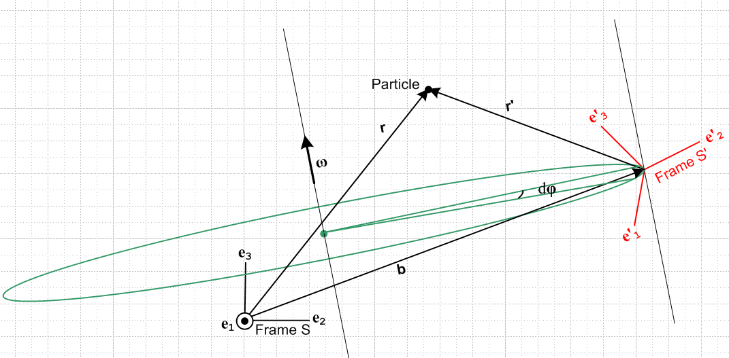 Fig 1

The Particle is located at position r relative to the Frame S origin, and at position r' relative to the Frame S' origin. These vectors are related by r = r' + b where b is a dynamic vector connecting the frame origins. Rotation is about some possibly moving axis with some angular velocity ω which might be changing in both direction and magnitude.
We describe the relationship between the properties of the Particle as measured in these two frames of reference. The entire discussion takes place in a non-relativistic framework where time is the same in the two frames. Even in this limited context, things are fairly complicated.
An important subtopic of the rotating frames discussion might be called "Newtonian mechanics in non-inertial frames" where one considers the fate of F = ma in a non-inertial frame. This is where the famous fictitious forces and less-famous fictitious torques appear.
Most mechanics textbooks which treat rotating frames, having a multitude of other topics to address, spend 10-20 pages on the subject with the following itinerary: state the G Rule (see below), use it to derive an inter-frame velocity and/or acceleration relation, discuss fictitious forces in a rotating frame with emphasis on the Coriolis force, do a few basic problems, and end up treating the Foucault pendulum. A notable exception is the book of Taylor which devotes 40 pages to the subject including a nice discussion of the tides. (In his book, our frames S and S' are called S0 and S.)
In this document, having the luxury of no space limitations, we try to probe more deeply into the technical nuts and bolts of rotating frames analysis. Almost all calculations are done in line for the reader to see.
The "papal we" mode of presentation is often used below, as if this paper had multiple authors who seem to own the equations, drawings and experiments as their personal possessions. The approved mode of course is to use passive or impersonal sentence constructions as if the author did not exist. Interestingly, Taylor uses the "I mode" which is perhaps more honest and is certainly refreshing.

Summary

SECTIONS

Section 1 is quite long and lays the notational foundation for the entire document with lots of examples.
As shown in Fig 1, a decision was made that Frame S' is the rotating frame, even though this conflicts with the choice made by many textbook authors. We refer to this notation as our non-swap notation and all our development work is done in this notation. One can imagine another version of Fig 1 with S ↔ S', which is then our swap notation. Often it is more convenient to have Frame S be the rotating frame to avoid an avalanche of primes in the equations of interest, and in that case the "swap" notation is more useful. All key results are summarized in Sections 12 and 13 in both "non-swap" and "swap" notations.
Unit basis vectors are ei and e'i for Frame S and Frame S'. A generic vector V can be expanded on either basis.
The presence of two frames of reference often associates with vector V another vector V' which leads to the need for a compact notation which distinguishes the components (V')i and (V)'i which are often different. The prime symbol ' plays a central role in the notation and is never used to indicate time differentiation (overdots are used for that purpose).
The Dirac notation is introduced as a method of making meanings clearer and expression evaluations more efficient.
What we call the Basis Theorem keeps track of two ways to deal with basis vectors: e'n = R-1en and e'n = ΣmRnmem where the first involves a sum over basis vector components while the second involves a linear combination of basis vectors.
Concatenation of transformations is treated in both these notations.
Because primes are special purpose labels for frame-related vectors, rotations of vectors and tensors are generally expressed in Passive View notation to avoid ambiguity.
After considering the meaning of equality for two vectors, we develop the notion of "conical motion" according to = ω x a and then apply that notion to the basis vectors. The need for putting a frame label on the time derivative of a vector (but not a scalar or vector component) is demonstrated. It is then shown that the Particle in Fig 1 has four distinct velocities and eight distinct accelerations, reinforcing the need for a precise notation.
Finally, it is noted that the operations of computing a time derivative and taking a component do not always commute.

Section 2 derives and discusses what we call "the G Rule", namely, (da/dt)S = (da/dt)S'+ ω x a where Frame S' rotates at rate ω relative to Frame S and a is an arbitrary vector.

Section 3 describes an Observer and an Apparatus containing a Particle, all of which are in the rotating Frame S'.

Section 4 explains the relationship between Frames S and S' for a general placement of the instantaneous rotation axis about which Frame S' rotates at vector angular frequency ω. Two special cases are identified for the location of this axis, and then three application scenarios are roughly outlined.

Section 5 (which is a very brief) states the goal of subsequent sections which is basically to determine how, given Particle properties in Frame S', one may determine these properties in Frame S. The results are eventually summarized in Section 12.

Section 6 derives the relationships among the four velocities mentioned above.

Section 7 derives the relationship among three of the eight accelerations. This and the preceding section are as dry as dust (mud's thirsty sister), but the results are of key importance, so everything is done step by step.

Section 8 addresses the traditional subject of fictitious forces and interprets them. First the centrifugal and Euler forces are interpreted with the aid of some drawings, then comes the Coriolis force. An arm-waving interpretation of this force is provided for a simple four-projectile problem (on a turntable), and an exact solution to this problem later appears in Section 15. Three applications involving fictitious forces are then considered, but not fully analyzed: problems with moving objects near the surface of the Earth, tethered satellites, and ocean tides.

Section 9 relates our notation to that used by Marion (1970) and Thornton & Marion [T&M] (2003). It is found that the Marion texts are very close to our "swap" notation.

Section 10 then relates our notation to that used by Goldstein (1950) and Goldstein, Poole and Safko [GPS] (2001). These texts assume that both reference frames have the same origin which simplifies their presentations.

Section 11 comments on the angular momentum vector L and its time derivative, and establishes how these vectors are related in the two frames. The notion of fictitious torques is introduced. It is demonstrated how both fictitious forces and torques are applied in fluid dynamics. Brief comments are made concerning fluid material and control volumes and the Reynolds Transport Theorem.

Section 12 summarizes the set of equations which fulfill the goal stated in Section 5: given properties in Frame S', what are they in Frame S? The results are given in both "non-swap" and "swap" notation.

Section 13 then considers the Inverse Problem: given properties in Frame S, what are they in Frame S'? The inverse equations are first obtained by laboriously inverting those presented in Section 12.1, and are then reobtained by a simple symmetry operation. The Inverse Problem equations are then summarized in both "non-swap" and "swap" notation.

Section 14 briefly adds the complication of having a different orthogonal curvilinear coordinate system in each of Frames S and S'. Up to this point, only Cartesian coordinates have been used.

Section 15 treats three "ant on turntable" problems in some detail. In the first two problems, the ant crawls in a certain manner on the turntable as it rotates (Frame S') and the ant's position, velocity and acceleration are computed in inertial Frame S. In the third problem, the ant flies in a straight line in Frame S just over the turntable surface, and the ant's position, velocity and acceleration are computed in Frame S'. Many (hopefully entertaining) Maple trajectory plots are presented, along with the very simple code for these plots. In the final section, the projectile problem of Section 8.3 is solved using the third problem results, and it is noted that sometimes there are hard ways to solve rotation problems that can be avoided.

APPENDICES

Appendix A computes a certain matrix R(ξ) which relates spherical unit vectors to Cartesian ones.

Appendix B derives the G Rule for a general tensor of rank-n.

Appendix C contains a detailed discussion of the plane (simple) pendulum, the spherical pendulum, and the Foucault mode of the spherical pendulum, including details of the Airy precession. Some Maple solution plots are provided. A compact summary may be found at the start of Appendix C.

Appendix D defines the notion of a center of gravity (as distinct from a center of mass) and computes the location of the center of gravity for various orientations of a dumbbell satellite. Certain intuitive notions regarding the location of the center of gravity are seen to be not fully accurate.

Appendix E summarizes useful facts about spherical coordinates. An emphasis is on relations involving the spherical unit vectors including their spatial and time derivatives. The position, velocity and acceleration of a point particle are expressed in terms of these spherical unit vectors. A small section provides similar information for polar coordinates.

Appendix F undertakes a detailed study of the motion of a dumbbell or tethered satellite in circular orbit around the Earth. The equations of motion are obtained both from a fictitious torque analysis and a fictitious force analysis. Numerical solutions are presented for satellite librations and more general motions. A compact summary may be found at the start of Appendix F.

Appendix G provides an in-depth discussion of general rotation matrices exp(-iθn•J) and their Lie algebra generators Ji. Sandwich formulas providing expressions for exp(-iθn•J)Jkexp(+iθn•J) are derived. Following a proof of the Baker-Campbell-Hausdorff formula, Rexp(-iθn•J)R-1 = exp(-iθn'•J) is proven, describing an arbitrary rotation of a general rotation matrix. Matrix exponentiation is explained, and det(eA) = etr(A) is proved. The last section provides some generalization to groups other than the rotation group and to dimensions other than three.

Appendix H describes the Euler Angles based on Goldstein's picture of same. The relations among the many involved rotations and unit vectors are laid out in full detail. The subject of time-changing Euler angles is addressed, and expressions for the rotation vector ω which relates Frame S and Frame S' are obtained in both Frame S and Frame S' components. These calculations of ω are carried out in several ways and the Frame S' result is verified with external sources. This result is essential to the description of rigid body motion where Frame S' is the body frame. Finally it is shown how the Euler angles are related to spherical coordinates.

Appendix I presents the theory of rigid body motion in non-swap notation where Frame S' is the rotating body frame and Frame S is the inertial space frame. Careful attention is paid to notation. The path is fairly standard, involving various ellipsoids, the Poinsot construction with its polhodes and herpolhodes, axisymmetric free rotation and fancy cone pictures, the de rigueur spinning top, and precession due to torques on non-spherical planets. Both the Chandler wobble and precession of the equinoxes of the Earth are discussed. An expression is derived for the torques exerted by astronomical bodies on other bodies which are slightly oblate or prolate spheroids. McCullough's formula is obtained relating moments of inertia to the ellipticity of a planet. Then after treating an electric dipole dumbbell and a general top with an embedded electric or magnetic dipole, we examine the Larmor precession of a self-generating magnetic dipole rotor and end with a few comments about MRI use of such dipoles, how MRI spatial localization works, and why MRI machines make so much noise.

Appendix J shows the connection between this document and Tensor Analysis and Curvilinear Coordinates. Both involve transformations, vectors and tensor objects.

References are then given for all works mentioned.

1. Notation, important role of the Prime Symbol, and other Preliminaries

1.1 Basis vectors en , e'n , rotation R, Dirac notation, the Basis Theorem, and Concatenation

Unless otherwise specified, repeated indices have implicit sums. For example (e'n)iei means Σi(e'n)iei.
This is known as the Einstein convention. We write δij in place of the usual δi,j. Both these conventions are efforts to reduce symbol clutter.

We have in mind operating in Euclidian space E3, but most everything in this section is valid in EN.

Let Frame S have orthonormal basis vectors en.
Let Frame S' have orthonormal basis vectors e'n. Thus,

en • em = δnm e'n • e'm = δnm . (1.1.1)

Assume that the two basis vector sets are related in this manner (implied sum on m),

e'n = Rnm em n = 1,2,3 RRT = 1 . (1.1.2)

This says that each basis vector of Frame S' is a certain linear combination of Frame S basis vectors. We shall assume that the matrix R of coefficients is real orthogonal (R-1 = RT or RRT = RTR = 1). Since RRT = 1, we know that det(R) = ± 1. Real orthogonal matrices with det(R) = - 1 are combinations of regular rotations with a reflection, whereas for regular rotations one has det(R) = +1.

Notice that the n on en and e'n is a label and not a component index.

Using a notation described more in the Section 1.2, we expand each basis vector onto both bases:

expansions projections

e'n = (ei • e'n) ei = (e'n)i ei (e'n)i = (ei • e'n)

e'n = (e'i • e'n) e'i = (e'n)'i e'i (e'n)'i = (e'i • e'n)

en = (ei • en) ei = (en)i ei (en)i = (ei • en)

en = (e'i • en) e'i = (en)'i e'i (en)'i = (e'i • en) . (1.1.3)

Lines 2 and 3 are not very interesting because they just say what we already know,

e'n = δin e'i = (e'n)'i e'i (e'n)'i = δin projection

en = δin ei = (en)i ei (en)i = δin projection . (1.1.4)

Now dot (1.1.2) [ e'n = Rnm em] first with ei and then with e'i and use the projections in (1.1.3) to get

(e'n)i = Rnm (em)i Frame S components

(e'n)'i = Rnm (em)'i Frame S' components . (1.1.5)

Using (1.1.1) write the first equation as

(e'n)i = Rnm δmi = Rni . (1.1.6)

For the second equation, one has

δni = Rnm (em)'i ⇒ RTknδni = RTknRnm (em)'i
⇒ RTki = (RTR)km (em)'i = δkm(em)'i= (ek)'i
and therefore

(ek)'i = RTki = Rik ⇒ (en)'i = Rin . (1.1.7)

So now we know all about the components of the basis vectors in each Frame :

(e'n)i = Rni (en)i = δni Frame S components

(en)'i = Rin (e'n)'i = δni Frame S' components (1.1.8)

Equation (1.1.1) says that either set of basis vectors is orthonormal. It is also true that each set of basis vectors is complete. In Frame S this means that any vector a can be expanded as a = anen. As in (1.1.3) one can then write

a = anen where an = (en • a ) ⇒ a = (en • a )en .

Writing this last equation out in Frame S components, one gets

aj = ( (en)iai )(en)j or aj = [(en)i(en)j] ai .

In order that this last equation be valid for any a, it must be true that (implicit sum on n) ,

(en)i(en)j = δij . // completeness of the en (1.1.9a)

This is the formal statement that the en are complete. The equation is obvious since with (1.1.1) it just says δniδnj = δij. Starting instead with a = (e'n • a )e'n one finds ai = ( (e'n)iai )(e'n)j and concludes that,

(e'n)i(e'n)j = δij // completeness of the e'n (1.1.9b)

From (1.1.8) this says RniRjn = δij which we know is true since RRT = 1. Thus the completeness statements are "nothing new". As we shall see in the Dirac world, completeness is very useful tool.

The Notation Problem

We shall soon be pondering equations of the following form,

a = Tb .

If we had only one basis en to worry about, we would simply state that T was a matrix and the meaning of the equation a = Tb is ai = Tijbj where ai and bi are Frame S components of a and b. However, when there are multiple bases involved (such as in dealing with "rotating frames of reference"), the meaning of the above equation is not so clear, especially when a and b are basis vectors in different bases. As we shall see, the existence of multiple bases implies the existence of tensors which are defined in terms of the transformation between those bases.
We have found, after a lifetime of pain regarding this subject, that the so-called Dirac notation described below always provides a clean, efficient and unambiguous meaning for expressions of the above type. In a sense, it is the Gold Standard, although we generally use simpler vector notations that have more ambiguity. Whenever an equation's meaning seems unclear, one should ask what that equation looks like in Dirac notation. For this reason, we ask the reader to absorb the following Dirac Notation digression.
The Dirac notation was invented for use in quantum mechanics by Paul Dirac (1947). It appears in most quantum mechanics texts (including Saxon, Schiff, Messiah and Shankar). Various Hilbert Spaces are associated with the notation in quantum mechanics applications (spin space, configuration space, momentum space, etc.) but we will only be concerned about the Hilbert Space E3 whose operators can always be represented by 3x3 real matrices in any given basis.
The Dirac notation does not add any new math or physics, it just makes things clearer. For example, we will say things like the following,

(T)'ij = <e'i| T | e'j> = (e'i)T T (e'j) = (* * *) $\left(\begin{matrix}* & * & * \\ * & * & * \\ * & * & *\end{matrix}\right)$$\left(\begin{matrix}* \\ * \\ *\end{matrix}\right)$
= (e'i)TnTnm(e'j)m = RinTnmRjm = (RTRT)mn .

In <e'i| T | e'j> we imagine the existence of an operator T whose matrix in the e'n basis is (T)'ij . As the vector notation on the right shows, this can all be done with normal vector/matrix notation and no "operator" is needed.
Various other notations have appeared in the literature from time to time to express the above idea. For example,

<e'i| T | e'j> = (e'i)TnTnm(e'j)m = e'i • (Te'j) = e'i • T • e'j = e'ie'j .

Often the Dirac notation is made even more compact by writing

<e'i| T | e'j> = <i'| T | j'> and 1 = | e'j><e'j | = | j'><j' | (completeness)

where only the minimal necessary information is displayed. We shall not take things this far.

Dirac Notation

In this notation, one writes

a = |a> = $\left(\begin{matrix}a1 \\ a2 \\ a3\end{matrix}\right)$ = "vector" // known as a "ket"

aT = <a| = ( a1,a2,a3) = "transpose vector" // known as a "bra" . (1.1.10)

In formal language |a> is a vector in the space H while <a| is a corresponding vector in the "dual space" H* (sometimes <a| called a covector). Notice how the dot product (scalar product, inner product) works in the following example,

a • b = aTb = ( a1,a2,a3) $\left(\begin{matrix}b1 \\ b2 \\ b3\end{matrix}\right)$ = <a|b> = a1b1+a2b2+a3b3 = a number . (1.1.11)
On the other hand, one writes

|a><b| = abT = $\left(\begin{matrix}a1 \\ a2 \\ a3\end{matrix}\right)$( b1, b2, b3) = $\left(\begin{matrix}a1b1 & a1b2 & a1b3 \\ a2b1 & a2b2 & a2b3 \\ a3b1 & a3b2 & a3b3\end{matrix}\right)$ = a 3x3 matrix (1.1.12)

where the vector components are implicitly in the en basis (since they have no primes).

Comments:

1. Sometimes abT is written ab and is called a "dyadic product" or a "dyad". Since [ab]ij = aibj, as (1.1.12) shows, the dyad is really just the "outer product" of two vectors, so abT = ab = a⊗b = |a><b| in four different notations!

2. A Hilbert Space is basically a vector space with an inner product a • b = <a|b>. Using |a| = •and then d(a,b) = | a-b | this space has an implicit "natural" norm and metric.

Since our space H is real (not complex), we know that

<a|b> = <b|a> or a • b = b • a . (1.1.13)

We can of course let a and b be any of the basis vectors en, e'n . For example, using (1.1.8),

δnm = (em)n = en • em = enTem = <en|em> = <em|en>

Rmn = (e'm)n = en • e'm = enTe'm = <en|e'm> = <e'm|en> . (1.1.14)

We now imagine that T is some operator in H, and |a> is some vector in H. We write,

T |a> = |Ta> where |Ta> is some new vector in H (new vector name is "Ta") (1.1.15)

In particular, we can write for the basis vectors en

T |en> = |Ten> . (1.1.16)

The definition of |Ten> is that it is what one gets by applying operator T to the vector |en> .

If we want to know the Frame S components of the vector |Ten>, we calculate them :

<em| T |en> = <em| Ten> = [Ten]m . (1.1.17)

We then define the matrix T to be

Tmn ≡ <em| T |en> so then [Ten]m = Tmn . (1.1.18)

Repeating the above in Frame S' gives,

(T)'mn ≡ <e'm| T |e'n> = <e'm|Te'n> = [Te'n]'m (1.1.19)

where we have now found the Frame S' components of |Te'n > = T |e'n>.

Notice the distinction between the matrices T and (T)', and the symbol T in the vectors [Ten] and [Te'n]. It is the same symbol T because these vectors are T |en> and T |e'n> with the same operator T. The symbol T in [Te'n] is not itself a matrix, it is part of the name of the vector [Te'n] .

One operator in H of special interest is the unity operator 1 such that 1 |a> = | 1a> = |a> for any vector |a> in H. In the Dirac notation one can write, for example in the e'n basis,

1 = |e'n><e'n| . // implied sum on n !!

This is in fact the statement of completeness in the e'n basis as we now show. "Closing" with <ei| on the left and |ej> on the right, one gets

δij = <ei|ej> = <ei| 1 |ej> = <ei| e'n><e'n| ej> = (e'n)i(e'n)j

and this replicates the completeness statement (1.1.9b). Completeness is valid in any basis, so

1 = |ei><ei| = |e'i><e'i| = |e"i><e"i| completeness in Frames S, S' and S" . (1.1.20)

By definition, any basis is a complete basis for the space it spans.

One might wonder how the matrices T and T' are related. Consider,

(T)'mn ≡ <e'm| T |e'n> = <e'm|1T1|e'n> = <e'm |ei><ei|T |ej><ej|e'n>

= Rmi Tij Rnj = Rmi Tij (R-1)jn = [R T R-1]mn

Thus the relationship is

(T)' = RTR-1 . (1.1.21)

This is in fact the (Passive View) transformation rule for the rank-2 tensor T, analogous to the Passive View transformation rule for a rank-1 tensor which is (V)' = RV (see Comment below). The actual tensor is the operator T while T is the matrix which represents T in the en basis. This tensor T can be expanded on the various bases in this manner

T = Tij |ei><ej| = (T)'ij |e'i><e'j| = (T)"ij |e"i><e"j| . // implied sum on i and j (1.1.22)

To verify that this is true, we can close for example with <e'm | and |e'n> to get

<e'm | T |e'n> = (T)'ij <e'm |e'i><e'j|e'n> = (T)'ij δmiδjm = (T)'mn

Similarly,

<e'm | T |e'n> = Tij <e'm |ei><ej|e'n> = Tij RmiRnj = RmiTij(R-1)jn = [RTR-1]mn = (T)'mn
and
<em | T |en> = (T)'ij <em |e'i><e'j|en> = (T)'ij RimRjn = (R-1)mi (T)'ij Rjn = [R-1T'R]mn = Tmn

If T = 1, then (1.1.22) replicates the statement of completeness,

1 = (1)ij |ei><ej| = δij |ei><ej| = |ei><ei| .

Sometimes one writes T = |ei>Tij<ej| so then 1 = |ei>δij<ej| = |ei><ei| .

Comment: The reader might be more used to the notations T' = RTR-1 and V' = RV to describe the transformations of rank-2 and rank-1 tensors under transformations. These two notations are appropriate if one takes the Active View of transformations where there is only one frame (Frame S) and then V' and V are different vectors in Frame S and similarly T and T' are different tensors in Frame S. Because we are dealing with two frames, Frame S and Frame S', each having different basis vectors en and e'n, we shall find it more convenient (and in fact essential) that we work in the Passive View of transformations, and in this view there are no objects V' and T', there are only V and T viewed from two coordinate systems. The transformation rules are then (T)' = RTR-1 and (V)' = RV which are shorthand statements for the component equations (T)'ij = RiaTabR-1bj and (V)'i = RijVj. This subject is discussed in Section 1.3 below.

The Basis Theorem

Recall now our assumed linear combination sum (1.1.2) which states

e'n = Rnm em or |e'n> = Rnm |em> . (1.1.23)

One regards the matrix Rnm as the representation of an operator R in the en basis, as in (1.1.18) for T, so

Rnm = <en | R |em> . (1.1.18) (1.1.24)

Note that

δnm = <en|em> = <en | RR-1 |em> = <en | R |ei><ei| R-1 |em> = Rni <ei| R-1 |em>

so one must conclude that

<ei| R-1 |em> = (R-1)im . (1.1.25)

Now apply R to (1.1.23) to get

R|e'n> = Rnm R|em> .

From (1.1.16) the left side is |Re'n> while the right side is

Rnm R|em> = Rnm |ei><ei|R|em> = Rnm |ei> Rim = RnmRim|ei> = RnmRTmi|ei>

= (RRT)ni |ei> = δni |ei> = |en> .

Thus we have shown that

e'n = Rnm em ⇒ |Re'n> = |en> or R|e'n> = |en> or Re'n = en (1.1.26)

where on the right we show three equivalent forms of the same equation.

[In the following sequence of steps, we show Dirac notation on the left and vector notation on the right.]

Conversely to the above, suppose we know that

R|e'n> = |en> Re'n = en .

Inverting we get

|e'n> = R-1|en> e'n = R-1en .

Since the basis en is complete, we know we can write, for some unknown coefficients Anm ,

|e'n> = Anm |em> e'n = Anmem . (1.1.27)

Comparing the last two equations one has,

Anm |em> = R-1|en> = |R-1en> Anmem = R-1en .

Now close with <ei| on the left to get

Anm <ei |em> = <ei |R-1|en> Anm (em)i = [R-1en]i = (R-1)ik(en)k
or
Anm δim = (R-1)in Anm δmi = (R-1)ik δnk = (R-1)in
or
Ani = Rni Ani = Rni .

Therefore (1.1.27) becomes,

|e'n> = Rnm |em> .

Thus we have shown that

R|e'n> = |en> ⇒ |e'n> = Rnm |em> (1.1.28)
or
Re'n = en ⇒ e'n = Rnm em .

We have now proved a simple theorem which seems to have no name, so we give it a name:

The Basis Theorem:

en = Re'n ⇔ e'n = Rnm em // vector notation
(1.1.29)
|Re'n> = |en> ⇔ |e'n> = Rnm |em> // Dirac notation
R|e'n> = |en>

The equation on the right concerns Frame S' basis vectors being linear combinations of Frame S basis vectors. The equation on the left says that the rotation operator R acting on |e'n> creates a rotated vector called |Re'n> (or Re'n) which is equal to |en> (or en ).

We can invert both sides of this theorem to get

e'n = R-1en ⇔ en = (R)-1nm e'm // vector notation
(1.1.30)
|R-1en> = |e'n> ⇔ |en> = (R)-1nm |e'm> // Dirac notation
R-1|en> = |e'n>

Alternate shorthand notations

en = Re'n ⇔ (e1, e2, e3) = R (e'1, e'2, e'3) = R (e'1, e'2, e'3) (1.1.31)

e'n = Rnm em ⇔ $\left(\begin{matrix}e'1 \\ e'2 \\ e'3\end{matrix}\right)$ = R $\left(\begin{matrix}e1 \\ e2 \\ e3\end{matrix}\right)$ . (1.1.32)

The first alternate notation implies for example that e1 = Re'1 . This is not implied by the second alternate notation which is meant to say e'1 = R11e1 + R12e2 + R13e3 = linear combination of vectors. These alternate notations are useful when the basis vectors have names like ,, or ,, as in Appendix H.

The matrices R and R'

Consider now the relation en = Re'n so that R relates the Frame S and Frame S' bases, as above. In this case, taking components one gets,

(en)i = [Re'n]i = Rij (e'n)j Frame S components

(en)'i = [Re'n]'i = (R)'ij (e'n)'j Frame S' components // note prime on (R)'ij (1.1.33)

In Dirac notation the above two lines may be expressed as,

(en)i = <ei | en > = <ei | Re'n> = <ei | R | e'n> = <ei | R | ej><ej | e'n> = Rij(e'n)j

(en)'i = <e'i | en > = <e'i | Re'n> = <e'i | R | e'n> = <e'i | R | e'j><e'j | e'n> = (R)'ij (e'n)'j .

We encounter two matrices here,

Rij = <ei | R | ej>

(R)'ij = <e'i | R | e'j> . (1.1.34)

Because the operator R is the same operator which relates the two bases, these two matrices are the same,

(R)'ij = <e'i | R | e'j> = <e'i | en><en | R | em><em | e'j> = Rin Rnm Rjm

= Rin Rnm RTmj = Rin (RRT)nj = Rin δnj = Rij . (1.1.35)

This fact is abundantly clear from (1.1.21) (T)' = RTR-1 which in this case says (R)' = RRR-1 = R.

As (1.1.14) shows, Rnm can also be written Rnm = <e'm|en> = <e'm| 1 |en>. Rnm is thus the matrix element of the unity operator in a "mixed basis". R is the "basis change matrix" between the two bases. One can consider any tensor in a mixed basis, but the notation gets a bit messy. For example one could write

T(e',e)mn = <e'm| T | en>

where instead a label prime or no prime for T, we have to supply a label which shows the two bases being used. For the unmixed bases we just say T(e,e)mn = Tmn and T(e',e')mn = (T)'mn.

Other Dirac Facts

We have managed so far to avoid the following Dirac notation facts, but now is a good time to get them on the table. Here we show Dirac notation on the left, and vector notation on the right :

|a> = |Xb> = X |b> a = Xb

<a| = <Xb | = <b| XT aT = (Xb)T = bTXT

<c | X |d> = <c | Xd> = <Xd |c> = <d| XT |c> cTXd = (cTXd)T = dTXTc . (1.1.36)

Notice in <a| = <b| XT that the operator XT acts to the left, just as the matrix in bTXT acts to the left on the transpose vector bT. Also, cTXd is just a number, so (cTXd) = (cTXd)T .

(1.1.24) acts to left (1.1.36) line 2 real orthog (1.1.29) (1.1.14)
Example: Rnm = <en | R |em> = [<en |R ] |em> = <RTen | em> = <R-1en | em> = <e'n|em> = Rnm

Suppose one knows that XXT = 1. That says Xij(XT)jk = δik or XijXkj = δik or

<ei| X|ej><ek| X|ej> = δik
or
<ei| X|ej><ej| XT|ek> = δik // (1.1.36)
or
<ei| XXT|ek> = δik . // (1.1.20)

Thus it must be that

XXT = 1 ⇔ XXT = 1 or XX-1 = 1 ⇔ XX-1 = 1 (1.1.37)

as one would expect.

Example:

(1.1.34) (1.1.37) (1.1.36) (1.1.29) (1.1.24) (1.1.34)
(R)'nm = <e'n | R |e'm> = <e'n | RTRR |e'm> = <Re'n | R |Re'm> = <en | R |em> = Rnm = (R)'nm

As an application of the above consider this fact, where R is our usual real orthogonal rotation matrix,

a • b = [Ra] • [Rb] or <a|b> = <Ra|Rb> . (1.1.38)

Proof: In vector notation one has, using en vector components,
(1.1.33)
[Ra] • [Rb] = [Ra]k[Rb]k = RkiaiRkjbj = (RT)jk Rkiaibj

= (RTR)jiaibj = δjiaibj = aibi = a • b .

In Dirac notation the proof reads, using (1.1.36) and (1.1.37),

<Ra|Rb> = <a|RTR|b> = <a| 1 |b> = <a|b> .

We can repeat our Proof using Frame S' components:
(1.1.35)
[Ra] • [Rb] = [Ra]'k[Rb]'k = R'ki(a)'iR'kj(b)'j = Rki(a)'iRkj(b)'j = (RT)jk Rki(a)'i(b)'j

= (RTR)ji(a)'i(b)'j = δji(a)'i(b)'j = (a)'i(b)'i = a • b .

Time dependence of the Rij

If Frame S is fixed and Frame S' is rotating, then we really have en = R(t)e'n(t) where the R matrix is a function of time, so we have Rij(t). Similarly, if Frame S is moving and Frame S' is fixed, en(t) = R(t) e'n and again one has Rij(t). Only in the case where there is no rotation between the frames are the Rij independent of time. This means that ω = 0 in Fig 1.

Concatenated Two Transformations

In this and the next section we use the notation T' to mean (T)' and similarly for other tensors.

Up to this point, we have dealt with a single rotation transformation en = R e'n for which the following facts are true (the left side is the Basis Theorem),

(1.1.29) (1.1.8) (1.1.21) (1.1.35)
en = R e'n ⇔ e'n = Rnm em e'i • ej = Rij , T' = RTR-1 , R = R' . (1.1.39)

Suppose we have a second rotation transformation e'n = S e"n . Then the claim is that,

e'n = S e"n ⇔ e"n = S'nm e'm e"i • e'j = S'ij , T" = S'T'S'-1 , S' = S" . (1.1.40)

Again, the left side is just a statement of the Basis Theorem for this second transformation. To verify the items on the right, consider

e"i • e'j = [S'im e'm] • e'j = S'im [ e'm • e'j ] = S'im δmj = S'ij .

Then,

T"ij = <e"i | T |e"j> = <e"i | e'm><e'm| T|e'n><e'n | e"j> = S'im T'mn S'jn

= S'im T'mn S'Tjn = S'im T'mn S'-1jn = (S'T'S'-1)jj

which shows that

T" = S'T'S'-1 .

Finally, applying this last equation to T" = S" one finds,

S" = S'S'S'-1 = S' .

so all three items in the right of (1.1.40) are verified.

Notice now that

en = R e'n = R (S e"n) = RS e"n . // |en> = RS |e"n>

Also,

e"n = S'nm e'm = S'nm (Rmk ek) = S'nm Rmk ek = (S'R)nkek .

On the other hand, we can apply the Basis Theorem directly to Q ≡ SR to get

en = RSe''n ⇔ e"n = (RS)nk ek .

Comparing the right sides of the last two e"n expressions one finds the seemingly contradictory result that

(S'R)nkek = (RS)nk ek

where the matrices seem to have reverse order on the two sides. But there is no contradiction because we know that S' = RSR-1 and therefore S'R = RS.

Concatenated Three Transformations

Since we are going to be dealing later with Euler angles which involve three basis transformations, we consider finally a third rotation transformation U whose facts the reader can easily verify,

e''n = U e"'n ⇔ e"'n = U"nm e''m e"'i • e''j = U"ij , T"' = U"T"U"-1 , U" = U"' . (1.1.41)

Concatenating transformations in the ways shown above one gets,

en = Re'n = RSe"n = RSUe"'n // = RSU |e"'n> (1.1.42)

e"'n = U"nm e''m = U"nmS'mi e'i = U"nmS'mi Rij ej = (U"S'R)nj ej ,

Now thinking RSU = Q, the Basis Theorem says,

en = RSUe'''n ⇔ e"'n = (RSU)nk ek . (1.1.43)

Comparing the last two expressions for e"'n we get (again with reverse ordered matrices),

(U"S'R)nj ej = (RSU)nk ek .

Can we show that in fact U"S'R = RSU ? Consider, using the tensor rules shown above,

U"S'R = (S'U'S'-1)S'R = S'U'R = (RSR-1)(RUR-1)R = RSU

so again there is no contradiction.

Since the matrices like R, S and U in basis en (Frame S) are likely to be known, whereas the others might have to be calculated, we prefer the RSU form shown in (1.1.43). In the alternate shorthand notation of (1.1.31) and (1.1.32) we shall write (1.1.42) and (1.1.43) in this manner

(e1, e2, e3) = RSU(e'''1, e'''2, e'''3) or (|e1>, |e2>, |e3>) = RSU(|e'''1>, |e'''2>, |e'''3>) (1.1.44)

$\left(\begin{matrix}e'1 \\ e'2 \\ e'3\end{matrix}\right)$ = RSU $\left(\begin{matrix}e'''1 \\ e'''2 \\ e'''3\end{matrix}\right)$ . (1.1.45)

In (1.1.45), R S and U are always matrices in the en (Frame S) basis. In (1.1.44), recall that [RSUe'''1] is the name of the vector obtained by applying RSU to the vector e'''1. If we take en components of this equation, then we may regard R, S and U as Frame S matrices, since in that case,

(en)i = (RSU)ij (e'''n)j = RinSnmUmj (e'''n)j .

However, if we take Frame S' (or some other frame) components, we get different matrices, for example,

(en)'i = (RSU)'ij (e'''n)'j = R'inS'nmU'mj (e'''n)'j .

We shall make use of (1.1.44) and (1.1.45) in our discussion of Euler Angle rotations in Appendix H.

1.2 Expansions of a vector and use of primes and parentheses

Note: We write (a)i as a component of vector a , but (en)i as a component of en . In the first case the a in (a)i is not bolded, but since en is decorated with a label n, it gets bolded. It is just our convention.

We now formalize what we have been doing all along in Section 1.1.

Any vector a can be expanded on either set of basis vectors ei (Frame S) or e'i (Frame S') so that, with implied summation on i,

a = ai ei = a'i e'i . ai = a • ei a'i = a • e'i . (1.2.1)

If some other vector named a' is lurking in the wings, one might want to be more careful labeling components. A safe method is this (which we have already used in Section 1.1),

a = (a)i ei = (a)'i e'i (a)i = a • ei (a)'i = a • e'i
a' = (a')i ei = (a')'i e'i (a')i = a' • ei (a')'i = a' • e'i . (1.2.2a)

Here, a prime inside a parentheses is part of the vector name, whereas a prime outside a parentheses denotes a vector component in Frame S' (whereas no prime outside means a component in Frame S). Unless the relationship between vectors a and a' has a certain simple form, it is very likely that (a')i ≠ (a)'i . In this case the notation a'i would be ambiguous since one doesn't know whether it refers to (a')i or (a)'i. It is true that the notation ai could be unambiguously identified with (a)i, but we shall sometimes maintain the parentheses just to be uniform.
We repeat (1.2.2a) in Dirac notation

|a> = (a)i |ei> = (a)'i |e'i> (a)i = <ei|a> (a)'i = <e'i|a>
|a'> = (a')i |ei> = (a')'i |e'i> (a')i = <ei|a'> (a')'i = <e'i|a'> . (1.2.2b)

Matrix Notation to show how components are related.

Let R be the transformation appearing in the Basis Theorem (1.1.29) such that e'n = Rnm em and en = Re'n.
Consider the following expansion of vector a on the basis vectors e'j,

a = (a)'j e'j // (1.2.2)

= (a)'j { Rji ei } // e'n = Rnm em , linear combination of vectors

= (a)'j { (R-1)ij ei } // R = (R-1)T real orthogonal rotation

= { (R-1)ij(a)'j )ei . // reorder (1.2.3)

Comparing this to a = (a)i ei of (1.2.2) we conclude that, since ei is a complete basis,

(a)i = (R-1)ij(a)'j so (a)'i = Rij(a)i // (a)' = Ra (1.2.4)

where R-1 is a 3x3 rotation matrix.

We can repeat the above discussion replacing a with a' with this result,

(a')i = (R-1)ij(a')'j . so (a')'i = R ij(a')i // (a')' = Ra' (1.2.5)

These matrix equations are convenient for computing the components of a vector in the ei basis if they are known in the e'i basis (and vice versa). The commented notations are described below.

1.3 Active and Passive Views of rotation, and a review of dot products

Basis Vectors, Kinematic Vectors, Active and Passive Views

We imagine an Apparatus in Frame S which "contains" (is described by, is associated with) various vectors of interest (in addition to scalars and perhaps fancier tensors). We refer to these vectors as Kinematic Vectors, examples being the position r of some particle of the apparatus, or the velocity v or acceleration a of that particle, or some electric field E at point r.

Active View

If the entire apparatus is forward-rotated (by a positive angle according to the right hand rule) by R about the Frame S origin, all these Kinematic Vectors transform in the usual manner (V')i = RijVi or V' = RV. For example, a point that was located at position r in the apparatus (in Frame S) is now located at a new position r' = Rr in Frame S. The Frame S Basis Vectors en do not move, only the apparatus moves. We call this the Active View of rotation. The vector V' is a new vector in Frame S that is different from V. There are no vectors e'n and there is no Frame S'. Graphically,

R = Rz(α) V' = RV = Rz(α)V

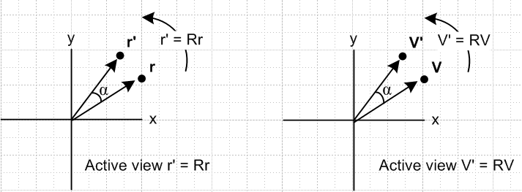 (1.3.1)

In the Active View one writes,

(V')i = RijVj ⇔ V' = RV or (V') = RV . (1.3.2)

Passive View

Alternatively, suppose the apparatus stays put, but the basis vectors en are back-rotated about the Frame S origin into new Frame S' basis vectors e'n such that e'n = R-1en . In this case, the components of vector V (which were Vi in Frame S) become (V)'i = RijVj in Frame S'. There is no vector named V'. We call this the Passive View of rotation. Our convention for writing (V)'i = RijVj in vector notation is this

(V)'i = RijVj ⇔ (V)' = RV // but e'n = R-1en (1.3.3)

Graphically we illustrate the above passive view situation (also valid with V replaced by r ) :

e'n = R-1en = [Rz(α)]-1 en = Rz(-α) en R-1 = Rz(-α) = "back-rotation"

' = Rz(-α) ' = Rz(-α) basis vectors are "back-rotated" by right-hand-rule

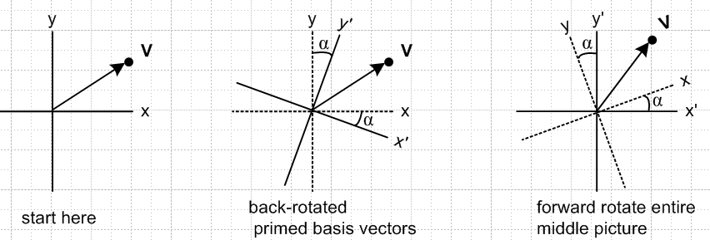

Basis vectors and new basis vectors ' and '

(a) Frame S seen (b) Frame S and Frame S' (c) Frame S and Frame S'
from Frame S seen from Frame S seen from Frame S'
(1.3.4)
Here is a Dirac interpretation of the Passive View and (1.3.3) :

|e'n> = |R-1en> = R-1 |en> basis vectors e'n = R-1en

(1.1.20) (1.1.14)
(V)'i = <e'i|V> = <e'i |ej><ej| V> = RijVj kinematic vectors (V)' = RV

In the passive view, one might choose to create a new vector V' according to the rule V' ≡ RV. In this case, one now has two vectors V' and V with (V')i = (V)'i. One can then replace (V)' = RV with the statement V' ≡ RV which is then exactly the same statement one sees for the Active View.

Aside: The equation V' ≡ RV really is a vector equation, and you could evaluate it in either Frame S or Frame S' as (V')i = RijVj or (V')'i = [RV]'i = (R')ijV'j = RijV'j. The equation (V)' = RV is not a real vector equation, it is just a vector shorthand notation for (V)'i = RijVj .

However, suppose the vector V' already has some other meaning unrelated to the above discussion. Then we cannot use the Active View, because then V' = RV (being the actively rotated vector V), will very likely not be the same as the vector V' from its unrelated other meaning. In this case we have an overloaded notation. In terms of components, we will have (V')i ≠ (V)'i .

To restate the above, if V' has some other predefined meaning, we can (and will) use the Passive View, but we cannot go that extra step to create V' ≡ RV because then V' would be overloaded. So in this case, we must always use (V)' = RV (which does not involve the vector V' ).

We shall directly encounter this situation in subsequent sections. For example, in Fig 1 we show the relation r' = r + b so the vector r' already has a definition, so we cannot define r' ≡ Rr. Similarly, we shall write write in (6.6.c) that v = v' + ω x r + S' where v and v' are the "natural" velocities of a particle in Frames S and S'. This is of course incompatible with v' ≡ Rv , but (v)' ≡ Rv of the Passive View is OK. Again here we shall have (v')i ≠ (v)'i .

To summarize, The Kinematic Vectors and the Basis Vectors are in two disjoint classes: no vector is in both classes. In the Active View, all the Kinematic Vectors forward-rotate while all the Basis Vectors en stay put. In the Passive View the Kinematic Vectors all stay put, while the Basis Vectors en are back-rotated into new basis vectors e'n which define Frame S'.

This subject can be deceptive, so we roll out a simple example in an attempt to exterminate a recurring confusion.

Example: The vector is a Basis Vector so one has ' = R-1 in the Passive View. If the vector r is a point in the Apparatus, one has r' = Rr in the Active View. There is no equation which says ' = R analogous to r' = Rr because is not an Kinematic Vector, it is a Basis Vector.
Now suppose in Frame S some point in the apparatus happens to be located at r = . This is potentially confusing since r is a Kinematic Vector and is a Basis Vector and in Frame S these vectors happen to be equal. Consider,

View General r Specific r =

Active r' = Rr r' = R ≠ ' since ' does not exist

Active + Create ' ≡ R-1 r' = Rr r' = R ≠ ' (since ' = R-1)

Passive (r)' = Rr (r)' = R ≠ ' (since ' = R-1)

Passive + Create r' ≡ Rr r' = (r)' = Rr r' = (r)' = R ≠ ' (since ' = R-1)
(1.3.5)

In all of these possible Views, although we start with r = , we always find r' ≠ ' or (r)' ≠ .

The reason this can be confusing is that one says p = mv in Frame S, so one gets p' = mv' in the Active View, or (p)' = m(v)' in Frame S' in the Passive View. Similarly, one casually thinks that with r = in Frame S, one ought to get r' = ' or (r)' = ' in Frame S'. In the first case p and v are both Kinematic Vectors, but in the second case r is a Kinematic Vector but is a Basis Vector.

Reminder: The last line of (1.3.5) is not an acceptable View if the vector r' already has some other definition.

Rank-2 tensors in Active and Passive View

In the Active View, the tensor T' = RTR-1 is a new tensor in Frame S, different from T. There is no Frame S', there are no basis vectors e'n .

In the Passive View one has (T)' = RTR-1 meaning (T)'ij = RiaTabR-1bj . There is no tensor named T' different from T, there is only tensor T viewed from the two frames. In Dirac notation we quote
the statement made above (1.1.21),

(T)'mn ≡ <e'm| T |e'n> = <e'm|1T1|e'n> = <e'm |ei><ei|T |ej><ej|e'n>

= Rmi Tij Rnj = Rmi Tij (R-1)jn = [R T R-1]mn ⇒ (T)' = RTR-1

Dot Products and Scalars

Suppose a and b are two apparatus Kinematic Vectors. Barring external definitions of a' or b', in the Active View we then have a' = Ra and b' = Rb. We know using (1.1.38) that

a • b = [Ra] • [Rb] = a' • b'. (1.3.6)

As an example, one then has a • a = a' • a' which says |a|2 = |a'|2. Thus a real orthogonal transformation R is one which preserves the length of a vector. Note that both regular rotations (detR = 1) and reflections (detR = -1) have this property.
Since the dot product a • b has the same value in Frame S as in Frame S', it is a "rotational scalar", as distinct from a "scalar" which sometimes just means a 1-tuple.
Instead of dealing with two Kinematic Vectors, we can look at the dot product of two Basis Vectors. We have already seen in (1.1.1) that

en • em = e'n • e'm = δnm . (1.3.7)

Although this dot product is the same in both Frames, it is not a scalar. It is a rank-2 tensor which is known as the metric tensor.

From (1.1.3) and (1.1.8) the other possible Basis Vector dot product is

en • e'm = (e'm)n = e'm • en = (en)'m = Rmn = (R)'mn // last equality is (1.1.35) (1.3.8)

which is the rotation matrix. One can regard Rmn as a trivial rank-2 tensor since it transforms as T' = RTR-1 for T = R. This dot product has "one foot in each Frame" so it makes no sense to ask if it is a scalar which has the same value in the two Frames.
What about the dot product of a Kinematic Vector with a Basis Vector? We find

a • en = (a)n a • e'n = (a)'n a' • en = (a')n a' • e'n = (a')'n . (1.3.9)

These dot products are neither scalars nor rank-2 tensors. They are all some kind of vector components. If a' has no other externally predefined meaning, we can write a' = Ra and then from (1.1.38),

(a')n = a' • en = [Ra] • [Re'n] = a • e'n = (a)'n ≡ a'n (1.3.10)

In this special case we end up with (a')n = (a)'n which we could then call a'n without ambiguity. But as shown in (1.2.5), we are still stuck with (a')'n = R nm(a')m = Rnma'm = (Ra')n = (R2a)n ≠ an.

As noted above, soon we shall be dealing with the Fig 1 equation r' = r - b. Since this is not of the form r' ≡ Rr , we may not dispense with the parentheses, and we expect that (r')i and (r)'i will be different.

Comment: If both Frame S and Frame S' are static (so they are inertial frames), then both force F and acceleration a transform as kinematic variables so F' = RF and a' = Ra. In this case Newton's Law F = ma in Frame S becomes F' = ma' in Frame S'. Since this equation has the same form in both Frames, it is said to be covariant under rotations. All valid laws of physics must be covariant under rotations, and also under the velocity boost transformations of special relativity.

1.4 When are two vectors equal?

This topic will probably seem strange and unnecessary, but it has been a constant annoyance to the author so here are some words on the subject.
When we say two vectors A and B are the same or are equal, we mean that the two vectors have the same components in the same coordinate system and we write A = B. This does not require that vectors A and B coincide. It might be that B is a translated copy of A. To be really fussy, we could define a stronger equality A B to mean that not only do the vectors have the same components in the sense of A = B, but the vectors actually coincide with each other. We shall have no use for A B in this document. For us, two vectors are "the same" even if translated from one another.
In light of this interpretation of vectors being equal, we can examine the meaning of certain statements. For example, we normally say "a particle is located at r in Frame S ". This really means the particle is at point r in Frame S which has coordinates (x,y,z). What this means in terms of the graphic vector r is that if the vector r is translated so that its tail is at the origin of Frame S, then its tip will be at the particle location. The vector r can be drawn anywhere in a picture. It describes the displacement of a particle in Frame S from the origin in Frame S.

Example: When we say en = Re'n as in (1.1.29), it is understood that the tails of all vectors involved (the en and the e'n) are at a common location, as in this picture

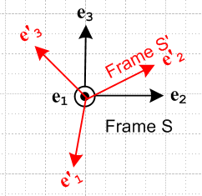 (1.4.1)

even though, in our application of Fig 1, the en are drawn with their tails at the origin of Frame S while the e'n are drawn with their tails at the origin of Frame S'.

Example: In the expansion r = (r)iei we normally think of vector r having its tail at the origin of Frame S, while in the expansion r = (r')'ie'i one would be inclined to think of vector r as having its tail at the origin of Frame S'. In our stricter sense of coincidence noted above, we might say (r)i ei (r')'i e'i but this is not of interest. What we care about is that (r)i ei = (r')'i e'i in the sense A = B above and we don't care if the vectors A and B are translated relative to one another. What we care about is that the vectors have the same components in any given Frame.

1.5 The small rotation of a vector about an axis

We do this first algebraically and second geometrically. In the algebraic (linear algebra) approach, the reader must accept a few facts about rotation matrices. The 3x3 matrix which rotates a vector by angle φ about rotation axis according to the right hand rule is obtained by exponentiating another 3x3 matrix,

R(φ) = exp(-i φ • J) , (1.5.1)

where the (J)k are 3x3 matrices known as the rotation generator matrices:

J1 = 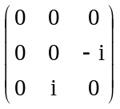 J2 = 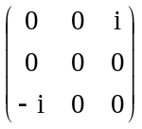 J3 = 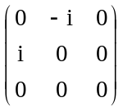 . (1.5.2a)

The numbers in these three matrices can be summarized in this single statement,

(Jk)ij = - i εkij (1.5.2b)

where ε is the totally antisymmetric permutation tensor defined by

εabc = +1 if abc is an obtained from 123 by an even number of pairwise swaps (such as 312)
εabc = -1 if abc is an obtained from 123 by an odd number of pairwise swaps (such as 213)
εabc = 0 otherwise (ie, when two or more indices have the same value such as 122 or 333) . (1.5.3)

Note that εabc = - εbac regardless of index value. A cross product component can be expressed in terms of the permutation tensor as [a x b]i = εijkajbk with implied sums on j and k. The determinant of a 3x3 matrix can be written detA = εijkA1iA1jA1k = εijkAi1Aj1Ak1. As is easy to show, cyclic forward or reverse permutations create no minus signs, so εabc = εbca = εcab.

It is convenient to define a vector rotation angle in this manner

φ ≡ φ (1.5.4)

and then the rotation (1.5.1) may be written in these new ways,

R(φ) = R(φ) = exp(-i φ • J) . (1.5.5)

For a small rotation dφ = dφ , this may be approximated as (using ex = 1 + x + ... but applied to x = matrix)

R(dφ) = exp(-i dφ • J) ≈ 1 - i dφ • J . (1.5.6)

With these preliminary remarks out of the way, we can consider the rotation of a vector a by a small amount as we move from time t to time t + dt ,

a(t+dt) = R(dφ) a(t) (1.5.7)

where dφ ≡ dφ is in some arbitrary direction which is unrelated to the direction of the vector a(t) . The change in vector a is given by

da = a(t+dt) - a(t) = R(dφ) a(t) - a(t) ≈ [1 - i dφ • J] a(t) - a(t) = - i dφ • J a(t) = - i dφk Jk a(t) .

Taking the ith component of the above equation we get

dai = - i dφk[Jka]i = - i dφk(Jk)ijaj = - i dφk( -i εkij ) aj = - εkij dφk aj = + εikj dφk aj

and going back to vector notation we find that

da = dφ x a (1.5.8)

which is our main result. It tells us the change in a vector a under a small rotation dφ.
Here then is a graphical derivation of this same fact for a limited geometry. Consider this picture

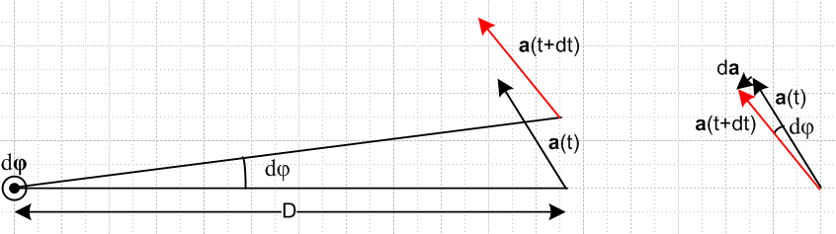
(1.5.9)

where the small rotation vector dφ points out of the plane of paper, and where a(t) happens to lie in the plane of paper (hence this picture does not cover the most general case). Using the right hand rule for cross products, we can see that da (shown on the right) lies in the direction of dφ x a, so we can write that da = C dφ x a where C is some number. We can determine C from the equation |da| = C |dφ x a| . Since dφ and a are at right angles, we know that |dφ x a| = |dφ| |a| = dφ a. But from the picture on the right it seems quite clear that |da| ≈ a dφ. Therefore

|da| = C |dφ x a| => dφ a = C dφ a => C = 1 (1.5.10)

so we end up with da = dφ x a which agrees with (1.5.8). In the case that a does not lie in the plane of paper, the geometric derivation takes more work, and in this case we just rely on the algebraic result. We have made free use of the notion that translated vectors are "equal".
Notice the fact that da = dφ x a does not depend on the distance D between the rotation axis and the tail of vector a! The result is true even if this distance is 0 so that the tail of vector a lies right on the rotation axis. In this case the pair of arrows in the left picture coincides with the pair of arrows in the right picture.

Generalizations of the above rotation idea appear in Appendix G.

1.6 The time rate of change of a rotating vector

In the previous section we found that,

da = dφ x a . (1.5.8)

Dividing by dt gives

(da/dt) = ω x a where ω ≡ dφ/dt . (1.6.1)

This equation is of fundamental importance in this document. It describes the rotation of vector a at rate ω about an axis parallel to ω. The equation can be represented by either of these "cone pictures" :

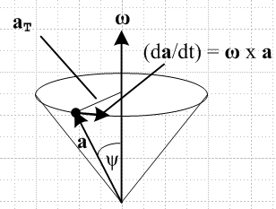 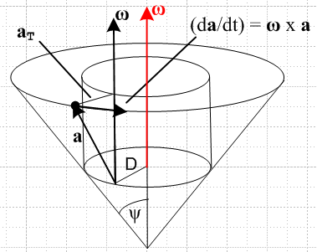 (1.6.2)
(a) (b)
Comments:

1. In (b), the tip of vector a traverses a circular path and so does the tail. The tail is always distance D from the rotation axis. One usually sees the simpler picture (a) where D = 0. Recall from above that distance D of the tail from the rotation axis is irrelevant. The motion of the vector a is exactly the same in both these cone pictures. ( Recall the comments in Section 1.4 about "when are two vectors equal". )

2. It is probably best to describe the rotating motion of vector a as a conical motion rather than a "circular motion", even though the tip of vector a travels in a circular motion. In the special case that ψ = π/2, meaning the tip of the cone has moved to the center of its circular end face (and ω • a = 0), then vector a would swing around in a true "circular motion".

3. Note that one might have ω = ω(t) so the vector ω could be changing in both direction and magnitude as time progresses. But at time t we have a definite (t), and this is sometimes referred to as the instantaneous direction (axis) of rotation at time t, and ω(t) the instantaneous angular velocity. In everything below, we always think of ω in this instantaneous sense, even though we might draw guide circles and cones to show the instantaneous motion at some instant of time t.

4. Knowledge of vector ω does not in fact say where the rotation axis is located. Again we invoke the comments of Section 1.4 above. There are two translational degrees of freedom in that the rotation axis can be translated parallel to itself in two dimensions. Comparing (a) and (b) above, one sees an example of the same ω but two different rotation axes, one translated relative to the other. In (b) the red and black ω vectors are the same vector. One normally draws the vector ω on the rotation axis as done in red.

5. As noted, in (a) and (b) the conical motion of vector a is the same and is independent of the placement of the rotation axis as long as it is parallel to ω. However, in Fig 1 there is a large change in the physical relationship between Frame S and Frame S' if the rotation axis is translated and ω stays the same.

6. In the case that ω = constant, a simple solution to (1.6.1) = ω x a can be obtained. This equation is a system of three coupled first-order linear ordinary differential equations. Writing a = ax + ay + az and ω = ω, the three equations become x = -ωay, y = ωax, and z = 0. Thus x = -ω2ax and we end up with this general solution,

ax(t) = Acos(ωt) – Bsin(ωt) ax(0) = A // ax2 + ay2 = A2 + B2 = circle
ay(t) = Asin(ωt) + Bcos(ωt) ay(0) = B
az(t) = az(0) = C = constant az(0) = C . (1.6.3)

The vector a starts out at some a(0) = (A,B,C) and does the conical motion drawn above, not just in the instantaneous sense, but in the full sense so that a really goes around the entire cone.

1.7 Rate of change of the basis vectors

We can apply our rate of change rule (1.6.1) to the basis vectors e'n to obtain

(de'n/dt ) = ω x e'n .

We are implicitly computing this derivative while "standing" in Frame S. That is to say, looking at Fig 1 in the Introduction above, we can regard Frame S as being fixed to the paper and Frame S' is rotating and its basis vectors e'n are changing as stated above. It is extremely important to make this fact explicit, so we now add a label S showing this fact,

(de'n/dt)S = ω x e'n . (1.7.1)

Were we to compute this same derivative standing in Frame S', we would get

(de'n/dt)S' = 0 (1.7.2)

because in Frame S' the basis vectors e'n are not rotating at ω, but are just sitting there frozen. By the same argument, we know that

(den/dt)S = 0 . (1.7.3)

What about the fourth possible derivative (den/dt )S' ? We will show in (2.5) below that in fact

(den/dt)S' = – ω x en . (1.7.4)

It seems at least reasonable that if the e'n are rotating relative to the en by ω, then the en are rotating relative to the e'n by -ω.

Main Conclusion: We thus arrive at the notion that, when dealing with rotation and multiple frames of reference and vectors represented in terms of their respective basis vectors, we absolutely must indicate with a label the frame in which a time derivative is being calculated.

1.8 Notations for the many time derivatives of vectors r, r', b and L

In the Overview we described r and r' as the position vectors of a Particle with respect to Frames S and S'. We can associate with these two vectors four different time derivatives.

(dr/dt)S (dr/dt)S' (dr'/dt)S (dr'/dt)S' (1.8.1)

In the usual manner, we represent a time derivative of a vector by an over-dot, and a second time derivative by an over-double-dot. The first time derivative of position r is velocity v, and the second is acceleration a. The same for r', v' and a' , so

v = v' = '
a = = a' = ' = ' . (1.8.2)

In order to save space, we can define these two operators

∂S ≡ (d/dt)S ∂S' ≡ (d/dt)S' (1.8.3)

Although the ∂ symbol is used for partial differentiation, our use here is exactly as defined above.

The list of derivatives above can be written now in several ways. Within each column below, all objects are exactly the same, just written in different notations: (r in Frame S appears as r' in Frame S' )

Table of first derivatives of r Table of first derivatives of r'

(dr/dt)S (dr/dt)S' (dr'/dt)S (dr'/dt)S'
S ≡ S' 'S 'S' ≡ '
vS ≡ v vS' v'S v'S' ≡ v'
∂Sr ∂S'r ∂Sr' ∂S'r' . (1.8.4)

For further clutter reduction, we have added the four new notations shown in red according to the following rule: When a vector and all its derivatives (here only one) are all in (or associated with) the same frame, we suppress the frame subscript and just let the prime or lack of it "do the talking", and refer to such as object as being "natural". There is no notational ambiguity in so doing.
The velocities shown in the center two columns above, vS' = (dr/dt)S' and v'S = (dr'/dt)S, shall be referred to as "cross velocities", as distinct from the two "natural velocities".

What about second derivatives? Things are more complicated now because vector r can have four distinct second derivatives, and so can vector r'. Just as done above, we construct a table for each, and within each column of each table, all objects are the same object : (r in Frame S appears as r' in Frame S' )

Table of second derivatives of r

∂S∂Sr ∂S∂S'r ∂S'∂Sr ∂S'∂S'r
SS ≡ S ≡ SS' S'S S'S' ≡ S'
SS ≡ S ≡ SS' S'S S'S' ≡ S'
aSS ≡ aS ≡ a aSS' aS'S aS'S' ≡ aS' (1.8.5)

Table of second derivatives of r'

∂S∂Sr' ∂S∂S'r' ∂S'∂Sr' ∂S'∂S'r'
'SS ≡ 'S 'SS' 'S'S 'S'S' ≡ 'S' ≡ '
'SS ≡ 'S 'SS' 'S'S 'S'S' ≡ 'S' ≡ '
a'SS ≡ a'S a'SS' a'S'S a'S'S' ≡ a'S' ≡ a' (1.8.6)

Here we again use the rule mentioned above that when a vector and all its derivatives are in the same frame, we let the overall prime or lack of it do the talking. We have introduced a second rule as well, which says that whenever both frame subscripts are the same, we suppress one of them to save space. In the tables above we then have two "natural" accelerations a and a', and six "cross accelerations".

So now we have the following "natural" vectors having minimal (that is, no) frame subscript clutter:

v a natural in Frame S
' v' ' ' a' natural in Frame S' (1.8.7)

Recall from the Introduction that the vector b connects the origins of two frames. We can make a table of first and second derivatives for this vector as well. Although is a velocity and is an acceleration, we shall not make up separate symbol names for these objects (though some authors do). Also, note that there is no vector in Fig 1 called b', we just have r = r' + b. Here are the corresponding tables for first and second derivatives of b, where we use only the second rule above that when two frame subscripts are the same we suppress one of them.

Table of first derivatives of b . (Items are the same within each column.)

(db/dt)S (db/dt)S'
S S'
∂Sb ∂S'b (1.8.8)

Table of second derivatives of b

∂S∂Sb ∂S∂S'b ∂S'∂Sb ∂S'∂S'b
SS ≡ S SS' S'S S'S' ≡ S' (1.8.9)

Comment: Just as a reminder, any derivative in the above section can be expanded onto either Frame S or Frame S' basis vectors, so any derivative has Frame S and Frame S' components. This statement would be true for any vector and we just remind the reader that the notation like (dr/dt)S does not mean the components are evaluated only in Frame S. Just as an example, this first derivative has these two expansions where the expansion coefficients (components) are shown on the right,

(dr/dt)S = [(dr/dt)S]i ei [(dr/dt)S]i = (dr/dt)S • ei
(dr/dt)S = [(dr/dt)S]'i e'i [(dr/dt)S]'i = (dr/dt)S • e'i . (1.8.10)

1.9 Angular momentum

The drawing of interest is a reoriented Fig 1, to which we have added arbitrary points c and c',

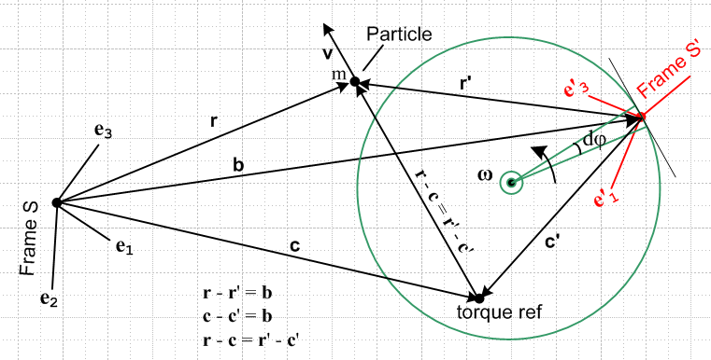 (1.9.1)

Whereas the linear momentum p = mv of a particle does not require a reference point, angular momentum L does require such a reference point. For example, the Particle in the above figure has many different values of L in Frame S, some of which we might denote as follows,

L(0) = r x mv // L in Frame S with respect to Frame S origin
L(c) = (r-c) x mv // L in Frame S with respect to Frame S point c
L(b) = (r-b) x mv // L in Frame S with respect to Frame S point b
L(b) = r' x mv . // L in Frame S with respect to Frame S' origin (1.9.2)

The last two lines are exactly the same since b is a vector between the two origins so r'= r-b.
Using the general form L(c), we may identify the following two "natural" angular momenta in Frames S and S',

L(c)S ≡ (r-c) x mvS = (r-c) x mv = (r-c) x p ≡ L(c)

L'(c')S' ≡ (r'-c') x mv'S' = (r'-c') x mv' = (r'-c') x p' ≡ L'(c') . (1.9.3)

These definitions are analogous to p ≡ mv and p' ≡ mv' in the linear momentum world.

The time derivative of the first of these objects is given by

(c) = (c)S = ∂S L(c)S = ∂S [ (r-c) x mvS] = (vS - S) x mvS + (r-c) x ∂S(mvS)
= – S x mvS + (r-c) x maS
= – x mv + (r-c) x ma .

A similar result is obtained by priming everything on the above line, so we end up with these four equations:

L(c) = (r-c) x mv (1.9.4)
(c) = (r-c) x ma – x mv (1.9.5)

L'(c') = (r'-c') x mv' (1.9.6)
'(c') = (r'-c') x ma' – ' x mv' . (1.9.7)

If one thinks of L(c) = (r-c) x mv just as a cross product of two vectors to get a third vector, one can apply our Theorem (A.20) to write (L(c))' = (r'-c') x mv' and therefore (L(c))' = L'(c'). It is just another notation.

The discussion of angular momentum continues in Section 11.

1.10 No frame label is needed for d/dt of a scalar function

If one is differentiating a specific component of a vector, such as ai(t) = 3t2, there is no need to add the frame label since the derivative of this function is 6t no matter what frame it is computed in. This is true when differentiating any component of any tensor. That is to say, if Tij..(t) is a component of a tensor, then

(dTij..(t)/dt)S = (dTij..( (t)/dt)S' = (dTij..(t)/dt) . (1.10.1)

We would like simply to say that the d/dt derivative of any scalar function does not need a label S or S', but the word "scalar" has multiple meanings. In one meaning, any single function f(t) is a scalar function since it is a 1-tuple of functions, but in another meaning (tensorial scalar), only a function which is a rotational scalar is a scalar function, and this would rule out the component of a vector as being a scalar function. We refer to the first meaning in the title of this subsection.

1.11 When do operations d/dt and taking a component "commute" ?

We claim the following theorem (to be proved below) :

Commutation Theorem: (1.11.1)

If the time derivative (∂X) is computed in the same frame (Frame X) in which components are taken, then the operations of taking the time derivative and taking the component can be done in either order with the same result, so these operations are said to commute. Otherwise the operations do not commute. Thus

(∂Sa)j = ∂S[(a)j] but in general (∂Sa)'j ≠ ∂S(a)'j
(∂S'a)'j = ∂S'[(a)'j] (∂S'a)j ≠ ∂S'(a)j .

In each of these four equations, on the left we compute ∂Xa and then we take a component, while on the right side we take a component and then compute ∂X on that component.

Goldstein makes a point about the non-commuting cases as a "word of caution" on the bottom of page 133 with an example on the top of page 134. In Goldstein, Poole and Safko the caution is stated on page 173 below (4.86), but the example has been removed.

As a preliminary to proving the theorem, we note that for a scalar u and vector v one can write,

(d[uv]/dt)S = (du/dt) v + u (dv/dt)S S
(d[uv]/dt)S' = (du/dt) v + u (dv/dt)S' S'
or
∂S(uv) = (∂Su) v + u (∂Sv) S
∂S'(uv) = (∂S'u) v + u (∂S'v) S' (1.11.2)

where recall that ∂S = ∂S' = ∂t when applied to a scalar like u. Within either frame this is just the calculus Leibniz product rule applied to as function u(t) times a vector function v(t),

∂t(uv) = (∂tu) v + u (∂tv) ,

so (1.11.2) is just a statement of this known rule in the two frames.

One can trivially generalize (1.11.2) to a sum of the form uivi (implied sum on i) to get

∂S(uivi) = (∂Sui) vi + ui (∂Svi) S
∂S'(uivi) = (∂S'ui) vi + ui (∂S'vi) . S' (1.11.3)

Reader Exercise: Show that ∂X(a x b) = (∂Xa) x b + a x (∂Xb) for X = S or S' (more Leibniz). (1.11.4)

Proof of the Commutation Theorem: In the proof we use all the following facts developed above and gathered below for convenience. Notice that it is not assumed that a' = Ra and in fact the vector a' does not appear anywhere.

(R-1)ij = (RT)ij = Rji rotation is real orthogonal (1.1.2) (1.11.5)

Rij(t) = function of time so (∂tRij(t)) ≠ 0 and (∂t(R-1)ij(t)) ≠ 0 (ω ≠ 0) "rotating frames"

a = (a)i ei = (a)'i e'i expansions in the two frames (1.2.1)

(en)i = δn,i (e'n)'i = δn,i
(en)'i = (R-1)ni = Rin (e'n)i = Rni basis vector components (1.1.8)

(a)'i = Rij(a)j . components of a in the two frames (1.2.4)

∂Sen = 0 and ∂S'e'n = 0 basis vector constant in its frame (1.7.3), (1.7.2)

∂S f(t) = ∂S' f(t) = ∂t f(t) time derivative of a component (1.10.1)

∂S(uivi) = (∂Sui) vi + ui (∂Svi) product rule in frame S
∂S'(uivi) = (∂S'ui) vi + ui (∂S'vi) product rule in frame S' (1.11.3)

Here then is the detailed proof of the above theorem. First, consider ∂S with a = (a)i ei :

(∂Sa)j = (∂S[(a)iei])j = (∂S(a)i) (ei)j = (∂t(a)i) δi,j = ∂t(a)j // ∂S(ei)j = 0
∂S(a)j = ∂t(a)j
⇒ ∂S(a)j = (∂Sa)j // commutes (∂S with Frame S components)

(∂Sa)'j = (∂S[(a)iei])'j = (∂S(a)i) (ei)'j = (∂t(a)i) Rji = Rji(∂t(a)i)
(∂S(a)'j) = ∂S[Rji(a)i] = Rji(∂S(a)i) + (∂SRji) (a)i = Rji(∂t(a)i) + (∂tRji) (a)i
⇒ (∂S(a)'j) = (∂Sa)'j + (∂tRji) (a)i
⇒ (∂S(a)'j) ≠ (∂Sa)'j // does not commute (∂S with Frame S' components)

Next consider ∂S' with a = (a)'i e'i :

(∂S'a)j = (∂S'[(a)'ie'i])j = (∂S'(a)'i) (e'i)j = (∂S'(a)'i) Rij = (R-1)ji (∂t(a)'i)
(∂S'(a)j) = ∂S'[(R-1)ji(a)'i] = (∂t(R-1)ji)(a)'i + (R-1)ji(∂t(a)'i)
⇒ (∂S'(a)j) = (∂S'a)j + (∂t(R-1)ji)(a)'i
⇒ (∂S'(a)j) ≠ (∂S'a)j // does not commute (∂S' with Frame S components)

(∂S'a)'j = (∂S[(a)'ie'i])'j = (∂S'(a)'i) (ei')'j = (∂S'(a)'i) δi,j = (∂S'(a)'j) = (∂t(a)'j)
∂S'(a)'j = ∂t(a)'j
⇒ ∂S'(a)'j = (∂S'a)'j // commutes (∂S' with Frame S' components)

2. The G Rule for arbitrary vector a and its derivation

In this section, a is a generic vector -- it could be any vector.

The "G Rule for vector a" is the following vector equation (written several equivalent ways),

∂Sa = ∂S'a + ω x a
(da/dt)S = (da/dt)S' + ω x a
S = S' + ω x a . (2.1)

In the first line we use the abbreviations ∂X = (d/dt)X where X is a frame of reference. G is in honor of Herbert Goldstein since the Rule appears on page 133 of his classic 1950 book Classical Mechanics (and he uses the vector G instead of our a). Perhaps another name for this rule would be "the rule which relates the time derivatives of a vector taken in two frames of reference S and S' where Frame S' is rotating relative to Frame S at instantaneous vector angular velocity ω about some unspecified rotation axis which is parallel to the vector ω".
Equation (2.1) goes by a few obscure names, some people calling it a "transport theorem" or a "basic kinematic equation", but most authors who use it give it no name.

Comment: The content of (2.1) must have been known to Coriolis in 1835, but the cross product notation was not in use at that time. According to Crowe, the cross product idea arose gradually from the work of Hamilton (quaternions) and Grassmann (vector areas) as early as the 1840's, and later from work of Gibbs in the 1880's, with the possible involvement of a certain Reverend O'Brien in 1852. In any event, the cross product notation (and bolded vector notation in general) was first introduced to the textbook-reading public when Gibbs gave his student Wilson the task of publishing and improving his notes. Their book Vector Analysis, published in 1901, was reprinted 7 times and was then made a Dover book in 1960 and can be found online. It happens, however, that this book makes no mention of the G Rule or Coriolis forces or "frames of reference". It is a math book, not a physics book. See our Refs for works of Coriolis, Crowe and Wilson.

Since the G Rule applies to any vector a, sometimes the vector is left out and one writes this operator equation,

(d/dt)S = (d/dt)S' + ω x . (2.2)

Here is where and how the G rule appears in some popular mechanics texts:

(dG/dt)space = (dG/dt)body + ω x G // Goldstein p 133 (4-100)
// Goldstein Poole Safko p 172 (4.82)
(dQ/dt)fixed = (dQ/dt)rotating + ω x Q // Marion p 342 (11.7)
// Thornton Marion p 390 (10.12)
(dQ/dt)S$_{0}$ = (dQ/dt)S + ω x Q // Taylor p 342 (9.30)

(d/dt)space = (d/dt)body + ω x // Goldstein p 133 (4-102)
(d/dt)s = (d/dt)r + ω x // Goldstein Poole Safko p 173 (4.86)

Proof of the G Rule :

We want to show that

∂Sa = ∂S'a + ω x a . (2.1)

Start with the known fact (1.7.1),

∂Se'i = ω x e'i . (1.7.1)

Then using the above equation and facts collected in (1.11.5) we find,

∂Sa = ∂S[(a)'ie'i] = (∂S(a)'i)e'i + (a)'i(∂Se'i) = (∂S(a)'i)e'i + (a)'i ω x e'i

= (∂S(a)'i)e'i + ω x [(a)'ie'i] = (∂S(a)'i)e'i + ω x a . (2.3)
But,

∂S'a = ∂S'[(a)'ie'i] = (∂S'(a)'i) e'i since ∂S'e'i = 0 . (2.4)

Inserting this into (2.3) then gives

∂Sa = ∂S'a + ω x a

which is the desired G rule (2.1). QED

Comment: The G Rule involves two frames of reference called Frame S and Frame S'. It is true that in Fig 1 and Fig (1.9.1) we think of Frame S as being "glued to the paper", but there is nothing that says the paper might not be rotating about some other axis ω'. In other words, even if Frame S and Frame S' are both non-inertial frames, the G Rule is still valid because nothing in its derivation requires that either frame be inertial. Inertial only matters when we later start talking about F = ma. The G Rule involves Frame S' rotating by ω relative to Frame S. An implication is that any equation obtained below by use of the G Rule is also valid even if both Frame S and Frame S' are non-inertial.

Example 1: (reversing the above) Suppose a = e'i . Then our rule (2.1) says

(de'i/dt)S = (de'i/dt)S' + ω x e'i .

But we noted in (1.7.2) the obvious fact that (de'i/dt)S' = 0, so the above becomes

(de'i/dt)S = ω x e'i

which agrees with (1.7.1).

Example 2: Suppose a = ei . Then rule (2.1) says

(dei/dt)S = (dei/dt)S' + ω x ei .

But we noted in (1.7.3) the obvious fact that (dei/dt)S = 0, so the above becomes

(dei/dt)S' = – ω x ei (2.5)

and we have now derived the claim made in (1.7.4).

Example 3: Suppose a = ω. Then rule (2.1) says

(dω/dt)S = (dω/dt)S' + ω x ω = (dω/dt)S'

so for this one vector ω both derivatives are the same and we write

(dω/dt)S = (dω/dt)S' ≡ dω/dt = . (2.6)

Example 4. Using the dot notation of (1.8.2), and assuming there are two related vectors a and a', the G Rule states

S = S' + ω x a that is ∂S = ∂S' + ω x a
'S = 'S' + ω x a' that is ∂S' = ∂S'' + ω x a' . (2.7)

Example 5. We can apply this rule to any of the vectors listed in Section 1.8. Here are a few examples:

S = S' + ω x b (2.8)

S = S' + ω x r or vS = vS' + ω x r
'S = 'S' + ω x r' or v'S = v'S' + ω x r' (2.9)
S = S' + ω x vS or aS = aS' + ω x vS
'S = 'S' + ω x v'S or a'S = a'S' + ω x v'S . (2.10)

Question: Are there any restrictions on the vector a for which the G Rule applies? The only fact used above about a is that a can be expanded on Cartesian basis vectors as a = a'i e'i and that the component functions a'i(t) are differentiable. If the tail of vector a does not lie at the origin of Frame S', we just translate a such that this is the case, as per Section 1.4.

Significance of the G Rule: In all the computations below, basically the only operations done are these:

• Apply the G Rule to some vector
• Apply ∂S to both sides of some equation
• Apply ∂S' to both sides of some equation

Note: In Appendix B we generalize the G Rule to tensors of arbitrary rank, so the G Rule of this Section is the general case applied to rank 1 tensors (vectors).

3. The Apparatus and its Observer at Rest in Frame S'

In our general "experiment" to be described below, Frame S' is rotating with respect to Frame S. This does not necessarily imply that Frame S is "at rest", but Frame S is at rest with respect to the paper on which we draw Fig 1. If Frame S is truly at rest with respect to the stars, then Frame S is called an inertial frame, and in such a frame Newton's 2nd Law F = ma is valid. We do not in general assume that S is such an inertial frame.
Imagine now that we have some Apparatus sitting in Frame S' which contains a Particle which undergoes some motion. The Particle might be a mass on one or more springs, or it might be a Particle in ballistic flight, or it might be a Particle of matter in a gear wheel which is turning in some complicated machine, or it might be a Particle of a fluid or of an elastic solid.
An Observer also sitting (at rest) in Frame S' has some measurement equipment, can see the axes of Frame S' of course, and does certain measurements on the Particle while Frame S' is rotating with respect to Frame S. The Particle is located at position r in Frame S and position r' in Frame S'. The Observer can see Frame S and is aware of both r and r' and can make measurements of them both.
For example, although r is the position vector of the Particle relative to the Frame S origin, our Observer measures its components in Frame S' this way

r = (r)'ie'i (r)'i = r • e'i .

Meanwhile, measurements of r' reveal these different components

r' = (r')'ie'i (r')'i = r' • e'i .

However, the Observer can only measure frame-S' derivatives. From our list we then select some items :

vS' = S' = (dr/dt)S' // cross velocity
v'S' = 'S' = (dr'/dt)S' ≡ v' // natural (1.8.4)

aS' = S' = (dvS'/dt)S' = (d2r/dt2)S' // cross acceleration
a'S' = 'S' = (dv'S'/dt)S' = (d2r'/dt2)S' ≡ a' // natural (1.8.6)

S' = (db/dt)S' rate of change of b as viewed from Frame S' . (1.8.9)

For example, the Frame S' Observer might measure the frame-S Particle location r(t) at time t, wait one time tick dt, then measure it again to get r(t+dt). Then (the components of r(t) are [r(t)]'i ),

vS'(t) = [r(t+dt) – r(t)]/(dt) or vS'(t) = (dr/dt)S' // cross velocity

Alternatively, the Observer could measure r'(t) and r'(t+dt) and get

v'S'(t) = [r'(t+dt) – r'(t)]/(dt) or v'S'(t) = (dr'/dt)S' = v' . // natural

Waiting another dt tick, one could measure r(t+2dt) and r'(t+2dt) and then deduce vS'(t+dt) and v'S'(t+dt). From these the Observer could determine

aS'(t) = [vS'(t+dt) - vS'(t)]/(dt) or aS'(t) = (dvS'/dt)S' // cross

a'S'(t) = [v'S'(t+dt) - v'S'(t)]/(dt) or a'S'(t) = (dv'S'/dt)S' = a' . // natural

As a final example, here the Observer measures a cross angular momentum and a natural one :

L(c) = (r-c) x mv (1.9.4)
(c)S' = ∂S'L(c) = [L(c+dt)(t+dt) - L(c)(t)]/(dt) // cross

L'(c') = (r'-c') x mv' (1.9.6)
'(c')S' = ∂S'L'(c') = [L'(c'+dt)(t+dt) - L'(c')(t)]/(dt) = '(c') . // natural

4. The Relationship between the Two Frames S and S'

4.1 Explanation of Fig (4.1.1): Frame S in the plane of paper

The relation between the two frames is shown in this picture, a snapshot at some time t :

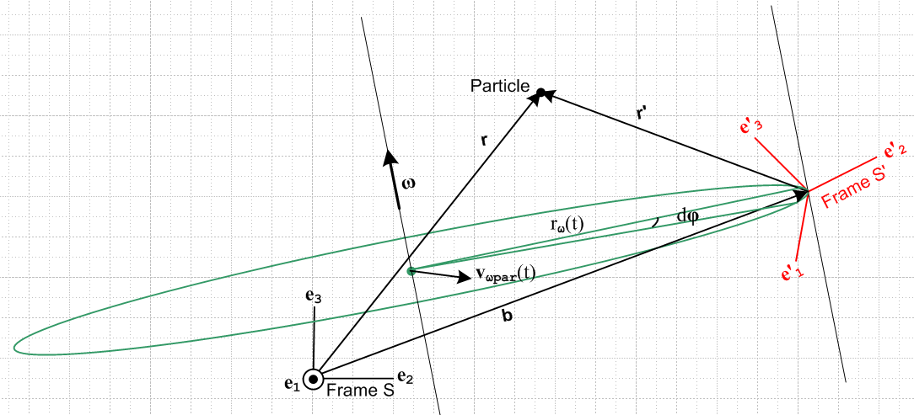
(4.1.1)

There is a lot to be said about this picture (which is the same as Fig 1 in the Overview) .

The axes e2 and e3 of Frame S lie in the plane of paper and are "aligned with paper" as shown and remain fixed relative to paper, so the Frame S origin lies in the plane of paper. The origin of Frame S' is displaced by amount b from the origin of Frame S, and this S' origin does not lie in the plane of paper. The location of the Particle does not lie in the plane of paper, so vectors r, r' and b , although coplanar with each other, are each not in the plane of paper. Similarly, the ω rotation axis does not lie in the plane of paper nor is it parallel to it.
Frame S' is instantaneously rotating about some axis indicated by ω(t). Each of the basis vectors e'n is rotating according to (1.7.1), (de'n/dt)S = ω x e'n, as the Frame S' moves rigidly in rotation about the ω rotation axis. The origin of Frame S' is instantaneously rotating along the green circle of some instantaneous radius rω which has its center on the rotation axis at a green dot. This green dot, meanwhile, is moving at some velocity vωpar in the plane of the green circle relative to Frame S. This indicates the motion of the rotation axis parallel to itself.
Suppose Frame S' contains a rigid object fixed relative to the Frame S' axes. If we were to select some point P in that rigid object, that point P would be instantaneously rotating about the ω(t) axis along a circle similar to the one shown above, but which has a different radius and a different center point along the same rotation axis.
If were constant in time and if vωpar were 0, the origin of Frame S' really would move along the full green circle shown, but we have in mind that ω = ω(t) and this varies in time, both in magnitude and direction. Thus, the green circle is itself tilting to stay in a plane perpendicular to ω(t).
Viewed from Frame S, the unit vectors of Frame S' are oriented and move according to several equations we have already dealt with,

e'n(t) = R-1(t) en (1.1.30)

e'n(t) = Rnm(t) em // Basis Theorem (1.1.29)

(de'n/dt)S = ω(t) x e'n(t) . (1.7.1)

4.2 Explanation of Fig (4.2.1) : Vector ω pointing directly out of paper

We now draw Fig (4.1.1) from a different perspective. The reader will hopefully forgive the "artist" for not attempting to draw Fig (4.2.1) as a precision 3D rotated version of Fig (4.1.1), but hopefully the general features of the drawing are sufficient for our purposes below.

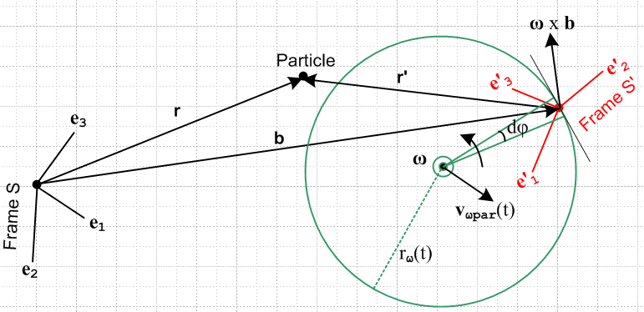
(4.2.1)

Frame S remains fixed relative to paper as time varies, but is now rotated relative to Fig (4.1.1) and the S origin no longer lies in the plane of paper. At time t for which the picture is drawn, the origin of Frame S' and the green circle and its center do lie in the plane of paper. The ω vector points straight out at the viewer as indicated by the circled dot. Vectors r, r' and b do not lie in the plane of paper.
Fig (4.1.1) is meant to give the general lay of the land, but Fig (4.2.1) is the one we will work with below.

4.3 Comments on S and S'

The quantity S = (db/dt)S describes the instantaneous velocity of the Frame S' origin relative to that of Frame S. When ω = 0, Frame S' merely translates relative to Frame S with position b, velocity S and acceleration S . When ω ≠ 0, however, for a general placement of the rotation axis one can regard b,
S and S as quantities derived from the location and movement of that axis and from the value of ω, all of which one imagines are controlled by some mechanical outside agency. An exception is Special Case #2 below where the rotation axis passes through the Frame S' origin.

The quantity S' = (db/dt)S' is a "cross velocity" in the sense of Section 1.8 and is difficult to interpret. In Special Case #1 below, however, the vector b is effectively glued to the Frame S' axes and S' = 0, causing simplification of several equations which will be obtained below.

The connection between S and S' is provided by the G Rule (2.1) applied to vector b,

S = S' + ω x b . (4.3.1)

In Section 7.5 we derive the relationship between accelerations S = ∂SS and S' = ∂S'S' .

4.4 Special Case #1 : ω axis through Frame S origin

Here the rotation axis always passes through the origin of Frame S, so Fig (4.2.1) appears as follows,

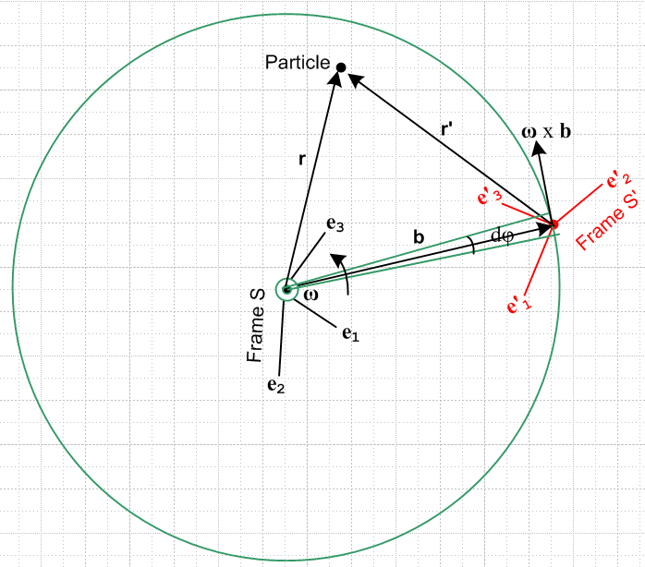 Special Case #1
(4.4.1)

The Frame S' origin and the green circle are still in the plane of paper, but the Frame S origin is in general not, so vector b is not in the plane of paper. In this situation, the vector b and the vectors e'n all rotate together as if they were thin metal rods soldered together. If b" = Rb and e"n = Re'n then angles are fixed, as indicated by b" • e"n = [Rb] • [Re'n] = b • e'n using (1.1.38) and R = Rω(dφ). See Fig (1.5.9).

This has the immediate implication that, just as (de'n/dt)S' = 0 in (1.7.2), here we have

S' ≡ (db/dt)S' = 0 . (4.4.2)

Again, the vector b is soldered to the e'n axes so appears fixed in Frame S'.

Therefore, from (4.3.1), we have instantaneous conical motion for b as seen in Frame S,

S ≡ (db/dt)S = ω x b . // Special Case #1 (4.4.3)

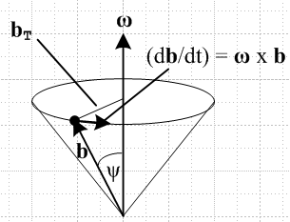 (4.4.4)

This says that, as seen in Frame S, the change in b is always perpendicular to b, so the length of b does not change. We still allow ω = ω(t) and, as (t) changes, the tip of vector b (which is the origin of Frame S') describes some path on the surface of a sphere of radius b in Frame S. Here we allow (t) to change, but the rotation axis must always pass through the Frame S origin.

4.5 Special Case #2 : ω axis through Frame S' origin

Here the rotation axis always passes through the origin of Frame S' :

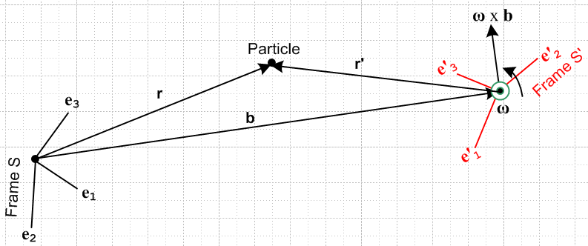 Special Case #2
(4.5.1)

In this case our Fig (4.2.1) green circle has shrunk around the Frame S' origin. In this situation, we can think of the "driving parameters" being the three parameters of b and the three parameters of ω giving the 6 independent (Galilean) parameters defining the instantaneous relationship between the frames. Think of Frame S' as a camera platform which is supported on a boom b(t) and which independently controls its own orientation and rotation ω(t). Then S and S are determined by b(t), and S' is given by (4.3.1) as

S' = S – ω x b . (4.5.2)

We now look at three sample applications. The first two fall into the Special Case #1 category, while the third is Special Case #2.

4.6 The Turntable

Although obsolete (but not very everyone), the phonograph turntable continues to provide an excellent visualization of rotating frames. It turns slowly enough for one to actually see it turn, it is fairly large, and the surface is not shiny and completely featureless. It is believed that throughout history such turntables normally rotated clockwise in both hemispheres of the Earth, but in our drawings below we shall think of our turntable as turning counterclockwise relative to the little spindle sticking up. Frame S has its origin at the spindle and is fixed relative to the turntable case.

 (4.6.1)

An ant (Particle) is crawling around on such a turntable which is rotating with some ω(t). The Frame S' is set up some distance b = |b(t)| from the spindle, and has its e'1 axis pointing "to the right" and its e'2 axis pointing to the spindle. That is to say, e'1 = and e'2 = - if we think of r,θ as polar coordinates for fixed Frame S. In this application, ω(t) = ω(t)e3 and the rotation axis passes though the origin of Frame S, so this is a Special Case #1 situation with (t) = e3 being constant. Conversely, vector b(t) maintains its magnitude b, but (t) rotates about the spindle at angular rate ω(t) as seen from Frame S which is at rest.

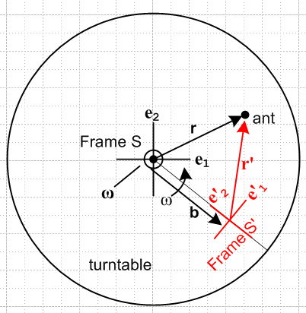 (4.6.2)

This type of Frame S' designation would be familiar to merry-go-round riders hanging on and facing the center. While once in Sydney, the author rode "The Rotor" for which Frame S' can be regarded as being at the cylindrical wall to which the rider is glued by centrifugal force (the circular floor then drops away).

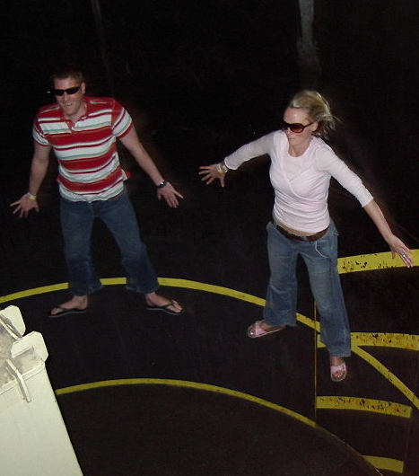
(wiki) (4.6.3)

In Section 15 we shall solve three "ant on turntable" problems using the above geometry.

4.7 The Earth

The non-rotating Cartesian Frame S is located at Earth center with e3 pointing to the North Pole. The e1 axis points out through a point on the equator to some fixed distant star (Star 1), and then e2 is the third Cartesian axis which points out through a different point on the equator to Star 2. If we ignore the Earth's orbiting around the Sun, and the motion of the Orion spiral galactic arm containing the Sun, and the motion of the Milky Way galactic center away from the "Dipole repeller" and so on, then Frame S is an inertial frame.

Rotating Frame S' has its origin at some arbitrary fixed point on the surface of the Earth. For this system, the e'3 axis points "up", meaning in the direction for Frame S spherical coordinates. The e'1 axis points to the east, and the e'2 axis points north.
The Earth rotates at some ω = ωe3 with ω > 0. Since the ω axis passes through the Frame S origin, this is another Special Case #1 application.

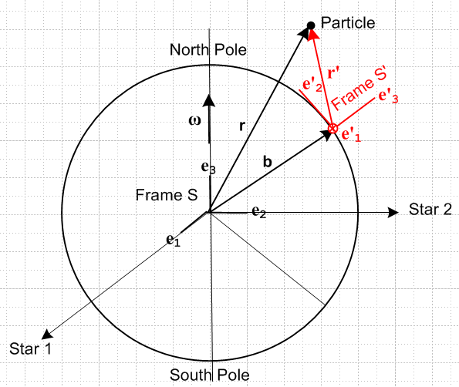
(4.7.1)

Figure (4.7.1) and the discussion of this section are in the "non-swap" notation mentioned in the Section 1 summary at the start of this document. In practice, one usually uses the "swap" notation S↔S' for Earth problems in order to avoid the appearance of primes in equations. This will be done in Appendix C concerning the Foucault pendulum.

4.8 The Flying Camera Platform

Some Apparatus is located in Frame S instead of S', and Frame S' is a "camera platform" which flies around in some complicated way and observes the activity in Frame S. In this case, both ω(t) and b(t) would be under the command of the pilot of the camera platform. One would set this up as a Special Case #2 situation, so ω passes through the Frame S' origin and S is the velocity of the platform origin and b(t) is its location relative to Frame S. One would use the "inverse problem" equations of Section 13 to get the primed quantities in terms of the unprimed ones.

5. The Goal of the next two sections

The symbols appearing here are defined in Section 1.8.

An Observer in Frame S' measures various properties of a Particle in motion,

r' v' a' L'(c') '(c')

We want to know how these properties of the Particle appear in Frame S,

r v a L(c) (c)

and we want to know the various other v and a forms of Section 1.8 in terms of the basic Frame S' objects listed above.
Later in Section 13 we will want to know how to solve "the inverse problem" of finding the primed quantities if the unprimed ones are known.

6. Determination of velocities

The notations used here are described in Section 1.8. There are four distinct velocities, and we want to express three of them in terms of the fourth which is the natural velocity in Frame S',

(dr'/dt)S' = v'S' ≡ v' .

We shall make frequent use of the Fig 1 relationship between r and r',

r = r' + b (6.1)

as well as the G Rule for vector b, as in (4.3.1)

S = S' + ω x b . (6.2a)

Inserting (6.1) as b = r - r' into (6.2a) gives identity

S + ω x r' = S' + ω x r . (6.2b)

6.1 Velocity vS'

Apply (d/dt)S' to (6.1) to get (6.3a), then use (6.2a) to get (6.3b) :

vS' = v' + S' (6.3a)
vS' = v' + S – ω x b . (6.3b)

6.2 Velocity v ≡ vS

Apply (d/dt)S to (6.1) to get ∂Sr = ∂Sr' + ∂Sb or

v = v'S + S . (6.4)
Now use the G Rule (2.1) for vector r', ∂Sr' = ∂S'r' + ω x r', to get

v'S = v' + ω x r' . (6.5)

Insert (6.5) into (6.4) to get the first line below. The second and third lines make use of (6.2a) and (6.1) .

v = v' + ω x r' + S (6.6a)
v = v' + ω x r' + S' + ω x b (6.6b)
v = v' + ω x r + S' . (6.6c)

6.3 Velocity v'S

Solve (6.4) for v'S,

v'S = v – S . (6.7)

Then solve (6.6a) for v - S and install into (6.7) to get the first line below,

v'S = v' + ω x r' (6.8a)
v'S = v' + ω x r – ω x b (6.8b)
v'S = v' + ω x r + S' - S . (6.8c)

The remaining two lines come from using (6.1) and (6.2a).

6.4 Velocity Summary

v = v' + ω x r' + S = v' + ω x r + S' (6.6a,c)
vS' = v' + S – ω x b = v' + S' (6.3b,a)
v'S = v' + ω x r' (6.8a) (6.9)

Thus we have expressed the three velocities vS = v, vS' and v'S in terms of v'S' = v'.

6.5 Velocities for Special Cases

These cases were discussed above in Section 4.4 and 4.5.

For Special Case #1, where the ω axis passes through the Frame S origin, in any equations above set

S' = 0 // (4.4.2)
S = ω x b = ω x(r – r') = ω x r – ω x r' . // (4.4.3) (6.10)

Then the Section 6.4 summary becomes

v = v' + ω x r Special Case #1 only (6.6a)
vS' = v' Special Case #1 only (6.3b)
v'S = v' + ω x r' . general (6.8a) (6.11)

For Special Case #2, where the ω axis passes through the Frame S' origin, S is a driving parameter, so we select just the S forms from the summary

v = v' + ω x r' + S general (6.6a)
vS' = v' + S – ω x b general (6.3b)
v'S = v' + ω x r' . general (6.8a) (6.12)

6.6 Comments

1. Consider these two results from above (picked more or less at random)

r = r' + b (6.1)
v = v' + ω x r + S' . (6.6c)

Either equation can be "evaluated" in either Frame S or Frame S'. Evaluation in Frame S gives

(r)i = (r')i + (b)i
(v)i = (v')i + εijk(ω)j(r)k + (S')i

while evaluation in Frame S' gives

(r)'i = (r')'i + (b)'i
(v)'i = (v')'i + εijk(ω)'j(r)'i + (S')'i . // (ω)'j = (ω)j

This is a situation where we fully expect to have (r')i ≠ (r)'i and (v')i ≠ (v)'i as mentioned in Section 1.2, so the careful placement of primes is important. This is just a reminder.

2. Based on the equations above, it is clear that we have

r' ≠ Rr v' ≠ Rv

where R is the rotation appearing in (1.1.29) which relates our two frames, en = Re'n . As noted in Section 1.3, for this reason we use the Passive View of rotations without the extra step of creating vectors r' and v' defined by r' ≡ Rr and v' ≡ Rv. The vector names r' and v' are already used.

3. On the other hand, the vectors ω and b appearing in these formulas are normal kinematic "vectors under rotations" in the sense Section 1.3,

b' = Rb ω' = Rω
so
(b')i = Rij(b)j = (b)'i = b'i (ω')i = Rij(ω)j = (ω)'i = ω'i (6.13)

since, according to (1.3.10), we can dispense with parentheses for such vectors. These equations then give us the components of b and ω in Frame S'. For example, e'i• b = (b)'i = b'i.

4. In deriving the various velocity relations above, we have basically only used r = r' + b and the G Rule. Both the fact that r = r' + b and the G Rule are valid even if both Frame S and Frame S' are non-inertial frames, so one could think of "the paper" to which Frame S is glued in Fig (4.2.1) as possibly rotating. The implication is that the velocity relations above do not require that either frame be inertial. This same comment applies to the acceleration relations derived in Section 7 below. It is only when we later add the equation F = ma to the story in Section 8 that we have to regard Frame S as being an inertial frame.

7. Determination of accelerations

The notations used here are described in Section 1.8. There are eight distinct accelerations of interest, and we could express seven of them in terms of the eighth which is the natural acceleration in Frame S',

(da'/dt)S' = a'S' ≡ a' .

We shall only express the three accelerations aS = a, aS' and a'S in terms of a'S' = a'. Below (6.9) one sees that this is exactly what we did with the velocities. Here, however, we examine a'S first.
As noted in the Section 7 Summary, "dry as dust", and our apologies.

7.1 Acceleration a'S

The G Rule (2.1) for v'S says

∂Sv'S = ∂S'v'S + ω x v'S
or
a'S = a'S'S + ω x v'S . (7.1)

Notice the unusual cross derivative a'S'S which involves both S and S'. This is one those cross accelerations appearing in (1.8.6). To compute this, we must go back to the G Rule (2.1) for r',

v'S = v' + ω x r' . // v'S = ∂Sr', v' = ∂S'r' (6.8a)

Apply ∂S' ≡ (d/dt)S' to both sides to get

∂S'v'S = ∂S'v' + ∂S'(ω x r') = ∂S'v' + x r' + ω x (∂S'r') // see (1.11.4) and (2.6)
or
a'S'S = a' + x r' + ω x v' . (7.2)

Here we used (2.6) that ∂Sω = ∂S'ω = . Now install (7.2) for a'S'S into (7.1) to get

a'S = [a' + x r' + ω x v'] + ω x v'S . (7.3)

Now replace v'S in the last term using the G Rule for r' [ (6.8a) a few lines above ]

a'S = [a' + x r' + ω x v'] + ω x [v' + ω x r' ]
or
a'S = a' + x r' + 2 ω x v' + ω x (ω x r') . (7.4)

The famous "Coriolis factor of 2" has now appeared and will be trivially transferred into aS in the next section. It is useful to review the steps above to see where this factor of 2 comes from :

1. Write the G Rule for v'S a'S = a'S'S + ω x v'S
2. Write the G Rule for r' v'S = v' + ω x r'
3. Insert 2 into 1 a'S = a'S'S + ω x v' + ω x (ω x r') // 1st ω x v' term
4. Apply ∂S' to 2 to get a'S'S = a' + x r' + ω x v' // 2nd ω x v' term,
5. Install 4 into 3: a'S = [a' + x r' + ω x v'] + ω x v' + ω x (ω x r')

and now we have two ω x v' terms and only natural Frame S' objects r', v' and a'.

7.2 Acceleration a ≡ aS

Start with (6.4) which is ∂S applied to r = r' + b ,

v = v'S + S . (6.4)

Apply ∂S again to get

a = a'S + S . (7.5)

Then insert (7.4) for a'S into (7.5) to get the same result as (7.4) but with S tacked on,

a = a' + x r' + 2 ω x v' + ω x (ω x r') + S . (7.6a)
S S' Euler Coriolis centripetal frame

We have attached a name to each contribution to a and will discuss these terms below. Since we really want all primed objects on the right side, we can anticipate the result (7.12) derived in Section 7.5 below,

S = S' + x b + 2ω x S' + ω x (ω x b) (7.12)

to get this alternate form for a ,

a = a' + x r' + 2 ω x v' + ω x (ω x r') + [S' + x b + 2ω x S' + ω x (ω x b) ]

= a' + x r + 2 ω x v' + ω x (ω x r) + 2ω x S' + S' (7.6b)

where we think here of r as just a shorthand for b + r' to reduce the number of terms.

7.3 Acceleration aS'

Start with (6.3a) which is ∂S' applied to r = r' + b,

vS' = v' + S' . (6.3a)

Apply ∂S' again to get

∂S'vS' = ∂S'v' + S'
or
aS' = a' + S' . (7.7)

7.4 Acceleration Summary

a = a' + x r' + 2 ω x v' + ω x (ω x r') + S (7.6a)
a'S = a' + x r' + 2 ω x v' + ω x (ω x r') (7.4)
aS' = a' + S' (7.7) (7.8)

7.5 Relation between S and S'

Write the G Rule (2.1) for S' then solve it for S'

∂SS' = S' + ω x S'
S' = ∂SS' – ω x S' . (7.9)

Now apply ∂S to (6.2a) then solve for ∂SS',

S = ∂SS' + ∂S (ω x b)
∂SS' = S – ∂S (ω x b) . (7.10)

Insert (7.10) into (7.9) to get the first line below, then use (6.2a) to get the second line,

S' = [ S – ∂S (ω x b)] – ω x S'
= S – ∂S (ω x b) – ω x [S – ω x b]
= S – x b – 2ω x S + ω x (ω x b) . (7.11)

The inversion of this equation may be found by using (6.2a), S = S'+ ω x b,

S' = S – x b – 2ω x [S' + ω x b] + ω x (ω x b)

= S – x b – 2ω x S' – ω x (ω x b)

so then

S = S' + x b + 2ω x S' + ω x (ω x b) . (7.12)

In a Special Case #1 problem we have S' = 0 from (6.10), hence S' = 0, so that

S = x b + ω x (ω x b) . // Special Case #1 (7.13)

8. The Fictitious Forces

8.1 Development of the Fictitious Forces

We start with (7.6a) which says

a = a' + x r' + 2 ω x v' + ω x (ω x r') + S . (7.6a) (8.1.1)
S S' Euler Coriolis centripetal frame

Now for the first time we assume that Frame S is an inertial reference frame. Newton's law in inertial Frame S says ( m = mass of the Particle)

F = ma (8.1.2)

with a given as above in (8.1.1), so that, reordering the 5 terms,

F = ma = mS + ma' + mω x (ω x r') + 2m ω x v' + m x r' . (8.1.3)

Now suppose we imagine an "effective" version of Newton's Law that works in rotating Frame S',

F'eff = ma' . (8.1.4)

Solving (8.1.3) for ma' tells us that (second line uses (8.1.2))

ma' = F'eff = F – mS – mω x (ω x r') – 2m ω x v' – m x r' (8.1.5)
ma' = F'eff = ma – mS – mω x (ω x r') – 2m ω x v' – m x r' . (8.1.6)

We can write the second equality in (8.1.5) as

F'eff = F + F'fict where (8.1.7)
F'fict = – mS – mω x (ω x r') – 2m ω x v' – m x r' . (8.1.8)
frame centrifugal Coriolis Euler

Here F'fict represents "fictitious" forces ("pseudo" forces) that mysteriously have to be added to "real forces" F to make our bogus (8.1.4) "Newton's Law" F'eff = ma' be valid in Frame S'. We put a prime on F'fict as a reminder that it is a force which appears in non-inertial Frame S'

8.2 Interpretation of the Centrifugal and Euler Fictitious Forces

To emphasize the long and short vector idea in our interpretation of the centrifugal and Euler fictitious forces, we take the Earth scenario of Fig (4.7.1) rather than a more general situation like Fig (4.2.1) :

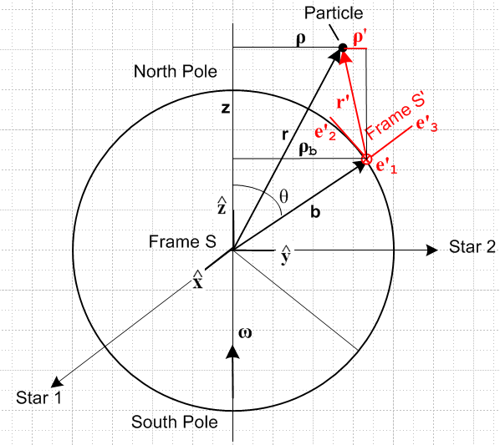 (8.2.1)

Suppose in the above picture v' = 0 so r' is static in Frame S'. Then (8.1.8) becomes

F'fict = – mS – mω x (ω x r') – m x r' . (8.1.8) with v' = 0 (8.2.2)
frame centrifugal Euler

In this expression it is the short vector r' which appears in both the centrifugal and Euler terms.
Since Fig (8.2.1) is a Special Case #1 situation, we know from (7.13) that,

S = x b + ω x (ω x b) . // Special Case #1 (7.13) (8.2.3)

Inserting this into (8.2.2) gives,

F'fict = – m [ ω x (ω x b) + x b] – mω x (ω x r') – m x r'

= – mω x (ω x [b+ r']) – m x [b+ r']

= – mω x (ω x r) – m x r .
centrifugal Euler (8.2.4)

Now the frame term – mS is gone and it is the long vector r which appears in the two fictitious force terms. Equation (8.2.4) is the conventional form for F'fict. The centrifugal term may be written

Ax(AxC)=(A•C)A - A2C
– mω x (ω x r) = – mω2[ x ( x r)] = – mω2 [ (• r) - r ] = – mω2 [ z - r ]

= + mω2ρ (8.2.5)

which is the usual way one states this centrifugal force. The vector r in Fig (8.2.1) is doing conical motion about the ω vector, and the tip of r executes circular motion with radius vector ρ.

If the Earth ω were varying only in magnitude, one would have for the Euler force in (8.2.4),

– m x r = – mr x = – mr sinθ // (E.2.15)

= – mρ = – maφ // (E.3.6) (8.2.6)

and this is the expected fictitious linear force directed in the - direction. Accelerate your Persian Rug to the right, you feel a fictitious force to the left. We end up then with

F'fict = + mω2ρ – maφ . (8.2.7)
centrifugal Euler

Looking at the expression (8.2.3) for the frame acceleration component S, we can break it down in similar fashion to get (see Fig (8.2.1),

– mS = – m ω x (ω x b) – m x b
= mω2ρb – mρb . (8.2.8)
centrifugal Euler

where these terms are for the origin of Frame S' located at b in Frame S. The vector b in Fig (8.2.1) is doing conical motion about the ω vector, and the tip of b executes circular motion with radius vector ρb.

Finally, we return to the two short-vector terms in (8.2.2),

ΔF'fict = – mω x (ω x r') – m x r'
= mω2ρ' – mρ' . (8.2.9)
centrifugal Euler

These terms describe the two fictitious forces relative to the Frame S' origin. The vector r' in Fig (8.2.1) is doing conical motion "about the ω vector", and the tip of r' executes "circular motion" with radius vector ρ'. To see this conical motion more clearly, we show on the left below how the static (in Frame S') vector r' moves on the blue lampshade surface as the Earth rotates. When the tails of the r' vectors on this lampshade are translated to a common point, one obtains the conical motion shown on the right. The angle ψ is determined by r' • = r'cosψ.
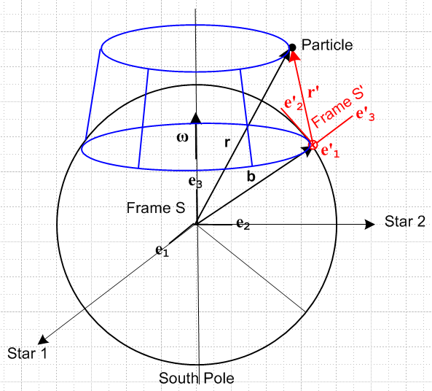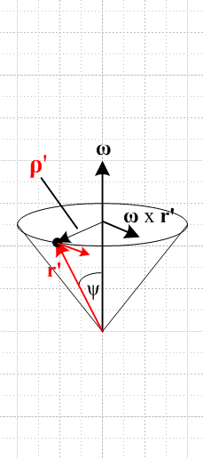
(8.2.10)

The point of this interpretative section is that, since b + r' = r, the centrifugal and Euler forces are additive: those of the Frame S' origin (b) plus those relative to the Frame S' origin (short r') add up those relative to the center of the Earth (long r).

8.3 Interpretations of the Coriolis Fictitious Force

Qualitative Arm-Waving Interpretation of the Coriolis Force

The Coriolis fictitious term is always the main topic of any textbook or web page which deals with motion in rotating frames, so we won't have much to say about it other than to give a popular qualitative explanation of the direction of the effect. We did show very carefully how the factor of 2 arises in the derivation of the term which is F'cor = -2m ω x v', and indeed, the expression itself was derived in full.

Consider the pictures below where at t = 0 we launch four colored projectiles horizontally from a launch platform that is screwed to a large frictionless turntable surface (perhaps the projectiles are hockey pucks). Fixed Frame S and rotating Frame S' have a common origin at the spindle. The launching is done in rotating Frame S' and the projectiles are sent off in the four directions of the compass at equal speeds V. These velocities are represented by the four black equal-length arrows in the right side picture below. The colored arrows on the left show the initial Frame S velocities of these projectiles. In Frame S the initial v's are not the same size because the turntable adds an upward tangential amount vt to each (vt = aω). Since Frame S is an inertial frame, we can regard the colored arrows on the left as also representing the straight-line trajectories of the projectiles in Frame S.

So, each projectile is launched with the same initial adder vt in Frame S and, being in free flight, maintains that vt during its flight. Notice that three of the projectiles move into to a region of larger radius, while the orange one heads to a smaller radius region. When a projectile moves to a larger radius, the particles of the turntable move faster CCW than the projectile's vt causing a velocity differential between the turntable and the projectile. We want now to examine this differential in the four cases. The short black arrows on the left show the motion of the turntable particles relative to the projectile, as will now be reviewed.

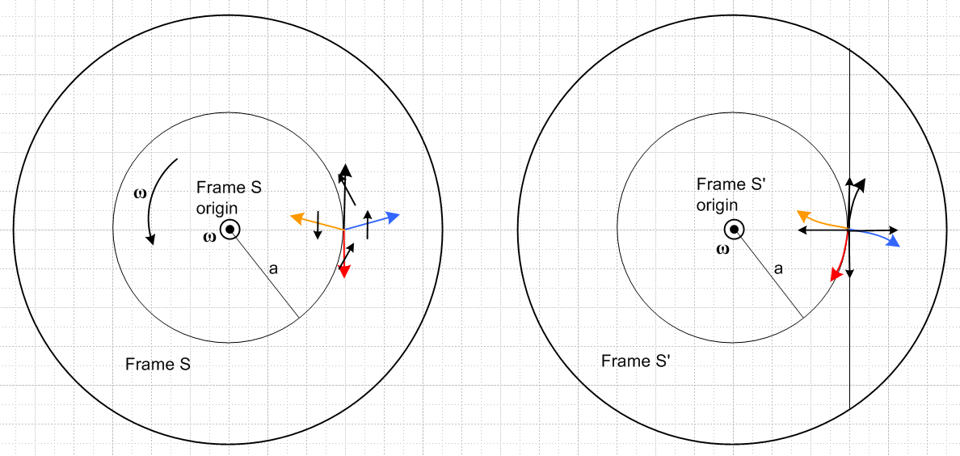
(8.3.1)

For the black projectile in mid flight, the turntable particles under the projectile are moving to the northwest relative to the projectile, so the projectile is seen by the turntable particles to be drifting to the right. Hence the curved black trajectory path on the right of Fig (8.3.1). On the left below is a crude strobe picture where a turntable particle's path in Frame S is shown in red and the arrows are then transferred to the right with a common tail to show what projectile motion the turntable particle sees in its rest frame.

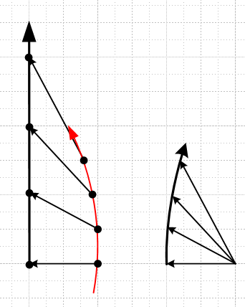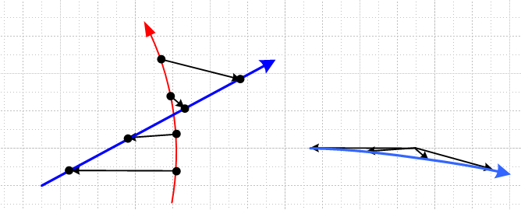
black blue (8.3.2)

For the blue projectile in mid flight, the turntable particles under the projectile are moving to the north relative to the projectile, so the projectile is seen to be drifting south. Hence the curved blue trajectory path on the right of Fig (8.3.1). The right strobe picture above shows this effect.

For the red projectile in mid flight, the turntable particles under the projectile are moving to the northeast relative to the projectile, so the projectile is seen to be drifting to the left. Hence the curved red trajectory path on the right.

For the orange projectile in mid flight, the turntable particles under the projectile are moving to the south relative to the projectile (these particles are at a smaller radius and move more slowly than vt), so the projectile is seen to be drifting to the north. Hence the curved orange trajectory path on the right.

Viewed from the direction of launch in Frame S', all four trajectories drift "to the right". This is in agreement with the right hand rule applied to our expression F'cor = -2m ω x v' = +2m v' x ω. The v' of each projectile is perpendicular to ω, and at t = 0 the four |v'| values are the same. Thus the t = 0 value of |F'cor| is exactly the same for all four projectiles, and indeed for a projectile launched in any direction, so any projectile launched with this |v'| will have the same initial deflection path shape. As time goes on, the particles experience different centrifugal forces causing their path shapes to differ, as discussed below.

Comments:

1. If the turntable were going CW instead of CCW, the drift directions would all be reversed, both by the qualitative argument, and by the F'cor expression. Projectiles would drift to the left instead of to the right.

2. One can think of Fig (8.3.1) as a view of the Earth from above the North Pole. In this case, the vectors do not lie in the plane of paper, but qualitatively the conclusion is the same: projectiles drift to the right in the Northern Hemisphere. A view from the South Pole would then show drift to the left in the Southern Hemisphere since ω is reversed.

3. The colored trajectories on the right in Fig (8.3.1), when applied to air masses moving into a region of Low pressure, look like this (air heading for the Low is deflected to the right)

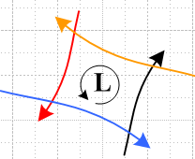 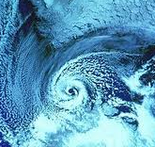 (8.3.3)

This explains why low pressure regions are counter-clockwise cyclonic in the Northern Hemisphere. Since lows often drift to the east in the western US, warm Mexican air is felt prior to the low's arrival, and cool Canadian air is felt afterwards. Of course such storms rotate clockwise in the Southern Hemisphere.

Superposition Interpretation of the Coriolis Force

Recall now the fictitious forces seen by the projectiles in Fig 8.3.1,

F'fict = – mS – mω x (ω x r') – 2m ω x v' – m x r' . (8.1.8)
frame centrifugal Coriolis Euler

Since the Frame S and Frame S' origins align, b = 0 and S = 0 . If we assume ω = constant, and express the centrifugal term in the simpler form of (8.2.9), then the projectiles are controlled by

F'fict = mω2r' – 2m ω x v' . (8.3.4)
centrifugal Coriolis

[To obtain the first term, set ψ = 90o in the cone picture of Fig (8.2.10) so then ρ' = r'.]
One can think of the above as the superposition of two problems. The centrifugal term alone accelerates the projectiles radially outward in proportion to their distances from the turntable center, so the effect of this term is different for the four projectiles as they progress in flight. The Coriolis term alone causes each projectile to deflect to its right (ω > 0) along a path that is part of a circle as we now show. Recall the bogus Newton's Law F'fict = ma' from (8.1.4) where a' = (dv'/dt)S'. If F'fict = – 2m ω x v' alone, then we have a' = -2ω x v' or

(dv'/dt)S' = Ω x v' where Ω = (-2ω) . (8.3.5)

According to (1.6.1) and Fig (1.6.2) vector v' must rotate on a cone whose axis is Ω. For the turntable situation, however, v' is always in the plane of the turntable, so that cone must be flat, so vector v' goes in a circle at rate Ω. The trajectory r'(t) is then also circular so the Coriolis deflection is part of a circle. Here is some Maple code illustrating this fact for the blue projectile. We enter the circular v' (called v) and integrate to get the trajectory.

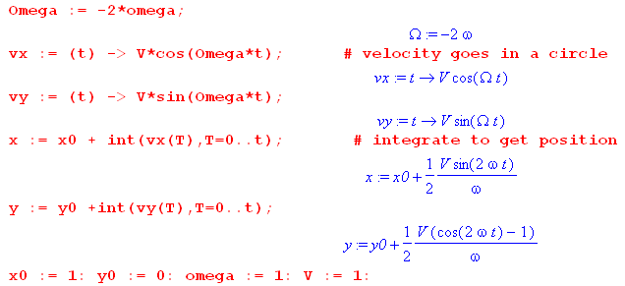

We set parameters ω = +1, a = 1,V = 1 with initial condition v'(0) = V' and then create a plot,

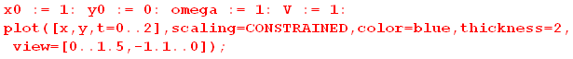
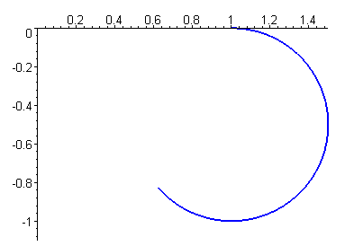 (8.3.6)

The projectile is deflected "to the right" in this case since ω > 0.
The actual deflection of the four projectiles is then a superposition of the centrifugal and Coriolis motions and is therefore not perfectly circular. We shall solve this problem exactly in Section 15.5 and plot the all four projectile trajectories.

8.4 Special Case #1 Problems

Recall from (8.1.5) that

F'eff = F – mS – mω x (ω x r') – 2m ω x v' – m x r' . (8.1.5)
frame centrifugal Coriolis Euler

If the rotation axis passes through the center of Frame S, we know from (7.13) that

S = x b + ω x (ω x b) Special Case #1 (7.13)

so that, using r = r' + b (6.1) in the third line below,

F'eff = F – m[ x b + ω x (ω x b)] – mω x (ω x r') – 2m ω x v' – m x r'

= F – m ω x (ω x [b +r' ]) – 2m ω x v' – m x [b + r'] // = F + F'fict

= F – mω x (ω x r) – 2m ω x v' – m x r . Special Case #1 (8.4.1)
so
F'fict = – mω x (ω x r) – 2m ω x v' – m x r Special Case #1 (8.4.2)

This is similar to (8.2.4) but now we have included the Coriolis term. Here r is the long vector, but v' is the rate of change of the short vector r'.

Problems involving the motion of objects on or near the Earth's surface, or of objects in orbit around the Earth, fall into Special Case #1. In the first problem class, Frame S' can be defined as shown in Fig (4.7.1).

8.5 Problems on the surface of the Earth

Let F0 = mg0 where go = -g0 is a vector pointing to the center of the Earth, and g0 = GME/RE2. Then for
problems involving motions of objects near the surface of the Earth, one has these real forces,

F = mg0 + possible other real forces . (8.5.1)

Possible other real forces might include air friction, wind, the action of magnetic fields on charged particles, etc.

Let T = 24*60*60 = 86400 ~ 105 sec be the nominal period of a day. The day has a seasonal variation in its duration of roughly (see e.g. https://www.iers.org/IERS/EN/Science/EarthRotation/LODplot.html )

dT/dt ~ 0.5 msec/day ~ 10-3 * 10-5 ~ 10-8 // rms (8.5.2)

with smaller short-term variations. From this we compute a rough value for ,

|| = |d(2π/T)/dt| = 2πT-2 (dT/dt) ~ 6 * 10-10 * 10-8 ~ 10-17 sec-2 . (8.5.3)

For activities on the surface of the Earth, r ≈ RE ~ 107 m so,

x r ~ 10-17 * 107 ~ 10-10 ~ 10-9 g . // max value at the equator (8.5.4)

Thus in (8.4.1) we neglect the Euler term – m x r to get

F'eff = (mg0 + possible other real forces) – mω x (ω x r) – 2m ω x v' . (8.5.5)

Carrying out a static experiment (v' = 0) to measure the g vector at some location on the Earth (no other forces in this experiment), one finds from (8.5.5),

F'eff = mg0 – mω x (ω x r) r = RE

≡ mg , (8.5.6)

where g is then the local gravity vector (which does not quite point to Earth center). In terms of this g, one then has

F'eff = (mg + possible other real forces) – 2m ω x v' (8.5.7)

so only the Coriolis fictitious force is left -- the centrifugal term has been absorbed into mg.
By how much do g0 and g differ? We can write [ see (8.2.5) and Fig (8.2.10 ]

g - g0 = - ω x (ω x r) = ω2ρ = ω2r cosα r = RE (8.5.8)

where α is latitude measured from the equator and is the usual cylindrical unit vector pointing away from the rotation axis of the Earth at our point on the surface. So we see the direction of the difference to be for any α. The magnitude of g - g0 is roughly

ω = 7.27 x 10-5 sec-1 // ω = ωE = 2π radians / [ 24*60*60 sec ]

r ≈ 6.37 x 106 // = RE (8.5.9)

ω2r cosα = (7.27)2(6.37) 10-4cosα = 337 x 10-4 cosα ~ 3 x 10-2 m/sec2 cosα ~ (3/1000)g0 cosα

so the difference is small but not zero. Presumably the local surface of the Earth is perpendicular to g and not g0, and one would certainly expect this to be true for a quiet ocean surface.

We now repeat the above discussion in the "swap" notation mentioned at the start of the Summary.

Swap Notation. The meaning of "swap notation" is that, in Fig 1, the vectors ω and b stay put, but all other vectors undergo V↔V'. This latter group includes basis vectors ei ↔ e'i, r ↔ r' , v ↔ v', a ↔ a' and of course Frame S ↔ Frame S'. This is nothing more than a change of the way things are labeled. If a non-swap equation has the number (x.x.x), then the corresponding equation in swap notation will be given the number (x.x.x)s . (8.5.10)

Here we rewrite equations (8.5.5), (8.5.6), (8.5.7) and (8.5.8) in swap notation.

Feff = (mg0 + possible other real forces) – mω x (ω x r') – 2m ω x v . (8.5.5)s

Carrying out a static experiment (v = 0) to measure the g vector at some location on the Earth (no other forces in this experiment), one finds from (8.5.10),

Feff = mg0 – mω x (ω x r') r' = RE'

≡ mg , (8.5.6)s

where g is the local gravity vector (which does not quite point to Earth center). In terms of this g, one then has

Feff = (mg + possible other real forces) – 2m ω x v (8.5.7)s

so only the Coriolis fictitious force is left -- the centrifugal term has been absorbed into mg. Finally,

g - g0 = - ω x (ω x r') = ω2ρ' = ω2r' cosα' ' . r' = RE (8.5.8)s

8.6 Tethered satellites and Tidal Forces

Consider a satellite, consisting of a pair of radially-aligned tethered masses m1 and m2, which orbits the Earth at angular frequency ω. Inertial Frame S is fixed with its origin at the center of the Earth, while Frame S' is fixed to the tethered satellite and so Frame S' rotates at ω as the satellite moves around the Earth.

The tethered masses are assumed to be at rest in Frame S' and are radially aligned with r1 > r2. One can show (see Appendix F) that such a system is stable due to a restoring torque and, in the stable position, the line between the masses points to the center of the Earth as the satellite orbits. It might take some damping effort to achieve this stable configuration. This restoring torque plus damping over time is what caused the slightly distorted Moon to present its same face to the Earth as it orbits (apart from a small residual libration).

Since we have a Special Case #1 situation (rotation axis through Frame S origin) we use (8.4.1) for the effective force acting on a mass m in Frame S' (F is the real force),

F'eff = F – mω x (ω x r) – 2m ω x v' – m x r . Special Case #1 (8.4.1)
real centripetal Coriolis Euler

where r is a long vector from the center of the Earth to mass m.

In their stable positions, the two masses have vi' = 0 so there is no Coriolis term. The orbit has a constant ω, so there is no Euler term. Thus the effective force on a static mass m in Frame S' is given by,

F'eff = F – mω x (ω x r) = F – m[(ω•r)ω - ω2r]
= F + mω2r . (8.6.1)

The real force F is the force of gravity plus the force of the tether tension T > 0. We then write for our two tethered masses, recalling that r1 > r2,

F'eff,1 = - (GmEm1/r12) – T + m1ω2r1 = [ - (GmEm1/r12) + m1ω2r1 - T ]
F'eff,2 = - (GmEm2/r22) + T + m2ω2r2 = [ - (GmEm2/r22) + m2ω2r2 + T ] (8.6.2)

where ME = mass of Earth, G = gravitational constant. It is convenient to define a function,

f(r,m) ≡ -mMEG/r2 + mω2r // f '(r,m) = 2mMG/r3 + mω2 (8.6.3)
so
F'eff,1 = [ f(r1, m1) - T]
F'eff,2 = [ f(r2,m2) + T ] . (8.6.4)

Since both masses are at rest in Frame S', their accelerations are a'i = 0 so F'eff,i = mia'i = 0, and we conclude that the tether tension is given by

T = f(r1, m1) = - f(r2.m2) . (8.6.5)

We now borrow a picture from page 120 of the Tethers in Space Handbook (Cosmo and Lorenzini) which shows the tethered satellite situation. The upper mass is at r1, the lower at r2, and the "center of gravity" is at r0, all measured from the center of the Earth. We refer to the two masses as m1 and m2 and to ω0 as ω.
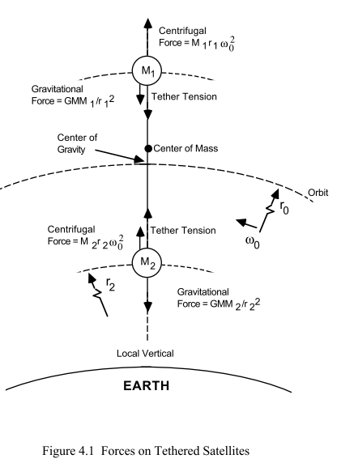 (8.6.6)

If the entire satellite were suddenly compressed to a point mass M = m1+ m2 and if this point mass were placed at the center-of-gravity location, that point mass M would continue to orbit the Earth at radius r0 and frequency ω and nothing exciting happens. For either of these "systems" we have the following balance between gravitational force and centrifugal force,

(GMEM/r02) = Mω2r0 or GME/r02 = ω2r0 . (8.6.7)

Comment: There is a very small distance between the satellite's center of mass and its center of gravity. See Appendix D on this subject and in particular the numerical examples of (D.3.16).

At this point to make things simple we shall assume m1 = m2 = m. Then from (8.6.5),

T = f(r1) = - f(r2)
f(r) ≡ -mMEG/r2 + mω2r // gravitational force + centrifugal force
f '(r) = 2mMG/r3 + mω2 . (8.6.8)

Note that f(r0) = 0 according to (8.6.7). Setting r1 = r0 + Δr in (8.6.8),

T = f(r0 + Δr) = -mMG/ (r0+Δr)2 + mω2(r0+Δr)

= -(mMG/r02) (1 + Δr/ r0)-2 + mω2(r0+Δr) // assume Δr << r0

≈ -(mMG/r02) (1 - 2 Δr/ r0) + mω2(r0+Δr) // (1+x)n ~ 1 + nx for small x

= - mω2r0 (1 - 2 Δr/ r0) + mω2(r0+Δr) // using (8.6.7)

= 3mω2(Δr)

= 3 (mMG/r03)(Δr) . (8.6.9)

The real gravitational force gives 2/3 of this result, while the fictitious centrifugal term gives 1/3 of the result, a fact we will note again several times below.

If ρ represents an arbitrary vertical displacement away from r0, so r = r0 + ρ, then the above says,

f(r0 + ρ) = 3mω2ρ (8.6.10)

which looks like this near ρ=0
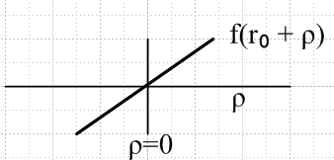 (8.6.11)

This f(r0+ρ) represents the radial force on any untethered Particle that might be present in Frame S' located a radial distance ρ from r0. A particle at r > r0 is pushed up in Frame S', while a particle at r < r0 is pushed down (toward Earth center). Again, this force in Frame S' is due to the combination of gravitational (2/3) and centrifugal (1/3) forces.

Another way to view the above calculation is this,

T = [f(r0 + Δr) - f(r0)] + f(r0)

≈ f '(r0) Δr + f(r0) // f '(r0) is the gradient of the force f(r) at r=r0

= f '(r0) Δr // f(r0) = 0 from (8.6.7)

= (2mMG/r03 + mω2) Δr // f '(r0) from (8.6.8)

= (2 mω2 + mω2) Δr // (8.6.7) again

= 3mω2 Δr . (8.6.12)

So the tension in the tether due to tidal force is equal to Δr times the derivative of f(r) evaluated at r = r0,

T ≈ Δr f '(r0) = Δr 3mω2 = 3 Δr (mGM/r03) . (8.6.13)

Again, the tidal force acting up the upper mass is T pushing up, and the tidal force acting on the lower mass is T pulling down, all in Frame S'. One might then write

tidal force per unit mass = ± 3 Δr (GM/r03) . // tidal acceleration (8.6.14)

Once again, 2/3rds of the tidal force arises from the gravitational gradient at the satellite while 1/3 arises from the centrifugal gradient. The result (8.6.14) appears in Cosmo and Lorenzini p 123 with Δr=L and ω=ω0.

Comments:

1. One may regard tension T as an example of a "tidal force" which tends to "rip apart" objects in orbit around a central force. In our example, the tidal force is T = f '(r0) Δr = 3 (mMG/r03) Δr. For objects in orbit around the Earth, this is a small or moderate force, but for objects orbiting massive black holes, the force is strong enough to rip apart all known materials, a process called "spaghettification", a sort of cosmic disposal.

2. According to (8.6.14), an untethered water droplet on the surface of the upper mass will migrate to the upper extremity of that mass, while a water droplet on the surface of the lower mass will migrate to the lower extremity of that mass. A crude intuition would seem to say that the Earth ought to pull both water drops to the lower extremity of each mass, but that is not what happens. One must get into the rotating Frame S' to see what happens. This is essentially why the usual tides on the Earth "bulge" on the side facing the Moon and on the side facing away from the Moon. The Sun also has its smaller effect. This subject is considered in the next section.

3. See comments below (8.8.26) for a discussion of why the tether tidal force (8.6.14) has a leading factor of 3, whereas the lunar Earth tide (8.8.26) has a leading factor of 2.

4. Appendix F presents a more complete analysis of the tether or "dumbbell" satellite, allowing for an arbitrary 3D orientation of the masses and analyzing their motion when not in the stable vertical orientation. For example, a general dynamic expression for the tether tension T appears in (F.6.26). For the tether vertically aligned and at rest the limit of this expression is (F.6.30) which is the same as (8.6.12) above. The reader is warned that Appendix D and F are both written in "swap" notation where prime and noprime labels are swapped relative to the no-swap notation used above. This is done to reduce the annoying number of primes that would otherwise be present in many expressions.

5. Real tethered satellites have seen action since the 1960's (including snapped tethers), see the brief history of Chen et al. [2013]. Tether applications include: (1) Power generation and thrust using a conducting tether in solar and planetary magnetic fields and plasmas; (2) lifting, stabilizing and moving objects around in space (et, reboosting tired satellites); (3) research in controlled-gravity environments (distance down the tether see (8.6.12)); (4) gravity-wave and conventional antenna experiments. Tether lengths have varied from tens of meters to tens of kilometers.

8.7 Special Case #3

Consider the following situation which we shall call Special Case #3 where we have replaced the rotation vector ω by Ω where now Ω = dφ/dt :

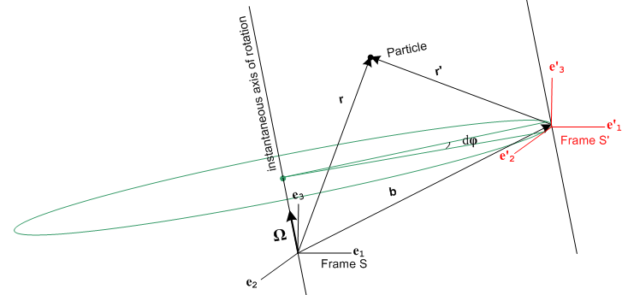 (8.7.1)

This resembles Special Case #1 because the rotation axis passes through the origin of Frame S. However, in this figure we intend that the axes of Frame S' always line up with those of Frame S, so the only thing that varies is the vector b(t). The axes e'i are no longer "soldered" to the b vector, and e'i = ei at all times. Although the axes of Frame S' do not rotate relative to those of Frame S, we still put this case into our "rotating frames" basket because the origin of Frame S' is instantaneously rotating about the Ω axis.
In Special Case #3 there is no distinction between ∂Sa and ∂S'a for any vector a :

∂Sa = ∂S[aiei] = (∂Sai) ei = (∂tai) ei

∂S'a = ∂S'[aiei] = (∂S'ai) ei = (∂tai) ei . (8.7.2)

One can interpret ∂Sa = ∂S'a as being the G Rule ∂Sa = ∂S'a + ω x a with ω= 0.

Thus we can just write = ∂Sa = ∂S'a . The complicated analysis of Sections 6,7 and 8 is now much simpler:

r = r' + b

= ' + ⇒ v = v' +

= ' + ⇒ a = a' + . (8.7.3)

Newton's Law in Frame S' now has only one fictitious force,

ma' = ma - m

F'eff = F - m

F'fict = – m . // Special Case #3 (8.7.4)

Recall that our general case fictional force expression was

F'fict = – mS – mω x (ω x r') – 2m ω x v' – m x r' . (8.1.8)
frame centrifugal Coriolis Euler

In Special Case #3 only the "frame" portion of the fictitious force exists and we can interpret this as being the full fictional force in which we set ω = 0 and = 0.
Regardless of how the Frame S' origin moves through space, we can always interpret its motion as an instantaneous rotation, as suggested by this drawing,

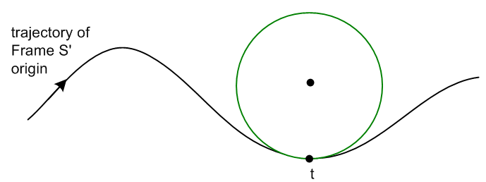 (8.7.5)

At time t the Frame S' origin is rotating along the green circle shown.

Comment: Historical authors have compared the behavior of Frame S' to a frying pan in the fast-moving hands of a busy cook who always maintains the pan's orientation. We are instead reminded of the behavior of a gimbaled alcohol stove often used in sailboats, or better yet, a gimbaled sailboat compass.

8.8 Tides on the Earth

The basic picture

In general, the orbital pattern of a binary gravitational system has this planar appearance, where each object traverses its own ellipse
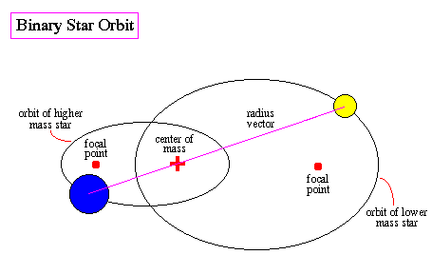 (8.8.1)
http://abyss.uoregon.edu/~js/ast122/lectures/lec10.html

In this section, however, we restrict our interest to a special case where each mass traces out a circular path, not an elliptical one. The picture is this, where we define R1,R2, M1,M2, r12,R,R' as shown:

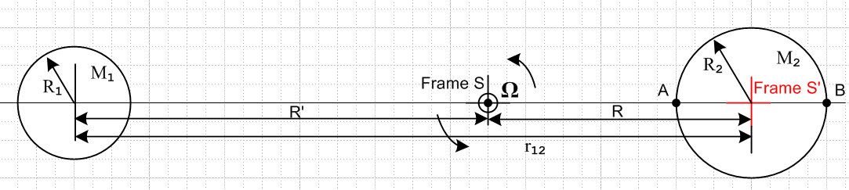
(8.8.2)

Each object is assumed to be a spherically symmetric mass distribution and can thus be treated as a point mass at its center for gravitational purposes (see Section D.5). An inertial Frame S has its origin at the center-of-mass point, and the binary system rotates in the plane of paper at angular frequency Ω about this Frame S origin. Frame S' is attached to sphere 2 and we assume that sphere 2 maintains its orientation "relative to the stars" so that at some later time we have this picture

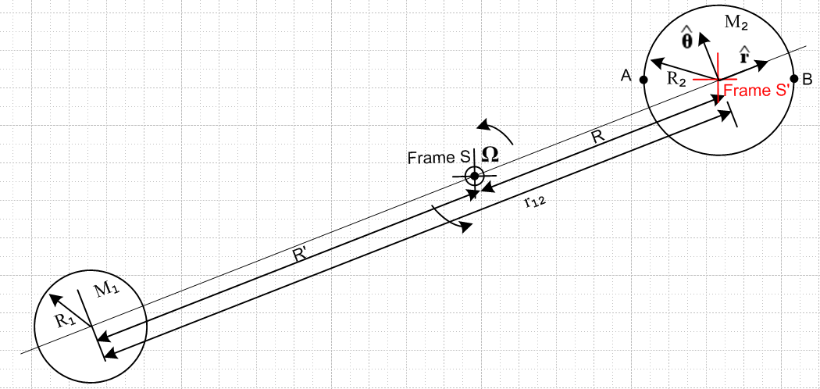
(8.8.3)

The situation with Frame S and Frame S' is then exactly that of Special Case #3 described in the previous section, where b = R and the only fictitious force in Frame S' is F'fict = – m . Points A and B are two fixed points on the surface of sphere 2. To apply Fig (8.8.3) to the Moon-Earth system, we temporarily turn off the rotation of the Earth (M2) about its axis (not shown), so the this new Earth has a fixed orientation relative to the stars.

Distance R can be found from the usual center-of-mass equation (viewed from Frame S),

0 = [M2R - M1R' ]/(M1+M2) R+R' = r12 (8.8.4)

which reports out the obvious fact that

R = r12 [M1/(M1+ M2)]
R' = r12 [M2/(M1+ M2)] . (8.8.5)

We collect here some data on the Sun, Earth and Moon :

MS = 1.989 x 1030 kg RS = 695,700 km G = 6.674 x 10-11 m3/(kg-sec2)
ME = 5.972 x 1024 kg RE = 6371 km (8.8.6)
MM = 7.342 x 1022 kg RM = 1737 km TM = 27.32 days (sidereal)

rES = 1.496 x 108 km // average e = .0167
rME = 384,400 km // average e = .0549

We then compute,

1 ------- 2
Earth-Sun R/R2 = r12 [M1/(M1+ M2)] /R2 = rES [ME/(ME+ MS)] /RS = .000646
Moon-Earth R/R2 = r12 [M1/(M1+ M2)] /R2 = rME [MM/(MM+ ME)] /RE = 0.737

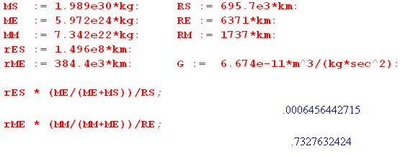 (8.8.7)

So for the Earth-Sun system, the center of mass is basically at the center of the Sun, while for the Moon-Earth system, the center of mass lies at a point 3/4 the radius of the Earth from the center. We could redraw our figure for these two cases, but the kinematics does not change, so we won't bother.

Force Equations

Newton's Law for a mass m in non-inertial Frame S' is, according to (8.7.4),

F'eff = ma' where F'eff = F – m (8.8.8)

and F is the sum of all Frame S forces acting on mass m.

It is clear from Fig (8.8.3) that (since R is a constant)

b = R d/dt = Ω d/dt = - Ω // see (E.5.6)
= R d/dt = RΩ
= RΩ d/dt = - RΩ2 . (8.8.9)

Therefore (8.8.8) becomes

ma' = F'eff = F + m RΩ2 . (8.8.10)

For a Particle in or on the Earth, the real forces are

F = Fg1 + Fg2 + Fng where

Fg1 = the gravitational force due to sphere 1 (the Moon)
Fg2 = the gravitational force due to sphere 2 (the Earth)
Fng = any non-gravitational forces (8.8.11)

and then (8.8.10) may be written

ma' = Fg1 + Fg2 + Fng + m RΩ2 . (8.8.12)

This is the effective Newton's Law for a mass m in Frame S'. If a mass m is at rest on the surface of the Earth (in Frame S') , then a' = 0 and we find

Fng = - Fg1 - Fg2 - m RΩ2 . (8.8.13)

If there are no other non-gravitational forces affecting mass m, then Fng is just the force of the Earth's surface pushing up on mass m to hold it in place so it has a' = 0.

The relation between r12 and Ω

If we were to replace sphere 2 (the Earth) with a point mass M2 at its center, nothing would change in our orbiting picture. This point mass M2 does a circular orbit around the binary center of mass with radius R and angular frequency Ω. The usual rule for circular motion of a point particle says that the gravitational force balances the centrifugal force, so

M1M2G/r122 = M2Ω2R
or
M1G/r122 = Ω2R . (8.8.14)

Now we do a thought experiment. We imagine the Earth's core to be solid and we grind out a small spherical cavity around the Earth's center point. We take the ground-out material and compress it into a point mass m and we place that mass m at the center of the cavity. The orbit of the Earth-Moon system is unaffected by this alteration. In effect we now have two point masses in identical orbits with the Moon: the Earth of mass M2-m and the central particle of mass m. For each we have M1G/r122 = Ω2R. The claim then is that the point mass m simply floats in the center of the cavity. In Frame S' there is no total force acting on this mass m to cause it to move from its position. This total force of 0 is the sum of the gravitational force pulling it to the Moon, and the centrifugal force pushing it away from the Moon,

0 = - (Fg1 + m RΩ2)
or
mM1G/r122 = m RΩ2
or
M1G/r122 = Ω2R

which is the same as (8.8.14) above. We can replace the R in (8.8.14) with the R of (8.8.5) to get

M1G/r122 = Ω2 r12 [M1/(M1+ M2)]
or
(M1+ M2)G/r123 = Ω2 (8.8.15)

and this is the relationship between r12 and Ω for given masses M1 and M2.
Using (8.8.14) in (8.8.12) one finds,

ma' = Fg1 + Fg2 + Fng + (mM1G/r122) . (8.8.16)

Tidal Force at an arbitrary point on the Earth

Now consider a particle of mass m at some arbitrary location C on the surface of the Earth. We define angles θ and β as shown, where β is very small,

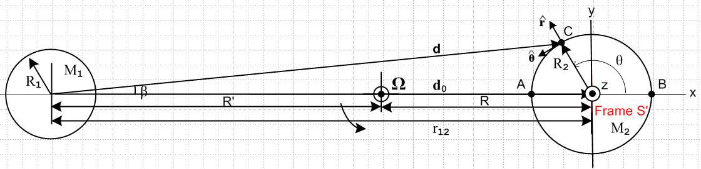
(8.8.17)

Here we show a brand new and which have nothing to do with those used in Fig (8.8.3). The old in (8.8.16) is now 0, a unit vector to the right in (8.8.17). Vector d points to point C from the center of sphere 1 while vector d0 links the two object centers, so d0 = r12. We can then write

Fg1 = - (M1mG/d2) (8.8.18)

and so (8.8.16) is recast once again as

ma' = Fg1 + Fg2 + Fng +( mM1G/r122) 0

= - (M1mG/d2) + Fg2 + Fng + (mM1G/d02) 0

= Fg2 + Fng + mM1G ( 0/d02 – /d2)

= Fg2 + Fng + Ftid, (8.8.19)
where
Ftid ≡ mM1G ( 0/d02 – /d2) . // tidal force (8.8.20)

For a mass m at the center of the Earth, d = d0 so Ftid = 0 in agreement with our thought experiment above.
It is the fact that sphere 1's gravitational field varies slightly (in direction and magnitude) at different points on sphere 2 (as shown in (8.8.18)) which results in the tidal force. Equation (8.8.20) appears in Taylor p 332 as equation (9.12) and in Butikov as equation (2). We have tried to match Taylor's notation.

Comment: If the rotating Moon-Earth system in Fig (8.8.17) were replaced by a static non-rotating system in which the Earth and Moon were held apart by a very long, stiff (1020 N) rod, would the tidal force be the same as shown in (8.8.20)? Or would the water bulge only on the side of the Earth facing the Moon? In this case we have in inertial Frame S' the following force on a mass m on the surface of the Earth

F' = ma' = Fg1 + Fg2 + Fng // Earth, Moon and Stick

Since the gravitational force Fg1 of M1 on a mass m at point A is larger than at point B in Fig (8.8.17), it seems likely that water would bulge on the A side of the Earth and recede on the B side. So it is not just the non-uniformity of the gravitational field that causes the double-bulge tide on the real Earth, it is this non-uniformity in combination with the balance provided by the rotation which causes there to be zero force on a particle at the center of the Earth.

Tidal force in Cartesian coordinates

It is useful to express Ftid in both Cartesian and polar coordinates with the approximation that
R2/d0 << 1. In that case, from the Law of Cosines and Fig (8.8.17),

d2 = R22 + d02 - 2d0R0cos(π-θ) = R22 + d02 + 2d0R0cosθ = d02[ 1 + (R2/d0)2 + 2 (R2/d0)cosθ ]

≈ d02[ 1 + 2 (R2/d0)cosθ ] (8.8.21)

so that

d-3 ≈ d0-3 [ 1 + 2(R2/d0)cosθ]-3/2 ≈ d0-3 [ 1 - 3(R2/d0)cosθ ] . (8.8.22)

Armed with this fact, we next write, again looking at Fig (8.8.17),

d0 = d0
d = (d0 + R2 cosθ) + R2sinθ . (8.8.23)

We assume for now the usual x axis to the right and y axis up, though this will be changed below. Then,

Ftid = mM1G { d0/d03 – d/d3 }

= mM1G { d0/d03 – [(d0 + R2 cosθ) + R2sinθ ] d0-3 [ 1 - 3(R2/d0)cosθ ]}

= (mM1G/d02) { – [(1 + (R2/d0) cosθ) + (R2/d0) sinθ ] [ 1 - 3(R2/d0)cosθ ] }

= (mM1G/d02) { – + 3(R2/d0)cosθ - (R2/d0) cosθ) - (R2/d0) sinθ) } + O((R2/d0))2

≈ (mM1G/d02) {2(R2/d0)cosθ - (R2/d0) sinθ) }

= (mM1G/d03) {2R2cosθ - R2sinθ) }

= (mM1G/d03) ( 2x - y ) . (8.8.24)

Using this simple form, it is easy to plot the tidal force field Ftid(x,y) in the region of the Earth,

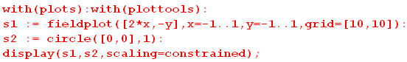

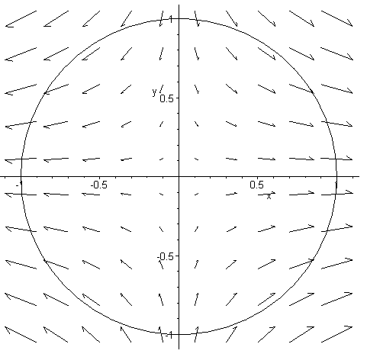 (8.8.25)

We can evaluate Ftid in (8.8.24) at the left, right, top and bottom of the Earth:

left: A (x,y) = (-R2,0) Ftid = -2R2(mM1G/d03) points left
right: B (x,y) = (R2,0) Ftid = 2R2(mM1G/d03) points right
top: (x,y) = (0,R2) Ftid = -R2(mM1G/d03) points down
bottom: (x,y) = (0,-R2) Ftid = R2(mM1G/d03) points up (8.8.26)

and these results seem in agreement with the above field plot (zero force at Earth center).

2 versus 3

Question: For the Earth tide situation we have just shown that at point B farthest from the Moon there is a total force |Ftid| = (2mM1G/d03)R2. For the tether analysis of (8.6.9) setting Δr = R2 produces a tidal force of |Ftid| = T = (3mMG/r03)R2 . Why are the two red integers different?

Answer: For the tether satellite, the axes of the satellite Frame S' are rotating so the fictitious force set includes both the frame and "local" centrifugal contributions – mS – mω x (ω x r') of (8.1.8). It was shown that the centrifugal term accounts for 1/3 of the tidal force. But for the Earth tide analysis, the axes of Frame S' do not rotate, so only – mS exists so that extra 1/3 is missing. We might expect that extra 1/3 to reappear if we did an analysis of tides on an Earth which is phase locked to always have the same face pointing toward the Moon (Reader Exercise). On the other hand, for a tethered satellite that is dropping straight down toward the Earth, we would expect the 1/3 to be missing (Reader Exercise).

One gets the general impression that the water surface might have the following shape, where the black arrows show the magnitude of the tidal force at various locations, in agreement with (8.8.25) and (8.8.26),

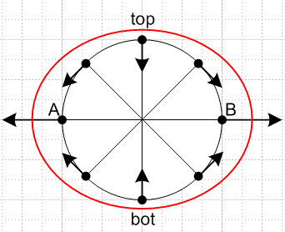 (8.8.27)

The tidal acceleration is very weak compared to the local gravitational force on the Earth. For the lunar tidal case, continuing the Maple code above we find for the tidal acceleration at point B,

aB = 2R2(M1G/d03) = 2(M1G/d02)(R2/d0) = 2(MMG/rM-E2)(RE/rM-E)

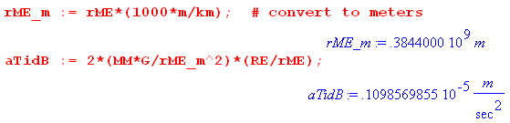 (8.7.28)

so basically the tidal acceleration is 10-7 the size of g = 9.8. It is rather amazing what such a small force can do when it is differentially applied to a lot of water.

Tidal force in polar coordinates

To express the tidal force in polar coordinates, we use (E.5.4) with ρ→ r = R2 and φ→θ to get

= cosθ – sinθ r = R2
= sinθ + cosθ . (8.8.29)

Then,

Ftid = (mM1G/d03) { 2x - y }

= (mM1G/d03) { 2rcosθ [cosθ – sinθ ] - rsinθ [sinθ + cosθ ]

= (mM1G/d03) { (2cos2θ - sin2θ) + ( -3cosθsinθ) } . (8.8.30)

The coefficients of the unit vectors can be simplified,

2cos2θ - sin2θ = 2(1/2)*(1+cos2θ) - (1/2)(1-cos2θ) = (1/2) [ 2 + 2cos2θ - 1 + cos2θ ]

= (1/2) [ 1 + 3cos2θ] = (3/2) [ cos2θ +1/3 ]

-3cosθsinθ = (-3/2) 2sinθcosθ = -(3/2)sin2θ . (8.8.31)

Therefore the tidal force in the polar coordinates appearing in Fig (8.8.17) is,

Ftid = (3/2) (mM1G R2/d03) [ (cos2θ +1/3) - sin2θ ] . (8.8.32)

Since the term with the 1/3 is radially symmetric around the Earth, it really has no effect on tides and is usually just dropped. This last result appears in Butikov as (5), (6) and (7).

Equation of the water surface

Here we follow the development of Butikov. We first make an ansatz that the water surface on an idealized non-rotating water-covered Earth is described by the following simple equation,

r(θ) = R2 + a cos2θ . a > 0 (8.8.33)

The constant term is R2 so that <r(θ)> = R2. One chooses the angle 2θ to get the shape suggested in Fig (8.8.27). The problem then is to determine the constant a which will be << R2. This is not the true equation of an ellipse, but we shall call it an ellipse anyway.
Consider the following picture of the water on the Earth,

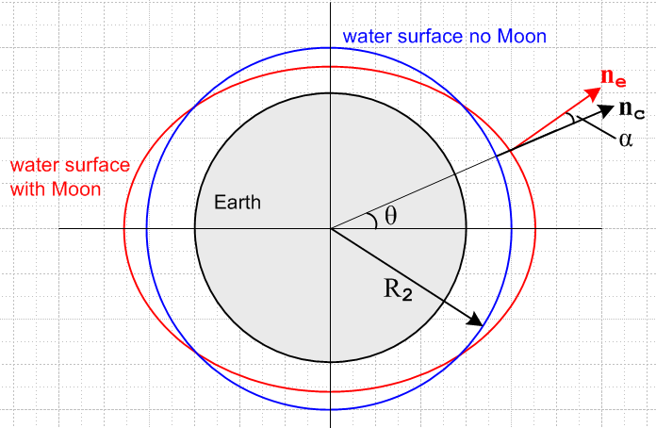 (8.8.34)

Here nc is normal to the blue circle at angle θ, while ne is normal to the red ellipse. In polar coordinates, we know that c = , and we wish to compute e. Our motivation is to compute angle α which will then lead us to an expression for a. So far we know that cosα = c• e = • e .
Define

f(r,θ) = r - R2 - acos2θ

and the ellipse (8.8.33) is then given by f(r,θ) = 0. We know that the normal to a 2D surface is given by its gradient, so in polar coordinates we have

ne = ∇f(r,θ) = (∂rf) + (1/r)(∂θf) = + 2(a/r)sin2θ

|ne| = (1 + [2(a/r)sin2θ]2 )1/2

1/|ne| = (1 + [2(a/r)sin2θ]2 )-1/2 ≈ 1 - (1/2) [2(a/r)sin2θ]2 (8.8.35)

cosα = c• e = • e = • ne / |ne| = • [ + 2(a/r)sin2θ ] / |ne| = 1/|ne|

≈ 1 - (1/2) [2(a/r)sin2θ]2

≈ 1 - α2/2 . // approx of cosα (8.8.36)

Therefore using r = R2,

α = 2(a/R2)sin2θ . (8.8.37)

Having found a geometric value for α, we now seek another expression for α based on physics. Consider,

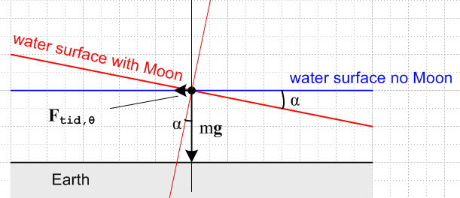 (8.8.38)

Since the affected water surface is assumed stable, the total force on the particle of water at the dot must be normal to the red surface. Therefore

|Ftid,θ| / mg = tanα ≈ α where g = GM2/R22 (8.8.39)

From (8.8.32) we then write

α ≈ |Ftid,θ| / mg = (3/2) (mM1G R2/d03) sin2θ / (mGM2/R22)

= (3/2) (M1/M2) (R2/d0)3 sin2θ . (8.8.40)

Comparing this α to that of (8.8.37) one finds,

2(a/R2)sin2θ = (3/2) (M1/M2) (R2/d0)3 sin2θ
so
a = (3/4) R2 (M1/M2) (R2/d0)3 . (8.8.41)

Thus the shape "ansatz" (8.8.33) was a good one. This result for "a" appears in Butikov as (9) and (11). Taylor obtains the same result in his (9.18) (h=2a) by treating the water surface as an equipotential surface (see Footnote at the end of this section).

The variation between low and high tides is H = 2a and we may compute this from (8.8.41) for both the Moon-Earth and Sun-Earth systems (in km),

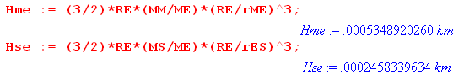
Therefore,

Hlunar_tide = 53.49 cm ~ 1.8 feet .
Hsolar_tide = 24.58 cm ~ 0.8 feet . (8.8.42)

A non-inlander will recognize these as reasonable ballpark values for ocean tides, lending credence to the model at hand.

Comment: The red "ellipse" shown in (8.8.34) is the cross section in the plane of paper of a red ellipsoid formed by rotating the ellipse about the z axis. This ellipsoid then specifies the water level at all places on the Earth.

Idealized Tidal patterns for an arbitrary rotation axis of the Earth

We now turn the rotation of the Earth back on (we turned if off earlier). For the real Earth, there are many tidal complications that arise. There are land masses. Lake water has nowhere to go. There is friction between the water and the land which slows down the Earth's rotation slightly over time. There is weather and there are ocean tidal currents which do not flow infinitely fast. We shall not attempt to analyze this general situation.
Instead, we imagine an idealized Earth covered with water and the Earth turns under the water with no "friction", and an Observer just stands in the water and measures the tide height as a function of time.
What does that Observer see? It of course depends on where the Earth's axis of rotation is located relative to our picture. Consider,

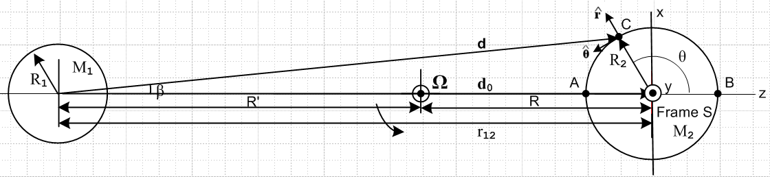
(8.8.43)

Frame S has basis vectors , and . We now define Frame S' as having a new set of basis vectors as follows,

(',',') = Rz(φ1)Rx(θ1) (,,) for example ' = Rz(φ1)Rx(θ1) .

In our Passive View discussion of Section 1.3, we think of basis vectors back-rotated e'n = R-1en, so we shall then define R1-1 = Rz(φ1)Rx(θ1) and then we have (',',') = R1-1(,,). The matrix of interest is shown in (E.2.2) so in Frame S components we may write,

' = R1-1 = $\left(\begin{matrix}cosθ1cosφ1 & -sinφ1 & sinθ1cosφ1 \\ cosθ1sinφ1 & cosφ1 & sinθ1sinφ1 \\ -sinθ1 & 0 & cosθ1\end{matrix}\right)$$\left(\begin{matrix}0 \\ 0 \\ 1\end{matrix}\right)$ = $\left(\begin{matrix}sinθ1cosφ1 \\ sinθ1sinφ1 \\ cosθ1\end{matrix}\right)$ . (8.8.44)

We now assume that the Earth rotates about this new ' axis at rate φ' = ωt.
As noted in (1.3.3), if a Kinematic Vector V has components Vi in Frame S, then it has components (V)'i = R1Vi in Frame S', which we write in vector notation as (V)' = R1V . Applying to V = r we find, for the position of some point in the two frames,

(r)' = $\left(\begin{matrix}x' \\ y' \\ z'\end{matrix}\right)$ = R1 r = $\left(\begin{matrix}cosθ1cosφ1 & cosθ1sinφ1 & -sinθ1 \\ -sinφ1 & cosφ1 & 0 \\ sinθ1cosφ1 & sinθ1sinφ1 & cosθ1\end{matrix}\right)$$\left(\begin{matrix}x \\ y \\ z\end{matrix}\right)$ . (8.8.45a)

Since R1-1 = R1T, the matrix appearing here is just the transpose of that appearing in (8.8.44). Inverting one gets,

r = $\left(\begin{matrix}x \\ y \\ z\end{matrix}\right)$ = R1-1 (r)' = $\left(\begin{matrix}cosθ1cosφ1 & -sinφ1 & sinθ1cosφ1 \\ cosθ1sinφ1 & cosφ1 & sinθ1sinφ1 \\ -sinθ1 & 0 & cosθ1\end{matrix}\right)$$\left(\begin{matrix}x' \\ y' \\ z'\end{matrix}\right)$ . (8.8.45b)

Suppose we define spherical coordinates in Frame S and Frame S' as so that (since a rotation, r' = r),

$\left(\begin{matrix}x \\ y \\ z\end{matrix}\right)$ = $\left(\begin{matrix}rsinθcosφ \\ rsinθsinφ \\ rcosθ\end{matrix}\right)$ and $\left(\begin{matrix}x' \\ y' \\ z'\end{matrix}\right)$ = $\left(\begin{matrix}rsinθ'cosφ' \\ rsinθ'sinφ' \\ rcosθ'\end{matrix}\right)$ . (8.8.46)

Then (8.8.45b) says, cancelling the r factors,

$\left(\begin{matrix}sinθcosφ \\ sinθsinφ \\ cosθ\end{matrix}\right)$ = $\left(\begin{matrix}cosθ1cosφ1 & -sinφ1 & sinθ1cosφ1 \\ cosθ1sinφ1 & cosφ1 & sinθ1sinφ1 \\ -sinθ1 & 0 & cosθ1\end{matrix}\right)$ $\left(\begin{matrix}sinθ'cosφ' \\ sinθ'sinφ' \\ cosθ'\end{matrix}\right)$ . (8.8.47)

The last of these three equations reads

cosθ = - sinθ1sinθ' cosφ' + cosθ1 cosθ'

= cosθ1 cosθ' - sinθ1sinθ'cos(ωt) (8.8.48a)

= cosθ1sinθ'L - sinθ1cosθ'Lcos(ωt) . (8.8.48b)

In (8.8.48b) we replace colatitude θ' by latitude θ'L = π/2 - θ which causes sin↔cos.
Recall the equation of the water surface from (8.8.33),

r(θ) = R2 + a cos2θ . a > 0 (8.8.33)

This implies a tide height of

h(θ) = a cos2θ = 2cos2θ - 1 . (8.8.49)

Therefore on our idealized Earth which rotates about an axis (θ1,φ1) relative to Fig (8.8.43) we obtain the following tide height during the day

h(t) = a cos2θ(t) = a [ 2cos2θ(t) - 1 ]

= a [ 2 ( cosθ1 cosθ' - sinθ1sinθ'cos(ωt) )2 - 1 ] (8.8.50a)

a [ 2 ( cosθ1 sinθ'L - sinθ1cosθ'Lcos(ωt) )2 - 1 ] (8.8.50b)

The tide height does not depend on the angle φ1 because z is a symmetry axis of Fig (8.8.43) and the tides are thus symmetrical about this axis.

Example 1: Consider the case ' = (θ1 = 90o)

Suppose the Earth's rotation axis were in the direction in Fig (8.8.43) (pointing out of the plane of paper). In that case one has θ1= π/2 and φ1= π/2, since

' = Rz(π/2) Ry(π/2) = $\left(\begin{matrix}sinθ1cosφ1 \\ sinθ1sinφ1 \\ cosθ1\end{matrix}\right)$ = $\left(\begin{matrix}0 \\ 1 \\ 0\end{matrix}\right)$ = . (8.8.51)

Then from (8.8.50),

h(t) = a [ 2( cosθ1 cosθ' - sinθ1sinθ'cos(ωt) )2 - 1 ]

= a [ 2( 0 cosθ' - 1 sinθ'cos(ωt) )2 - 1 ]

= a [ 2(-sinθ'cos(ωt))2 - 1 ]

= a [ 2sin2θ'cos2ωt - 1 ] . (8.8.52)

If the Observer were at the Earth's equator θ' = π/2 (which is in the plane of paper of Fig (8.8.43)), one would have

h(t) = a [ 2cos2ωt - 1 ] = a cos(2ωt) .

Comparing to (8.8.49), one then has θ = ωt . The Observer sees a full amplitude swing of ±a in the tide. As this Observer moves toward the pole so θ' decreases, the amplitude of the tide decreases as (8.8.52) shows. At the pole, where θ' = 0, one finds h(t) = -a (a constant) all the time, which seems reasonable since θ = π/2 all the time and so h(θ) = a cos2θ = a cosπ = -a, as depicted below,

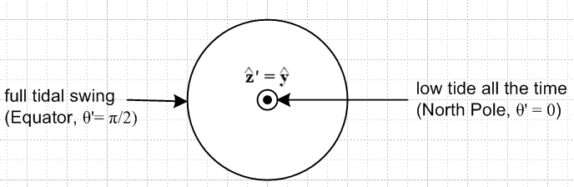 (8.8.53)

Here is a Maple rendition of this Example 1 where we set a = 1 and ω = 1 so one day lasts T = 2π. In this code we use θ'L = lat and the first equation is (8.8.48b) :

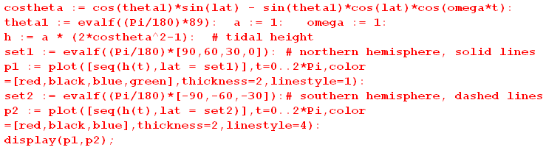
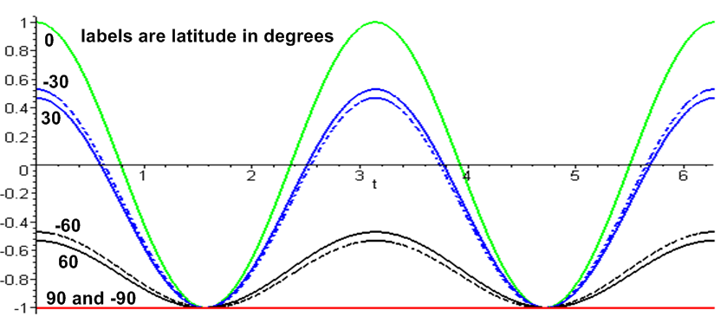 (8.8.54)

The solid lines are the equator (green) and northern hemisphere latitudes 30o (blue), 60o (black) and 90o (red); the dashed lines are southern hemisphere latitudes -30o (blue), -60o(black), and -90o (red). We set θ1 = 89o instead of 90o to pull apart the solid and dashed lines a bit. At θ'L = +90o (north pole) and -90o (south pole), the red solid and red dashed lines always coincide. The lines are horizontal because at each pole, there is no motion at all as the Earth rotates. The lines coincide because the tides are azimuthally symmetric about the symmetry axis as shown in (8.8.27) so both poles see the same h = -a = -1.

Example 2: Start with ' = and then slowly increase θ1 from 0 to 90o so ' tips away from .

Here we show a set of plots from the above code for various values of the tilt θ1. At θ1 = 0 we of course expect there to be no tides at all again due to the azimuthal symmetry of the tides about the z axis.

θ1= 1o θ1= 10o
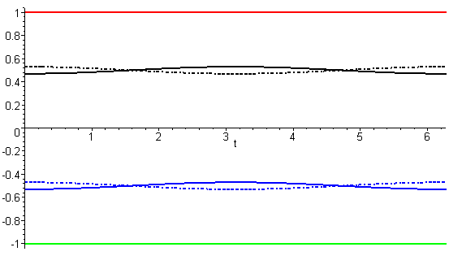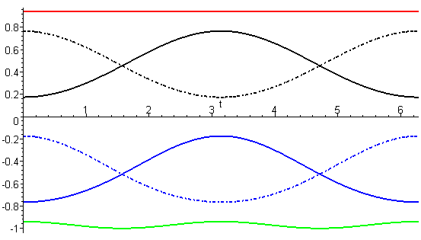

θ1= 30o θ1= 50o
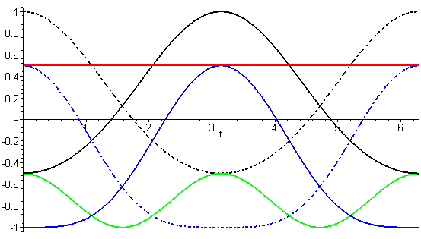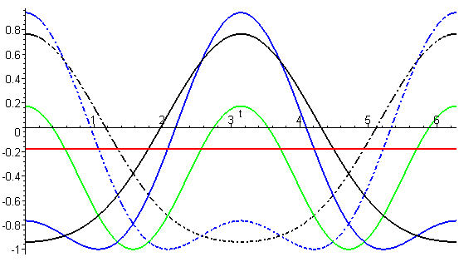

θ1= 70o θ1= 85o
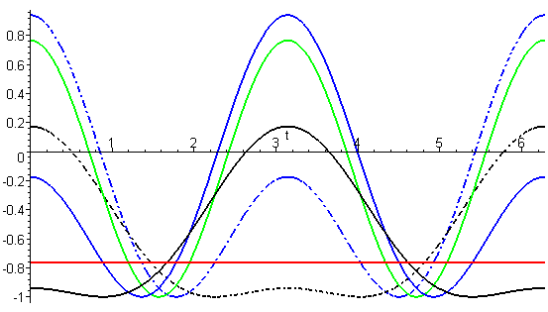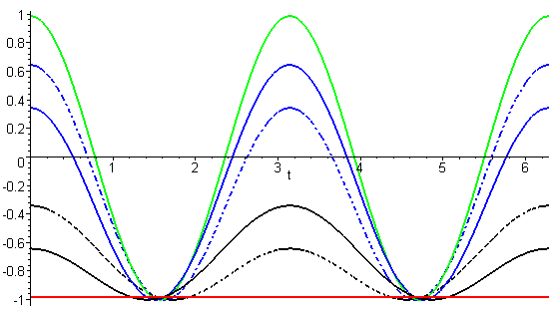

(8.8.55)

Equation (8.8.50b) shows that the curves for ± mirror latitudes have the same shape but are time-shifted half a day, and the figures bear this out.
For θ1 = 90o + Δ the solid and dashed curves are swapped compared to θ1 = 90o - Δ so we don't show plots for θ1 > 90o.

As an aid to interpreting the above curves, consider this drawing with θ1 = 45o.

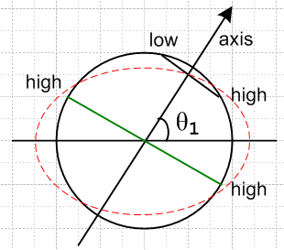 (8.8.56)

• At the poles the tides are constant (red horizontal lines in plots) and decrease as θ1 is increased.

• At the equator there will always be two equal high tides during each day, as marked by the green equatorial line. These become more pronounced as θ1 increases.

• At high latitudes (as shown in black), we expect only one high tide per day.

• At some latitude there must be a gradual transition from two tide cycles per day at the equator to one tide cycle per day at high latitudes. For example, our θ1= 50o plot shows that at the low latitudes ±30o (blue) there are two tide cycles (albeit quite unequal) while at ± 60o latitudes (black) there is only one tide cycle.

• As we shall see below, the real Earth's θ1 lies in the rough range 60o ≤ θ1≤ 120o so the two-tide pattern is more predominant, as in the θ1 = 85o plot.

What is the angle θ1 for the real Earth?

Relative to Fig (8.8.43) the actual axis ' of the Earth's rotation varies over time, as suggested by this picture from wiki,

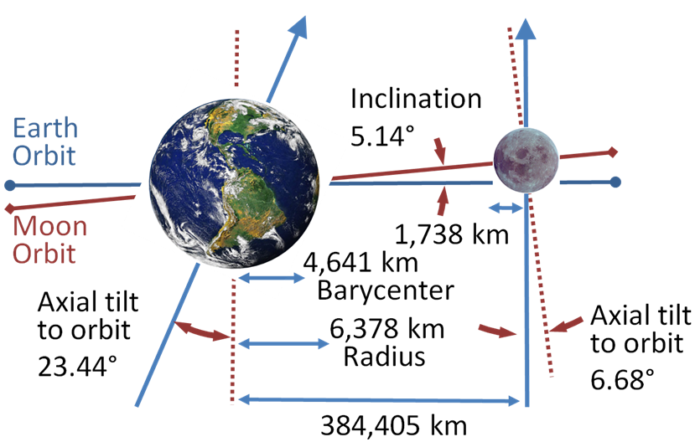 (8.8.57)

https://upload.wikimedia.org/wikipedia/commons/4/43/Earth-Moon.PNG

We transcribe the situation depicted above into a drawing more compatible with Fig (8.8.43), and we then try to explain what is going on (it is a bit complicated).

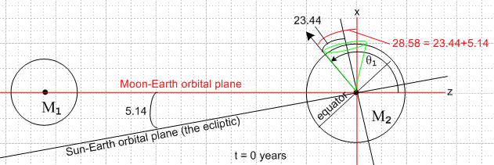 (8.8.58a)

Here the black arrow is ' (Earth's rotation axis) and it is located at θ1= 90 + 28.58 = 118.6o and is in the plane of paper so φ1 = 0. The intersection of the two orbital planes is called the line of nodes and for the time indicated in the picture, that line is perpendicular to the plane of paper. This situation of maximum tilt 28.58o occurs once every 18.6 years, a time called the major lunar standstill. At a time 9.3 years later than the above drawing, the Earth's rotation axis in effect moves to the right edge of the green cone and then the 28.58o = 23.44+5.14 gets replaced by 18.30o = 23.44-5.14 which is the minor lunar standstill. The half-angle of the green cone is 23.44o.
The 18.6 year motion of the Earth's rotation vector around this green cone could be observed from a space camera platform which moves in such a way to keep the Moon to the left of the Earth, as in the figure, and which takes a strobe picture once a lunar month when the line of nodes points to the camera. The reason for the green cone is that the plane of the Moon's orbit precesses once every 18.3 years relative to the stars, meaning relative to the ecliptic plane (ignoring its small precession over period 112,000 years). This 18.3 year wobble period of the moon's orbital plane is called its axial precession. During this time the line of nodes (intersection of the two planes) rotates a full circle relative to the stars, so this is also called the nodal precession. The moon's orbit is slightly elliptical, and it happens that within the plane of its orbit, this ellipse precesses around once every 8.85 years, known as the apsidal precession, but this has no relation to the green cone.
To see the Earth's rotation axis on the other side of the green cone, we draw the above figure 9.3 years later at which time the axial precession of the moon's orbital plane has gone half way around :

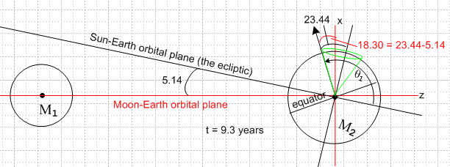 (8.8.58b)

Near the time depicted Fig (8.8.58a), the Earth's rotation axis in effect moves around a different cone once per (lunar) month as indicated in blue in this picture (blue cone half-angle = 28.58o)

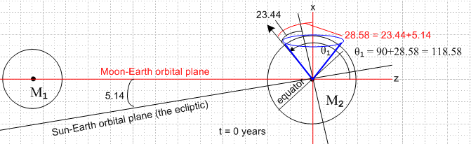 (8.8.59)

Our same space camera platform running its video camera sees the black earth axis vector sweep around the blue cone once per lunar month. For example, a half month later than the above drawing, the moon will be on the right, but then our camera platform will have moved so it sees the moon back on the left, so at that time the Earth's rotation axis black arrow will be on the right extreme of the blue cone above. At the time shown in (8.8.59) the Earth's rotation axis is at θ1 = 90 + 28.58 = 118.58o. A half month later it will be at 90 - 28.58 = 61.4o. At times in between, θ1 lies in the range ( 61.4o, 118.6o) and φ1 takes small values with |φ1| ≤ 28.58o . At other times during the 18.3 year wobble cycle, the range of θ1 is smaller. For example, at the time of Fig (8.8.58b) the blue cone will have an opening angle of 18.30o and the θ1 range limits are 90 ± 18.30 so we end up with θ1 lying in the range ( 71.7o, 108.3o).

Tidal patterns for the rotating Earth (but still a water world in which water flows instantly)

Here we run our plot routine above set above for θ1 = 100o just as an example:

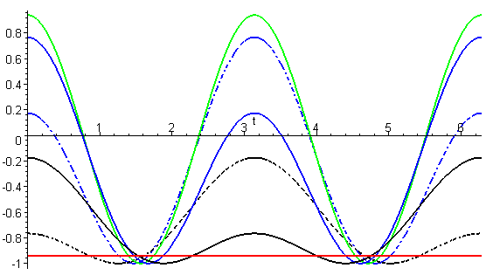 (8.8.60)

At the equator (green) there are two equal tides per day. At other latitudes there are still two tides per day, but they are unequal.

As the Earth rotates, it is true that at any latitude θ' there is an outward-pointing centrifugal force of equal magnitude all around the Earth, but we expect this not to affect the tides.

The high tides are nominally 12 hours apart. In fact the Moon moves with a 27.3 day period in the same direction the Earth rotates, so when 12 hours has passed, the Moon has moved ahead 12/27.3 = 0.44 hours = 26.4 minutes, so one has to wait another 26 minutes for the next lunar high tide, so the time between high tides is about 12 hours 26 minutes. This causes the time of high tide to move relative to a wall clock in any location, which is why we have tide tables and tide clocks.

Roughly the solar tides have half the influence of the lunar ones as indicated in (8.8.42). They add and cancel depending on the position of the Sun and Moon. This nice picture of D.J. Jeffery shows the extremal situations (the word spring does not mean the season Spring)

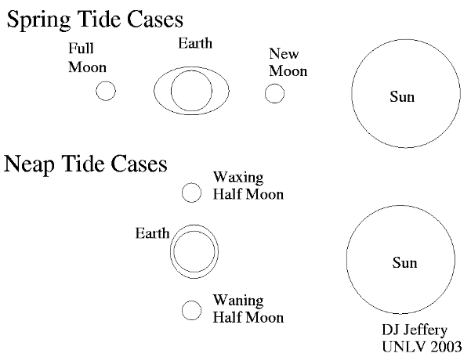 (8.8.61)

So the maximal spring tides are about 2 weeks apart and the same is true for the intervening minimal neap tides.
A good discussion of the above tidal model is given in Taylor's textbook p 330-336. A more detailed discussion is presented in the excellent (and downloadable) paper by Butikov. Both sources are very readable.

Tides on the real Earth

We leave the reader with this perhaps disappointing picture of actual tides on the Earth.
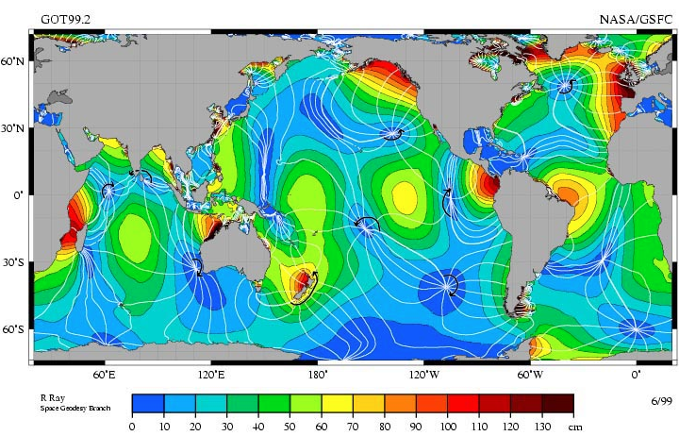
http://www.nauticed.org/sailing-blog/how-the-tides-work/ (8.8.62)

(We are unable to locate the original source of this graphic.) Presumably these are measured long-term averages of tidal high-low differences and one sees how they generally range from 0 cm to 140 cm. A wave resonance at the Bay of Fundy can cause a 1700 cm (50 foot) high/low tide difference there.
Recall our toy model calculation that

Hlunar_tide = 53.49 cm ~ 1.8 feet .
Hsolar_tide = 24.58 cm ~ 0.8 feet . (8.8.42)

At least the values in the map are in the same ballpark as the toy model! The sailing author at the above link notes that tides are almost non-existent in the Caribbean and Mediterranean seas, which are dark blue in the figure.
As Butikov points out, the simple model in which the Earth rotates under a static ellipsoid of water in a frictionless manner is very far from reality. One must consider the dynamical aspects of the problem which involve the massive water currents which attempt to maintain the tidal ellipsoid and the interaction of such currents with land masses and the ocean bottom and with themselves (water has some viscosity). The currents of course are subject to Coriolis forces. Water flow velocity is not infinite and is affected by ocean depth. One result is that there is a delay between the Moon being at local meridian (transit) and the occurrence of high tide (the "local lunitidal interval"). This delay is extremely variable, ranging from a few minutes to ~20 hours. The white lines in (8.8.62) are loci on which a high tide occurs at the same time (equal tidal phase) and the white line nodes have no tides at all (known as amphidromes) for a particular tidal "component" like the main one called M2. Tides flow around these points. The problem is one of wave dynamics and forced oscillation on a rotating object and is well beyond the scope of our document (but is treated by Butikov and in his references).

Footnote: Equation of the Water Surface by the Potential Method

There are many ways to set up the potential method for determining the idealized tidal shape of Fig (8.8.34), see Taylor and Butikov for alternatives to our somewhat inelegant method. In the following presentation we omit some detailed steps which involve small-ε approximations.

We seek a potential V(x,y) which solves this equation (no minus sign in ∇V=F)

∇V(x,y) = Fg2 + Ftid = - (GM2m/r2) + (mM1G/d03) ( 2x - y ) , (8.8.63)

where we use (8.8.24) for Ftid. The exact solution for V is the following (by inspection) :

V(x,y) = (GM2m/r) + (GM1m/d03)( x2 - y2/2) . // ∇(1/r) = -(1/r2), r > 0 (8.8.64)

Of interest are surfaces on which V = V0 = constant (since we expect the water surface to be such a surface) so we let 1/k = V0/(Gm) be a constant and write

(M2/r) + (M1/d03)( x2 - y2/2) = 1/k . dim(k) = L/M (8.8.65)

Note that the second term on the left is much smaller than the first term, so 1/k ~ (M2/r) in scale.

Rewrite (8.8.65) as

(kM2/r) + (kM1/2d03)(2x2 - y2) = 1
or
(kM2/r) = 1 - (kM1/2d03)(2x2 - y2) . (8.8.66)

The second term on the right is much smaller than 1 since

(kM1/2d03)( 2x2 - y2) ~ (kM1/2d03)(r2) ~ (r/M2)(M1/2d03)(r2) = (1/2)(M1/M2)(r/d0)3 << 1 .

Thus we square both sides of (8.8.66) to get

(kM2/r)2 = [1 - (kM1/2d03)( 2x2 - y2)]2 ≈ 1 - 2(kM1/2d03)( 2x2 - y2)

= 1 - (kM1/d03)( 2x2 - y2) = 1 - ε( 2x2 - y2)

= (1 - 2εx2 + εy2) ε ≡ (kM1/d03) . (8.8.67)

Then multiply by r2 to get

(kM2)2 ≈ (x2+y2)(1 - 2εx2 + εy2) = r2(1 - 2εr2cos2θ + εr2sin2θ) . (8.8.68)

This is a quartic equation whose shape is very similar to the "ellipse" of (8.8.33). For example, for kM2= 1 and ε = .05 we may compare the quartic (red) to the unit circle (blue) :

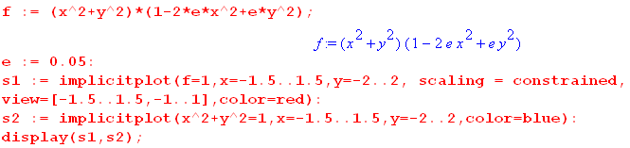

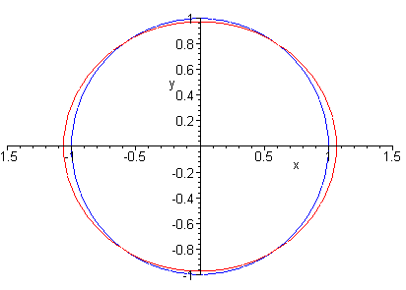 (8.8.69)

To zeroth order in ε we can identify (kM2) ≈ R2, the radius of the Earth. We can use this within quantities already of order ε, but more accuracy is needed for the standalone (kM2). Equation (8.8.68) is a quadratic in r2 and we solve it for r2(θ) and then r(θ) to get, always for small ε,

r(θ) ≈ (kM2)[ 1 - (1/8)ε(sin2θ - 2cos2θ)(kM2)2] . (8.8.70)

We then demand that <r(θ)> = R2 (averaged over θ), just as was done in (8.8.33), so

R2 = <r(θ)> = (kM2)[ 1 - (1/8)ε( $\frac{1}{2}$- 2 $\frac{1}{2}$)(kM2)2] = (kM2)[ 1+ (1/16)(kM2)2ε ] . (8.8.71)

This is then solved for (kM2) to order ε with the result

(kM2) ≈ R2[1- (1/16)εR22] (8.8.72)

which shows the first order correction from just using R2. The locus of the quartic (8.8.68) is now,

R22[1-(1/16)εR22]2 = (x2+y2) [1 -ε(2x2 - y2)]

ε ≈ (M1/M2)R2/d03 . (8.8.73)

We then examine the quartic at its right edge (high tide y=0) and its top edge (low tide x=0) to find

|Δ|high = (15/16)(M1/M2)R24/d03
|Δ|low = (9/16)(M1/M2)R24/d03

H = |Δ|high + |Δ|low = (M1/M2)R24/d03 { (15/16) + (9/16) } (8.8.74)

= (3/2)(M1/M2)R24/d03 .

But H = 2a in terms of (8.8.33) so we get

a = (3/4)(M1/M2)R24/d03 (8.8.75)

in agreement with (8.8.41).

Comment: Requiring <r(θ)> = R2 (averaged over θ) both here and implicitly in (8.8.33) is a reasonable approximation, but in the true 3D problem one should really average over θ,φ so that the water volume displaced by low tides equals that piled up by high tides.

9. Notation comparison with Marion (1970) and Thornton & Marion (2003)

In this Section we compare our notation for rotating-frame kinematics and non-inertial-frame physics to that of Marion (1970) and Thornton and Marion (T&M 2003).

Their notation is close to our "swap" notation, so before making any comparisons, we restate various of our equations in swap notation. A swap notation equation has an s subscript on the equation number and is obtained from the corresponding non-swap equation by prime ↔ noprime (b and ω do not change) :

r' = b + r (6.1)s
v' = v + ω x r + S' (6.6a)s
F' = ma' = mS' + ma + mω x (ω x r) + 2m ω x v + m x r (8.1.3)s
ma = Feff = F' - mS' – mω x (ω x r) – 2m ω x v – m x r . (8.1.5)s

In the above swap notation equations, Frame S' is fixed (f) and Frame S is the rotating frame (r).

We now compare these equations with those of the Marion series authors:

r' = b + r (6.1)s
r' = R + r // Marion p 341 (11.1)
// T&M p 388 (10.1)

v' = v + ω x r + S' (6.6a)s
vf = vr + ω x r + V // Marion p 344 (11.12)
// T&M p 391 (10.17)
F' = ma' = mS' + ma + mω x (ω x r) + 2m ω x v + m x r (8.1.3)s
F = maf = mf + mar + mω x (ω x r) + 2m ω x vr + m x r // Marion p 344 (11.17)
// T&M p 392 (10.23)

ma = Feff = F' - mS' – mω x (ω x r) – 2m ω x v – m x r // = F' + Ffict (8.1.5)s
mar = Feff = F - mf – mω x (ω x r) – 2m ω x vr – m x r // Marion p 344 (11.19)
// T&M p 392 (10.25)

Based on these comparisons, we make the following translation table:

our swap Marion (9.1)
notation authors

S r name of the rotating frame (r = rotating)
S' f name of the fixed frame (f = fixed)
∂S (d/dt)rotating time derivative in the rotating frame
∂S' (d/dt)fixed time derivative in the fixed frame

r r position in rotating frame
v vr velocity in rotating frame
a ar acceleration in rotating frame

r' r' position in fixed frame
v' vf velocity in fixed frame
a' af acceleration in fixed frame

F' F force in fixed frame = true force in rotating frame
Feff Feff total effective force in the rotating frame
Ffict total fictitious force in the rotating frame

b R location of the rotating frame origin (measured in the fixed frame)
S' f,V velocity of the rotating frame origin (measured in the fixed frame)
S' f acceleration of the rotating frame origin (measured in the fixed frame)

10. Notation comparison with Goldstein (1950) and Goldstein, Poole and Safko (2001)

In this Section we compare our notation for rotating-frame kinematics and non-inertial-frame physics to that of Goldstein (1950) and Goldstein, Poole and Safko (GFS 2001).

These books don't say much about the locations of the origins of the reference frames they use. The discussion of rotating frames and the G Rule appears in Goldstein Sections 4.8, 4.9 (GPS 4.9, 4.10). In Goldstein (p135) we are told that r is a "vector from the origin of the terrestrial system" and that "terrestrial measurements are usually made with respect to a coordinate system fixed in the earth, which therefore rotates with a constant angular velocity ω relative to the inertial system". Having studied their rotational equations, it is our conclusion that their two frames of reference must have their origins co-sited at the center of the Earth,

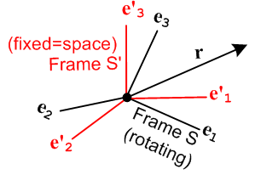 (10.1)

More generally, Goldstein and GPS assume that b = 0 which means that the rotation axis passes through the origin of both frames. This then is the combination of our Special Case #1 and #2 which we shall call Special Case #4. When b = 0, we have from (6.1) that

r = r' b = 0

so there is only one position vector r to worry about. In applications the common origin is placed at a point in a rotating rigid object which is fixed in space.

Here are some of our equations simplified to Special Case #4, keeping in mind that r = r'

r' = r // b = 0 (6.1)

v = v' + ω x r (6.6c)

a = a' + x r + 2 ω x v' + ω x (ω x r) (7.6a)
S S' Euler Coriolis centripetal

ma' = F'eff = F + F'fict = F – mω x (ω x r) – 2m ω x v' – m x r (8.1.4, 7, 8)

We start our comparison with equation (6.6c) :

v = v' + ω x r (6.6c)
vs = vr + ω x r . // Goldstein p 135 (4-104)
// GPS p 175 (4.88)
The next comparison is (we add x r to their equations),

a = a' + x r + 2 ω x v' + ω x (ω x r) (7.6a)
as = ar + x r + 2 ω x vr + ω x (ω x r) . // Goldstein p 135 (4-105)
// GPS p 175 (4.89)

And finally,

ma' = F'eff = F – mω x (ω x r) – 2m ω x v' – m x r (8.1.4, 7, 8)
mar = Feff = F – mω x (ω x r) – 2m ω x vr – m x r . // Goldstein p 135 (4-106,7)
// GPS p 175 (4.90,1)

Based on these comparisons, we construct the following translation table where Goldstein's rotating frame is associated with our Frame S' in our non-swap notation:

our non-swap Goldstein (10.3)
notation authors b = 0 so r = r'

S' r name of the rotating frame (r = rotating or body)
S s name of the fixed frame (s = space)
(d/dt)S' (d/dt)r time derivative in the rotating frame
(d/dt)S (d/dt)s time derivative in the fixed frame

r'= r r position in rotating frame
v' vr velocity in rotating frame
a' ar acceleration in rotating frame

r r position in fixed frame
v vs velocity in fixed frame (s = space)
a as acceleration in fixed frame

F F force in fixed frame = true force in rotating frame
F'eff Feff total effective force in the rotating frame
Ffict total fictitious force in the rotating frame

b 0 location of the rotating frame origin (measured in the fixed frame)
S' 0 velocity of the rotating frame origin (measured in the fixed frame)
S' 0 acceleration of the rotating frame origin (measured in the fixed frame)

Since b = 0 is assumed, the Goldstein and GPS texts only treat a special case of the "rotating frames of reference" scenario we depict in Fig 1 in which b(t) is a general dynamic vector.

In the Goldstein and GPS discussion of the Euler angles (Section 4-4) their figure shows that the "space" frame has unprimed axes (our Frame S) and the "body" frame has primed axes (our Frame S'). The body frame is a frame that is fixed within the body of a rotating object like a top, while the space frame is inertial. For a top, the origins of both Frame S and Frame S' are co-sited at the non-moving tip of the rotating top.

However, in the Goldstein and GPS discussion of rigid body motion on Chapter 5, the authors switch to our swap notation so that now the rotating body-frame variables are Frame S (no primes). The same footnote (nearly) appears in both books which we quote, regarding the rotating body frame:

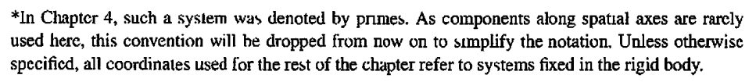

The phrase "spatial axes" means the axes of the "space" frame of reference.

For example, the rotating-frame ω components which were called ωx', ωy', ωz' on page 134 4-103 (GPS p 174 4.87) are referred to in Chapter 5 as ωx, ωy, ωz. As an exercise, we derive these components two ways in Appendix H.

11. Angular Momentum and Fictitious Torques; the Reynolds Transport Theorem

11.1 Introduction

Nomenclature is an issue for this subject, and here is a vague partial table of usage:

"physics" continuum mechanics
r x p angular momentum L moment of momentum (moment of p)
r x F torque N or τ moment of force (moment of F), moment (M or m)
r⊥ = rsinθ moment arm moment arm
Σi ri x Fi with ΣiFi= 0 a sum of torques a couple, a torque, a pure moment (11.1.1)

The moment arm r⊥ is the component of r which is perpendicular to F (or p) as in the drawings below.

We shall use the "physics" terminology, so :

A Particle located at position r and having linear momentum p is said to have angular momentum
L = r x p about the origin, in reference to the origin, or with respect to the origin. (11.1.2)
A Particle located at position r which is acted upon by a force F is said to experience a torque
N = r x F about the origin, in reference to the origin, or with respect to the origin. (11.1.3)

In other words, the tail of vector r is at the origin of the coordinate system and L and N as above are both shown with respect to that point, as in the picture on the left below.
Note that a Particle could refer to an actual point particle, or to a small piece of a rigid body, or to a small chunk of a fluid or an elastic solid.
Sometimes we want to use L and N with respect to some other reference point, call it c, which is not the origin of the coordinate system. This is shown on the right where the origin of the picture on the left has been translated slightly down and to the right,

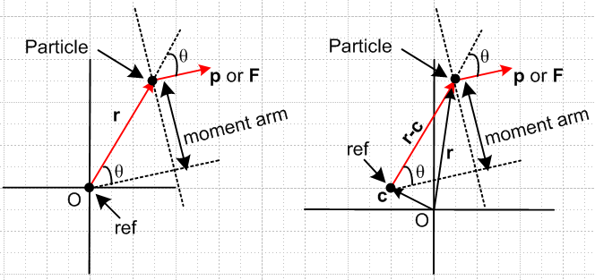 (11.1.4)

The angular momentum and torque with respect to point c are given by

L(c) = (r-c) x p L(0) = r x p
N(c) = (r-c) x F N(0) = r x F . (11.1.5)

We therefore introduce a label "c" (as in (1.9.2)) to indicate the point of reference for an L or an N. If the reference point is the origin, then we write things as shown on the right above.
In the work below, a certain amount of complexity is introduced by allowing c ≠ 0, but the intention is to "do the general case". This then brings up the significance of the last line in (11.1.1) above, and suggests the benefits of dealing with "a couple" when possible. Consider:

Theorem: If the sum of a set of forces acting on an object is 0, then the sum of the torques associated with those forces (acting on that same object) is independent of the point c chosen as the reference point for all the torques. (11.1.6)

proof: N(c) = Σi(ri-c) x Fi = Σi rix Fi - c x (ΣiFi) = Σi rix Fi - 0 = N(0) .

Example: Imagine a cylindrical steel bar in a state of torsional strain due to equal and opposite torques applied to the ends of the bar through small grabber chucks, one at each end (no gravity). So N1 = -N2 = N and each torque is twisting the bar counterclockwise as seen looking at each end. The effect of a chuck on the bar can be represented as a continuous sum of tangential forces acting on the thin band of surface of the bar under the chuck, which forces add up to zero (think pairwise). Therefore, since the total force of a chuck on the bar is zero, the torque of a chuck on the bar is independent of reference point. Since the same is true for each end, one can pick some arbitrary point c (such as c = 0) and reference both torques to that point, and then add them "legally" to conclude that the total torque on the bar is 0. The bar thus shows no angular acceleration.

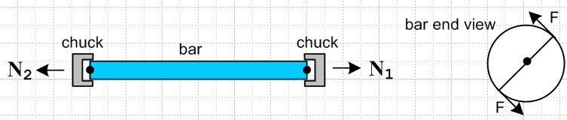 (11.1.7)

In this example, each chuck represents a couple or pure moment acting on the bar.

11.2 Expression of L(c) and (c) in terms of Frame S' objects

We replicate Fig (1.9.1) which includes a single torque reference point which is c is Frame S and c' in Frame S'.

(11.2.1)

The following three equations are obvious from the drawing,

r - r' = b (11.2.2)
c - c' = b (11.2.3)
r - c = r'- c' . (11.2.4)
For arbitrary reference point c one has from (1.9.4-7),

L(c) = (r-c) x mv (1.9.4) (11.2.5)
(c) = (r-c) x ma – x mv (1.9.5) (11.2.6)
L'(c') = (r'-c') x mv' (1.9.6) (11.2.7)
'(c') = (r'-c') x ma' – ' x mv' . (1.9.7) (11.2.8)

The reference point c might be moving. We know from Sections 6 and 7 how r,v,a and r',v',a' are related,

r = r' + b (6.1) (11.2.9)
v = v' + ω x r' + S or p = p' + m(ω x r' + S) (6.6a) (11.2.10)
a = a' + x r' + 2 ω x v' + ω x (ω x r') + S . (7.6a) (11.2.11)

Eq (11.2.10) can be written,

= ' + ω x r' + S . (11.2.12)

The torque reference point c in Fig (11.2.1) is just like the particle point r, so the above for c becomes

= ' + ω x c' + S . (11.2.13)
Part of the goal stated in Section 5 is to express L(c) and (c) in terms of Frame S' quantities. In the following all algebra is shown to provide an easily traceable path since there won't be any result verifications:

L(c) = (r-c) x p = (r'-c') x [ p' + m(ω x r' + S)] // (11.2.4), (11.2.10)
= (r'-c') x p' + m(r'-c') x (ω x r' + S)
= L'(c') + m(r'-c') x [ (ω x r') + S] . // (11.2.7)

Now take the ∂S time derivative of L(c) to get,

(c) = m(r-c) x a – m x v // (11.2.6)

= m(r'-c') [ a' + x r' + 2 ω x v' + ω x (ω x r') + S] – m x v // (11.2.4), (11.2.11)

= [m(r'-c') x a' – m' x v'] + m(r'-c') x [ x r' + 2 ω x v' + ω x (ω x r') + S] – m x v + m' x v'

= '(c') + m(r'-c') x [ x r' + 2 ω x v' + ω x (ω x r') + S] // (11.2.8)
– m x v + m' x v'

= '(c') + m(r'-c') x [ x r' + 2 ω x v' + ω x (ω x r') + S]
– m(' + ω x c' + S) x ( v' + ω x r' + S) + m ' x v' . // (11.2.13), (11.2.10)

These results may now be summarized:

L(c) = L'(c') + m(r'-c') x [ (ω x r') + S] (11.2.14)

(c) = '(c') + m(r'-c') x [ x r' + 2 ω x v' + ω x (ω x r') + S]
– m(' + ω x c' + S) x ( v' + ω x r' + S) + m ' x v' . (11.2.15)

These equations express L(c) and (c) entirely in terms of Frame S' objects, for the general case where the angular momentum reference point c is arbitrarily selected. The second equation can be rewritten

'(c') – (c) = (r'-c') x Ffict + m(' + ω x c' + S) x ( v' + ω x r' + S) – m' x v' (11.2.16)

where F'fict = – mS – mω x (ω x r') – 2m ω x v' – m x r' . (8.1.8)

Comment: Just as with the v and a equations of Section 6, the above equations involving angular momentum and its time derivative are valid even if both Frame S and Frame S' are non-inertial. This is so because the derivations above are based on the G Rule and those v and a equations, both of which do not require that either Frame be inertial.

11.3 Fictitious Torques and Newton's Rotational Law in a non-inertial frame

We now assume that Frame S is an inertial frame and we compare Newton's (2nd) Law for linear motion with that for circular motion, both in Frame S,

F = = ma = m // and "natural" in Frame S (11.3.1)

N(c) = (c) = I(c) α = I(c) = (mr2) . // (c) and "natural" in Frame S (11.3.2)

Here is a drawing showing the various parameters ( I(c) is the moment of inertia about point c ).

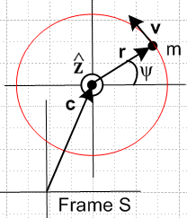 (11.3.3)

Below we concentrate on the left equation in (11.3.2), N(c) = (c). We return to the other expressions in (11.3.2) for general geometries in Appendix I regarding the inertia tensor and rigid body motion.

L(c) is the angular momentum of our Particle in Frame S relative to reference point c, while N(c) is some externally applied torque about that same reference point acting on the Particle.

In Frame S' we want to find some effective Newton's Rotational Law,

N'(c')eff = '(c') (11.3.4)

N'(c')eff = N(c) + N'(c')fict . // defines N'(c')fict (11.3.5)

Here N'(c')fict is the fictitious torque that mysteriously appears in non-inertial Frame S', so then

N(c) + N'(c')fict = '(c') . (11.3.6)

We can then apply this bogus Newton's Rotational Law in non-inertial Frame S'. This is in complete analogy with the use of fictitious forces as reviewed in Section 8.

Solve (11.3.6) for N'(c')fict and then replace N(c) by (c) in (11.3.2) to get

N'(c')fict = '(c') - (c) . (11.3.7)
Replacing the right side of the above using (11.2.16) gives

N'(c')fict = (r'-c') x F'fict + m(' + ω x c' + S) x ( v' + ω x r' + S) – m' x v' (11.3.8)

where

F'fict = – mS – mω x (ω x r') – 2m ω x v' – m x r' . (8.1.8) (11.3.9)
frame centrifugal Coriolis Euler

Writing this out in full,

N'(c')fict = - (r'-c') x [ mS +mω x (ω x r') + 2m ω x v' + m x r']
+ m(' + ω x c' + S) x ( v' + ω x r' + S) – m' x v' . (11.3.10)

In the special case that b = 0 and c = 0 we know from (11.2.3) that c' = 0 as well. In this case, (11.3.8) simplifies to become

N'(c')fict = r' x F'fict . (11.3.11)

11.4 Application: Fictitious Torques in Fluid Dynamics

The object of interest is a blob of fluid contained in a moving volume Vm . The boundary Sm of this volume Vm moves and changes shape such that every point on Sm moves at a velocity which matches the local fluid flow velocity v(r,t). As a result, no particles of fluid either enter or leave the blob volume Vm as it moves. One implication is that the mass M of the blob Vm remains constant. This blob, of some fixed mass M, is our "object of mechanical interest" (later called "the system").
At time t, we imagine that Vm sheds a snake skin Vc which then remains frozen in time. Then Vm(t) aligns with Vc at time t and probably at no other time. Whereas Vm moves, Vc is fixed. Vm is called a "material volume" since it flows with the material, while Vc is called a "control volume". In general, all volume integrals except those being differentiated in time are expressed as integrals over Vc.
Here is Newton's Rotational Law N = (11.3.2) for the this blob of mass M in inertial Frame S,

N(0) = ∫Sc r x t dS + ∫Vc r x ρB dV = (d/dt)S [ ∫Vm r x ρv dV ] . // Lai (7.9.1) (11.4.1)

This equation appears in Lai et al. p 430 as equation (7.9.1). Here t is a possible external "surface traction" (force per area) acting on the blob's surface Sc, B is some possible "body force" per unit mass acting on the blob's interior (perhaps gravity g), and ρ is the mass density of the fluid. Notice that
∫Vm r x ρv dV is an integral of dL = r x dp over the blob, where dp = dm v and dm = ρdV, so this integral L(0)blob is referenced to the point c = 0.
Frame S' is some rotating frame whose origin is aligned with that of Frame S, so b = 0, and the angular momentum reference point in Frame S' is chosen as c' = 0 (recall (11.2.3) c - c' = b).
The integrals for N(0) can be evaluated in any frame one likes, and evaluating them in rotating Frame S' gives

N(0) = ∫Sc' r' x t dS' + ∫Vc' r' x ρB dV' . (11.4.2)

Here the integration point r' runs over surface Sc' in the first integral, and over volume Vc' in the second.
The body force B and the surface traction t are unchanged but are now expressed in terms of r'.

What does equation (11.4.1) look like in non-inertial Frame S' ? According to (11.3.4) and (11.3.5) it is this:

N(0) + N'(0)fict = '(0) = (d/dt)S'L'(0) . (11.3.4),(11.3.5)

Using (11.4.2) for N(0)this may be written as,

( ∫Sc' r' x t dS' + ∫Vc' r' x ρB dV' ) + N'(0)fict = (d/dt )S' [ ∫Vm' r' x ρv' dV'] . (11.4.3)

Here everything is computed in rotating Frame S', but t and B are the same as in Frame S since they are not affected by the fact that Frame S' is rotating. Also, ρ' = ρ since this is mass per volume and the differential volume element is not affected by a rotation. The control volume Vc' and its boundary Sc' are fixed in Frame S'. On the right, Vm' aligns with Vc' at time instant t, and

∫Vm' r' x ρ'v' dV' = L'(0)blob . (11.4.4)

The question remains: what is the fictitious torque N'(0)fict appearing in (11.4.3)? For a particle of mass dm' at location r' in the blob the contribution is, from (11.3.11), (terms reordered on second line)

dN'(0)fict = r' x dF'fict = r' x [– S – ω x (ω x r') – 2 ω x v' – x r'] dm'

= r' x [– S – x r' – ω x (ω x r') – 2 ω x v'] dm' . (11.4.5)

When this is integrated over the blob, one finds

N'(0)fict = ∫Vc'r' x [– S – x r' – ω x (ω x r') – 2 ω x v'] dm' // Lai (7.9.9) (11.4.6)

= – (∫Vc'r' dm') x S – ∫Vc'r' x( x r'] dm' – ∫Vc'r' x [ω x (ω x r')]dm' - 2 ∫Vc'r' x (ω x v')dm' .
frame Euler centrifugal Coriolis
This expression appears in Lai et al. as p 431 (7.9.9).
Equation (11.4.3) with (11.4.6) is applied on Lai et al. pp 431-432 to a conventional rotating sprinkler. One wants to know how fact the sprinkler turns. The sprinkler is at translational rest and its horizontal watering tube of length 2r0 rotates at ω. The control volume Vc' is the interior of this rotating watering tube (angled ends are very short), so Vc' is fixed in rotating Frame S'. The solution to the problem is shown to be ω = -(Q/A)sinθ/r0 where A is the area of the orifice on each end of the watering tube, Q is the volume of water flow delivered to the sprinkler per unit time, and θ is the angle of each tube-end opening viewed from above. As expected, ω is maximal when θ = π/2 and it turns clockwise.

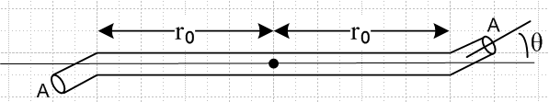 (11.4.7)

11.5 Application: Fictitious Forces in Fluid Dynamics

A similar equation applies for the fictitious forces (rather than torques) in this same fluid dynamics example. Perhaps this should have appeared in Section 8, but the groundwork has been laid here. The corresponding equations are

F = dp/dt
or
F = (∫Sc t dS + ∫VcρB dV) = (d/dt)S [ ∫Vm r x ρv dV ] (11.5.1)

and

F + F'fict = (d/dt )S' [ p']
or
( ∫Sc t dS + ∫Vc ρB dV ) + F'fict = (d/dt)S' [ ∫Vm' ρv' dV'] . (11.5.2)

Again using (11.3.9) for F'fict integrated over the blob with dm' = ρdV',

F'fict = – S ∫V' dm' – ω x (ω x ∫Vc'r' dm' ) – 2 ω x ∫Vc' v' dm' – x ∫Vc'r' dm' .
(11.5.3)
Setting M ≡ ∫V'dm' = total mass of the blob, and combining the last two equations while reordering terms, one gets

(d/dt)S' [ ∫Vm' ρv' dV'] = ( ∫Sc t dS + ∫Vc ρB dV )
– [ MS + 2 ω x ∫Vc' v' dm' + x ∫Vc'r' dm' + ω x (ω x ∫Vc'r' dm' ) ] .

// Lai (7.7.14) (11.5.4)
This appears as equation (7.7.14) on p 429 of Lai et al. (they use a0 = S and m = M).

Here is a translation table relating our notation to that of Lai et al. (figure on page 428)

Lai us
F1 S fixed frame
F2 S' rotating frame (moving frame)
r r position in fixed frame
x r' position in rotating frame
(dr/dt)F1 = vF1 (dr/dt)S = vS = v velocity in fixed frame
(dx/dt)F2 = vF2 (dr'/dt)S' = v'S' = v' velocity in rotating frame
R0 b vector linking frame origins
r = R0 + x r = b + r'
(D/Dt)F1 = (D/Dt) (d/dt)S derivative in fixed frame
(a0) F1 = a0 S (11.5.5)

In Lai et al. equations (7.9.1) through (7.9.8) symbol v means vF1 which is our v.
In Lai et al. equation (7.9.9) showing the fictitious torque, symbol v means vF2 which is our v' .

11.6 Comments on the Reynolds Transport Theorem

Although a bit off our path, it seems useful to tie this topic in with the previous section.

1. The operation ∂/∂t differs from the operation d/dt when applied to an "Eulerian" function of space and time, in which case d/dt is called a material derivative and is written D/Dt in fluid dynamics notation,

df(r,t)/dt = ∂f/∂t + ∇f • dr/dt = ∂f/∂t + v • (∇f) ≡ Df(r,t)/Dt . (11.6.1)

In an Eulerian function, the position coordinate r is the current position of a Particle of fluid as one would expect. (In a Lagrangian function, the position argument is the position at which a Particle started out at some earlier time t0. ) In general, any property of a fluid f(r,t) (such as temperature or density or velocity) varies with r, so the term v • (∇f) does not in general vanish.

2. The right side of equation (11.4.1) or (11.5.1) shows the total time derivative of an integral over a material volume Vm, which integral represents a mechanical property of our blob object of interest. It is always possible to replace such a time derivative with a set of control volume and control surface integrals using a rather elegant theorem known as the Reynolds Transport Theorem (1903) ,

(d/dt) [ ∫Vm T dV ] = ∫Vc (∂T/∂t) dV + ∫Sc T(v•n) dS = ∫Vc [(dT/dt)+ T div v] dV (11.6.2)

where T = T(r,t) is any reasonable function. For example, T could be a scalar like ρ, or a component of a vector like r x ρv in (11.5.1), or a component of any tensor Tijk.... This theorem appears as (7.4.1) and (7.4.2) in Lai et al. page 418 and a proof is given on the next page. [ n is a unit normal to the surface ]
Notice that each term has the units of T times volume/sec.
If T = ρ, the left expression is dM/dt = 0 and the far right integral being 0 for any Vc requires that (dρ/dt) + ρ div v = 0 which is a form of the continuity equation ∂ρ/∂t + div(ρv) in which ρ is mass density and J = ρv is the mass-current density.

3. Although we write Vc = Vm(t) at time t, it is understood that Vc is independent of time -- it is that shed snake skin referred to above. Therefore, one regards (∂Vc/∂t) = (dVc/dt) = 0, and then in (11.6.2) we can write

∫Vc (∂T(r,t)/∂t) dV = (∂/∂t) [∫Vc T(r,t) dV ] = (d/dt) [∫Vc T(r,t) dV ] (11.6.3)

where in the last step we use the fact that the integral is a function only of time, since r is integrated out. So The Reynolds Transport Theorem (11.6.2) can be written this way

(d/dt) [∫Vm TdV] = (d/dt) [∫Vc TdV ] + ∫Sc T(v•n) dS = ∫Vc [(dT/dt)+ T div v] dV . (11.6.4)

4. Writing T = ρb where b is some extensive blob property per unit mass, (11.6.4) becomes

(d/dt) [∫Vm b ρdV] = (d/dt) [∫Vc b ρdV ] + ∫Sc bρ(v•n) dS
= ∫Vc [(d(ρb)/dt)+ (ρb) div v] dV . (11.6.5)

In this case, one can regard ∫Vm b ρdV = ∫Vm b dm as the "total amount of b" in the moving fluid blob. This moving blob which recall maintains all its particles is sometimes called "the system", and the total amount of b in the system might be called Bsys. Then (11.6.5) can be written as

(dBsys/dt) = (dBCV/dt) + ∫CS bρ(v•n) dS = ∫CV [(d(ρb)/dt)+ (ρb) div v] dV (11.6.6)

where CV (or C.V.) is a traditional notation for Vc, the control volume, and CS is Sc, the control surface. For example, here is a typical web appearance of the Reynolds Transport Theorem in the form of the left equality in (11.6.6) and (11.6.5),

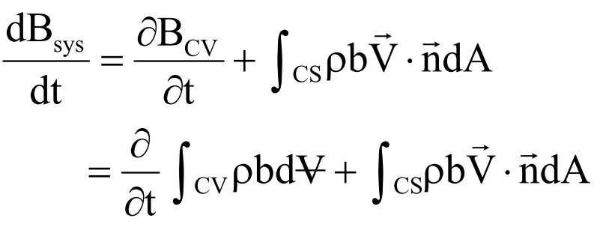 (11.6.7)

which points out another common notation: V with a horizontal bar () refers to volume, to distinguish it from V without a slash which refers to velocity. We solved this problem by using lower case v for velocity. When the bar is short, one gets which looks a bit like an upside down A, and in fact the logic "for all" symbol ∀ is sometimes used.

5. Conceivably, the vague similarity between the left equation in (11.6.6) and the G Rule (2.1) might be the reason some people refer to the G Rule as a transport theorem. This does seem far fetched.

6. Applying the left equality of (11.6.4) to T = r x ρv gives, in Frame S,

(d/dt)S [ ∫Vm r x ρv dV ] = (d/dt)S [ ∫Vc r x ρv dV ] + ∫Sc r x ρv (v•n) dS , (11.6.8)

so that (11.4.1) may be written

N(0) = ( ∫Sc r x t dS + ∫Vc r x ρB dV )
= (d/dt) [ ∫Vc r x ρv dV ] + ∫Sc (r x ρv) (v•n) dS . // Lai (7.9.8) (11.6.9)

This says that the total torque on a fluid blob equals the rate of change of the angular momentum contained in the frozen control volume Vc plus the rate of outflow of angular momentum from that volume. This equation appears as (7.9.8) in Lai et al. p 431.
When working in a rotating frame, we have to add to the left side of (11.6.9) the fictitious torques stated in (11.4.6) and which Lai et al. states as (7.9.9). Here then are a few quotes from Lai et al. (p 430-431) which use the continuum mechanics terminology as shown in the table at the start of this Section :

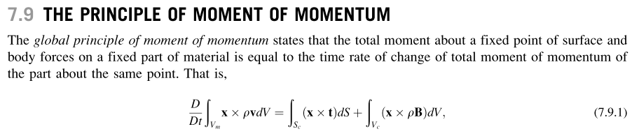
---------------

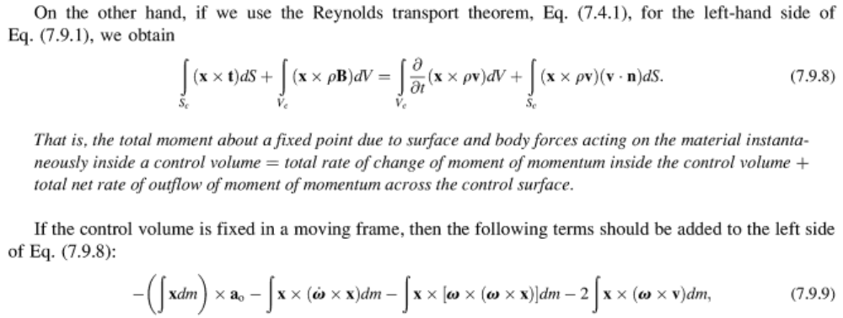

The equation (7.9.8) and its italicized interpretation express the familiar law of conservation of angular momentum. In Chapter 7 Lai et al. have similar sections for conservation of mass, energy, and linear momentum, and a final section on the inequality of entropy, each of these being a "principle". Each section uses the Reynolds Transport Theorem to replace its D/Dt [∫Vm ...] object, and each section ends up with an equation like (7.9.8) with an italicized interpretation.

12. Summary of the Forward Problem Solution

12.1 Summary of the Forward Problem equations (non-swap notation)

We now summarize the results of Sections 6, 7, 8 and 11. The first set of equations below is valid regardless of whether either of these frames is inertial (they could both be non-inertial). The second set of equations involving fictitious forces and torques assumes that Frame S is inertial (and Frame S' is not).

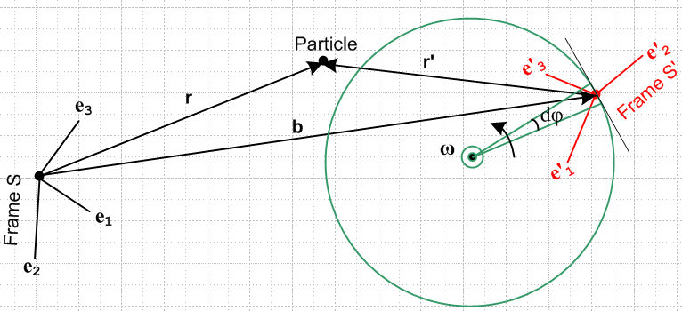 (12.1.1)

Definitions and Equations

r, v, a position, natural velocity and natural acceleration in Frame S (12.1.2)
r', v', a' position, natural velocity and natural acceleration in Frame S'
ω angular velocity of Frame S' relative to Frame S
b vector directed from origin of Frame S to origin of Frame S'
r = b + r' (6.1) (a)

v = v' + ω x r' + S (6.6a) (b)
v = v' + ω x r + S' (6.6c) (c)

a = a' + x r' + 2 ω x v' + ω x (ω x r') + S (7.6a) (d)
S S' Euler Coriolis centripetal frame

a = a' + x r + 2 ω x v' + ω x (ω x r) + 2ω x S' + S' (7.6b) (e)

L(c) = L'(c') + m(r'-c') x [ (ω x r') + S] (11.2.14) (f)

(c) = '(c') + m(r'-c') x [ x r' + 2 ω x v' + ω x (ω x r') + S]
– m(' + ω x c' + S) x ( v' + ω x r' + S) + m ' x v' (11.2.15) (g)

Fictitious Forces and Torques (Section 8 and 11)

F = ma N(c) = (c) // true law
F'eff = ma' N'eff(c') = '(c') // fake law

F'eff = F + F'fict N'eff(c') = N(c) + N'fict(c')
F'fict = ma' - ma = ' - N'fict(c') = '(c') – (c) . (12.1.3)

For the general case, the fictitious forces can be expressed as

F'fict = – mS – mω x (ω x r') – 2m ω x v' – m x r' . (8.1.8) (12.1.4)
frame centrifugal Coriolis Euler

For Special Case # 1 problems (ω axis passes through Frame S origin), we have

F'fict = – mω x (ω x r) – 2m ω x v' – m x r . Special Case #1 (8.4.2) (12.1.5)
centrifugal Coriolis Euler

The fictitious torques may be written,

N'(c')fict = (r'-c') x F'fict + m(' + ω x c' + S) x ( v' + ω x r' + S) – m' x v' (11.3.8)
or
N'(c')fict = - (r'-c') x [ mS + mω x (ω x r') + 2m ω x v' + m x r'] (12.1.6)
+ m(' + ω x c' + S) x ( v' + ω x r' + S) – m' x v' (11.3.10)

Special Case #4 (Forward Problem, non-swap notation)

If the origins of Frame S and Frame S' coincide, then b = 0. In this case one of course has r = r' and also c = c' for the torque and angular momentum reference points. It is usual in this case to select c = c' = 0. We then write L ≡ L(0), L' ≡ L'(0), N ≡ N(0) and N' ≡ N'(0). The new drawing is this,

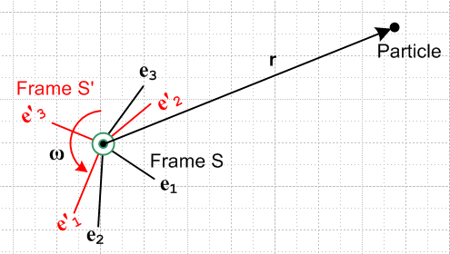 (12.1.7)

We have placed the common origin in the plane of paper and are viewing things from a direction which causes the instantaneous ω vector to point toward the viewer. Frame S' is rotating relative to Frame S at rate ω. The vector r in general is not in the plane of paper. Here are the simplified equations obtained from those above with r = r', b = S = S' = S = c = c' = 0 :

r, v, a position, natural velocity and natural acceleration in Frame S (12.1.8)
r, v', a' position, natural velocity and natural acceleration in Frame S'
ω angular velocity of Frame S' relative to Frame S
r = r' (a)

v = v' + ω x r' ALL SPECIAL CASE #4 (b) = (c)

a = a' + x r' + 2 ω x v' + ω x (ω x r') (d) = (e)
S S' Euler Coriolis centripetal

L = L' + mr' x (ω x r') (f)

= ' + mr' x [ x r' + 2 ω x v' + ω x (ω x r') ] (g)

For the following items, Frame S is inertial and Frame S' is rotating

F = ma N = // true law
F'eff = ma' N'eff = ' // fake law

F'eff = F + F'fict N'eff = N + N'fict
F'fict = ma' - ma = ' - N'fict = ' – (12.1.9)

F'fict = – mω x (ω x r') – 2m ω x v' – m x r' (12.1.10)
centrifugal Coriolis Euler

N'fict = r' x F'fict = – r' x [ mω x (ω x r') + 2m ω x v' + m x r'] (12.1.11)

12.2 Summary of the Forward Problem equations (swap notation)

We are now going to translate everything in Section 12.1 into swap notation using rules (13.2.2).
Fig (12.2.1) is the same as Fig (12.1.1) but the primes are swapped with no-primes.

The first set of equations below is valid regardless of whether either of these frames is inertial (they could both be non-inertial). The second set of equations involving fictitious forces assumes that Frame S' is inertial (and Frame S is not).

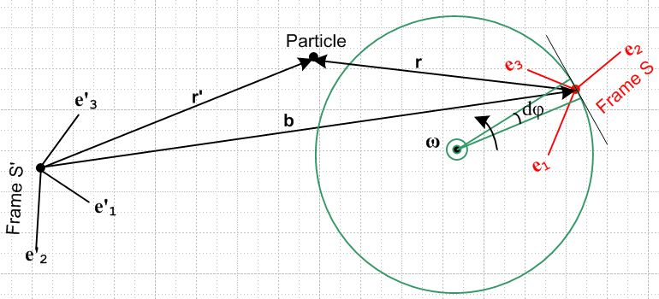 (12.2.1)

Definitions and Equations

r', v', a' position, natural velocity and natural acceleration in Frame S' (12.2.2)
r, v, a position, natural velocity and natural acceleration in Frame S
ω angular velocity of Frame S relative to Frame S'
b vector directed from origin of Frame S' to origin of Frame S
r' = b + r (6.1)s (a)

v' = v + ω x r + S' (6.6a)s (b)
v' = v + ω x r' + S (6.6c)s (c)

a' = a + x r + 2 ω x v + ω x (ω x r) + S' (7.6a)s (d)
S' S Euler Coriolis centripetal frame

a' = a + x r' + 2 ω x v + ω x (ω x r') + 2ω x S + S (7.6b)s (e)

L'(c') = L(c) + m(r-c) x [ (ω x r) + S'] (11.2.14)s (f)

'(c') = (c) + m(r-c) x [ x r + 2 ω x v + ω x (ω x r) + S']
– m( + ω x c + S') x ( v + ω x r + S') + m x v (11.2.15)s (g)

Fictitious Forces and Torques (Section 8 and 11)

F' = ma' N'(c') = '(c') // true law
Feff = ma Neff(c) = (c) // fake law

Feff = F' + Ffict Neff(c) = N'(c') + Nfict(c)
Ffict = ma - ma' = - ' Nfict(c) = (c) – '(c') . (12.2.3)

For the general case, the fictitious forces can be expressed as

Ffict = – mS' – mω x (ω x r) – 2m ω x v – m x r (8.1.8)s (12.2.4)
frame centrifugal Coriolis Euler

For Special Case # 1 problems (ω axis passes through Frame S' origin), we have

Ffict = – mω x (ω x r') – 2m ω x v – m x r' Special Case #1 (8.4.2)s (12.2.5)
centrifugal Coriolis Euler

The fictitious torques may be written,

N(c)fict = (r-c) x Ffict + m( + ω x c + S') x ( v + ω x r + S') – m x v (11.3.8)s
or
N(c)fict = - (r-c) x [ mS' + mω x (ω x r) + 2m ω x v + m x r] (12.2.6)
+ m( + ω x c + S') x ( v + ω x r + S') – m x v (11.3.10)s

Special Case #4 (Forward Problem, swap notation)

If the origins of Frame S and Frame S' coincide, then b = 0. In this case one of course has r = r' and also c = c' for the torque and angular momentum reference points. It is usual in this case to select c = c' = 0. We then write L ≡ L(0), L' ≡ L'(0), N ≡ N(0) and N' ≡ N'(0). The new drawing is this,

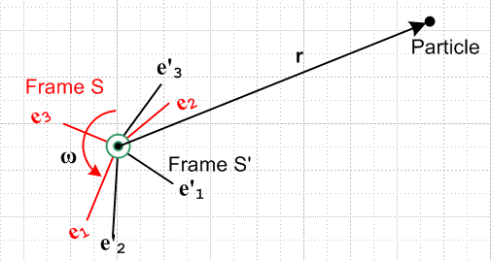 (12.2.7)

We have placed the common origin in the plane of paper and are viewing things from a direction which causes the instantaneous ω vector to point toward the viewer. Frame S is rotating relative to Frame S' at rate ω. The vector r in general is not in the plane of paper. Here are the simplified equations obtained from those above with r = r', b = S = S' = S = c = c' = 0 :

r, v', a' position, natural velocity and natural acceleration in Frame S' (12.2.8)
r, v, a position, natural velocity and natural acceleration in Frame S
ω angular velocity of Frame S relative to Frame S'
r' = r (a)

v' = v + ω x r ALL SPECIAL CASE #4 (b) = (c)

a' = a + x r + 2 ω x v + ω x (ω x r) (d) = (e)
S' S Euler Coriolis centripetal

L' = L + mr x (ω x r) (f)

' = + mr x [ x r + 2 ω x v + ω x (ω x r) ] (g)

For the following items, Frame S' is inertial and Frame S is rotating

F' = ma' N' = ' // true law
Feff = ma Neff = // fake law

Feff = F' + Ffict Neff = N' + Nfict
Ffict = ma - ma' = - ' Nfict = – ' (12.2.9)

Ffict = – mω x (ω x r) – 2m ω x v – m x r (12.2.10)
centrifugal Coriolis Euler

Nfict = r x Ffict = – r x [ mω x (ω x r) + 2m ω x v + m x r] (12.2.11)

13. The Inverse Problem

Consider these two problems which concern the exact same physical situation (non-swap notation):

Forward Problem: given: r', v', a', L'(c'), '(c')
find: r, v, a, L(c), (c) // summarized in Section 12.1 above

Inverse Problem: given: r, v, a, L(c), (c)
find: r', v', a', L'(c'), '(c') // to be summarized in Section 13.3 below

Recall that equations involving just the above quantities are valid even if both Frames S and S' are non-inertial. On the other hand, equations involving F'fict and N'(c)fict require that Frame S be inertial. If Frame S is inertial for the Forward Problem, it is also inertial for the Inverse Problem and in that case we know that there is no fictitious force or torque in Frame S, so these items are not included on the list of quantities shown above.

We shall first compute the inverse equations by brute force, then at the end show how they can be obtained by a set of simple swap rules.

13.1 Brute Force Method

Looking at the Section 12.1 summary, equation (6.1) is easily inverted

r = b + r' =>

r' = r - b (13.1.1)

Similarly for (6.6a), where the third line below uses identity (6.2b),

v = v' + ω x r' + S (6.6a)
v' = v – ω x r' – S (13.1.2)
v' = v – ω x r – S' . (13.1.3)

Equation (7.6a) requires a bit more effort to invert. We first solve (7.6a) for a'

a = a' + x r' + 2 ω x v' + ω x (ω x r') + S (7.6a)
a' = a – x r' – 2 ω x v' – ω x (ω x r') – S . (13.1.4)

Replace v' using (13.1.2),

a' = a – x r' – 2 ω x [v – ω x r' – S] – ω x (ω x r') – S

= a – x r' – 2 ω x v + 2 ω x (ω x r') + 2 ω x S – ω x (ω x r') – S

= a – x r' – 2 ω x v + ω x (ω x r') + 2 ω x S – S . (13.1.5)

With r' = r – b we can regard the RHS of (13.1.5) as being expressed entirely in terms of Frame S objects.

Now, by first shuffling terms in (7.11),

S' = S – x b – 2ω x S + ω x (ω x b) => (7.11)

2ω x S – S = – x b + ω x (ω x b) – S'

we can replace the last two terms in (13.1.5) to get

a' = a – x r' – 2 ω x v + ω x (ω x r') – x b + ω x (ω x b) – S'

= a – x r – 2 ω x v + ω x (ω x r) – S' (13.1.6)

Inversion of the L(c) and (c) can also be done by this brute force method, but we spare the reader and instead quote the results later after establishing the "swap rules method".

Summary of the inverse problem results obtained by brute force:

r' = r - b (13.1.1)
v' = v – ω x r' – S (13.1.2)
v' = v – ω x r – S' (13.1.3)
a' = a – x r' – 2 ω x v + ω x (ω x r') + 2 ω x S – S (13.1.5)
a' = a – x r – 2 ω x v + ω x (ω x r) – S' (13.1.6)

13.2 Swap Rules Method

Without any justification yet, let us postulate that we can obtain our inverse problem equations directly from the forward problem equations (and vice versa) using this set of Swap Rules :

forward problem equations ← swap rules → inverse problem equations

r ↔ r' b ↔ – b ω ↔ – ω L(c) ↔ L'(c') (13.2.1)
v ↔ v' S ↔ – S' (c) ↔ '(c')
a ↔ a' S ↔ – S' // Swap Rules

This set of rules is different from our rules for going between swap and no-swap notation, which are these

r ↔ r' b ↔ b ω ↔ ω L(c) ↔ L'(c') S ↔ S' (13.2.2)
v ↔ v' S ↔ S' (c) ↔ '(c')
a ↔ a' S ↔ S' // rules for going between swap and no-swap notation.

The big difference is that with the Swap Rules we are negating the vectors b (and its derivatives) and ω. Later in Section 13.5 we will justify the set of rules (13.2.1). Whereas the change from non-swap notation to swap notation is just a cosmetic relabeling of a problem's variables, application of the Swap Rules changes a problem which is the Forward Problem into a different problem which is the Inverse Problem defined at the start of Section 13.1.

Since the inverse problem equations computed by brute force are sitting just above, let's apply the Swap Rules (13.2.1) to them and see what we get:

r = r' + b (13.1.1)swapped
v = v' + ω x r + S' (13.1.2)swapped
v = v' + ω x r' + S (13.1.3)swapped
a = a' + x r + 2 ω x v' + ω x (ω x r) + 2 ω x S' + S' (13.1.5)swapped
a = a' + x r' + 2 ω x v' + ω x (ω x r') + S . (13.1.6)swapped

And now we directly quote from the summary (12.1.2) above

r = b + r' (6.1)
v = v' + ω x r + S' (6.6c)
v = v' + ω x r' + S (6.6a)
a = a' + x r + 2 ω x v' + ω x (ω x r) + 2ω x S' + S' (7.6b)
a = a' + x r' + 2 ω x v' + ω x (ω x r') + S . (7.6a)

Since the last two sets of equations are identical, we have demonstrated that the Swap Rules presented in (13.2.1) do indeed convert either set of equations into the other.

13.3 Summary of the Inverse Problem Equations (non-swap notation)

As noted above, we obtain the Inverse Problem equations by applying the Swap Rules (13.2.1) to the Forward Problem equations. But the Swap Rules can be thought of as having two steps: (1) do the swap one usually does to go from swap to non-swap notation as in (13.2.2); (2) then take b→ -b (including derivatives) and ω→ -ω (including derivatives). We have step (1) already carried out in Section 12.2, so to get the equations below we need only carry out step (2) on the Section 12.2 equations. Here is a repeat of Fig (12.1.1) which of course applies to both the Forward Problem and the Inverse Problem :

(13.3.1)

r', v', a' position, natural velocity and natural acceleration in Frame S' (13.3.2)
r, v, a position, natural velocity and natural acceleration in Frame S
ω angular velocity of Frame S' relative to Frame S
b vector directed from origin of Frame S to origin of Frame S'
r' = - b+ r (a)

v' = v – ω x r – S' // all these equations are from (12.2.2) with ω and b negated (b)
v' = v – ω x r' – S (c)
a' = a – x r – 2 ω x v + ω x (ω x r) – S' (d)
a' = a – x r' – 2 ω x v + ω x (ω x r') + 2 ω x S – S (e)

L'(c') = L(c) + m(r-c) x [ - (ω x r) - S'] (f)

'(c') = (c) + m(r-c) x [- x r - 2 ω x v + ω x (ω x r) - S']
– m( - ω x c - S') x ( v - ω x r - S') + m x v (g)

Special Case #4 (Inverse Problem, non-swap notation)

If the origins of Frame S and Frame S' coincide, then b = 0. In this case one of course has r = r' and also c = c' for the torque and angular momentum reference points. It is usual in this case to select c = c' = 0. We then write L ≡ L(0), L' ≡ L'(0), N ≡ N(0) and N' ≡ N'(0). The new drawing is this,

(13.3.3)

We have placed the common origin in the plane of paper and are viewing things from a direction which causes the instantaneous ω vector to point toward the viewer. Frame S' is rotating relative to Frame S at rate ω. The vector r in general is not in the plane of paper. Here are the simplified equations obtained from those above with r = r', b = S = S' = S = c = c' = 0 :

r, v', a' position, natural velocity and natural acceleration in Frame S' (13.3.4)
r, v, a position, natural velocity and natural acceleration in Frame S
ω angular velocity of Frame S relative to Frame S'
r = r' (a)

v' = v – ω x r (b) = (c)

a' = a – x r – 2 ω x v + ω x (ω x r) (d) = (e)
S' S Euler Coriolis centripetal

L' = L – m r x (ω x r) (f)

' = + mr x [ – x r – 2 ω x v + ω x (ω x r) ] (g)

13.4 Summary of the Inverse Problem Equations (swap notation)

The results of this section are those of Section 13.3 but with S ↔ S' and v'↔v for all vectors except b and ω. Again, this is just a change of labeling. We repeat Fig (12.2.1) which shows the swap notation case :

(13.4.1)

r, v, a position, natural velocity and natural acceleration in Frame S (13.4.2)
r', v', a' position, natural velocity and natural acceleration in Frame S'
ω angular velocity of Frame S relative to Frame S'
b vector directed from origin of Frame S' to origin of Frame S
r = - b+ r' (a)

v = v' – ω x r' – S (b)
v = v' – ω x r – S' (c)
a = a' – x r' – 2 ω x v' + ω x (ω x r') – S (d)
a = a' – x r – 2 ω x v' + ω x (ω x r) + 2 ω x S' – S' (e)

L(c) = L'(c') + m(r'-c') x [ -(ω x r') - S] (f)

(c) = '(c') + m(r'-c') x [- x r' - 2 ω x v' + ω x (ω x r') - S]
– m(' - ω x c' - S) x ( v' - ω x r' - S) + m ' x v' (g)

Special Case #4 (Inverse Problem, swap notation)

If the origins of Frame S and Frame S' coincide, then b = 0. In this case one of course has r = r' and also c = c' for the torque and angular momentum reference points. It is usual in this case to select c = c' = 0. We then write L ≡ L(0), L' ≡ L'(0), N ≡ N(0) and N' ≡ N'(0). The new drawing is this,

(13.4.3)

We have placed the common origin in the plane of paper and are viewing things from a direction which causes the instantaneous ω vector to point toward the viewer. Frame S is rotating relative to Frame S' at rate ω. The vector r in general is not in the plane of paper. Here are the simplified equations obtained from those above with r = r', b = S = S' = S = c = c' = 0 :

r, v, a position, natural velocity and natural acceleration in Frame S (13.4.4)
r, v', a' position, natural velocity and natural acceleration in Frame S'
ω angular velocity of Frame S relative to Frame S'
r = r' (a)

v = v' – ω x r' (b) = (c)

a = a' – x r' – 2 ω x v' + ω x (ω x r') (d) = (e)

L = L' – m r' x (ω x r') (f)

= ' + mr' x [- x r' - 2 ω x v' + ω x (ω x r')] (g)

13.5 Why the Swap Rules Work

Preview: We are going to show here that if one starts with an initial picture of the physical situation between two frames of references and a Particle, and if one applies the Swap Rules (13.2.1) to that picture, one ends up with a final picture which is exactly the same as the initial picture. Therefore, if the initial physical picture is described by a set of equations, then applying the Swap Rules to those equations gives new equations which also apply to the initial picture (since it is the same as the final picture). Thus, if the initial set of equations is valid, so is the final set of equations obtained via these Swap Rules. The equations obtained by application of the Swap Rules provide the "answers" for our Inverse Problem defined at the start of Section 13.

Start with Fig (12.1.1),

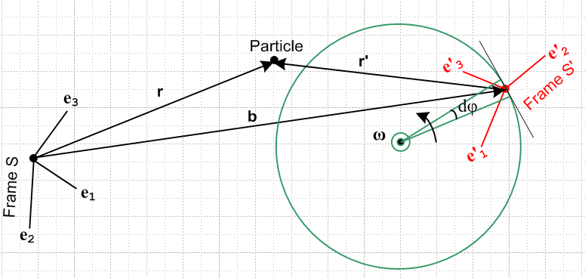 (13.5.1)

Apply the Swap Rules of (13.2.1) to get

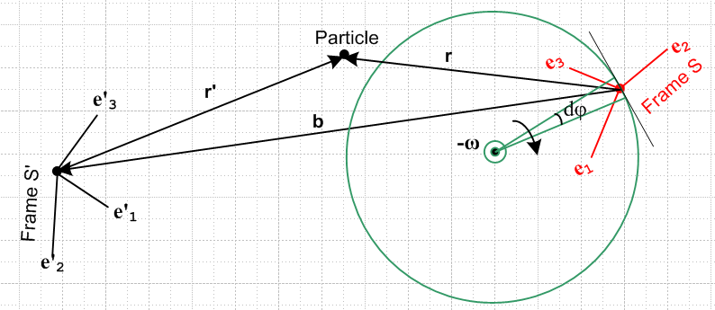 (13.5.2)

Rather than take b → -b as a label, we have flipped the arrow on the b vector to achieve the same result.

Now observe the above scenario from a camera platform which is rotating clockwise at rate ω with its rotation axis the same as that shown in the figure. Viewed from this camera's rotating frame, Frame S is at rest, and Frame S' is rotating counterclockwise. That camera-viewed picture is then,

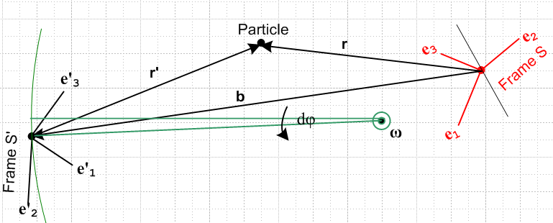 (13.5.3)

This is the picture one sees if one observes things from Frame S. Our equations of interest remain valid despite the camera's rotation because these equations are based on the G Rule which is a function only of the relative relationship between frames, and making the camera rotate above does not change this relationship.
Moreover, these equations are the same regardless of where one puts the ω axis, regardless of where one places the Particle, and regardless of where and how one orients the two Reference frames. So let's move these things around a bit in the above picture to get this new drawing which has the same equations,

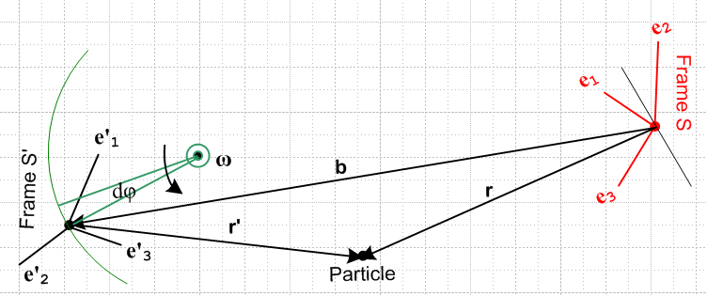 (13.5.4)

Now we rotate this picture about an axis near the center and perpendicular to the plane of paper. Such a rotation again does not change the equations associated with the picture. We then have

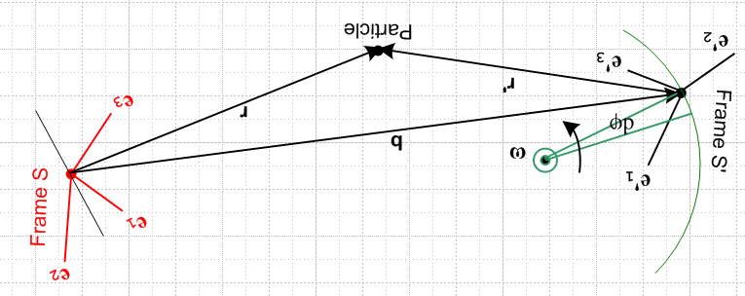 (13.5.5)

But this is the same as the picture we started with above (apart from colors and text orientation),

(13.5.1)

Since the Swap Rules, along with various equation-invariant reorientations, produce a final picture which is the same as the initial picture, when those Swap Rules are applied to a valid set of equations which apply to the initial picture, the resulting equations are also valid for the initial picture since this is the same as the final picture.

14. Rotating Frames in Curvilinear Coordinates

The solution equations for our Forward Problem are summarized in Section 12.1 and 12.2 above, and those for the Inverse Problem are summarized in Section 13.3 and 13.4. All equations are stated in bolded vector notation. Such equations may be projected onto (dotted with) any complete set of basis vectors, such as the , , used in spherical coordinates. Every orthogonal curvilinear coordinate system has such a set of orthonormal unit basis vectors which we shall call i, orthonormality meaning i • j = δi,j. In general, curvilinear basis vectors like i= , , are different at different points in space, so one can think of them as i(r). It is appropriate then to use them as basis vectors for a vector field V(r) or for a vector associated with a discrete Particle located at position r such as the velocity or acceleration of that Particle.
We might want to use one curvilinear system of coordinates ξi with basis unit vectors i for Frame S, and an entirely different system ξ'i with basis unit vectors 'i for Frame S'. We might, for example, have ξi be spherical coordinates and ξ'i be toroidal coordinates. Here then is the situation,

Cartesian coords and basis vectors Curvilinear coords and basis vectors
Frame S ri ei ξi i
Frame S' (r')i e'i (ξ')i 'i (14.1)

ei• ej = e'i• e'j = i • j = 'i • 'j = δi,j // orthonormality of all bases (14.2)

There must exist some matrix R(ξ) such that i(r) = R(ξ)-1ei for any given curvilinear system. Recall now the Basis Theorem (1.1.30),

e'n = R-1en n = 1,2,3 ⇔ en = (R)-1nm e'm or e'n = Rnm em (14.3)

In these equations replacing en → en and e'n → n and R → R(ξ) to get,

n = R(ξ)-1en n = 1,2,3 ⇔ en = (R(ξ))-1nm m or n = R(ξ)nm em (14.4)

Example of an R(ξ) matrix. In spherical coordinates with ordering 1,2,3 = r,θ,φ, where θ is the polar angle and φ the azimuth, the matrix R(ξ) is given by (note that R-1 = RT),

[R(ξ)]-1 = $\left(\begin{matrix}cosφsinθ & cosφcosθ & -sinφ \\ sinφsinθ & sinφcosθ & cosφ \\ cosθ & -sinθ & 0\end{matrix}\right)$ R(ξ) = $\left(\begin{matrix}cosφsinθ & sinφsinθ & cosθ \\ cosφcosθ & sinφcosθ & -sinθ \\ -sinφ & cosφ & 0\end{matrix}\right)$ (14.5)

This matrix is derived in (A.9) and (A.11). We can then use (14.4) that n = R(ξ)nm em to write, using the alternate notation of (1.1.32),

= = $\left(\begin{matrix}cosφsinθ & sinφsinθ & cosθ \\ cosφcosθ & sinφcosθ & -sinθ \\ -sinφ & cosφ & 0\end{matrix}\right)$ = R(ξ) = R(ξ)$\left(\begin{matrix}e1 \\ e2 \\ e3\end{matrix}\right)$ (14.6)

or
= cosφsinθ + sinφsinθ + cosθ
= cosφcosθ + sinφcosθ – sinθ
= –sinφ + cosφ . (14.7)

Expansions and naming. If V is an arbitrary vector, we then have these four expansions of interest :

V = Viei Vi = V • ei
V = (V)'i e'i (V)'i = V • e'i
V = (V)i i (V)i = V • i
V = (V)'i 'i (V)'i = V • ei (14.8)

where we use italics to denote curvilinear vector components. It is common practice, once a curvilinear system is selected, to make these replacements so the italics are no longer needed,

(V)i → Vξ$_{i}$ (V)'i → Vξ$_{i}$' (14.9)

In cylindrical coordinates r,θ,z and r',θ',z' this would mean, for example,

(V)1 → Vr (V)'1 → Vr'
(V)2 → Vθ (V)'1 → Vθ'
(V)3 → Vz (V)'2 → Vz' . (14.10)

Equation Example. Consider now this equation taken from the Section 12.1 summary,

v = v' + ω x r + S' . (6.6c) (14.11)

We can view such an equation in any of our four bases as just discussed above,

(v)i = (v')i + εijk(ω)j(r)k + (S')i components in basis ei
(v)'i = (v')'i + εijk(ω)'j(r)'k + (S')'i components in basis e'i
(v)i = (v')i + εijk(ω)j(r)k + (S')i components in basis i
(v)'i = (v')'i + εijk(ω)'j(r)'k + (S')'i . components in basis 'i (14.12)

For example, in ρ,θ,z cylindrical coordinates if we have ω = ω, then (ω)j = δj3ω, so in the third line above we get

εijk(ω)j(r)k = εijk ω δj3 (r)k = ω εi3k(r)k = - ω εik3(r)k

so that line becomes

(v)i = (v')i - ω εik3(r)k + (S')i components in basis i
or
(v)1 = (v')1 - ω ε123(r)2 + (S')1 = (v')1 - ω (r)2 + (S')1
(v)2 = (v')2 - ω ε213(r)1 + (S')2 = (v')2 + ω(r)1 + (S')2
(v)3 = (v')3 - ω ε3k3(r)k + (S')3 = (v')3 + (S')3 . (14.13)

This then translates into (since in cylindrical coordiinates r = ρ + z = rρ + rz and rθ = 0)

vρ = v'ρ - ω rθ + (S')ρ = v'ρ + (S')ρ
vθ = v'θ + ω rρ + (S')θ = v'θ + ω ρ + (S')θ
vz = v'z + (S')z . (14.14)

For any Special Case #1 problem (see Section 4.4) one has S' = 0 and the above equations become extremely simple

vρ = v'ρ
vθ = v'θ + ω ρ
vz = v'z . (14.15)

Changing now from cylindrical ρ,θ,z to cylindrical r,θ,z the above becomes

vr = v'r
vθ = v'θ + ω r
vz = v'z . (14.16)

15. Ant on Turntable Problems

The main purpose of the following four "ant problem" examples is to exercise the results summarized in Sections 12 and 13 above and to demonstrate the use of non-Cartesian coordinates as outlined in Section 14.
Problems 1 and 2 are "forward" problems, while Problems 3 and 4 are "inverse" problems. Problem 4 concludes the analysis of the 4-projectile problem begun in Section 8. Everything is done in "no-swap" notation where Frame S' is the rotating frame.
Some secondary purposes are to provide the reader with many examples of manipulating basis vectors, using the bulletproof vector component notation of Section 1, and applying simple matrix methods.

Kinematics common to all Ant Problems

Consider a turntable occupied by an ant as shown in this drawing. Here Frame S is a fixed frame with origin at the turntable center, while Frame S' (glued to the turntable surface) is a rotating frame.

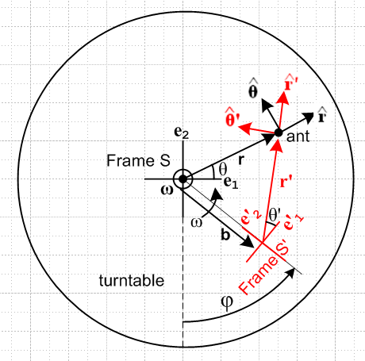 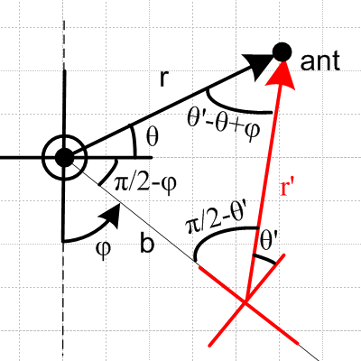 (15.1)

In Frame S, the vector r has coordinates (r,θ) in standard polar coordinates.
In Frame S', the vector r' has coordinates (r',θ') in standard polar coordinates.

When φ = 0, red Frame S' lies directly under black Frame S and the axes line up. For any angle φ one has b = -b e'2. Since the rotation axis goes through the origin of Frame S, the turntable problems fall into Special Case #1 of Section 4.4. Basis vectors e3 = e'3 (not labeled) point to the viewer as does the ω vector for ω>0.
The relation between the three angles θ, θ' and φ is complicated and can be indirectly obtained by writing the laws of sines and cosines for the triangle shown on the right above. The left and bottom internal triangle angles are obvious. The top one is then

π - (θ + π/2 - φ) - (π/2 - θ') = θ'-θ+φ (15.2)

None of this angle detail will be needed below (except in a Reader Exercise).

In the first two Problems considered below, an ant executes some crawling motion on the turntable as described by certain r', v', and a' in Frame S'. Our task in each problem is to use our Section 12.1 summary results to compute r, v, and a as seen in Frame S and to plot some trajectories r(t).

In the third problem, the ant becomes a flying ant doing a straight-line fly-by at constant velocity in Frame S just over the turntable surface, a fly-by described by a certain r, v, and a. This is an example of the Inverse Problem discussed in Section 13 and our goal here is to compute r', v', and a' in Frame S' using the equations provided in Section 13.3.

In each frame we define Cartesian and cylindrical coordinates and unit vectors as follows:

Frame S ri = x,y,z basis vectors ei = , ,
ξi = r,θ,z basis vectors i = , , .

Frame S' r'i = x',y',z' basis vectors e'i = ', ', '
ξ'i = r',θ',z' basis vectors 'i = ', ', ' (15.3)

We are thus providing a specific example of (14.1) concerning general curvilinear coordinates in two frames of reference.

What do we know about all the basis vectors?

In order to illustrate some of the work of Section 1.1, we provide the reader with a complete set of socket wrenches even though only a few of these tools will actually be used below. All of the following relations can be obtained by inspection from the above figure:

Within Frame S we have (each of these equations has the (1.1.30) template form e'n = R-1en) :

i = Rz(θ)ei . for example = Rz(θ) (a)

A corresponding equation applies in Frame S' ,

'i = Rz(θ')e'i . for example ' = Rz(θ') ' (b)

The relation between the Frame S and Frame S' Cartesian unit vectors is

e'i = Rz(φ)ei . for example ' = Rz(φ) (c)

The relation between the Frame S and Frame S' cylindrical unit vectors is

'i = Rz(φ)i . for example ' = Rz(φ) (d)

Relations (d) and (a) can be combined to get

'i = Rz(φ+θ)ei . for example ' = Rz(φ+θ) (e) (15.4)

Writing the basis vector relations in matrix notation

Recall the Basis Theorem of (1.1.30) : (we use dummy basis vector names an and a'n ) ,

a'n = R-1 an ⇔ an = Σm(R-1)nm a'm (15.5)

On the left, we rotate vector an by R-1 to get vector a'n.
On the right, we express an as a linear combination of the basis vectors a'n.
Remember that the subscripts on the a and a' are labels, not components!

Suppose we take the kth component of the equation on the right of (15.5),

[an]k = Σm(R-1)nm [a'm]k . (15.6a)

One can write this as

Ank = Σm(R-1)nm A'mk where Ank = [an]k and A'nk = [a'n]k . (15.6b)

For a matrix Ank one knows that n is the row index and k is the column index. Therefore, saying Ank = [an]k is the same as saying that the vector an is the nth row of matrix A. Thus we can write (15.6a) in this manner,

$\left(\begin{matrix}a1 \\ a2 \\ a3\end{matrix}\right)$ = R-1 $\left(\begin{matrix}a'1 \\ a'2 \\ a'3\end{matrix}\right)$ ⇔ an = Σm(R-1)nm a'm, n = 1,2,3 . (15.7a)

Inverting,

$\left(\begin{matrix}a'1 \\ a'2 \\ a'3\end{matrix}\right)$ = R $\left(\begin{matrix}a1 \\ a2 \\ a3\end{matrix}\right)$ . (15.7b)

We have thus provided an interpretation for the "alternative notation" shown in (1.1.32) : the three vectors in a column can be regarded as rows of a matrix.

All our rotations of interest in (15.4) are z-rotations which, from (A.1), have the form

Rz(ψ) = $\left(\begin{matrix}cosψ & -sinψ & 0 \\ sinψ & cosψ & 0 \\ 0 & 0 & 1\end{matrix}\right)$ . (A.1)z
Example 1: Apply (15.7b) to (15.4e) which says 'i = Rz(φ+θ)ei = R-1ei so R = Rz(-θ-φ) :

= Rz(-θ-φ) $\left(\begin{matrix}e1 \\ e2 \\ e3\end{matrix}\right)$ = $\left(\begin{matrix}cos(θ+φ) & sin(θ+φ) & 0 \\ -sin(θ+φ) & cos(θ+φ) & 0 \\ 0 & 0 & 1\end{matrix}\right)$$\left(\begin{matrix}e1 \\ e2 \\ e3\end{matrix}\right)$ // see (A.1)
or
= $\left(\begin{matrix}cos(θ+φ) & sin(θ+φ) & 0 \\ -sin(θ+φ) & cos(θ+φ) & 0 \\ 0 & 0 & 1\end{matrix}\right)$ .

Writing out the linear combinations, one gets

' = cos(θ+φ) + sin(θ+φ)
' = - sin(θ+φ) + cos(θ+φ)
' = . (15.8)

Example 2: Apply (15.7b) to (15.4c) which says e'i = Rz(φ)ei = R-1ei so R = Rz(-φ) :

$\left(\begin{matrix}e'1 \\ e'2 \\ e'3\end{matrix}\right)$ = Rz(-φ)$\left(\begin{matrix}e1 \\ e2 \\ e3\end{matrix}\right)$ = $\left(\begin{matrix}cosφ & sinφ & 0 \\ -sinφ & cosφ & 0 \\ 0 & 0 & 1\end{matrix}\right)$$\left(\begin{matrix}e1 \\ e2 \\ e3\end{matrix}\right)$
or
= $\left(\begin{matrix}cosφ & sinφ & 0 \\ -sinφ & cosφ & 0 \\ 0 & 0 & 1\end{matrix}\right)$ .

Writing out the linear combinations, one gets

' = cosφ + sinφ
' = -sinφ + cosφ // e'2 = - sinφ e1 + cosφ e2
' = . (15.9)

We could reduce our 3x3 matrix work to 2x2 for the turntable examples, but other problems require the full 3x3 notation so we maintain it throughout.

Relation between Frame S and Frame S'

Assume at time t = 0 we have φ = φ0 in Fig (15.1).

If the rotation follows some angular velocity profile ω = ω(t), and since ω = dφ/dt, one has

dφ/dt = ω(t) => φ(t) = φ0 +$^{\int_{0}^{t}{}}$ ω(τ)dτ . (15.10)

For simplicity, we shall assume constant ω in which case,

φ(t) = φ0 + ωt . (15.11)

Motion of vector b

From Fig (15.1) and from (15.9) one finds,

b(t) = -b e'2 = -b [- sinφ + cosφ ] = bsinφ – b cosφ . (15.12)

15.1 Problem 1: Ant crawls at constant speed V to the Origin of Frame S'

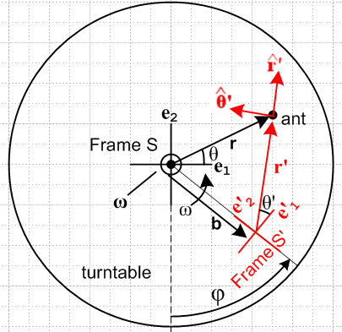 (15.1.1)

Ant's Motion in Frame S'.

Assume the ant starts at some (r'0,θ'0) at t = 0 and crawls with constant speed V toward the S' origin,

v' = -V' . (15.1.2)

We can integrate this within Frame S' (where ' is fixed) to get

r'(t) = r'0 -Vt ' where r'0 = r'0' = (r'0,θ'0) . (15.1.3)

The magnitude of r'(t) is given by

r' = r'0 - Vt (15.1.4)

since we shall only be interested in times small enough so r' > 0. The angle θ' never changes, so

θ' = θ'0 . (15.1.5)

Finally, since V = constant, the acceleration is

a' = 0 . (15.1.6)

Thus, in line with our Forward Problem statement, these are the given quantities in Frame S' ,

r' = r'0 – Vt '
v' = –V '
a' = 0 . (15.1.7)

Using (15.8) for ', we can write v' = -V' as

v' = –Vcos(θ'+φ) – Vsin(θ'+φ) . (15.1.8)

Our goal is to compute r, v and a as seen in Frame S.

Trajectory r(t) of the ant in Frame S

Above we found that

b(t) = bsinφ – b cosφ (15.12)

' = cos(θ'+φ) + sin(θ'+φ) . (15.8)

Recall from (12.2.1a) that,

r = b + r' = b + r' ' . (12.2.1a)

Therefore from (15.12) and (15.8) quoted just above we can write

r(t) = ( bsinφ – b cosφ ) + r' (cos(θ'+φ) + sin(θ'+φ) )

= [bsinφ + r'cos(θ'+φ)] + [– b cosφ + r'sin(θ'+φ)] .

Setting r' = (r'0 - Vt) by (15.1.4), and thinking of φ = φ(t) (ie, a function of time) as in (15.10,11),

r(t) = [ bsinφ + (r'0 - Vt)cos(θ'+φ)] + [ –b cosφ + (r'0 - Vt) sin(θ'+φ)]
or
r(t) = x + y
where (15.1.9)
x = bsinφ + (r'0 – Vt)cos(θ'+φ)
y = – bcosφ + (r'0 – Vt)sin(θ'+φ) .

This r(t) then is the trajectory of the ant in Frame S.

Velocity v(t) of the ant in Frame S

Since the turntable falls into our Special Case #1 of Section 4.4 (ω through origin of Frame S), we know that S' = 0 (vector b is soldered to the Frame S' unit vectors). From (12.1.2b) we have,

v = v' + ω x r + S' (12.1.2b)

which then says, setting S' = 0,

v = v' + ω x r . (15.1.10)

The first term v' we will replace by (15.1.8); the second we compute,

v' = –Vcos(θ'+φ) – Vsin(θ'+φ) (15.1.8)

ω x r = [ω] x [x + y ] = ωx – ωy . (15.1.11)

Therefore (15.1.10) says

v = [ –Vcos(θ'+φ) – Vsin(θ'+φ) ] + ωx – ωy

= [–V cos(θ'+φ) – ωy ] + [–V sin(θ'+φ) + ωx]

or
v = vx + vy
where (15.1.12)
vx = –Vcos(θ'+φ) – ωy
vy = –Vsin(θ'+φ) + ωx

where x,y are given in (15.1.9). We can go ahead and insert x and y from there to get

– ωy = -ω[– bcosφ + (r'0 – Vt)sin(θ'+φ)] = ωbcosφ – ω(r'0 – Vt)sin(θ'+φ)

ωx = ω[ bsinφ + (r'0 – Vt)cos(θ'+φ)] = ωbsinφ + ω(r'0 – Vt)cos(θ'+φ)
so
vx = –Vcos(θ'+φ) + ωbcosφ – ω(r'0 – Vt)sin(θ'+φ)
vy = –Vsin(θ'+φ) + ωbsinφ + ω(r'0 – Vt)cos(θ'+φ) . (15.1.13)

This v(t) then is the velocity of the ant in Frame S.

Acceleration a(t) of the ant in Frame S

From (12.1.2e) we find that

a = a' + x r + 2 ω x v' + ω x (ω x r) + 2ω x S' + S' (12.1.2e)

but in this Special Case #1 problem we have S' = 0 and S' = 0 so

a = a' + x r + 2 ω x v' + ω x (ω x r) . (15.1.14)

We shall ponder the terms one at a time.

As noted in (15.1.6), a' = 0.

Our turntable is restricted to have = so, similar to (15.1.11) above, we find

x r = x – y . (15.1.15)

Next, we install (15.1.8) for v' to get

ω x v' = [ω] x [–Vcos(θ'+φ) – Vsin(θ'+φ) ] = -ωV cos(θ'+φ) + ωV sin(θ'+φ)

= ωVsin(θ'+φ) – ωVcos(θ'+φ) . (15.1.16)

With (15.1.11) the last term of (15.1.14) becomes

ω x (ω x r) = [ω] x [ωx – ωy] = -ω2x – ω2y . // = -ω2 r, centripetal accel. (15.1.17)

Combining all the terms then gives

a = a' + x r + 2 ω x v' + ω x (ω x r)

= 0 + (x – y) + 2ωVsin(θ'+φ) - 2ωVcos(θ'+φ) -ω2x – ω2y

= [– y + 2ωVsin(θ'+φ) – ω2x] + [x – 2ωVcos(θ'+φ) – ω2y]

or
a = ax + ay
where (15.1.18)
ax = – y + 2ωVsin(θ'+φ) – ω2x
ay = x – 2ωVcos(θ'+φ) – ω2y

where x,y are given by (15.1.9).

This a(t) then is the acceleration of the ant in Frame S.

Summary of the Solution to Problem 1

r(t) = x + y
where (15.1.9)
x = bsinφ + (r'0 – Vt)cos(θ'+φ)
y = – bcosφ + (r'0 – Vt)sin(θ'+φ)

v = vx + vy
where (15.1.12)
vx = – Vcos(θ'+φ) – ωy
vy = – Vsin(θ'+φ) + ωx

a = ax + ay
where (15.1.18)
ax = – y + 2ωVsin(θ'+φ) – ω2x
ay = x – 2ωVcos(θ'+φ) – ω2y

and
φ = φ(t) = φ0 +$^{\int_{0}^{t}{}}$ ω(τ)dτ = φ0 + ωt for constant ω . (15.10) (15.1.19)

The x and y in equations (15.1.19) are given by (15.1.9), and θ' = θ'0 by (15.1.5).

Selected Plots

We set φ0 = 0 so Frame S' starts directly below Frame S and is aligned with it, so then φ = ωt.
We set θ'0 = θ' = 0 so our ant approaches the Frame S' origin along the e'1 axis :

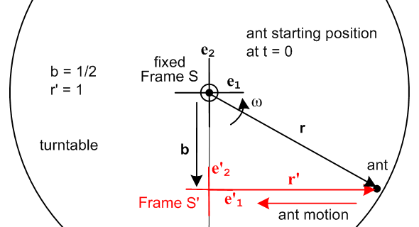 (15.1.20)

With these assumptions (15.1.9) becomes

r(t) = x + y
where (15.1.21)
x = bsin(ωt) + (r'0 – Vt)cos(ωt)
y = – bcos(ωt) + (r'0 – Vt)sin(ωt) .

Each plot is finite because the trip is over when the ant reaches the S' origin at tmax = r'0/V.
We set b = 0.5, r'0 = 1, V = 0.1. The ant therefore starts at (x,y) = (r'0,-b) = (1,-0.5). Here are trajectory plots for various values of ω :

ω = 1/2 ω = 1 ω = 3
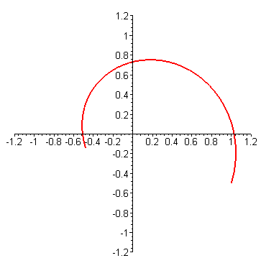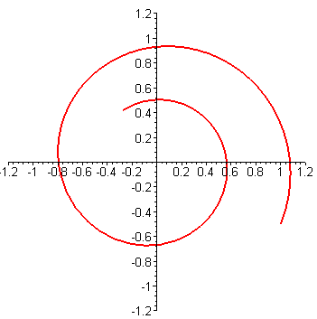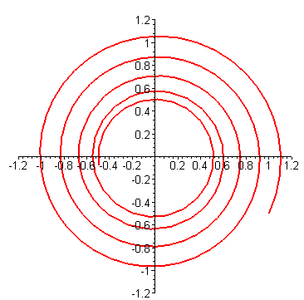
b = 0.5, r'0 = 1, V = 0.1 (15.1.22)

The middle plot was generated by the following Maple code based on (15.1.21), where R ≡ r'0,

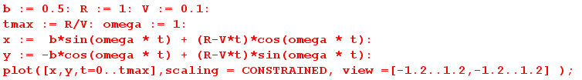

Similar code is used to make all the other plots below.

Setting b = 0, we get these more traditional plots (Frame S and Frame S' origins now coincide) :

ω = 1/2 ω = 1 ω = 3
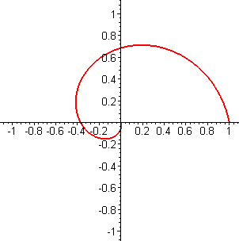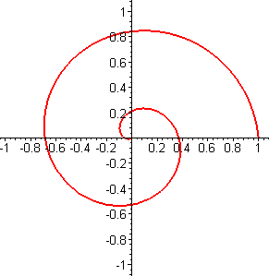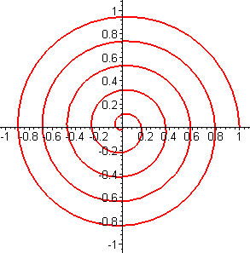
b = 0, r'0 = 1, V = 0.1 (15.1.23)

Next we plot the velocity v from (15.1.12) only for the middle ω = 1 case above on the right below, with the corresponding trajectory plot r on the left:

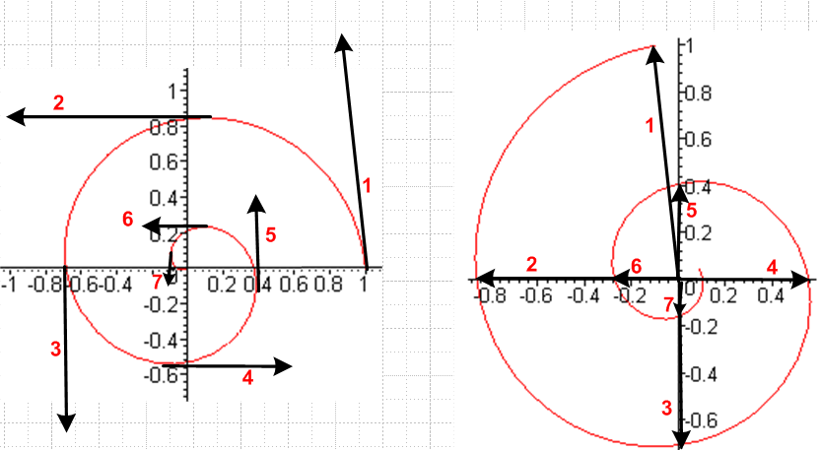 (15.1.24)

ω = 1 plot of r(t) ω = 1 plot of v(t)

For seven different (but unknown) times, we draw the velocity vector on the right and then transfer it to where we think it ought to go on the trajectory plot on the left. Things at least seem reasonable. A proper visual check would require a program to automate the above process.

Next we plot the acceleration a on the right below using (15.1.18), again for ω = 1, with the corresponding trajectory plot r on the left:

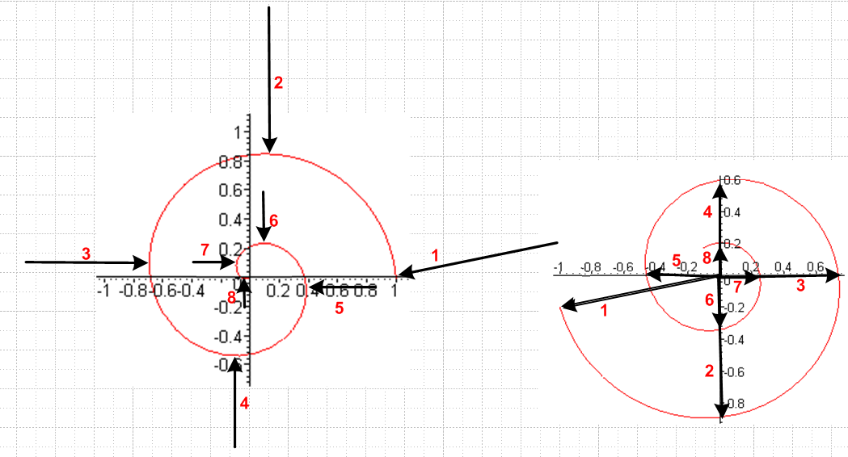
ω = 1 plot of r(t) ω = 1 plot of a(t) (15.1.25)

For the same seven (still unknown) times plus one more, we draw the acceleration vector on the right and transfer it to where we think it ought to go on the left. Again, this is just a sanity check to make sure things seem reasonable.

Reader Exercise: From (15.1.2) one has v' = -V' so that

v'r = v' • = -V' • = -V cos(θ'-θ+φ)

according to Fig (15.1), where v'r is the radial component of the ant velocity v' in polar coordinates. On the other hand, the radial component of v is given in (15.1.13) as,

vr = • v = • [vx + vy ] = vx • + vy • = vx cosθ + vysinθ
where
vx = –Vcos(θ'+φ) + ωbcosφ – ω(r'0 – Vt)sin(θ'+φ)
vy = –Vsin(θ'+φ) + ωbsinφ + ω(r'0 – Vt)cos(θ'+φ) . (15.1.13)

Looking at the above expressions for v'r and vr, it seems unlikely that they could be equal since vr involves terms linear in time t and is a function of ω, b, r'0 whereas v'r does not seem to involve these terms and parameters at all. Yet equation (14.16), which applies to any Special Case #1 problem like Problem 1, claims vr = v'r . The Exercise is to demonstrate that in fact vr = v'r .

Hints:
(1) Set r'0 – Vt = r' and show that vr = ωb cos(φ-θ) - ωr' sin(θ'+φ-θ) - V cos(θ'+φ-θ) .
(2) Show that the first two terms cancel due to a Law of Sines for Fig (15.1). QED.

Results expressed in matrix notation

In the case that b = 0, = 0, φ0 = 0, φ = ωt and θ'0 = θ' = 0 ( triplet of plots in (15.1.23) ) we can summarize our results as follows:

r(t) = x + y
where (15.1.9) (a)
x = (r'0 – Vt)cos(ωt)
y = (r'0 – Vt)sin(ωt)

v = vx + vy
where (15.1.12) + (15.1.13) (b)
vx = –Vcos(ωt) – ω (r'0 – Vt)sin(ωt)
vy = –Vsin(ωt) + ω (r'0 – Vt)cos(ωt)

a = ax + ay
where (15.1.18) (c)
ax = + 2ωVsin(ωt) – ω2 (r'0 – Vt)cos(ωt)
ay = – 2ωVcos(ωt) – ω2 (r'0 – Vt)sin(ωt) . (15.1.26)

These equations can be written in matrix notation as follows,

$\left(\begin{matrix}x \\ y \\ z\end{matrix}\right)$ = $\left(\begin{matrix}cosωt & -sinωt & 0 \\ sinωt & cosωt & 0 \\ 0 & 0 & 1\end{matrix}\right)$$\left(\begin{matrix}r'0-Vt \\ 0 \\ z\end{matrix}\right)$ = Rz(ωt) $\left(\begin{matrix}r'0-Vt \\ 0 \\ z\end{matrix}\right)$

$\left(\begin{matrix}vx \\ vy \\ vz\end{matrix}\right)$ = $\left(\begin{matrix}cosωt & -sinωt & 0 \\ sinωt & cosωt & 0 \\ 0 & 0 & 1\end{matrix}\right)$$\left(\begin{matrix}-V \\ ω(r'0-Vt) \\ vz\end{matrix}\right)$ = Rz(ωt) $\left(\begin{matrix}-V \\ ω(r'0-Vt) \\ vz\end{matrix}\right)$

$\left(\begin{matrix}ax \\ ay \\ az\end{matrix}\right)$ = $\left(\begin{matrix}cosωt & -sinωt & 0 \\ sinωt & cosωt & 0 \\ 0 & 0 & 1\end{matrix}\right)$$\left(\begin{matrix}-ω2(r'0-Vt) \\ -2ωV \\ az\end{matrix}\right)$ = Rz(ωt) $\left(\begin{matrix}-ω2(r'0-Vt) \\ -2ωV \\ az\end{matrix}\right)$ . (15.1.27)

Using more systematic notation, we rewrite the above three matrix equations as,

r = (r)iei where $\left(\begin{matrix}(r)1 \\ (r)2 \\ (r)3\end{matrix}\right)$ = Rz(ωt) $\left(\begin{matrix}r'0-Vt \\ 0 \\ (r)3\end{matrix}\right)$

v = (v)iei where $\left(\begin{matrix}(v)1 \\ (v)2 \\ (v)3\end{matrix}\right)$ = Rz(ωt) $\left(\begin{matrix}-V \\ ω(r'0-Vt) \\ (v)3\end{matrix}\right)$

a = (a)iei where $\left(\begin{matrix}(a)1 \\ (a)2 \\ (a)3\end{matrix}\right)$ = Rz(ωt)$\left(\begin{matrix}-ω2(r'0-Vt) \\ -2ωV \\ (a)3\end{matrix}\right)$ . (15.1.28)

The components shown in these matrix equations describe the spiral solution path, velocity and acceleration of our Problem 1 ant in Frame S. It happens that (r)3 = (v)3 = (a)3 = 0.

15.2 Problem 2: Ant spirals in at constant V and Ω to the Origin of Frame S'

Ant's Motion in Frame S'

In order to challenge our formalism a bit, the ant now crawls on the turntable in a more complicated manner. The ant in Frame S' starts at r'0 = r'0 ' and crawls in a spiral path toward the S' origin. This spiral path is the output of Problem 1 with the Problem 1 parameters set to b = 0, = 0, φ0 = 0 and θ'0 = 0. The ant moves at constant radial speed V toward the S' origin while at the same time rotating CCW at constant Ω about that origin. In order to find r', v' and a' for this problem, we merely adjust the results stated in (15.1.28) by taking ω → Ω and priming appropriate objects.

r' = (r')'ie'i where $\left(\begin{matrix}(r')'1 \\ (r')'2 \\ (r')'3\end{matrix}\right)$ = Rz(Ωt) $\left(\begin{matrix}r'0-Vt \\ 0 \\ (r')'3\end{matrix}\right)$

v' = (v')'ie'i where $\left(\begin{matrix}(v')'1 \\ (v')'2 \\ (v')'3\end{matrix}\right)$ = Rz(Ωt) $\left(\begin{matrix}-V \\ Ω(r'0-Vt) \\ (v')'3\end{matrix}\right)$

a' = (a')'ie'i where $\left(\begin{matrix}(a')'1 \\ (a')'2 \\ (a')'3\end{matrix}\right)$ = Rz(Ωt) $\left(\begin{matrix}-Ω2(r'0-Vt) \\ -2ΩV \\ (a')'3\end{matrix}\right)$ . (15.2.1)

This ant path in Frame S' has the following general appearance (depending on parameters),

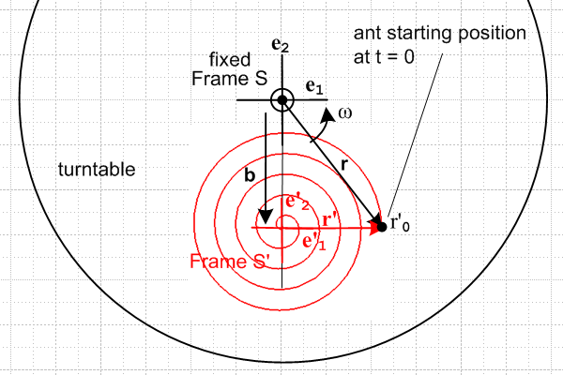 (15.2.2)

We first wish to know the components of r', v' and a' on the en basis vectors. This problem was addressed in (1.2.5) which we quote

(a')i = (R-1)ij(a')'j ⇔ $\left(\begin{matrix}(a')1 \\ (a')2 \\ (a')3\end{matrix}\right)$ = R-1 $\left(\begin{matrix}(a')'1 \\ (a')'2 \\ (a')'3\end{matrix}\right)$ . (1.2.5)
where (15.2.3)

en = R e'n n = 1,2,3 or (en)i = Rij(e'n)j . (1.1.29)

In our application here, we know from (15.4c) that,

e'n = Rz(φ)en ⇒ en = Rz(-φ)e'n ⇒ R = Rz(-φ) ⇒ R-1 = Rz(φ) . (15.2.4)

Therefore, first setting a' = r' , we find from (15.2.3) and (15.2.1) that

$\left(\begin{matrix}(r')1 \\ (r')2 \\ (r')3\end{matrix}\right)$ = Rz(φ) $\left(\begin{matrix}(r')'1 \\ (r')'2 \\ (r')'3\end{matrix}\right)$ = Rz(φ)Rz(Ωt) $\left(\begin{matrix}r'0-Vt \\ 0 \\ (r')'3\end{matrix}\right)$ = Rz(Ωt+φ)$\left(\begin{matrix}r'0-Vt \\ 0 \\ (r')'3\end{matrix}\right)$

= $\left(\begin{matrix}cos(Ωt+φ) & -sin(Ωt+φ) & 0 \\ sin(Ωt+φ) & cos(Ωt+φ) & 0 \\ 0 & 0 & 1\end{matrix}\right)$$\left(\begin{matrix}r'0-Vt \\ 0 \\ (r')'3\end{matrix}\right)$ r' = (r')iei . (15.2.5)

Consider next a' = v' and a' = a' and use the column vectors on the right in (15.2.1) to get,

$\left(\begin{matrix}(v')1 \\ (v')2 \\ (v')3\end{matrix}\right)$ = $\left(\begin{matrix}cos(Ωt+φ) & -sin(Ωt+φ) & 0 \\ sin(Ωt+φ) & cos(Ωt+φ) & 0 \\ 0 & 0 & 1\end{matrix}\right)$$\left(\begin{matrix}-V \\ Ω(r'0-Vt) \\ (v')'3\end{matrix}\right)$ v' = (v')iei

$\left(\begin{matrix}(a')1 \\ (a')2 \\ (a')3\end{matrix}\right)$ = $\left(\begin{matrix}cos(Ωt+φ) & -sin(Ωt+φ) & 0 \\ sin(Ωt+φ) & cos(Ωt+φ) & 0 \\ 0 & 0 & 1\end{matrix}\right)$$\left(\begin{matrix}-Ω2(r'0-Vt) \\ -2ΩV \\ (a')'3\end{matrix}\right)$ a' = (a')iei . (15.2.6)

Then do the matrix multiplication to obtain,

(r')1 = (r'0-Vt)cos(Ωt+φ)
(r')2 = (r'0-Vt)sin(Ωt+φ)

(v')1 = -Vcos(Ωt+φ) - Ω(r'0-Vt)sin(Ωt+φ)
(v')2 = -Vsin(Ωt+φ) + Ω(r'0-Vt)cos(Ωt+φ)

(a')1 = -Ω2(r'0-Vt )cos(Ωt+φ) + 2ΩVsin(Ωt+φ)
(a')2 = -Ω2(r'0-Vt )sin(Ωt+φ) - 2ΩVcos(Ωt+φ) . (15.2.7)

Using our less formal notation we have now shown that the trajectory of our spiraling ant in Frame S' can be expressed in terms of Frame S basis vectors as follows ( later we will set φ = ωt ) ,

r'(t) = (r')x + (r')y
where (a)
(r')x = (r'0 – Vt)cos(φ + Ωt)
(r')y = (r'0 – Vt)sin(φ + Ωt)

v' = (v')x + (v')y
where (b)
(v')x = –Vcos(φ + Ωt) – Ω (r'0 – Vt)sin(φ + Ωt)
(v')y = –Vsin(φ + Ωt) + Ω (r'0 – Vt)cos(φ + Ωt)

a' = (a')x + (a')y
where (c)
(a')x = 2ΩVsin(φ + Ωt) – Ω2(r'0 – Vt)cos(φ + Ωt)
(a')y = – 2ΩVcos(φ + Ωt) – Ω2(r'0 – Vt)sin(φ + Ωt) . (15.2.8)

Trajectory r(t) of the ant in Frame S

According to (15.2.8a),

r'(t) = (r'0 – Vt) [ cos(φ + Ωt) + sin(φ + Ωt) ] . (15.2.8a) (15.2.9)

From (12.1.2a) and then from (15.12) we have

r = b + r' (12.1.2a)

b(t) = bsinφ – b cosφ . (15.12)

Therefore, installing (15.2.9) for r' and just above for b,

r(t) = x + y
where (15.2.10)
x = bsinφ + ( r'0 – Vt)cos(φ + Ωt)
y = – bcosφ + (r'0 – Vt)sin(φ + Ωt) .

The Ω = 0 limit of this result agrees with the θ' = 0 limit of (15.1.9), the Problem 1 trajectory.

This r(t) then is the trajectory of the ant in Frame S.

Velocity v(t) of the ant in Frame S

Start with two equations used in Problem 1,

v = v' + ω x r (15.1.10)
ω x r = [ω] x [x + y ] = ωx – ωy . (15.1.11)

Then use v' from (15.2.8b) in (15.1.10) just above to get

v = vx + vy
where (15.2.11)
vx = –Vcos(φ + Ωt) – Ω (r'0 – Vt)sin(φ + Ωt) – ωy
vy = –Vsin(φ + Ωt) + Ω (r'0 – Vt)cos(φ + Ωt) + ωx .

Finally, insert (15.2.10) for x and y so that,

vx = –Vcos(φ + Ωt) – Ω (r'0 – Vt)sin(φ + Ωt) – ω[– bcosφ + (r'0 – Vt)sin(φ + Ωt)]
vy = –Vsin(φ + Ωt) + Ω (r'0 – Vt)cos(φ + Ωt) + ω[bsinφ + ( r'0 – Vt)cos(φ + Ωt)]
or
vx = –Vcos(φ + Ωt) – (ω + Ω) (r'0 – Vt)sin(φ + Ωt) + ωbcosφ
vy = –Vsin(φ + Ωt) + (ω + Ω) (r'0 – Vt)cos(φ + Ωt) + ωbsinφ . (15.2.12)

The Ω = 0 limit of these last equations gives the θ' = 0 limit of (15.1.13).

This v(t) then is the velocity of the ant in Frame S.

Acceleration a(t) of the ant in Frame S

Start again with (15.1.14),

a = a' + x r + 2 ω x v' + ω x (ω x r) . (15.1.14) (15.2.13)

The first term is given by (15.2.8c)

a' = (a')x + (a')y
where (15.2.8c)
(a')x = 2ΩVsin(φ + Ωt) – Ω2(r'0 – Vt)cos(φ + Ωt)
(a')y = – 2ΩVcos(φ + Ωt) – Ω2(r'0 – Vt)sin(φ + Ωt) .

The 2nd and 4th terms we obtain by quoting these results from the previous problem,

x r = x – y (15.1.15)

ω x (ω x r) = [ω] x [ωx – ωy] = -ω2x – ω2y . // = -ω2 r, centripetal accel. (15.1.17)

The third term of (15.2.13) is

2ω x v' = 2[ω] x [(v')x + (v')y ] = 2ω(v')x – 2ω (v')y .

Adding these terms one can rewrite (15.2.13) as,

a = ax + ay
where (15.2.14)
ax = 2ΩVsin(φ + Ωt) – Ω2(r'0 – Vt)cos(φ + Ωt) – y – ω2x – 2ω (v')y
ay = – 2ΩVcos(φ + Ωt) – Ω2(r'0 – Vt)sin(φ + Ωt) + x – ω2y + 2ω(v')x
where
x = bsinφ + ( r'0 – Vt)cos(φ + Ωt) (15.2.10)
y = – bcosφ + (r'0 – Vt)sin(φ + Ωt)
and
(v')x = –Vcos(φ + Ωt) – Ω (r'0 – Vt)sin(φ + Ωt)
(v')y = –Vsin(φ + Ωt) + Ω (r'0 – Vt)cos(φ + Ωt) . (15.2.8b)

This a(t) then is the acceleration of the ant in Frame S.

The result is admittedly a bit complicated, but the point is that we were able to obtain the result using our Section 12 summary equations without too much effort. [ See "The Hard Way" in Section 15.4 below. We have not dealt with any differential equations in obtaining the above results. ]

Trajectory Plots

We set φ0 = 0 so Frame S' starts directly below Frame S and is aligned with it, and then φ = ωt. Equation (15.2.10) then reads

r(t) = x + y
where (15.2.15)
x = bsin(ωt) + ( r'0 – Vt)cos(ωt + Ωt)
y = – bcos(ωt) + (r'0 – Vt)sin(ωt + Ωt) .

Each plot is finite because the trip is over when the ant reaches the S' origin at tmax = r'0/V.

We set b = 3, r'0 = 2, V = 0.4 and ω = 1. The ant therefore starts at (x,y) = (r'0,-b) = (2,-3). Here are trajectory plots for various values of Ω :

Ω = 6 Ω = 10 Ω = 20
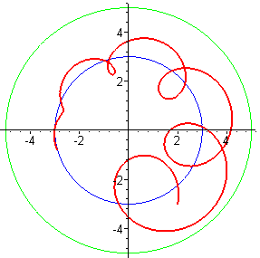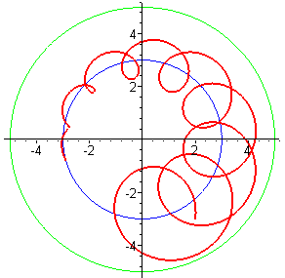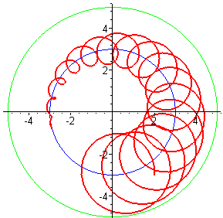
b = 3, r'0 = 2, V = 0.4, ω = 1 (15.2.16)

The blue circles have radius b = 3 (origin of Frame S'), and the green circles have radius b+r'0 = 5.

These trajectories should seem quite reasonable to the reader, knowing what that ant is up to in Frame S', shown generically in Fig (15.2.2).

The middle plot was generated by the following Maple code based on (15.2.15), where R ≡ r'0, :

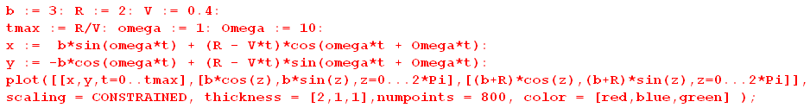
(15.2.17)
When ω and Ω have opposite sign, things can look quite different,

Ω = -2 Ω = -3 Ω = -3.6
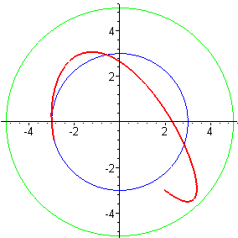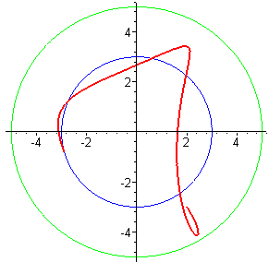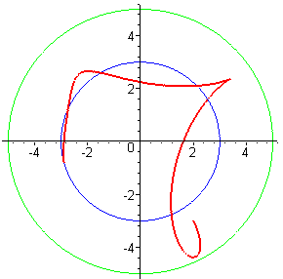
(15.2.18)

Finally, here are some trajectories with V = 0 :

r'0 = 0.7, b = 3, V = 0, ω = 1 and :

Ω = 3.5 Ω = -7 Ω = 25.1
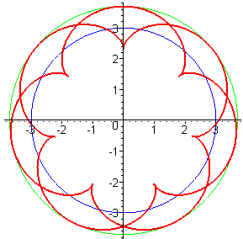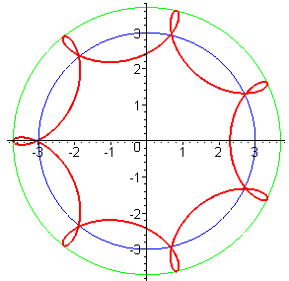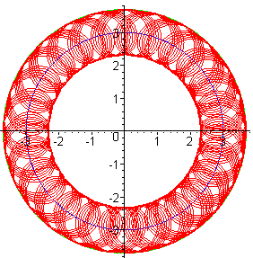
(15.2.19)

The closure of the plots occurs whenever Ω/ω is a ratio of integers, but that could take many revolutions if those integers are large. A random orbital sander works on this principle.

15.3 Problem 3: Inverse Problem: Ant flies in Frame S at constant velocity V

A flying ant starting at position r0 flies just above the turntable surface in Frame S in a straight line at constant velocity V at angle θ relative to the x axis. First state r,v,a and then compute r',v',a' and plot the trajectory r' of the particle as seen in Frame S'. Use the same Frame S / Frame S' setup as in the previous problems.

In this problem we continue to use both notations for the unit vectors as in (1.1.1),

x1, x2, x3 = x, y, z e1, e2, e3 = , , e'1, e'2, e'3 = ', ', ' (1.1.1)

Ant's Motion in Frame S

The flying ant starts at location r0 and has velocity V = V with V constant, so

v = V
r = Vt + r0
a = 0 . (15.3.1)

As noted, the ant flies on a line which has angle θ relative to the e1 axis, so

= Rz(θ) e1 = Rz(θ) . (15.3.2)

This angle θ is defined in the usual polar sense: it is counterclockwise from the positive x axis.

Trajectory r'(t) of the ant in Frame S'

First, we need to write in Frame S' basis vectors. Recall (15.4c) which says

e'i = Rz(φ) ei for example e'1 = Rz(φ) e1 . (15.4c)

Therefore

= Rz(θ) e1 = Rz(θ) Rz(-φ) e'1 = Rz(θ-φ) e'1 . (15.3.3)

Second, how does the point r0 in Frame S appear in Frame S' ? Using (15.4c) just above gives

r0 = (r0)i ei = (r0)i Rz(-φ)e'i . (15.3.4)

Third, from (15.12) ( or just looking at Fig (15.1) ) we know that

b = - b e'2 . (15.12)

Now for the trajectory we start with (13.3.2a),

r' = r - b (13.3.2a)

= (Vt + r0 ) + b e'2 // from (15.3.1) and (15.12)

= Vt Rz(θ-φ) e'1 + (r0)i Rz(-φ)e'i + b e'2 // from (15.3.3) and (15.3.4)
so
r' = Vt Rz(θ-φ) e'1 + Rz(-φ) [(r0)i e'i] + b e'2 . (15.3.5)

We now use the following notations (these are all "natural" components in sense of Section 1.8 )

(r0)1 = x0 (r')'1 = x'
(r0)2 = y0 (r')'2 = y' .

In Frame S', e'1 = (1,0,0), so we write (15.3.5) in matrix notation in Frame S' as follows :

$\left(\begin{matrix}x' \\ y' \\ z'\end{matrix}\right)$ = Vt $\left(\begin{matrix}cos(θ-φ) & -sin(θ-φ) & 0 \\ sin(θ-φ) & cos(θ-φ) & 0 \\ 0 & 0 & 1\end{matrix}\right)$ $\left(\begin{matrix}1 \\ 0 \\ 0\end{matrix}\right)$ + $\left(\begin{matrix}cosφ & sinφ & 0 \\ -sinφ & cosφ & 0 \\ 0 & 0 & 1\end{matrix}\right)$$\left(\begin{matrix}x0 \\ y0 \\ 0\end{matrix}\right)$ + b $\left(\begin{matrix}0 \\ 1 \\ 0\end{matrix}\right)$
or
x' = Vt cos(θ-φ) + x0cosφ + y0sinφ
y' = Vt sin(θ-φ) – x0sinφ + y0cosφ + b
z' = 0 .

The conclusion is this :

r'(t) = x' ' + y' '
where (15.3.6)
x' = Vt cos(θ-φ) + x0cosφ + y0sinφ
y' = Vt sin(θ-φ) – x0sinφ + y0cosφ + b
where φ = φ0 + ωt .

This then is the trajectory r' of the flying ant as seen in Frame S'.
Trajectory r'(t) of the ant in Frame S': Alternate Method

Since we are going to have a discrepancy with Thornton and Marion below, it seems healthy to confirm (15.3.6) by an alternate derivation that does not make use of the matrix notation used above. We start as before above (15.3.5),

r' = r - b = (Vt + r0 ) + b e'2 . r' = trajectory of ant in Frame S'

Using the theorem (1.1) + (1.2) we find from (15.3.3) and (15.3.4) that,

= Rz(θ-φ) e'1 = Rz(φ-θ)11 e'1 + Rz(φ-θ)12 e'2 = cos(φ-θ) e'1 - sin(φ-θ) e'2

r0 = (r0)i ei = (r0)i Rz(-φ)e'i = x0 Rz(-φ)e'1 + y0 Rz(-φ)e'2

= x0 { Rz(φ)11 e'1 + Rz(φ)12 e'2 } + y0 { Rz(φ)21 e'1 + Rz(φ)22 e'2 }

= x0 { cos(φ) e'1 – sin(φ) e'2 } + y0 {sin(φ) e'1 + cos(φ) e'2 }

= [x0 cos(φ) + y0 sin(φ)] e'1 + [– x0 sin(φ) + y0 cos(φ)] e'2 .

Therefore,

r' = Vt + r0 + b e'2

= Vt [cos(φ-θ) e'1 - sin(φ-θ) e'2] + [x0 cos(φ) + y0 sin(φ)] e'1 + [- x0 sin(φ) + y0 cos(φ)] e'2 + b e'2

= [Vt cos(φ-θ) + x0 cos(φ) + y0 sin(φ) ]e'1 + [- Vt sin(φ-θ) - x0 sin(φ) + y0 cos(φ) + b]e'2

= [Vt cos(θ-φ) + x0 cos(φ) + y0 sin(φ) ]e'1 + [ Vt sin(θ-φ) - x0 sin(φ) + y0 cos(φ) + b]e'2

and this does agree with (15.3.6).

Velocity v'(t) of the ant in Frame S'

From the Inverse Problem equations of Section 13.3 we have from (13.3.2b),

v' = v – ω x r – S' . (13.3.2b)

Since this is a Special Case #1 problem, we have S' = 0 and then

v' = v – ω x r = v – ω x (r'+b) = v – ω x r' – ω x b // (13.3.2a) that r' = r - b

= V Rz(θ-φ) ' – ω x [ x' ' + y' '] – ω x [ -b '] // (15.3.1) v, (15.3.3) and (15.12) b

= V Rz(θ-φ) ' –ωx' ' + ωy' ' – ωb ' . // ω = ω '

Using the following unofficial notations,

(v')'1 = v'x'
(v')'2 = v'y'

the above equation in matrix notation in Frame S' is

$\left(\begin{matrix}v'x' \\ v'y' \\ v'z'\end{matrix}\right)$= V $\left(\begin{matrix}cos(θ-φ) & -sin(θ-φ) & 0 \\ sin(θ-φ) & cos(θ-φ) & 0 \\ 0 & 0 & 1\end{matrix}\right)$ $\left(\begin{matrix}1 \\ 0 \\ 0\end{matrix}\right)$ + $\left(\begin{matrix}ωy'-ωb \\ -ωx' \\ 0\end{matrix}\right)$
or
v'x' = V cos(θ-φ) + ω(y'-b)
v'y' = V sin(θ-φ) - ωx'
v'z' = 0 .

Then using (15.3.6) for x' and y' we get,

v'(t) = v'x' ' + v'y' '
where (15.3.7)
v'x' = V cos(θ-φ) + ω[Vt sin(θ-φ) – x0sinφ + y0cosφ]
v'y' = V sin(θ-φ) – ω[Vt cos(θ-φ) + x0cosφ + y0sinφ]
where φ = φ0 + ωt .

This then is the velocity v' of the flying ant as seen in Frame S'.
Acceleration a'(t) of the ant in Frame S'

From the Inverse Problem equations in Section 13.3 we have from (13.3.2d),

a' = a – x r – 2 ω x v + ω x (ω x r) – S' . (13.3.2d)

Setting S'= 0 for our Special Case #1 problem, and using (15.3.1) for r, v and a (a = 0) we get

a' = – x [Vt + r0] – 2 ω x [V] + ω x (ω x [Vt + r0]) .

We shall stop here, but the calculation can be continued in a manner similar to that for r' and v'.

Trajectory Plots

Recall (15.3.6) from above

r'(t) = x' ' + y' '
where (15.3.6)
x' = Vt cos(θ-φ) + x0cosφ + y0sinφ
y' = Vt sin(θ-φ) – x0sinφ + y0cosφ + b
where φ = φ0 + ωt .

For plotting purposes, we set φ0 = 0 so φ = ωt. Since b merely offsets plots vertically by amount b, we lose no interest by setting b=0, causing the Frame S and Frame S' origins to coincide. Then from (15.3.6),

x' = Vt cos(θ-ωt) + x0cos(ωt) + y0sin(ωt)
y' = Vt sin(θ-ωt) – x0sin(ωt) + y0cos(ωt) . (15.3.8)

In all plots below we set ω = 1. In the first three plots the flying ant starts out at r0 = (-1/2,0) and flies north so θ = π/2. We superpose a green circle of radius R = 1 and take note of the time T it takes for the ant to reach the circle. The Maple code used for the left plot is this (x' = xp) :

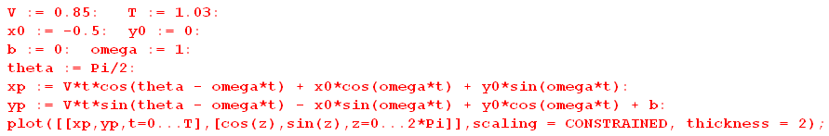

Here then are plots for three decreasing values of V. As the ant flies more slowly, the turntable turns more radians before the ant reaches a distance R = 1 from the turntable center.

V = .85 , T = 1.03 V = 0.3, T = 2.9 V = .061, T = 14

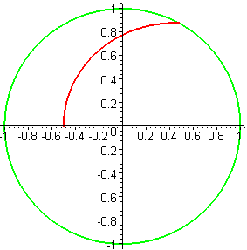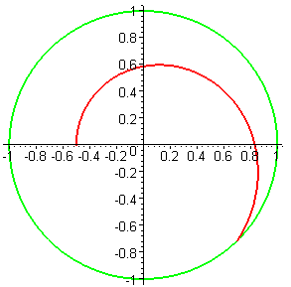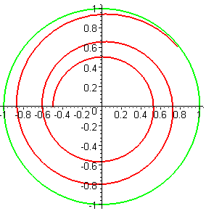
(15.3.9)
These plots may be compared to those appearing on on page 395 of Thornton and Marion,
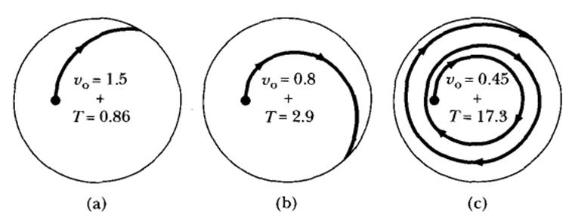
(15.3.10)

Their plotting method is to compute the fictitious force acceleration

a' = – 2 ω x v + ω x (ω x r)

and then to numerically integrate a' twice to get v' and then r' which is then plotted. [ Again, see "The Hard Way" in Section 15.4 below.] Although our plots are close to theirs in appearance, our numbers for V and T differ significantly from theirs. Here are the three plots our code generates using the numbers specified in the T&M images above,

V = 1.5 , T = 0.86 V = 0.8, T = 2.9 V = 0.45, T = 17.3
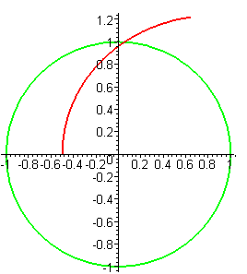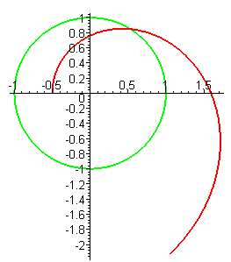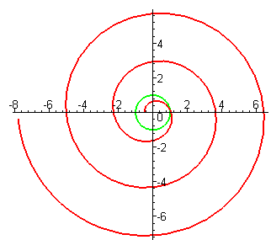
(15.3.11)

For the next three plots, we still have ω = 1 and the flying ant starts in the same place r0 = (-1/2,0), but now the ant flies southeast at speed V so θ = -π/4. Interestingly, we see that it is possible for the ant (as seen in Frame S') to execute a loop, a cusp, or a bump soon after taking flight. The lower set of figures show blowups of the parts of the upper paths,

V = 0.42, T = 3.1 V = 0.35, T = 3.7 V = 0.31, T = 4.2 (15.3.12)
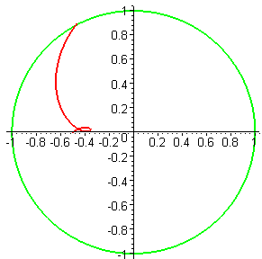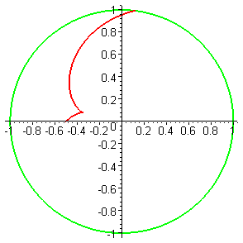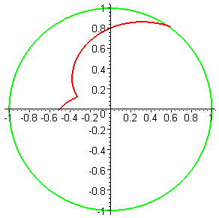
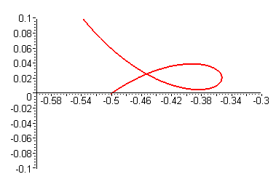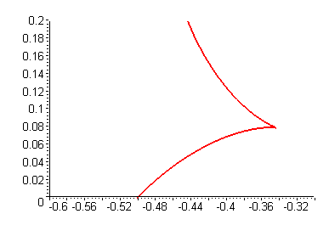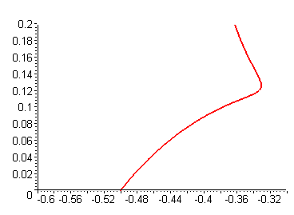

(15.3.13)

It is not easy to intuitively explain these plots. We do know that for all plots vt = ωr = 1*(1/2) = 0.5 at time t = 0. So even though the ant is flying southeast in Frame S, in Frame S' there is at t = 0 a vt adder of 0.5 upwards (north) due to the motion of the turntable so in Frame S' the ant starts off going northeast. The ant moves to a smaller radius so vt is reduced so the and moves more toward the east and in the left case to the south as well, but then Frame S' which started under Frame S is rotating up to the right

The left pair of plots in (15.3.12) may be compared to two other plots appearing in T&M on page 395,

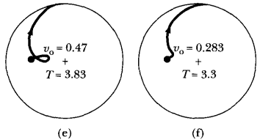 (15.3.14)

Again the plots are similar, but the numbers are different (but in the same ball park).

Using (15.3.7) we plot the velocity that goes with the second trajectory shown in the first triplet above, and at least things seem reasonable:

r(t) for V = 0.3, T = 2.9 v(t) for V = 0.3, T = 2.9
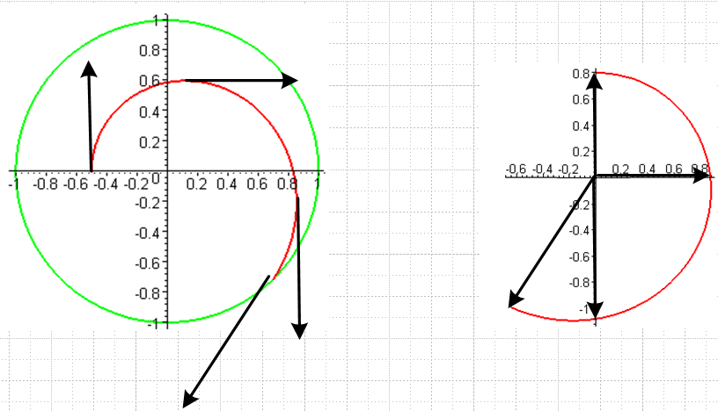 (15.3.15)

Finally, we move the starting position to (-1,-1) and have the ant fly northeast so θ = π/4. This path takes him over the origin of Frame S (and Frame S'), so we expect to see the Frame S' trajectory touch the origin at one point along the trajectory (except in the left plot where V = 0)

V = 0, T = 5 V = 0.11, T = 25 V = 0.2, T = 15
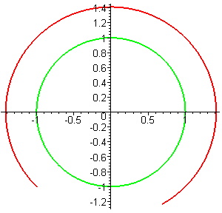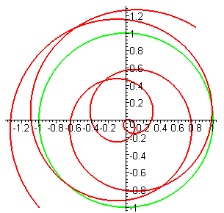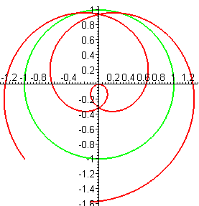
(15.3.16)

Since the turntable is rotating counterclockwise at ω=1, these trajectories run clockwise at all times. When V = 0, the apparent motion of the static fly is circular in Frame S'. In the middle plot we see that the ant spirals in, reaches the origin, the spirals out. In the right plot he does the same thing, but more quickly.

In the 1960's some excellent frames-of-reference movies were produced. One of them involves a frictionless puck moving on a smooth table mounted to a large wooden frame which is rotated (no doubt by students). Two affable "doctors" are rotating on that frame with the table. Doctor #1 on the left launches the puck, but Doctor #2 has nothing to do since the puck just returns to Doctor #1.

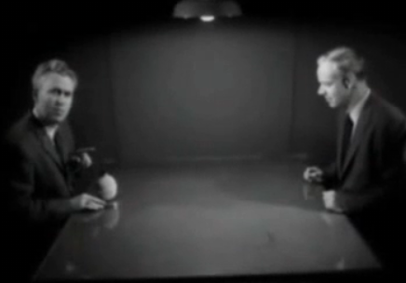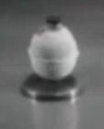
(15.3.17)

We show two possible Frame S' paths for a puck launched from (x0, y0) = (-1,0) and ω = 1.

V = 0.6, T = 3.2, θ = 0 V = 0.2, T = 5, θ = π/4
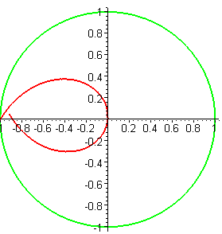 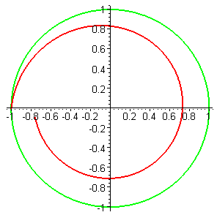 (15.3.18)

This classic movie is archived at http://www.youtube.com/watch?v=3ug23VTMies . (The next film in this series treats the Foucault Pendulum which we describe in Appendix C.)

15.4 Problem 4: The Projectile Problem of Section 8.3

It will be recalled that in Section 8.3, as a demonstration of the Coriolis force, four projectiles are fired horizontally in four directions as in Figure (8.3.1). Since each projectile is like one of our flying ants, we already have a complete solution to this problem which we shall plot below. But first, it is very enlightening to approach this problem "the hard way" and then to appreciate the power of the equations which directly relate particle properties in Frame S and Frame S'.

The Hard Way

It was noted in (8.3.4) that the projectiles (or our flying ant) experience the following fictitious forces,

F'fict = mω2r' – 2m ω x v' . (8.3.4)
centrifugal Coriolis

Using bogus Newton's Law (8.1.4) that F'eff = ma', the above equation can be written,

(dv'/dt)S' = ω2r' – 2ω x v' . (15.4.1)

Since ω is a constant, and working in Frame S', we differentiate once to get

(d2v'/dt2)S' = ω2 (dr'/dt)S' – 2ω x (dv'/dt)S' .

In the abbreviated "natural" notation of Section 1.8 this says

' + 2ω x ' - ω2v' = 0 . (15.4.2)

Now for the rest of this section, we temporarily drop all primes just to reduce clutter. Then the above becomes

+2ω x - ω2v = 0 . (15.4.3)

Expanding the vectors of interest,

v = vx + vy + vz
= x + y + z
= x + y + z

ω x = [ω] x [x + y + z] = ωx - ωy .

Inserting these expansions into (15.4.3) and isolating the coefficients of the three unit vectors, we get

x - 2ωy - ω2vx = 0
y + 2 ωx - ω2vy
z - ω2vz = 0 . (15.4.4)

The third equation has obvious solutions, one of which is vz = 0 which is what applies to our turntable problems. That leaves the first two equations,

x - 2ωy - ω2vx = 0
y + 2ωx - ω2vy = 0 . (15.4.5)

This is a system of two coupled, second-order, linear ODE's with constant coefficients. It takes some amount of work to solve such an equation and we will start down that path. Apply a Laplace Transform,

[ s2Vx(s) - s vx (0) - x (0) ] - 2ω[ s Vy(s) - vy(0) ] - ω2 Vx(s) = 0
[ s2Vy(s) - s vy (0) - y (0) ] + 2ω[ s Vx(s) - vx(0) ] - ω2 Vy(s) = 0 (15.4.6)

(s2-ω2)Vx(s) – 2ωs Vy(s) = s vx (0) + x (0) – 2ω vy(0) // get Vx and Vy on the left
(s2-ω2)Vy(s) + 2ωs Vx(s) = s vy (0) + y (0) + 2ω vx(0)

$\left(\begin{matrix}s2-ω2 & -2ωs \\ 2ωs & s2-ω2\end{matrix}\right)$$\left(\begin{matrix}Vx(s) \\ Vy(s)\end{matrix}\right)$ = // write as matrix equation

$\left(\begin{matrix}Vx(s) \\ Vy(s)\end{matrix}\right)$ = $\left(\begin{matrix}s2-ω2 & 2ωs \\ -2ωs & s2-ω2\end{matrix}\right)$ / (s2+ω2)2 // Maple assists

Vx(s) = { (s2-ω2) [s vx (0) + x (0) – 2ω vy(0)] +2ωs [s vy (0) + y (0) – 2ω vx(0)] }/(s2+ω2)2
Vy(s) = { -2ωs [s vx (0) + x (0) – 2ω vy(0)] + (s2-ω2) [s vy (0) + y (0) – 2ω vx(0)] }/(s2+ω2)2

One can then look up the inverse Laplace transforms of all these functions,

s3/(s2+ω2)2 cos(ωt) - (1/2)ωt sin(ωt)
s2/(s2+ω2)2 [sin(ωt) + ωtcos(ωt)]/(2ω)
s/(s2+ω2)2 t sin(ωt)/(2ω)
1/(s2+ω2)2 [sin(ωt) - ωtcos(ωt)]/(2ω3) (15.4.7)

and the problem is solved including the initial conditions.

But, we don't have to solve this coupled system of differential equations because we already know the solution, and we didn't have to even look at a differential equation to find it! The solution is (15.3.7) which we quote

v'(t) = v'x' ' + v'y' '
where (15.3.7)
v'x' = V cos(θ-φ) + ω[Vt sin(θ-φ) – x0sinφ + y0cosφ]
v'y' = V sin(θ-φ) – ω[Vt cos(θ-φ) + x0cosφ + y0sinφ]
where φ = φ0 + ωt .

Changing this to our temporary no-primes de-cluttered notation,

v(t) = vx + vy
where
vx = V cos(θ-φ) + ω[Vt sin(θ-φ) – x0sinφ + y0cosφ]
vy = V sin(θ-φ) – ω[Vt cos(θ-φ) + x0cosφ + y0sinφ]
where φ = φ0 + ωt .

We shall now use Maple to verify that these functions solve the coupled equations (15.4.5):

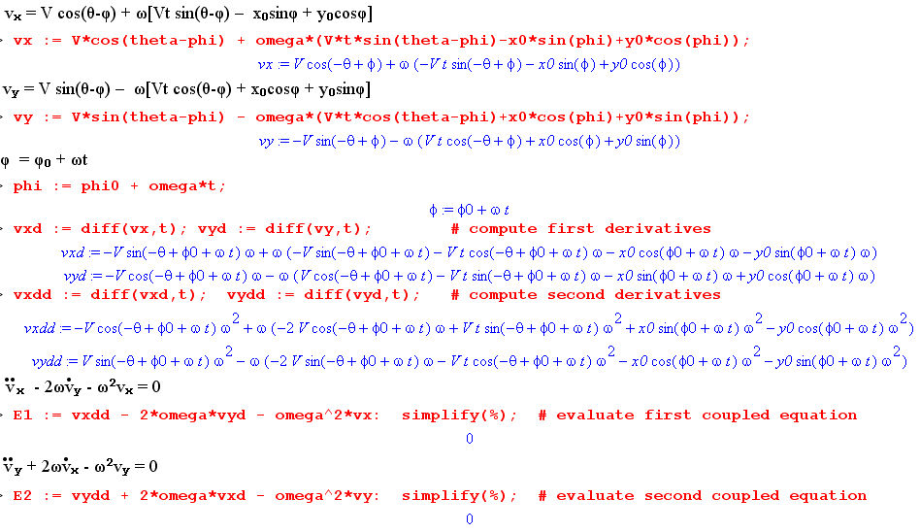
(15.4.8)

Sometimes, for a given problem in rotational motion, there is an easy way and a hard way to solve the problem. Another example of a hard way is the numeric integration mentioned after Fig (15.3.10).

At this point we restore the primes on Frame S' quantities.

The Four Projectiles

Recall Fig (8.3.1) which shows the deflecting projectiles on the right.

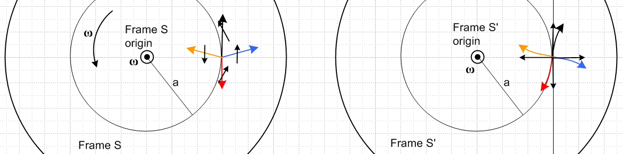 (8.3.1)

In Frame S' at t = 0 the four projectiles are launched in the four Frame S' axis directions and each has the same speed V' (black arrows on the right). This V' was called V in Section 8.3, but since it is a speed in Frame S' we now call it V'.

We now examine the initial speeds and launch angles θ of the four projectiles as seen in Frame S:

black (upper) V' + vt θ = π/2 V = V' + vt

red (lower) -V' + vt θ = -(π/2)*sign(V'-vt) V = |V' - vt|

orange (left) -V' + vt θ = π - Δθ V = $\sqrt{V'2+vt2}$

blue (right) V' + vt θ = Δθ V = $\sqrt{V'2+vt2}$

Here vt = aω is the turntable upward speed where the launch occurs. The angle θ is the usual polar azimuthal angle measured CCW from the axis which points to the right, and Δθ = tan-1(vt/V') .

We treat each of these Frame S velocities as the velocity of a Problem 3 ant flyover. The Frame S' trajectories are then given by (15.3.8) where the Frame S and Frame S' origins coincide at the spindle (b=0) and have aligned axes at time t = 0,

x' = Vt cos(θ-ωt) + x0cos(ωt) + y0sin(ωt)
y' = Vt sin(θ-ωt) – x0sin(ωt) + y0cos(ωt) . (15.3.8)

At t=0 the four projectiles start at (x0,y0) = (x'0,y'0) = (a,0) so things simplify a bit more,

x'(t) = Vt cos(θ-ωt) + acos(ωt)
y'(t) = Vt sin(θ-ωt) – asin(ωt) . (15.4.9)

These are very simple expressions indeed, considering the coupled differential equations above.

It remains only to have Maple plot the projectile trajectories with the initial velocities installed :

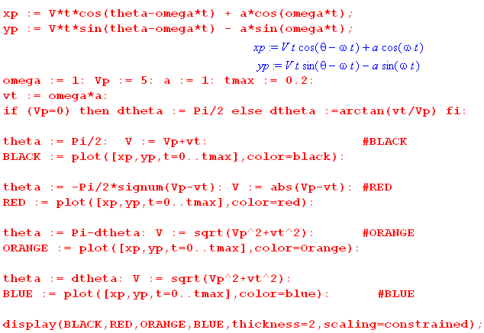 (15.4.10)

Here then are some plots. The first four all have V' = 5 but have increasing duration. The notion of the deflections being roughly circular (end of Section 8.3) is not too bad for tmax ≤ 1 :

V' = 5: tmax = 0.2 tmax = 0.5 tmax = 1.0 tmax = 4
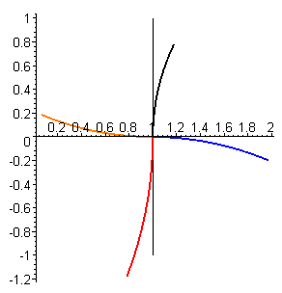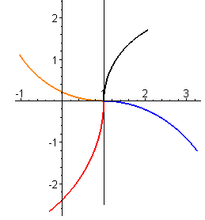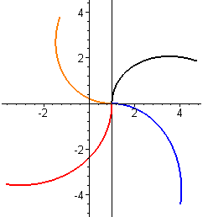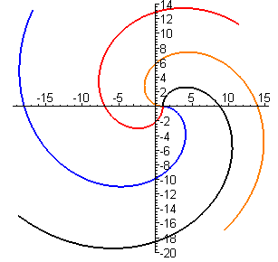
(15.4.11)

In the next plots we fix tmax = 3 but take V' to ever-decreasing values :

tmax=3: V' = 1 V' = 0.5 V' = 0.2 V' = 0.05
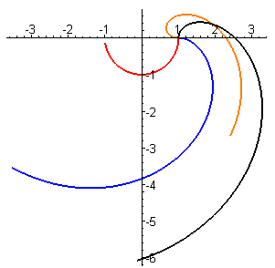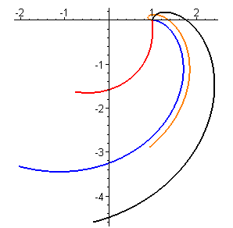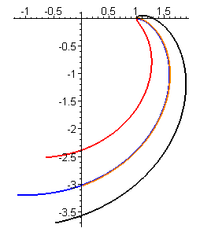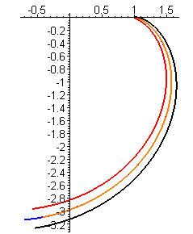
(15.4.12)

As V' → 0, all four curves eventually become the same curve. The blue and orange curves line up early because, with small V', both projectiles accelerate radially outward in Frame S' with no tangential velocity. The orange one first goes to the left, then reverses and goes to the right and follows the blue particle in nearly the same trajectory.

Appendix A: Derivation of R(ξ) and Properties of Rotation Matrices

Here we derive equations (14.4) through (14.6) for spherical coordinates. First, just for reference, here are the three active rotation matrices used below :

Rx(θ) = $\left(\begin{matrix}1 & 0 & 0 \\ 0 & cosθ & -sinθ \\ 0 & sinθ & cosθ\end{matrix}\right)$ Ry(θ) = $\left(\begin{matrix}cosθ & 0 & sinθ \\ 0 & 1 & 0 \\ -sinθ & 0 & cosθ\end{matrix}\right)$ Rz(θ) = $\left(\begin{matrix}cosθ & -sinθ & 0 \\ sinθ & cosθ & 0 \\ 0 & 0 & 1\end{matrix}\right)$ . (A.1)

These are called "active" since they rotate a vector forward (counterclockwise) relative to fixed axes by amount θ according to the right hand rule when the thumb is aligned with the axis in question.

From the usual picture of spherical coordinates,

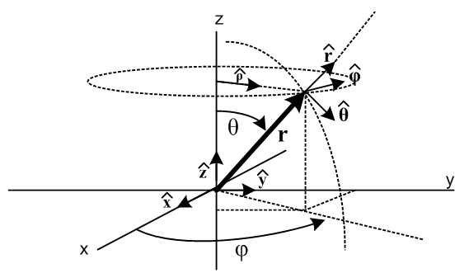 (A.2)
one can see (by staring hard enough) that

= Rz(φ) Ry(θ) = R R ≡ Rz(φ) Ry(θ)
= Rz(φ) Ry(θ) = R
= Rz(φ) Ry(θ) = R // Ry(θ) does nothing here (A.3)

which we rewrite as

1 = R e3 where 1 = e3 =
2 = R e1 2 = e1 =
3 = R e2 3 = e2 = . (A.4)

We can repair the ordering of the basis vectors en on the right using R2 = (,,) as follows

e3 = R2 e1 $\left(\begin{matrix}0 \\ 0 \\ 1\end{matrix}\right)$ = $\left(\begin{matrix}0 & 1 & 0 \\ 0 & 0 & 1 \\ 1 & 0 & 0\end{matrix}\right)$$\left(\begin{matrix}1 \\ 0 \\ 0\end{matrix}\right)$ R2 = $\left(\begin{matrix}0 & 1 & 0 \\ 0 & 0 & 1 \\ 1 & 0 & 0\end{matrix}\right)$ = (,,)
e1 = R2 e2 $\left(\begin{matrix}1 \\ 0 \\ 0\end{matrix}\right)$ = $\left(\begin{matrix}0 & 1 & 0 \\ 0 & 0 & 1 \\ 1 & 0 & 0\end{matrix}\right)$$\left(\begin{matrix}0 \\ 1 \\ 0\end{matrix}\right)$
e2 = R2 e3 $\left(\begin{matrix}0 \\ 1 \\ 0\end{matrix}\right)$ = $\left(\begin{matrix}0 & 1 & 0 \\ 0 & 0 & 1 \\ 1 & 0 & 0\end{matrix}\right)$$\left(\begin{matrix}0 \\ 0 \\ 1\end{matrix}\right)$ . (A.5)

Maple tells us that R2-1 = R2T and det(R2) = 1, confirming that R2 is a rotation. Putting (A.5) into (A.4),

1 = R R2 e1
2 = R R2 e2
3 = R R2 e3 (A.6)
or
i = [R R2] ei . (A.7)

Recalling (14.4) (here the generic coordinate vector ξ is spherical coordinates r,θ,φ )

n = R(ξ)-1en n = 1,2,3 ⇔ en = (R(ξ))-1nm m or n = [R(ξ)]nm em (14.4)

we have therefore found the sought-after matrix R(ξ),

[R(ξ)]-1 = R R2 . (A.8)

Specific evaluation gives

R = Rz(φ) Ry(θ) = $\left(\begin{matrix}cosφ & -sinφ & 0 \\ sinφ & cosφ & 0 \\ 0 & 0 & 1\end{matrix}\right)$$\left(\begin{matrix}cosθ & 0 & sinθ \\ 0 & 1 & 0 \\ -sinθ & 0 & cosθ\end{matrix}\right)$ = $\left(\begin{matrix}cosφcosθ & -sinφ & cosφsinθ \\ sinφsinθ & cosφ & sinφsinθ \\ -sinθ & 0 & cosθ\end{matrix}\right)$ (A.9)

and then
[R(ξ)]-1 = R R2 = $\left(\begin{matrix}cosφcosθ & -sinφ & cosφsinθ \\ sinφsinθ & cosφ & sinφsinθ \\ -sinθ & 0 & cosθ\end{matrix}\right)$$\left(\begin{matrix}0 & 1 & 0 \\ 0 & 0 & 1 \\ 1 & 0 & 0\end{matrix}\right)$ = $\left(\begin{matrix}cosφsinθ & cosφcosθ & -sinφ \\ sinφsinθ & sinφcosθ & cosφ \\ cosθ & -sinθ & 0\end{matrix}\right)$ (A.10)

Since [R(ξ)]-1 = [R(ξ)]T we obtain R(ξ) by transposing the above matrix, so

R(ξ) = $\left(\begin{matrix}cosφsinθ & sinφsinθ & cosθ \\ cosφcosθ & sinφcosθ & -sinθ \\ -sinφ & cosφ & 0\end{matrix}\right)$ . (A.11)

From the right side of equation (14.4) (quoted above) we can write,

i = R(ξ)ij ej = R(ξ)i1 e1 + R(ξ)i2 e2 + R(ξ)i3 e3 . (A.12)

This can be written in the alternative notation of (1.1.32) as,

= $\left(\begin{matrix}cosφsinθ & sinφsinθ & cosθ \\ cosφcosθ & sinφcosθ & -sinθ \\ -sinφ & cosφ & 0\end{matrix}\right)$$\left(\begin{matrix}e1 \\ e2 \\ e3\end{matrix}\right)$ = R(ξ) $\left(\begin{matrix}e1 \\ e2 \\ e3\end{matrix}\right)$ (A.13a)
or
= $\left(\begin{matrix}cosφsinθ & sinφsinθ & cosθ \\ cosφcosθ & sinφcosθ & -sinθ \\ -sinφ & cosφ & 0\end{matrix}\right)$ = R(ξ) (A.13b)
or
= cosφsinθ + sinφsinθ + cosθ
= cosφcosθ + sinφcosθ - sinθ
= -sinφ + cosφ (A.13c)

which are the well known expressions for the spherical unit vectors in terms of the Cartesian ones. The inverse of the last three equations can be obtained in the following manner (matrix from (A.10))

$\left(\begin{matrix}e1 \\ e2 \\ e3\end{matrix}\right)$ = [R(ξ)]-1 = $\left(\begin{matrix}cosφsinθ & cosφcosθ & -sinφ \\ sinφsinθ & sinφcosθ & cosφ \\ cosθ & -sinθ & 0\end{matrix}\right)$ (A.14a)
or
= [R(ξ)]-1 = $\left(\begin{matrix}cosφsinθ & cosφcosθ & -sinφ \\ sinφsinθ & sinφcosθ & cosφ \\ cosθ & -sinθ & 0\end{matrix}\right)$ (A.14b)
or
= cosφsinθ + cosφcosθ - sinφ
= sinφsinθ + sinφcosθ + cosφ
= cosθ - sinθ . (A.14c)

Appendix E contains further information on spherical coordinates.

Some Properties of Rotation Matrices

A rotation matrix R is always real orthogonal which means R-1 = RT. It follows that

RRT = 1 ⇒ ΣkRik(RT)kj = δi'j ⇒ ΣkRikRjk = δi,j
RTR = 1 ⇒ Σk(RT)ikRkj = δi'j ⇒ ΣkRkiRkj = δi,j . (A.15)

Also

RRT = 1 ⇒ det(RRT) = det(1) ⇒ [det(R)]2 = 1

For a rotation matrix, det(R) = +1. (A.16)

The determinant of R may be written using a standard expansion for the determinant of a matrix,

1 = det(R) = ΣijkεijkRi1Rj2Rk3 , (A.17)

where the permutation tensor was described in (1.5.3). This can be generalized to read

εabc = ΣijkεijkRiaRjbRkc for any a,b,c (A.18)

where (A.17) is the particular case with abc = 123. We leave the proof of (A.18) as a Reader Exercise.

Now apply ΣaRna to both sides of (A.18) and sum on a to get

ΣaRna εabc = ΣaRna ΣijkεijkRiaRjbRkc

= Σijkεijk [ ΣaRnaRia] RjbRkc

= Σijkεijk [δn,i] RjbRkc // (A.15)

= Σjk εnjkRjbRkc .

We have just derived the following rarely-stated property of any 3x3 rotation matrix R :

ΣaRnaεabc = ΣjkεnjkRjbRkc for any n,b,c . (A.19)

Theorem: If A' = RA, B' =RB and C' = RC, then C = A x B ⇔ C' = A' x B' . (A.20)

Proof ⇐ : C' = A' x B'

⇒ C'n = Σjkεnjk A'jB'k ⇒ (RC)n = Σjkεnjk (RA)j(RB)k

⇒ (ΣaRnaCa) = Σjkεnjk(ΣbRjbAb)(ΣcRkcBc) =

= Σbc [ ΣjkεnjkRjbRkc] AbBc

= Σbc [ ΣaRnaεabc] AbBc // (A.19)

= ΣaRna [ΣbcεabcAbBc ]

= Σa Rna [A x B ]a .

In vector notation we have just shown that RC = R(AxB). Apply R-1 from the left to conclude that
C = A x B, QED. Run the steps in reverse to prove ⇒ .
This theorem confirms the intuitive fact that if A,B,C all transform as normal vectors under R, then if C = AxB in Frame S, then C' = A'xB' in rotated Frame S' . The fact that A•B = A'•B' is more obvious and requires only (A.15) : Σj(A')j(B')j = Σj(ΣbRjbAb)(ΣcRjcBc) = Σbc δbcAbBc = ΣbAbBb .

Appendix B: The G Rule for a Tensor of Rank n

In this section we continue to use these shorthand operator notations,

∂S ≡ (d/dt)S ∂S' ≡ (d/dt)S' ∂t ≡ (d/dt) . (1.8.3) (B.1)

Recall from (1.10.1) that for a scalar function or for a component of any tensor one has,

(∂STijk...) = (∂S'Tijk...) = (∂tTijk...) , (1.10.1) (B.2)

and from (2.5) that

∂S'ei = – ω x ei . (2.5) (B.3)

So far we know all about the G Rule for tensors of rank 0 and 1 (scalar and vector),

∂SA = ∂S'A // = ∂tA; A is a scalar function of t (B.2)

∂SA = ∂S'A + ω x A . // A is a vector (2.1) (B.4)

What happens for tensors of rank 2 or more? To explore this question, we first collect a few facts.

A tensor of rank-n has the following expansion (where q represents the nth letter of the alphabet)

T = Σabc..q.Tabc..q (ea⊗eb⊗ec.....⊗eq) . (B.5)

Here T has n subscripts and there is a tensor product of n basis vectors ei. This expansion is a generalization of the expansion of a vector,

V = ΣiViei . (B.6)

The basis vectors are axis-aligned unit vectors, so we have

(en)i = δn,i . (1.1.8) (B.7)

The meaning of the ⊗ symbol is nothing more than the following,

[A⊗B⊗....⊗Q ]abc...q = AaBbCc....Qq . (B.8)

This particular tensor A⊗B⊗....⊗Q happens to be the direct product of the n vectors A,B,C...Q, but there are of course general tensors T which cannot be written as such a direct product.

As a simple tensor product example,

(ea⊗eb)ij = (ea)i (eb)j = δa,i δb,j . (B.9)

Here is the expansion of the direct product tensor T = A⊗B,

A⊗B = Σab [A⊗B]ab ea⊗eb = Σab AaBb ea⊗eb . (B.10)

[ For more details on such tensor products and expansions, see Lucht Tensor Products with ei→ ui] .

Before continuing, we develop two very similar Lemmas:

Lemma 1: ∂S(A⊗B) = (∂SA) ⊗ B + A⊗(∂SB) (B.11)

where A and B are vectors whose components are functions of time.

Proof of Lemma 1:

∂S(A⊗B) = ∂S( Σab AaBb ea⊗eb ) // expansion (B.10)

= Σab ∂S(AaBb) ea⊗eb // since ∂Sen = 0 by (1.7.3)

= Σab ∂t(AaBb) ea⊗eb // (B.2)

= Σab [(∂tAa)Bb + Aa(∂tBb)] ea⊗eb // regular calculus product rule

= Σab [(∂SAa)Bb + Aa(∂SBb)] ea⊗eb // restore ∂S using (B.2)

= Σab [(∂SA)aBb + Aa(∂SB)b] ea⊗eb /// commutation rule (1.11.1)

= Σab [(∂SA)aBb] ea⊗eb + Σab Aa(∂SB)b ea⊗eb // write as two terms

= (∂SA) ⊗ B + A⊗(∂SB) . // expansion (B.10) QED

Recall from (1.2.1) that one can expand a vector A on either the ei or the e'i basis,

A = ΣiAiei = ΣiA'ie'i . // A'i means (A)'i (1.2.1) (B.12)

Similarly, one can expand the tensor T of (B.5) on the e'i basis to get

T = Σabc..q.T'abc..q (e'a⊗e'b⊗e'c.....⊗e'q) (B.13)

with this special case

A⊗B = Σab [A⊗B]'ab e'a⊗e'b = Σab A'aB'b e'a⊗e'b . (B.14)

We then have Lemma 2 which is the same as Lemma 1 but with S→S' ,

Lemma 2: ∂S'(A⊗B) = (∂S'A) ⊗ B + A⊗(∂S'B) (B.15)

The proof exactly follows that of Lemma 1 but we show it anyway:

∂S'(A⊗B) = ∂S'( Σab A'aB'b e'a⊗e'b ) // expansion (B.14)

= Σab ∂S'(A'aB'b) e'a⊗e'b // since ∂S'e'n = 0 by (1.7.2)

= Σab ∂t(A'aB'b) e'a⊗e'b // (B.2)

= Σab [(∂tA'a)B'b + A'a(∂tB'b)] e'a⊗e'b // regular calculus product rule

= Σab [(∂S'A'a)B'b + A'a(∂S'B'b)] e'a⊗e'b // restore ∂S' using (B.2)

= Σab [(∂S'A)'aB'b + A'a(∂S'B)'b] e'a⊗e'b // commutation rule (1.11.1)

= Σab [(∂S'A)'aB'b] e'a⊗e'b + Σab A'a(∂S'B)'b e'a⊗e'b // write as two terms

= (∂S'A) ⊗ B + A⊗(∂S'B) . // expansion (B.14) QED

G Rule for a Rank-2 Tensor

Recall from (B.5) that,

T = ΣabTab (ea⊗eb) . (B.5) (B.16)

Then apply ∂S, using the facts ∂Sen = 0 and (B.2),

(∂ST) = Σab(∂STab) (ea⊗eb) = Σab(∂tTab) (ea⊗eb) . (B.17)

On the other hand,

(∂S'T) = Σab (∂S'Tab) (ea⊗eb) + ΣabTab ∂S'(ea⊗eb)

= Σab (∂tTab) (ea⊗eb) + ΣabTab ∂S'(ea⊗eb) // (B.2)

= (∂ST) + ΣabTab ∂S'(ea⊗eb) . // (B.17) (B.18)
But,

∂S'(ea⊗eb) = (∂S'ea) ⊗ eb + ea⊗(∂S'eb) // by Lemma 2 (B.15)

= – [ (ω x ea) ⊗ eb + ea⊗ (ω x eb) ] . // (B.3) (B.19)

Inserting this last result into (B.18) and swapping sides then gives the G rule for a rank-2 tensor,

(∂ST) = (∂S'T) + ΣabTab [ (ω x ea) ⊗ eb + ea ⊗ (ω x eb) ] . (B.20)

We can write the G rule for a vector T (rank-1 tensor) in a similar form,

(∂ST) = (∂S'T) + ω x T

= (∂S'T) + ω x (ΣaTaea)

= (∂S'T) + ΣaTa ω x ea . (B.21)
G Rule for a Rank-n Tensor

It is easy to show that the above general pattern applies to tensors of rank 3 and higher, and one ends up with the following lowest tensor G rules, where the tensor rank is shown on the left .

0 (∂ST) = (∂S'T)

1 (∂ST) = (∂S'T) + ΣaTa ω x ea

2 (∂ST) = (∂S'T) + ΣabTab [ (ω x ea) ⊗ eb + ea⊗ (ω x eb) ]

3 (∂ST) = (∂S'T) + ΣabcTabc [ (ωxea)⊗eb⊗ec + ea⊗(ωxeb)⊗ec + ea⊗eb⊗(ωxec) ] (B.22)

These G rule results may also be expressed in components. For example:

1 (∂ST)i = (∂S'T)i + ΣaTa (ω x ea)i

= (∂S'T)i + ΣaTa εirs ωr (ea)s

= (∂S'T)i + ΣaTa εirs ωr δa,s

= (∂S'T)i + εirs ωrTs . (B.23)

2 (∂ST)ij = (∂S'T)ij + ΣabTab [ (ω x ea) ⊗ eb + ea⊗ (ω x eb) ]ij

= (∂S'T)ij + ΣabTab [ (ω x ea)i (eb)j + (ea)i(ω x eb)j ]

= (∂S'T)ij + [ Σab Tab (ω x ea)i δb,j + Σab Tab δa,i (ω x eb)j ]

= (∂S'T)ij + [ Σa Taj (ω x ea)i + Σb Tib (ω x eb)j ]

= (∂S'T)ij + [ Σa Taj εirsωr(ea)s + Σb Tib εjrsωr(eb)s ]

= (∂S'T)ij + [ Σa Taj εirsωrδa,s + Σb Tib εjrsωrδb,s ]

= (∂S'T)ij + [ Tsj εirsωr+ Tis εjrsωr ]

= (∂S'T)ij + εirsωr Tsj + εjrsωrTis . (B.24)

We shall do one more case to establish the general pattern,

3 (∂ST)ijk - (∂S'T)ijk = ΣabcTabc [ (ωxea)⊗eb⊗ec + ea⊗(ωxeb)⊗ec + ea⊗eb⊗(ωxec) ]ijk

= ΣabcTabc [ (ωxea)i(eb)j(ec)k + (ea)i(ωxeb)j(ec)k + (ea)i(eb)j(ωxec)k ]

= ΣabcTabc(ωxea)iδb,jδc,k + ΣabcTabcδa,i(ωxeb)jδc,k + ΣabcTabcδa,i δb,j(ωxec)k

= ΣaTajk(ωxea)i + ΣbTibk(ωxeb)j + ΣcTijc(ωxec)k

= ΣaTajkεirsωr (ea)s + ΣbTibkεjrsωr (eb)s + ΣcTijcεkrsωr (ec)s

= ΣaTajkεirsωr δa,s + ΣbTibkεjrsωr δb,s + ΣcTijcεkrsωrδc,s

= Tsjkεirsωr+ Tiskεjrsωr + Tijsεkrsωr

so we conclude that

(∂ST)ijk = (∂S'T)ijk + εirsωrTsjk + εjrsωrTisk + εkrsωrTijs . (B.25)

Looking at the last two results we can infer the rank-4 result

(∂ST)ijkl = (∂S'T)ijkl + εirsωrTsjkl + εjrsωrTiskl + εkrsωrTijsl + εlrsωrTijks . (B.26)

Summary of G rule for all ranks (tensor form) (B.27)

0 (∂ST) = (∂S'T)

1 (∂ST) = (∂S'T) + ΣaTa ω x ea

2 (∂ST) = (∂S'T) + ΣabTab [ (ω x ea) ⊗ eb + ea⊗ (ω x eb) ]

3 (∂ST) = (∂S'T) + ΣabcTabc [ (ωxea)⊗eb⊗ec + ea⊗(ωxeb)⊗ec + ea⊗eb⊗(ωxec) ]

4 (∂ST) = (∂S'T) + ΣabcdTabcd [ (ωxea)⊗eb⊗ec⊗ed + ea⊗(ωxeb)⊗ec⊗ed
+ ea⊗eb⊗(ωxec)⊗ed + ea⊗eb⊗ec⊗(ωxed) ]
etc.

Summary of G rule for all ranks (component form) (B.28)

0 (∂ST) = (∂S'T)

1 (∂ST)i = (∂S'T)i + εirs ωrTs = (∂S'T)i + (ω x T)i

2 (∂ST)ij = (∂S'T)ij + εirsωr Tsj + εjrsωrTis

3 (∂ST)ijk = (∂S'T)ijk + εirsωrTsjk + εjrsωrTisk + εkrsωrTijs

4 (∂ST)ijkl = (∂S'T)ijkl + εirsωrTsjkl + εjrsωrTiskl + εkrsωrTijsl + εlrsωrTijks

etc.

In the main body of our document we deal only with vector quantities r, v and a , but one can easily imagine "frames of reference problems" which deal also with tensors, such as the inertia tensor in Appendix I. Applications involving continuum mechanics abound in tensors.

Appendix C: The Foucault Pendulum

This is a long appendix so here is an overview :

The opening section reviews the traditional brief treatment of the Foucault pendulum precession.

Section C.1 sets up the kinematics of the spherical pendulum.

Section C.2 gives a quick qualitative explanation of the Foucault precession.

Section C.3 derives the Foucault pendulum angular equations of motion, stated in (C.3.9).

Section C.4 derives the exact solution to the simple (plane) pendulum in (C.4.20) or (C.4.26).

Section C.5 reviews the exact solution of spherical pendulum, and also gives qualitative hints as to the nature of the pendulum motion. After stating the simple conical motion solution, the motion of thin ellipses is reviewed and the Airy precession appears. After reviewing the Foucault mode of the spherical pendulum, the interference between the Airy and Foucault precessions is analyzed. A detailed analysis of the Foucault pendulum at the Pantheon in Paris is presented. Finally, it is shown how to numerically obtain 2D and 3D plots of arbitrary motions of a spherical pendulum using Maple.

Section C.6 derives the Foucault equations of motion in Cartesian coordinates in (C.6.9).

Section C.7 shows that the x,y,z equations of motion of Section C.6 are entirely equivalent to the θ,φ equations of motion of Section C.3.

Section C.8 studies numerical solutions of both the Foucault and Spherical pendulums. For the latter the Airy precession is demonstrated.

Nutshell Analysis of the Foucault Pendulum

This subject is usually treated in the small oscillation limit in Cartesian coordinates (e.g. Taylor, Marion, Thornton and Marion). Applying Newton's Law Feff = ma including the Coriolis force one quickly obtains a pair of coupled linear ODE's which, in "top view" (x,y) notation, are

– 2ωcosβ + Ω2x = 0 ω = Earth rotation rate, β = polar angle (colatitude) from North Pole
+ 2ωcosβ + Ω2y = 0 Ω = $\sqrt{g/l}$ = swing rate, ω << Ω, l = string length, g=gravity . (C.1)

If the second equation is multiplied by i and added to the first, one gets

+ 2iωcosβ = - Ω2η . η ≡ x + iy (C.2)

We ask Maple to try out the following candidate solution to (C.2), keeping in mind that ω << Ω,

η(t) = A e-i(ωcosβ)t cos(Ωt) . (C.3)

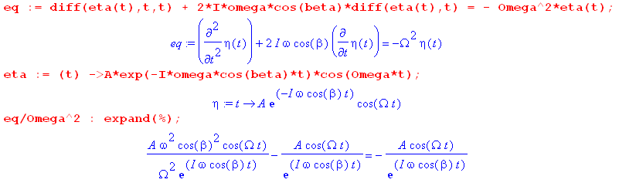
(C.4)
Thus the equation (C.2) is solved by the candidate solution (C.3) to order (ω/Ω)2 and so is a good approximate solution. Writing out x = Reη and y = Imη one finds that y/x = tanφ where

φ = - ωcosβ t = - ωcosβ (C.5)

which indicates a slow clockwise rotation of the swing axis for cosβ > 0 (Northern Hemisphere). This is in agreement with one's knowledge that, in said hemisphere, on each swing the pendulum is deflected a little to the right by the Coriolis force (see Fig (C.2.1) or Fig (C.8.7) below ).

Our treatment below does not assume small oscillation. The pendulum is treated as a full-blown "spherical pendulum" which is influenced by the rotation of the Earth. We derive the pendulum equations of motion first in spherical coordinates in Section C.3, then later in Cartesian coordinates in Section C.6, since these are better for the numerical work of Section C.8. We show in (C.6.14) that equations (C.1) above are in fact the small-oscillation limit of the general equations of motion.

C.1 Drawings, Notation, Coordinates and Basis Vectors

Fig (4.7.1) showed a typical Earth problem kinematic scenario in the "non-swap" notation where Frame S' is the rotating frame. Here, we choose instead to use the "swap" notation where Frame S is the rotating frame, since this eliminates the need for scores of prime symbols which would otherwise clutter the equations. So now Frame S' is at the center of the Earth and is an inertial frame, and Frame S is on the surface of the Earth and is a non-inertial frame. This use of primes is then in accordance with the Marion references discussed in Section 9..
In addition to this S↔S' swap, we make a few other changes compared to Fig (4.7.1).
First, we select the basis vectors en differently. Since we are going to be dealing with a spherical pendulum, we would like the angle between the pendulum string and local vertical to be the polar angle of a spherical coordinate system for Frame S. This means that we want the = e3 axis associated with this spherical system to be pointed toward the center of the Earth, rather than pointing "up". This then suggests that we take = e1 as pointing "north", and = e2 as pointing "east" and then the resulting vectors en form a right-handed coordinate system.
Second, we place the origin of Frame S at a height l above the surface of the Earth, where l is the length of the spherical pendulum's string. Then the length of vector b is b = Re + l, where Re is the radius of the Earth. The Frame S origin is then at the pendulum pivot point.
The new kinematic picture is then,

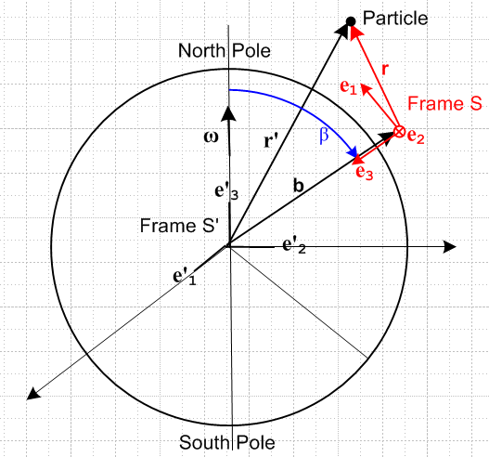 (C.1.1)

The next step is to use spherical coordinates in both Frames S and S'.
For Frame S', with origin at the center of the Earth and assumed fixed relative to distant stars, we select spherical coordinates, so r' = (r',θ',φ'). We shall assume that the origin of Frame S is located at b = (b, β, α) where β is the polar angle measured down from the North Pole (colatitude, range 0 to π), α is the origin's azimuth (longitude), and b = Re+ l where Re is the radius of the Earth and l is the length of the pendulum string (picture coming soon). Parameters α and b will play no role in what follows.
Note that ω = ωe'3 with ω > 0 since the Earth rotates counterclockwise as viewed from above the North Pole, causing the Sun to rise in the east. The same Earth, viewed looking upward from beneath the South Pole, appears to rotate clockwise (and the Sun still rises in the east).
For Frame S (red, shown in the Northern Hemisphere) we select another set of spherical coordinates r = (r,θ,φ) as will be described momentarily.

The Cartesian unit basis vectors en of Frame S can be expressed in terms of the Frame S' spherical unit basis vectors ', ', ' evaluated at the position r' = b = (b, β, α) as follows,

e1 = -' = "north" =
e2 = ' = "east" =
e3 = - ' = "down" = .

According to the picture above, ω = ωe'3 can be expanded on these Frame S basis vectors,

ω = - ωcosβ e3 + ωsinβ e1 . (C.1.2)

As noted, the origin of Frame S is located distance l above the surface of the Earth. If we position ourselves at this origin and gaze down onto the Earth's surface we see what is shown on the left below. A side view is presented on the right, and a 3D view below:

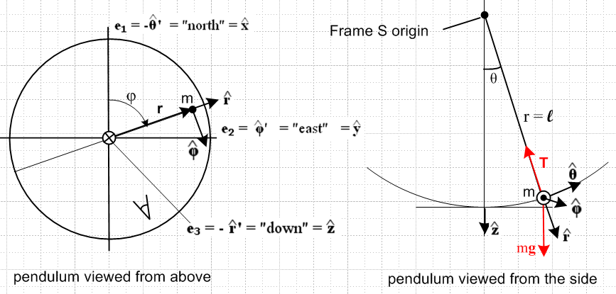

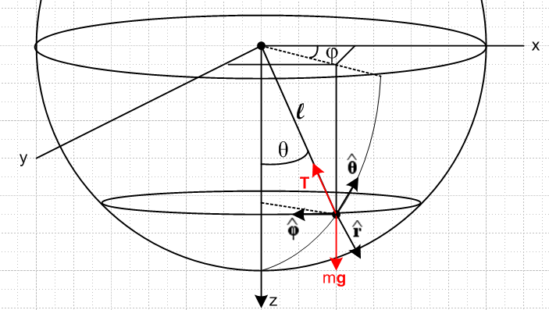 (C.1.3)

The meaning of the Frame S spherical coordinates r,θ,φ should be clear. These are the standard coordinates one would use to study a spherical pendulum in the absence of the Coriolis force.
The Cartesian basis vectors en for Frame S are related to the spherical ones for Frame S as follows (see (A.14c) or (E.2.7)),

e1 = = sinθcosφ + cosθcosφ - sinφ
e2 = = sinθsinφ + cosθsinφ + cosφ
e3 = = cosθ - sinθ . (C.1.4)

C.2 Qualitative Solution

On each swing the pendulum veers "a little to the right" in the Northern Hemisphere due to the Coriolis fictitious force -2m ω x v, so the problem is to compute the time for a full 360 degree rotation. Here we show the first four swings of the pendulum (viewed from above)

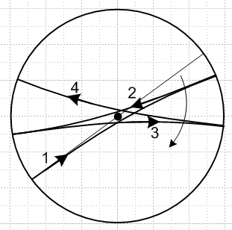 (C.2.1)

The net effect is that the plane of the swinging pendulum precesses clockwise. The amount of veering shown in the drawing is highly exaggerated since we know that when the pendulum is located at the North Pole the period will be one sidereal day ( ≈ 23 hours 56 minutes). If each swing takes 10 seconds, that would be about 24*3600/10 = 8,640 swings for a full revolution, so each swing would show only 360/8640 ≈ .04 degrees of precession. Away from the North Pole we know the precession rate will be even slower, at the equator it will be zero, and in the Southern Hemisphere the pendulum will precess in the opposite direction. These qualitative facts may be deduced from the direction and magnitude of the Coriolis force as discussed in Section 8.3. The general pattern was noted for the small-angle limit of the theory in the solution (C.3).

C.3 Equations of Motion for the Foucault Pendulum (Spherical Coordinates)

In our "swap" notation context, the bogus Newton's law for non-inertial Frame S is,

Feff = ma . (8.1.4)s (C.3.1)

The effective force Feff consists of real forces and fictitious forces. At the end of Section 8.5 in (8.5.7)s we showed that, for surface-of-the-Earth problems (which are Special Case #1), and in the "swap" notation,

Feff = (mg + possible other real forces) – 2m ω x v , (8.5.7)s

where force mg already incorporates the effect of the fictitious centrifugal force. In the spherical Foucault pendulum problem, we have "possible other real forces" = T, the tension of the massless pendulum string pulling on the pendulum of mass m. Thus,

Feff = mg + T – 2m ω x v . (C.3.2)

Although g does not point to the exact center of the Earth, we shall assume that it does, so g = g. The directional error in making this assumption is on the order of Δg/g0 ~ .003 radians (see (8.5.8,9) ) which is insignificant in our analysis of the Foucault pendulum. The error is probably even less than this when one considers that the Earth's surface is perpendicular to g and not g0, but we don't want to get involved with such fine details. Using g = g in (C.3.2) and using the latter in (C.3.1) we find

ma = mg + T – 2m ω x v (C.3.3)

which is our vector "equation of motion" for the pendulum. Our task now is to evaluate the terms in (C.3.3) and then to balance the components on both sides to come up with three scalar equations of motion.

The ω vector (C.1.2) can be expanded, using (C.1.4) for e3 and e1,

ω = - ωcosβ e3 + ωsinβ e1

= - ωcosβ[cosθ - sinθ ] + ωsinβ[cosφsinθ + cosφcosθ - sinφ ]

= ω(-cosβcosθ + sinβcosφsinθ) + ω(cosβsinθ + sinβcosφcosθ ) + ω(-sinβ sinφ) . (C.3.4)
The string tension vector may be written as follows, where T > 0,

T = - T . (C.3.5)

If one wants to consider unusual initial conditions for the pendulum which would cause negative string tension, such as starting it at position r = - l with some tiny velocity, one can imagine the string to be replaced with a massless rigid stick of length l. Such a stick pendulum then works for either sign of tension T and then matches the equations of motion.

It remains to find expressions for v and a expanded on the spherical unit vectors. These are developed in (E.2.11) from which we quote:

(d/dt)S = = + sinθ
(d/dt)S = = - + cosθ
(d/dt)S = = - sinθ - cosθ . (E.2.11) (C.3.6)

Using (E.3.6) for acceleration a one then has,

r = l
v = = l = l [ + sinθ ]
a = = l (- 2- sin2θ 2) + l ( - sinθcosθ 2) + l ( 2cosθ + sinθ ) (C.3.7)

so we now have a viable v and a to use in (C.3.3). The Coriolis cross product can now be computed from (C.3.4) and (C.3.7),

ω x v =
[ω(-cosβ cosθ + sinβcosφsinθ) + ω(cosβ sinθ + sinβ cosφcosθ ) + ω(-sinβ sinφ) ]
x [l [ + sinθ ]
or
ω x v /(ωl) = (-cosβcosθ + sinβcosφsinθ) x [ + sinθ ]
+ (cosβsinθ + sinβ cosφcosθ ) x [ + sinθ ]
+ (-sinβsinφ) x [ + sinθ ]

= (-cosβcosθ + sinβcosφsinθ) [ - sinθ ] // see (E.2.12)
+ (cosβsinθ + sinβcosφcosθ ) [sinθ ]
+ (-sinβ sinφ) [- ]

= [(cosβsinθ + sinβcosφcosθ )sinθ + sinβ sinφ ]
– [(-cosβcosθ + sinβcosφsinθ)sinθ ]
+ [(-cosβcosθ + sinβcosφsinθ) ] . (C.3.8)

We can now assemble the pieces from (C.1.4), (C.3.5), (C.3.7) and (C.3.8) to write the equation of motion (C.3.3) divided by m,

a = g + T/m – 2 ω x v , (C.3.3)
as
l(- 2- sin2θ 2) + l( - sinθcosθ 2) + l( 2cosθ + sinθ )
= g(cosθ - sinθ ) - (T/m)
– 2ωl [(cosβsinθ + sinβcosφcosθ )sinθ + sinβ sinφ ]
+ 2ωl [(-cosβcosθ + sinβcosφsinθ)sinθ ]
– 2ωl [(-cosβcosθ + sinβcosφsinθ) ] .

Matching components gives these three scalar equations of motion (the unit vectors on the right are just reminders of the origin of the equations),

l(- 2- sin2θ 2) = gcosθ – (T/m) – 2ωl [(cosβsinθ + sinβcosφcosθ )sinθ + sinβsinφ ]
l( - sinθcosθ 2) = - g sinθ + 2ωl [(-cosβcosθ + sinβcosφsinθ)sinθ ]
l( 2cosθ + sinθ ) = – 2ωl [(-cosβcosθ + sinβcosφsinθ) ]

which we can simplify slightly to get

2 + sin2θ 2 = -(g/l)cosθ + T/(ml) + 2ω [(cosβsinθ + sinβcosφcosθ )sinθ + sinβsinφ ]
- sinθcosθ 2 = - (g/l) sinθ - 2ωsinθ (cosβcosθ - sinβcosφsinθ)
2cosθ + sinθ = 2ω (cosβcosθ - sinβcosφsinθ) . (C.3.9)

These are the equations of motion for a spherical pendulum operating on the rotating Earth with no approximations other than the modest ones that g does not vary over the small distance l and that g = g. Of course there is no air friction and the string is massless and lossless where it attaches.

Reader Exercise: Can equations (C.3.9) be obtained from the conventional Lagrangian or Hamiltonian formalisms? Are these approaches valid in non-inertial frames, or are modifications needed?

C.4 The Simple Pendulum

In this section we temporarily turn off the rotation of the Earth to study the behavior of the pendulum without that complication. Setting ω = 0 in (C.3.9) the pendulum equations of motion become

2 + sin2θ 2 = -(g/l)cosθ + T/(ml)
- sinθcosθ 2 = - (g/l)sinθ
2cosθ + sinθ = 0 . (C.4.1)

We now seek a solution of (C.4.1) for which = 0. In this case the last equation requires = 0 and we are left with just two equations,

2 = -(g/l)cosθ + T/(ml)
= - (g/l)sinθ . (C.4.2)

These equations describe a pendulum that seems to swing in the plane φ = constant and so this is an example of a plane pendulum, also known as a simple pendulum. One can solve the second equation for θ(t), and then the first equation gives the tension T(t).
If the pendulum is started at some polar angle θ0 and released perfectly so φ = φ0 and = 0, the pendulum swings in a plane, but as it swings through θ = 0 the coordinate φ = φ0 discontinuously jumps to φ = φ0+π, so there is a continuity issue for φ at θ = 0. We could treat this technically using Heaviside and delta functions, but shall not go down that road. It is a simple fact that, for spherical coordinates, points on the z-axis where θ = 0 have an undefined value of φ.

For small angles θ, one finds for the above initial condition that

+(g/l)θ = 0 ⇒ θ(t) = θ0cos(Ωt) Ω ≡ $\sqrt{g/l}$ {θ(0) = θ0, (0) = 0} (C.4.3)

On the other hand, if the pendulum is initialized with θ = 0 and some velocity sufficient to take it up to a maximum angle θ0 we get

+(g/l)θ = 0 ⇒ θ(t) = θ0sin(Ωt) Ω ≡ $\sqrt{g/l}$ {θ(0) = 0, θmax = θ0 } (C.4.4)

Exact Solution for the Simple Pendulum

We provide this detailed solution because it generally does not appear in textbooks.

For larger θ0 the simple pendulum equation + (g/l)sinθ = 0 falls into a class of second order non-linear ODE's which have the form = f(x) where means ∂t2x and we seek x(t). The solution is not hard to obtain, as we now outline. The first step is to define v ≡ :

v ≡ ⇒ = (dv/dt) = (dv/dx)(dx/dt) = (dv/dx)v ⇒ (dv/dx)v = f(x)

⇒ vdv = f(x)dx ⇒ (v2/2) = $^{\int_{}^{x}{}}$f(x')dx' + C

⇒ (dx/dt) = $\sqrt{2}$ ⇒ dt = $\sqrt{2}$ $^{\int_{}^{x}{}}$

⇒ t(x) = ( $\sqrt{2}$$^{\int_{}^{x}{}}$ $^{\int_{}^{x"}{}}$) + C' (C.4.5)

where integration constants C and C' are determined by initial conditions. This solution gives t = t(x) which one must then "invert" to obtain x = x(t).

If we take f(x) = - Ω2sinx and then x→ θ the (v2/2) result of (C.4.5) becomes

(2/2) = $^{\int_{}^{θ}{}}$f(θ')dθ' + C = - Ω2$^{\int_{}^{θ}{}}$sin(θ')dθ' + C = Ω2cosθ + C . (C.4.6)

We set the zero of potential energy for the pendulum at the bottom, θ = 0. At angle θ the pendulum has risen a height h = l - lcosθ so the potential energy at θ is then V = mgh = mgl(1-cosθ).
We shall now apply the boundary conditions of (C.4.4). At t = 0 the pendulum is at θ = 0 and we give it a kick in the +θ direction with some initial velocity l(0). We assume that this causes the pendulum to rise up to some max angle θ0 < π. A too-large kick results in over-the-top behavior which we exclude.
At t = 0 the total pendulum energy is (1/2)m[ l(0)]2 .
At the top of the swing the total energy is mgl(1-cosθ0). Therefore from energy conservation,

(1/2)m[ l(0)]2 = mgl(1-cosθ0)
or
(1/2)[ (0)]2 = (g/l)(1-cosθ0) = Ω2(1-cosθ0)
so
(0) = $\sqrt{2}$Ω $\sqrt{1-cosθ0}$= 2Ωsin(θ0/2) . (C.4.7)

Evaluating (C.4.6) at t = 0 gives

(1/2)[ (0)]2 = Ω2cos(0) + C = Ω2 + C .

Comparing this last equation with the middle line of (C.4.7) gives,

C = -Ω2cosθ0 . (C.4.8)

From (C.4.5) the solution for t(θ) is then

⇒ t(θ) = ( $\sqrt{2}$$^{\int_{}^{θ}{}}$ $^{\int_{}^{θ"}{}}$) + C' = ( $\sqrt{2}$$^{\int_{}^{θ}{}}$ $\sqrt{Ω2cosθ" + C}$) + C'

= ( $\sqrt{2}$$^{\int_{}^{θ}{}}$ $\sqrt{cosθ" - cosθ0}$) + C' (C.4.9)

The integral of interest appears on page 179 of GR7 as 2.571.4 (where we shall use the second form),

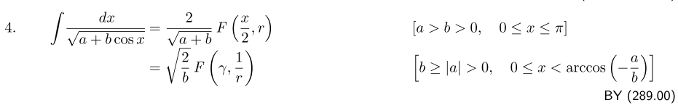
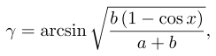 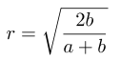 (C.4.10)

and where F(φ,k) is "the elliptic integral of the first kind". In our case b = 1 and a = -cosθ0 so

r = $\frac{2}{a+1}$= $\frac{2}{1-cosθ0}$ = $\frac{1}{sin(θ0/2)}$

γ = sin-1[ $\frac{1-cosθ}{1-cosθ0}$ ] = sin-1 [ $\frac{sin(θ/2)}{sin(θ0/2)}$] . (C.4.11)

Using integral evaluation (C.4.10) in (C.4.9) one finds that,

t(θ) = $\frac{1}{Ω}$ F( sin-1 [ $\frac{sin(θ/2)}{sin(θ0/2)}$], sin(θ0/2) ) + C'

= $\frac{1}{Ω}$ F(φ, k) + C' where φ = sin-1 [ $\frac{sin(θ/2)}{k}$] , k = sin(θ0/2) . (C.4.12)

The function F is defined in GR7 page 860 as 8.111.2,

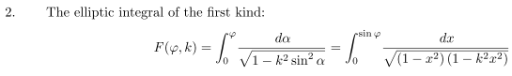 (C.4.13)
from which we see that F(0,k) = 0. Recall our boundary condition that θ(0) = 0 with some (0) > 0. From (C.4.12) we find at t = 0 and θ = 0 that

0 = $\frac{1}{Ω}$ F(0, k) + C' = 0 + C' ⇒ C' = 0 . (C.4.14)

Our final solution before inversion is then

t(θ) = $\frac{1}{Ω}$ F(φ, k) where φ = sin-1 [ $\frac{sin(θ/2)}{k}$] , k = sin(θ0/2), Ω ≡ $\sqrt{g/l}$ . (C.4.15)

The Jacobi elliptic function sn(u) is usually defined in this rather obscure manner,

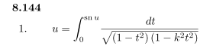 (C.4.16)

If one writes sn(u) = sin(φ), then the right sides of (C.4.13) and (C.4.16) are the same, so

F(φ,k) = u = sn-1(sinφ) or sn(F(φ,k)) = sinφ . (C.4.17)

We now apply this last equation to (C.4.15) as follows:

sn(F(φ,k)) = sinφ
or
sn(Ωt) = sin { sin-1 [ $\frac{sin(θ/2)}{k}$] } = $\frac{sin(θ/2)}{k}$
so
sin(θ/2) = k sn(Ωt) k = sin(θ0/2)
and
θ(t) = 2 sin-1( k sn(Ωt) ) k = sin(θ0/2) (C.4.18)

and the inversion of (C.4.15) is now complete. Following the convention of GR7, since sn(u) has an implicit parameter k, we make it explicit by writing sin(u) = sin(u,k) and then our solution is

sin(θ/2) = k sn(Ωt,k) k = sin(θ0/2)
θ(t) = 2 sin-1( k sn(Ωt,k) ) k = sin(θ0/2) (C.4.19)
or

sin(θ/2) = sin(θ0/2) sn(Ωt, sin(θ0/2)) // boundary conditions below ⇒ θmax = θ0
θ(t) = 2 sin-1[ sin(θ0/2) sn(Ωt, sin(θ0/2)) ] for θ(0) = 0, (0) = 2Ωsin(θ0/2) . (C.4.20)

When k is not too large, one has sn(x,k) ≈ sin(x). If θ0 is small, then so is θ and the first line of (C.4.20) reads,

θ/2 ≈ (θ0/2) sin(Ωt) ⇒ θ(t) = θ0 sin(Ωt) (C.4.21)

which is the correct small-angle solution for θ(0) = 0 and max angle θ0 as was stated in (C.4.4).

Here is a Maple plot of θ(t) from (C.4.20) with a selection of peak angles θ0 with Ω = 1 so that the small-angle period is T = 2π/Ω = 2π :

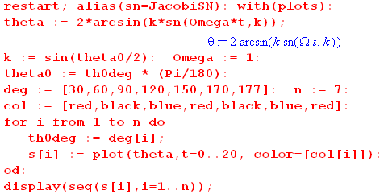

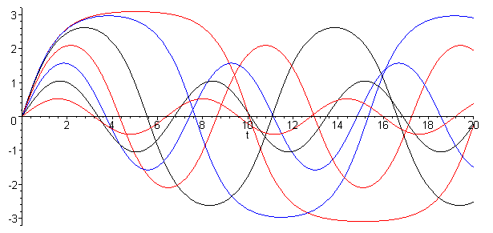 (C.4.22)

For small θ0 the function θ(t) is very sine-like with period T = 2π, but for larger θ0 the period increases and the top flattens out. For θ0 = 177o the top is quite flat, indicating a long "hang time" when the pendulum (on its rigid massless stick) lingers in the near-vertical position.

The complete elliptic integral of the first kind is defined by (some sources write K as K),

K(k) ≡ F(π/2,k) = $^{\int_{0}^{π/2}{}}$$\sqrt{1-k2sin2α}$ // see (C.4.13), and note K(0) = π/2 (C.4.23)

Since sn(u) = sin(φ) as shown above (C.4.17), we know that the peak value of sn(u) is 1 and this occurs one quarter of a wave into the sn(u) waveform. From (C.4.17) we know that

sn(F(φ,k)) = sinφ ⇒ sn(F(π/2,k)) = 1 ⇒ sn(K(k)) = 1 (C.4.24)

Thus, a quarter period of the function sn(u,k) along the real u axis is just K(k) and so the full period is then T = 4K(k). Here is a plot of 4K(k) showing how it increases from 2π to larger values slowly approaching the limit 4K(∞) = ∞ :

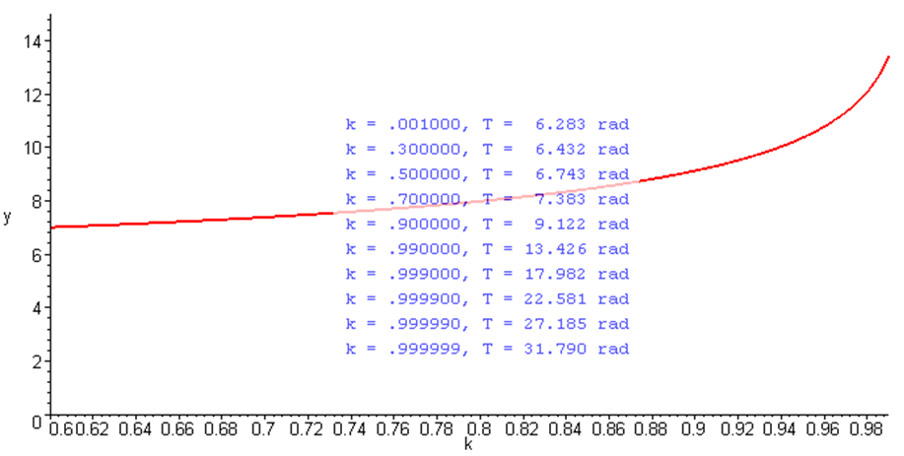 (C.4.25)

Since a quarter period of sn(x,k) is K(k), a quarter period of sn(Ωt,k) is then K(k)/Ω. For the more standard boundary conditions shown in (C.4.3) where θ(0) = θ0 and .(0) = 0, the solution is obtained by shifting (C.4.20) ahead by a quarter period, which means taking t → t + K(k)/Ω or Ωt → Ωt + K(k) . The result is then, with k = sin(θ0/2),

sin(θ/2) = sin(θ0/2) sn(Ωt + K(sin(θ0/2)), sin(θ0/2))
θ(t) = 2 sin-1[ sin(θ0/2) sn(Ωt + K(sin(θ0/2)), sin(θ0/2)) ] θ(0) = θ0 , (0) = 0 . (C.4.26)

Now for small angles the first line gives

θ/2 ≈ θ0/2 sin(Ωt+π/2) = θ0/2 cos(Ωt) ⇒ θ(t) = θ0 cos(Ωt) (C.4.27)

in agreement with (C.4.3)

Conventions: We have adopted the notation for K(k) and sn(u,k) which is used by the 2010 NIST Handbook of Mathematical Functions, by Gradshteyn and Ryzhik 7th edition (2007), and by the Bateman Manuscript Project (1953), though the last two sources write K as K. The reader is warned that there is another common convention which appears in the precursor to the NIST Handbook, namely the heavily-used 1964 Handbook of Mathematical Functions of Abramowitz and Segun (AS). The connection is this

K(k) = KAS(k2) // k2 = m
sn(u,k) = snAS(u,k2) = sn(u | k2) // sometimes = sn(u; k2) (C.4.28)

In using these functions one must be very careful to learn the convention used by a given source. For example, our ancient Maple V states that (notice the k2 in the integral but k in the argument),

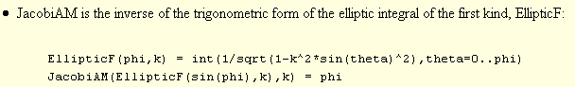

// am(z,k) = sin-1sn(z,k)

So this version of Maple is using our "modern" NIST 2010 notation for argument k.

C.5 The Spherical and Foucault Pendulums

Having studied the simple pendulum, we now return the more general spherical pendulum and at the end we look at the Foucault mode of this pendulum. Since there are many short subsections below, here is a list of their headings:

(a) The equations of motion for the Spherical Pendulum
(b) Lz as constant of the motion
(c) E as another constant of the motion
(d) Exact solution to the Spherical Pendulum (outline)
(e) The nature of the general solution for the Spherical Pendulum
(f) The Conical Motion solution of the Spherical Pendulum
(g) The thin ellipse scenario for the Spherical Pendulum
(h) The Intrinsic Airy Precession of the Spherical Pendulum
(i) The Foucault Mode of the Spherical Pendulum
(j) Interference between the Airy and Foucault precession
(k) The Foucault Pendulum at the Pantheon in Paris
(l) General Numerical solutions of the Spherical Pendulum

The French name Foucault is pronounced foo-ko' with accent on the ko (sounds like so).

(a) The equations of motion for the Spherical Pendulum

As before, we turn off the rotation of the Earth by setting ω = 0, so equations (C.3.9) become

2 + sin2θ 2 = -(g/l)cosθ + T/(ml)
- sinθcosθ 2 = - (g/l)sinθ
2cosθ + sinθ = 0 . (C.5.1)

These are the equations of motion for a spherical pendulum in the presence of a uniform gravitational field of strength g. It is useful to know something about the solution of these equations before we turn the Earth's rotation back on.
Operationally, in the sense of a numerical solution, one can regard the last two equations of (C.5.1) as a pair of coupled second-order non-linear ODE's for functions θ(t) and φ(t) subject to initial conditions θ0, φ0, 0 and 0. Once these equations are solved (physically we know a unique solution must exist), the first equation may be used to determine T(t), the string tension.

(b) Lz as constant of the motion

The last equation in (C.5.1) may be written in this form

d/dt ( sin2θ ) = 0 (C.5.2)

which says that sin2θ must be a "constant of the motion". To understand the meaning of this constant, we first compute the torque about the string pivot point due to the gravitational force on the mass m,

N = r x mg = r x mg = mgl x [cosθ - sinθ ] = -mgl sinθ . (C.5.3)

Since this torque lies in a plane normal to the z axis, as in (C.1.3), we may conclude that the Cartesian torque component Nz = 0. The angular version of Newton's Law says N = dL/dt , and therefore we expect that the quantity Lz will be a constant of the motion. Direct calculation shows that

Lz = L • = m (r x v) • = m ( x r) • v = m lsinθ • (l [ + sinθ ])
= ml2sin2θ (C.5.4)

where we have made use of (C.1.4) for and (C.3.7) for v. Thus, we see that our third equation of motion in (C.5.1), rewritten as in (C.5.2), is just the statement that dLz/dt = 0. In the Lagrangian formulation one finds that Lz is one of the canonical momenta which is constant because φ is a cyclic coordinate, meaning it does not appear in the Lagrangian (see Comment below).
In terms of the spherical unit vectors, one finds (again using (C.3.7) for v) that the vector angular momentum of the pendulum mass is given by

L = m r x v = ml2 [ - sinθ ] . (C.5.5)

Then application of N = dL/dt, with N as in (C.5.3) and unit-vector change rates as in (C.3.6), simply reproduces the last two equations of motion in (C.5.1).
So we conclude that :

h ≡ Lz/(ml2) = sin2θ (C.5.6)

is a constant of the motion of the spherical pendulum.

Comment: In Lagrangian dynamics one has L = KE-PE = (1/2)mv2+mlcosθ with v2 = l2(2+ sin2θ2).
The Euler Lagrange equations dt(∂L/∂) = (∂L/∂θ) and dt(∂L/∂) = (∂L/∂φ) produce the last two equations of (C.5.1). Since φ is cyclic (does not appear in L) the second equation says dt(∂L/∂) = 0 which says dtLz = 0. The first equation in (C.5.1) does not appear since it is an equation of constraint.

(c) E as another constant of the motion

We have shown in (C.5.6) that = h/sin2θ. If this is substituted into the second equation of (C.5.1) one obtains

- h2cosθ /sin3θ + (g/l)sinθ = 0 (C.5.7)

and we just put this equation on hold for a moment, noting that it is a second-order non-linear ODE.

Another constant of the motion is the total energy E which may be regarded as E = T + V = kinetic energy + potential energy (here the zero point of potential is put at the pendulum pivot point),

E = (1/2)mv2 - mglcosθ = (1/2) m l2(2+ sin2θ2) – mglcosθ (C.5.8)

where v2 = l2(2+ sin2θ 2) according to (C.3.7) for v. By rescaling the energy, we can take this constant of the motion to be (note that E and E could have either sign),

E = 2/2 + sin2θ2/2 – (g/l)cosθ where E = m l2E . (C.5.9)

Using (C.5.6) to eliminate gives,

E = 2/2 + (h2/2sin2θ) – (g/l)cosθ
or (C.5.10)
E = 2/2 + Ve(θ) where Ve(θ) ≡ (h2/2sin2θ) – (g/l)cosθ .

Unlike (C.5.7), equation (C.5.10) is a first-order ODE so we prefer it to (C.5.7). In fact, if one multiplies (C.5.7) by and notes that = (1/2) ∂t(2) and does a few easy integrals, one obtains an equation of the form ∂t[stuff] = 0 so then stuff = constant. That "stuff" is the right side of (C.5.10) and we have then provided an interpretation for the constant (energy) [ is an "integrating factor" for (C.5.7) ].

(d) Exact solution to the Spherical Pendulum (outline)

Equation (C.5.10) is a first order non-linear ODE for θ(t) which we know how to solve:

= (2E - 2Ve(θ) )1/2 => dθ = (2E - 2Ve(θ) )1/2dt

=> dt = (2E - 2Ve(θ) )-1/2 dθ
boundary condition
=> t(θ) = $^{\int_{θ0}^{θ}{}}$dθ' $\sqrt{2E - (h2/sin2θ') + (2g/l)cosθ'}$ . // t(θ0) = 0 so θ(0) = θ0 (C.5.11)

Letting z' = cosθ', so dz' = -sinθ' dθ' = - $\sqrt{1-z'2}$dθ' one finds

$\sqrt{2E - (h2/sin2θ') + (2g/l)cosθ'}$ = - $\sqrt{1-z'2}$ $\sqrt{2E - (h2/[1-z'2]) + (2g/l)z'}$

= - $\sqrt{2E [1-z'2] - h2 – (2g/l)z'[1-z'2]}$ = - $\sqrt{2E -2Ez'2 - h2 – (2g/l)z'+ (2g/l) z'3]}$

= - $\sqrt{(2g/l) [ z'3 - (El/g) z'2 - z' + (l/g) (E- h2/2) ]}$ . (C.5.12)

Therefore

t(θ) = $^{\int_{z}^{z0}{}}$dz' $\sqrt{(2g/l) [ z'3 - (El/g) z'2 - z' + (l/g) (E- h2/2) ]}$ // z = cosθ, z0 = cosθ0

= $\sqrt{l/(2g)}$$^{\int_{z}^{z0}{}}$dx $\sqrt{(x-a)(x-b)(x-c)}$ (C.5.13)

where a,b,c are the roots of the cubic equation x3 - (El/g) x2 - x + (l/g) (E-h2/2 ) = 0. The dimensionless integral appearing on the last line can be evaluated in closed form using this indefinite integral,

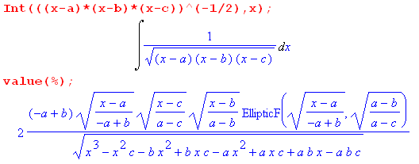 . (C.5.14)

Here EllipticF is the incomplete elliptic integral of the first kind as was defined in (C.4.13) and (C.4.17),

EllipticF(sin(φ),k) = $^{\int_{0}^{sin(φ)}{}}$dt $\sqrt{(1-t2)(1-k2t2)}$ = F(φ,k) = sn-1(sinφ,k) . (C.5.15)

There are standard (albeit complicated) formulas for the roots of a cubic. Therefore, we have a closed form result for t(θ) which can then be "inverted" to obtain a solution for θ(t). Then from (C.5.6) we get

= h/sin2(θ(t)) => φ(t) = φ0 + h $^{\int_{0}^{t}{}}$dt' /sin2(θ(t')) (C.5.16)

and the problem of the spherical pendulum is completely solved more or less in closed form. The string tension is then determined by the first equation in (C.5.1). The solution θ(t) is a function of θ0, l, g, m and the two constants of the motion E = ml2E and Lz = ml2h. Somehow it must describe both low-amplitude pendulum motions (E < 0) as well as violent high-speed over-the-top maneuvers (large E > 0).

(e) The nature of the general solution for the Spherical Pendulum

Recall (C.5.10) where E is the total scaled energy for the pendulum mass,

E = 2/2 + Ve(θ) where Ve(θ) ≡ (h2/2sin2θ) – (g/l)cosθ . (C.5.10)

The "effective potential" Ve(θ) has the following shape (plotted here for h2/2 = .3 and (g/l) = 1)

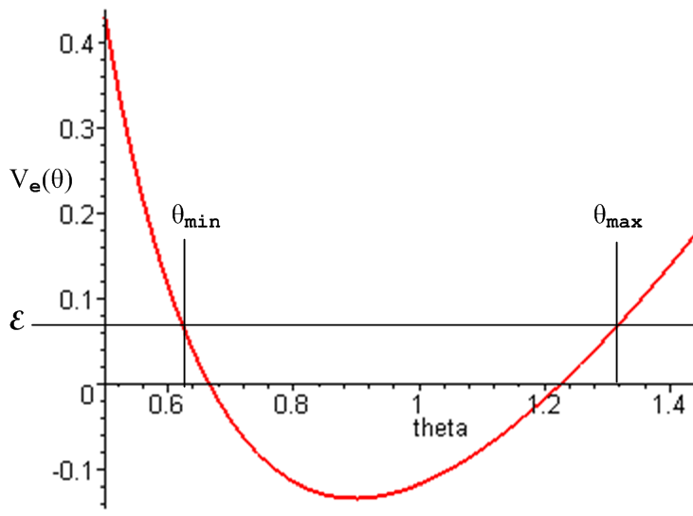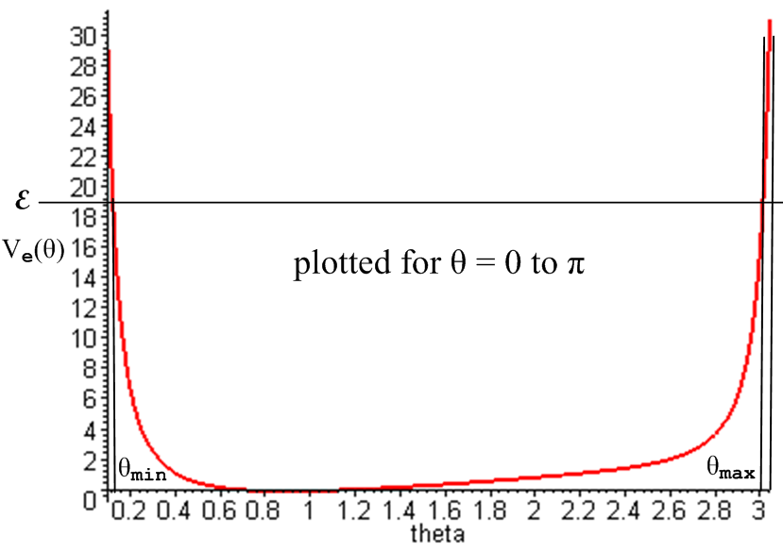

(C.5.17)

Since 2/2 = (E - Ve(θ)) must be positive, one must have Ve(θ) ≤ E which is valid only between θmin and θmax as shown. These are the "turning points" where = 0. Differentiation of (C.5.10) tells us that,

0 = + Ve'(θ) // Ve'(θ) ≡ dVe(θ)/dθ = slope of Ve(θ)
or
= – Ve'(θ) . (C.5.18)

At the right turning point the slope Ve'(θ) is positive so < 0 which accelerates the particle to the left. At the left turning point the slope Ve'(θ) is negative so > 0 which accelerates the particle to the right. The particle therefore bounces back and forth between these two turning points in some manner. Thus the motion of the pendulum is constrained on the spherical surface r = l between two horizontal circles of angles θmin and θmax and hits both these angles once per "oscillation".
Meanwhile, from (C.5.16) the action in the φ dimension of the problem is controlled by

= h/sin2(θ(t)) => φ(t) = φ0 + h $^{\int_{0}^{t}{}}$dt' /sin2(θ(t')) (C.5.16) (C.5.19)

so as θ(t) does the oscillation just discussed between θmin and θmax, φ(t) increases as shown in its own complicated functional manner.
A quick tour of web animations of the spherical pendulum shows the amazing complexity of the possible motions. If the string is replaced with a massless stiff rod, over-the-top motions are included. Some examples (search youtube if these are dead links) :

http://www.youtube.com/watch?v=6hCLkTENfSA .
http://www.youtube.com/watch?v=VS1dU5HpfOM&feature=relmfu

Both animations demonstrate the θmin ≤ θ ≤ θmax idea, though it takes a while to see in the first animation.

(f) The Conical Motion solution of the Spherical Pendulum

The spherical pendulum has an obvious simple solution where θ = θ0 = constant, so the string motion traces out a cone. In this case the equations of motion (C.5.1) become

sin2θ0 2 = -(g/l) cosθ0 + T/(ml)
cosθ0 2 = (g/l)
= 0 . (C.5.20)

The second equation says ωφ ≡ = $\sqrt{(g/l)secθ0}$. Since this is a constant, the third equation is satisfied as well, and then the first says T = mg secθ0. In the small angle limit for θ0, ωφ slows down to its smallest possible value ωφ ≡ $\sqrt{g/l}$ = Ω which is the frequency of a small-angle plane pendulum. Conversely, as we try to achieve θ0 → π/2, secθ0→ ∞ and both ωφ and tension T become infinite, which seems pretty reasonable. This solution can of course be obtained by elementary methods as well.

Reader Exercise: For the conical motion solution, = 0 so E = Ve(θ) in (C.5.10). How does this fit in with Fig (C.5.17)? Is the pendulum stuck at a turning point? Are there two conical solutions for any given energy E ? Can one have a small conical motion with θ near π ( string = stick)?

(g) The thin ellipse scenario for the Spherical Pendulum

We now return to the general spherical pendulum equations

2 + sin2θ 2 = -(g/l)cosθ + T/(ml)
- sinθcosθ 2 = - (g/l)sinθ
2cosθ + sinθ = 0 . (C.5.1) (C.5.21)

In the plane pendulum analysis of Section C.4 we set = 0 to simplify these equations. However, once the plane swing path is opened even slightly into a thin elliptical path, the φ(t) function becomes just as active as the θ(t) function. For such a thin ellipse, θ bounces between the θmax and θmin turning points and θmin will be very small. Roughly speaking, for each full elliptical swing cycle of θ, φ(t) wraps 2π about the origin, so the functions have similar "frequencies". From (C.5.16) the velocity = h/sin2(θ(t)) is very uneven and will have large peaks when θ is near θmin.
It is useful to look at an actual simulation to see the action of the two angle variables. We start by entering the last two equations in (C.5.21) using Ω2 = g/l :

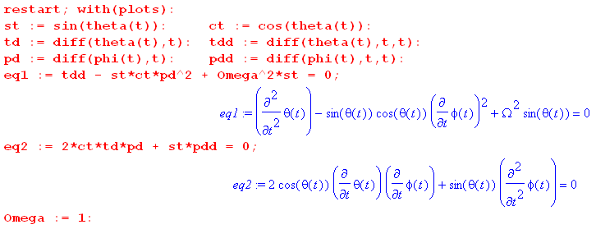 (C.5.22)

Then we set in some initial conditions and create the simulation (numerical solution). Here we start at θ(0) = 90o and some small amount of (0) = 0.4 which results in an ellipse that is thin but not very thin :

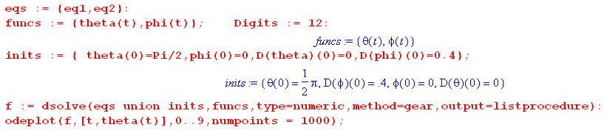
(C.5.23)
Next we extract the four solution functions of interest which are θ(t),φ(t),(t) and (t) [ see our Maple User's Guide ] ,

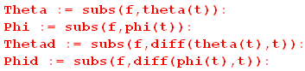 (C.5.24)

We are now ready to make plots:

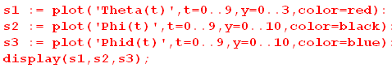

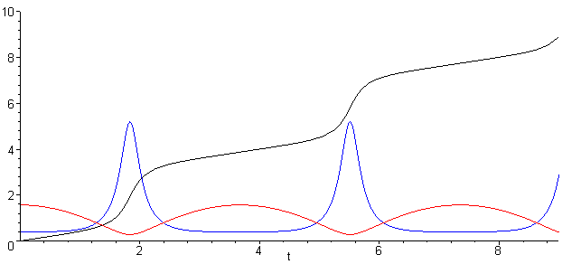 θ = red φ = black = blue (C.5.25)

We see in red the expected θ(t) bouncing between θmax= π/2 and θmin ≈ 0.3. The blue (t) has peaks when θ is small, as noted above. The black φ just winds around to ever-increasing φ as the pendulum bob goes in its elliptical path (not an exact ellipse).
We conjecture that for a thin elliptical orbit, the behavior of the pendulum for small or large θmax is very similar to what we saw for the plane pendulum in Section C.4. In particular if we set θmax very close to π, we expect to see the top of the red θ curve become flat, corresponding to the long hang time mentioned in that Section. Here we set θmax = 0.995*π :

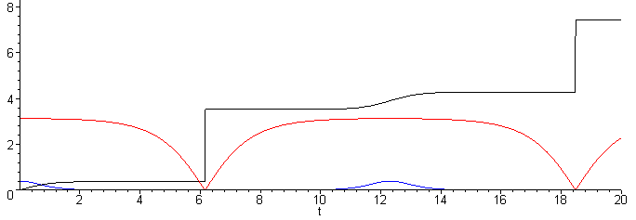
θ = red φ = black = blue (C.5.26)

The period of the θ motion is correspondingly increased.
We have no similar conjecture to make about the φ(t) behavior of the pendulum!

(h) The Intrinsic Airy Precession of the Spherical Pendulum

Consider again the two equations of motion.

- sinθcosθ 2 = - Ω2 sinθ
2cosθ + sinθ = 0 . (C.5.21) (C.5.27)

A pair of equivalent equations was noted earlier,

- h2cosθ /sin3θ + Ω2sinθ = 0 (C.5.7)
= h/sin2(θ(t)) (C.5.6) (C.5.28)

With this second pair, one solves the first for θ(t) and uses that in the second to get φ(t).
In all these equations the terms are of similar size, so nothing can be neglected in an attempt to make any approximation for a "thin orbit". For this reason it is difficult to come up with an arm-waving explanation of the fact that the orbit processes due to the relation between the θ and φ behavior. It turns out that, when θmax is not too large, for each period of the θ motion, the azimuth φ wraps around a little less than 2π and this causes the orbit to precess as the pendulum swings (this has nothing to do with Earth rotation which is turned off). Here we demonstrate this effect using θ(0) = 1 radian and doing mod(φ,2π) in the plot of φ:

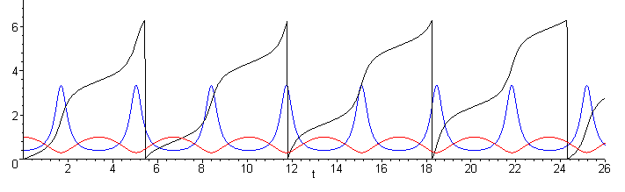
θ = red mod(φ,2π) = black = blue (C.5.29)

The vertical edge of the black φ curve is slipping to the left relative to the red and blue curves.
In his 1851 paper Airy (see Refs.) derived an expression for this "intrinsic apsidal precession rate" of the spherical pendulum doing thin elliptical orbits which our numerical solution above demonstrates. His formula (now called "the Airy precession") is,

ωairy/ωswing = Tswing/Tairy = (3/8)(ab/l2) = (3/8π)(πab/l2) = (3/8π)(A/l2) . (C.5.30)

In this approximate formula, a and b are the semimajor and semiminor axes of the narrow ellipse which is slowly precessing, and l is the length of the string (A = πab is the area of the ellipse). This formula is most accurate for small oscillations and gets less precise for larger ones, requiring correction terms. The orbit precesses in the same direction that the bob rotates around the ellipse (see Fig. (C.8.14) ).
The derivation in Airy's paper is quite involved. An alternate derivation appears in the text of Synge and Griffith, pp 373-381. The result appears on p 381 in the form δφ = (3A/4l2) where δφ is the amount of precession during one full swing of the pendulum. Then it takes N = δφ/2π swings to get 2π of precession and so 1/N = 2π/δφ = (3/8π)(A/l2) in agreement with (C.5.30) above.
We shall return to this precession in the next section and later when we plot orbits in Section C.8.

(i) The Foucault Mode of the Spherical Pendulum

We now turn the Earth's rotation back on and are faced with the full equations of motion from (C.3.9),

2 + sin2θ 2 = -(g/l)cosθ + T/(ml) + 2ω [(cosβsinθ + sinβcosφcosθ )sinθ + sinβsinφ ]
- sinθcosθ 2 = - (g/l) sinθ - 2ωsinθ (cosβcosθ - sinβcosφsinθ)
2cosθ + sinθ = 2ω (cosβcosθ - sinβcosφsinθ) . (C.3.9)

We seek a planar-like solution where ω, and are all very small. It is still true that φ must wind roughly 2π for each θ swing, but most of the time (away from the low point) is very small since the assumed orbit is nearly planar. The equations then reduce to the following,

2 = -(g/l)cosθ + T/(ml) + 2ω [sinβsinφ ]
= - (g/l) sinθ
2cosθ = 2ω (cosβcosθ - sinβcosφsinθ) . (C.5.31)
The second equation is the standard equation for the general-amplitude plane pendulum. This problem was exactly solved in Section C.4 for two different initial conditions. Here is one of those solutions,

θ(t) = 2 sin-1[ sin(θ0/2) sn(Ωt + K(sin(θ0/2)), sin(θ0/2)) ] θ(0) = θ0 (0) = 0 . (C.4.26)

Dividing the third equation of (C.5.31) by 2cosθ gives,

= ω (cosβ - sinβcosφtanθ) . (C.5.32)

For small oscillations (in θ) we drop the second term to get

= ωcosβ (C.5.33)

In our arrangement of the spherical coordinates with pointing down, this indicates a clockwise precession of the pendulum when it is viewed from above, and so is consistent with our initial Foucault calculation (C.5) .

(j) Interference between the Airy and Foucault precession

We have found that for small-angle motion of a spherical pendulum on the Earth's surface (magnitudes),

ωF = 2ω|cosβ| // Foucault precession, ω = rotation rate of the Earth

ωI ≈ Ω(3/8π)(A/l2) // Intrinsic precession, Ω = $\sqrt{g/l}$ = pendulum swing frequency

where ω ≈ Ω = $\sqrt{g/l}$ is the small-angle pendulum frequency. The ratio is then

ωI/ωF = Ω(3/8π)(A/l2) / (2ω|cosβ|) = (3/16π) ($\sqrt{g/l}$/ω) (A/l2) |secβ| // dimensionless

= (3/16π) $\sqrt{g}$A ω-1 l-5/2 |secβ| . (C.5.34)

We would like the intrinsic precession rate to be much less than the Foucault rate so that one can then ignore the intrinsic effect. To make this ratio small, one of course wants to make the ellipse area A as small as possible, one wants to stay away from the Earth's equator where β = π/2 and secβ = ∞, and one wants a large l .
This subject gets a good treatment in Schumacher and Tarbet (2009), where the Airy formula appears as equation (2). These authors propose an electronic device to neutralize the intrinsic precession to allow for a much shorter string on a Foucault pendulum.

(k) The Foucault Pendulum at the Pantheon in Paris

According to Google Maps (notice that London and Paris are only 2.3o separated in longitude),

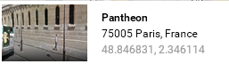

the Pantheon is located at latitude 48.8468 degrees, so β = 90-48.8468= 41.1532 degrees.
The length of the pendulum is purported to be 67 meters which we assume is the exact distance from the pivot point to the center of mass of the swinging weight.
Wiki http://units.wikia.com/wiki/Gravity_of_Earth says g = 9.81 m/sec2 in Paris (Wolfram calc?)
According to https://en.wikipedia.org/wiki/Sidereal_time the Earth's sidereal (relative to the stars) rotation period is 23.9344699 hours.
We now have Maple do a few calculations. First we compute the pendulum period (w used for ω, and the function evalf means "evaluate to a floating point number") :

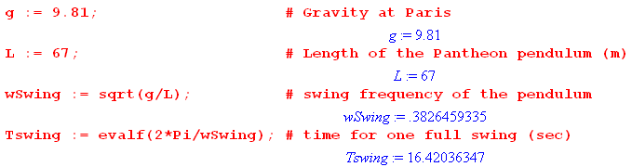 (C.5.35)

The full-cycle period is therefore Tswing = 16.42 seconds. Stopwatch measurements for the first full swing in this video https://www.youtube.com/watch?v=59phxpjaefA were 16.37, 16.38. 16.36 which average to 16.37, pretty close. (One is never sure that video reproduces the exact real time motion.)

Next we compute the Foucault rotation period using ωFouc = ωEarthcosβ from (C.5.33) or (C.5) :

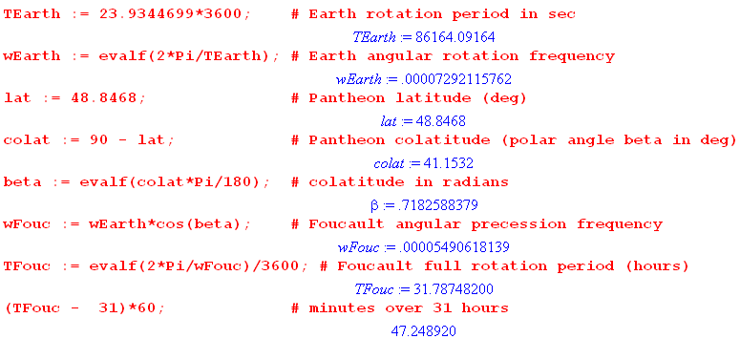
(C.5.36)
The period is then 31.787 hours or 31 hours and 47.2 minutes.
The site https://en.wikipedia.org/wiki/List_of_Foucault_pendulums#France claims 31 hours and 50 minutes, but that is probably a calculated and not a measured value. They say m = 28 kg so this pendulum does not blow around much in the breeze.
Next we estimate the effect of the Airy precession, assuming the swing is about 2 meter long and the ellipse width is 2 cm (hopefully it is smaller than that). The ratio_Airy is taken from (C.5.30)

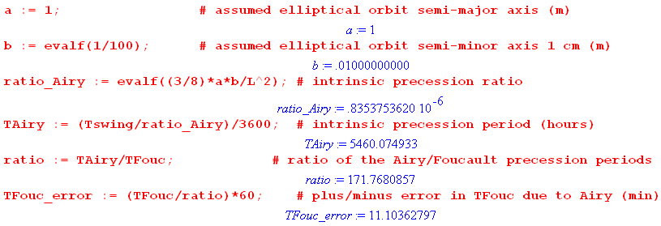
(C.5.37)

Thus suggests that we get one Airy precession for every 171.76 Foucault precessions. The direction of the Airy precession depends on which way the ellipse path is traversed. The error induced in the Foucault period is then about ± 11 minutes, assuming the a and b values shown. One would think that with a careful "burned string" launch of the pendulum, one could get "a" down to maybe 1 mm, which would reduce the 32 hour period error to ± 1 minute.

(l) General Numerical Orbits of the Spherical Pendulum

In Section C.6 below we derive the spherical pendulum equations of motion directly in Cartesian coordinates and then in Section C.8 we plot various pendulum trajectories in Cartesian space. As long as one avoids hitting the singular points θ = 0 and θ = π, one can do this directly from the angular equations of motion as we now show. This method has an advantage over that of Section C.8 in that negative values of z here are allowed, meaning motion of the pendulum bob in the upper hemisphere is permitted.

The spherical pendulum equations of motion are given in (C.5.1),

2 + sin2θ 2 = -(g/l)cosθ + T/(ml)
- sinθcosθ 2 = - (g/l)sinθ
2cosθ + sinθ = 0 . (C.5.1) (C.5.38)

We enter into Maple the last two equations as was shown in (C.5.22), and have dsolve find solutions as in (C.5.23). Here is an example where we give the pendulum a good kick at t = 0,

θ(0) = 0.5 φ(0) = 0 (0) = 1.7 (0) = 1.0 (C.5.39)

We then extract θ(t) and φ(t) and plot them : red θ bounces and black φ winds around,

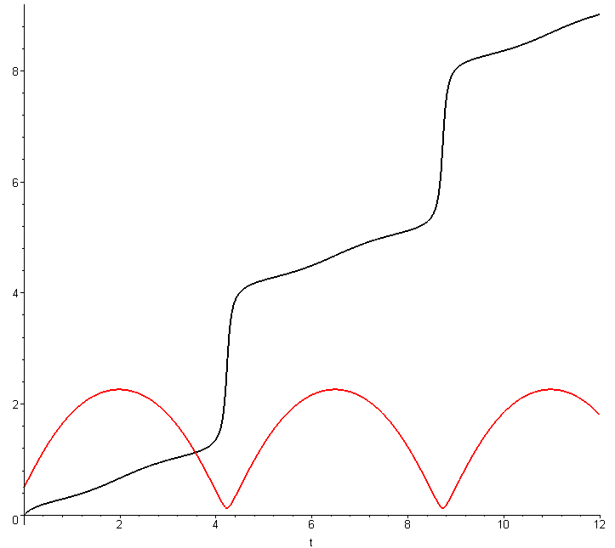
θ(t) = red φ(t) = black (C.5.40)

Alternatively, one can plot the trajectory in (θ,φ) space where θ bounces and φ winds up vertically,

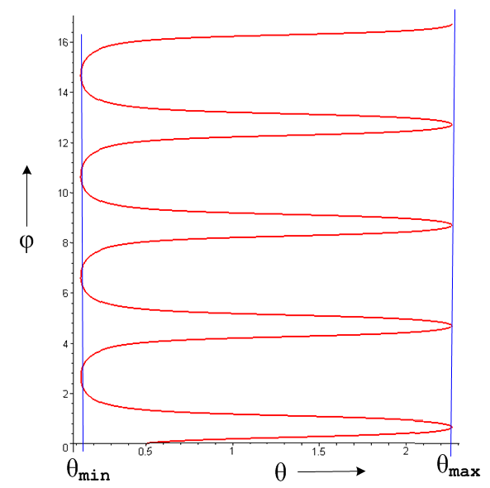 (C.5.41)

We then generate Cartesian coordinates (l = 1),

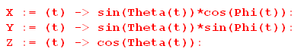 (C.5.42)

and plot the trajectory in these coordinates (recall that points down),

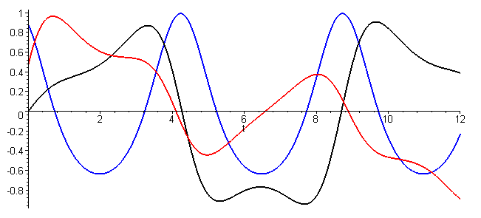 (C.5.43)
x(t) = red y(t) = black z(t) = blue

We can make a 3D plot of the trajectory as follows ( axis points down, up is up)

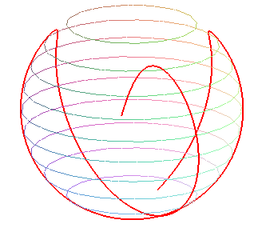 (C.5.44)
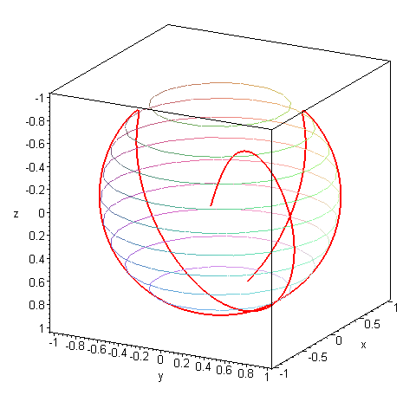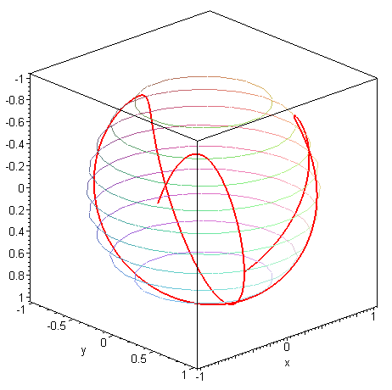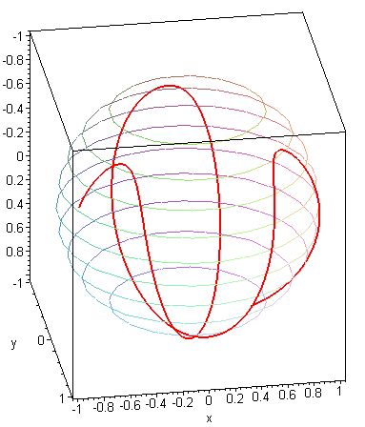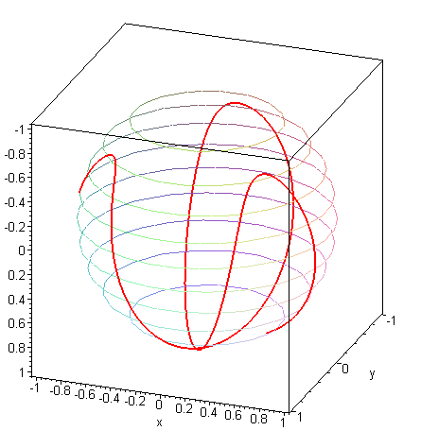

Solving the first equation in (C.5.38) for T, and using m = 1 kg, l = 1 m, and g = 9.8 m/s2, we can plot the string tension for the above trajectory,

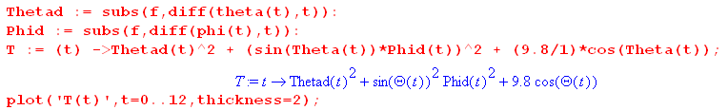

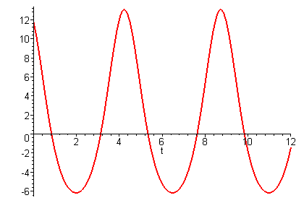 (C.5.45)

Since the string tension goes negative at the three high spots in the motion shown in (C.5.44), the pendulum must have a massless stick in place of a string in order to realize the trajectories of this example.

C.6 Equations of Motion for the Foucault Pendulum (Cartesian Coordinates)

We start with the vector equation (C.3.3), which is Newton's Law in non-inertial Frame S,

ma = mg + T – 2m ω x v . (C.3.3) (C.6.1)

where points down. From (C.1.2) ω can be written

ω = - ωcosβ e3 + ωsinβ e1 = ω[- cosβ + sinβ ] (C.6.2)

so
– 2m ω x v = -2mω [ - cosβ + sinβ ] x [vx + vy + vz ]

= -2mω [ - cosβ(vx - vy) + sinβ(vy - vz) ]

= -2mω [ cosβvy - (cosβvx+ sinβvz) + sinβvy ] . (C.6.3)

From (C.3.5) the string tension is,

T = - T = -(T/l)(x + y + z) . // l = $\sqrt{x2+y2+z2}$ (C.6.4)

The three equations of motion from (C.6.1) are then

max = -(T/l)x - 2mωcosβvy
may = -(T/l)y + 2mω (cosβvx+ sinβvz)
maz = mg - (T/l)z - 2mωsinβvy (C.6.5)
or
= -(T/ml)x - 2ωcosβ
= -(T/ml)y + 2ω (cosβ+ sinβ)
= g -(T/ml)z - 2ωsinβ . (C.6.6)

Eliminate T from the first two equations :

y = -(T/ml)xy - 2ωycosβ
x = -(T/ml)xy + 2ωx(cosβ+ sinβ)

y - x = - 2ωycosβ - 2ωx(cosβ+ sinβ) . (C.6.7)

Do this again for the first and third equations of (C.6.6) :

z = -(T/ml)xz - 2ωzcosβ
x = xg -(T/ml)xz - 2ωxsinβ

z - x = -xg - 2ωzcosβ + 2ωxsinβ . (C.6.8)

We then have these three equations of interest

1 y - x = - 2ωycosβ - 2ωx(cosβ+ sinβ)

2 z - x = - xg - 2ω(zcosβ - xsinβ )

3 x2+y2+z2 = l2 (C.6.9)

where l is the length of the pendulum string. These are the equations of motion for the Foucault pendulum in Cartesian coordinates. We can in theory solve for x(t), y(t) and z(t) given some initial conditions. Once the three equations are solved, we can find the tension T(t) from (say) the first equation of (C.6.6) :

= -(T/ml)x - 2ωcosβ ⇒ (T/ml)x = - 2ωcosβ - ⇒

T = - ml(2ωcosβ + )/x . (C.6.10)

Small oscillation limit

For very small pendulum swings one has

T ≈ mg ⇒ T/ml ≈ (g/l)
and are small
≈ 0 (C.6.11)

In zeroth order the first two equations of (C.6.6) then say (r = l = length of string)

+ (g/l)x ≈ 0
+ (g/l)y ≈ 0 ⇒ Ω = $\sqrt{g/l}$ (C.6.12)

and the pendulum swings as x.y ~ sin(Ωt) with Ω = $\sqrt{g/l}$. To first order we add back the small velocity terms in (C.6.6) to get

+ Ω2x + 2ωcosβ ≈ 0
+ Ω2y - 2ωcosβ ≈ 0 . // bottom view (C.6.13)

In our system points down, but if it were to point up we could take x→x and y→ -y as coordinates one would use when viewing the pendulum from above. The equations are then

+ Ω2x - 2ωcosβ ≈ 0
+ Ω2y + 2ωcosβ ≈ 0 // top view (C.6.14)

These equations appear in (C.1).

C.7 Verification of the Cartesian equations of motion and string tension

The algebra above is quite complex so we want to be sure that our Cartesian equations of motion are correct. First, here are the last two angular equations of motion from (C.3.9) with l set to r,

eq1 - sinθcosθ 2 = - (g/r) sinθ - 2ωsinθ (cosβcosθ - sinβcosφsinθ) // r = l
eq2 2cosθ + sinθ = 2ω (cosβcosθ - sinβcosφsinθ) . (C.3.9) (C.7.1)

Meanwhile, here are the Cartesian equations of motion from (C.6.9) (in reverse order),

eq3 z - x = - xg - 2ω(zcosβ - xsinβ )
eq2 y - x = -2ωycosβ - 2ωx(cosβ+ sinβ) . (C.6.9) (C.7.2)

Below we shall show that :

Task (a): eq2 of (C.7.2) ⇒ eq2 of (C.7.1)

Task (b): [eq3 + (cosθsinφ)*eq2] of (C.7.2) ⇒ eq1 of (C.7.1)

That is to say, angular eq1 of (C.7.1) is a certain linear combination of eq3 and eq2 of (C.7.2). If we can show Task (a) and Task (b) above, then we have shown that (C.7.2) ⇔ (C.7.1), and this then serves as verification of (C.7.2).

Maple must replace x,y,z and derivatives with r,θ,φ and derivatives. For coordinates and first derivatives,

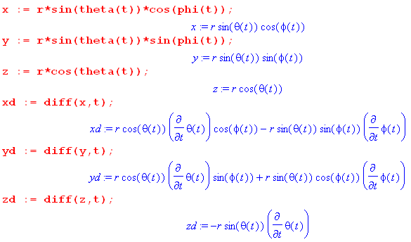 (C.7.3)
The second derivatives are messier, but Maple is happy to do the calculations,

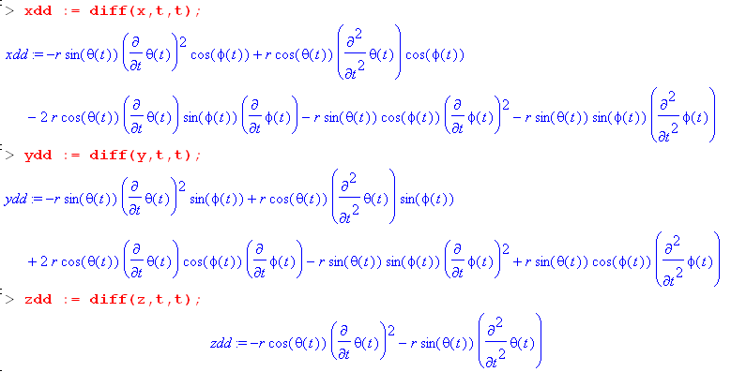 (C.7.4)
Task (a): Show that eq2 of (C.7.2) ⇒ eq2 of (C.7.1)

We enter eq2 of (C.7.2) and do some manipulations, suppressing the output except for the last step :

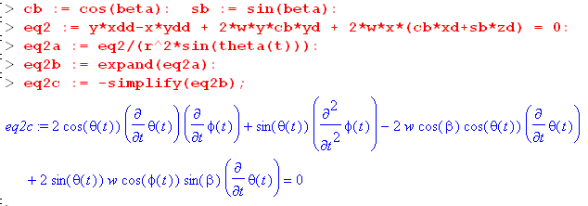 (C.7.5)
We manually transcribe the resulting equation,

2cosθ + sinθ -2ωcosβcosθ + 2ωsinθcosφsinβ = 0
or
2cosθ + sinθ = 2ωcosβcosθ - 2ωsinθcosφsinβ
or
2cosθ + sinθ = 2ω(cosβcosθ - sinθcosφsinβ) . (C.7.6)

This last equation is a match for eq2 of (C.7.1) so we have accomplished Task (a).

Task (b): eq3 + (cosθsinφ)eq2 of (C.7.2) ⇒ eq1 of (C.7.1)

The code continues from that shown above. Equation eq2 is already entered, so we now enter eq3, form the linear combination for eq1, then process the results with a series of typical tortuous Maple steps,

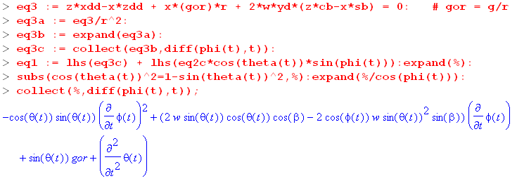 (C.7.7)
We again manually transcribe the resulting equation,

-cosθsinθ 2 + (2ωsinθcosθcosβ - 2ωsin2θcosφsinβ) + sinθ(g/r) + = 0
or
- cosθsinθ 2 = – sinθ(g/r) - 2ωsinθ(cosθcosβ - sinθcosφsinβ) . (C.7.8)

This is a match for eq1 of (C.7.1) so we have accomplished Task (b).

Tension equation verification

Using the angular equations of motion (C.7.1), we now show that the following two tension expressions are equivalent (the second is Cartesian (C.6.10) while the first is angular (C.3.9)), where r = l ,

T/mr = 2 + sin2θ 2 + (g/r)cosθ - 2ω [(cosβsinθ + sinβcosφcosθ )sinθ + sinβsinφ ]
T/mr = - (2ωcosβ + )/x . (C.7.9)

Our task of showing that the above equations have equal right sides is the same as showing that

x{2 + sin2θ 2 + (g/r)cosθ - 2ω [(cosβsinθ+sinβcosφcosθ )sinθ + sinβsinφ ]} = -(2ωcosβ + )
or
LHS = RHS . (C.7.10)

We first get the complicated left hand side LHS entered:

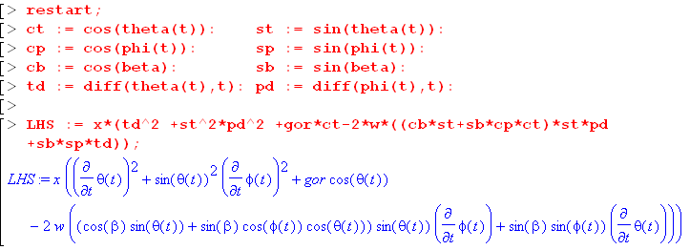 (C.7.11)

We then compute RHS = -(2ωcosβ + ),

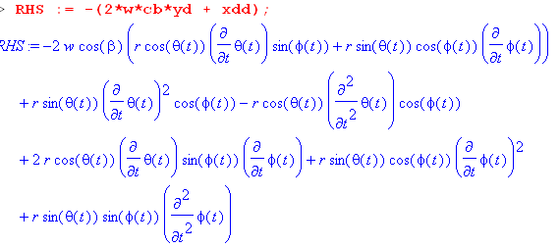 (C.7.12)
Notice that RHS contains second derivatives and . We shall eliminate these derivatives by manually solving the angular equations of motion (C.7.1) for Tdd = and Pdd = :

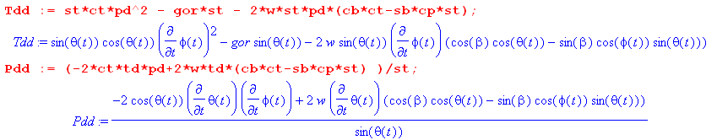
(C.7.13)
To show that LHS = RHS, we define d = LHS-RHS and show that d = 0:

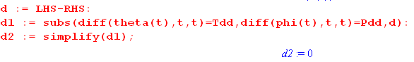 (C.7.14)
Thus d = 0 and LHS = RHS and the two expressions for T in (C.7.9) are equivalent.

C.8 Numerical solutions of the equations of motion (Cartesian Coordinates)

Our task is to solve the set of equations (C.6.9) (eq1 now has a new meaning) :

eq1 x2+y2+z2 = r2 // r = l
eq2 y - x = -2ωycosβ - 2ωx(cosβ + sinβ)
eq3 z - x = -xg -2ω(zcosβ - xsinβ ) . (C.6.9) (C.8.1)

We enter eq2 and eq3 writing derivatives for example as = xdd :

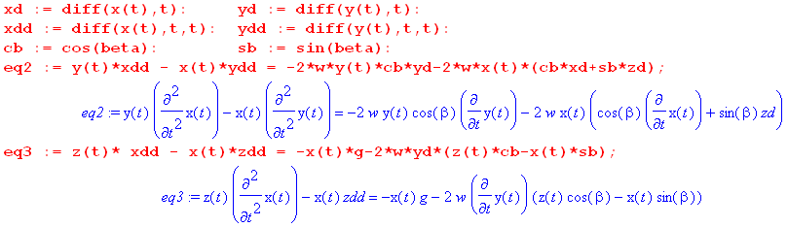
(C.8.2)
At this point zd = and zdd = are unspecified. We use eq1 of (C.8.1) to compute and in terms of x and y,

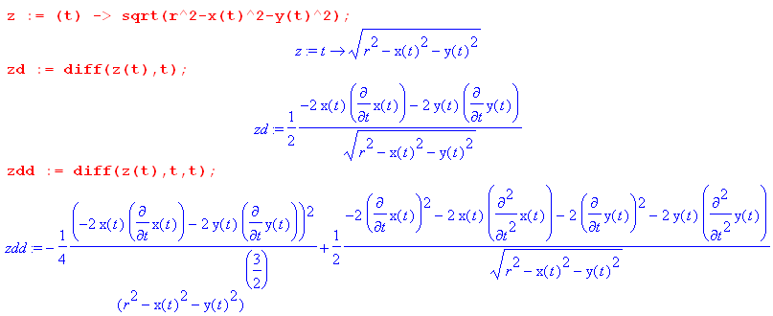
(C.8.3)

When these expressions are installed, eq2 and eq3 becomes these formidable-looking equations which contain two unknown functions x(t) and y(t) and constants r = l, β,g and ω = w :

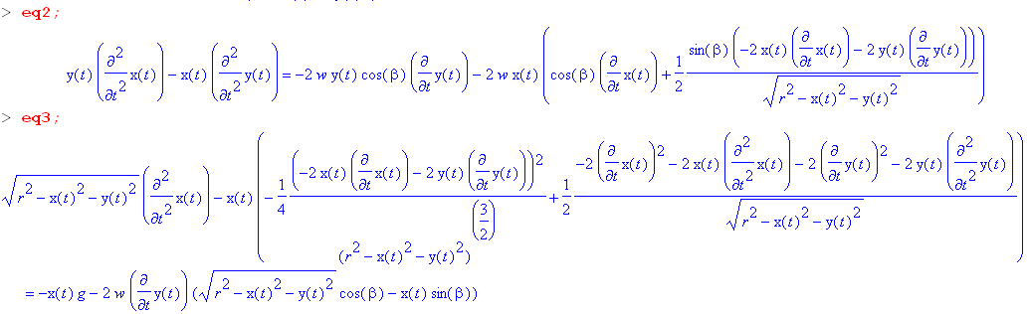
(C.8.4)

The Foucault Pendulum at the Pantheon in Paris (revisited)

For our first plot, we again consider the Foucault pendulum set up in the Pantheon. The numbers are discussed above (C.5.35) :

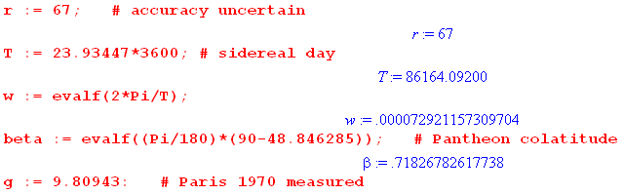 (C.8.5)

The Maple code to invoke a solution is as follows:

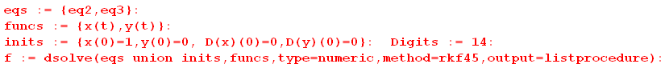
(C.8.6)
We have initialized the pendulum at x(0) = 1m. Here is a plot of the first few swings,

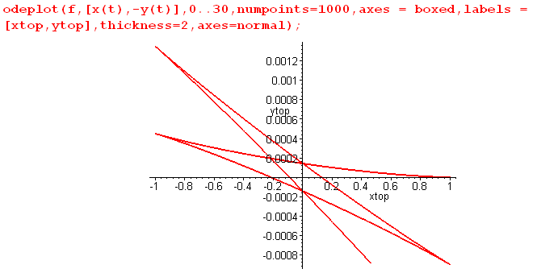 (C.8.7)

Notice that the vertical scale is highly magnified, so really these swings are very close to the x axis.

We want to view the orbits from above, not from below. Since the z axis points down, and since we are viewing from above, we negate the original y axis to get a new y axis appropriate for our plots viewed from the top. This negation is done in the odeplot call seen above.

As expected, and as shown earlier in (C.2.1), the Coriolis force deflects each half-swing to the right (as seen from above).

In order to plot functions like x(t) more generally, we extract our functions of interest from the Maple dsolve environment as follows,

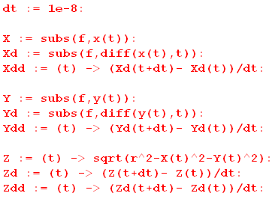 (C.8.8)

Here functions like X(t) are taken directly from the dsolve listprocedure output structure while unavailable derivatives such as Xdd = are manually approximated. For details on how this works and other information on dsolve (including a debugger's guide), see the author's Maple User Guide. We can now make a plot of the three functions x(t),(t) and (t) for the first swing,

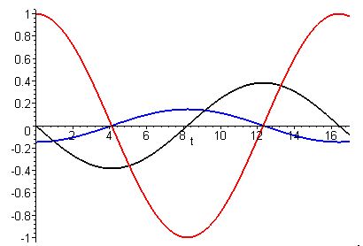
x = red = black = blue (C.8.9)

The shape of red x(t) appears to be sinusoidal as predicted by the small angle model. The black curve vx(t) = (t) seems to cross the x axis around 16.4 suggesting that this is the period of the first swing of the pendulum, in agreement with (C.5.35). We can zoom in on the crossing to get a better view,

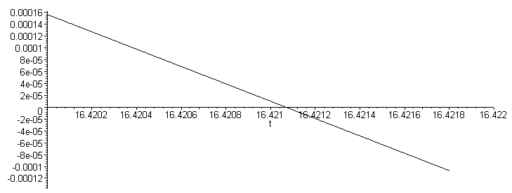
(C.8.10)
This indicates that the period is about 16.4211 sec.

Foucault Pendulum on a rotating platform

We now stop the Earth's rotation, transport the entire Pantheon to the North Pole (β = 0o) and mount it on a sturdy platform which rotates once every 77 seconds. We do this just to explore the pendulum orbit trajectories that might result. With equally-scaled axes we get this Foucault path for a duration of 90.3 seconds,

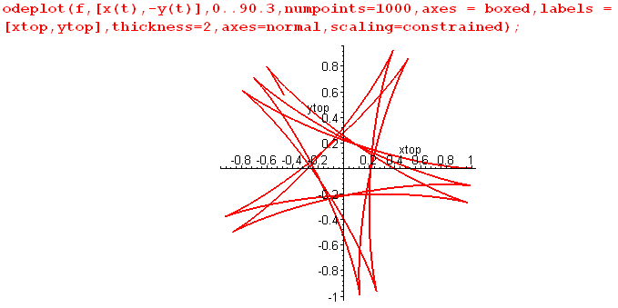 (C.8.11)

Next, when the pendulum is released at x = 1m, it is given a small vy velocity of -0.1 m/s, which means that vytop = +0.1 m/s :

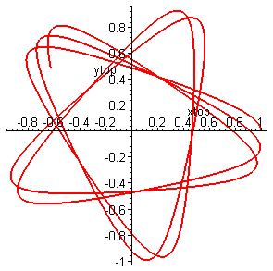 (C.8.12)

The sharp cusps of the previous orbit are now smoothed out. Conversely, if we apply vy = +0.1 m/s so that vytop = -0.1 m/s :

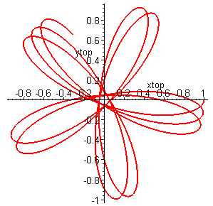 (C.8.13)
Desktop Spherical Pendulum

Here we set l = 1 m and turn off the Earth's rotation completely with ω = 0, so our Foucault pendulum becomes a spherical pendulum. We start it moving with these initial conditions :

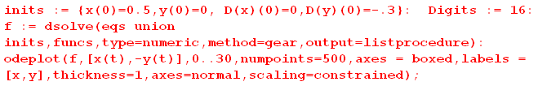

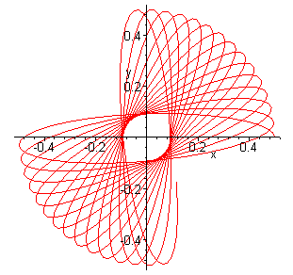 (C.8.14)

In 30 seconds the orbit precesses as shown, a phenomenon known as the intrinsic apsidal Airy precession discussed near (C.5.30). The orbit precesses in the same directional sense in which it orbits. This effect has nothing to do with the Earth's rotation, and turning ω back on makes no visible change in the above picture.

Reader Exercise:

(1) Construct the above pendulum with 1 meter of thread and a small weight hung from a ceiling light fixture. With x ~ 1/2m start an elliptical motion of the shape shown above. Count the number of swings it takes for the orbit to precess 90 degrees and compare to the above figure.

If we change the initial position to x(0) = 0.9 to get more swing, here is the orbit out to t = 10:

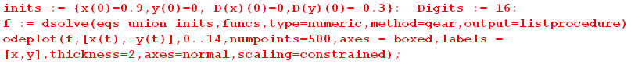

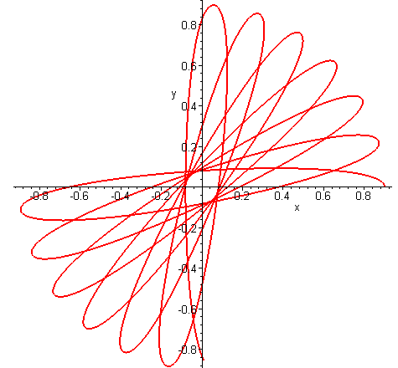 (C.8.15)

It appears that the higher starting point has increased the precession rate.

Here are some 3D plots of the above solution trajectory :

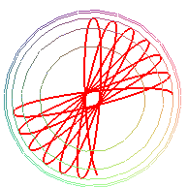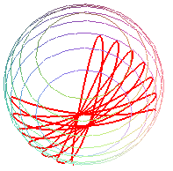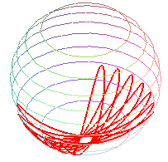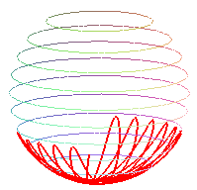
(C.8.16)

In the left image, the camera is looking down from the pivot point of the pendulum so the previous 2D picture is roughly replicated. Then the camera moves down to lower viewing angles.

We already discussed in (C.5.30) Airy's 1851 formula for the precession of the elliptical orbit,

ωairy/ωswing = Tswing/Tairy = (3/8)(ab/l2) = (3/8π)(πab/l2) = (3/8π)(A/l2) . (C.5.30)

As noted there, in this approximate formula, a and b are the semimajor and semiminor axes of the narrow ellipse which is slowly precessing, and l is the length of the string (A = πab is the area of the ellipse). This formula is most accurate for small oscillations and gets less precise for larger ones, requiring correction terms. We can apply it to our two examples above.

A tick mark in (C.8.14) is .04m, so staring the picture we can estimate, since l = 1 m,

a = 0.50 m
b = 2.25 ticks = 2.25 *.04 = 0.09 m
1/N = (3/8)*(0.5)*(.09) = .016875000 // Maple
N = 59.25925926
N/4 = 14.81481482 (C.8.17)

The Airy prediction for Fig (C.8.14) is that there are 14.8 ellipses per quarter turn of the precession. A count of ellipses in the figure gives about 13.5, fairly close given that these are not really small narrow ellipse oscillations.

For (C.8.15) the numbers are

a = 0.90 m
b = 2 ticks = 2 *.04 = 0.08 m
1/N = (3/8)*(0.9)*(.08) = .027000000
N = 37.03703704
N/4 = 9.259259260 (C.8.18)

The formula predicts 9.26 ellipses per quarter turn, while Fig (C.8.15) shows about 6.5. We expect
a worse result since this is definitely not a small oscillation. But both results are in the ballpark, and Airy predicts that the second figure has fewer ellipses per quarter turn than the first figure.

Appendix D: Center of gravity and torque for a tethered satellite

D.1 Definition of Center of Gravity

The phrase "center of gravity" is often used as a synonym for "center of mass" which complicates searching for information about the former concept. The "center of mass" of a system of particles is well known to be

rcms = $\frac{Σimiri}{Σimi}$ = $\frac{1}{M}$ Σimiri M = Σimi // discrete
rcms = $\frac{∫dVρ r}{∫dVρ}$ = $\frac{1}{M}$ ∫dV ρ r M =∫dV ρ // continuous . (D.1.1)

We use "cms" to mean center of mass even though "com" might be more reasonable. Notice that rcms is measured with respect to the same origin used for the ri or r. For a rigid object, the center of mass is a definite point that does not move around relative to the object. It is completely determined by the spatial mass distribution of the object.
The center of gravity is a completely different animal, though it happens to align with the center of mass for a uniform gravitational field. For that reason one never deals with a distinct center of gravity concept for human-scale engineering objects on the Earth's surface.
Consider a system of masses mi each of which experiences some force Fi. We define

F = ΣiFi N(R) = Σi (ri-R) x Fi N(0) = Σiri x Fi . (D.1.2)

Here F is the sum of the forces acting on all the masses mi, N(R) is the total torque on the system with respect to some arbitrary point R, and N(0) is the total torque with respect to the selected origin. An obvious theorem is that

N(R) = Σi (ri-R) x Fi = Σiri x Fi - R x ΣiFi

= N(0) - R x F (D.1.3)

which shows how the two torques are related. If F = 0, which is often the case, then the torque is the same with respect to any point.
One characteristic of a center of gravity point rcog is that the total torque on a system measured with respect to point rcog vanishes, so N(r$_{cog}$) = 0. From (D.1.3) we see that this is the same as saying N(0) = rcog x F , so

N(r$_{cog}$) = 0 ⇔ N(0) = rcog x F rcog = "center of gravity" . (D.1.4)

The significance of rcog is that it is a point which allows the relation between the total system torque N(0) and the total system force F to have the same form as Ni = ri x Fi for a single point particle. It is not obvious that such a point rcog exists for some arbitrary system of particles.
So far this notion of "center of gravity" has nothing to do specifically with gravity, but below we shall add an additional part of the definition which does bring in gravity.
Unlike the center of mass, the center of gravity (if it exists) may not be unique and it generally moves around in an object as the object changes orientation in an external force field If we dot N(0) = rcog x F with the vector F we find

N(0)• F = 0 . (D.1.5)

As shown above, N(0) and F are well-defined computable quantities and if N(0)• F ≠ 0, then rcog cannot possibly exist (because if it did exist one must have N(0)• F = 0). So (D.1.5) is a condition for the existence of rcog.
Here is a method for locating rcog, a variation of Symon p 258 which we present in the context of an asteroid of mass M near the Earth. This description includes the second characteristic of the center of gravity point which is that it is point at which gravitational action is effectively focused.
One first computes the total gravitational force F = ΣiFi due to the Earth (summed over all points in the asteroid) and one then knows the direction of the sum vector F. One creates a line along F and then translates that line parallel to F until the line passes through the center of the Earth. The center of gravity of the asteroid lies on that translated line a distance rcog from the center of the Earth where rcog is determined by,

GMEM/rcog2 = F ⇒ rcog = $\sqrt{GMEM/F}$

rcog = rcog (-) F = F . (D.1.6)

Here is an illustration,

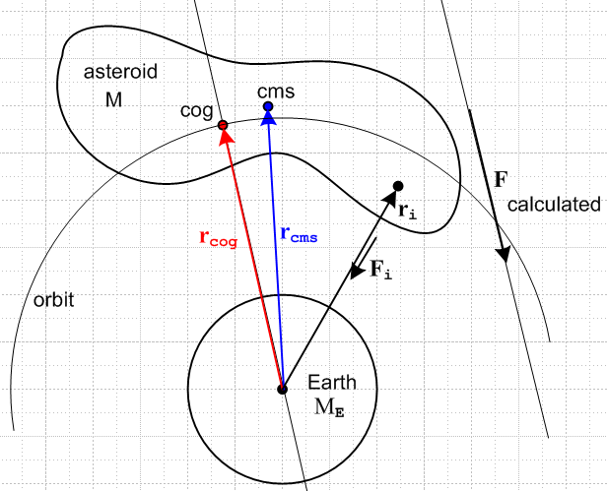 (D.1.7)

From the Earth's point of view, one could replace the entire asteroid with a point mass M at location rcog and the Earth would feel the same gravitational pull from that point mass as it does from the asteroid. Furthermore, if the asteroid were in a circular orbit around the Earth keeping its same aspect facing the Earth (not very likely), then the orbiting characteristics of the asteroid would be the same as for its replacement point mass, and one would have for example GMEM/rcog2 = Mω2rcog as the balance between gravitational and centrifugal force. If the asteroid does not rotate or tumbles in some manner, at any point in its orbit rcog will lie on the orbit shown, but the location of that point within the asteroid changes so that the new rcog computed for a new position and orientation still equals the orbit radius. In this case the rcog position will change relative to the asteroid, whereas the cms point always has the same position relative to the asteroid. Here we enhance the above drawing by adding another position of the tumbling asteroid in its orbit,

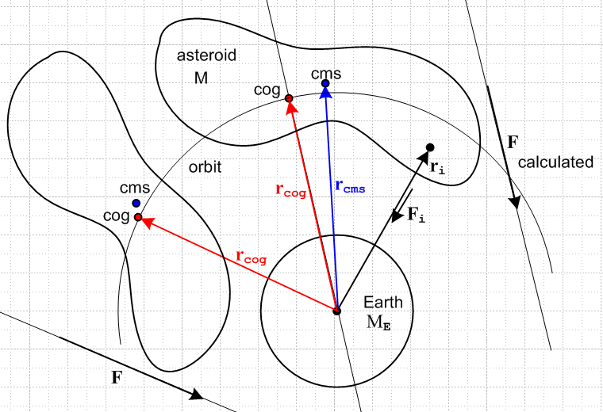 (D.1.8)

One implication is that, for any orientation of the asteroid in orbit, there exists a position of the asteroid such that the total force F will have the same magnitude as at any other position, since rcog is the same.

One might wonder what Symon's operational prescription for computing rcog has to do with our opening section about torque. First, for each point in the asteroid we know that ri x Fi = 0 (ri tails are at Earth center) because each ri to mass mi is parallel to the force Fi on mass mi. Thus according to (D.1.2) we have N(0) = 0. Therefore the condition (D.1.5) that N(0)• F = 0 is trivially satisfied. Then rcog exists and is a vector which satisfies the center of gravity definition (D.1.4) that N(0) = rcog x F. This equation is satisfied by Symon's computed rcog because rcog is parallel to F, so the equation says 0 = 0. From (D.1.4) we then see that the N(r$_{cog}$) = 0 so rcog is a point with respect to which the total torque on the asteroid (due to gravitational force from the Earth) is 0. In this example it happens that any point R along the rcog line satisfies N(0) = R x F and any such point R therefore is a point of zero total torque N(R) = 0. But only one point on this line gives the concentration point of the gravitational force such that GMEM/rcog2 = F .
We shall now consider a 2-mass tethered satellite as a relatively simple example where we can compute the cog point and then watch it move relative to the cms point.

D.2 Center of Gravity for a 2-mass Dumbbell Satellite

To head off a proliferation of primes, we now switch to "swap notation" in which Frame S is the rotating frame while Frame S' is the fixed inertial frame. Rather than assume an arbitrary dumbbell orientation, we assume for this section that the dumbbell lies in the plane of paper:

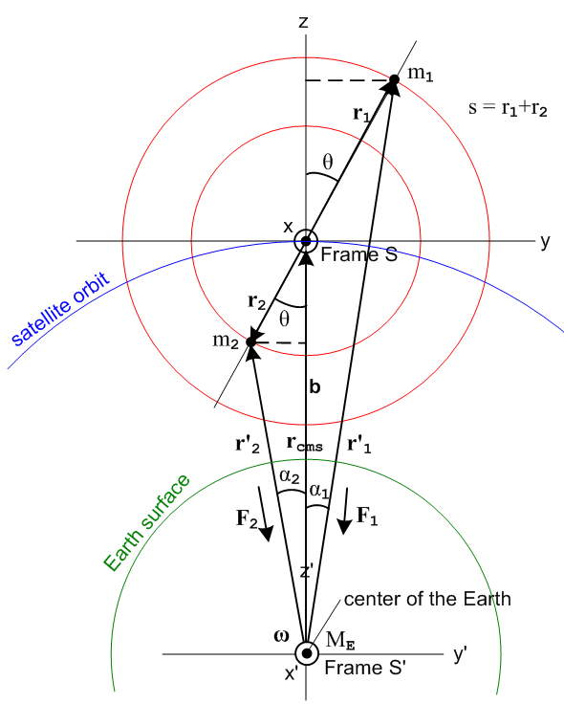 (D.2.1)

Frame S' has its origin at the center of the Earth and is assumed fixed relative to the stars.
Frame S has its origin at the center of mass of the satellite as shown.
The orbit of the satellite lies in the plane of paper.
The vector ω describes the angular velocity of the satellite and has nothing to do with Earth's rotation.

Moreover, at t = 0 the axes of both frames line up: = ', = ' and = ' .

The two masses m1 and m2 are connected by a massless rigid stick of length s = r1+r2 . Since the masses are assumed to be unequal, mass m1 is restricted to lie on a sphere of radius r1 in Frame S', while mass m2 lies on a different sphere of radius r2 (to be computed below). For purposes of the drawing, we have m2 > m1 so that r2 < r1.

The polar angle in Frame S of m1 (and the stick) is θ. The angles α1 and α2 are positive.

Assumption: We will show below that the center of gravity is very close to the center of mass for any angle θ. For example, if the stick is 10 m long, the distance between these two centers for a low-Earth orbit is about 3 microns. For this reason, we shall assume that it is the center of mass point rcms which goes in a circular orbit around the Earth, even though we know from Section D.1 that it is really rcog that does this. So as the satellite goes around the Earth and θ varies in time, the point rcog moves a very small amount relative to rcms, and we shall just ignore this tiny motion.
The satellite center of mass point then rotates around the Earth at some rate ω = 2π/T. For a low-Earth orbit, T is on the order of 88 minutes. As the satellite moves in this orbit, Frame S rotates with the satellite while Frame S' stays fixed relative to the stars. This means that the Frame S axis z always points away from the center of the Earth.
One can generalize the discussion for an elliptical orbit, but things are complicated enough for a circular orbit so we stick with that simplification. In Appendix F we allow the dumbbell to move out of the plane of paper, but here for simplicity we assume it is in the plane of paper for any θ.

With the above assumption, we may identify rcms with b, our usual vector connecting the two Frame origins, so

b = rcms (D.2.2)

and then from the figure,

b + r1 = r'1
b + r2 = r'2 . (D.2.3)

The Law of Cosines gives, for the right and left triangles,

r'12 = r12 + b2 - 2r1b cos(π-θ) = r12 + b2 + 2r1b cosθ

r'22 = r22 + b2 - 2r2b cosθ . (D.2.4)

Center of Mass

From (D.1.1) we know that the center of mass of the satellite is given by,

rcms = $\frac{m1r1+m2r2}{m1+m2}$ = 0 Frame S (D.2.5)

r'cms = $\frac{m1r'1+m2r'2}{m1+m2}$ = b . Frame S' (D.2.6)

Due to the constraint of the massless stick one has,

2 = - 1 (D.2.7)

so (D.2.5) says

m1r1 = - m2r2 ⇒ m1r1 = m2r2 , r2/r1 = m1/m2 , 2 = – 1 . (D.2.8)

Angles

Looking at the right triangles from the center of the Earth to the two dashes lines, one sees that

sinα1 = (r1sinθ) / r'1 ⇒ r'1sinα1 = r1sinθ
sinα2 = (r2sinθ) / r'2 ⇒ r'2sinα2 = r2sinθ . (D.2.9)

The same triangles reveal that

cosα1 = (b + r1cosθ)/r'1 ⇒ r'1cosα1 = b + r1cosθ
cosα2 = (b - r2cosθ)/r'2 ⇒ r'2cosα2 = b - r2cosθ . (D.2.10)

We shall need the following dot products,

'1 • = cosα1 '1 • = cos(π/2-α1) = sinα1
'2 • = cosα2 '2 • = cos(π/2+α1) = -sinα2 (D.2.11)

'1 • '2 = cos(α1+α2) = cosα1 cosα2 - sinα1 sinα2

= (r'1r'2)-1[ (r'1cosα1) (r'2cosα2) - (r'1sinα1) (r'2sinα2) ]

= (r'1r'2)-1[ ( b + r1cosθ) ( b - r2cosθ) - (r1sinθ) (r2sinθ) ] // (D.2.9) and (D.2.10)

= (r'1r'2)-1[b2 +b(r1-r2)cosθ - r1r2cos2θ - r1r2sin2θ ]

= (r'1r'2)-1[b2 +b(r1-r2)cosθ - r1r2 ] . (D.2.12)

Where is the Center of Gravity of the Satellite?

The gravitational forces acting on the two satellite masses due to the Earth are.

F1 = - (GMEm1/r'12) '1 = - (GMEm1/r'13) r'1
F2 = - (GMEm2/r'22) '2 = - (GMEm2/r'23) r'2 . (D.2.13)

Note the direction of the "long" vectors r'1 and r'2 in the drawing.

Following the prescription of Section D.1 for finding the location of the center of gravity, we compute the total gravitational force on the satellite,

F = - (GMEm1/r'12) '1 - (GMEm2/r'22) '2

= (-GME) [ (m1/r'12) '1 + (m2/r'22) '2 ] . (D.2.14)

Taking components:

Fy = F • = (-GME) [ (m1/r'12) '1• + (m2/r'22) '2• ]

= (-GME) [ (m1/r'12)sinα1 – (m2/r'22) sinα2 ] // (D.2.11)

= (-GME) [ (m1/r'13) r'1sinα1 – (m2/r'23) r'2 sinα2 ]

= (-GME) [ (m1/r'13) r1sinθ – (m2/r'23) r2sinθ ] // (D.2.9)

= (-GME) [ (m1/r'13) r1sinθ – (m1/r'23) r1sinθ ] // (D.2.8)

= (-GME) (m1r1sinθ) [ (1/r'13) – (1/r'23) ]

Fz = F • = (-GME) [ (m1/r'12) '1• + (m2/r'22) '2• ]

= (-GME) [ (m1/r'12)cosα1 + (m2/r'22)cosα2 ] // (D.2.11)

= (-GME) [ (m1/r'13)r'1cosα1 + (m2/r'23)r'2cosα2 ]

= (-GME) [ (m1/r'13)( b + r1cosθ) + (m2/r'23)(b - r2cosθ) ] // (D.2.10)

= (-GME) [ b {(m1/r'13) + (m2/r'23)} + cosθ { (m1r1/r'13) - (m2r2/r'23) } ]

= (-GME) [ b {(m1/r'13) + (m2/r'23)} + cosθ { (m1r1/r'13) - (m1r1/r'23) } ] // (D.2.8)

= (-GME) [ b {(m1/r'13) + (m2/r'23)} + m1r1cosθ { (1/r'13) - (1/r'23) } ]
so

Fy = (-GME) (m1r1sinθ) [ (1/r'13) – (1/r'23) ]

Fz = (-GME) [ b {(m1/r'13) + (m2/r'23)} + m1r1cosθ { (1/r'13) - (1/r'23) } ] . (D.2.15)

Recall now from (D.1.6) the rule for obtaining rcog :

GMEM/rcog2 = F ⇒ rcog = $\sqrt{GMEM/F}$

rcog = rcog (-) F = F . (D.1.6) (D.2.16)

Just to have a picture, we now add rcog to Fig (D.2.1), picking a graphic location for the point which makes things easy to draw (we don't know yet where it actually lies),

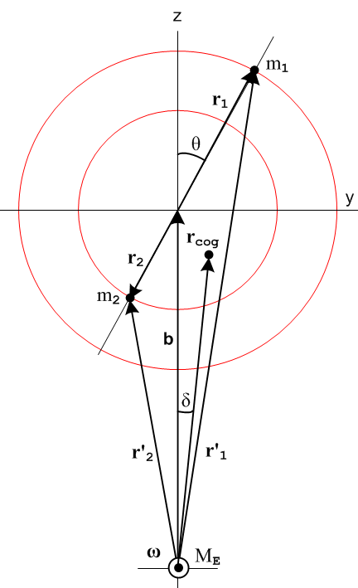 (D.2.17)

The center of gravity point lies a distance rcog (to be computed) along a line which makes some angle δ relative to the vertical axis. Since cog = - , we may write using (D.2.15),

tan(δ) = - Fy/Fz = - (m1r1sinθ) $\frac{(1/r'13) – (1/r'23)}{b [ (m1/r'13) + (m2/r'23) ] + m1r1 cosθ [ (1/r'13) - (1/r'23)]}$

= - (m1r1sinθ) $\frac{r'23 – r'13}{b [ (m1r'23) + (m2r'13) ] + m1r1 cosθ [ r'23 - r'13]}$ . (D.2.18)

If the masses are vertically aligned, meaning θ = 0 or π, then sinθ = 0 and we see that δ = 0, as expected.

Since for general masses and angle θ one does not have r'1 = r'2, one may conclude:

Fact 1: In general the center of gravity does not lie on the line between the center of the Earth and the center of mass. (D.2.19)

Earlier we conjectured that this was the case, and here we see it in our dumbbell satellite example.

Next we wish to compute the distance rcog to the center of gravity. Using (D.2.14) and (D.2.12),

F2 = (GME)2 [ (m1/r'12)2 + (m2/r'22)2 + (m1/r'12) (m2/r'22) '1 • '2 ] // (D.2.14)

= (GME)2 [(m1/r'12)2 + (m2/r'22)2 + (m1/r'12)(m2/r'22)(r'1r'2)-1(b2 +b(r1-r2)cosθ - r1r2) ] // (D.2.12)

= (GME)2 [(m1/r'12)2 + (m2/r'22)2 + (m1/r'13)(m2/r'23)(b2 +b(r1-r2)cosθ - r1r2) ]

so

F = GME $\sqrt{(m1/r'12)2 + (m2/r'22)2 + 2 (m1/r'13) (m2/r'23)(b2 + b(r1-r2)cosθ - r1r2)}$ . (D.2.20)

Then, using M = (m1+m2) and mi = μiM, we find from (D.2.16) that,

rcog = $\sqrt{GMEM/F}$
= $\frac{1}{[ (μ1/r'12)2 + (μ2/r'22)2 + 2 (μ1/r'13) (μ2/r'23)(b2 + b(r1-r2)cosθ - r1r2) ]1/4}$ (D.2.21)

r'12 = r12 + b2 + 2r1b cosθ
r'22 = r22 + b2 - 2r2b cosθ // μi ≡ mi/M (D.2.4)

which is somewhat more complicated than our expression for rcms,

rcms = b . (D.2.2)

We are then led to:

Fact 2: In general the center of gravity does not lie the same distance from the center of the Earth as the center of mass. (D.2.22)

Quick check on (D.2.21) : If m1= 0, then μ1 = 0 and μ2 = 1 and the result is rcog = r'2 which is correct.

Reader Exercise: If the two masses are vertically aligned with θ = 0, then

(a) Show that: r2 = b - r'2 r'1+r'2 = 2b
r1 = r'1 - b (b2 +b(r1-r2)cosθ - r1r2) = r'1r'2 (D.2.23)
(b) Show that rcog = $\sqrt{(μ1/r'12) + (μ2/r'22)}$ = $\frac{m1+m2}{(m1/r'12) + (m2/r'22)}$ (D.2.24)

(c) Show that rcog < rcms , where rcms = b = (r'1+r'2)/2 and μ1+μ2= 1

D.3 Dumbbell Satellite Center of Gravity with the Far Approximation: Numerical Examples

A practical tethered satellite is not going to have Earth-scale dimensions so we now make the obvious assumption that r'1, r'2 and b are much larger than r1 and r2. We then define smallness parameters,

ε1 ≡ (r1/b) (D.2.8)
ε2 ≡ (r2/b) = (r2/r1) (r1/b) = (m1/m2)ε1 = (μ1/μ2)ε1 . (D.3.1)

Then

(b2 + b(r1-r2)cosθ - r1r2) = b2 (1 + (ε1-ε2)cosθ - ε1ε2) (D.3.2)

so that from (D.2.21),

rcog = $\frac{1}{[ (μ1/r'12)2 + (μ2/r'22)2 + 2 (μ1/r'13) (μ2/r'23)b2(1 + (ε1-ε2)cosθ - ε1ε2) ]1/4}$ . (D.3.3)

From (D.2.4) we know also that

r'12 = r12 + b2 + 2r1bcosθ = b2 [ 1 + 2(r1/b)cosθ + (r1/b)2] = b2 [ 1 + 2ε1cosθ + ε12]

r'22 = r22 + b2 - 2r2b cosθ = b2 [ 1 – 2(r2/b)cosθ + (r2/b)2] = b2 [ 1 – 2ε2cosθ + ε22]

so then

r'1 = b $\sqrt{1 + 2ε1cosθ + ε12}$
r'2 = b $\sqrt{1 – 2ε2cosθ + ε22}$ . (D.3.4)

So far everything is exact, but we shall now expand rcog as a series in our small parameters. Since ε2 = (μ1/μ2)ε1, we replace ε2 by this expression so there is then only one small parameter ε1. Maple is ready to carry out this task. We first enter our expressions of interest, using rp1 for r'1 etc :

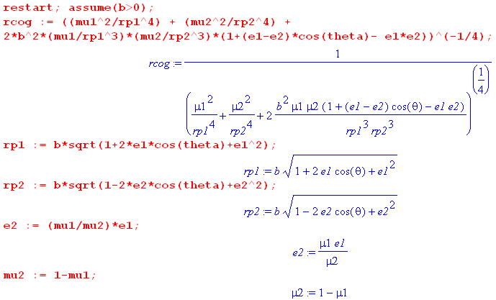 (D.3.5)

We then instruct Maple to expand rcog in a power series around ε1 = 0 and we ask for the first four terms of the expansion,

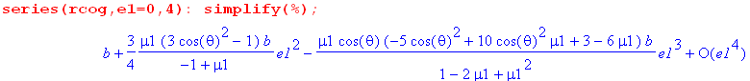 (D.3.6)

A perhaps unexpected result is that there is no term linear in ε1, regardless of the masses. We leave it to the energetic reader to concoct a theoretical explanation of this fact (not all odd terms vanish, just the first odd term). Our conclusion then is, to second order in smallness parameter ε1,

rcog ≈ b [ 1 + $\frac{3}{4}$$\frac{μ1}{1-μ1}$(-3cos2θ +1) ε12 ] = b [ 1 + $\frac{3}{4}$$\frac{m1}{m2}$(-3cos2θ +1) ε12 ]

= b [ 1 + $\frac{3}{4}$$\frac{m1}{m2}$( 1 - 3 cos2θ ) $\frac{r12}{b2}$ ] = b [ 1 + $\frac{3}{4}$$\frac{r2}{r1}$( 1 - 3 cos2θ ) $\frac{r12}{b2}$ ] // (D.2.8)

= b [ 1 + $\frac{3}{4}$( 1 - 3 cos2θ ) $\frac{r1r2}{b2}$ ] . (D.3.7)

Then

rcog - rcms = rcog - b ≈ [ $\frac{3}{4}$( 1 - 3 cos2θ ) $\frac{r1r2}{b2}$ ] b (D.3.8)

and

$\frac{rcog - rcms}{rcms}$ ≈ $\frac{3}{4}$( 1 - 3cos2θ ) $\frac{r1r2}{b2}$ . (D.3.9)

Fact 3: If θ = ±54.7o, we get rcog = rcms through order ε12, since this angle has cosθ = 1/$\sqrt{3}$. But the line to the center of gravity does not in general have δ = 0 since in general r'1 ≠ r'2 at this angle. (D.3.10)

Fact 4: If the masses are vertically aligned, meaning θ = 0 or π, then cos2θ = 1 and we find that

$\frac{rcog - rcms}{rcms}$ = $\frac{3}{4}$( 1 - 3 ) $\frac{r1r2}{b2}$ = - $\frac{3}{2}$$\frac{r1r2}{b2}$. (D.3.11)

Since the right side is negative, we have rcog < rcms and the center of gravity in this case is closer to the Earth than the center of mass and of course lies on the line to the center of mass.

Fact 5: If the masses are horizontally aligned, meaning θ = ±π/2, then cosθ = 0 and we find that

$\frac{rcog - rcms}{rcms}$ = $\frac{3}{4}$( 1 - 0 ) $\frac{r1r2}{b2}$ = + $\frac{3}{4}$$\frac{r1r2}{b2}$ . (D.3.12)

The center of gravity in this case is farther from the Earth than the center of mass. The line to the center of gravity does not have δ = 0 unless m1 = m2.

The above cases show the extremes of the factor ( 1 - 3 cos2θ ) and hence of rcog - rcms . For a general angle θ the result lies between the two limiting cases.

Numerical Examples

From (8.8.6) one has RE = 6371 km. If we put our satellite in orbit 200 km above the Earth's surface, then b = 6371+200 = 6571 km. A higher orbit of course gives a larger b and a smaller offset between rcms and rcog. We take the maximum displacement between rcog and rcms from Fact 5 to obtain

| $\frac{rcog - rcms}{rcms}$|max = $\frac{3}{4}$$\frac{r1r2}{b2}$ . (D.3.13)

For a given mass separation (tether length) s = r1 + r2 the product r1r2 is maximized when r1= r2 (easy to show) and this in turn means m1 = m2, so to get the worst case we set r1 = r2 = s/2 to get

| $\frac{rcog - rcms}{rcms}$|max = $\frac{3}{4}$$\frac{1}{4}$(s/b)2 = (3/16)(s/b)2 s = stick length = tether length (D.3.14)

Note the quadratic dependence on the ratio s/b. Regarding the left side of this equation as dr/b, we have Maple compute dr for three cases:

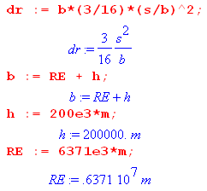 (D.3.15)

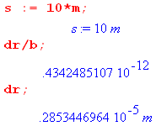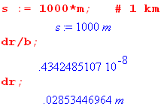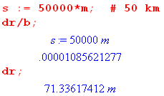

For a s = 10 m tether length, the max offset is 2.8 microns which we feel pretty comfortable ignoring.
For a s = 1 km tether length, the max offset is 2.8 cm, still pretty small.
For a s = 50 km tether length, the max offset is about 70 m. (D.3.16)

The quantities | $\frac{rcog - rcms}{rcms}$|max for each case are shown as dr/b : 10-12, 10-8 and 10-5.

This justifies our approximation that it is essentially the center of mass point which orbits the Earth, and the variation between rcog and rcms is generally relatively small. However, in the last case if one really deployed a 50 km tether from a small spacecraft, the center of gravity point would lie 70 meters out onto the tether. (The YES2 satellite in 2007 deployed a 30 km tether, see Chen et al.).

D.4 Dumbbell Satellite Center of Gravity for equal masses and no approximation

(a) Equal Masses and general θ

Recall the general no-approximation results (D.2.18) and (D.2.21),

tan(δ) = - (m1r1sinθ) $\frac{(1/r'13) – (1/r'23)}{b [ (m1/r'13) + (m2/r'23) ] + m1r1 cosθ [ (1/r'13) - (1/r'23)]}$ (D.2.18)

rcog = $\frac{1}{[ (μ1/r'12)2 + (μ2/r'22)2 + 2 (μ1/r'13) (μ2/r'23)(b2 + b(r1-r2)cosθ - r1r2) ]1/4}$ (D.2.21)

where

r'12 = r12 + b2 + 2r1b cosθ
r'22 = r22 + b2 - 2r2b cosθ . (D.2.4) (D.4.1)

Setting m1 = m2 (which implies r1 = r2 = s/2 and also μ1 = μ2 = 1/2) gives these simpler forms,

tan(δ) = - (r1sinθ) $\frac{r'23 – r'13}{b (r'23 + r'13) + r1 cosθ (r'23 - r'13)}$

rcog = $\sqrt{2}$ . (D.4.2)

(b) Equal Masses and θ = 0 (vertically aligned)

If we further specify that θ = 0 we get δ = 0 and moreover,

r'1 = (b+r1) r'2 = (b- r1) (D.4.3)

b2 = r'12 + r12 - 2r'1r1 ⇒ b2 - r12 = r'1(r'1-2r1) (D.4.4)

rcog = $\sqrt{2}$ = $\sqrt{2}$

= $\sqrt{2}$ = $\sqrt{2}$$\sqrt{2}$$\sqrt{b2+ r12}$ = $\sqrt{b2+ r12}$ = $\frac{b2}{b}$$\sqrt{1+ (r1/b)2}$

= b $\sqrt{1+ (r1/b)2}$ . (D.4.5)
The exact results are then (equal masses and θ = 0):

tan(δ) = 0 ⇒ δ = 0 (D.4.6)

rcog = b $\sqrt{1+ (r1/b)2}$ . // m1= m2 and θ = 0 (D.4.7)

We then find that

rcog - rcms = b [ $\sqrt{1+ (r1/b)2}$- 1 ]

$\frac{rcog - rcms}{rcms}$ = $\sqrt{1+ (r1/b)2}$- 1 . (D.4.8)

The first term is less than 1, so the right side is negative and thus rcog < rcms. So in this vertically aligned case the center of gravity is closer to the Earth than the center of mass.

This figure summarizes our result (with rcms - rcog exaggerated)

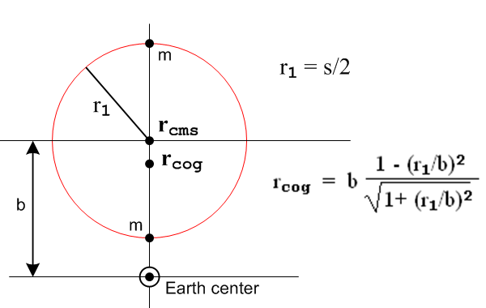 (D.4.9)

Looking back at the force equation (D.2.14), we can confirm result (D.4.7) fairly quickly :

F = - (GMEm1/r'12) '1 - (GMEm2/r'22) '2 = - [(GMEm1/r'12) + (GMEm2/r'22) ] // θ = 0

F = GMEm1[ (1/r'12) + (1/r'22)] = GMEm1[r'22 + r'12] / [r'1r'2]2 // m1= m2

= GMEm1[(b-r1)2 +(b+r1)2] / [(b+r1)(b-r1)]2 =

= GMEm1[2b2 + 2r12] / (b2-r12)2 = 2 GMEm1 (b2 + r12) / (b2-r12)2

= 2 GMEm1 b-2 (1 + (r1/b)2) / (1-(r1/b)2)2

so from (D.2.16),

rcog = $\sqrt{GME(2m1)/F}$ = b (1-(r1/b)2) / $\sqrt{1 + (r1/b)2}$, (D.4.10)

in agreement with (D.4.7).

If we now further assume (r1/b) << 1 then (D.4.7) becomes

rcog ≈ b (1 - (r1/b)2) (1 - (1/2) (r1/b)2 ) = b [ 1 - (3/2)(r1/b)2] .

$\frac{rcog - rcms}{rcms}$ = $\frac{rcog - b}{b}$ = - (3/2)(r1/b)2 (D.4.11)

in agreement with (D.3.11).

(c) Equal Masses and θ = π/2 (horizontally aligned)

We start again with (D.4.2) for equal masses,

tan(δ) = - (r1sinθ) $\frac{r'23 – r'13}{b (r'23 + r'13) + r1 cosθ (r'23 - r'13)}$
rcog = $\sqrt{2}$ (D.4.2)

r'12 = r12 + b2 + 2r1b cosθ r'22 = r22 + b2 - 2r2b cosθ . (D.4.1)

When θ = π/2 we not only have r1 = r2 but also r'1 = r'2 along with cosθ = 0. This at once implies that tan(δ) = 0, and for rcog we find

r'12 = r12 + b2 ⇒ - r12 = b2 - r'12 ⇒ [b2 - r12] = 2b2 - r'12

rcog = $\sqrt{2}$ = $\sqrt{2}$ = $\sqrt{2}$

= [$\frac{r'16}{b2}$]1/4 = [$\frac{r'13}{b}$]1/2 = $\frac{r'13}{b}$ (D.4.12)

= [$\frac{r'16}{b2}$]1/4 = [$\frac{(b2+ r12)3}{b2}$]1/4 = b [1 + (r1/b)2 ]3/4 . (D.4.13)

The exact results are then (equal masses and θ = π/2)

tan(δ) = 0

rcog = $\frac{r'13}{b}$ = b [1 + (r1/b)2 ]3/4

rcog - rcms = b { [1 + (r1/b)2 ]3/4 – 1 }

$\frac{rcog - rcms}{rcms}$ = [1 + (r1/b)2 ]3/4 – 1 (D.4.14)

Since the first term on the right is greater than 1, we find rcog > rcms so for the horizontally-aligned equal-mass satellite the center of gravity is farther from the center of the Earth than the center of mass, in agreement with our earlier conclusion based on approximation.

This figure summarizes our result (with rcog - rcms exaggerated),
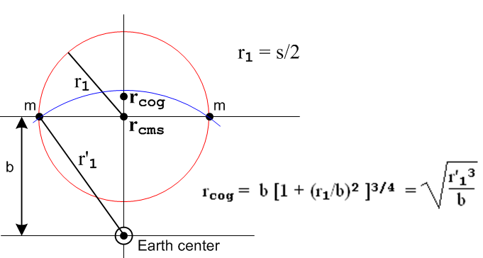 (D.4.15)

We have added in blue a portion of a circle centered at Earth center which passes through the masses. The point rcog lies below this circle, as we now verify,

rcog < r'1 ?

$\frac{r'13}{b}$< r'1 ?

r'13 < r'12 b ?

r'1 < b ? yes . (D.4.16)

Looking back at the force equations (D.2.15), we can confirm result (D.4.12) very quickly,

Fz = -2GMEm1(b/r'13) Fy = 0
rcog = $\sqrt{GME(2m1)/F}$ = $\frac{r'13}{b}$ . (D.4.17)

If we now further assume (r1/b) << 1 the result (D.4.13) becomes

rcog = b [1 + (r1/b)2 ]3/4 ≈ b [1 + (3/4) (r1/b)2 ]
so
$\frac{rcog - rcms}{rcms}$ = $\frac{rcog - b}{b}$ = + (3/4)(r1/b)2 (D.4.18)

in agreement with (D.3.12).

D.5 Center of Gravity for a single-sphere satellite

For the vertically aligned dumbbell satellite, we found that rcog < rcms. People argue that this is so because gravity acts more strongly on the mass closer to the Earth. This argument does not help much, however, for the horizontally aligned satellite where instead one has rcog > rcms and neither mass is closer than the other to the Earth.
One wonders if one can assemble a rigid satellite from a finite number of masses such that these two opposite effects cancel out, resulting in rcog = rcms, at least for some orientation of the masses. Could such a solution be found that works for any orientation of the rigid satellite? We leave these questions to the reader and return instead to the above "argument".
The argument applied to a sphere gives a wrong answer. One would argue for a spherical satellite that the near half of the sphere is closer to the Earth (where gravity is stronger) than the far half, so the center of gravity should be offset toward the Earth from the center of mass. As the reader no doubt knows, a uniform sphere or spherical shell is in fact a "rigid assembly of masses" for which rcog = rcms. So in such an object, the two effects found for the vertically and horizontally aligned satellites do in fact exactly cancel out.
Here we demonstrate that rcog = rcms for a uniform thin shell by two basic methods. Once this is shown, the result then applies for any symmetric assembly of shells such as a sphere or a thick spherical shell.

Method A. In electrostatics one of Maxwell's equations says divE = 4πρ (cgs units). One applies the integral form of this law ∫E • dA = 4π∫ρ dV = 4πQ to show that the electric field outside a uniform spherical shell of charge is independent of the radius of the shell and thus is the same as if the charge were all concentrated at the center of the shell. The argument is that, due to rotational invariance (or "symmetry"), the direction of the electric field can only be radial, so then ∫E • dA = E * 4πR2 and one then finds that E = Q/R2 which is indeed the electric field of a point charge Q at distance R.
The same argument can be applied to a uniform shell of mass so that the gravitational field must be in the radial direction and is independent of the shell radius R, so the shell acts as a point mass at its center. If this shell is a satellite then the Earth cannot determine from gravity alone the radius of that satellite, so one can replace the satellite by a point mass at its center. The Earth never knows, and nothing changes in the orbit. But for the point mass certainly rcog = rcms , so this fact applies as well to any uniform spherical shell or sphere satellite.

Method B (the ever-popular brute force method). This method is more direct, and is found in high-school physics texts, though the integral we obtain below is not. The drawing below is upside-down relative to our earlier drawings, to be more compatible with usual spherical coordinate notation. So the center of the Earth is now at the top and the center of mass of the satellite is located a distance b from Earth center, as earlier. This particular satellite is a spherical shell of radius r and very thin thickness dr. The mass of the shell is then Mshell = [(4πr2)dr]ρ where ρ is the shell's uniform mass density.

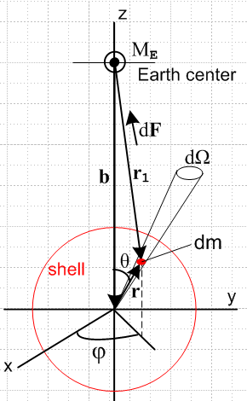 (D.5.1)

Quantity dm is a tiny chunk of mass on the spherical shell of radius r with

dm = ρ(dA)dr = ρ(r2dΩ)dr = ρ (r2sinθdθdφ)dr . (D.5.2)

The force experienced by this mass dm due to mass ME is given by

dF = -(GMEdm/r12)1 = -(GME/r13) dm r1 . (D.5.3)

As usual in spherical coordinates, and as shown in (E.2.6),

r = rsinθcosφ + rsinθsinφ + rcosθ (D.5.4)

so then

r1 = b + r = -b + rsinθcosφ + rsinθsinφ + rcosθ

= rsinθcosφ + rsinθsinφ + (-b+ rcosθ) . (D.5.5)

Therefore,

dF = -(GME/r13) dm r1

= -(GME/r13) dm [rsinθcosφ + rsinθsinφ + (-b+ rcosθ) ] . (D.5.6)

Then,

dFx = dF • = -(GME/r13) ρ (r2sinθdθdφ)dr (rsinθcosφ)
dFy = dF • = -(GME/r13) ρ (r2sinθdθdφ)dr (rsinθsinφ)
dFz = dF • = -(GME/r13) ρ (r2sinθdθdφ)dr (-b+rcosθ) . (D.5.7)

Now integrate dφ from 0 to 2π to get the force on a ring of mass of angular width dθ on the shell at fixed θ. But sinφ has zero integral over this range and so does cosφ, so the first two terms integrate to nothing, while the integral of dφ in the last line gives 2π. We are left with this resulting force, all in the z direction,

dFring = (GME/r13) ρ (r2sinθdθ 2π) dr (b-rcosθ) . (D.5.8)

Now integrate over all rings of the shell to get a total force F experienced by the spherical shell satellite,

F =$^{\int_{0}^{π}{}}$dθ (GME/r13) ρ (r2sinθdθ 2π) dr (b-rcosθ)

= 2πρGME r2dr $^{\int_{0}^{π}{}}$dθ $\frac{sinθ (b-rcosθ)}{(r2+b2-2rbcosθ)3/2}$ . (D.5.9)

This is a famous discontinuous integral that we evaluate below, but for now we use Maple. Assuming that r < b which means the Earth center lies outside the shell, Maple says,

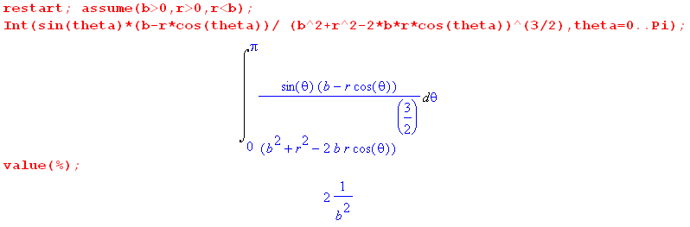
(D.5.10)
where 2/b2 is the value of the integral. Thus we have shown that

F = 2πρGME r2dr $^{\int_{0}^{π}{}}$dθ $\frac{sinθ (b-rcosθ)}{(r2+b2-2rbcosθ)3/2}$ = 2πρGME r2dr (2/b2)

= GME (4πr2dr)ρ /b2 = GMEMshell / b2 . (D.5.11)

We now use the center of gravity definition from (D.1.6) to find,

rcog = $\sqrt{GMEMshell/F}$ = b (D.5.12)

Since rcms = b as well, we conclude that for a spherical shell satellite one has rcog = rcms .

If the mass center ME were inside the shell so b < r, Maple gives a different answer ,

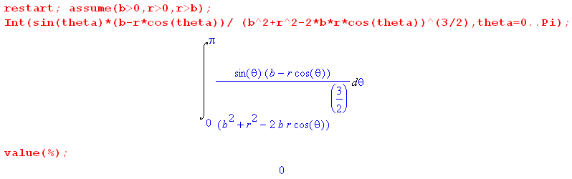
(D.5.13)

showing that the force experienced by the uniform shell due to a mass ME inside the shell is zero.

It seems unsportsmanlike not to actual do the integral to see why it is discontinuous at r = b. Here is a brief tour:

1. Change variables from θ to r1 and look at the endpoints in the new variable,

r12(θ=0) = r2 + b2-2rb(1) = (b-r)2 ⇒ r1(θ=0) = |b-r| ≡ α
r12(θ=π) = r2 + b2-2rb(-1) = (b+r)2 ⇒ r1(θ=π) = b+r ≡ β

It is the absolute value that causes the discontinuous behavior at b = r, as we shall see.

2. Since r12 = r2 + b2 - 2rbcosθ one has sinθdθ = r1dr1/(rb) . (D.5.14)

3. The factor (b - rcosθ) = (b2-r2+r12)/(2b), while the denominator of the integral is just r13.

4. The integral reduces to two elementary power integrals to give

I(r) = $^{\int_{0}^{π}{}}$dθ $\frac{sinθ (b-rcosθ)}{(r2+b2-2rbcosθ)3/2}$ = [ (b2-r2)$^{\int_{α}^{β}{}}$dr1/r12 + $^{\int_{α}^{β}{}}$dr1 1 ] / (2rb2)

= [ (b-r) {$\frac{(b+r) - |b-r|}{|b-r|}$} + (b+r) - |b-r| ] / (2rb2) . (D.5.15)

For b > r one has |b-r| = b-r and the value comes out

I(r) = [ 2r + 2r ] / (2rb2) = 2/b2 . (D.5.16)

For b < r one has |b-r| = r-b and the value is instead

I(r) = [ -2b + 2b ] / (2rb2) = 0 . (D.5.17)

The full result is then

I(r) = (2/b2)H(b-r) // Heaviside function (D.5.18)

which has this appearance,
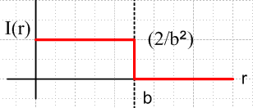 (D.5.19)

On can argue that I(b) = (1/b2) which is the average of the values at the discontinuity.

Appendix E: Spherical Coordinate Unit Vectors and Particle Kinematics

E.1 Angle Conventions

Here is our "physics" convention for spherical coordinate angles θ and φ :

(E.1.1)

The reader is advised that the results below are often quoted in the literature with θ↔φ which is the "math" convention (eg, Wolfram, left below). Sometimes after doing θ↔φ some sources replace polar angle φ with latitude π/2 - φ (right below) :

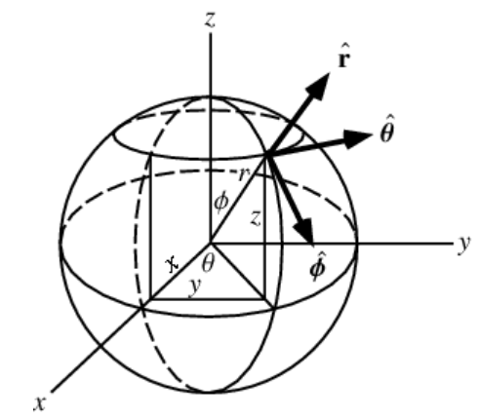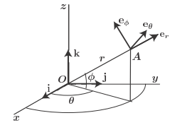
Two spherical angle conventions we do not use.

In the right picture, φ and θ might be longitude and latitude, or right ascension and declination.

If you are in charge of getting a spacecraft to Vulcan, please pay attention to these conventions.

E.2 Matrix Approach

The usual matrices for actively rotating a vector about the x, y, or z axis are these:

Rx(θ) = 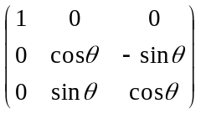 Ry(θ) = 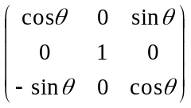 Rz(θ) = 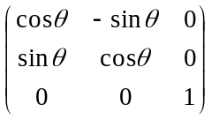 .
(E.2.1)
The Cartesian unit vectors , . can be rotated into the spherical unit vectors , , as follows

= Rz(φ) Ry(θ) = 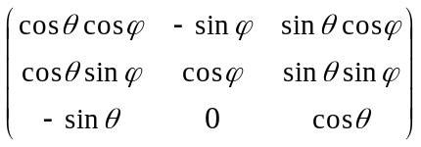$\left(\begin{matrix}1 \\ 0 \\ 0\end{matrix}\right)$ = $\left(\begin{matrix}cosθcosφ \\ cosθsinφ \\ -sinθ\end{matrix}\right)$ = •••

= Rz(φ) Ry(θ) = $\left(\begin{matrix}0 \\ 1 \\ 0\end{matrix}\right)$ = $\left(\begin{matrix}-sinφ \\ cosφ \\ 0\end{matrix}\right)$
= Rz(φ) Ry(θ) = $\left(\begin{matrix}0 \\ 0 \\ 1\end{matrix}\right)$ = $\left(\begin{matrix}sinθcosφ \\ sinθsinφ \\ cosθ\end{matrix}\right)$ . (E.2.2)

One can interpret the elements of the vectors on the right as dot products as s on the first line. Notice that these three vectors on the right are just the columns of the matrix shown, so one can say

( ) = = Rz(φ) Ry(θ) ≡ R . (E.2.3)

It is then obvious that

••••••••• = = Rz(φ) Ry(θ) = R (E.2.4)

from which one can read off any desired dot product. As verification, consider an example,

Example: • = • (R) = Σi ()i(R)i = Σij()iRij()j = Σijδ2iRijδ1j = R21.

Looking at the last equation of (E.2.2) multiplied by r, since r = r one sees that

x = rsinθcosφ
y = rsinθsinφ
z = rcosθ (E.2.5)

which is the "inverse transformation" associated with spherical coordinates. See Section E.4 below.

The three equations (E.2.2) can be trivially written out as follows (changing to a standard r,θ,φ order)

= sinθcosφ + sinθsinφ + cosθ
= cosθcosφ + cosθsinφ - sinθ
= -sinφ + cosφ (E.2.6)

which can be inverted to give

= sinθcosφ + cosθcosφ - sinφ
= sinθsinφ + cosθsinφ + cosφ
= cosθ - sinθ . (E.2.7)

For those not wanting to invert (transpose) the 3x3 matrix R, (E.2.7) can be quickly verified by looking at the unit vector dot products in (E.2.4). Eq. (E.2.6) can be similarly verified .

The spherical unit vectors are orthogonal due to their construction in (E.2.3).

Example: • = (R ) • (R ) = • (RTR) = • = 0

Example: • = (R ) • (R ) = • (RTR) = • = 1

Here R ≡ Rz(φ) Ry(θ) has the property RTR = 1 since it is a rotation. So

• = • = • = 0 . (E.2.8)

The spatial derivatives of the spherical unit vectors are easy to compute (∂θ means ∂/∂θ ),

∂r = 0 ∂θ = ∂φ = sinθ
∂r = 0 ∂θ = - ∂φ = cosθ
∂r = 0 ∂θ = 0 ∂φ = -sinθ -cosθ . (E.2.9)

Example: ∂θ = ∂θ $\left(\begin{matrix}cosθcosφ \\ cosθsinφ \\ -sinθ\end{matrix}\right)$ = $\left(\begin{matrix}-sinθcosφ \\ -sinθsinφ \\ -cosθ\end{matrix}\right)$ = - .

In Fig (E.1.1) one can see for example that ∂θ = . Often one draws a little triangle to verify an equation like this:
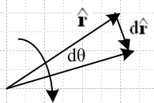 (E.2.10)

d = dr ≈ 1*dθ = dθ ⇒ d = dθ ⇒ = d/dθ = ∂θ .

Time derivatives of the unit vectors are then obtained by the chain rule ( ∂t means d/dt ),

∂t = + sinθ
∂t = – + cosθ
∂t = – sinθ – cosθ . (E.2.11)

Example: ∂t = (∂r) + (∂θ) + (∂φ) = 0 + + sinθ .

Note: If we regard r,θ,φ as coordinates of Frame S, then ∂t = (d/dt)S = ∂S as in Section 1.7 and 1.8.

The cross products of the spherical unit vectors follow the right hand rule, so looking at Fig (E.1.1):

x = x = x = (E.2.12)

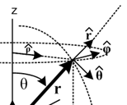

The first cross product has ordering r,θ,φ and the last two are cyclic permutations. Here are some other cross products:

x = [sinθcosφ + cosθcosφ - sinφ ] x = - cosθcosφ - sinφ
x = [sinθcosφ + cosθcosφ - sinφ ] x = sinθcosφ + sinφ
x = [sinθcosφ + cosθcosφ - sinφ ] x = -sinθ cosφ + cosθcosφ (E.2.13)

x = [ sinθsinφ + cosθsinφ + cosφ ] x = -cosθsinφ + cosφ
x = [ sinθsinφ + cosθsinφ + cosφ ] x = sinθsinφ - cosφ
x = [ sinθsinφ + cosθsinφ + cosφ ] x = - sinθsinφ + sinθsinφ (E.2.14)

x = [cosθ - sinθ ] x = sinθ
x = [cosθ - sinθ ] x = cosθ
x = [cosθ - sinθ ] x = -cosθ - sinθ (E.2.15)

E.3 The motion of a particle in spherical coordinates

The equations below are easily derived from (E.2.11):

r = r // position (E.3.1)

v = vr + vθ + vφ // velocity
vr =
vθ = r
vφ = r sinθ (E.3.2)

a = ar + aθ + aφ // acceleration
ar = - r2 – r 2 sin2θ
aθ = 2 + r - r 2 sinθ cosθ
aφ = 2 sinθ + 2 r cosθ + rsinθ . (E.3.3)

Example: v = = ∂t(r) = + r(∂t) = + r[ + sinθ ] = + r + rsinθ .

Notice that = r ≠ ar and similarly for other components.

If for some reason particle motion is restricted to a spherical surface of radius r (such as in our dumbbell satellite), we can set = = 0 in the above equations to get

r = r // position (E.3.4)

v = vθ + vφ // velocity is tangent to the sphere : r • v = 0
vθ = r
vφ = r sinθ (E.3.5)

a = ar + aθ + aφ // acceleration
ar = - r2 – r 2 sin2θ
aθ = r - r 2 sinθ cosθ
aφ = 2 r cosθ + rsinθ . (E.3.6)

From these equations many other useful results can be obtained, for example,

x v = vθ x + vφ x = vθ – vφ

x a = aθ x + aφ x = aθ – aφ (E.3.7)

E.4 Curvilinear coordinates approach

Spherical coordinates are defined by the "inverse transformation" on the left below:

inverse transformation transformation
x = rsinθcosφ r = +$\sqrt{x2+y2+z2}$ 0 ≤ r < ∞
y = rsinθsinφ cosθ = z/r 0 ≤ θ ≤ π -1 ≤ cosθ ≤ 1
z = rcosθ sinθ = +$\sqrt{1-(z/r)2}$ 0 ≤ sinθ ≤ 1
sinφ = y/(rsinθ) -1 ≤ sinφ ≤ 1
cosφ = x/(rsinθ) 0 ≤ φ < 2π -1 ≤ cosφ ≤ 1 (E.4.1)

We quote now a set of results from our Tensor document which won't be needed but which we include for completeness. Equation numbers (...)T refer to that document.

Spherical coordinates are just an example of curvilinear coordinates which fit into a general formalism:

x = (x1, x2, x3 ) = (x,y,z) // x-space coordinates
x' = (x1', x2',x3') = (r,θ,φ) // x'-space coordinates

x = F-1(x') ↔ x = rsinθcosφ // a non-linear inverse transformation
y = rsinθsinφ
z = rcosθ . (1.6)T

The linearized transformation local to a point defines certain R and S matrices (the "differentials") :
dx' = R(x) dx Rik(x) ≡ (∂x'i/∂xk) R = S-1 // dx'i = Rij dxj
dx = S(x') dx' Sik(x') ≡ (∂xi/∂x'k) S = R-1 // dxi = Sij dx'j . (2.1.6)T

S = $\left(\begin{matrix}sinθcosφ & rcosθcosφ & -rsinθsinφ \\ sinθsinφ & rcosθsinφ & rsinθcosφ \\ cosθ & -rsinθ & 0\end{matrix}\right)$ // compute from above definition of Sij (3.4.4)T

' = STS = $\left(\begin{matrix}1 & 0 & 0 \\ 0 & r2 & 0 \\ 0 & 0 & r2sin2θ\end{matrix}\right)$, det(') = r4sin2θ // metric tensor and its determinant (5.13.14)T

J(r,θ,φ) = det(S) = = r2sinθ . // Jacobian (5.13.16)T

(ds)2 = Σij'ij dx'i dxj = (dr)2 + r2(dθ)2 + r2sin2(dφ)2 // distance (5.13.18)T

Because the metric tensor ' is diagonal, the coordinates r,θ.φ are orthogonal.

Footnote: Above we use the temporary developmental notation of Tensor where all indices are down and covariant objects get an overbar. Some rules for conversion to the Standard Notation are these:

ij → gij covariant metric tensor i → vi covariant vector
gij → gij contravariant metric tensor vi → vi contravariant vector (dxi → dxi)
dx'i = Rij dxj → dx'i = Rij dxj

E.5 Polar Coordinates

Here we use a notation common for two of the cylindrical coordinates (ρ,φ,z),

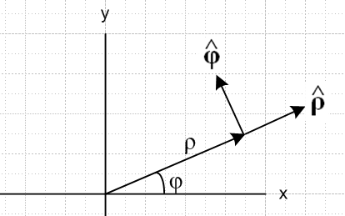 (E.5.1)

x = ρcosφ
y = ρsinφ (E.5.2)

= cosφ + sinφ = Rz(φ)
= -sinφ + cosφ = Rz(φ) (E.5.3)

= cosφ – sinφ = Rz(-φ)
= sinφ + cosφ = Rz(-φ) (E.5.4)

• = cosφ • = sinφ
• = -sinφ • = cosφ (E.5.5)

=
= - (E.5.6)

Proof of (E.5.6) :

= d/dt = d/dt(cosφ + sinφ ) = -sinφ + cosφ
= -sinφ [cosφ – sinφ ] + cosφ [ sinφ + cosφ ]
=

= d/dt = d/dt( -sinφ + cosφ ) = -cosφ - sinφ
= -cosφ [cosφ – sinφ ] - sinφ [ sinφ + cosφ ]
= -

E.6 The Affine Connection

Recall from above the claim that

∂r = 0 ∂θ = ∂φ = sinθ
∂r = 0 ∂θ = - ∂φ = cosθ
∂r = 0 ∂θ = 0 ∂φ = -sinθ -cosθ . (E.2.9) (E.6.1)

We wish to put these equations into a more general framework which is an extension of the discussion of Section E.4.

In the notation of our Tensor document, for an arbitrary curvilinear coordinate system x' the derivatives of the tangent base vectors (called en in that document) are written

∂'jen = ΣiΓ 'ijn ei . (E.6.2)

This just says that the change in a basis vector obtained by moving a small amount in some direction is (and of course must be) some linear combination of the basis vectors. The coefficients of the linear combination are known as the affine connection (or Levi-Civita connection) Γ 'cab = Γ 'cba. The reason for the primes is that Cartesian coordinates are thought of as x, while curvilinear ones of some particular type are x'. In Cartesian x-space one has Γcab = 0 because basis vectors don't vary with position in that space. Then Γ'cab is the affine connection in x'-space. For example, as noted in Section E.4, in spherical coordinates one has

x = (x1,x2,x3) = (x,y,z)
x' = (x'1,x'2,x'3) = (r,θ,φ) (E.6.3)

and the inverse transformation (E.2.5) is x = F-1(x'). As shown below, e1(x') = e1(r,θ,φ) = and then as an example of (E.6.2) we write (for j=2 and n=1, and the linear combination has only one non-zero term):

∂'2e1 = ∂x$_{2}$'e1 = ∂θe1(r,θ,φ) = ∂θ(r,θ,φ) = = (1/r)eθ = (1/r)e2 = Γ' 221 e2 = Γθθr eθ . (E.6.4)

The curvilinear unit basis vectors n are related to the tangent base vectors by n = (1/h'n) en where the h'n = |en| are the so-called scale factors. The derivatives of the n are then given by :

∂'jn = ∂'j(h'n-1en) = (∂'jh'n-1)en + h'n-1(∂'jen)

= - h'n-2 (∂'jh'n) en + h'n-1( ΣiΓ 'ijn ei)

= - h'n-1 (∂'jh'n) n + h'n-1( ΣiΓ 'ijn h'i i)

= (1/h'n) [Σi h'i Γ 'ijni – (∂'jh'n) n] . (E.6.5)

In Tensor the Cartesian basis vectors of x-space are called ui, but in this document they are called ei so we need a different symbol ei for the tangent base vectors. In Section 14 we use these ei with i as the unit tangent base vectors, ξ = (ξ1,ξ2,ξ3) in place of x' = (x'1,x'2,x'3), and Γ' = Γ with no prime since ξ has no prime (trying not to confuse Γ = 0 of x-space with Γ ≠ 0 of ξ-space). In this notation (E.6.5) would appear as

(∂n/∂ξj) = (1/hn) [Σi(hiΓ ijni) - (∂hn/∂ξj)n] . (E.6.6)

Going back to the Tensor notation, the affine connection for a coordinate system is related to the system's metric tensor g according to

Γdab = (1/2) gdc [ ∂abc + ∂bca – ∂cab] = 0 since ij = δij x-space (Cartesian)

Γ'dab = (1/2) g'dc [ ∂'a'bc + ∂'b'ca – ∂'c'ab] . x'-space (E.6.7)

For spherical coordinates, one has (using r,θ,φ = 1,2,3 where θ = polar, φ = azimuth)

1 2 3
hr = 1 hθ = r hφ = rsinθ // scale factors (h'1= hr)
er = eθ = r eφ = rsinθ // tangent base vectors (e1 = er)
r = θ = φ = // curvilinear unit basis vectors

'ab = $\left(\begin{matrix}1 & 0 & 0 \\ 0 & r2 & 0 \\ 0 & 0 & r2sin2θ\end{matrix}\right)$ g'ab = inverse('ab) // metric tensor (E.6.8)

where for example '33 = gφφ = r2sin2θ. For spherical coordinates only 9 of the 27 elements of Γ'dab are non-zero (computed from (E.6.7)) :

Γ' 122 = - r Γ' 212 = Γ' 221 = 1/r // notation example: Γ' 122 = Γrθθ
Γ' 133 = - r sin2θ Γ' 313 = Γ' 331 = 1/r
Γ' 233 = - cosθsinθ Γ' 323 = Γ' 332 = cotθ . (E.6.9)

Example done in Section 14 notation with (E.6.6) :

(∂n/∂ξj) = (1/hn) [Σi(hiΓ ijni) - (∂hn/∂ξj)n]

(∂3/∂ξ2) = (1/h3) [Σi(hiΓ i23i) - (∂h3/∂ξ2)3]

(∂/∂θ) = (1/rsinθ) [(h3Γ 3233) - (∂[rsinθ]/∂θ)3]

= (1/rsinθ) [(rsinθ * cotθ * ) - rcosθ * ]

= (1/rsinθ) [rcosθ - rcosθ ]

= 0 (E.6.10)

and with some effort we have verified that ∂θ = 0 as appears in (E.6.1). This fact is of course obvious just looking at Fig (E.1.1), but things can be less obvious in obscure coordinate systems.

Footnote : To be consistent with the Footnote at the end of Section E.4 we really should use j to indicate the derivative in (E.6.2) since it transforms as a covariant vector, but it just adds confusion to do so.

Appendix F : The Dumbbell (Tethered) satellite as an example of rotating frame analysis

Our main purpose is to use this interesting physical system to demonstrate Newton's Second Law in a non-inertial frame, both in the rotational sense (with fictitious torques) and the linear sense (with fictitious forces). Equations of motion are obtained in both spherical and Cartesian coordinates, and some numerical solutions are plotted using Maple, including those of libration.

This is a very long appendix (~ 50 pages) so we provide an overview.

Section F.1 lays out kinematic details of the coordinates we use and discusses simple geometric facts of the satellite. We use the "swap notation" wherein Frame S' is the inertial frame and Frame S is the rotating frame. The masses m1 and m2 can be equal or different.

Section F.2 computes the angular momentum L(0) of the satellite and its time derivative (0) in rotating Frame S where the origin of Frame S is used as a reference point.The effective Newton's rotational law in rotating Frame S is then stated.

Section F.3 computes the true torque N'(b) on the satellite due to the Earth's gravitational attraction acting on the two masses. The resulting torque is computed in inertial Frame S' and has only a component as shown in (F.3.7). This computation is done in two extra ways to verify the result. In the far approximation, the expression for N'(b) simplifies to that shown in (F.3.13).

Section F.4 then computes the fictitious torque which appears in rotating Frame S. This torque N(0)fict is stated in (F.4.11) and has and components. An interpretation is provided.

Section F.5 then uses "Newton's Angular Law" (0) = N'(b) + N(0)fict to obtain the angular equations of motion for the satellite as stated in (F.5.7) using the far approximation. Certain special-case solutions are extracted which demonstrate the notion of in-plane and out-of-plane small-θ libration of the satellite with frequencies given in (F.5.10) and (F.5.13).

Section F.6 basically starts over working only with forces, not torques. The two angular equations of motion obtained in Section F.5 are again obtained, and a third equation determines the tension T in the dumbbell stick. One can interpret this tension T as a tidal force acting on mass m1 which is distance r1 from the Frame S center of mass. An equal and opposite tidal force acts on mass m2 at the other end of the stick. When the satellite is vertically aligned, one finds T = 3m1 ω2r1 in (F.6.30). The tension T does not appear in the angular analysis of Section F.5 since T makes no contribution to torque about the Frame S origin, being aligned with the stick. Tension T is part of the radial force equation (F.6.19) of Section F.6, but there is no radial equation in Section F.5. There the stick is regarded just as a constraint, and it is typical for the forces of constraint not to be determined in the simplest analysis.

Section F.7 provides some Maple numerical solutions of the far-approximation θ,φ equations of motion of the satellite stated in (F.5.7). The two libration modes are verified, and a more general case is examined.

Section F.8 reworks the satellite force analysis entirely in Cartesian coordinates. The equations of motion for the variables x,y,z are shown in (F.8.15) with tension T provided by (F.8.20).

Section F.9 shows that the x,y,z equations of motion of Section F.8 are entirely equivalent to the θ,φ equations of motion of Section F.5.

Section F.10 examines various numerical solutions for the dumbbell satellite, working now in Cartesian coordinates. The libration modes are again examined, and a more general solution is studied. There is no "conical solution" as there is for the spherical pendulum.

F.1 Kinematics of the satellite in rotating Frame S

As with Appendix D, this section uses the "swap notation" described in the Summary for Section 1 where the rotating frame is Frame S and the non-rotating frame is Frame S'. This is done to reduce the number of primes since most activity will be in the rotating satellite Frame S.

We now place the dumbbell satellite in a more general orientation than it was in Appendix D :

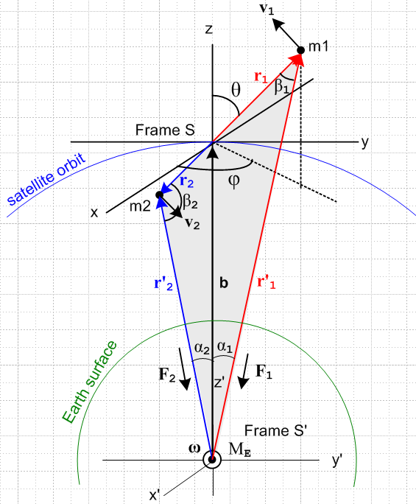 (F.1.1)

Description of the Figure

Half the battle is having a clear picture of what is going on and we shall expend many words to describe the above drawing. It shows the dumbbell satellite in orbit in a completely arbitrary orientation. The two masses m1 and m2 are connected by a massless stick (not shown) of length r1+r2 = s . If we find that this stick is always in tension for some situation, we can replace it in that situation with a non-stretching massless tether. If the stick were to go into compression, the replacement tether would lose its linear shape and we don't want to deal with that problem. As shown much later in Section F.10, the stick is always in tension for normal situations.
The gray-filled triangle is a part of the plane φ = constant which has normal vector . This plane is not in the plane of paper. The fill region contains two non-right triangles shown in blue and red. The red triangle is on the viewer's side of paper, while the blue one lies behind the paper. Each of these triangles contains the vector b as an edge.
Frame S' is an inertial frame whose center is the center of the Earth and which is assumed fixed with respect to the stars.
Frame S is a non-inertial frame whose center is located at the satellite center of mass point. We make the assumption discussed above (D.2.2) that we can ignore the tiny offset between the center of mass and center of gravity of the satellite, so we then regard the Frame S origin as travelling in a circular orbit around the Earth. Recall from (D.3.16) that this offset is about 3 cm for s = 1 km.
At time t = 0 shown in the figure, the axes of both Frames align with each other. At any time, axes y,z and y',z' are in the plane of paper. The unit vector always points from the center of the Earth to the origin of Frame S. so b = b at any time. The axes x,x' always point directly out of the plane of paper so = ' .
The orbital rotation vector ω = ω also points out of the plane of paper and recall that ω = 2π/T where T is about 88 minutes for a low-Earth orbit. We have in mind an orbit at any altitude, but we do assume a circular orbit.
The circled dot at the bottom is the center of the Earth (mass ME) and we have drawn the Earth surface in green. The blue circle is the orbit of the center of mass of the satellite (the Frame S origin) and it lies in the plane of paper. Note that ω is for the orbit and has nothing whatsoever to do with the rotation of the Earth. The above picture is the same whether or not the Earth rotates at its 24 hour ωE rate about some obscure E axis (not shown).
One could treat the satellite as a rigid body (Appendix I) or perhaps as a reduced-mass single-particle system as is done for planetary orbits, but this would obscure details we want to be visible. We really have here a 3-body problem where the three bodies are point masses, but there is a constraint (the stick), so perhaps it is a 2 1/2-body problem. If the dumbbell were treated as a rigid object, it is then a 2-body problem where one body is not a point mass.

Naming of coordinates

In Frame S mass m1 has spherical coordinates (r1,θ1,φ1) while mass m2 has coordinates (r2,θ2,φ2). The reader is now forewarned about our upcoming slipshod notation. We define (θ,φ) ≡ (θ1,φ1). Thus Fig (F.1.1) shows θ,φ and not θ1,φ1. The three unit vectors of spherical coordinates for mass m1 will always be called , , and never 1, 1, 1.
These spherical coordinates are in the "physics" convention: angle θ is the polar angle down from the "vertical" z axis, φ is the azimuthal angle measured from the x axis toward the y axis. See Appendix E.1 regarding conventions.
Because r1 and r2 are collinear, we know that θ2 = π -θ and φ2 = π + φ. Since the Frame S origin is the center of mass, we also know that r2 = (m1/m2)r1. Our strategy is to avoid the subscript-2 coordinates whenever possible and express everything in terms of the mass m1 coordinates (r1,θ,φ).
The mass m2 unit vectors are related to the m1 unit vectors by 2 = - , 2 = + , and 2 = - . Each unit vector points toward increasing parameter value for its associated mass. To see these last relations, it helps to stare at Fig (F.1.1) and temporarily think of the gray triangle as being in the plane of paper. We shall only make use of 2 = - below. See Appendix E regarding the unit vectors , and .

To summarize :

r1 = [x1,y1,z1] = (r1,θ,φ) = coordinates of mass m1 velocity = v1
r2 = [x2,y2,z2] = (r2,θ2,φ2) = coordinates of mass m2 velocity = v2

θ2 = π-θ φ2 = φ+π r2 = (m1/m2) r1 2 = - 1 = - . (F.1.2)

In Frame S mass m1 is constrained to lie on a sphere of radius r1, while mass m2 is constrained to lie on a sphere of radius r2. The picture assumes m1 < m2 so r1 > r2. If m1 lies at a point on its sphere, m2 lies on the inverse point but on its sphere, as the spherical coordinates above show. If the masses are the same, the two spheres coincide.
Due to these constraints on the vectors r1 and r2, the corresponding velocity vectors v1 and v2 of the two masses must be tangential to their respective spheres. Thus, for example, for mass m1 we can write

v1 = v1θ + v1φ , whereas r1 = r1 . (F.1.3)

Some Basic Kinematic Facts

The internal angles of the red triangle are β1, α1 and π-θ at the Frame S origin. Thus we know from a Law of Cosines that

r'12 = b2 + r12 - 2br1cos(π-θ) = b2 + r12 + 2br1cosθ .

The internal angles of the blue triangle are β2, α2 and θ at the Frame S origin. Thus,

r'22 = b2 + r22 - 2br2cosθ .

The three Laws of Sines for the two triangles tells us that

$\frac{sinβ1}{b}$ = $\frac{sinα1}{r1}$= $\frac{sin(π-θ)}{r1'}$ = $\frac{sinθ}{r1'}$ // red triangle

$\frac{sinβ2}{b}$ = $\frac{sinα2}{r2}$= $\frac{sinθ}{r'2}$ . // blue triangle

Looking at the drawing it is clear that b + r1 = r'1 and b + r2 = r2', so one can write

r'2 - r2 = r'1 - r1 = b .

Recall the center of mass condition from (D.2.8) that

m1r1 = - m2r2 ⇒ m1r1 = m2r2 , r2/r1 = m1/m2 , 2 = – . (D.2.8)

Applying the Frame S time derivative ∂S gives similar results for r → v and r → a, see below (velocity and acceleration).

Summary:

r'12 = b2 + r12 + 2br1cosθ (F.1.4)
r'22 = b2 + r22 - 2br2cosθ (F.1.5)

$\frac{sinβ1}{b}$ = $\frac{sinα1}{r1}$ = $\frac{sinθ}{r1'}$ // red triangle (F.1.6)
$\frac{sinβ2}{b}$ = $\frac{sinα2}{r2}$= $\frac{sinθ}{r'2}$ // blue triangle (F.1.7)

r'2 - r2 = r'1 - r1 = b r'1 = b + r1 r'2 = b + r2 (F.1.8)

m1r1 = - m2r2 ⇒ m1r1 = m2r2 , r2/r1 = m1/m2 , 2 = – 1 (F.1.9)

m1v1 = - m2v2 ⇒ m1v1 = m2v2 , v2/v1 = m1/m2 , 2 = – 1 (F.1.10)

m1a1 = - m2a2 ⇒ m1a1 = m2a2 , a2/a1 = m1/m2 , 2 = – 1 (F.1.11)

F.2 Angular momentum of the satellite and its time derivative in Frame S

Our upcoming path is to obtain the equations of motion for the satellite in terms of θ, φ coordinates. As a demonstration of the method of Section 11.3 we shall do this first using Newton's rotational second law with fictitious torques. Later in Section F.6 we will do this again using Newton's linear second law with fictitious forces as a demonstration of the method of Section 8.1.

For angular momentum (and later torque) we take our reference point to be c = 0 in Frame S (the origin) and thus c' = b in Frame S'. Then (we show all detail in this first calculation),

L(0) = r1 x p1 + r2 x p2 = m1 r1 x v1 + m2 r2 x v2 // dim = ML2/T

= m1r1 x v1 + m2[-(m1/m2)r1] x [-(m1/m2)v1] // (F.1.9) and (F.1.10)

= m1r1 x v1 + [m1r1] x [(m1/m2)v1] = m1{ r1 x v1 + (m1/m2) r1 x v1 }

= m1[ 1 + (m1/m2) ] r1 x v1 = m1[ (m2+m1)/m2 ] r1 x v1

= (m1/m2) M r1 x v1 = (m1/m2) Mr1 x v1 // M ≡ m1+m2 (F.2.1)

= (m1/m2) Mr1 x (v1θ + v1φ) = (m1/m2) Mr1 [ v1θ x + v1φ x ] // (F.1.3)

= (m1/m2) M r1 (v1θ – v1φ ) // (E.2.12)

= (m1/m2) M r12 ( – sinθ ) . // (E.3.5) dim=ML2/T

The dumbbell has no angular momentum around the axis which seems very reasonable since it consists of two point masses aligned with . (A real tethered satellite has non-point masses and one could imagine undesired torsion oscillation being a problem.)

Taking a ∂S time derivative gives the rate of change of angular momentum in Frame S (all variables here are the "natural" ones in Frame S ),

(0) = ∂S{ (m1/m2) M r1 x v1 } // (F.2.1)

= (m1/m2) M (v1 x v1 + r1 x a1 )

= (m1/m2) Mr1 ( x a1 ) = (m1/m2) Mr1 x [ ar + aθ + aφ ] // (E.3.6)

= (m1/m2) Mr1 [ aθ - aφ ] // (E.2.12) and then (E.3.6) for next line

= (m1/m2) Mr12 [ (- 2 sinθ cosθ) – (2 cosθ + sinθ) ] .

Here are the conclusions so far:

L(0) = (m1/m2) M r12 ( – sinθ ) (F.2.2)

(0) = (m1/m2) Mr12 [ (- 2 sinθ cosθ) – (2 cosθ + sinθ) ] . (F.2.3)

One obvious statement can be made looking at these equations: there is no angular momentum about the axis and this vanishing angular momentum never changes.

The equation of motion for the satellite within Frame S is given by (11.3.4), but converted to swap notation,

N(0)eff = (0) . (11.3.4)s (F.2.4)

Our next task then is to compute the total effective torque on the satellite in Frame S which from (11.3.5)
is (again converted to swap notation),

N(0)eff = N'(b) + N(0)fict . (11.3.5)s (F.2.5)

Here N'(b) is the Frame S' torque on the satellite relative to point b in Frame S', and N(0)fict is the fictitious torque that arises because Frame S is a rotating frame of reference.

F.3 The torque on the satellite in Frame S'

The torque (in Frame S') of the Earth on the satellite (relative to the Frame S origin) is given by

N'(b) = r1 x F1 + r2 x F2 // dim = L2 M /T2 (F.3.1)

where all four of these vectors are shown in Fig (F.1.1). Recall from (D.2.13) that

F1 = - (GMEm1/r'12) '1 = - (GMEm1/r'13) r'1 F1 ≡ |F1| = (GMEm1/r'12)
F2 = - (GMEm2/r'22) '2 = - (GMEm2/r'23) r'2 F2 ≡ |F2| = (GMEm2/r'22) . (F.3.2)

// The stick tension T exerts no torque on the satellite masses since T is collinear with r1 and r2.

Therefore,

r1 x F1 = r1 x [ - (GMEm1/r'13) r'1 ] = - (GMEm1/r'13) r1 x r'1

r2 x F2 = r2 x [ - (GMEm2/r'23) r'2 ] = - (GMEm2/r'23) r2 x r'2 . (F.3.3)

Using (F.1.8) we evaluate the cross products making use of the first line of (E.2.15) for x ,

r1 x r'1 = r1 x (b + r1) = r1 x b = r1b x = r1b (-sinθ ) = -r1bsinθ

r2 x r'2 = r2 x (b + r2) = r2 x b = [-r2] x [b] = -r2b x = -r2b(-sinθ ) = r2bsinθ . (F.3.4)

Then inserting (F.3.4) into (F.3.3),

r1 x F1 = (GMEm1/r'13) r1b sinθ (F.3.5)

r2 x F2 = - (GMEm2/r'23) r2bsinθ

= - (GMEm1/r'23) r1bsinθ . // (F.1.9) (F.3.6)

Thus the Earth's torque on the satellite in Frame S' is,

N'(b) = r1 x F1 + r2 x F2 = (GMEm1/r'13) r1b sinθ - (GMEm1/r'23) r1bsinθ

= (GMEm1br1sinθ) [1/r'13 - 1/r'23] . (F.3.7)

Note that this equation uses r1 and r2 and not r'1 and r'2 because the torque reference point is point b.

We can confirm the two torque contributions by computing them geometrically from Fig (F.1.1) using these right-hand-rule helper drawings:

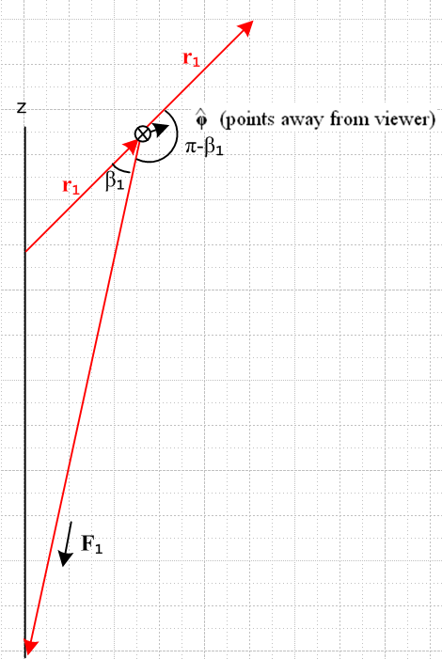 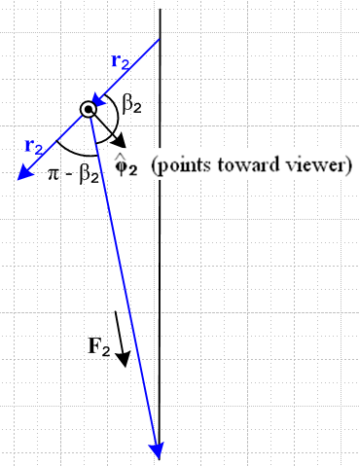 (F.3.8)

Then:

r1 x F1 = r1F1 sin(π-β1) = r1F1sinβ1 = r1F1(bsinθ/r'1) // (F.1.6) then (F.3.2)

= r1(GMEm1/r'12)(bsinθ/r'1) = (GMEm1/r'13) r1b sinθ // agrees with (F.3.5)

r2 x F2 = r2F2 sin(π-β2) 2 = r2F2 sinβ2 2 = r2F2 sinβ2 [ - ]

= r2F2 (bsinθ/r'2) [ - ] = r2(GMEm2/r'22) (bsinθ/r'2) [ - ] // (F.1.7) and (F.3.2)

= r1(GMEm1/r'22) (bsinθ/r'2) [ - ] // (F.1.9)

= - (GMEm1/r'23) r1bsinθ // agrees with (F.3.6)

where we have used the fact that 2 = - 1 = - .

There is a third way to compute the above torque, based on the torque theorem (D.1.3) which says that N(R) = N(0) - R x F . In our current context of working in Frame S' this reads

N'(b) = N'(0) - b x F . (F.3.9)

The torque N'(0) relative to the Frame S' origin is exactly 0

N'(0) = r' x F1 + r'2 x F2 = 0 + 0 = 0

since r'1 is collinear with F1 and r'2 is collinear with F2 as shown in Fig (F.1.1). We should include the stick tension/compression T, but (r'1 - r'2) x T = (r1 - r2) x T = 0 - 0 = 0 so T can be ignored. Thus we find from (F.3.9) that

N'(b) = - b x (F1+ F2) = - b x[ - (GMEm1/r'13) r'1 - (GMEm2/r'23) r'2 ]

= (GMEm1/r'13) b x r'1 + (GMEm2/r'23) b x r'2

= (GMEm1/r'13) (r'1-r1) x r'1 + (GMEm2/r'23) (r2' - r2) x r'2 // (F.1.8)

= - (GMEm1/r'13) r1 x r'1 - (GMEm2/r'23) r2 x r'2

= - (GMEm1/r'13)[-r1bsinθ ] - (GMEm2/r'23) [ r2bsinθ ] // (F.3.4) then (F.1.9)

= (GMEm1br1sinθ) [1/r'13 - 1/r'23] (F.3.10)
in agreement with (F.3.7).

Here are some quick checks on (F.3.10) :

• If the satellite is vertically aligned, θ = 0,π, then sinθ=0 and N'(b) = 0 as expected (no moment arms).

• If the satellite is horizontally aligned and m1= m2, then r'1 = r'2 so N'(b) = 0 (balanced moment arms).

• If m2> m1, then r2< r1 so for horizontal alignment one has r'2<r'1 so [ (1/r'13) - (1/r'23) ] < 0. Then if m1 is on the right, we have θ = π/2 and sinθ = 1 and then (F.3.10) has N(b) = -(positive). But for this orientation = 1 = - so N(b) = (positive) :

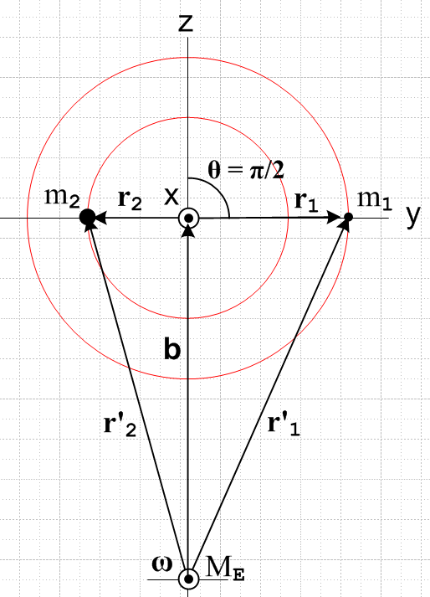 (F.3.11)

In this case the lever arms balance in the sense that m2r2 = m1r1, but m2 is closer to Earth center so it feels the stronger force and so we expect N'(b) = (positive) .

Far Approximation

If we now assume as before that r1',r'2,b >> r1, r2 we can approximate [ (1/r1'3) - (1/r'23) ] by adding on to the Maple code shown in (D.3.5) to get

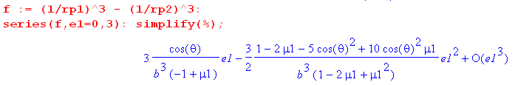

where recall e1 = ε1 ≡ (r1/b). This time there is a leading linear term in ε1 so

(1/r'13) - (1/r'23) ≈ 3 $\frac{cosθ}{b3(-μ2)}$(r1/b) = - 3r1cosθ/ (μ2b4) . (F.3.12)

Installing this result into (F.3.7) gives

N'(b) = GMEm1b r1sinθ [ (1/r'13) - (1/r'23)] (F.3.7)

≈ - GMEm1b r1sinθ ( 3r1cosθ/ (μ2b4) )

= - 3GME(m1/μ2) b-3r12sinθcosθ . (F.3.13)

To this order of approximation, the torque N(b) vanishes when the satellite is horizontally aligned as well as when it is vertically aligned, and this is due to r1' ≈ r'2 in the horizontal case.

F.4 The fictitious torque on the satellite in Frame S

Recall the general fictitious torque expression given in (11.3.10), acting on a single particle of mass m,

N'(c')fict = - (r'-c') x [ mS +mω x (ω x r') + 2m ω x v' + m x r' ]
+ m(' + ω x c' + S) x ( v' + ω x r' + S) – m' x v' . (11.3.10)

Converted to swap notation this says,

N(c)fict = - (r-c) x [ mS' +mω x (ω x r) + 2m ω x v + m x r ]
+ m( + ω x c + S') x ( v + ω x r + S') – m x v . (11.3.10)s (F.4.1)

Here ω is the angular rotation rate of the satellite about the Earth.

Our application has the torque center at c = 0 (and c' = b) so this simplifies somewhat to

N(0)fict = - mr x [ S' +ω x (ω x r) + 2 ω x v + x r] + S' x ( mv + ω x [mr] ) . (F.4.2)
frame centrifugal Coriolis Euler

Recall from (8.1.8) that the square bracket in the above is - Ffict/m so we can trace the origin of the terms.

Now write (F.4.2) separately for each of the two masses of the satellite :

N(0)f,1 = - m1r1 x [ S' + ω x (ω x r1) + 2ω x v1 + x r1] + S' x ( m1v1 + ω x[m1r1])
N(0)f,2 = - m2r2 x [ S' + ω x (ω x r2) + 2ω x v2 + x r2] + S' x ( m2v2 + ω x [m2r2]) . (F.4.3)

In the second line, use (F.1.9) to replace m2r2 = - m1r1 and (F.1.10) to replace m2v2 = - m1v1 :

N(0)f,2 = + m1r1 x [ S' + ω x (ω x r2) + 2ω x v2 + x r2] + S' x ( -m1v1 + ω x [-m1r1]) . (F.4.4)

Next, add the two torques to get the total fictitious torque on the satellite seen in Frame S,

N(0)fict = N(0)f,1 + N(0)f,2

= - m1r1 x [ S' + ω x (ω x r1) + 2ω x v1 + x r1] + S' x ( m1v1 + ω x[m1r1])
+ m1r1 x [ S' + ω x (ω x r2) + 2ω x v2 + x r2] + S' x ( -m1v1 + ω x [-m1r1])

= - m1r x { ω x (ω x [r1- r2]) + 2ω x [v1-v2] + x [r1- r2] }
centrifugal Coriolis Euler

= - m1r x { ω x (ω x [r1 + $\frac{m1}{m2}$r1]) + 2ω x [v1 + $\frac{m1}{m2}$v1] + x [r1 + $\frac{m1}{m2}$r1] }

= - m1 (1+$\frac{m1}{m2}$) r1 x { ω x (ω x r1) + 2ω x v1 + x r1 }

= - $\frac{m1}{m2}$M r1 x { ω x (ω x r1) + 2ω x v1 + x r1 } . (F.4.5)

All terms involving S' and S' have cancelled out. For the Earth orbit we have = 0 and ω = ω.

Now consider this vector identity:

C x [A x (A x C)] = C x [ (A•C)A - A2C ] = (A•C) C x A = – (A•C) A x C . (F.4.6)

Then

r1 x [ ω x (ω x r1) ] = – (ω•r1) (ω x r1)

= - ω2r12 ( • )( x ) // use (E.2.4) for • and (E.2.13) for x

= - ω2r12 ( sinθcosφ )(- cosθcosφ - sinφ )

= ω2r12 sinθcosφ (cosθcosφ + sinφ ) . (F.4.7)

Next, the Coriolis term in (F.4.5) involves,

r1 x (ω x v1) = (r1•v1)ω - (r1•ω)v1 // A x (B x C) = (A•C)B - (A•B)C . (F.4.8)

But v1 is tangent to the radius-r1 sphere to which m1 is constrained, so (r1•v1) = 0. Then

r1 x (ω x v1) = - (r1•ω)v1 = - r1ω (•)v1 = - r1ω sinθcosφ v1 . (F.4.9)

We now have this somewhat complicated expression for N(0)fict :

N(0)fict = - (m1/m2)M r1 x [ ω x (ω x r1) + 2ω x v1 ]

= - (m1/m2)M { r1 x [ω x (ω x r1)] + 2 r1 x (ω x v1) }

= - (m1/m2)M { ω2r12 sinθcosφ [ cosθcosφ + sinφ ] - 2r1ω sinθcosφ v1 } (F.4.10)
centrifugal Coriolis
Now using (E.3.5),

v1 = v1θ + v1φ = r1 + r1 sinθ (E.3.5)

we then have,
centrifugal Coriolis
N(0)fict = - (m1/m2)M{ω2r12sinθcosφ [cosθcosφ + sinφ ] - 2r1ω sinθcosφ (r1 + r1 sinθ ) }

= - (m1/m2)M { (ω2r12 sinθcosφsinφ - 2r12ωsinθcosφ)
+ (ω2r12 sinθcosφ cosθcosφ - 2r12ωsinθcosφsinθ ) }

= - (m1/m2)M { ωr12 sinθ cosφ (ωsinφ -2) +ωr12sinθcosφ (ω cosθ cosφ - 2sinθ ) }

= - (m1/m2)Mωr12sinθcosφ [ (ωsinφ -2) + (ω cosθ cosφ - 2sinθ ) ] . (F.4.11)

How might one interpret this simple result?

We examine the pieces of N(0)fict= 0 as they appear in (F.4.11). Terms involving velocities and arise from the Coriolis term, the other terms come from the centrifugal term.

(a) the "frame effects" due to the motion of b (S' and S') are equal and opposite for the two masses because the origin of Frame S is at the center of mass causing m2r2 = - m1r1, as shown in (F.1.9).

(b) within Frame S, the (F.4.5) centrifugal acceleration term ω x (ω x r1) = -ω2r1 tries to push m1 to a larger radius. But r1 is constrained to lie on a sphere of radius r1 so m1 cannot go to a larger radius. This centrifugal acceleration is neutralized by part of the tension in the stick which we avoided talking about.
This centrifugal term, by the way, involves "the short vector" r1 and not the long vector r'1. We discussed this situation in Section 8.2 for an Earth-based Frame S'. In our current context, the picture that corresponds to Fig (8.2.10) is the following

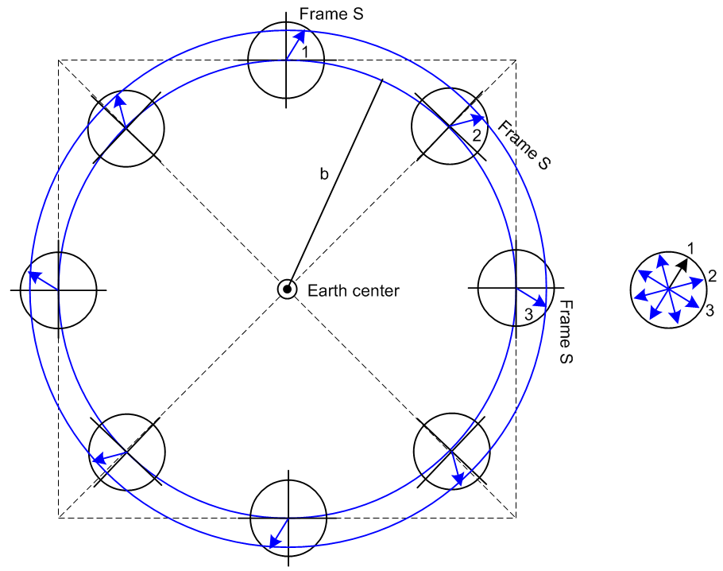 (F.4.12)

The arrow in each location during the orbit represents the position vector r1 of mass m1 where we assume that other effects are turned off so r1 stays fixed in Frame S. When these arrows are transferred to the picture on the right with common tails, we see that the tip of r1 does in fact go around in a circle of radius r1 and that is why the corresponding centrifugal force acting on m1 is -ω2r1 .

(c) Within Frame S, the Coriolis force - 2m1 ω x v1 tries to deflect mass m1 "to the right" in Fig (F.1.1). But again, r1 is constrained to lie on a sphere of radius r1 so m1 cannot deflect to a different radius. This Coriolis force is neutralized by the rest of the tension in the stick.

F.5 Equations of Motion for the satellite in Frame S (Spherical Coordinates)

After much effort, we have arrived at this set of results for the satellite :

L(0) = (m1/m2) M r12 ( – sinθ ) (F.2.2)

(0) = (m1/m2) Mr12 [ (- 2 sinθ cosθ) – (2 cosθ + sinθ) ] . (F.2.3)

N(b) = (GMEm1br1sinθ) (1/r'13 - 1/r'23) (F.3.7)

r'12 = b2 + r12 + 2br1cosθ (F.1.4)
r'22 = b2 + r22 - 2br2cosθ (F.1.5)

N(0)fict = - (m1/m2)Mωr12 sinθcosφ [ (ωsinφ -2) + (ω cosθ cosφ - 2sinθ ) ] . (F.4.11)

Using the orbit equation (8.6.7) applied to the satellite,

GME = ω2b3 , // larger b means smaller ω (F.5.1)

we can rewrite the true torque above as

N'(b) = (ω2b4m1r1sinθ) (1/r'13 - 1/r'23) . (F.5.2)

Writing (0) = N'(b) + N(0)fict then gives the satellite vector equation of motion,

(m1/m2) Mr12 [ (- 2 sinθ cosθ) – (2 cosθ + sinθ) ]

= (ω2b4m1r1sinθ) (1/r'13 - 1/r'23)

- (m1/m2)Mωr12 sinθcosφ [ (ωsinφ -2) + (ω cosθ cosφ - 2sinθ ) ] . (F.5.3)

Divide all three terms by the factor (m1/m2)Mr12. The coefficient of the first term on the right becomes

(ω2b4m1r1sinθ) / [ (m1/m2)Mr12] = (1/r1) (ω2b4(m2/M)sinθ)

so the vector equation of motion is then,

[ (- 2 sinθ cosθ) – (2 cosθ + sinθ) ]

= (1/r1)(ω2b4μ2sinθ) (1/r'13 - 1/r'23)

- ωsinθcosφ [ (ωsinφ -2) + (ω cosθ cosφ - 2sinθ ) ] . (F.5.4)

Using now the far approximation (F.3.12) that (1/r'13) - (1/r'23) = -3r1cosθ/ (μ2b4), we get

[ (- 2 sinθ cosθ) – (2 cosθ + sinθ) ]

= -3ω2sinθcosθ
- ωsinθcosφ [ (ωsinφ -2) + (ω cosθ cosφ - 2sinθ ) ] . (F.5.5)

As a reminder, the first line above is (0), the second line is true torque N'(b), and the last line is the fictitious torque N(0)fict created by the fact that Frame S is a rotating frame of reference, and we display the fictitious contributions in blue to keep track of them for a while below.

Comment: Notice that the equation of motion is independent of m1 and m2 and hence of r1 and r2. If we were to vary the ratio m1/m2, we just "slide the stick" in Fig (F.1.1) so the Frame S origin remains at the center of mass point. The equation does depend on b through ω, since ω2 = GME/b3.

Moving all terms to the left side, (F.5.5) becomes

(- 2 sinθ cosθ) – (2 cosθ + sinθ) (F.5.6)
+ 3ω2sinθcosθ + ωsinθcosφ (ωsinφ -2) + ωsinθcosφ (ω cosθ cosφ - 2sinθ ) = 0 .

The component equations are then

- 2 sinθ cosθ + 3ω2sinθcosθ + ωsinθcosφ (ω cosθ cosφ - 2sinθ ) = 0 //
– (2 cosθ + sinθ) + ωsinθcosφ (ωsinφ -2) = 0 //

where the fictitious torque terms are shown in blue. Changing the sign of the second equation and making a few adjustments we get,

+ sinθcosθ(3ω2 - 2) + ωsinθcosφ (ω cosθ cosφ - 2sinθ ) = 0 //
+ 2 cotθ – ωcosφ (ωsinφ -2) = 0 // (F.5.7)

After much effort using the fictitious torque method we have finally arrived at the spherical equations of motion for the dumbbell satellite!

These are two ordinary differential equations with time t as the variable. The equations are 2nd order in both θ(t) and φ(t) and they are non-linear due to terms like and 2 and sinθ. Finally, the equations are coupled, so they form a system of two 2nd order, coupled, non-linear ODE's. This system of two non-linear 2nd order ODE's can be trivially replaced with an equivalent system of four non-linear 1st order ODE's as follows,

θ + sinθcosθ(3ω2 - 2) + ωsinθcosφ (ω cosθ cosφ - 2sinθ ) = 0 //
φ + 2 cotθ – ωcosφ (ωsinφ -2) = 0 //
= vθ
= vφ (F.5.8)

We mention this only because this is the first step Maple takes (internally) when it sets about solving a pair of 2nd order ODE's with its numerical dsolve command (coming soon).

Right now, we make an ansatz that (F.5.7) has a solution for which φ = π/2 (so cosφ = 0) and φ does not change, so that both and = 0 at all times. For such a solution, the dumbbell lies in the plane of paper of Fig (F.1.1) (in the plane of the orbit) and the only Frame S motion is in the θ degree of freedom. In this case the two equations in (F.5.7) simplify to

+ 3ω2sinθcosθ = 0 //
0 = 0 . // in-plane // (F.5.9)

For small θ, the first equation becomes

+ 3ω2θ = 0

which indicates sinusoidal oscillation in θ of the dumbbell about θ = 0 with frequency ωosc2 = 3ω2 so

ωosc1 = $\sqrt{3}$ω Tosc1 = (1/$\sqrt{3}$) T ≈ 0.58 T // in-plane libration (F.5.10)

where recall that ω is the orbital rotation rate of the satellite. For a low-Earth orbit with T = 88 minutes, the dumbbell initialized to φ = π/2 and a small angle θ would have an oscillation period of 88*.58 = 51 minutes.
Next we look for a solution with φ = = 0 where the satellite at t = 0 is in a plane perpendicular to the plane of paper in Fig (F.1.1) (perp to the orbit plane). In this case the equations (F.5.7) become,

+ 3ω2sinθcosθ + ωsinθ(ω cosθ) = 0 //
sinθ – ωsinθ ( -2) = 0 //
or
+(2ω)2sinθcosθ = 0 //
+2ω = 0 . // out-of-plane // (F.5.11)

For small angles θ we have then

+(2ω)2θ = 0 //
= -2ω . // (F.5.12)

The first equation implies θ oscillation at frequency

ωosc2 = 2ω Tosc2 = 0.5T // out-of-plane libration (F.5.13)

while the second equation shows that the dumbbell cannot remain very long at φ = 0 since ≠ 0, so this oscillation solution is only a temporary solution and the dumbbell is not stable in the plane φ = 0.

Both libration frequencies appear on page 126 of Cosmo and Lorenzini with a reference (on C&L p 169) to the following item,

2. Beletskii, V. V. and Levin, E. M., "Dynamics of Space Tether Systems", Advances in the
Astronautical Sciences , Vol. 83. (Univelt, Inc. 1993)

Reader Exercise: Is the in-plane libration solution stable against small perturbations?

F.6 Force analysis of the satellite in Frame S (Spherical Coordinates)

Having obtained the dumbbell satellite θ,φ equations of motion in (F.5.7) using the fictitious torques method. we now set out to rederive these same equations using Newton's linear second law with fictitious forces. This time we also obtain an expression for the stick tension T which enables us to comment on the tidal forces for a static satellite positioned at θ = 0.

Obtain the three equations of motion

The only true forces on a dumbbell mass are gravity and stick tension T. From (F.3.2) we then write

F'1 = - (GMEm1/r'13) r'1 - T 1 = - (GMEm1/r'13)( b + r1) - T 1
F'2 = - (GMEm2/r'23) r'2 - T 2 = - (GMEm2/r'23)( b + r2) - T 2 . (F.6.1)

As noted earlier, the center of gravity is not quite at the center of mass in Fig (F.1.1), but the above equations are exact despite this fact. The forces are primed because they are forces in the inertial Frame S'. The reader is reminded that we are using the "swap notation" where prime↔noprime relative to the non-swap notation.
In order to use Newton's Law in rotating Frame S, we must include the fictitious forces. We translate the result of (8.1.8) to swap notation to obtain

Ffict,1 ≈ – m1S' – m1ω x (ω x r1) – 2m1 ω x v1 – m1 x r1
Ffict,2 ≈ – m2S' – m2ω x (ω x r2) – 2m2 ω x v2 – m2 x r2 . (F.6.2)
frame centrifugal Coriolis Euler

In these equations, the b acceleration is given by the swap version of (7.13) which then states

S' = x b + ω x (ω x b) . // Special Case #1 (7.13)s (F.6.3)

and the vectors b and ω are given as in Fig (F.1.1) by

ω = ω
b = b . (F.6.4)

Finally we may state Newton's Law for each mass,

Feff,1 = m1 a1 (F.6.5)
≈ - (GMEm1/r'13)r'1 - T 1 – m1S' – m1ω x (ω x r1) – 2m1 ω x v1 – m1 x r1

Feff,2 = m2a2 (F.6.6)
≈ - (GMEm2/r'23)r'2 - T 2 – m2S' – m2ω x (ω x r2) – 2m2 ω x v2 – m2 x r2

where we have now a set of six scalar equations. Using (F.1.9) through (F.1.11), (F.6.6) can be rewritten,

Feff,2 = - m1a1 (F.6.7)
≈ - (GMEm2/r'23)r'2 + T 1 – m2S' + m1ω x (ω x r1) + 2m1 ω x v1 – m1 x r1 .

Adding (F.6.5) and (F.6.7) gives

0 = - (GMEm1/r'13) r'1 - (GMEm2/r'23)r'2 - (m1+m2)S'
or
(m1+m2)S' = - (GMEm1/r'13) r'1 - (GMEm2/r'23)r'2 (F.6.8)
This equation is just F = ma in inertial Frame S' for the total satellite where b is the center of mass. Ignoring the small offset between center of mass and center of gravity, the three equations (F.6.8) describe the circular orbit of the satellite around the Earth. We may then regard the equation (F.6.5) as a set of three scalar equations for the three unknowns θ,φ and T where recall r1 = (r1,θ,φ) in the spherical coordinates of Fig (F.1.1).

Our next task is to write vector equation (F.6.5) in spherical coordinates to obtain the three equations of motion. After expanding the left side, we then consider the right side of (F.6.5) one term at a time:

Feff,1 = m1 a1 (F.6.5)
≈ - (GMEm1/r'13)r'1 - T 1 – m1S' – m1ω x (ω x r1) – 2m1 ω x v1 – m1 x r1
1 2 3 4 5 6

Left side of (F.6.5): m1 a1 = m1(ar + aθ + aφ ) (E.3.6)

= m1r1[( - 2 - 2 sin2θ) 1 + ( - 2 sinθ cosθ) + (2 cosθ + sinθ) ] (F.6.9)

Term 1: - (GMEm1/r'13)r'1 = - (GMEm1/r'13)(b + r1) // (F.1.8)

= - (GMEm1/r'13)(b + r1) // (F.6.4)

= - (GMEm1/r'13)(bcosθ 1 - b sinθ + r1) // (E.2.7)

= - (GMEm1/r'13)[ (bcosθ +r1) 1 - b sinθ ] (F.6.10)

Term 2: - T 1 as is (F.6.11)

Term 3: – m1S' = – m1 x b - m1 ω x (ω x b) // (F.6.3)

= - m1ω x (ω x b) // satellite in circular orbit, = 0

= - m1(ω•b)ω + m1ω2b //- A x (A x C) = -(A•C)A + A2C

= m1ω2b = m1ω2b // (F.6.4)

= m1ω2b [ cosθ 1 - sinθ ] // (E.2.7) (F.6.12)

Term 4: – m1ω x (ω x r1) = -m1(ω•r1)ω + m1ω2r1 // identity shown above

= -m1ω2r1(•1) + m1ω2r1 1 // (F.6.4)

= -m1ω2r1sinθcosφ + m1ω2r1 1 // (E.2.4))

= -m1ω2r1sinθcosφ[sinθcosφ 1 + cosθcosφ - sinφ ] + m1ω2r1 1 // (E.2.7)

= - m1ω2r1 [ (sin2θcos2φ - 1) 1 + (sinθcosθcos2φ) + (- sinθcosφsinφ) (F.6.13)

Term 5: -2m1 ω x v1 = -2m1 [ω] x ( vθ + vφ) // (E.3.5)

= -2m1ω [vθ x + vφ x ]

= -2m1ω [vθ (sinθcosφ + sinφ 1)+ vφ(-sinθ cosφ + cosθcosφ 1)] // (E.2.13)

= -2m1ω [ (vθsinφ + vφcosθcosφ)1 + (-vφsinθ cosφ) + (vθsinθcosφ) ]

= -2m1ωr1 [ ( sinφ + sinθ cosθcosφ)1 + (- sin2θ cosφ) + ( sinθcosφ) ] // (E.3.2)
(F.6.14)

Term 6: – m1 x r1 = 0 because we assume = 0 (F.6.15)

Having all the bits and pieces, we now assemble the three component equations of (F.6.5).

Feff,1 = m1 a1 (F.6.5)
≈ - (GMEm1/r'13)r'1 - T 1 – m1S' – m1ω x (ω x r1) – 2m1 ω x v1 – m1 x r1
1 2 3 4 5 6
1: m1r1( - 2 - 2 sin2θ) = - (GMEm1/r'13)(bcosθ +r1) - T + m1ω2b cosθ - m1ω2r1(sin2θcos2φ - 1)
1 2 3 4
- 2m1ωr1 ( sinφ + sinθ cosθcosφ) (F.6.16)
5
: m1r1 ( - 2 sinθ cosθ) = + (GMEm1/r'13) b sinθ - m1ω2bsinθ
1 3
- m1ω2r1 sinθcosθcos2φ + 2m1ωr1 sin2θcosφ (F.6.17)
4 5
: m1r1(2 cosθ + sinθ) = + m1ω2r1sinθcosφsinφ - 2m1ωr1( sinθcosφ) (F.6.18)
4 5

We now rewrite the three equations dividing by m1 and using (F.5.1) that GME = ω2b3 :

1: r1( - 2 - 2 sin2θ) = - ( ω2b3/r'13)(bcosθ +r1) - T/m1 + ω2b cosθ - ω2r1(sin2θcos2φ - 1)
- 2ωr1 ( sinφ + sinθ cosθcosφ) (F.6.19)

: r1 ( - 2 sinθ cosθ) = + (ω2b3/r'13) b sinθ - ω2bsinθ
- ω2r1 sinθcosθcos2φ + 2ωr1 sin2θcosφ (F.6.20)

: (2 cosθ + sinθ) = + ω2sinθcosφsinφ - 2ω( sinθcosφ) (F.6.21)

If one uses (F.1.4) that r'12 = b2 + r12 + 2br1cosθ in (F.6.20), the pair of equations (F.6.20) and (F.6.21) can in theory be solved for θ(t) and φ(t), given appropriate initial conditions. The solutions can then be inserted into (F.6.19) to obtain a result for the stick tension T(t).

Verify the angular equations of motion

We can rewrite(F.6.21) as

: sinθ + 2 cosθ - ωsinθcosφ (ωsinφ - 2) = 0 (F.6.22)

which matches the torque equation (F.5.7),

sinθ + 2 cosθ – ωsinθcosφ (ωsinφ -2) = 0 . // (F.5.7)

Next, the equation (F.6.20) may be rewritten

r1 ( - 2 sinθ cosθ) = + (ω2b3/r'13) b sinθ - ω2bsinθ - ω2r1 sinθcosθcos2φ + 2ωr1 sin2θcosφ
or
r1 ( - 2 sinθ cosθ) = +ω2bsinθ [(b/r'1)3 - 1] - ω2r1 sinθcosθcos2φ + 2ωr1 sin2θcosφ
or
- 2 sinθ cosθ = +ω2bsinθ [(b/r'1)3 - 1]/r1 - ω2sinθcosθcos2φ + 2ω sin2θcosφ . (F.6.23)

Now assume the far approximation where r'1, b >> r. Recall that

r'12 = b2 + r12 + 2br1cosθ

(r'1/b)2 = 1 + (r1/b)2 + 2(r1/b)cosθ

(r'1/b)3 = [ 1 + (r1/b)2 + 2(r1/b)cosθ ]3/2

(b/r'1)3 = [ 1 + (r1/b)2 + 2(r1/b)cosθ ]-3/2 ≈ 1 + (-3/2) [(r1/b)2 + 2(r1/b)cosθ ]

≈ 1 + (-3/2) 2(r1/b)cosθ = 1 - 3(r1/b)cosθ
so
[(b/r'1)3 - 1] ≈ - 3(r1/b)cosθ . (F.6.24)

Then (F.6.23) becomes

- 2 sinθ cosθ = +ω2bsinθ [- 3(r1/b)cosθ]/r1 - ω2sinθcosθcos2φ + 2ω sin2θcosφ
or
- 2 sinθ cosθ = -3ω2sinθcosθ - ω2sinθcosθcos2φ + 2ω sin2θcosφ
or
- 2 sinθ cosθ + 3ω2sinθcosθ + ω2sinθcosθcos2φ -2ω sin2θcosφ = 0
or
+ 3ω2sinθcosθ - 2 sinθ cosθ + ωsinθcosφ(ωcosθcosφ - 2sinθ) = 0 (F.6.25)

which matches the torque equation (F.5.7),

+ 3ω2sinθcosθ - 2 sinθ cosθ + ωsinθcosφ (ω cosθ cosφ - 2sinθ ) = 0 // (F.5.7)

At this point we have derived the same angular equations of motion (F.5.7) in two different ways.

Obtaining the tension in the stick (or tether)

Finally we come to the 1 equation (F.6.19),

1: r1( - 2 - 2 sin2θ) = - ( ω2b3/r'13)(bcosθ +r1) - T/m1 + ω2b cosθ - ω2r1(sin2θcos2φ - 1)
- 2ωr1 ( sinφ + sinθ cosθcosφ) . (F.6.19)

Inserting the far approximation (F.6.24) that (b/r'1)3 ≈ 1 - 3(r1/b)cosθ into the above gives

r1( - 2 - 2 sin2θ) = -ω2[1 - 3(r1/b)cosθ] (bcosθ +r1) - T/m1 + ω2b cosθ - ω2r1(sin2θcos2φ - 1)
- 2ωr1 ( sinφ + sinθ cosθcosφ)

r1( - 2 - 2 sin2θ) = -ω2(bcosθ +r1) + 3ω2(r1/b)cosθ(bcosθ +r1) - T/m1 + ω2b cosθ
- ω2r1(sin2θcos2φ - 1) - 2ωr1 ( sinφ + sinθ cosθcosφ)

r1( - 2 - 2 sin2θ) = -ω2bcosθ - ω2r1 + 3ω2r1cosθ(cosθ +r1/b) - T/m1 + ω2b cosθ
- ω2r1sin2θcos2φ + ω2r1 - 2ωr1 ( sinφ + sinθ cosθcosφ)

r1( - 2 - 2 sin2θ) = 3ω2r1cosθ(cosθ +r1/b) - T/m1 - ω2r1sin2θcos2φ - 2ωr1( sinφ + sinθ cosθcosφ)

( - 2 - 2 sin2θ) ≈ 3ω2cos2θ - T/(m1r1) - ω2sin2θcos2φ - 2ω( sinφ + sinθ cosθcosφ)

( - 2 - 2 sin2θ) ≈ ω2(3cos2θ -sin2θcos2φ) - T/(m1r1) - 2ω( sinφ + sinθcosθcosφ) .

The stick tension is then given by (this will later be verified in Section F.9),

T = m1r1[ ω2(3cos2θ - sin2θcos2φ) + 2 + 2 sin2θ - 2ω( sinφ + sinθcosθcosφ) ] . (F.6.26)

If the angular velocities are very small such that | | << ω and | | << ω, the result becomes

T ≈ m1ω2r1(3cos2θ - sin2θcos2φ) . // small velocities (F.6.27)

In Cartesian coordinates this becomes,

T ≈ (m1ω2/r1)(3r12cos2θ- r12sin2θcos2φ)

= (m1ω2/r1)(3z2-x2) . // small velocities (F.6.28)

In this small-velocity limit, the tension in the stick is positive as long as

|x| < $\sqrt{3}$|z| ⇒ T > 0 // small velocity limit (F.6.29)

so for small x displacements T is always positive.

As noted, in general one must solve (F.6.20) and (F.6.21) for θ(t) and φ(t), then (F.6.26) gives T(t).

Tidal Force

If the dumbbell is static at θ = 0, we see from (F.6.26) or (F.6.27) that

T = 3m1ω2r1 (F.6.30)

which we associated with a "tidal force". The factor of 3 arises from (F.6.24) which in turn arises from the power 3 in the gravitational force factor in (F.6.1),

(GMEm1/r'13) = (ω2b3 m1/r'13) = ω2m1 (b/r'1)3 .

It happens that in Frame S' the gradient of the radial gravitational field at mass m1 is

∂r$_{1}$'(-GMEm1/r'12) = ∂r1'(-ω2b3m1/r'12) = -ω2b3m1 ∂r1' (r'1-2) = 2ω2b3m1/r'13

= 2ω2m1(b/r'1)3 (F.6.31)

so one can associate the factor of 3 in (F.6.30) with this gradient. However, the result (F.6.30) really comes from a sum of several terms in (F.6.5) for a static dumbbell, as we now review (the 1 equation):

Feff,1 = m1 a1 (F.6.5)
≈ - (GMEm1/r'13)r'1 - T 1 – m1S' – m1ω x (ω x r1) – 2m1 ω x v1 – m1 x r1
1 2 3 4 5 6
1: m1r1( - 2 - 2 sin2θ) = - (GMEm1/r'13)(bcosθ +r1) - T + m1ω2b cosθ - m1ω2r1(sin2θcos2φ - 1)
1 2 3 4
- 2m1ωr1 ( sinφ + sinθ cosθcosφ) (F.6.16)
5
m1r1( 0 - 0) = - (GMEm1/r'13)(b +r1) - T + m1ω2b - m1ω2r1(0 - 1) - 2m1ωr1 (0 + 0)
1 2 3 4 5

0 = - m1(ω2b3/r'13)(b +r1) - T + m1ω2b + m1ω2r1
1 2 3 4

0 = {- m1ω2[1 - 3(r1/b)](b +r1)} - T + m1ω2b + m1ω2r1
1 2 3 4

0 = { - m1ω2 - m1ω2b +3m1ω2r1 } - T + m1ω2b + m1ω2r1
1 2 3 4

0 = 3m1ω2r1 - T (F.6.32)
1,3,4 2

Thus in rotating Frame S the expression (F.6.30) for the tidal force T has contributions from the gravitational gradient (term 1) and from the "frame" term – m1S (term 3) which is the centrifugal contribution due to the acceleration of Frame S toward the Earth, and finally from the "local centrifugal term" – m1ω x (ω x r1) (term 4).

F.7 Numerical solutions of the equations of motion (Spherical Coordinates)

The angular equations of motion for mass m1 of the dumbbell (or tether) satellite are stated in (F.5.7) which we replicate here,

+ sinθcosθ(3ω2 - 2) + ωsinθcosφ (ω cosθ cosφ - 2sinθ ) = 0
+ 2 cotθ – ωcosφ (ωsinφ -2) = 0 . (F.5.7) (F.7.1)

The first step is to enter these two equations into Maple:

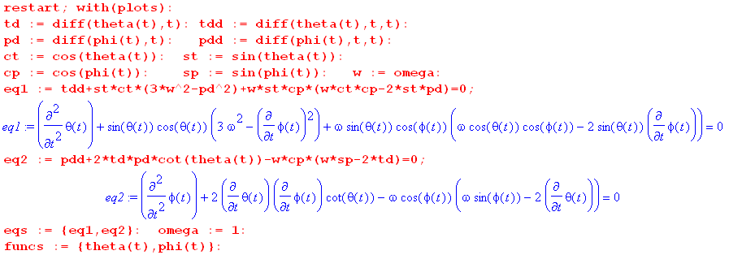
(F.7.2)
For illustration purposes we have set the satellite orbit frequency to ω = 1 sec-1 so

ω = 1 ⇒ T = 2π = 6.28 sec

Verification of in-plane libration

The initial conditions are taken to be ( see Fig (F.1.1) to see that φ = π/2 is the in-plane situation )

θ = 0.2 φ = π/2 = 0 = 0.01 . (F.7.3)

Here θ = 0.2 = 11.5o is a fairly small angle. We now call Maple's ODE solver routine dsolve and plot 40 times θ(t) in red and Mod2Pi(φ) in black. The peaks of the red curve are thus at 40*.2 = 8. Without this mod routine, the black φ curve just winds up without limit.

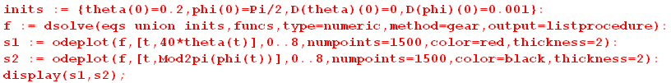
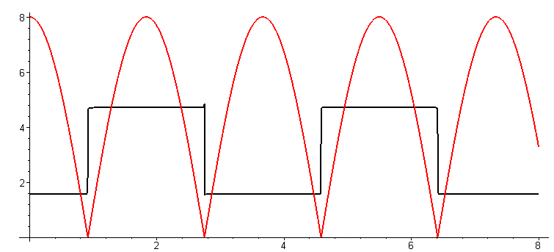 (F.7.4a)
red = 40*θ black = Mod2p(φ)

Rather than plot a cosine wave, dsolve keeps θ positive all the time and has φ jump by π each time the solution passes through θ = 0. In spherical coordinates the figure shows the expected θ curve! In order to avoid exactly hitting θ = 0 which is a singular point in spherical coordinates (φ is undefined there), we have added a small = .001 to cause the dumbbell to slightly miss the z axis. One can see from the second equation in (F.7.1) that the numerical integrator is faced with = 2 cotθ + stuff, and cotθ blows up at θ = 0 (and generates an error message in odeplot). We can expand the region t = (2,4) :

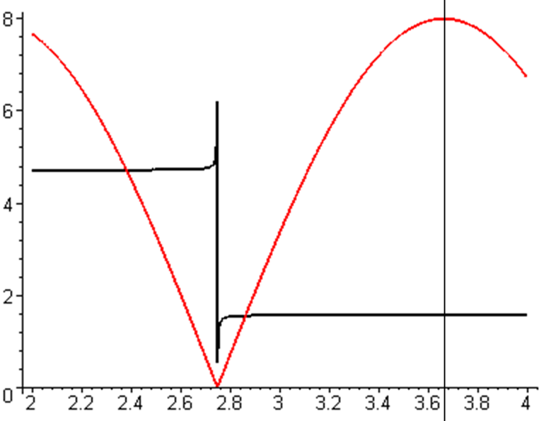 (F.7.4b)

From (F.5.10) for in-plane libration one predicts,

Tocs1 = T/$\sqrt{3}$ = 6.28/1.73 = 3.63 sec (F.7.5)

and this value is verified by the vertical line in the above figure (each tick is .04)

Verification of out-of-plane libration

The initial conditions are now taken to be

θ = 0.2 φ = 0 = 0 = 0 (F.7.6)

We then rerun the above code with a different set of "inits" :

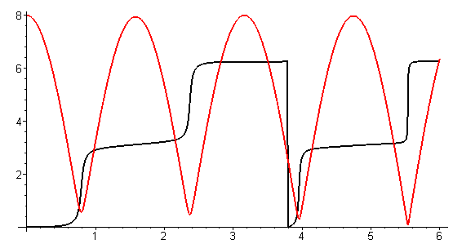 (F.7.7a)

Now the swing misses θ = 0 of its own accord. One can see that the black φ curve starts moving away from φ = 0 at about t = 0.5 and in general the black φ curve has smooth rises near small θ. We again expand the region t = (2,4) :

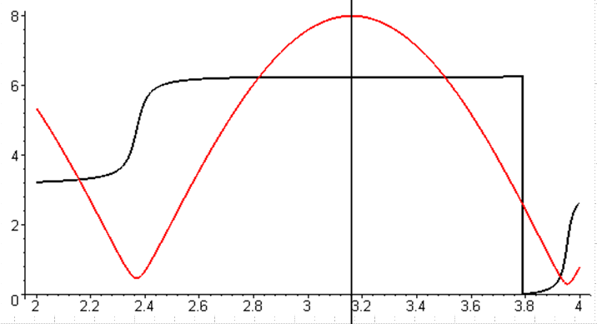 (F.7.7b)

From (F.5.13) for out-of-plane libration one predicts,

Tocs2 = T/2 = 6.28/2 = 3.14 (F.7.8)

while the figure shows about 3.16, close enough.

Maple can also plot (t) and (t) and here is a plot showing all four curves :

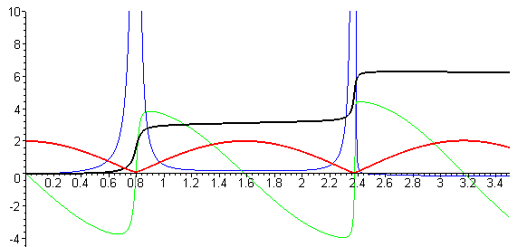 (F.7.9)
red = 10*θ black = φ green = 10* blue =

When red θ nears θ = 0, blue has major action since φ is quickly changing by π. And the green of spherical coordinates has to make a radical change since it is in effect suddenly reversing course.

A more general solution

Here in addition to starting with θ(0) = 0.2 and φ(0) = 0, we provide a push in the azimuthal direction so that mass m1 of the dumbbell satellite then swings around in azimuth while it oscillates in θ :

θ = 0.2 φ = 0 = 0 = 2 . (F.7.10)

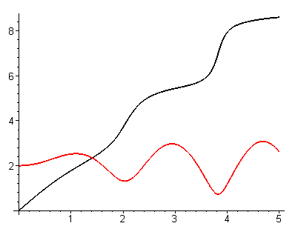 (F.7.11)

Notice that the black azimuthal velocity slows down near the peaks of red θ(t). Energy is transferred back and forth between the θ and φ degrees of freedom in this system.

One can use the same odeplot routine used above to make "orbital" plots in angle space,

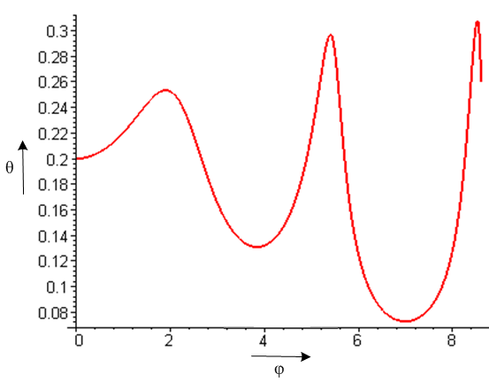 (F.7.12)

Rather than produce more plots here, we shall defer to Section F.9 where we shall plot x(t) and y(t) instead of θ(t) and φ(t).

F.8 Force analysis of the satellite in Frame S (Cartesian Coordinates)

Section F.6 used the force analysis to develop equations of motion for the dumbbell satellite in spherical coordinates. Here we repeat that development but in Cartesian coordinates where things are in many ways simpler. We follow Section F.6 down Newton's Law (F.6.5) ,

Feff,1 = m1 a1 (F.6.5) (F.8.1)
≈ - (GMEm1/r'13)r'1 - T 1 – m1S' – m1ω x (ω x r1) – 2m1 ω x v1 – m1 x r1 .
1 2 3 4 5 6

As a reminder, this is Newton's Law (Feff = ma) for mass m1 of the satellite in Frame S where fictitious forces are included. Although this mass has coordinate r1 in Frame S, we shall refer to its components without 1 subscripts, so r1 = (x,y,z). This is similar to how we used r1 = (r1,θ,φ) in spherical coordinates where θ and φ had implied "1" subscripts. We also write v1 = v and a1 = a to reduce clutter. The quantity T is the tension in the stick (or tether).

We now evaluate the six terms of (F.8.1) in Cartesian coordinates, mimicking (F.6.9) through (F.6.14):

Left side of (F.8.1): m1a1 = m1a = m1(ax + ay + az ) (F.8.2)

Term 1: - (GMEm1/r'13)r'1 = - (GMEm1/r'13)(b + r1)

= - (GMEm1/r'13) [ b + x + y + z ]

= - (GMEm1/r'13) [ x + y + (b+z) ] (F.8.3)

Term 2: - T 1 = -(T/r1)r1 = -(T/r1) [ x + y + z] (F.8.4)

Term 3: – m1S' = – m1 x b - m1 ω x (ω x b) // (F.6.3)

= - m1ω x (ω x b) // satellite in circular orbit, = 0

= - m1(ω•b)ω + m1ω2b //- A x (A x C) = -(A•C)A + A2C

= m1ω2b = m1ω2b (F.8.5)

Term 4: – m1ω x (ω x r1) = -m1(ω•r1)ω + m1ω2r1 // identity shown above

= -m1ω2(•r1) + m1ω2r1 = -m1ω2(x) + m1ω2 [ x + y + z]

= m1ω2 [ y + z] (F.8.6)

Term 5: -2m1 ω x v1 = -2m1 [ω] x ( vx + vy + vz)

= -2m1ω [ vy - vz] (F.8.7)

Term 6: – m1 x r1 = 0 because we assume = 0 (F.8.8)

Having all the bits and pieces, we now assemble the three component equations of (F.8.1). The numbers show the Term above associated with each piece:

Feff,1 = m1 a (F.8.1)
≈ - (GMEm1/r'13)r'1 - T 1 – m1S' – m1ω x (ω x r1) – 2m1 ω x v1 – m1 x r1
1 2 3 4 5 6

: m1 ax = - (GMEm1/r'13) x - (T/r1)x
1 2
: m1 ay = - (GMEm1/r'13) y - (T/r1)y + m1ω2y + 2m1ωvz
1 2 4 5
: m1 az = - (GMEm1/r'13) (b+z) - (T/r1)z + m1ω2b + m1ω2z - 2m1ω vy (F.8.9)
1 2 3 4 5

We now rewrite the three equations dividing by m1 and using (F.5.1) that GME = ω2b3 . At the same time we replace velocity and acceleration components with dot notation components like and :

= - [(ω2b3/r'13) + (T/m1r1)]x

= - [(ω2b3/r'13) + (T/m1r1) - ω2]y + 2ω

= - [(ω2b3/r'13) - ω2] (b+z) - (T/m1r1)z - 2ω

x2+y2+z2 = r12 (F.8.10)

where

r'12 = (r1+b)2 = r12 + b2 + 2 r1• b = r12 + b2 + 2 r1• [b] = r12 + b2 + 2bz . (F.8.11)

Eq. (F.8.10) is a system of 4 equations in 4 unknowns x,y,z,T. To simplify manipulations below, define

A ≡ (ω2b3/r'13)
B ≡ (T/m1r1) // rescaled tension

so the system of equations becomes

1 = - (A + B)x

2 = - (A + B - ω2)y + 2ω

3 = - (A - ω2) (b+z) - Bz - 2ω

4 x2+y2+z2 = r12 . (F.8.12)

We now wish to eliminate the rescaled tension B from the equation set. We first eliminate B between equations 1 and 2 :

1*y y = - (A + B)xy

2*x x = - (A + B - ω2)xy + 2ωx .

Subtract so that the -(A + B)xy terms cancel,

y - x = -ω2xy - 2ωx . (F.8.13)

Next, we eliminate B between equations 1 and 3:

1*z z = - (A + B)xz

3*x x = - (A - ω2)(b+z)x - Bxz - 2ωx

= -Abx -Azx +ω2(b+z)x - Bxz - 2ωx

= - (A + B)xz - Abx +ω2(b+z)x - 2ωx .

Subtract so that the -(A + B)xy terms cancel,

z - x = Abx -ω2(b+z)x + 2ωx . (F.8.14)

We now have a system of 3 equations in three unknowns x,y,z, where we now restore A = (ω2b3/r'13)

1 y - x = - ω2xy - 2ωx

2 z - x = (ω2b3/r'13)bx - ω2(b+z)x + 2ωx where r'12 = r12 + b2 + 2bz

3 x2+y2+z2 = r12 . (F.8.15)

For convenience, we now reorder and rename equations 1 and 2 of this set as follows:

eq3 z - x = (ω2b3/r'13)bx - ω2(b+z)x + 2ωx

eq2 y - x = - ω2xy - 2ωx . (F.8.16)

Now apply the far approximation in equation eq3. From (F.6.24) we know that

[(b/r'1)3 - 1] ≈ - 3(r1/b)cosθ . (F.6.24)
so
(b/r'1)3 ≈ 1 - 3(z/b) // z = r1cosθ
and
A ≡ (ω2b3/r'13) ≈ ω2[1 - 3(z/b) ] . (F.8.17)

Equation eq3 above then becomes,

z - x = (ω2b3/r'13)bx - ω2(b+z)x + 2ωx

= ω2[1 - 3(z/b) ]bx - ω2(b+z)x + 2ωx = ω2bx - 3(z/b)ω2bx - ω2bx - ω2zx + 2ωx

= - 3(z/b)ω2bx - ω2zx + 2ωx = - 3ω2xz - ω2zx + 2ωx

= - 4ω2xz + 2ωx . (F.8.18)

This in the far approximation the equations of motion of mass m1 of the dumbbell satellite are

eq3 z - x = - 4ω2xz + 2ωx

eq2 y - x = - ω2xy - 2ωx

x2+y2+z2 = r12 . (F.8.19)

Once these three equations are solved for x(t), y(t) and z(t), we can find the tension T(t) from (say) the first equation of (F.8.12) :

/x +A+B = 0 ⇒ B = - /x - A ⇒ (T/m1r1) = - /x - (ω2b3/r'13)
so
T = - m1r1[ /x + (ω2b3/r'13) ]
so
T = - m1r1[ /x + ω2 ] . // far approximation (F.8.17) (F.8.20)

F.9 Verification of the Cartesian equations of motion and stick tension

In Section C.7 we showed that the x,y,z Foucault pendulum equations of motion were the same as the θ,φ ones. Here we repeat that task for the dumbbell satellite equations of motion. We do these verifications to strengthen our confidence in all the equations since there are not many external sources for verification. A trusting reader can just skip this section.

First, here are the satellite angular equations of motion from (F.5.7),

eq1 + sinθcosθ(3ω2 - 2) + ωsinθcosφ (ω cosθ cosφ - 2sinθ ) = 0
eq2 + 2cotθ – ωcosφ (ωsinφ -2) = 0 . (F.5.7) (F.9.1)

These were derived in (F.5.7) using the effective torque method and were then verified using the effective force method in (F.6.22) and (F.6.25).

Meanwhile, here are the Cartesian equations of motion from Section F.8,

eq3 z - x = - 4ω2xz + 2ωx
eq2 y - x = - ω2xy - 2ωx . (F.8.19) (F.9.2)

Below we shall show that

Task (a): eq2 of (F.9.2) ⇒ eq2 of (F.9.1)

Task (b): [(sinθ)*eq3 - (cosθsinφ)*eq2] of (F.9.2) ⇒ eq1 of (F.9.1)

That is to say, angular eq1 of (F.9.1) is a certain linear combination of eq3 and eq2 of (F.9.2). If we can show Task (a) and Task (b) above, then we have shown that (F.9.2) ⇔ (F.9.1), and this then serves as verification of (F.9.2).

Maple must replace x,y,z and derivatives with r1,θ,φ and derivatives. For coordinates and first derivatives,

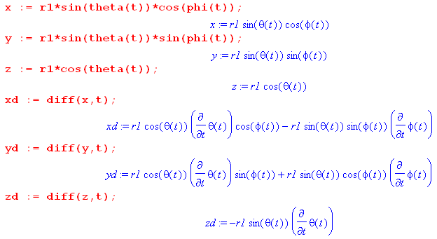 (F.9.3)
The second derivatives are messier, but Maple is happy to do the calculations,

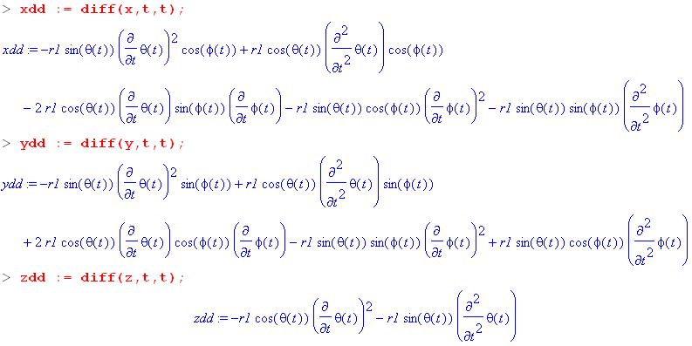 (F.9.4)

Task (a): Show that eq2 of (F.9.2) ⇒ eq2 of (F.9.1)

We enter eq2 of (F.9.2) and do some manipulations, suppressing the output except for the last step :

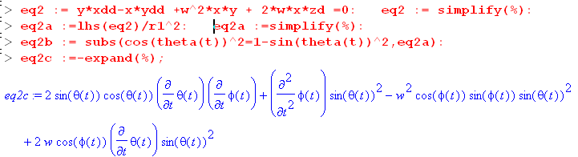 (F.9.5)

On the first red code line we enter eq2 of (F.9.2) and then divide the result by r12. We then replace occurrences of cos2θ by 1-sin2θ. We use lhs = "left hand side" so we end up only with the left side of an equation which says stuff = 0. Symbol % refers to the last computed quantity. The blue result can be manually transcribed as

2sinθcosθ + sin2θ - ω2sin2θ cosφsinφ + 2ωsin2θ cosφ = 0 .

Now divide by sin2θ and reorder the four terms to get

+ 2cot(θ) - ω2cosφsinφ + 2ωcosφ = 0
or
+ 2cot(θ) - ωcosφ(ωsinφ - 2) = 0 (F.9.6)

This is a match for eq2 of (F.9.1) so we have accomplished Task (a).

Task (b): (sinθ)eq3 - (cosθsinφ)eq2 of (F.9.2) ⇒ eq1 of (F.9.1)

The code continues from that shown above. Equation eq2 is already entered, so we now enter eq3, form the linear combination for eq1, then process the results with a series of typical tortuous Maple steps,

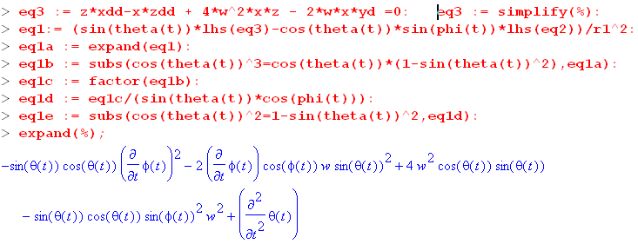 (F.9.7)

We again manually transcribe the result

-sinθcosθ 2 - 2ωsin2θcosφ +4ω2sinθcosθ - ω2sinθcosθsin2φ +
or
-sinθcosθ 2 - 2ωsin2θcosφ +3ω2sinθcosθ +ω2sinθcosθ - ω2sinθcosθsin2φ +
or
+ sinθcosθ 3ω2 -sinθcosθ 2 + ω2sinθcosθ - ω2sinθcosθsin2φ - 2ωsin2θcosφ
or
+ sinθcosθ( 3ω2 - 2) + ω2sinθcosθ(1-sin2φ) - 2ωsin2θcosφ
or
+ sinθcosθ( 3ω2 - 2) + ω2sinθcosθcos2φ - 2ωsin2θcosφ
or
+ sinθcosθ( 3ω2 - 2) + ωsinθcosφ (ω cosθ cosφ - 2sinθ ) (F.9.8)

and after "pulling teeth" we do end up with a match for eq1 of (F.9.1), so Task (b) is accomplished.

Tension equation verification

Using the angular equations of motion (F.9.1), we now show that the following two tension expressions are the same (the first is angular (F.6.26) while the second is Cartesian (F.8.20)) ,

T/(m1r1) = ω2(3cos2θ - sin2θcos2φ) + 2 + 2 sin2θ - 2ω( sinφ + sinθcosθcosφ) (F.6.26)
T/(m1r1) = - [ /x + ω2 ] . (F.8.20) (F.9.9)

Our task of showing (F.9.9) is the same as showing that

x [ω2(3cos2θ - sin2θcos2φ) + 2 + 2 sin2θ - 2ω( sinφ + sinθcosθcosφ) ] = - - ω2x
or
x [ω2(3cos2θ - sin2θcos2φ + 1) + 2 + 2 sin2θ - 2ω( sinφ + sinθcosθcosφ) ] = -
or
LHS = RHS . (F.9.10)

We first get the complicated left hand side LHS entered:

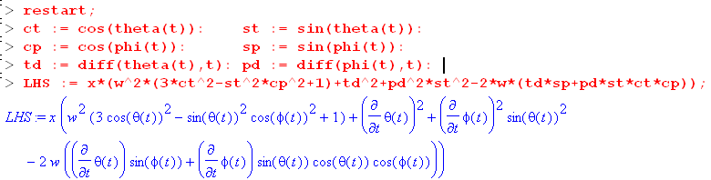
(F.9.11)
We then compute RHS = - as done earlier in this section,

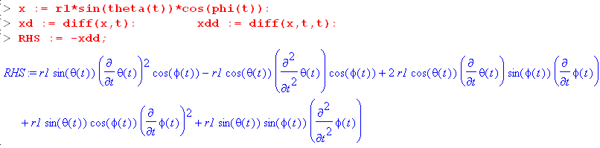
(F.9.12)
Notice that RHS contains second derivatives and . We shall eliminate these derivatives by manually solving the angular equations of motion (F.9.1) for Tdd = and Pdd = :

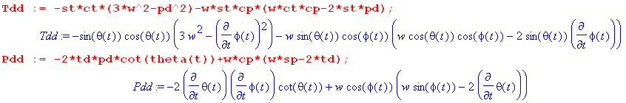

To show that LHS = RHS, we define d = LHS-RHS and show that d = 0:
(F.9.13)
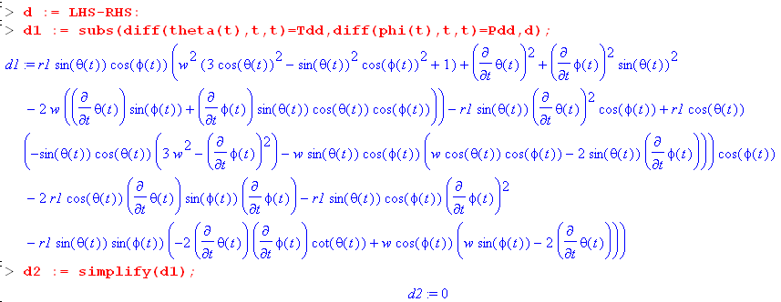
(F.9.14)
Thus d = 0 and LHS = RHS and the two expressions for T in (F.9.9) are the same.

F.10 Numerical solutions of the equations of motion (Cartesian Coordinates)

We have done a lot of "work" in this Appendix F, and now it is time to "play", making use of our hard-won Cartesian equations of motion which don't have the singularity problems had by the angular equations at θ = 0.

Our task is to solve the set of equations (F.8.19) (eq1 now has a new meaning) :

eq1 x2+y2+z2 = r12
eq2 y - x = - ω2xy - 2ωx
eq3 z - x = - 4ω2xz + 2ωx (F.8.19) (F.10.1)

These equations describe the motion of mass m1 of the dumbbell satellite in rotating Frame S as depicted in Fig (F.1.1). The position of mass m1 is (x,y,z) where x2+y2+z2 = r12. The motion of mass m2 is then determined by (D.2.8) m1r1 = - m2r2 so (x2,y2,z2) = - (m1/m2)(x,y,z). The length of the stick of the dumbbell satellite is s = r1+ r2 = r1+ (m1/m2)r1 = [1 + (m1/m2] r1.

We enter eq2 and eq3 writing derivatives for example as = xdd (and w = ω) ,

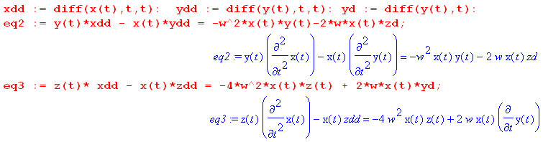
(F.10.2)
At this point zd = and zdd = are unspecified. We use eq1 to compute and in terms of x and y, using eq1 above:

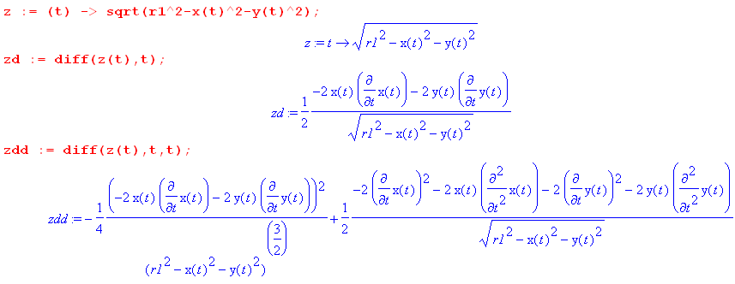
(F.10.3)
When these expressions are installed, eq2 and eq3 becomes these formidable-looking equations which contain two unknown functions x(t) and y(t) and constants r1 and ω :

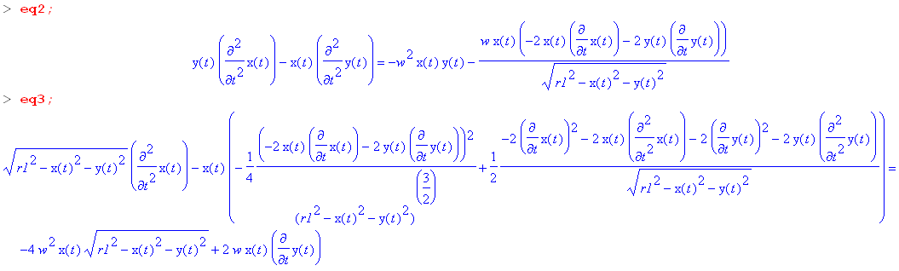
(F.10.4)
The reader is reminded of the geometry of Fig (F.1.1) where z points up, away from Earth center, y points to the right and is in the plane of the satellite orbit, while x is perpendicular to the plane of the satellite.

(F.10.5)

Our plots below in the (x,y) plane are what a viewer would see looking at mass m1 "from above", that is, from a point at perhaps z = b+2s on the z axis in the above figure.

In-Plane Libration

As our first test, we shall look for the "in-plane libration" behavior. We examined this behavior earlier below (F.7.3) in angular coordinates, and we now look in Cartesian coordinates. The initial conditions are:

x(0) = 0 y(0) = 1 (0) = 0 (0) = 0 (F.10.6)

With ω = 1, we expect to get a simple swinging back in the x=0 plane with period T = 3.63 sec as shown in (F.7.5). A half period is then 1.82 seconds.

The Maple code to invoke a solution is as follows (for a numerical integration from t = 0 to t = 1.82 sec):

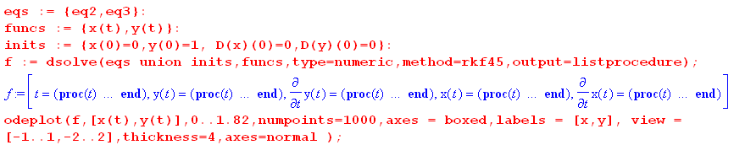
(F.10.7)

We show the result below on the left, and then from t = 0 to t = 0.91 (quarter period) on the right :

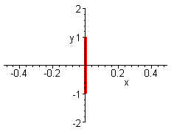 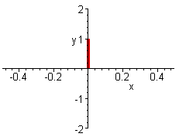 (F.10.8)

Thus both the "orbit" and the period for in-plane libration are visually confirmed. If we run from t = 0 to t = 10, the graph is as on the left above since mass m1 just swings back an forth in the same orbit, never leaving the y-axis.

Out-of-Plane Libration

We examined this behavior earlier below (F.7.6) in angular coordinates, and we now look in Cartesian coordinates. The initial conditions are now,

x(0) = 1 y(0) = 0 (0) = 0 (0) = 0 (F.10.9)

With ω = 1, we expect to get a swinging back in the y=0 with period T = 3.14 sec as shown in (F.7.8). Here is what Maple has to say:

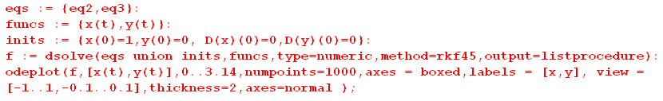

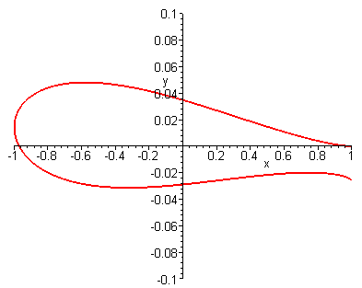 (F.10.10)

The period looks right since mass m1 swings back close to its initial position after 3.14 seconds, but one sees that the motion is not quite in the y=0 plane, so out-of-plane libration is an approximate concept as we noted earlier below (F.5.13). Note in the figure the fine scale of the vertical axis relative to horizontal.

Here are orbits for a selection of final integration times:

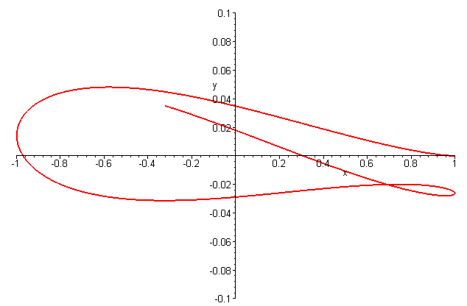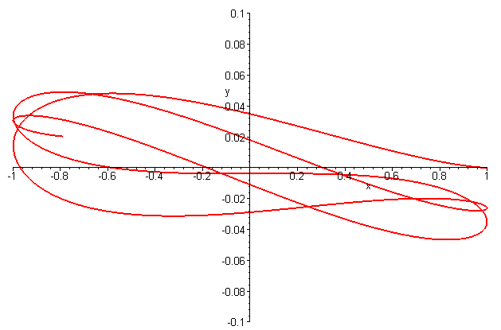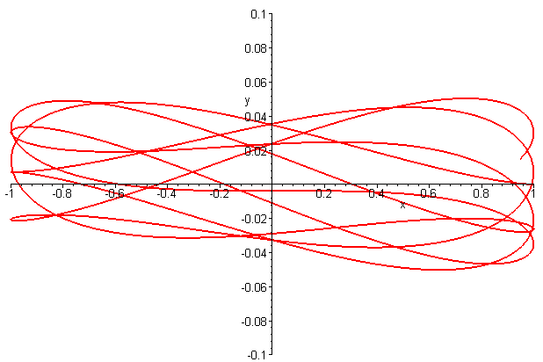
t = 4.1 t = 8.2 t = 15.9

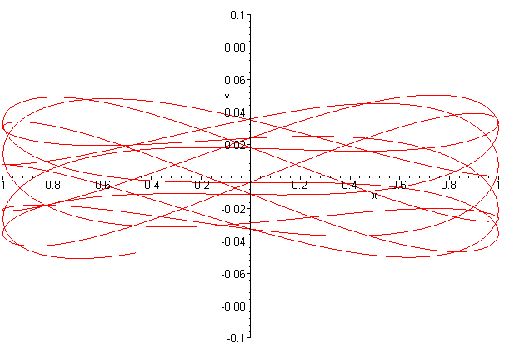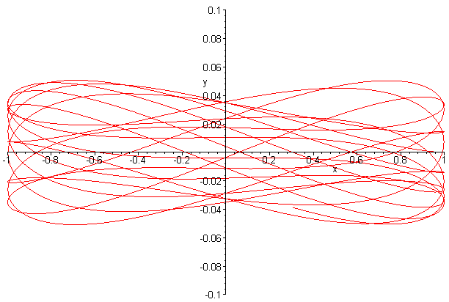
t = 21 t = 41.6 (F.10.11)
It does seem that the out-of-plane libration stays within a certain small band of deviation in the y direction which we shall leave to the reader to theoretically calculate. In each plot the time was selected to make the tail of the trace clearly visible. The author is reminded of a lecture given by Shelly Glashow on the question: What can be said about orbits on an arbitrarily-shaped-but-convex billiard table? Do they all eventually close on themselves, or might some never close? (Exercise for the reader). As regards the above plots, the fact that the ratio of the two libration frequencies is an irrational number $\sqrt{3}$/2 might have some bearing on the closure of the orbits.

In the examples above r1 = 10 and we have used x(0) = 1 or y(0) = 1 to obtain "small oscillation". If in the in-plane libration case we use y(0) = 9, there is no change in the orbit, but the oscillation period is slightly altered. If in the out-of-plane libration case we use x(0) = 9, the orbit no longer maintains the narrow band as in the above examples. For example, going again to t = 64 seconds with x(0) = 9,

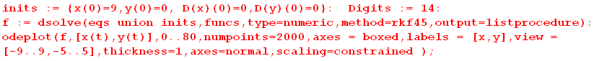

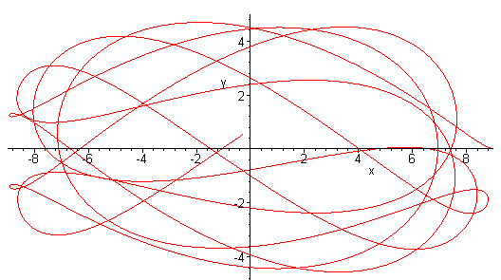 (F.10.12)

The Digits := 14 command tells Maple to compute the numerical integration with 14 decimal places of accuracy instead of the default 10 digits.

Starting with a diagonal initial position

x(0) = 1 y(0) = 1 (0) = 0 (0) = 0

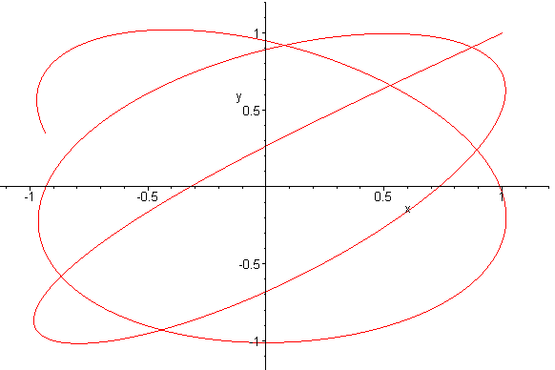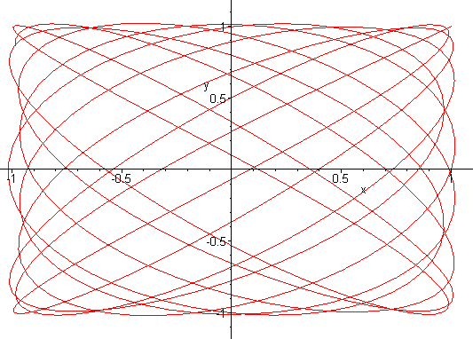
t = 8 t = 64
(F.10.13)

The t=64 result is reminiscent of a Lissajous pattern on an oscilloscope screen when the x and y axes are driven by different frequency sine ways. (See sine plots below.) In some sense these are the two libration frequencies.

Attempting a Circular Orbit (Conical Solution)

We have made many attempts to get a circular-like orbit by giving the mass m1 an initial velocity kick in some useful direction, but this system does not want to cooperate. Here is an example :

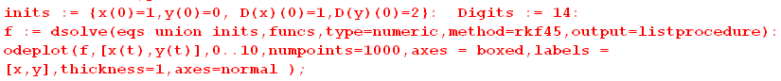

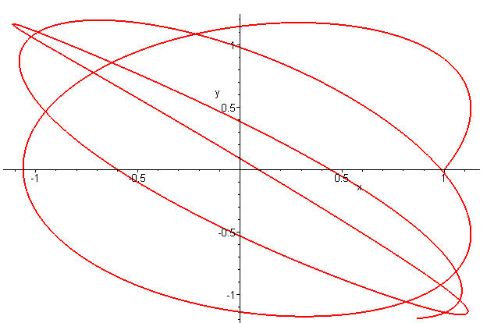 (F.10.14)

What starts as a rough circle is soon distorted into a narrow orbit. In the case of the spherical pendulum we had a Conical Solution in (C.5.20) where θ = θ0 and = constant. Assuming θ = θ0 in the satellite angular equations (F.5.7) gives

sinθ0cosθ0(3ω2 - 2) + ωsinθ0cosφ (ω cosθ0 cosφ - 2sinθ0 ) = 0 //
– ωcosφ (ωsinφ) = 0 . //

Since this is two ODE's for the one function φ(t), it seems unlikely there is any general non-static solution. If = 0 the equations become

sinθ0cosθ0(3ω2) + ωsinθ0cosφ (ω cosθ0 cosφ) = 0
– ωcosφ (ωsinφ) = 0 .

If φ = 0 the first equation requires that θ0 = 0 or π/2 which are static vertical and horizontal positions.
The same is true for φ = π/2 .

Three-dimensional plots

To make such plots, one must first extract the solution functions from the dsolve environment. For details on how this works and other information on dsolve (including a debugger's guide), see the author's Maple User Guide. Here we extract the functions calling them X,Y and Z ,

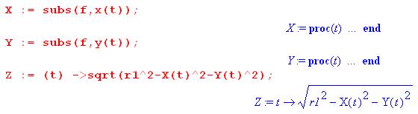 (F.10.15)

The following code then creates a 3D orbit and superposes it on a contour sphere of radius r1 ,

(F.10.16)

For a sample application, we start mass m1 on the z axis and give it a good kick in the x and y directions with (0) = 10 and (0)= 10 to get an x,y plot :

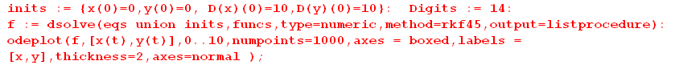

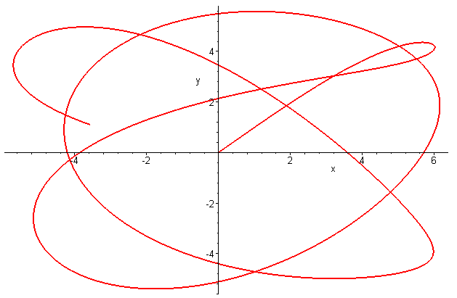 (F.10.17)

Here then is the corresponding 3D plot

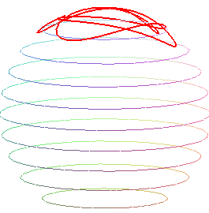 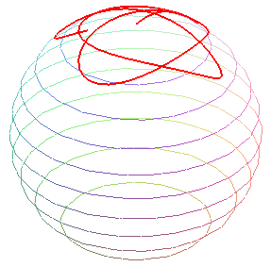 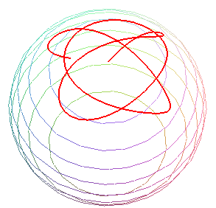(F.10.18)

where the sphere of radius r1 is gradually tipped down toward the viewer.

Conventional plots

In order to plot x(t), y(t) and so on, we first extract all functions from the dsolve system and then crudely add missing pieces like Xdd:

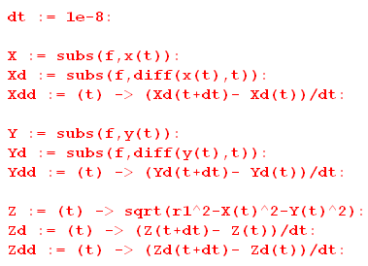 (F.10.19)

Here then is a plot of x(t),y(t),z(t) = red,black,blue for the above example:

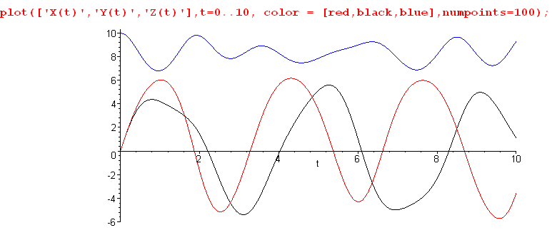
red = x(t) black = y(t) blue = z(t) (F.10.20)

Here one sees red x and black y executing roughly sinusoidal motions. In a ballpark sense x and y are sinusoidal at their respective libration periods (3.14 and 3.63), and at least we see that black y has a longer period than red x (this black y period seems more like ~4). This is what creates the Lissajous pattern in our earlier figures. Meanwhile, blue z(t) is not coming down much from its maximum value of z = 10.

Here is a plot of x,, = red.black,blue :

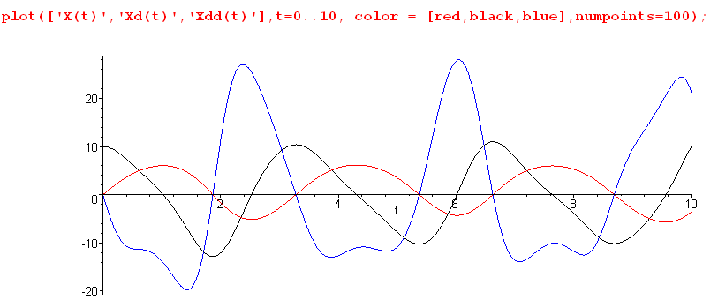
red = x(t) black = (t) blue = (t) (F.10.21)

Notice that red x and blue always cross the axis at the same time, which allows /x to be finite at all values of t (see below).

Tension in the the stick or tether

The tension in the stick (tether) is stated in (F.8.20),

T = - m1r1[ /x +ω2 ], (F.8.20)

which we then plot with m1 = 1 for the above example :

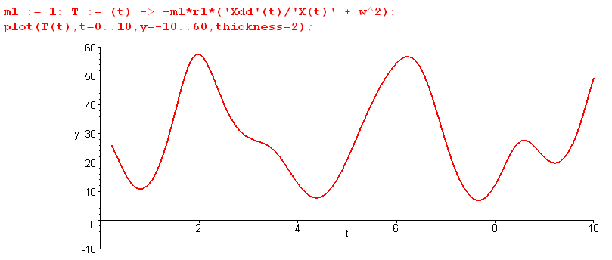 (F.10.22)

If we lower (0) = (0) = 10 to (0) = (0) = 1 to get a milder motion, the tension is less variable,

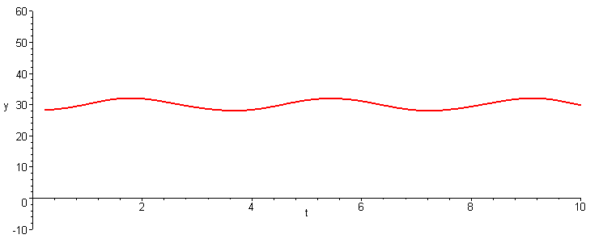 (F.10.23)

Here T is roughly equal to the "DC" value for the static dumbbell with θ = 0. From (F.6.30) that value is

T ≈ 3m1ω2r1 = 3 * 1 * 12 * 10 = 30 N . // tether tension (F.10.24)

We have been using ω = 1, but for a low-Earth orbit satellite one has Torbit ≈ 88*60 seconds so

ω = 2π/Torbit ≈ .0012 . (F.10.25)

Then mass m1 = 1 kg on a 20 meter tether with equal masses (r1 = 10 m) would feel a tidal force of

T ≈ 3m1ω2r1 = 3 * 1 * (.0012)2 * 10 = .4320e-4 N = 43 μN (F.10.26)

which is a very small tension.

Appendix G: Rotation Matrices and Related Theorems

Here we present still more information on rotation matrices and demonstrate some typical manipulations done with such matrices.

G.1 Generators and finite rotation matrices

The general active rotation matrix for a rotation by angle θ about some n unit vector axis is given by,

Rn(φ) = exp(-i θ n • J) , (G.1.1)

where the Jk are 3x3 matrices known as the rotation generator matrices,

J1 = $\left(\begin{matrix}0 & 0 & 0 \\ 0 & 0 & -i \\ 0 & i & 0\end{matrix}\right)$ J2 = $\left(\begin{matrix}0 & 0 & i \\ 0 & 0 & 0 \\ -i & 0 & 0\end{matrix}\right)$ J3 = $\left(\begin{matrix}0 & -i & 0 \\ i & 0 & 0 \\ 0 & 0 & 0\end{matrix}\right)$ . (G.1.2)

The numbers in these three matrices can be summarized in this single statement,

(Ja)bc = - i εabc // for example, (J1)23 = - i ε123 = -i
or
(iJa)bc = εabc (G.1.3)

where the εabc permutation tensor is described in (1.5.3).
Defining the commutator of two square matrices X,Y as [X, Y] = XY-YX, one can show that the above three matrices satisfy this "commutation relation",

[Ji, Jj] = iεijkJk . // [J1,J2] = iJ3 and cyclic (G.1.4)

Proof: These easily demonstrated facts will be used in the proof (implied sum on repeated indices) ,

εabcεABc = δaAδbB - δaBδbA δab ≡ δa,b εabc = εbca = εcab (G.1.5)

LHSac = (Ji)ab(Jj)bc - (Jj)ab(Ji)bc = (-i)2[εiabεjbc - εjabεibc ] = - [εiabεcjb - εjabεcib]

= - [(δicδaj - δijδac) - (δjcδai - δjiδac)] = δjcδai - δicδaj .

RHSac = iεijk(Jk)ac = iεijk[-iεkac] = εijkεkac = εijkεack = δiaδjc - δjaδic . QED

The expression shown in (G.1.1) involves the exponentiation of a square matrix to produce a new square matrix of the same dimension. This notion of exponentiating a matrix is straightforward as we demonstrate with a simple example:

Rx(θ) = exp(-i θ • J) = exp(-i θJ1) ≡ Σn=0∞ (-iθ)n (J1)n /n!

= 1 + Σ2,4,6.. (-iθ)n (J1)n /n! + Σ1,3,5.. (-iθ)n (J1)n /n!

It is easy to show that (J1)n = J1 for odd n, while (J1)n = $\left(\begin{matrix}0 & 0 & 0 \\ 0 & 1 & 0 \\ 0 & 0 & 1\end{matrix}\right)$ for even n > 0. Thus,

Rx(φ) = $\left(\begin{matrix}1 & 0 & 0 \\ 0 & 1 & 0 \\ 0 & 0 & 1\end{matrix}\right)$ + $\left(\begin{matrix}0 & 0 & 0 \\ 0 & 1 & 0 \\ 0 & 0 & 1\end{matrix}\right)$ Σ2,4,6.. (-iθ)n/n! + $\left(\begin{matrix}0 & 0 & 0 \\ 0 & 0 & -i \\ 0 & i & 0\end{matrix}\right)$ Σ1,3,5.. (-iθ)n/n! .

But

Σ2,4,6.. (-iθ)n/n! = - θ2/2! + θ4/4! + ... = (cosθ - 1)
Σ1,3,5.. (-iφ)n/n! = (-iθ) + (-iθ)3/3! + ... = (-i) [ θ - θ3/3! + ..] = -i sinθ (G.1.6)

and therefore

Rx(φ) = $\left(\begin{matrix}1 & 0 & 0 \\ 0 & 1 & 0 \\ 0 & 0 & 1\end{matrix}\right)$ + $\left(\begin{matrix}0 & 0 & 0 \\ 0 & 1 & 0 \\ 0 & 0 & 1\end{matrix}\right)$ (cosθ - 1) + $\left(\begin{matrix}0 & 0 & 0 \\ 0 & 0 & -i \\ 0 & i & 0\end{matrix}\right)$ (-isinθ)

= $\left(\begin{matrix}1 & 0 & 0 \\ 0 & cosθ & 0 \\ 0 & 0 & cosθ\end{matrix}\right)$ + $\left(\begin{matrix}0 & 0 & 0 \\ 0 & 0 & -sinθ \\ 0 & sinθ & 0\end{matrix}\right)$ = $\left(\begin{matrix}1 & 0 & 0 \\ 0 & cosθ & -sinθ \\ 0 & sinθ & cosθ\end{matrix}\right)$. (G.1.7)

The three axis-aligned rotations are found in this manner to be

Rx(θ) = $\left(\begin{matrix}1 & 0 & 0 \\ 0 & cosθ & -sinθ \\ 0 & sinθ & cosθ\end{matrix}\right)$ Ry(θ) = $\left(\begin{matrix}cosθ & 0 & sinθ \\ 0 & 1 & 0 \\ -sinθ & 0 & cosθ\end{matrix}\right)$ Rz(θ) = $\left(\begin{matrix}cosθ & -sinθ & 0 \\ sinθ & cosθ & 0 \\ 0 & 0 & 1\end{matrix}\right)$ . (G.1.8)

The general rotation (G.1.1) applied to a vector v produces a forward right-hand-rule rotation of vector v by an angle θ about an arbitrary axis to create v' = Rv. We call this an active rotation. For example, if one applies Rz(θ) shown in (G.1.8) to the unit column vector = (1,0,0) one gets (cosθ,sinθ,0) which for small θ is a vector in the first quadrant of the x,y plane.
Some authors define rotation matrices which rotate vectors backwards according to the right hand rule, with the connection to our matrices then being θ ↔ -θ. The motivation for doing this is the fact that, whereas v' = Rv in the active view where the vector moves and the axes stay put, one can instead do e'n = R–1en and have the vector stay put and the axes are back-rotated, which is the passive viewpoint. The definition of the rotation matrices is just a convention and (G.1.8) shows our definitions.

One says that the matrices Ji "generate" the finite rotations when they are exponentiated.

An alternative approach: First, one can show that Ri(dθ) ≈ 1 - idθJi describes a 3x3 matrix which, when applied to a vector, causes that vector to rotate by the small amount dθ about the i axis (an "infinitesimal rotation"). Setting dθ = θ/n, one shows that limn→∞(1-i[θ/n]Ji)n = exp(-iθJi). This last limit is analogous to limn→∞(1+x/n)n = ex for a scalar value x.

G.2 About the general rotation matrix

An explicit expression for the general rotation matrix

We present this subsection as a Reader Exercise with a set of steps. The result is stated in (G.2.8).

We are interested in the following general rotation matrix:

Rn(θ) = exp(-i θ n • J) ≡ Σn=0∞ (-iθ)n (n • J)n/n! . n = = a unit vector (G.2.1)

(a) using (G.1.3) and (G.1.5), show that (n•J)2 = T where Tab = (δab - nanb) . (G.2.2)
// T = 1 - N where Nab ≡ nanb
(b) show that

(n•J)n = (n•J) T for n = 3,5,7,....
(n•J)n = T for n = 2,4,6... (G.2.3)

(c) show that exp(-iθn•J) = cos(θn•J) - i sin(θn•J) where each term is defined by its series

(d) show that

cos(θn•J) = 1 + T(cosθ - 1)

sin(θn•J) = (θn•J) + (n•J)T (sinθ - θ) (G.2.4)

(e) show therefore that

exp(-iθn•J) = 1 + T (cosθ - 1) - i (n•J){ θ + T (sinθ - θ) } (G.2.5)

(f) show that the right side simplifies to become

exp(-iθn•J) = 1 + (cosθ - 1) T + sinθ[ -i(n•J)] (G.2.6)

Hint: (n•J)abnbnc = ni(-iεiab)nbnc = -inc [ εiabninb] = -inc [0] = 0 since [antisym x sym].

(g) show that

T = $\left(\begin{matrix}1-n12 & -n1n2 & -n1n3 \\ -n1n2 & 1-n22 & -n2n3 \\ -n1n3 & -n2n3 & 1-n32\end{matrix}\right)$ -i(n•J) = $\left(\begin{matrix}0 & -n3 & n2 \\ n3 & 0 & -n1 \\ -n2 & n1 & 0\end{matrix}\right)$ (G.2.7)

giving this final result,

Rn(θ) = exp(-iθn•J) = $\left(\begin{matrix}1 & 0 & 0 \\ 0 & 1 & 0 \\ 0 & 0 & 1\end{matrix}\right)$ + (cosθ - 1) $\left(\begin{matrix}1-n12 & -n1n2 & -n1n3 \\ -n1n2 & 1-n22 & -n2n3 \\ -n1n3 & -n2n3 & 1-n32\end{matrix}\right)$ + sinθ $\left(\begin{matrix}0 & -n3 & n2 \\ n3 & 0 & -n1 \\ -n2 & n1 & 0\end{matrix}\right)$ .

(G.2.8)
Note that the first two terms are symmetric matrices, while the third is antisymmetric.

(h) verify the special cases shown in (G.1.8) above. These cases have n = (1,0,0), (0,1,0), (0,0,1).

Finding n and θ

Problem: One is handed a 9-element rotation matrix R and one wants to find n,θ so R = exp(-iθn•J) .

Solution: We are unaware of a single magic formula that solves this problem, so we use brute force.

One can break R into the sum of two pieces, one symmetric and one antisymmetric by constructing

Sab ≡ (Rab+Rba)/2 Aab ≡ (Rab-Rba)/2 Rab = Sab + Aab R = S + A . (G.2.9)

Looking at (G.2.8) one then has,

S = $\left(\begin{matrix}S11 & S12 & S13 \\ S12 & S22 & S23 \\ S31 & S23 & S33\end{matrix}\right)$ = $\left(\begin{matrix}1 & 0 & 0 \\ 0 & 1 & 0 \\ 0 & 0 & 1\end{matrix}\right)$ + (cosθ - 1) $\left(\begin{matrix}1-n12 & -n1n2 & -n1n3 \\ -n1n2 & 1-n22 & -n2n3 \\ -n1n3 & -n2n3 & 1-n32\end{matrix}\right)$

A = $\left(\begin{matrix}0 & A12 & A13 \\ -A12 & 0 & A23 \\ -A13 & -A23 & 0\end{matrix}\right)$ = sinθ $\left(\begin{matrix}0 & -n3 & n2 \\ n3 & 0 & -n1 \\ -n2 & n1 & 0\end{matrix}\right)$ (G.2.10)

which can be written as these nine equations

A12 = -n3sinθ S11 = 1 + (cosθ-1)(1-n12) S12 = (cosθ-1)(-n1n2)
A13 = n2sinθ S22 = 1 + (cosθ-1)(1-n22) S13 = (cosθ-1)(-n1n3)
A23 = -n1sinθ S33 = 1 + (cosθ-1)(1-n32) S23 = (cosθ-1)(-n2n3) . (G.2.11)

• If θ = 0, then the original matrix must be R = 1 and then there is no work to do.

• If θ = π, the entire A matrix vanishes according to (G.2.10) leaving only S. The equations above are then

S11 = 1 + (-2)(1-n12) S12 = 2n1n2
S22 = 1 + (-2)(1-n22) S13 = 2n1n3
S33 = 1 + (-2)(1-n32) S23 = 2n2n3 .

Since n12 + n22 + n32 = 1, not all three ni can vanish. The left column of equations says

ni2 = 1 - (1-Sii)/2 i = 1,2,3 .

Inspect the three ni2 and select one nr2 which is non-zero. Then select the plus sign to get,

nr = +$\sqrt{1 - (1-Srr)/2}$.

To be specific, assume nr = n1. Then from the right column, n2 = S12/(2n1) and n2 = S13/(2n1) and we are done. So at least one of the following solutions must be viable:

θ = π n1 = $\sqrt{1 - (1-S11)/2}$ n2 = S12/(2n1) n3 = S13/(2n1)
θ = π n2 = $\sqrt{1 - (1-S22)/2}$ n1 = S12/(2n2) n3 = S23/(2n2)
θ = π n3 = $\sqrt{1 - (1-S33)/2}$ n1 = S13/(2n3) n2 = S23/(2n3) (G.2.12)

• If θ ≠ 0 or π, then note from (G.2.10) that

A122 + A132 + A232 = sin2θ
S11+ S22 + S33 = 1 + 2 cosθ . (G.2.13)

Using the sign ambiguity in the direction of n, we can assume that 0 < θ < π so sinθ > 0. Then from (G.2.13) and the left column of (G.2.11) we have this solution,

sinθ = $\sqrt{A122 + A132 + A232}$
cosθ = [ S11+ S22 + S33 - 1]/2
n1 = -A23/sinθ
n2 = A13/sinθ
n3 = -A12/sinθ (G.2.14)

and thus a viable θ and n have been found such that R = exp(-iθn•J) .

Example: Let R = $\left(\begin{matrix}cosα & -sinα & 0 \\ sinα & cosα & 0 \\ 0 & 0 & 1\end{matrix}\right)$ so then S = $\left(\begin{matrix}cosα & 0 & 0 \\ 0 & cosα & 0 \\ 0 & 0 & 1\end{matrix}\right)$ and A = $\left(\begin{matrix}0 & -sinα & 0 \\ sinα & 0 & 0 \\ 0 & 0 & 0\end{matrix}\right)$ .

sinθ = $\sqrt{A122 + A132 + A232}$ = $\sqrt{sinα2 + 0 + 0}$ = sinα
cosθ = [ S11+ S22 + S33 - 1]/2 = [cosα + cosα + 1 - 1]/2 = cosα ⇒ θ = α
n1 = -A23/sinθ = 0
n2 = A13/sinθ = 0
n3 = -A12/sinθ = sinα/sinθ = 1 ⇒ n = (0,0,1)

Therefore R = exp(-iαJ3) = Rz(α) , as verified in (G.1.8).

G.3 The Baker-Campbell-Hausdorff and Sandwich Formulas

Statement and proof of the Baker-Campbell-Hausdorff (BCH) formula

We now quote a fascinating fact known as the Baker-Campbell-Hausdorff formula involving two square matrices A and B, where commutator [X,Y] ≡ XY-YX ,

e-ABeA = B + [B,A]/1! + [[B,A],A]/2! + [[[B,A],A],A]/3! + ..... (G.3.1)

Outline of BCH proof: LHS = RHS

(a) Show that LHS = Σn=0∞Σm=0∞ (-A)nBAm / (n!m!) .

(b) Set k = n+m to rewrite as LHS = Σk=0∞Σn=0k (-A)nBAk-n / (n![k-n]!) .

(c) Rewrite again as LHS = Σk=0∞Tk/k! where Tk ≡ Σn=0k $\left(\begin{matrix}k \\ n\end{matrix}\right)$(-A)nBAk-n .

(d) Define C0 = B, C1 = [B,A], C2 = [[B,A],A] , etc. so that RHS = Σk=0Ck/k! .
Note that [Ck,A] = Ck+1.

The proof LHS = RHS is complete if one can show that Tk = Ck.

(e) Show Tk= Ck by induction: show T0 = C0 and Tk= Ck ⇒ Tk+1= Ck+1 . QED

Statement and proof of the Sandwich Formula

Now using this BCH formula, along with the commutation relation (G.1.4) that [Ji, Jj] = iεijkJk, one can show that

exp(- iθn•J) J exp(+ iθn•J) = cosθ J + sinθ J x n + (1 - cosθ) n(n•J) . (G.3.2)

This "vector of matrices" notation is just a shorthand for the following equations for k = 1,2,3 :

exp(- iθn•J) Jk exp(+ iθn•J) = cosθJk + sinθ[J x n ]k + (1 - cosθ) nk (n•J)

= cosθ Jk + sinθ εkmsns Jm + (1 - cosθ ) nk (n•J) . (G.3.3)

This is the "sandwich formula" since Jk on the left is sandwiched between two rotations R and R-1.

Outline of Sandwich proof: LHS = RHS

(a) We will use the BCH formula with A = iθ n•J and B = Jk. First, define Ck as in (d) above.

(b) show that C0 = Jk, C1 = -θniεkijJj, C2 = θ2 (nkniJi - Jk), C3 = -θ2C1, C4 = -θ2C2

(c) deduce (or use induction to show) that in general,

Cn = - (-1)n/2 θn ( nk ni Ji - Jk ) n = 2,4,6....

Cn = - (-1)(n-1)/2 θn ni εkij Jj n = 1,3,,5...

At this point we have from the BCH formula,

exp(- iθn•J) Jk exp(+ iθn•J) = Σn=0∞ Cn/n! with Cn as in (c) above

(d) Show that Σn=0∞ Cn/n! =

Jk - ni εkij Jj Σn=1,3,5.. (-1)(n-1)/2 θn/n! - ( nk ni Ji - Jk ) Σn=2,4,6.. (-1)n/2 θn/n!

= Jk - ni εkij Jj [θ - θ3/3! + ...] - ( nk ni Ji - Jk ) [ -θ2/2! + θ4/4! + .... ]

= Jk - ni εkij Jj sinθ - ( nk ni Ji - Jk ) (cosθ - 1)

= Jkcosθ + εkji Jj n_{i} sinθ + nk (n•J)(1-cosθ) . QED

Comments

A vector v (rank-1 tensor) transforms ("rotates") according to v' = Rv (Active View) .
For a matrix M (rank-2 tensor) the corresponding transformation is M' = RMR-1, and this is what one sees on the left side of (G.3.3) where M = Jk and R = exp(-iθ • J). In the expression RJkR-1 the rotation generator Jk is "sandwiched" between the two rotations.

The above sandwich formulas play a major role in Magnetic Resonance Imaging. The connection is that protons in your body have magnetic moments (spins) which can be lined up by a strong magnetic field. When the proton spins are slammed with a certain radio frequency pulse, they do conical rotation (precession) about the magnetic field axis at the so-called Larmor frequency. After the pulse this proton precession decays away (time T1) and bulk-decoheres (time T2) producing a certain return RF signal which can be analyzed. These return signals are sensitive to the local environment of the protons. The location of a particular response is determined by giving the magnetic field a spatial gradient which affects the Larmor frequency. In this manner, an image can be formed. The sandwich formulas are not applied directly to individual spin angular momenta J, but to the average spin (polarization) density M(t) in the object being scanned. The analysis is quite complicated since it must take into account thermal and statistical effects which are managed with the use of the density matrix formalism. See the very readable text of Levitt for all the details. We comment further on this topic in Section I.11 (3), showing how the MRI image is constructed.

Special cases of the sandwich formula

We shall have our own purposes for the sandwich formulas in Appendix H. For rotations about the i axis we set

ns = δs,i ⇒ n • J = Ji and εkmsJmns = εkmiJm = εikmJm . (G.3.4)

Then from the sandwich formula (G.3.3),

exp(- iθn•J) Jk exp(+ iθn•J) = cosθ Jk + sinθ εkmsnsJm + (1 - cosθ) nk(n• J), (G.3.3)

we find that (there is no implied sum on i in the rightmost term and εkmi = εikm )

exp(- iθJi) Jk exp(+ iθJi) = cosθ Jk + sinθεikmJm + (1 - cosθ) δk,i Ji

so then

Ri(θ) Jk Ri(-θ) = cosθ Jk + sinθ εikm Jm + (1 - cosθ) δk,i Ji . (G.3.5)

In the case i = k we know that the left side is just Jk since everything then commutes. This is verified on the right since εiim = 0 and the other two terms then add up to Jk. So although obvious, we state:

Rk(θ) Jk Rk(-θ) = Jk . i = k (G.3.6)

In the case i ≠ k the third term in (G.3.5) does not contribute and one has,

Ri(θ) Jk Ri(-θ) = cosθ Jk + εikmsinθ Jm . i ≠ k

Here is a table of all the cases for which i ≠ k : (G.3.7)

R1(θ) J2R1(-θ) = cosθ J2 + ε12m sinθ Jm = cosθ J2 + sinθ J3
R1(θ) J3R1(-θ) = cosθ J3 + ε13m sinθ Jm = cosθ J3 - sinθ J2

R2(θ) J1R2(-θ) = cosθ J1 + ε21m sinθ Jm = cosθ J1 - sinθ J3
R2(θ) J3R2(-θ) = cosθ J3 + ε23m sinθ Jm = cosθ J3 + sinθ J1

R3(θ) J1R3(-θ) = cosθ J1 + ε31m sinθ Jm = cosθJ1 + sinθ J2
R3(θ) J2R3(-θ) = cosθ J2 + ε32m sinθ Jm = cosθJ2 - sinθ J1 . (G.3.8)

G.4 Two more theorems for the rotation matrix toolbox

Theorem 1: RJR-1 = R-1J (G.4.1)

This is another vector/matrix notation theorem which makes a claim about rotating a vector of matrices. The above ambiguous notation is a shorthand for the following,

RJiR-1 = [R-1J]i = R–1ijJj i = 1,2,3 . (G.4.2)

The object on the left is a product of three 3x3 matrices, while the right side is a linear combination of 3x3 matrices, so at least the theorem's claim is dimensionally reasonable. More generally Ji might be an abstract "operator" and R a rotation which acts on that operator, see Section G.5.

Proof: Start with the general rotation form given in (G.2.6),

R = exp(-iθn•J) = 1 + (cosθ - 1) T + sinθ[ -i(n•J)] where Tab = (δab - nanb) . (G.4.3)

Sandwich this rotation around Ji and then use the sandwich formula (G.3.3),

RJiR-1 = exp(- iθn• J) Ji exp(+ iθn• J)

= cosθ Ji + sinθ εijknk Jj + (1 - cosθ ) ni (n• J)

= cosθ δijJj + sinθ εijknk Jj + (1 - cosθ ) ninjJj

= [ cosθ δij + sinθ εijknk + (1 - cosθ ) ninj ] Jj . (G.4.4)

Our theorem is proved if, comparing (G.4.2) and (G.4.4), we can show that

R–1ij = cosθ δij + sinθ εijknk + (1 - cosθ ) ninj ? (G.4.5)

Looking back at (G.4.3), one has

R-1 = exp(+iθn•J) = 1 + (cosθ - 1) T + sinθ[ +i(n•J)]
so
R-1ij = δij + (cosθ - 1) Tij + sinθ[+nk (iJk)ij]

= δij + (cosθ - 1) (δij - ninj) + sinθ nk εkij // (G.1.3) and def of Tij

= δij cosθ + (1-cosθ) ninj + sinθ εijknk . (G.4.6)

But this is the same as (G.4.5) so the theorem is proved. QED

Theorem 2: R exp(-iθn•J) R-1 = exp(-iθn'•J) where n' = Rn (G.4.7)

or R Rn(θ) R-1 = Rn'(θ) where n' = Rn

The matrix R is an arbitrary rotation. On the left we have a product of three 3x3 matrices, while the right side is a 3x3 matrix. One proof of this theorem might be to say "what else could it be? ". We shall provide a more substantial proof below.

Proof: Start by inserting the general rotation form (G.2.6) into the left side of (G.4.7),

R exp(-iθn•J) R-1 = R [ 1 + (cosθ - 1) T - i sinθ (n•J) ] R-1

= 1 + (cosθ - 1)RTR-1 - i sinθ nk RJkR-1 . (G.4.8)

Now consider

[RTR-1]ad = RabTbcR-1cd = Rab(δbc - nbnc)RTcd

= δad - Rab nbncRdc = δad - ( Rab nb)(Rdcnc) = δad - n'an'd n' = Rn

≡ T'ad . // in other words, RTR-1 = T' (G.4.9)

From Theorem 1 (G.4.2) we know that

RJkR-1 = R–1kjJj . (G.4.2)

Inserting this last item and (G.4.9) into (G.4.8) gives

R exp(-iθn•J) R-1 = 1 + (cosθ - 1)T' - i sinθ nkR–1kjJj

= 1 + (cosθ - 1)T' - i sinθ Rjknk Jj = 1 + (cosθ - 1)T' - i sinθ [Rn]j Jj

= 1 + (cosθ - 1)T' - i sinθ n'jJj = 1 + (cosθ - 1)T' - i sinθ (n' • J)

= exp(-iθn'•J) // using (G.2.6) with n → n' (G.4.10)
Thus the theorem is proved. QED

The fact (G.4.9) that RTR-1 = T' is just the standard rule for the transformation of a rank-2 tensor under rotations, see (1.1.21) [ also (J.24) and (J.25)]. That is to say, if an Observer in Frame S sees T, an Observer in rotated Frame S' will see T' = RTR-1. This same statement applies at the higher level of our theorem,

R Rn(θ) R-1 = Rn'(θ) n' = Rn . // Theorem 2 restated (G.4.11)

The rotation Rn(θ) seen by an Observer in Frame S appears as Rn'(θ) in Frame S' where e'n = R-1en as in (1.1.30). Like T, the rotation Rn(θ) transforms as a rank-2 tensor under rotations.
Applying (G.4.11) to a vector v, one finds,

R Rn(θ) R-1v = Rn'(θ)v where n' = Rn . (G.4.12)

Instead of rotating a vector v by amount θ about axis ', one can first back-rotate the vector v by R-1, then rotate by amount θ about axis , the forward rotate the result by R.

Example: Rz(π/2)Rx(θ)Rz(-π/2) = ?? Here n = and n' = Rz(π/2) = so we conclude that

Rz(π/2)Rx(θ)Rz(-π/2) = Ry(θ) . (G.4.13)

Here is a graphical interpretation of (G.4.13) applied to a particular vector v :

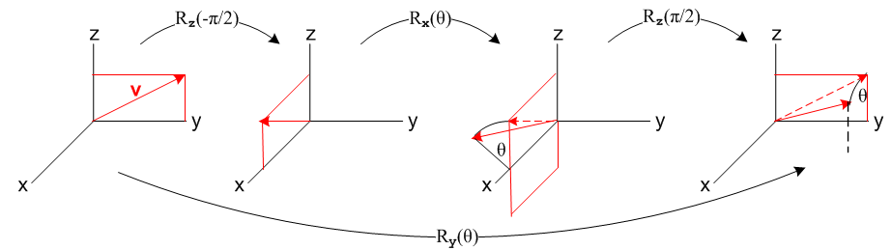
(G.4.14)

G.5 Generalizations of the Rotation Group

Here we consider some generalizations of the ideas presented above in Section G.1 .

N dimensional representations of the rotation group

The generators Ji shown in (G.1.2) are a special case of a more general idea which starts with the commutation relation

[Ji, Jj] = iεijkJk . // for example, [J1,J2] = iJ3 (G.1.4) (G.5.1)

One first thinks of the Ji as abstract "operators" in some abstract "operator space". One can show that it is possible to find a set of three NxN matrices of any integer dimension N which satisfy (G.5.1). The matrices are not unique, so (G.1.2) for the Ji in three dimensions is not unique, but it is a standard form.
The three NxN generator matrices Ji are said to form an N-dimensional "irreducible representation" of the abstract generators Ji. One can always create new viable generator matrices by taking a "direct sum" of existing viable generator matrices, such as in this block-diagonal-form picture

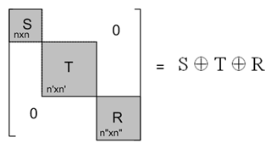 (G.5.2)

This generator matrix is "reducible" into a direct sum of S, T and R. An "irreducible" representation is one that cannot be reduced in this manner, even after attempts to bring the matrix to block-diagonal form using a unitary similarity transformation, see Section I.3. The same comment applies to rotation matrices.
The commutation relation (G.5.1) is an example of a Lie Algebra. Our particular Lie Algebra is called so(3), so we can represent the algebra elements Ji of this algebra by three NxN matrices Ji. It is possible to write down a formula analogous to (G.1.3) (iJa)bc = εabc which works for any N, but (G.1.3) itself only applies to N = 3. This is so because εabc has no meaning for N ≠ 3. But it always has meaning in (G.5.1) because there are only three generators regardless of the value of N.
For general N, the object Ri(θ) = exp(-iθJi) is an NxN matrix which represents the action of a rotation of an N-vector in a Euclidean space EN. The set of such rotation matrices forms an "irreducible representation" of the rotation group SO(3) in N dimensions. The integer N is usually written N = 2j+1 where j = 0, 1/2, 1, 3/2 ... and this j then serves as a label for a given matrix representation.
The value of j in N = 2j+1 is associated with "angular momentum" or "spin". In the case N=2 (having j=1/2) the generator matrices are the 2x2 "Pauli matrices". In this case the 2x2 matrices exp(-iθJi) describe the rotations of spin-1/2 particles such as electrons or protons. Here are the details for N=2 :

Jx = (1/2) 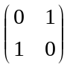 Jy = (1/2) 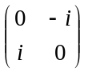 Jz = (1/2) 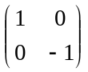

Rx = 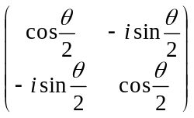 Ry = 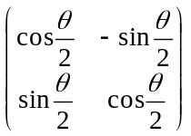 Rz = 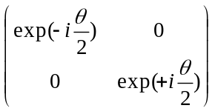

(G.5.3)
The "vectors" for spin-1/2 particles have two components $\left(\begin{matrix}u \\ d\end{matrix}\right)$ . The special case $\left(\begin{matrix}1 \\ 0\end{matrix}\right)$ is called "spin up" and $\left(\begin{matrix}0 \\ 1\end{matrix}\right)$ is "spin down".
For the Lie Algebra so(3) one can show that J2 ≡ J12 + J22 + J32 and any particular Ji commute with each other, so for example [J2,J3] = 0. J2 is called a Casimir operator of this Algebra, and fancier Lie Algebras can have several such Casimirs.

A differential operator representation of the rotation group

It is also possible to "represent" the three rotation generators Ji by three differential operators in spherical coordinates θ and φ. These operators satisfy [Ji, Jj] = iεijkJk and in this context they are usually called Li but we shall stick with Ji. In this case, one can compute the differential operator J2 and one can ponder differential equations which take the form J2 fjm(θ,φ) = j(j+1) fjm(θ,φ) and Jz fjm(θ,φ) = m fjm(θ,φ). [The facts that the eigenvalue of J2 is j(j+1) and not j2, and that m runs from -j to j, derive from the structure of the Lie Algebra.] The solutions fjm(θ,φ) are able to have well-defined eigenvalues j(j+1) and m because [J2,J3] = 0. If we instead had [J2,J3] ≠ 0, then [J2,J3] fjm(θ,φ) = j(j+1)m - mj(j+1) = 0 is a contradiction and the two eigenfunction equations could not exist. The solutions fjm(θ,φ) of these equations are called the spherical harmonics and are usually written Yjm(θ,φ). These functions shall reapppear in (I.9.16) where we do a brief review of potential theory and j is called n.

Just for the record, here is what the differential operators look like, where C = cos and S = sin (for example, Sφ = sinφ and ∂φ = ∂/∂φ) :

J1 = i [ Sφ ∂θ + cotθ Cφ ∂φ] J± = e±iφ [ ±∂θ + i cotθ ∂φ ] = J1 ± iJ2
J2 = −i [ Cφ ∂θ − cotθ Sφ ∂φ] J2 = − [ ∂θ2 + cotθ ∂θ + (1/Sθ)2 ∂φ2]
J3 = -i ∂φ J2 = − [ (1/Sθ) ∂θ [ Sθ ∂θ ] + (1/Sθ)2 ∂φ2 ] . (G.5.4)

Reader Exercise: Verify that the three operators on the left satisfy the Lie Algebra [Ji, Jj] = iεijkJk.

For the hydrogen atom with a spinless electron, there are three mutually commuting quantities H, J2 and J3 where H is the Hamiltonian. This means that the solution eigenfunctions can have well defined E, j and m values and these eigenfunctions are those painful "orbitals" appearing in chemistry books. When the Hamiltonian commutes with some other operator like J2, that operator is called a "symmetry". Solution functions then bear a label for each such symmetry, such as j for J2.

The Lie Algebra so(3) is isomorphic (one-to-one related) to another Lie Algebra called su(2).
The Lie Group SO(3) is isomorphic to another Lie Group called SU(2).

In the above we discuss only the Lie Group SO(3) with its three generators Ji. There are many Lie Groups (they have continuous parameters) as well as discrete symmetry groups which have physics applications.

Some Other Lie Groups of Interest

The group SO(n) is the orthogonal group in n dimensions and it has n(n-1)/2 generators.

The group SO(3,1) is the Lorentz Group which has 6 generators Ji and Ki which generate 3 rotations and 3 "boosts" (velocity transformations). The Lie Algebra is this,

[ Ji, Jj] = +i εijkJk
[ Ji, Kj] = +i εijk Kk
[ Ki, Kj] = -i εijkJk . (G.5.5)

There are two Casimirs : J2 - K2 and J•K .

In the Lorentz Group "vector representation" known as 1/2⊗1/2 the generators are represented as 4x4 matrices. When these are exponentiated, one obtains the finite rotation and boost matrices used in special relativity. For example, with space-time vectors ordered xμ = (ct,x,y,z) one has

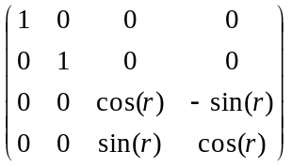 = exp(-irJ1) where (J1)μν = 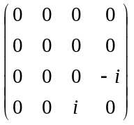 // rotation Rx(r)
(G.5.6)
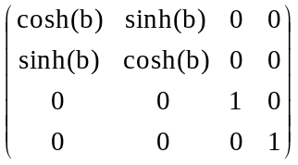 = exp(-ibK1) where (K1)μν = 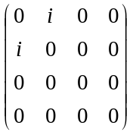 // boost Bx(b)

The Poincare Group is basically the Lorentz group SO(3,1) bolted onto the group T(4) of translations in four directions ct,x,y,z. It thus has 10 generators Ji, Ki and Pμ where these last four are momentum and energy. The Poincare algebra has two Casimir operators whose eigenvalues are associated with mass and spin. For example, the mass Casimir is PμPμ. The irreducible representations of the Poincare Group are associated with "elementary particles" which have well defined mass and spin.

The group SU(3) has 8 generators and 2 Casimirs. In one key representation the generators are represented by 3x3 matrices which act on 3-vectors. Instead of having up and down states as with spin-1/2 noted above, these vectors have up, down and strange (sideways) states called u,d.s which are associated with quarks. The full symmetry group for the Standard Model of elementary particles is SU(3) x SU(2) x U(1) in which SU(3) plays its part.

Special Groups have Traceless Generators

It is desirable that "rotation matrices" have unit determinant because such matrices then do not change the "length" of a vector on which they act. When the representation matrices are restricted to have unit determinant, they are called "special" and the group name is prefixed by the letter S, as in SO(3) for the rotation group. For the 3x3 representation of the rotation group we know that the matrices are real orthogonal which means RRT = 1 which in turn means [det(R)]2 =1 and in SO(3) we select only those R with det(R) = +1. A "rotation" which just negates z (reflection) still satisfies RRT = 1 but has det(R) = -1.

An elegant theorem concerning exponentiated square matrices is this (proved below):

det(eA) = etr(A) (G.5.7)

where det is the determinant and tr(A) ≡ ΣiAii is the "trace" or "spur" of the matrix A -- the sum of the diagonal elements. If we want the matrix exp(-i θ • J) to have unit determinant so it is "Special", the exponent must be traceless, and in this case that means that the generators Ji must all be traceless. One can see from examples (G.1.2) and (G.5.3) and (G.5.6) that this is indeed the case.

Offhand, the matrix identity det(eA) = etr(A) seems very unlikely and almost too simple. For that reason, we include here a straightforward proof which we feel is "one for the Book".

Proof of (G.5.7) There are no implied sums in this proof!

Write A = ΣijAij s(ij) where [s(ij)]ab ≡ δiaδjb . To verify,

Aab = ΣijAij [s(ij)]ab = ΣijAijδiaδjb = Aab .

The matrix s(ij) is all zeros except for a single 1 located in row a and column b. Using ex+y.. = exey ... one can write

eA = exp( ΣijAij s(ij)) = Πi,j exp(Aij s(ij)) .

Then using det(XY..) = det(X)det(Y).... ,

det(eA) = det {Πi,j exp(Aij s(ij)) } = Πi,j det [ exp(Aij s(ij)) ] . (G.5.8)

[Case i ≠j :] We first note that [s(ij)]2 = 0 :

[s(ij)]2ac = Σb[s(ij)]ab [s(ij)]bc = Σbδiaδjb δibδjc = δiaδjiδjc = 0 since i ≠ j .

Then [s(ij)]n = 0 for n ≥ 2. In this case one has

exp(Aij s(ij)) = Σn=0∞ (Aij)n [ s(ij)]n/n! = 1 + Aij [ s(ij)]

and so

det [exp(Aij s(ij)) ] = det [ 1 + Aij s(ij)] = 1 .

This is so because the matrix in question has all 1's on the diagonal and one non-vanishing off-diagonal element at (i,j). In fact, any triangular matrix (one side all zeros) with 1's on the diagonal has det = 1.

[Case i=j : ] In this case one has [s(ii)]2 = [s(ii)] :

[s(ii)]2ac = Σb[s(ii)]ab [s(ii)]bc = Σbδiaδib δibδic = δiaδiiδic = δiaδic = [s(ii)]ac .

Note that [s(ii)]ab = δiaδib = 1 only when a = b = i, so s(ii) is an all-zero matrix with a single 1 at location i on the diagonal.

Since [s(ii)]2 = s(ii) it follows that [s(ii)]n = s(ii) for n ≥ 1. Then,

exp(Aii s(ii)) = Σn=0∞ (Aii)n [ s(ii)]n / n! = 1 + s(ii) [Σn=1∞(Aii)n / n!]

= 1 + s(ii) [ -1 + Σn=0∞(Aii)n/n! ] = 1 + s(ii)[-1 + exp(Aii) ] .

This last item is the unit matrix with the ith diagonal 1 replaced by exp(Aii) . Therefore,

det [exp(Aii s(ii)) ] = det { 1 + s(ii)[-1 + exp(Aii)] } = exp(Aii) .

Now go back to (G.5.8),

det(eA) = Πi,j det [exp(Aij s(ij)) ]

= (Πi≠j det [exp(Aij s(ij)) ] ) * (Πi=j det [exp(Aij s(ij)) ] )

= (1*1*1*1...... ....*1*1) * ( exp(A11)exp(A22) ..... )

= 1 * exp(A11 + A22 + ...) = exp (tr(A))

= etr(A) . QED

Appendix H: The Euler Angles and Computation of ω

H.1 Euler Angles, Intermediate Rotations, and Unit Vectors

As the reader no doubt knows, it is possible to specify an arbitrary rotation in terms of three Euler angles,

Rz(φ)Rx(θ)Rz(ψ) . (H.1.1)

As shown below, the matrix shown in (H.1.1) will be identified with R-1 of our Section 1 formalism so that

R-1 = Rz(φ)Rx(θ)Rz(ψ) R = Rz(-ψ)Rx(-θ)Rz(-φ) . (H.1.2)

Some authors use other letters for the angles, and some put Ry in the middle in place of Rx.

In this Appendix we are going to strictly use the Euler angles as they are presented in Goldstein (p 107) and GPS (p 152). Similar Euler angle pictures appear in Marion (p 385) and T&M (p 441). Both author groups use the same names for the Euler angles. However, the Goldstein authors start with (x,y,z) and end up with (x',y',z') while the Marion authors start with (x'1,x'2,x'3) and end up with (x1,x2,x3).

The reader will notice in (H.1.1) that we have italicized the Euler angle φ but not θ and ψ. This italic φ is used throughout this Appendix as one of the Euler angles. Eventually in Section H.6 we shall explain why the italic is used, but we can preview that discussion right here. We use the symbols r,θ,φ to represent spherical coordinates (no italic on φ), as for example in Appendix A and Appendix E. As shown there, the rotation Ry(θ) is natural for defining spherical unit vectors, whereas Goldstein uses Rx(θ) in (H.1.1) above. It turns out that if we want the Goldstein ' unit vector to align with of spherical coordinates, then the connection between spherical coordinate angle φ and Goldstein Euler angle φ is φ = φ+π/2. We like to think of = ' as defining the symmetry axis (figure axis) for a rotating object such as the top treated in Section I.1. If there were no heavy-duty precedents for Euler angles, one might use Ry(θ) in place of Rx(θ) in (H.1.1), and this is the approach of Taylor (p 401) and others. The main issue is this: for the Goldstein and Marion authors, if φ = 0 then the "tipped down by θ" z' axis lies over the negative y axis which is φ = -π/2. If Ry(θ) were used instead, then the tipped down z' axis would lie over the positive x axis and would have φ = 0, and this is the way things work for spherical coordinates as shown in Appendix E.

We have in mind that the matrices shown in (H.1.1) are specifically the active rotation matrices shown in (A.1),

Rx(θ) = $\left(\begin{matrix}1 & 0 & 0 \\ 0 & cosθ & -sinθ \\ 0 & sinθ & cosθ\end{matrix}\right)$ Ry(θ) = $\left(\begin{matrix}cosθ & 0 & sinθ \\ 0 & 1 & 0 \\ -sinθ & 0 & cosθ\end{matrix}\right)$ Rz(θ) = $\left(\begin{matrix}cosθ & -sinθ & 0 \\ sinθ & cosθ & 0 \\ 0 & 0 & 1\end{matrix}\right)$ . (H.1.3)

To get Maple warmed up for activities below, we enter the three matrices of (H.1.3),

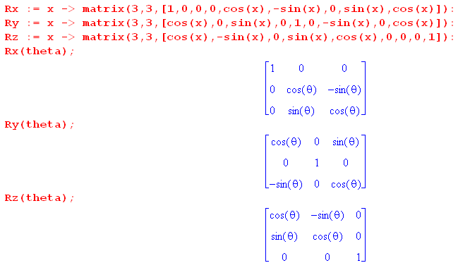

As noted below (G.1.8), these (H.1.3) matrices are "active" because, using the right-hand-rule, they rotate a vector forward by angle θ in the Active View described at the start of Section 1.3. For example, for small θ the rotation Rz(θ) acting on produces a vector in the first quadrant of the x-y plane:

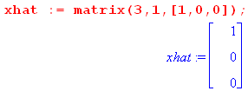 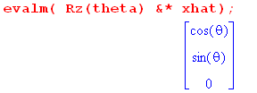 (H.1.4)

Here now is Goldstein's Euler Angle picture (G p 107, GPS p152), enhanced a bit for readability,

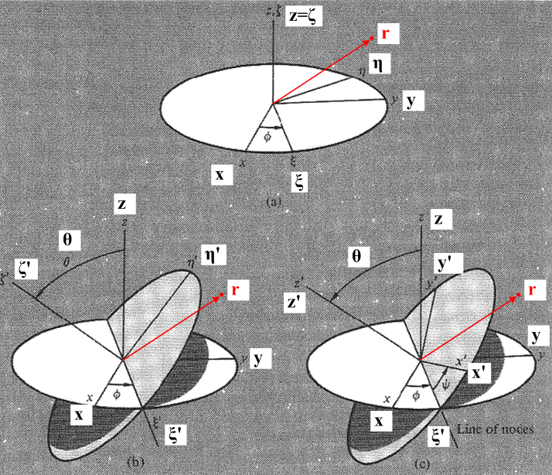 (H.1.5)

Astronomy Footnote: Imagine that the white disk is a "reference plane" (perhaps the equatorial plane of the Earth) and the grey disk perimeter denotes the orbit of some object about another (perhaps the Moon about the Earth). That orbiting object crosses the reference plane in two places called "nodes" (ascending and descending by some convention). The intersection of the two planes is called the "line of nodes". In Goldstein's drawing this coincides with the ξ' axis. In this application, the Euler angles θ,φ define the plane of the Moon's orbit, and Euler angle ψ shows the progress of the Moon in this orbit. As noted in Section 8.8, the Moon's orbital plane precesses, so the line of nodes rotates in the white disk plane.

Fig (H.1.5) shows how one can start with x,y,z axes at the top, and end up with x',y',z' axes on the lower right. There are really three sequential transformations occurring here, and we can just read off the effects on unit vectors by looking at the pictures: ( ξ = xi = "zeye", η = eta = "ate'uh", ζ = zeta = "zay'ta")

top (,,) = Rz(φ) (,,) where =

left (',',') = Rξ(θ) (,,) where ' =

right (',',') = Rζ'(ψ)(',',') where ' = ' . (H.1.6)

For example, the first of these nine equations says = Rz(φ) which seems clear from the top picture. The rotation Rξ(θ) is an active rotation of θ about the axis, and similarly for Rζ'(ψ).

We can combine transformations in various obvious ways :

(,,) = Rz(φ) (,,) // each equation is like e'n = R-1en

(',',') = Rξ(θ) (,,) = Rξ(θ) Rz(φ) (,,)

(',',') = Rζ'(ψ) (',',') = Rζ'(ψ) Rξ(θ) (,,) = Rζ'(ψ) Rξ(θ) Rz(φ) (,,) . (H.1.7)

For example, ' = Rζ'(ψ)' = Rζ'(ψ) Rξ(θ) = Rζ'(ψ) Rξ(θ)Rz(φ) .

These equations are all of the template form e'n = (R-1)en appearing in our Basis Theorem (1.1.30). The meaning is |e'n> = R-1|en> = |R-1en>. If one takes Frame S components of these equations, then in e'n = (R-1)en one can interpret (R-1) as a matrix. For example, for = Rz(φ) one can write ()i = [Rz(φ)]ij()i in which case [Rz(φ)]ij is the matrix shown in (H.1.3).

In going all the way from the Frame S basis en to the Frame S' basis e'n we see from the last line in (H.1.7) that in order to interpret this last line as e'n = (R-1)en, we must make the identification

R-1 = Rζ'(ψ) Rξ(θ) Rz(φ) . (H.1.8)

The R symbol here is the R that appears in our Section 1 formalism. In particular, recall the Basis Theorem (1.1.29) and (1.1.30), and the alternate notation of (1.1.32),

e'n = R-1en ⇔ e'n = Rnm em or $\left(\begin{matrix}e'1 \\ e'2 \\ e'3\end{matrix}\right)$ = R $\left(\begin{matrix}e1 \\ e2 \\ e3\end{matrix}\right)$ . (1.1.29,30) + (1.1.32)

Define Q ≡ R-1 and rewrite the Basis Theorem as,

e'n = Qen ⇔ e'n = (Q-1)nm em or $\left(\begin{matrix}e'1 \\ e'2 \\ e'3\end{matrix}\right)$ = [Q]-1 $\left(\begin{matrix}e1 \\ e2 \\ e3\end{matrix}\right)$ . (H.1.9)

This form of the Basis Theorem then serves as a template with which we can convert the equations of (H.1.7) to the corresponding linear combination equations of basis vectors :

= [Rz(φ)]-1 = Rz(-φ) Q = Rz(φ)

= [Rξ(θ) Rz(φ)]-1 = Rz(-φ) Rξ(-θ) Q = Rξ(θ) Rz(φ)

= [Rζ'(ψ) Rξ(θ)Rz(φ)]-1 = Rz(-φ) Rξ(-θ)Rζ'(-ψ) . (H.1.10)

We constantly use facts like [ABC]-1 = C-1B-1A-1 and R-1s(α) = Rs(-α).

These equations can be inverted in the obvious manner. The last one would give

= Rζ'(ψ) Rξ(θ)Rz(φ) . (H.1.11)

If we install this equation on the right of the first two equations in (H.1.10), the results are

= Rz(-φ) = Rz(-φ) Rζ'(ψ) Rξ(θ)Rz(φ)

= Rz(-φ) Rξ(-θ) = Rz(-φ) Rξ(-θ) Rζ'(ψ) Rξ(θ)Rz(φ) . (H.1.12)

We know all about the rotations Rx, Ry and Rz since they are specifically stated in (H.1.3). But what about the strange rotations Rξ and Rζ' which dot the landscape above? In Theorem 3 below we shall show that each of these rotations may be written as a certain product of the Rx, Ry and Rz. Specifically, in Theorem 3 we shall prove the first three results below :

(1) Rξ(θ) = Rz(φ) Rx(θ) Rz(-φ)

(2) Rζ'(ψ) = Rz(φ) Rx(θ)Rz(ψ)Rx(-θ)Rz(-φ)

(3) Rζ'(ψ) Rξ(θ) Rz(φ) = Rz(φ)Rx(θ)Rz(ψ) = R-1

Using these equations one can clear out all the strange rotations from (H.1.10,11,12) as follows :
(1)
(4) Rz(-φ) Rξ(-θ) = Rz(-φ) [Rz(φ) Rx(-θ) Rz(-φ)] = Rx(-θ) Rz(-φ)
(3)
(5) Rz(-φ) Rξ(-θ)Rζ'(-ψ) = [Rζ'(ψ) Rξ(θ) Rz(φ)]-1 = [Rz(φ)Rx(θ)Rz(ψ)]-1 = Rz(-ψ)Rx(-θ)Rz(-φ)
(2) (1)
(6) Rz(-φ) Rζ'(ψ) Rξ(θ)Rz(φ) = Rz(-φ) [Rz(φ) Rx(θ)Rz(ψ)Rx(-θ)Rz(-φ)] [Rz(φ) Rx(θ) Rz(-φ)]Rz(φ)
= Rx(θ)Rz(ψ) // use Rz(-φ)Rz(φ) = 1 in three places, then Rx(-θ)Rx(θ) = 1

(7) Rz(-φ) Rξ(-θ) Rζ'(ψ) Rξ(θ)Rz(φ)
= Rz(-φ) [Rz(φ) Rx(-θ) Rz(-φ)] [Rz(φ) Rx(θ)Rz(ψ)Rx(-θ)Rz(-φ)][Rz(φ) Rx(θ) Rz(-φ)]Rz(φ)
= Rz(ψ) (1) (3) (1)
(H.1.13)
One can then rewrite (H.1.10,11,12) as

(a) = Rz(-φ) // written out in (H.1.15)

(b) = Rx(-θ) Rz(-φ) // using (4) // written out in (H.4.2)

(c) = Rz(-ψ)Rx(-θ)Rz(-φ) // using (3) // written out in (H.3.19)

(d) = Rz(φ)Rx(θ)Rz(ψ) // using (5) // written out in (H.3.18)
(e) = Rx(θ)Rz(ψ) // using (6) // written out in (H.4.5)

(f) = Rz(ψ) . // using (7) // written out in (H.1.16) (H.1.14)

Using these equations, one has explicit formulas for writing any of the nine basis vectors either as a linear combination of ,, or as a linear combination of ',',' .

Example 1: Consider (H.1.14) (a):

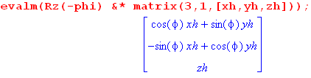
Therefore,

= cosφ + sinφ
= -sinφ +cosφ
= . (H.1.15)

Example 2: Consider (H.1.14) (f):

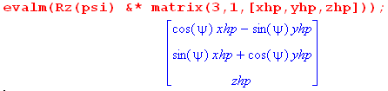
Therefore,

' = cosψ ' - sinψ '
' = sinψ ' +cosψ '
' = ' (H.1.16)

By inspection one can rewrite the six equations of (H.1.14) in the form shown on the right side of the Basis Theorem (H.1.9),

$\left(\begin{matrix}e'1 \\ e'2 \\ e'3\end{matrix}\right)$ = [Q]-1 $\left(\begin{matrix}e1 \\ e2 \\ e3\end{matrix}\right)$ ⇔ e'n = Qen (H.1.9)

Therefore,

(a) (,,) = Rz(φ) (,,)

(b) (',',') = Rz(φ)Rx(θ) (,,)

(c) (',',') = Rz(φ)Rx(θ)Rz(ψ) (,,)

(d) (,,) = Rz(-ψ)Rx(-θ)Rz(-φ) (',',')

(e) (,,) = Rz(-ψ)Rx(-θ) (',',')

(f) (',',') = Rz(-ψ) (',',') . (H.1.17)

We shall now prove the three facts quoted above as (H.1.13) (1), (2) and (3), and then we shall resume our discussion of the Euler Angles .

H.2 Theorem 3: Elimination of the Intermediate Rotations

Theorem 3 : The following claims are made : (H.2.1)

(1) Rξ(θ) = Rz(φ) Rx(θ) Rz(-φ)

(2) Rζ'(ψ) = Rz(φ) Rx(θ)Rz(ψ)Rx(-θ)Rz(-φ)

(3) Rζ'(ψ) Rξ(θ) Rz(φ) = Rz(φ)Rx(θ)Rz(ψ) = the Euler angle rotation R-1 of (H.1.8)

Recall from (G.1.1) that a rotation of α about axis may be written Rn(α) = exp(-i α n • J) .

Proof of (1) :

Recall Theorem 2 of (G.4.7) which says,

R exp(-iθn•J) R-1 = exp(-iθn'•J) where n' = Rn . (G.4.7)

Note from line 1 of (H.1.6) that = Rz(φ) . We take n' = , R = Rz(φ), n = to get

Rz(φ) exp(-iθ•J) Rz(-φ) = exp(-iθ•J)

or
Rξ(θ) = exp(-iθ•J) = Rz(φ) Rx(θ) Rz(-φ) . QED (1)

and we have thus proved item (1).
One can see intuitively how this works, as in our example of (G.4.14). Instead of rotating θ about the axes, we first back-rotate around by -φ, use the aligned Rx(θ) to create a tilted disk in the top drawing of Fig (H.1.5), then forward rotate that result by Rz(φ) to get the tilted disk in the left picture. The good news is that we don't have to rely on such visualizations to get the result right.

Proof of (2) :

Recall again Theorem 2 of (G.4.7) which says (now with dummy argument θ → ψ),

R exp(-iψn•J) R-1 = exp(-iψn'•J) where n' = Rn . (G.4.7)

Note from lines 2,1 of (H.1.6) that that ' = Rξ(θ) = Rξ(θ). We take n' = ', R = Rξ(θ), n = to get

Rξ(θ)exp(-iψ•J)Rξ(-θ) = exp(-iψ'• J) = Rζ'(ψ) .

Therefore

Rζ'(ψ) = Rξ(θ)Rz(ψ)Rξ(-θ) .

Then installing result (1) twice one gets

Rζ'(ψ) = [Rz(φ) Rx(θ) Rz(-φ)] Rz(ψ) [Rz(φ) Rx(-θ) Rz(-φ)]

= Rz(φ) Rx(θ) Rz(ψ) Rx(-θ) Rz(-φ) QED (2)

and thus item (2) is proved.

Reader Exercise: Interpret this result in terms of back-rotations and Fig (H.1.5).

Proof of (3) :
(2) (1)
Rζ'(ψ) Rξ(θ) Rz(φ) = [Rz(φ) Rx(θ)Rz(ψ)Rx(-θ)Rz(-φ)] [Rz(φ) Rx(θ) Rz(-φ)] Rz(φ)

= Rz(φ) Rx(θ) Rz(ψ) Rx(-θ) Rz(-φ) Rz(φ) Rx(θ) Rz(-φ) Rz(φ)

= Rz(φ) Rx(θ) Rz(ψ) Rx(-θ) Rx(θ)

= Rz(φ) Rx(θ) Rz(ψ) . QED (3)

H.3 Euler Angles : Triple Concatenation and Transformation of Vectors

Comparison with Goldstein and GPS

Resuming the Euler angle discussion, from (H.1.8) and Theorem 3 (3) we know that

R-1 = Rζ'(ψ) Rξ(θ) Rz(φ) = Rz(φ) Rx(θ) Rz(ψ)
so
R = Rz(-ψ) Rx(-θ) Rz(-φ) . (H.3.1)
On Goldstein p 109 (GPS p 153) this last equation R = Rz(-ψ)Rx(-θ)Rz(-φ) appears as A = BCD which is written out in detail in (4-46) (GPS 4.46), and which Maple verifies,

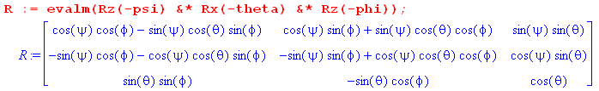 (H.3.2)

The transpose R-1 = RT then appears in Goldstein (4-47) (GPS 4.47) .

Interpretation of the Goldstein's Triple Concatenation

In our Section 1 formalism, we discuss the idea of three concatenated transformations near (1.1.41). One can compare the equations there to those of (H.1.6),

e"'n = U-1e''n e"n = S-1e'n e'n = R-1en (H.3.3)

(',',') = Rζ'(ψ) (',',') (',',') = Rξ(θ) (,,) (,,) = Rz(φ) (,,) .

It follows that the three "back-rotations" are

U-1 = Rζ'(ψ) S-1 = Rξ(θ) R-1 = Rz(φ) . (H.3.4)

In Fig (1.3.4) we show an example where R-1 = Rz(-α) = "back-rotation" and we draw the figure for some small α > 0. In Goldstein's back rotations, the role of α is played by -ψ ,-θ and -φ. Figure (H.1.5) shows that the basis vector "back rotations" are really forward rotations by ψ, θ and φ.

Doing the triple concatenation one gets,

e"'n = U-1S-1R-1en = Rζ'(ψ)Rξ(θ) Rz(φ)en
or
(',',') = Rζ'(ψ) Rξ(θ) Rz(φ) (,,) (H.3.5)

in agreement with (H.1.7).

Transformation of Kinematic Vectors

The corresponding Passive View transformations of Kinematic Vectors for the three concatenations are,

(V)''' = UV" (V)" = SV' (V)' = RV . (H.3.6)

Doing the concatenation and then changing the Section 1 triple-prime to Goldstein's single-prime,

(V)' = USR V

= Rζ'(-ψ)Rξ(-θ)Rz(-φ) V . (H.3.7)

Redefining R to be the notation for Goldstein's overall transformation, one gets

(',',') = R-1(,,) R-1 = Rζ'(ψ) Rξ(θ) Rz(φ)
= Rζ'(ψ) Rξ(θ) Rz(φ) (,,)

(V)' = R V R = [Rζ'(ψ) Rξ(θ) Rz(φ)]-1
= [Rζ'(ψ) Rξ(θ) Rz(φ)]-1 V . (H.3.8)

One can rewrite the above lines making use of Theorem 3 item (3) to get

(',',') = R-1(,,) R-1 = Rz(φ)Rx(θ)Rz(ψ)
= Rz(φ)Rx(θ)Rz(ψ) (,,)

(V)' = R V R = [ Rz(φ)Rx(θ)Rz(ψ)]-1
= [ Rz(φ)Rx(θ)Rz(ψ)]-1 V

= Rz(-ψ)Rx(-θ)Rz(-φ) V . (H.3.9)

This last item is the rule for finding the Frame S' components (V)'i of a vector V in terms of its Frame S components Vi .

Figure (H.1.5) shows the Kinematic Vector V = r which is the position of some point in Frame S .

Exercise 1:

Compute the Frame S' components of the vector r which in Frame S has components (x,y,z) .

(r)' = R r = Rz(-ψ)Rx(-θ)Rz(-φ) r (H.3.10)

(H.3.11)

Therefore
(r)' = $\left(\begin{matrix}x' \\ y' \\ z'\end{matrix}\right)$ = R$\left(\begin{matrix}x \\ y \\ z\end{matrix}\right)$
and so

x' = (cosψcosφ - sinψcosθsinφ) x + (cosψsinφ + sinψcosθcosφ) y + sinψsinθ z

y' = (- sinψcosφ - cosψcosθsinφ) x + (-sinψsinφ + cosψcosθcosφ) y + cosψsinθ z

z' = sinθsinφ x - sinθcosφ y + cosθ z . (H.3.12)

Application: What are the Frame S' components of ?

We set r = (x,y,z) = = (1,0,0) in (H.3.12) to get

()x' = cosψcosφ - sinψcosθsinφ = ()'1
()y' = - sinψcosφ - cosψcosθsinφ = ()'2
()z' = sinθsinφ = ()'3 (H.3.13)

Inspect the basis vector in the lower right drawing of Fig (H.1.5). For the small Euler angles used in the figure, appears to have positive x' and z' components, but a negative y' component. This is confirmed by looking at (H.3.13).

We now reverse Exercise 1 to get Exercise 2.

Exercise 2:

Compute the Frame S components of the vector r which in Frame S' has components (x',y',z') .

r = R-1(r)' = Rz(φ)Rx(θ)Rz(ψ)(r)' . (H.3.14)

The matrix R-1 = RT is just the transpose of the matrix shown above; Maple computes it anyway,

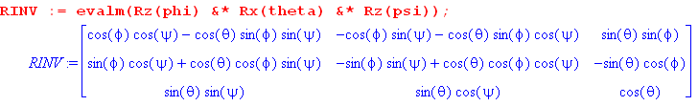 (H.3.15)
Therefore
r = $\left(\begin{matrix}x \\ y \\ z\end{matrix}\right)$ = R-1$\left(\begin{matrix}x' \\ y' \\ z'\end{matrix}\right)$
and so

x = (cosφcosψ-cosθsinφsinψ) x' + (-cosφsinψ-cosθsinφcosψ) y' +sinθsinφ z'

y = (sinφcosψ + cosθcosφsinψ) x' + (-sinφsinψ+cosθcosφcosψ) y' - sinθcosφ z'

z = sinθsinψ x' + sinθcosψ y' + cosθ z' . (H.3.16)

Application: What are the Frame S components of ' ?

We set (r)' = (x',y',z') = ' = (1,0,0) in (H.3.16) to get

(')x = cosψcosφ - sinψcosθsinφ = (')1
(')y = sinφcosψ + cosθcosφsinψ = (')2
(')z = sinθsinψ = (')3 . (H.3.17)

Inspect the basis vector ' in the lower right drawing of Fig (H.1.5). For the small Euler angles used in the figure, ' appears to have positive x,y and z components. This is confirmed in (H.3.17).

Exercise 3: Express (,,) in terms of (',',') .

According to (H.1.14) (d) we know that

= Rz(φ)Rx(θ)Rz(ψ) // = R-1 (H.1.14) (d)

where Maple computes the matrix,

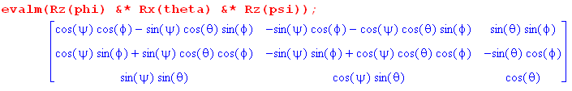 .

Therefore

= (cosψcosφ - sinψsinφcosθ) ' + (-sinψcosφ - cosψsinφcosθ) ' + (sinφsinθ) '

= (cosψsinφ + sinψcosφcosθ) ' + (-sinψsinφ + cosψcosφcosθ) ' + (-cosφsinθ) '

= (sinψsinθ) ' + (cosψsinθ) ' + (cosθ) ' . (H.3.18)

And now we go the other direction:

Exercise 4: Express (',',') in terms of (,,)

According to (H.1.14) (c) we know that

= Rz(-ψ)Rx(-θ)Rz(-φ) // = R (H.1.14) (c)

We can then use the Exercise 3 result with φ,θ,ψ → -ψ,-θ,-φ. But to avoid errors, we just use Maple again to get

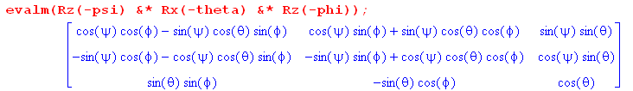

Therefore,

' = (cosψcosφ - sinψsinφcosθ) + (cosψsinφ + sinψcosφcosθ) + (sinθsinψ)

' = (-sinψcosφ - cosψsinφcosθ) + (-sinψsinφ + cosψcosφcosθ) + (sinθcosψ)

' = (sinφsinθ) + (-cosφsinθ) + (cosθ) . (H.3.19)

Exercise 5: Compute the Euler angle unit vectors , , .

Looking at Fig (H.1.5), we can read off

= = -sinφ +cosφ // (H.1.15)

= - ' = - sinψ ' - cosψ ' // (H.1.16)

= ' (H.3.20)

One can then use results (H.3.18) or (H.3.19) to express these all in terms of (,,) or (',',') .

H.4 Euler angles which change in time: computation of ω (Method 1)

Suppose now that all the Euler angles are changing in time. The combination of all these movements creates an overall ω angular rotation vector relating the relative motion of the two Frames (as in Fig 1). Looking at Fig (H.1.5) we see that ω will have three contributions, one from each Euler angle movement,

ωφ =
ωθ = '
ωψ = ' . (H.4.1)

Pause for Comment: We are going to claim that ω = ωφ + ωθ + ωψ so we compute the above three items and add them to get the result. But why are we allowed to do this? How do we know for example that might not make some contribution to ωθ? In answer, we are taking ω to be some generic vector and we expand it onto a (nonorthogonal) set of basis vectors ,' and ', so ω = ωz + ωξ'' + ωz'' . If one were to take a linear velocity and expand it as v = vx + vy + vz , one would argue that the meaning of vy was that it is the linear velocity in the y direction. Similarly, in expanding the angular velocity ω we argue that ωξ' is the angular velocity about the ' axis, and in the Euler picture (H.1.5) it happens that θ is associated by the right-hand rule with the ' axis, so ωξ' = dθ/dt. We then give ωξ' the more suggestive name ωθ so ωθ = dθ/dt . Thus, makes no contribution to ωθ just as vx makes no contribution to vy.

To learn the (H.4.1) contributions in Frame S components, one must replace ' and ' with their appropriate linear combinations of , and . From (H.1.14) (b),

= Rx(-θ) Rz(-φ) (H.1.14) (b)

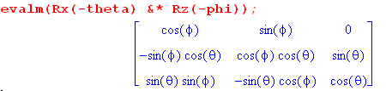
Therefore,

' = cosφ + sinφ . // this first eq is obvious from Fig (H.1.5) top
' = -cosθsinφ + cosθcosφ + sinθ
= sinθsinφ - sinθcosφ + cosθ . (H.4.2)

From (H.3.19),

' = sinθsinφ - sinθcosφ + cosθ . (H.3.19)

Inserting (H.4.2) for ' and (H.3.19) for ' into (H.4.1) gives,

ωφ =
ωθ = cosφ + sinφ
ωψ = sinθsinφ - sinθcosφ + cosθ . (H.4.3)

Add up to get

ω = ωφ + ωθ + ωψ
= [ sinθsinφ + cosφ] + [- sinθcosφ + sinφ ] + [ cosθ + ]
or
(ω)x = sinθsinφ + cosφ
(ω)y = - sinθcosφ + sinφ
(ω)z = cosθ + . // Frame S (H.4.4)

These then are the Frame S components of the ω vector.

Conversely, suppose we want (as Goldstein does want) the components of ω in Frame S' components, Frame S' being the rotating frame in which a "rigid body" might lie. From (H.1.14) (e),

= Rx(θ)Rz(ψ) (H.1.14) (e)

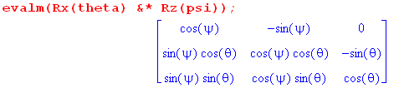
Therefore

' = = cosψ ' - sinψ '
= cosθsinψ ' + cosθcosψ ' - sinθ '
= sinθsinψ ' + sinθcosψ ' + cosθ ' . (H.4.5)

The first line can be verified by staring for a while at the lower right drawing in Fig (H.1.5). There we see that ' = Rz'(-ψ)' which implies the above. The author is prone to making errors staring at drawings and for this reason prefers the bulletproof Maple approach to computing things.

From (H.3.18),

= sinθsinψ ' + sinθcosψ ' + cosθ ' . (H.3.18)

Inserting (H.4.5) for ' and (H.3.18) for into (H.4.1) gives,

ωφ = = sinθsinψ ' + sinθcosψ ' + cosθ '
ωθ = ' = cosψ ' - sinψ '
ωψ = ' . (H.4.6)

Add up to get

ω = ωφ + ωθ + ωψ
= [ sinθsinψ + cosψ ] ' + [ sinθcosψ - sinψ] ' + [ cosθ + ] '
or
(ω)'x = sinθsinψ + cosψ ≡ ωx'
(ω)'y = sinθcosψ - sinψ ≡ ωy'
(ω)'z = cosθ + . ≡ ωz' // Frame S' (H.4.7)

These then are the Frame S' components of the ω vector.

This result is in agreement with Goldstein page 134 (GPS page 174),

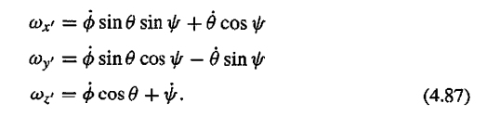

A quick verification of (H.4.4)

From (H.3.1) one has

R = Rz(-ψ)Rx(-θ)Rz(-φ) . (H.3.1)
The rule for the transformation of a kinematic vector is given by (H.3.9),

(ω)' = Rω (H.4.8)
so
(ω)'i = Rijωj = [ Rz(-ψ)Rx(-θ)Rz(-φ) ]ijωj . (H.4.9)

Inverting,

ωi = [ Rz(φ)Rx(θ)Rz(ψ)]ij (ω)'j . (H.4.10)

We enter the (ω)'j components (H.4.7) into Maple and then compute the ωi using (H.4.10),

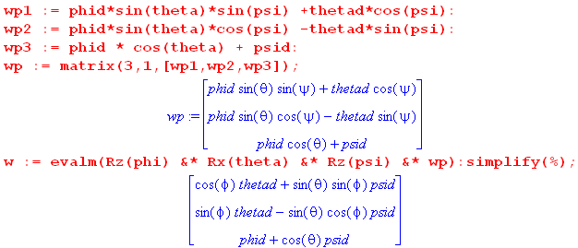 (H.4.11)

Transcribing the result gives,

(ω)x = cosφ + sinθsinφ
(ω)y = sinφ - sinθcosφ
(ω)z = + cosθ . (H.4.12)

This agrees with (H.4.4) above, providing some verification for our Frame S components of ω.

H.5 Computation of ω (Method 2)*

In this section our approach to computing ω for the Euler Angle rotation is to find an equation which involves ω and solve it for ω! More or less at random, we choose (1.7.4),

(den/dt)S' = – ω x en . (1.7.4) (H.5.1)

Unlike our Method 1 computation of ω in the previous section, here we shall have no need for Goldstein's geometric Figure (H.1.5) or intermediate angles like ξ and ζ. We will, however, need various algebraic results developed in Section G.3. This is an algebraic approach rather than a geometric approach.

* Method 2 is much more complicated than Method 1, and we only carried it through as a stress test of our various notations, facts and theorems developed earlier. We strongly recommend that the reader skip the details of this section and jump to the concluding "Summary of what happened" below (H.5.39). No new results are developed here, all results of interest were found by Method 1 in the previous section.
_____________________________________________________________________________________

Recall from (H.3.1) that the Goldstein Euler angle rotation is given by

R = Rz(-ψ)Rx(-θ)Rz(-φ) . (H.3.1) (H.5.2)

In order to avoid a hundred minus signs, we shall temporarily negate all three angles. Then when we are done, we will undo this negation. We therefore temporarily take R to be,

R(ψ,θ,φ) = Rz(ψ)Rx(θ)Rz(φ) ≡ R(Φ) = exp(-i Φ • J) . // temp (H.5.3)

Comment: To find Φ we could write out the matrix Rz(ψ)Rx(θ)Rz(φ),

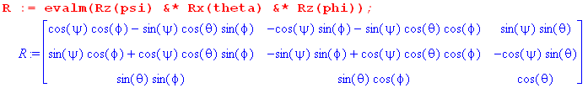

and decompose it into its symmetric and antisymmetric components S and A. In theory we could then compute Φ (=θ) and (=) from (G.2.14) and come up with an explicit expression for Φ = Φ. The reader is just reminded that this is mechanically possible, but luckily we have no need for the result (which is quite complicated). We could also compute dΦ from the following

R(ψ+dψ,θ+dθ,φ+dφ) = R(Φ+dΦ) = exp(-i [Φ+dΦ]• J)

but again there is no need to do this. Note that Φ and dΦ will generally not be in the same direction.

We now set about constructing the left side of (H.5.1) starting with our fundamental equation from (1.1.29) which relates the Frame S and Frame S' basis vectors,

en(Φ) = R(Φ)e'n or |en(Φ)> = |R(Φ)e'n> = R(Φ) |e'n> . (H.5.4)

Here we have in mind that Φ = Φ(t), showing how the Frame S basis vectors change in time as viewed from Frame S'. In contrast, the basis vectors e'n are static. The basis vectors |en(Φ)> are complete at time t so we can write, in analogy with (1.1.20),

1 = |en(Φ)><en(Φ)| completeness of the en at time t (a)

1 = |en(Φ+dΦ)><en(Φ+dΦ)| completeness of the en at time t+dt (b)

1 = |e'n><e'n| . completeness of the e'n at any time (c) (H.5.5)

In (b) the rotation vector has changed from Φ to some Φ+dΦ as time moved from t to d+dt. A key point is that the en basis vectors are complete at any point in time. The rotation operator R(Φ) similarly is real orthogonal at any time, analogous to (1.1.37),

RT(Φ) = R-1(Φ) and similarly for matrices RT(Φ) = R-1(Φ) . (H.5.6)

Now we close the Dirac equation in (H.5.4) on the left with <e'm| to get

<e'm| en(Φ) > = <e'm|R(Φ) |e'n> = [R(Φ)]'mn . (H.5.7a)

Since this is true for any Φ, one also has

<e'm| en(Φ+dΦ) > = <e'm|R(Φ+dΦ) |e'n> = [R(Φ+dΦ)]'mn . (H.5.7.b)

Recall from (1.1.35) that (R)'ij = Rij. Here we confirm that fact in the current fancier notation,

[R(Φ)]mn = <em(Φ)| R(Φ) |en(Φ)>

= <em(Φ) |e'i><e'i| R(Φ) |e'j><e'j|en(Φ)> = [R(Φ)]'im [R(Φ)]'ij[R(Φ)]'jn

= [ RT(Φ)R(Φ)R(Φ)]'mn = [ R-1(Φ)R(Φ)R(Φ)]'mn = [R(Φ)]'mn . (H.5.8a)

Since this is true for any Φ, one also has

[R(Φ+dΦ)]mn = [R(Φ+dΦ)]'mn . (H.5.8b)

PART 1: DETERMINATION OF THE FRAME S' COMPONENTS OF ω

First expression for: [(den/dt)S']'i

We now examine (from Frame S') a small change in the basis vector en(Φ) ,

|(den(Φ))S'> ≡ |en(Φ+dΦ)> - |en(Φ)>

= |e'i><e'i|en(Φ+dΦ)> - |e'i><e'i|en(Φ)> // completeness twice

= |e'i> [R(Φ+dΦ)]'in - |e'i>[R(Φ)]'in // (H.5.7b,a)

= ( [R(Φ+dΦ)]'in - [R(Φ)]'in ) |e'i> // reorder

= ( [R(Φ+dΦ)]in - [R(Φ)]in ) |e'i> // (H.5.8b,a) to remove primes

= ( R(Φ+dΦ) - R(Φ) )in |e'i>

= ( RT(Φ+dΦ) - RT(Φ) )ni |e'i> . (H.5.9)

The next step is to replace |e'i> as follows

|e'i> = |ej(Φ)><ej(Φ) | e'i> = |ej(Φ)>[R(Φ)]'ij = [R(Φ)]ij |ej(Φ)> . (H.5.10)

Then

|(den(Φ))S'> = ( RT(Φ+dΦ) - RT(Φ) )ni[R(Φ)]ij |ej(Φ)>

= ( RT(Φ+dΦ)R(Φ) - RT(Φ)R(Φ) )nj |ej(Φ)>

= ( RT(Φ+dΦ)R(Φ) - 1 )nj |ej(Φ)> . (H.5.11)

We then add dt/dt to the left side to get

dt |(den(Φ)/dt )S'> = ( RT(Φ+dΦ)R(Φ) - 1 )nj |ej(Φ)> . (H.5.12)

We wish to evaluate the above vector equation in Frame S' components. To do this, we close both sides with <e'i |, obtaining

dt <e'i |(den(Φ)/dt )S'> = ( RT(Φ+dΦ)R(Φ) - 1 )nj <e'i |ej(Φ)>
or
dt [(den/dt)S']'i = ( RT(Φ+dΦ)R(Φ) - 1 )nj R(Φ)ij

= ( RT(Φ+dΦ)R(Φ) - 1 )njRT(Φ)ji = [( RT(Φ+dΦ)R(Φ) - 1 )RT(Φ)]ni

= [ RT(Φ+dΦ) - RT(Φ) ]ni = [ R(Φ+dΦ) - R(Φ) ]in

≡ (dR)in where dR ≡ R(Φ+dΦ) - R(Φ) . (H.5.13)

Divide both sides by dt to obtain

[(den/dt)S']'i = (dR/dt)in dR ≡ R(Φ+dΦ) - R(Φ) . (H.5.14)
Second expression for: [(den/dt)S']'i

Recall (H.5.1),

(den/dt)S' = – ω x en . (1.7.4) (H.5.1)

We evaluate the above vector equation in Frame S' components,

[(den/dt)S']'i = - εikc(ω)'k(en)'c = - εikc(ω)'k [R(Φ)]'cn = -εikc(ω)'k [R(Φ)]cn . (H.5.15)

Equate the two expressions for: [(den/dt)S']'i

At this point we have shown that doing component evaluations of (den/dt)S' in Frame S' gives,

[(den/dt)S']'i = (dR/dt)in dR ≡ R(Φ+dΦ) - R(Φ) (H.5.14)

[(den/dt)S']'i = - εikc(ω)'k [R(Φ)]cn . (H.5.15)

Setting the right sides equal, one obtains,

- εikc(ω)'k [R(Φ)]cn = (dR/dt)in .

Multiply both sides on the right by [R-1(Φ)]nj to get

- εikc(ω)'k [R(Φ)]cn [R-1(Φ)]nj = (dR/dt)in [R-1(Φ)]nj
or
- εikc(ω)'kδcj = [ (dR/dt)R-1(Φ) ]ij
or
- εikj(ω)'k = [ (dR/dt)R-1(Φ) ]ij
or
εijk(ω)'k = Aij where A ≡ (dR/dt)R-1(Φ) . (H.5.16a)

It seems that the object Aij must be antisymmetric in its two indices, so the matrix Aij has only three significant elements. Setting ijk = 231 gives the first line below, then the next two lines follow from cyclic permutation :

(ω)'1 = A23 A ≡ (dR/dt)R-1(Φ)
(ω)'2 = A31
(ω)'3 = A12 . (H.5.16b)

Thus we have succeeded in solving for the components of ω in Frame S' . Recall that Frame S' is rotating at rate ω relative to Frame S as in Fig 1. It remains to compute the three Aij matrix elements so we can learn the specific expressions for the (ω)'i in terms of Euler Angles.

Recall from above that

(den/dt)S' = – ω x en (H.5.1)

(den/dt)S' = [ ( RT(Φ+dΦ)R(Φ) - 1 )nj ej ] / dt (H.5.11)

giving the following vector equation

– ω x en dt = ( RT(Φ+dΦ)R(Φ) - 1 )nj ej . (H.5.17)

We have evaluated the Frame S' components of this equation just above, and later we will evaluate the Frame S components.

Computation of A and Statement of Final Result

Our task is to compute A ≡ (dR/dt)R-1(Φ) where our "temporary" R(Φ) is given by

R(Φ) = Rz(ψ)Rx(θ)Rz(φ) (H.5.3)

and where

dR = R(Φ+dΦ) - R(Φ) . (H.5.13)

The first step is to compute dR in terms of the Euler angles. We make use of the obvious fact that
Ri(α +dα) = Ri(α)Ri(dα) and then the fact (1.5.6) that Ri(dα) ≈ 1 - idα Ji for small dα. Keeping only terms of first order in the differential angles, one finds

dR = R(Φ+dΦ) - R(Φ)

= Rz(ψ+dψ) Rx(θ+dθ) Rz(φ+dφ) - Rz(ψ) Rx(θ) Rz(φ)

= Rz(ψ) Rz(dψ) Rx(θ) Rx(dθ) Rz(φ) Rz(dφ) - Rz(ψ) Rx(θ) Rz(φ)

= Rz(ψ){1-idψJ3}Rx(θ){1-idθJ1}Rz(φ){1-idφJ3} - Rz(ψ) Rx(θ) Rz(φ)

= -idψ Rz(ψ)J3Rx(θ)Rz(φ) - idθ Rz(ψ) Rx(θ)J1Rz(φ) - idφ Rz(ψ) Rx(θ)Rz(φ)J3 (H.5.18)

where the leading terms exactly cancel. Dividing by dt one then has

(dR/dt) = -i Rz(ψ)J3Rx(θ)Rz(φ) - i Rz(ψ)Rx(θ)J1Rz(φ) - i Rz(ψ)Rx(θ)Rz(φ)J3 . (H.5.19)

The next step is to compute A ≡ (dR/dt)R-1(Φ) using R-1(Φ) = Rz(-φ)Rx(-θ)Rz(-ψ). In doing so, we shall three times in blue use the fact that Ji commutes with Ri as formally stated in (G.3.6) :

A ≡ (dR/dt) R-1(Φ)

= [ -i Rz(ψ)J3Rx(θ)Rz(φ) - i Rz(ψ)Rx(θ)J1Rz(φ) - i Rz(ψ)Rx(θ)Rz(φ)J3] Rz(-φ)Rx(-θ)Rz(-ψ)

= [ -i Rz(ψ)J3 Rx(θ) - i Rz(ψ) Rx(θ)J1 - i Rz(ψ) Rx(θ)Rz(φ)J3Rz(-φ) ] Rx(-θ) Rz(-ψ)

= [ -i Rz(ψ)J3 Rx(θ) - i Rz(ψ) Rx(θ)J1 - i Rz(ψ) Rx(θ)J3 ] Rx(-θ) Rz(-ψ)

= [ -i Rz(ψ)J3 - i Rz(ψ) Rx(θ)J1Rx(-θ) - i Rz(ψ) Rx(θ)J3Rx(-θ) ] Rz(-ψ)

= [ -i Rz(ψ)J3 - i Rz(ψ) J1 - i Rz(ψ) Rx(θ)J3Rx(-θ) ] Rz(-ψ)

= [ -i Rz(ψ)J3 Rz(-ψ) - i Rz(ψ) J1 Rz(-ψ) - i Rz(ψ) Rx(θ)J3Rx(-θ) Rz(-ψ) ]

= [ -i J3 - i Rz(ψ) J1 Rz(-ψ) - i Rz(ψ) Rx(θ)J3Rx(-θ) Rz(-ψ) ]

= [ -i J3 - i M1 - i M2 ]

where (H.5.20)

M1≡ Rz(ψ) J1Rz(-ψ) = [ R3(ψ) J1R3(-ψ)]

M2 ≡ Rz(ψ) Rx(θ)J3Rx(-θ)Rz(-ψ) = R3(ψ) [ R1(θ)J3R1(-θ) ] R3(-ψ) .

We now call upon our non-trivial sandwich formulas in (G.3.8) to simplify thing further :

M1 = R3(ψ) J1R3(-ψ) = cosψJ1 + sinψ J2 // (G.3.8) line 5

M2 = R3(ψ) [ R1(θ)J3R1(-θ) ] R3(-ψ)

= R3(ψ) [ cosθ J3 - sinθ J2 ] R3(-ψ) // (G.3.8) line 2

= cosθ [ R3(ψ) J3 R3(-ψ)] - sinθ [R3(ψ)J2R3(-ψ)]

= cosθ J3 - sinθ (cosψJ2 - sinψ J1) // (G.3.6) and (G.3.8) line 6

= sinθsinψJ1 - sinθcosψJ2 + cosθ J3 . (H.5.21)

Then,

A = [ -i J3 - i M1 - i M2 ]

= [ -i J3 - i (cosψJ1 + sinψ J2) - i (sinθsinψJ1 - sinθcosψJ2 + cosθ J3) ]

= [ -i J3 - i cosψJ1 - i sinψ J2 - i sinθsinψJ1 + i sinθcosψJ2 - i cosθ J3 ]

= (-i)[ J3 + cosψJ1 + sinψ J2 + sinθsinψJ1 - sinθcosψJ2 + cosθ J3 ]

= (-i)[ ( cosψ + sinθsinψ)J1 + ( sinψ - sinθcosψ)J2 + ( + cosθ)J3 ]

= - [ ( cosψ + sinθsinψ)(iJ1) + ( sinψ - sinθcosψ)(iJ2) + ( + cosθ)(iJ3) ] . (H.5.22)

We now take the ij element of this matrix using the fact (G.1.3) that (iJk)ij = εkij ,

Aij = - [ ( cosψ + sinθsinψ)ε1ij + ( sinψ - sinθcosψ)ε2ij + ( + cosθ)ε3ij ] . (H.5.23)

The tensor εkij is antisymmetric in i↔j and therefore the entire matrix A is antisymmetric (as conjectured earlier) and thus has only three distinct matrix elements. They are:

A23 = - ( cosψ + sinθsinψ)ε123 = - ( cosψ + sinθsinψ)

A31 = - ( sinψ - sinθcosψ)ε231 = - ( sinψ - sinθcosψ)

A12 = - ( + cosθ) ε312 = - ( + cosθ) . (H.5.24)

From (H.5.17) we then conclude that

(ω)'1 = A23 = - ( cosψ + sinθsinψ)
(ω)'2 = A31 = - ( sinψ - sinθcosψ)
(ω)'3 = A12 = - ( + cosθ) . // angles still negated

We now undo the temporary negation of the angles ψ,θ,φ enacted below (H.5.2). The velocities and sines then negate. Our final result for the Frame S' components of ω is then,

(ω)'1 = sinθsinψ + cosψ ≡ ωx'
(ω)'2 = sinθcosψ - sinψ ≡ ωy'
(ω)'3 = cosθ + ≡ ωz' . (H.5.25)

This is in agreement with our Method 1 calculation (H.4.7) and with Goldstein's result which we again quote from Goldstein page 134 (GPS page 174),

PART 2: DETERMINATION OF THE FRAME S COMPONENTS OF ω

Here we shall review three different Plans for computing the Frame S components of ω.

Plan A: Since we just computed the (ω)'i in Frame S', we just use ω = R-1(ω)' to get the Frame S components. This was done at the end of Section H.4 with the result stated in (H.4.12).

Plan B: Start with (1.7.1) that (de'n/dt)S = ω x e'n in place of (H.5.1) that (den/dt)S' = – ω x en, which adds an overall minus sign to the result. The new (H.5.4) becomes e'n(Φ) = R-1(Φ)en with en = constant in Frame S. Things go through as presented above, but since R(Φ) → R-1(Φ) and since R(Φ) = Rz(ψ)Rx(θ)Rz(φ), one has R-1(Φ) = Rz(-φ)Rx(-θ) Rz(-ψ). Thus, to convert the result (H.5.25) to the Frame S result, we have to make these changes: (1) φ, ψ, θ → -ψ, -φ , -θ ; (2) add the overall minus sign just noted. We do that right here:
φ, ψ, θ → -ψ, -φ , -θ
(ω)'1 = sinθsinψ + cosψ ≡ ωx'
(ω)'2 = sinθcosψ - sinψ ≡ ωy'
(ω)'3 = cosθ + ≡ ωz' . (H.5.25)
→
-(ω)1 = [-][-sinθ][-sinφ] + [-] cosφ ⇒ ω1 = sinθsinφ +cosφ
-(ω)2 = [-][-sinθ]cosφ - [-][-sinφ] ⇒ ω2 = - sinθcosφ + sinφ
-(ω)3 = [-] cosθ + [-] ⇒ ω3 = cosθ + (H.5.26)

and this agrees with (H.4.12).

Plan C: Compute the ωi directly using the machinery developed earlier in this section, but take Frame S components instead of Frame S' components. We regard this as a "stress test" of the machinery.

First expression for: [(den/dt)S']i

Start with (H.5.11)

|(den(Φ))S'> = ( RT(Φ+dΦ)R(Φ) - 1 )nj |ej(Φ)> . (H.5.11)

Instead of closing on the left with <e'i | to get Frame S' components, this time close on the left with <ei | to get Frames S components,

[(den)S']i = <ei |(den(Φ))S'> = ( RT(Φ+dΦ)R(Φ) - 1 )nj <ei(Φ) |ej(Φ)>

= ( RT(Φ+dΦ)R(Φ) - 1 )nj δji // (1.1.14) line 1

= ( RT(Φ+dΦ)R(Φ) - 1 )nj (R-1(Φ)R(Φ))ji = [( RT(Φ+dΦ)R(Φ) - 1 )R-1(Φ)R(Φ)]ni

= [( RT(Φ+dΦ) - RT(Φ) ) R(Φ)]ni = [RT(Φ)( R(Φ+dΦ) - R(Φ) )]in

= [RT(Φ)(dR)]in = [RT(Φ)(dR) R-1(Φ)R(Φ)]in .

Divide by dt,

[(den/dt)S']i = [RT(Φ)(dR/dt)R-1(Φ) R(Φ)]in = [RT(Φ)A R(Φ)]in (H.5.27)

where recall that A ≡ (dR/dt)R-1(Φ) from (H.5.16).

Second expression for: [(den/dt)S']i

Recall (H.5.1),

(den/dt)S' = – ω x en . (1.7.4) (H.5.1)

We evaluate the above vector equation in Frame S components,

[(den/dt)S']i = - εikcωk(en)c = - εikcωkδnc = - εiknωk . (H.5.28)

Equate the two expressions for: [(den/dt)S']i

At this point we have shown that doing component evaluations of (den/dt)S' in Frame S gives,

[(den/dt)S']i = [RT(Φ)A R(Φ)]in . (H.5.27)

[(den/dt)S']i = - εiknωk . (H.5.28)

Setting the right sides equal, we obtain

- εiknωk = [RT(Φ)A R(Φ)]in ≡ Bin
or
εinkωk = Bin
or
εijkωk = Bij B = RT(Φ)A R(Φ) . (H.5.29)

Thus we arrive at (H.5.16) with (ω)'i replaced by ωi and with A replaced by B,

ω1 = B23
ω2 = B31
ω3 = B12 . (H.5.30)

It remains only to compute the Bij.

Computation of B and Statement of Final Result

Recall from (H.5.22) that

A = - [ ( cosψ + sinθsinψ)(iJ1) + ( sinψ - sinθcosψ)(iJ2)+ ( + cosθ)(iJ3) ] . (H.5.22)

We may write this as

A = aiJi

where (H.5.31)
a1 = - i( cosψ + sinθsinψ)
a2 = - i( sinψ - sinθcosψ)
a3 = - i( + cosθ) .

Entering into Maple,

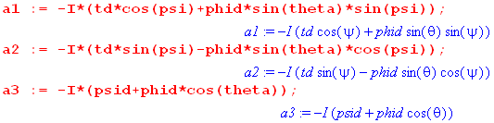. (H.5.32)
Then the matrix B in (H.5.29) can be written,

B = R-1(Φ)A R(Φ) = R-1(Φ)[aiJi] R(Φ)

= ai [R-1(Φ)JiR(Φ)[ = aiR(Φ)ijJj // Theorem 1 of (G.4.1) with R→R-1

= aiQi where Qi ≡ R(Φ)ijJj . (H.5.33)

Using our "temporary" R(Φ) in (H.5.3) we compute the vector Q as follows (a vector of matrices),

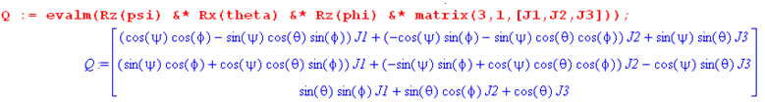
(H.5.34)
The quantity B = aiQi is then,

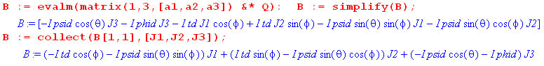
(H.5.35)
We move the factors of i (Maple I) next to the Jk and transcribe the last line above:

B = (- cosφ - sinθsinφ)(iJ1) + (sinφ - sinθcosφ)(iJ2) + (- cosθ - )(iJ3) . (H.5.36)

Using (G.1.3) that (iJk)ij = εkij the matrix elements of B are then,

Bij = (- cosφ - sinθsinφ)ε1ij + (sinφ - sinθcosφ)ε2ij + (-cosθ - )ε3ij . (H.5.37)

Therefore,

B23 = - cosφ - sinθsinφ
B31 = sinφ - sinθcosφ
B12 = -cosθ - . (H.5.38)

Then from (H.5.30),

ω1 = B23 = - cosφ - sinθsinφ
ω2 = B31 = sinφ - sinθcosφ
ω3 = B12 = -cosθ - . // angles still negated

We now undo the temporary negation of the Euler angles ψ,θ,φ enacted below (H.5.2). The velocities and sines then negate. Our final result for the Frame S components of ω is then,

ω1 = B23 = cosφ + sinθsinφ
ω2 = B31 = sinφ - sinθcosφ
ω3 = B12 = cosθ + . (H.5.39)

This is in agreement which (H.4.12) which we now quote,

(ω)x = cosφ + sinθsinφ
(ω)y = sinφ - sinθcosφ
(ω)z = + cosθ . (H.4.12)

PART 3: SUMMARY OF WHAT HAPPENED

Frame S and Frame S' are related by some angular velocity ω as shown in Fig 1.

Our task is to solve the following equation for ω

(den)S' = – ω x en dt . (1.7.4) (H.5.1)

Acting as an Observer in Frame S', we study the change in the Frame S basis vectors (den)S' caused by the time-varying Euler angles. In (H.5.11) we obtain a vector equation for this change,

(den)S' = [ RT(Φ+dΦ)R(Φ) -1 ]nj ej where R(Φ) ≡ Rz(-ψ)Rx(-θ)Rz(-φ) . (H.5.11)

Equating the right sides of the above two equations, we obtain the following vector equation which we want to solve for ω,

– ω x en dt = ( RT(Φ+dΦ)R(Φ) -1 )nj ej . (H.5.17)

We find that, to lowest order, the quantity (RT(Φ+dΦ)R(Φ) -1 )nj is linear in the differential angles dψ, dθ and dφ and when both sides are divided by dt, these become rates , and .

If, while observing things from Frame S', one obtains a vector equation like (H.5.17), one is certainly allowed to evaluate both sides of the equation either in Frame S' components or Frame S components.

By taking the Frame S' components of (H.5.17) we obtain the Frame S' components of ω in (H.5.25), and these are seen to agree with the results (H.4.7) from the Method 1 calculation.

By taking the Frame S components of (H.5.17) we obtain the Frame S components of ω in (H.5.39), and these are seen to agree with the results (H.4.12) from the Method 1 calculation.

Along the way we get to exercise various earlier results : the sandwich formulas (G.3.6) and (G.3.8) in the computation of A, Theorem 1 of (G.4.1) saying RJiR-1= R–1ijJj in the computation of B, and the rotation generator matrix representations of (G.1.3). Finally, we are able to exercise the Dirac notation of Section 1.1. The approach of this section makes use of the "linear combination" side of the Basis Theorem (1.1.29) rather than the "operator" side, so matrices appear right from the start.

H.6 The connection between Euler Angles and Spherical Coordinates

Appendix E presents the spherical coordinates unit vectors in the following manner,

= Rz(φ) Ry(θ)
= Rz(φ) Ry(θ)
= Rz(φ) Ry(θ)
or (H.6.1)
(, , ) = Rz(φ) Ry(θ) (, , ) .

This can be "derived" basically by staring at this picture and using one's right hand,

(H.6.2)

In order to use the Euler angles shown in Fig (H.1.5) to describe things like spinning tops, and then to be able to use spherical coordinates to describe the location of the top symmetry axis, we want the unit vector ' to be the same as in the above spherical coordinates picture. From (H.1.17) (c) one has

(',',') = Rz(φ)Rx(θ)Rz(ψ) (,,) (H.6.3)

and in particular,

' = Rz(φ)Rx(θ)Rz(ψ) . (H.6.4)

Comparing this to (H.6.1), in order to get ' = one must have

Rz(φ)Rx(θ)Rz(ψ) = Rz(φ)Ry(θ) . (H.6.5)

This requires that

Rz(φ)Rx(θ)Rz(ψ) = Rz(φ)Ry(θ)Rz(α) (H.6.6)

where α is an arbitrary angle (since Rz(α)= ). From (G.4.13) we know that

Rz(π/2)Rx(θ)Rz(-π/2) = Ry(θ) (H.6.7)

so the requirement (H.6.6) becomes

Rz(φ)Rx(θ)Rz(ψ) = Rz(φ) [Rz(π/2)Rx(θ)Rz(-π/2)]Rz(α)
or
Rz(φ)Rx(θ)Rz(ψ) = Rz(φ+π/2)Rx(θ)Rz(-π/2+α) . (H.6.8)

These two 3x3 matrices will be equal provided one chooses,

φ = φ + π/2 and ψ = α - π/2 . (H.6.9)

Since α is arbitrary, one can always set α = ψ + π/2, but the first equation is more significant. As long as φ = φ+π/2, we will have ' = , the rigid body symmetry axis can be identified with , and the "top" is then spinning about this axis at angular rate . Here is a look at Fig (I.7.1) to come,

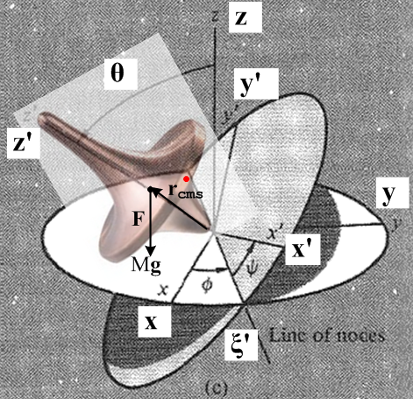 (H.6.10)

So we have lined up ' = . What happens to the other Goldstein unit vectors? From (H.6.3), (H.6.6) and (H.6.9),

' = Rz(φ)Rx(θ)Rz(ψ) = Rz(φ)Ry(θ)Rz(α) = Rz(φ)Ry(θ)Rz(ψ+π/2)

' = Rz(φ)Rx(θ)Rz(ψ) = Rz(φ)Ry(θ)Rz(α) = Rz(φ)Ry(θ)Rz(ψ+π/2) . (H.6.11)

Setting ψ = -π/2 on the figure axis, one finds

' = Rz(φ)Ry(θ) =
' = Rz(φ)Ry(θ) =

so we end up with these results,

' = for any value of ψ
' = for ψ = -π/2
' = for ψ = -π/2 . (H.6.12)

Finally, notice that

φ = φ+π/2 ⇒ sinφ = sin(φ+π/2) = cosφ and cosφ = cos(φ+π/2) = -sinφ

so that

sinφ = cosφ
cosφ = -sinφ . (H.6.13)

Recall the equations describing the ω vector in Frame S coordinates,

ω1 = sinθsinφ + cosφ
ω2 = - sinθcosφ + sinφ
ω3 = cosθ + . // Frame S (H.4.4)

If one is using spherical coordinates r,θ,φ to describe a rigid body, these equations must be rewritten as

ω1 = sinθcosφ - sinφ
ω2 = sinθsinφ + cosφ
ω3 = cosθ + . // Frame S (H.6.14)

Similarly the expressions for the Frame S' coordinates,

(ω)'1 = sinθsinψ + cosψ
(ω)'2 = sinθcosψ - sinψ
(ω)'3 = cosθ + // Frame S' (H.4.7)

get rewritten as

(ω)'1 = sinθsinψ + cosψ
(ω)'2 = sinθcosψ - sinψ
(ω)'3 = cosθ + // Frame S' (H.6.15)

Appendix I: Rigid Body Dynamics

We develop here the equations of motion for a rigid body's angular velocity vector ω(t). This is done using ω components (ω)'i in Frame S', the body frame. It is shown that one might as well choose the Frame S' axes to line up with some set of principal axes of the rigid body since this diagonalizes the inertia tensor, simplifying equations. We examine the general torque-free solution for ω using the construction of Poinsot, and then analytically solve for ω for the special axisymmetric case. The results for ω are obtained in both Frame S' and inertial Frame S, and appropriate "cone pictures" are displayed. It is noted that the Earth exhibits a tiny torque-free precession called the Chandler wobble. We then consider the torque-present problem of a spinning top. For the Earth, weak torques are applied by the Sun and Moon causing a slow precession known as the precession of the equinoxes. We then derive an expression for the torque of the Sun or Moon on the slightly oblate Earth. The final sections deal with rotors involving electric or magnetic dipoles, with MRI providing an engineering example.

I.1 The Appearance of the Inertia Tensor

Assume that Frame S' is embedded into a rigid body, so that Frame S' and that rigid body are rotating at angular velocity ω relative to an inertial Frame S. This is the situation of our "non-swap notation". Goldstein uses the appropriate term "body frame" for such a Frame S'. All sensible authors use "swap notation" for this analysis to avoid an avalanche of prime symbols (or other labels), but we shall be obstinate in using the non-swap notation because it forces us to think carefully about many details. We have to decide whether to put a prime or not put a prime on each entity.

In Frame S' the rigid body is at rest, so the Frame S' velocity v'α of any particle α of the rigid body vanishes, v'α = 0. For particle α we also have p'α = mαv'α = 0 and L'α = r'α x p'α = 0. In particular, the total Frames S' angular momentum of the rigid body is L' = ΣαL'α = 0. These facts are quite obvious but we state them anyway. Note that α here is a label and not a component index. We shall use α in this manner as a particle label, and the usual i,j,k indices as component indices. Obviously, for a continuous rigid body Σα is really an integration over the particles of the body.

In Frame S, however, the rigid body has some non-vanishing angular momentum L = Σα rα x mvα .

In what follows, we shall be very careful with the use of "primes" to clearly show what objects are the natural objects in what frames, and what frame components are being evaluated. As noted in Section 1.3, in order to mark our "natural" objects with primes or no primes depending on whether they are associated with Frame S' or Frame S, we must use the Passive View of rotation transformations. For vectors this means (V)' = RV and for rank-2 tensors (T)' = RTR-1 (with Frame S' components (V)'i and (T)'ij ).

Angular Momentum, the Inertia Tensor, and Kinetic Energy

We shall assume Special Case #1 where the ω rotation axis passes through the origin of Frame S. In this case recall from (6.11) that

v = v' + ω x r . // Special Case #1 only (6.11)

Comment: This is valid also for Special Case #4 where the two Frame origins coincide so the ω axis passes through both origins.

For a rigid body particle α one has, from (6.11) above,

vα = v'α + ω x rα = 0 + ω x rα = ω x rα . (I.1.1)

Then the total Frame S angular momentum of the rigid body is (with respect to the Frame S origin),

L = Σα rα x pα = Σα rα x mαvα = Σα mα rα x (ω x rα)

= Σα mα [ rα2ω - (rα • ω) rα ] . //A x (B x C) = (A•C)B - (A•B)C (I.1.2)

Taking Frame S components,

Li = Σα mα [ rα2ωi - (rα • ω) (rα)i ]

= Σα mα [ rα2Σjωjδij - Σj(rα)jωj (rα)i ]

= Σα mα Σj[ rα2δij - (rα)i(rα)j ] ωj

= Σj { Σαmα [ rα2δij - (rα)i(rα)j ] } ωj

= Σj Iijωj
where
Iij ≡ Σαmα [ rα2δij - (rα)i(rα)j ] = the inertia tensor (I.1.3)
or Iij ≡ ∫dx1dx2dx3 ρ(x)[ r2δij - xixj] . // continuum notation

We rewrite Li = Σj Iijωj as a vector equation,

L = Iω . (I.1.4)
Exercise: Write an expression for the Dirac inertia operator I (script I, not T) :

<ei| I | ej> = Iij = Σαmα [ rα2δij - (rα)i(rα)j ]

= Σαmα [ rα2<ei|ej> - <ei|rα><rα|ej> = <ei| { Σαmα [ rα2 1 - |rα><rα| } |ej>

⇒ I = Σαmα ( rα21 - |rα><rα| ) . (I.1.5)

In equation (I.1.4) L, I and ω are all associated with a Frame S observer. L is the "natural" angular momentum of the rigid body as seen in Frame S, and ω is the angular velocity of Frame S' (and its rigid body) as seen from Frame S. Finally Iij are the inertia tensor components viewed from Frame S.

Although L = Iω is a Frame S equation, as with any vector equation one can take components of the equation in either Frame S or Frame S' :

Li = Iij (ω)j Iij = Σαmα [ rα2δij - (rα)i(rα)j ] // rα2 = (rα)i(rα)i
(I.1.6)
(L)'i = (I)'ij (ω)'j (I)'ij = Σαmα [ r'α2δij - (rα)'i(rα)'j ] . // r'α2 = (rα)'i(rα)'i

Notice in (I)'ij that (rα)'i = <e'i| rα > is constant in time. The components of a vector static in Frame S' do not change in time, although Frame S' moves relative to Frame S. Thus ∂t(rα)'i = 0. The magnitude of the vector rα is obviously constant in time, but we verify: ∂tr'α2 = 2(r'α) • ∂t[(rα)'i] = 0. Therefore ∂t(I)'ij = 0 for the entire tensor (I)'. In contrast, ∂tIij ≠ 0 . Note that rα2 = r'α2 .

Exercise: Verify that (I)' = RIR-1, thus showing that I is a rank-2 tensor (in the Passive View) :

(RIR-1)ij = RiaIabR-1bj = Ria[ Σαmα ( rα2δab - (rα)a(rα)b )]R-1bj

= Σαmα (rα2 RiaδabR-1bj - Ria(rα)aR-1bj(rα)b )

= Σαmα (rα2RiaR-1aj - [Ria(rα)a][Rjb(rα)b] )

= Σαmα (r'α2 δij - (rα)'i(rα)'j) = (I)'ij . QED

In what follows, we ignore kinetic energy associated with motion of the rigid body center of mass. We think of this center of mass being at rest in both Frame S and Frame S'.

The total rotational Frame S kinetic energy T of the rigid body is given by, using (I.1.1),

T = Σα(1/2)mαvα2 = Σα(1/2)mα vα • (ω x rα) = Σα(1/2)mα ω • (rα x vα) // cyclic rule

= Σα (1/2) ω • (rα x mαvα) = (1/2) ω • Σα rα x pα = (1/2) ω • L

= (1/2) ω • (Iω) . // (I.1.4) (I.1.7)

We pause to note the various notations one can use for this dot product :

ω • (Iω) = ωTIω (matrix notation) = ωiIijωj = ωiωjIij (all Frame S components)

= <ω | I | ω> (Dirac notation, where I is the abstract inertia operator

= <ω |ei><ei| I |ej><ej| ω> = ωi Iij ωj // completeness (1.1.20)

= ω • I • ω (Goldstein p 149 5-15) = ωω = ωIω . (I.1.8)

Comments: We feel it is useful to keep stressing these notational issues:

• The Frame S' kinetic energy T' = (1/2) ω' • I' • ω' = 0 because ω' = 0, meaning (ω')i= 0. This is so because the rigid body is at rest in Frame S' -- nothing is moving in Frame S' !

• The Frame S kinetic energy T = (1/2)ω•I•ω can be written out in either Frame S or Frame S' components,

T = (1/2) ω•I•ω = (1/2) ωiωjIij = (1/2) (ω)'i(ω)'j(I)'ij . (I.1.9)

Proof: In Dirac notation,

T = (1/2) <ω | I | ω> = (1/2) <ω |ei><ei| I |ej><ej| ω> = (1/2) ωiIijωj

T = (1/2) <ω | I | ω> = (1/2) <ω |e'i><e'i| I |e'j><e'j| ω> = (1/2)(ω)'i(I)'ij (ω)'j .

Using the Goldstein double dot notation, kinetic energy can be rewritten as

T = (1/2) ( • I • ) ω2 = (1/2) I ω2 where I ≡ • I • , (I.1.10a)

in analogy with T = (1/2)mv2 for linear motion. The scalar object I is called the moment of inertia of the rigid body about the axis,

I ≡ • I • = ijIij = ij Σαmα [ rα2δij - (rα)i(rα)j ]

= Σαmα [ rα2ijδij - (rα)i i(rα)jj ]

= Σαmα [ rα2 - (rα • )2] = Σαmα [ rα2 - (rα)||2]

= Σαmα (rα)⊥2, (I.1.10b)

where (rα)⊥ is the perpendicular distance of particle α from the ω rotation axis,

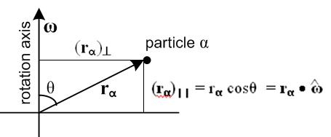 (I.1.10c)

I.2 Rigid Body Equations of Motion : Part 1

Up to this point, there has been no requirement that Frame S be an inertial frame, but we now add that requirement. Then Newton's Second Law (11.3.2) (for angular motion) applied in Frame S states,

N = // = ∂SL = (dL/dt)S (I.2.1)

where we set the torque and angular momentum reference point to the Frame S origin. This law is valid because Frame S is an inertial frame so there are no fictitious torques. N is the Frame S torque, and is the natural time derivative of natural L in Frame S (see (1.8.4) and (1.9.3)).

Using the G Rule (2.1) one finds, in the notation of (1.8.3) where ∂S ≡ (d/dt)S and ∂S' ≡ (d/dt)S',

≡ ∂SL = ∂S'L + ω x L (2.1)

so Newton (I.2.1) says

(∂S'L) + ω x L = N . (I.2.2)

Note that (∂S'L) is not a "natural" object in the sense of Section 1.8 since L is a Frame S object, but the time derivative is taken in Frame S', the body frame. Now consider,

(∂S'L) = (∂S'[Iω]) = (∂S'I)ω + I(∂S'ω) . (I.2.3)

We noted above that the inertia tensor is constant in Frame S' so we expect that (∂S'I) = 0. To make sure, we examine the components of (∂S'I) in Frame S',

[(∂S'I)]'ij = ∂S'(I)'ij // commutation theorem (1.11.1) applied to a tensor

= ∂t(I')ij // (1.10.1)

= 0 . // shown below (I.1.6) (I.2.4)

If [(∂S'I)]'ij = 0 for all components, then (∂S'I) = 0 as a tensor statement. We also know from (2.6) that

∂S'ω = ∂Sω = ∂tω = . (2.6)

Therefore (I.2.3) reads,

(∂S'L) = (∂S'[I ω]) = (∂S'I) ω + I (∂S'ω) = 0 + I = I . (I.2.5)

Inserting this into (I.2.2) then produces our vector equation of motion for ω,

N = I + ω x (Iω) . (I.2.6)

Taking components in Frame S' (the body frame) one finds

(N)'i = (I)'ij ()'j + εijk(ω)'j(I)'ka (ω)'a . (I.2.7)

In what follows we shall always solve (I.2.6) in Frame S' components because only in Frame S' can the inertia tensor be diagonalized in a manner that applies for all time t.

I.3 Diagonalization of the Inertia Tensor in Frame S'

So far we have not paid much attention to the manner in which the Frame S' basis vectors are selected, and so far we have called them e'i. One is of course free to define new orthonormal Frame S' basis vectors e"i according to

e"i ≡ Qij e'j or | e"i> ≡ Qij | e'j> ⇒ <e'k | e"i> = Qik

where Q is some arbitrary rotation matrix (Q-1 = QT). Then in this new basis the inertia tensor is

(I)"ij = <e"i| I | e"j> = <e"i |e'a><e'a| I |e'b><e'b| e"j> =

= Qia(I)'abQjb = [Q I Q-1]ij // (I)" = Q I Q-1

Note that (I)'ij = Σαmα [ r'α2δij - (rα)'i(rα)'j ] is a symmetric matrix, (I)'ij = (I)'ji.

A staple matrix theorem is that any real symmetric matrix M can be brought to diagonal form by a "similarity transformation" with some real orthogonal matrix S, so Λ = S-1MS where Λ is diagonal. There is a specific method for determining a suitable matrix S that does this diagonalization task. If we then select Q = S-1, the matrix (I)" = Q I Q-1 will be diagonal in the e"i basis. The basis vectors e"i are called "the principal axes" of the rigid body in question, and Q = S-1 is "the principal axis transformation". Note that the principle axes are fixed to a rigid body and do not change relative to the body as the body is reoriented (like the center of mass, and unlike the center of gravity, as both discussed in Appendix D).

Realizing this fact, we might as well start off selecting e'i to be a set of principle axes. From now on, then, we shall assume that the e'i have been so selected and thus the inertia tensor I is diagonal in Frame S' components.

Comments: In general, any real symmetric matrix M can be diagonalized by some real orthogonal matrix S to become the diagonal matrix Λ = S-1MS where then Λ = diag(λ1,λ2,λ3). Suppose the matrix M has some eigenvectors vi with eigenvalues μi so that Mvi = μivi. Then since M = S-1MS one gets,

(SΛS-1)vi = μivi ⇒ Λ(S-1vi) = μi(S-1vi)

⇒ Λwi = μiwi . // wi ≡ S-1vi

But the eigenvalues of a diagonal matrix Λ are those diagonal elements, so we identify λi = μi and conclude that when M is diagonalized to Λ, the diagonal elements are the eigenvalues of M. The eigenvalues can be found by writing the eigenvalue equation as (M - μi1)vi = 0. If det(M-μi1) ≠ 0 one can invert this equation to conclude that vi = 0 which is wrong, so one must have det(M-μi1) = 0. This so-called "secular equation" or "characteristic equation" is then a cubic in variable μi which can be solved for three values of μi (the three roots of the secular equation).
In the complex world, the claim is that any Hermitian matrix H can be diagonalized by a unitary transformation U. A matrix H is Hermitian if H†= H( HT* = H), and a matrix U is unitary if U†U = 1 so U† = U-1. Then one has Hd = U-1HU. As above, the diagonal elements of Hd are the eigenvalues of H. It is easy to show that the eigenvalues of H are real:

Hd* = U*-1H*U* = UT* HT*U*-1T = U† H†U-1† = U-1HU = Hd.

In quantum mechanics, all observable quantities X are represented by Hermitian operators (matrices) and the diagonal elements of the diagonalized Xd (the eigenvalues of X) are the possible physical values the observable can take.

Given that the e'i are selected as a set of principal axes for a rigid body, the diagonal elements of the diagonal inertia tensor can be written I'i and are called the principal moments of inertia. So

(I)'ij = I'i δij . (I.3.1)

We maintain a prime on I'i as a reminder that these are associated with Frame S' where the inertia tensor I has been made diagonal by selection of the e'i basis vectors of Frame S'.

I.4 Rigid Body Equations of Motion : Part 2

We now insert the diagonal form (I.3.1) for (I)'ij into the equations of motion (I.2.7) to get

(N)'i = (I)'ij ()'j + εijk(ω)'j(I)'ka (ω)'a

= I'i δij ()'j + εijk(ω)'j I'k δka (ω)'a

= I'i ()'i + εijk(ω)'j I'k(ω)'k

= I'i ()'i + εijk(ω)'j(ω)'k I'k . (I.4.1)

Setting i =1 gives

(N)'1 = I'1 ()'1 + ε1jk(ω)'j(ω)'k I'k

= I'1 ()'1 + ε123(ω)'2(ω)'3 I'3 + ε132(ω)'3(ω)'2 I'2

= I'1 ()'1 + (ω)'2(ω)'3 I'3 - (ω)'3(ω)'2 I'2

= I'1 ()'1 - (ω)'2(ω)'3 (I'2 - I'3) . (I.4.2)

Examining the other components (or just doing cyclic permutations), we may state the three component rigid-body equations of motion as follows (all components are Frame S' components),

(N)'1 = I'1 ()'1 - (ω)'2(ω)'3 (I'2 - I'3)
(N)'2 = I'2 ()'2 - (ω)'3(ω)'1 (I'3 - I'1)
(N)'3 = I'3 ()'3 - (ω)'1(ω)'2 (I'1 - I'2) . (I.4.3)

This is a non-linear system of first-order ODE's and they appear in Goldstein p 158 (5-34) or GPS p 200 (5.39'). At this point Goldstein is using our swap notation so there are no primes on any of his quantities.

For torque-free motion one then has

I'1 ()'1 = (ω)'2(ω)'3 (I'2 - I'3)
I'2 ()'2 = (ω)'3(ω)'1 (I'3 - I'1)
I'3 ()'3 = (ω)'1(ω)'2 (I'1 - I'2) . (I.4.4)

Goldstein p 159 (GPS p 201) notes that equations (I.4.4) can in principle be analytically solved in terms of elliptic functions, but that the resulting complicated solutions are not very enlightening. We have seen what such solutions look like for the spherical pendulum in (C.5.13), and the elliptic forms appear again in (I.7.17) for the treatment of the gravity top.

I.5 Zero-torque motion of a Rigid Body : Ellipsoids and Poinsot

One might naively think that an arbitrary rigid body floating in space which is initialized to rotate about some rotation axis with some ω might continue to do so. If it happens that the initialized ω points in the direction of the largest or the smallest principal axis of inertia of the rigid body, this is in fact what happens. Otherwise the rigid body tumbles in a complicated manner in order to satisfy equations (I.4.4).

Suppose the principle moments of inertia are such that I'3 > I'2 > I'1 . If rotation is initialized such that ω = ωe'2 so that only (ω)'2 ≠ 0, one finds that the three equations (I.4.4) are in fact satisfied by solution (ω)'2 = constant. However, as shown for example in Marion p 399 (T&M p 460), the tiniest perturbation causes the rigid body to lose its simple motion and to tumble in a complicated manner. This is traditionally demonstrated by initializing a rubber-banded book or tennis racket to rotate about its middle principle axis while tossing the object a few feet into the air. Even in this short time, the I'2 axis rotation cannot be maintained and the object tumbles. In contrast, rotation is stable about the other two principal axes. The book case is well-demonstrated here: https://www.youtube.com/watch?v=BPMjcN-sBJ4 (1st 30 sec).

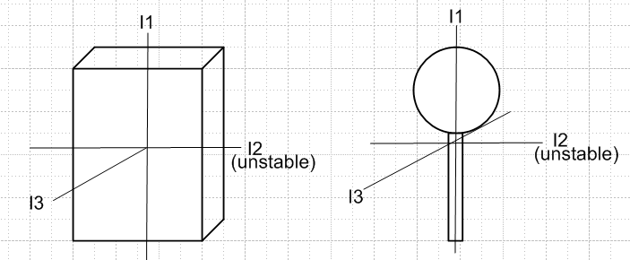 (I.5.0)

In lieu of the complicated elliptic solutions noted above, there are various geometric constructions involving ellipsoids that are used to interpret torque-free motion of a rigid body. If the e'i are the principal axes of a rigid body in Frame S', one may write (I.1.9) and (I.1.4) squared as follows,

2T = ω•I•ω = (I)'i(ω)'i2 ⇒ 1 = $\frac{(ω)'12}{2T/ I'1}$ + $\frac{(ω)'22}{2T/ I'2}$ + $\frac{(ω)'32}{2T/ I'3}$ // "inertia ellipsoid"

L2 = Iω • Iω = (I)'i2(ω)'i2 ⇒ 1 = $\frac{(ω)'12}{L2/ I'12}$ + $\frac{(ω)'22}{L2/ I'22}$ + $\frac{(ω)'32}{L2/ I'32}$. // L-ellipsoid (I.5.1)

A torque-free isolated system will have fixed values for rotational kinetic energy T and angular momentum L2. One can then regard each of the above equations as an axis-aligned ellipsoid centered at the origin of ω-space with axes e'i. The denominators shown are the squares of the three semi-axes of each ellipsoid. The rigid body of interest is aligned with the inertia ellipsoid since it is aligned with the e'i basis vectors in Frame S'. If I'3 is the smallest principal moment of inertia (suggesting prolateness of the object in that direction), then the longest axis of the inertia ellipsoid lies in the (ω)'3 direction. The inertia ellipsoid is sometimes called Poinsot's ellipsoid.

Goldstein defines ρ ≡ (1/$\sqrt{2T}$)ω as a rescaled version of ω and then one has

1 = ρ•I•ρ = (I)'i(ρ)'i2 ⇒ 1 = (I)'1(ρ')12 + (I)'2(ρ')22 + (I)'3(ρ')32 .

This is the "official" inertia ellipsoid, but we shall not do this rescaling and shall refer to the first line of (I.5.1) as the inertia ellipsoid.

Since rigid body problems do have solutions, we know that the two ellipsoids of (I.5.1) must intersect. In general, the intersection of two axis-aligned ellipsoids is a set of two non-planar curves which are mirror images of each other. In the solution of a torque-free rigid body problem the tip of the ω vector must move along one of these intersection curves. One can thus regard such a curve as a closed "orbit" for the ω vector in Frame S'. This is somewhat analogous to finding the orbit r(θ) for the polar coordinate position r of a planet without actually solving for the detailed r(t) and θ(t) of the planet's motion.
Finding the equation of a curve that is the intersection of two ellipsoids is not easy, even when the ellipsoids are axis-aligned, but it is easy to graphically display the curved intersection orbits.
In the Maple code below we enter three different ellipsoids Red, Blue and Green, where the Green one is a sphere. One should think of [x,y,z] as [(ω)'1 ,(ω)'2,(ω)'3] = ω in Frame S' components.

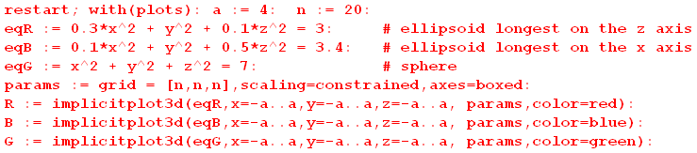

We then plot the Red and Green ellipsoids,

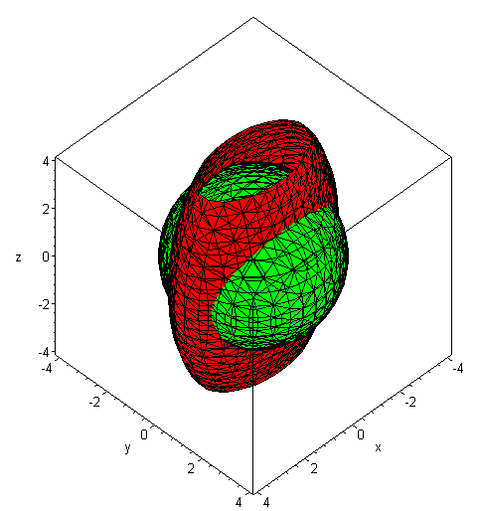 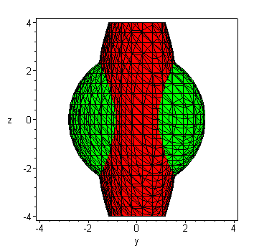 (I.5.2)

One can see that the intersection curves are distinctly non-planar and warped like a potato chip. Nevertheless, in this example the length of the ω vector is constant on each orbit curve, since one ellipsoid is a sphere. (The Green sphere could be the inertia ellipsoid of a tumbling cube.)

We now look at the Red and Blue ellipsoids,

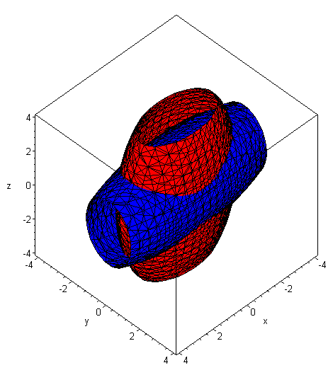 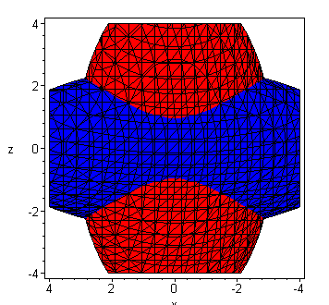 (I.5.3)

Again, the intersection curves are non-planar. We then ask: it is possible that ω has a constant magnitude on these Red/Blue intersection curves? If so, then the curves must also lie on a sphere. We now add the Green sphere into the above picture :

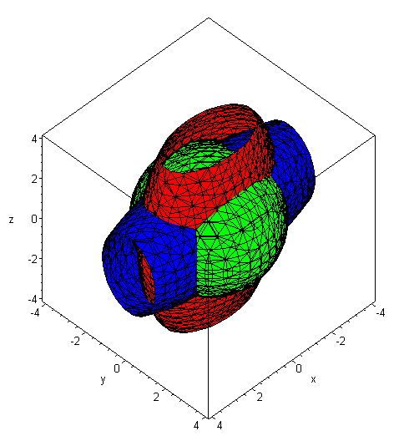 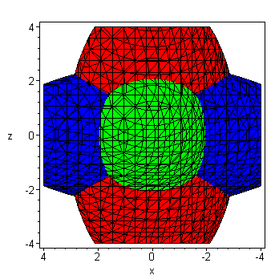 (I.5.4)

Although one knows that the Red/Green intersection curves are warped, one can see that their shape is never going to match the shape of the Red/Blue intersection curves no matter what radius is selected for the Green sphere:

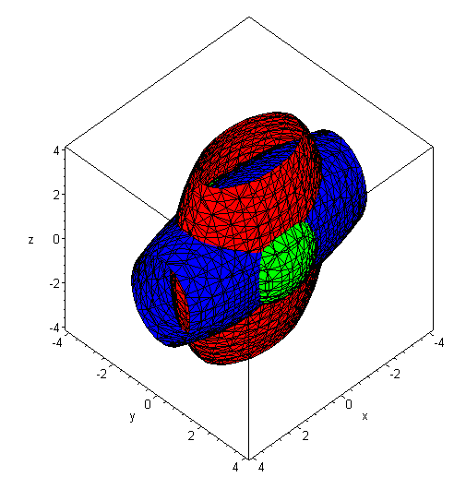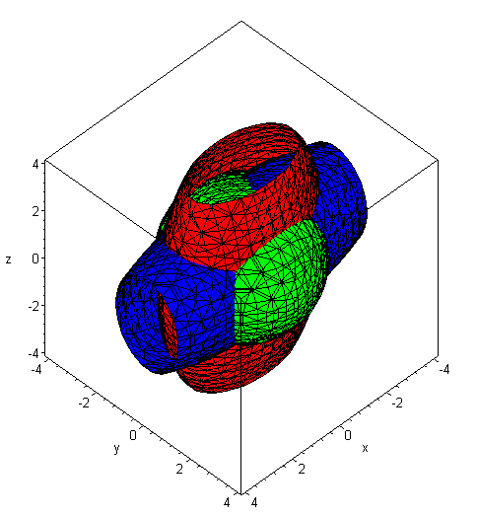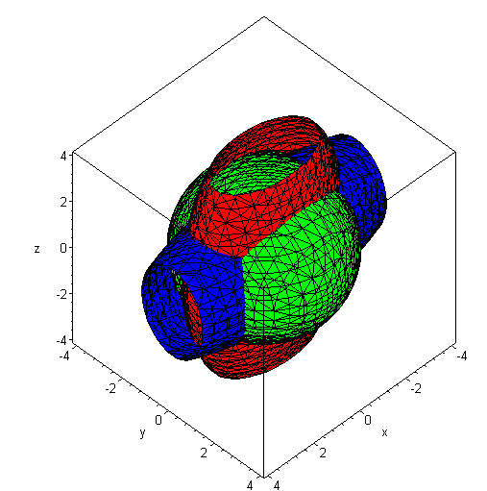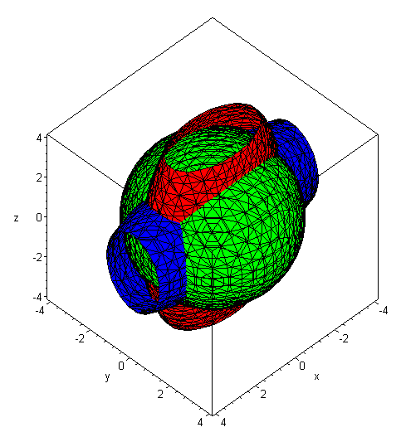

We therefore reach a conclusion that is perhaps obvious:

Fact: When equations (I.4.4) are solved, the orbit of the solution vector ω(t) is such that the magnitude ω is (in general) not constant.

Magnitude ω is constant if the tip of ω(t) does conical motion, as vector a does in (1.6.2) where the tip goes in a circle. But the warped orbits shown above in general are not circles.

In our final example, suppose the rigid body is "axisymmetric" so I'1 = I'2. We adjust the example above so that

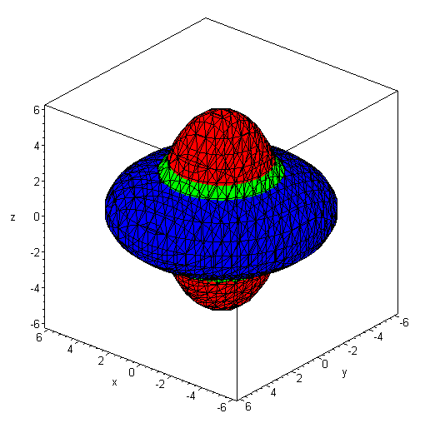 (I.5.5)

Here we selected the green sphere radius so the Green sphere is just visible. It seems clear in this situation that the Red/Blue intersection curves are no longer warped, but are just circles perpendicular to the z axis on which ω moves, this z axis being the (ω)'3 axis. As we shall see below in Fig (I.6.14), in this case the ω vector does do conical motion where its tail lies at the center of the ellipsoids (the origin of ω space) and its tip goes around one of the Blue/Red intersection circles of (I.5.5). The ω vector moves at a uniform rate as shown below, and this motion of ω is called precession.

An ellipsoid intersection curve of the type seen in the above examples is called a polhode (a pole path),

polhode: mod. f. Gr. □ pole +  way, path (Poinsot 1852) // OED2

For a given choice of the (I)'i moments, if one keeps T fixed and varies L in (I.5.1), one generates a family of polhode intersection curves on the inertia ellipsoid, as shown here (Arnold and Maunder p 111, moments of inertia are called A,B,C )

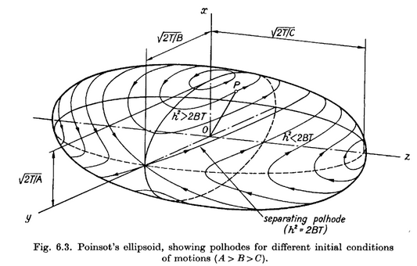 (I.5.6)

As already noted, in ω-space, the solution vector ω(t) has its tail glued to the center of the inertia ellipsoid while its tip rides along a polhode. The drawing shows that for the largest and smallest inertia axes, the extremal polhodes are circular, suggesting a possible slightly circular motion of a rigid body axis set to rotate close to one of these axes. There are no such circles for the intermediate axis, which is why that axis is unstable against perturbation as was noted above. Any tiny variation away from the exact axis point causes the solution to run off on a large polhode which encircles the ellipsoid.

The conclusion so far is that, for torque-free motion of a rigid body, the ω(t) vector in Frame S' (the body frame) moves on some relatively simple closed polhode path which is in general non-planar.

What does one of these potato-chip warped polhode paths look like when viewed from inertial Frame S?

Perhaps surprisingly, one thing we do know is that in Frame S the path of the ω vector tip lies in a plane, so the potato chip polhodes are de-warped in their transformation from Frame S' to Frame S. The reason for this planarity is simple. In Frame S we know that the vector L is fixed in space (since no torque), and one has

• ω = (1/L) L • ω = (1/L) (Iω) • ω = (1/L) ω • I • ω = (1/L)(2T) = 2T/L . (I.5.7)

Now in E3 space the equation • r = d describes a plane with normal vector lying distance d from the origin (d is the closest distance from plane to origin). Thus, in ω-space the vector ω always lies on a plane with normal which lies distance 2T/L from the origin. Since this plane is fixed in Frame S, it is called "the invariable plane".
At any time t, the solution ω(t) lies both on the inertia ellipsoid and on the invariable plane, so the inertia ellipsoid viewed in Frame S must be tangent to the invariable plane. Here is a picture where we have drawn pointing down,

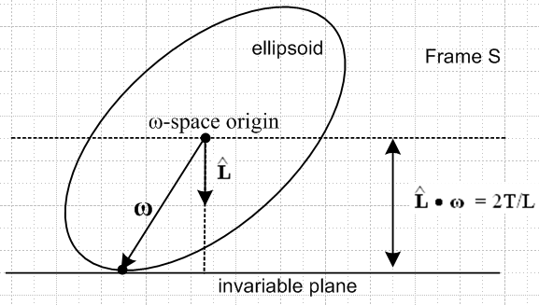 (I.5.8)

If the ellipsoid were an ellipse and if the above were a 2D picture, the ellipse would be unable to roll on the "invariable line", since any such rolling would change the height of the ellipse center above the plane. But in the 3D picture with an ellipsoid, such rolling is possible. If the ellipsoid were axisymmetric, it would roll around the vertical L axis, thus inscribing a circle on the invariable plane. That, we shall see, is the solution found in the next section and shown in (I.6.30). If the ellipsoid is more general in shape, then the rolling motion of the ellipsoid produces some complicated path going round and round on the invariable plane. This path is called a herpolhode (a snaky pole path) and is generally a path which does not close on itself, but which is confined between two radii in the invariable plane. Here is a sample numerically-generated herpolhode (Arnold and Maunder p 111 )

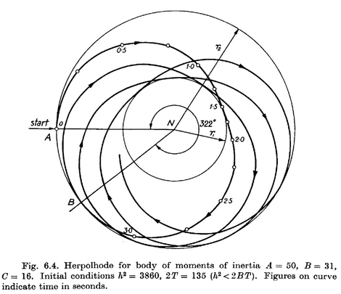 (I.5.9)

If the ellipsoid in Fig (I.5.8) were covered with ink and if the invariable plane were paper, the rolling ellipsoid would inscribe the herpolhode on the invariable plane. Conversely, if the ellipsoid were paper and the invariable plane were coated with ink, the invariable plane would inscribe on the ellipsoid one of the closed, non-planar polhode paths.
In general, this geometric view of the ω vector motion is called "Poinsot's construction" (Louis Poinsot 1777 –1859). It is briefly described in Goldstein p 159 (GPS p 201).
Here is an excellent ellipsoid animation showing both polhode and herpolhode for a case where the latter is also a closed curve: https://www.youtube.com/watch?v=BwYFT3T5uIw .

I.6 Zero-torque motion of an Axisymmetric Rigid Body (Rigid Rotor)

Finding the Frame S' components of ω

Here we specialize to rigid objects for which two of the principal moments of inertia are equal, and we shall take the two equal moments to be I'1 = I'2. A rigid object which is a solid of revolution falls into this class, where the symmetry axis will be the axis with I'3. The other two orthonormal principal axes can be selected in any manner to lie in the plane perpendicular to the symmetry axis. For a pancake, the symmetry axis has the largest principal moment, while for a crayon it has the smallest principal moment.
Less symmetric objects can have I'1 = I'2 as well, such as a rod whose cross section is a regular polygon with an even number of faces. For such a rod, the two transverse principal axes can be any two orthonormal axes which are also symmetry axes of the rod cross section. All objects having the same values of I'3 and I'1 = I'2 tumble in exactly the same manner, regardless of their shape.

Example 1: Square centered at the origin of uniform density ρ :

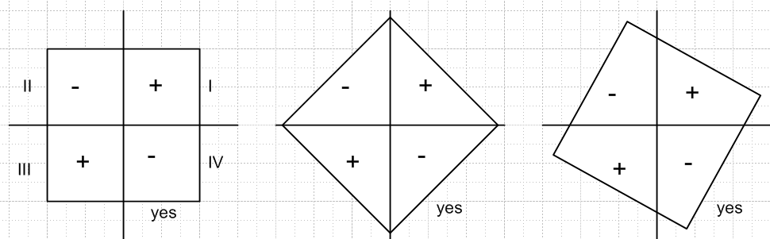 (I.6.1)

We know that Ixy = - ρ∫dxdy (xy). In the left picture one can see that the positive xy contributions from quadrants I and III exactly offset the negative xy contributions from quadrants II and IV. Thus Ixy = 0 and the axes shown are principal axes. The exact same is true for the other two figures because the shape in each quadrant is the same. So any perpendicular pair of axes through the enter of a square can serve as principal axes. Similarly for a cube, any three orthogonal axes through the center point can be principal axes. Because the inertia tensor has only one set of eigenvalues (which are the principal moments), those moments are the same for any legal set of principal axes.

Example 2: Hexagon centered at the origin of uniform density ρ :

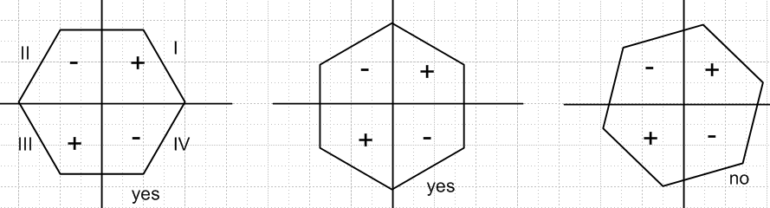 (I.6.2)

In this case the previous example's argument holds for the left two pictures, so those axes can be taken to be principal axes. For the orientation on the right, the QI and QII shapes are not the same. In this case only the left two pictures show principal axes.

If e'3 is the symmetry axis and I'1 = I'2, the last of equations (I.4.4) reads 0 = I'3()'3 , so (ω)'3 = constant. The other two equations in (I.4.4) are then easily solved. Writing them out,

()'1 = (ω)'3(ω)'2(I'1 - I'3)/ I'1 = - Ω'(ω)'2 where Ω' ≡ (ω)'3 (I'3-I'1)/I'1
()'2 = (ω)'3(ω)'1(I'3 - I'1)/I'1 = Ω'(ω)'1 . (I.6.3)

Then

()'1 = - Ω'()'2 = - Ω'2 (ω)'1 ⇒ ()'1 + Ω'2 (ω)'1 = 0 . (I.6.4)

A simple solution to his harmonic motion ODE is as follows,

(ω)'1 = A' cos(Ω't) (ω)'2 = - ()'1 / Ω' = A' sin(Ω't) . (ω)'3 = K (I.6.5)

Without loss of generality, we take A' > 0 and so A' = $\sqrt{(ω)'12+(ω)'22}$. This solution describes "conical motion" (as for vector a in (1.6.2)) of the ω vector where the cone half-angle α is determined by

sinα = A'/ω cosα = K/ω tanα = A'/K . (I.6.6)

For (ω)'3 = K > 0, α lies in the range (0,π/2), and for (ω)'3 = K < 0, α lies in the range (π/2,π) .

Thus we have this simple precession solution for the Frame S' components of the ω vector for zero-torque rotation of an axisymmetric rigid body :

(ω)'1 = ωsinα cos(Ω't) Ω' = ωcosα (I'3-I'1)/I'1
(ω)'2 = ωsinα sin(Ω't)
(ω)'3 = ωcosα . α = cone half-angle, 0 ≤ α ≤ π (I.6.7)

The direction of the precession depends on the sign of cosα and on the sign of I'3-I'1. For a "fat" rotor (oblate), the symmetry axis will have the larger moment, so I'3 > I'1. For α < π/2 this means Ω' > 0, and the precession is CCW about the cone axis as viewed from the circle end of the cone.

One can then ask about the behavior of the L vector in Frame S'. Since (L)'i = I'i(ω)'i one has,

(L)'1 = I'1ωsinα cos(Ω't) Ω' = ωcosα (I'3-I'1)/I'1
(L)'2 = I'1ωsinα sin(Ω't)
(L)'3 = I'3ωcosα . (I.6.8)

Notice that for a "very fat rotor" (oblate) where I'3 >> I'1, most of the angular momentum is in the (L)'3 component. But for a "very thin rotor" (prolate) where I'3 << I'1 , most of the angular momentum is in the transverse precession components (L)'1 and (L)'2 .
From this last set of equations one finds that

L2 = ω2 ( I'12sin2α + I'32cos2α ) (I.6.9)

where L is the magnitude of L. The kinetic energy T of the rigid body is determined from (I.6.7) to be,

2T = ω • I • ω = I'i(ω)'i2 = I'1[ ωsinα cos(Ω't)]2 +I'2[ ωsinα sin(Ω't)]2 + I'3 [ ωcosα]2

= I'1 ω2sin2α + I'3ω2cos2α

= ω2 ( I'1sin2α + I'3cos2α ) . (I.6.10)
To summarize,

L2 = ω2 ( I'12sin2α + I'32cos2α )

T = (1/2) ω2 ( I'1sin2α + I'3cos2α ) . (I.6.11)

If ω and α are specified, then L and T are determined by these equations. Conversely, if L and T are specified one can determine values for α and ω.

Reader Exercise: Show that the solutions for α and ω are given by

tan2α = (I'3/I'1) $\frac{|2TI'3 - L2|}{|2TI'1 - L2|}$ ω2 = $\frac{|2TI'1 - L2|}{I'3|I'1-I'3|}$ + $\frac{|2TI'3 - L2|}{I'1|I'1 - I'3|}$ . (I.6.12)

Returning now to the L equations (I.6.8),

(L)'1 = I'1ωsinα cos(Ω't) Ω' = ωcosα (I'3-I'1)/I'1 (I.6.8)
(L)'2 = I'1ωsinα sin(Ω't)
(L)'3 = I'3ωcosα .

one sees that the L vector (in Frame S') precesses on a cone at the same rate Ω' that ω precesses in (I.6.7). However, for L the cone half-angle β is determined by

sinβ = I'1ωsinα /L cosβ = I'3ωcosα/L tanβ = (I'1/I'3)tanα . (I.6.13)

In all the figures bellow we assume that 0 < α < π/2 so cosα > 0.

The size of β relative to α depends on whether the inertia moment ratio (I'1/I'3) is > 1 or < 1.
If the rotor is "thin" (prolate), then I'1 > I'3 and (I'1/I'3) > 1. Therefore β > α and
Ω' = ωcosα (I'3-I'1)/I'1 < 0. This is shown in the left figure below.
If the rotor is "fat" (oblate), then I'1 < I'3 and (I'1/I'3) < 1. Therefore β < α and
Ω' = ωcosα (I'3-I'1)/I'1 > 0. This is shown in the right figure below.
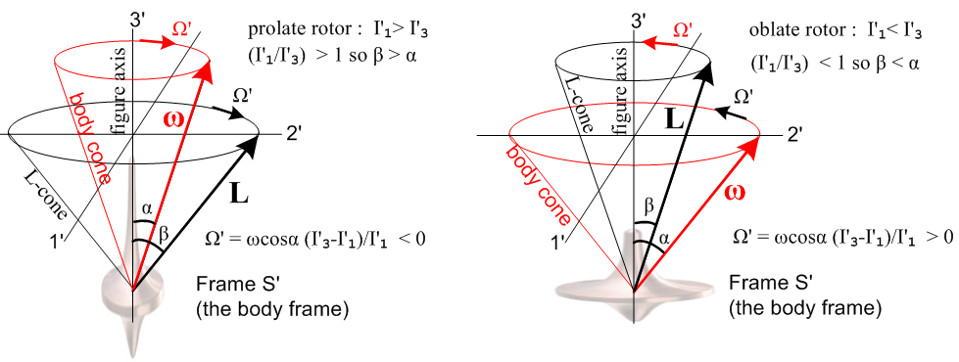
(I.6.14)

In either case, the ω and L vectors rotate in the same direction. The dizzy Frame S' Observer of course sees the rigid body rotor at complete rest with its symmetry axis ("figure axis") pointing in the ' = e'3 direction ("up"). Frame S and any objects at rest in Frame S are seen to be violently rotating about this Frame S' Observer. The vector L is the Frame S angular momentum of the rigid body, but we are just showing it in Frame S' coordinates. The Frame S' angular momentum L' of the rigid body is of course 0. The Observer can note that -ω is the angular velocity of Frame S relative to Frame S'. The Figures are not particularly interesting, but they do show the solution to the problem in Frame S' coordinates. Soon we shall show that β = θ, an Euler angle of the rigid body in Frame S.

The behavior of the Rigid Rotor in Frame S : solving for the Euler angles

Of much more interest is what things look like to an Observer in inertial Frame S. This takes a bit more work.

First, we shall assume that the position of the symmetric rigid rotor is described by the Euler angles (φ,θ,ψ) of Fig (H.1.5), so in Frame S one has

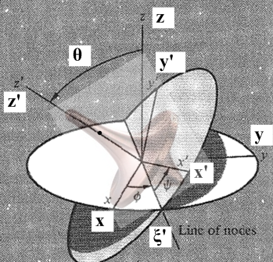 (I.6.15)

Frame S has axes x,y,z while Frame S' has axes x',y',z'. Recall from (H.3.12) the transformation for a vector r going from Frame S to Frame S',

x' = (cosψcosφ - sinψcosθsinφ) x + (cosψsinφ + sinψcosθcosφ) y + sinψsinθ z
y' = (- sinψcosφ - cosψcosθsinφ) x + (-sinψsinφ + cosψcosθcosφ) y + cosψsinθ z
z' = sinθsinφ x - sinθcosφ y + cosθ z . (H.3.12)

In Frame S where N = and N = 0, L must be a constant vector. We arbitrarily put this in the +z direction, so that L = L in Frame S. Applying the above transformation to L instead of r gives,

(L)'1 = sinθsinψ L
(L)'2 = sinθcosψ L
(L)'3 = cosθ L . (I.6.16)

But our Frame S' problem solution (I.6.8) with (I.6.13) gives

(L)'1 = Lsinβ cos(Ω't) Ω' = ωcosα (I'3-I'1)/I'1
(L)'2 = Lsinβ sin(Ω't)
(L)'3 = Lcosβ . (I.6.17)

Comparison of these last two equation sets requires that,

sinθsinψ = sinβ cos(Ω't) so: cos(π/2-ψ) = sinψ = cos(Ω't)
sinθcosψ = sinβ sin(Ω't) sin(π/2-ψ) = cosψ = sin(Ω't) ⇒ Ω't = π/2-ψ
cosθ = cosβ . (I.6.18)

The solution to these equations is

θ = β
ψ = - Ω't +π/2
= - Ω' . (I.6.19)

This says that Euler angle θ is a constant, and also, from (I.6.13),

sinθ = I'1ωsinα /L cosθ = I'3ωcosα/L tanθ = (I'1/I'3)tanα . (I.6.20)

We now rewrite (I.6.7) as

(ω)'1 = ωsinα sinψ
(ω)'2 = ωsinα cosψ
(ω)'3 = ωcosα . (I.6.21)

Now if we set = 0 in our Frame S' Euler-angle evaluation of the (ω)'i given in (H.6.15), we find

(ω)'1 = sinθsinψ // ψ = Ω't, = Ω'
(ω)'2 = sinθcosψ
(ω)'3 = cosθ + = cosθ - Ω' . (H.6.15) (I.6.22)

Comparison of these last two equation sets requires that,

sinθ = ωsinα
cosθ - Ω' = ωcosα . (I.6.23)

From the first line above and then using (I.6.20) one finds,

= ωsinα/sinθ = L/I'1 ⇒ φ(t) = (L/I'1) t . (I.6.24)

We have now solved for the behavior of all the Euler angles which describe the orientation of our rigid rotor in Frame S:

θ = tan-1[ (I'1/I'3) tanα ] // θ(t) = constant
ψ(t) = - Ω't + π/2 = - Ω' // Ω' = ωcosα (I'3-I'1)/I'1
φ(t) = (L/I'1)t = L/I'1 . (I.6.25)

With regard to Fig (I.6.15), the rigid rotor spins at rate -Ω' about its symmetry z' axis. While this happens, the symmetry axis precesses CCW at rate = (L/I'1) about the z axis. There is no nutation since the polar angle θ is a constant. The precession is CCW because we assumed that L = L where L = |L| . (If the rotor is a cube, since I'3 = I'1 one has = 0 since Ω' = 0. )

The behavior of the Rigid Rotor in Frame S : solving for ω

Recall the Frame S' solution for ω shown in (I.6.21),

(ω)' = $\left(\begin{matrix}ωsinα sinψ \\ ωsinα cosψ \\ ωcosα\end{matrix}\right)$ . // sinψ = cos(Ω't) and cosψ = sin(Ω't) (I.6.21)

To obtain the Frame S components of ω we have Maple compute ω = R-1(ω)' :

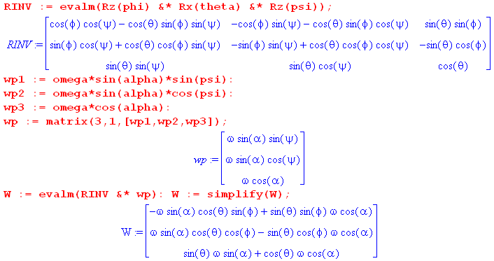

where W = ω . The resulting vector can be simplified by combining the trig terms:

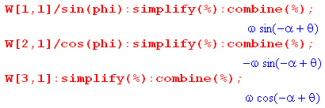
The final result is then

ω1 = ωsin(θ-α)sinφ
ω2 = - ωsin(θ-α)cosφ
ω3 = ωcos(θ-α) . (I.6.26)

Using (H.6.13) we write this in terms of spherical coordinates azimuth φ,

ω1 = ωsin(θ-α)cosφ
ω2 = ωsin(θ-α)sinφ
ω3 = ωcos(θ-α) . (I.6.27)

Reader Exercise.
(1) Use Ω' = ωcosα (I'3-I'1)/I'1 from (I.6.7) and tanθ = (I'1/I'3)tanα from (I.6.20) to show that
Ω' = ω sin(α-θ)/sinθ.
(2) Using (I.6.25), show that (I.6.27) for ωi agrees with (H.6.14) for ωi. (I.6.28)

With φ = (L/I'1)t from (I.6.24), (I.6.26) can be written,

ω1 = ω sin(θ-α) cos[(L/I'1)t ]
ω2 = ω sin(θ-α) sin[(L/I'1)t ]
ω3 = ω cos(θ-α) . (I.6.29)

If 0 < θ-α < π, then sin(θ-α) > 0. In this case, equations (I.6.29) describe (in Frame S) the CCW precession at rate(L/I'1) of the vector ω.

Here for the prolate case is the famous picture traditionally used to torture students of rotational dynamics, where one should momentarily ignore the red cone :
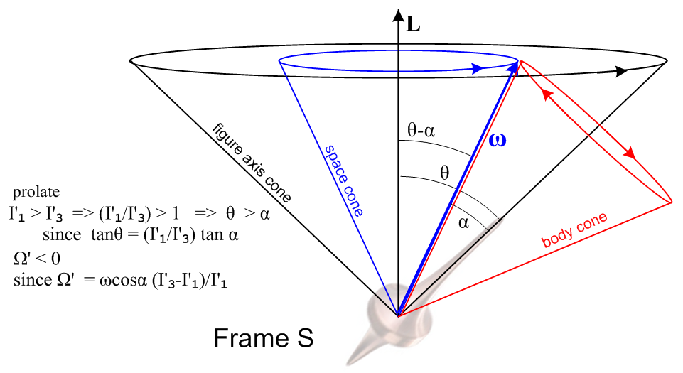(I.6.30)

As just noted, ω does CCW conical motion at rate (L/I'1) on a cone of half-angle θ-α, shown in blue. The rigid rotor's symmetry axis meanwhile moves on the black θ cone and precesses along with ω at the same rate (L/I'1).
The is really the end of the Frame S story since it tells how the rotor figure axis moves, how its ω vector moves, and how L is fixed in the vertical direction since this is a torque-free system in Frame S.
One can (if one wants) superpose the red body cone from our Frame S' picture (I.6.14). Since there is only one ω vector, the body cone must be at a position like that shown. As blue ω rotates around on its fixed space cone, the red body cone must roll without slipping around the perimeter of the blue cone to maintain ω on the intersection of the two cones. Notice that the red direction arrows on the body cone match the rotation sense of the red arrow in the left drawing in (I.6.14). To see why this corresponds to rolling without slipping, one must physically play with two cones. A substitute is two coins where one holds the left one fixed and rotates the right one about the boundary of the left one. Only then does one understand the red arrows! It is too difficult to put into words.
One can see that when the red cone is made narrower (smaller α), the angular rate of motion of ω on the red cone perimeter increases relative to the angular rate of ω on the blue cone. The blue rate is (L/I'1) while the red rate is Ω' = ωcosα (I'3-I'1)/I'1.
At this point, as an illustration of the above figure, the reader is invited to view Eric Johnson's short animation https://www.youtube.com/watch?v=s9wiRjUKctU showing the motion of a prolate rotor. One sees how his purple L vector (called H) says fixed, and how the blue ω vector moves on its cone, and how the figure axis moves on a larger cone.
An American football in flight is a good example of a prolate rotor, see Horn and Fearn.

On the other hand, if the rotor is fat (oblate) in shape with I'1< I'3, then Ω' > 0 and θ < α. The corresponding figure is shown below, where the blue and black cones of (I.6.30) have not changed :

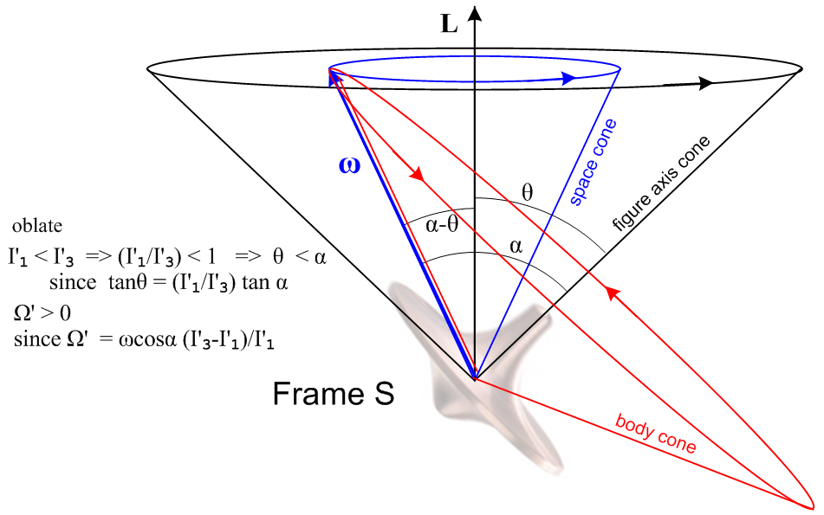 (I.6.31)

Now the red arrows on the body cone have the same directional sense as the right drawing in (I.6.14) .

Reader exercise: Use two coins or two drink coasters to verify the direction of the red arrows.

Eric Johnson's oblate rotor animation is here: https://www.youtube.com/watch?v=PDLXVSkDFVk .
Again the purple L = H vector is fixed, but now the figure axis cone lies outside the ω cone.

See https://www.youtube.com/watch?v=WUkUL3Hp67A for an animation of the prolate case body cone rolling around the space cone.

See https://www.youtube.com/watch?v=1n-HMSCDYtM for a fascinating video of torque-free rotation of a small handle in zero gravity (ISS). There are many similar videos.

Reader Exercise: Explain this motion (the "Dzhanibekov effect"). Is it the same as the tennis racket "theorem" of Fig (I.5.0)? The stable states do seem exagerated. Correlate to Fig (I.5.6). Concoct a useful engineering application.

Reader Question: Since L = Iω, and since L = constant, one can write ω = I-1L . Why is ω not constant?

Answer: In Frame S, the inertia tensor I (relative to the fixed Frame S axes) constantly changes with time because the integration in (I.1.3) is a function of time, as if the rotating rotor were an object constantly changing shape. Another answer: I = R-1(I)' R and R = Rz(-ψ(t)) Rx(-θ(t)) Rz(-φ(t)) varies with time. In fact one has for the axisymmetric case (Reader Exercise),

I(t) = Rz(φ)Rx(θ)Rz(ψ)(I)'Rz(-ψ(t)) Rx(-θ(t) Rz(-φ(t)) = Rz(φ)Rx(θ)(I)'Rx(-θ(t) Rz(-φ(t)) .

The Earth as an oblate rigid rotor : The Chandler Wobble

An ideal model of the Earth has it being a rigid rotor that is slightly oblate due to the centrifugal force on the slightly elastic matter of the Earth (and its water) pulling matter out to a radius larger than the average radius of the Earth as one approaches the equator. As Goldstein notes on p 163 (GPS p 207), the moment ratio appearing in Ω' is about .0033 which predicts a precession rate of Ω' ≈ (ω)'3/300 or T ≈ 300 days. Various inadequacies in this idealized model (Earth is not rigid, nor is it an exact oblate spheroid) are blamed for the fact that the precession period is more like 434 days. Due to this precession the North pole moves in a circle of radius about 6 m. The precession cone half angle is a tiny 0.2 arc seconds, meaning 0.2/3600 of one degree. This effect is called the "free precession of the Earth" and is also known as the Chandler wobble (S.C. Chandler 1891). Sometimes this precession is called a nutation since it is superposed on longer timescale precessions due to the torque of the Sun and Moon acting on the Earth as described below.
Note that the free precession effect of the spinning Earth would occur if the Earth were completely isolated in space. It has nothing to do with external torques acting on the Earth.

In fine detail, there are many factors which contribute to the Earth's axis wobble which in its aggregate is called the Chandler wobble. For an ideal axisymmetric oblate Earth, the polhode path should be circular as in Fig (I.5.5) or (I.6.31). Here are some real world polhodes (Zemstov), where each small square is 3 meters on a side (it seems that the squares should be 0.1" rather than 0.01"),
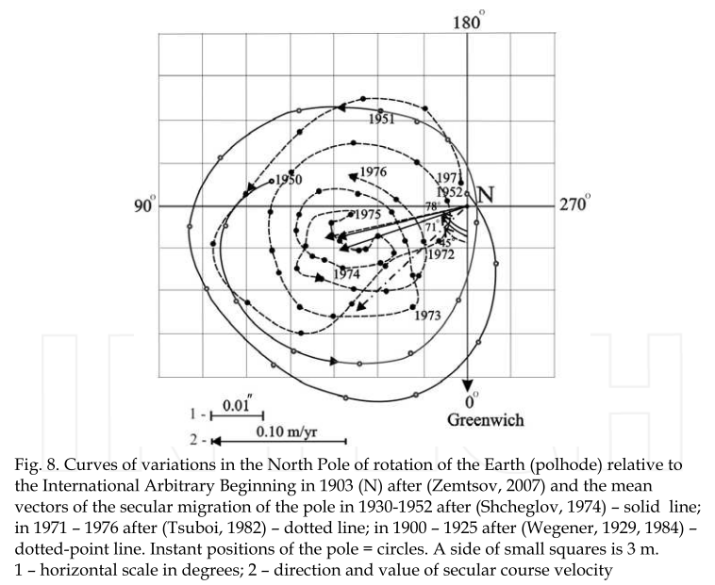(I.6.32)

I.7 Rigid Body with External Torque: Spinning Symmetric Top

In this problem Frames S and S' have their origins co-sited at the top's point of contact with a "table". Frame S is the inertial frame of the table, with z pointing up. Frame S' is embedded in the spinning top. We assume that the top is symmetric and is spinning about its symmetry axis e'3 = ' and then I'1 = I'2. If we put a red paint dot on the top at some value of ψ, we can describe the position of the top at some time t by the Euler angles φ,θ,ψ of Section H.1 :

(I.7.1)

Gravity g = -g creates a downward force F = Mg = -Mg acting on the center of mass of the top, which lies at point rcms on the top's symmetry z' axis, some distance rcms up from the pivot point. Since F is parallel to while rcms is parallel to ', the torque N = rcms x F (referred to the common origin) must be perpendicular to both and '. The locus of points perpendicular to and ' is the line of nodes in the figure, the intersection of the two discs, so N points toward the viewer along the ' axis in (I.7.1).
We now refer to the z axis as axis 3. The fact that (N)3 = 0 tells us that L3 = constant since Frame S is an inertial frame where Newton's law N = (dL/dt)S is valid.
One is tempted to say that since (N)'3 = 0, it follows that (L)'3 = constant, but this fact is not obvious from Newton's law because the ' axis is moving and Frame S' is not an inertial frame. One would have to show that there are no fictitious torques in Frame S' in the ' direction. Alternatively, from N = (dL/dt)S we know that (N)'3 = [(dL/dt)S]'3 but in general we don't know this is (d [(L)'3]/dt)S' since in general the two operations do not commute, as shown in (1.11.1).
However, it does in fact turn out that (L)'3 = constant by the following argument. In Frame S' we know that, since L = Iω, one has (L)'3 = (I)'3(ω)'3 since the inertia tensor is diagonal. Then from the last equation of motion in (I.4.3),

(N)'3 = I'3 ()'3 - (ω)'1(ω)'2 (I'1 - I'2), (I.4.3)

since we have (N)'3 = 0 and I'1 - I'2 = 0 it follows that (ω)'3 is constant, so then is (L)'3 = (I)'3(ω)'3 .

In Lagrangian language, this means that the coordinates φ and ψ do not appear in L and are therefore cyclic, so their generalized momenta pψ = (L)'z and pφ = (L)z are constants of the motion. Exploring the Lagrangian method, note first from (I.1.9) the expression for kinetic energy T in Frame S' components,

T = (1/2) (ω)'i(ω)'j(I)'ij = (1/2)(ω)'i2 I'i = (1/2)[ (ω)'12 + (ω)'22 ] I'1 + (1/2)(ω)'32 I'3 . (I.7.2)

Recall from (H.6.15) that

(ω)'1 = sinθsinψ + cosψ
(ω)'2 = sinθcosψ - sinψ
(ω)'3 = cosθ + // Frame S' (H.6.15)
so that

(ω)'12 + (ω)'22 = [ sinθsinψ + cosψ]2 + [ sinθcosψ - sinψ]2

= 2 sin2θ + 2 . // cross terms cancel (I.7.3)

Thus

T = (1/2)(2 sin2θ + 2) I'1 + (1/2)( cosθ + )2 I'3 . (I.7.4)

If the zero of potential is set at z = 0, the Lagrangian L is then

L = T - V = (1/2)(2 sin2θ + 2) I'1 + (1/2)( cosθ + )2 I'3 - Mgrcmscosθ (I.7.5)

confirming that φ and ψ are cyclic.

The two constant generalized momenta are then (they are constant since ∂L/∂φ = 0 and ∂L/∂ψ = 0),

pψ = ∂L/∂ = ( cosθ + )I'3 ≡ aI'1 // = (ω)'3I'3
(I.7.6)
pφ= ∂L/∂ = sin2θ I'1 + ( cosθ + )cosθ I'3 = (sin2θ I'1 + cos2θ I'3) + cosθ I'3 ≡ bI'1 ,

where constants a and b are defined as shown. Since (ω)'3 = cosθ + , one sees from the pψ line above that,

(ω)'3 = (aI'1/I'3) . (I.7.7)

We already knew that (ω)'3 was a constant, and this shows the constant in terms of "a".

Exercise: Show directly (without using the Lagrangian) that the constants of the motion (L)'z and (L)z are the same as the generalized momentum expressions pψ and pφ stated above.

(a) From L = Iω we know that (L)'z = (L)'3 = I'3 (ω')3 = I'3 ( cosθ + ), thus (L)'z = pψ . QED1

(b) Write (L)z = L • = L • [(sinψsinθ)' + (cosψsinθ)' + (cosθ) ' ] using (H.3.18). Then

(L)z = sinψsinθ(L)'1 + cosψsinθ(L)'2 + cosθ(L)'3

= sinψsinθ I'1(ω)'1 + cosψsinθ I'2(ω)'2 + cosθ I'3(ω)'3 // now use (H.6.15) above,

= sinψsinθ I'1[ sinθsinψ + cosψ] + cosψsinθ I'2[ sinθcosψ - sinψ] + cosθ I'3[ cosθ + ]

= [sin2θI'1 + cos2θI'3 ] + cosθ I'3 since I'1 = I'2, thus (L)z = pφ . QED2

We are closely following Goldstein page 165 (GPS p 211) where the constants of the motion (L)'z and (L)z are replaced by constants a and b. The equations of interest (I.7.6) are then

I'3 cosθ + I'3 = aI'1
(sin2θ I'1 + cos2θ I'3) + cosθ I'3 ≡ bI'1 . (I.7.8)

Multiply the first equation by cosθ and subtract 2nd - 1st to get

(sin2θ I'1 + cos2θ I'3) - I'3 cos2θ = bI'1 - cosθ aI'1
sin2θ I'1 = bI'1 - cosθ aI'1
sin2θ = b - cosθ a
so
= $\frac{b-acosθ}{sin2θ}$ . (I.7.9)

Now put this into the first equation of (I.7.8) to get

I'3[( b - cosθ a)/sin2θ] cosθ + I'3 = aI'1

( b - cosθ a)/sin2θ] cosθ + = a (I'1/I'3)

= a (I'1/I'3) - cosθ( b - cosθ a)/sin2θ . (I.7.10)

Once θ(t) is determined as outlined below, one can integrate (I.7.9) and (I.7.10) to get φ(t) and ψ(t).

A third constant of the motion is the total energy of the top, where T was stated in (I.7.4),

E = T + V = (1/2)(2 sin2θ + 2) I'1 + (1/2)( cosθ + )2 I'3 + Mgrcmscosθ . (I.7.11)

The second term in E is just a constant from (I.7.6),

(1/2)( cosθ + )2 I'3 = (1/2)(ω'3)2 I'3 = (1/2)(aI'1/I'3)2 I'3 = (1/2)a2(I'12/I'3) = K (I.7.12)

so we define E' = E - K as a re-zeroed energy to get,

E' = (1/2)(2 sin2θ + 2) I'1+ Mgrcmscosθ . (I.7.13)

Multiply by (2/I'1),

(2E'/I'1) = (2 sin2θ + 2) + (2Mgrcms/I'1) cosθ
or
α = (2 sin2θ + 2) + β cosθ where α ≡ (2E'/I'1) β ≡ (2Mgrcms/I'1)
or
α sin2θ = 2 sin4θ + sin2θ 2 + βcosθsin2θ . (I.7.14)

From (I.7.9) replace 2 sin4θ by (b-acosθ)2,

α sin2θ = (b-acosθ)2 + sin2θ 2 + βcosθsin2θ

and rearrange to get

sin2θ 2 = sin2θ(α - βcosθ) - (b-acosθ)2 . (I.7.15)

Set u = cosθ so = -sinθ and then sin2θ 2 = 2, so the ODE becomes

2 = (1-u2)(α-βu) - (b-au)2 = α - u2α - βu +βu3- b2 +2abu - a2u2

= βu3 - (α+a2)u2 + (2ab-β)u + (α-b2)

= β(u-A)(u-B)(u-C) (I.7.16)

where one can write A,B,C in terms of a,b,α,β (although this is a very sordid affair as one can tell by looking at standard formulas for the roots of a cubic ).

Equation (I.7.16) is a solvable non-linear first-order ODE. Write

du/dt = $\sqrt{β(u-A)(u-B)(u-C)}$

and so

dt = du/$\sqrt{β(u-A)(u-B)(u-C)}$ and then

t(u) = (1/$\sqrt{β}$) $^{\int_{u0}^{u}{}}$dx $\sqrt{(x-A)(x-B)(x-C)}$ . (I.7.17)

This is the exact same elliptic integral we encountered with the spherical pendulum in (C.5.13), though with different A,B,C. One does the integral to get t(u) = (1/$\sqrt{β}$) [ f(A,B,C,u) - f(A,B,C,u0) ] and then one "inverts" to get u = u(t) and thus one has found θ(t) = cos-1u(t). Functions φ(t) and ψ(t) are then found by integrating (I.7.9) and (I.7.10).

From (I.7.13) and (I.7.9) squared one may write

E' = (1/2)I'12 + { (1/2)I'1$\frac{(b-acosθ)2}{sin2θ}$+ Mgrcmscosθ }
or
α = 2 + {$\frac{(b-acosθ)2}{sin2θ}$+ βcosθ } = 2 + Ve(θ) α = 2E'/I'1, β = 2Mgrcms/I'1 (I.7.18)

where Ve(θ) is the effective potential for the top problem. We can then carry out the same qualitative turning point analysis as shown in Fig (C.5.17) and we find that θ(t) bounces back and forth between two angles θ1 and θ2. The tip of the top then has these typical motion patterns depending on the size of the four parameters a,b,α,β (GPS p 215) :

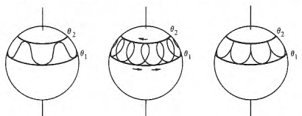 (I.7.19)

The pattern on the left is usually called nutation during precession. In the middle pattern, changes sign during the run from θ1 to θ2. See Thornton and Marion pp 456-460 for details of fast and slow precession and of the above patterns. Texts treating the top often spend a lot of column inches refining the qualitative top behavior which we have merely outlined above.

Reader Exercise: Solve this problem directly from the equations of motion (I.4.3) where (N)'3 = 0.

Here is a comparison of characteristics of the spinning top and the torque-free rotor of Section I.6 ;

Torque-free rotor Spinning Gravity Top

(ω)'3 = constant = ωcosα (ω)'3 = constant = (aI'1/I'3) (I.7.7)
(ω)'1 = ωsinα cos(Ω't) (ω)'1 = sinθsinψ + cosψ
(ω)'2 = ωsinα sin(Ω't) (I.6.7) (ω)'2 = sinθcosψ - sinψ (H.6.15)

ω2 = constant ω2(t) = 2 sin2θ + 2 + (aI'1/I'3)2 (I.7.3)

θ = constant = tan-1[ (I'1/I'3) tanα ] θ(t) = involves elliptic functions (I.7.15)
= constant = - Ω' (t) = a (I'1/I'3) - cosθ( b - cosθ a)/sin2θ (I.7.10)
= constant = (L/I'1) (I.6.25) (t) = $\frac{b-acosθ}{sin2θ}$ (I.7.9)

T = constant T + Mgrcmscosθ = constant

L = constant Lz = constant = aI'1 = pφ
Lz' = constant = bI'1 = pψ (I.7.6)

ω1(t) = ω sin(θ-α) cos[(L/I'1)t ] ω1(t) = sinθcosφ - sinφ
ω2(t) = ω sin(θ-α) sin[(L/I'1)t ] ω2(t) = sinθsinφ + cosφ
ω3 = ω cos(θ-α) (I.6.29) ω3(t) = cosθ + . (H.6.14) (I.7.20)

Comments: The symmetric top is a very difficult problem, so much so that in 1910 Felix Klein and Arnold Sommerfeld (heavyweights) issued a four volume German set of books just on this topic (Uber die Theorie des Kreisles). The books were finally translated into English circa 2010 and the very energetic reader will find the set at Amazon for a sale price of $335.11 (but free Prime shipping). Goldstein spends 12 long pages on the subject, studying the cubic f(u) = (1-u2)(α-βu) - (b-au)2. There are pure conical motion solutions (no nutation) when the smallest two turning point roots u1 and u2 of f(u) are equal, but it is hard to say what values of a,b,α,β gives such solutions. The Marion authors use the Ve(θ) approach to identify the turning points θ1 and θ2. The Ve(θ) curve does have a minumum θ0 which implies conical motion, and one can see their stuggle to identify the value of θ0 which gives this minimum. Neither the Goldstein nor Marion author groups makes any attempt to state the vector ω or L for the problem solution. In our table above one can see ω indirectly stated on the top right, then of course L = I ω. For a very fast spinning heavy top, one imagines that both L and ω are fairly close to the symmetry axis of the top. There are no relatively simple torque-free "cone diagrams" like those of (I.6.14), (I.6.30) and (I.6.31), though probably some diagrams appear in the Kreisles volumes (which we have never read). Whereas Goldstein uses Euler angles to represent rotations of the rotation group SO(3), the Kreisles authors use other parameters such as the Cayley-Klein parameters which appear in SU(2) ~ SO(3) as well as quaternion coefficients, so the reader of these volumes may have to invest in those subjects.

Even if the symmetric top is spherical, the solutions are still complicated. For example, the equations

a = (I'3/I'1) cosθ + (ω)'3 = (aI'1/I'3) α ≡ (2E'/I'1)
b = [sin2θ + cos2θ (I'3/I'1)] + cosθ (I'3/I'1) β ≡ (2Mgrcms/I'1)
= a (I'1/I'3) - cosθ( b - cosθ a)/sin2θ = $\frac{b-acosθ}{sin2θ}$

become, setting I'3 = I'1,

a = cosθ + (ω)'3 = a α ≡ (2E'/I'1)
b = + cosθ β ≡ (2Mgrcms/I'1)
= a - cosθ( b - cosθ a)/sin2θ = $\frac{b-acosθ}{sin2θ}$

which, though simpler, do not remove the elliptic function nature of the solution based on a,b,α,β. At least in this case one knows that L = Iω = (2/5)MR2ω so that L and ω are collinear. One could imagine, by the way, a spherical top with a small indent which is then delicately mounted on a vertical pin.

I.8 Gravitational Torque on an oblate Earth: Precession of the Equinoxes

For motivation, we consider the gravitational torque due to a large distant mass M on an circle of equally-spaced point masses m (only 4 are shown), with everything lying in a plane The masses m are glued to the rigid circle and we ignore their gravitational attraction to each other. The large distance from mass M to the circle center is b.
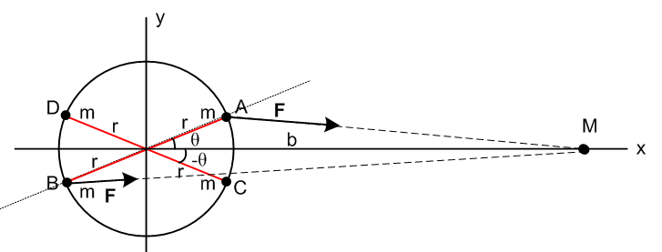 (I.8.1)

We consider the mass pair AB to be a "dumbbell" of masses, and we have already computed in (F.3.13) the torque (about the circle center) on this dumbbell due to the gravity of mass M, assuming b >> r,

NAB = - 6GMmb-3r2sinθcosθ . // μ2 = 1/2 (F.3.13) (I.8.2)

Because the mass A is closer to M than the mass B, the torque on mass A going into the plane of paper (right hand rule N = r x F ) is larger than the torque on mass B going out of the plane of paper, and the resultant torque on the dumbbell AB is into the plane of paper. This torque wants to restore the dumbbell AB to an aligned orientation, just as it does for any dumbbell satellite. However, the torque on the dumbbell CD is just the opposite of the torque on AB :

NAB = - 6GMmb-3r2sinθcosθ

NCD = - 6GMmb-3r2sin[-θ]cos[-θ] =
= + 6GMmb-3r2sinθcosθ
so
NAB + NCD = 0 . (I.8.3)

When we sum over all pairs of masses on the circle, the net result is that mass M exerts zero torque on the circle of masses.

Consider now a tilted ellipse of equal point masses:

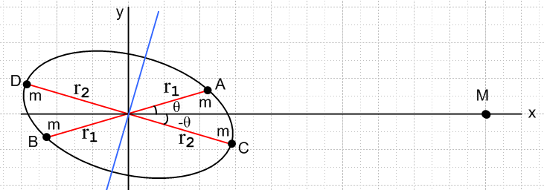 (I.8.4)

We one has,

NAB = - 6GMmb-3r12sinθcosθ

NCD = - 6GMmb-3r22sin[-θ]cos[-θ] =
= + 6GMmb-3r22sinθcosθ

NAB + NCD = 6GMmb-3(r22 - r12) sinθcosθ . (I.8.5)

Since r2 > r1, the total torque exerted by M on the pairs AB and CD is non-zero and is directed toward the viewer. When we sum over all pairs of masses on the ellipse, the net result is that mass M exerts a torque toward the viewer which wants to restore the ellipse of masses to an aligned position with the long ellipse axis lying along the x axis.

With this planar example as motivation, consider the following very busy 3D picture of gravitational mass M orbiting the oblate red Earth on a blue orbit (circular or elliptical),

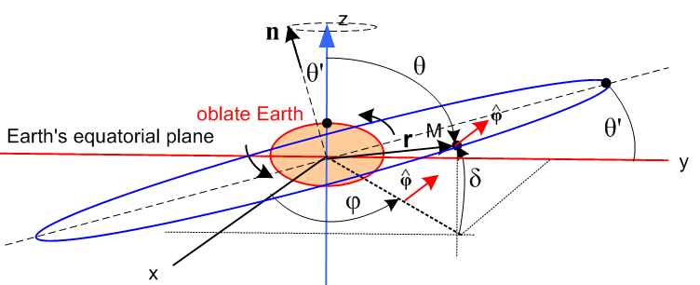 (I.8.6)

At the instant shown in the drawing, mass M (imagined to lie on the Celestial Sphere) is at some latitude δ (declination) relative to the Earth's equatorial plane. This point is also at polar angle θ, where θ+δ = π/2.
Azimuthally, M is located at longitude φ (right ascension) relative to some specified meridian (vernal equinox) on the Celestial Sphere. The unit vector is the usual azimuthal unit vector which appears in Fig (E.1.1). In particular, = (-sinφ, cosφ, 0) as shown in (E.2.6).
For simplicity we have assumed that the highest point of the blue orbit occurs over the y axis. There the declination reaches its maximum value δ = θ', where θ' is the assumed inclination of the orbital plane relative to the Earth's equatorial plane. The blue orbit then intersects the xy plane on the x axis (the "nodes"). The normal to the orbit, which could be taken to be n = x , makes an angle of θ' relative to the axis. When the dust all settles, one finds that this normal vector n precesses around the axis at some slow rate.
Based on our 2D example, we expect mass M to exert a torque on the Earth in the sense of the black arrows when it is at δ = θ' on the far right. This torque is attempting to rotate the Earth toward a position where M then lies on the Earth's equatorial plane.
If M is the Sun then, as the Sun orbits, the declination δ moves between +23.44o and -23.44o in our current era.
If M is the Moon, then, as the Moon orbits, declination δ moves between 28.58o and -28.58o near the major lunar standstill, and between 18.30o and -18.30o near the minor lunar standstill which occurs 9.3 years after the major one. See Fig (8.8.58a) and (8.8.58b) which show these two standstills (the wiki lunar standstill page is very good on this subject). The range variation is caused by the fact that the Moon's orbital plane is tilted 5.14o relative to the Sun's orbital plane causing the 23.44 ± 5.14 ranges.

The torque N of mass M on the Earth is stated in Williams equation (2) to be,

N = - 3GM b-3(I3 - I1) sinδ cosδ = $\left(\begin{matrix}-sinφ \\ cosφ \\ 0\end{matrix}\right)$ . (I.8.7)

The parameters here correspond to Fig (I.8.6) and I3 > I1 are the two moments of inertia for the oblate Earth (which of course is axisymmetric). The result is valid for any axially symmetric mass distribution (including prolate). If δ is replaced by polar angle θ = π/2 - δ, one can replace,

sinδ cosδ = sin(π/2-θ) cos(π/2-θ) = cosθ sinθ = sinθ cosθ . (I.8.8)

We shall derive (I.8.7) in the next section. For now, one can see that for φ = π/2 one will have = - so N = (positive) which is a torque trying to rotate the Earth CCW to become aligned with the mass M line (length r=b). In this case Nx = 3GMb-3(I3 - I1) sinθcosθ which bears a resemblance to our toy planar example result (I.8.5) that (NAB + NCD)⊥ = 6GMb-3(mr22 - mr12) sinθcosθ .

We shall not attempt to compute the precession rate from the torque (I.8.7). GPS do this on page 223-228 using a certain average potential and an average precession rate they earlier developed for the top. Using their resulting rate expression they obtain the correct 81,000 year number quoted below for oblate Earth precession due to the Sun, were there no Moon.

Comment: The reader is warned that the GPS angle names differ from our angle names. If one defines e'i = Rx(θ')ei to obtain a coordinate system whose ' axis is normal to the orbital plane, and if the polar angles are called θ',φ' in this system, then φ' is the azimuth angle within the plane of the orbit, and one can show that tanφ = cosθ' tanφ' and cosθ = sinθ' sinφ'. One then finds that <cos2θ> = sin2θ' <sin2φ'> = sin2θ' (1/2) and this is then used to compute <P2(cosθ)> in the potential (I.9.31) we shall derive below. To translate to GPS notation, one must take cosθ → γ, θ'→ θ and φ' = η+π/2. Their orbit has its high point over the x axis instead of the y axis. Note that θ' is the inclination of the orbital plane in Fig (I.8.6).

From N = the equations of motion for the orbiting mass M motion are these,

- 3GM b-3(I3 - I1) sinθ cosθ = Mr [2 + r - r 2 sinθ cosθ]
0 = 2 sinθ + 2 r cosθ + rsinθ (I.8.9)

and for a circular orbit they simplify to

- 3GM b-3(I3 - I1) sinθ cosθ = Mr2 [ - 2 sinθ cosθ]
0 = 2 cosθ + sinθ . (I.8.10)

We may compare these to the equations of motion of the spherical pendulum shown in (C.5.1),

- sinθcosθ 2 = - (g/l)sinθ
2cosθ + sinθ = 0 . (C.5.1)

One sees that the pendulum has a sinθ driving term, while the orbiting M has sinθ cosθ. Both sets of equations "conceal" processional motion, and in the pendulum case it was called the Airy precession as plotted in (C.8.14), having nothing to do with Foucault precession.

Precession of the Equinoxes and the Pope

We think now of Frame S as an inertial frame associated with the Sun, and rotating Frame S' being embedded in the Earth. When torque (I.8.7) is put into the equations of motion (I.4.3) with I'1 = I'2 and averages are taken, one finds (Williams p 716 Table 3) that the Earth's ω vector would precess relative to the stars at a rate of 15.95 arcsec/year which is a period of 81,254 years. This is precession due only to the Sun. The Moon alone produces a precession rate of 34.46 arcsec/year (37,609 years). If the two rates are added along with various small corrections, one gets a precession rate of 50.288 arcsec/year (25,771 years) which is the oft-quoted number of about 26,000 years. As with the tides, the Moon's effect is about twice that of the Sun. These precession periods are long because the Earth is only slightly oblate and the resulting gravitational torques are relatively small. The net effect is known as "axial precession" and historically as "the precession of the equinoxes" since the seasons of the year slide about one degree per 71.6 years (25,771/360). In terms of the a wall calendar (not a sidereal calendar), there is a slide of one day every 129.4 years. Since this slippage threatened to pull Easter away from the vernal equinox (Spring), Pope Gregory in 1582 adopted the Gregorian calendar to neutralize the slippage. In this scheme, there is no leap year every XX00 year except when XX is a multiple of 4. This knocks out 3 days every 400 years, and 400/3 = 133.3 ≈ 129.4.

I.9 Derivation of the Oblate Earth torque formula

In this Section we take a whirlwind tour of "advanced" potential theory and then abstract out the relatively simple pieces needed for our problem.

Sturm Liouville Transforms

Away from sources of charge, the electrostatic potential must satisfy the Laplace equation. The same is true for the gravitational potential away from mass sources. In general any such potential can be expressed as a sum over the "atomic forms" (harmonics) of a given coordinate system. For spherical coordinates the Laplace equation atomic forms can be taken as

[rn , r-n-1] [ Pnm(z), Qnm(z) ] [eimφ, e-imφ] z = cosθ (I.9.1)

where n = 0,1.2.. and m = -n,-n+1,..0,1,..n. These forms are appropriate for a region of space which has the full range of angle φ. In such a region, for the potential to be single valued in azimuth one must have m = integer so eim(φ+2π) = eimφ. For technical reasons, this in turn forces n to be an integer n. If θ = 0 is part of the range of interest, one cannot have Qnm(z) terms since Qnm(z) blows up at z = 1. In this case one has a reduced set of atoms to work with,

[rn , r-n-1] [ Pnm(z)] [eimφ, e-imφ] z = cosθ . (I.9.2)

The associated Legendre functions Pnm(z) are solutions to a standard-issue Sturm Liouville problem and as such one can write down a transform (expansion and projection), an orthogonality condition, and a completeness condition,

g(z) = Σn=|m|∞gnm Pnm(z) z = cosθ // expansion
gnm = (1/Knm)$^{\int_{-1}^{1}{}}$dz Pnm(z) g(z) Knm = (n+1/2)-1 f(n,m) // projection
$^{\int_{-1}^{1}{}}$dz Pnm(z)Pn'm(z) = δn,n' Knm n,n' = |m|, |m|+1, ... // orthogonality
Σn=|m|∞(1/Knm) Pnm(z') Pnm(z) = δ(z'-z) f(n,m) = Γ(n+m+1)/Γ(n-m+1) . // completeness
(I.9.3)
For verification of orthogonality, see Jackson (3.52).

For example, one may expand g(z) onto the Pnm(z) with coefficients gnm which in turn are given by the projection on the second line. The various constants are shown on the right. In these equations, the parameter m is somewhat of a bystander parameter.
For m = 0 one sees that f(n,0) = 1 and then Kn0 = 1/(n+1/2) so setting gn0 = gn one gets,

g(z) = Σn=0∞gn Pn(z) // expansion
gn = (n+1/2)$^{\int_{-1}^{1}{}}$dz Pn(z) g(z) // projection
$^{\int_{-1}^{1}{}}$dz Pn(z)Pn'(z) = δn,n'/ (n+1/2) // orthogonality
Σn=0∞(n+1/2) Pn(z') Pn(z) = δ(z'-z) . // completeness (I.9.4)

Expression for 1/R in Spherical Coordinates

In potential theory, if one places a point source q at location r' and views it from point r, the potential at r is given by

V(r) = k $\frac{q}{R}$ R = |r-r'| . (I.9.5)

For this potential, we define two regions of space: inside and outside of the " r' circle" , as shown on the left below.

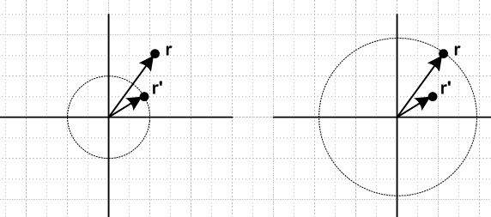 (I.9.6)

In each of these regions 1/R, being a solution of the Laplace equation, must be expressible as a linear combination of the atomic forms (the sum is Σmn = Σn=0∞ Σm=-nn) ,

1/R = Σmn Amn(r',θ',φ') rn Pnm(cosθ) eimφ for r inside the r' circle
1/R = Σmn Bmn(r',θ',φ') r-n-1 Pnm(cosθ) eimφ for r outside the r' circle . (I.9.7)

Inside the r' circle the powers r-n–1 for n = 0,1,2.. are ruled out since they blow up at r = 0.
Outside the r' circle the powers rn for n = 1,2.. are ruled out since they blow up as r→ ∞.

Since R is completely symmetric under r ↔ r' one must also be able to write,

1/R = Σmn Amn(r,θ,φ) r'n Pnm(cosθ') e-imφ' for r' inside the r circle
1/R = Σmn Bmn(r,θ,φ) r'-n-1 Pnm(cosθ') e-imφ' for r' outside the r circle . (I.9.8)

Here we have taken the liberty to change eimφ' to e-imφ'since we know that the imaginary parts make no contribution to 1/R since R is real and functions and coefficients are real.

The implication is that one must be able to write

1/R = Σmn Cmn (rn Pnm(cosθ) eimφ)( r'-n-1 Pnm(cosθ') e-imφ') for r inside the r' circle
1/R = Σmn Dmn ( r-n-1 Pnm(cosθ) eimφ)(r'n Pnm(cosθ') e-imφ') for r outside the r' circle
or (I.9.9)
1/R = Σmn Cmn rn r'-n-1 Pnm(cosθ)Pnm(cosθ')eim(φ-φ') for r inside the r' circle
1/R = Σmn Dmn r'n r-n-1Pnm(cosθ)Pnm(cosθ')eim(φ-φ') for r outside the r' circle .

As r'→r, one sees that the two coefficient sets must be the same, Cmn= Dmn. The final result is then usually written as a single line in this obvious manner, where r> = max(r,r') and r< = min(r,r'),

1/R = Σmn Cmn (r<)n (r>)'-n-1 Pnm(cosθ)Pnm(cosθ')eim(φ-φ') . (I.9.10)

By using a small and thin Gaussian box in the right place, throwing around some delta functions and curvilinear scale factors, and making appropriate invocations about jump conditions across the box, one can evaluate the coefficients Cmn in the equivalent of the above 1/R atomic expansion for any curvilinear coordinate system. For spherical coordinates one finds,

Cmn = f(n,-m) ≡ Γ(n-m+1)/Γ(n+m+1) . (I.9.11)

Thus

1/R = Σn=0∞ Σm=-nn f(n,-m) (r<)n (r>)'-n-1 Pnm(cosθ)Pnm(cosθ')eim(φ-φ') . (I.9.12)

By reflecting the negative m values to the positive side, this may also be expressed as

1/R = Σn=0∞ Σm=0n εm f(n,-m) (r<)n(r>)-n-1 Pnm(z) Pnm(z') cos[m(φ-φ')] (I.9.13)

where εm = 2 - δm,0 is the so-called Neumann factor (ε0 = 1, εother = 2) .

Potential of a Source Distribution

In potential theory, if there is some isolated source distribution ρ(r) (charge in electrostatics, mass in gravitation), the potential can be written as an integral over the source distribution in this manner,

V(r) = k ∫dV' $\frac{ρ(r)}{|r-r'|}$ = k ∫dV' $\frac{ρ(r')}{R}$ . (I.9.14)

There are no boundary conditions here, the source sits in empty infinite space. This is just the superposition of V = k(q/R) for a point source q where q = ρ(r')dV' . In electrostatics the constant k is 1 in cgs units, and is 1/4πε0 in SI units. For gravity k = -G. Inserting the 1/R expansion above we find that for r outside the r' circle.

V(r) = k ∫dV' ρ(r') {Σn=0∞ Σm=-nn f(n,-m) (r<)n(r>)-n-1 Pnm(cosθ)Pnm(cosθ')eim(φ-φ')}

= k Σn=0∞ Σm=-nn f(n,-m) Pnm(cosθ)eimφ r-n-1∫dV' ρ(r') r' n Pnm(cosθ') e-imφ' . (I.9.15)

We note in passing that one usually defines the "spherical harmonics" in this manner

Ynm(θ,φ) ≡ $\frac{2n+1}{4π}$ Pnm(cosθ)eimφ // Jackson (3.53) (I.9.16)

Therefore,

f(n,-m) Pnm(cosθ)eimφ Pnm(cosθ') e-imφ' = $\frac{4π}{2n+1}$Ynm(θ,φ) Y*nm(θ',φ') (I.9.17)

and then

V(r) = k Σn=0∞ $\frac{4π}{2n+1}$ Σm=-nn f(n,-m) Ynm(θ,φ) r-n-1∫dV' ρ(r') r' n Y*nm(θ',φ') (I.9.18)

1/R = Σn=0∞ $\frac{4π}{2n+1}$ Σm=-nn (r<)n (r>)'-n-1 Ynm(θ,φ) Y*nm(θ',φ') . // Jackson (3.70) (I.9.19)

One can define the exterior "multipole moments" Tnm as

Tnm ≡ ∫dV' ρ(r') r' n Y*nm(θ',φ') // dV' = r'2dr' sinθ'dθ'dφ' (I.9.20)

and then the V(r) expansion becomes,

V(r) = k Σn=0∞ $\frac{4π}{2n+1}$ Σm=-nn f(n,-m) Ynm(θ,φ) r-n-1 Tnm (I.9.21)

The interior multipole moment expansion then has rn ↔ r-n-1.

Although for a given n there are 2n+1 multipole moments, the historical names for n = 0,1,2,3 are monopole, dipole, quadrupole and octupole. These terms refer to simple source patterns in Cartesian space which have such moments. We will be dealing with n = 2 quadrupole below.

For a mass distribution (the oblate Earth) which is azimuthally symmetric, only the Tn0 moments are non-vanishing due to the e-imφdφ integration in (I.9.20). The exterior expansion (I.9.15) then becomes,

V(r) = k Σn=0∞ Pn(cosθ) r-n-1∫dV' ρ(r',θ') r' n Pn(cosθ') // f(n,0) = 1 (I.9.22)

and we define some new moments Jn such that (Jn are constants, not Bessel functions)

Jn ≡ k∫dV' ρ(r') r' n Pn(cosθ') // projection

V(r) = Σn=0,1.. Pn(cosθ) r-n-1 Jn . // expansion (I.9.23)

If the source distribution ρ(r') is invariant under vertical reflection, as is the case for the oblate Earth, the odd Jn vanish. For example, this knocks out the n = 1 dipole term. Even if ρ(r') is is not vertically invariant, J1 vanishes if the origin is taken at the center of mass point so rcms = 0 :

J1 ≡ k∫dV'ρ(r') r'P1(cosθ') = k∫dV'ρ(r') r'cosθ' = k∫dV'ρ(r') ( r' • )
= k [∫dV'ρ(r')r'] • = k M rcms • = k M 0 • = 0 . // (D.1.1)

The decay factor r-n-1 becomes more severe for larger n, so "far away" one takes only the first few terms in the expansion. We shall take the first two contributing terms,

V(r) ≈ P0(cosθ) r-1 J0 + P2(cosθ) r-3 J2 . // P0(z) = 1 (I.9.24)

The moments here are

J0 = -G ∫dV' ρ(r') r' 0 P0(cosθ') = -G ∫dV' ρ(r',θ') = -GME
J2 = -G∫dV' ρ(r') r' 2 P2(cosθ') (I.9.25)

so

V(r) ≈ -GME/r + J2 P2(cosθ)/r3 . (I.9.26)

The first term is the potential of the spherical Earth, while the second term is a correction due to oblateness. Our next task is to compute the moment J2.

Calculation of the moment J2

We shall assume for our azimuthally symmetric mass distribution that any line segment from the origin to a point on the boundary lies within the boundary. The region is "star-like" since all star rays from the origin lie in the region. In this case, when we do the volume integration to compute moments, the θ and φ integrations have full range, but the r integration runs from r = 0 to some r = r(θ) which defines the boundary. This boundary allows for both oblate or prolate shape types.

Removing the dummy primes in (I.9.25) one has,

J2 = -G ∫dV ρ(r) r2 P2(cosθ) = -2πG $^{\int_{0}^{π}{}}$dθ sinθ P2(cosθ)$^{\int_{0}^{r(θ)}{}}$dr r4 ρ(r,θ) . (I.9.27)

We now digress to recall some facts about moments of inertia from Section I.1 above,

Iij ≡ ∫dx1dx2dx3 ρ(x)[ r2δij - xixj] = ∫dV ρ(r)( r2δij - xixj) . (I.1.3)

In particular, since our "planet" is axisymmetric, the inertia tensor is diagonal with I1 = I2 and

I33 = I3 = ∫dV ρ(r)( r2 - z2)
I11 = I1 = ∫dV ρ(r)( r2 - x2) = I22 = I2 . (I.9.28)

Therefore,

I3 - I1 = ∫dV ρ(r)(x2-z2) = ∫dV ρ(r)([rsinθcosφ]2-[rcosθ]2)

= ∫dV ρ(r) r2(sin2θ cos2φ - cos2θ)

= $^{\int_{0}^{2π}{}}$dφ $^{\int_{0}^{π}{}}$dθ sinθ (sin2θ cos2φ - cos2θ)$^{\int_{0}^{r(θ)}{}}$r4dr ρ(r,θ)

= $^{\int_{0}^{π}{}}$dθ sinθ (π sin2θ - 2πcos2θ)$^{\int_{0}^{r(θ)}{}}$r4dr ρ(r,θ) // $^{\int_{0}^{2π}{}}$dφ cos2φ = π

= π$^{\int_{0}^{π}{}}$dθ sinθ (sin2θ - 2cos2θ)$^{\int_{0}^{r(θ)}{}}$r4dr ρ(r,θ)

= π$^{\int_{0}^{π}{}}$dθ sinθ (1 - 3cos2θ)$^{\int_{0}^{r(θ)}{}}$r4dr ρ(r,θ)

= -2π$^{\int_{0}^{π}{}}$dθ sinθ P2(cosθ)$^{\int_{0}^{r(θ)}{}}$r4dr ρ(r,θ) . (I.9.29)

Comparing this with the J2 integral in (I.9.27) one sees that for any azimuthally symmetric mass distribution,

J2 = G(I3-I1) (I.9.30)

and then the potential is

V(r) ≈ - GME/r + G (I3-I1) P2(cosθ)/r3. (I.9.31)

This result is valid for any "star" perimeter r(θ) and for any mass distribution ρ(r,θ). We shall come back later and compute I3-I1 for a slightly oblate or prolate spheroid of uniform density. But first we want to derive the torque equation (I.8.7) as promised.
Equation (I.9.31) appears as (5.88) in GPS p 225. Their V is in fact potential energy, not potential, and so includes an extra factor of M of a point mass experiencing the potential.

Calculation of the Torque

In Fig (I.8.6) we show mass M which is "far away" from the Earth. The Earth generates a potential V(r) as computed in (I.9.31). This potential creates a force F = -M∇V(r) on mass M. That force in turn creates a torque r x F acting on mass M. Mass M of course then creates a reverse torque N = - r x F on the Earth.
We first compute ∇V(r)as follows:

∇V(r) = -GME∇(1/r) + G (I3-I1) [ ∇( P2(cosθ) )/r3 + P2(cosθ)∇(1/r3) ]

Since ∇f(r) = f'(r), the terms with ∇(1/r) and ∇(1/r3) have no effect on the torque. One then has,

N = - r x F = M r x ∇V(r) = GM (I3-I1) r-3 r x ∇(P2(cosθ)) . (I.9.32)

In spherical coordinates,

∇( P2(cosθ) ) = (1/r) ∂θP2(cosθ) . (I.9.33)

Then,

N = - r x F = GM (I3-I1) r-3 r x [ (1/r) ∂θP2(cosθ)

= GM (I3-I1)r-3 ∂θP2(cosθ) x

= GM (I3-I1)r-3 ∂θP2(cosθ) // (E.2.12)

= GM (I3-I1)r-3 ∂θ{(1/2)(3cos2θ - 1)}

= GM (I3-I1)r-3 (3/2)∂θ{cos2θ}

= GM (I3-I1)r-3 (3/2)[-2cosθ sinθ ]

= - 3GM r-3 (I3-I1) cosθ sinθ . (I.9.34)

This is the result quoted from Williams in (I.8.7) with r = b and (I.8.8).

Description of the perimeter of a slightly oblate or prolate spheroid

We now digress a bit on ellipses and spheroids created from them.

Consider an ellipse of the form x2/A2 + z2/C2 = 1,

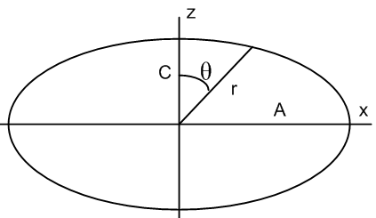 (I.9.35)

If we measure polar angle θ down from the z axis, then x = rsinθ and z = rcosθ and the ellipse equation becomes

r2 = $\frac{A2C2}{C2sin2θ+A2cos2θ}$ . (I.9.36)

For an "oblate" (wide) ellipse one has A > C. If the ellipse is only slightly oblate, write

A = C + δ .

For oblate δ > 0, and for prolate δ < 0.

In this case one gets,

r2 = $\frac{A2C2}{C2sin2θ+(C+δ)2cos2θ}$ ≈ $\frac{A2C2}{C2 + 2Cδcos2θ}$ = $\frac{A2}{1+ 2(δ/C)cos2θ}$

≈ A2 [ 1-2(δ/C)cos2θ ] ≈ A2 [ 1-2(δ/A)cos2θ ] .

Then

r ≈ A [ 1-(δ/A)cos2θ ] . (I.9.37)

The "eccentricity" e of the ellipse is

e2 ≡ (A2-C2)/A2 = (A+C)(A-C)/A2 ≈ 2Aδ/A2 = 2δ/A .

One then has

r = A [ 1- (1/2)(2δ/A)cos2θ ] = [ 1- (1/2)e2cos2θ ] .

On the other hand, the "ellipticity" of the ellipse (also known as the flattening parameter) is

ε ≡ (A-C)/A = δ/A // ε = e2/2 (I.9.38)

where ε > 0 for oblate and ε < 0 for prolate. Then

r(θ) = A [ 1- (1/2)(2ε)cos2θ ] = A[ 1- ε cos2θ ] . (I.9.39)

We now form a slightly oblate spheroid by rotating our slightly oblate ellipse about the vertical axis, introducing an azimuthal coordinate φ.

The average value of r over this spheroid is given by,

a ≡ <r> = A[ 1- ε <cos2θ> ] . (I.9.40)

At this point assume a uniform mass density ρ(r) = ρ so that

<cos2θ> = $\frac{∫dV ρ(r)cos2θ}{∫dV ρ(r)}$ = $^{\int_{0}^{2π}{}}$$^{\int_{0}^{π}{}}$$^{\int_{0}^{r(θ)}{}}$$^{\int_{0}^{2π}{}}$$^{\int_{0}^{π}{}}$$^{\int_{0}^{r(θ)}{}}$

= $^{\int_{0}^{π}{}}$$^{\int_{0}^{r(θ)}{}}$$^{\int_{0}^{π}{}}$$^{\int_{0}^{r(θ)}{}}$ ≈ $^{\int_{0}^{π}{}}$$^{\int_{0}^{a}{}}$$^{\int_{0}^{π}{}}$$^{\int_{0}^{a}{}}$

= $^{\int_{0}^{π}{}}$$^{\int_{0}^{π}{}}$ = $\frac{(2/3)}{2}$ = 1/3 (I.9.41)

where corrections of order ε can be ignored since these create order ε2 in a. Then from (I.9.40),

a ≡ <r> = A[ 1- ε (1/3) ] . (I.9.42)

Now process r(θ) of (I.9.39) as follows,

r(θ) = A[ 1- ε cos2θ ] = $\frac{a}{1-ε/3}$[ 1- ε cos2θ ]

≈ a(1+ε/3)(1- ε cos2θ)

≈ a [ 1 + ε/3 - ε cos2θ ]

= a [ 1 - (ε/3)(3cos2θ - 1) ]

= a [ 1 - (2/3)ε P2(cosθ) ] // since P2(cosθ) = (1/2)(3cos2θ - 1)
or

r(θ) = a [ 1 - (2/3)ε P2(cosθ) ] . (I.9.43)

One can regard r(θ) as a function defining the perimeter of the slightly oblate or prolate spheroid of ellipticity (flatness) ε. If ε = 0, one of course finds that r = a for a sphere.

The reader seeking verification will find (I.9.43) to be the very first equation on this nice web page

http://farside.ph.utexas.edu/teaching/336k/Newtonhtml/node108.html

which we have used as a guide throughout. These are notes by Richard Fitzpatrick.

Calculation of I3- I1

Recall from (I.9.29) that

I3 - I1 = -2π$^{\int_{0}^{π}{}}$dθ sinθ P2(cosθ)$^{\int_{0}^{r(θ)}{}}$r4dr ρ(r,θ)

= -2πρ$^{\int_{0}^{π}{}}$dθ sinθ P2(cosθ) (1/5) r(θ)5 . (I.9.44)

Now from (I.9.43),

r(θ) = a [ 1 - (2/3)ε P2(cosθ) ]
so
r(θ)5 ≈ a5 [ 1 - 5 (2/3)ε P2(cosθ) ] . (I.9.45)

Then

I3 - I1 = -2π ρ (1/5) a5$^{\int_{0}^{π}{}}$dθ sinθ P2(cosθ) [ P0(cosθ) - 5 (2/3)ε P2(cosθ) ] . (I.9.46)

Recall from (I.9.4) that

$^{\int_{-1}^{1}{}}$dz Pn(z)Pn'(z) = δn,n'/ (n+1/2) . (I.9.4)

The first integral in (I.9.46) thus vanishes leaving

I3 - I1 = -2πρ (1/5) a5 [ - 5 (2/3)ε] {$^{\int_{0}^{π}{}}$dθ sinθ P2(cosθ) P2(cosθ) }

= 2πρ (1/5) a5 5 (2/3)ε {1/[5/2]} = 2πρ (1/5) a5 5 (2/3)ε (2/5)

= 2πρ (1/5) a5 (2/3)ε (2)

= (8π/15)ερa5 . (I.9.47)

To zeroth order the mass density is that of a sphere, so

ρ = ME/V = ME / [ (4/3)πa3] (I.9.48)

and then

I3 - I1 = (8π/15)εa5 * ME / [ (4/3)πa3] = (8/15)εa2 * ME / [ (4/3)] = (8/15)εa2 * ME (3/4)

= (2/5) ε MEa2 (I.9.49)

and the moment J2 is then

J2 = G(I3 - I1) = (2/5) ε GMEa2 . (I.9.50)

The potential can then be written

V(r) = -GME/r + G (I3-I1) P2(cosθ)/r3.

= -GME/r + (2/5) ε GMEa2 P2(cosθ)/r3 . (I.9.51)

Reader Exercise: Show that a uniform sphere of radius a and mass M has a moment of inertia about any axis of I = (2/5) Ma2 .

For the Earth then one has roughly I1 ≈ I3 ≈ (2/5) Ma2 and then (I.9.49) states,

I3 - I1 = (2/5) ε MEa2 ≈ ε I1

so
ε ≈ $\frac{I3 - I1}{I1}$ // one form of "McCullough's formula" (I.9.52)

which relates the ellipticity to the moments of inertia for an axially symmetric "planet".

Reader Exercises:

1. Compute the integrals I1 and I3 separately as in (I.9.29) and conclude that McCullough's formula is valid for any "star-like" shape and any azimuthally symmetric mass density distribution ρ(r,θ).

2. Show that McCullough's formula is valid even if the boundary is not "star-like".

3. For a uniform arbitrary oblate spheroid (not one that is just slightly oblate) compute, with no approximations, the exact external gravitational potential and resulting torque exerted by an external point mass M. Use oblate spheroidal coordinates. A candidate potential solution appears on page 62 of MacMillan (which may be available online). That solution is quoted here,

http://scienceworld.wolfram.com/physics/OblateSpheroidGravitationalPotential.html

In the electrostatics problem of a charged conducting spheroid, the mobile source (charge) is distributed unevenly on the spheroidal surface, while in the gravitational problem the fixed mass is distributed uniformly throughout the spheroidal volume. How does this fact affect the two problem solutions?

I.10 Motion of an electric dipole dumbbell in a uniform E field

The kinematic setup is similar to that for the dumbbell satellite shown in Fig (F.1.1), but here we simplify so that r1 = r2 = r and m1 = m2 = m, so the picture is this,

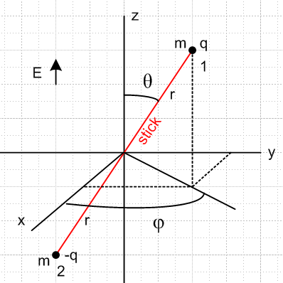 (I.10.1)

Two equal point masses m are separated by a massless stick of length 2r which has a universal pivot point at the origin, allowing the dumbbell to rotate freely in θ and φ. The pivot point won't really be needed but it helps to think about the problem. One mass has charge q and the other -q. Instead of the gravitational field of the Earth, this dumbbell is immersed in a uniform electric field E in the z direction. As we shall see, this problem is a hybrid of the dumbbell satellite and the spherical pendulum, though the latter will soon be declared the winner.

Force and Torque

In the dumbbell satellite problem both masses were attracted to the Earth, but here one mass is pushed up and the other is pushed down. In fact, letting T be the tension in the stick,

F1 = qE + T = qE + T

F2 = (-q)E - T = -qE - T = - F1 r2 = - r1 = - r

F = F1 + F2 = 0 (I.10.2)

so the center of mass does not move (hence no pivot needed).

The torques on the two masses about the origin are (same as about any point since F = 0),

N1 = r1x F1 = [r] x [ qE] = rqE x = rqE [ -sinθ ] = -rqEsinθ

N2 = r2x F2 = (-r1)x (-F1) = N1 . (I.10.3)

Here we ignored the stick tension forces since r1 x r = r2 x r = 0. The total torque is then,

N = N1+ N2 = 2N1 = -2rqEsinθ . (I.10.4)

Now define the dipole moment p as

p ≡ (2r)q p ≡ 2rq . (I.10.5)

Then using (E.2.15) that x = sinθ we may write,

N = -2rqEsinθ = -2rqEsinθ [ x /sinθ ] = 2rqE x

= [ 2rq ] x [E ] = p x E (I.10.6)

which is the classic result for the torque on a dipole in an electric field.

Newton's Angular Law and Equations of Motion

Newton tells us that (in inertial Frame S),

N = , (I.10.7)

so we have the following vector equation of motion for the dipole dumbbell,

= p x E = -2rqEsinθ = -pEsinθ . (I.10.8)

Here θ,φ refer to the angular position of the stick in (I.10.1). The three equations of motion are therefore

()r = 0
()θ = 0
()φ = -pEsinθ . (I.10.9)

But from (F.2.2) and (F.2.3) we know that

L = 2mr2 ( – sinθ ) (F.2.2)
= 2mr2 [ (- 2 sinθ cosθ) – (2 cosθ + sinθ) ] . (F.2.3) (I.10.10)

The three equations of motion are then

()r = 0 = 0 // nothing very interesting here
()φ = -pEsinθ = 2mr2 (- 2 sinθ cosθ)
()θ = 0 = – 2mr2(2 cosθ + sinθ) . (I.10.11)

Thus, there are really only two equations of motion :

- 2 sinθ cosθ + [pE/2mr2] sinθ = 0
2 cosθ + sinθ = 0 . (I.10.12)

Let [pE/2mr2] = a, so then

- 2 sinθ cosθ + a sinθ = 0 a = pE/2mr2 = (2qr)E/2mr2 = qE/mr
2 cosθ + sinθ = 0 . (I.10.13)

The tension on the stick can be evaluated by going to the rest frame of mass #1 (the body frame). That mass has a true electrostatic force and a fictitious centrifugal force. These forces are

qE = qE [ cosθ - sinθ ] ⇒ Fr,elec = qEcosθ

Fr,cent = mv2/r where v2 = vθ2 + vφ2 . (I.10.14)

From (E.3.5) one knows that vθ = r and vφ = r sinθ . Thus

Fr,cent = (m/r) (vθ2 + vφ2) = (m/r) (r2 2 +r2 2 sin2θ) = mr( 2 + 2 sin2θ ) . (I.10.15)

The stick tension is then

T = mr( 2 + 2 sin2θ ) + qEcosθ
so
T/mr = ( 2 + 2 sin2θ ) + [qE/mr]cosθ = 2 + 2 sin2θ + a cosθ . (I.10.16)

Including this with the equations of motion (I.10.13), one gets

T/mr = 2 + 2 sin2θ + a cosθ
- 2 sinθ cosθ + a sinθ = 0 a = qE/mr
2 cosθ + sinθ = 0 . (I.10.17)

Compare these equations to those for the spherical pendulum found in Appendix C,

2 + sin2θ 2 = -(g/l)cosθ + T/(ml)
- sinθcosθ 2 = - (g/l)sinθ
2cosθ + sinθ = 0 . (C.5.1)

If we make the associations l = r and (g/l) = a, these equation sets are identical. Then,

g = la = ra = r qE/mr = qE/m . (I.10.18)

It is not surprising that the equations of motion are the same, since both problems have a uniform force field in the z direction. The spherical pendulum has a mass swinging on a stick whose other end is fixed, while our current problem has a free-floating dumbbell consisting of two oppositely charged masses on a stick.

With the above identification, anything said about the spherical pendulum solution applies to the dipole dumbbell problem. For example we then know from (C.5.2) and (C.5.4) that Lz = (2m)r2sin2θ is a constant of the motion. The problem may be solved exactly as shown in Section C and has numerical solutions as shown there, such as shown in (C.5.44).

Conical motion solution

In particular, there is a conical motion solution which has θ = constant. In this case the equations (I.10.17) become

T/mr = 2 sin2θ + a cosθ
- 2 sinθ cosθ + a sinθ = 0 a = qE/mr
sinθ = 0 . (I.10.19)

The second equation says

2 = a/cosθ = qE/(mrcosθ) . (I.10.20)

Recall from (I.10.4) the torque on the dumbbell,

N = -2rqEsinθ (I.10.4)

so we expect the dumbbell to precess clockwise around its cone, and therefore from (I.10.20),

= - $\sqrt{qE/(mrcosθ)}$. (I.10.21)

The third equation of (I.10.19) is then satisfied since is a constant, and the tension T is

T = mr[ (a/cosθ) sin2θ + a cosθ ] = mra ( sin2θ + cos2θ)/ cosθ

= qE/cosθ . (I.10.22)

From (I.10.10) and (I.10.21) one then has,

L = –2mr2 sinθ = 2mr2 || sinθ

= 2mr2 $\sqrt{qE/(mrcosθ)}$sinθ . (I.10.23)

From (I.10.28) obtained below one finds the obvious result that,

ω = (0, 0, ) . (I.10.24)

Here then is the "cone picture" showing this special solution for the electric dipole dumbbell,

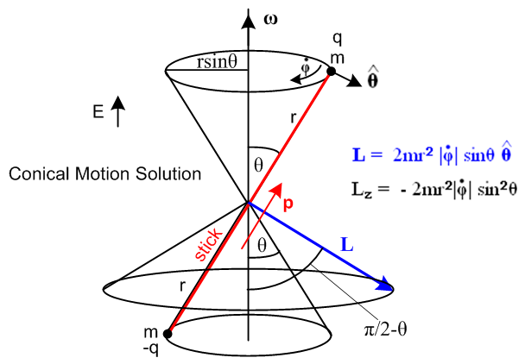 (I.10.25)

The direction of angular momentum L seems unusual, but it is in the direction of r x mv for either mass. Vector L is perpendicular to the stick and is in the direction. This example provides dramatic evidence of L (= Iω) and ω not being in the same direction. We shall in fact compute I below and show that L = Iω is in the direction shown above and as computed in (I.10.23).

The kinetic energy for this conical solution is just 2 * (1/2)mv2 with v = rsinθ so

KE = mv2 = m r2sin2θ 2 = m r2sin2θ qE/(mrcosθ) = rqEsinθ tanθ . (I.10.26)

One can regard θ as being set by the magnitude of L or by the kinetic energy.

Notice that as θ→π/2, the following items become infinite: KE, L , tension T, , ω, v. The dumbbell has to spin around infinitely fast to maintain a circular path in the xy plane, because the electric field wants to line the dumbbell up with the z axis. Only an infinite centrifugal force can offset the E field's influence.

We now return to the general solution context.

Angular Velocity ω

The "Frame S" angular velocity ω of the dipole dumbbell is given by (H.6.14) [ here is a place where it is important to distinguish spherical coordinate φ from Euler angle φ = φ+π/2 ],

ωx = sinθcosφ - sinφ
ωy = sinθsinφ + cosφ
ωz = cosθ + . // Frame S (H.6.14) (I.10.27)

Since the dumbbell has no moment of inertia about its symmetry axis (I'3= 0), coordinate ψ is not relevant and we just set ψ = constant so the above equations become

ω = (- sinφ, cosφ, ) . (I.10.28)

Inertia tensor I

From (I.1.6),

Li = Iij (ω)j Iij = Σαmα [ rα2δij - (rα)i(rα)j ] . // rα2 = (rα)i(rα)i (I.1.6)

Since we have done no examples of computing inertia tensors in the space frame, we do it here. This is a special case I where there are two equal terms in the particle sum Σα . The reason is that one mass is at location r, and the other at -r, and all the inertia terms for the second mass are the same as for the first mass since each term is invariant under r → -r. We use the standard spherical coordinate components,

x = rsinθcosφ
y = rsinθsinφ
z = rcosθ (E.2.5)

and compute the entire tensor as follows:

I11 = 2m(r2 - x2) = 2m(r2 - r2sin2θcos2φ) = 2mr2 (1 - sin2θcos2φ)

I22 = 2m(r2 - y2)= 2mr2 (1 - sin2θsin2φ)

I33 = 2m(r2 - z2) = 2m(r2 - r2cos2θ ) = 2mr2sin2θ

I12 = 2m(-xy) = -2mr2sin2θcosφsinφ

I13 = 2m(-xz) = -2mr2sinθcosθcosφ

I23 = 2m(-yz) = -2mr2sinθcosθsinφ . (I.10.29)

Thus, the symmetric I tensor is this

I = 2mr2 $\left(\begin{matrix}1 - sin2θcos2φ & -sin2θcosφsinφ & -sinθcosθcosφ \\ -sin2θcosφsinφ & 1 - sin2θsin2φ & -sinθcosθsinφ \\ -sinθcosθcosφ & -sinθcosθsinφ & sin2θ\end{matrix}\right)$. (I.10.30)
Angular momentum L

Recall now a result quoted in (I.10.10) above,

L = 2mr2 ( – sinθ ) . (I.10.10)
Since L = Iω from (I.1.4), it would be interesting to compute ω from ω = I-1L and see if we get result (I.10.28). It happens, however, that this particular inertia tensor has zero determinant and so has no inverse.

Reader Exercise: Assuming Iij = r2δij - xixj, show that det(I) = 0 (a single-term inertia tensor) .

Hint: det(I) = εijkI1iI2jI3k = εijk(r2δ1i - x1xi)(r2δ2j - x2xj)(r2δ3k - x3xk) .

Since we cannot compute ω = I-1L, we shall instead assume ω as in (I.10.28) and compute L = Iω and verify that this produces the result (I.10.10). We write the inertia tensor in (I.10.30) as I = 2mr2M and enter matrix M into Maple,

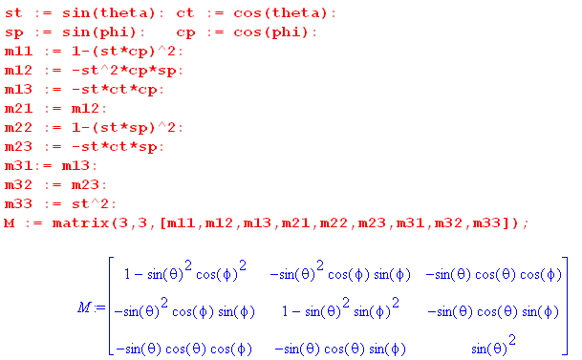 (I.10.31)

We verify as noted above that detM = 0,

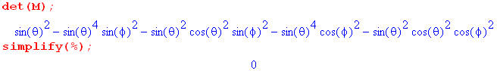
Finally we enter ω from (I.10.28) (td = and pd = )

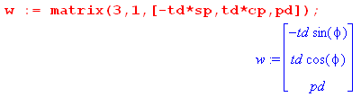
and then compute L = Iω :

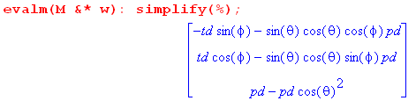

Transcribing the result and adding back the factor 2mr2,

Lx = 2mr2(- sinφ - sinθcosθcosφ )
Ly = 2mr2( cosφ - sinθcosθsinφ )
Lz = 2mr2( sin2θ) . (I.10.32)

Meanwhile, from (I.10.10) one has,

L = 2mr2 ( – sinθ ) // next step uses (E.2.7):

= 2mr2 ( [-sinφ + cosφ ] – sinθ [cosθcosφ + cosθsinφ - sinθ ])

= 2mr2 { (- sinφ - sinθcosθcosφ ) + ( cosφ - sinθcosθsinφ) + ( sin2θ) } (I.10.33)

and this does agree with (I.10.32) .

Reader Exercises:

1. Redo this problem using the Lagrangian approach.

2. Redo this problem with the point masses replaced by uniform density spheres of radius R assuming that the charge is uniformly distributed on the sphere surfaces ("sticky charge"). Is this new problem trivial, or does it require work? What if the charge is allowed to move freely on the conducting sphere surfaces?

3. Compute the radiation pattern for the point-mass conical dipole dumbbell solution. One does expect accelerating charges to radiate, see Jackson Chapter 9. This would be a classical model for radiation from an isolated dipole molecule executing conical motion in a uniform E field.

I.11 Rotors involving electric or magnetic dipoles

We consider here three final rigid body rotation problems. The first two problems are isomorphic to the gravity top, while the third is somewhat in a class by itself and has great engineering significance.

1. Spherical top with fixed embedded electric dipole in a uniform E field
2. Spherical top with fixed embedded magnetic dipole in a uniform B field
3. Rigid charged rotor which creates its own magnetic dipole moment, in a uniform B field .

1. rotor with fixed embedded electric dipole in a uniform E field

The rotor has some axisymmetric shape, perhaps it is spherical. This rotor is operating in zero-gravity space and here we take the uniform electric field to be E = -E. Consider then the torques involved in the gravity top problem of Section I.7 compared with the dipole top problem considered here,

gravity top: N = rcms x F F = -mg

fixed dipole top: N = p x E E = -E . (I.11.1)

The two torques can be written,

gravity top: N = [rcms] x[ -mg] = - rcmsmg x

fixed dipole top: N = [p] x [ -E] = - pE x . (I.11.2)

The torques have the exact same form and are identical with this association

rcmsmg = pE . (I.11.3)

The force situation is a bit different. For the gravity top, F = 0 because the down gravity force is balanced by the pivot point force up. For the fixed dipole top, F = 0 without a pivot point. The dipole top in effect pivots about its center of mass.

Consider the potential energy situation for these two systems,

V = mgrcmscosθ gravity top max when θ = 0, top vertical

V = pEcosθ dipole top max when θ = 0, top anti-aligned with E (I.11.4)

Again the connection is seen to be rcmsmg = pE.

The upshot is that the problem of a fixed electric dipole top operating in a uniform E field and no gravity is isomorphic to the gravity top problem discussed in Section I.7. We expect solutions which precess and nutate as shown in Fig (I.7.19). As noted there, having the top be spherical does not simplify the general nature of these complicated solutions.

2. rotor with fixed embedded MAGNETIC dipole in a uniform B field

We arrive at this problem by making the changes E → B and p → μ where μ is a fixed magnetic dipole (a chunk of magnet) embedded into a top along the symmetry axis. The torque here is N = μ x B instead of N = p x E, see Jackson (5.1). Thus, the fixed magnetic moment top is isomorphic with the gravity top with this association,

rcmsmg = μB . (I.11.5)

As with the electric dipole top above, this magnetic system has the same solution complexity as the gravity top system.

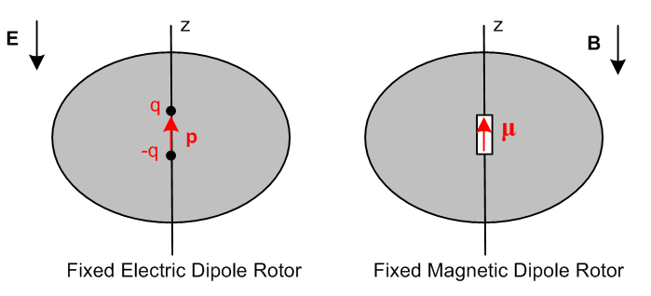 (I.11.6)

3. THE CHARGED ROTOR AND LARMOR PRECESSION

This problem is similar to the magnetic dipole rotor discussed just above, but here the magnetic moment is not fixed but is self-generated by charge embedded in the rotor. To keep things simple, consider a very thin round "wagon wheel rotor" (radius a) which is made of "charged matter" and has massless spokes to hold it in shape, and a massless axle. Here we show the wheel tilted so its axis points in the direction,

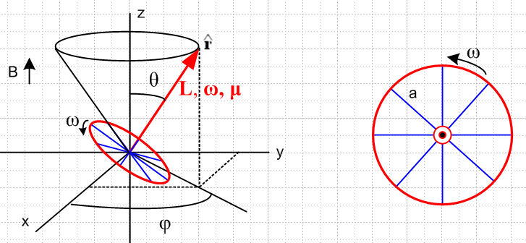 (I.11.7)
We anticipate a conical motion solution so a cone is displayed in black.

Assume that the red ring is made of particles of mass m and electric charge q. These particles are glued down to a massless wheel substrate that prevents them from flying away. We assume the particles are uniformly distributed on the ring. The linear charge density is λ and the linear mass density is ρ. Thus,

M = 2πaρ total mass of ring

Q = 2πaλ total charge of ring

I = Ma2 moment of inertial of ring

λ/ρ = Q/M = q/m . ratio of linear densities (I.11.8)

The wheel is going to precess, but we assume that it spins much faster than it precesses, so we can ignore the resulting precession when computing ω and L. Then,

ω = ω

L = Iω = (Ma2)ω = (Ma2ω) . (I.11.9)

As shown in Jackson (5.5.7), when an electric current i circulates in a closed planar loop of wire of any shape but of area A, a magnetic dipole moment is generated by the current which is normal to the loop (by the right hand rule with the current), and has magnitude μ = iA. Our rotating ring of charge constitutes a current of i = aωλ, and the area is A = πa2. To obtain the current, note that the amount of charge which passes through a radial line in time dt is dq ≈ (adθ)λ so i = dq/dt = (adθ)λ/dt = aλ(dθ/dt) = aλω. Thus,

μ = iA = [aωλ][ πa2] = (πωλa3) . (I.11.10)

Comparing the last two equations, one sees that μ and L are related as follows,

μ = (πωλa3) = [ (πωλa3) / (Ma2ω) ] L = (πλa/M) L

= (πλa/2πaρ) L = (1/2)(λ/ρ) = (1/2) q/m L = (q/2m) L
or

μ = γc L γc ≡ q/(2m) = " the classical gyromagnetic ratio" (I.11.11)

(sometimes called the magnetogyric ratio). The torque on the ring is

N = μ x B = [ πλωa3 ] x [B] = πλωa3 Bx = πλωa3B [-sinθ]

= - πλωa3Bsinθ . (I.11.12)

Alternatively one can use (I.11.11) to write

N = μ x B = γc L x B . (I.11.13)

Since Newton's Law says

= N = - πλωa3Bsinθ (I.11.14)

we end up with this equation of motion

= γc L x B . (I.11.15)

This says that in time dt, dL is perpendicular to L and B which indicates conical motion. In more detail, recall from (I.11.9) above that

L = (Ma2ω) (I.11.9)
so
= (Ma2ω)∂t = (Ma2ω)( + sinθ ) // (E.2.11) (I.11.16)

where we assume that for our fast-spinning wheel ω ≈ constant. Comparing (I.11.16) with (I.11.14) gives

= 0

(Ma2ω) sinθ = - πλωa3Bsinθ . (I.11.17)

The first equation confirms conical motion θ = constant, while the second gives an expression for the precession rate ,

(M) = - πλaB

⇒ = - πλaB/M = - πλaB/(2πaρ) = - λB/(2ρ) = - (λ/2ρ)B = - (q/2m)B

with result

= - (q/2m)B = - γc B γc = (q/2m) . (I.11.18)

This = ωL is called the Larmor precession frequency (Joseph Larmor, 1897, yet another Lucasian Professor at Cambridge). For a given charge/mass ratio q/m and a given B, is a constant, so one can at least imagine that can be neglected in the assumption we made above that that ω ≈ ω, given a large enough ω. If ω is not "large", then the cone motion will incur some small nutation as in the top solution, a fact Goldstein points out in the last sentence of his Chapter 5 (not mentioned in GPS) with a reference to a paper he published in 1951.

Significantly, the Larmor precession rate = - γcB is independent of the radius "a" of our ring of particles. Thus the conclusion = - γcB certainly applies to anything that can be made from a set of rings, such as a cylinder or a spherical shell or a solid sphere of particles (or particle matter).

Also significantly, the Larmor precession frequency is independent of the θ angle of the precession cone. Classically, a set of protons with angular momentum L, if placed in a uniform magnetic field B = B, would be precessing at random cone values θ, but all at the same Larmor frequency.

A classical electron can be modeled as a spinning sphere (of some very small radius) of uniform charge and mass distribution, and in this model it was just shown that γc = e/2m.

Enter Quantum Mechanics

However, an electron or proton is a quantum object and not a classical object, so the above two paragraphs have little meaning.
For an electron (or any spin-1/2 particle), the relation between its magnetic moment μ and its "spin" angular momentum L is given by ( = h/2π where h is Planck's constant and is called "h bar"),

μ = γ L, Lz = ± /2 for quantum states up = $\left(\begin{matrix}1 \\ 0\end{matrix}\right)$ and down = $\left(\begin{matrix}0 \\ 1\end{matrix}\right)$ (I.11.19)

and for the quantum electron one finds experimentally that,

γ ≈ 2γc = 2(e/2m) . (I.11.20)

Traditionally one defines the dimensionless "g-factor" (g maybe for "gyro") as

g ≡ γ/γc (I.11.21)

so for the classical electron g = 1 as computed above, but for the quantum electron g ≈ 2.

Comment 1 : In this context, L is usually called S, the "intrinsic spin" of a particle. The reader may recall from Section G.5 that the mass and spin of a particle are related to the two invariant Casimir operators of the Poincare Group which is a basic symmetry group of nature. In a sense, this group predicts that particles should have a well-defined mass and a well-defined spin.

Comment 2: Due to a quantum electrodynamics (QED) correction (a Feynman diagram calculation which is actually doable), one finds that g ≈ 2.002 but this depends on the value of the QED "coupling constant" α. Experimentally one finds g/2 = 1.001 159 652 180 85 (76), this being a 2007 experiment and (76) indicating the ± error in the 85. This is an astonishingly high-precession experiment and implies a similarly astonishingly precise value for the famous α ≈ 1/137 coupling constant of QED.
See https://en.wikipedia.org/wiki/Precision_tests_of_QED .

All charged particles with spin > 0 have magnetic moments and g-factors, such as electrons, muons, protons and atomic nuclei.

As a fairly meaningless but entertaining calculation, in light of the Lz value shown in (I.11.19), and using a nebulous number known as the classical electron radius re, we can calculate the classical value of ω and see if it is in fact much larger than the Larmor precession rate ωL = . In SI units,

re = 2.8 x 10-15 m = 6.6 x 10-34 me = 9.1 x 10-31 e = 1.6 x 10-19 .

Then from (I.11.9) we have

Lz = mere2ω = /2 ⇒ ω = /(2mere2)

whereas (ignoring signs)

ωL = γB ≈ (e/m)B . // B = 3 Tesla is found in a good MRI machine

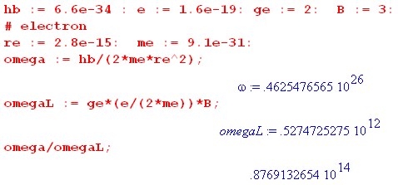

So this toy calculation suggests that ω ~ 1014 ωL , "justifying" our assumption made earlier that we could ignore = ωL relative to ω in computing ω. The numbers for a proton are

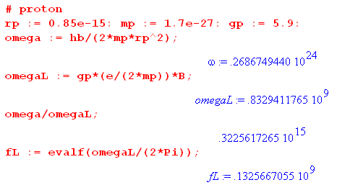

so in this case ω ~ 1014 ωL as well. The last line shows that in a 3 Tesla MRI machine, the nominal Larmor frequency is around 132 MHz. Earlier machines were 1.5T and 66 MHz.

In the quantum picture there is no classical μ vector for a proton magnetic moment doing conical motion as in Fig (I.11.7). Instead, there is a 2-component state vector |ψ(t)> which evolves in time. The analog of μ is the "expectation value" of a magnetic moment "operator" μ in state |ψ(t)>, μ(t) = <ψ(t)| μ |ψ(t)>. This concept is refined using a tool called the density matrix to account for the statistics of a large number of particles which have thermal motion. The resulting quantity of interest is called the magnetization M(t).

MRI Machines (Magnetic Resonance Imaging)

For MRI the spinning particles of interest are protons which are the nuclei of hydrogen atoms which permeate the human body, mostly in the form of water. The proton spins (and thus magnetic moments) naturally tend to align with the large B = B field of an MRI machine's superconducting magnet, causing M(t) to point statically in the direction. An RF pulse having a By field component is then applied, which causes M(t) to precess about . If the RF pulse is applied for 1/4 of the y-direction Larmor period, M(t) moves from to and then precesses in the x-y plane around the huge static B field at the z-direction Larmor rate. M(t) then spirals around ending up after some long time T1 back in the direction due to "friction" effects. But before this can happen, the many protons in a sample "dephase" in time T2 due to small local variations in B, killing off the transverse M(t) signal. The time for this to happen depends on physical characteristics of the sample being scanned (fat, bone, water) and this is one tool that is used to get "contrast" at different points in an MRI image. Injected Gadolinium "dye" affects T2, thus affecting the contrast. The main contrast effect is that the B field actually seen by a proton is reduced by that proton's environment, causing a "chemical shift" in the Larmor frequency for that sample point.
The precessing M(t) radiates an RF signal that is received by the MRI machine's receiver coil and is analyzed and stored. The method by which an image is constructed is extremely clever and is beyond the scope of our discussion here, but we can give a crude outline. Here is one type of "pulse sequence" called spin-echo :

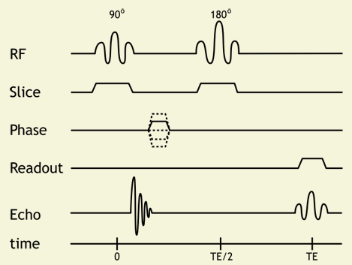 (I.11.22)

http://xrayphysics.com/sequences.html

The initial 900 By RF pulse moves M(t) from to the direction, but M(t) quickly dephases and the signal on the Echo line quickly fades away, perhaps before the MRI hardware can be ready to receive the signal. But after time TE/2 a double-length By RF pulse is applied (1/2 the y-Larmor period) which in effect causes all the dephasing to run backwards so that at time TE, the M(t) is momentarily restored (this is the echo), during which time it is "read" by the receiver. All this happens in a time smaller than T1 during which M(t) naturally fades away.
Here is a simple animation of spin-echo: https://www.youtube.com/watch?v=yKmEbCPV4Cg .
The other plots in the graph relate to spatial localization of the signal. During applied RF pulses, a Bz gradient magnet is turned on, causing the RF pulses to activate only a slice of the sample. By tuning this frequency, any axial slice (think head to feet) can be selectively activated because the Larmor frequency only of protons in that slice resonates with the applied RF pulse. So M(t) tips down from to only in that slice. The static M(t) in the direction in all other slices makes no signal. That is the meaning of the trace labeled Slice in the above waveform (current pulses to the Bz gradient magnet).
In order to create an image in the x direction of the activated z slice, a Bx field gradient magnet is turned on while the signal is read by the receiver. This causes protons at different values of x to radiate at different frequencies, and the signal is then Fourier-analyzed to get an amplitude for each location x (perhaps there are 256 frequency bins so the x-resolution of the image is 256 pixels). This is the meaning of the trace labeled Readout.
Localization in the final y direction is then done by running the above sequence perhaps 256 times each with a different amplitude (or length) By field gradient pulse on the Phase trace. For each run, the phase of the received signal is compared to some fixed reference, and the signal is then partitioned into phase bins which can be Fourier inverted to provide signals at 256 different y positions. The frequency and phase data comprises a data array in "K-space" and when this data is run through a 2D fast Fourier transform, out pops the x-y image for that z slice. The entire process is then repeated for different z slices spaced a few mm apart.
Each time a gradient magnet is switched on or off in the presence of the huge constant superconducting-magnet B field, there is a large force on the gradient coil causing it to "bang" loudly against its housing. The period of the repeated RF pulse sequences is on the order of some milliseconds, causing the characteristic cacophony the patient hears while in the machine.
Levitt's book gives an excellent and systematic explanation of how NMR (nuclear magnetic resonance) works. It is a large and fascinating subject, and there are many web resources available.

Appendix J : Connection with Tensor Analysis and Curvilinear Coordinates

Although we use covariant notation in this Appendix, a reader unfamiliar with that subject should not be put off , and can perhaps peruse the document mentioned for an explanation.

In our document Tensor Analysis and Curvilinear Coordinates there is a general transformation x' = F(x) with dx' = Rdx where Rik(x) ≡ (∂x'i/∂xk) is the "differential" of the transformation F, and S = R-1 with Sik(x') ≡ (∂xi/∂x'k). This transformation is represented by "Picture A",

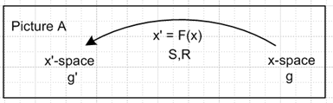 (J.1)

Each space has its own covariant metric tensor: gij for x-space and g'ij for x'-space.

If we let X = x-space and X' = x'-space, then F is a mapping F: X→ X' and F: x → x' = F(x) .

A contravariant vector V transforms with respect to x' = F(x) as V'a = RabVb.

There are axis-aligned basis vectors in x-space called un. Also in x-space are the tangent base vectors en which are tangent to the coordinate lines in x-space, en = ∂'nx = (∂x/∂x'n). In general the en are not unit vectors, and in general they are not orthogonal to each other. In our polar coordinate example below, they happen to be orthogonal because polar coordinates is an orthogonal curvilinear coordinate system.

Notice that

(en)i = (∂xi/∂x'n) = Sin (J.2)

so the tangent base vectors en are the columns of the matrix S. Note also that

(en)i = Sin = Sim δmn = Sim (un)m = (R-1)im(un)m = [R-1un]i
so
en = R-1un (J.3)

One can expand a vector V onto either of these basis vector sets,

V = Vi ui = V'i ei . (J.4)

Picture A thus has a simple Passive View interpretation : There is a single vector V whose components in the ui basis are Vi, and whose components in the ei basis are V'i The components are related by the equation V'a = RabVb. In the Passive View, we can express this equation as (V)'a = RabVb to stress the fact that there is only one vector V. As a shorthand, we can then say (V)' = RV .

In the Active View we write the vector transformation equation as (V')a = RabVb to suggest that R acts on the vector V to create a new vector V' whose components are (V')a = RabVb . The original vector V lies in x-space, while the new vector V' lies in x'-space. We have R: X → X' and R: V → V' = RV .

In Tensor there is no "other meaning" for the vector V', so we can write (V)'a = (V')a = V'a .

With respect to the underlying transformation x' = F(x) (having differential matrix R), the transformation rules for tensors of rank 0,1,2,3 are

Passive View Active View Generic View (J.5)

0 (s)' = s // scalar (s') = s s' = s

1 (V)'a = RaiVi (V')a = RaiVi V'a = RaiVi

2 (T)'ab = Rai RbjTij (T')ab = Rai RbjTij T'ab = Rai RbjTij

3 (T)'abc = RaiRbjRcbTijk (T')abc = RaiRbjRcbTijk T'abc = RaiRbjRcbTijk

Example 1: The Transformation from Cartesian to Polar Coordinates

Let x' = F(x) be the non-linear transformation connecting Cartesian x,y and polar θ,r coordinates:

x1 = x2' cos(x1') or x = rcosθ // x = F-1(x') (J.6)
x2 = x2' sin(x1') or y = rsinθ .

The differential matrix R and its inverse S = R-1 are easily computed using the definitions above,

Sij = $\left(\begin{matrix}-rsinθ & cosθ \\ rcosθ & sinθ\end{matrix}\right)$ Rij = (S-1)ij = $\left(\begin{matrix}-sinθ/r & cosθ/r \\ cos(θ) & sinθ\end{matrix}\right)$ . (J.7)

Space X is Cartesian with metric tensor gij = δij and basis vectors

u1 = (J.8)
u2 = .

The tangent base vectors can be computed using en = ∂x/∂x'n and one finds that

e1 = eθ = r // note that e1 is not a unit vector
e2 = er = . // but e1 and e2 are orthogonal (J.9)

This is almost obvious recalling that the en are the columns of Sij.

The metric tensor in space X' is determined by g'ij = ei • ej so one finds that

g'ij = $\left(\begin{matrix}r2 & 0 \\ 0 & 1\end{matrix}\right)$ ≠ δij . (J.10)

Picture A for this example appears this way,

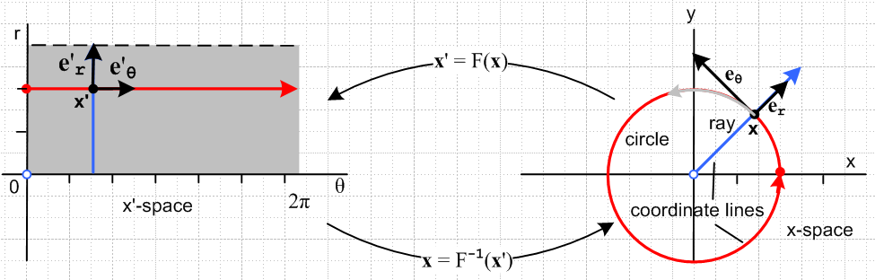
(J.11)

The blue locus on the right is the "r coordinate line" obtained by varying r and holding other components constant. The tangent base vector er is tangent to the blue coordinate line at point x. Similarly, the tangent base vector eθ is tangent to the red coordinate "line" at point x .

The position vector x = F-1(x') does not transform as a vector so x' ≠ Rx. But one always has dx' = Rdx so we know that velocity v = dx/dt transforms as a vector. Thus, v' = Rv. We can then expand a velocity vector in the two ways shown above.

v = vi ui = vx + vy

v = v'i ei = v'1e1 + v'2e2 = v'1( r ) + v'2() = r + ≡ vθ + vr . (J.12)

In the Passive View there is only one velocity v, and we can determine its components in either basis. The components in the two basis are related by v' = Rv so

v'i = Rijvj // note that R is not a rotation matrix
or
$\left(\begin{matrix}v'1 \\ v'2\end{matrix}\right)$ = R $\left(\begin{matrix}v1 \\ v2\end{matrix}\right)$ = $\left(\begin{matrix}-sinθ/r & cosθ/r \\ cos(θ) & sinθ\end{matrix}\right)$$\left(\begin{matrix}vx \\ vy\end{matrix}\right)$ (J.13)
so
v'1 = -(sinθ/r)vx + (cosθ/r)vy ⇒ r v'1 = -sinθvx+ cosθvy = vθ = r
v'2 = cosθ vx + sinθ vy ⇒ v'2 = cosθ vx + sinθ vy = vr = (J.14)

Example 2: Lorentz Transformations

For the special case that x' = F(x) is a linear transformation, one can write x' = Fx where F is a matrix, and in this case R = F. A special case of this special case occurs when spaces X and X' are the same space. We can then regard F: X → X' to be a mapping F : X → X so that space X' (our x'-space) is completely unnecessary. Picture A above then becomes

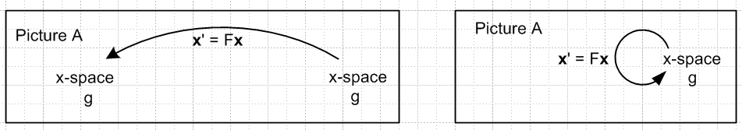 (J.15)

A further special case occurs when the elements of Fij are constants and don't depend on position x. This is the situation for Lorentz transformations in Minkowski space (spacetime).

For Lorentz transformations, the space X is a four dimensional space of 4-vectors. One has

x' = Fx F: x → x' x = (x1,x2,x3,x4) = (x,y,z,ct)
x' = (x'1,x'2,x'3,x'4) = (x',y',z',ct') (J.16)

where c is the speed of light and where we show the contravariant components of x. The metric tensor is gij = diag(1,1,1,-1) so that x•x = gijxixj = x2+y2+z2-c2t2. The Lorentz transformations are restricted by the requirement that x•x = x'•x' which makes them be rotations or boosts (velocity transformations). For example, Rz(θ) which rotates the (x,y) components into (x',y') and leaves (t,z) unchanged is a rotation, whereas Bx(u) which changes (t,x) into (t',x') and leaves (y,z) unchanged is a boost.
One speaks of the coordinates xi as being those in Frame S and x'i being those for Frame S', but both these frames are in the same space X. The idea behind x•x = x'•x' is that all reference frames related by boosts or rotations should be equivalent, none is special (there is no "ether").

For either type of Lorentz transformation (or for any combination), we can talk about an Active View:

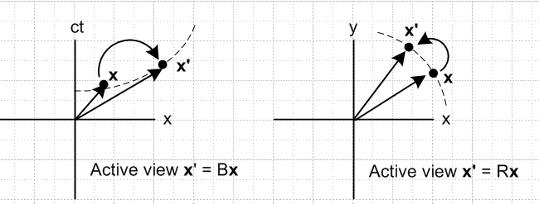 (J.17)

For either a boost or a rotation, the transformation x' = Fx starts with x in X and generates a new vector x' in the same space X. Because our pictures are both drawn in Cartesian space, it is not very easy to see that the quantity x•x = x'•x' for the boost picture on the left. The dotted curve represents x2-c2t2 = K < 0, and so it is in fact true that x•x = x2+y2+z2-c2t2 = x'2+y2+z2-c2t'2 = x'•x'.
We can redraw the above pictures replacing the 4-vector x by some generic 4-vector V to get

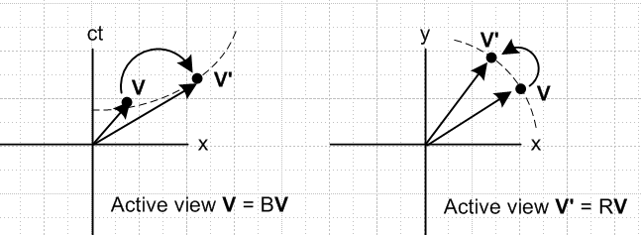 (J.18)

The meaning of the axis labels is this: in either picture, the horizontal component of V is Vx .

A typical vector Vμ would be the momentum of a particle pμ in which case p•p = pμpμ = -m2c2 where m is the particle mass, pμ = (px, py, pz, E/c) and p•p = px2 + py2 + pz2 - E2/c2. If the particle is at rest, one finds that -E2/c2 = -m2c2 or E = mc2.

In the Active View, one maps a vector V into a new vector V' whose components are (V')a = RabVb.

The axis-aligned unit basis vectors ui for space X are the expected , , , .

For any specific Lorentz transformation x' = Fx we have tangent base vectors en = ∂x/∂x'n ,

(en)i = (∂xi/∂x'n) = (∂[(F-1)ijx'j]/∂x'n) =(F-1)ij(∂x'j/∂x'n) = (F-1)ij δjn = (F-1)in . (J.19)

Unlike the case for polar coordinates, these en are the same at all points in X. We can expand V as noted earlier

V = Vi ui = V'i ei (J.20)

and we can then take the Passive View that there is one 4-vector V and it has coordinates Vi in the ui basis and V'i = (V)'i in the ei basis.

In many special relativity discussions, one writes x = (x0, x1, x2, x3) = (t, x, y, z) where units are selected to make the speed of light be c = 1. The metric tensor is gij = diag(-1,1,1,1) and then one has pμpμ = +m2c2 = m2. Component indices are Greek letters and a Lorentz transformation is written x'μ = Λμνxν .

Example 3: Rotations

This is a subcase of the previous case where now we ignore boosts and the only transformations are rotations. There is still of course an Active and Passive View and this is described in Section 1.3. For rotations there is no need to use covariant up and down indices since gij = δij, so we use only down indices in that Section and below.

For rotations, the vector x is a "tensorial" vector (unlike x in the polar coordinates example), and we can write x' = Rx where R is both the transformation matrix F and the differential matrix R. The tangent base vectors un span Frame S in space X, while the tangent base vectors en span Frame S' in the same space. Since R is a rotation, both the un and the en are orthonormal basis vectors.

Recall that the en are the columns of S. Since S = R-1 = RT for a rotation, this means the en are also the rows of R. Consider the specific rotation Rz(α) of (A.1) and we look only at the x and y axis. The R matrix is

R = Rz(α) = $\left(\begin{matrix}cosα & -sinα \\ sinα & cosα\end{matrix}\right)$ . (J.21)

Thus, the tangent base vectors are

e1 = cosα - sinα
e2 = sinα + cosα (J.22)
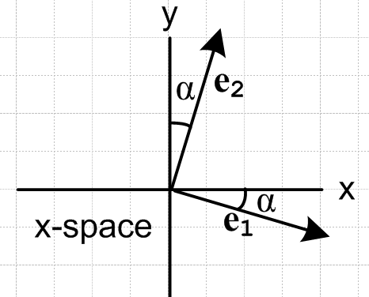 (J.23)

Notice that these basis vectors are versions of and that are "back-rotated" by α.

With respect to the underlying rotation x' = Rx having differential matrix R, the transformation rules for tensors of rank 0,1,2,3 are

Passive View Active View Generic View (J.24)

0 (s)' = s (s') = s s' = s

1 (V)'a = RaiVi (V')a = RaiVi V'a = RaiVi

2 (T)'ab = Rai RbjTij (T')ab = Rai RbjTij T'ab = Rai RbjTij

3 (T)'abc = RaiRbjRcbTijk (T')abc = RaiRbjRcbTijk T'abc = RaiRbjRcbTijk

As noted in Section 1.3, because the prime symbol has another meaning in our document's treatment of rotations, we use the Passive View to avoid overloading the meaning of objects like V'a and T'ab.

It happens that, for the rank 1 and rank 2 cases (only), matrix notation may be used to make the statements more compact. This is obvious for the vector case. For the rank-2 tensor T one has,

T'ab = Rai RbjTij = RaiTijRbj = RaiTijRTjb = (RTRT)ab = (RTR-1)ab . (J.25)

Thus we can rewrite rows 1 and 2 of the above table as

Passive View Active View Generic View

1 (V)' = RV (V') = RV V' = RV

2 (T)' = RTR-1 (T') = RTR-1 T' = RTR-1 (J.26)

Key Fact: The connection between this Appendix and our main document is as follows:

Basis Vectors Basis Vectors
This Appendix Main document Relation

Frame S un en en = R-1un
Frame S' en e'n e'n = R-1en (J.27)

It is unfortunate that the symbol en has a different meaning in the two systems.

Footnote: Tensor has other basis vectors it refers to as e'n and u'n which are axis-aligned and tangent base vectors for x'-space. Since these are associated with X' = x'-space. and since this space X' is not used in the rotation analysis, these basis vectors can be ignored.

References

Listed in alphabetical order by last name of first author. A quick web search on an article title can usually
locate documents with broken links. All links below were verified on 9 Feb 2017.

M. Abramowitz and I.A. Segun, Handbook of Mathematical Functions, with Formulas, Graphs and Mathematical Tables (Dover, New York, 1964). Apart from the mathematical tables of function values, this pre-computer reference has been replaced by NIST (2010), see below.

G.B. Airy, "On the Vibration of a Free Pendulum in an Oval Differing little from a Straight Line", Memoirs of the Royal Astronomical Society, Vol. 20, p.121-130 (May 9, 1851).
http://home.t01.itscom.net/allais/whiteprior/airy/airyprecession.pdf (original)
www.nawcc-index.net/Articles/Airy-Vibration_of_Pendulum.pdf (typeset with annotation)
The Airy precession formula appears in the middle of page 8 in the form n/m = (3/8)bc/a2.

R.N Arnold and L. Maunder, Gyrodynamics and Its Engineering Applications (Academic Press/ Elsevier, Amsterdam, 2014).

E. I. Butikov, "A dynamical picture of the ocean tides" (2002),
http://faculty.ifmo.ru/butikov/Oceanic_Tides.pdf .

Y. Chen et al., "History of the Tether Concept and Tether Missions: A Review", ISRN Astronomy and Astrophysics, Volume 2013 (2013), Article ID 502973, 7p .
https://www.hindawi.com/journals/isrn/2013/502973/

Gaspard-Gustave de Coriolis, "Sur les équations du mouvement relatif des systèmes de corps". J. De l'Ecole royale polytechnique 15: 144–154 (1835). This paper (in French) begins at page 37 of the following pdf file: http://www.bibnum.education.fr/sites/default/files/coriolis-force-texte.pdf

M.L. Cosmo and E.C. Lorenzini, Tethers in Space Handbook, 3rd Ed. (Smithsonian, 1997). Available at https://ntrs.nasa.gov/archive/nasa/casi.ntrs.nasa.gov/19980018321.pdf
www.tethers.com/papers/TethersInSpace.pdf (cleaner photos)

M.J. Crowe, A History of Vector Analysis ( Dover Books, Mineola, NY, 2011)

M.J. Crowe, talk (17p, 2002) related to his book A History of Vector Analysis .
www.worrydream.com/refs/Crowe-HistoryOfVectorAnalysis.pdf

P.A.M. Dirac, The Principles of Quantum Mechanics, 3rd Ed. (Oxford University Press, London, 1947).

[Bateman] A. Erdelyi et al., Higher Transcendental Functions, Volumes 1, 2 and 3 (McGraw-Hill, New York, 1953); Tables of Integral Transforms, Volumes 1 and 2 (McGraw-Hill, New York, 1954). This is the 5-volume Bateman Manuscript Project.

H. Goldstein, Classical Mechanics (Addison-Wesley, Boston, 1950).

[GPS] H. Goldstein, C. Poole, J. Safko, Classical Mechanics, 3rd Ed. (Addison-Wesley, Boston, 2001). Herbert Goldstein (1922-2005) was the sole author of the first two editions 1950 and 1980.

[GR7] I.S. Gradshteyn and I.M. Ryzhik, Table of Integrals, Series, and Products, 7th Ed. (Academic Press, New York, 2007). The 8th Edition [GR8] appeared 2 Oct 2014 (no CD). Dan Zwillinger is collecting errata here for the 9th Edition : http://www.mathtable.com/gr/

C. Horn and H. Fearn, "On the Flight of the American Football" (2013), https://arxiv.org/pdf/0706.0366

J.D. Jackson, Classical Electrodynamics, 3rd Ed. (John Wiley & Sons, New York, 1999).

W.M. Lai, D. Rubin and E. Krempl, Introduction to Continuum Mechanics, 4th Ed. (Butterworth-Heinemann/Elsevier, Amsterdam, 2010). This book has had the same three authors since its first edition in 1974. P. Lucht has some errata online.

M.H. Levitt, Spin Dynamics: Basics of Nuclear Magnetic Resonance, 2nd. Ed (John Wiley & Sons, New York, 2008).

P. Lucht, A Maple User's Guide (http://user.xmission.com/~rimrock/ , 2016).

P. Lucht, Tensor Analysis and Curvilinear Coordinates (http://user.xmission.com/~rimrock/ , 2016).

P. Lucht, Tensor Products, Wedge Products and Differential Forms (http://user.xmission.com/~rimrock/ , 2016).

W.D. MacMillan, The Theory of the Potential (Dover, New York, 1958), original book 1930.

J.B. Marion, Classical Dynamics of Particles and Systems, 2nd Ed. (Academic Press, New York, 1970).

[NIST] F.W.J. Olver, D.W. Lozier, R.F. Boisvert and C.W. Clark, NIST Handbook of Mathematical Functions (Cambridge University Press, 2010). NIST is the U.S. National Institute of Standards and Technology (formerly National Bureau of Standards). This work is an update of the well-known 1964 version with editors Abramowitz and Segun, known affectionately as "A&S". The greatly expanded 2010 edition (968 p) can be freely accessed online at dlmf.nist.gov which also has errata. The book ($30-$60) comes with a CD containing a bookmarked PDF file which of course has been bootlegged onto the web. Olver died in 2013.

R.A. Schumacher and B. Tarbet, "A Short Foucault Pendulum Free of Ellipsoidal Precession",
https://arxiv.org/abs/0902.1829

K.R. Symon, Mechanics, 2nd Ed. (Addison-Wesley, Reading MA, 1960).

J.L. Synge and B.A. Griffith, Principles of Mechanics, 2nd Ed. (McGraw-Hill, New York, 1949). This book has a lot to say about tops and pendulums. The Airy precession formula appears on page 381.

J.B. Tatum, Classical Mechanics Notes, http://astrowww.phys.uvic.ca/~tatum .

J.R. Taylor, Classical Mechanics (University Science Books, Mill Valley, CA, 2005).

[T&M] S.T. Thornton and J.B. Marion, Classical Dynamics of Particles and Systems, 5th Ed., (Thomson-Brooks/Cole, Belmont, CA, 2003). This textbook carries on the legacy of the founding author of the first two editions 1965 and 1970 (Jerry B. Marion 1929-1981).

J.G. Williams 1994, "Contributions to the Earth's Obliquity Rate, Precession, and Nutation", The Astronomical Journal Vol. 108, pp. 711-724.

E.B. Wilson (notes of J.W. Gibbs), Vector Analysis (Dover, New York, 1960). https://www.forgottenbooks.com/en/download_pdf/Vector_Analysis_1000079578.pdf

V. Zemstov, Evolution of Rotation Structures in the Earth's Geological History (Intech, 2011).
DOI: 10.5772/21305 , http://www.intechopen.com/download/pdf/17105 .

