Rewrite of Section 8 after 8.8.42 PhL 2.27.17

This has been installed, do not edit here!

Tidal patterns for an arbitrary rotation axis of the Earth

We now turn the rotation of the Earth back on (we turned if off earlier). For the real Earth, there are many tidal complications that arise. There are land masses. Lake water has nowhere to go. There is friction between the water and the land which slows down the Earth's rotation slightly over time. There is weather and there are ocean tidal currents which do not flow infinitely fast. We shall not attempt to analyze this general situation.
Instead, we imagine an idealized Earth covered with water and the Earth turns under the water with no "friction", and an Observer just stands in the water and measures the tide height as a function of time.
What does that Observer see? It of course depends on where the Earth's axis of rotation is located relative to our picture. Consider,

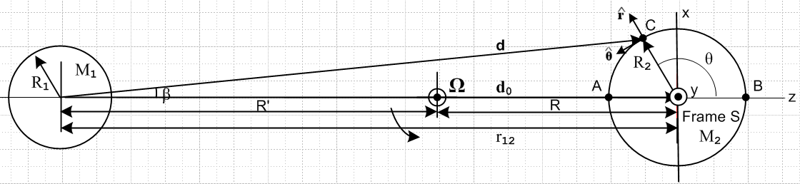
(8.8.43)

Frame S has basis vectors , and . We now define Frame S' as having a new set of basis vectors as follows,

(',',') = Rz(φ1)Rx(θ1) (,,) for example ' = Rz(φ1)Rx(θ1)

In our Passive View discussion of Section 1.3, we think of basis vectors back-rotated e'n = R-1en, so we shall then define R1-1 = Rz(φ1)Rx(θ1) and then we have (',',') = R1-1(,,). The matrix of interest is shown in (E.2.2) so in Frame S components we may write,

' = R1-1 = $\left(\begin{matrix}cosθ1cosφ1 & -sinφ1 & sinθ1cosφ1 \\ cosθ1sinφ1 & cosφ1 & sinθ1sinφ1 \\ -sinθ1 & 0 & cosθ1\end{matrix}\right)$$\left(\begin{matrix}0 \\ 0 \\ 1\end{matrix}\right)$ = $\left(\begin{matrix}sinθ1cosφ1 \\ sinθ1sinφ1 \\ cosθ1\end{matrix}\right)$ . (8.8.44)

We now assume that the Earth rotates about this new ' at rate φ' = ωt.
As noted in (1.3.3), if a Kinematic Vector V has components Vi in Frame S, then it has components (V)'i = R1Vi in Frame S', which we write in vector notation as (V)' = R1V . Applying to V = r we find, for the position of some point in the two frames,

(r)' = $\left(\begin{matrix}x' \\ y' \\ z'\end{matrix}\right)$ = R1 r = $\left(\begin{matrix}cosθ1cosφ1 & cosθ1sinφ1 & -sinθ1 \\ -sinφ1 & cosφ1 & 0 \\ sinθ1cosφ1 & sinθ1sinφ1 & cosθ1\end{matrix}\right)$$\left(\begin{matrix}x \\ y \\ z\end{matrix}\right)$ . (8.8.45a)

Since R1-1 = R1T, the matrix appearing here is just the transpose of that appearing in (8.8.44). Inverting one gets,

r = $\left(\begin{matrix}x \\ y \\ z\end{matrix}\right)$ = R1-1 (r)' = $\left(\begin{matrix}cosθ1cosφ1 & -sinφ1 & sinθ1cosφ1 \\ cosθ1sinφ1 & cosφ1 & sinθ1sinφ1 \\ -sinθ1 & 0 & cosθ1\end{matrix}\right)$$\left(\begin{matrix}x' \\ y' \\ z'\end{matrix}\right)$ . (8.8.45b)

Suppose we define spherical coordinates in Frame S and Frame S' as so that (since a rotation, r' = r),

$\left(\begin{matrix}x \\ y \\ z\end{matrix}\right)$ = $\left(\begin{matrix}rsinθcosφ \\ rsinθsinφ \\ rcosθ\end{matrix}\right)$ and $\left(\begin{matrix}x' \\ y' \\ z'\end{matrix}\right)$ = $\left(\begin{matrix}rsinθ'cosφ' \\ rsinθ'sinφ' \\ rcosθ'\end{matrix}\right)$ . (8.8.46)

Then (8.8.45b) says, cancelling the r factors,

$\left(\begin{matrix}sinθcosφ \\ sinθsinφ \\ cosθ\end{matrix}\right)$ = $\left(\begin{matrix}cosθ1cosφ1 & -sinφ1 & sinθ1cosφ1 \\ cosθ1sinφ1 & cosφ1 & sinθ1sinφ1 \\ -sinθ1 & 0 & cosθ1\end{matrix}\right)$ $\left(\begin{matrix}sinθ'cosφ' \\ sinθ'sinφ' \\ cosθ'\end{matrix}\right)$ . (8.8.47)

The last of these three equations reads

cosθ = - sinθ1sinθ' cosφ' + cosθ1 cosθ'

= cosθ1 cosθ' - sinθ1sinθ'cos(ωt) (8.8.48a)

= cosθ1sinθ'L - sinθ1cosθ'Lcos(ωt) . (8.8.48b)

In (8.8.48b) we replace colatitude θ' by latitude θ'L = π/2 - θ which causes sin↔cos.
Recall the equation of the water surface from (8.8.33),

r(θ) = R2 + a cos2θ . a > 0 (8.8.33)

This implies a tide height of

h(θ) = a cos2θ = 2cos2θ - 1 . (8.8.49)

Therefore on our idealized Earth which rotates about an axis (θ1,φ1) relative to Fig (8.8.43) we obtain the following tide height during the day

h(t) = a cos2θ(t) = a [ 2cos2θ(t) - 1 ]

= a [ 2 ( cosθ1 cosθ' - sinθ1sinθ'cos(ωt) )2 - 1 ] (8.8.50a)

a [ 2 ( cosθ1 sinθ'L - sinθ1cosθ'Lcos(ωt) )2 - 1 ] (8.8.50b)

The tide height does not depend on the angle φ1 because z is a symmetry axis of Fig (8.8.43) and the tides are thus symmetrical about this axis.

Example 1: Consider the case ' = .

Suppose the Earth's rotation axis were in the direction in Fig (8.8.43) (pointing out of the plane of paper). In that case one has θ1= π/2 and φ1= π/2, since

' = Rz(π/2) Ry(π/2) = $\left(\begin{matrix}sinθ1cosφ1 \\ sinθ1sinφ1 \\ cosθ1\end{matrix}\right)$ = $\left(\begin{matrix}0 \\ 1 \\ 0\end{matrix}\right)$ = . (8.8.51)

Then from (8.8.50),

h(t) = a [ 2( cosθ1 cosθ' - sinθ1sinθ'cos(ωt) )2 - 1 ]

= a [ 2( 0 cosθ' - 1 sinθ'cos(ωt) )2 - 1 ]

= a [ 2(-sinθ'cos(ωt))2 - 1 ]

= a [ 2sin2θ'cos2ωt - 1 ] . (8.8.52)

If the Observer were at the Earth's equator θ' = π/2 (which is in the plane of paper of Fig (8.8.43)), one would have

h(t) = a [ 2cos2ωt - 1 ] = a cos(2ωt) .

Comparing to (8.8.49), one then has θ = ωt . The Observer sees a full amplitude swing of ±a in the tide. As this Observer moves toward the pole so θ' decreases, the amplitude of the tide decreases as (8.8.52) shows. At the pole, where θ' = 0, one finds h(t) = -a (a constant) all the time, which seems reasonable since θ = π/2 all the time and so h(θ) = a cos2θ = a cosπ = -a, as depicted below,

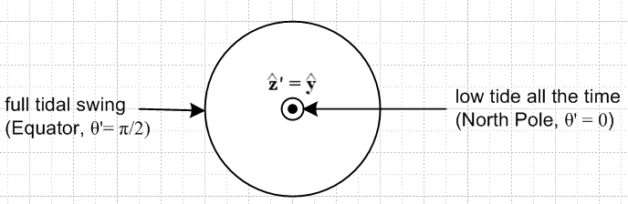 (8.8.53)

Here is a Maple rendition of this Example 1 where we set a = 1 and ω = 1 so one day lasts T = 2π. In this code we use θ'L = lat and the first equation is (8.8.48b) :

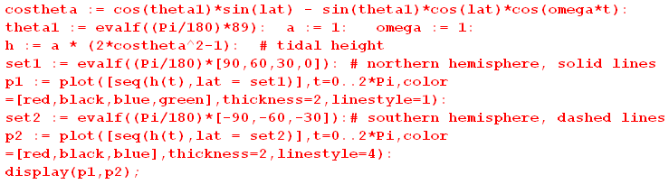
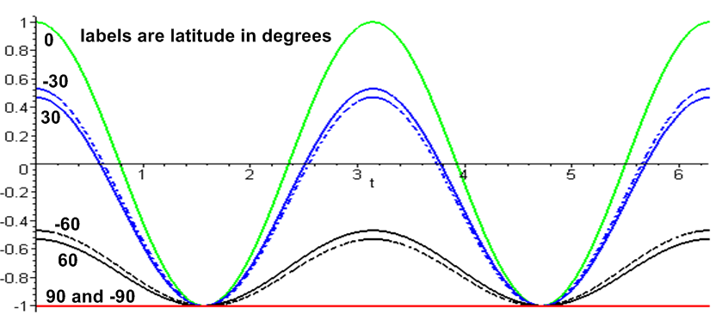 (8.8.54)

The solid lines are the equator (green) and northern hemisphere latitudes 30o (blue), 60o (black) and 90o (red); the dashed lines are southern hemisphere latitudes -30o (blue), -60o(black), and -90o (red). We set θ1 = 89o instead of 90o to pull apart the solid and dashed lines a bit. At θ'L = +90o (north pole) and -90o (south pole), the red solid and red dashed lines always coincide. The lines are horizontal because at each pole, there is no motion at all as the Earth rotates. The lines coincide because the tides are azimuthally symmetric about the symmetry axis as shown in (8.8.27) so both poles see the same h = -a = -1.

Example 2: Start with ' = and then slowly increase θ1 from 0 to π/2 so ' tips away from .

Here we show a set of plots from the above code for various values of the tilt θ1. At θ1 = 0 we of course expect there to be no tides at all again due to the azimuthal symmetry of the tides about the z axis.

θ1= 1o θ1= 10o
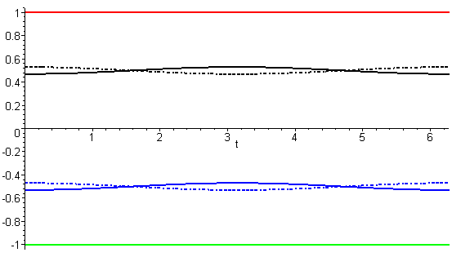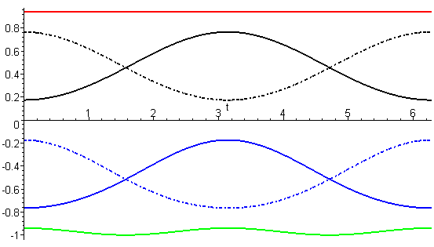

θ1= 30o θ1= 50o
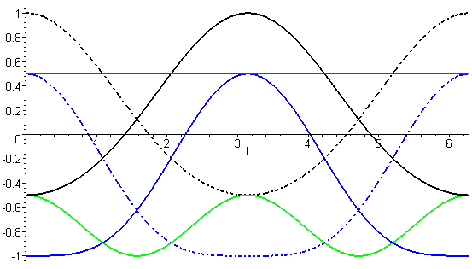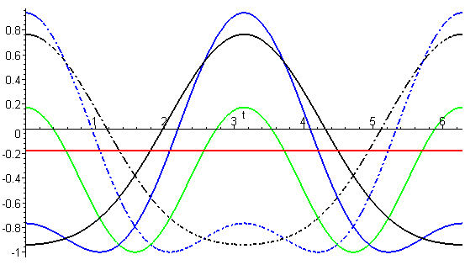

θ1= 70o θ1= 85o
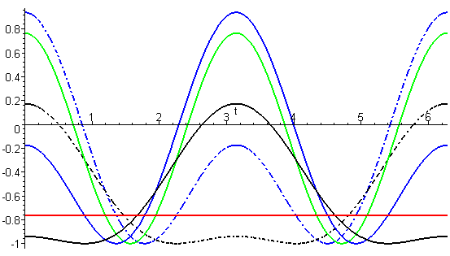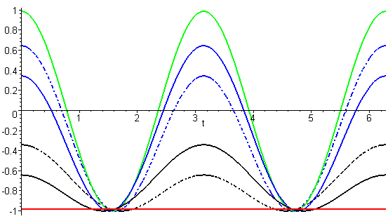

(8.8.55)

Equation (8.8.50b) shows that the curves for ± mirror latitudes have the same shape but are time-shifted half a day, and the figures bear this out.
For θ1 = 90o + Δ the solid and dashed curves are swapped compared to θ1 = 90o - Δ so we don't show plots for θ1 > 90o.

As an aid to interpreting the above curves, consider this drawing with θ1 = 45o.

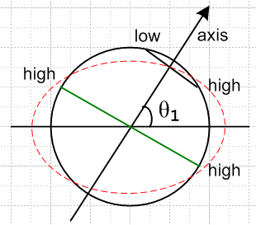 (8.8.56)

• At the poles the tides are constant (red horizontal lines in plots) and decrease as θ1 is increased.

• At the equator there will always be two equal high tides during each day, as marked by the green equatorial line. These become more pronounced as θ1 increases.

• At high latitudes (as shown in black), we expect only one high tide per day.

• At some latitude there must be a gradual transition from two tide cycles per day at the equator to one tide cycle per day at high latitudes. For example, our θ1= 50o plot shows that at the low latitudes ±30o (blue) there are two tide cycles (albeit quite unequal) while at ± 60o latitudes (black) there is only one tide cycle.

• As we shall see below, the real Earth's θ1 lies in the rough range 60o ≤ θ1≤ 120o so the two-tide pattern is more predominant, as in the θ1 = 85o plot.

