This is the Title PhL 1.11.15

This little improved chunk near (8.8.58) was installed 2.28.17, do not edit here.

What is the angle θ1 for the real Earth?

Relative to Fig (8.8.43) the actual axis ' of the Earth's rotation varies over time, as suggested by this picture from wiki,

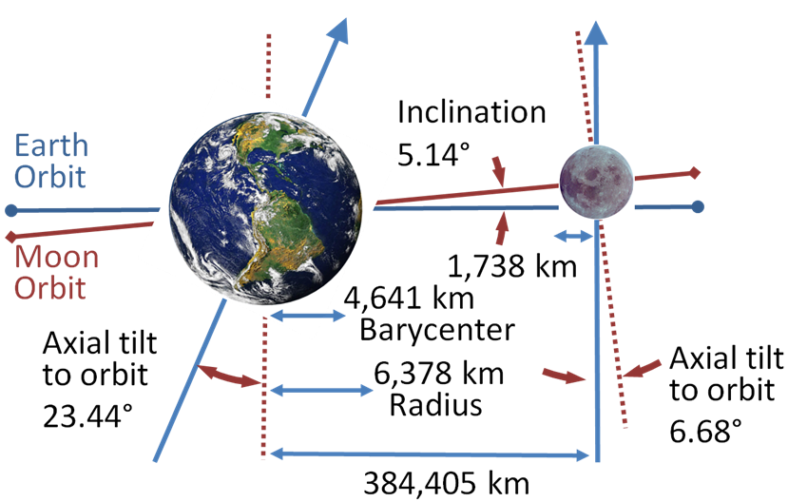 (8.8.57)

https://upload.wikimedia.org/wikipedia/commons/4/43/Earth-Moon.PNG

We transcribe the situation depicted above into a drawing more compatible with Fig (8.8.43), and we then try to explain what is going on (it is a bit complicated).

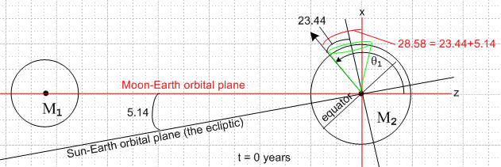 (8.8.58a)

Here the black arrow is ' (Earth's rotation axis) and it is located at θ1= 90 + 28.58 = 118.6o and is in the plane of paper so φ1 = 0. The intersection of the two orbital planes is called the line of nodes and for the time indicated in the picture, that line is perpendicular to the plane of paper. This situation of maximum tilt 28.58o occurs once every 18.6 years, a time called the major lunar standstill. At a time 9.3 years later than the above drawing, the Earth's rotation axis in effect moves to the right edge of the green cone and then the 28.58o = 23.44+5.14 gets replaced by 18.30o = 23.44-5.14 which is the minor lunar standstill. The half-angle of the green cone is 23.44o.
The 18.6 year motion of the Earth's rotation vector around this green cone could be observed from a space camera platform which moves in such a way to keep the Moon to the left of the Earth, as in the figure, and which takes a strobe picture once a lunar month when the line of nodes points to the camera. The reason for the green cone is that the plane of the Moon's orbit precesses once every 18.3 years relative to the stars, meaning relative to the ecliptic plane (ignoring its small precession over period 112,000 years). This 18.3 year wobble period of the moon's orbital plane is called its axial precession. During this time the line of nodes (intersection of the two planes) rotates a full circle relative to the stars, so this is also called the nodal precession. The moon's orbit is slightly elliptical, and it happens that within the plane of its orbit, this ellipse precesses around once every 8.85 years, known as the apsidal precession, but this has no relation to the green cone.
To see the Earth's rotation axis on the other side of the green cone, we draw the above figure 9.3 years later at which time the axial precession of the moon's orbital plane has gone half way around :

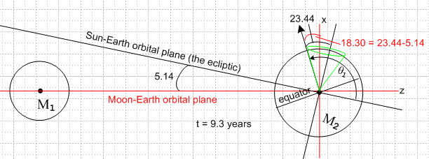 (8.8.58b)

Near the time depicted Fig (8.8.58a), the Earth's rotation axis in effect moves around a different cone once per (lunar) month as indicated in blue in this picture (blue cone half-angle = 28.58o)

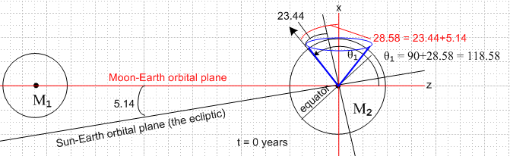 (8.8.59)

Our same space camera platform running its video camera sees the black earth axis vector sweep around the blue cone once per lunar month. For example, a half month later than the above drawing, the moon will be on the right, but then our camera platform will have moved so it sees the moon back on the left, so at that time the Earth's rotation axis black arrow will be on the right extreme of the blue cone above. At the time shown in (8.8.59) the Earth's rotation axis is at θ1 = 90 + 28.58 = 118.58o. A half month later it will be at 90 - 28.58 = 61.4o. At times in between, θ1 lies in the range ( 61.4o, 118.6o) and φ1 takes small values with |φ1| ≤ 28.58o . At other times during the 18.3 year wobble cycle, the range of θ1 is smaller. For example, at the time of Fig (8.8.58b) the blue cone will have an opening angle of 18.30o and the θ1 range limits are 90 ± 18.30 so we end up with θ1 lying in the range ( 71.7o, 108.3o).

