archive old Section 8 chunk (which had errors) PhL 2.28.17

Tidal patterns for an arbitrary rotation axis of the Earth

We now turn the rotation of the Earth back on (we turned if off earlier). For the real Earth, there are many complications that arise. There are land masses. Lake water has nowhere to go. There is friction between the water and the land which slows down the Earth's rotation slightly over time. There is weather and there are ocean tidal currents which do not flow infinitely fast. We shall not attempt to analyze this general situation.
Instead, we imagine an idealized Earth covered with water and the Earth turns under the water with no "friction", and an Observer just stands in the water and measures the tide height as a function of time.
What does that Observer see? It of course depends on where the Earth's axis of rotation is located relative to our picture. Consider,

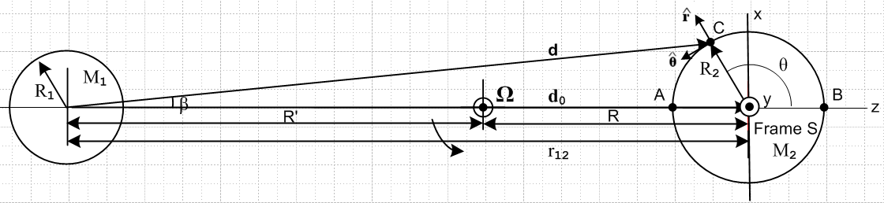
(8.8.43)

We have now redefined the Earth frame on the right to be Frame S (formerly it was Frame S') and we have drawn new x,y,z axes for this new Frame S so the z axis points away from mass M1. In Frame S then the angle θ is the usual spherical-coordinates polar angle.
We now assume that the Earth rotates about some axis ' (new Frame S') which is obtained by rotating the axis by angles θ1 and φ1 as follows (see (E.2.2) for the matrix),

' = Rz(φ1) Ry(θ1) ≡ R1 = $\left(\begin{matrix}cosθ1cosφ1 & -sinθ1 & sinθ1cosφ1 \\ cosθ1sinφ1 & cosφ1 & sinθ1sinφ1 \\ -sinθ1 & 0 & cosθ1\end{matrix}\right)$

= $\left(\begin{matrix}cosθ1cosφ1 & -sinθ1 & sinθ1cosφ1 \\ cosθ1sinφ1 & cosφ1 & sinθ1sinφ1 \\ -sinθ1 & 0 & cosθ1\end{matrix}\right)$ $\left(\begin{matrix}0 \\ 0 \\ 1\end{matrix}\right)$ = $\left(\begin{matrix}sinθ1cosφ1 \\ sinθ1sinφ1 \\ cosθ1\end{matrix}\right)$ . (8.8.44)

This rotation is sufficient to put the ' in any desired direction (θ1.φ1). The rotation R1 moves all vectors r to new vectors r' = R1r. Thus we may write

r' = $\left(\begin{matrix}x' \\ y' \\ z'\end{matrix}\right)$ = $\left(\begin{matrix}cosθ1cosφ1 & -sinθ1 & sinθ1cosφ1 \\ cosθ1sinφ1 & cosφ1 & sinθ1sinφ1 \\ -sinθ1 & 0 & cosθ1\end{matrix}\right)$$\left(\begin{matrix}x \\ y \\ z\end{matrix}\right)$ = R1 r
and
r = $\left(\begin{matrix}x \\ y \\ z\end{matrix}\right)$ = $\left(\begin{matrix}cosθ1cosφ1 & cosθ1sinφ1 & -sinθ1 \\ -sinθ1 & cosφ1 & 0 \\ sinθ1cosφ1 & sinθ1sinφ1 & cosθ1\end{matrix}\right)$$\left(\begin{matrix}x' \\ y' \\ z'\end{matrix}\right)$ = R1-1 r' = R1T r' (8.8.45)

where the second matrix is the transpose of the first since rotations are real orthogonal R-1 = RT. If we define spherical coordinates (r,θ,φ) for (x,y,z) and (r'.θ',φ') for (x',y',z') (of course r' = r) then the above may be written, cancelling the r factors,

$\left(\begin{matrix}sinθcosφ \\ sinθsinφ \\ cosθ\end{matrix}\right)$ = $\left(\begin{matrix}cosθ1cosφ1 & cosθ1sinφ1 & -sinθ1 \\ -sinφ1 & cosφ1 & 0 \\ sinθ1cosφ1 & sinθ1sinφ1 & cosθ1\end{matrix}\right)$$\left(\begin{matrix}sinθ'cosφ' \\ sinθ'sinφ' \\ cosθ'\end{matrix}\right)$ (8.8.46)

which is three scalar equations. The third equation is this

cosθ = sinθ1cosφ1sinθ'cosφ' + sinθ1sinφ1sinθ'sinφ' + cosθ1cosθ' . (8.8.47)

If the Earth turns at rate ω so φ' = ωt, we then have

cosθ = sinθ1cosφ1sinθ'cosωt + sinθ1sinφ1sinθ'sinωt + cosθ1cosθ'
(8.8.48)
cos2θ = 2cos2θ - 1 .

Recall the equation of the water surface from (8.8.33),

r(θ) = R2 + a cos2θ . a > 0 (8.8.33)

This implies a tide height of

h(θ) = a cos2θ . (8.8.49)

Therefore on our idealized Earth which rotates about an axis (θ1,φ1) relative to Fig (8.8.43) we obtain the following tide height during the day

h(t) = a cos2θ(t) = a [ 2cos2θ(t) - 1 ]

= a [ 2 (sinθ1cosφ1sinθ'cosωt + sinθ1sinφ1sinθ'sinωt + cosθ1cosθ')2 - 1 ] . (8.8.50)

Here θ' indicates the line of latitude at which our Observer is positioned and φ' = ωt.

Example 1: (' = )

Suppose the Earth's rotation axis were in the direction in Fig (8.8.43) (pointing out of the plane of paper). In that case one has θ1= π/2 and φ1= π/2, since

' = Rz(π/2) Ry(π/2) = $\left(\begin{matrix}sinθ1cosφ1 \\ sinθ1sinφ1 \\ cosθ1\end{matrix}\right)$ = $\left(\begin{matrix}0 \\ 1 \\ 0\end{matrix}\right)$ = . (8.8.51)

Then from (8.8.50),

h(t) = a [ 2(sinθ1cosφ1sinθ'cosωt + sinθ1sinφ1sinθ'sinωt + cosθ1cosθ')2 - 1 ]

= a [ 2(sinθ'sinωt)2 - 1 ]

= a [ 2sin2θ'sin2ωt - 1 ] . (8.8.52)

If the Observer were at the Earth's equator θ' = π/2 (which is in the plane of paper of Fig (8.8.43)), one would have

h(t) = a [ 2sin2ωt - 1 ] = a sin(2ωt) = a cos(2ωt - π/2) . (8.8.53)

Comparison with (8.8.49) shows that 2θ = 2ωt - π/2 so θ = ωt - π/4. The Observer sees a full amplitude swing of ±a in the tide. As this Observer moves toward the pole so θ' decrease, the amplitude of the tide decreases as (8.8.52) shows. At the pole, where θ' = 0, one finds h(t) = -a (a constant) all the time, which seems reasonable since θ = π/2 all the time and so h(θ) = a cos2θ = a cosπ = -a.
Here is a Maple rendition of this Example where we set a = 1 and ω = 1 so one day lasts T = 2π. In this code we refer to θ' as θ2:

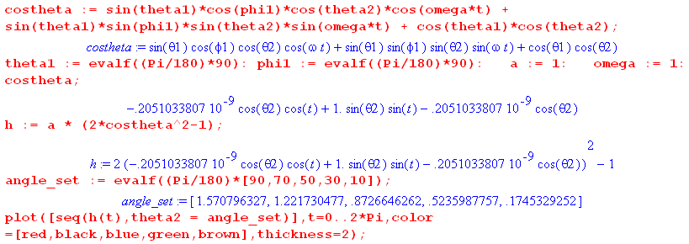

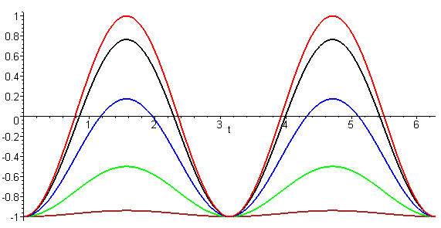 (8.8.54)

The top trace is for θ' = 90o (equator) which has the full tide amplitude, and then as one approaches the pole in steps of 20o this amplitude decreases ending up with h(t) ≈ -a for θ' = 10o. On this Earth there are always two equal high tides per day.

Example 2: (tipping ' toward the direction)

Suppose however that the Earth's rotation axis points in the direction of (8.8.43) so θ1= 0 and φ1= 0. In this case we expect to have no tides at all since for any θ' latitude line θ = θ' is constant. This is borne out in the above Maple code Maple where we again plot h(t),

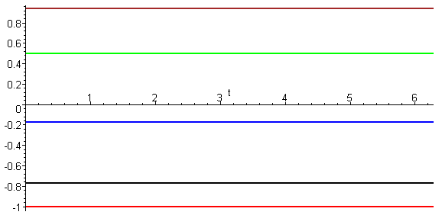 (8.8.55)

At the equator the Observer is stuck low tide all the time (bottom trace). Conversely, an Observer at the pole is stuck at high tide all the time (top trace is θ' = 10o).

As we start increasing θ1 away from 0, the nature of the tidal traces changes. Here is a set of trace sets for various θ1 always with φ1= 0:

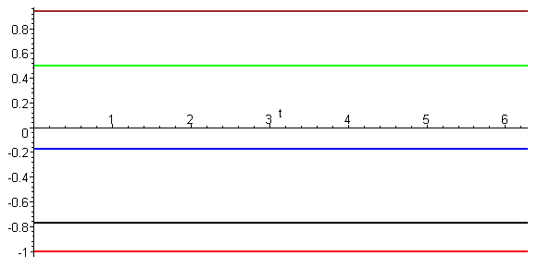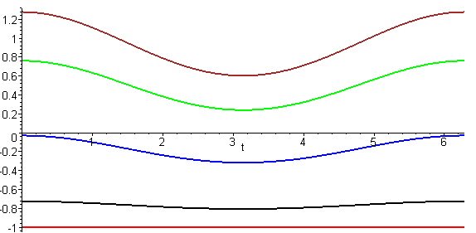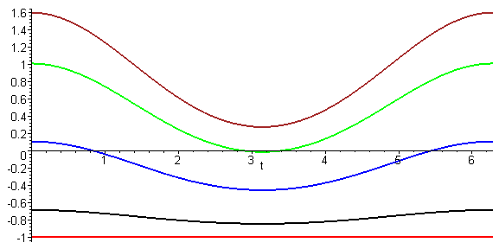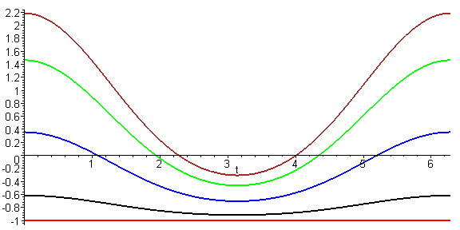
θ1 = 0 θ1 = 5o θ1 = 10o θ1 = 20o
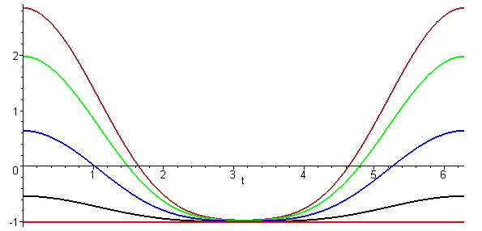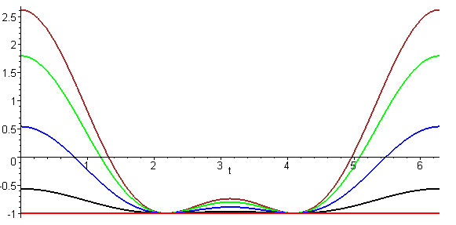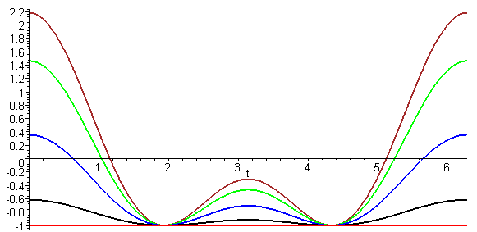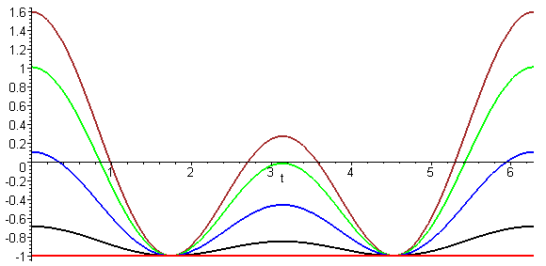
θ1 = 40o θ1 = 60o θ1 = 70o θ1 = 80o

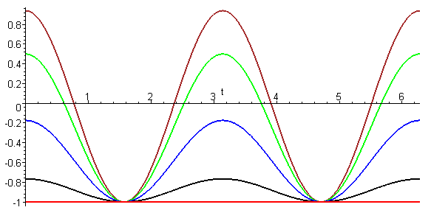 (8.8.56)
θ1 = 90o

When θ1= 0o there are no tides at all since the rotation is in the direction in Fig (8.8.43). As we gradually tip the Earth's rotation axis toward the direction, things change. Up to about θ1 = 40o there is one tide per day, but beyond this point there are two unequal tides per day and they become equal when θ1 reaches 90o. The point here is that many tidal patterns are possible depending on the Earth's direction of rotation.

