archive old section 8_8 chunk on cones PhL 2.28.17

What is the angle θ1 for the real Earth?

Relative to Fig (8.8.43) the actual axis ' of the Earth's rotation varies over time, as suggested by this picture from wiki,

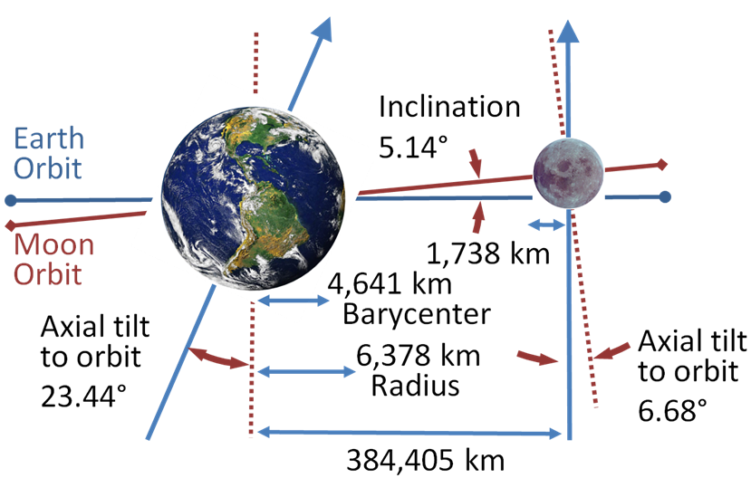 (8.8.57)

https://upload.wikimedia.org/wikipedia/commons/4/43/Earth-Moon.PNG

We transcribe the situation depicted above into a drawing more compatible with Fig (8.8.43),

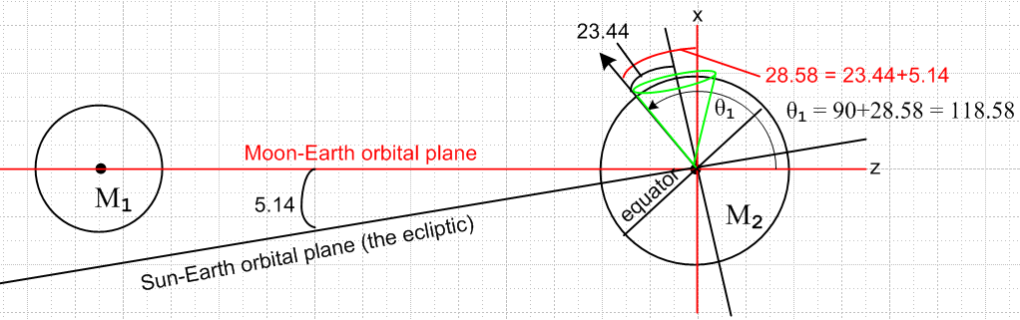 (8.8.58)

Here the black arrow is ' (Earth's rotation axis) and it is located at θ1= 90 + 28.58 = 118.6o and is in the plane of paper so φ1 = 0. The intersection of the two orbital planes is called the line of nodes and for the time indicated in the picture, that line is perpendicular to the plane of paper. This situation of maximum tilt 28.58o occurs once every 18.6 years, a time called the "major lunar standstill". At a time 9.3 years later than the above drawing, the Earth's rotation axis in effect moves to the right edge of the green cone and then the 28.58o = 23.44+5.14 gets replaced by 18.30o = 23.44-5.14 which is the "minor lunar standstill". The half-angle of the green cone is 23.44o. Motion of the Earth's rotation vector on this green cone could be observed from a space camera platform which moves in such a way to keep the Moon to the left of the Earth as in the figure.
Near the time depicted Fig (8.8.58), the Earth's rotation axis in effect moves around a different cone once per month as indicated in blue in this picture (blue cone half-angle = 28.58o)

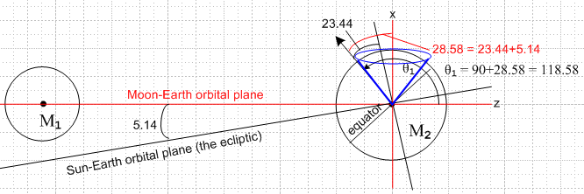 (8.8.59)

Thus, a half month later than the configuration shown (θ1= 118.6o), one will have θ1 = 90 - 28.58 = 61.42o. At times in between, θ1 lies in the range ( 61.4o, 118.6o) and φ1 takes small values with |φ1| ≤ 28.58o .

