Moon Earth Problems in frames PhL 1.17.17

I knew there was a loose bolt somewhere in this section of frames doc, and I think I have found it. It relates to several other "mysteries" such as the factor of 2 versus 3 in tidal force.

The basic problem is this: My overall Fig 1 playing field for frames doc involves a frame of reference that is "soldered" to the b vector. I don't really make this clear in my opening discussion! The issue is that in my earth-moon discussion, the axes of Frame S' are NOT soldered to the b vector but rather we have the "gimbals" situation. So really my moon-earth application is invalid! This is of course a disaster for the moon-earth section of frames doc.

Where does this notion of "soldered" come into play?

1. Notation, important role of the Prime Symbol, and other Preliminaries
1.1 I talk about the two sets of basis vectors en and e'n related by some rotation operator R.
1.2 Expansion of vectors on the two bases.
1.3 If a' = Ra for a and a', then parens order does not matter.
1.4 When are two vectors equal? Moving the tails.
1.5 When R is a small rotation. Drawing (1.5.9) suggests "soldering" for vector a
1.6 The notion of (da/dt) = ω x a I think assumes soldering. We rotate vector a about some ω axis. If we apply this equation to basis vectors e'n in Fig 1, then we are implying soldering!
1.7 Here we make the big statement that (de'n/dt)S = ω x e'n . So we are treating e'n as a soldered vector! It is rotating about the ω axis wherever that axis might lie and that is what Fig 1 shows.
1.8 The forms of velocity and acceleration.
1.9 Angular momentum.
1.10 no label needed for dt on a scalar function
1.11 commutation of dt and "taking a component"

2. The G Rule for arbitrary vector a and its derivation
Again we are talking "soldered" vectors. Vector a rotates about the ω axis.

3. The Apparatus and its Observer at Rest in Frame S'
How things are measured by observers in different Frames.

4. The Relationship between the Two Frames S and S'

4.1 Explanation of Fig (4.1.1): Frame S in the plane of paper

Here I again draw Fig 1. Here I "have a lot to say" so let's now read what I say:

"Each of the basis vectors e'n is rotating according to (1.7.1), (de'n/dt)S = ω x e'n, as the Frame S' moves rigidly in rotation about the ω rotation axis."

I think this is the statement of "soldering" but I don't yet use that word. Here is more:

"Viewed from Frame S, the unit vectors of Frame S' are oriented and move according to several equations we have already dealt with

e'n(t) = R-1(t) en (1.1.1)

e'n(t) = Rnm(t) em (1.2.2)

(de'n/dt)S = ω(t) x e'n(t) . (1.7.1) "

I have not really said anything about the R matrix other than it exists.

We now draw

4.2 Explanation of Fig (4.2.1) : Vector ω pointing directly out of paper

Figure (4.2.1) has the ω vector pointing to the viewer. I think soldering is again implied but not stated. I should be clearer about this.

4.3 Comments on S and S'

Here I say: "In Special Case #1 below, however, the vector b is effectively glued to the Frame S' axes and S' = 0, causing simplification of several equations which will be obtained below. "

This seems a misleading statement. Special Case #1 has the ω vector passing thru Frame S origin. But no matter where the ω axis is located, Frame S axes are "glued to" the b vector. I claim that

S = S' + ω x b . (4.3.1)

This is nothing but the G Rule, so applies to any case, not just SC#1.

Correction: Equation (4.3.1) is valid, but if we are not Special Case #1, then S' ≠ 0 as shown below, so it is just not true what I say above that " no matter where the ω axis is located, Frame S axes are "glued to" the b vector."

4.4 Special Case #1 : ω axis through Frame S origin

Here I finally say it: " In this situation (meaning Special Case 1), the vector b and the vectors e'n all rotate together as if they were thin metal rods soldered together."

But again that is misleading because this claim is true no matter where the ω axis lies. [wrong] I then say

S' ≡ (db/dt)S' = 0 (4.4.2)

Is this really just for SC#1 ? If the Frame S' axes are always soldered, then this is always true!!!

Look back at Fig 1 where ω has an arbitrary position. Frame S' and its axes rotate as shown. If an observer in Frame S' were to observe the vector b, I would say he sees b moving in Frame S'. In this picture, the metal Frame S' is soldered to the unnamed vector where dφ is written. but it is not soldered to vector b. Let's calculate:

(db/dt)S' = (db/dt)S - ω x b

Maybe Fig (4.2.1) is clearer.

Sub question. Look at Fig (4.2.1). What can be said about possible translation of Frame S' at the same time it is rotating?

Answer: The origin of Frame S' has some "trajectory" through space as seen from inertial Frame S:

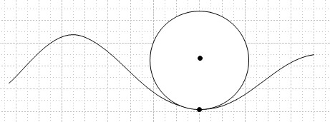

At any time t, you can regard the motion of that origin as doing instantaneous rotation with no translation. I have picked an arbitrary time with a • in the drawing, and at that instant of time it is rotating on the circle shown. So I think the issue of "velocity" is taken care of and does not have to be "added on". I keep saying "instantaneous rotation".

Now back to Fig (4.2.1) and (db/dt)S' = (db/dt)S - ω x b . I think neither of these two terms vanishes. The vector ω x b is perp to b as shown. But (db/dt)S I think is tangent to the circle. Since these two vectors are not collinear, they cannot add up to 0, so in this general case I claim (db/dt)S' ≠ 0 and this agrees with my intuition that Frame S' observer should see a moving b vector. As the ω axis moves closer to the Frame S' origin, this intuition becomes stronger. If ω is through the Frame S' origin, then certainly the Frame S' sees the b vector moving.

So I guess my claim is true: The Frame S' axes are only soldered to the b vector for Special Case #1.

Clarification of the notion of the Frame S' axes being "soldered" to something.

Here is Fig 1 where I have added a blue vector Q,

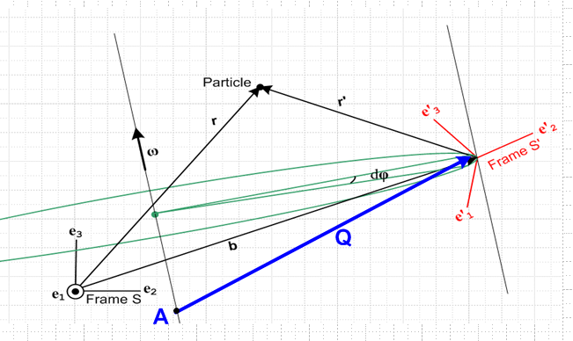

The vector Q has its tail on the rotation axis. The vector Q and the basis vectors e'n can be regarded as parts of a rigid object that rotates about the ω axis. During the rotation, a viewer looking at point A on the axis sees that point at a fixed location in Frame S'. Imagine being on a Merry Go Round and you look at a point A anywhere on the central pole about which you are rotating. The height of that point above your head does not vary during the rotation, nor does the horizontal direction to point A. So (dQ/dt)S' = 0.
On the other hand, the vector b as shown in the above picture DOES move because the origin of Frame S moves as seen from Frame S'. Thus, (db/dt)S' ≠ 0 and the axes of Frame S' are NOT soldered to vector b. On that Merry Go Round if you look at some point fixed in space but not on the pole, that point moves around.
However, if we move the origin of Frame S to point A so that the rotation axis passes through the Frame S origin (which is Special Case #1), then Q = b and then (db/dt)S' = 0 and only then can we say that the axis of Frame S' are soldered to b.

How do I deal with a Frame S' whose axis remain fixed in space, but whose origin moves?

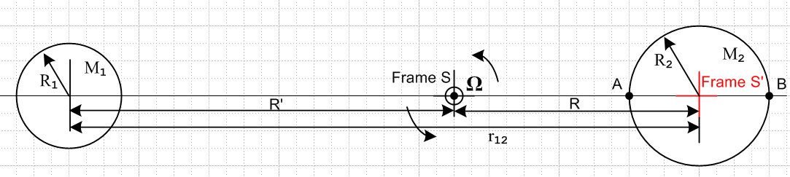

Here is my situation of interest where Frame S is fixed and we are Special Case #1 EXCEPT the Frame S' axes are NOT soldered to the b vector but stay fixed in space. My formalism does not seem to allow for this case.

Question: In Ch 6 6 "Determination of Velocities" where is it that I assume axes are soldered?

Here is a Special Case #1 picture that might be useful

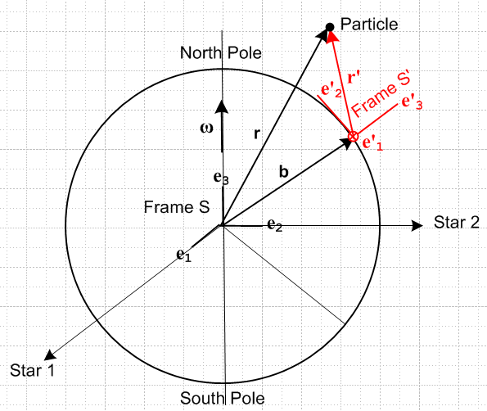

Suppose Frame S' had axes which don't rotate although the earth rotates? Then I would say

(de'n/dt)S = 0

which is not the case in my general formalism. Now in this case what can I say about the location of the Particle? First, let's assume it moves exactly as before with the rotation of the earth. Now r' moves in Frame S' and r moves in Frame S. I think r = r' + b is still true, what changes is the components vectors in Frame S'. So I think (6.1) and (6.2a) and (6.2.b) are still valid. I think (6.4a,b) are also OK. It is only where e'n get involved that there will be a change.
Start into section 6.2. G Rule is still valid for vectors b, r, r' . So I think all of (6.6) is still valid.

Fact: In deriving the summary (6.9) I have never used any fact about e'n being soldered or not. Am I really sure of this claim? The only external refs are the G Rule!! So must be still OK.

Start into section 6.5. I think the first equation in (6.10) is no longer true!! It says S' = 0, but if the Frame S' axis are fixed, this will not be 0 because one sees b changing from Frame S'. So let's just ignore my comments about the two special cases and try to move on.

Start into Section 7.1 on accelerations. I think (7.1) is OK since just the G Rule. I think (7.2) is OK. I think also that (7.4) is OK, nothing assumed more than G Rule and earlier validated equations.

Start into Section 7.2. I seem to have my main result still being valid!!

a = a' + x r' + 2 ω x v' + ω x (ω x r') + S . (7.6a)
S S' Euler Coriolis centripetal frame

It is because I have said nothing about "components of any vector" in Frame S'. I think the entire acceleration summary in 7.4 is then still OK!

Start into section 7.5. It all seems valid! EVERYTHING seems valid as long as I don't use e'n anywhere. I don't really believe this, but let's try it out. Special Case #1 is NOT valid.

Let's now stare at

a = a' + x r' + 2 ω x v' + ω x (ω x r') + S . (7.6a) (8.1.1)
S S' Euler Coriolis centripetal frame

and

Aha! Maybe the G Rule assumes soldering! Look back at its proof! Yes, the proof immediately fails because right off the bat I assume ∂Se'i = ω x e'i which means the axes e'i are soldered to any vector from the rotation axis ω.
So all of the above discussion of velocities and accelerations no longer applies since the G Rule no longer applies.

Idea: Maybe I need a separate "theory" for Frame S and Frame S' where the axes are always aligned and it is only b that moves. How would such a theory look?

8.7 Special Case #3

Consider the following situation which we shall call Special Case #3 where we have replaced the rotation vector ω by Ω where now Ω = dφ/dt :

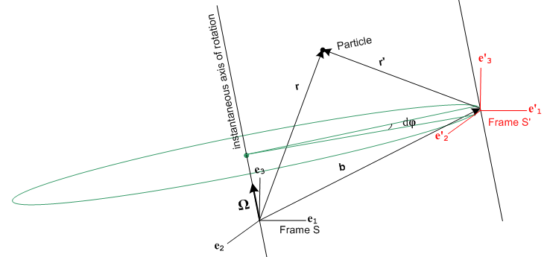

This resembles Special Case #1 because the rotation axis passes through the origin of Frame S. However, in this figure we intend that the axis of Frame S' always line up with those of Frame S, so the only thing that varies is the vector b(t). The axes e'i are no longer "soldered" to the b vector, and e'i = ei at all times. Although the axes of Frame S' do not rotate relative to those of Frame S, we still put this case into our "rotating frames" basket because the origin of Frame S' is instantaneously rotating about the ω axis.
In Special Case #3 there is no distinction between ∂Sa and ∂S'a for any vector a :

∂Sa = ∂S[aiei] = (∂Sai) ei = (∂tai) ei

∂S'a = ∂S'[aiei] = (∂S'ai) ei = (∂tai) ei

One can interpret ∂Sa = ∂S'a as being the G Rule ∂Sa = ∂S'a + ω x a with ω= 0.

Thus we can just write = ∂Sa = ∂S'a . The complicated analysis of Sections 6,7 and 8 is now much simpler:

r = r' + b

= ' + ⇒ v = v' +

= ' + ⇒ a = a' +

Newton's Law in Frame S' now has only one fictitious force,

ma' = ma - m

F'eff = F - m

F'fict = – m // Special Case #3

Recall that our general case fictional force expression was

F'fict = – mS – mω x (ω x r') – 2m ω x v' – m x r' . (8.1.8)
frame centrifugal Coriolis Euler

In Special Case #3 only the "frame" portion of the fictitious force exists and we can interpret this as being the full fictional force in which we set ω = 0 and = 0.
Regardless of how the Frame S' origin moves through space, we can always interpret its motion as an instantaneous rotation, as suggested by this drawing,

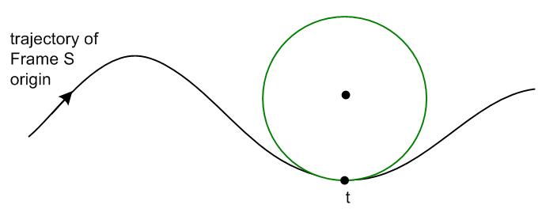

At time t the Frame S' origin is rotating along the green circle shown.

