A Review of the Projectile Problem PhL 2.4.17

The starting premise is that the four objects are launched with the same B in the four axis directions all done in rotating Frame S'.
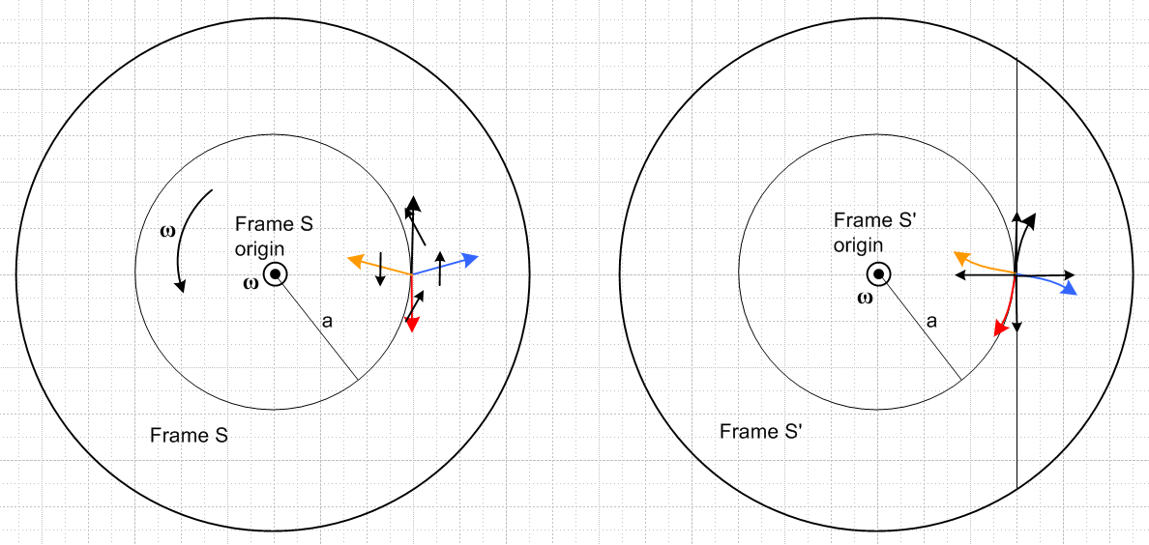

Consider the black puck. In Frame S' it is launched at V = 50 m/sec up, say. Suppose the launch point is moving at 5 m/sec up as seen in Frame S. Then it seems that the ant is going up at 55 m/sec in Frame S.

The launch platform in Frame S is translating UP at 5 m/sec. A projectile on that platform is launched UP at 50 m/sec relative to the platform. You ADD these speeds.

Suppose the black projectile is launched at V = 0 in Frame S'. Then in Frame S it goes UP at +5 m/sec. For example, the platform itself moves UP in Frame S at 5 m/sec.

Conclusion: to get the launch velocities of any projectile in Frame S, you add an upward velocity of 5 mph. Thus, if the colored arrows on the left represent velocity, they are correct (whew!).

Example: Suppose the up adder is vt = +1 m/sec. Suppose V = 0.7 m/sec (slow). What do we see on the left for velocities?

Black velocity is up at 1.7 m/sec, it gets an extra boost of +1 from the rotation effect.

Red goes down at 0.7, but you add 1.0 up, so red goes UP at 0.3 m/sec.

Orange has 0.7 to the left, who which you add 1.0 up, so it is about the same direction as picture.

Blue has 0.7 to the right and you add 1.0 up, so about same as picture.

My picture is correctly drawn for V > vt.

Conclusion: Something is wrong with my Maple problem because it shows red going down instead of up for these numbers!!!! Section 8.3 discussion is however all OK.

Note: Problem 3 has b = 0, ω = 1, r0 = (-1/2,0). We use θ = π/2, and later θ = -π/4.

Note: Problem 4 has b = 0, ω = 1, r0 = (-1/2,0). We use θ = π/2, and later θ = -π/4.

Review of Problem 3. The velocity solution for the ant flyover is

v'(t) = v'x' ' + v'y' '
where (15.3.7)
v'x' = V cos(θ-φ) + ω[Vt sin(θ-φ) – x0sinφ + y0cosφ]
v'y' = V sin(θ-φ) – ω[Vt cos(θ-φ) + x0cosφ + y0sinφ]
where φ = φ0 + ωt .

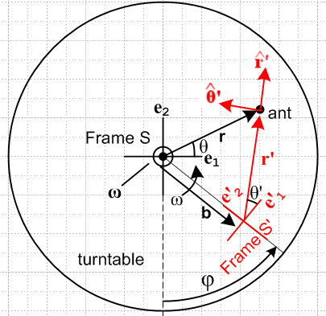

Now: to apply this to any of the projectiles, if projectile launch is at t = 0 and is on the right we must have

φ = π/2 b = 0 In this case e'1 = up, for example. BE VERY CAREFUL !

The launches are then (axes are lined up at t = 0)

black up θ' = π/2

red down θ' = -π/2

orange left θ' = π

blue right θ' = 0

At the lined up position at t = 0, it is true that θ = θ' = regular polar angle. BUT the launch velocity angles in Frame S are NOT the simple four you see above. Two of them have adders as we see below.

This problem is confusing! It has two steps:

1. Compute the launch velocities in Frame S, given the launch method in Frame S'
Each Frame S velocity represents a Problem 3 flying-ant problem.

2. Write down the Frame S' solution to each of the 4 flying ant problems.

Step 1: OK (Sun), here are the results for step 1 for Frame S velocities. For θ we are using the θ shown in Figure (15.1.1), it is the usual polar angle!!!!

black V' + vt = (V'+vt) θ = π/2 V = V' + vt

red -V' + vt = (-V'+vt) θ = -π/2 V = |V' - vt|

orange -V' + vt θ = π - Δθ V = $\sqrt{V'2+vt2}$

blue V' + vt θ = Δθ V = $\sqrt{V'2+vt2}$

This is the first mistake I made! In Frame W they don't all just have V = V'.

Step 2: Given these as four fly-over init velox, we use this formula to get trajectory in Frame S' on the right,

r'(t) = x' ' + y' '
where (15.3.6)
x' = Vt cos(θ-φ) + x0cosφ + y0sinφ
y' = Vt sin(θ-φ) – x0sinφ + y0cosφ + b
where φ = φ0 + ωt .

Question: For Problem 4, what is φ0? As shown WAY back in Fig (15.1.1) φ = 0 puts Frame S' UNDER Frame S. If b = 0, then φ = 0 causes axes to be lined up at t = 0 and same origin. That seems reasonable to do for Problem 4 as well.

I will now attempt a rewrite:

________________________________________________________

In Frame S' at t = 0 the four projectiles are launched in the four Frame S' axis directions and each has the same speed V' (black arrows on the right).

We now examine the initial speeds V and launch angles θ of the four projectiles as seen in Frame S. Here vt = aω is the turntable upward speed at t = 0 when the launch occurs , and Δθ = tan-1(vt/V') :

black (upper) V' + vt θ = π/2 V = V' + vt

red (lower) -V' + vt θ = -(π/2)*sign(V'-vt) V = |V' - vt|

orange (left) -V' + vt θ = π - Δθ V = $\sqrt{V'2+vt2}$

blue (right) V' + vt θ = Δθ V = $\sqrt{V'2+vt2}$

We use these four situations as initial ant-flyover velocities in Problem 3. The trajectories are then given by (15.3.8) where the Frame S and Frame S' origins coincide at the spindle (b=0) and have aligned axes at time t = 0,

x = Vt cos(θ-ωt) + x0cos(ωt) + y0sin(ωt)
y = Vt sin(θ-ωt) – x0sin(ωt) + y0cos(ωt) . (15.3.8)

The four projectiles start at (x0,y0) = (a,0) so things simplify a bit more,

x(t) = Vt cos(θ-ωt) + acos(ωt)
y(t) = Vt sin(θ-ωt) – asin(ωt) . (15.4.9)

These are very simple expressions indeed, considering the coupled differential equations above.

It remains only to have Maple plot the projectile trajectories with these angles installed and . First, here is the code,

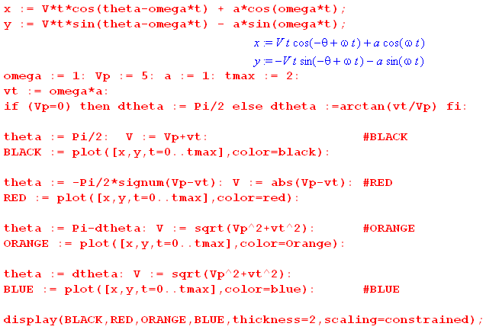

And here are some plots. The first four have the same parameters, just varying durations. The notion of the deflections being roughly circular (end of Section 8.3) is not too bad for our chosen parameters

V' = 5, tmax = 0.2 V' = 5, tmax = 0.5 V' = 5, tmax = 1.0
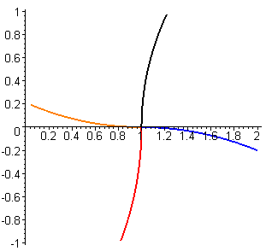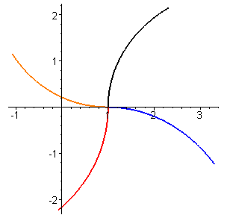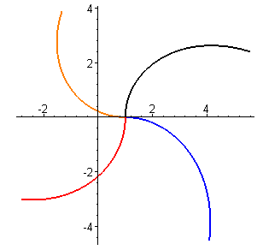

__________________________________________

When V' = 0, the orange trace screws up! Before setting in params we have

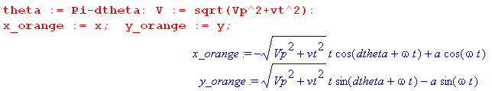

After I set a = 1 and ω = 1 and Δθ = arctan(vt/V') I get for orange,

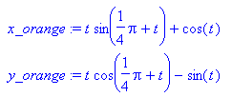

And I also see dtheta = π/4. Where is that coming from???

