Tether doc notes PhL 1.22.17

I got a 1997 3rd edition handbook copy with relatively clean graphics and am just browsing it. Today is of course 20 years later, I don't see an intervening 4th edition.

The handbook opens with a review of tether actions that have already happened. Tethers from a few hundred meters to up to 20 km have been involved. Activity in the 1990's in the Space Shuttle era.

Section 2.0 is a long list of "proposed" tether flights. (again, 1997)

Section 3.0 is on tether "applications", which I found interesting.

power generation using conducting tethers in magnetic field and/or plasma
thrust generation
use as an antenna
gravity wave experiments
tool to lifting and moving things around in space
tool for stabilizing objects in space.
reboosting satellites
tether material (Kevlar) and micrometeorite damage rate
to provide specific gravity strength environments.

Section 4.0 is "tether fundamentals" starting page 118 out of 274. I will pay more attention here.

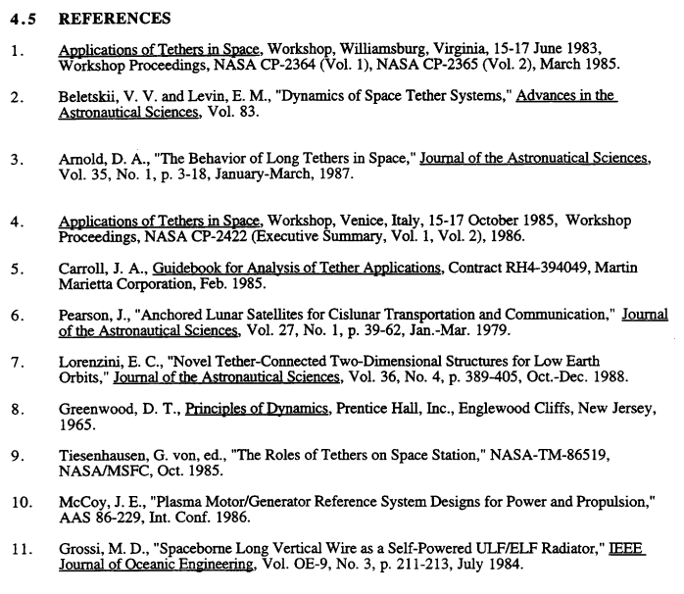

I browsed it all, not much relevant to my stuff.

Section 5.0 tether data

Lots of stuff, mention of Arnold's equations but they include and do not match mine.

Section 6.0 Space Science and Tethers

There are lots of tether papers, might be nice to see histogram versus date!
I am done with this review.

found a recent history from China, added a ref.

Not sure how I will wedge in tether interest stuff.

